

662

*internal report*

Radon-222 diffusion from acrylic containers used in eriss gamma spectrometry analysis

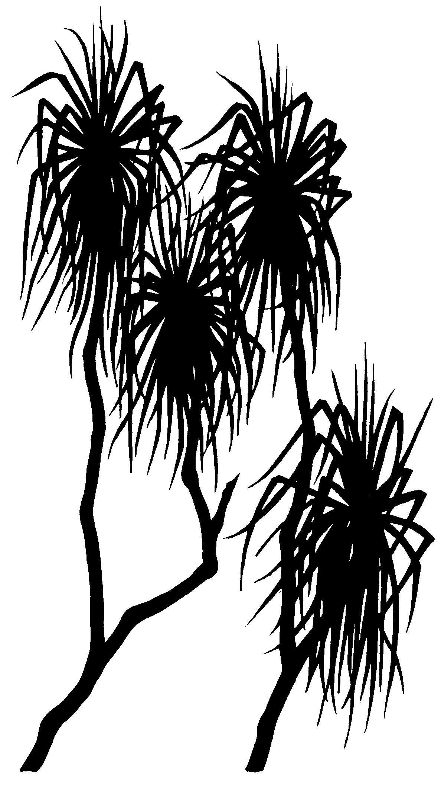

John Pfitzner & Scott McMaster

June 2021

Release status – Unrestricted

Project number – RES-2019-023

*The Department acknowledges the traditional custodians of country throughout Australia and their continuing connection to land, sea and community. We pay our respects to them and their cultures and to their elders both past and present.*

# Radon-222 diffusion from acrylic containers used in eriss gamma spectrometry analysis

John Pfitzner & Scott McMaster

Supervising Scientist

GPO Box 461, Darwin NT 0801

June 2021

(Release status – Unrestricted)



*How to cite this report:*

Pfitzner J & McMaster S 2021. Radon-222 diffusion from acrylic containers used in eriss gamma spectrometry analysis. Internal Report 662, June 2021, Supervising Scientist, Darwin.

*Project number: (RES-2019-023)*

*Authors of this report:*

John Pfitzner –Supervising Scientist, GPO Box 461, Darwin NT 0801, Australia

Scott McMaster –Supervising Scientist, GPO Box 461, Darwin NT 0801, Australia

Supervising Scientist is a branch of the Australian Government Department of   
Agriculture, Water and the Environment.

Supervising Scientist   
Department of Agriculture, Water and the Environment   
GPO Box 461, Darwin NT 0801 Australia

**environment**.gov.au/science/supervising-scientist/publications

© Commonwealth of Australia 2021

Ownership of intellectual property rights

Unless otherwise noted, copyright (and any other intellectual property rights) in this publication is owned by the Commonwealth of Australia (referred to as the Commonwealth).

Creative Commons licence All material in this publication is licensed under a Creative Commons Attribution 4.0 International Licence except content supplied by third parties, logos and the Commonwealth Coat of Arms. Inquiries about the licence and any use of this document should be emailed to copyright@awe.gov.au.



The Australian Government acting through the Department of Agriculture, Water and the Environment has exercised due care and skill in preparing and compiling the information and data in this publication. Notwithstanding, the Department of Agriculture, Water and the Environment, its employees and advisers disclaim all liability, including liability for negligence and for any loss, damage, injury, expense or cost incurred by any person as a result of accessing, using or relying on any of the information or data in this publication to the maximum extent permitted by law.

# Contents

Contents iv

Executive summary v

1 Introduction 6

1.1 Background 6

1.2 Aim 10

2 Experimental methods 10

2.1 Samples 10

2.2 Test chambers 11

2.3 RAD7 radon detectors 11

2.4 HPGe gamma detectors 12

3 Results and discussion 13

3.1 222Rn leakage 13

3.2 Free 222Rn 16

3.3 Identifying 222Rn leakers 19

4 Conclusion 22

References 23

Appendix A RAD7 cross-calibration plots 24

Appendix B RAD7 measurement data 25

# Executive summary

Radium-226 (226Ra) is a radionuclide of importance in post-mining rehabilitation dose calculations. Gamma spectrometry is used to measure 226Ra in soils, sediments and biota. The principal gamma emission line for 226Ra is of low emission intensity and is overlaid with an emission line of uranium-235 (235U). Greater accuracy of 226Ra activity can be gained by measuring stronger gamma emissions from radionuclides further down the uranium-238 (238U) decay chain. However, this method relies on the retention of the noble gas radon-222 (222Rn) within the sample container, so that its progeny radionuclides, bismuth-214 (214Bi) and lead-214 (214Pb), can reach secular equilibrium with 226Ra. The acrylic sample containers in use at the Environmental Research Institute of the Supervising Scientist (eriss) have been tested for 222Rn diffusion to ensure that the reported 226Ra results are consistently accurate.

In the samples that we tested the diffusion of 222Rn was consistently low and ranged from 0.74–1.5% of the total 222Rn (or 226Ra) activity in the sample. This diffusion was found to not have a significant effect on reported 226Ra activity concentrations measured by gamma spectrometry, as calibration and counting uncertainties are typically larger than these 222Rn losses. Moreover, the 222Rn diffusion is comparable between detector calibration standards and environmental samples, further reducing any effect on the reported 226Ra results.

Tests for free 222Rn (i.e. 222Rn that has emanated from the sample material and is potentially free to escape the acrylic container if not properly sealed) were also conducted. The tests showed that a considerable percentage (>50% for some sample matrices) of the 222Rn in the containers is free, highlighting the need to carefully follow the existing procedure for gamma spectrometry sample preparation to avoid any excessive loss of 222Rn, identified here as ‘leakage’. This will ensure that high standards of accuracy and precision are maintained in measuring and reporting 226Ra activity concentrations in environmental samples analysed by gamma spectrometry.

If the seal between the acrylic container, lid and o-ring are not radon tight, leakage of 222Rn will be apparent in the gamma spectrometry results, where the 226Ra calculated from 214Bi and 214Pb will appear to be lower activity than the 226Ra measured directly at 186.2 keV. In these rare cases, the cause is often excessive sample which prevents the lid, o-ring and container contacting with sufficient pressure. This is remedied by the removal of excess sample material, with the appropriate adjustment to the weight used in calculations, and requires repacking, careful resealing and then recounting after reaching secular equilibrium.

# 1 Introduction

## 1.1 Background

The Environmental Research Institute of the Supervising Scientist (eriss) uses gamma spectrometry to measure radionuclides in a range of environmental samples including milled rock, sediments, soils and biota (Murray et al 1987). Radium-226 (226Ra) is a radionuclide of particular interest due to its potential to contribute a radiation dose to the public, particularly via consumption of freshwater mussels (Bollhöfer et al 2011) and as the precursor of radioactive radon-222 (222Rn) gas (Doering et al 2018).

Gamma spectrometry measurement of 226Ra can be performed directly using the 186.2 keV emission line, although its relatively low emission intensity (3.6%) (LNHB 2021) and conflict with a similar emission energy of uranium-235 (235U) at 185.7 keV can result in high uncertainties. To overcome this, 226Ra activity is determined based on the measurement of higher emission intensity radionuclides further down the uranium-238 (238U) decay chain. These radionuclides are bismuth-214 (214Bi) (45.5% intensity @ 609 keV) and lead-214 (214Pb) (35.6% intensity @ 352 keV and 18.4% @ 295 keV) (LNHB 2021). However, this technique relies on the sample measurement container retaining all of the elusive 222Rn gas, so that secular equilibrium can be reached between 222Rn, 214Bi & 214Pb, and 226Ra (Figure 1). To achieve greater than 98% secular equilibrium, samples need to be sealed in air-tight containers and stored until at least six half-lives of 222Rn (>23 days) have elapsed prior to analysis. Radon-222 leakage from a sample container can cause the reported 226Ra activity concentration to be underestimated. Conversely, 222Rn leakage from the measurement container of a detector calibration standard can result in an overestimate of reported 226Ra activity concentration in samples due to detector efficiency being underestimated.

Historically at eriss, pulverised solid samples and calibration standards had been prepared for gamma spectrometry analysis by casting in polyester resin (Murray 1987, Marten 1992, Pfitzner 1993) (Figure 2). Although the resin casting method gave reliable results, there were specific workplace health and safety (WHS) risks involved with the sample preparation method due to the use of chemical substances. Also, the destructive nature of the resin casting method essentially destroys the sample for any further analysis. Consequently, in 2002, it was decided to change the method of sample preparation for gamma spectrometry.

As no containers with volumes between 5 and 50 cm3 designed specifically for gamma spectrometry were available, several other laboratories have re-purposed existing containers, including steel and aluminium tins, glass jars and petri dishes, with varying degrees of success (Suursoon et al 2014, Drew Watson Queensland Health pers. comm., Jon Ollie University of Queensland pers. comm.). Steel containers have the problem of attenuation at low gamma energies which particularly affects lead-210 (210Pb) gamma emissions at 46.5 keV. Steel and glass can have varying backgrounds of radionuclide activity which impacts the ability to confidently analyse samples of low activity. Suitable sized steel and aluminium containers are generally not available with hermetic seals, so improvised seals are employed, most commonly epoxy resin (e.g. Araldite). If epoxy resin was used, the sample could only be retrieved by destruction of the container or by using solvents to dissolve the epoxy resin, both methods of sample removal increase the WHS risks and potentially cause sample contamination.

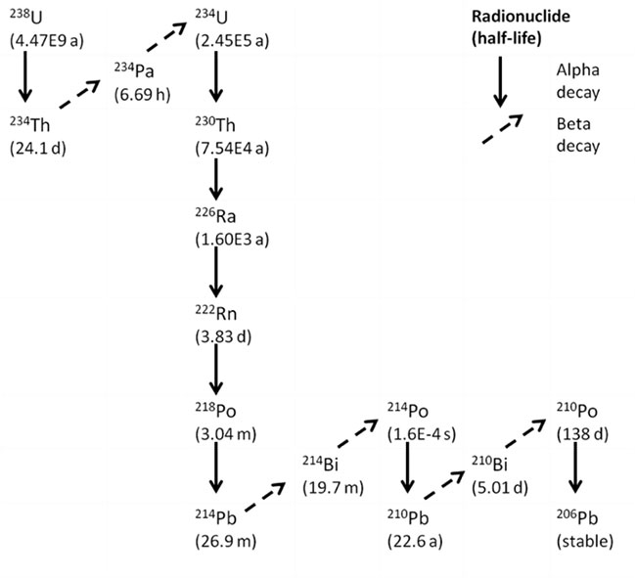

**Figure 1** 238U decay chain, highlighting the relationship between 226Ra, 222Rn and 214Bi and 214Pb.

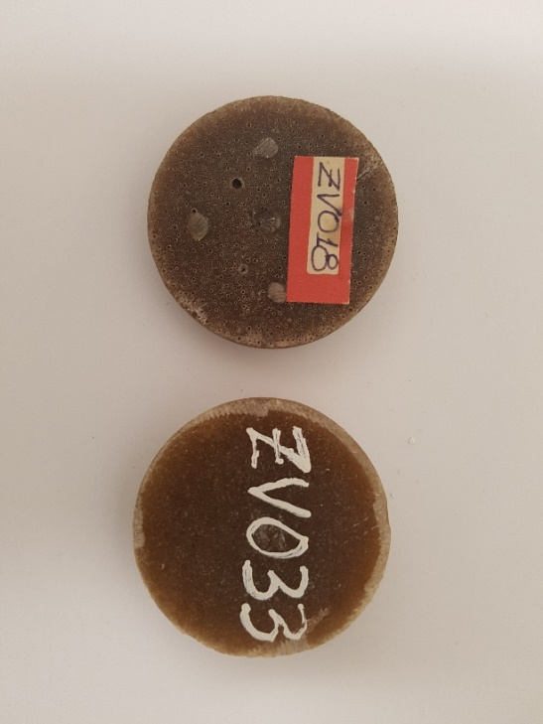

**Figure 2** Pre-2002 resin style casts for gamma spectrometry analysis.

Eriss opted for resealable acrylic containers which were originally designed and manufactured by the Australian Institute of Marine Science (AIMS) and subsequently produced and adopted by several other gamma spectrometry laboratories. The acrylic containers consist of five components:

1. a machined acrylic base which holds the pressed pulverised sample material and has a groove for an o-ring and a threaded body to match a screw cap;
2. a rubber o-ring;
3. a clear acrylic disc or lid to seal against the o-ring;
4. a screw cap to ensure a tight seal between the base, o-ring and disc lid; and
5. vacuum grease or Vaseline which assists in sealing the o-ring.

A significant additional component of the acrylic container usage by eriss is the hydraulic press (Figure 3) which compresses the powdered sample material into the base, to maximize the quantity of material in the container and for consistent density. The use of the hydraulic press is described in the eriss standard operating procedure for ‘Gamma Sample Pressing’.

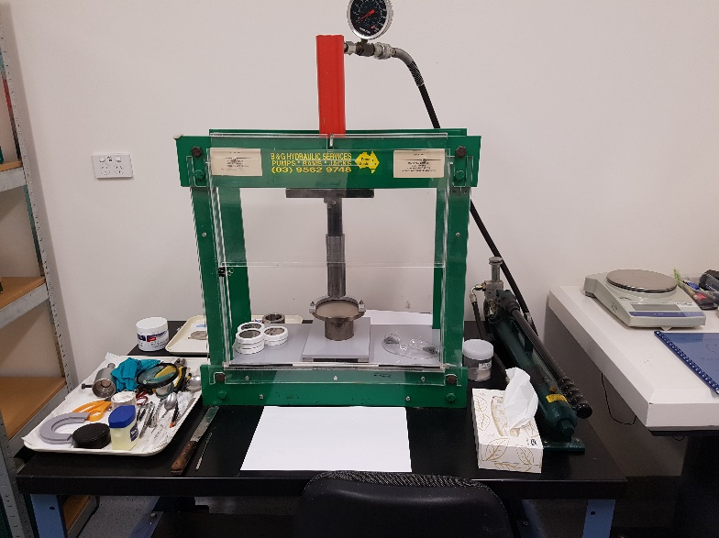

**Figure 3** Hydraulic press for compressing sample material into acrylic containers.

Three sizes of acrylic containers are currently used by eriss and are shown in Figure 4. The eriss designation of the different container sizes (geometries) and their nominal sample capacities are:

* ‘B’, 1.6 cm3 (20 mm diameter × 5 mm depth);
* ‘Q’, 8 cm3 (45 mm diameter × 5 mm depth); and
* ‘R’, 92 cm3 (73 mm diameter × 22 mm depth).

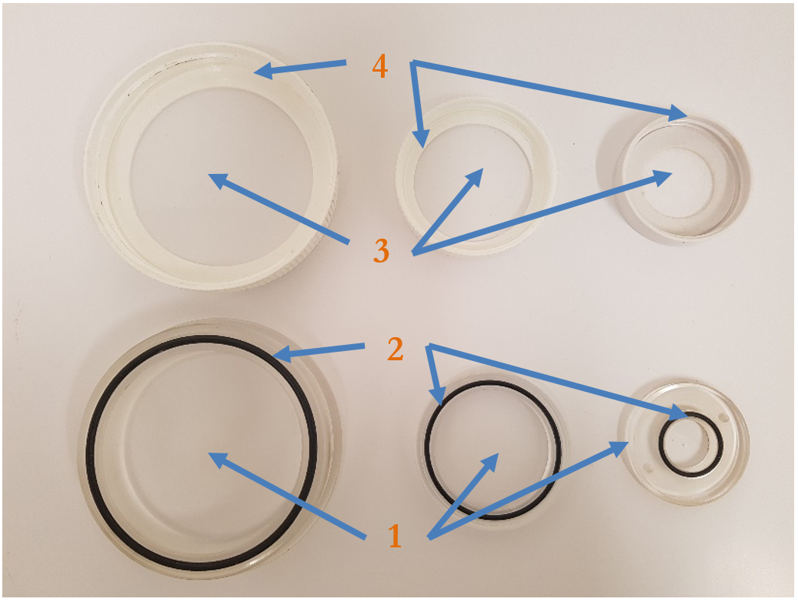

**Figure 4** Eriss acrylic containers of designation R, Q and B (left to right). Numbered components are identified in the text, except for the vacuum grease which is applied to the o-rings.

Gamma spectrometry analysis of samples in these acrylic containers has been a standard practice at eriss for almost 20 years and at AIMS for 11 years (1995–2006). They have also been used at other Australian laboratories including the former Commonwealth Scientific and Industrial Research Organisation (CSIRO) Land and Water laboratories (Leslie 2009) and Australian National University (ANU) (Dr Steve Tims pers. comm.). Using the containers, these laboratories participated in 226Ra proficiency tests conducted by the International Atomic Energy Agency (IAEA) and other groups, covering a range of radiation measurement activities (IAEA 2010). The 226Ra activity concentrations reported by the Australian laboratories were within the range of other participating laboratories, indicating that gamma measurement of 214Bi and 214Pb was at approximate secular equilibrium with 226Ra and hence that the leakage of 222Rn was low.

The designers of the containers were aware of the potential for 222Rn diffusion through acrylic material. To mitigate this effect, acrylic sheet was used for manufacturing the base such that the extrusion flow, and any imperfections associated with the extrusion process, were across the base, not through the base (Figure 5). All container bases manufactured at AIMS were made from acrylic sheet, not acrylic rods. Lids were also cut from acrylic sheet.

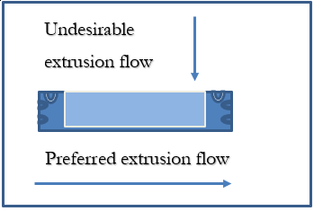

**Figure 5** Schematic of acrylic base showing preferred direction of extrusion.

## 1.2 Aim

The aim of this study is to quantify the diffusion and variability of diffusion of 222Rn from the acrylic containers used by eriss for gamma spectrometry analysis. The study enables the significance of any 222Rn leakage on the accuracy and precision of 226Ra gamma spectrometry measurements to be determined.

# 2 Experimental methods

## 2.1 Samples

Since October 2015 no samples have been prepared for gamma spectrometry analysis in the larger R geometry, only 11 samples have been prepared exclusively for the smaller B geometry and the remaining 554 samples were all pressed in the medium Q geometry. Therefore, all testing was done on samples pressed in ‘Q’ containers.

Three samples containing BL-5 uranium ore reference material mixed with low activity sand were tested for 222Rn leakage/diffusion using custom-made test chambers (section 2.2) connected to RAD7 radon detectors (sections 2.3). These samples were also used to explore a novel method of identifying potentially leaky containers based on high purity germanium (HPGe) gamma spectrometry counting (section 2.4). Details of the samples are given in Table 1. The samples are calibration standards routinely used for determining the efficiency of the eriss HPGe gamma detectors. All samples had relatively high 226Ra activity (>400 Bq) and were chosen to minimise counting uncertainties associated with their testing. The samples were prepared (pressed and sealed) in their acrylic container at least 1 month prior to testing to allow for secular equilibrium between 222Rn and 226Ra.

Table 1. Samples tested for 222Rn leakage using test chambers connected to RAD7 radon detectors.

|  |  |  |
| --- | --- | --- |
| Sample ID | Matrix | 226Ra activity (Bq) |
| ZQ081 | BL-5 mixed with sand | 428.9 |
| ZQ083 | BL-5 mixed with sand | 473.6 |
| ZQ084 | BL-5 mixed with sand | 498.4 |

Three additional samples were tested using the test chambers and RAD7 detectors to determine the proportion of ‘free’ 222Rn in the acrylic container (i.e. 222Rn that has emanated from the sample material and is potentially free to escape the container if not properly sealed). Details of the samples are given in Table 2. The samples included one additional calibration standard and two environmental samples representing typical sediment and biota matrices. They were first tested with the acrylic container lid closed (after allowing sufficient time after pressing and sealing for secular equilibrium between 226Ra and 222Rn to establish) and then again with the acrylic container lid open. The former measurements provided additional estimates of 222Rn diffusion from properly prepared samples, while the latter measurements enabled estimates of free 222Rn.

Table 2. Samples tested for free 222Rn using test chambers connected to RAD7 radon detectors.

|  |  |  |
| --- | --- | --- |
| Sample ID | Matrix | 226Ra activity (Bq) |
| ZQ082 | BL-5 and 232Th mixed with sand | 529.5 |
| ZQ012 | Sediment | 314.2 |
| BQ008 | Mussel flesh | 2.66 |

Three waste rock samples from the Ranger trial landform were also tested for free 222Rn but by an alternate method using HPGe gamma detectors (section 2.4). Sample details are given in Table 3.

Table 3. Samples tested for free 222Rn using HPGe gamma detectors.

|  |  |  |
| --- | --- | --- |
| Sample ID | Matrix | 226Ra activity (Bq) |
| JQ2152 | Waste rock | 3.88 |
| JQ2153 | Waste rock | 4.31 |
| JQ2154 | Waste rock | 5.55 |

## 2.2 Test chambers

Three custom-made test chambers were manufactured from glued heavy duty PVC pipe fittings, the lid was sealed with a lubricated o-ring and fitted with two tubes for entry and exit of air, with an in-line ball valve in each tube (Figure 6). The test chamber internal dimensions were 100 mm diameter by 70 mm height. The volume was ~550 cm3.

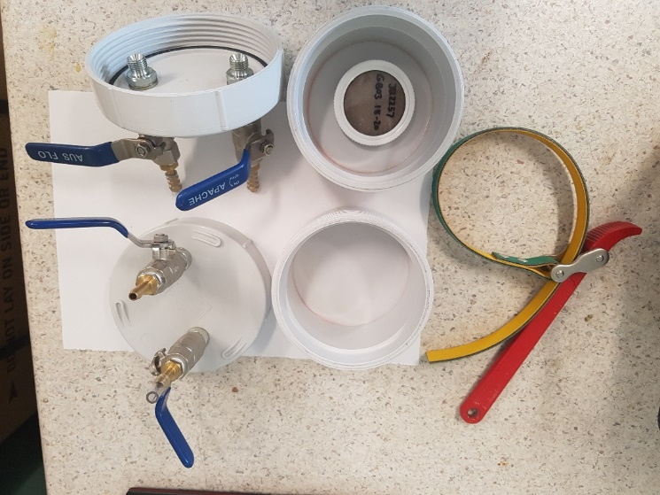

**Figure 6** Test chamber base, lid with o-ring and inlet and outlet ports, with flexible oil filter wrench to assist in sealing the chamber.

The tubing and test chamber setup were tested for hermetic seal by submerging the equipment under water and increasing the internal pressure to approximately 28,000 Pa with nitrogen gas. No bubbles were observed, indicating that the test chambers and tubing system was air-tight at that pressure.

## 2.3 RAD7 radon detectors

Three Durridge RAD7 radon detectors (<https://durridge.com/products/rad7-radon-detector/>) were used in conjunction with the test chambers to measure 222Rn diffusion from the acrylic containers. One RAD7 was connected to each test chamber by plastic hoses that attached to the air inlets in the lid of the chamber. An inline air filter (Gelman 0.45 µm) to avoid particulate contamination of the RAD7 and a drying tube containing a moisture reducing agent completed each setup (Figure 7). The desiccants in the tube were either silica gel (SiO2, <https://www.silicagel.com.au/1-kg-blue-silica-gel-beads-self-indicating/>) or 8 mesh Drierite (CaSO4, <https://secure.drierite.com/catalog3/page4b.cfm?activeMenu=0>), both of which are neutral to either trapping or emanating 222Rn.

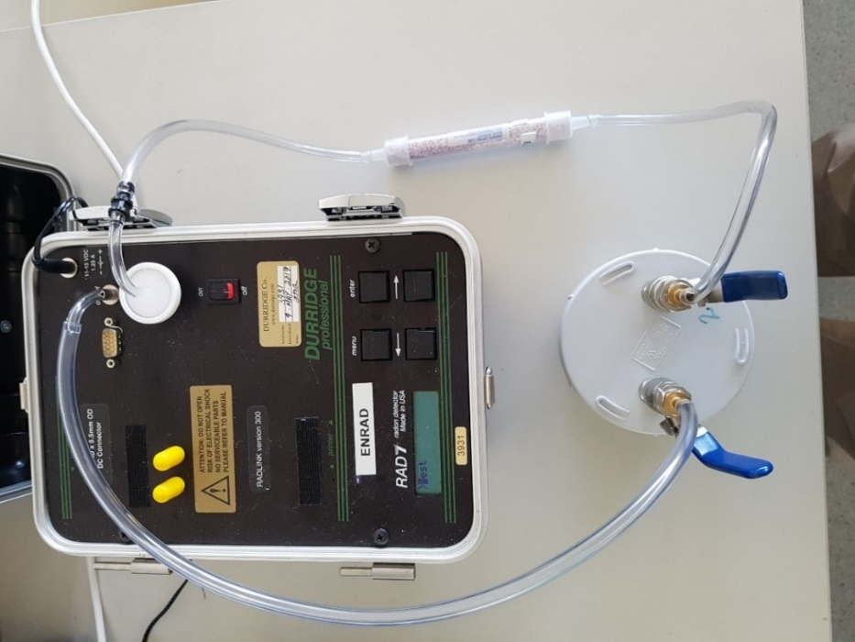

**Figure 7** A complete setup: RAD7, inline filter, plastic tubing, moisture reducer and test chamber.

Each sample in its acrylic container was placed inside the test chamber and the lid of the chamber closed. The build-up of 222Rn activity concentration inside the chamber due to 222Rn diffusion from the container was then measured with the RAD7. The RAD7s were operated in NORMAL mode (Durridge 2021) with 1 hour cycle times over measurement periods of 20–30 hours. The data collected and stored on the RAD7s were transferred to a computer via an RS-232/USB cable using the Durridge ‘Capture’ program. The program also applied a humidity correction to the data.

One RAD7 (serial number 3931) was calibrated at Durridge USA prior to commencing the study. The other two units (serial numbers 2527 and 3925) were cross calibrated to it. Cross-calibration plots are included in Appendix A. Instrument backgrounds were regularly checked. All tests were conducted either after a background run using ambient air or after a delay of more than 1 hour from the previous sample test.

The effective volume of the setup was ~1350 cm3 and included the volume of the test chamber (~550 cm3) and volume of the RAD7 detector chamber (~800 cm3). The volume of the hosing connecting the RAD7 to the test chamber of 28 cm3 (6 mm diameter × 1000 mm length) and the estimated 20% interstitial space within the dry tube of 5 cm3 (15 mm diameter × 150 mm length) was compensated for by the volume of the Q container inside the test chamber.

## 2.4 HPGe gamma detectors

Eriss currently uses three Ortec manufactured HPGe gamma detectors for radionuclide analysis of environmental samples. Counting is controlled by Ortec ‘Maestro’ version 7.0 software (<https://www.ortec-online.com/products/application-software/maestro-mca>). Spectrum analysis is performed using ‘FitzPeaks’ version 3.86 software (<http://www.jimfitz.co.uk/fitzpeak.htm>), following protocols defined in the eriss standard operating procedure for ‘Gamma Analysis using FitzPeaks’.

The HPGe gamma detectors were used to determine the proportion of free 222Rn in the three waste rock samples detailed in Table 3. The samples were counted for 222Rn progeny radionuclides (214Bi and 214Pb) immediately after they were prepared (pressed and sealed) in their acrylic containers and at regular intervals up until secular equilibrium was established.

The HPGe gamma detectors were also used to assess the variation in intensity of the gamma emissions from 214Bi at 609 keV and 214Pb at 295.2 and 352 keV relative to the gamma emission from 226Ra at 186.2 keV for the three samples of BL-5 uranium ore mixed with sand (Table 1). To negate differences in detector calibration, the net counts at peaks of interest were used for comparison. The net counts are the total counts of a peak, less the continuum and instrument backgrounds, and are calculated automatically by FitzPeaks.

# 3 Results and discussion

## 3.1 222Rn leakage

The RAD7 measurement data for the three samples of BL-5 uranium ore reference material (Table 1) are included in Appendix B and plotted in Figure 8. The data for all samples show a build-up in 222Rn activity concentration inside the test chamber over the measurement period, indicating that some leakage or diffusion of 222Rn from the acrylic containers was occurring.

Factors influencing the observed build-up of 222Rn inside the test chamber include the rate of 222Rn escape from the acrylic container and the radioactive decay of 222Rn atoms that have escaped from the container into the chamber. Additionally, as 222Rn activity concentration in the test chamber increases, the 222Rn concentration gradient between the sample in the acrylic container and the air in the test chamber decreases and can cause the rate of 222Rn escape from the container to decrease over the measurement period. The influence of changing concentration gradient can be effectively mitigated by basing the data analysis on measurements made earlier in the period which are less affected by this factor. We have used only the first ten measurements in our analysis of the data.

The model that was used to interpret the build-up in 222Rn activity concentration in the test chamber over the first ten measurements is:

$C=\frac{R}{λV}\left(1-e^{-λt}\right)$ (Equation 1)

where:

* C (Bq/m3) is the measured 222Rn activity concentration;
* R (Bq/s) is the rate of 222Rn diffusion from the acrylic container;
* λ (1/s) is the 222Rn decay constant;
* V (m3) is the effective volume of the test system; and
* t (s) is time.

|  |  |  |
| --- | --- | --- |
|  |  |  |
|  |  |  |
|  |  |  |

**Figure 8** Build-up of 222Rn activity concentration inside test chambers.

This model is the solution of the first order differential equation describing the net rate of change in the number of 222Rn atoms in the test chamber due to escape from the acrylic container and radioactive decay. It assumes that the activity concentration of 222Rn in the chamber at t=0 is negligible. All parameters in this equation other than C and t are constants such that a graph of C versus e-λt plotted from the RAD7 measurement data (first ten measurements) should give a linear relationship. The value of R can be determined from the slope (m) of the line of best fit as R = -mλV or from the intercept (b) of the line of best fit as R = bλV. Figure 9 shows graphs of C versus e-λt. The line of best fit and its equation are also shown in the graphs.

Table 4 gives the rate of 222Rn diffusion (R) calculated from the slope and intercept of the line of best fit for each test. The average percentage diffusion of 222Rn from the containers is given in Table 5. The percentage diffusion was determined by comparing the 222Rn diffusion rate expressed in atoms per second (i.e. R/λ) to the sample 226Ra activity in Becquerels (Table 1). As 226Ra decays directly to 222Rn, the sample 226Ra activity is a measure of the number of 222Rn atoms produced each second in the sample material.

|  |  |  |
| --- | --- | --- |
|  |  |  |
|  |  |  |
|  |  |  |

**Figure 9** 222Rn activity concentration (first ten measurements) versus e-λt showing lines of best fit.

**Table 4** Rates of 222Rn leakage from acrylic containers determined from regression fits in Figure 9.

|  |  |  |
| --- | --- | --- |
| Description | 222Rn diffusion rate from slope  (×10-6 Bq/s) | 222Rn diffusion rate from intercept  (×10-6 Bq/s) |
| ZQ081 in RAD7 #2527 | 8.2 | 8.4 |
| ZQ081 in RAD7 #3925 | 8.6 | 8.6 |
| ZQ081 in RAD7 #3931 | 7.2 | 7.2 |
| ZQ083 in RAD7 #2527 | 9.6 | 9.6 |
| ZQ083 in RAD7 #3925 | 5.3 | 5.2 |
| ZQ083 in RAD7 #3931 | 7.1 | 7.2 |
| ZQ084 in RAD7 #2527 | 14.4 | 14.4 |
| ZQ084 in RAD7 #3925 | 14.1 | 14.2 |
| ZQ084 in RAD7 #3931 | 16.3 | 16.2 |

**Table 5** 222Rn diffusion from acrylic containers as a percentage of total 222Rn in the sample (mean ± standard deviation as determined from diffusion rates in Table 4).

|  |  |
| --- | --- |
| Sample | 222Rn leakage (%) |
| ZQ081 | 0.89 ± 0.07 |
| ZQ083 | 0.74 ± 0.20 |
| ZQ084 | 1.4 ± 0.1 |

The average 222Rn diffusion from each sample container was low at 0.74–1.43% (Table 5). By comparison, gamma spectrometry counting uncertainty for 226Ra, based on the counting of 222Rn progeny radionuclides 214Bi and 214Pb, is typically 2.5% for most environmental samples analysed by eriss. The results suggest that 222Rn diffusion from properly prepared samples is unlikely to be a large source of additional uncertainty on 226Ra gamma spectrometry measurements reported by eriss.

## 3.2 Free 222Rn

The RAD7 measurement data for the samples tested for free 222Rn (Table 2) are included in Appendix B and plotted in Figure 10. Plots of C versus e-λt (Equation 1) based on the first ten measurements are shown in Figure 11. The 222Rn activity concentration for the closed container measurements on mussel flesh sample BQ008 are low (similar to normal 222Rn in air concentrations), have high uncertainty and do not show a distinct build-up over the measurement period. This is likely due to the low 226Ra activity (2.66 Bq) of the sample combined with low rate of 222Rn escape. The data analysis results for this sample may not be reliable.

|  |  |  |
| --- | --- | --- |
|  |  |  |
|  |  |  |

**Figure 10** Build-up of 222Rn activity concentration inside test chambers from open (top row) and closed (bottom row) acrylic containers.

|  |  |  |
| --- | --- | --- |
|  |  |  |
|  |  |  |

**Figure 11** 222Rn activity concentration (first ten measurements) versus e-λt showing lines of best fit to the data for open (top row) and closed (bottom row) acrylic containers.

Table 6 gives the rate of 222Rn escape calculated from the slope and intercept of the line of best fit to the C versus e-λt plots (Figure 11). It also gives the average 222Rn escape from the open and closed sample containers. The results for the open containers give the estimates of the percentage of free 222Rn relative to total 222Rn in the sample and provide an upper bound on possible 222Rn escape from the containers for different sample matrices. More than 33% of the total 222Rn in these samples is free, with potential to escape from poorly sealed containers. The percentage of free 222Rn is particularly high for the mussel flesh sample (BQ008) at about 80% and is perhaps related to the non-crystalline sample matrix from which 222Rn may more easily emanate. These results highlight that if acrylic containers are not properly sealed then there is potential for large uncertainties (i.e. underestimates) in 226Ra determination by gamma spectrometry based on the counting of 222Rn progeny radionuclides.

**Table 6** Rates of 222Rn escape from closed and open acrylic containers determined from regression fits in Figure 11.

|  |  |  |  |
| --- | --- | --- | --- |
| Description | 222Rn escape rate from slope  (×10-6 Bq/s) | 222Rn escape rate from intercept  (×10-6 Bq/s) | 222Rn escape  (%) |
| ZQ082 in RAD7 #2527 open container | 551 | 558 | 47 |
| ZQ012 in RAD7 #3925 open container | 228 | 227 | 33 |
| BQ008 in RAD7 #3931 open container | 4.7 | 4.7 | 80 |
| ZQ082 in RAD7 #2527 closed container | 17.3 | 17.2 | 1.5 |
| ZQ012 in RAD7 #3925 closed container | 5.5 | 5.5 | 0.80 |
| BQ008 in RAD7 #3931 closed container | 0.24 | 0.27 | 4.0a |

aResult considered unreliable due to large measurement uncertainties.

The results in Table 6 for the closed container measurements provide additional estimates of 222Rn diffusion from normally prepared samples. The 222Rn diffusion estimates for samples ZQ082 and ZQ012 are generally consistent with those obtained for the three BL-5 uranium ore samples (Table 5) and confirm that 222Rn escape is low from samples that have been prepared in accordance with the standard operating procedure. The closed container results for sample BQ008 are not considered reliable due to high measurement uncertainties (Figure 10).

Table 7 gives the results for the three waste rock samples tested for free 222Rn by repeated HPGe gamma spectrometry measurements. The ingrowth of 222Rn in the sample acrylic containers can be seen in the count rate data for the 352 keV gamma emission of 214Pb. The count rate increases from the first measurement starting on the day of sample preparation until about 2–4 weeks later when secular equilibrium between 222Rn and 226Ra is reached. Count rate data for the 338 keV gamma emission of actinium-228 (228Ac) (a member of the thorium-232 decay chain with no connection to 222Rn) is also included in Table 7 for reference to show that typical counting variations in this energy region of the gamma spectrum are small (relative standard deviation <5%) and have essentially no bearing on the measured increase in the 214Pb count rate.

**Table 7** Ingrowth of 222Rn as measured by the 352 keV emission line of 214Pb. The data for the 338 keV emission line of 228Ac is shown for reference and gives typical counting variations for the energy region.

|  |  |  |  |  |  |  |
| --- | --- | --- | --- | --- | --- | --- |
|  | JQ2152V | | JQ2153W | | JQ2154Y | |
| Timea (d) | 214Pb@352 keV (counts/ks) | 228Ac@338 keV (counts/ks) | 214Pb@352 keV (counts/ks) | 228Ac@338 keV (counts/ks) | 214Pb@352 keV (counts/ks) | 228Ac@338 keV (counts/ks) |
| 1.3 | 95.41 | 13.47 | 86.45 | 11.17 | 140.03 | 18.51 |
| 4.0 | 105.26 | 15.23 | 91.34 | 12.13 | 148.53 | 18.58 |
| 7.9 | 113.19 | 14.69 | 91.69 | 12.15 | 157.38 | 19.69 |
| 15.2 | 118.30 | 14.15 | 97.49 | 11.59 | 163.60 | 19.17 |
| 21.9 | 119.68 | 15.08 | 99.75 | 12.69 | 163.78 | 18.42 |
| 28.0 | 118.14 | 15.15 | 92.70 | 11.43 | 163.78 | 19.12 |

a Time that has elapsed from when the sample was pressed to the end of the measurement.

The model used to interpret the increase in the 214Pb count rate data over the measurement period was:

$Y=Y_{0}+Y_{1}\left(1-e^{-λt}\right)$ (Equation 2)

where:

* Y0 (counts/s) is the count rate at t=0 when the sample was pressed;
* Y1 (counts/s) is the change in count rate from t=0 to when secular equilibrium is achieved; and
* λ (1/s) is the 222Rn decay constant.

Figure 12 shows the model fitted to the 214Pb count rate data for each sample. There is strong correspondence between the measurements and model for samples JQ2152V and JQ2154Y but not for sample JQ2153W. The 214Pb count rate data for sample JQ2153W are variable and do not follow the expected pattern of 222Rn ingrowth. Results based on the model fit to data for this sample may not be accurate. The source of discrepancy in the measurements has been retrospectively identified as an issue with the specific HPGe detector used to count the sample.

|  |  |  |
| --- | --- | --- |
|  |  |  |

**Figure 12** Model fit to 214Pb count rate data from repeated sample counts on HPGe gamma detectors.

Table 8 gives the values of coefficients Y0 and Y1 determined from non-linear regression analysis using the Minitab 17 statistical software package. Table 8 also gives the proportion of free 222Rn relative to total 222Rn in the samples estimated as Y1/(Y0+Y1). The results show that up to 25% of the 222Rn in these samples is free and could potentially escape if the acrylic containers are not properly sealed.

**Table 8**. Coefficients Y0 and Y1 determined from fitting Equation 2 to the 214Pb count rate data and percentage free 222Rn calculated as Y1/(Y0+Y1). Uncertainties in Y0 and Y1 are the standard error of the estimate of the model fit.

|  |  |  |  |
| --- | --- | --- | --- |
| Sample | Y0 (counts/ks) | Y1 (counts/ks) | Free 222Rn (%) |
| JQ2152V | 89.6 ± 1.0 | 30.2 ± 1.2 | 25.2 ± 1.3 |
| JQ2153Wa | 84.0 ± 3.2 | 12.6 ± 4.1 | 13.0 ± 4.7 |
| JQ2154Y | 133.4 ± 0.9 | 31.2 ± 1.1 | 19.0 ± 0.8 |

a Results for this sample are not considered reliable due to anomalies in the measurement data.

## 3.3 Identifying 222Rn leakers

In standards where diffusion is considered to be the only contribution to the loss of 222Rn, the variation of 222Rn progeny to 226Ra parent, as measured by the ratio of peaks areas of the progeny (214Bi and 214Pb) to 226Ra at 186.2 keV, was between 1% and 4% (Table 9). The ratios derived from these measurements are independent of the activity and, for the Q geometry, also independent of the matrix (Laxman 2012). The ‘Average Counting Uncertainty’ is the average of the counting uncertainties for each energy emission across all three standards on a detector. All count times were 10,800 seconds.

The ratios of the areas of the emission lines of the 222Rn progeny to 226Ra in non-leaking containers are listed in column ‘Ratio:186’. The statistical counting uncertainty, in the ‘Ave. Counting Uncert. %’ column, is dominated by the 226Ra counting uncertainty. The combined counting uncertainty on each ratio is between 7 to 9% of the ratio. High activity standards give better counting statistics and lower uncertainties, increasing confidence that variations between the ratios would be exposed.

As noted in Section 1.1, the 226Ra peak at 186.2 keV is overlaid with the 185.7 keV peak of 235U. The 226Ra emission at 186.2 keV does not rely on 222Rn retention, however it is impacted by the contribution of 235U which is proportional to the uranium content of the sample. Although HPGe detectors have different efficiencies across a range of energies, on any one detector, the ratio of the 186.2 keV emission to the 214Bi and 214Pb emissions could be used to assess possible 222Rn ‘leakers’, despite the variable 235U contribution at 185.7 keV which could mask possible 222Rn leakage. This technique is only possible because the energy of emissions (186.2 keV to 609 keV) used in this comparison all have similar linear attenuation characteristics measured over a range of different soil matrices (Laxman, 2012) and the 0.5cm thickness of the samples or standards in Q geometry. The 238U:226Ra content can vary between environmental samples and the detector calibration standard, CANMET BL-5, which is in secular equilibrium with progeny radionuclides to 210Pb ([BL-5 Certificate of Analysis (nrcan.gc.ca)](https://www.nrcan.gc.ca/our-natural-resources/minerals-mining/mining-resources/bl-5-certificate-analysis/8115)).

Applying the above knowledge of the relationship between the activities of the 226Ra as measured at the 186 keV region and calculated from the 222Rn progeny (214Pb and 214Bi) it is possible to identify 222Rn ‘leakers’ when 226Ra activity at 186 keV is in excess of 214Pb and 214Bi activities. In properly sealed samples, the reverse is always true, i.e. 214Pb and 214Bi activities are always in excess of the 226Ra activity as measured by the 186 keV emission (Figure 13).

The uncertainty provided for 226Ra in BL-5 documentation is ±4.4%, which could be a limiting factor in our 226Ra accuracy. However, we have found that the consistency, or precision, of the 226Ra in BL-5 standards is closer to ± 2.5% and similar in accuracy, when checked against 226Ra certified solutions for which the uncertainty is much smaller.

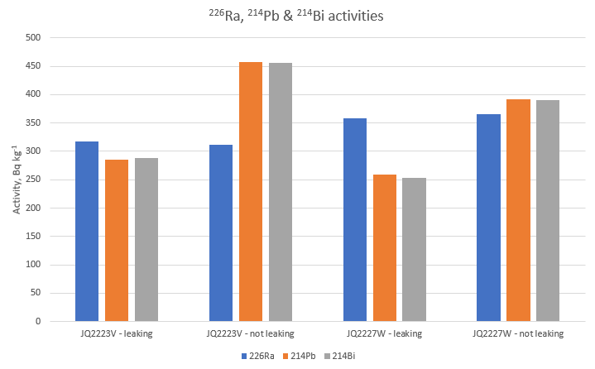

**Figure 13** Activities of 226Ra, 214Pb and 214Bi in leaking and non-leaking containers for samples JQ2223 and JQ2227 on detectors V and W respectively. The change in activity of 214Pb and 214Bi is highlighted.

**Table 9** Ratios of counts for 222Rn progeny (214Bi and 214Pb) relative to 226Ra to illustrate potential ratio variation in non-leaking standards. All count times were 10,800 seconds.

|  |  |  |  |  |  |  |  |  |  |
| --- | --- | --- | --- | --- | --- | --- | --- | --- | --- |
| Det - Y | Standard: | ZQ081 |  | ZQ083 |  | ZQ084 |  | Ave. Counting | Ratio :186 |
| Radionuclide | Energy (keV) | Net Counts | Ratio :186 | Net Counts | Ratio :186 | Net Counts | Ratio :186 | Uncert. % | Max % var |
| 226Ra | 186 | 33845 |  | 38467 |  | 40148 |  | 0.8 |  |
| 214Pb | 295 | 67492 | 1.994 | 76845 | 1.998 | 78720 | 1.961 | 0.3 | 1.704 |
| 214Pb | 352 | 115036 | 3.399 | 132413 | 3.442 | 137653 | 3.429 | 0.3 | 1.275 |
| 214Bi | 609 | 76480 | 2.260 | 85417 | 2.221 | 89325 | 2.225 | 0.4 | 1.765 |
|  |  |  |  |  |  |  |  |  |  |
| Det - W | Standard: | ZQ081 |  | ZQ083 |  | ZQ084 |  | Ave. Counting | Ratio :186 |
| Radionuclide | Energy (keV) | Net Counts | Ratio :186 | Net Counts | Ratio :186 | Net Counts | Ratio :186 | Uncert. % | Max % var |
| 226Ra | 186 | 38979 |  | 43191 |  | 45913 |  | 0.7 |  |
| 214Pb | 295 | 59905 | 1.537 | 65043 | 1.506 | 68610 | 1.494 | 0.5 | 2.844 |
| 214Pb | 352 | 94066 | 2.413 | 103376 | 2.393 | 107998 | 2.352 | 0.4 | 2.594 |
| 214Bi | 609 | 53146 | 1.363 | 57946 | 1.342 | 60548 | 1.319 | 0.5 | 3.389 |
|  |  |  |  |  |  |  |  |  |  |
| Det - V | Standard: | ZQ081 |  | ZQ083 |  | ZQ084 |  | Ave. Counting | Ratio :186 |
| Radionuclide | Energy (keV) | Net Counts | Ratio :186 | Net Counts | Ratio :186 | Net Counts | Ratio :186 | Uncert. % | Max % var |
| 226Ra | 186 | 48644 |  | 50035 |  | 56977 |  | 0.6 |  |
| 214Pb | 295 | 80690 | 1.659 | 83048 | 1.660 | 93181 | 1.635 | 0.4 | 1.491 |
| 214Pb | 352 | 129042 | 2.653 | 132869 | 2.656 | 149614 | 2.626 | 0.3 | 1.129 |
| 214Bi | 609 | 73511 | 1.511 | 76754 | 1.534 | 84900 | 1.490 | 0.4 | 2.948 |

# 4 Conclusion

The measured rate of 222Rn diffusion from the eriss gamma spectrometry acrylic containers was generally around 1% of the total 222Rn (or 226Ra) activity in the sample for properly sealed containers. This small amount of 222Rn loss does not significantly affect gamma spectrometry measurement results for 226Ra using 222Rn progeny radionuclides (214Bi and 214Pb) as proxies for 226Ra, as gamma spectrometry analysis counting and calibration uncertainties are typically larger than 2%. Also, the rates of 222Rn diffusion from environmental samples and calibration standards are comparable, further reducing the effect of any 222Rn diffusion on gamma spectrometry measurements of 226Ra.

The amount of free 222Rn inside the acrylic containers can be a considerable proportion of the total 222Rn (or 226Ra) activity in the sample. This free 222Rn can escape if containers are not correctly sealed and lead to underestimates of 226Ra activity in environmental samples when measured by gamma spectrometry. The finding emphasizes the need to carefully follow the existing standard operating procedure for gamma spectrometry sample preparation to completely seal the lid, o-ring and base of the acrylic containers, thereby avoiding excessive loss of 222Rn and inaccurate 226Ra results.

A poorly-sealed acrylic container will allow a much greater proportion of 222Rn to escape, or ‘leak’, from the container and therefore not be counted as progeny. This 222Rn leakage from samples will result in under reported 226Ra activity concentrations. A rapid method of identifying poorly-sealed acrylic containers, or ‘leakers’, is that the activity of 226Ra at 186 keV is greater than the activity calculated from the 222Rn progeny emissions (214Pb and 214Bi). Leaking samples are resealed and recounted, after a delay to reach secular equilibrium, to achieve optimum accuracy and precision of 226Ra activity concentration.

# 

# References

Bollhöfer A, Brazier J, Humphrey C, Ryan B & Esparon A 2011. A study of radium bioaccumulation in freshwater mussels, Velesunio angasi, in the Magela Creek catchment, Northern Territory, Australia. Journal of Environmental Radioactivity 102, 964–974.

Doering C, McMaster SA & Johansen MP 2018. Modelling the dispersion of radon-222 from a landform covered by low uranium grade waste rock. Journal of Environmental Radioactivity 192, 498–504.

Durridge 2021. RAD7 electronic radon detector user manual. Durridge Company Inc., Billerica. <https://durridge.com/documentation/RAD7%20Manual.pdf>

IAEA 2010. Worldwide Open Proficiency Test: Determination of Naturally Occurring Radionuclides in Phosphogypsum and Water. IAEA Analytical Quality in Nuclear Applications No. IAEA/AQ/18.

Laxman C & Dayanand R 2012. Attenuation coefficient of soil samples by gamma ray energy. Research Journal of Recent Sciences 1(9), 41–48.

Leslie C 2009. Analysing environmental radioactivity in soils and sediments using high-purity germanium gamma detectors at CSIRO Land and Water: procedures and protocols. CSIRO Land and Water Science Report 12/09.

LNHB 2021. Atomic and nuclear data. Laboratoire National Henri Becquerel. <http://www.lnhb.fr/nuclear-data/nuclear-data-table/>

Marten R 1992. Procedures for routine analysis of naturally occurring radionuclides in environmental samples by gamma-ray spectrometry with HPGe detectors. Internal Report 76, Supervising Scientist.

Murray AS, Marten R, Johnston A & Martin P 1987. Analysis for naturally occurring radionuclides at environmental concentrations by gamma spectrometry. Journal of Radioanalytical and Nuclear Chemistry, Articles, 115(2), 263–288.

Pfitzner J 1993. Sample collection and preparation manual for gamma-ray spectrometry analysis. Supervising Scientist, unpublished.

Suursoon S, Kiisk M, Semakalu A & Isakar K 2014. Radon leakage as a source of additional uncertainty in simultaneous determination of 226Ra and 228Ra by gamma spectrometry—Validation of analysis procedure. Applied Radiation and Isotopes 87, 447–451.

# Appendix A RAD7 cross-calibration plots



**Figure A1** Cross-calibration of RAD7 #2527 (uncalibrated) with RAD7 #3931 (calibrated).



**Figure A2** Cross-calibration of RAD7 #3925 (uncalibrated) with RAD7 #3931 (calibrated).

# Appendix B RAD7 measurement data

**Table B1** RAD7 measurement data from all tests. Data are humidity and calibration corrected. Uncertainty in 222Rn is 2-sigma of the counts.

| Sample | Container | RAD7 | Date & time | 222Rn (Bq/m3) | 222Rn 2-sigma uncertainty (Bq/m3) |
| --- | --- | --- | --- | --- | --- |
| ZQ081 | Closed | 2527 | 25/11/20 10:02 | 77 | 39 |
| ZQ081 | Closed | 2527 | 25/11/20 11:02 | 115 | 48 |
| ZQ081 | Closed | 2527 | 25/11/20 12:02 | 147 | 52 |
| ZQ081 | Closed | 2527 | 25/11/20 13:02 | 156 | 36 |
| ZQ081 | Closed | 2527 | 25/11/20 14:02 | 179 | 38 |
| ZQ081 | Closed | 2527 | 25/11/20 15:02 | 202 | 41 |
| ZQ081 | Closed | 2527 | 25/11/20 16:02 | 229 | 43 |
| ZQ081 | Closed | 2527 | 25/11/20 17:02 | 256 | 45 |
| ZQ081 | Closed | 2527 | 25/11/20 18:02 | 246 | 45 |
| ZQ081 | Closed | 2527 | 25/11/20 19:02 | 270 | 47 |
| ZQ081 | Closed | 2527 | 25/11/20 20:02 | 325 | 51 |
| ZQ081 | Closed | 2527 | 25/11/20 21:02 | 297 | 49 |
| ZQ081 | Closed | 2527 | 25/11/20 22:02 | 289 | 49 |
| ZQ081 | Closed | 2527 | 25/11/20 23:02 | 354 | 53 |
| ZQ081 | Closed | 2527 | 26/11/20 00:02 | 370 | 55 |
| ZQ081 | Closed | 2527 | 26/11/20 01:02 | 425 | 59 |
| ZQ081 | Closed | 2527 | 26/11/20 02:02 | 375 | 55 |
| ZQ081 | Closed | 2527 | 26/11/20 03:02 | 378 | 55 |
| ZQ081 | Closed | 2527 | 26/11/20 04:02 | 428 | 59 |
| ZQ081 | Closed | 2527 | 26/11/20 05:02 | 451 | 60 |
| ZQ081 | Closed | 2527 | 26/11/20 06:02 | 453 | 60 |
| ZQ081 | Closed | 2527 | 26/11/20 07:02 | 473 | 61 |
| ZQ081 | Closed | 2527 | 26/11/20 08:02 | 486 | 63 |
| ZQ081 | Closed | 2527 | 26/11/20 09:02 | 510 | 64 |
| ZQ083 | Closed | 2527 | 26/11/20 18:08 | 19 | 26 |
| ZQ083 | Closed | 2527 | 26/11/20 19:08 | 30 | 19 |
| ZQ083 | Closed | 2527 | 26/11/20 20:08 | 41 | 22 |
| ZQ083 | Closed | 2527 | 26/11/20 21:08 | 103 | 31 |
| ZQ083 | Closed | 2527 | 26/11/20 22:08 | 117 | 33 |
| ZQ083 | Closed | 2527 | 26/11/20 23:08 | 188 | 41 |
| ZQ083 | Closed | 2527 | 27/11/20 00:08 | 164 | 39 |
| ZQ083 | Closed | 2527 | 27/11/20 01:08 | 167 | 39 |
| ZQ083 | Closed | 2527 | 27/11/20 02:08 | 233 | 45 |
| ZQ083 | Closed | 2527 | 27/11/20 03:08 | 212 | 43 |
| ZQ083 | Closed | 2527 | 27/11/20 04:08 | 190 | 41 |
| ZQ083 | Closed | 2527 | 27/11/20 05:08 | 248 | 47 |
| ZQ083 | Closed | 2527 | 27/11/20 06:08 | 258 | 47 |
| ZQ083 | Closed | 2527 | 27/11/20 07:08 | 305 | 51 |
| ZQ083 | Closed | 2527 | 27/11/20 08:08 | 291 | 50 |
| ZQ083 | Closed | 2527 | 27/11/20 09:08 | 309 | 52 |
| ZQ083 | Closed | 2527 | 27/11/20 10:08 | 338 | 54 |
| ZQ083 | Closed | 2527 | 27/11/20 11:08 | 378 | 56 |
| ZQ083 | Closed | 2527 | 27/11/20 12:08 | 410 | 59 |
| ZQ083 | Closed | 2527 | 27/11/20 13:08 | 430 | 60 |
| ZQ083 | Closed | 2527 | 27/11/20 14:08 | 401 | 58 |
| ZQ083 | Closed | 2527 | 27/11/20 15:08 | 401 | 59 |
| ZQ083 | Closed | 2527 | 27/11/20 16:08 | 449 | 61 |
| ZQ083 | Closed | 2527 | 27/11/20 17:08 | 433 | 60 |
| ZQ083 | Closed | 2527 | 27/11/20 18:08 | 461 | 62 |
| ZQ083 | Closed | 2527 | 27/11/20 19:08 | 460 | 62 |
| ZQ083 | Closed | 2527 | 27/11/20 20:08 | 476 | 63 |
| ZQ083 | Closed | 2527 | 27/11/20 21:08 | 544 | 67 |
| ZQ084 | Closed | 2527 | 22/11/20 13:42 | 21 | 28 |
| ZQ084 | Closed | 2527 | 22/11/20 14:42 | 82 | 46 |
| ZQ084 | Closed | 2527 | 22/11/20 15:42 | 91 | 48 |
| ZQ084 | Closed | 2527 | 22/11/20 16:42 | 144 | 38 |
| ZQ084 | Closed | 2527 | 22/11/20 17:42 | 162 | 40 |
| ZQ084 | Closed | 2527 | 22/11/20 18:42 | 209 | 45 |
| ZQ084 | Closed | 2527 | 22/11/20 19:42 | 240 | 48 |
| ZQ084 | Closed | 2527 | 22/11/20 20:42 | 325 | 55 |
| ZQ084 | Closed | 2527 | 22/11/20 21:42 | 309 | 54 |
| ZQ084 | Closed | 2527 | 22/11/20 22:42 | 353 | 57 |
| ZQ084 | Closed | 2527 | 22/11/20 23:42 | 366 | 58 |
| ZQ084 | Closed | 2527 | 23/11/20 00:42 | 367 | 58 |
| ZQ084 | Closed | 2527 | 23/11/20 01:42 | 341 | 56 |
| ZQ084 | Closed | 2527 | 23/11/20 02:42 | 486 | 67 |
| ZQ084 | Closed | 2527 | 23/11/20 03:42 | 499 | 67 |
| ZQ084 | Closed | 2527 | 23/11/20 04:42 | 523 | 68 |
| ZQ084 | Closed | 2527 | 23/11/20 05:42 | 546 | 70 |
| ZQ084 | Closed | 2527 | 23/11/20 06:42 | 611 | 73 |
| ZQ084 | Closed | 2527 | 23/11/20 07:42 | 587 | 73 |
| ZQ084 | Closed | 2527 | 23/11/20 08:42 | 568 | 71 |
| ZQ084 | Closed | 2527 | 23/11/20 09:42 | 575 | 72 |
| ZQ084 | Closed | 2527 | 23/11/20 10:42 | 649 | 76 |
| ZQ084 | Closed | 2527 | 23/11/20 11:42 | 627 | 75 |
| ZQ084 | Closed | 2527 | 23/11/20 12:42 | 706 | 79 |
| ZQ081 | Closed | 3925 | 26/11/20 18:00 | 26 | 28 |
| ZQ081 | Closed | 3925 | 26/11/20 19:00 | 52 | 23 |
| ZQ081 | Closed | 3925 | 26/11/20 20:00 | 52 | 23 |
| ZQ081 | Closed | 3925 | 26/11/20 21:00 | 105 | 32 |
| ZQ081 | Closed | 3925 | 26/11/20 22:00 | 138 | 35 |
| ZQ081 | Closed | 3925 | 26/11/20 23:00 | 126 | 34 |
| ZQ081 | Closed | 3925 | 27/11/20 00:00 | 133 | 35 |
| ZQ081 | Closed | 3925 | 27/11/20 01:00 | 180 | 40 |
| ZQ081 | Closed | 3925 | 27/11/20 02:00 | 220 | 44 |
| ZQ081 | Closed | 3925 | 27/11/20 03:00 | 218 | 43 |
| ZQ081 | Closed | 3925 | 27/11/20 04:00 | 242 | 46 |
| ZQ081 | Closed | 3925 | 27/11/20 05:00 | 225 | 44 |
| ZQ081 | Closed | 3925 | 27/11/20 06:00 | 267 | 48 |
| ZQ081 | Closed | 3925 | 27/11/20 07:00 | 281 | 49 |
| ZQ081 | Closed | 3925 | 27/11/20 08:00 | 290 | 50 |
| ZQ081 | Closed | 3925 | 27/11/20 09:00 | 346 | 54 |
| ZQ081 | Closed | 3925 | 27/11/20 10:00 | 400 | 58 |
| ZQ081 | Closed | 3925 | 27/11/20 11:00 | 363 | 56 |
| ZQ081 | Closed | 3925 | 27/11/20 12:00 | 407 | 58 |
| ZQ081 | Closed | 3925 | 27/11/20 13:00 | 454 | 61 |
| ZQ081 | Closed | 3925 | 27/11/20 14:00 | 410 | 58 |
| ZQ081 | Closed | 3925 | 27/11/20 15:00 | 407 | 58 |
| ZQ081 | Closed | 3925 | 27/11/20 16:00 | 467 | 62 |
| ZQ081 | Closed | 3925 | 27/11/20 17:00 | 442 | 61 |
| ZQ081 | Closed | 3925 | 27/11/20 18:00 | 434 | 60 |
| ZQ081 | Closed | 3925 | 27/11/20 19:00 | 493 | 64 |
| ZQ081 | Closed | 3925 | 27/11/20 20:00 | 506 | 65 |
| ZQ081 | Closed | 3925 | 27/11/20 21:00 | 533 | 66 |
| ZQ081 | Closed | 3925 | 27/11/20 22:00 | 544 | 67 |
| ZQ083 | Closed | 3925 | 22/11/20 13:32 | 12 | 25 |
| ZQ083 | Closed | 3925 | 22/11/20 14:32 | 8 | 23 |
| ZQ083 | Closed | 3925 | 22/11/20 15:32 | 58 | 42 |
| ZQ083 | Closed | 3925 | 22/11/20 16:32 | 44 | 23 |
| ZQ083 | Closed | 3925 | 22/11/20 17:32 | 52 | 25 |
| ZQ083 | Closed | 3925 | 22/11/20 18:32 | 70 | 28 |
| ZQ083 | Closed | 3925 | 22/11/20 19:32 | 68 | 27 |
| ZQ083 | Closed | 3925 | 22/11/20 20:32 | 124 | 36 |
| ZQ083 | Closed | 3925 | 22/11/20 21:32 | 131 | 37 |
| ZQ083 | Closed | 3925 | 22/11/20 22:32 | 118 | 35 |
| ZQ083 | Closed | 3925 | 22/11/20 23:32 | 139 | 38 |
| ZQ083 | Closed | 3925 | 23/11/20 00:32 | 171 | 41 |
| ZQ083 | Closed | 3925 | 23/11/20 01:32 | 185 | 43 |
| ZQ083 | Closed | 3925 | 23/11/20 02:32 | 192 | 44 |
| ZQ083 | Closed | 3925 | 23/11/20 03:32 | 189 | 43 |
| ZQ083 | Closed | 3925 | 23/11/20 04:32 | 230 | 47 |
| ZQ083 | Closed | 3925 | 23/11/20 05:32 | 227 | 47 |
| ZQ083 | Closed | 3925 | 23/11/20 06:32 | 276 | 51 |
| ZQ083 | Closed | 3925 | 23/11/20 07:32 | 254 | 49 |
| ZQ083 | Closed | 3925 | 23/11/20 08:32 | 326 | 56 |
| ZQ083 | Closed | 3925 | 23/11/20 09:32 | 294 | 53 |
| ZQ083 | Closed | 3925 | 23/11/20 10:32 | 322 | 55 |
| ZQ083 | Closed | 3925 | 23/11/20 11:32 | 308 | 54 |
| ZQ083 | Closed | 3925 | 23/11/20 12:32 | 328 | 56 |
| ZQ084 | Closed | 3925 | 25/11/20 09:55 | 60 | 36 |
| ZQ084 | Closed | 3925 | 25/11/20 10:55 | 108 | 46 |
| ZQ084 | Closed | 3925 | 25/11/20 11:55 | 117 | 48 |
| ZQ084 | Closed | 3925 | 25/11/20 12:55 | 184 | 38 |
| ZQ084 | Closed | 3925 | 25/11/20 13:55 | 207 | 41 |
| ZQ084 | Closed | 3925 | 25/11/20 14:55 | 237 | 43 |
| ZQ084 | Closed | 3925 | 25/11/20 15:55 | 284 | 48 |
| ZQ084 | Closed | 3925 | 25/11/20 16:55 | 329 | 51 |
| ZQ084 | Closed | 3925 | 25/11/20 17:55 | 330 | 51 |
| ZQ084 | Closed | 3925 | 25/11/20 18:55 | 397 | 55 |
| ZQ084 | Closed | 3925 | 25/11/20 19:55 | 480 | 61 |
| ZQ084 | Closed | 3925 | 25/11/20 20:55 | 458 | 60 |
| ZQ084 | Closed | 3925 | 25/11/20 21:55 | 521 | 63 |
| ZQ084 | Closed | 3925 | 25/11/20 22:55 | 611 | 69 |
| ZQ084 | Closed | 3925 | 25/11/20 23:55 | 528 | 64 |
| ZQ084 | Closed | 3925 | 26/11/20 00:55 | 575 | 67 |
| ZQ084 | Closed | 3925 | 26/11/20 01:55 | 618 | 69 |
| ZQ084 | Closed | 3925 | 26/11/20 02:55 | 670 | 72 |
| ZQ084 | Closed | 3925 | 26/11/20 03:55 | 627 | 70 |
| ZQ084 | Closed | 3925 | 26/11/20 04:55 | 582 | 68 |
| ZQ084 | Closed | 3925 | 26/11/20 05:55 | 767 | 77 |
| ZQ084 | Closed | 3925 | 26/11/20 06:55 | 727 | 75 |
| ZQ084 | Closed | 3925 | 26/11/20 07:55 | 765 | 77 |
| ZQ084 | Closed | 3925 | 26/11/20 08:55 | 819 | 80 |
| ZQ081 | Closed | 3931 | 22/11/20 13:25 | 19 | 26 |
| ZQ081 | Closed | 3931 | 22/11/20 14:25 | 27 | 29 |
| ZQ081 | Closed | 3931 | 22/11/20 15:25 | 34 | 32 |
| ZQ081 | Closed | 3931 | 22/11/20 16:25 | 56 | 24 |
| ZQ081 | Closed | 3931 | 22/11/20 17:25 | 95 | 30 |
| ZQ081 | Closed | 3931 | 22/11/20 18:25 | 86 | 29 |
| ZQ081 | Closed | 3931 | 22/11/20 19:25 | 92 | 30 |
| ZQ081 | Closed | 3931 | 22/11/20 20:25 | 146 | 36 |
| ZQ081 | Closed | 3931 | 22/11/20 21:25 | 125 | 34 |
| ZQ081 | Closed | 3931 | 22/11/20 22:25 | 210 | 43 |
| ZQ081 | Closed | 3931 | 22/11/20 23:25 | 194 | 41 |
| ZQ081 | Closed | 3931 | 23/11/20 00:25 | 190 | 41 |
| ZQ081 | Closed | 3931 | 23/11/20 01:25 | 218 | 44 |
| ZQ081 | Closed | 3931 | 23/11/20 02:25 | 241 | 46 |
| ZQ081 | Closed | 3931 | 23/11/20 03:25 | 236 | 46 |
| ZQ081 | Closed | 3931 | 23/11/20 04:25 | 248 | 47 |
| ZQ081 | Closed | 3931 | 23/11/20 05:25 | 282 | 49 |
| ZQ081 | Closed | 3931 | 23/11/20 06:25 | 303 | 51 |
| ZQ081 | Closed | 3931 | 23/11/20 07:25 | 300 | 51 |
| ZQ081 | Closed | 3931 | 23/11/20 08:25 | 363 | 55 |
| ZQ081 | Closed | 3931 | 23/11/20 09:25 | 312 | 52 |
| ZQ081 | Closed | 3931 | 23/11/20 10:25 | 347 | 54 |
| ZQ081 | Closed | 3931 | 23/11/20 11:25 | 399 | 58 |
| ZQ081 | Closed | 3931 | 23/11/20 12:25 | 425 | 60 |
| ZQ083 | Closed | 3931 | 25/11/20 09:55 | 53 | 33 |
| ZQ083 | Closed | 3931 | 25/11/20 10:55 | 67 | 37 |
| ZQ083 | Closed | 3931 | 25/11/20 11:55 | 93 | 41 |
| ZQ083 | Closed | 3931 | 25/11/20 12:55 | 139 | 33 |
| ZQ083 | Closed | 3931 | 25/11/20 13:55 | 148 | 33 |
| ZQ083 | Closed | 3931 | 25/11/20 14:55 | 181 | 37 |
| ZQ083 | Closed | 3931 | 25/11/20 15:55 | 172 | 36 |
| ZQ083 | Closed | 3931 | 25/11/20 16:55 | 162 | 35 |
| ZQ083 | Closed | 3931 | 25/11/20 17:55 | 190 | 38 |
| ZQ083 | Closed | 3931 | 25/11/20 18:55 | 238 | 42 |
| ZQ083 | Closed | 3931 | 25/11/20 19:55 | 224 | 41 |
| ZQ083 | Closed | 3931 | 25/11/20 20:55 | 290 | 46 |
| ZQ083 | Closed | 3931 | 25/11/20 21:55 | 290 | 46 |
| ZQ083 | Closed | 3931 | 25/11/20 22:55 | 299 | 47 |
| ZQ083 | Closed | 3931 | 25/11/20 23:55 | 316 | 48 |
| ZQ083 | Closed | 3931 | 26/11/20 00:55 | 371 | 52 |
| ZQ083 | Closed | 3931 | 26/11/20 01:55 | 358 | 51 |
| ZQ083 | Closed | 3931 | 26/11/20 02:55 | 387 | 54 |
| ZQ083 | Closed | 3931 | 26/11/20 03:55 | 391 | 54 |
| ZQ083 | Closed | 3931 | 26/11/20 04:55 | 416 | 55 |
| ZQ083 | Closed | 3931 | 26/11/20 05:55 | 479 | 59 |
| ZQ083 | Closed | 3931 | 26/11/20 06:55 | 507 | 61 |
| ZQ083 | Closed | 3931 | 26/11/20 07:55 | 502 | 61 |
| ZQ083 | Closed | 3931 | 26/11/20 08:55 | 483 | 60 |
| ZQ084 | Closed | 3931 | 26/11/20 17:51 | 28 | 28 |
| ZQ084 | Closed | 3931 | 26/11/20 18:51 | 66 | 25 |
| ZQ084 | Closed | 3931 | 26/11/20 19:51 | 111 | 31 |
| ZQ084 | Closed | 3931 | 26/11/20 20:51 | 140 | 34 |
| ZQ084 | Closed | 3931 | 26/11/20 21:51 | 172 | 37 |
| ZQ084 | Closed | 3931 | 26/11/20 22:51 | 216 | 42 |
| ZQ084 | Closed | 3931 | 26/11/20 23:51 | 245 | 44 |
| ZQ084 | Closed | 3931 | 27/11/20 00:51 | 311 | 50 |
| ZQ084 | Closed | 3931 | 27/11/20 01:51 | 386 | 55 |
| ZQ084 | Closed | 3931 | 27/11/20 02:51 | 393 | 55 |
| ZQ084 | Closed | 3931 | 27/11/20 03:51 | 384 | 55 |
| ZQ084 | Closed | 3931 | 27/11/20 04:51 | 400 | 56 |
| ZQ084 | Closed | 3931 | 27/11/20 05:51 | 546 | 65 |
| ZQ084 | Closed | 3931 | 27/11/20 06:51 | 532 | 64 |
| ZQ084 | Closed | 3931 | 27/11/20 07:51 | 561 | 65 |
| ZQ084 | Closed | 3931 | 27/11/20 08:51 | 527 | 64 |
| ZQ084 | Closed | 3931 | 27/11/20 09:51 | 556 | 65 |
| ZQ084 | Closed | 3931 | 27/11/20 10:51 | 592 | 67 |
| ZQ084 | Closed | 3931 | 27/11/20 11:51 | 700 | 73 |
| ZQ084 | Closed | 3931 | 27/11/20 12:51 | 707 | 73 |
| ZQ084 | Closed | 3931 | 27/11/20 13:51 | 700 | 73 |
| ZQ084 | Closed | 3931 | 27/11/20 14:51 | 779 | 77 |
| ZQ084 | Closed | 3931 | 27/11/20 15:51 | 781 | 77 |
| ZQ084 | Closed | 3931 | 27/11/20 16:51 | 807 | 78 |
| ZQ084 | Closed | 3931 | 27/11/20 17:51 | 960 | 85 |
| ZQ084 | Closed | 3931 | 27/11/20 18:51 | 926 | 83 |
| ZQ084 | Closed | 3931 | 27/11/20 19:51 | 941 | 84 |
| ZQ084 | Closed | 3931 | 27/11/20 20:51 | 897 | 82 |
| ZQ084 | Closed | 3931 | 27/11/20 21:51 | 1025 | 88 |
| ZQ082 | Closed | 2527 | 10/06/20 13:01 | 36 | 36 |
| ZQ082 | Closed | 2527 | 10/06/20 14:01 | 68 | 43 |
| ZQ082 | Closed | 2527 | 10/06/20 15:01 | 112 | 51 |
| ZQ082 | Closed | 2527 | 10/06/20 16:01 | 154 | 39 |
| ZQ082 | Closed | 2527 | 10/06/20 17:01 | 212 | 45 |
| ZQ082 | Closed | 2527 | 10/06/20 18:01 | 246 | 47 |
| ZQ082 | Closed | 2527 | 10/06/20 19:01 | 298 | 52 |
| ZQ082 | Closed | 2527 | 10/06/20 20:01 | 391 | 59 |
| ZQ082 | Closed | 2527 | 10/06/20 21:01 | 352 | 56 |
| ZQ082 | Closed | 2527 | 10/06/20 22:01 | 419 | 61 |
| ZQ082 | Closed | 2527 | 10/06/20 23:01 | 477 | 65 |
| ZQ082 | Closed | 2527 | 11/06/20 00:01 | 508 | 67 |
| ZQ082 | Closed | 2527 | 11/06/20 01:01 | 518 | 67 |
| ZQ082 | Closed | 2527 | 11/06/20 02:01 | 626 | 74 |
| ZQ082 | Closed | 2527 | 11/06/20 03:01 | 697 | 77 |
| ZQ082 | Closed | 2527 | 11/06/20 04:01 | 693 | 77 |
| ZQ082 | Closed | 2527 | 11/06/20 05:01 | 737 | 79 |
| ZQ082 | Closed | 2527 | 11/06/20 06:01 | 829 | 84 |
| ZQ082 | Closed | 2527 | 11/06/20 07:01 | 858 | 85 |
| ZQ082 | Closed | 2527 | 11/06/20 08:01 | 834 | 84 |
| ZQ082 | Closed | 2527 | 11/06/20 09:01 | 890 | 86 |
| ZQ082 | Open | 2527 | 11/06/20 14:54 | 2262 | 432 |
| ZQ082 | Open | 2527 | 11/06/20 15:54 | 6283 | 662 |
| ZQ082 | Open | 2527 | 11/06/20 16:54 | 8798 | 749 |
| ZQ082 | Open | 2527 | 11/06/20 17:54 | 7171 | 408 |
| ZQ082 | Open | 2527 | 11/06/20 18:54 | 8774 | 452 |
| ZQ082 | Open | 2527 | 11/06/20 19:54 | 10874 | 494 |
| ZQ082 | Open | 2527 | 11/06/20 20:54 | 11987 | 525 |
| ZQ082 | Open | 2527 | 11/06/20 21:54 | 13752 | 556 |
| ZQ082 | Open | 2527 | 11/06/20 22:54 | 15279 | 582 |
| ZQ082 | Open | 2527 | 11/06/20 23:54 | 16534 | 610 |
| ZQ082 | Open | 2527 | 12/06/20 00:54 | 17508 | 630 |
| ZQ082 | Open | 2527 | 12/06/20 01:54 | 18844 | 646 |
| ZQ082 | Open | 2527 | 12/06/20 02:54 | 19763 | 670 |
| ZQ082 | Open | 2527 | 12/06/20 03:54 | 20622 | 690 |
| ZQ082 | Open | 2527 | 12/06/20 04:54 | 21389 | 703 |
| ZQ082 | Open | 2527 | 12/06/20 05:54 | 22236 | 714 |
| ZQ082 | Open | 2527 | 12/06/20 06:54 | 22666 | 724 |
| ZQ082 | Open | 2527 | 12/06/20 07:54 | 23799 | 738 |
| ZQ082 | Open | 2527 | 12/06/20 08:54 | 23961 | 750 |
| ZQ082 | Open | 2527 | 12/06/20 09:54 | 25565 | 775 |
| ZQ082 | Open | 2527 | 12/06/20 10:54 | 25446 | 776 |
| ZQ082 | Open | 2527 | 12/06/20 11:54 | 26406 | 790 |
| ZQ082 | Open | 2527 | 12/06/20 12:54 | 26796 | 794 |
| ZQ012 | Closed | 3925 | 10/06/20 12:56 | 16 | 27 |
| ZQ012 | Closed | 3925 | 10/06/20 13:56 | 24 | 30 |
| ZQ012 | Closed | 3925 | 10/06/20 14:56 | 69 | 43 |
| ZQ012 | Closed | 3925 | 10/06/20 15:56 | 53 | 25 |
| ZQ012 | Closed | 3925 | 10/06/20 16:56 | 62 | 26 |
| ZQ012 | Closed | 3925 | 10/06/20 17:56 | 98 | 32 |
| ZQ012 | Closed | 3925 | 10/06/20 18:56 | 99 | 32 |
| ZQ012 | Closed | 3925 | 10/06/20 19:56 | 127 | 36 |
| ZQ012 | Closed | 3925 | 10/06/20 20:56 | 124 | 35 |
| ZQ012 | Closed | 3925 | 10/06/20 21:56 | 144 | 38 |
| ZQ012 | Closed | 3925 | 10/06/20 22:56 | 176 | 42 |
| ZQ012 | Closed | 3925 | 10/06/20 23:56 | 206 | 45 |
| ZQ012 | Closed | 3925 | 11/06/20 00:56 | 197 | 44 |
| ZQ012 | Closed | 3925 | 11/06/20 01:56 | 257 | 49 |
| ZQ012 | Closed | 3925 | 11/06/20 02:56 | 215 | 46 |
| ZQ012 | Closed | 3925 | 11/06/20 03:56 | 193 | 43 |
| ZQ012 | Closed | 3925 | 11/06/20 04:56 | 270 | 50 |
| ZQ012 | Closed | 3925 | 11/06/20 05:56 | 259 | 49 |
| ZQ012 | Closed | 3925 | 11/06/20 06:56 | 295 | 53 |
| ZQ012 | Closed | 3925 | 11/06/20 07:56 | 276 | 51 |
| ZQ012 | Closed | 3925 | 11/06/20 08:56 | 308 | 54 |
| ZQ012 | Open | 3925 | 11/06/20 14:48 | 258 | 75 |
| ZQ012 | Open | 3925 | 11/06/20 15:48 | 904 | 129 |
| ZQ012 | Open | 3925 | 11/06/20 16:48 | 1558 | 168 |
| ZQ012 | Open | 3925 | 11/06/20 17:48 | 2038 | 130 |
| ZQ012 | Open | 3925 | 11/06/20 18:48 | 2729 | 152 |
| ZQ012 | Open | 3925 | 11/06/20 19:48 | 3511 | 172 |
| ZQ012 | Open | 3925 | 11/06/20 20:48 | 3944 | 182 |
| ZQ012 | Open | 3925 | 11/06/20 21:48 | 4363 | 192 |
| ZQ012 | Open | 3925 | 11/06/20 22:48 | 5054 | 207 |
| ZQ012 | Open | 3925 | 11/06/20 23:48 | 5440 | 214 |
| ZQ012 | Open | 3925 | 12/06/20 00:48 | 5728 | 220 |
| ZQ012 | Open | 3925 | 12/06/20 01:48 | 6129 | 227 |
| ZQ012 | Open | 3925 | 12/06/20 02:48 | 6609 | 236 |
| ZQ012 | Open | 3925 | 12/06/20 03:48 | 6809 | 240 |
| ZQ012 | Open | 3925 | 12/06/20 04:48 | 7107 | 245 |
| ZQ012 | Open | 3925 | 12/06/20 05:48 | 7591 | 253 |
| ZQ012 | Open | 3925 | 12/06/20 06:48 | 7861 | 258 |
| ZQ012 | Open | 3925 | 12/06/20 07:48 | 8155 | 262 |
| ZQ012 | Open | 3925 | 12/06/20 08:48 | 8516 | 268 |
| ZQ012 | Open | 3925 | 12/06/20 09:48 | 8749 | 274 |
| ZQ012 | Open | 3925 | 12/06/20 10:48 | 8626 | 272 |
| ZQ012 | Open | 3925 | 12/06/20 11:48 | 8792 | 275 |
| ZQ012 | Open | 3925 | 12/06/20 12:48 | 8887 | 275 |
| BQ008 | Closed | 3931 | 10/06/20 12:59 | 8 | 22 |
| BQ008 | Closed | 3931 | 10/06/20 13:59 | 4 | 19 |
| BQ008 | Closed | 3931 | 10/06/20 14:59 | 12 | 24 |
| BQ008 | Closed | 3931 | 10/06/20 15:59 | 9 | 13 |
| BQ008 | Closed | 3931 | 10/06/20 16:59 | 22 | 17 |
| BQ008 | Closed | 3931 | 10/06/20 17:59 | 13 | 14 |
| BQ008 | Closed | 3931 | 10/06/20 18:59 | 21 | 17 |
| BQ008 | Closed | 3931 | 10/06/20 19:59 | 19 | 16 |
| BQ008 | Closed | 3931 | 10/06/20 20:59 | 6 | 11 |
| BQ008 | Closed | 3931 | 10/06/20 21:59 | 11 | 14 |
| BQ008 | Closed | 3931 | 10/06/20 22:59 | 11 | 14 |
| BQ008 | Closed | 3931 | 10/06/20 23:59 | 6 | 11 |
| BQ008 | Closed | 3931 | 11/06/20 00:59 | 6 | 11 |
| BQ008 | Closed | 3931 | 11/06/20 01:59 | 17 | 15 |
| BQ008 | Closed | 3931 | 11/06/20 02:59 | 15 | 15 |
| BQ008 | Closed | 3931 | 11/06/20 03:59 | 13 | 14 |
| BQ008 | Closed | 3931 | 11/06/20 04:59 | 17 | 15 |
| BQ008 | Closed | 3931 | 11/06/20 05:59 | 28 | 19 |
| BQ008 | Closed | 3931 | 11/06/20 06:59 | 17 | 15 |
| BQ008 | Closed | 3931 | 11/06/20 07:59 | 15 | 15 |
| BQ008 | Closed | 3931 | 11/06/20 08:59 | 18 | 16 |
| BQ008 | Open | 3931 | 11/06/20 14:48 | 12 | 28 |
| BQ008 | Open | 3931 | 11/06/20 15:48 | 27 | 29 |
| BQ008 | Open | 3931 | 11/06/20 16:48 | 77 | 44 |
| BQ008 | Open | 3931 | 11/06/20 17:48 | 44 | 23 |
| BQ008 | Open | 3931 | 11/06/20 18:48 | 72 | 28 |
| BQ008 | Open | 3931 | 11/06/20 19:48 | 96 | 31 |
| BQ008 | Open | 3931 | 11/06/20 20:48 | 95 | 31 |
| BQ008 | Open | 3931 | 11/06/20 21:48 | 83 | 30 |
| BQ008 | Open | 3931 | 11/06/20 22:48 | 127 | 35 |
| BQ008 | Open | 3931 | 11/06/20 23:48 | 129 | 36 |
| BQ008 | Open | 3931 | 12/06/20 00:48 | 131 | 37 |
| BQ008 | Open | 3931 | 12/06/20 01:48 | 146 | 38 |
| BQ008 | Open | 3931 | 12/06/20 02:48 | 173 | 41 |
| BQ008 | Open | 3931 | 12/06/20 03:48 | 203 | 44 |
| BQ008 | Open | 3931 | 12/06/20 04:48 | 208 | 44 |
| BQ008 | Open | 3931 | 12/06/20 05:48 | 213 | 44 |
| BQ008 | Open | 3931 | 12/06/20 06:48 | 218 | 45 |
| BQ008 | Open | 3931 | 12/06/20 07:48 | 261 | 49 |
| BQ008 | Open | 3931 | 12/06/20 08:48 | 233 | 47 |
| BQ008 | Open | 3931 | 12/06/20 09:48 | 253 | 48 |
| BQ008 | Open | 3931 | 12/06/20 10:48 | 267 | 50 |
| BQ008 | Open | 3931 | 12/06/20 11:48 | 282 | 51 |
| BQ008 | Open | 3931 | 12/06/20 12:48 | 275 | 51 |