

663

*internal report*





J Lowry, T Coulthard, M Saynor & G Hancock

December 2020

Release status – Public

Project number – RES-2010-007

A comparison of landform evolution model predictions with multi-year observations from a rehabilitated landform

*The Supervising Scientist Branch pay our respects to all traditional owners of the lands where we conduct our research and monitoring and acknowledge Elders past, present and emerging.*

**A comparison of landform evolution model predictions with multi-year observations from a rehabilitated landform**

J Lowry, T Coulthard, M Saynor & G Hancock

Supervising Scientist

GPO Box 858, Canberra ACT 2601 Australia

December 2020

(Release status – Public)



*How to cite this report:*

*Lowry J, Coulthard T, Saynor M & Hancock G 2020. A comparison of landform evolution model predictions with multi-year observations from a rehabilitated landform. Internal Report 663, December, Supervising Scientist, Darwin.*

*Project number: RES-2010-007*

*Authors of this report:*

John Lowry –Supervising Scientist, GPO Box 461, Darwin NT 0801, Australia

Tom Coulthard – University of Hull, Hull HU6 7RX, United Kingdom

Mike Saynor –Supervising Scientist, GPO Box 461, Darwin NT 0801, Australia

Greg Hancock – University of Newcastle, Newcastle NSW 2308, Australia

Supervising Scientist is a branch of the Australian Government Department of   
Agriculture, Water and the Environment.

Supervising Scientist   
Department of Agriculture, Water and the Environment   
GPO Box 858, Canberra ACT 2601 Australia

**environment**.gov.au/science/supervising-scientist/publications

© Commonwealth of Australia 2020

**Ownership of intellectual property rights**

Unless otherwise noted, copyright (and any other intellectual property rights) in this publication is owned by the Commonwealth of Australia (referred to as the Commonwealth).

**Creative Commons licence**

All material in this publication is licensed under a Creative Commons Attribution 4.0 International Licence except content supplied by third parties, logos and the Commonwealth Coat of Arms. Inquiries about the licence and any use of this document should be emailed to copyright@awe.gov.au.



The Australian Government acting through the Department of Agriculture, Water and the Environment has exercised due care and skill in preparing and compiling the information and data in this publication. Notwithstanding, the Department of Agriculture, Water and the Environment, its employees and advisers disclaim all liability, including liability for negligence and for any loss, damage, injury, expense or cost incurred by any person as a result of accessing, using or relying on any of the information or data in this publication to the maximum extent permitted by law.

Executive summary v

1 Introduction 6

1.1 The CAESAR-Lisflood model 7

1.2 Study area – Ranger trial landform 8

2 Methods 10

2.1 Applying the CAESAR-Lisflood model 10

2.2 Sensitivity analysis and calibration 12

2.3 Model scenarios 13

2.4 Model outputs 14

3 Results 14

3.1 Comparison of modelled and measured water discharge 14

3.2 Modelled and measured sediment outputs 15

3.3 Predictions of topographic change 19

4 Discussion and conclusions 22

4.1 Model outputs 22

4.2 Caveats on results 23

4.2.1 Temporal range 24

4.2.2 Spatial extent 24

4.2.3 Data resolution: 24

4.3 Other issues 25

Acknowledgements 25

References 25

# Executive summary

Current Australian rehabilitation standards for uranium mine sites require multiple factors to be addressed. These include the need to ensure the long-term geomorphic stability of the final rehabilitated landform over time frames ranging from decades to millennia. Over such an extended time span, environmental conditions (including long term climate change), may result in erosion features such as gullies incising into containment structures on the landform. Without management intervention, this has the potential to lead to the exposure and transport of any encapsulated radioactive material, to increased sediment loads, and to the transport of other mine-related contaminants, off-site and into downstream waterways. While it is possible to monitor and assess erosion over the short-term (years to decades), monitoring landform behaviour in the longer-term (centuries to millennia) is not within any meaningful human management timeframe. Tools such as Landscape Evolution Models (LEMs) can be used to provide information on soil erosion rates over large spatial extents for time periods ranging from decades to millennia and to evaluate the sensitivity of these processes to environmental change. However, an important issue associated with the use of models is the ability to assess the reliability and accuracy of the model outputs. In this report, data is used from a series of 30 m x 30 m experimental plots constructed on a trial rehabilitated landform to assess the ability of the CAESAR-Lisflood LEM to accurately predict soil erosion from a rehabilitated landform. Model predictions of bedload and suspended sediment loads from the erosion plots were compared with field measured observations collected over five wet seasons from the trial landform. Once calibrated for the specific site hydrological conditions, the predicted sediment yield – both bedload and suspended sediment – demonstrated very good correspondence with the field data by the end of the (5-year) period simulated. While model calibration is reliable for the site and climate scenarios examined here, we recognise further work is required to extrapolate these results to larger spatial and temporal scales.

# Introduction

The Ranger uranium mine in the Northern Territory of Australia is approaching the end of its operational life. Mining ceased in 2012, and the processing of stockpiled ore is due to be completed by January 2021, with the minesite scheduled to be rehabilitated by 2026. Considerable effort has been directed at the development of closure criteria and rehabilitation plans for the mine, due to the unique location of the mine site which is surrounded by the dual World-Heritage listed Kakadu National Park and is upstream of extensive floodplains and wetlands listed as ‘Wetlands of International Significance’ under the Ramsar convention (Figure 1). Furthermore, the region is subject to the high, seasonally-episodic rainfall that characterises the wet-dry tropics of northern Australia.

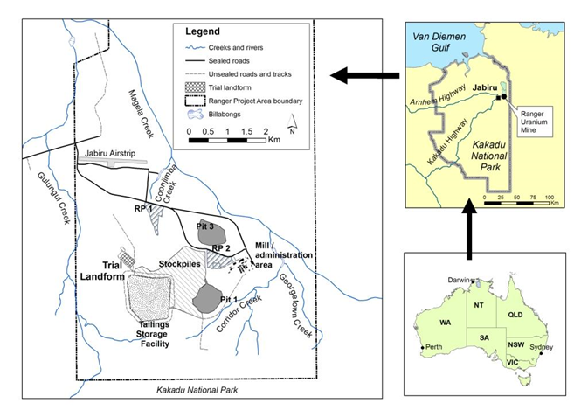

**Figure 1** Location of the Ranger Mine and the Trial Landform

Here, we focus on work underpinning the development of a Rehabilitation Standard for landform stability. Specifically, we apply the methods used to assess whether the rehabilitated landform can meet the relevant Australian Government’s Environmental Requirements, i.e. (i) isolation of mine tailings for a prescribed period of time (10,000 years in this instance), and (ii) erosion characteristics similar to surrounding comparable landforms thereby ensuring landform stability (Australian Government 1999). While erosion may be monitored and assessed over the short-term (years to decades), the longer-term behaviour (centuries to millennia) of such landscapes is outside of decision-making processes required (in the short term) to reach agreement on mine close out.

Numerical modelling provides a means for assessing the potential performance of constructed mine landforms in the longer term. Over the last 40 years a variety of models have been used to evaluate erosion and simulate post-mining landscape stability (Evans, 2000; Loch *et al*., 2000). These models include the water erosion prediction programme (WEPP) (Laflen *et al.,* 1991), universal soil loss equation (USLE) (Wischmeier and Smith, 1978), modified universal soil loss equation (MUSLE) (Onstad and Foster, 1975), revised universal soil loss equation (RUSLE) (Renard *et al*., 1994); and Siberia (Willgoose *et al.,* 1989).

The CAESAR-Lisflood landscape evolution model (LEM) (Coulthard *et al.,* 2013, Van de Wiel *et al.,* 2007) was originally developed to examine the effects of environmental change on river evolution, and to study the movement of contaminated river sediments. Recently, it has been adapted to study the evolution of proposed rehabilitated mine landforms in northern Australia (Hancock *et al.,* 2010; Lowry *et al.,* 2011, 2013; Saynor *et al.,* 2012).

LEMs such as CAESAR-Lisflood can provide estimates of rates of sediment movement at decadal or centennial scales over large spatial scales and evaluate the sensitivity of these processes to environmental changes. However, an important consideration associated with the use of models is the reliability and accuracy of the model predictions.

Our objective is to test the ability of the CAESAR-Lisflood LEM to accurately predict sediment loss from a rehabilitated landform. We do this by comparing modelled predictions of sediment load (bedload and suspended sediment) with measured observations of sediment load over a period of five years from 2009, using purpose-built and instrumented erosion plots constructed on a trial rehabilitated landform.

## 1.1 The CAESAR-Lisflood model

The CAESAR-Lisflood landscape evolution model (Coulthard et al., 2013, Van de Wiel et al., 2007) predicts landscape development by simulating the movement of water over a simulated landscape represented by a digital elevation model (DEM). The model adjusts the elevation values of the grid cells to represent erosion and deposition from fluvial and slope processes, which iteratively affects where water is routed. Coulthard et al., (2013) provide a full description of the formulation and operation of CAESAR-Lisflood, while a basic description is provided below.

CAESAR-Lisflood can be run in two modes: a catchment mode (as used here), with no external in-fluxes other than rainfall; or a reach mode, with one or more points where sediment and water enter the system. For both modes, the model requires the specification of several parameters or initial conditions, including elevation, grain sizes, and rainfall (catchment mode), or a flow input (reach mode). The initial topography of the landscape drives fluvial and hillslope processes that determine the spatial distribution of erosion (loss) and deposition (gain) that occurs during a given time step. This altered topography becomes the starting point for the next time step. Outputs of the model are elevation and sediment distributions through space and time, and discharges and sediment fluxes at the outlet(s) through time. There are four main components to CAESAR-Lisflood, i.e. a hydrological model, a flow model, fluvial erosion and deposition, and slope processes.

When running in catchment mode, runoff over the catchment is generated through the input of rainfall data. This is calculated using an adaptation of TOPMODEL (Bevan & Kirkby, 1979) that contains a lumped soil moisture store which, when it exceeds a threshold value, creates surface runoff. The surface runoff generated by the hydrological model is then routed using a flow model. The flow model is based directly on the two-dimensional Lisflood-FP formulation as described by Bates et al., (2010) where water is routed to a cell’s Manhattan neighbours dependent upon the local water slope, roughness and a simple approximation of the inertia terms. This generates flow depths and velocities for all cells where there is surface water.

Flow velocities are then used to calculate a bed shear stress that is subsequently used to determine the entrainment of sediment over (up to) nine separate grainsize fractions. CAESAR-Lisflood provides three different methods of calculating sediment transport, based on the Einstein (1950), Wilcock & Crowe (2003) and Meyer-Peter Muller (1948) equations (for this application, the Wilcock & Crowe (2003) method was used). The smallest grainsize can be treated as suspended sediment (i.e. <63 µm), whereby material entrained is carried with the flow until it settles according to a settling velocity. Larger grainsizes (i.e. >63 µm) are treated as bedload and transported to adjacent cells according to the velocity. These multiple grainsizes are embedded within a series of ‘active layers’ that allow surface and subsurface grainsize effects to be incorporated, such as surface armouring and the deposition of coarser and finer subsurface layers. For assessing landform stability – especially in northern Australia – a key attribute of the CAESAR-Lisflood model is the ability to use rainfall data recorded at 10-minute intervals from the study area, enabling the modelling of the effects of specific rainfall events. Field evidence from the modelled area indicates that the majority of erosion can occur during high-intensity events (Moliere et al., 2002). As the climatic region in which the Ranger mine occurs is dominated by seasonal, high-intensity rainfall events (McQuade et al., 1996), the ability to model specific rainfall events meant that CAESAR-Lisflood was the only suitable model for this project.

## 1.2 Study area – Ranger trial landform

The soil erosion monitoring plots providing the input data for this study are located on a trial landform that was constructed to study rates of soil erosion and restoration of terrestrial ecosystems at the Ranger mine. The trial landform was constructed by the mine operator, Energy Resources of Australia (ERA), between late 2008 and early 2009. It is located to the north-west of the tailings storage facility at Ranger mine (Figure 1).

The trial landform footprint covers a total area of 8 hectares. Excluding boundary batter slopes and perimeter access roads, the top surface area is 6 ha with a mean slope of 2.2%. The landform was designed to test two types of potential final cover material: waste rock alone; and waste rock blended with approximately 30% v/v of fine-grained weathered horizon material (referred to as ‘laterite’). Following initial construction, the surface was ripped along the contour using tynes attached to a large bulldozer at a horizontal spacing of 2 metres and to a depth of 0.5 metres.

During 2009, SSB constructed four erosion monitoring plots (approximately 30 m x 30 m) on the trial landform surface, with two plots in the area of waste rock, and two in the area of mixed waste rock and laterite (Figure 2). The plots were physically isolated from runoff from the rest of the landform area by constructed borders. The erosion plots were constructed to enable:

1. Measurement of erosion rates through time to assess effects of different surface treatments and vegetation establishment strategies.

2. Generation of input data for long term, predictive geomorphic computer modelling of the proposed landform designs.

3. Determination of loads of key contaminants present in the dissolved and fine suspended-sediment fractions available for export from the trial landform via the surface water runoff pathway.

Data have now been collected from the erosion plots on the trial landform since 2009. However, it has not been possible to successfully record sediment data for the full period from 2009 for each erosion plot. Consequently, here we focus on the bedload and suspended sediment data collected from Plot 1 for the period 2009-2014, with additional results for bedload data only from Plots 2, 3 and 4.

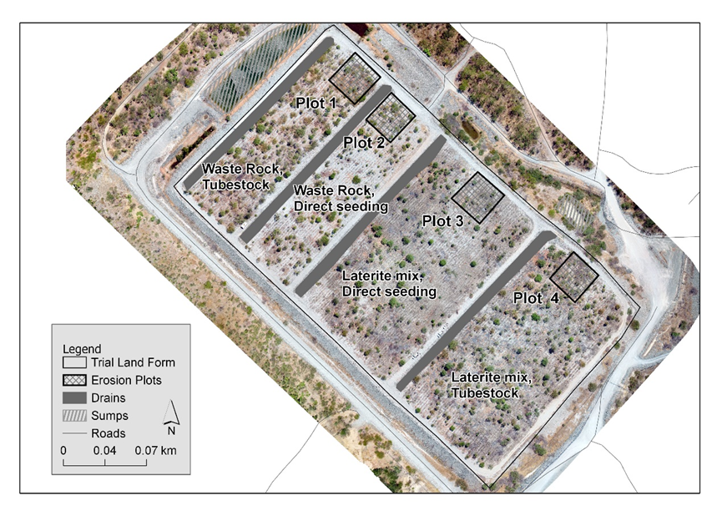

**Figure 2** Layout and location of erosion plots on the Ranger trial landform.

Field data were collected from the outlet of each erosion plot, each plot being instrumented with a range of sensors (Figure 3). These included: a pressure transducer and shaft encoder to measure stage height; a turbidity probe; electrical conductivity probes located at the inlet to the stilling basin and in the entry to the flume to provide a measure of the concentrations of dissolved salts in the runoff; an automatic water sampler to collect event-based samples; and a data logger with mobile phone telemetry connection. Data acquired over the study period from 2009-2014 were stored in the hydrological data management system, Hydstra (kisters.com.au).

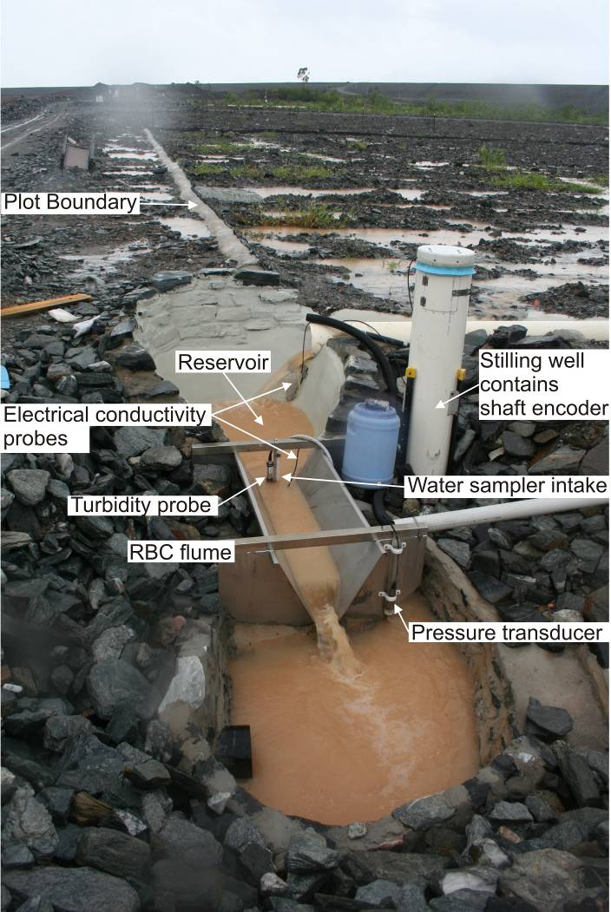

Figure 3 Instrumentation installed on individual erosion plots

# 2 Methods

We compared modelled predictions of sediment load (bedload and suspended load) with measured observations of sediment load. The methods employed here include:

* 1. applying the model through a series of simulated scenarios on the trial landform
  2. a sensitivity and uncertainty analysis on the CAESAR-Lisflood model to optimise the parameters used in model simulations

## 2.1 Applying the CAESAR-Lisflood model

The application of the CAESAR-Lisflood model to the trial landform required the collation and integration of data from a range of sources. The key data inputs used by the model were a digital elevation model (DEM), rainfall data, and surface particle size distribution data.

The model predictions of sediment load were compared with field data collected from the outlet of each erosion plot instrumented with a range of sensors (Figure 3).

DEMs of each of the erosion plots were generated from data collected by a Terrestrial Laser Scanner (TLS) in June 2010, approximately 12 months after the construction of the landform. Each erosion plot was scanned at a horizontal resolution of 0.02 m at a distance of 100 metres. The data for the erosion plots were interpolated to produce a surface grid with a horizontal resolution of 0.2 m, to reduce the processing time required by the model.

The DEMs were processed using ArcGIS software to ensure that they were pit-filled and hydrologically corrected. Pit filling was important in order to remove data artefacts, which included newly-established vegetation (peaks) as well as artificial depressions, or sinks. We acknowledge that pit filling itself may have a prejudicial influence on the modelled sediment yields, as discussed by Temme et al., (2006). As noted earlier, in this study the DEM of Plot 1 was used, as it was the plot which had the most complete discharge and sediment transport data for the period from 2009-14

Rainfall measurements were collected by a pluviometer located adjacent to each erosion plot. Rainfall measurements were recorded for each rainfall year between 2009 and 2015, with each rainfall year commencing the 1st of September and running through to the 31st August of the following year. While rainfall for each plot was collected, for this study, only the rainfall data for Plot 1 were used. For the purposes of this study, the CAESAR-Lisflood model was modified to run data recorded at 10-minute intervals, reflecting the much smaller catchment areas modelled and the corresponding shorter timeframes for system response to rainfall.

Sediment and water discharges (bedload and suspended sediment) were collected from the outlet of Erosion Plot 1 instrumented with a range of sensors (Figure 3).

Using the process described in Hancock et al., (2020), the grain size data required for CAESAR-Lisflood were obtained through the application of a grid-by-number method on the TLF. Grain size analysis was completed on these samples and the results averaged into nine grain size classes (Table 1) which were used for input into CAESAR-Lisflood. The sub 0.00063 m (i.e. <63 µm) fraction is treated as suspended sediment in CAESAR-Lisflood, while the 0.128 m fraction includes all particles greater than 0.128 m.

**Table 1** Grain size classes and proportions representing waste rock

|  |  |
| --- | --- |
| Grainsize (m) | Proportion of dataset |
| 0.000063 (suspended sediment) | 0.03 |
| 0.00009 | 0.029 |
| 0.00018 | 0.058 |
| 0.0005 | 0.037 |
| 0.001 | 0.1371 |
| 0.008 | 0.221 |
| 0.016 | 0.322 |
| 0.064 | 0.0888 |
| 0.128 | 0.0771 |

Following the sensitivity analysis and calibration of the CAESAR-Lisflood model, parameter values were derived for use in the model simulations. These values are shown in Table 2.

**Table 2** Final parameter values used in model simulations

|  |  |
| --- | --- |
| **Model parameter** | **Value** |
| Sediment transport equation | Wilcock and Crowe |
| b1 | 2 |
| k1 | 0.025 |
| c1 | -0.5 |
| c2 | 5 |
| k2 | 70 |
| c3 | -2.5 |
| c4 | 1 |
| Froude limit | 0.7 |
| Manning’s n | 0.04 |
| active layer thickness | 0.005 |
| Maximum erode limit | 0.001 |
| Courant number | 0.3 |

## 2.2 Sensitivity analysis and calibration

As this study seeks to assess the reliability of the CAESAR-Lisflood model for predicting sediment movement, it is important that the model outputs are meaningful and realistic. This evaluation was undertaken through a sensitivity analysis of the input parameters using the method described by Morris (1991), and subsequent calibration of the CAESAR-Lisflood model, applied specifically to the erosion plots on the Ranger trial landform.

This work builds on an earlier study by Skinner *et al*., (2018) who undertook a sensitivity analysis of the CAESAR-Lisflood model using the Tin Camp Creek catchment in western Arnhem Land as a case study.

The key finding from Skinner *et al.,* (2018) was that the parameter that had the greatest influence on model output was the choice of sediment transport equation. The Wilcock and Crowe equation was found to produce model results which best matched observed sediment loads at the erosion plot / small catchment scale (Coulthard 2019).

In this study, 22 parameters (Table 3) used in modelling of the erosion plots on the trial landform were assessed through the sensitivity analysis. A description of this process can be found in Skinner *et al.,* (2018).

**Table 3** List of parameters used in sensitivity analysis of CAESAR-Lisflood applied to the Ranger trial landform

|  |
| --- |
| Sediment transport law, Maximum erode limit, In channel lateral erosion rate, Slope failure, Input/output difference allowed, MinQ for depth calculation, MaxQ value, Slope for edge cells, Evaporation rate, Manning’s N, Grain size set, DEM resolution, Hydrology ‘m’ value, Lateral erosion rate, Water depth threshold, Bedrock lowering P1 value, Bedrock lowering b1 value, Physical weathering k1 value, Physical weathering c1 value, Physical weathering c2 value, Maximum velocity, Lateral smoothing |

Following the sensitivity analysis, an uncertainty analysis / auto-calibration exercise was carried out on the nine parameters that were most influential upon the final outcomes. These nine parameters are listed in Table 4 and from these, 100 random parameter combinations were chosen, and model outputs compared against known field outputs as percentage difference.

**Table 4** List of parameters calibrated

|  |
| --- |
| Maximum erode limit, In channel lateral erosion rate, Slope for edge cells, Manning’s , Lateral erosion rate, Water depth threshold, Soil creep, Settling velocity, Erosion factor |

However, the uncertainty analysis was not able to satisfactorily calibrate the model outputs to observed measurements, with none of the parameter combinations tested scoring better than 45% difference from actual observed/ measured values. More detail of the methodology employed in the uncertainty analysis and calibration phase is described in Coulthard (2019). Consequently, a more inductive approach was used.

The next step was to manually calibrate model outcomes to known outcomes from field measurements. This was done in two parts. The first part involved calibrating the hydrological component of CAESAR-Lisflood, in order to simulate the best possible hydrological (runoff) response to rainfall with measured runoff using rainfall data collected on Plot 1 from 2009-2014.

The second part of the calibration involved analysing the model output and making logical adjustments to the model parameterisation to attempt to match the modelled outputs to the field observations. These adjustments were informed by the results of the sensitivity and uncertainty analysis and by using field measured values – such as the particle grainsize. Specifically, this involved: applying the Wilcock and Crowe sediment transport equation; revising and applying a surface particle size distribution to represent the waste rock surface on the trial landform; reducing the minimum erode limit value; and raising the MaxQ value to 1, thereby focusing erosion towards the erosion plot exit.

## 2.3 Model scenarios

The comparison of CAESAR-Lisflood modelled results and field measurements of sediment load focussed on Plot 1 as it had the most complete set of measured and validated hydrological and sediment load data (both suspended and bedload).

Two scenarios, representing different simulated periods of time, were modelled for Plot 1:

1. A 5-year simulation using rainfall data collected on the landform for the period 2009-14 at intervals of 10 minutes. This dataset includes an extreme event in which 720 mm fell over 72 h between 17:00 on 27 February and 17:00 on 2 March 2011 (Erskine *et al.,* 2012) and simulates the period for which field measurements have been collected and which can be used for comparison.
2. A 30-year simulation using the 2009-14 rainfall looped six times. This simulation was used to simulate the decadal evolution of the landform, with the 2011 rainfall event repeated six times.

## 2.4 Model outputs

Sediment totals for each of the nine grain size classes and runoff values were recorded from the model at intervals of 1 day of simulated time. These outputs were used for comparing with measured sediment loads, and for calculating the denudation rate.

While suspended sediment data were not available for Plots 2, 3 and 4 for the entire period, simulations producing bedload yield were run for these plots using rainfall data collected on the trial landform and compared with field measurements from the respective plots for the 5 years between 2009-2014.

Digital elevation models representing surface topography were recorded for every week of simulated time and exported in ASCII raster format for analysis in the ArcGIS environment to assess topographic change on the landform.

# 3 Results

## 3.1 Comparison of modelled and measured water discharge

The first step for this study was to determine that the model was able to accurately predict discharge from the erosion plots on the trial landform. This parameter is important as it governs the predictions of sediment load for each plot. We found that the model was able to predict discharge that corresponded reasonably with the discharge that had been recorded for the plot. The calibration used rainfall data collected on Plot 1 from 2009-2014, and identified an ‘m’ value (which controls the peak and duration of the hydrograph generated by a rain event) of 0.01 as producing the best match with measured runoff. The results of the hydrological calibration are shown in Figure 4.

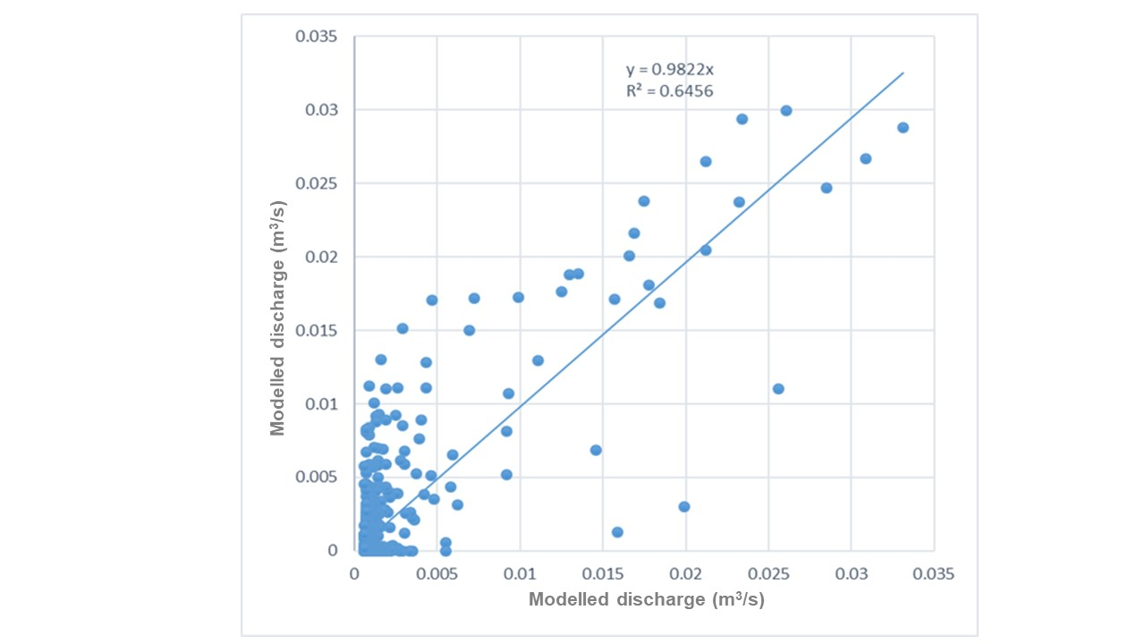

**Figure 4** Scatter plot between observed and modelled discharge (water) for Plot 1 using an ‘m’ value of 0.01.

In addition, we compared the results for cumulative modelled discharge and cumulative measured discharge for the period from 2009 to 2014. For brevity, here we show the results for Plot 1 in Figure 5. Modelled discharge was found to slightly exceed measured discharge for the same period for all plots. On all plots, modelled and measured discharge patterns corresponded well.

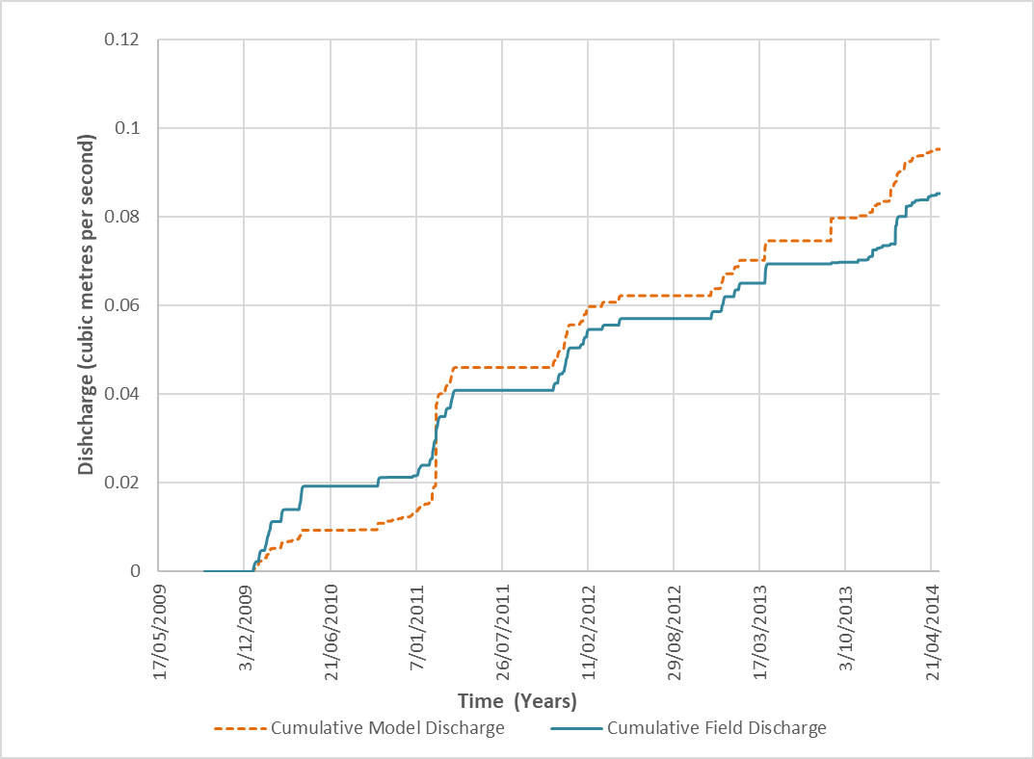

**Figure 5** Measured versus modelled prediction of cumulative discharge for Plot 1 2009-14

## 3.2 Modelled and measured sediment outputs

The results of cumulative measured sediment loads (bedload and suspended sediment) are compared with modelled predictions of cumulative sediment loads for the same period for Plot 1 in Figure 6. These show that the simulations run with the large rainfall event recorded in February 2011 predicted a large increase in sediment yield associated with the rainfall event, that exceeded the measured loads for the same period (Figure 6). However, after this rainfall event, subsequent increases in predicted load were much less.

In contrast, when simulations were run without the 2011 rainfall event, the modelled outputs matched the magnitude of the measured outputs more closely both before and after the 2011 rainfall event (Figure 6).The discrepancy observed between predicted bedload for scenarios with and without the 2011 rainfall event prior to the 2011 rainfall event is due to the different rainfall files used in the simulations, and variations in the parameterisation of the simulation.

Figure 6 Measured versus modelled prediction of bed load and suspended sediment for Plot 1 with and without 2011 extreme rainfall event.

As a further assessment of the model performance, the sediment totals (bedload and suspended sediment) and the ratios between the modelled and measured data are summarised in Table 5. In both scenarios (with /without the 2011 rainfall), at the end of the 5-year simulation the cumulative total sediment loads of both modelled and measured loads were within a range of 15% and thus similar.

**Table 5** Summary of cumulative totals and percentage deviations from field measurements after 5 years

|  |  |  |  |
| --- | --- | --- | --- |
|  | SS total (m3) | Bed load total (m3) | Ratio |
| Field | 0.014 | 0.085 | 6.218 |
| Model – no extreme rain event | 0.018 | 0.096 | 5.408 |
| Model – with extreme rain event | 0.015 | 0.088 | 5.856 |
| Percentage deviation from field values | | | |
| Model – no extreme rain event | 29.67 | 12.81 | 12.91 |
| Model – with extreme rain event | 10.00 | 3.62 | 5.71 |

A comparison of the modelled and measured bedload yields over the period 2009-2014 for Plots 2-4 are shown below in Figures 7-9, respectively. As with Plot 1, model simulations for all plots show an increase in the predicted sediment loads after the 2011 rainfall event that is greater than that measured in the individual plots.

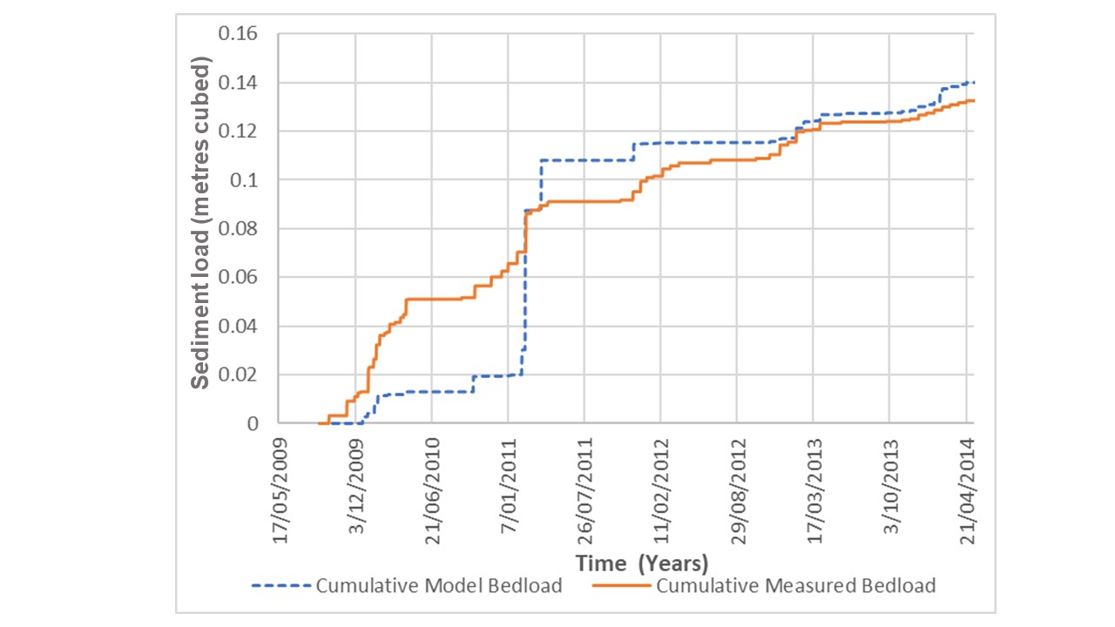

**Figure 7** Comparison of modelled cumulative bedload and field-measured cumulative bedload yield for Plot 2.

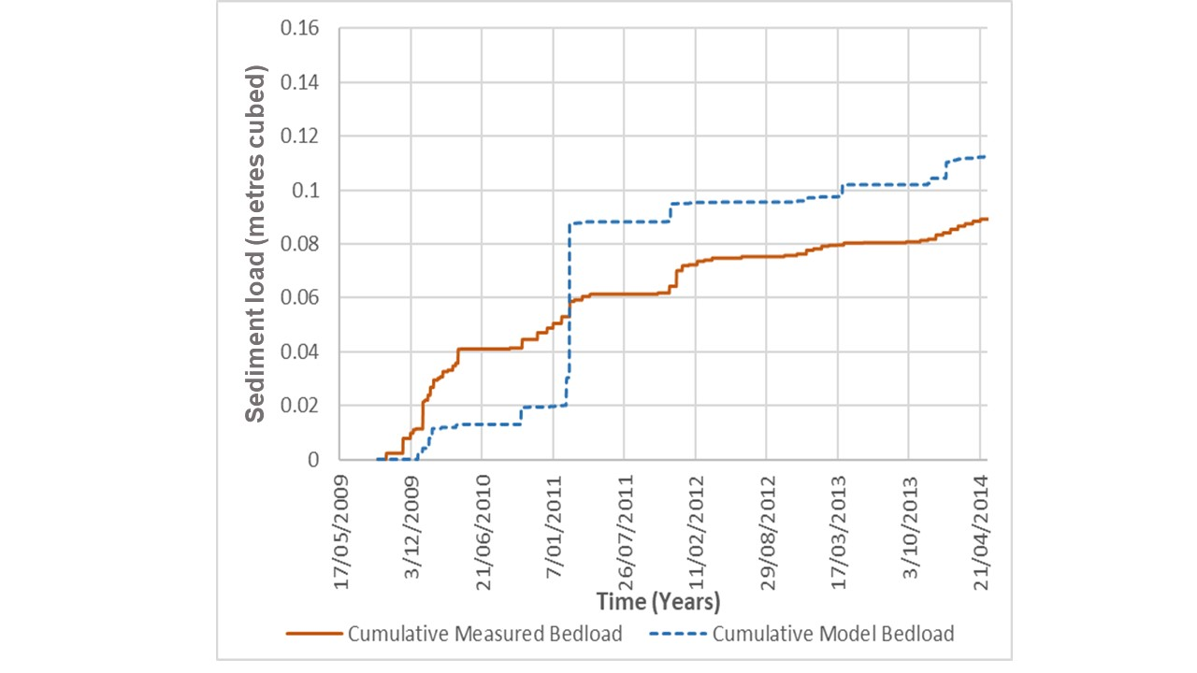

**Figure 8** Comparison of modelled cumulative bedload and field-measured cumulative bedload yield for Plot 3.

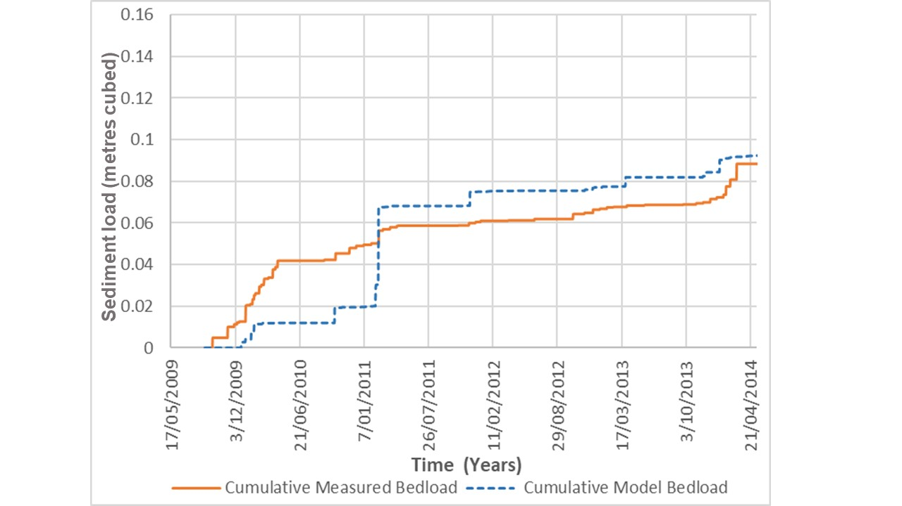

**Figure 9** Comparison of modelled cumulative bedload and field-measured cumulative bedload yield for Plot 4.

The mean annual rainfall and measured bedload yield for each plot for each water year in the period 2009-2014 are shown in Figure 10. In February 2011, a rainfall event produced 180 mm in 3 hours that had an annual return interval of greater than 100 years with an annual exceedance probability of less than 1%. Measured bedload yields were greatest in the 2009–10 year (immediately after the trial landform had been constructed), and declined steadily over the period of study. Model predictions show a similar overall trend of declining loads both with and without the 2011 rainfall event (Figures 6-9).

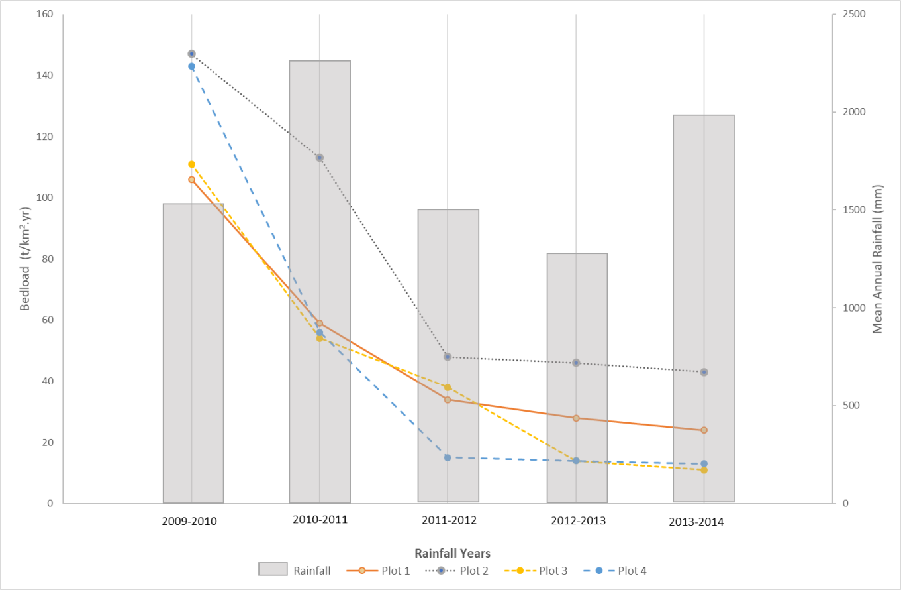

**Figure 10** Average annual rainfall and total bedload for Plots 1 - 4 from 2009-2014

## 3.3 Predictions of topographic change

The model enables the predicted evolution of the trial landform surface to be visualised through the generation of a series of high-resolution elevation surfaces at user-defined intervals. The model predicted little change in the topography of the landform over the initial five-year model period for each of the plots. Most change (sediment loss) is predicted to occur near the catchment outlet on the western edge of the plot, as represented in Plot 1 (Figure 11). Anecdotally, there is little visible change in the plot surface with the riplines still clearly visible amongst the expanding vegetation community (Figure 12)

Further gradual lowering of the surface was predicted when the simulation was extended for longer periods up to 30 years. Simulations for all plots showed similar trends, with little change in the surface topography, and only a slight lowering in the landform surface. As can be seen in Figure 13, the surface of the plot – in this case, Plot 1 – is predicted to be reworked, with some rip lines infilling after a period of 30 years.

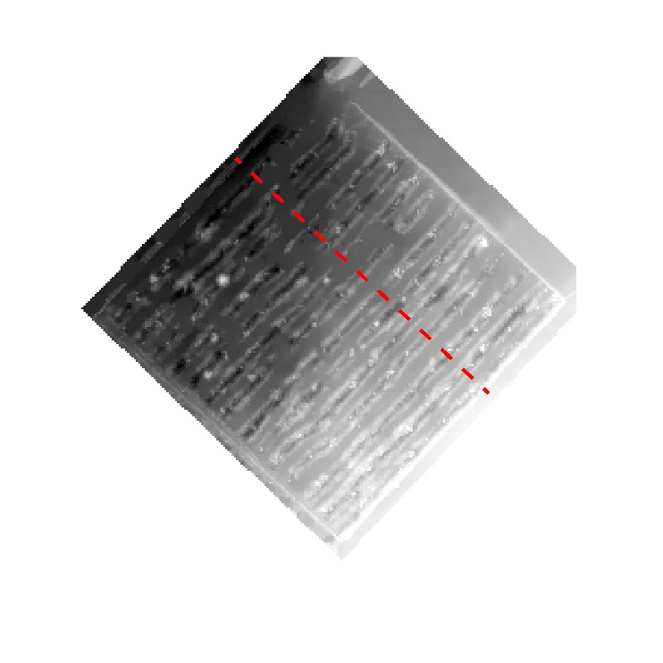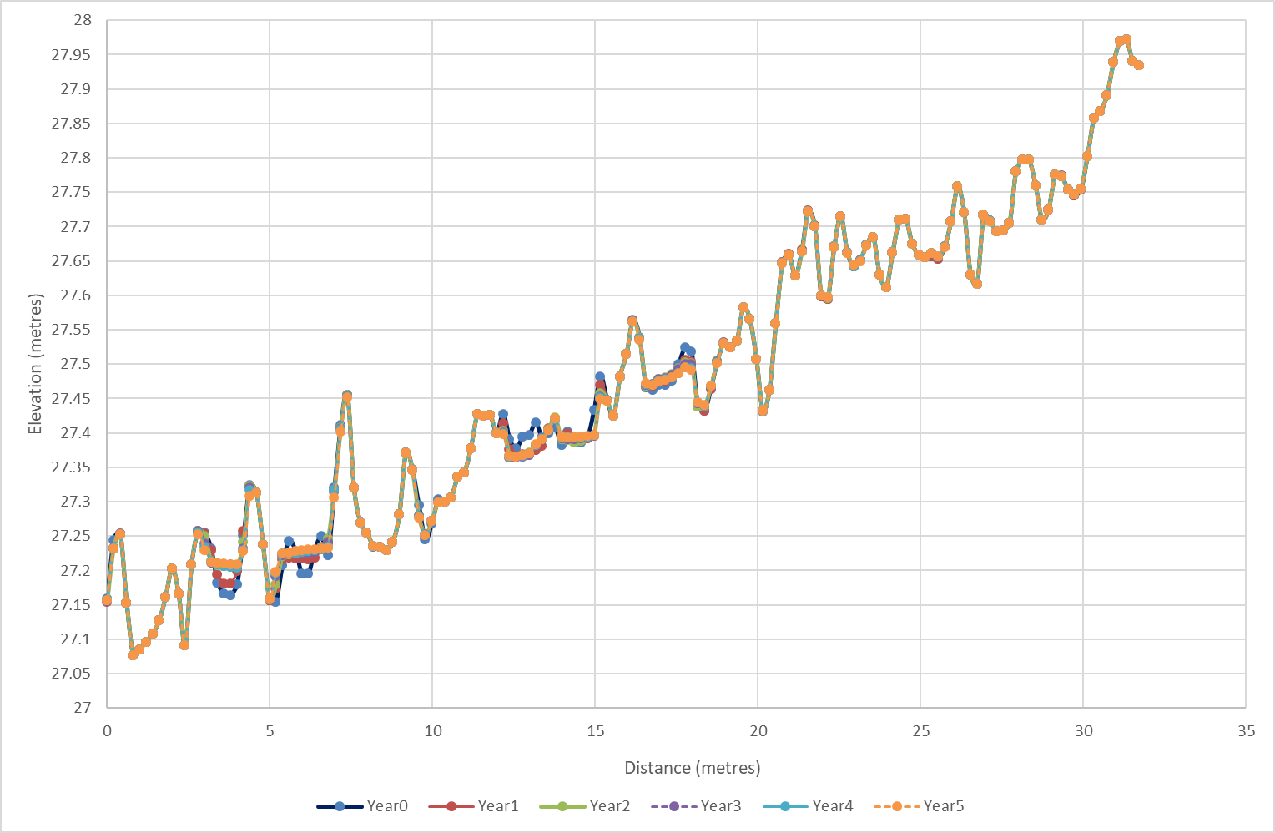

**E**

**W**

**W**

**E**

**Figure 11** (Top) location of west-to-east transect across Plot 1 (Bottom) West-to-East transect across modelled Plot 1 surfaces over simulated period of five years

Measurements of total sediment load were used to calculate the rate of denudation, or surface lowering, from Plot 1 for a period of 5 years. A good match is observed when compared with the modelled prediction of denudation rate from Plot 1 for the same period (Figure 14), with both modelled and measured denudation showing a steady decrease. In addition model simulations indicate that the denudation rate will continue to decrease over a period of 10 years. Importantly, both calculations indicate that the denudation rate from Plot 1 will fall within the background denudation rate for the region (0.07 mm yr.) established by Wasson et al., (2020) within 5 years.

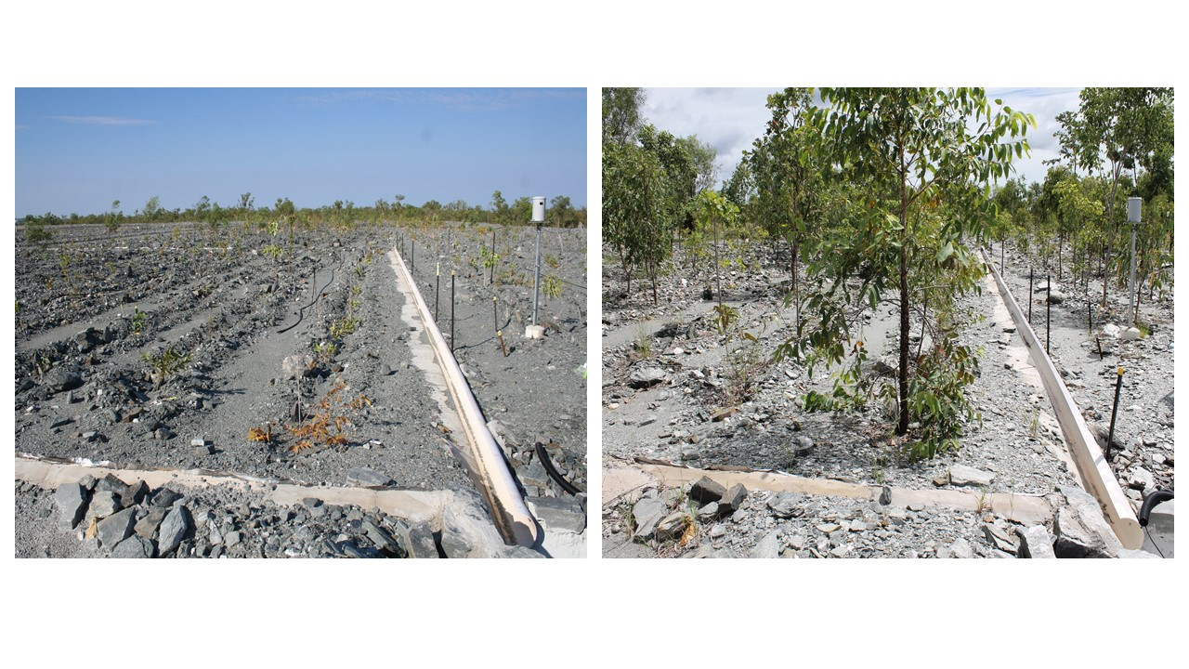

(**A**)

(**B**)

**Figure 12** Plot 1 surface in (A) 2010 and (B) 2014. Ripline mounds and depressions present with developing vegetation cover

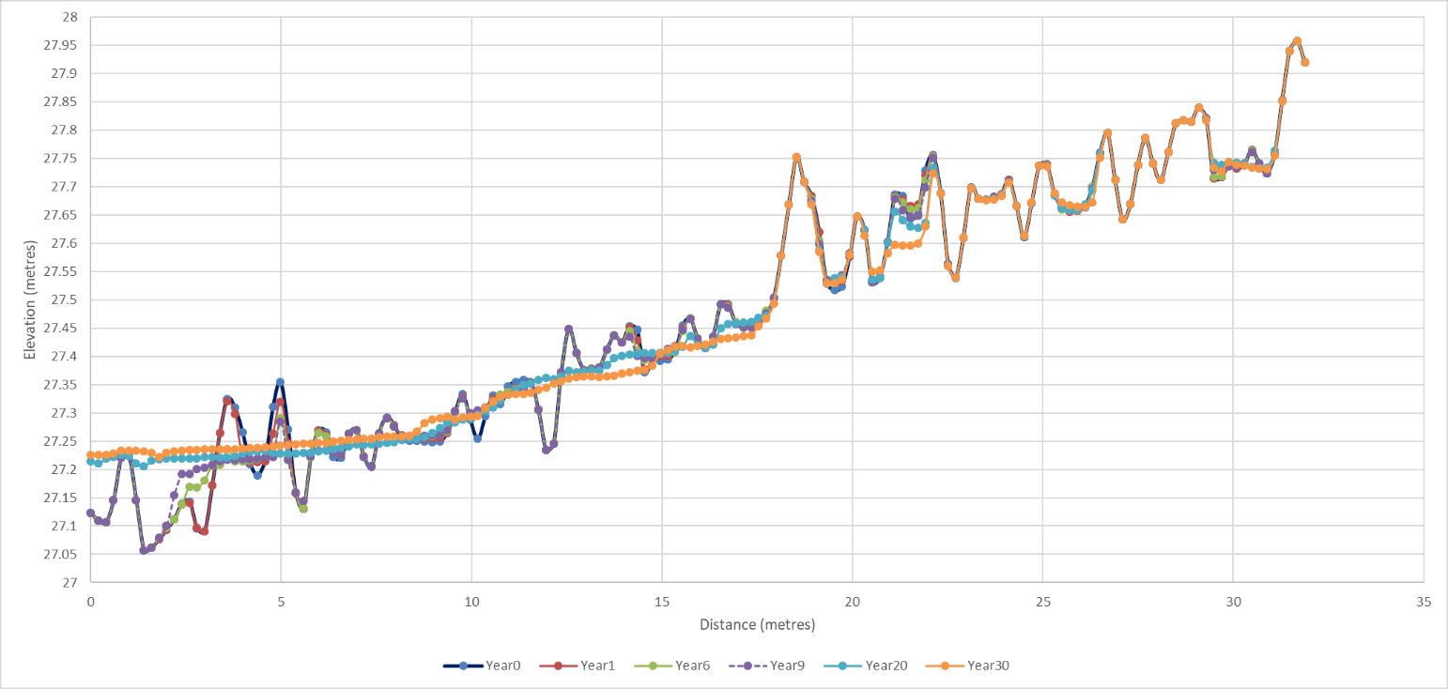

**Figure 13** Modelled evolution of Plot 1 surface over period of 30 years

**Figure 14** Predicted denudation rate from Plot 1 over 10 years

# 4 Discussion and conclusions

The objective of this study was to assess the ability of the CAESAR-Lisflood LEM model to accurately predict sediment transport and landform evolution when compared to measured erosion and transport rates from the Ranger trial landform.

In order to test and assess the model, we undertook sensitivity and uncertainty analyses of the model, as well as a manual calibration of parameters. The sensitivity analysis reinforced how the choice of sediment transport rule was important in altering model outputs. Specifically, the Wilcock and Crowe sediment transport equation produced the best results at the erosion plot scale when using the 0.2m DEM. In contrast, simulations that utilised the Einstein sediment transport equation produced sediment load predictions that were several times greater than the field observations. The manual calibration methods demonstrated that it is possible to calibrate the parameters within CAESAR-Lisflood to simulate sediment yield totals after 5 years that vary <15% from the measured values. Importantly, this was over three comparators, suspended sediment, bedload and the ratio between them (Table 5).

## 4.1 Model outputs

This study found that for the five-year period from 2009-2014, the predicted sediment yields from CAESAR-Lisflood corresponded well with the field measurements for the same period for Plot 1. For the first two years (2009-2011), measured cumulative bedload from Plot 1 (Figure 6) was higher than the predicted cumulative bedload. The occurrence of heavy rainfall events in 2011 lead to an increase in predicted loads, although this was not observed in the measured sediment loads produced by the landform. We believe this demonstrates that model outputs in this case were overly-responsive to large rainfall events occurring in the early period after landform construction. What our simulation results show is that while rainfall intensity has an important role in the magnitude and timing of sediment delivery for an event, the supply of sediment available to be eroded exerts an important control. Put simply, there is a limited amount of sediment that can be eroded from the erosion plot – and this is removed from the plot sooner in the simulations with the extreme rain event in 2011 than those without. We believe this is reflected in a notable flattening of the cumulative sediment yield curve after the event, that is not apparent in simulations run without the 2011 extreme event. We believe these results show that the model responds to the 2011 event through partially exhausting the supply of sediment within the plot. Further evidence for this effect of sediment supply is given by the decline in sediment load seen in all model simulations and in the measured field data through to 2014.

A further high rainfall event in 2013-14 results in an increase in predicted load, albeit on a smaller scale than the 2011 event. Importantly, at the end of the simulation period, the final predicted sediment load for Plot 1 was within 10% of the measured load (Table 5). On the basis of the results for the trial landform, predictions for any period less than 5 years could not be regarded as reliable.

By collating the bedload and suspended load totals for the simulations with and without the extreme rainfall event, we were able to calculate the ratio between the two and their percentage deviations from the measured field values in Table 5. These indicate that the model simulations with the extreme rainfall event present (Figure 6) gave the best match in terms of suspended, bedload and ratio fits to the field data over a 5-year period.

Although this study used data collected over a period of five years, which is a limited period of time for validation, it was possible to detect a consistent trend across all plots of declining sediment yield which would be expected to continue over time (Figure 10) (Saynor and Erskine 2016). Consequently, we believe data collected over this period representative of the long term trend for sediment yield for the plots on the trial landform.

Minor variations were observed between the different plots in the predicted and measured yields which we believe may be attributed to the variations in the microtopography of the respective plots. For example, we believe the relatively high bedload yields (both predicted and measured) for Plot 2 (Figure 7) may be attributed to the less defined nature of the riplines near the outlet of Plot 2. For each plot, the model appears to overpredict bedload yield, in response to large rain events as discussed earlier for Plot 1. Overall and after several years, the predicted and measured bedload values for all plots are within 20% of each other.

Overall, the close range of both the modelled and measured results from Plot 1 of the bedload and suspended sediment yields, together with the close range of the modelled and measured bedload values for the remaining plots 2-4 on the trial landform indicates that the model is able to successfully predict sediment load from a rehabilitated surface. It is notable, however, that reliability in the predictions is achieved only after several years as the model adjusts coarsely to extreme rainfall events. Confirmation of this will arise with additional comparisons of predicted versus observed sediment loads on the trial landform at future decadal intervals (e.g. 10, 20 and 30 years after landform construction).

## 4.2 Caveats on results

It is important to understand that the results of this study are qualified by several caveats, which affect the extent to which the methods and results of this study may be transferred or applied to other model applications at different scales. Specifically, they relate to the spatial and temporal scale and resolution of the data and parameters used in this study. We utilised high resolution (0.2m) data of a relatively small area (900m2), with a low gradient (2%) and over a geologically short time period (5 years). As noted earlier, the CAESAR-Lisflood model is intended to be used to assess the geomorphic stability of the final rehabilitated Ranger landform (encompassing about 800ha) over a period of up to 10,000 years. We recognise that in order to be able to confidently assess the final rehabilitated landform for a simulated period of thousands of years, the methods and results in this study will need to be reviewed and possibly revised to reflect the larger areas and longer time frame being assessed. We discuss the caveats associated with this study below.

### 4.2.1 Temporal range

We recognise that the five year-period used in this study is a relatively short period within which to test or validate a model. Specifically, we acknowledge that this time frame is unlikely to represent the range of rainfall patterns that may occur over an extended period of up to 10,000 years, particularly if climate change is considered. Similarly, we understand that extensive pedogenic and geomorphic development is unlikely to develop within the period of this study. However, very few mine sites have this type of data available with which to compare and assess model predictions for multi-year periods.

### 4.2.2 Spatial extent

We recognise that the simulations performed here have been for an ‘idealised’ environment of just 900m2. Furthermore, the erosion plots are located on a uniformly gently sloping (2.0%) surface that, while representative of a substantial proportion of the landform, is likely to be least susceptible to erosion. In addition, the modelled area within each plot boundary assumes no replenishment of material from upslope (or outside the boundaries of the erosion plots), thereby enabling the modelled area to be totally exhausted and as such may not be representative of catchment areas likely to be encountered on a rehabilitated landform. As demonstrated with the variations in predicted bedload between plots, differences in the surface topography can influence the predicted results, and may indicate an important sensitivity of the model to this attribute, particularly if applied at larger spatial and temporal scales to more geomorphically complex landscapes.

### 4.2.3 Data resolution:

In this study the modelled plots were compiled to a horizontal resolution of 0.2m. We recognise that model simulations at this resolution will be difficult to replicate for the final rehabilitated landform, which is expected to encompass an area of approximately 800 hectares. This means that a DEM of the entire landform, compiled to a resolution of 0.2m would comprise more rows and columns then can be currently processed by the CAESAR-Lisflood model in one simulation . To address this limitation, consideration must be given to determining the optimum resolution and scale at which to model the final landform. The selection of an appropriate DEM resolution is important as it directly affects the area, or geographic extent of the landform that can be modelled in one simulation, as well as the extent to which the topographic complexity or surface roughness of the landform may be assessed by the model. The latter in turn affects predictions of sediment load. Put simply, while a coarse DEM resolution of 10m may allow a larger area to be modelled, it will not be able to represent riplines or other controls structures that may be present in the landform, and will produce much lower sediment loads than finer resolution DEMs of the same area. Conversely, modelling too small an area limits the ability to model all aspects of erosion. For example, model predictions of topographic change on the erosion plots using data with a resolution of 0.2m indicate that riplines on the trial landform surface are predicted to gradually infill and lower over periods up to 30 years, while gullies are not predicted to form (Figure 13). This is not surprising given the small individual areas being modelled in this instance, the low slopes, and the relatively limited volume of material that may be transported from the plot. How this translates to model predictions on gully formation or potential exposure of tailings through erosion for larger areas and timespans – which represent the core of the assessment – is yet to be tested and validated against field observations.

## 4.3 Other issues

While consolidation of the landform surface is not an issue at the spatial and temporal scales used in this study, we recognise consolidation is an additional factor that may need to be considered when assessing landform stability for longer time frames and larger areas. However, we believe landform evolution modelling should use landform surfaces that represent fully consolidated landforms, and the derivation of consolidation effect should be done independently of landform modelling.

The role of vegetation establishment and growth (both overstorey and understorey) was not considered in the simulations. The trial landform at Ranger initially presented a bare surface as just after construction there was no vegetation present. However, since then canopy cover has increased each year. The role of fire, which impacts on vegetation establishment and growth, and thereby the susceptibility of the landform to erosion, may need to be incorporated into future longer-term simulations, but was out of the scope of this study. Continued monitoring of the trial landform over successive wet seasons will enable the effects of surface weathering, self-armouring, the development of vegetation cover, and introduction of fire, to be quantified.

We recognise that an area for further model calibration is calibrating predictions of changes in surface elevation /evolution with observed changes in the surface topography. While out of the scope of this study, this could potentially be done by comparing the predicted surface with a high-resolution digital elevation surface generated through a LiDAR, or similar technology, survey. The collection of data at larger spatial scales to enable model results to be applied to larger areas will further increase confidence in the ability of the CAESAR-Lisflood model to reliably predict the geomorphic evolution of a rehabilitated landform under different scenarios over simulated periods of thousands of years.

This study has demonstrated that, at the spatial and temporal scale applied here, the CAESAR-Lisflood model is able to successfully predict the sediment load of a rehabilitated landform at a decadal time scale. Additional field data from larger catchment scales if/when it is available should be used to further test the modelling capability of CAESAR-Lisflood.

# Acknowledgements

The authors wish to acknowledge the following current and former staff of SSB for their support and assistance: Richard Houghton, Renee Bartolo, Jon Taylor, Kate Turner, Sean Fagan, Michael Fromholtz, Andrew Esparon and James Boyden. Internal review was undertaken by Renee Bartolo and Chris Humphrey.

ERA is acknowledged for their assistance in the establishment of the erosion plots, access to the study site and assistance with sample collection.

# References

Australian Government 1999. Environmental requirements of the Commonwealth of Australia for the operation of the Ranger uranium mine. Australian Government Department of the Environment and Heritage, Canberra.

Bates, P D, Horritt, M S and Fewtrell, T J, 2010. A simple inertial formulation of the shallow water equations for efficient two-dimensional flood inundation modelling. *Journal of Hydrology*, 387 (1),33-45

Bevan, K and Kirkby, M J, 1979. A physically based contributing area model of basin hydrology. *Hydrological Science Bulletin*, 24:43-69.

Coulthard, T J, Neal, J C, Bates, P D, Ramirez, J, de Almeida, G A M and Hancock, G R, 2013. Integrating the LISFLOOD-FP 2D hydrodynamic model with the CAESAR model: implications for modelling landscape evolution. *Earth Surface Processes and Landforms*, DOI: 10.1002/esp.3478

Coulthard , T J 2019. Final Report for the Supervising Scientist Branch, Department of the Environment and Energy, in fulfilment of Contract 3600001290 “ CAESAR sensitivity analysis”. Unpublished report, 34p.

Einstein, H A 1950. The Bedload Function for Sediment Transport in Open Channel Flow, Soil Conservation Technical Bulletin No. 1026, U.S. Department of Agriculture, Washington, DC.

Erskine W D, Saynor M J, Jones D, Tayler K & Lowry J B 2012.Managing for extremes: potential impacts of large geophysical events on Ranger Uranium Mine, NT. In *Proceedings of the 6th Australian Stream Management Conference, Managing for Extremes*. Canberra 6–8 February 2012, eds JR Grove & ID Rutherfurd, River Basin Management Society, Melbourne, 183–189.

Evans, K G, 2000. Methods for assessing mine site rehabilitation design for erosion impact, *Australian Journal of Soil Research*, Vol. 38(2), pp. 231–248.

Hancock, G R, Lowry, J B C, Coulthard, T J, Evans, K G and Moliere, D R 2010. A catchment scale evaluation of the SIBERIA and CAESAR landscape evolution models, Earth Surface Processes and Landforms, Vol. 35, pp. 863–875.

Hancock, G R, Saynor, M, Lowry, J B C and Erskine W D 2020. How to account for particle size effects in a landscape evolution model when there is a wide range of particle sizes, *Environmental Modelling and Software*, 124 (In press)

Jones, D R, Humphrey, C, van Dam R, Harford A, Turner, K and Bollhoefer A, 2009. Integrated chemical, radiological and biological monitoring for an Australian uranium mine - a best practice case study in Proceedings International Mine Water Conference, 19-23 October, Pretoria, South Africa 95-104.

Laflen, J M, Elliot, W J, Simanton, J R, Holzhey, C S and Kohl K D 1991. WEPP soil erodibility experiments for rangeland and cropland soils, *Journal of Soil and Water Conservation* 39-34.

Loch, R J, Connolly, R D and Littleboy, M, 2000. Using rainfall simulation to guide planning and management of rehabilitated areas: Part 2, Computer simulations using parameters from rainfall simulation, *Land Degradation and Development*, Vol. 11(3), pp. 241–255.

Lowry, J B C, Coulthard, T J, Hancock, G R, Jones, D R 2011. Assessing soil erosion on a rehabilitated landform using the CAESAR landscape evolution model, in *Proceedings of the 6th International Conference on Mine Closure*, (eds: A B Fourie, M Tibbett and A Beersing) 18–21 September 2011, Australian Centre for Geomechanics, Perth, pp. 613–621.

Lowry, J B C, Coulthard, T J, Hancock, G R, 2013. Assessing the long-term geomorphic stability of a rehabilitated landform using the CAESAR-Lisflood landscape evolution model, in *Proceedings of the 8th International Conference on Mine Closure* (eds: M Tibbett, A B Fourie, and C Digby) 18–20 September 2013, Australian Centre for Geomechanics, Perth, pp. 611–624.

McQuade, C V, Arthur, J T and Butterworth, I J, 1996. Climate and hydrology, in *Landscape and Vegetation of the Kakadu Region, Northern Australia*, (eds: C.M. Finlayson and I. von Oertzen), Kluwer Academic Publishers, Dordrecht, pp. 17–35.

Meyer-Peter, E. and Muller, R (1948) Formulas for Bedload Transport. IAHSR 2nd meeting, Stockholm, Appendix 2

Moliere, D R, Evans, K G, Willgoose, G R and Saynor, M J, 2002. Temporal trends in erosion and hydrology for a post-mining landform at Ranger Mine. Northern Territory. Supervising Scientist Report 165, Supervising Scientist, Darwin.

Morris, M D 1991. Factorial sampling plans for preliminary computational experiments, *Technometrics*, Vol.33(2) pp161-174.

Onstad, C A and Foster, G R 1975. Erosion modelling on a watershed, *Transactions of the American Society of Agricultural Engineers*, Vol. 26, pp. 1102–1104.

Saynor, M J, Lowry, J, Erskine, W D, Coulthard, T, Hancock, G, Jones, D and Lu, P, 2012. Assessing erosion and run-off performance of a trial rehabilitated mining landform. Proceedings of the Life of Mine Conference, Brisbane Queensland 10–12 July 2012.

Saynor, M J & Erskine W D 2016. Bed load losses from experimental plots on a rehabilitated uranium mine in northern Australia. Proceedings of the Life of Mine Conference, Brisbane Queensland 28-30 September 2016.

Skinner, C J, Coulthard, T J, Schwanghart, W, Van De Wiel, M & Hancock, G 2018, ‘Global sensitivity analysis of parameter uncertainty in landscape evolution models’, Geoscientific Model Development, vol. 11, pp.4873–4888.

Renard, K G, Laflen, J M, Foster, G R and McCool D K 1994. The revised universal soil loss equation. In Lal, R. (ed.) *Soil Erosion Research Methods* (ed: R. Lal), Soil and Water Conservation Society, Ankeny, 2nd ed., 105–124.

Temme, A J A M, Schoorl, J M and Vedkamp A 2006. Algorithm for dealing with depressions in dynamic landscape evolution models. Computers and Geosciences 32(4) pp 452-461

Van De Wiel, M J, Coulthard, T J, Macklin, M G and Lewin, J, 2007. Embedding reach-scale fluvial dynamics within the CAESAR cellular automaton landscape evolution model. *Geomorphology*, Vol. 90 (3–4), pp. 283–301.

Wasson, R J, Saynor M J and Lowry J B C 2020. The natural denudation rate in the lowlands near the Ranger uranium mine, northern Australia: a target for mine site rehabilitation. *Geomorphology*, in prep.

Wilcock, P R and Crowe, J C 2003. Surface-based transport model for mixed-size sediment, *Journal of Hydraulic Engineering*, Vol. 129, pp. 120–128.

Willgoose, G R, Bras, R L and Rodriguez-Iturbe, I, 1989. A physically based channel network and catchment evolution model, TR 322, Ralph M. Parsons Laboratory, Department of Civil Engineering, MIT, Boston, USA, 464p.

Wischmeier, W H and Smith, D, 1978. Predicting rainfall erosion losses – a guide to conservation planning, Agriculture Handbook No. 537.2, US Department of Agriculture, 85p.