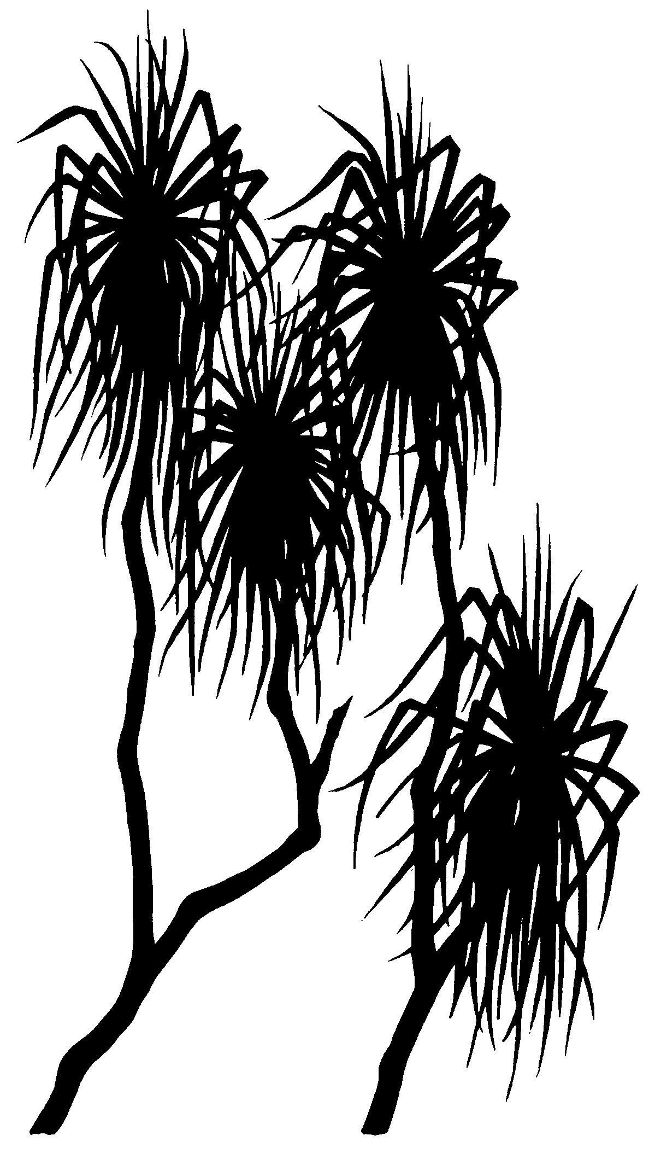
667
internal report
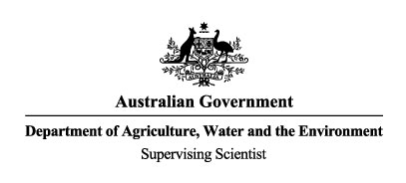
Mapping and characterisation of geomorphology of on-site creeks in and adjacent to the Ranger mine site.
J Lowry, M Saynor and S Muller

February 2022

Release status – Unrestricted
Project number – RES-2020-007

The Department acknowledges the traditional custodians of country throughout Australia and their continuing connection to land, sea and community. We pay our respects to them and their cultures and to their elders both past and present.

Mapping and characterisation of geomorphology of on-site creeks in and adjacent to the Ranger mine site

J Lowry, M Saynor and S Muller

Supervising Scientist
GPO Box 461, Darwin NT 0801

February 2022

(Release status – Unrestricted)



How to cite this report:
Lowry J, Saynor M & Muller S 2022. Mapping and characterisation of geomorphology of on-site creeks in and adjacent to the Ranger mine site. Internal Report 667, February 2022, Supervising Scientist, Darwin.
Project number: (RES-2020-007)
Authors of this report:
Author to populate, e.g.
John Lowry –Supervising Scientist Branch, GPO Box 461, Darwin NT 0801, Australia
Mike Saynor –Supervising Scientist Branch, GPO Box 461, Darwin NT 0801, Australia
Shenade Muller – Completed as a Department Graduate –Supervising Scientist Branch, GPO Box 461, Darwin NT 0801, Australia

Supervising Scientist is a branch of the Australian Government Department of
Agriculture, Water and the Environment.
Supervising Scientist
Department of Agriculture, Water and the Environment
GPO Box 461, Darwin NT 0801 Australia
environment.gov.au/science/supervising-scientist/publications

© Commonwealth of Australia 2022
Ownership of intellectual property rights
Unless otherwise noted, copyright (and any other intellectual property rights) in this publication is owned by the Commonwealth of Australia (referred to as the Commonwealth).
Creative Commons licence All material in this publication is licensed under a Creative Commons Attribution 4.0 International Licence except content supplied by third parties, logos and the Commonwealth Coat of Arms. Inquiries about the licence and any use of this document should be emailed to copyright@awe.gov.au.
The Australian Government acting through the Department of Agriculture, Water and the Environment has exercised due care and skill in preparing and compiling the information and data in this publication. Notwithstanding, the Department of Agriculture, Water and the Environment, its employees and advisers disclaim all liability, including liability for negligence and for any loss, damage, injury, expense or cost incurred by any person as a result of accessing, using or relying on any of the information or data in this publication to the maximum extent permitted by law.

Contents
Executive summary iv
1 Introduction 5
2 Methods 7
3 Results 9
4 Discussion 15
5 Conclusions 21
6 References 23
Appendix 1 – areal extent of billabongs 1950-2016 24
Appendix 2 – areal extent of sandy creeks 1950-2016 35
Appendix 3 – areal extent of grassy swales 1950-2016 40

Executive summary
The on-site creeks and waterbodies in and adjacent to the Ranger uranium mine have been mapped and characterised to understand changes to the geomorphology of creeks and billabongs in and adjacent to the Ranger mine over the period from 1950-2016 using remotely-sensed imagery. Specifically, the extent of the Gulungul, Coonjimba and Georgetown billabongs, and associated sandy creek systems and grassy swales, were manually digitised from the imagery and saved in the ESRI ArcGIS Pro environment as a series of individual shapefiles. When the shapefiles were analysed in a GIS environment, little difference was found between the area of the billabong outlines, or the length and number of sandy creeks over time. However, the length of grassy swales was observed to decrease over time. The decrease in swale length is attributed to the subsummation by the Ranger mine and other mine related activities from its construction, through to the cessation of mineral extraction in 2012.
Importantly, the data collected here provide a baseline dataset with which to assess any future changes to the area of the billabongs or length of the creeks or swales after the rehabilitation of the Ranger mine. Specifically, the presence of grassy swales may be used as an indicator of a geomorphically stable landscape. On-going monitoring of grassy swales can provide an early indication of sediment movement from the rehabilitated landform.

1 Introduction
Mining operations have the potential to cause significant change to channels and waterbodies by altering discharge and/or sediment load by either increasing or decreasing sediment supply downstream (East et al, 1988). Consequently, determining the baseline erosion and sediment transport characteristics in areas surrounding the Energy Resources of Australia (ERA) Ranger mine has been identified as a Key Knowledge Need (LAN1B – Determining baseline erosion and sediment transport characteristics in areas surrounding the Ranger Project Area) and endorsed by the Alligator Rivers Region Technical Committee (ARRTC). ARRTC was established to consider, and review research activities and programs relating to the impact of uranium mining activities in the Alligator Rivers Region, which includes the area occupied by the Ranger mine. Tributaries of the Ranger mine and their associated floodplains and backflow billabongs are potentially the most significant sediment storage sites downstream of the mine site (Erskine and Saynor, 2000). The specific focus of this project is the waterbodies and creeks associated with the Coonjimba, Georgetown and Gulungul billabongs, which will be mapped to investigate any historical change and to provide a baseline map of the creeks and tributaries surrounding Ranger Mine (see Figure 1).
Coonjimba Billabong, Georgetown Billabong and Gulungul Billabong have been described as backflow billabongs. Backflow billabongs of the region are surface waterbodies that are located on small tributaries at their junction with larger creeks, and are created from sediment damming at the tributary junction. They are typically filled by water from the main larger creek at early wet season flows, and periodically during the wet season thereafter (Erskine and Saynor, 2000). Gulungul, Georgetown and Coonjimba billabongs receive backflow from Magela Creek. The mine site tributaries that do not have a sand bed are referred to as unchanneled grassy swales in this report.
This project involved mapping and characterising the geomorphology of on-site creeks and waterbodies, to determine a baseline geomorphic map for the creeks and billabongs in and adjacent to the Ranger mine. The specific aims of the project were (i) to generate a baseline map of the creeks and waterbodies prior to the rehabilitation of the Ranger mine, and (ii) to determine, through the use of historical imagery, if change has occurred in the area, length and position of on-site creeks and water bodies.
The base map will be compared to future imagery obtained from Remotely Piloted Aircraft (RPA) data and other remotely sensed imagery to assess possible future impacts of the mine. Specifically, the creation of a base map will allow for detection of change in tributaries, including visualisation of increased sediment, and can potentially provide indications of gully formation should gullies occur.
This project was initiated as part of a graduate (S Muller) employee rotation through the department. It was intended to use existing historical aerial photography acquired through the savanna change project (RES-2013-002 - Quantifying spatial and temporal change in savanna). The project was completed by members of the Ecosystem Restoration and Landform team.
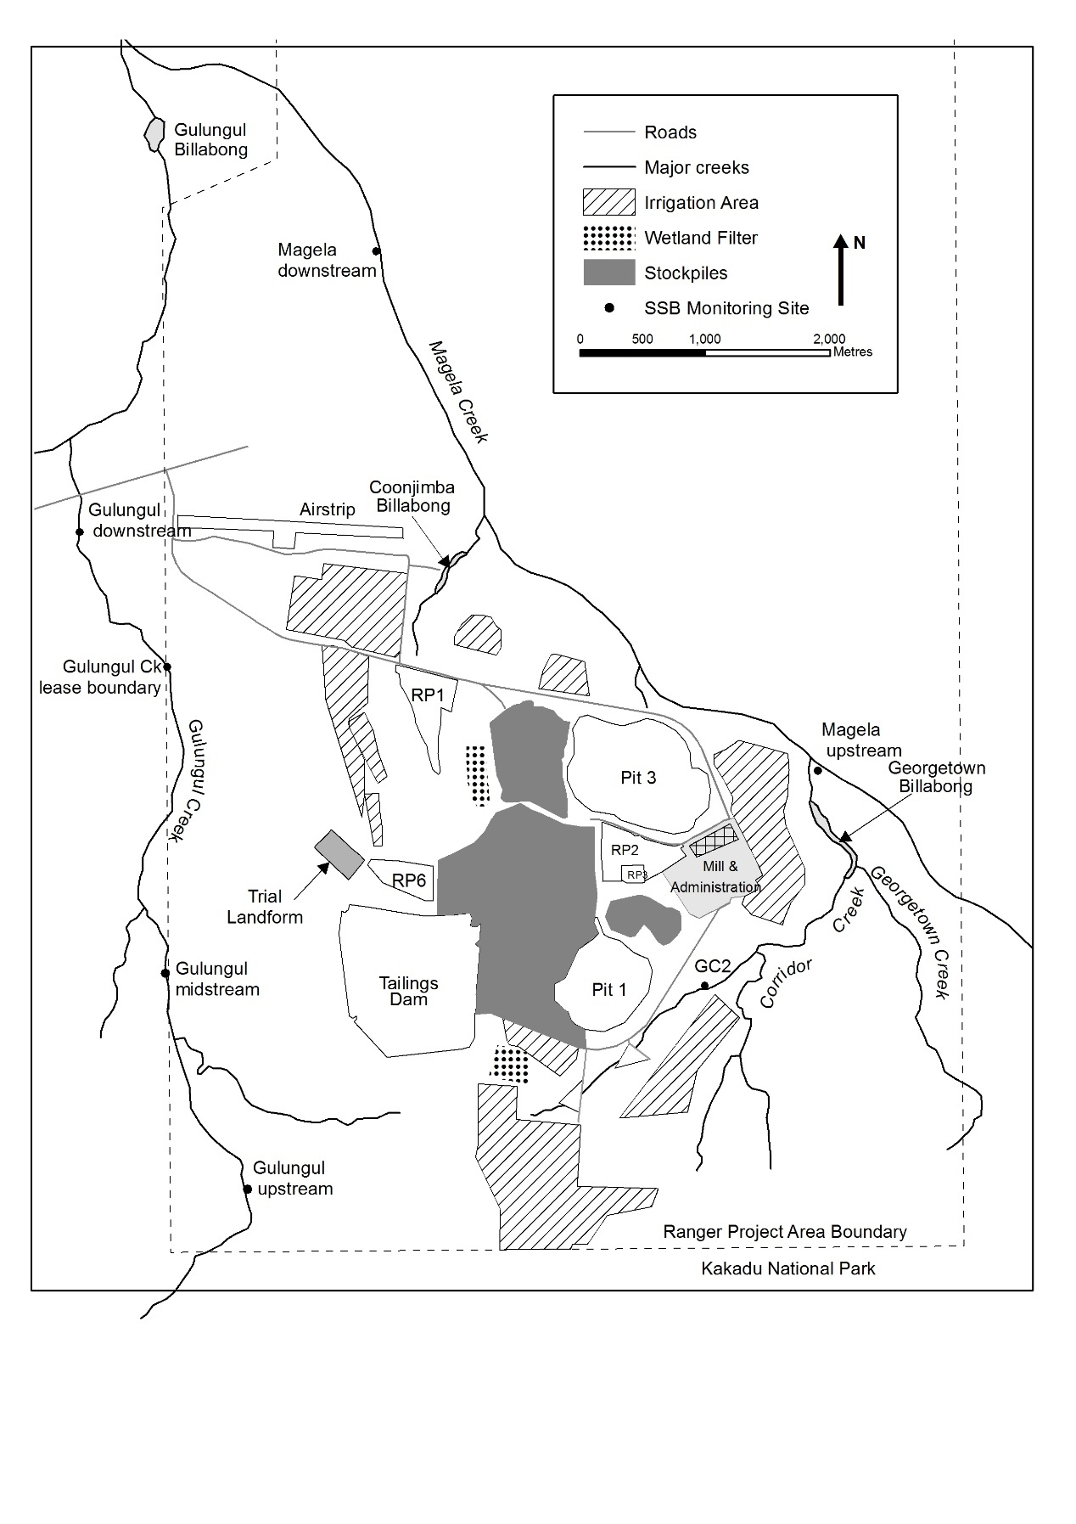
Figure 1 – Ranger mine showing location of creeks and billabongs. Baralil Creek flows into Gulungul Creek downstream of Gulungul downstream gauging station.

2 Methods
The project involved mapping and characterising the geomorphology of on-site creeks and waterbodies on the Ranger Project Area (RPA), through the use of remotely-sensed imagery (aerial photography and satellite imagery). The ESRI ArcGIS Pro software was used to map and assess changes in the environment from the different sets of imagery.
Sandy creek channels, grassy swales and billabongs of Gulungul Creek, Corridor Creek, Coonjimba Creek and part of Magela Creek are mapped as part of this project. For the purposes of this study, the sandy creek channels are defined as ‘well defined channels with sandy beds’. The term ‘grassy swales’ is applied to smaller channels that do not transport much sand and which are generally lined with grass with some riparian tree species. Finally, the billabongs in this study are at the junction of the tributaries with Magela Creek which in the literature have been called backflow billabongs. Importantly, in this study the billabong area has been mapped using the surrounding trees as the delineation line. The mapped area includes the visible water surface, bare ground and the low vegetation to the tree line, which is used to define the area of the billabong.
Baralil Creek is a tributary of Gulungul Creek that flows into Gulungul creek just downstream of the Arnhem Highway and is not mapped as part of this project as it will not be impacted by the Ranger Mine. Similarly, Georgetown Creek, which flows into Georgetown Billabong, is not impacted by the mine site and consequently has not been mapped. However, the western arm of Corridor Creek, which flows north past Pit 1 into Georgetown Billabong. has been mapped as part of this study. Djalkmara Creek and billabong are visible in the remotely-sensed images for the years 1950 and 1976. After these dates it was subsequently consumed by the construction and expansion of the mine site and eventually completely consumed by Pit 3. Consequently, these Djalkmara features have not been mapped, as they will not be recreated or incorporated into the final landform.
The study used mosaiced images of the area occupied by the Ranger mine for the years 1950 and 1976 (before the mine existed), and 1987 and 2016 (while the mine was in operation). The key characteristics of the individual mosaics (such as the horizontal resolution) are summarised in Table 1. It is important to note that variability exists between the different mosaics – specifically, temporal variability (the time of year and day the images were collected varies, although importantly, all images were taken during the dry season) and spatial variability (the scale of the mosaics). The variability is important as it affected the ability to identify features in the different mosaics consistently.
The mosaics used in this study had been previously created as part of a project (RES-2013-002) that mapped woody vegetation cover from historical time series aerial photography and satellite imagery (Whiteside et al 2020).
Each mosaic had been rectified and registered against the Geocentric Datum of Australia 1994 (GDA94), while the horizontal resolution of each mosaic was resampled to 1 metre. The process by which this was done is described in Whiteside et al (2020).

Table 1 – Summary information on mosaic imagery used in study
Year | Month | Resampled Horizontal resolution (m) | Scale | Type | Datum | Overall accuracy (%)*
1950 | May-June | 1 | 1:50,000 | Greyscale aerial photo mosaic | GDA94 | 92.2
1976 | June-July | 1 | 1:15000 | Colour infrared (CIR) aerial photo mosaic | GDA94 | 94.6
1987 | August | 1 | 1:60,000 | Colour (RGB) aerial photos mosaic | GDA94 | 93.9
2016 | July | 1 | N/A | World View 3 pan-sharpened multispectral satellite data | GDA94 | 94.9
*Overall accuracy derived as per Congalton and Green (2009) and reported in Whiteside et al (2020)
Recognising the limitations of the data – specifically the range in scales of the different images - billabongs, creeks and unchanneled grassy swales were identified and mapped for each year. Billabong features were manually digitised using ArcGIS Pro and saved as polygon shapefiles for each year for which there was a photo mosaic. Creek features and grassy swales were manually digitised using ArcGIS Pro and saved as arc / polyline feature shapefiles for each mosaic. All features that were digitised were created in the same datum as the image mosaics.
The areas of the billabongs, represented as polygons, and the lengths of the creek features (represented as polylines) were calculated using the “calculate geometry attribute” toolset of ArcGIS Pro.

3 Results
Billabongs, creek lengths, and grassy swales were identified in each of the mosaic images listed in Table 1. The location and extent of each of these features, as derived from the 1950 photo mosaic, are shown in Figure 2. The extent of these features in 1976 is shown in Figure 3. The images compiled for 1950 and 1976 represent the period before the construction of the Ranger mine while the image for 1987 (Figure 4) and 2016 (Figure 5) represent the period after the establishment of the mine. The latter 2016 image is important as it represents the current condition and extent of the billabong, creek and swale features around the mine site.
The calculated area for each of the three billabongs in this study between 1950 and 2016 is summarised in Table 2. The data show that the area of each billabong fluctuated slightly over the 66-year time-span of this study, with a slight overall increase in the area of each billabong by 2016. The small changes in area are due to the slightly different times of the year that the images were taken and the difference in resolutions between the years. As noted earlier, the area of visible open water was used to define the area of the individual billabongs. The individual areal extent of the billabongs for each of the years is illustrated in Appendix 1.
Table 2 - Changes in area (m²) of selected billabongs 1950-2016
Year | Coonjimba Billabong | Georgetown Billabong | Gulungul Billabong
1950 | 37,487 | 70,152 | 84,780
1976 | 41,454 | 70,201 | 85,943
1987 | 40,917 | 73,151 | 91,518
2016 | 40,035 | 73,763 | 91,997
% overall change | +6.8% | +5% | +8.5%
The length of each of the sandy creeks mapped in this study between 1950 and 2016 is summarised in Table 3. Importantly, the channel lengths reported here represent the visible length of sandy channel for each creek. As with the measurements of billabong area, variations in creek length may be attributed to the slightly different times of the year that the images were taken and the difference in resolutions between the years. The extent and distribution of the sandy creeks for each individual year is shown in Appendix 2.
Interestingly, there do not appear to be any sandy channels present in Coonjimba Creek, with the visible drainage lines represented by grassy swales, both prior to and after the advent of the Ranger mine.
Table 3 – Channel length (m) of selected sandy creeks 1950-2016
Year | Corridor Creek | Gulungul Creek
1950 | 5,532 | 14,644
1976 | 5,741 | 15,031
1987 | 6,159 | 15,976
2016 | 6,391 | 16,641
% overall change | +15% | +13%

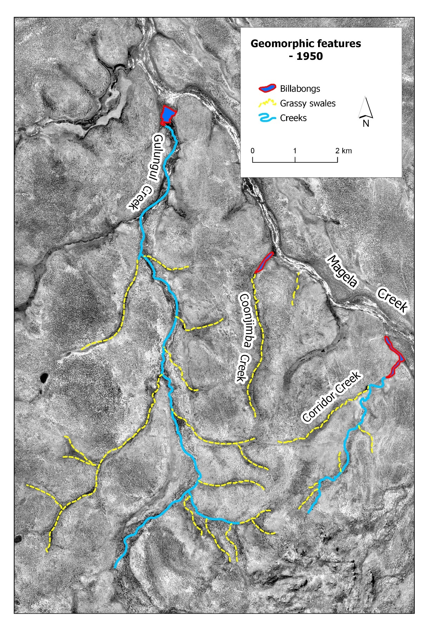
Figure 2 – location and extent of geomorphic features in 1950.

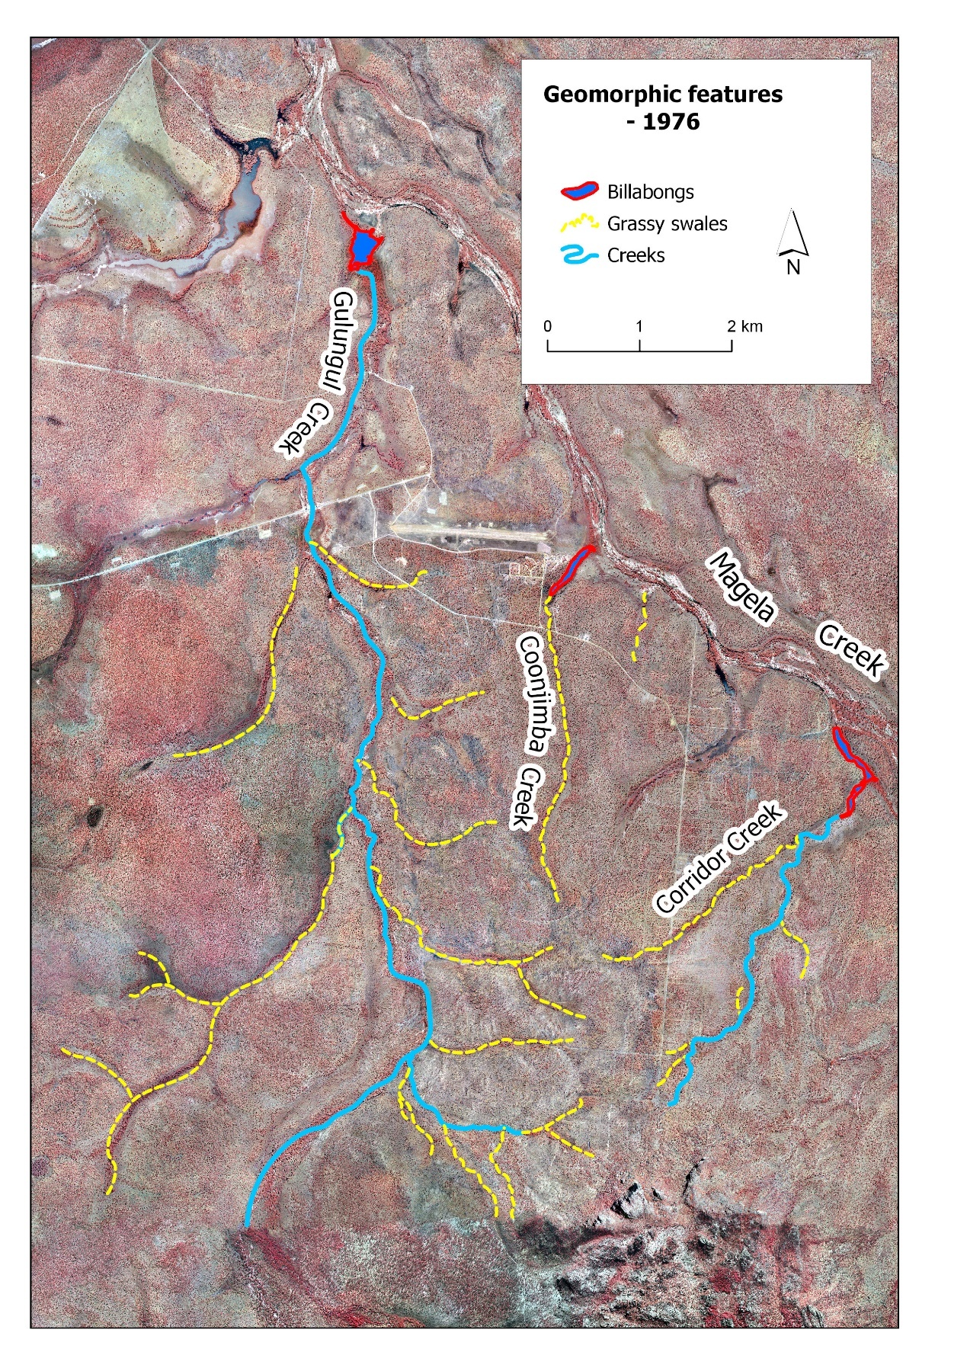
Figure 3 – location and extent of geomorphic features in 1976

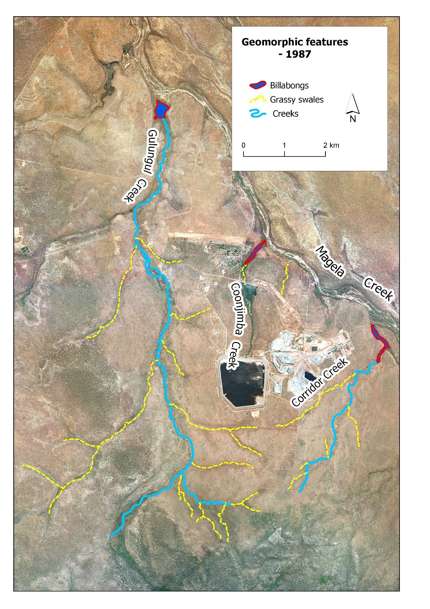
Figure 4 – location and extent of geomorphic features in 1987

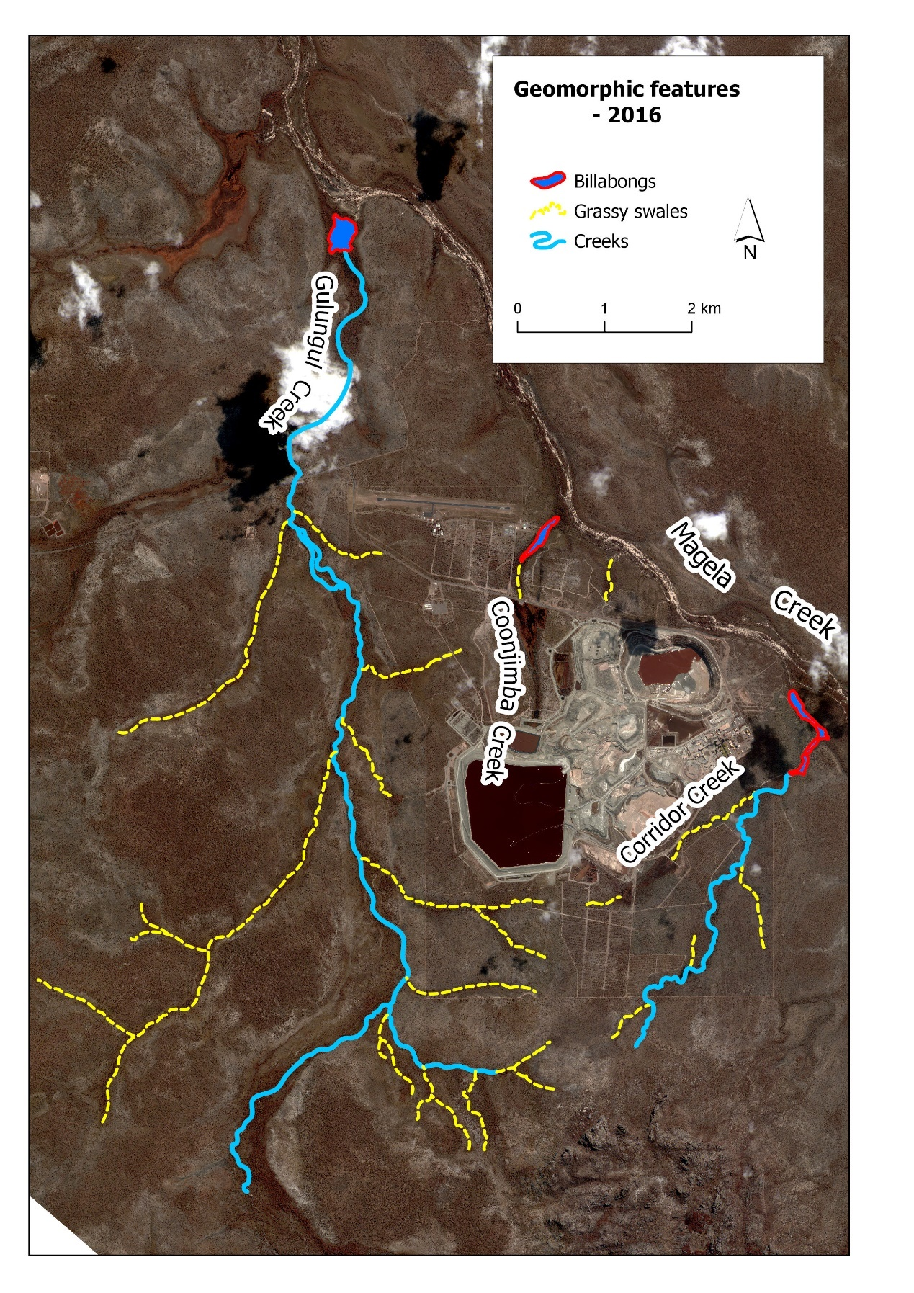
Figure 5 – location and extent of geomorphic features in 2016

The length of the grassy swales associated with each of the creeks mapped in this study - plus an un-named swale system located between Coonjimba Creek and the present Pit 3 (Figures A3.1-A-3.4) - is summarised in Table 4. The changes to the grassy swales can be directly attributed to the mine site activities, construction which subsumed large parts of the grassy swales as well as other associated mine site constructions, bunds weirs etc. The extent of the swales in each year are shown in Appendix 3.
The development of the mine has had a direct effect on the reduction of swales around the mine site. Specifically, the establishment and expansion of the mine from 1979 onwards, and specifically the construction of the tailings storage facility and retention Pond 1 (RP1) in Coonjimba catchment resulted in the reduction (by 88%) of grassy swale length for Coonjimba Creek. In addition, the construction of the land application areas north west of Pit 3 has resulted in the reduction of the un-named swale system after 1987, while the development of wetland filters and bunds along the western arm of Corridor Creek in the early 1990s has reduced the extent of swales. Only Gulungul Creek shows almost no change in the distribution of swales as this catchment has not been impacted by the construction and expansion of the mine site.
Table 4 – Visible changes length (m) of selected grassy swales 1950-2016
Year | Coonjimba Creek | Corridor Creek | Gulungul Creek | Other (un-named) Creek
1950 | 3,629 | 4,943 | 25,591 | 811
1976 | 3,535 | 4,665 | 25,948 | 809
1987 | 471 | 5,030 | 24,484 | 798
2016 | 427 | 3,940 | 25,790 | 525
% overall change | -88% | -20% | +0.7% | -35%

4 Discussion
To provide a means of monitoring changes in the geomorphic characteristics of creeks and billabongs associated with the Ranger mine, three different geomorphic features – billabongs, sandy creeks and grassy swales – have been mapped with a focus on developing a baseline map.
Mapping of the billabongs adjacent to the Ranger mine identified very little overall change in either the shape or area of these waterbodies over the period of time covered by the study. The polygon representing each billabong was delineated by the tree line surrounding each billabong location in the image. As shown in Table 1, the areal extent of each of the billabongs analysed showed just a small 5-9% increase over the 66-year period of the study, indicating that they are essentially stable. Of particular note is that the study period included several significant cyclonic rainfall and flood events, such as a rainfall event in March 2007 in which 784 mm of rain fell over a three-day period. This concept of stability is further supported by the work of Wasson et al (in prep) that indicates that the billabongs in question are of the order to 4 to 10 thousand years in age and hence are not ephemeral in the landscape in a spatial and temporal context.
Further study using historical imagery could usefully examine wetted area of billabongs. Noting that there has been an increase in aquatic vegetation in the billabongs since buffalo removal in the early 1980s, the reduced evapo-concentration of billabong surface waters associated with this may have led to an increase in dry season wetted area over time.
The shape of the billabongs in each year studied is shown in Figure 6.

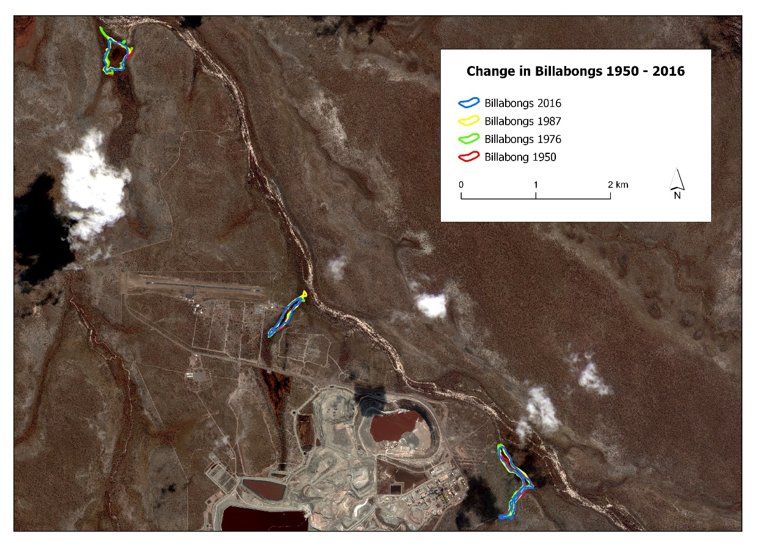
(a)
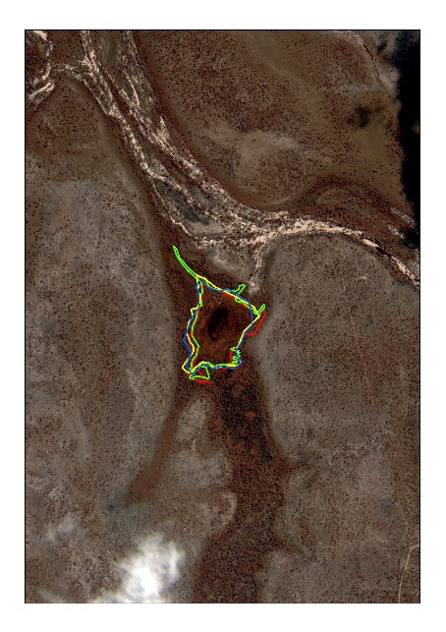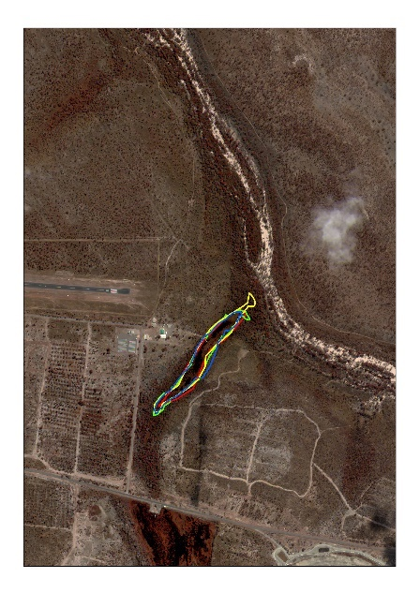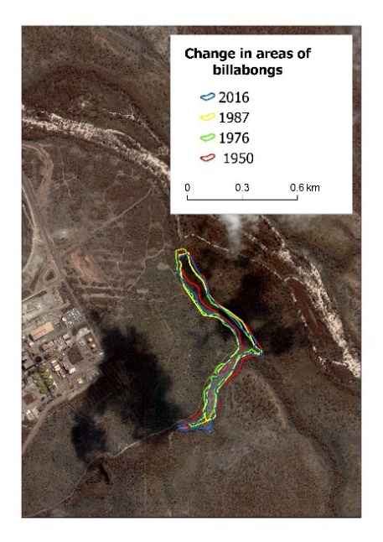
(d)
(c)
(b)
Figure 6 – change in billabong extent 1950-2016 (a)overview of all billabongs (b) Gulungul Billabong (c) Coonjimba Billabong (d) Corridor Billabong. Each billabong is shown at a larger scale in Appendix 1

Over the period of this study, both Corridor and Gulungul creeks show a slight increase in channel length of 15% and 13%, respectively (Table 3). As discussed further below, this increase may be attributed to a range of factors. However, there is little visible change when channel position and extent is compared over the period of study (Figure 7).
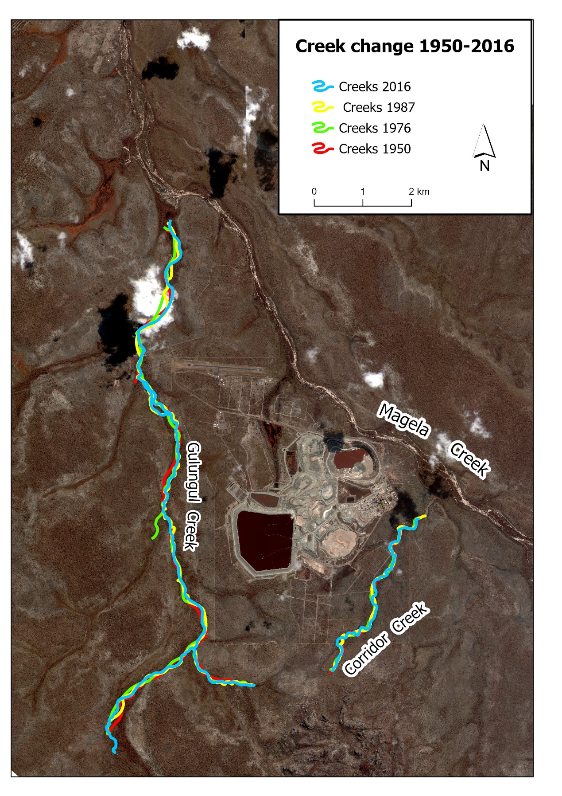
Figure 7 – change in channel position and extent 1950-2016

Changes in the length of grassy swales mapped in Gulungul Creek yielded different results to those mapped in the other creek systems (Table 4). Specifically, the length of swales in Gulungul essentially remained unchanged over the length of the study, while those in all the other creek systems decreased due to mine construction and expansion. This could indicate that Gulungul Creek is essentially stable, and mining operations have had little impact on the catchment.
In contrast, the decrease in swale length in the other systems is due to areas being subsumed by the mine site during construction and periods of mine expansion. The decrease and almost complete disappearance of grassy swales in Coonjimba Creek is attributed to the construction of the tailings storage facility and Retention Pond 1 (RP1) during the 1980’s. This has reduced the length of the grassy swales in the Coonjimba catchment by almost 90%. The decrease in grassy swales in the west arm of Corridor creek is due to construction of bunds and a wetland filter along the creek associated with management of water for the mine site. Similarly, the decrease in swale length in the un-named system between the Coonjimba and Corridor Creek systems is attributed to the expansion of the land application areas also a mine related activity. The visible change in the extent of the grassy swales for Gulungul and Coonjimba catchments is shown in Figure 8 while the visible change in the swales for Corridor creek is shown in Figure 9.
We recognise in this study that all the results delineating billabong area, and channel and swale length was a subjective process. Specifically, the identification of billabongs and channel features was done by visual inspection of the images in the ArcGIS Pro environment, which were then manually digitised into shapefile format. The identification of the features was subject to the interpretation of the analyst, which could be influenced by the shadows and colours present in the image. For example, the vegetation cover present (which may obscure or highlight billabongs and creek channels) varied both intra-annually (within a single year) and interannually (between years). Identification of billabong and creek features could be further obscured by the presence of cloud and or smoke cover. The skill and relative accuracy of the individual analyst at digitising the identified features may also influence the areas and lengths recorded. Further, we recognise a range of issues will need to be considered and addressed for billabong / stream classification procedures to be consistently applied in the future. These include ensuring imagery is captured at similar temporal (time of year) and spatial scales. Annual and monthly variation in rainfall will have an effect on visible water surface areas, as will flood events that may be associated with large rainfall events. Consequently, it is important to be able recognise if the visible differences between baseline and future aerial imagery is due to rainfall variances or if it is due to changes in mine site erosion.
Not-withstanding these limitations, remotely sensed imagery – from UAV, satellite, or manned aircraft – provide a means of monitoring the rehabilitated Ranger landform into the future and detecting changes in the channel morphology. A potential way of applying the imagery would be to standardise the process for identifying and mapping the extent of the billabongs, creeks and swales. Software programs are now available that can be trained to consistently classify features or objects in imagery (such as billabongs), removing the subjectivity of individual interpretation.
ERA should consider the former extent of grassy swales in planning restoration activities at Ranger, in particular in the design of the final landform.

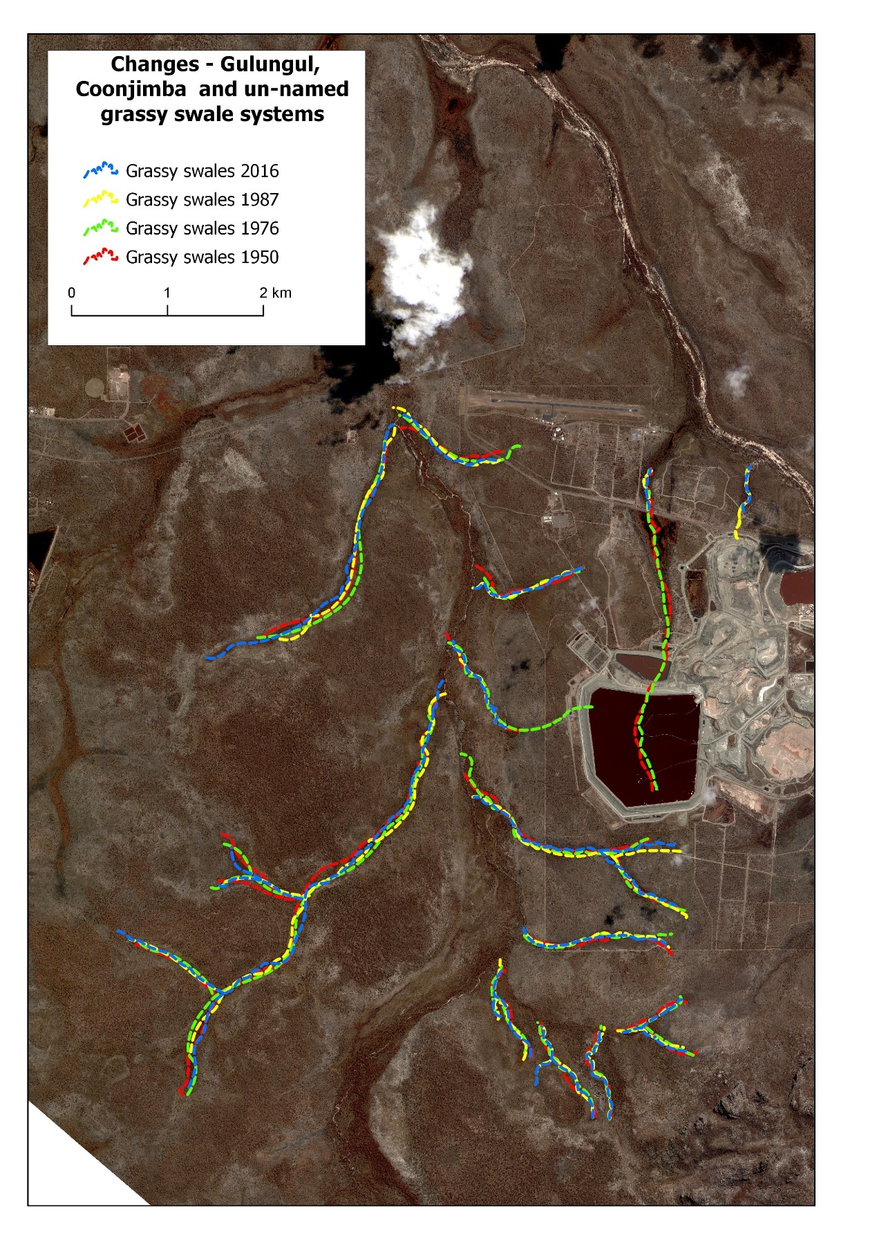Figure 8 – change in extent of grassy swales 1950-2016- Gulungul and Coonjimba creeks
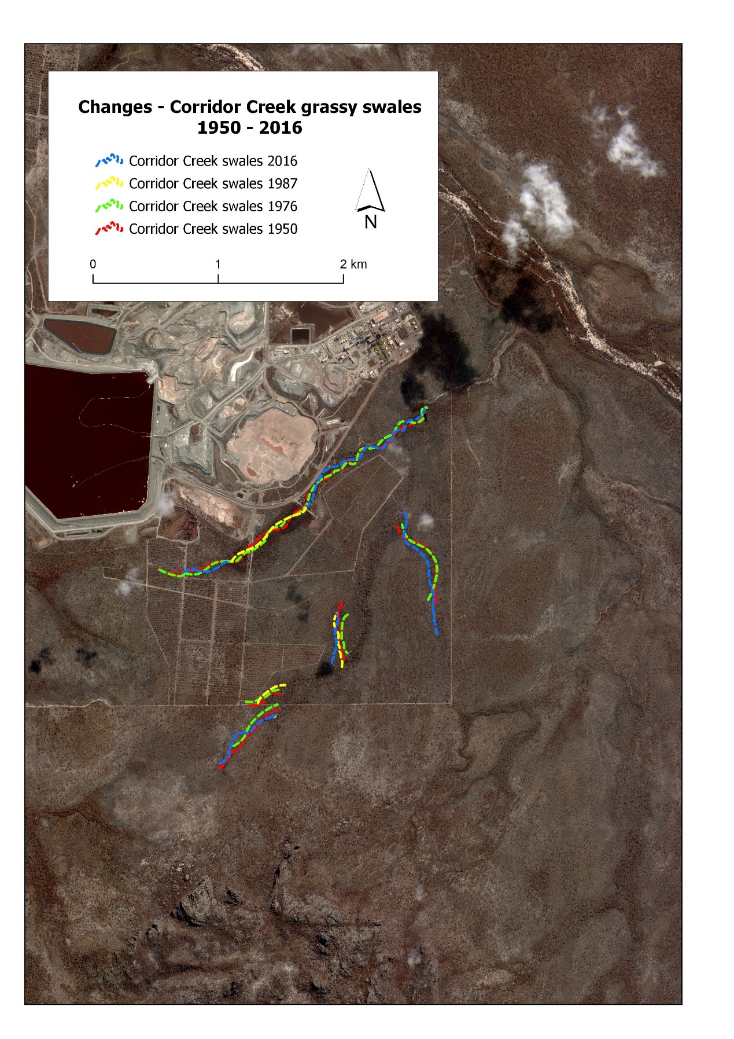Figure 9 – change in extent of grassy swales 1950-2016 - Corridor creek

5 Conclusions
This project has shown that over the 66-year time span represented by this study, there has been little change in the extent, and distribution of billabong area, length of sandy creek channels around the Ranger mine and of grassy swales in the Gulungul Creek catchment. The other creek systems can tell us little about natural variability as they have experienced reductions in swale length due to being subsumed by the mine and other mine related operations such as wetland filters, bunds land application areas etc.
Importantly, this study covers the period both prior to the establishment of the mine, and after the cessation of mineral extraction from the mine site. The final image mosaic used in this study from 2016 (Figure 10), should be used as a baseline, with which to monitor changes into the future, after the finalisation of rehabilitation on the mine site. As it has been recognised that mine site tributaries and billabongs and associated floodplains are the most significant sediment storage sites downstream of the mine site, any changes to these in the future will be able to be detected. From this study, it would appear particularly important that the condition (as at 2016) of grassy swales be monitored. This is particularly significant as the Ranger mine has commenced rehabilitation of the mine site from January 2021.
Noting the limitations with the methods used to date (specifically, the range in scales of the different images, and the subjective identification and delineation of geomorphic features), and if applied in the future, the ongoing capture of remotely sensed imagery provides a means of monitoring the impact of mine rehabilitation.

Figure 10 – Base map of geomorphic features determined from the 2016 satellite imagery.

6 References

Australian Government, 1999. Environmental Requirements of the Commonwealth of
Australia for the Operation of the Ranger Uranium Mine. Australian Government
Department of the Environment and Heritage, Canberra. http://www.environment.
gov.au/science/supervising-scientist/publications/environmental-requirements-ranger-uranium-mine (accessed 10 May 2021)
Congalton RG. & Green K. 2009 Assessing the Accuracy of Remotely Sensed Data: Principles and Practices. 2nd Edition, Lewis Publishers, Boca Raton.
Erskine WD & Saynor MJ 2000. Assessment of the off-site geomorphic impacts of uranium mining on Magela Creek, Northern Territory, Australia. Supervising Scientist Report. Darwin: Supervising Scientist.
East TJ & Cull RF 1988. Application of natural hillslope characteristics to rehabilitated mine structures. Supervising Scientist, Canberra.
Wasson RJ, Pfitzner J, Saynor MJ, Trinh K. McMaster S, McDonnell K., Spooner N. (In Prep) Sedimentation Rates in Billabongs Downstream Of The Ranger Uranium Mine, Northern Australia: A Pilot Study.
Whiteside TG, Esparon AJ & Bartolo RE 2020. A semi-automated approach for quantitative mapping of woody cover from historical time series aerial photography and satellite imagery. Ecological Informatics 55, 101012.

Appendix 1 – areal extent of billabongs 1950-2016
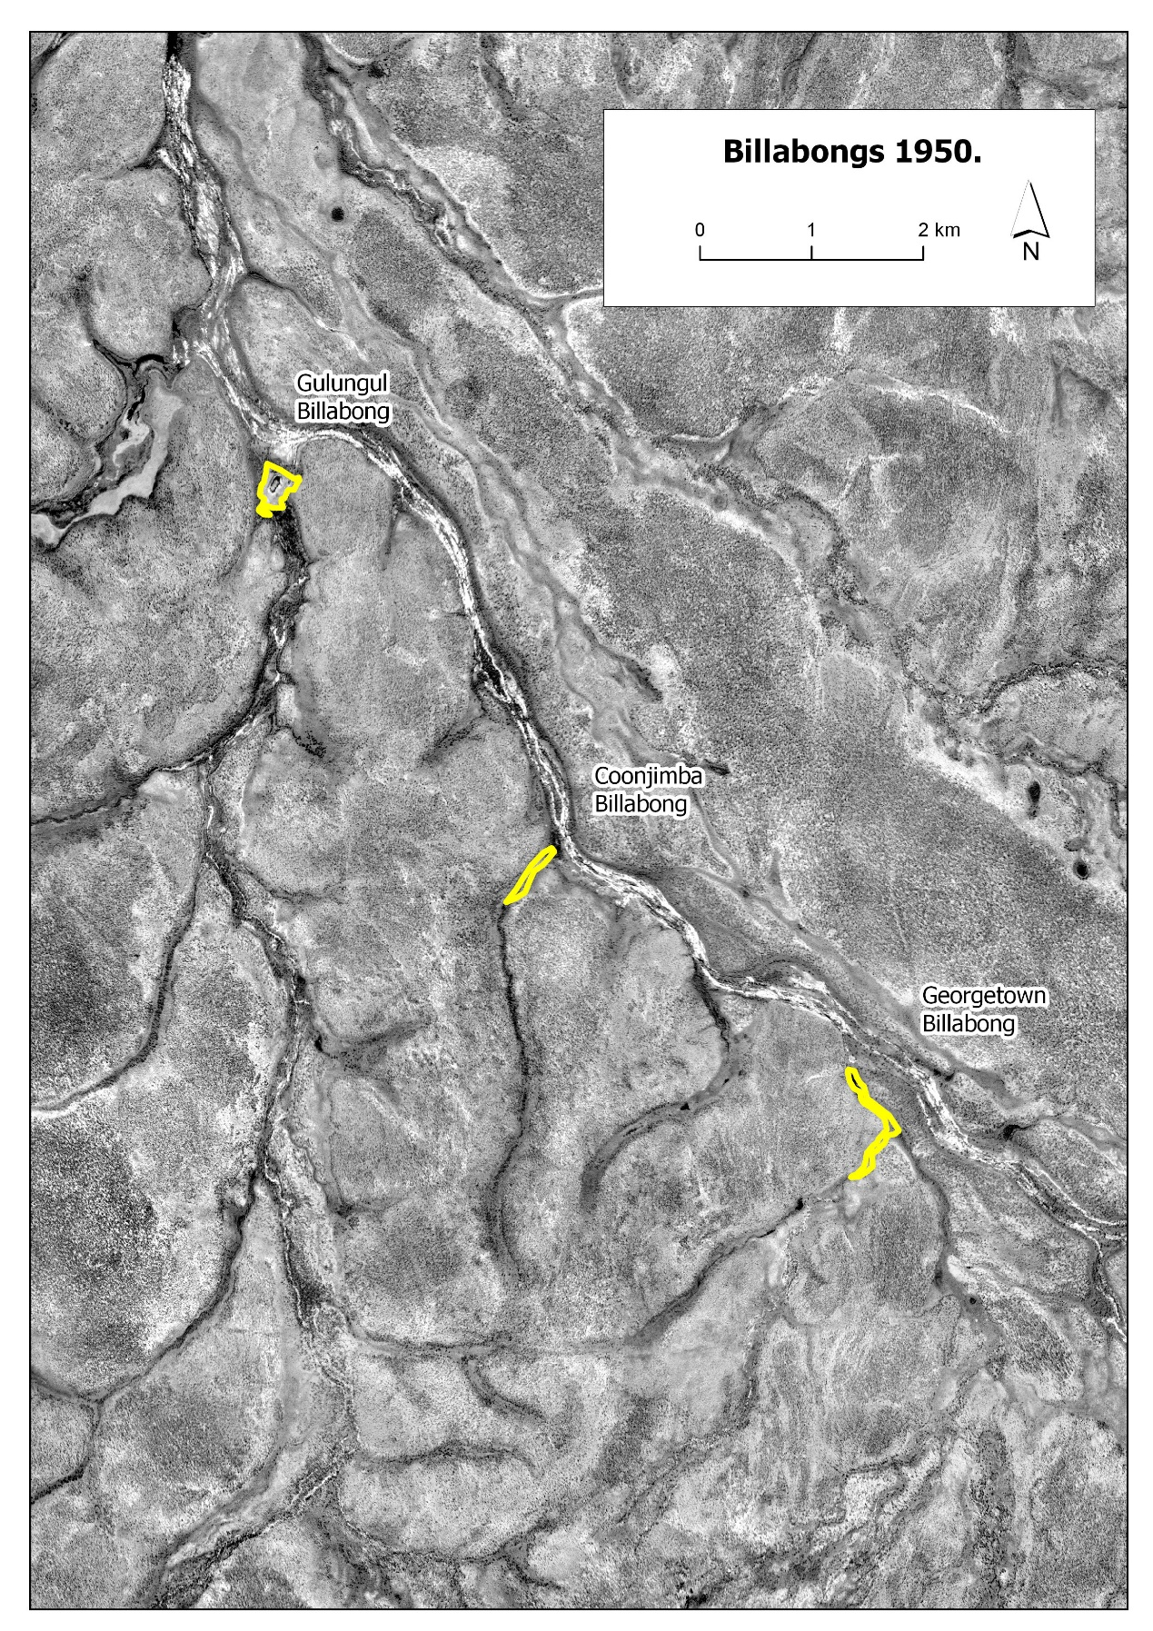
Figure A1-1 – Extent of selected billabongs, 1950.

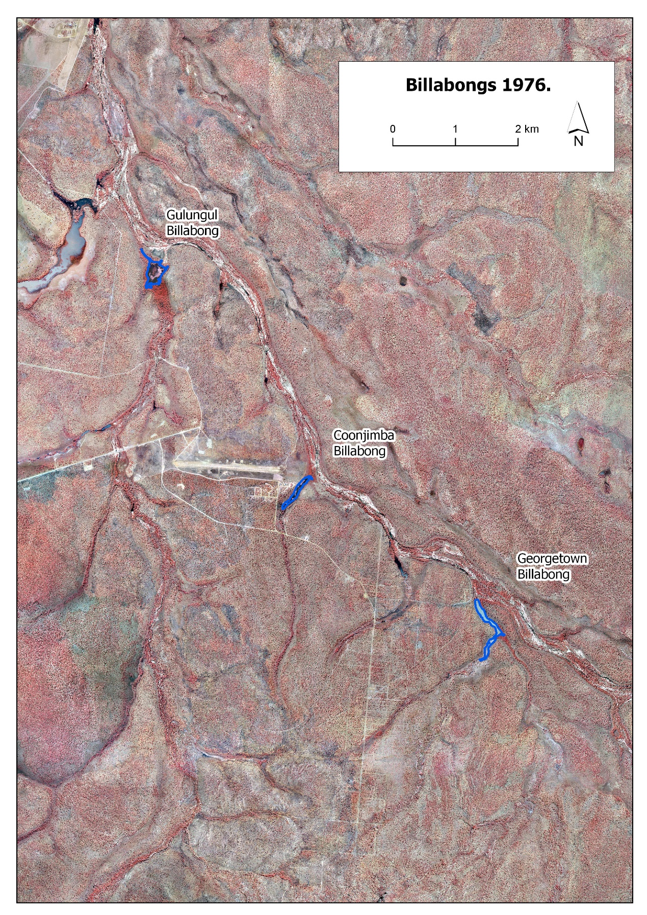
Figure A1-2 – Extent of selected billabongs, 1976.
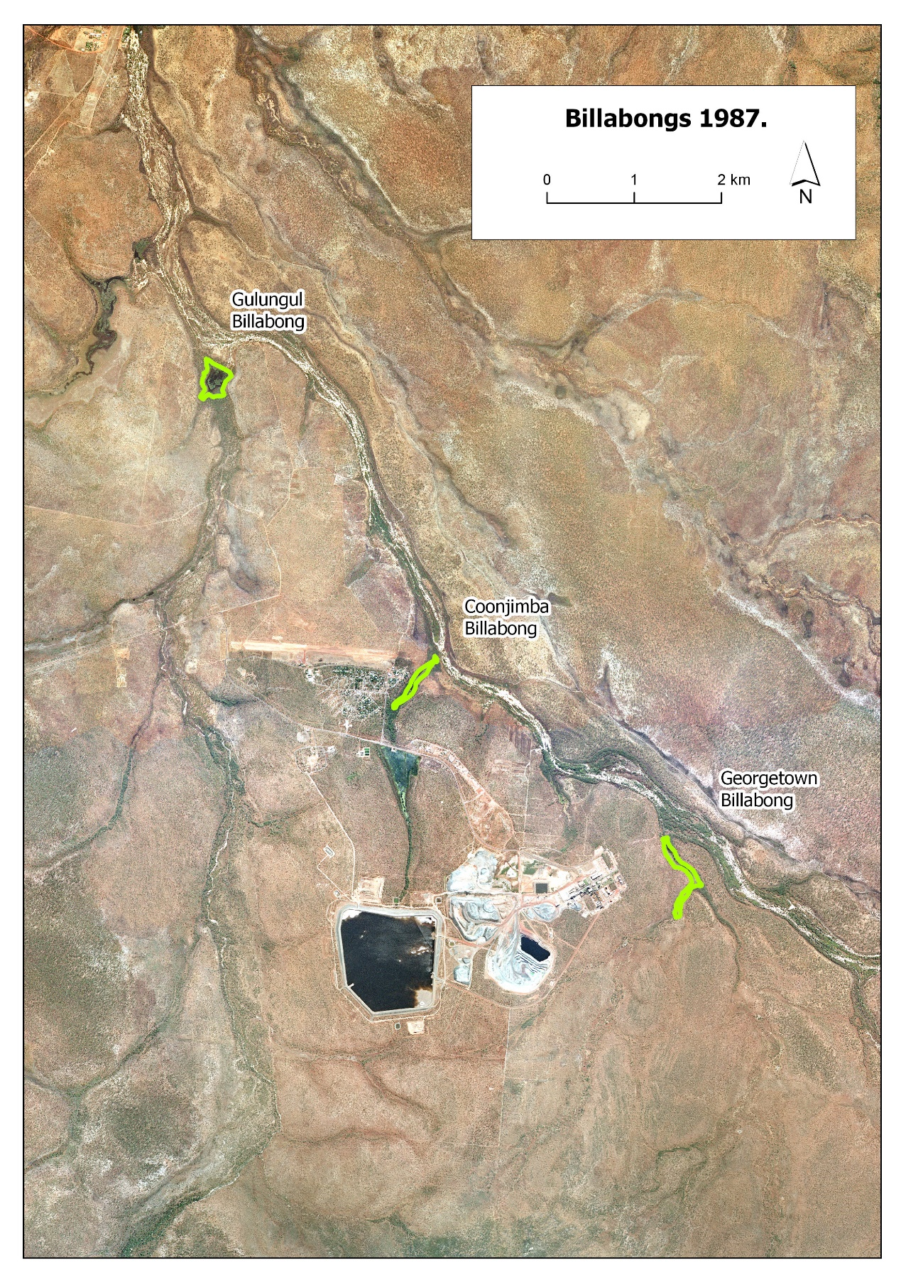
Figure A1-3 – Extent of selected billabongs, 1987.
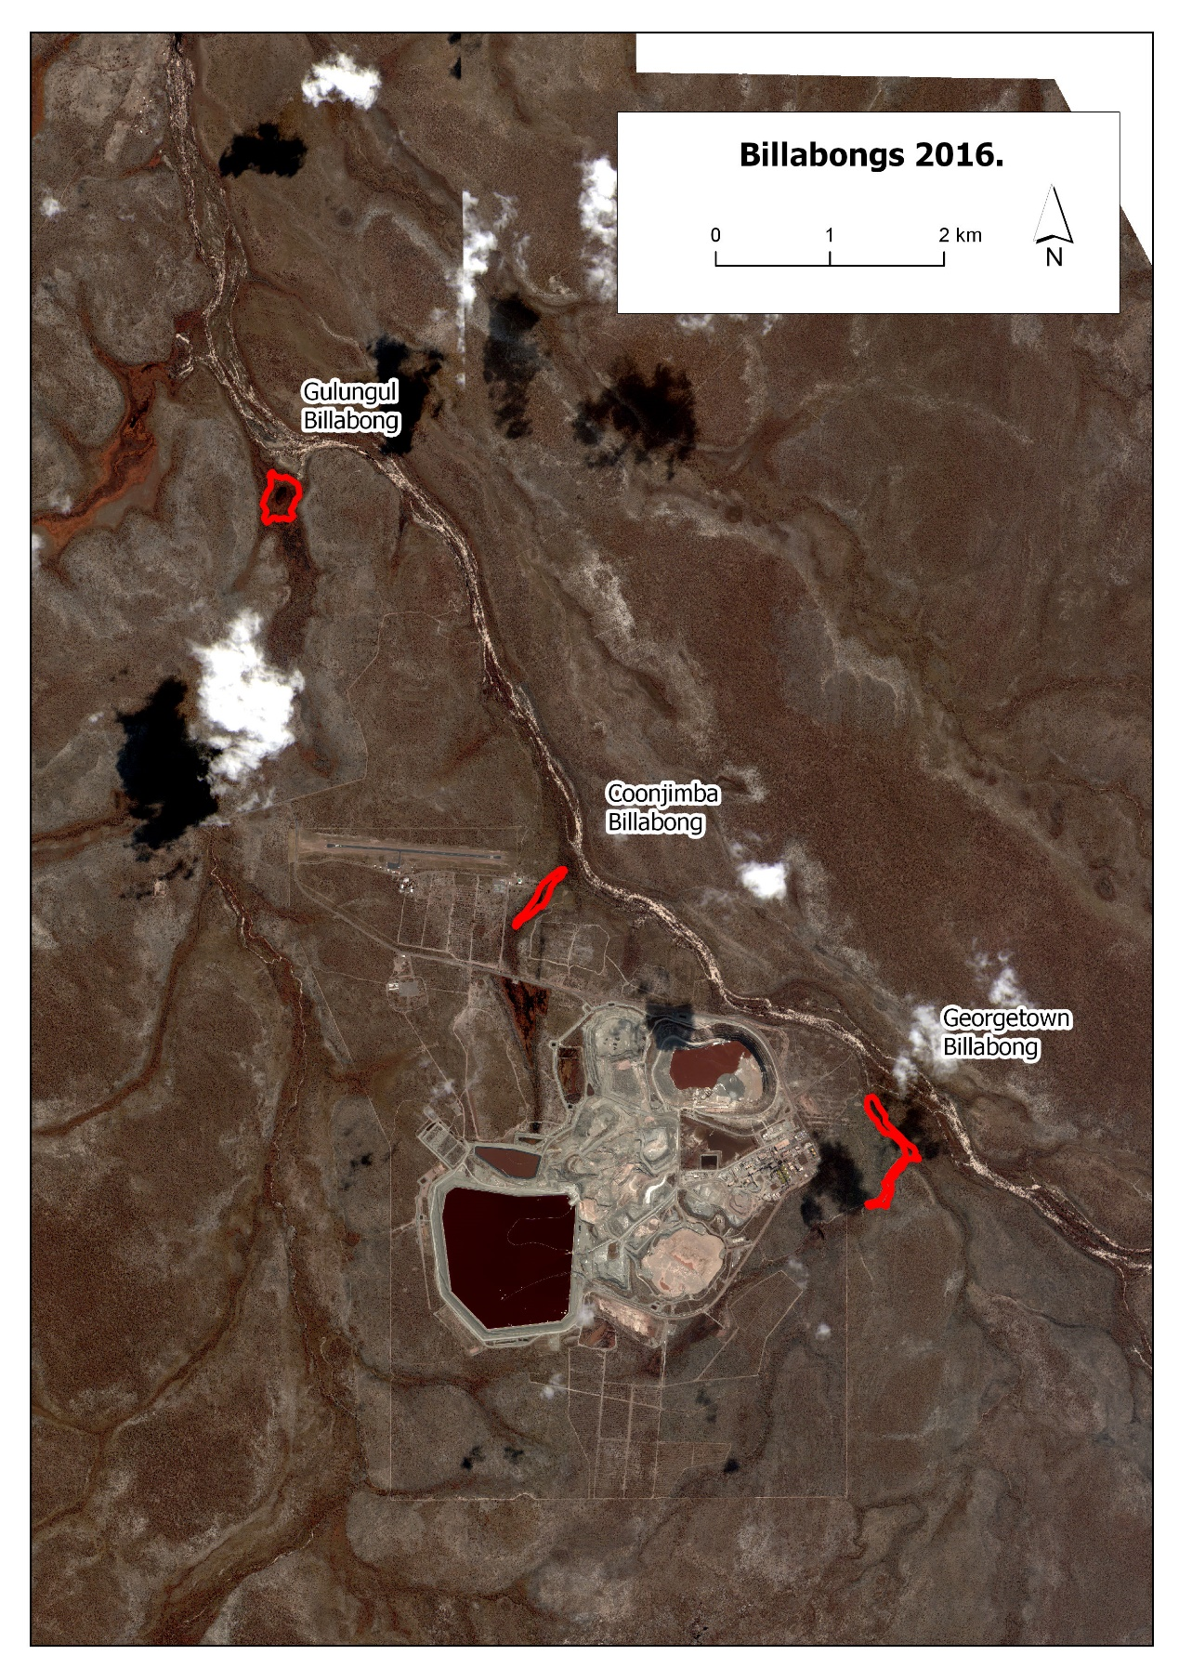
Figure A1-4 – Extent of selected billabongs, 2016.

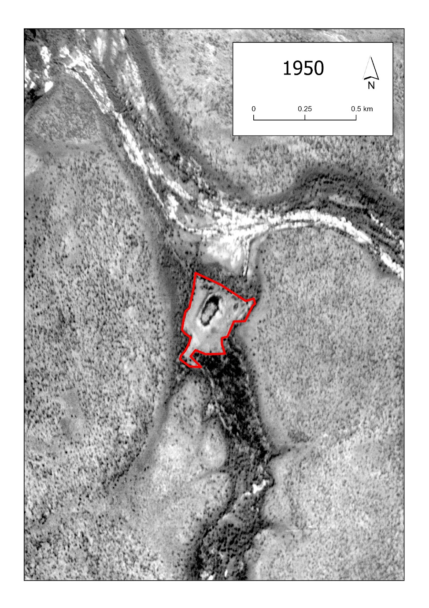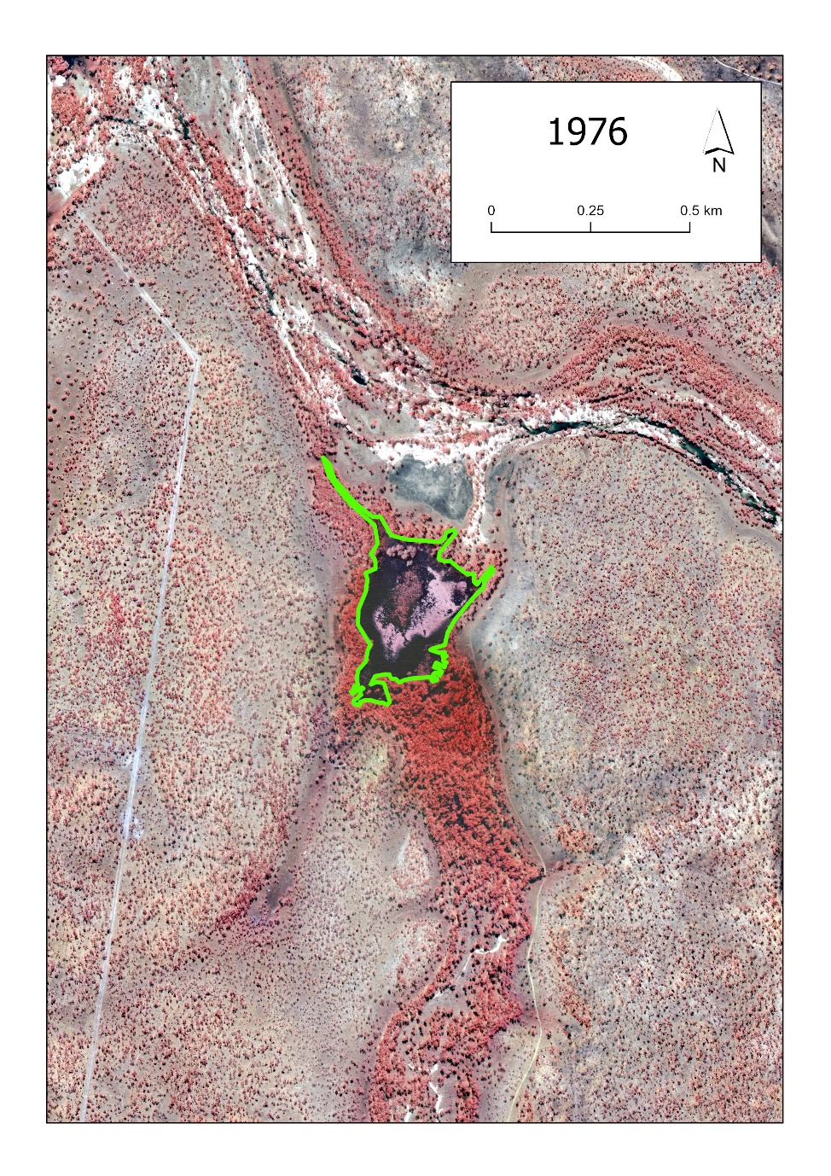
Figure A1-5 – Gulungul Billabong 1950 and 1976.
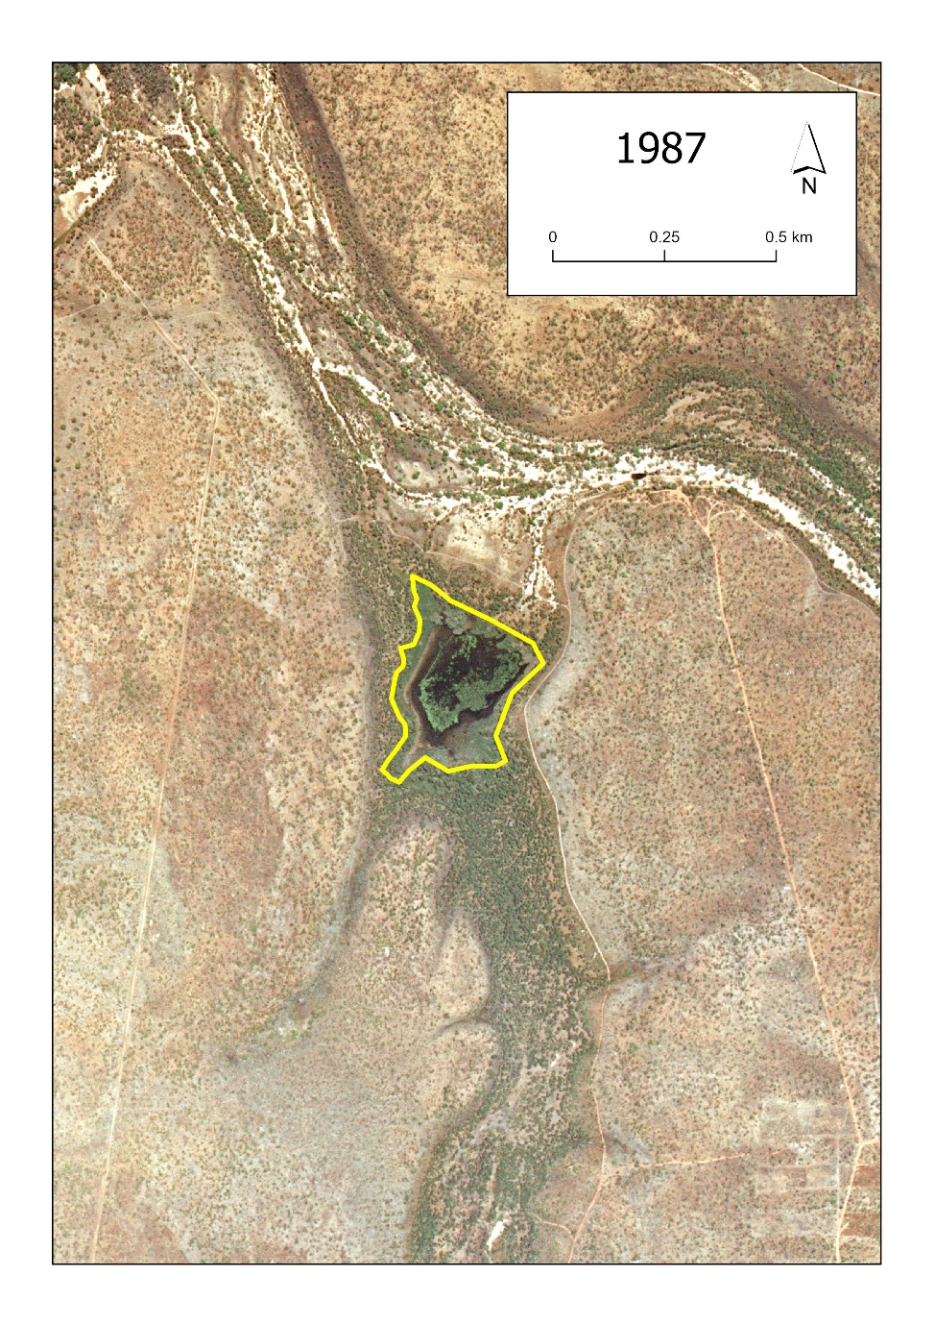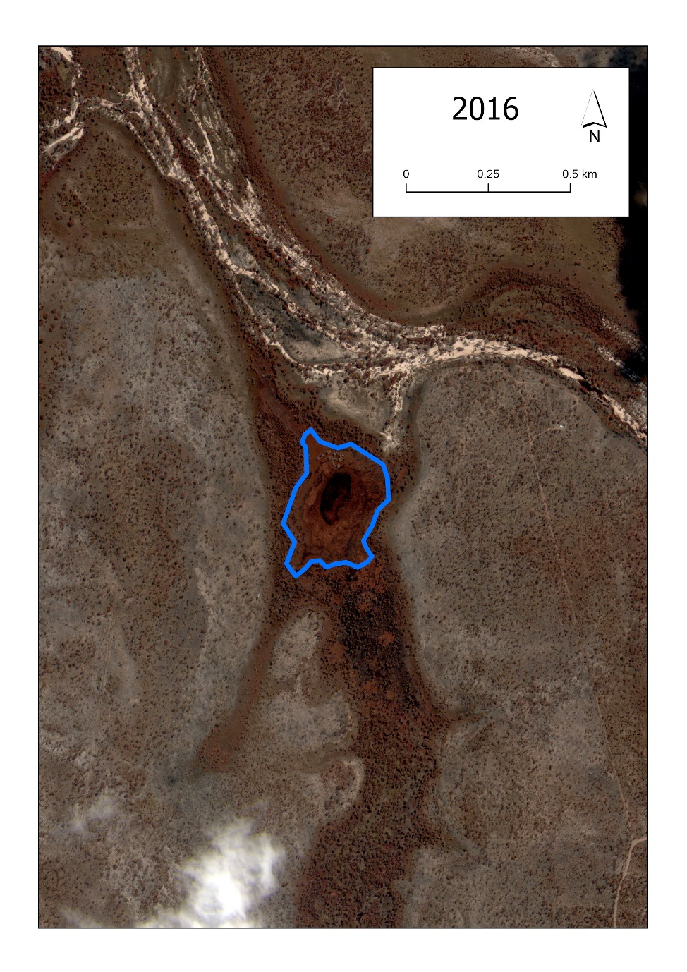
Figure A1-6 – Gulungul Billabong 1987 and 2016.
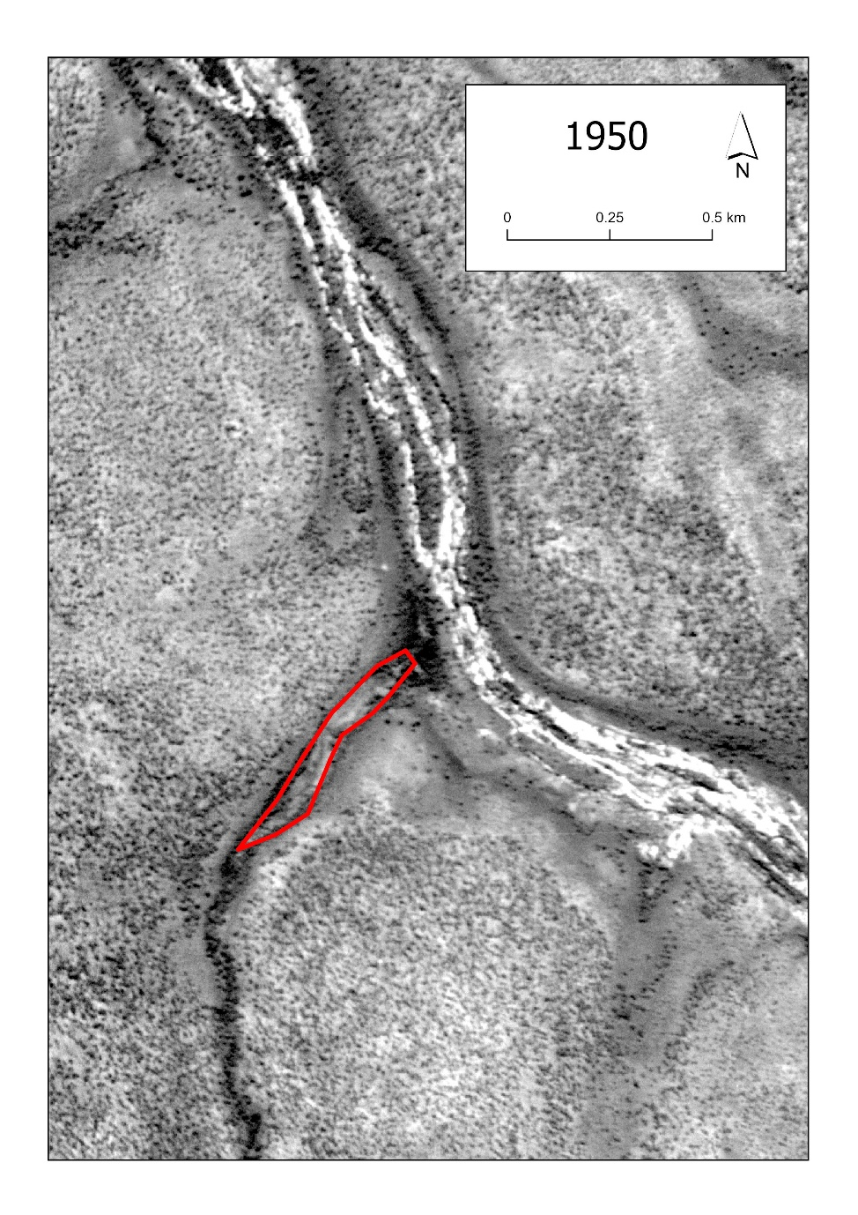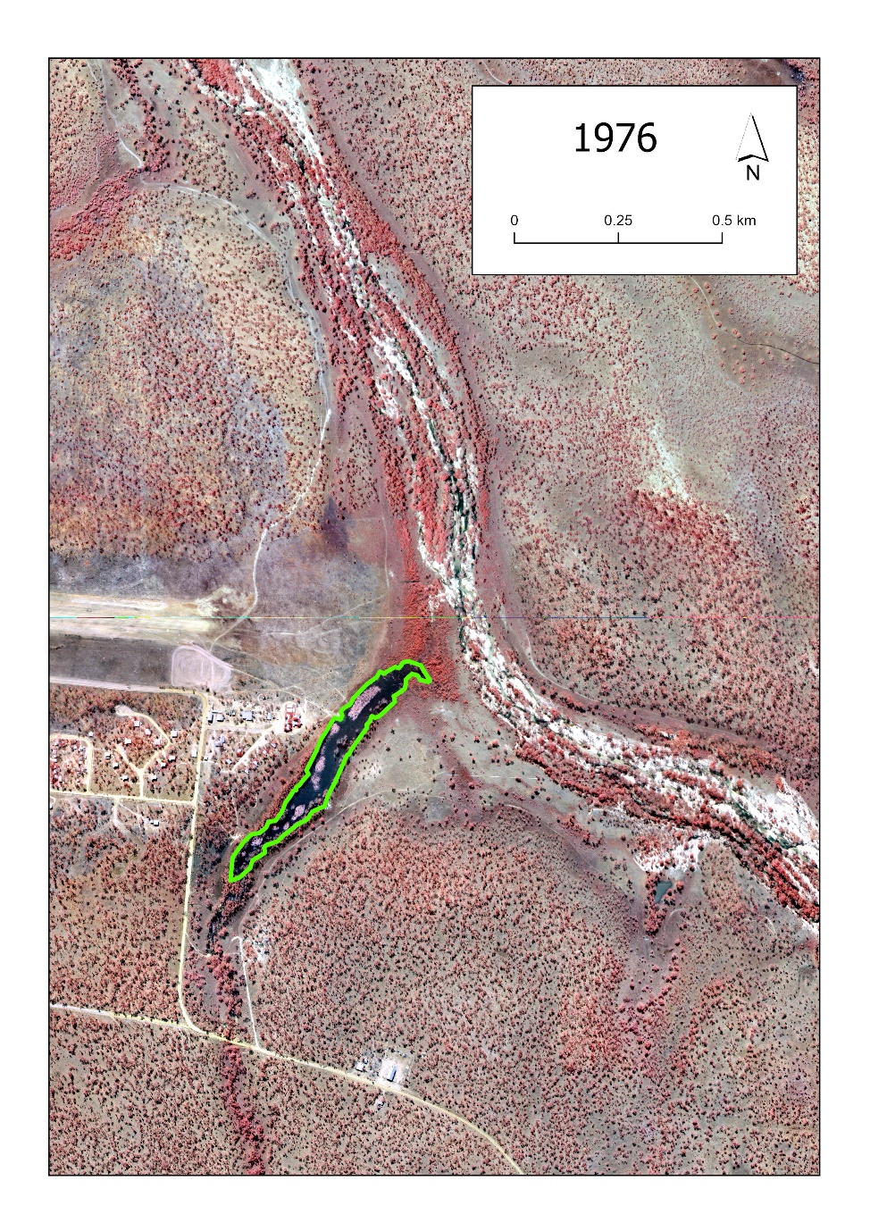
Figure A1-7 – Coonjimba Billabong 1950 and 1976.
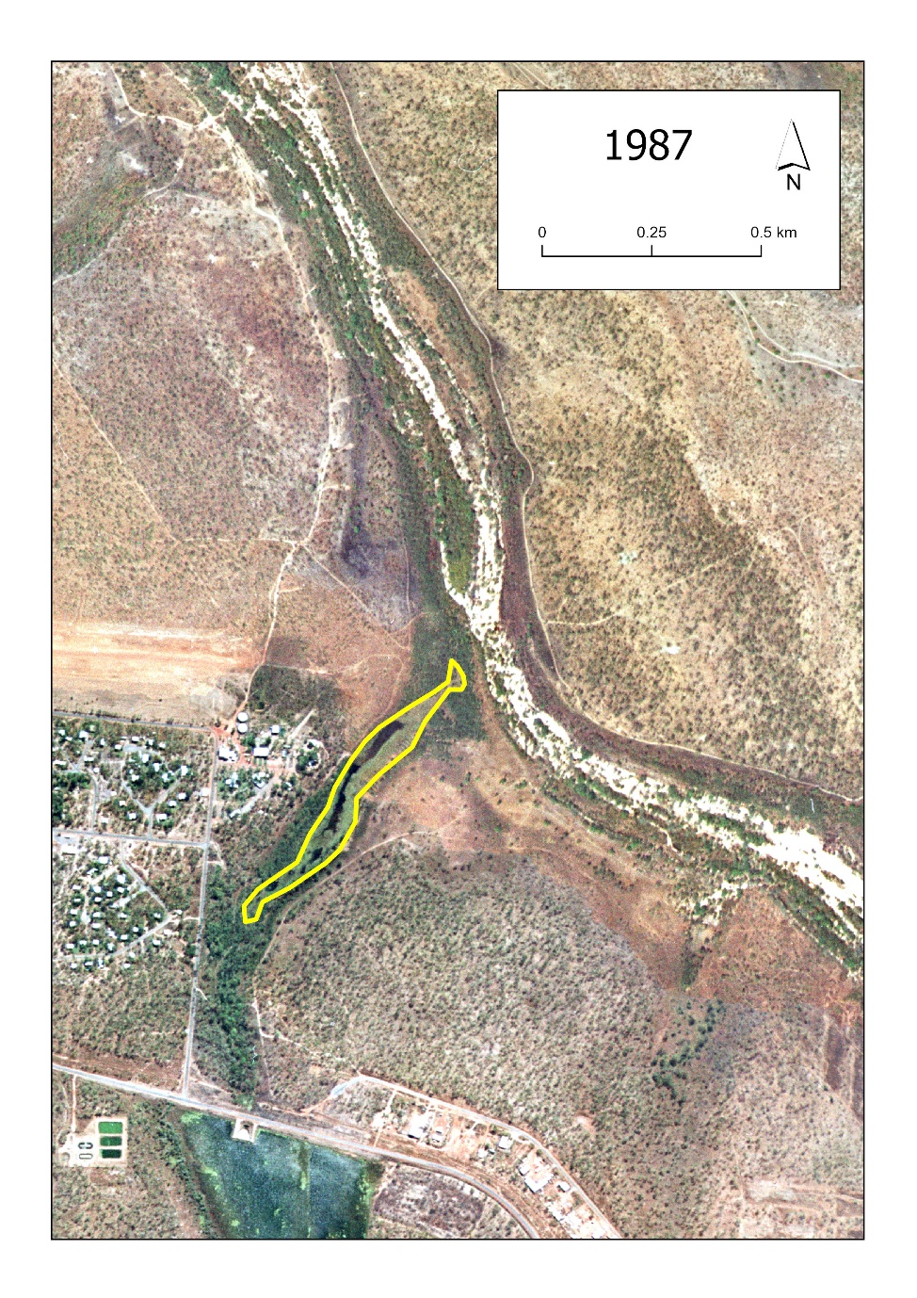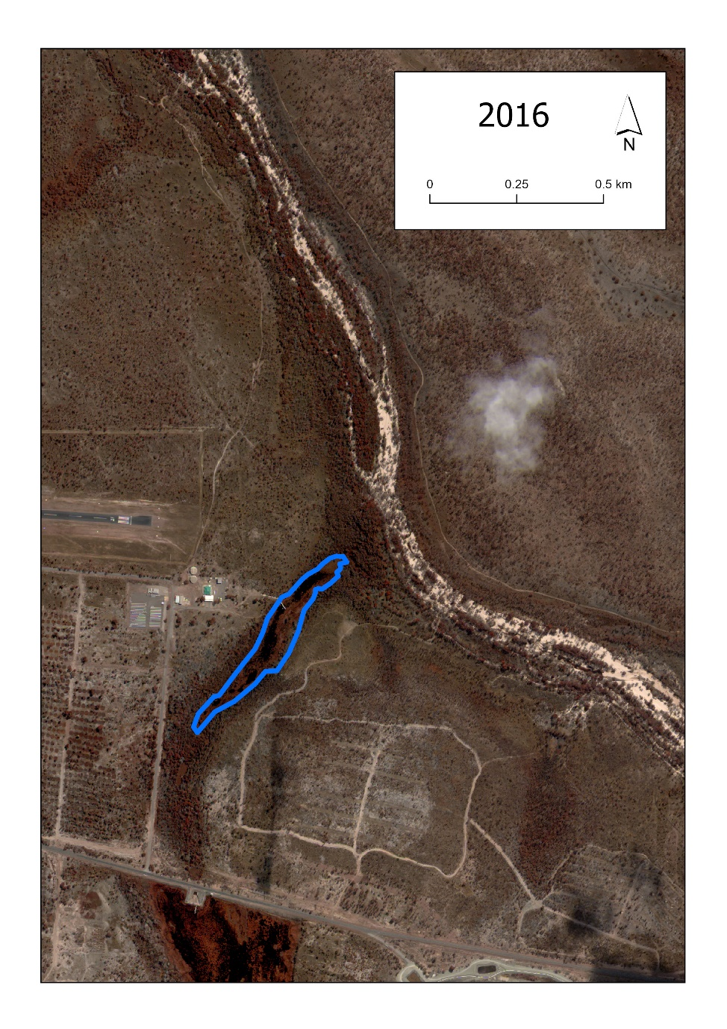
Figure A1-8 – Coonjimba Billabong 1978 and 2016.
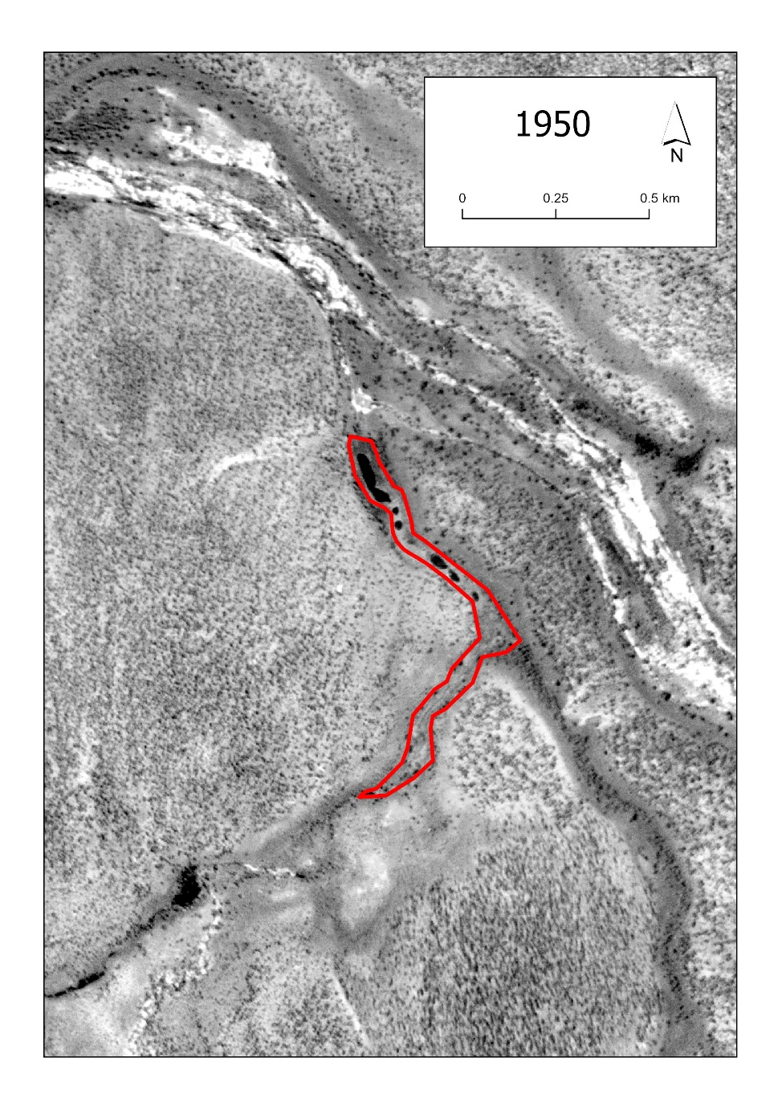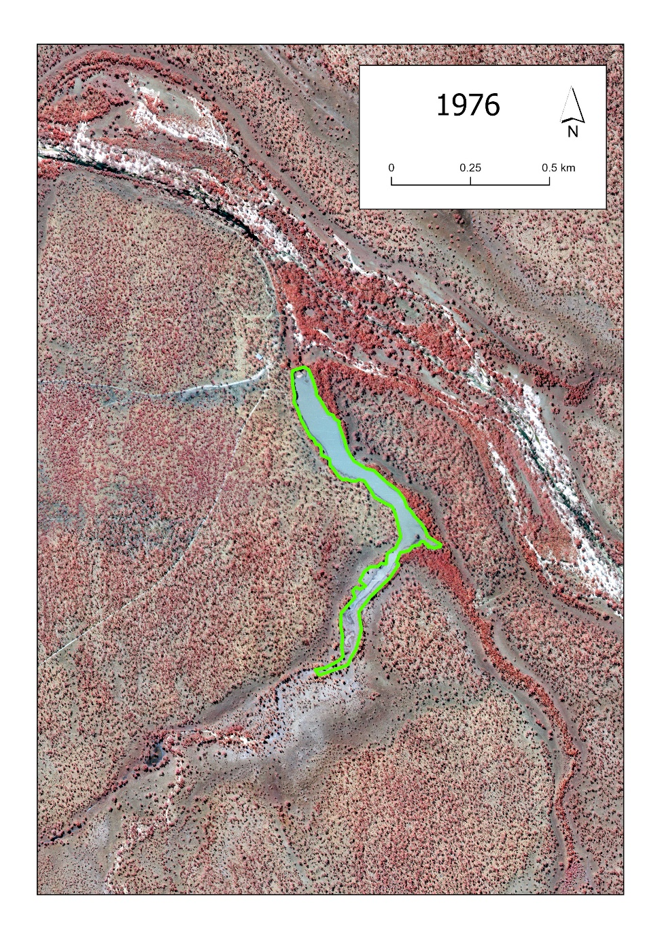
Figure A1-9 – Georgetown Billabong 1950 and 1976.
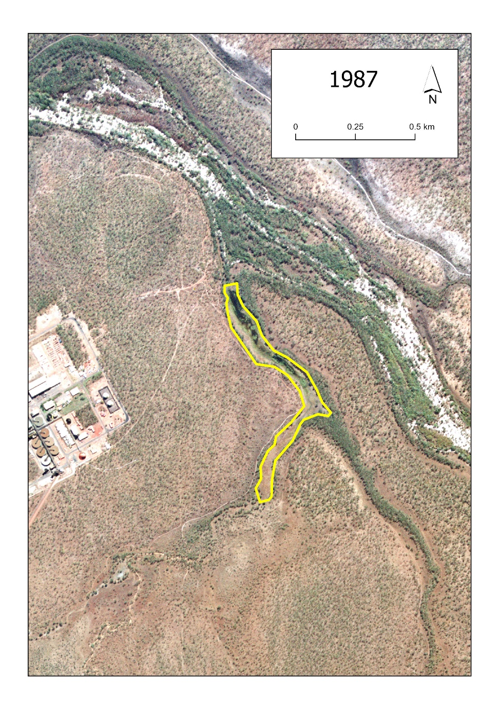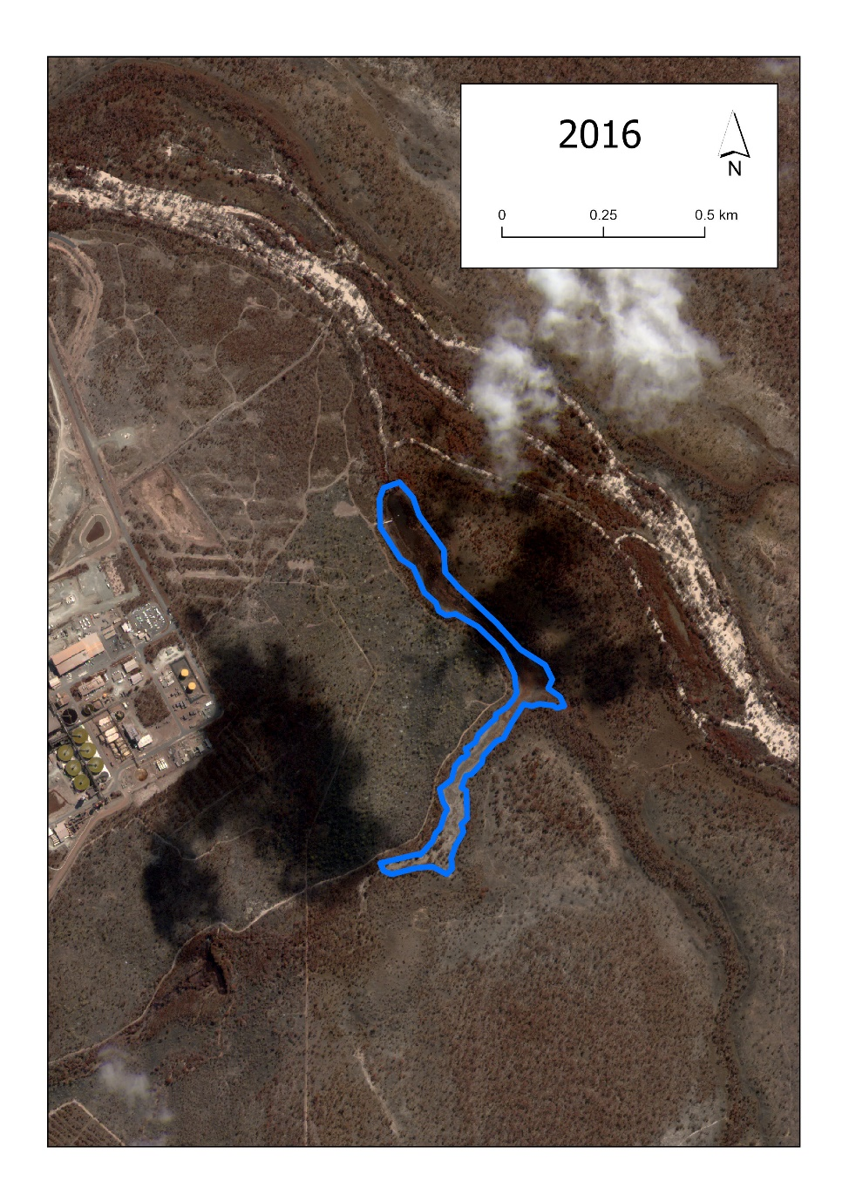
Figure A1-10 – Georgetown Billabong 1987 and 2016.

Appendix 2 – areal extent of sandy creeks 1950-2016

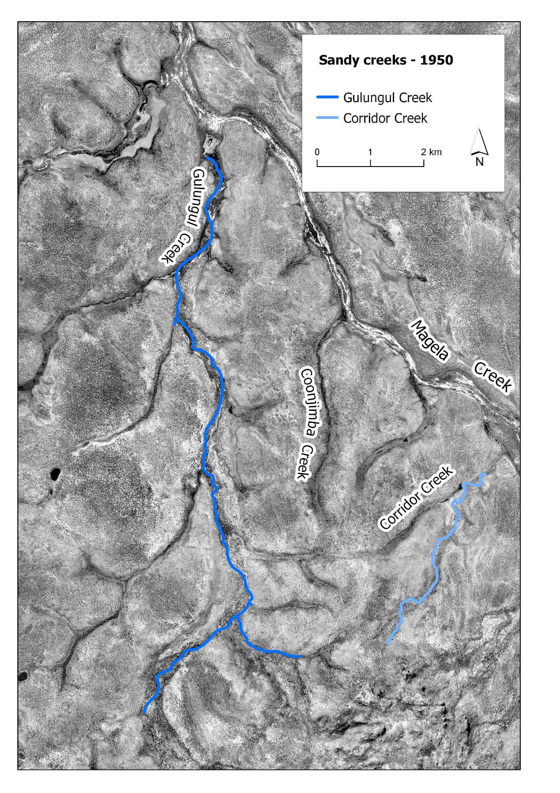
Figure A2-1 – Extent of selected creeks, 1950
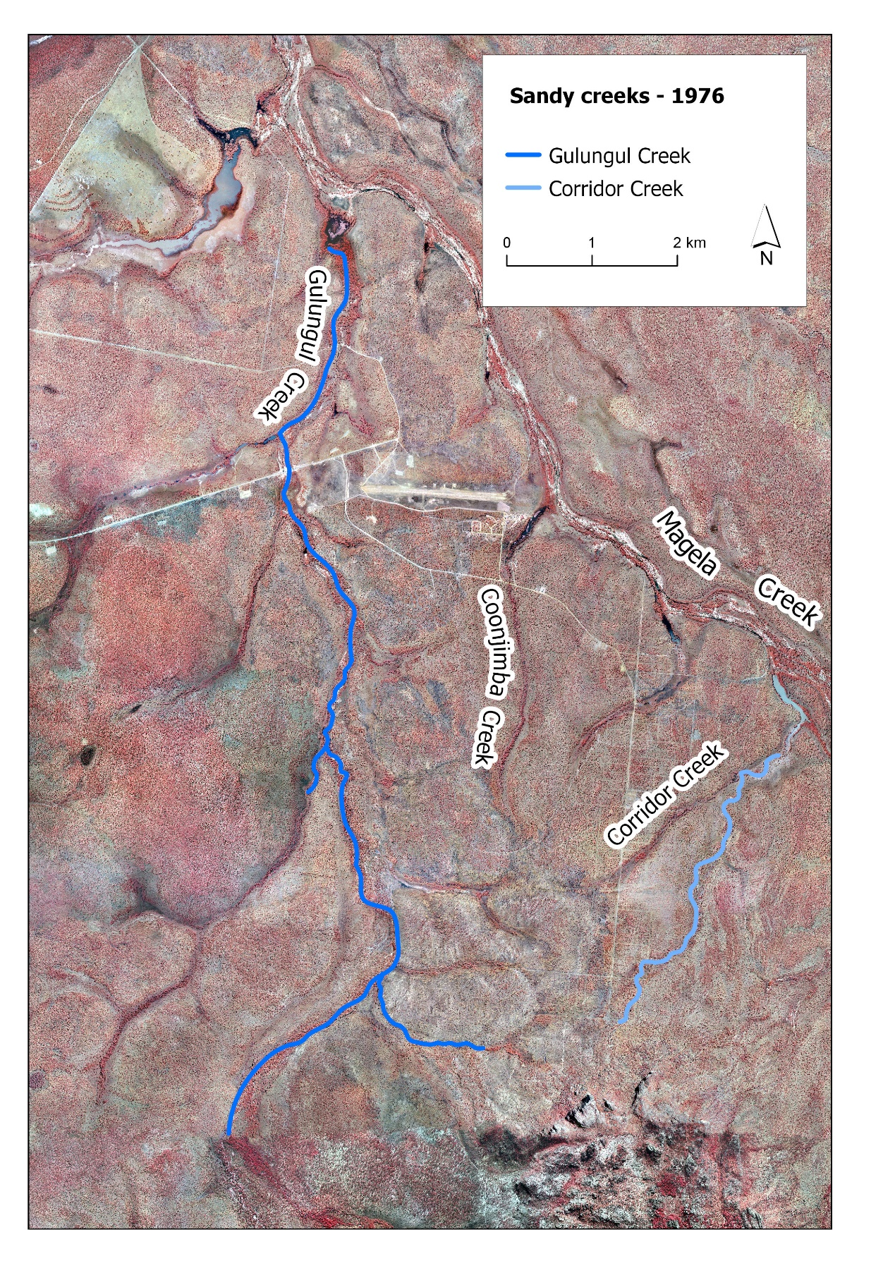
Figure A2-2 – Extent of selected creeks, 1976
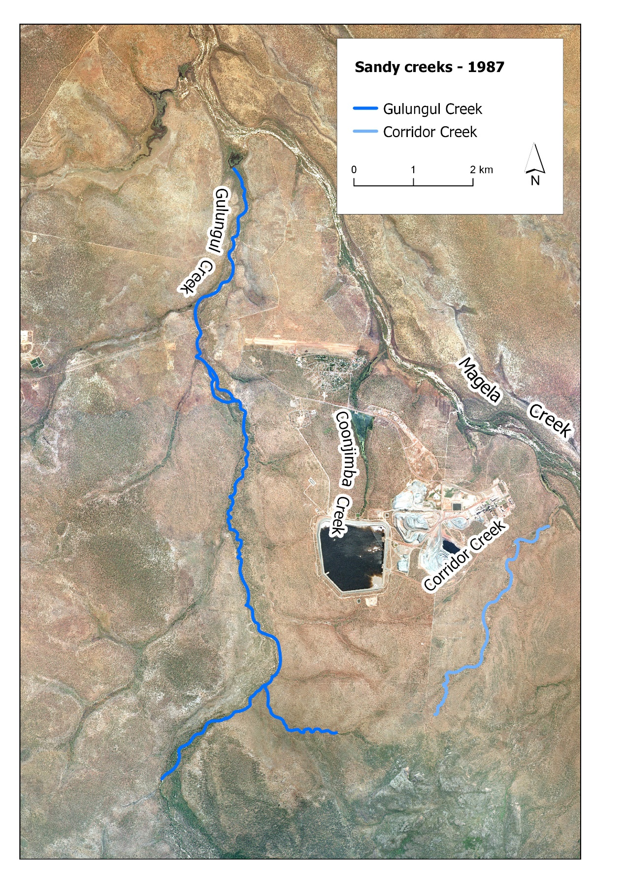
Figure A2-3 – Extent of selected creeks, 1987
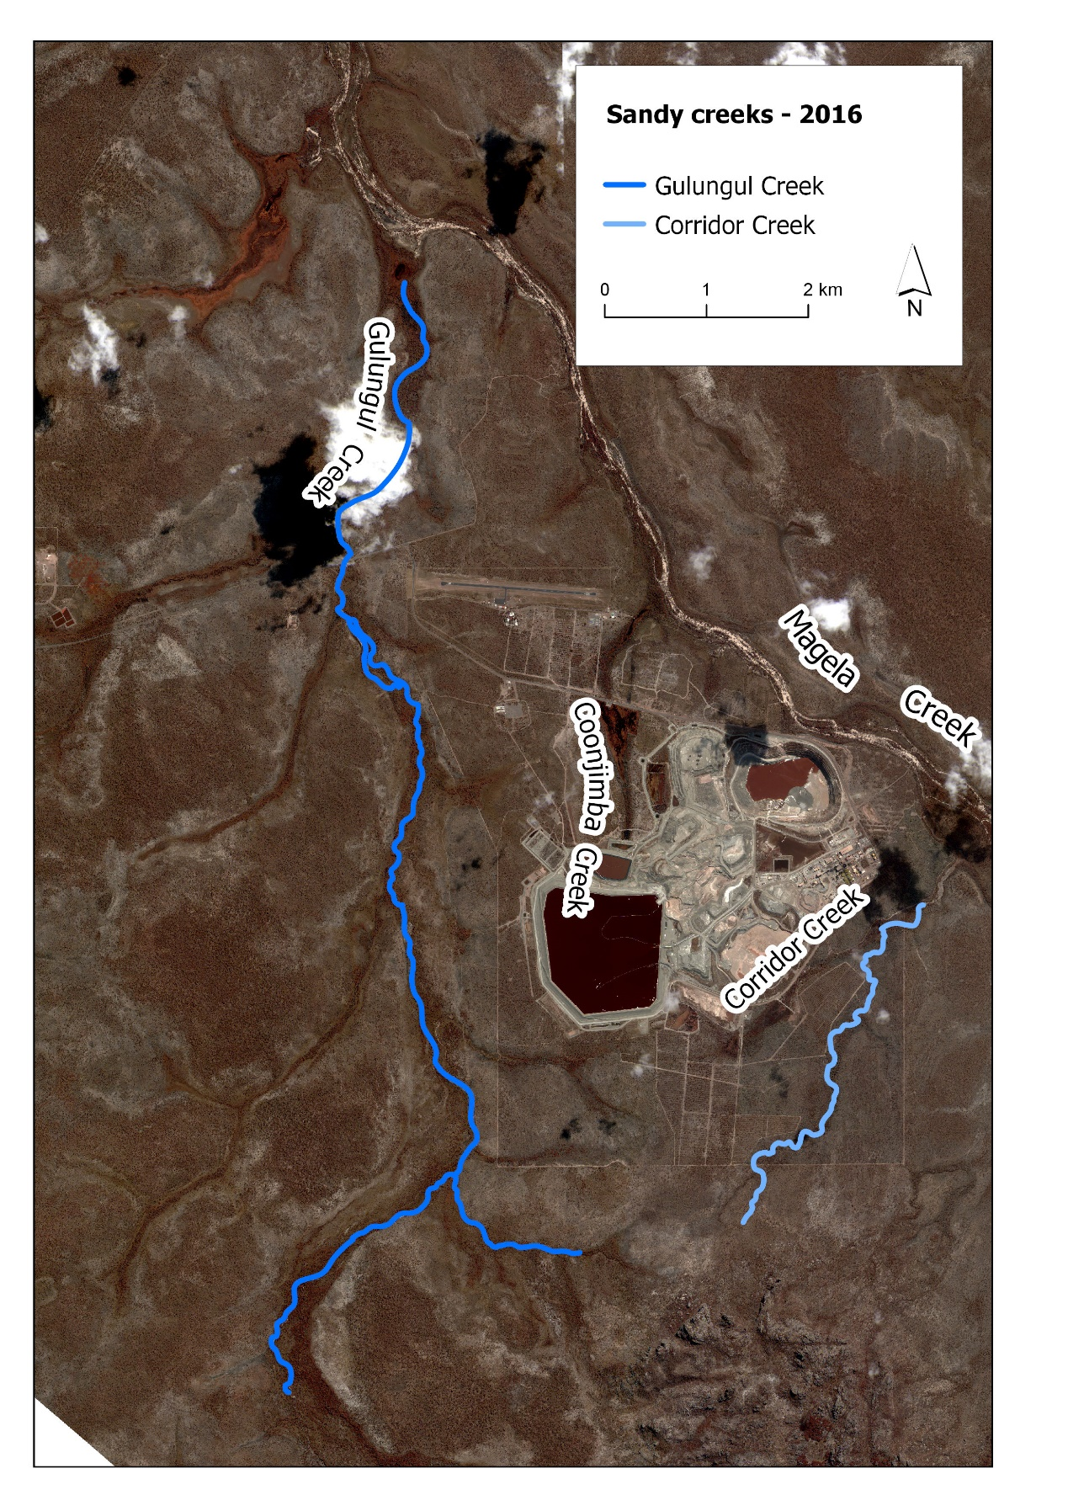
Figure A2-4 – Extent of selected creeks, 2016

Appendix 3 – areal extent of grassy swales 1950-2016

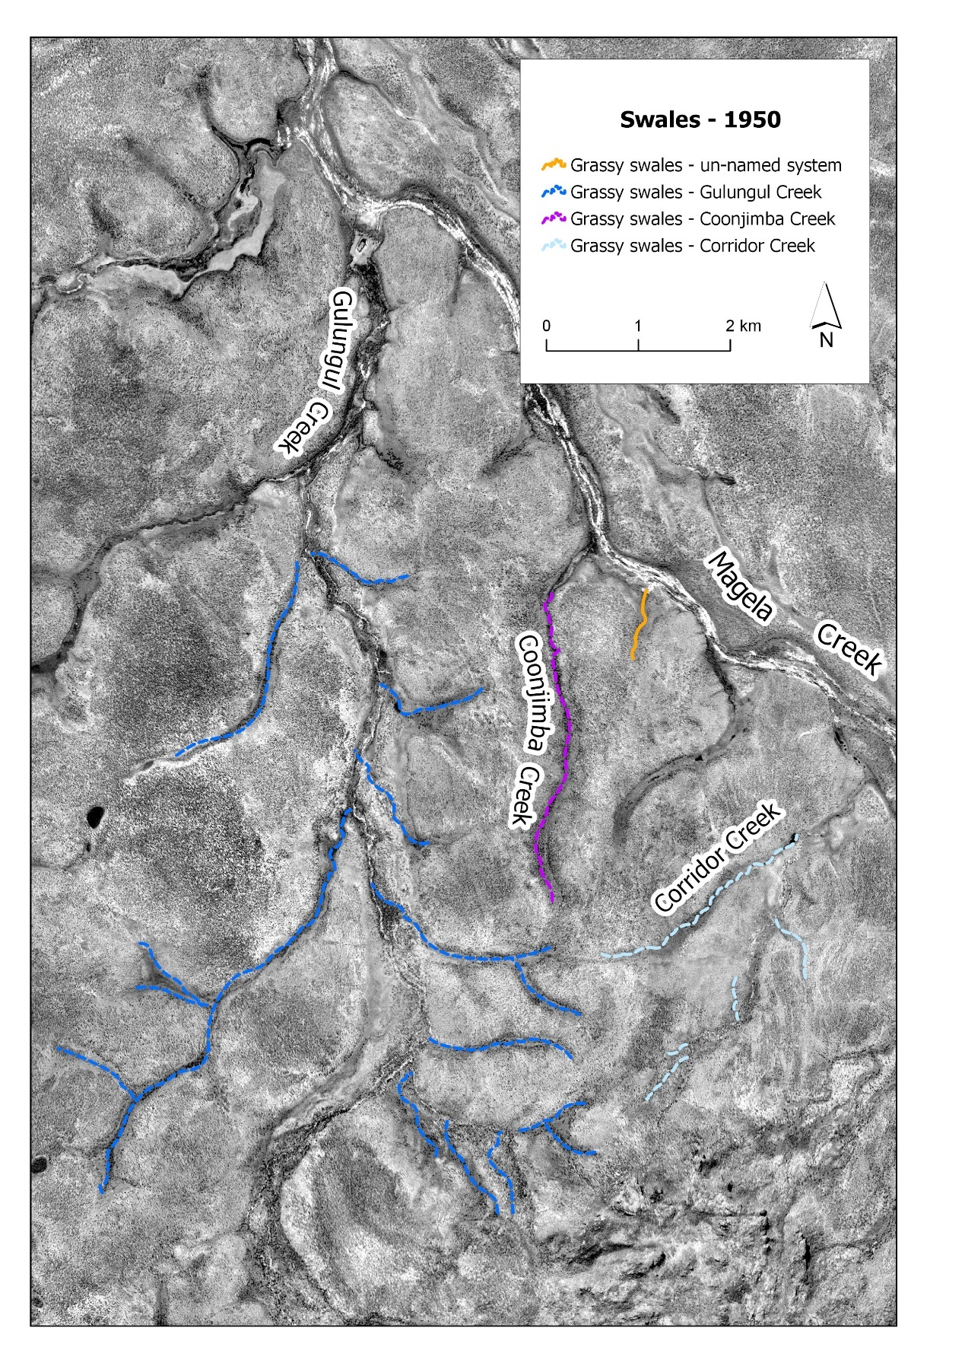Figure A3-1 – Extent of grassy swales associated with selected creeks, 1950.
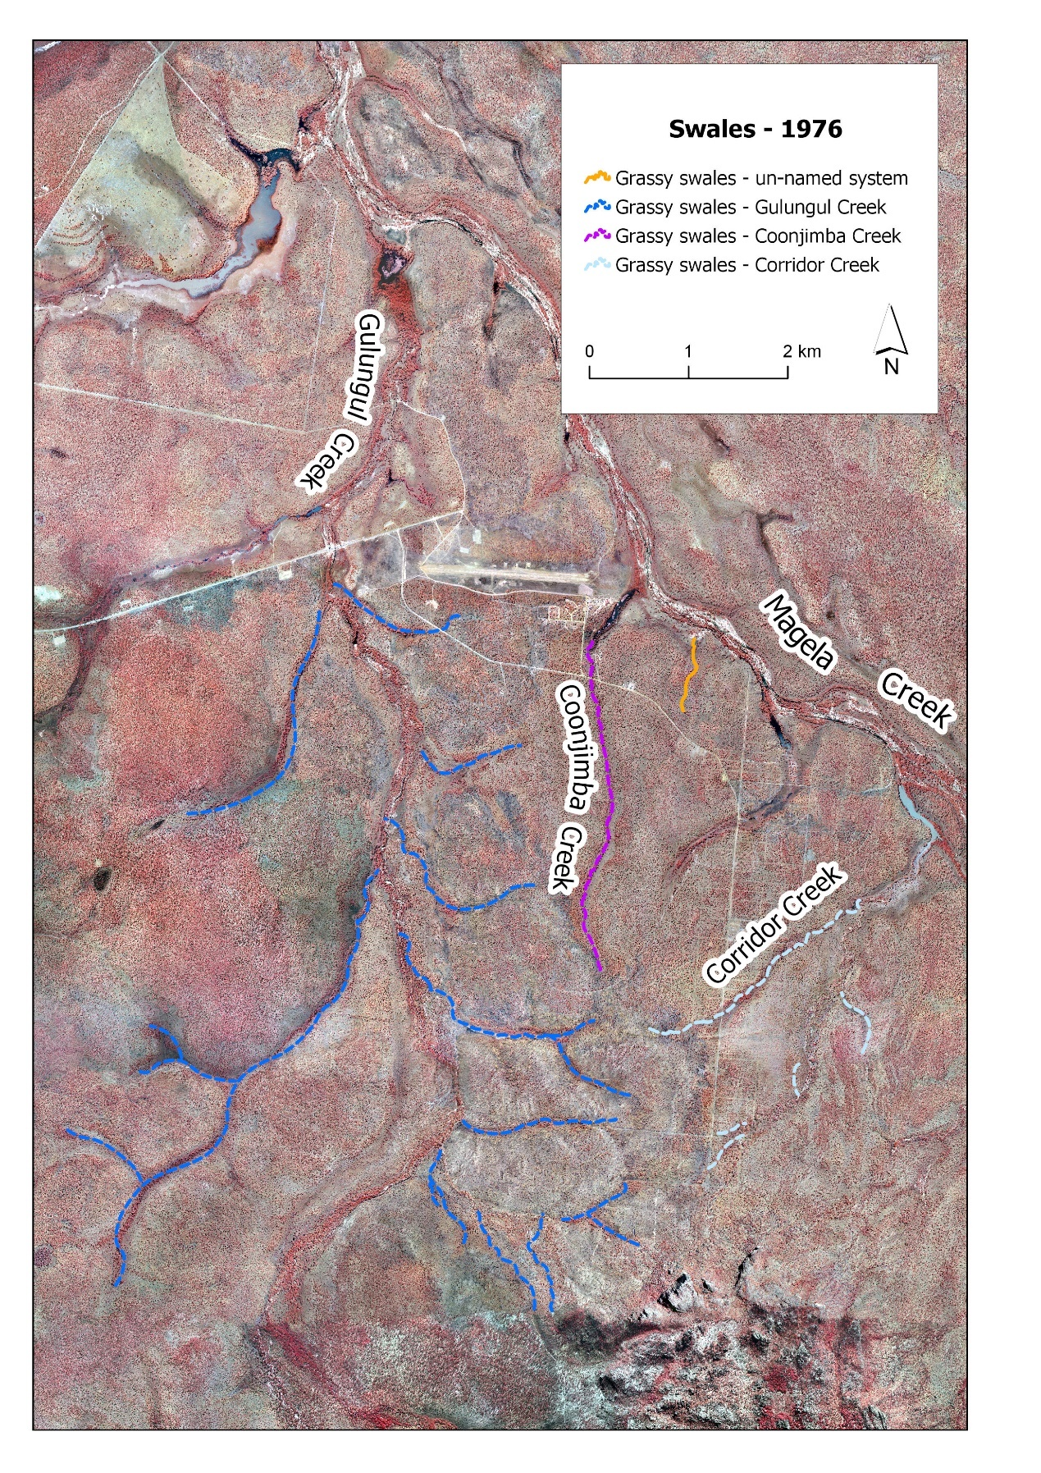
Figure A3-2 – Extent of grassy swales associated with selected creeks, 1976.
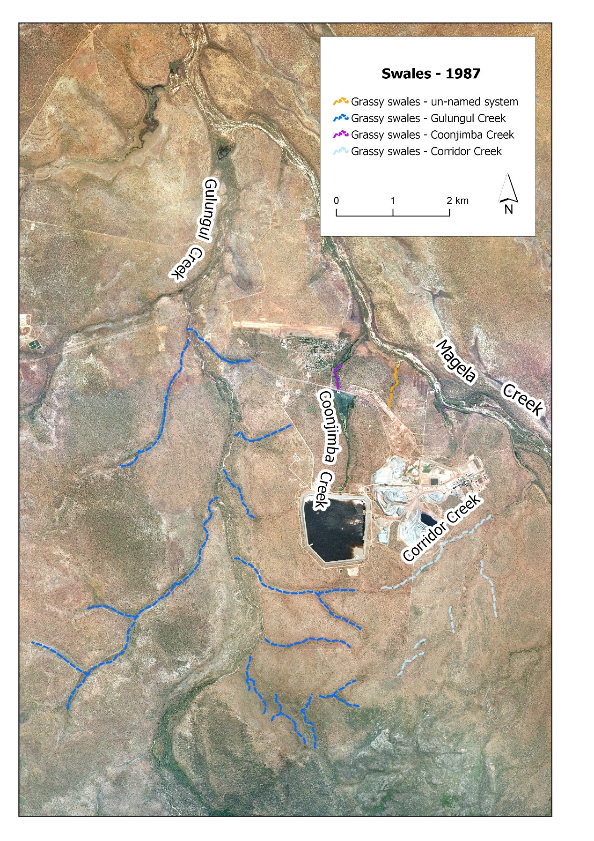
Figure A3-3 – Extent of grassy swales associated with selected creeks, 1987.
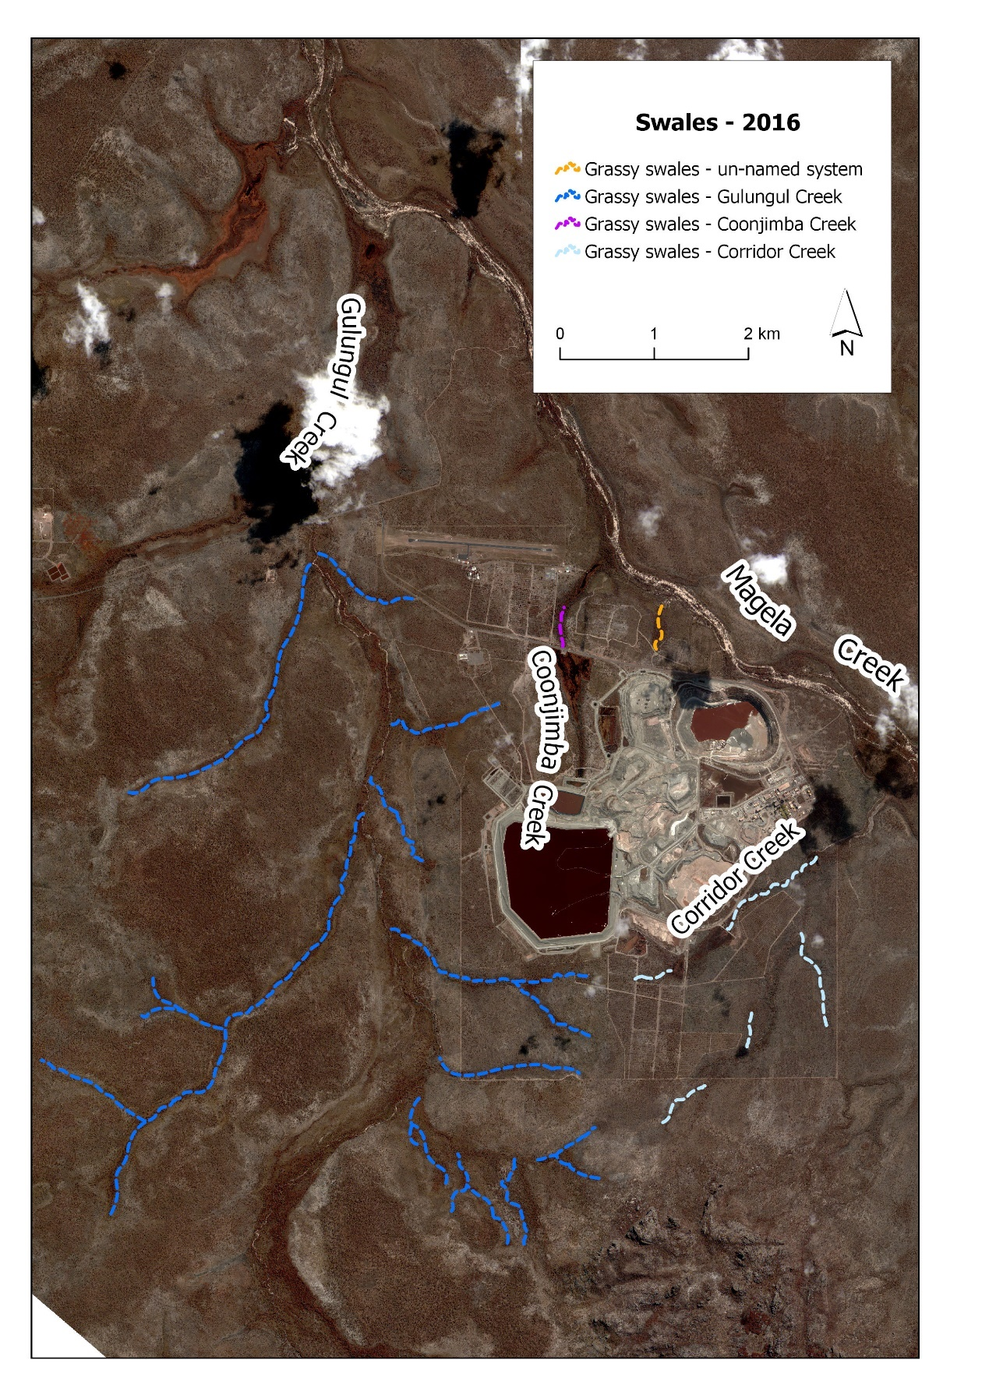
Figure A3-4 – Extent of grassy swales associated with selected creeks, 2016.

