Wave-shortWave-short

638

*internal report*

A review of Water Quality Objectives for Magela Creek and Gulungul Creek



K Turner, K Tayler and J Tyrrell  
September 2015

Release status – unrestricted

Project number – MON-2001-003

670

*internal report*

Revised Ranger Mine Water Quality Objectives for Magela Creek and Gulungul Creek



K Turner, K Tayler,   
JWR Tyrrell and A Leggett  
July 2019

Release status – unrestricted

Project number – MON-2001-003

*The Department acknowledges the traditional owners of country throughout Australia and their continuing connection to land, sea and community. We pay our respects to them and their cultures and to their elders both past and present.*

**Revised Ranger Mine Water Quality Objectives for   
Magela Creek and Gulungul Creek**

**K Turner, K Tayler, JWR Tyrrell and A Leggett**

Supervising Scientist

GPO Box 461, Darwin NT 0801

July 2019

(Release status – unrestricted)



*How to cite this report:*

Turner K, Tayler K, Tyrrell JWR & Leggett A 2019. Revised Ranger Mine Water Quality Objectives for Magela Creek and Gulungul Creek. Internal Report 670, Supervising Scientist, Darwin.

This report supersedes Internal Report Number 638. This report provides updated background information and Trigger Values for Total Ammonia Nitrogen.

Project number – MON-2001-003

*Authors of this report:*

Kate Turner – Supervising Scientist, GPO Box 461, Darwin NT 0801, Australia

Keith Tayler – Supervising Scientist, GPO Box 461, Darwin NT 0801, Australia

James Tyrrell – Supervising Scientist, GPO Box 461, Darwin NT 0801, Australia

Supervising Scientist is a branch of the Australian Government Department of   
the Environment.

Supervising Scientist   
Department of the Environment   
GPO Box 461, Darwin NT 0801 Australia

**environment**.gov.au/science/supervising-scientist/publications

© Commonwealth of Australia 2019

Copyright Image.tif

IR670 is licensed by the Commonwealth of Australia for use under a Creative Commons By Attribution 3.0 Australia licence with the exception of the Coat of Arms of the Commonwealth of Australia, the logo of the agency responsible for publishing the report, content supplied by third parties, and any images depicting people. For licence conditions see: http://creativecommons.org/licenses/by/3.0/au/

**Disclaimer**

The views and opinions expressed in this publication are those of the authors and do not necessarily reflect those of the Australian Government or the Minister for the Environment.

While reasonable efforts have been made to ensure that the contents of this publication are factually correct, the Commonwealth does not accept responsibility for the accuracy or completeness of the contents, and shall not be liable for any loss or damage that may be occasioned directly or indirectly through the use of, or reliance on, the contents of this publication.

**Contents**

Executive summary 1

1 Background 2

2 Ranger Mine Water Quality Objectives 4

2.1 pH 4

2.2 Turbidity 4

2.3 Magnesium and Electrical Conductivity 5

2.3.1 Magnesium Trigger Values 5

2.3.2 Electrical conductivity Trigger Values 8

2.4 Manganese 10

2.5 Total Ammonia Nitrogen 11

2.6 Uranium 12

2.7 Radium-226 13

3 Implementation of the Objectives 15

3.1 Statutory Monitoring Sites 15

3.2 Continuous monitoring 15

3.3 Event-based sampling 16

3.3.1 Sample collection 16

3.3.2 Sample analysis 16

3.4 Radium sampling 17

3.5 Data interpretation and reporting 17

4 Actions invoked by exceedance of a Trigger Value 19

4.1 Exceedance of a Focus Trigger Value 19

4.2 Exceedance of an Action Trigger Value 19

4.3 Exceedance of a Guideline Trigger Value 19

4.4 Exceedance of a Limit Trigger Value 20

4.5 Exceedance of the EC Investigation Trigger Value 20

5 Ranger Mine Water Quality Objectives 21

6 References 25

# Executive summary

This report provides a revised water quality compliance framework for the Ranger uranium mine. The revised framework follows the approach utilised in Iles (2004), but has been expanded to include water quality objectives for both Magela and Gulungul Creeks and now incorporates continuous monitoring methods in combination with event-based sampling. Trigger Values have been revised based upon additional information obtained by research conducted since 2004.

Specifically, the report proposes:

* A uranium Limit of 2.8 µg/L which considers the ameliorating effects of dissolved organic carbon;
* A chronic exposure magnesium Limit of 3 mg/L (for ≥ 72 hours) and a series of pulse exposure Guideline values for magnesium based on pulse duration and magnitude;
* An electrical conductivity Investigation Trigger value of 42 µS/cm (for > 6 hours);
* A manganese Limit of 75 µg/L;
* A radium-226 wet season geometric mean difference Limit of 3 mBq/L;
* A total ammonia nitrogen Limit of 0.4 mg/L;
* A turbidity Guideline value of 26 NTU; and
* Removal of statutory requirements for ph.

Actions invoked by the exceedance of a Trigger Value remain substantially unchanged from Iles (2004). Guidance is provided for the continuous monitoring of electrical conductivity and turbidity and for the collection of the event-based samples. It is recommended that water samples be analysed for total metals and major ions and a framework has been provided to allow the conversion of total metal concentrations to dissolved concentration. This conversion enables comparison of the measured concentrations to the toxicologically derived Trigger Values which are based on dissolved concentrations.

# Background

The *Environmental Requirements of the Commonwealth of Australia for the Operation of the Ranger Uranium Mine* (the ERs) provide key objectives to protect the environmental and cultural values of Kakadu National Park (KNP), which together see the site listed under both World Heritage and Ramsar conventions. These objectives must be met by Energy Resources of Australia (ERA) to minimise the environmental impacts of the Ranger uranium mine during operations and post-closure. The ERs outline specific objectives in relation to water quality, including the requirement for the Supervising Scientist to determine and report water quality criteria for key contaminants of concern. The current Water Quality Objectives outline water quality criteria for Magela Creek and were established by the Supervising Scientist in 2004 (Iles 2004). In accordance with the approach outlined in the Australian and New Zealand Guidelines for Fresh and Marine Water Quality (ANZECC & ARMCANZ 2000) these criteria were based upon either site-specific biological effects data (i.e. toxicity tests using multiple species) or site-specific reference data (i.e. water quality measured upstream of the mine site). The only exception being the criteria developed for 226Ra which was developed in line with international recommendations by the International Atomic Energy Agency (IAEA 2014) and the International Commission for Radiological Protection (ICRP 2007, ICRP 2008) where radiation doses to the environment were assessed to ensure that the radium-226 (226Ra) limit set for human radiation protection purposes was also protective for the environment (Klessa 2001).

Monitoring is undertaken at key off-site locations downstream of the mine site and the data are compared and assessed against these criteria to ensure that the environment remains protected, during mining operations and post-closure. To enable meaningful and reliable assessment and relevant and effective remedial management, an interpretive framework has been developed by which the current water quality criteria are implemented in the form of hierarchical Trigger Values: Focus, Action and Guideline/Limit. Exceedances of these Trigger Values indicates that mine related water quality indicators are deviating above background levels and each tier requires a different degree of subsequent remedial action in accordance with the level of risk to the environment. Schedule 7.1.1 of the Ranger Authorisation gives a statutory effect to the Ranger Mine Water Quality Objectives and allows for them to be periodically revised without the requirement to alter the Authorisation.

7.1.1 The operator of the mine shall comply with the requirements of the Ranger Mine Water Quality Objectives as approved by the Director in accordance with the advice of the Supervising Scientist.

This report proposes a revised version of the Ranger Mine Water Quality Objectives in accordance with Schedule 7.1.1, which introduces:

* Water quality objectives for Gulungul creek;
* Regulatory requirement to undertake continuous monitoring and event-based sampling;
* New toxicity based chronic exposure and pulse exposure Trigger Values for magnesium (Mg) and associated Trigger Values for electrical conductivity (EC);
* New toxicity based Trigger Values for manganese (Mn) and total ammonia nitrogen (TAN);
* Revised toxicity based Trigger Values for uranium (U);
* Revised Limit value for 226Ra;
* Revised reference based Trigger Values for turbidity; and
* The removal of statutory pH criteria for regulatory purposes.

Methods for continuously monitoring physico-chemical parameters have been used by the Supervising Scientist since 2005 and by ERA since the 2009. Data collected has shown that fluctuations in EC and turbidity occur as ‘pulses’ of varying magnitude and duration depending on the hydrological conditions in the creeks. Figure 1 shows the continuous EC measured at the Magela Creek downstream site over the 2009-10 wet season along with the EC measured in weekly grab samples, which is akin to the current statutory sampling program. This figure illustrates that the weekly grab sampling method is not able to detect inputs of mine-derived contaminants other than those present at the specific time of sample collection. In contrast, Figure 2 shows the continuous EC along with the EC measured in event-based samples, highlighting that event-based sampling effectively captures EC pulses that are missed by the weekly grab sampling method.

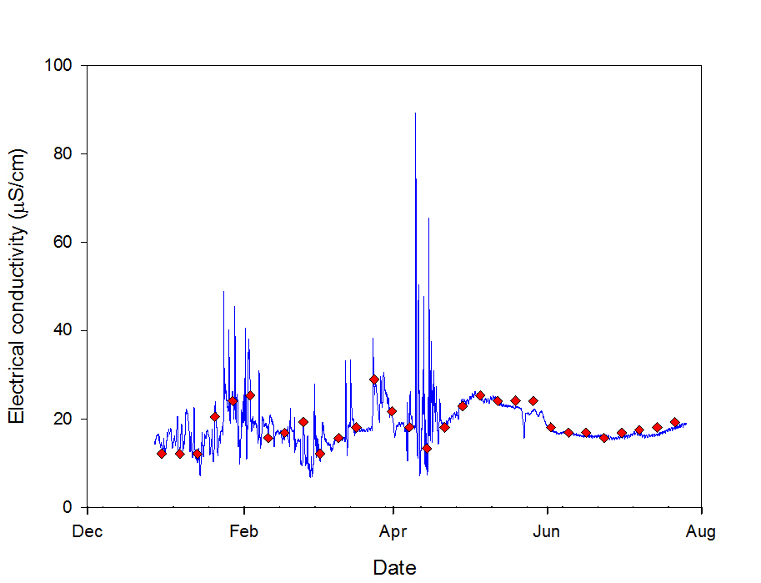

Figure 1 Continuous EC data (line) and weekly grab samples (dots).

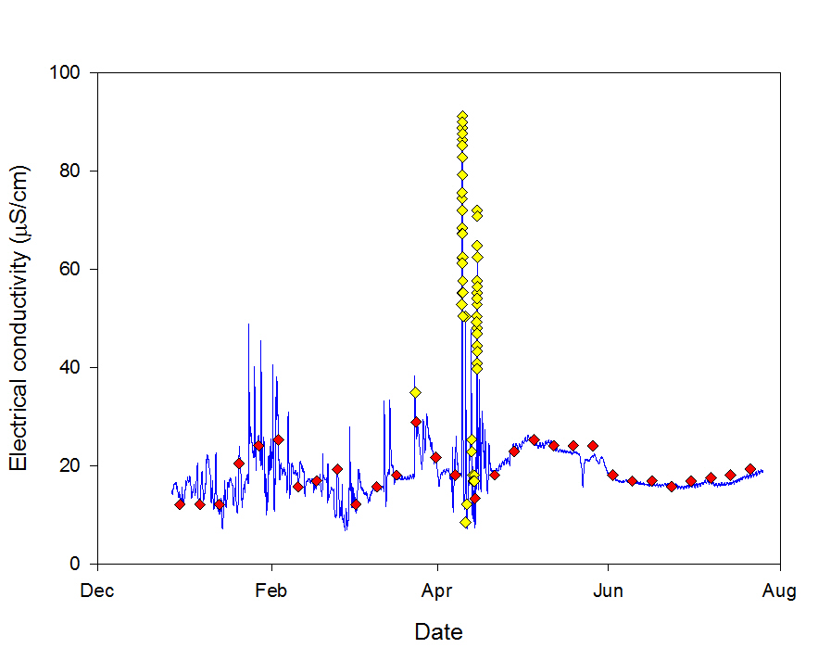

Figure 2 Continuous EC data (line) and event-based water samples (dots).

Several reviews (ed Hart & Taylor 2013, Australia 2003) have endorsed the continuous monitoring program implemented by the Supervising Scientist and recommended that it form the basis of a revised statutory monitoring program for Ranger Mine. Accordingly, it is recommended that the use of continuous data and event-based sampling are incorporated into the Ranger Mine Water Quality Objectives, as described below.

# Ranger Mine Water Quality Objectives

## pH

The pH in Magela Creek has a natural range of 4.7 to 7.9 and is highly variable. The continuously monitored pH at both the upstream and downstream monitoring sites regularly falls outside of the existing Guideline values for pH (5.0 and 6.9). The lower pH values at the upstream site are thought to result from low pH rainfall (pH 4 – 5), with values increasing further downstream due to inputs of well-buffered waters from billabongs, including Georgetown and Coonjimba (Noller et al 1990).

It is considered highly unlikely that a quantity of mine derived water sufficient to significantly alter the pH in Magela and Gulungul Creeks could be released. Such a release would be accompanied by a significant increase in solute concentration which would be detected by measurement of EC. As such, it is proposed that the statutory water quality criteria for pH are removed. However continuous monitoring and reporting of pH data should continue in both creeks to assist with the interpretation of other key analytes in terms of their reactivity, bioavailability and potential toxicity.

## Turbidity

Turbidity measurements are used to monitor and assess suspended sediment concentrations in water. Continuous turbidity data can be used to quantify suspended sediment loads which are important to determine levels and rates of additional anthropogenic inputs of sediments to an aquatic system (Moliere & Evans 2010).

During mine operations suspended sediment has not been considered to pose a significant ecological risk to Magela and Gulungul Creeks as there are currently no major mine derived sources of sediment. Thus turbidity Trigger Values are primarily implemented for operational controls and management. The new turbidity Trigger Values have been derived following the approach outlined in the Australian and New Zealand Guidelines for Fresh and Marine Water Quality (ANZECC & ARMCANZ 2000) for deriving site-specific water quality criteria using suitable reference site data. The Guideline, Action and Focus triggers values have been based upon the 99.7th, 95th and 80th percentiles respectively of pooled continuous monitoring data collected from Magela Creek and Gulungul Creek between 2005 and 2015 (Table 1).

The Trigger Values for Magela Creek were derived using reference site data collected at the upstream monitoring site since 2005. The Gulungul Creek catchment is relatively small in comparison to the Magela Creek catchment. According to the sediment delivery ratio theory, the headwaters of creeks generally have higher suspended sediment loads compared to sites further downstream (Walling 1983). This effect has been observed by the Supervising Scientist in Gulungul Creek, with continuous turbidity at the upstream site generally being higher than the downstream site. Given this and the fact that there has not been any significant mine influence on turbidity measured in Gulungul creek to date, the data collected at the Supervising Scientist’s downstream site (GCDS) was used to derive the turbidity Trigger Values for Gulungul Creek. The 99.7th percentiles for Magela Creek and Gulungul Creek are 26 NTU and 25 NTU, respectively. Given that error associated with continuous turbidity monitoring is approximately ± 1 NTU it was considered appropriate to make the Guideline value 26 NTU for both creeks, which like the Action and Focus values, remains unchanged from the previous Trigger Values   
(Iles 2004).

**Table 1** Percentiles of continuous turbidity data for Magela Creek upstream and Gulungul Creek downstream sites collected between 2005 and 2015. Existing turbidity Trigger Values derived using grab sample data are also shown (Iles 2004).

|  |  |  |  |
| --- | --- | --- | --- |
| **Site** | **99.7th Percentile (NTU)** | **95th Percentile (NTU)** | **80th Percentile (NTU)** |
| Previous Trigger Values (Iles 2004) | 26 | 10 | 5 |
| Magela Upstream | 26 | 9 | 4 |
| Gulungul Downstream | 25 | 9 | 5 |

***Turbidity at downstream compliance monitoring sites:***

* ***Must be monitored continuously to provide reliable data for assessment against the turbidity Trigger Values;***
* ***Will invoke actions according to Section 4 if they exceed Focus, Action or Guideline Trigger Values, unless accompanied by similar levels at the related upstream control site; and***
* ***Must not deteriorate compared to those measured in previous wet seasons without reasonable cause.***

**Turbidity Trigger Values**

Applied at: MG009W and GCLB

Focus: 5 NTU

Action: 10 NTU

Guideline: 26 NTU

## Magnesium and Electrical Conductivity

### Magnesium Trigger Values

#### Magnesium chronic exposure Limit

Magnesium (Mg) is primarily derived from the weathering of Mg dominant chlorite schists in the mine waste rock. Numerous studies have been undertaken to understand Mg toxicity to local freshwater species in Magela and Gulungul Creeks and these are discussed in more detail below.

Ecotoxicological research conducted by Supervising Scientist using a suite of local species has derived a site-specific chronic exposure Limit of 3 mg/L for Mg in Magela Creek, based on a 72 hour exposure duration (van Dam et al 2010). The Focus and Action Trigger Values for Mg are based on the lower 95 per cent and 80 per cent confidence intervals of the chronic exposure Limit, being 1 mg/L and 2 mg/L, respectively. Unlike the chronic exposure Limit, the Action and Focus Trigger Values are not time dependent as they are required to provide a tool for invoking management activities.

#### Magnesium pulse exposure Guideline values

The Supervising Scientist has shown that elevations in Mg typically occur as pulses that persist for less than the 72 hour chronic exposure duration. It is not appropriate to compare short-duration pulses with the chronic exposure Limit. Therefore, Hogan et al (2013) quantified the effects of short-duration (four, eight and 24 hours) Mg pulse exposures on six local freshwater species. Based on the data obtained for each of the different exposure periods, a 99 per cent species protection Mg Guideline value was derived for each species, following the approach recommended in ANZECC & ARMCANZ (2000). A relationship was derived between these Mg Guideline values (including the chronic exposure Limit, 3 mg/L) and the exposure duration (Figure 3). This relationship provides a framework for deriving a specific Mg pulse exposure Guideline value for any pulse duration from four hours to 72 hours, beyond which the chronic exposure Limit applies.



Figure 3 The relationship between Mg pulse exposure and 99 per cent species protection Guideline values (modified from Hogan et al 2013).

In order to determine the duration and the magnitude of a Mg pulse the continuous EC data can be used as a surrogate, as has been done previously (Iles 2004). This is possible because Mg is the main major ion contributing to the EC measured in both Magela and Gulungul Creeks. The relationship between EC and Mg for each creek (derived using historical Mg concentration and corresponding EC data collected by the Supervising Scientist) can be described using linear regression (Figure 4). These relationships can be used to estimate continuous Mg concentrations using continuous EC data, enabling assessment of the estimated Mg data against the Mg Trigger Values.

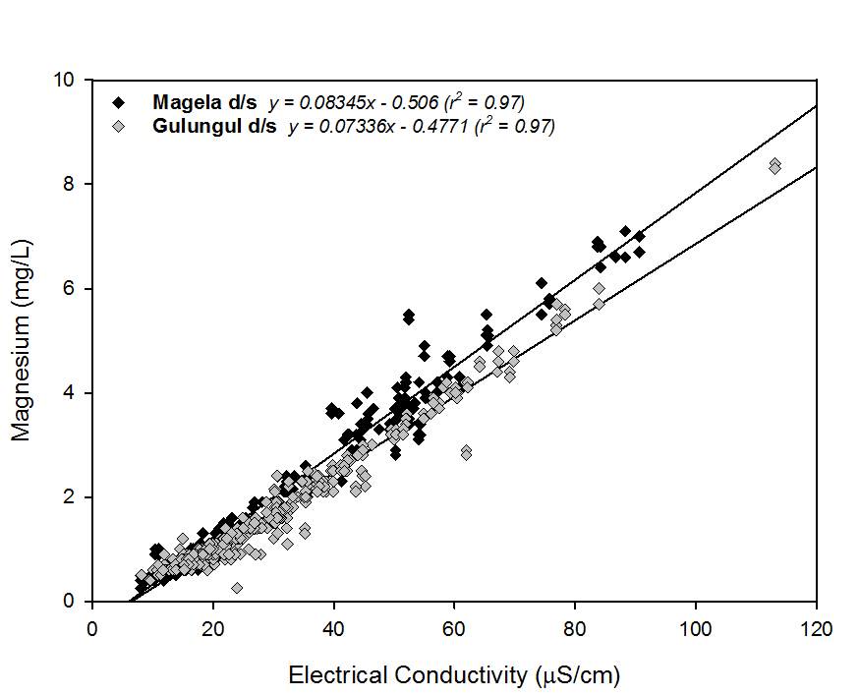

Figure 4 The long-term relationship between EC and Mg concentration for Magela creek (n=275) and Gulungul creek (n= 407) downstream monitoring sites using all Supervising Scientist data available.

The relationships between EC and Mg presented in Figure 4 have been observed to vary over time and in some cases between individual EC pulses in the creeks. This is due to variation in the ratio between different major ions in the water, which can occur due to:

i) Changes in quality of onsite water bodies;

ii) Changes in site water management practices; or

iii) Addition of new solute sources (emerging groundwater pathways).

Because of this variation in the EC-Mg relationships it is important to use the most relevant relationship between the two variables when estimating Mg from EC data. This can be done by calculating a pulse specific regression using the EC and Mg concentration data collected over the duration of an individual pulse. If the pulse regression is strong and statistically significant then it should be used to estimate Mg concentrations from the continuous EC data, otherwise the long-term EC-Mg relationship for the creeks (shown in Figure 4) should be used.

The estimated Mg concentration data should be used to define Mg pulses, including the pulse magnitude and duration, as described in Figure 5. If the estimated Mg concentration falls below 3 mg/L for up to four hours during any given 72 hour period, then the pulse will be treated as a single pulse event. Conversely, if the Mg concentration falls below 3 mg/L for more than four hours, the pulse will be deemed to have ended, and any subsequent exceedance of 3 mg/L will be treated as a separate pulse event. Once the Mg pulse has been defined it should be compared against the Mg Trigger Values.

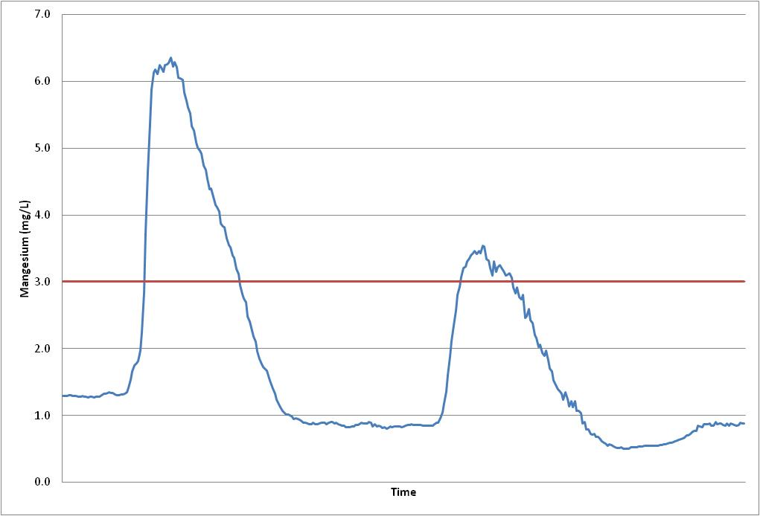

**Pulse**

**Duration**

**Pulse**

**Duration**

**3mg/L Limit**

**Pulse Magnitude**

**Pulse Magnitude**

Figure 5 Determination of Mg pulse magnitude and duration.

It is acknowledged that this method assumes the maximum Mg concentration was sustained for the entire pulse duration, and is therefore a highly conservative approach. As such, the pulse exposure trigger values for magnesium will remain as Guideline values rather than Limits. The Supervising Scientist is currently investigating more representative methods of pulse delineation and will update this report in due course.

### Electrical conductivity Trigger Values

A set of EC Trigger Values have been derived to indicate when Mg concentrations might be approaching levels that exceed the Mg Trigger Values. The EC Trigger Values are essentially the same as the Mg Trigger Values (described above), converted to EC using the long term EC-Mg relationship for Magela Creek (which provides more conservative values compared to Gulungul Creek). The EC Focus and Action Trigger Values are 18 µS/cm and 30 µS/cm respectively, based on the Mg Focus and Action Trigger Values. The EC Investigation Trigger value is 42 µS/cm for greater than six hours. This is equivalent to the Mg Limit of 3 mg/L. The time dependence is applied to prevent unnecessary action for short duration (< 6 hours) pulses that go above 42 µS/cm but do not approach the Mg Guideline value, which for a six hour event would be approximately 300 µS/cm. When the EC exceeds the EC Investigation Trigger value the event is defined as a pulse and the corresponding Mg must be estimated, as described above. The estimated Mg concentrations are compared to the Mg Trigger Values.

Should EC exceed the EC Investigation Trigger, and sufficient data are available, a pulse specific EC-Mg regression should be calculated to ensure that estimated Mg concentrations are as accurate as possible.

The process for assessing the continuous EC data against the EC and Mg Trigger Values is shown in Figure 6.

Figure 6 Process for assessing the EC data against the EC and the Mg Trigger Values.

It is important to note that the presence of calcium (Ca) has been shown to have an ameliorative effect on Mg toxicity (van Dam et al 2010). The Mg Trigger Values take into account this effect, however, the Supervising Scientist intends to further investigate the effect of Ca on Mg toxicity, and the implications, if any, on the Mg Trigger Values.

***Electrical Conductivity at downstream compliance monitoring sites:***

* ***Must be monitored continuously to provide reliable data for assessment against the electrical conductivity and magnesium Trigger Values;***
* ***Will invoke actions according to Section 4 if they exceed Focus or Action Trigger Values unless accompanied by a similar pulse at the related upstream control site; and***
* ***Must be converted to continuous magnesium concentration if they exceed the electrical conductivity Investigation Trigger Value, using either the:***

1. ***pulse-specific EC/Mg regression; or the***
2. ***long-term EC/Mg regression presented in Figure 5 if a suitable pulse specific regression is not available.***

**Electrical Conductivity Trigger Values**

Applied at: MG009W and GCLB

Focus: 18 µS/cm

Action: 30 µS/cm

Investigation Trigger: 42 µS/cm for > 6 hours

***Magnesium concentrations at downstream compliance monitoring sites:***

* ***Must be monitored using a scientifically robust method that provides reliable data for assessment against the magnesium Trigger Values;***
* ***Will invoke actions according to Section 4 if they exceed Focus or Action Trigger Values, unless accompanied by similar concentrations at the related upstream control site; and***
* ***Must not deteriorate compared to those measured in previous wet season without reasonable cause.***

***Magnesium concentrations estimated using continuous EC data at downstream compliance monitoring sites:***

* ***Will invoke actions according to Section 4 if they exceed a pulse exposure Guideline Trigger Value or the magnesium chronic exposure Limit value unless accompanied by a similar pulse at the related upstream control site; and***
* ***Must not deteriorate compared to those measured in previous wet season without reasonable cause.***

**Magnesium Trigger Values (Dissolved Fraction)**

Applied at: MG009W and GCLB

Focus: 1 mg/L

Action: 2 mg/L

Chronic exposure Limit (exposure ≥ 72 hours): 3 mg/L

Pulse exposure Guideline (exposure < 72 hours): Derive from Figure 3

## Manganese

Manganese (Mn) is an additive used in the U extraction process and is present in high concentrations in mine waters (mean indicative concentration in process water is ~1800 mg/L). Given the potential for residual concentrations of Mn in the brine concentrator distillate and the fact that groundwater modelling of Pit 1 and Pit 3 (post-closure) indicated potential for elevated Mn concentrations in Magela Creek, local aquatic species may be at risk of exposure to Mn (Harford et al 2014).

Work was undertaken to assess the toxicity of Mn to six local freshwater species. The reliability and applicability of the derived Limit value was increased by including toxicity data for an additional three non-local species from a similar water type (i.e. low pH and low hardness). From this dataset of nine species, a 99 per cent protection site-specific Mn Limit of 75 µg/L was derived and the Focus and Action Trigger Values were 35 µg/L and 45 µg/L respectively, representing the 95 per cent and 80 per cent confidence intervals of the Limit (Harford et al 2014).

***Manganese concentrations at downstream compliance monitoring sites:***

* ***Must be monitored using a scientifically robust method that provides reliable data for assessment against the manganese Trigger Values;***
* ***Will invoke actions according to Section 4 if they exceed Focus, Action or Limit Trigger Values unless accompanied by similar concentrations at the related upstream control site or unless the creek flow is dominated by groundwater inputs (when discharge in Magela creek is < 5 cumecs and Gulungul Creek is < 1 cumec); and***
* ***Must not deteriorate compared to those measured in previous wet season without reasonable cause.***

**Manganese Trigger Values (Dissolved Fraction)**

Applied at: MG009W and GCLB

Focus: 35 µg/L

Action: 45 µg/L

Limit: 75 µg/L

## Total Ammonia Nitrogen

Ammonia gas is used to precipitate extracted U from the leach solution and it is present in high concentrations in Ranger process water (mean indicative concentration is ~600 mg/L total ammonia nitrogen). Brine concentrator distillate contains residual amounts of ammonia (~0.5 mg/L total ammonia nitrogen), and, like Mn, there is potential for seepage of ammonia from the rehabilitated mine pits, so local aquatic species may be at risk of exposure to ammonia (Harford et al 2013).

Work was undertaken to assess the toxicity of total ammonia nitrogen (TAN) to eight local species, including two freshwater mussels. From this dataset, a 99 per cent protection site-specific TAN Guideline value of 0.4 mg/L was derived (Mooney et al 2018). Given that the toxicity of ammonia is highly dependent on pH and temperature, the Guideline value was adjusted using site-specific water quality of Magela Creek, being pH 6.4 and temperature 31.9 °C. These values represent the 90th percentiles of the Supervising Scientist monitoring data, which were chosen conservatively as ammonia is more toxic at higher pH and temperature (USEPA 1999). The Action and Focus Trigger Values for TAN were calculated from the lower 80 per cent and 95 per cent confidence intervals of the Guideline Trigger Value, at 0.33 mg/L and 0.29 mg/L, respectively.***Total ammonia nitrogen concentrations at downstream compliance monitoring sites:***

* ***Must be monitored using a scientifically robust method that provides reliable data for assessment against the total ammonia nitrogen Trigger Values;***
* ***Will invoke actions according to Section 4 if they exceed Focus, Action or Guideline Trigger Values unless accompanied by similar concentrations at the related upstream control site; and***
* ***Must not deteriorate compared to those measured in previous wet season without reasonable cause.***

**Total Ammonia Nitrogen Trigger Values (Total Fraction)**

Applied at: MG009W and GCLB

Focus: 0.29 mg/L

Action: 0.33 mg/L

Limit: 0.40 mg/L

## Uranium

The U Limit has been revised to include additional toxicity data for the existing test species as well as toxicity data for three new test species (Hogan et al 2010, Markich 2013). The new Limit also takes into account the ameliorative effects of dissolved organic carbon (DOC) on U toxicity (Trenfield et al 2011, van Dam et al 2012).

The revised U Limit is 2.8 μg/L. The reduction from 6 μg/L is due largely to the fact that one of the three new species tested was the most sensitive species yet tested and another was the third most sensitive species. Associated Focus and Action Trigger Values are generally derived using the lower 95 per cent and 80 per cent confidence intervals of the Limit value. For U these values would be 1.1 μg/L and 1.7 μg/L, respectively. Given the naturally low background levels of uranium in Magela and Gulungul Creeks (mean uranium concentration from 2002-14 at the Magela Creek upstream site is 0.02 μg/L) Focus and Action levels of 1.1 μg/L and 1.7 μg/L would not provide useful management tools. It was agreed by all stakeholders at the Minesite Technical Committee meeting held on 13 November 2015 that the existing U Focus and Action levels of 0.3 μg/L and 0.9 μg/L are retained.

There is an inverse relationship between U toxicity and DOC concentration (Trenfield et al 2011, van Dam et al 2012). The revised 2.8 μg/L U Limit was set based on a DOC concentration of 2 mg/L, representing the low end of the natural DOC concentration range observed in the creeks. Should the U concentration exceed 2.8 μg/L, and corresponding DOC data is available, the U Limit value may be adjusted as shown in Table 2.

**Table 2** Dissolved organic carbon (DOC) modified uranium Limit values (99 per cent species protection) based on dissolved organic carbon concentration.

| **DOC in creek water (mg/L)** | **DOC modified U Limit values (μg/L)** |
| --- | --- |
| 2 | 2.8 |
| 3 | 3.0 |
| 4 | 3.2 |
| 5 | 3.4 |
| 6 | 3.7 |
| 7 | 3.9 |
| 8 | 4.1 |
| 9 | 4.3 |
| 10 | 4.5 |
| 15 | 5.6 |
| 20 | 6.6 |

***Uranium concentrations at downstream compliance monitoring sites:***

* ***Must be monitored using a scientifically robust method that provides reliable data for assessment against the uranium Trigger Values;***
* ***Will invoke actions according to Section 4 if they exceed Focus, Action or Limit Trigger Values (including DOC adjusted Limits where applicable) unless accompanied by similar concentrations at the related upstream control site; and***
* ***Must not deteriorate compared to those measured in previous wet season without reasonable cause.***

**Uranium Trigger Values (Dissolved Fraction)**

Applied at: MG009W and GCLB

Focus: 0.3 µg/L

Action: 0.9 µg/L

Limit: 2.8 µg/L

DOC modified Limit: Table 2

## Radium-226

The 226Ra Limit ensures that radiation exposure to people ingesting mussels from potentially impacted water bodies along Magela Creek remains below a dose constraint of 0.3 mSv per year (Klessa 2001). The current Limit for 226Ra is a wet season median difference of 10 mBq/L between the total 226Ra activity concentrations measured at the downstream compliance site and the upstream control site, measured on a monthly basis (Iles 2004). This Limit value was derived by assessing the activity concentrations of 226Ra in mussel flesh from various billabongs in the Alligator Rivers Region and deriving a mean concentration ratio (CR) for 226Ra in mussels of 19 000 L kg-1(Johnston et al 1984). Calculation of the Limit value was done by dividing the dose constraint (0.3 mSv) by the product of the mean CR, the 226Ra ingestion dose conversion coefficient   
(8.0·10-7 mSv mBq-1 (ICRP 1996)) and the mass of mussels consumed by a 10 year old child per year (2 kg) (Ryan 2005).

A similar approach was used to derive a revised 226Ra Limit of 3 mBq/L (Bollhöfer et al 2015). However the revised Limit offers an increased level of protection for people living in the Mudginberri community as it:

* Is based on a dose constraint of 0.2 mSv/yr (rather than 0.3 mSv/yr) to take into account that ingestion is only one pathway through which the public can receive a dose;
* Is based on 226Ra uptake in mussels from Mudginberri billabong only;
* Incorporates 226Ra activity CR data in mussels greater than three years old only;
* Was calculated using geometric mean CRs rather than mean CR’s, placing less emphasis to outliers in the log normally distributed dataset; and
* Is also protective for the environment as it will limit the average additional dose rate to the mussel population to levels that are not considered to have an impact at the population level (UNSCEAR 1996, UNSCEAR 2008).

The wet season difference should be calculated by subtracting the geometric mean of the upstream monthly data from the geometric mean of the downstream monthly data. Event-based sampling results should not be included in the calculation as the short-term increases in 226Ra concentration can skew annual average concentrations.

As discussed in Iles (2004), it is not necessary to implement Focus or Action Trigger Values for 226Ra. Analysis of 226Ra in water samples is not possible in a timeframe that would be useful in the implementation of the management actions invoked by Focus or Action Trigger Values.

***The Radium-226 wet season geometric mean difference between the downstream compliance monitoring sites and the related upstream control sites:***

* ***Must be monitored using a scientifically robust method that provides accurate data for assessment against the 226Ra Limit Trigger Value;***
* ***Will invoke actions according to Section 4 if they exceed the Limit Trigger Value; and***
* ***Must not deteriorate compared to those measured in previous wet season without reasonable cause.***

**Radium-226 Trigger Value (Total Fraction)**

Applied at: MG009W and GCLB

Monthly routine sample collection

Limit: Geometric mean downstream less geometric mean upstream > 3 mBq/L

# Implementation of the Objectives

## Statutory Monitoring Sites

The downstream statutory compliance site for Magela Creek should be located in the western channel (MG009W), which supports the majority of flow during moderate to low flow conditions. This will ensure that all mine inputs, which flow preferentially along the western channel in Magela Creek, are captured, including water discharging from Georgetown and Coonjimba Billabongs and diffuse inputs of contaminated groundwater occurring along the western bank. The upstream reference control site should remain at MCUS.

The downstream statutory compliance site for Gulungul Creek should be located at the lease boundary (the existing GCLB site) which is the point at which Gulungul Creek re-enters KNP. This will ensure that mine inputs to Magela Creek that occur via Gulungul Creek are captured within the regulatory framework. This site will capture point and diffuse mine inputs to Gulungul Creek, including those which flow preferentially along the east bank. The upstream reference control site should remain at the current Gulungul Creek Control site (GCC), however data from this site will need to be routinely reviewed against investigative data collected from upstream of the confluence with Gulungul Creek Tributary South (GCTS) and within GCTS itself. If the recent increasing trend observed at GCC is determined to be due to mine inputs to the creek then this control site will be considered to be inappropriate for the purposes of impact detection and a site further upstream will need to be confirmed as the compliance site.

Compliance and reference control site locations are provided in Table 3.

**Table 3** Compliance and reference control site locations.

|  |  |  |  |  |
| --- | --- | --- | --- | --- |
| **Site Name** | | **Approximate Site Location[1] (WGS84)** | | **Location Description** |
| Magela 009 West | MG009W | 132.900378°E | -12.641449°S | Western channel of Magela Creek adjacent to G8210009 gauging station |
| Magela Creek Upstream | MCUS | 132.937896°E | -12.679327°S | Magela Creek upstream of Georgetown Creek confluence |
| Gulungul Creek Lease Boundary | GCLB | 132.885382°E | -12.668138°S | Eastern bank of Gulungul Creek where it exits on the RPA[2] |
| Gulungul Creek Control | GCC | 132.890115°E | -12.705188°S | Eastern bank of Gulungul Creek in south western corner the RPA |

## Continuous monitoring

Continuous monitoring data for EC, turbidity and pH should be recorded at a frequency that is sufficient to capture the environmentally relevant magnitude and duration of any given water quality pulse.

ERA should provide details of their continuous monitoring data recording methodology in the Annual Water Management Plan for stakeholder approval.

In order to use the continuous monitoring data for compliance monitoring a comprehensive quality control program is required to ensure data accuracy and reliability, including a routine program of in-situ check monitoring and instrument calibrations.

ERA should provide details of their continuous monitoring quality control program in the Annual Water Management Plan for stakeholder approval.

## Event-based sampling

Event-based sampling should be implemented to ensure that each EC pulse recorded by the continuous monitoring system is sufficiently chemically characterised to allow effective assessment against the relevant Trigger Values. Event-based sampling for turbidity pulses is not required. A method comparison should commence during the 2015-16 wet season where the current grab sampling program, as stipulated in Annex A.3 of the Ranger Authorisation, is undertaken in parallel to the event-based sampling program. After the 2015-16 wet season the comparison between results should be summarised and reported to the Mine Technical Committee for review.

### Sample collection

To ensure that EC pulses are adequately characterised, as depicted in Figure 7, the sampling frequency should be based on both:

* Rate of change (e.g. samples are collected when EC increases by a prescribed amount over a prescribed time period); and
* Duration above threshold values (e.g. samples are collected when the EC reaches prescribed threshold values).

ERA should provide details of their event-based sample collection methodology in the Annual Water Management Plan for stakeholder approval.

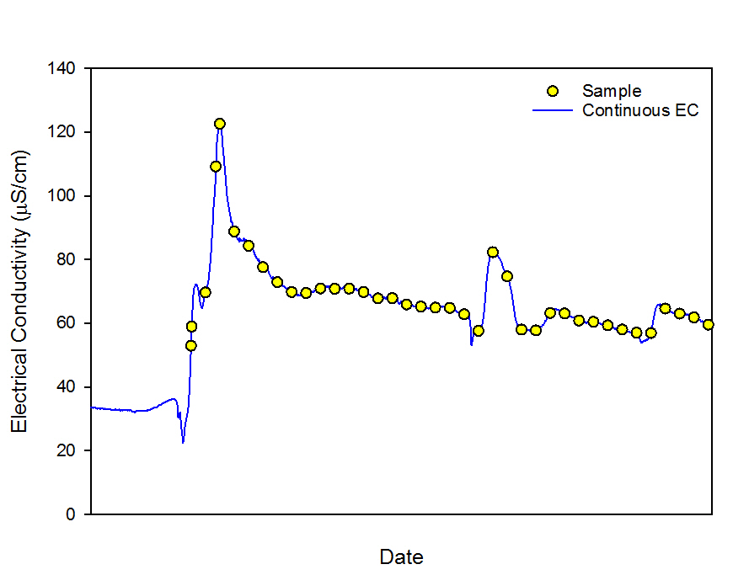

Figure 7 Samples collected over a pulse.

### Sample analysis

To reduce chemical alteration in collected samples (such as loss of solutes from the solution phase by adsorption to particulate matter in the solid phase) it is recommended that event-based samples are processed within 24 hours of collection, where safe and practical to do so.

From the samples that are collected (Figure 7) the number of samples sent for analysis will depend on the duration and the magnitude of the pulse. It is considered that at a minimum, each EC pulse should be defined by at least two samples during the rise, one sample as close to the peak as possible and two samples during the fall. More samples should be selected for analysis for longer duration pulses (Figure 8).

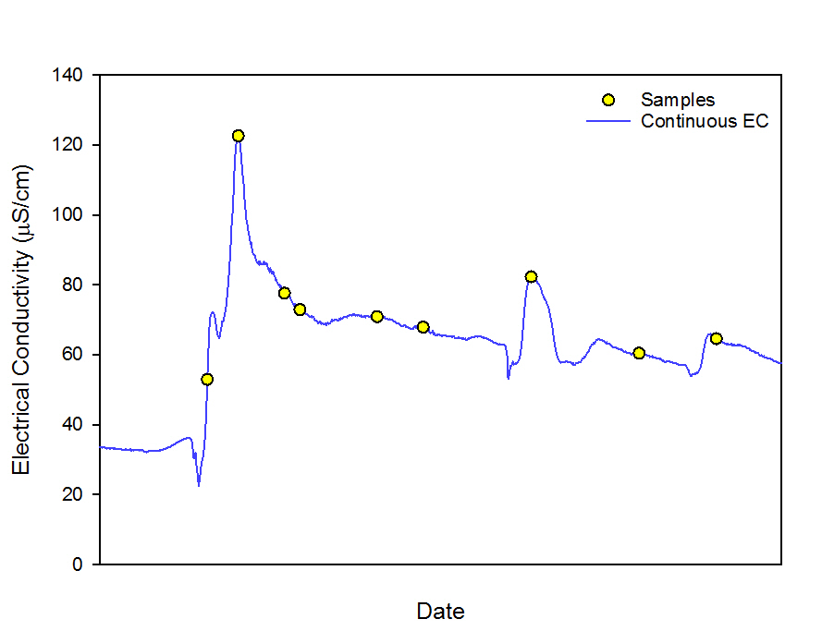

Figure 8 Samples selected for analysis.

Unfiltered samples should be analysed for total concentrations of key analytes, which will account for the proportion of dissolved metals that absorb to particulate material during sample standing periods. This also satisfies the Independent Surface Water Working Group recommendation to measure total (unfiltered) heavy metal concentrations in the statutory compliance monitoring program in place of filterable metal concentrations (ed Hart & Taylor 2013).

Total concentrations of metals and major ions should be measured by acidifying unfiltered samples to 5 per cent with nitric acid and digesting them at 100-110 ºC for a minimum of six hours, prior to analysis.

Failure to follow this method may void the concentration conversion factor (described below).

## Radium sampling

Radium sampling will be conducted as stipulated in Annex A.3 of the Ranger Authorisation.

## Data interpretation and reporting

With the exception of TAN and radium, the toxicity derived Trigger Values are based on dissolved concentrations of toxicants. To use total concentrations to assess environmental impacts based on these Trigger Values the Supervising Scientist has developed a set of concentration conversion factors (CCFs) that can be used to estimate an equivalent dissolved concentration from the measured total concentration.

In order to compare total metal concentrations against the Water Quality Objectives the total concentrations measured must be converted to equivalent dissolved concentrations using:

*Equivalent dissolved concentration = Total concentration x Concentration Conversion Factor*

The CCFs were derived using total and dissolved concentrations of key analytes measured by the Supervising Scientist between 2001 and 2014. From these data the mean proportion of the total concentration that was present in dissolved form was calculated, along with standard deviation (values shown in brackets in Table 4). Given the level of variability in the data, one standard deviation was added to the mean to generate the CCF. Hence, the CCF is the mean proportion of the total concentration that is present in the dissolved form plus one standard deviation.

**Table 4** Magnesium, manganese and uranium concentration conversion factors for the Supervising Scientist monitoring sites on Magela and Gulungul Creeks (figures in brackets are mean dissolved fraction percentage ± 1 standard deviation).

|  |  |  |  |  |
| --- | --- | --- | --- | --- |
|  | **Manganese CCF** | **Magnesium CCF** | **Uranium CCF** | |
| Magela upstream | 0.96 (0.81 ±0.15) | 1.0 (0.94 ±0.12) | 0.86 (0.71 ±0.15) |
| Magela downstream | 0.87 (0.59 ±0.28) |
| Gulungul upstream |
| Gulungul downstream |

These CCFs are only applicable to total concentrations that are analysed using the same method used by the Supervising Scientist (as described in Section 3.3.1). New CCFs can be derived for different sample analysis methods however sufficient data should be collected to provide confidence in the CCFs before they are applied.

# Actions invoked by exceedance of a Trigger Value

The actions invoked by an exceedance of a Trigger Value at a compliance site during periods of flow are described below.

## Exceedance of a Focus Trigger Value

#### Management action

Values that are higher than the *Focus level* but lower than the *Action level* will result in a *watching brief*. A watching brief involves precautionary ongoing data assessment to verify whether or not a trend away from background is occurring, possibly including further sampling if required.

#### Reporting requirement

A Focus Trigger Value exceedance shall be reported in the *Weekly Water Quality Report* provided by the company to the Supervising Authorities and key stakeholders.

## Exceedance of an Action Trigger Value

#### Management action

Values that are higher than the *Action level* but lower than the *Guideline/Limit* will result in a *data assessment*. Where assessment of the data shows the value represents a trend away from background the company must undertake:

* + An *investigation* into the cause of the exceedance; and
  + *Correction* of the cause if it is deemed to be mining related.

#### Reporting requirement

Values that are higher than the *Action* level but lower than the *Guideline/Limit* must be reported[3] to the Supervising Authorities and key stakeholders as soon as practicable.

An explanation of the cause (and any corrective action taken) shall be reported in the *Weekly Water Quality Report* provided by the company to the Supervising Authorities and key stakeholders.

## Exceedance of a Guideline Trigger Value

The company shall treat values in excess of the *Guideline* the same as a *Limit* exceedance except:

* + When there is a corresponding increase at the upstream site; and
  + For the Mn Limit when the flow is less than five cumecs.

Under the above circumstances a *Guideline* exceedance will be treated as for an *Action* exceedance.

## Exceedance of a Limit Trigger Value

#### Management action

Values that are higher than the *Limit* will result in a *full investigation*, including:

* Determining the cause of the exceedance;
* Collecting further samples and data; and
* Undertaking immediate *correction* of the cause if it is deemed to be mining related.

#### Reporting requirement

Values that are higher than a *Limit* must be reported both verbally and in writing to stakeholders immediately. The company will also provide a detailed written report as soon as practical to stakeholders detailing:

* All relevant data;
* The circumstances surrounding the exceedance of the Limit;
* The corrective actions taken to date; and
* Options for further corrective action.

#### Supervising Scientist action

If in the opinion of the Supervising Scientist the exceedance of a *Limit* is due to operations at Ranger mine the Supervising Scientist will advise the Minister with regard to:

* The circumstances surrounding the exceedance of the Limit; and
* Whether there has been a breach of the Ranger ERs.

In drawing a conclusion that the exceedance of the limit for 226Ra constitutes a breach of the ERs, the Supervising Scientist must be convinced that the mine derived radiation dose to the critical group has exceeded 1mSv (above background) in one year.

## Exceedance of the EC Investigation Trigger Value

#### Management action

When the *EC Investigation Trigger Value* is exceeded the Mg concentration for the duration of the event needs to be estimated using either the long-term Mg/EC relationships in Figure 4 or the event-specific relationship as described in Section 2.3.2. The process outlined in Figure 6 must then be followed in order to determine whether or not the estimated Mg concentration has exceeded the *Mg Pulse Exposure Guideline Value* of the *Mg Chronic Exposure Limit*. Exceedances of the *Mg Pulse Exposure Guideline Value* of the *Mg Chronic Exposure Limit* will invoke action according to Sections 4.3 or 4.4, respectively.

#### Reporting requirement

An exceedance of the *EC Investigation Trigger Value* will be reported in the same manner as an exceedance of an *Action* value.

# Ranger Mine Water Quality Objectives

**Table 5** Water Quality Objectives for Magela and Gulungul Creeks – to be applied at MG009W and GCLB during periods of flow.

| **Parameter** | **Objective** | **Trigger Values** | | | | **Measures of success** |
| --- | --- | --- | --- | --- | --- | --- |
| **Focus** | **Action** | **Guideline** | **Limit** |
| **pH** | (i) Undertake continuous monitoring of pH and report as appropriate. | - | - | - | - | (i) pH is monitored accurately and continuously.  (ii) Sufficient pH data are collected to enable reliable interpretation of key analytes in terms of their reactivity, bioavailability and toxicity. |
| **Turbidity** | (i) Undertake continuous monitoring of turbidity.  (ii) Retain the natural distribution of turbidity in Magela and Gulungul Creeks.  (iii) Report and act on Trigger Value exceedances at the downstream compliance sites.  (iv) Minimise mine derived turbidity at the downstream compliance sites to the greatest extent practicable. | 5 NTU | 10 NTU | 26 NTU | - | (i) Turbidity is accurately and monitored continuously.  (ii) Focus, Action and Guideline Trigger Values are not exceeded at downstream compliance sites (without accompanying exceedances at upstream control sites) more often than statistically expected.  (iii) All Trigger Value exceedances are investigated and reported as outlined in Section 4 of the Revised Water Quality Objectives for Magela Creek and Gulungul Creek (2015) *“Actions Invoked by Trigger Value Exceedances”*.  (iv) Turbidity values will not deteriorate compared to those measured in previous wet seasons, without reasonable cause. |
| **Manganese** | (i) Undertake event-based sampling for manganese.  (ii) Report and act on Trigger Value exceedances at the downstream compliance sites.  (iii) Minimise mine derived manganese at the downstream compliance sites to the greatest extent practicable. | 35 μg/L | 45 μg/L | - | 75 μg/L  (only applicable when discharge is > 5 cumecs) | (i) Manganese Limit is not exceeded at the downstream compliance sites without accompanying exceedances at upstream control sites.  (ii) All Trigger Value exceedances are investigated and reported as outlined in Section 4 of the Revised Water Quality Objectives for Magela Creek and Gulungul Creek (2015) *“Actions Invoked by Trigger Value Exceedances”*.  (iii) Manganese concentrations will not deteriorate compared to those measured in previous wet seasons, without reasonable cause. |
| **Electrical Conductivity and Magnesium** | (i) Undertake continuous monitoring of electrical conductivity and event-based sampling for magnesium.  (ii) When the electrical conductivity Investigation Trigger (42 μS/cm for > 6 hours) is exceeded, convert continuous electrical conductivity data to magnesium concentration data.  (ii) Report and act on Trigger Value exceedances at the downstream compliance sites.  (iii) Minimise mine derived magnesium at the downstream compliance sites to the greatest extent practicable. | 18 μS/cm  1 mg/L | 30 μS/cm  2 mg/L | -  Derived from  Figure 3  (Pulse exposure Guideline for exposures < 72 hours) | -  3 mg/L  (Chronic exposure Limit for exposures ≥ 72 hours) | (i) Electrical conductivity is monitored accurately and continuously.  (ii) Electrical conductivity Investigation Trigger is not exceeded at downstream compliance sites (without accompanying exceedances at upstream control sites) without reasonable cause.  (iii) Sufficient magnesium data are collected to enable reliable and accurate estimation of magnesium concentrations from electrical conductivity data.  (iv) Magnesium pulse exposure Guideline Trigger Values are not exceeded at downstream compliance sites (without accompanying exceedances at upstream control sites) without reasonable cause.  (v) Magnesium Limit is not exceeded at the downstream compliance sites without accompanying exceedances at upstream control sites.  (vi) All Trigger Value exceedances are investigated and reported as outlined in Section 4 of the Revised Water Quality Objectives for Magela Creek and Gulungul Creek (2015) *“Actions Invoked by Trigger Value Exceedances”*.  (vii) Electrical conductivity and magnesium concentrations will not deteriorate compared to those measured in previous wet seasons, without reasonable cause. |
| **Total Ammonia Nitrogen** | (i) Undertake event-based sampling for total ammonia nitrogen.  (ii) Report and act on Trigger Value exceedances at the downstream compliance sites.  (iii) Minimise mine derived total ammonia nitrogen at the downstream compliance sites to the greatest extent practicable. | 0.29 mg/L | 0.33 mg/L |  | 0.4 mg/L | (i) Total ammonia nitrogen Guideline Trigger Value is not exceeded at downstream compliance sites (without accompanying exceedances at upstream control sites) without reasonable cause.  (ii) All Trigger Value exceedances are investigated and reported as outlined in Section 4 of the Revised Water Quality Objectives for Magela Creek and Gulungul Creek (2015) *“Actions Invoked by Trigger Value Exceedances”*.  (iii) Total ammonia nitrogen concentrations will not deteriorate compared to those measured in previous wet seasons, without reasonable cause. |
| **Uranium** | (i) Undertake event-based sampling for uranium.  (ii) Report and act on Trigger Value exceedances at the downstream compliance sites.  (iii) Minimise mine derived uranium at the downstream compliance sites to the greatest extent practicable. | 0.3 μg/L | 0.9 μg/L | - | 2.8 μg/L  (DOC Modified Limits derived from Table 2 when DOC data is available) | (i) Uranium Limit value is not exceeded at the downstream compliance sites without accompanying exceedances at upstream control sites.  (ii) All Trigger Value exceedances are investigated and reported as outlined in Section 4 of the Revised Water Quality Objectives for Magela Creek and Gulungul Creek (2015) *“Actions Invoked by Trigger Value Exceedances”*.  (iii) Uranium concentrations will not deteriorate compared to those measured in previous wet seasons, without reasonable cause. |
| **Radium-226** | (i) Undertake routine sampling for Radium-226.  (ii) Report and act on Trigger Value exceedances at the downstream compliance sites.  (iii) Minimise mine derived radium-226 at the downstream compliance sites to the greatest extent practicable. | - | - | - | 3 mBq/L  (wet season geometric mean difference between compliance and upstream sites) | (i) The wet season geometric mean total radium-226 activity concentration measured at the downstream compliance sites minus that measured at the upstream control sites is not greater than the Limit.  (ii) All Trigger Value exceedances are investigated and reported as outlined in Section 4 of the Revised Water Quality Objectives for Magela Creek and Gulungul Creek (2015) *“Actions Invoked by Trigger Value Exceedances”*.  (iii) Radium-226 activity concentrations will not deteriorate compared to those measured in previous wet seasons, without reasonable cause. |

**Table 6** Guidance for continuous monitoring and event-based sampling methods.

|  |  |  |
| --- | --- | --- |
| **Methods** | **Purpose** | **Control** |
| **Event-based Sample Collection** | Event-based sampling should be implemented to ensure that each EC pulse recorded by the continuous monitoring system is sufficiently chemically characterised to allow effective assessment against the relevant Trigger Values.  Total concentrations of metals and major ions should be measured by acidifying unfiltered samples to 5 per cent nitric acid and digesting them at 100-110 ºC for a minimum of six hours, prior to analysis. | ERA should provide details of their sample collection methodology in the Annual Water Management Plan for stakeholder approval.  Total metal concentrations should be converted to equivalent dissolved metal concentrations by use of the appropriate concentration conversion factor prior to comparison with the Ranger Water Quality Objectives. Details in Section 3.5 of the Revised Water Quality Objectives for Magela Creek and Gulungul Creek (2015) *“Data Interpretation and Reporting”*. |
| **Continuous Monitoring Data** | Continuous monitoring data for EC, turbidity and pH should be recorded at a frequency that provides assurance that the full magnitude of a given pulse will be captured to an environmentally relevant resolution. | ERA should provide details of their data recording methodology in the Annual Water Management Plan for stakeholder approval. |
| **Continuous Monitoring QA/QC** | In order to use the continuous monitoring data for compliance monitoring a comprehensive quality control program is required to ensure data accuracy and reliability, including a routine program of in-situ check monitoring and instrument calibrations. | ERA should provide details of their continuous monitoring quality control program in the Annual Water Management Plan for stakeholder approval. |

# References

Australia, Parliament 2003. *Parliamentary and government publications: Report from the Environment, Communications, Information Technology and the Arts References Committee.* Regulating the Ranger, Jabiluka, Beverley and Honeymoon uranium mines. Chairperson J Cherry, Senate paper, Canberra.

Bollhöfer A, Doering C & Medley P 2015. A revised operational limit for the water 226Ra activity concentration downstream of Ranger mine. Internal report 643, Supervising Scientist, Darwin, NT.

Harford A & van Dam R 2013. An interim trigger value for ammonia in Magela Creek. In *eriss* research summary 2012–2013. Supervising Scientist Report 205, Supervising Scientist, Darwin NT, 14–20.

Harford A, Trenfield M, Cheng K & van Dam R 2014. Ecotoxicological assessment of manganese. Internal report 630, Supervising Scientist, Darwin, NT.

Hart B & Taylor M (eds) 2013. *Review of the surface water management and monitoring associated with the Ranger Uranium Mine, Northern Territory, Australia, Volume 1 - Main Report.* Report of the Independent Surface Water Working Group, Energy Resources of Australia Ltd, Darwin NT.

Hogan A, Trenfield M, Harford A & van Dam R 2013. Toxicity of magnesium pulses to tropical freshwater species and the development of a duration based water quality Guideline. *Environmental Toxicology and Chemistry* 32 (4), 1969-1980.

Hogan A, van Dam R, Houston M, Harford A & Nou S 2010. Uranium exposure to the tropical duckweed, Lemna aequinoctialis, and pulmonate snail, Amerianna cumingi: fate and toxicity. *Archives of Environmental Contamination and Toxicology* 59, 204–215.

IAEA (International Atomic Energy Agency) 2014. *Radiation Protection and Safety of Radiation Sources*. General Safety Requirements. International Atomic Energy Agency, Vienna.

ICRP (International Commission on Radiological Protection) 1996. Age-dependent Doses to Members of the Public from the Intake of Radionuclides: Part 5. Compilation of Ingestion and Inhalation Dose Coefficients. *ICRP Publication* 72.

ICRP (International Commission on Radiological Protection) 2007. The 2007 Recommendations of the International Commission on Radiological Protection. *ICRP Publication* 103 (37), 2-4.

ICRP (International Commission on Radiological Protection) 2008. Environmental Protection - the Concept and Use of Reference Animals and Plants. *ICRP Publication* 108 (38), 4-6.

Iles M 2004. Water Quality Objectives for Magela Creek – revised November 2004. Internal Report 489, Supervising Scientist, Darwin NT.

Johnston A, Murray A & Martin P 1984. Investigation of radium-226 concentrations in mussels. In Supervising Scientistresearch report 1983−84. Supervising Scientist, Darwin NT, 31−33.

Klessa D 2001. Water quality in Magela Creek upstream and downstream of Ranger: A summary of performance for 2000–2001 and derived triggers and limits for 2001–2002. Internal Report 380, Supervising Scientist, Darwin, NT.

Markich S 2013. Water hardness reduces the accumulation and toxicity of uranium in a freshwater macrophyte (Ceratophyllum demersum). *Science of the Total Environment* 443, 582-589.

Moliere D & Evans K 2010. Development of trigger levels to assess catchment disturbance on stream suspended sediment loads in the Magela Creek, Northern Territory, Australia. *Geographical Research* 48, 370-385.

Mooney TJ, Pease CJ, Hogan AC, Trenfield M, Kleinhenz LS, Humphrey C, van Dam RA & Harford AJ 2018. Freshwater chronic ammonia toxicity: a tropical‐to‐temperate comparison. *Environmental Toxicology and Chemistry*. In press.

Noller B, Currey N, Ayers G, Gillett R 1990. Chemical composition and acidity of rainfall in the Alligator Rivers Region, Northern Territory, Australia. *Science of The Total Environment* 91, 23-48.

Ryan B, Martin P, Humphrey C, Pidgeon R, Bollhöfer A, Fox T & Medley P 2005. Radionuclides and Metals in Fish and Freshwater Mussels from Mudginberri and Sandy Billabongs, Alligator Rivers Region. Internal Report 498, Supervising Scientist, Darwin, NT.

Trenfield M, Ng J, Noller B, Markich S & van Dam R 2011. Dissolved organic carbon reduces uranium bioavailability and toxicity. 2. Uranium[VI] speciation and toxicity to three tropical freshwater organisms. *Environmental Science and Technology* 40, 3082–3089.

UNSCEAR (United Nations Scientific Committee on the Effects of Atomic Radiation) 1996. *Sources and Effects of Ionizing Radiation*. Report to the General Assembly with Scientific Annexes. United Nations, New York.

UNSCEAR (United Nations Scientific Committee on the Effects of Atomic Radiation) 2008. *Sources and Effects of Ionizing Radiation*. Report to the General Assembly with Scientific Annexes. United Nations, New York.

USEPA (United States Environmental Protection Agency) 1999. *Toxicity reduction evaluation guidance for municipal wastewater treatment plants*. Office of Wastewater Management, United States Environmental Protection Agency, Washington, DC.

USEPA (United States Environmental Protection Agency) 2013. *Aquatic life ambient water quality criteria for ammonia – freshwater*. Office of Water, United States Environmental Protection Agency, Washington, DC.

van Dam R, Hogan A, McCullough C, Houston M, Humphrey C & Harford A 2010. Aquatic toxicity of magnesium sulfate, and the influence of calcium, in very low ionic concentration water. *Environmental Toxicology and Chemistry* 29 (2), 410-421.

van Dam R, Trenfield M, Markich S, Harford A, Humphrey A & Stauber J 2012. Re-analysis of uranium toxicity data for selected freshwater organisms and the influence of dissolved organic carbon. *Environmental Toxicology and Chemistry* 31(11), 2606–2614.

Walling D 1983. The sediment delivery problem. In Rodriguez-Iturbe I & Gupta V (eds), Scale Problems and Hydrology. *Journal of Hydrology* 65, 209-237.

1. In the event *site location* differs from *location description*; *location description* will take precedence.
2. Ranger Project Area.
3. Reporting by way of verbal communication is acceptable (Ranger Minesite Technical Committee 17/10/2003).