Recovery Plan for the Golden Bandicoot Isoodon auratus and Golden-backed Tree-rat Mesembriomys macrurus

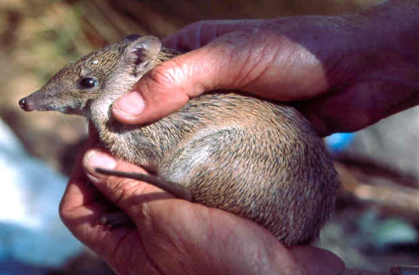
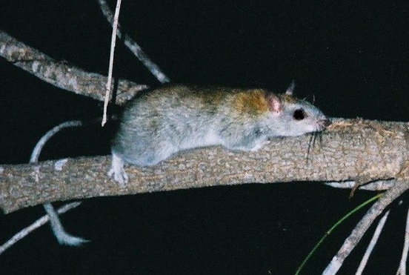
2004 – 2009

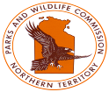

Recovery plan for the Golden Bandicoot Isoodon auratus and Golden-backed Tree-rat Mesembriomys macrurus 2004 - 2009

© Department of Infrastructure, Planning and Environment, Northern Territory

This work is copyright. It may be reproduced for study, research or training purposes subject to an acknowledgment of the sources and no commercial usage or sale. Requests and enquires concerning reproduction and rights should be addressed to Senior Wildlife Management Officer, Parks and Wildlife Service, PO Box 496 Palmerston 0831.

Citation

Palmer, C. Taylor, R. and Burbidge, A. (2003). Recovery plan for the Golden Bandicoot Isoodon auratus and Golden-backed Tree-rat Mesembriomys macrurus 2004 - 2009. Northern Territory Department of Infrastructure Planning and Environment, Darwin.

A Recovery Plan prepared under the Commonwealth Environment Protection and Biodiversity Conservation Act 1999.

Acknowledgments
This plan was prepared with support from the Natural Heritage Trust. Thanks to Bretan Clifford for map production, Tricia Handasyde for organising sections of the Kimberley data, Murray Ellis from NSW National Parks and Wildlife Service for information on past distribution and John Woinarski, Tony Start, Norm McKenzie and Chris Pavey for comments on earlier drafts.

ISBN: 190277226X

Front cover: Golden Bandicoot - Photo: Andrew Burbidge and Tricia Handasyde
Golden-backed Tree-rat – Photo: Terry Mahney

CONTENTS

summary 4

General information 6

Description 6
Conservation status 6
International obligations 8
Distribution 8
Ecology 14
Habitat critical for survival 16
Threats 16
Affected interests 18
Consultation with indigenous people 18
Benefits to other species or communities 18
Social and economic impact 18

Objectives, actions and performance criteria 19

Overall objectives 19
Specific objectives 19

Management Practices 24

References 25

summary

The Golden Bandicoot is listed nationally as Vulnerable and is known to have disappeared from almost all of its former wide distribution across half of the Australian continent, where it occupied a large range of habitats. The Golden Bandicoot is a small omnivorous marsupial which is now restricted to rocky sandstone spinifex habitats and vine thickets in the north Kimberley region, four Western Australian (WA) islands (two Pilbara, two Kimberley) and one island off the northeast Arnhem Land coast of the Northern Territory (NT). On the Kimberley mainland the Golden Bandicoot appears to have discrete and restricted populations. There are population estimates for three of the islands where the species is recorded. Golden Bandicoot populations have been estimated for Barrow Island (tens of thousands) and Middle Islands (1,000) in WA and Marchinbar Island (1,400) in the NT.

The Golden-backed Tree-rat is listed nationally as Vulnerable as its range has declined substantially in WA and it is known from only three historic records in the NT. The Golden-backed Tree-rat is a large rodent, which has been recorded from a broad range of habitats. There is little information on the ecology of this species and this lack of information provides a poor base for assessing the overall status of this species in WA and NT.

Populations of surviving Golden Bandicoots and Golden-backed Tree-rats are recorded on a range of tenures including Defence Land, Aboriginal Land, Conservation Land and Unallocated Crown Land. In the Kimberley there is no specific on-ground conservation management for either species. Likewise, in the NT, there is no on ground conservation management for the Golden Bandicoot. There are no population estimates for either species from the mainland or Kimberley islands.

No factor has yet been identified as causing the decline of either species or critical weight range (CWR) mammals generally in the Kimberley and Top End of the NT. The most likely causal factors are predation by feral cats and changed fire regimes. These factors may be operating synergyistically with increased susceptibility to predation after the undergrowth is destroyed by intense fires. Changed fire regimes and grazing by livestock and feral animals may have altered the availability of tall fruit bearing understorey shrubs for the semi-arboreal Golden-backed Tree-rat. The status of the Golden Bandicoot and Golden-backed Tree-rat is indicative of processes affecting critical weight range mammals associated with the tropical savannas of northern Australia.

Recovery actions detailed in this report include:

- Develop and implement cooperative management arrangements between relevant agencies, land managers and landowners (Commonwealth, State, Territory and at the regional level).
- Convene a multiple species recovery team (collaborating across jurisdictions) to address the issue of faunal decline in northern Australia;
- Monitor both species to determine population trends;
- In the NT translocate Golden Bandicoots from Marchinbar Island to two other suitable islands and follow-up with ongoing monitoring of source and translocated populations. Investigate recent possible sightings/records of Golden-backed Tree-rat;
- Identify key threatening processes affecting critical weight range mammals in the tropical savannas generally and initiate management to ameliorate threats;
- Develop appropriate educational and communication materials targeted at the diverse range of stakeholders; and
- Inform and involve the community and all stakeholders in the recovery process

Surviving populations of Golden Bandicoot and Golden-backed Tree-rat occur in remote areas with poor accessibility. There are thus high costs associated with on-ground management and adaptive research.

This Recovery Plan has been developed as a two-species Recovery Plan. However, recovery actions detailed in this document are likely to benefit a range of other declining species that co-occur with the Golden Bandicoot and Golden-backed Tree-rat. These include Northern Quoll Dasyurus hallucatus, Scaly-tailed Possum Wyulda squamicaudata, Rock Ringtail Possum Petropseudes dahli, Kimberley Rock Rat Zyzomys woodwardi and Pale Field Rat Rattus tunneyi, Partridge Pigeon Geophaps smithii and Black Grasswren Amytornis housei.

General information

Description

Golden bandicoot
Isoodon auratus is a small bandicoot generally weighing up to 670 g (mean adult weight 450 g), though recently two Golden Bandicoots were recorded weighing 820 g (Start unpubl. data). The Golden Bandicoot has golden-brown fur on its back and sides and stiff, quill-like guard hairs that give it a sleek appearance (McKenzie et al. 1995). It is superficially similar to the more common Northern Brown Bandicoot, Isoodon macrourus, though the Golden Bandicoot is smaller and has a flatter and more elongate head. The species are able to be distinguished unequivocally from differences in the morphology of their hair. Both species may have been marginally sympatric (Parker 1973) and have been recorded recently co-occurring in some areas (Palmer et al. in prep; Start unpubl. data). Recently, the Northern Brown Bandicoot has been reported to be prone to sudden declines in abundance, possibly linked to the occurrence of intense fires (Pardon et al. 2003).

The Golden Bandicoot was first described in 1897 from a specimen collected near Derby, Western Australia. Three bandicoot species are recognised in northern Australia; I. obesulus from Queensland, I. auratus from the Northern Territory and Western Australia and I. macrourus which occurs in all three states. For I. auratus two subspecies are recognised, Isoodon auratus barrowensis from Barrow Island and I. auratus auratus from the Kimberley and Northern Territory. However, the taxonomy of the genus Isoodon has recently been reviewed (Pope et al. 2001) based on mitochondrial DNA analysis. Pope et al. (2001) recognises two distinct lineages I. macrourus and an I. obesulus complex. This analysis does not recognise I. auratus as a separate species, but rather identifies it, including the Barrow Island subspecies, as a form of I. obesulus. This concurs with earlier work by Lyne and Mort (1981).

Golden-backed Tree-rat
Mesembriomys macrurus is a large rodent (about 200 g), midway in size between two other large semi-arboreal tree-rat species occurring in northern Australia, the smaller Brush-tailed Tree-rat Conilurus penicillatus and the larger Black-footed Tree-rat Mesembriomys gouldii. Distinctive features include a long slightly brush-tipped tail that is white for at least the distal half and white feet. The type specimen was collected in 1875 near Roebourne, WA.

Conservation status
Golden Bandicoot
The conservation status of the Golden Bandicoot (Isoodon auratus) varies across jurisdictions and is classified as:
- Nationally – both subspecies, I. auratus barrowensis and I. auratus auratus, are listed as Vulnerable under the Environment Protection and Biodiversity Conservation Act 1999
- Northern Territory - Endangered under the Northern Territory Parks and Wildlife Conservation Act 2000
- Western Australia – Schedule 1 (Fauna that is rare or likely to become extinct), Western Australia Wildlife Conservation (Specially protected fauna) Notice 2003, ranked as Vulnerable by the WA Threatened Species Scientific Committee
- South Australia - Endangered in Schedule 7, Part 1 of the National Parks and Wildlife Act 1972 South Australia
- New South Wales – Species presumed Extinct, Part 4 Threatened Species Conservation Act 1995 No.101

The listing at the national level has no associated documentation as to what IUCN categories the species qualifies under. Under version 3.1 of the International Union for the Conservation of Nature (IUCN) Red List Categories it does not qualify under the extent of population or range reduction as the reductions, although massive, occurred longer ago than the 10 years specified under the categories. It appears that the species declined from it’s former distribution by the early 20th Century (Lee 1995). It can be considered under criteria B as its area of occupancy is less than 2000 km² (see below). Under B2 it qualifies for criteria a (known to exist at no more than 10 locations, treating the whole of an island as one location). However, it also needs to qualify under another criteria to be considered as Vulnerable. Under criteria b a continuing decline in population or range is required. Recent surveys suggest that there has been no range decline in the north Kimberley since the first extensive surveys of that area in the 1970s (Tony Start pers comm.) There is no evidence of population declines in the island populations. However it is unknown as to whether populations on the mainland are still declining. If a precautionary approach is adopted the possibility of a continuing population decline on the mainland would qualify the species as Vulnerable under criteria B2ab(v).

In the Northern Territory it is classified as Endangered under criteria B1ab (I,ii,iii,iv,v); C2a(i) of version 3.1 of the IUCN Red List Categories¹:
- Extent of occurrence estimated to be <5,000 km²
- Population size estimated to number <2,500 mature individuals
- Severely fragmented or known to exist at no more than five locations
- A continuing decline, observed, projected or inferred
- No sub-population estimated to contain more than 250 mature individuals

Golden-backed Tree-rat
The Golden-backed Tree-rat is listed as:
- Nationally - Vulnerable under the Environment Protection and Biodiversity Conservation Act 1999
- Northern Territory - Endangered under the Northern Territory Parks and Wildlife Conservation Act 2000
- Not considered threatened under Western Australian legislation.

The listing at the national level has no associated documentation as to what IUCN categories the species qualifies under. Under version 3.1 of the IUCN Red List Categories it does not qualify under the extent of population or range reduction as the reductions, although large, occurred longer ago than the 10 years specified under the categories. There appears to be no reduction in its present range on the mainland (in the northern Kimberley) since the 1970’s (see below). It can be considered under criteria B as its area of occupancy is less than 2000 km² (see below).
Under B2 it qualifies for criteria a (known to exist at no more than 10 locations, treating the whole of an island as one location). However it also needs to qualify under another criteria to be considered as Vulnerable. Under criteria b a continuing decline in population or range is required. Recent surveys suggest that there has been no range decline in the north Kimberley since the first extensive surveys of that area in the 1970s (Tony Start, pers comm.) However it is unknown as to whether populations on the mainland are still declining. If a precautionary approach is adopted the possibility of a continuing population decline on the mainland would qualify the species as Vulnerable under criteria B2ab(v).

In the NT it is classified as Endangered (under criteria B1ab(I,ii,iii,iv,v); C2a(i)) based on:
- extent of occurrence estimated to be <5,000 km²
- population size estimated to number <2,500 mature individuals
- severely fragmented or known to exist at no more than five locations
- a continuing decline, observed, projected or inferred and
- no subpopulation estimated to contain more than 250 mature individuals.
However, there is a high level of uncertainty about total population size and extent of occurrence for the Golden-backed Tree-rat. There have been no recordings of the species in the Northern Territory since 1969 despite extensive wildlife surveys including many apparently suitable areas and it is possible the species is no longer present (Woinarski 2002).

International obligations
The Golden Bandicoot as part of the family Peramelidae is listed under Appendix 1 of the Convention on International Trade in Endangered Species of Wild Fauna and Flora (CITES). The Recovery Plan is consistent with CITES and with Australia’s other obligations under international agreements. The Golden-backed Tree-rat is not listed under CITES. Both species are listed as Vulnerable on the IUCN Red List (IUCN 2003).

Distribution
Golden bandicoot
The Golden Bandicoot was once widely distributed across northern and central Australia, including parts of South Australia and New South Wales (Ellis et al. 1991). The Golden Bandicoot occupied a wide range of habitats (McKenzie et al. 1975, 1978, 1995) including:
- Hummock and tussock grasslands on sand-dunes and sand-plains in the arid zone
- Acacia and Eucalyptus woodlands in the tropical semi-arid zone
- Vine thickets
- Heath and woodlands in rugged sandstone
- Volcanic country in the subhumid tropics

As recently as 1930 the range included vast areas of central Australia (McKenzie et al. 1995). A dramatic range contraction occurred in the middle of the 20th century and the species has not recently been recorded in inland areas. The most recent record for central Australia from The Granites (north Tanami Desert area) in the NT in 1952. In the NT the species is now known only from Marchinbar Island in the Wessel Islands group off north-east Arnhem Land (Southgate et al. 1996). Suitable habitat is present on other islands in the group but available evidence suggests the Golden Bandicoot does not occur on these islands.

In Western Australia, the species survives on the north Kimberley mainland, two islands off the Kimberley coast (Augustus and Uwins) and two islands off the Pilbara coast (Barrow and Middle) (Figure.1). It formally occurred on Hermite Island in the Montebello Islands (north of Barrow Island) but became extinct there about 1900. Extinction has been attributed to the introduction of feral cats and black rats (Burbidge et al. 2000).

Approximate total area of occupancy is 65,260 ha. This is based on 5 km² at the point data sites and the total area of islands where the species is recorded from for post 1990 records.

Golden-backed Tree-rat
All specimens, apart from one, come from areas that have a mean annual rainfall of more than 600 mm (McKenzie and Kerle 1995) both in the Northern Territory and Western Australia. The exception was the type specimen collected in 1875 from the wettest part of the relatively arid Pilbara coastline near Roebourne, Western Australia with an annual rainfall of 320 mm. There is some question about where the specimen actually originated (McKenzie pers. comm.). Today the Golden-backed Tree-rat is restricted to areas near the coast in the north Kimberley. Early records suggest that the species was previously found in drier inland woodlands of the Kimberley and the Top End of the Northern Territory. Dahl (1897) stated that the species frequented the hollow trees of the Eucalyptus shrubs (eucalypt-acacia woodlands on red sandy plains) around Broome and noted that it was a common species. Fauna surveys in 2003 recorded the species in 5 coastal areas of the north Kimberley including Uwins Island (Start unpubl. data). The species has previously been recorded in coastal areas of the north Kimberley and five offshore Kimberley islands (Carlia, Conilurus, Hidden, Uwins and Wollaston) (Abbott and Burbidge 1995). Recent surveys suggest that there has been no range decline in the North Kimberley since the first extensive mammal surveys of that area in the 1970s (Start pers comm.).

In the Northern Territory, the Golden-backed Tree-rat is known from only three records (Parker 1973): at “Balanbrinni” (probably Balbarini) in the upper McArthur in 1901; from Nellie Creek (in the upper Mary) in 1903; and from Deaf Adder Gorge in 1969. Limited subsequent attempts to capture the species at the latter site have failed (McKenzie and Kerle 1995). It has not been confirmed elsewhere despite many surveys across much of the Top End over the last 30 years. However, there are several unconfirmed records based on possible sightings (Gerowie Creek ca1998; Melville Island ca 1990; Tjenya Falls ca 1988) and limited hair samples in one case (Marchinbar Island) (Woinarski 2002). Comprehensive fauna surveys on Melville Island from 1999 to 2002 failed to locate the species (Woinarski et al. 2003).

Approximate total area of occupancy is 123 km². This is based on 5 km² at the point data sites and total area of islands where the species is recorded from post 1990 records.

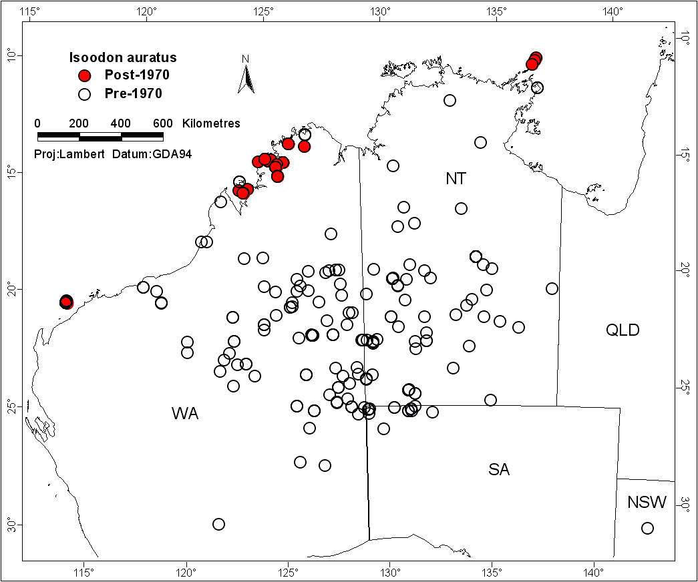

Figure 1. Pre 1970 and post 1970 distribution of the Golden Bandicoot Isoodon
auratus.

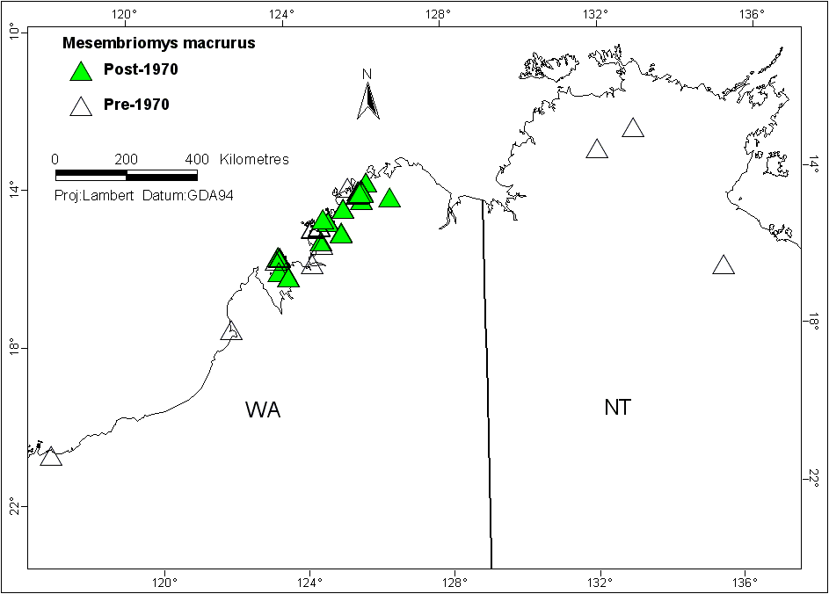

Figure 2. Pre 1970 and post 1970 distribution of the Golden-backed Tree-rat
Mesembriomys macrurus.

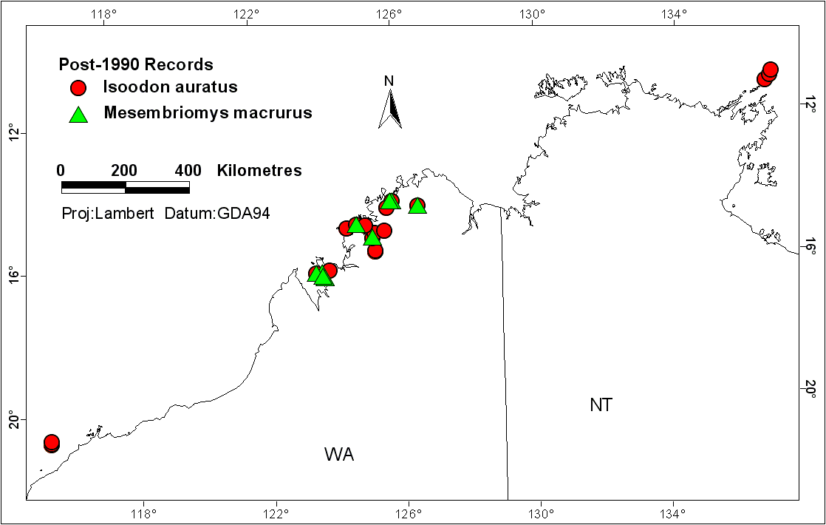
Figure 3. Post 1990 distribution for Golden Bandicoot Isoodon auratus and Golden-backed Tree-rat Mesembriomys macrurus.

Table 1. Known populations of the Golden Bandicoot and Golden-backed Tree-rat.

Location of current known populations | Species | Most recent record | State | Tenure | Estimated population and data type | Habitat | Potential threats | Some examples of co-occurring declining species
Bachsten Creek (mainland) | golden bandicoot | 2002 | WA | Unallocated Crown Land | unknown | King Leopold Sandstone – heathland on dissected sandstone | - loss of structural diversity via frequent fire  - predation by feral cats | - Northern Quoll  - Scaly-tailed Possum  - Rock-ringtail Possum  - Black Grasswren  - Partridge Pigeon
Augustus Island (Kimberley) | golden bandicoot | 2003 | WA | Aboriginal Lands Trust | unknown | Warton Sandstone -heathland on dissected sandstone | - introduction of feral cats  - loss of structural diversity via frequent fire | - Northern Quoll
Barrow Island | golden bandicoot | 2003 | WA | Class A Nature Reserve | several tens of thousands | Limestone, Triodia spp. | - introduction of foxes, feral cats or rats  - gas field development | - Burrowing Bettong  - Spectacled Hare-wallaby  - Black-flanked Rock-wallaby  - Brush-tailed Possum
Middle Island | golden bandicoot | 1998 | WA | Class A Nature Reserve | 1,000 | Quaternary sand with Spinifex longifolius | - introduction of foxes, feral cats or rats  - inappropriate fire regimes
Marchinbar Island | golden bandicoot | 1994 | NT | Aboriginal Freehold | 1,400 | Heathland on dissected sandstone | - introduction of feral cats  - loss of structural diversity via frequent fire | - Northern Quoll  - possibly Golden-backed Tree-rat
Yampi Sound Training Area (mainland) | both species | 2002 | WA | Defence | unknown | King Leopold Sandstone – heathland on dissected sandstone | - loss of structural diversity via frequent fire,  - predation by feral cats  - development of live firing range | - Northern Quoll  - Partridge Pigeon
Location  of current known populations | Species | Most recent record | State | Tenure | Estimated population and data type | Habitat | Potential threats | Some examples of co-occurring declining species
Prince Regent Nature Reserve  (mainland) | both species | 2003 | WA | Class A Nature Reserve | unknown | King Leopold Sandstone – heathland on dissected sandstone, vine thicket | - loss of structural diversity via frequent fire  - predation by feral cats | - Northern Quoll  - Scaly-tailed Possum  - Black Grasswren  - Partridge Pigeon
Mitchell Plateau (mainland) | both species | 2003 | WA | Aboriginal Reserve National Park | unknown | King Leopold Sandstone – heathland on dissected sandstone, vine thicket | - loss of structural diversity via frequent fire  - predation by feral cats  - unmanaged cattle | - Northern Quoll  - Scaly-tailed Possum  - Rock-ringtail Possum  - Black Grasswren  - Partridge Pigeon
Carlia Island (Kimberley) | golden-backed tree-rat | 1973 | WA | Unallocated Crown Land | unknown | Warton Sandstone – heath on dissected sandstone | - introduction of feral cats  - loss of structural diversity via frequent fire | - Northern Quoll
Wollaston Island (Kimberley) | golden-backed tree-rat | 1972 | WA | Unallocated Crown Land | unknown | Heath on dissected sandstone | - introduction of feral cats  - loss of structural diversity via frequent fire | - Northern Quoll
Hidden Island (Kimberley) | Golden-backed tree-rat | 1982 | WA | Unallocated Crown Land | unknown | King Leopold Sandstone – heath on dissected sandstone | - introduction of feral cats  - loss of structural diversity via frequent fire | - Northern Quoll  - Nabarlek
Conilurus Island (Kimberley) | Golden-backed tree-rat | 1982 | WA | Unallocated Crown Land | unknown | King Leopold Sandstone – heath on dissected sandstone | - introduction of feral cats  - loss of structural diversity via frequent fire

Ecology

Golden Bandicoot
Most information on the ecology of the Golden Bandicoot comes from a single short-term study on Marchinbar Island (Southgate et al. 1996). Like other peramelids, the Golden Bandicoot is omnivorous. From scat analyses, Southgate et al. (1996) concluded the diet on Marchinbar Island was comprised mainly of beetles and ants but included cockroaches, spiders, centipedes and plant material. On the Western Australia mainland the diet includes insects, arachnids and plant material (McKenzie et al. 1995). On Barrow Island Golden Bandicoots have been observed eating turtle eggs and reptiles (McKenzie et al. 1995)

The Golden Bandicoot appears to be a solitary species (McKenzie et al. 1995) although home ranges have some overlap (Southgate et al. 1996). On Marchinbar Island, male home ranges vary from 4.4 ha to 35 ha while female ranges varied from 1.7 ha to 12.7 ha. Sample sizes were small in the NT study and home ranges of males and females did not differ statistically. Home ranges also tended to be larger in the dry season, although again the difference between seasons was not significant. A preliminary radio tracking study by Graham (1996) in the north Kimberley indicated that Golden Bandicoots have defined areas of activity centred on nest sites.

On Marchinbar Island, Golden Bandicoots tend to be associated with low heath vegetation or shrubland comprising Grevillea sp., Asteromyrtus sp. and Acacia sp. on sand or sandstone, with ground cover vegetation dominated by Triodia spp. Similarly, on Barrow Island Golden Bandicoots were observed to seek shelter primarily in hummock grasses but also in limestone caves. On the Kimberley mainland, Golden Bandicoots have been recorded in King Leopold Sandstone with an understorey comprising Triodia sp., Cymbopogon sp., Eragrotis sp., Eriachne sp. and perennial Sorghum sp. (Palmer et al. in prep).

Some differences have been recorded between Golden Bandicoot populations at different sites. Marchinbar Island Golden Bandicoots are sexually dimorphic and larger than Golden Bandicoots on Barrow Island (Bradshaw et al.1994; Southgate et al. 1996;), but smaller than those in the Kimberley (McKenzie et al. 1975; Friend et al. 1991). Golden Bandicoots on Marchinbar Island appear to breed all year round (Southgate et al. 1996), whereas the Golden Bandicoot population on Barrow Island shows a strong seasonality with a summer peak. In the Kimberley, Golden Bandicoots have been recorded with two pouch young in May (Tony Start unpubl. data) and September (Carol Palmer unpubl. data).

There have been three published estimates for the Golden Bandicoot population on Barrow Island: 1000+ (Butler 1970), 4,000 (Short et al. 1988) and 60,000 to 80,000 (McKenzie et al. 1995). Ongoing trapping and radio tracking data for Barrow Island suggest a population of some tens of thousands (Burbidge pers comm.). On Middle Island the population has been estimated around 1,000 (Burbidge pers comm.) and Marchinbar Island 1400 (Southgate et al. 1996). Apart from Barrow Island and occasionally Middle Island there is currently no monitoring of any of the surviving Golden Bandicoot populations and no explicit conservation management undertaken.

Golden-backed Tree-rat
Most information on the Golden-backed Tree-rat comes from a 10-day study at Mitchell Plateau and a short-term diet analysis study (Morton 1992). Hence, ecological information on Golden-backed Tree-rat is based on limited data. The species has never been recorded commonly in any habitat (Kerle 1987). Rather has been recorded around the ecotone between monsoon forest patches and some savanna woodland types, some distance from monsoon forest, mangroves and the boulder edges of a plateau (Kerle 1987). Friend et al. (1991) described the habitat of Golden-backed tree-rats as rainforest patches, some woodlands with fan palms (Livistona spp.) or screw palms (Pandanus spp.) and, occasionally, rugged sandstone scree. McKenzie and Kerle (1995) describe the habitats used in the Kimberley as:
- Rainforest patches on volcanic, lateritic
- Sandstone and floodplain surfaces
- Eucalypt-dominated woodlands over tussock
- Hummock grasslands on volcanic hill country
- Lateritic uplands (with Livistona palms)
- Blacksoil plains (with Pandanus trees)
- Rugged sandstone screes
- Coastal beaches adjacent to the above communities
- Mangroves

During a fauna survey of Yampi Sound Training Area in 2002 (Palmer et al. in prep), Golden-backed Tree-rats were recorded in King Leopold Sandstone comprising a shrub layer of Erythrophleum chlorostachys, Acacia stigmatophylla, Cycas furfuracea, Petalostigma pubescens, Buchanania obovata. At this site they co-existed with the Golden Bandicoot Isoodon auratus. Presence and absence data collected during a mammal survey in the north Kimberley during 2003 suggest that Golden-backed Tree-rats were common in open woodland (Tony Start unpubl. data).

In the NT, the specimen from Deaf Adder Gorge collected in 1969 was found among Pandanus along a watercourse in sandstone country. There is no habitat information for the other two NT sites.

Diet of the Golden-backed tree-rat was assessed via scat analysis from five individuals collected during the dry season from a site that encompasses escarpment, vine thicket and savanna woodland in the Mitchell Plateau area of WA. They were found to eat predominantly fruit, flowers (Persoonia falcata, Hypoestes floribunda, Canarium australianum, Eucalyptus tetrodonta), and termites with small amounts of some grass, dicotyledon leaves, ants and beetles (Morton 1992).

The species roosts in tree hollows or occasionally in loose woven nests under the spiky crown of pandanus. In the wild, pregnant females and immatures have been found from August through to October (Kitchener et al. 1981). In captivity animals breed readily and all year round (S. Templeton pers. comm.) and it is possible that this also occurs in the wild (McKenzie and Kerle 1995) as occurs with black-footed tree-rats (B. Rankmore pers. comm.). Females have four teats and usually have two, but sometimes one or three, young.
Young are weaned at six or seven weeks and are fully-grown at four months and mature at around 12 months. A female and young have been found in a nest of woven strips of leaves in the foliage of a Pandanus tree (McKenzie and Kerle 1995).

Radio tracking of Golden-backed tree-rats at Mitchell Plateau found them to be relatively solitary with large home ranges (500 m in length) (Kerle 1992). The larger black-footed tree-rat has a home range of around 30-50 ha in open forest near Darwin (B. Rankmore pers. comm.) and the smaller brush-tailed tree-rat ranged from 0.1 to 4.4 ha in open forest on Cobourg Peninsula (Firth 2003). The patchy nature of the occurrence of fruit probably requires individuals to be reasonably mobile and the need for a large home area indicates that a patch of suitable habitat cannot support many individuals. One pair of adults and, probably, some juveniles occupy a home range (McKenzie and Kerle 1995).

Habitat critical to the survival of the Golden Bandicoot and Golden-backed Tree-rat
On the Kimberley mainland the Golden Bandicoot is now only recorded in rocky sandstone habitats and vine thickets within the medium to high rainfall area (700 to 1200mm). In the Pilbara, Golden Bandicoots survive on two islands with an arid climate and on one island the Northern Territory where they occupy heathland on sandstone.

There are remarkably few records for the Golden-backed Tree-rat from the NT and this provides an inadequate basis for assessing habitat critical to the species survival. In the Kimberley, presence/absence data suggest a range of habitats including rugged King Leopold and Warton sandstone with Eucalyptus sp. open woodland over hummock grassland and the ecotone between monsoon forest patches and some savanna woodland types.

Given the large declines shown by both species all areas that have extant populations should be regarded as habitat critical to the species. This is particularly the case with island populations because of their isolation from threatening processes such as feral cats.

Threats
Australia’s terrestrial mammal fauna is particularly susceptible to declines and extinction (McKenzie and Burbidge 2002). Twenty-two species of mammals are extinct in Australia with eight other species remaining only on continental islands (McKenzie and Burbidge 2002). The causal factors most frequently cited as the cause of decline are predation and changed fire regimes. In northern Australia, although large-scale extinction has not occurred, there is a pattern of general decline (Woinarski et al. 2001) and the causes of this decline are unknown. Woinarski et al. (2001) and McKenzie and Burbidge (2002) considered the most likely cause of mammal decline in the north to be changed fire regimes and pastoralism. Recent research on fire impacts in Kakadu National Park has been inconclusive (Watson and Woinarski unpubl. data) because of complex and inconsistent patterns being exhibited. Mammal declines in southern Australia have been linked to the fox, which is not present in northern Australia. However, the feral cat Felis catus is present. Cats have been shown to prevent the introduction of mammals to arid areas (Gibson et al. 1994; Short and Smith 1994), and cause major mortality for the endangered Barred Bandicoot Perameles gunni (Seebeck et al. 1991). Cats have caused the extinction of populations on islands (Delroy et al. 1986; Dickman 1993).
The extinction of the Golden Bandicoot from Hermite Island (near Barrow Island) before 1912 has been attributed to the introduction of the feral cats (McKenzie et al. 1995; Burbidge et al. 2000). Species can recover on islands once feral cats have been removed (Dickman 1996). In northern Australia, predation from cats, in conjunction with intense fires, could be causing the decline of mammals. Intensive fires, by opening up the undergrowth, may make animals more susceptible to predation.

Recent studies in northern Australia have confirmed that relatively intense late dry season fires are having a significant impact on rainforest patches and obligate seeder species, particularly in rugged sandstone areas (Russell-Smith et al. 1998; Russell-Smith et al. 2001). Many obligate seeder species in this rocky habitat require a five years fire free period to reproduce (Russell-Smith et al. 2001). Fire history for the Kimberley mapped from coarse resolution NOAA satellite images inferred that large hot dry season fires are occurring in some places about every two years in this rugged sandstone habitat. There is anecdotal evidence of increasing Sorghum loads in these rocky areas matched by a decrease in Triodia (spinifex) cover potentially due to annual or biannual fires occurring in this habitat. Recent assumptions that areas of the Top End and north Kimberley provide a refuge for a range of mammal species (Woinarski and Braithwaite 1990) would appear to be overly optimistic (McKenzie and Burbidge 2002; Palmer et al. in prep).

Golden Bandicoot

The greatest threat to the island populations in both the NT and WA is the deliberate or inadvertent introduction of cats.

Predators of the Golden Bandicoot include the feral dog, dingo and feral cat, and native species such as pythons and monitor lizards. Bandicoots on Marchinbar Island were in the past hunted occasionally by Aboriginal landowners. Native predators are not considered a threat to healthy populations. Feral dogs have been present on Marchinbar Island for around 30-50 years, and these are known to take some bandicoots. However, this predation is considered low level. Marchinbar Island has no feral cats.

In Western Australia there is no information on the level of mortality from feral predators. Feral cats, dogs and dingoes are present on the mainland and a dingos have been recorded on Uwins and Augustus Islands. Middle and Barrow Islands are free of feral predators. Barrow Island is subject to strict environmental protection procedures that controls damage to vegetation and prevent the invasion of exotic species (McKenzie et al. 1995).

Golden-backed Tree-rat
The decline of the Golden-backed Tree-rat from the Northern Territory and drier areas of WA is symptomatic of a more general decline occurring in many mammals in northern Australia. The causes of this decline are unknown. The patchy nature of food resources, and their susceptibility to disturbance, could explain the decline of tree-rat populations, particularly in the more inland areas of their distribution. Grazing by introduced cattle and buffalo and changes in fire regimes since European settlement may have reduced the understorey trees and shrubs that the animals rely on for food and opened up the understorey making animals vulnerable to predation by feral cats. These factors probably had a more severe impact in the drier areas of the species distribution leading to a contracting of populations to the higher rainfall coastal areas.

Affected interests
The Golden Bandicoot and Golden-backed Tree-rat occur on a range of tenures. In WA the Department of Conservation and Land Management is responsible for fire, ferals and weeds on Conservation Land which would include Prince Regent Nature Reserve, Barrow and Middle Islands, and Unallocated Crown Land (via funding from Department of Land Administration). The Defence Department is responsible for managing Yampi Sound Training Area. Aboriginal Reserves are mostly Crown Lands vested in the Aboriginal Lands Trust for benefit, use and enjoyment of Aboriginal People.

All land in the Kimberley where the species occur is under the Dameimangari Native Title Claim made by the Worrora people of the north Kimberley. In the NT, the extant range of the golden bandicoot is an island within the Arnhem Land Aboriginal Trust. The Northern Land Council has legislative responsibility for identifying traditional ownership and advising on land use and management issues.

A multiple species recovery group would include Aboriginal traditional owner groups or their representative organisations and the Defence Department. Planned recovery actions include employment of local Aboriginal people, particularly in undertaking regular “cat-watch” patrols over islands.

Consultations with indigenous people
Recovery actions under this plan include the development and implementation of cooperative management arrangements between the relevant agencies, land managers and landowners. The multiple species recovery group would include representatives of traditional owners from areas where the species occurs. These representatives attending recovery group meetings would be consulted directly during the recovery process.

Benefits to other species or communities
Recovery actions detailed in this document are likely to benefit a range of other critical weight range mammals. Species include Northern Quoll Dasyurus hallucatus, Scaly-tailed Possum Wyulda squamicaudata, Rock Ringtail Possum Petropseudes dahli, Kimberley Rock Rat Zyzomys woodwardi and Pale Field Rat Rattus tunneyi. Declining granivorous birds such as Partridge Pigeon Geophaps smithii and Black Grasswren Amytornis housei are also likely to benefit via implementation of more suitable fire regimes (Franklin 1999; Fraser et al. 2003).

Social and economic impacts
The Recovery Plan aims to contribute positively to people and local communities within the distribution of the Golden Bandicoot and Golden-backed Tree-rat by providing part-time employment to traditional owners via “cat-watch” patrols. The implementation of the plan is unlikely to cause any adverse social or economic impacts.

objectives, actions and pERFORMANCE CRITERIA

Sites where the Golden Bandicoot and Golden-backed-Tree-rat have been recorded are extremely remote. Tenures on these sites are Aboriginal Land (4 sites including 3 islands), Defence Land (1 site), Conservation Reserve (3 sites including 2 islands) and Unallocated Crown Land (5 sites including 3 islands). There are major constraints to implementation of this Plan due to the high costs associated with work in remote areas, and the absence of any existing regional threatened species management programs where the species survives. The successful conservation of the species will be reliant on:
- the commencement of monitoring for feral cats (“cat watch”) on islands where the species occurs (this could be done in conjunction with AQIS and Norforce) and
- development of cooperative management arrangements between Government agencies, Aboriginal landowners and their representative organisations. Long-term funding programs could be targeted towards local people who live in these remote areas and who could be employed to undertake strategic early dry season fire management, maintain a regular “cat-watch” over islands and undertake feral animal control.

Overall objectives
- To maintain or improve the conservation status of the Golden Bandicoot and Golden-backed Tree-rat (currently listed nationally as Vulnerable)
- To achieve an accurate assessment of population trends and
- To identify the key threatening processes.

Specific objectives
- Develop and implement cooperative management arrangements between relevant agencies, land managers and land owners (Commonwealth, State, Territory and regional level).
- Convene a multiple species recovery team (collaborating across jurisdictions) to address the issue of faunal decline in northern Australia.
- Monitor both species to determine population trends.
- In the NT translocate Golden Bandicoots from Marchinbar Island to two other suitable islands and follow-up with ongoing monitoring of source and translocated populations. Investigate recent possible sightings/records of Golden-backed Tree-rat.
- Identify key threatening processes affecting critical weight range mammals in the tropical savannas generally and initiate management to ameliorate threats.
- Develop appropriate educational and communication materials targeted at the diverse range of stakeholders.
- Inform and involve the community and all stakeholders in the recovery process.

Table 2. Recovery objectives, actions and performance criteria.

Objectives | Actions | Performance criteria | Stakeholders | $ contributed | $ needed
1. Develop and implement cooperative management arrangements between relevant agencies, land managers and land owners (Commonwealth, State, Territory and regional level) | 1.1 Establish cooperative management processes and procedures between various Government agencies (CALM, EA, Defence, PWCNT) and relevant Aboriginal landowners | - “Across border” distribution data base and research portfolio set-up and maintained.  - Number of management agreements brokered with land owners or managers. | EA, PWCNT, CALM, Defence, Land Councils |  | $10K per year
 | 1.2 Establish process and procedures for engagment of Traditional Owners and other stakeholders in Recovery Plan | - Number of consultations undertaken with Traditional owners and other stakeholders  - Number of stakeholder groups involved in management on an on-going basis. | EA, CALM, PWCNT, Defence, Land Councils and representative bodies |  | $10K per year
2. Convene a multiple species recovery team (collaborating across jurisdictions) to address the issue of faunal decline in northern Australia. | 2.1 Form northern Australian multiple species recovery group, collaborate across jurisdictions via multiple species recovery group | - By 2009 group has met at least 5 times | EA, CALM, PWCNT, Defence, TSM-CRC, Land Councils |  | $20K per year
3. Monitor both species to determine population trends. | 3.1 Establish population monitoring sites at two WA mainland sites (Mitchell Plateau and Yampi Sound Training Area) | - By 2006 population estimates determined  - monitored annually | EA, CALM, PWCNT, Wunambal-Gaambera Aboriginal Corporation |  | $12K per year

Objectives | Actions | Performance criteria | Stakeholders | $ contributed | $ needed
 | 3.2 Determine population estimates for Uwins Island and establish monitoring sites | - By 2006 population estimates determined  - monitored once every 2 year | EA, CALM, Wunambal-Gaambera Aboriginal Corporation |  | $12K bi-annual
 | 3.3 Continue monitoring program on Barrow Island | - Population monitored annually or bi-annually | CALM | $31K
 | 3.4 Determine current status of Golden Bandicoot population on Marchinbar Island | - By 2005 population estimates determined | EA, PWCNT, NLC | $10K | $15K
4. In the NT translocate Golden Bandicoots from Marchinbar Island to two other suitable islands and follow-up with ongoing monitoring of source and translocated populations. Investigate recent possible sightings/records of Golden-backed Tree-rat. | 4.1 Translocate Golden bandicoot populations on at least two other suitable islands in the Wessel or English Company Island groups of northeastern Arnhem Land | - Populations translocated, viable and increasing.  - Annual monitoring of Marchinbar Island and translocated populations for 2 years after translocation. | EA, PWCNT, NLC | $60K | $12K per year
 | 4.2 Determine whether Golden Bandicoot still extant on the Napier Peninsula. | - By 2007 presence clarified and if applicable population estimates determined | EA, PWCNT, NLC | $5K | $5K
 | 4.3 Clarify status of Golden-backed Tree-rat on Marchinbar Island | - By 2005 presence clarified and if applicable population estimates determined | EA, PWCNT, NLC | $5K | $5K
Specific Objectives | Actions | Performance criteria | Stakeholders | $ contributed | $ needed
 | 4.4 Sample historic locations of Golden-backed Tree-rat to determine if populations persist. | - By 2006 presence clarified and if applicable population estimates determined | EA, PWCNT | $10K | $5K
5. Identify key threatening processes affecting critical weight range mammals in the tropical savannas generally and initiate management to ameliorate threats. | 5.1 Identify factors that are driving the decline in critical weight mammals through a landscape scale experiment based in the NT. | - By 2008 factors determined and management effort focussed on halting decline at a number of key areas and for a number of critical weight range mammals | EA, PWCNT, Cobourg Board | $65K | $330K
6. Develop appropriate educational and communication materials targeted at the diverse range of stakeholders | 6.1 Develop and disseminate educational and communication materials concerning fire and the introduction of feral animals, particularly cats, onto islands where the Golden Bandicoot and Golden-backed Tree-rat survives | - By 2007 video and A3 booklets produced and distributed | EA, CALM, PWCNT, Aboriginal organisations, Land Councils, Tourism Organisations, |  | $20K per year
 | 6.2 Develop contingency plan in case of feral animal introduction onto islands | - By 2005 policy and procedures manual produced and distributed to relevant organisations | EA, CALM, PWCNT |  | $5K

Objectives | Actions | Performance criteria | Stakeholders | $ contributed | $ needed
7. Inform and involve the community and all stakeholders in the recovery process | 7.1 Produce educational packages and communication material on the Recovery Plan for all stakeholder groups in the region | - Stakeholder groups informed and involved in implementation of the recovery plan | CALM, PWCNT, relevant Aboriginal people, Defence Force, shire Councils |  | $10K per year
 | 7.2 “Cat-watch Patrol” local people with tracking skills employed to undertake tracking transects on Uwins, Augustus and Marchinbar Islands to monitor presence/absence of cats, rats, dogs | - By 2005 tracking transects established on islands  - visited once every 6 months to undertake feral animal tracking transects | CALM, PWCNT, relevant Aboriginal people, Defence Force (Norforce), Quarantine |  | $15K per year

Management practices

A formal mammal monitoring program on Barrow Island was commenced in 1998 (Morris et al. 2002) to address:

a) Monitoring of mammal populations inside and outside the oilfield using a combination of spotlight transects and trapping;

b) Monitor fauna response where rat eradication was undertaken; and

c) Monitor to ensure that feral animal, especially rodents and cats do not establish on the island.

Monitoring feral animals regularly on the islands where the species occurs is recommended and in the Kimberley and on Marchinbar Island the monitoring program could incorporate local peoples tracking skills (combined with the formal monitoring program). The development of a contingency plan including operational procedures in the advent of feral cat/rat introductions will be the key to managing the feral animal threat in an efficient manner.

One island in the Kimberley stands out for biodiversity conservation as both species are present (Uwins Island). It is suggested that a regular trapping program to monitor the populations be commenced in conjunction with the two Kimberley mainland sites where both species are also present (Yampi Sound Training Area and Mitchell Plateau).

Since Golden Bandicoots only occur on one island in the Northern Territory there is a high risk of loosing the population in the event of feral cats being introduced or the occurrence of an intense fire over the whole island. To reduce this risk it is recommended that new populations be established via translocation from Marchinbar to at least two other suitable islands in the Wessel or English Company Island groups of northeastern Arnhem Land. The Parks and Wildlife Commission of the Northern Territory (PWCNT) has undertaken a comprehensive survey of plants and animals across all main islands in the Wessel and English Company Island groups, in the vicinity of Marchinbar Island (Woinarski et al. 1999, 2000). Based on this information, a number of islands are considered potentially suitable (on the basis of size, appropriateness of habitat, access, and absence of known threats) for establishing new populations of golden bandicoot. The suitability of these islands for translocation obviously needs more than an ecological assessment, but also must involve an approval from the particular Aboriginal landowners, and a willingness from those owners to be involved in ongoing cooperative management and the need to keep islands free of cats and rodents.

Fire management practices
In the north Kimberley, fire frequency and the spatial extent of fires will need to be reduced considerably below what currently exists if populations of Golden Bandicoot and Golden-backed Tree-rat (and other CWR mammals) are to be maintained. The current fire regime is reducing structural diversity and important resources over large areas. We would suggest the establishment of Aboriginal fire management teams to undertake strategic early dry season fire breaks around mainland and island sites where the species persist (in conjunction with relevant Government Agencies) and develop a fire management program that complements the aerial control-burning program.
In these remote areas where the species survives, the active involvement of Aboriginal landholders and neighbouring landholders in developing fire management strategies on lands they own or have an interest in should be encouraged by relevant agencies. Fire management strategies could involve planning a burn program for the forthcoming year (in the early dry season) using satellite images to determine where best to burn (or where not to burn) and on ground fire management techniques could include walking, horseback, quad, 4WD and aerial.

In an effort to minimise the possibility of the occurrence of large scale wildfires on Marchinbar Island, on ground fire management should be aimed towards reducing fuel loads via patchy burning undertaken in late wet or early dry season.

References

Abbott, I and Burbidge, A.A. (1995). The occurrence of mammal species on the islands of Australia: a summary of existing knowledge. CalmScience 1, 259-324.
Bradshaw, S.D., Morris, K.D., Dickman, C.R., Withers, P.C. and Murphy, D. (1994). Field metabolism and turnover in the golden bandicoot (Isoodon auratus) and other small mammals from Barrow Island, Western Australia. Australian Journal of Zoology 42, 29-42.
Burbidge, A.A. and McKenzie, N.L. (1989). Patterns in the modern decline of Western Australia’s vertebrate fauna: causes and conservation implications. Biological Conservation 50, 143-198.
Burbidge, A.A., Blyth, J.D., Fuller, P.J., Kendrick, P.G., Stanley, F.J. and Smith, L.E. (2000). The terrestrial vertebrate fauna of the Montebello Islands, Western Australia. CALMScience 3(2), 95-107.
Butler, W.H. (1970). A summary of the vertebrate fauna of Barrow Island, WA. Western Australian Naturalist 11, 149-60.
Dahl, K. (1897). Biological notes on north-Australian mammalia. The Zoologist (London) 4,191-215.
Delroy, L.B., Earl, J., Radbone, I., Robinson, AC. and Hewitt, M. (1986). The breeding and re-establishment of brush-tailed bettongs Bettongia penicillata in South Australia. Australian Wildlife Research 13, 387-396.
Dickman, C.R. (1993). Raiders of the lost ark: cats in inland Australia. Australian Natural History 24 (5), 44-52.
Dickman, C.R. (1996). Overview of the impact of feral cats on Australian native fauna. Australian nature Conservation Agency: Canberra.
Ellis, M., Wilson, P. and Hamilton, S. (1991). The Golden Bandicoot, Isoodon auratus Ramsay 1887, in western New South Wales during European times. Australian Zoologist 27, 36-37.
Franklin, D.C. (1999). Evidence of disarray amongst granivorous bird assemblages in the savannas of northern Australia, a region of sparse human settlement. Biological Conservation 90, 53-68.
Fraser, F., Lawson, V., Morrison, S., Christophersen, P., McGreggor, S., and Rawlinson, M. (2003). Fire management experiment for the declining partridge pigeon, Kakadu National Park. Ecological Management and Restoration 4, 94-102.
Friend, G.R., Morris, K.D and McKenzie, N.L. (1991). The mammal fauna of Kimberley rainforests. In Kimberley Rainforests of Australia. Eds McKenzie, N.L., Johnson, R.B. and Kendrick, P.G.. Surrey Beatty & Sons, Chipping North.
Firth, R.S.C. (2003). Activity and den trees of the brush-tailed rabbit-rat on Cobourg Northern Territory, Australia. In Rats, Mice and People: Rodent Biology and Management. Eds. G. R. Singleton, L. A. Hinds, C. J. Krebs and D. M. Spratt. Monograph No 96. ACIAR: Canberra..
Gibson, D.F., Johnson, K.A., Langford, D.G., Cole, D.E., Clarke, D.E. and Willowra Community. (1994). The Rufous Hare-wallaby Lagorchestes hirutus: a history of experimental reintroduction in the Tanami Desert, Northern Territory. Pp 171-176. In Reintroduction Biology of Australian and New Zealand fauna. Ed M. Serena. Surrey Beatty & Sons, Chipping North.
Graham, G. (1996). Golden Bandicoot: taxonomy, distribution in the Kimberley. Report to Australian Nature Conservation Agency: Canberra.
IUCN. (2000) IUCN Red List Categories Version 3.1. IUCN: Gland, Switzerland.
IUCN (2003) 2003 IUCN Red List of Threatened Species. <www.redlist.org>.
Kerle, J.A. (1987). Ecological comparison of three species of tree-rat on the Mitchell Plateau, Western Australia. A Report to the Science and Industry Endowment Fund.
Kerle, J.A. (1992). Rats of the Treetops. Landscope 8,10-15.
Kitchener, D.J., Keller, L.E., Chapman, A., McKenzie., Start, A.N. and Kenneally, K.F. (1981). Observations on Mammals of the Mitchell Plateau Area, Kimberley, Western Australia. In Biological Survey of the Mitchell plateau and Admiralty Gulf, Western Australia. Part 4, pp. 123-165. Western Australian Museum, Perth.
Lee, A. K. (1995). The Action Plan for Australasian Rodents. Environment Australia, Canberra.
Lyne, A.G. and Mort, P.A. (1981). A comparison of skull morphology in the marsupial bandicoot genus Isoodon: Its taxonomic implications and notes on a new species, Isoodon arnhemensis. Australian Mammalogy 4, 107-133.
McKenzie, N.L. and Burbidge, A.A. (2002). Australian Mammal Audit. Report to the National Land and Water Resources Audit. Department of Conservation and Land Management.
McKenzie, N.L. and Kerle, J.A. (1995). Golden-backed Tree-rat Mesembriomys Macrurus (Peters, 1876). Pp. 566-568 In The Mammals of Australia. Ed R. Strahan. Reed, Chatswood.
McKenzie, N.L., Morris, K.D. and Dickman, C.R. (1995). Golden Bandicoot Isoodon Auratus (Ramsay 1887). Pp. 172-173 in The Mammals of Australia. Ed R. Strahan. Reed, Chatswood.
McKenzie, N.L., Burbidge, A.A., Chaoman, A. and Youngson, W.K. (1978). Mammals of the islands of the north-west Kimberley, Western Australia. In The Islands of the North-West Kimberley, Western Australia. Wildlife Research Bulletin No.7. Department of Fisheries and Wildlife, Perth.
McKenzie, N.L., Chapman, A. and Youngson, W.K. (1975). Mammals of the Prince Regent Nature Reserve, northwest Kimberley, Western Australia. In A biological survey of the Prince Regent River Reserve, north-west Kimberley, Western Australia in August 1974. Eds Miles, J.M and Burbidge, A.A. Wildlife Research Bulletin Western Australia no. 3. Department of Fisheries and Wildlife, Perth.
Morton, C.M.(1992). Diets of three species of Tree-rat, Mesembriomys gouldii (Gray), M. macrurus (Peters) and Conilurus penicillatus (Gould) from the Mitchell Plateau, Western Australia. B. App. Sc. Honours Thesis, University of Canberra, Canberra.
Morris, K., Burbidge, A.A., Drew, M. and Kregor, G. (2002). Mammal Monitoring Barrow Island Nature Reserve October 2002. Report to the Department of Conservation and Land Management, Perth.
Palmer, C., Fisher, A. and Russell-Smith, J. (in prep.). Assessments of fire regimes in the Kimberley region of Western Australia and implications for biodiversity.
Parker, S. A. (1973). An annotated checklist of the native land mammals of the Northern Territory. Records of the South Australian Museum 16, 1-57.
Pardon, L.G., Brook, B.W., Griffiths, A..D. and Braithwaite, R.W. (2003). Determinants of survival for the northern brown bandicoot under a landscape-scale fire experiment. Journal of Australian Ecology 72, 106-115.
Pope, L., Storch, D., Adams, M., Moritz, C. and Gordon, Greg. (2001). A phylogeny for the genus Isoodon and a range extension for I. obesulus peninsulae based on mtDNA control region and morphology. Australian Journal of Zoology 49, 411-434.
Russell-Smith, J., Ryan, P.G., Cheal, D.C. (2001) Fire regimes and the conservation of sandstone heath in monsoonal northern Australia: frequency, interval, patchiness. Biological Conservation 104: 91-106.
Russell-Smith, J., Ryan, G. P., Klessa, D., Waights, G. and Harwood, R. (1998) Fire regimes, fire-sensitive vegetation and fire management of the sandstone Arnhem Plateau, monsoonal northern Australia. Journal of Applied Ecology 35, 829 –846.
Seebeck, J., Greenwood, L. and Ward, D. (1991). Cats in Victoria. pp. 18-29. In The Impact of Cats on Native Wildlife. Ed. C. Potter. Australian National Parks and Wildlife Service: Canberra.
Short, J. and Smith, A.P. (1994). Mammal decline and recovery in Australia. Journal of Mammalogy 75, 288-297.
Short, J., Turner, B. and Cale, P. (1988). The distribution and relative abundance of rare macropods and bandicoots on Barrow and Dorre Islands. Final report - Feasibility of reintroducing the Burrowing Bettong B. lesueur to mainland Western Australia Phase 1. CSIRO Division of Wildlife and Ecology, Perth.
Southgate, R., Palmer, C., Adams, M., Masters, P., Triggs, B. and Woinarski, J. (1996). Population and habitat characteristics of the Golden Bandicoot (Isoodon auratus) on Marchinbar Island, Northern Territory. Wildlife Research 23, 647-664.
Woinarski, J.C.Z. (2000). The conservation status of rodents in the Top End of the Northern Territory. Wildlife Research 27, 421-435.
Woinarski, J.C.Z. (2002). Golden-back Tree-rat Mesembriomys macrurus. Threatened Species Information Sheets. Parks and Wildlife Commission of the Northern Territory, Palmerston.
Woinarski, J., Brennan, K., Hempel, C., Armstrong, M., Milne, D., and Chatto, R. (2003). Biodiversity conservation on the Tiwi islands, Northern Territory. Part 2. Fauna. 127 pp. (Department of Infrastructure Planning and Environment: Darwin.)
Woinarski, J.C.Z., Palmer, C. Fisher, A., Southgate, R., Masters, P. and Brennan, K. (1999). Distributional patterning of mammals on the Wessel and English Company Islands, Arnhem Land, Northern Territory, Australia. Australian Journal of Zoology 47, 87-111.
Woinarski, J.C.Z., Milne, D.J., and Wanganeen, G. (2001). Changes in mammal populations in relatively intact landscapes of Kakadu National Park, Northern Territory Australia. Austral Ecology 26, 360-370.
Woinarski, J.C.Z. and Braithwaite, R.W. (1990) The terrestrial vertebrate fauna and vegetation of the Kakadu Conservation Zone. Results of a field survey and interpretation of available data. Resource Assessment Commission Consultancy Series. (AGPS: Canberra).

 IUCN deals with taxa globally not taxa jurisdiction data. Nevertheless to facilitate prioritising actions within the NT, IUCN criteria has been applied.

