



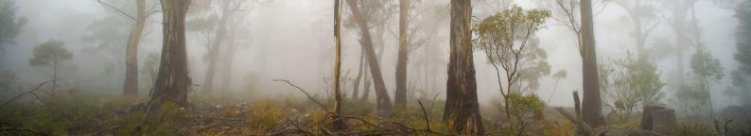Communities for Communities Newsletter

**Issue 20 (July 2017)—Special Reconciliation Edition**

**In this issue:**

* Ecological Communities Section update
  + Newly listed threatened ecological communities
  + Finalised Priority Assessment List
  + Nominations
  + New guidelines for nominating and assessing ecological communities
* The importance of recognising Indigenous natural and cultural heritage
* Profiles of new ecological communities

The Department of the Environment and Energy acknowledges the traditional owners and custodians over all the regions of Australia we work across. We pay respects to their elders, past, present and future, and their ongoing connection to land, sea and communities. We recognise the key role Aboriginal and Torres Strait Islander peoples play in protecting and managing their cultural and natural heritage.

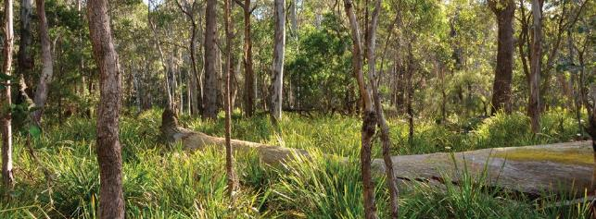

Southern Highlands Shale Forest and Woodlands (© Copyright Department of the Environment and Energy). Top image: Fog Forest (© Copyright Department of the Environment and Energy).

BIO584.0517

# Ecological Communities Section update

Over the past year, the crucial role of conserving Australia’s most threatened ecological communities has progressed, with several new listings and many new assessments underway. The Ecological Communities Section continues to work closely with the Threatened Species Scientific Committee (TSSC) to conduct rigorous scientific assessments on ecological communities nominated for listing. Publishing information to promote protection and recovery of ecological communities listed as threatened under the *Environment Protection and Biodiversity Conservation Act 1999* (EPBC Act) is another key responsibility of the section.

## Newly-listed Threatened Ecological Communities (TECs)

The following ecological communities have been added to the national list:

* Southern Highlands Shale Forest and Woodland in the Sydney Basin Bioregion (critically endangered, Aug 2015).
* Eucalypt Woodlands of the Western Australian Wheatbelt (critically endangered, Dec 2015).
* Natural Temperate Grassland of the South Eastern Highlands (critically endangered, April 2016) (replaced previous listing of Natural Temperate Grassland of the Southern Tablelands of NSW and the Australian Capital Territory (endangered), which was delisted at the same time).
* Warkworth Sands Woodland of the Hunter Valley (critically endangered, May 2016).
* Banksia Woodlands of the Swan Coastal Plain (endangered, Sep 2016).
* Illawarra and South Coast Lowland Forest and Woodland (critically endangered, Sep 2016).

A summary on each TEC is included later in this newsletter. Further information regarding all nationally listed ecological communities, including full Conservation Advices, detailed descriptions, threat analyses, distribution maps, and priority research and conservation actions (within national conservation advices and/or recovery plans), can be found on the Department’s website at:

[www.environment.gov.au/cgi-bin/sprat/public/](http://www.environment.gov.au/cgi-bin/sprat/public/publiclookupcommunities.pl)  [publiclookupcommunities.pl](http://www.environment.gov.au/cgi-bin/sprat/public/publiclookupcommunities.pl)

## Finalised Priority Assessment List

The Minister for the Environment and Energy, the Hon Josh Frydenberg MP, approved the Finalised Priority Assessment List (FPAL) for the assessment period beginning 1 October 2016.

The FPAL for this assessment period included three ecological communities nominated for consideration in the critically endangered category:

* Tuart (*Eucalyptus gomphocephala*) woodlands of the Swan Coastal Plain.
* Tasmanian White Gum (*Eucalyptus viminalis*) wet forest.
* River-flat eucalypt forest on coastal floodplains of New South Wales.

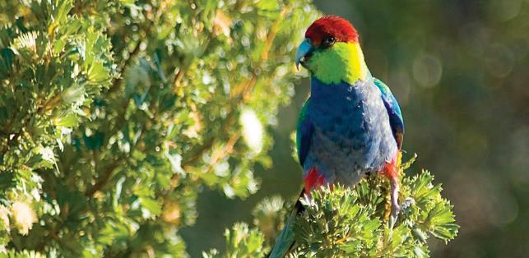

Red capped parrot (*Purpureicephalus spurius*) feeding on *Banksia sessilis* in Banksia Woodlands of the Swan Coastal Plain (© Copyright B Knott).

Assessments of these ecological communities began in October and are expected to be completed within the next three years.

The full FPAL is available at [www.environment.gov.au/biodiversity/threatened/assessments/fpal](http://www.environment.gov.au/biodiversity/threatened/assessments/fpal)

## Nominations

Nominations were recently invited for threatened species, threatened ecological communities or key threatening processes to be considered for listing under the *Environment Protection and Biodiversity Conservation Act 1999*.

Nominations for the 2017-18 assessment period opened in January 2017 and closed on 31 March 2017. The Minister nominated a conservation theme of ‘freshwater species and ecological communities’ for this assessment period and nominations that fit this theme were encouraged. Nominations outside this theme are also being considered. The nominations that are approved by the Minister for addition to the FPAL will be announced by October 2017.

The next nomination round is expected to open in late 2017.

Information on the nomination process, can be found at [www.environment.gov.au/biodiversity/threatened/nominations.html](http://www.environment.gov.au/biodiversity/threatened/nominations.html)

## New guidelines for nominating and assessing ecological communities

In January 2017 the Ecological Communities Section and the Threatened Species Scientific Committee released the updated *Guidelines for nominating and assessing threatened ecological communities*. These guidelines represent the Department’s and TSSC’s current thinking on the nomination and assessment process for ecological communities. They cover general concepts and definitions and provide specific advice on each of the listing criteria.

The updated guidelines are available from [www.environment.gov.au/system/files/pages/d72dfd1a-](http://www.environment.gov.au/system/files/pages/d72dfd1a-f0d8-4699-8d43-5d95bbb02428/files/guidelines-ecological-communities.pdf)  [f0d8-4699-8d43-5d95bbb02428/files/guidelines-ecological](http://www.environment.gov.au/system/files/pages/d72dfd1a-f0d8-4699-8d43-5d95bbb02428/files/guidelines-ecological-communities.pdf)-[communities.pdf](http://www.environment.gov.au/system/files/pages/d72dfd1a-f0d8-4699-8d43-5d95bbb02428/files/guidelines-ecological-communities.pdf)

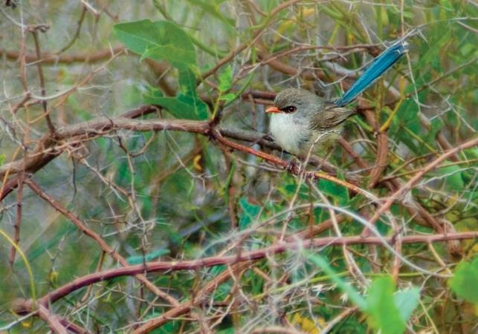

Splendid wrens (*Malurus splendens*) occur in many parts of Banksia Woodlands (© Copyright B Knott).

*This edition of Communities for Communities has an Indigenous focus to help highlight the connection between the cultural heritage values and the biodiversity values of ecological communities.*

*On the following pages the location of each ecological community is displayed with reference to local Aboriginal language groups (as defined in the Australian Institute of Aboriginal and Torres Strait Islander Studies (AIATSIS) map of Indigenous Australia). Links to more detailed maps of each ecological community are shown after each article.*

*Information on cultural heritage values are included for each ecological community, and what follows is an article written by Vanessa Farrelly, an Indigenous intern with the Ecological Communities Section of the Department of the Environment and Energy.*

# The importance of recognising Indigenous natural and cultural heritage

*We are the land and the land is us.*

There is a landscape in an ecological community that is not mapped or acknowledged. It is rendered invisible through botanical descriptions, or place names.

It is the Indigenous cultural landscape, where spiritual, social and cultural life is deeply intertwined into the land.

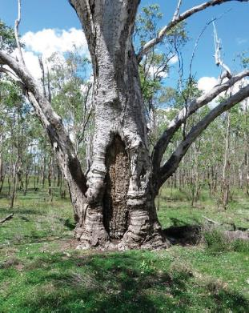

Scar tree on Barunggam country, Jondaryan Queensland. (© Copyright Anthony Hoffman).

Scar trees are trees that Aboriginal people have removed bark from to create objects such as canoes, shields, coolamons and shelters. They are part of the evidence left in country demonstrating that Aboriginal people have influenced the landscape for tens of thousands of years.

For Aboriginal people, the Dreaming is creation that is not a past event, but an ongoing process where ancestral beings that shaped the landscape reside there and define people’s connection to each other and the country. Law, protocols, kinship relationships, art, dance and wellbeing all originate from country.

*This is the cultural landscape that overlays all land in Australia.*

It is part of Indigenous custom and culture to care for the land, and have the land in return care for them. This reciprocity and connection to country is a core responsibility of what it means to be Indigenous. Because an Indigenous person’s existence cannot be separated from the land, isolating a traditional custodian from decisions that impact their country impacts on their human rights to self-determine their lives and livelihoods.

Indigenous people are the traditional land managers of Australia, with tens of thousands of years of experience and deep knowledge of this landscape. Australia is the driest inhabited continent on Earth, and has undergone massive changes in climate and land formation. Throughout all this, Indigenous people have been here and are still here as the oldest living culture on Earth.

When you consider the ecological communities listed by the Government, look at the landscape with a different lens. Look beyond the scientific listing of flora and fauna and imagine a landscape tens of thousands of years old that continues to support and be supported by human life. Imagine a landscape alive with our creators and our ancestors, residing there with us. Imagine the people who belong to this land, whose identity and culture is entwined so deeply in that place. Imagine their history stretching through that land for time immemorial and their futures that will always be there. Then you see everything that is at stake.

By Vanessa Farrelly, proud Southern Arrernte woman

# Southern Highlands Shale Forest and Woodland in the Sydney Basin Bioregion

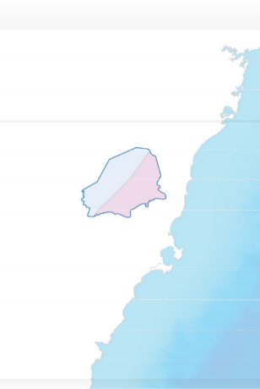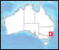

Southern Highlands Shale Forest and Woodland in the Sydney Basin Bioregion

*Gundungurra*

* Wollongong

*Tharawal*

*The ecological community is part of the country of Gundungurra and D’harawal peoples.*

**Date listed:** August 2015

**Category:** Critically endangered

**Location:** The Southern Highlands Shale Forest and Woodland of the Sydney Basin Bioregion ecological community is endemic to New South Wales, occurring within the Sydney Basin Bioregion. The ecological community occurs on the Southern Highlands plateau and is typically associated with clay soils derived from Wianamatta Group shales.

**Descriptive features:** The ecological community has a tree canopy dominated by eucalypts and a typically herbaceous understorey. Three ‘forms’ of the ecological community are recognised: ‘typical’, ‘tall wet’ and ‘short dry’:

* + **“Typical” canopy species** — Paddy’s River box (*Eucalyptus macarthurii*). Snow gum (*Eucalyptus pauciflora*) may also be present but not as a dominant species.
  + **“Tall wet” canopy species** — mountain grey gum (*Eucalyptus cypellocarpa*), river peppermint (*Eucalyptus elata*), stringybark (*Eucalyptus obliqua*), swamp gum (Eucalyptus ovata), white-topped box (*Eucalyptus quadrangulata*), gully peppermint/blackbutt peppermint (*Eucalyptus smithii*) and/or manna gum/ribbon gum (*Eucalyptus viminalis*).
  + **“Short dry” canopy species** — Argyle apple/silver leaved stringybark (*Eucalyptus cinerea*), broad leaved peppermint (*Eucalyptus dives*), brittle gum (*Eucalyptus mannifera*), candlebark (*Eucalyptus rubida*).

Characteristic canopy species of the Southern Highlands Shale Forest and Woodland that may be found in all forms of the ecological community include: *Eucalyptus globoidea* (white stringybark), *Eucalyptus piperita* (Sydney peppermint) and *Eucalyptus radiata* (narrow-leaved peppermint).

Area where Southern Highlands Shale Forest and Woodland in the Sydney Basin Bioregion may occur with the local Aboriginal language groups that occur within the boundary displayed (data from AIATSIS).

### Key threats:

* vegetation clearing and fragmentation (and associated loss of plant and animal diversity)
* residential and commercial development
* inappropriate grazing, mowing and slashing
* invasion by weeds and pathogens/disease
* introduced animals
* inappropriate fire regimes
* potential impacts from climate change.

**Cultural Heritage:** The country that this ecological community occurs in is an essential component of Indigenous physical and spiritual connection with the land. Throughout the area, cultural heritage sites are present that show evidence of continuous Indigenous occupation for tens of thousands of years, such as rock shelters, shell middens, paintings, axe grinding marks and tools. Many eucalypt trees surrounding creeks and swamplands have carvings of totems, natural objects that link Aboriginal people to their relationship with land, creation, and their roles and responsibilities to each other and country.

**Other features:** The ecological community supports a diverse range of fauna providing essential shelter and food for wildlife including: long-eared bats (*Nyctophilus* spp.), eastern pygmy possum (*Cercartetus nanus*), regent honeyeater (*Anthochaera phrygia*), scarlet robin

(*Petroica boodang*), koala (*Phascolarctos cinereus*) and giant burrowing frog (*Heleioporus australiacus*).

Further information, including a more detailed map showing where the ecological community occurs, can be found at [www.environment.gov.au/cgi-bin/sprat/public/publicshowcommunity.pl?id=62](http://www.environment.gov.au/cgi-bin/sprat/public/publicshowcommunity.pl?id=62)

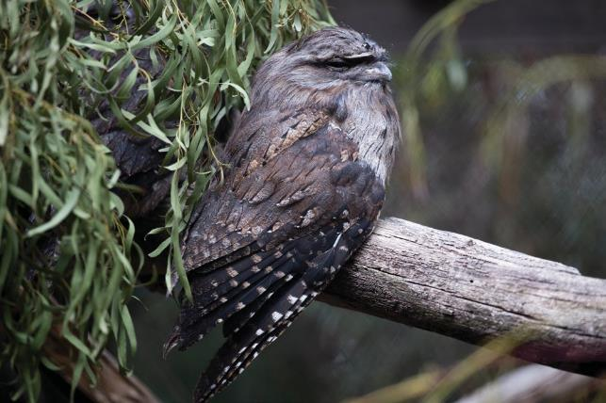

Tawny frogmouth (*Podargus strigoides*) found throughout the Southern Highlands Shale Forest and Woodlands in the Sydney Basin Bioregion (© Copyright Peter Ridgeway).

# Eucalypt Woodlands of the Western Australian Wheatbelt

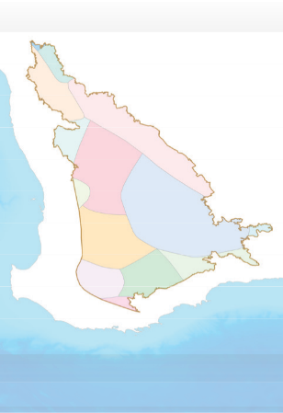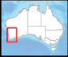

*Watjarri*

*Badimaya*

Eucalypt Woodlands

of the Western Australian Wheatbelt

*Amangu*

*Yuat*

*Kalaamaya*

*Balardung*

*Wajuk*

Perth !

*Nyaki-Nyaki*

*Malpa*

*Wiilman*

*Wudjari*

*Kaniyang*

*Goreng*

*Minang*

*The ecological community is part of the country of Noongar/ Nyungar and Yamaji/Yamatji peoples.*

**Date listed:** 4 December 2015

**Category:** Critically endangered

**Location:** The Eucalypt Woodlands of the Western Australian Wheatbelt are distributed across inland southwestern Western Australia, between the Darling Range and the Great Western Woodlands, a region known as the ‘Wheatbelt’. The Eucalypt Woodlands are found on the flatter landscapes of the Wheatbelt such as plains, valley floors, along water courses, the surrounds of salt lakes and wetlands and extending onto breakaways and gravel rises.

**Descriptive features:** The woodlands are dominated by a suite of eucalypt trees that typically have a single trunk. The woodlands occur as a complex mosaic involving about 30 tree species. Many are trees iconic to the Wheatbelt such as York gum (*Eucalyptus loxophleba*), salmon gum (*Eucalyptus salmonophloia*), red morrel (*Eucalyptus longicornis*), gimlet (*Eucalyptus salubris*), wandoo (*Eucalyptus wandoo*), Kondinin blackbutt (*Eucalyptus kondininensis*) and various species of eucalypts collectively known as mallet trees. The mix of trees present varies across the landscape. The native understorey also is highly diverse, ranging from largely bare to grassy to herbs and wildflowers to shrubby. The composition of native understorey species varies greatly, even from patch to patch. These woodlands were formerly extensive across the Wheatbelt but now occur as mostly small scattered remnants, often along road verges.

### Key threats:

* + land clearing and fragmentation (and associated loss of biodiversity and habitat)
  + invasion by weed species and feral animals
  + changes to natural fire regimes
  + increased salinity, soil acidification and other hydrological changes
  + management practices such as fertiliser addition and overgrazing
  + potential impacts from climate change.

Area where Eucalypt Woodlands of the Western Australian Wheatbelt may occur with the local Aboriginal language groups that occur within the boundary displayed (data from AIATSIS).

**Cultural heritage:** The Noongar people understood and managed their natural landscapes sustainably for tens of thousands of years. Kaartdijin (knowledge) was strongly valued and passed down by elders and moort (family groups). Each moort identified with a particular tract of budjar (country). Karl (fire) was a key tool used to manage the country and ensure a long-term supply of the plant and animal resources on which they relied. Noongar people migrated between coastal and inland areas depending on where and when resources were available and plentiful during each season.

The granite outcrops scattered through the Wheatbelt were important to the Noongar people, serving as vantage points in the landscape and locations of gnamma (rock holes that fill with rain water), that were considered sacred. Gnamma provided essential sources of water in this harsh landscape and also attracted animals such as kangaroos, ducks and lizards that were hunted.

**Other features:** The Eucalypt Woodlands of the Western Australian Wheatbelt ecological community provides habitat for at least 16 animal and 71 plant taxa that are listed as nationally threatened. They include iconic WA animals such as the woylie (*Bettongia penicillata*), chuditch or western quoll (*Dasyurus geoffroii*) and black cockatoos (*Calyptorhynchus* spp.), notably Carnaby’s black cockatoo (*Calyptorhynchus latirostris*).

Southwestern Western Australia is an international biodiversity hotspot, recognised for its extensive diversity of native plant and animal species. Many are endemic and occur nowhere else on Earth. However, the Wheatbelt region also is one of the most heavily cleared areas of Australia, from which more than 85 per cent of native vegetation has been lost. This is one of the reasons for its critically endangered status and for protecting what’s left of these unique assemblages and habitats.

Further information, including a more detailed map showing where the ecological community occurs, can be found at [www.environment.gov.au/cgi-bin/sprat/public/publicshowcommunity.pl?id=128](http://www.environment.gov.au/cgi-bin/sprat/public/publicshowcommunity.pl?id=128)

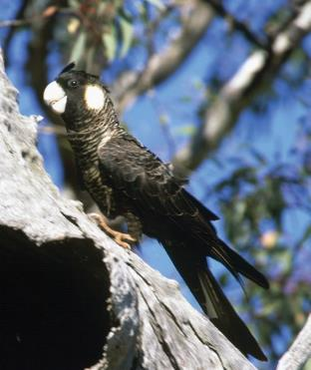

The endangered *Calyptorhynchus latirostris* (Carnaby’s cockatoo) found throughout the Eucalypt Woodlands of the Western Australian Wheatbelt (© Copyright Brian Furby).

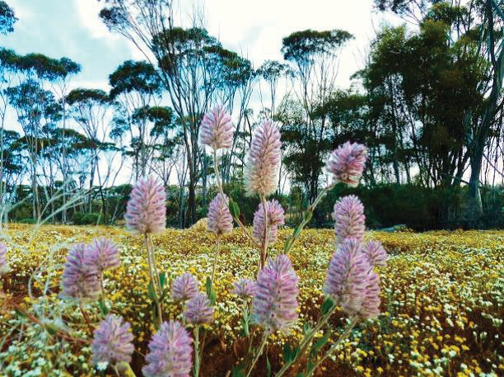

The mass wildflower displays of the unique woodlands and shrublands are a major tourist attraction across the Wheatbelt. (© Copyright Matt White).

# Natural Temperate Grassland of the South Eastern Highlands

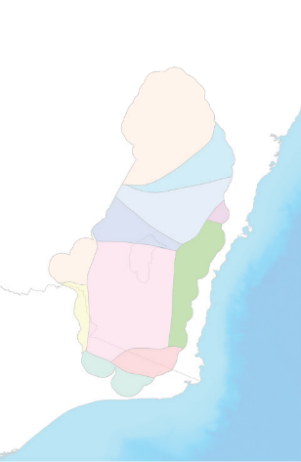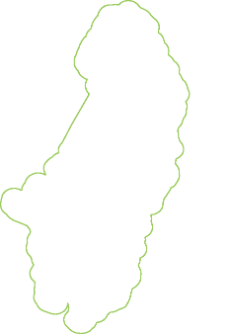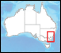

Natural Temperate

Grassland of the South Eastern Highlands

*Wiradjuri*

*Dharug*

*Gundungurra*

*Tharawal*

*Ngunawal*

*Wiradjuri*

*Yuin*

* BATEMANS BAY

*Ngarigo*

*Jaitmatang*

*Bidwell*

*Kurnai*

*The ecological community is part of the country of Wiradjuri, Dharug, Gundungurra, Ngunnawal, Ngarigo, Ngambri, Yuin, Gunai Kurnai, Jaitmathang, Djilamatang and Walgalu peoples.*

**Date listed:** 6 April 2016

**Category:** Critically endangered

**Location:** The revised listing recognises a broader area of grasslands across the South Eastern Highlands and immediately adjacent areas in NSW, ACT and Victoria, and adds a ‘minimum condition threshold’, which identifies which areas of grassland are protected by the EPBC Act.

Low quality grasslands that do not meet this threshold are not protected.

**Descriptive features:** The ecological community is dominated by native tussock grasses with a rich diversity of wildflowers and other grassland plants and animals, with few trees or shrubs. The grasslands provide vital habitat for at least nineteen threatened species, such as the grassland earless dragon (*Tympanocryptis pinguicolla*), striped legless lizard (*Delma impar*), pink-tailed worm lizard (*Aprasia parapulchella*), golden sun moth (*Synemon plana*) and button wrinklewort daisy (*Rutidosis leptorrhynchoides*) and is a refuge for many other locally-rare species.

### Key threats:

* + land clearing and fragmentation (and associated loss of biodiversity and habitat)
  + invasion by weed species and feral animals
  + changes to natural fire regimes
  + increased salinity, soil acidification and other hydrological changes
  + inappropriate management practices such as fertiliser addition and overgrazing
  + potential impacts from climate change.

Area where Natural Temperate Grasslands of the South Eastern Highlands may occur with the local Aboriginal language groups that occur within the boundary displayed (data from AIATSIS).

**Cultural Heritage:** Aboriginal people relied heavily on the grasslands as a food source. For example, open grasslands were attractive to grazing by kangaroos and other animals that provided meat, but amongst the grass were also many non-grass plant species that provided food. Many of these plants were yam species, tuber-forming plants of which *Microseris lanceolata* (known as Garngeg, Nyamin, Myrnong, yam daisy) is a key example. Fire is used by Aboriginal people to maintain suitable conditions for the growth of food-bearing plants amongst the grass tussocks, and post-fire grass growth also attracted kangaroos and other animals, which can be hunted.

**Other features:** These native grasslands are important for agriculture as they provide year round forage and are drought tolerant, recovering quickly from extended drought. This makes them useful in low input production systems and for fine wool production. Native grasslands also provide other ecosystem services such as carbon storage, improving water infiltration, reducing soil erosion and suppressing weeds.

Further information, including a more detailed map showing where the ecological community occurs, can be found at [www.environment.gov.au/cgi-bin/sprat/public/publicshowcommunity.pl?id=152](http://www.environment.gov.au/cgi-bin/sprat/public/publicshowcommunity.pl?id=152)

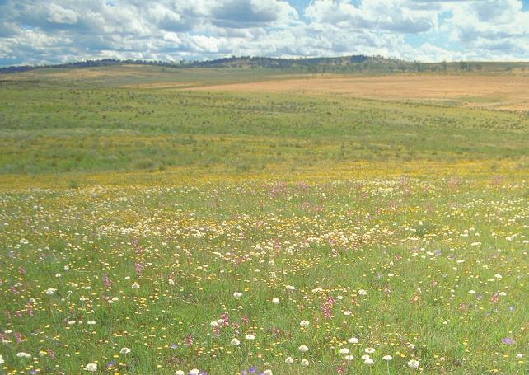

Flora assemblage within Top Hut Travelling Stock Reserve at Dry Plains within the Natural Temperate Grassland of the South Eastern Highlands ecological community (© Copyright David Eddy).

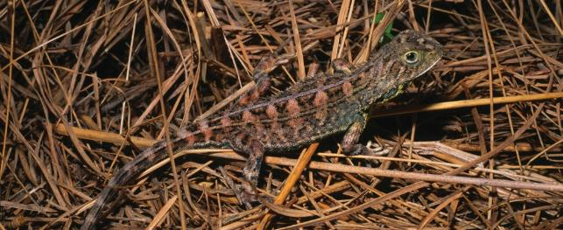

The endangered grassland earless dragon (*Tympanocryptis piguicolla*) found in the Natural Temperate Grassland of the South Eastern Highlands critically endangered ecological community (© Copyright Steve Wilson).

# Warkworth Sands Woodland of the Hunter Valley

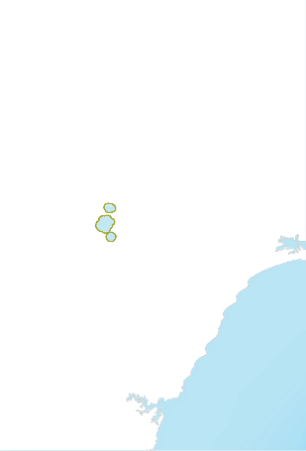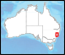

Warkworth Sands Woodland of the Hunter Valley

* Muswellbrook
  + Singleton

*Wonnarua*

* + - Newcastle

*The ecological community is part of the country of the Wonnarua peoples.*

**Date listed:** May 2016

**Category:** Critically endangered

**Location:** The Warkworth Sands Woodland of the Hunter Valley ecological community occurs in the Hunter River catchment, in the Central Hunter region of the Hunter Valley in north east NSW. It is confined to small areas of sandy soil, west of Singleton, in the Singleton Local Government Area. The majority of patches are in the Warkworth district.

**Descriptive features:** It is a mid to low woodland (occasionally forest), typically dominated by rough-barked apple (*Angophora floribunda*) in the canopy and coast banksia (*Banksia integrifolia* subsp. *integrifolia*) and/or fern- leaved wattle (*Acacia filicifolia*) in a sub-canopy; together with other small trees, shrubs and groundcover species that are typical of sandy soils in the Hunter Valley region. On shallower sands (e.g. in swales) Blakely’s red gum x forest red gum hybrid (*Eucalyptus blakelyi x Eucalyptus tereticornis*) and narrow leaved ironbark (*Eucalyptus crebra*) may be more numerous. Other tree species may include: Blakely’s red gum (*Eucalyptus blakelyi*) and kurrajong (*Brachychiton populneus* subsp. *populneus*).

Species composition is influenced by factors such as the size of the site and depth of sandy substrate, recent rainfall, or drought conditions and by its disturbance history (including clearing, grazing and fire). On the shallower sands there may be more grasses and herbs typical of the surrounding clay landscapes. The ecological community also comprises lichens, mosses, fungi and micro-organisms, as well as fauna.

### Key threats:

* + vegetation clearing and landscape fragmentation— mining continues to be the main driver of clearing
  + invasive flora species which compete with locally indigenous flora species for available resources (water, light, nutrients)
  + altered fire regimes (fire intensity, frequency, seasonality and patchiness all influence vegetation composition and structure)
  + predation of native fauna by feral species.

Area where Warkworth Sands Woodland of the Hunter Valley may occur with the local Aboriginal language groups that occur within the boundary displayed (data from AIATSIS).

**Cultural Heritage:** The Hunter Valley has an Indigenous history of tens of thousands of years and the Wonnarua people have maintained a strong sense of their own cultural identity and links with the land despite the impact of European contact on their traditional lands and culture. Historically, people moved widely around their natural and cultural landscape, utilising all landscape areas. The ecological community provided them with raw materials such as tree bark (e.g. for huts, shields and water containers). Trees, such as the kurrajong, also produced fruit and seeds to eat, as well as providing habitat for food animals, including flying foxes, possums and gliders.

**Other features:** The community provides potential habitat for at least 41 nationally and/or state listed threatened species including: Austral toadflax (*Thesium australe*), brush-tailed rock-wallaby (*Petrogale penicillata*), Corben’s long-eared bat (*Nyctophilus corbeni*), green and golden bell frog (*Litoria aurea*), grey-headed flying fox (*Pteropus poliocephalus*), koala (*Phascolarctos cinereus*), large-eared pied bat (*Chalinolobus dwyeri*), painted honeyeater (*Grantiella picta*), regent honeyeater (*Anthochaera phrygia*), spotted-tail quoll (*Dasyurus maculatus*) and swift parrot (*Lathamus discolor*).

Further information, including a more detailed map showing where the ecological community occurs, can be found at [www.environment.gov.au/cgi-bin/sprat/public/publicshowcommunity.pl?id=143](http://www.environment.gov.au/cgi-bin/sprat/public/publicshowcommunity.pl?id=143)

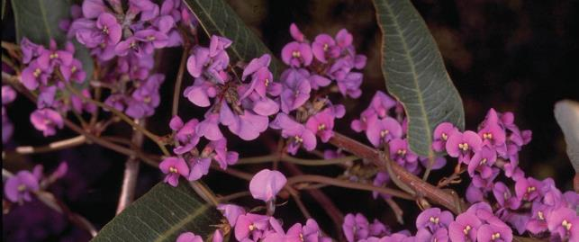

Common understorey species of the Warkworth Sands Woodland of the Hunter Valley *Hardenbergia violacea* (false sarsaparilla, happy wanderer). (© Copyright M. Fagg).

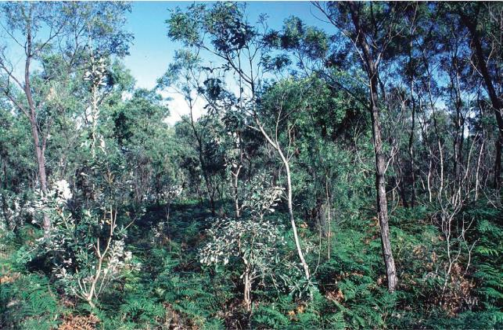

Vegetation at Warkworth Sands Woodland of the Hunter Valley critically endangered ecological community (© Copyright Travis Peake).

# Banksia Woodlands of the Swan Coastal Plain

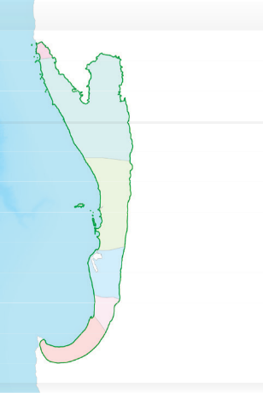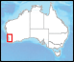

*Amangu*

Banksia Woodlands of

the Swan Coastal Plain

*Yuat*

*Wajuk*

Perth !

*Pinjarup*

*Kaniyang*

*Wardandi*

*The ecological community is part of the country of the Whadjuk, Binjareb and Wardandi Noongar peoples.*

**Date listed:** September 2016

**Category:** Endangered

**Location:** The Banksia Woodlands ecological community is only found on the Swan Coastal Plain of Western Australia, within the Southwest Australia global biodiversity hotspot. This coastal plain stretches from around Jurien Bay in the north, to Dunsborough in the south, extending into adjacent areas of the lower Whicher and Darling escarpments.

**Descriptive features:** The ecological community typically has a prominent tree layer of Banksia sometimes with scattered eucalypts and other tree species within or above the Banksia canopy. The understorey is species rich with many wildflowers, including sclerophyllous shrubs, sedges and herbs. Banksia Woodlands vary in their structure and species composition, but are united by having a generally dominant banksia component, which includes at least one of four key species—candlestick banksia (*Banksia attenuata*), firewood banksia (*Banksia menziesii*), acorn banksia (*Banksia prionotes*) and/or holly-leaved banksia (*Banksia ilicifolia*). It typically occurs on well drained, low nutrient soils in sands of dune landforms.

### Key threats:

* + clearing and fragmentation (habitat loss)
  + dieback diseases (e.g. *Phytophthora* root rot fungal disease)
  + invasive weeds and feral animals
  + changes to fire regimes
  + hydrological degradation (including changes to groundwater levels)
  + potential impacts from climate change.

Area where Banksia Woodlands of the Swan Coastal Plain may occur with the local Aboriginal language groups that occur within the boundary displayed (data from AIATSIS).

**Cultural Heritage:** The Noongar people have lived, managed and been connected to the Swan Coastal Plain area for tens of thousands of years. The rivers and the associated creek systems, the flow of lakes, wetlands and surrounding landscape were not only an important economic resource but were also intricately linked to the Dreaming stories of ancestral beings. In the southwest of Australia, the Noongar seasonal calendar includes six different seasons in a yearly cycle. This six-season calendar is extremely important to Noongar people, as it is a guide to what nature is doing at every stage of the year, as well as understanding respect for the land in relation to plant and animal fertility cycles and land and animal preservation.

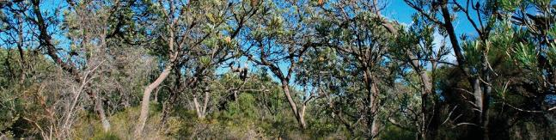

Healthy banksia woodland (© Copyright: Rob Davis).

**Other features:** Banksia Woodlands provide vital habitat for over 20 nationally threatened species such as Carnaby’s black cockatoo (*Calyptorhynchus latirostris*), forest red-tailed black cockatoo (*Calyptorhynchus banksii naso*), chuditch/ western quoll (*Dasyurus geoffroii*) and western ringtail possum (*Pseudocheirus peregrinus occidentalis*); as well as many wildflowers unique to the south-west and other animals that depend on them, such as the honey possum (*Tarsipes rostratus*).

Further information, including a more detailed map showing where the ecological community occurs, can be found at [www.environment.gov.au/cgi-bin/sprat/public/publicshowcommunity.pl?id=131](http://www.environment.gov.au/cgi-bin/sprat/public/publicshowcommunity.pl?id=131)

### Noongar calendar of six seasons for southwest WA.

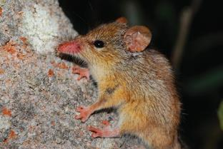

Honey possum (*Tarsipes rostratus*) in woolly bush (© Copyright Department of Parks and Wildlife, WA).

|  |  |  |  |  |  |
| --- | --- | --- | --- | --- | --- |
| December – January | February – March | April – May | June – July | August – September | October – November |
| Birak | Bunuru | Djeran | Makuru | Djilba | Kambarang |
| Dry and hot | Hottest part of | Cooler | Coldest and | Mixture of | Longer |
|  | the year | weather begins | wettest time of | wet days with | dry periods |
|  |  |  | the year; more | increasing |  |
|  |  |  | frequent gales | number of clear, |  |
|  |  |  | and storms | cold nights |  |
|  |  |  |  | and pleasant |  |
|  |  |  |  | warmer days |  |
| Season of | Season of | Season of | Fertility season | Season of | Season of birth |
| the young | adolescence | adulthood |  | conception |  |

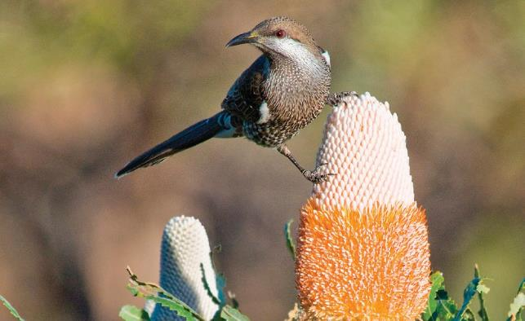

Honey-eater with flowering Banksia prionotes (*acorn banksia*) (© Copyright B Knott).

# Illawarra and South Coast Lowland Forest and Woodland

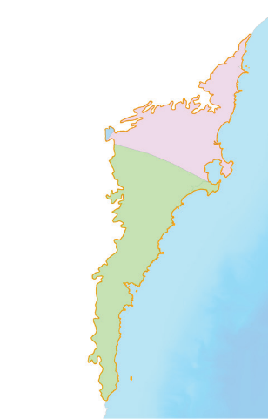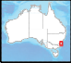

Illawarra and south coast lowland

forest and woodland

*Gundungurra*

*Tharawal*

*Yuin*

!

Batemans

Bay

*The ecological community is part of the country of D’harawal and Yuin peoples.*

**Date listed:** September 2016

**Category:** Critically Endangered

**Location:** This ecological community occurs on the NSW south coast, mainly between Wollongong and just south of Moruya. The majority of the remaining patches are in the Illawarra region. It typically occurs within 30 km of the coast on floodplains, coastal valleys and low-lying foothills below the steep slopes of the eastern coastal escarpment. It can occur from near sea level up to approximately 350 m altitude, but most occurrences are at the lower end of this range.

**Descriptive features:** The Illawarra and south coast lowland forest and woodland ecological community is a eucalypt forest or woodland. Within the tree canopy forest red gum (*Eucalyptus tereticornis*) or woollybutt (*Eucalyptus longifolia*) are typically present. Other tree species likely to be present include: rough-barked apple (*Angophora floribunda*); coast grey box (*Eucalyptus bosistoana*); thin-leaved stringybark (*Eucalyptus eugenioides*) and white stringybark (*Eucalyptus globoidea*). There is also often a sub-canopy of paper bark (*Melaleuca decora*), swamp paper bark (*Melaleuca ericifolia*), prickly-leaved tea tree (*[Melaleuca.styphelioides](http://Melaleuca.styphelioides/)*), tree-sized acacias and/or swamp oak (*Casuarina glauca*). The understorey varies between sites and contains a ground layer of grasses, herbs and sedges and/or a shrubby layer.

### Key threats:

* + clearing and fragmentation of vegetation (in the past for agriculture and grazing, logging, and quarrying; currently mainly for land development)
  + weeds
  + feral animals
  + unsuitable fire regimes
  + potential impacts from climate change.

**Cultural Heritage:** Indigenous communities, such as D’harawal and Yuin people, have traditionally managed the area containing the ecological community and relied on its plants and animals to provide food. For example, roots of milk vine (*Marsdenia rostrata*) and fruits of native cherry (*Exocarpus cupressiformis*) (D’harwawal name *Goo’weregan*), shelter, clothing, tools (the leaves of black-anther flax-lily

Area where Illawarra and South Coast Lowland Forest and Woodland may occur with the local Aboriginal language groups that occur within the boundary displayed (data from AIATSIS).

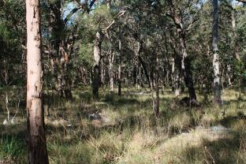

Illawarra and south coast lowland forest and woodland. Illawarra greenhood (*Pterostylis gibbosa*), a nationally threatened orchid found in the ecological community.(© Copyright Department of the Environment and Energy).

(*Dianella revoluta*) (D’harawal name *Pokulbi*) can be used for making string), entertainment and support spiritual wellbeing; note that these are D’harawal uses and are specific to the region.

The ecological community supports agricultural productivity through increased landscape health, provides recreational opportunities in reserves such as Morton, Eurobodalla and Murramarang National Park and supports people’s health. Listing this ecological community is helping to protect it from future damage and thereby conserving the associated cultural values, as well as creating opportunities for its management and restoration.

**Other features:** The ecological community provides habitat for nationally threatened species such as regent honeyeater (*Anthochaera phrygia*), swift parrot (*Lathamus discolor*), koala (*Phascolarctos cinereus*), large-eared pied bat (*Chalinolobus dwyeri*) and Illawarra greenhood orchid (*Pterostylis gibbosa*).

Further information, including a more detailed map showing where the ecological community occurs, can be found at [www.environment.gov.au/cgi-bin/sprat/public/publicshowcommunity.pl?id=144](http://www.environment.gov.au/cgi-bin/sprat/public/publicshowcommunity.pl?id=144)

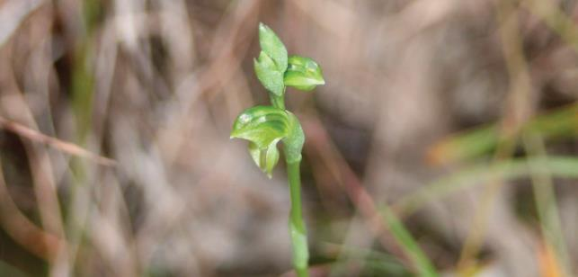

Illawarra greenhood (*Pterostylis gibbosa*), a nationally threatened orchid found in the ecological community (© Copyright Department of the Environment and Energy).

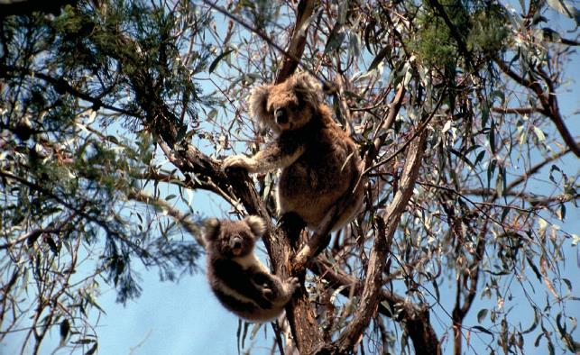

The threatened Koala (*Phascolarctos cinereus*), found in the Illawarra and South Coast Lowland Forest and Woodland (© Copyright Robert Thorn).

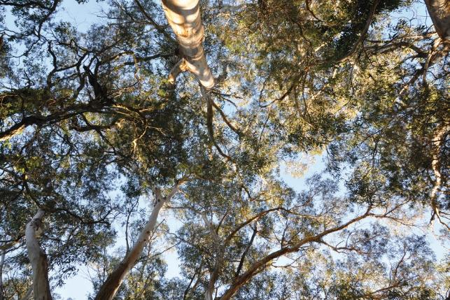

Tree canopy of the Southern Highlands Shale Forest and Woodlands (© Copyright Department of the Environment and Energy)

# Who’s who in the Ecological Communities Section?

**Director**: Matt White

### Assistant Directors:

Nikki Ward John Vranjic

**Project Officers:**

Paul Barraclough Mark Bourne Andrew Chalklen Anthony Hoffman Trudy O’Connor Louise Armstrong

Benjamin Karlson (Graduate) Vanessa Farrelly (Indigenous Intern)

# Media enquiries

Please direct all media enquiries to

### [media@environment.gov.au](mailto:media@environment.gov.au)

**© Commonwealth of Australia, 2017.**

This fact sheet is licensed by Commonwealth of Australia under a Creative Commons Attribution 4.0 International licence.

The views and opinions expressed in this publication are those of the authors and do not necessarily reflect those of the Australian Government or the Minister for the Environment and Energy.