Assessment of alternative measures for Cavendish bananas from the Philippines: issues paper

© Commonwealth of Australia 2026
Ownership of intellectual property rights
Unless otherwise noted, copyright (and any other intellectual property rights) in this publication is owned by the Commonwealth of Australia (referred to as the Commonwealth).
Creative Commons licence
All material in this publication is licensed under a Creative Commons Attribution 4.0 International Licence except content supplied by third parties, logos and the Commonwealth Coat of Arms.

Cataloguing data
This publication (and any material sourced from it) should be attributed as: DAFF 2026, Assessment of alternative measures for Cavendish bananas from the Philippines: issues paper, Department of Agriculture, Fisheries and Forestry, Canberra. CC BY 4.0.
This publication is available at agriculture.gov.au/biosecurity-trade/policy/risk-analysis/plant/banana-philippines.
Department of Agriculture, Fisheries and Forestry
GPO Box 858 Canberra ACT 2601
Telephone 1800 900 090
Web agriculture.gov.au
Disclaimer
The Australian Government acting through the Department of Agriculture, Fisheries and Forestry has exercised due care and skill in preparing and compiling the information and data in this publication. Notwithstanding, the Department of Agriculture, Fisheries and Forestry, its employees and advisers disclaim all liability, including liability for negligence and for any loss, damage, injury, expense or cost incurred by any person as a result of accessing, using or relying on any of the information or data in this publication to the maximum extent permitted by law.
Acknowledgement of Country
We acknowledge the continuous connection of First Nations Traditional Owners and Custodians to the lands, seas and waters of Australia. We recognise their care for and cultivation of Country. We pay respect to Elders past and present, and recognise their knowledge and contribution to the productivity, innovation and sustainability of Australia’s agriculture, fisheries and forestry industries.

Contents
Summary iv
Introduction 1
1.1 Australia’s biosecurity policy framework 1
1.2 Biosecurity import risk analysis framework 1
1.3 Regulated steps in the biosecurity import risk analysis process 2
1.4 Assessment of alternative measures for bananas from the Philippines 3
1.5 Existing policy for the importation of fresh bananas 6
1.6 Banana production in the Philippines 6
1.7 Banana production in Australia 7
2 Assessment approach 8
2.1 Assessments for Moko, black Sigatoka and banana freckle 8
2.2 Consideration of additional banana cultivar and export province 9
2.3 Review of 2008 import risk analysis 10
2.4 Consultation and expert advice 10
3 Stakeholder feedback 12
Appendix A: Summary of BIRA process and trade implementation 13
Glossary 14
References 17

Summary
This issues paper is in relation to the Biosecurity Import Risk Analysis (BIRA) for the importation of commercially produced fresh Cavendish banana fruit from the Philippines for human consumption.
Australia does not currently permit the import of fresh bananas from any market.
This issues paper is a required step in the BIRA process under section 24 of the Biosecurity Regulation 2016.
This issues paper contains:
- an overview of Australia’s biosecurity policy framework
- background information on the assessment of alternative measures
- information on the commodity
- an overview of the assessment approach
- a summary of the steps in the BIRA process, including opportunities for consultation.
We are conducting the assessment of alternative measures in response to a formal request from the Philippines. The Philippines have requested that Australia consider:
- alternative measures to manage 3 pathogens of concern identified in the 2008 import risk analysis for bananas from the Philippines. These are Moko (Ralstonia solanacearum Moko strains), black Sigatoka (Pseudocercospora fijiensis) and banana freckle (Phyllosticta cavendishii)
- an additional Cavendish cultivar (Formosana or ‘GCTCV-218’) and an additional export province (Davao de Oro) that were not assessed in the 2008 import risk analysis.
As a member of the World Trade Organization, Australia is obliged to consider formal requests for imports from trading partners. This includes requests for alternative measures. Where possible, we must develop import conditions that achieve Australia’s appropriate level of protection (ALOP), are scientifically justified, and do not unreasonably restrict trade. Australia’s ALOP is expressed as providing a high level of protection for plant, animal and human life and health aimed at reducing risk to a very low level, but not to zero.
The assessment will involve:
- a comprehensive scientific assessment of biosecurity risks, including 3 pathogens (Moko, black Sigatoka and banana freckle) and consideration of alternative risk management measures, where required
- consideration of biosecurity risks that may be associated with the importation of the additional cultivar and the additional export province
- a review of the 2008 import risk analysis to ensure the assessments of other pests are still appropriate and to determine whether any new biosecurity risks have emerged since 2008.
The key plant pests/pest groups of fresh Cavendish banana fruit from the Philippines that will be considered in the assessment are:
- Moko (Ralstonia solanacearum Moko strains)
- black Sigatoka (Pseudocercospora fijiensis)
- banana freckle (Phyllosticta cavendishii)
- armoured scales
- mealybugs
- mites
- thrips
- fruit flies
- viruses
- Panama disease Tropical Race 4 (Fusarium oxysporum f. sp. cubense Tropical Race 4).
We will also review the status of pests/pest groups of fresh Cavendish bananas that are not present in the Philippines but that are emerging in the region, including:
- Blood disease (Ralstonia syzygii subsp. celebesenis)
- phytoplasma diseases
- Eumusae leaf spot (Mycosphaerella eumusae).
The assessment will identify biosecurity risks associated with fresh Cavendish banana fruit for human consumption from the Philippines. For risks that do not achieve Australia’s ALOP, we will propose measures to effectively manage the risk to achieve Australia’s ALOP.
We invite interested parties to provide feedback on the issues contained in this paper (or others not identified) by 16 July 2026. Further details on providing feedback are outlined in section 3.
To contribute scientific information relevant to this assessment, email plantstakeholders@aff.gov.au.

Introduction

Australia’s biosecurity policy framework
Australia’s biosecurity policies aim to protect Australia against the risks that may arise from exotic pests entering, establishing and spreading in Australia. Exotic pests threaten Australia’s unique flora and fauna, as well as Australia’s agricultural industries that are relatively free from serious pests.
The risk analysis process is an important part of Australia’s biosecurity policy development. It enables the Australian Government to formally consider the level of biosecurity risk that may be associated with proposals to import goods into Australia. If the biosecurity risks do not achieve the ALOP for Australia, risk management measures are recommended to reduce the risks to an acceptable level. If the risks cannot be reduced to an acceptable level, the goods will not be imported into Australia until suitable measures are identified or developed.
Successive Australian governments have maintained a stringent, but not a zero risk, approach to the management of biosecurity risks. This approach is expressed in terms of the ALOP for Australia, which is defined in the Biosecurity Act 2015 as providing a high level of protection aimed at reducing risk to a very low level, but not to zero.
Australia’s risk analyses are undertaken by the department using technical and scientific experts in relevant fields and involve consultation with stakeholders at various stages during the process.
Risk analyses may take the form of a BIRA or a review of biosecurity import requirements (such as scientific review of existing policy and import conditions, pest-specific assessments, weed risk assessments, biological control agent assessments or scientific advice).
For information about Australia’s biosecurity framework, see the Biosecurity Import Risk Analysis guidelines.

Biosecurity import risk analysis framework
A BIRA is a science-based assessment of the biosecurity risks associated with the import of a particular good, which is provided for under law. Under the Biosecurity Act 2015, a BIRA must be conducted in accordance with the process prescribed in the Biosecurity Regulation 2016 (see section 1.3) and take into account the matters set out in the Biosecurity Import Risk Analysis guidelines.
The BIRA will assess whether the import of a product with no risk management measures applied (the unrestricted risk) poses an unacceptable biosecurity risk. If so, the analysis will recommend risk management measures to reduce the risks to a level that achieves Australia’s ALOP. The importation of commercially produced fresh Cavendish banana fruit from the Philippines cannot occur until suitable import conditions have been developed.
This issues paper is part of the formal BIRA process.

Regulated steps in the biosecurity import risk analysis process
Under the Biosecurity Regulation 2016, the following steps must be undertaken when conducting a BIRA:
- The Director of Biosecurity must appoint a scientific advisory group.
- The Director of Biosecurity must publish a notice on the department’s website stating:
  - that we are proposing to conduct a BIRA
  - the opportunities for consultation that will occur during the BIRA process.
- The Director of Biosecurity must prepare an issues paper and publish it on the department’s website. The issues paper will set out background information about the request, the commodity/goods and some of the main matters that will be considered during the analysis.
- The Director of Biosecurity must:
  - prepare a draft BIRA report
  - publish on the department’s website the draft report and an invitation to the public to provide submissions about the assessment of the level of biosecurity risk associated with the relevant goods or class of goods including proposed risk management measures for the goods to achieve ALOP within a period specified in the invitation
  - the consultation period must be at least 60 calendar days, including the day the invitation is published
  - if the Director of Biosecurity considers that the public may not have a reasonable opportunity to consider the draft BIRA report, the period for public submissions may be extended only once by a period the Director of Biosecurity considers appropriate.
- The Director of Biosecurity must prepare a provisional BIRA report and publish it on the department’s website.
- Within 30 calendar days of the provisional BIRA report’s publication, a person may make a request to the Inspector-General of Biosecurity to review the process used to conduct the BIRA.
- If a person requests a review of the process for conducting the BIRA, and the Inspector-General is satisfied that a review can proceed, the Inspector-General must tell the Director of Biosecurity, in writing, about the request. The Inspector-General must then conduct a review of the process for conducting the BIRA.
- If the Inspector-General conducts a review of the process for conducting the BIRA, the Director of Biosecurity must consider any recommendations in their report and must publish a final BIRA review report.
- If the Inspector-General is not requested to conduct a review of the process for conducting the BIRA, the Director of Biosecurity must publish the provisional BIRA report as the final BIRA report as soon as is practical to do so.
The final BIRA report must be published within 30 months from the day of the notice announcing the BIRA was published, unless specific circumstances apply.
The Director of Biosecurity may publish a notice on the department’s website to stop the counting of time for a BIRA if:
- the Director of Biosecurity is waiting for requested further information, research or expert advice, or
- the Director of Biosecurity is waiting for examination by the scientific advisory group of a requested part of the BIRA process.
If the Inspector-General reviews the process for conducting the BIRA, the time taken for the review does not count towards the 30-month timeframe.
The 30-month timeframe also may not be met if a biosecurity circumstance of national or international significance occurs.
Publication of the final BIRA report represents the end of the process. The risk management measures recommended in the final report will be the basis of any import conditions in import permits issued.
A summary of the BIRA process and trade implementation steps is available at Appendix A.
Step 1 of the BIRA process is complete. We have a standing scientific advisory group who were appointed on 30 March 2026. On 16 June 2026, we published a notice of intention that we are conducting the BIRA on our website. This signals the commencement of the BIRA process and completes step 2. We also published this issues paper, which represents the completion of step 3.

Assessment of alternative measures for bananas from the Philippines

Background
In 1995, the Philippines’ Bureau of Plant Industry submitted a request to Australia for market access for fresh Cavendish bananas for human consumption.
In 2000, we commenced an import risk analysis to determine if fresh Cavendish bananas from the Philippines were safe to import. That is, we assessed whether any biosecurity risks associated with bananas from the Philippines could be managed to achieve Australia’s ALOP, which is ‘very low’.
In 2008, we completed the import risk analysis. The analysis identified 21 quarantine plant pests that posed a biosecurity risk exceeding Australia’s ALOP:
- Moko (Ralstonia solanacearum Moko strains)
- black Sigatoka (Pseudocercospora fijiensis)
- banana freckle (Phyllosticta cavendishii)
- several arthropod pests, including 7 species of armoured scales, 4 species of mealybugs, 5 species of mites and 2 species of thrips.
Consequently, we proposed risk management measures to reduce the risk to achieve ALOP.
In March 2009, we made a policy determination that the importation of bananas from the Philippines may be permitted, subject to risk management measures as outlined in the risk analysis.
The proposed measures were never finalised with the Philippines within an operational workplan. Consequently, no trade has occurred.
In 2018, we received a formal request from the Philippines to consider alternative measures to manage 3 pathogens of concern identified in the 2008 import risk analysis (Moko, black Sigatoka and banana freckle).
In March 2025, the Philippines requested that Australia consider an additional Cavendish cultivar and an additional export province that were not considered in the 2008 assessment. The additional cultivar is ‘GCTCV-218’ or Formosana. The additional province is Davao de Oro in the Davao Region or Region 11.
Since we received the Philippines’ request in 2018, we have been conducting a preliminary review of the request to inform the assessment.
Following this preliminary review, we allocated the required resources to progress the assessment. We then notified stakeholders on 16 September 2025 that we would be conducting the assessment. From September to November 2025, we held virtual and in-person information sessions with stakeholders to explain the assessment process and answer questions.
From 23 to 27 March 2026, we undertook a technical visit to the Philippines. This was to gather information on the Philippines’ commercial production, pest management and export practices for bananas. The technical visit is one source of information we are using to inform the assessment. We have published a summary of the technical visit on our website.
On 16 June 2026, we published a notice of intention to conduct the assessment as a BIRA and publish this issues paper.

Scope

Assessment of alternative measures
The scope of this assessment is to consider:
- alternative risk management measures to those proposed in the 2008 import risk analysis for fresh Cavendish bananas from the Philippines for 3 pathogens (Moko, black Sigatoka and banana freckle)
- the biosecurity risk that may be associated with the importation of the additional Cavendish banana cultivar ‘GCTCV-218’ (also known as ‘Formosana’) and the additional export province Davao de Oro in the Davao Region or Region 11.
We will also review the 2008 import risk analysis to ensure the assessments of other pests, including any recommended measures, are still appropriate. We will determine whether any new biosecurity risks have emerged since the risk analysis was finalised. This will include a review of the pest initiation and categorisation including a comprehensive search for any additional pests of potential concern on the banana fruit pathway.

Banana fruit
The assessment is limited to considering the biosecurity risk that may be associated with the pathway of imported fresh Cavendish banana fruit from the Philippines, produced using standard commercial production practices, for human consumption in Australia.
The assessment covers commercially produced fresh mature hard green banana fruit of the Cavendish cultivars ‘Extra Dwarf’, ‘Giant Cavendish’, ‘Grand Nain’, ‘Williams’ and ‘GCTCV-218’ from the following provinces on the island of Mindanao, Philippines:
- Bukidnon in Region 10 (Northern Mindanao)
- Davao del Norte, Davao del Sur, Davao Occidental (created in 2013, previously this was part of Davao del Sur), Davao de Oro and Davao Oriental in Region 11 (Davao Region)
- South Cotabato, Cotabato (also known as North Cotabato) and Sarangani in Region 12 (SOCCSKARGEN).
Banana fruit are defined as the entire finger, comprising the pulp and peel (including the flower end, with possibly some dried floral remnants attached, and the pedicel), and a portion of the crown (Figure 1). Several fingers may be connected at the crown as part of a hand or cluster. Banana fruit are generally traded in the form of hands or clusters.
Figure 1 Banana fruit images and diagrams
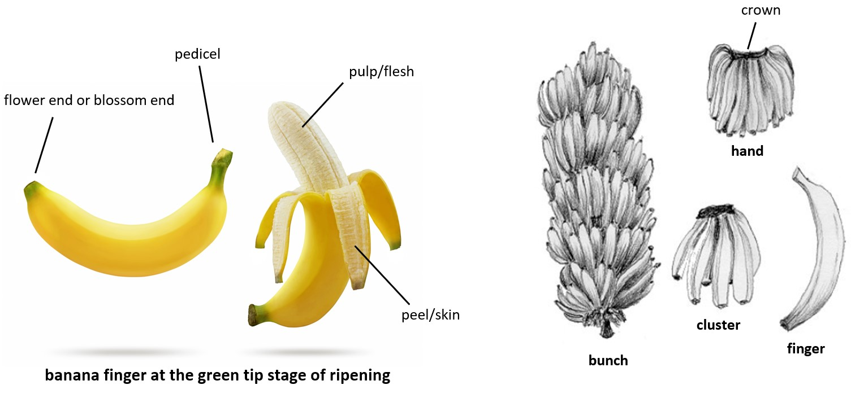
Sources: Adapted from Shutterstock (photos) and Transport Information Service n.d. (diagrams).

Trash
Trash is plant, animal or other extraneous material other than fruit as defined in the scope of this assessment. Examples of trash include soil, splinters, twigs, leaves, loose stem and leaf material, and seeds. Trash is not usually included in the scope of horticultural risk assessments. This is because the risk associated with trash is managed through the standard ‘freedom from trash’ operational requirement that applies to all fresh horticultural produce imported into Australia. Freedom from trash is confirmed by the inspection of the goods conducted on arrival in Australia by Australian Government biosecurity officers.
Black Sigatoka, banana freckle, Moko and Panama disease Tropical Race 4 could be present on trash associated with banana fruit imported into Australia (e.g. on infected leaf material or soil). As part of the assessment, we will consider whether the standard ‘freedom from trash’ requirement is sufficient to manage the risk of these pathogens or if additional measures are required.

Existing policy for the importation of fresh bananas
We made a policy determination in 2009 permitting the import of bananas from the Philippines, subject to the risk management measures proposed in the 2008 import risk analysis. These risk management measures were never finalised with the Philippines within an operational workplan. Import conditions were not published and no trade has occurred.
Australia does not currently permit the import of fresh bananas from any market.
We will consider the pests and diseases previously identified in the 2008 import risk analysis for bananas from the Philippines. Where relevant, information from that assessment will be considered in the BIRA. We will also review the latest scientific literature and other information and, where relevant, include this new information in the assessment of alternative measures.

Previous consultation and engagement
We have been regularly engaging with the Australian Banana Growers’ Council (ABGC), the peak industry body for the banana industry, on the assessment of alternative measures for bananas from the Philippines.
On 16 September 2025, we notified stakeholders that we are conducting the assessment of alternative measures for Cavendish bananas from the Philippines. Key domestic stakeholders notified included ABGC, peak horticultural industry bodies, the Australian banana industry, including growers, researchers and those in the supply chain, and state and territory governments.
From September to November 2025, we held virtual and in-person meetings for all interested stakeholders. In-person meetings were held in Innisfail and Mareeba in Queensland, Coffs Harbour in New South Wales and Carnarvon in Western Australia. We provided stakeholders with background information on the assessment, the assessment process and how and when we will engage with stakeholders.
For information on engagement activities, see bananas from the Philippines.
On 16 June 2026, Plant Biosecurity Advice 2026/P03 announced our intent to conduct a BIRA and the release of this issues paper. We invite stakeholders to provide feedback on the issues raised in this issues paper by 16 July 2026.

Banana production in the Philippines
The Philippines’ banana industry is well established. The industry produced approximately 8.69 million tonnes of bananas in 2024. Approximately 50% of production is Cavendish. Philippine banana production occurs year round. The Philippines export fresh bananas to multiple markets including Japan, Korea, China and the Middle East.

Banana production in Australia
The Australian banana industry is well established. The industry produced 368,701 tonnes of bananas valued at $719.4 million in 2024–25. Bananas are produced year round with peak production occurring between March and November. Approximately 97% of varieties grown are Cavendish. Bananas are predominately grown in Queensland (94%). The major growing regions include the Cassowary Coast (Tully, Innisfail and Kennedy), the Atherton Tablelands and Lakeland. Bananas are also grown in northern New South Wales, Western Australia and the Northern Territory.

Assessment approach

Assessments for Moko, black Sigatoka and banana freckle
We will conduct a comprehensive scientific assessment for 3 pathogens of concern:
- Moko
- black Sigatoka
- banana freckle.
We will also consider alternative risk management measures to those proposed in 2008, where required.
The 2008 Philippine bananas import risk analysis used a complex quantitative methodology for assessing the probability of the entry, establishment and spread for the pathogens of concern. The department stopped using this methodology in 2010.
The risks posed by Moko, black Sigatoka and banana freckle will be re-assessed using our current methodology for pest risk analyses (PRAs). This method is consistent with the International Standards for Phytosanitary Measures (ISPMs), including ISPM 2: Framework for pest risk analysis (FAO 2019a) and ISPM 11: Pest risk analysis for quarantine pests (FAO 2019b), and the World Trade Organization (WTO) Agreement on the Application of Sanitary and Phytosanitary Measures (SPS Agreement) (WTO 1995).
This will include an assessment of the likelihood that each pathogen will:
- arrive in Australia in a viable state with the importation of Cavendish bananas from the Philippines (likelihood of importation)
- be distributed within Australia in a viable state as a result or the processing, sale or disposal of Cavendish bananas from the Philippines, and subsequently transfer to a susceptible part of a host plant (likelihood of distribution)
- establish within Australia, based on a comparison of factors in the source and destination areas that affect pathogen survival and reproduction (likelihood of establishment)
- spread within Australia, based on a comparison of factors in the source and destination areas that affect the expansion of the geographic distribution of the pathogen (likelihood of spread).
It will also include an assessment of the potential consequences of the entry (importation and distribution), establishment and spread of the pathogens in Australia.
As part of the consequences assessment, where applicable, we will consider direct and indirect impacts on the following factors across different geographic levels.

Direct impacts
- The life or health of plants and plant products (e.g. pest impacts on the life or health of the plants and production effects (yield or quality) either at harvest or during storage).
- Impacts on the life or health of humans or of animals and animal products.
- Other aspects of the environment.

Indirect impacts
- Eradication and control costs (e.g. pest impacts on new or modified eradication, control (including fungicide resistance), surveillance or monitoring and compensation strategies or programs).
- Non-commercial values (e.g. pest impacts on the community and environment, including reduced tourism, reduced rural and regional economic viability, loss of social amenity and any ‘side effects’ of control measures).
- Domestic trade (e.g. pest impacts on domestic trade or industry, including changes in domestic consumer demand for a product resulting from quality changes and effects on other industries supplying inputs to, or using outputs from, directly affected industries).
- international trade (e.g. loss of markets, meeting new technical requirements to enter or maintain markets and changes in international consumer demand for a product resulting from quality changes).
Based on this assessment, we will determine the unrestricted risk estimate. This is the level of risk that would be present if there were no risk management measures in place. The final rating will either be negligible, very low, low, moderate, high or extreme.
If the unrestricted risk is determined to be higher than ‘very low’, this does not meet Australia’s ALOP. Consequently, we will then determine whether there are risk management measures alternative to those identified in the 2008 import risk analysis that would reduce the biosecurity risk of the pest to meet Australia’s ALOP.

Consideration of additional banana cultivar and export province
We will consider the biosecurity risk that may be associated with the importation of the additional Cavendish banana cultivar ‘GCTCV-218’ (also known as ‘Formosana’) and the additional export province Davao de Oro in the Davao Region or Region 11.
We will determine whether the additional cultivar and export province pose any different biosecurity risks to those identified in the 2008 import risk analysis and the current assessment.
If there are different biosecurity risks identified, we will conduct an assessment to determine if the risks achieve ALOP. If the risks don’t achieve ALOP, we will determine whether there are risk management measures that would reduce the biosecurity risk to meet Australia’s ALOP.

Review of 2008 import risk analysis
We will review the 2008 import risk analysis to ensure the assessments of other pests are still appropriate. The review will also determine whether any new biosecurity risks have emerged since the risk analysis was finalised. The review will include:
- A review of the initiation and pest categorisation stages that identify and categorise potential quarantine pests associated with the importation of fresh Cavendish bananas from the Philippines. This will include a comprehensive search for any additional pests of potential concern on the banana fruit pathway.
  - As part of this process, we will review the status of phytoplasmas, Eumusae leaf spot, blood disease and other emerging threats in the region.
- Pest categorisation will determine whether risk assessment is required to determine the level of biosecurity risk of any additional pests and if measures are required. More information on this process is available on our website.
  - As part of this process, we will review the pest categorisation for Panama disease Tropical Race 4 (Fusarium oxysporum f. sp. cubense Tropical Race 4), taking into consideration information that has become available since 2008. This will determine whether further assessment of Panama disease Tropical Race 4 is required.
- A review of all pest risk assessments (other than those for Moko, black Sigatoka and banana freckle) to check whether the outcomes of those assessments are still appropriate.
- A review of any recommended measures for pests.

Consultation and expert advice
We will draw on the expertise of independent experts to review and provide comments on the assessment as needed.
As the assessment is being conducted as a BIRA, we may ask the Scientific Advisory Group at any stage in the process to examine and provide comments on any aspect of the assessment.

Expert Advisory Group
We recognise that specific expert advice may be required for this assessment. To support this, we are establishing an Expert Advisory Group (EAG) comprising of experts in banana pests and diseases, production practices and pest management systems to provide independent, expert advice on this assessment.

ABARES economic consequences project
The Australian Bureau of Agricultural and Resource Economics and Sciences (ABARES) are undertaking a project to examine the potential economic impacts key banana diseases could have if they were to become established in Australia. The project will focus on Moko, black Sigatoka, banana freckle and Panama disease TR4.
As part of this project, ABARES are engaging with key stakeholders to gather information. This includes information on banana disease management practices, response activities and costings for such activities.
The outcomes of this project will inform our assessment of the economic consequences of these diseases. This information will be included in the draft report.

Stakeholder feedback
We welcome your feedback on any aspects of this issues paper.
We also invite stakeholders to provide any relevant information they would like us to consider when preparing the draft report.
Only feedback that is within scope of the assessment will be considered. Commercial competition matters and non-biosecurity issues are out of scope for this assessment.
To provide feedback on this issues paper, email plantstakeholders@aff.gov.au by 16 July 2026. We will carefully consider all feedback received when preparing the draft report.
The next opportunity for consultation will be when we release the draft report. We expect to release the draft report in early 2027, noting this timing is subject to change. For updates on upcoming consultations, see bananas from the Philippines.
To receive regular updates on this process, email plantstakeholders@aff.gov.au.
To receive notices about plant biosecurity policy and biosecurity risk analysis, including this assessment, subscribe to Biosecurity Risk Analysis Plant.
For information on how we conduct risk analyses and our international obligations, see undertaking an import risk analysis.

Appendix A: Summary of BIRA process and trade implementation
Figure A1 outlines the BIRA process and the subsequent steps that are required before trade is permitted to commence. The trade implementation steps can only occur if the BIRA determines that any biosecurity risks can be managed to achieve Australia’s appropriate level of protection (ALOP).
Figure A1 BIRA process
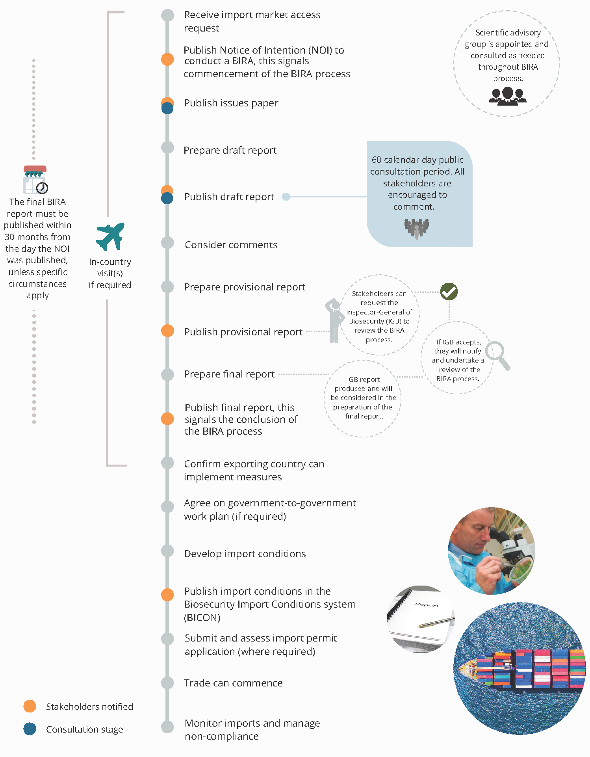

Glossary
Term | Definition
appropriate level of protection | The level of protection deemed appropriate by the Member establishing a sanitary or phytosanitary measure to protect human, animal or plant life or health within its territory (WTO 1995).
appropriate level of protection for Australia | The Biosecurity Act 2015 defines the appropriate level of protection (or ALOP) for Australia as a high level of sanitary and phytosanitary protection aimed at reducing biosecurity risks to very low, but not to zero.
area | An officially defined country, part of a country or all or parts of several countries (FAO 2024b).
arthropod | The largest phylum of animals, including the insects, arachnids and crustaceans.
Australian territory | Australian territory as referenced in the Biosecurity Act 2015 refers to Australia, Christmas Island and Cocos (Keeling) Islands and any external Territory to which that provision extends.
BA | Biosecurity Advice.
BICON | Australia’s Biosecurity Import Conditions system.
biosecurity | The prevention of the entry, establishment or spread of unwanted pests and infectious disease agents to protect human, animal or plant health or life, and the environment.
biosecurity import risk analysis (BIRA) | The Biosecurity Act 2015 defines a BIRA as an evaluation of the level of biosecurity risk associated with particular goods, or a particular class of goods that may be imported, or proposed to be imported, into Australian territory, including, if necessary, the identification of conditions that must be met to manage the level of biosecurity risk associated with the goods, or the class of goods, to a level that achieves the ALOP for Australia. The risk analysis process is regulated under legislation.
biosecurity measures | The Biosecurity Act 2015 defines biosecurity measures as measures to manage any of the following: biosecurity risk, the risk of contagion of a listed human disease, the risk of listed human diseases entering, emerging, establishing themselves or spreading in Australian territory, and biosecurity emergencies and human biosecurity emergencies.
biosecurity risk | The Biosecurity Act 2015 refers to biosecurity risk as the likelihood of a disease or pest entering, establishing or spreading in Australian territory, and the potential for the disease or pest to cause harm to human, animal or plant health or the environment, or the potential for economic consequences associated with the entry, establishment or spread of the disease or pest.
control (of a pest) | Suppression, containment or eradication of a pest population (FAO 2024b).
entry (of a pest) | Movement of a pest into an area where it is not yet present, or present but not widely distributed and being officially controlled (FAO 2024b).
establishment (of a pest) | Perpetuation, for the foreseeable future, of a pest within an area after entry (FAO 2024b).
FAO | Food and Agriculture Organization of the United Nations.
fresh | Living; not dried, deep-frozen or otherwise conserved (FAO 2024b).
general surveillance | An official process whereby information on pests in an area is obtained through various non-official or official sources other than surveys (FAO 2024b).
genus | A taxonomic category ranking below a family and above a species and generally consisting of a group of species exhibiting similar characteristics. In taxonomic nomenclature the genus name is used, either alone or followed by a Latin adjective or epithet, to form the name of a species.
goods | The Biosecurity Act 2015 defines goods as an animal, plant (whether moveable or not), a sample or specimen of a disease agent, a pest, mail or any other article, substance or thing (including, but not limited to, any kind of moveable property).
import permit | Official document authorising importation of a commodity in accordance with specified phytosanitary import requirements (FAO 2024b).
inspection | Official visual examination of plants, plant products or other regulated articles to determine if pests are present or to verify conformity with phytosanitary requirements (FAO 2024b).
intended use | Declared purpose for which plants, plant products or other articles are imported, produced or used (FAO 2024b).
International Plant Protection Convention (IPPC) | The IPPC is an international plant health agreement, established in 1952, that aims to protect cultivated and wild plants by preventing the introduction and spread of pests. The IPPC provides an international framework for plant protection that includes developing International Standards for Phytosanitary Measures (ISPMs) for safeguarding plant resources.
International Standard for Phytosanitary Measures (ISPM) | An international standard adopted by the Conference of FAO, the Interim Commission on Phytosanitary Measures or the Commission on Phytosanitary Measures, established under the IPPC (FAO 2024b).
introduction (of a pest) | The entry of a pest resulting in its establishment (FAO 2024b).
mature fruit | Commercial maturity is the start of the ripening process. The ripening process will then continue and provide a product that is acceptable to consumers. Maturity assessments include colour, starch, index, soluble solids content, flesh firmness, acidity, and ethylene production rate.
pathogen | A biological agent that can cause disease to its host.
pathway | Any means that allows the entry or spread of a pest (FAO 2024b).
pedicel | The stalk of a single flower within an inflorescence, which develops into fruit.
pest | Any species, strain or biotype of plant, animal or pathogenic agent injurious to plants or plant products (FAO 2024b).
pest categorisation | The process for determining whether a pest has or has not the characteristics of a quarantine pest or those of a regulated non-quarantine pest (FAO 2024b).
pest risk analysis (PRA) | The process of evaluating biological or other scientific and economic evidence to determine whether an organism is a pest, whether it should be regulated, and the strength of any phytosanitary measures to be taken against it (FAO 2024b).
pest risk assessment (for quarantine pests) | Evaluation of the probability of the introduction and spread of a pest and the magnitude of the associated potential economic consequences (FAO 2024b).
pest risk assessment (for regulated non-quarantine pests) | Evaluation of the probability that a pest in plants for planting affects the intended use of those plants with an economically unacceptable impact (FAO 2024b).
pest risk management (for quarantine pests) | Evaluation and selection of options to reduce the risk of introduction and spread of a pest (FAO 2024b).
pest risk management (for regulated non-quarantine pests) | Evaluation and selection of options to reduce the risk that a pest in plants for planting causes an economically unacceptable impact on the intended use of those plants (FAO 2024b).
pest status (in an area) | Presence or absence, at the present time, of a pest in an area, including where appropriate its distribution, as officially determined using expert judgement on the basis of current and historical pest records and other information (FAO 2024b).
phytosanitary regulation | Official rule to prevent the introduction or spread of quarantine pests, or to limit the economic impact of regulated non-quarantine pests, including establishment of procedures for phytosanitary certification (FAO 2024b).
quarantine | Official confinement of regulated articles for observation and research or for further inspection, testing or treatment.
quarantine pest | A pest of potential economic importance to the area endangered thereby and not yet present there, or present but not widely distributed and being officially controlled (FAO 2024b).
regulated non-quarantine pest | A non-quarantine pest whose presence in plants for planting affects the intended use of those plants with an economically unacceptable impact and which is therefore regulated within the territory of the importing contracting party (FAO 2024b).
Regulated pest | A quarantine pest or a regulated non-quarantine pest (FAO 2024b).
Risk analysis | Refers to the technical or scientific process for assessing the level of biosecurity risk associated with the goods, or the class of goods, and if necessary, the identification of conditions that must be met to manage the level of biosecurity risk associated with the goods, or class of goods, to a level that achieves the ALOP for Australia.
Risk management measure (measure) | Conditions that must be met to manage the level of biosecurity risk associated with the goods, or the class of goods, to a level that achieves the ALOP for Australia. In this risk analysis, the term ‘risk management measure’ and ‘phytosanitary measure’ may be used interchangeably.
Spread (of a pest) | Expansion of the geographical distribution of a pest within an area (FAO 2024b).
SPS Agreement | World Trade Organization Agreement on the Application of Sanitary and Phytosanitary measures.
Stakeholders | Government agencies, individuals, community or industry groups or organisations, whether in Australia or overseas, including the proponent/applicant for a specific proposal, who have an interest in the policy issues.
Surveillance | An official process which collects, and analyses information related to animal health.
Trash | Soil, splinters, twigs, leaves and other plant material, other than fruit as defined in the scope of this risk analysis.  For example, stem and leaf material, seeds, soil, animal matter/parts or other extraneous material.
Treatment (as a phytosanitary measure) | Official procedure for killing, inactivating, removing, rendering infertile or devitalising regulated pests (FAO 2024b).
Unrestricted risk | Unrestricted risk estimates apply in the absence of risk mitigation measures.
WTO | World Trade Organization.

References
FAO 2019a, International Standards for Phytosanitary Measures (ISPM) no. 2: Framework for pest risk analysis, Secretariat of the International Plant Protection Convention, Food and Agriculture Organization of the United Nations, Rome, Italy, accessed 11 June 2026.
——2019b, International Standards for Phytosanitary Measures (ISPM) no. 11: Pest risk analysis for quarantine pests, Secretariat of the International Plant Protection Convention, Food and Agriculture Organization (FAO) of the United Nations, Rome, Italy, accessed 11 June 2026.
——2024, International Standards for Phytosanitary Measures (ISPM) no. 5: Glossary of phytosanitary terms, Secretariat of the International Plant Protection Convention, Food and Agriculture Organization of the United Nations, Rome, Italy, accessed 11 June 2026.
Transport Information Service n.d., Bananas – Transport Information Service (TIS): Cargo loss prevention information from German marine insurers, German Insurance Association (GDV), accessed 11 June 2026.
WTO 1995, Agreement on the application of sanitary and phytosanitary measures (90.6 KB), World Trade Organization, Geneva, accessed 11 June 2026.

