# Saudi Arabia food and agriculture market snapshot – January 2022

Increased tourism and hospitality, coupled with a greater focus on healthy eating, will provide opportunities for premium food and agriculture exports to Saudi Arabia over the medium term.

## Saudi Arabia market overview

* Saudi Arabia has a population of 35.5 million. GDP is expected to grow by 5% in 2022 (0.3% higher than the G20 average). Population, urbanisation, discretionary spending, and the prevalence of hyper/supermarkets selling high quality food products are increasing in Saudi Arabia.
* Saudi Arabia is a growing market with a rising middle class. Many residents have spent time abroad and have developed a taste for Western-style foods.
* Saudi Arabia is seeking to diversify its economy, including expanding its hospitality and tourism sector. This will increase the demand for premium food products.

## Saudi Arabian food and agriculture imports

* In 2020, Saudi Arabia imported US$20.6b (AU$27.5b) of food and agricultural products. Saudi Arabia’s climate means that imports are important for domestic food security.
* In 2020–21, Australia exported AU$1.2b of agricultural and fisheries products to Saudi Arabia, 204% more than in 2019–20. This was due to increased barley and wheat exports – mostly for animal feed.
* In 2020–21, Saudi Arabia was Australia’s largest agricultural export market in the Middle East, and over the past 5 years the second largest after the United Arab Emirates.

Figure 1 Saudi Arabian food and agricultural product imports from the world in 2020

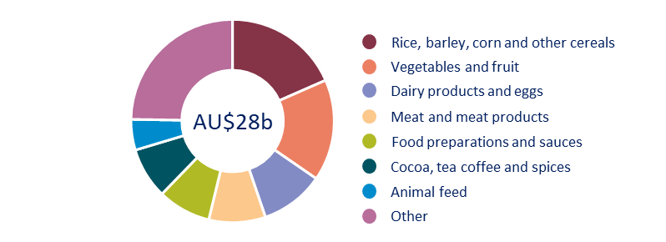

Source: UN Comtrade 2021.

Figure 2 Australian food and agricultural product exports to Saudi Arabia

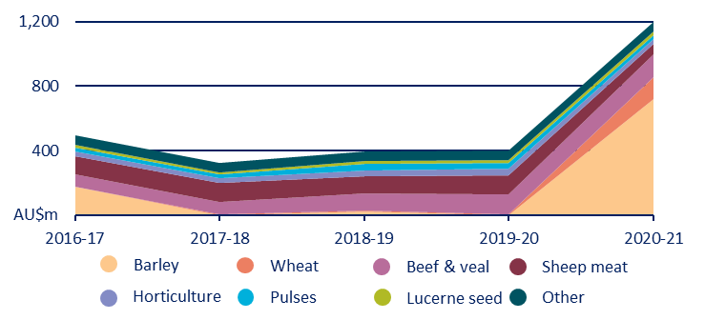

Source: ABS Catalogue 9920.0.

## Outlook for Australian food and agriculture exports to Saudi Arabia

* Saudi Arabia is a promising but complex market.
* Halal accreditation is the primary consideration for most consumers. Many consumers are also price sensitive.
* Consumer preference for high quality food with health benefits is increasing. Organic (fresh or processed) and vegan food are increasingly popular.
* There is ongoing strong demand for Australian feed grains, particularly wheat and barley. However, in most cases, prices in Saudi Arabia are below the global average.
* There is increasing interest in Australian horticulture, including avocado, peaches and nectarines, cherries and citrus. Saudi Arabia is an attractive market for most fruit.
* Salmon is growing in popularity. The value of Saudi salmon grew by 16% in 2020 (relative to the 2017 to 2019 average).
* Saudi Arabian nut consumption, especially almonds, macadamias and walnuts, has increased. Nuts are seen as a premium product with positive health benefits.