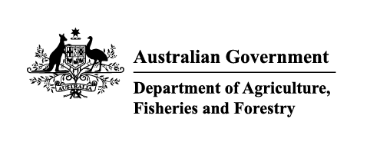

Instrument revoking a holding order under section 15(2) of the Imported Food Control Act 1992
The listed holding orders, having satisfied the circumstances under which the orders will be revoked, are revoked under section 15(2) of the Imported Food Control Act 1992 (the Act).
The circumstances being that the Secretary or delegate is satisfied that the basis for the order no longer applies.
Holding order number | Date revoked
17448 | 05/01/2026
17449 | 05/01/2026
17766 | 05/01/2026
17789 | 05/01/2026
17959 | 05/01/2026
18070 | 05/01/2026
18296 | 05/01/2026
18486 | 05/01/2026
18555 | 05/01/2026
18640 | 05/01/2026
18647 | 05/01/2026
18773 | 05/01/2026
18819 | 05/01/2026
18864 | 05/01/2026
18869 | 05/01/2026
18876 | 05/01/2026
18877 | 05/01/2026
18880 | 05/01/2026
18887 | 05/01/2026
18890 | 05/01/2026
18894 | 05/01/2026
18903 | 05/01/2026
18904 | 05/01/2026
18905 | 05/01/2026
18907 | 05/01/2026
18908 | 05/01/2026
18913 | 05/01/2026
18914 | 05/01/2026
18915 | 05/01/2026
18916 | 05/01/2026
18910 | 06/01/2026
20071 | 15/01/2026
18428 | 19/01/2026
18858 | 19/01/2026
19302 | 19/01/2026
19400 | 19/01/2026
20014 | 19/01/2026
20014 | 19/01/2026
18192 | 20/01/2026
19756 | 20/01/2026
20025 | 23/01/2026
18298 | 27/01/2026
19154 | 27/01/2026
19990 | 27/01/2026
20057 | 27/01/2026
Delegate position number | Date
100091 | 24/02/2026
Delegate of the secretary for the purposes of section 15(2) of the Act.

