**Australian summer stone fruit export snapshot - January 2022**

Favourable seasonal conditions in south-eastern Australia and constrained global supply will support Australian stone fruit exports this summer. Disruptions to logistic networks, including high costs and delays, are the main challenge for exporters.

## Australian summer stone fruit export overview

1. Summer is the key harvesting and exporting time for fresh Australian cherries, nectarines, peaches and plums (stone fruit).
   1. Collectively, 84% of exports for these four stone fruit varieties occur between December and February (Figure 1).
2. Most of Australia’s stone fruit exports are grown in New South Wales, Victoria and Tasmania.
3. The value of Australian stone fruit exports grew strongly in the years leading up to 2018-19 and have been steady over the last three years.
4. China is the key market for most stone fruit exports. Other Asian markets, including Hong Kong, Singapore and Vietnam are also important (Figure 2).
5. Australia produces summer fruit during Northern Hemisphere winter. This supports demand for Australian fruit in international markets.

Figure 1 - Australian stone fruit export value by season

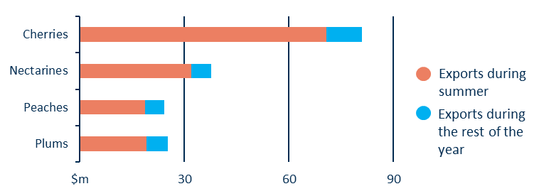

Figure 2 - Australian summer stone fruit exports by country

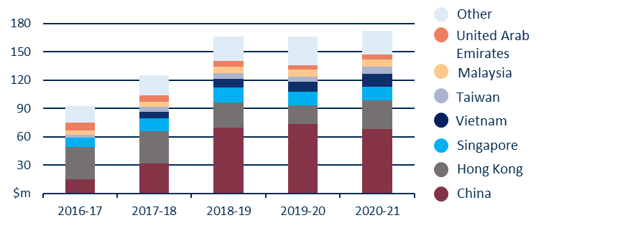

## Outlook for summer 2021-22

1. Generally favourable seasonal conditions in south-eastern Australia should support average to good production for the 2021-22 season. Untimely rain and storms can have a substantial impact on crop size and fruit quality, which means actual production outcomes can vary right up until harvest.
2. Chile is Australia’s major global competitor for stone fruit during December-February. Drought may slightly reduce Chilean stone fruit production; however, export volumes are unlikely to be affected. As a result, global prices in 2021-22 are likely to be similar to 2020-21.
3. Logistics are the major challenge for stone fruit exporters in 2021-22. Airfreight availability remains limited, and transport costs are elevated. Even short delays at ports have the potential to cause spoilage.
4. Horticulture producers are likely to continue to face workforce challenges in 2021–22. This will increase costs for stone fruit producers.