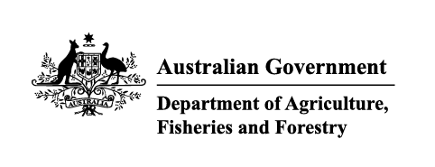

Instrument revoking a holding order under section 15(2) of the Imported Food Control Act 1992
The listed holding orders, having satisfied the circumstances under which the orders will be revoked, are revoked under section 15(2) of the Imported Food Control Act 1992 (the Act).
The circumstances being that the Secretary or delegate is satisfied that the basis for the order no longer applies.

Holding order number | Date revoked
15904 | 01/06/2026
16853 | 01/06/2026
18080 | 01/06/2026
18099 | 01/06/2026
18122 | 01/06/2026
18219 | 01/06/2026
18325 | 01/06/2026
18358 | 01/06/2026
18494 | 01/06/2026
18508 | 01/06/2026
18509 | 01/06/2026
18511 | 01/06/2026
18583 | 01/06/2026
18731 | 01/06/2026
18857 | 01/06/2026
19090 | 01/06/2026
19093 | 01/06/2026
19094 | 01/06/2026
19095 | 01/06/2026
19096 | 01/06/2026
19097 | 01/06/2026
19116 | 01/06/2026
19117 | 01/06/2026
19119 | 01/06/2026
19121 | 01/06/2026
19123 | 01/06/2026
19124 | 01/06/2026
19129 | 01/06/2026
19131 | 01/06/2026
19132 | 01/06/2026
19133 | 01/06/2026
19141 | 01/06/2026
19142 | 01/06/2026
19159 | 01/06/2026
19160 | 01/06/2026
19167 | 01/06/2026
19169 | 01/06/2026
INC23008 | 01/06/2026
REC24002 | 01/06/2026
REC24002 | 01/06/2026
20327 | 02/06/2026
18648 | 12/06/2026
18333 | 23/06/2026
19802 | 23/06/2026
20171 | 23/06/2026
20204 | 23/06/2026
20253 | 23/06/2026
20280 | 23/06/2026
20324 | 23/06/2026
20083 | 29/06/2026
20371 | 29/06/2026

Delegate position number | Date
100091 | 29/07/2026
Delegate of the secretary for the purposes of section 15(2) of the Act.

