
National Khapra Beetle Action Plan 2021–2031

Plant Health Committee
© Commonwealth of Australia 2021
Ownership of intellectual property rights
Unless otherwise noted, copyright (and any other intellectual property rights) in this publication is owned by the Commonwealth of Australia (referred to as the Commonwealth).
Creative Commons licence
All material in this publication is licensed under a Creative Commons Attribution 4.0 International Licence except content supplied by third parties, logos and the Commonwealth Coat of Arms.
Inquiries about the licence and any use of this document should be emailed to copyright@awe.gov.au.

Cataloguing data
This publication (and any material sourced from it) should be attributed as: DAWE 2021, National Khapra Beetle Action Plan, Department of Agriculture, Water and the Environment, Canberra, December. CC BY 4.0.
ISBN 978-1-76003-503-7
This publication is available at https://www.awe.gov.au/biosecurity-trade/pests-diseases-weeds/plant/national-action-plans.
Department of Agriculture, Water and the Environment
GPO Box 858 Canberra ACT 2601
Telephone 1800 900 090
Web awe.gov.au
Disclaimer
The Australian Government acting through the Department of Agriculture, Water and the Environment has exercised due care and skill in preparing and compiling the information and data in this publication. Notwithstanding, the Department of Agriculture, Water and the Environment, its employees and advisers disclaim all liability, including liability for negligence and for any loss, damage, injury, expense or cost incurred by any person as a result of accessing, using or relying on any of the information or data in this publication to the maximum extent permitted by law.
Cover page
The image on the cover: Field of wheat ready for harvest with grain silos in background © Shutterstock
Version control
27 Jul 2021 v1.0 Endorsed by Plant Health Committee

Contents

Acknowledgments v
Executive summary 1
1. Introduction 2
2. Khapra beetle and affected commodities 3
3. National Khapra Beetle Action Plan 7
3.1 Scope of the plan 7
3.2 Structure of the plan 7
4. National context 8
4.1 Legislation 8
4.2 National arrangements 9
5. Action areas 11
Action area 1: Prevention 11
Action area 2: Detection 22
Action area 3: Response 27
Action area 4: Cross-cutting issues 30
6. Implementation 34
7. Monitoring, evaluation and review 35
8. Relevant sources of information 36
9. Acronyms and abbreviations 38
10. Definitions/glossary 39

Figures
Figure 1. Lateral view of an adult khapra beetle v
Figure 2. In the larval phase, dorsal and head frontal view 3
Figure 3. Lifted floor boards of shipping container 17
Figure 4. Shipping movements around Australia 21

Information Box
Box 1. Characteristics of khapra beetle contributing to the pest status 2

Tables
Table 1. Legislation relevant to the management of biosecurity risks 8
Table 2. Peak industry body for plant industries affected by khapra beetle 9
Table 3. Summary table of Action area 1: PREVENTION 21
Table 4. Summary table of Action area 2: DETECTION 26
Table 5. Summary table of Action area 3: RESPONSE 30
Table 6. Summary table of Action area 4: CROSS-CUTTING ISSUES 33

Acknowledgments
The Department of Agriculture, Water and the Environment has prepared the National Khapra Beetle Action Plan, drawing on input and feedback from a diverse group of experts and stakeholders following a national workshop and public consultation. The workshop identified the need for a plan to take a holistic approach to manage the risk of khapra beetle by addressing critical points along the supply chain to reduce reliance on any one biosecurity measure. This input has assisted the identification of some of the core biosecurity activities to prevent and prepare for khapra beetle should it be detected in Australia, and to validate the actions proposed in this plan. The contribution of these people and organisations is acknowledged.
Our particular thanks go to presenters at the National Khapra Beetle Preparedness Workshop, 13 and 14 June 2019: Dr Marion Healy, Bill Crowe, Graeme Kruger, Barry Large, Dr Jonathan Banks, Caroline Martin, Adam Broadley, Dr Sam Hair, Dr Susie Collins, Nick Secomb, Laura Williamson and Jessica Russell.
Figure 1 Lateral view of an adult khapra beetle
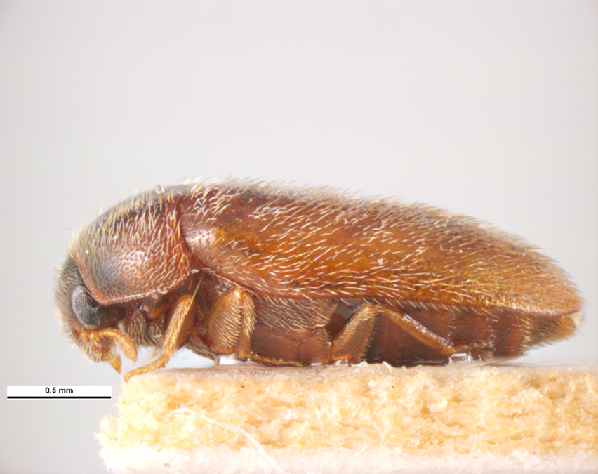
© Simon Hinkley and Ken Walker, Museums Victoria

Executive summary
Trogoderma granarium (khapra beetle, see Figure 1) is a serious pest of stored grain, nuts, and dry foodstuffs worldwide. Large populations can develop in stored produce and completely destroy it. Should khapra beetle become established in Australia, it would pose a major threat to Australia’s grains industry due to potential production losses and impacts on international trade. Contamination from beetles or cast skins, and hairs from larvae, can also pose a health risk and are very difficult to remove from storage structures and conveyances.
The Plant Health Committee, as the relevant national committee for plant biosecurity, has endorsed khapra beetle as Australia’s number two National Priority Plant Pest (2019). It is a Category 2 Emergency Plant Pest in Schedule 13 of the Emergency Plant Pest Response Deed (EPPRD). Seven Australian plant industry bodies (grains, various nut industries, cotton, dried fruits and rice) have identified khapra beetle as a High Priority Pest through Plant Health Australia’s biosecurity planning processes.
Three recorded khapra beetle detections in Australia up until 2020 were associated with imported goods: in Western Australia in 2007, from personal goods; in South Australia in 2016, from plastic boxes; and in 2018 in Victoria, from polymer beads. All detections were successfully contained, treated and eradicated. In 2020 there were 16 detections at the border, ten linked to containers, five to goods, with the source of the remaining detection unknown. One of these detections was in a container of white goods and another in a consignment of highchairs, both imported by major retailers. Up to the end of May 2021 there have been three detections at the border in goods and one detection in a shipping container of flat cardboard.
This plan provides a nationally agreed approach to enhance Australia’s capacity to manage the threat of khapra beetle entering and establishing in Australia. Priority areas to prevent, prepare for, and respond to khapra beetle incursions are identified. The actions for each priority area may also assist in prevention and response to other exotic species of Trogoderma.
The plan outlines areas of further work to better understand khapra beetle, including how the pest can be detected, identified, and treated, and how to build national expertise and capability. The success of the plan will depend on a high level of cooperation and collaboration between all levels of government, plant industries, the import supply chain, experts, research agencies and the public (including visitors to Australia).
Relevant research and development corporations, relevant industry bodies, the Plant Biosecurity Research Initiative, and other research and development forums will be encouraged or used to promote opportunities for research and development to address gaps in our knowledge of khapra beetle and its surveillance and control. The actions set out in the plan will evolve as knowledge is gained through local and overseas experience and research.
The Plant Health Committee has endorsed the plan and will oversee its implementation on behalf of jurisdictions through its Plant Biosecurity Preparedness Working Group. Actions contained in the plan will be progressed according to their priority. Some will be conducted as business-as-usual and others will be undertaken as resources are committed to take them forward. Progress in implementing the plan will be assessed annually and the plan will be formally reviewed after five years, or as determined by the Plant Health Committee

1. Introduction
Trogoderma granarium (khapra beetle) is a serious pest of stored grain, nuts, and dry foodstuffs worldwide. The purpose of the plan is to guide the implementation of nationally agreed actions for a strategic and risk-based approach to prevent the introduction of khapra beetle and to prepare for a rapid response should khapra beetle be detected in Australia.
The actions in the plan may also have potential to assist in prevention and response activities for other exotic species of Trogoderma. For these other species, surveillance undertaken in an eradication response would be based on their biology. Different Trogoderma species can have different hosts, and other aspects of their behaviour and ecology that will affect how, where and when to look for them.
The plan identifies areas for further work to better understand khapra beetle and how the pest can be detected, identified, and treated, and how to build national expertise and capability.
The endorsement of khapra beetle as Australia’s number two National Priority Plant Pest (2019) reflects the significant potential impact of the pest on some of Australia’s major plant industries. The Plant Health Committee identifies National Priority Plant Pests as exotic pests and diseases that are not established in Australia and pose the highest risk to our environment, public spaces, heritage, way of life or plant production industries. Legislation across jurisdictions relevant to the management of khapra beetle is provided in Table 1. Plant industry bodies provide an important role in raising awareness and seven Australian plant industry bodies have identified khapra beetle as a High Priority Pest through Plant Health Australia’s biosecurity planning processes (see Table 2). Characteristics of khapra beetle that highlight the potential threat to Australia are below in Box 1.

Box 1 The khapra beetle:
1. is a pest of most stored products, and can infest areas where stored products are kept or transported
2. is a dirty feeder that can destroy stored products, make foodstuffs inedible and is a potential human health risk
3. is small and frequently cryptic, sheltering in cracks in walls, under paint, between joins, and under floors in sea containers
4. is capable of maintaining a low level, very difficult to detect ‘background’ population for extended periods in areas almost free of host material
5. adults do not fly or eat, and lay large numbers of eggs
6. produce numerous larvae with voracious appetites for stored products
7. larvae can enter a facultative diapause and survive without food for over 12 months, or up to five or 10 years when food is intermittently available
8. larval stages are not reliably identifiable using traditional morphological taxonomy, particularly early instar larvae owing to their similarity to closely related Dermestidae, particularly other Trogoderma
9. are challenging to treat with fumigation
10. spread is almost entirely human mediated
11. has the potential to significantly impact Australian exports of grain and stored products.

2. Khapra beetle and affected commodities
Considered native to India, khapra beetle is found throughout the Middle East, Asia, Africa and a few countries in Europe (IPPC DP3 2012). A list of countries where it is known to be present is available on our website.
Khapra beetle adults are small (1.6–3 mm long and 1–2 mm wide); yellowish brown, with an oval-shaped body, covered by dense, short hairs and with three indistinct transverse bands of pale hairs on the elytra (hardened forewings) (Figure 2 top right). In stored products, particularly cereals, grain movement will damage dry dead adults making morphological characters problematic. In most individuals, the legs and antennae will break off and most of the setae on the elytra and pronotum will be rubbed off. Wings may be almost completely broken off.
Khapra beetle eggs hatch into small hairy larvae that are reddish brown and darken as they mature, growing up to 1.6–4.5 mm long. The larvae have characteristic long hairs all over their bodies, especially noticeable at the rear end. Khapra beetle larvae can survive without food for over 12 months by entering a facultative diapause, which can be triggered by temperature (Wilches et al. 2017), lack of or inadequate food sources, and isolated or crowded conditions (Burges 1959). When provided with food after a period of starvation, most diapausing khapra beetle larvae will pupate after some feeding, but some will return to diapause as larvae (Burges 1959). This behaviour may be responsible for reports of diapausing larvae surviving for up to ten years (Banks 2019), with Burges (1959) finding 16% of larvae had not begun to pupate after four years.
Figure 2 In the larval phase, Khapra beetle is pale and hairy, and darkens as it ages
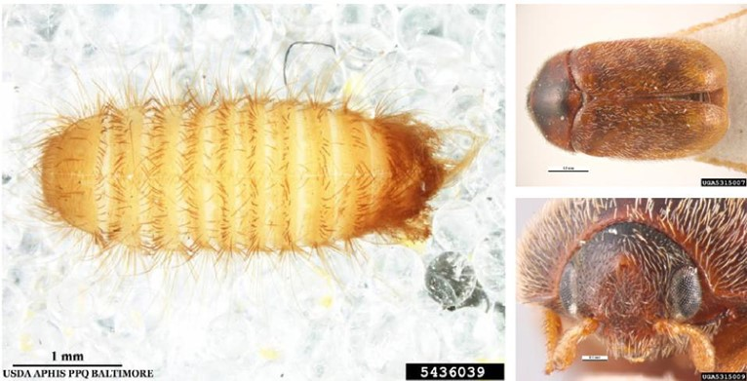
Khapra beetle in the larval phase © James D. Young, USDA APHIS PPQ, Bugwood.org (left), dorsal view (top right) and head frontal view (bottom right) of an adult khapra beetle © Simon Hinkley and Ken Walker (Museums Victoria)

Khapra beetle is known to establish in hot dry climates and is very tolerant to low relative humidity environments. Optimum conditions for development are 33–37 degrees Celsius with a relative humidity of 45–75%, but temperature extremes (up to 60 degrees Celsius and down to 15 degrees Celsius) can be tolerated for short periods (Howe 1958 cited by Grains Industry 2005). Reproduction in khapra beetle ceases above 40 degrees Celsius (Banks 2019). Warehouses, food storage and processing areas, dwellings or other built environments provide ideal conditions for development of khapra beetle larvae irrespective of the season.
The Australian environment is favourable to khapra beetle establishing, particularly in the Western Australian grain belt, which could impact the technical feasibility of eradication.
Pasek (1998) concluded that establishment of this pest would not be expected to have significant direct or indirect impacts upon natural environments or threatened or endangered species. Any potential indirect impacts on the environment would be from the effects of chemical pest control treatments.
Khapra beetle is spread through human movement of stored grain and products, or as contamination of shipping containers, seed, machinery, and straw. The approach to managing this pest needs to involve the whole of the supply chain, as there are many points where infestation could occur if khapra beetle were to hitchhike on non-commodity products.
Khapra beetle will feed on almost any kind of material, from substances of animal origin such as dried blood and dead insects, to cereal products (flour, malt, noodles), and stored grain, including rice and maize (Noon 1958). Adults do not normally feed (Hosseininaveh et al. 2007, Rees 2004), with most damage to stored products caused by larvae.
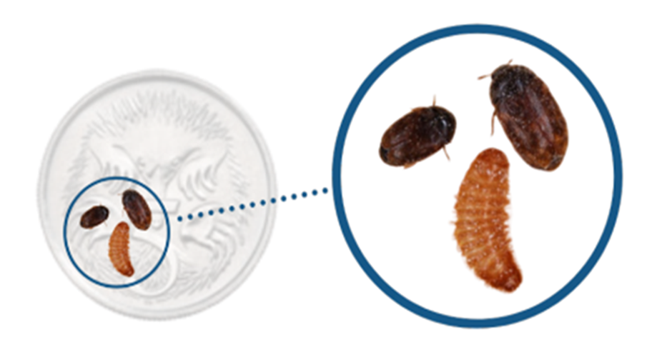
Australian five-cent piece showing comparative size of khapra beetle and larvae © Department of Agriculture, Water and the Environment

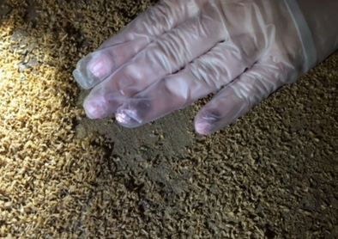
Large populations of khapra beetle may develop in stored grain and nuts, which can spoil and be almost completely destroyed (International Plant Protection Convention 2012). Khapra beetle larvae infestation can result in losses of up to 70% of stored grains, reduce seed germination, viability and result in grain weight loss. The loss in quality of grains is seen as reduced sugar content, crude fats, carbohydrates and the protein profile (Honey et al. 2017). Some of these effects have also been reported for stored nuts (Hayward 1955) leading to an unpalatable product.
Heavy infestation under the flooring of a shipping container comprising larvae and larval skins © Department of Agriculture, Water and the Environment
Khapra beetle is considered a ‘dirty feeder’ as more stored product is damaged than is consumed. Larvae contaminate stored products with body parts and barbed hairs, which are highly allergenic to humans (Rees 2004, Stibick 2007), and difficult to remove from bulk storage structures and transport vessels. Stibick (2007) summarised the health risks caused by barbed hairs as skin irritation to those handling infested grain and ulcerative colitis (inflammatory bowel disease) experienced if swallowed. Inhaling hairs can irritate airways and cause asthma (Honey et al. 2017). Khapra beetle may also be contaminated with bacteria that are potential human pathogens (Channaiah et al. 2010).
Shipping containers imported into Australia may harbour persistent and potentially large, difficult to detect khapra beetle infestations, which have been caused by the container having previously carried an infested commodity. Prior to 2020, there were three recorded khapra beetle detections in Australia associated with imported goods in shipping containers. These detections have been successfully contained, treated and eradicated. These are: in Western Australia in 2007, from personal goods; in South Australia in 2016, from plastic boxes; and in 2018 in Victoria, from polymer beads (Inspector-General of Biosecurity 2019).
In 2020, the number of detections increased significantly. In that year, there were 16 detections at the border, 10 linked to containers, five to goods, with the source of the remaining detection unknown. One of these detections was in a container of white goods and another in a consignment of highchairs, both imported by major retailers. Some of these detections have been in consignments that khapra beetle previously had no association with, and from countries not known to have khapra beetle. Tracing, inspection, surveillance and treatment were undertaken to ensure the interceptions did not pose an ongoing biosecurity risk. Surveillance plans have been developed for the ongoing monitoring of the locations. We established an Incident Management Team to ensure appropriate action was taken to manage the interceptions.
These recent detections also highlight the need to maintain training resources for surveillance staff; and to develop new and effective means of applying eradication treatments in urban environments where non-chemical treatments may be available.
We are undertaking urgent actions to address the risk of khapra beetle hitchhiking in shipping containers. These activities can be seen under Action Area 1: Prevention.


3. National Khapra Beetle Action Plan
The khapra beetle is one of the world’s 100 worst invasive species (Global Invasive Species Database 2020). As one of the most destructive stored grain pests, infestations can destroy the quality of grain and other commodities, rendering the product unfit for human or animal consumption. Australia’s khapra beetle-free status is important for access to valuable international markets—an incursion or establishment of khapra beetle in Australia could potentially cause huge losses for Australian agribusiness.
The majority of Australian wheat is sold overseas with Western Australia the largest exporting state. The major export markets are in the Asian and Middle East regions and include Indonesia, Japan, South Korea, Malaysia, Vietnam and Sudan. About 85% of Australian rice is exported to more than 70 destinations. Australia exported an average of 350,000 tonnes per year of rice between 2010–11 and 2019–20. Australia also exports cotton, oilseeds and pulses.
The plan identifies priority areas to target for khapra beetle preparedness, and identifies roles, responsibilities, and required resources needed to protect Australia’s primary and export industries.

3.1 Scope of the plan
The plan aims to develop preparedness, which is about building national capacity and capability to prevent and prepare for responses to plant biosecurity threats. It does so by describing the priority areas for a national approach across prevention, detection and response, and sets out specific actions and priorities to improve the management of risks associated with khapra beetle. As Australia is free of khapra beetle, the plan does not include actions relating to containment and asset-based protection or ongoing management.

3.2 Structure of the plan
The plan first describes the national context for biosecurity risk management in Australia and is then structured into the three priority action areas to address preparedness: prevention, detection, and response, and one additional priority action area for cross-cutting issues. Actions from the cross-cutting priority action area fit into two or more of the key priority action areas and are equally important to reduce risks and threats of khapra beetle. The final sections describe how the plan will be implemented, and how progress will be monitored and evaluated.
Many specific actions provided in the document link to the Australian Biosecurity Act 2015 (Cth). Some actions may relate to Australian state and territory legislation or may be important for other reasons. Users of the plan should look to identify and implement, or contribute to, actions for which they have responsibility. Priorities for implementation will need to be assessed against current work programs and budgets, and research project funding.
Stevedoring shot of ship with containers
© Department of Agriculture, Water and the Environment

4. National context
Australia’s biosecurity system operates under Commonwealth, state and territory legislation which are administered and managed by the respective government agricultural and environmental agencies. These agencies also contribute to early detection, national response arrangements, and committees, in collaboration and consultation with industry and other stakeholders.

4.1 Legislation
Legislative provisions as shown in Table 1 are used to prevent the entry, establishment and spread of khapra beetle in Australia. Other legislative instruments, for example, relating to food for consumption, may apply if product contaminated with khapra beetle is found in Australia.
Table 1 Legislation relevant to the management of biosecurity risks
Jurisdiction | Administering authority Unit | Primary legislation
Commonwealth | Department of Agriculture, Water Resources and the Environment | Biosecurity Act 2015
Australian Capital Territory | Environment Planning and Sustainable Development Directorate | Pest Plants and Animals Act 2005
New South Wales | Department of Primary Industries | Biosecurity Act 2015
Northern Territory | Department of Primary Industries and Resources | Plant Health Act 2008
Queensland | Department of Agriculture and Fisheries | Biosecurity Act 2014
South Australia | Primary Industries and Regions | Plant Health Act 2009
Tasmania | Department of Primary Industries, Parks, Water and Environment | Plant Quarantine Act 1997
Victoria | Department of Jobs, Precincts and Regions | Plant Biosecurity Act 2010
Western Australia | Department of Primary Industries and Regional Development | Biosecurity and Agricultural Management Act 2007

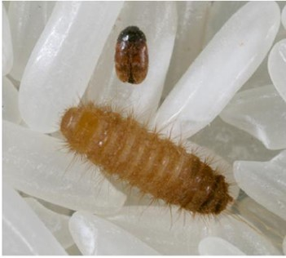

4.2 National arrangements
Well-established relationships and national arrangements are in place between the Australian, state and territory governments, industry, and other stakeholders to coordinate and implement national actions on biosecurity issues, including khapra beetle.

Khapra beetle and larvae on grains of rice © Department of Agriculture, Water and the Environment, Science and Surveillance Group

Biosecurity planning and preparedness
Plant Health Australia works with industries and governments to develop strategies and plans that improve biosecurity standards, as well as providing assistance with implementation of agreed risk mitigation measures, such as biosecurity plans, biosecurity manuals for producers and awareness raising extension services.
Each of Plant Health Australia’s plant industry members (39 in late 2020) undertakes biosecurity planning to identify the industry’s High Priority Pests (those assessed to pose the greatest risk) and risk mitigation measures. Through this process, seven plant industries have identified khapra beetle as a High Priority Pest (Table 2).
Table 2 Peak industry body for plant industries that could potentially be affected by khapra beetle
Peak industry body for plant industry | Emergency Plant Pest Response Deed signatory? | Identified khapra beetle as High Priority Pest?
Almond Board of Australia | Yes | Yes
Australian Ginger Industry Association | Yes | No
Australian Pecan Association | No | Yes
Australian Walnut Industry Association | Yes | Yes
Cotton Australia | Yes | No
Dried Fruits Australia | Yes | Yes
Grain Producers Australia | Yes | Yes
Pistachio Growers Association | Yes | Yes
Ricegrowers’ Association of Australia | Yes | Yes

Emergency response arrangements
For khapra beetle, the relevant national agreement governing a response is the Emergency Plant Pest Response Deed (EPPRD). The EPPRD is a formal, legally binding agreement between the Australian, state and territory governments, plant industry body signatories, and Plant Health Australia. Plant Health Australia is the national coordinator of the government-industry partnership for plant biosecurity in Australia and is the custodian of the EPPRD. It covers the management and funding of responses to emergency plant pest (EPP) incidents, including the potential for owner reimbursement costs for growers. It also formalises the role of plant industries’ participation in decision making, as well as their contribution towards the costs related to approved eradication responses.
A nationally agreed technical plan, PLANTPLAN, supports the EPPRD. All governments and industry signatories have agreed that eradication of economically important plant pests should be pursued when it is technically feasible and cost beneficial to do so, and that the costs of eradication are shared across affected parties.
Khapra beetle is a Category 2 Emergency Plant Pest under the EPPRD, meaning that if a national eradication response plan was endorsed, the cost of implementing the response plan would be shared 80:20 between governments and affected industry parties, respectively.

National committees
Australian governments have established national committees to provide a formal mechanism for developing and coordinating key plant biosecurity policies and procedures that are nationally consistent, and to identify activities to enhance national biosecurity preparedness and response capability.
The National Biosecurity Committee is responsible for a national strategic approach to emerging and ongoing biosecurity policy issues across jurisdictions. The National Biosecurity Committee is supported by a number of sectoral committees which provide policy, technical and scientific advice on matters affecting their sectors for all pest and disease risks to terrestrial and aquatic (inland water and marine) animals and plants, and the environment. For khapra beetle, the Plant Health Committee (supported by the Subcommittee on Plant Health Diagnostics, Subcommittee on National Plant Health Surveillance, and Subcommittee on Domestic Quarantine and Market Access, and the plant biosecurity preparedness working group) is the relevant sectoral committee to provide advice to the National Biosecurity Committee.

5. Action areas
This section describes a national approach covering the priority biosecurity action areas of prevention, detection and response. The biosecurity focus for khapra beetle is on preventing entry into Australia, or early detection leading to a rapid and effective response aiming for eradication. This is because preventing entry of a pest is the most cost-effective strategy. We have established a khapra beetle working group in 2020 to focus on implementing revised import conditions in response to an increase in detections of khapra beetle as a hitchhiker pest in empty sea containers, sea containers of goods that khapra beetle previously had no association with, and from countries not known to have khapra beetle. The urgent actions are being implemented in several phases. Plant Health Committee will be regularly updated on the working group’s progress.
Specific actions and priorities to improve the management of biosecurity risks associated with khapra beetle are set out in the plan. Several cross-cutting actions are also identified which are relevant to two or more of the priority action areas.

Action area 1: Prevention
Prevention is aimed at minimising the likelihood of entry, establishment, and spread of a new pest into Australia. The actions identified in this priority action area will deliver a better understanding of the biology of khapra beetle, potential pathways into Australia, and how to minimise the risk of pest entry, establishment and spread.
These actions are summarised in Table 3.

Action 1.1: Conduct a new pest risk assessment of khapra beetle and maintain appropriate regulation at the Australian border to minimise the risk of introduction into Australia.
Pest risk assessments are important tools that consider the changing global distribution of the pest/s to ensure that the most effective risk management measures are implemented to prevent entry of the pest/s into Australia.
We maintain biosecurity controls at the Australian border to prevent the entry, establishment and spread of khapra beetle and other exotic pests. The risk profile of khapra beetle is changing, reflected in an increasing rate of pre-border detections in imported rice, as well as non-commodity items, including shipping containers, mail and personal effects. Commercial and non-commercial interceptions of khapra beetle in Australia since 2003 identified that about 50% were in rice or rice products (for example, rice flour). The USA prohibited the importation of non-commercial rice from khapra beetle risk countries in 2011, and Mexico banned commercial imports of rice from Pakistan in 2013.
Consignments arriving by sea also remain a risk. Just over three million 20-foot equivalent shipping containers arrived in Australia in 2017–18 from 171 countries. Some 96% of these containers arrived full, with four per cent arriving empty. Assessment of biosecurity risk of these consignments is based on country of origin and the destination of the consignment within Australia.
Goods that are hosts for khapra beetle largely currently require phytosanitary certification from the exporting country’s government that the product is free from khapra beetle. However, khapra beetle has also been detected in Australia within consignments from non-khapra beetle countries, most likely within shipping containers that had been contaminated from a previous consignment. Contamination occurs because khapra beetle can exit infested goods, and hide in cracks and crevices, and under floorboards inside a container and remain in diapause for extended periods. When a future consignment of goods includes suitable foodstuffs, khapra beetle larvae may be stimulated to move from hiding places and into the new goods. The risk of such infestation on non-repeatable (indirect) pathways is not currently covered by risk analyses of non-commodity imports.
Khapra beetle has recently emerged as a hitchhiker in containers, sea containers of consignments that khapra beetle previously had no association with, and from countries not known to have khapra beetle. Import conditions have been reviewed owing to the risk this presents and urgent actions to address this risk are being implemented in several phases. Container profiling may need to address more than just the last country the container visited, potentially by means of a ‘passport’ system. Emerging technology such as chemical sensor technology may assist to evaluate the biosecurity risk.
With the number of international traveller arrivals increasing significantly over time, the potential biosecurity risk also increases. A sizeable proportion of these travellers could be expected to be arriving from one of the more than 80 countries where khapra beetle is found (Department of Agriculture, Water and the Environment 2020a). As a result, the khapra beetle risk profile needs to be regularly reviewed to ensure appropriate intervention are applied for high-risk khapra countries.

Khapra beetle detections in the United States of America
Infestable commodity pathways include seeds, spices, dried fruit, nuts, plant gums and resin, flours, dried vegetables, dates, fresh fruit and vegetables. A pest risk assessment for khapra beetle in the USA found rice to be the second most frequent commodity to be infested with khapra beetle for imports into the USA from 1985 to 1998 (Pasek 1998). The vast majority of khapra beetle interceptions were found in shipments of seeds. It was intercepted infrequently for most species of seeds, with the exception of the Cuburbitaceae (including Citrullus sp., C. lanatus, Cucumis sp., C. melo, Cucurbita sp., C. maxima, and Mormordica charantia) and Oryza (including Oryza sp. and O. sativa). These two plant groups (cucurbits and rice) accounted for 18% and 14%, respectively, of all interceptions of khapra beetle found from 1985 through May 1998.
From 1985 to 2010 khapra beetle was identified 559 times of the total 666 Trogoderma species intercepted (Myers and Hagstrum 2012 cited in Day and White 2016). About a half of the detections were found in passenger luggage, about 30% were in general cargo and the remainder in mail, ship holds and stores, and other cargo (Myers and Hagstrum 2012 cited in Day and White 2016). During 1985 and 1998, 63% of interceptions were via airports and 36% at ports (Stibick 2007). Authorities were prompted to introduce additional import restrictions when over 300 interceptions were reported in 2011 and 2013, and a spike of more than 550 were reported in 2012 (Myers et al. 2013 cited in Day and White 2016, USDA-APHIS 2012). More than 43 countries were identified as the originating country, but the majority of interceptions were from India, Saudi Arabia, Pakistan and Iran. Asia and the Middle East and North African regions accounted for 88% of the originating countries of interceptions at US-ports during 1984 to 2010 (Myers and Hagstrum 2012 cited in Day and White 2016). In 2012 the restrictions or prohibitions were increased on the commercial or non-commercial importation of rice, soybeans, Cicer species such as chickpeas, and safflower seeds from countries known to have khapra beetle (USDA-APHIS 2012). From October 2013 to September 2014, 197 khapra beetle interceptions occurred, and by April 2015 there had been 98 (US-Government 2016 cited in Day and White 2016).
Some of the detections by US-Customs and Border Protection from 2011 to 2020 are related to khapra beetle as a hitchhiker and are listed below.
- June 2011: two live larvae and one live adult beetle were found in Michigan in luggage of passengers returning from India. The khapra beetle appeared to be eating glue on decorative feather fans purchased in India.
- April 2012: live khapra beetle larvae were intercepted at a cargo facility in Detroit. The incoming sea container from the Ivory Coast was destined for Washington State containing wood veneer. Upon arrival, the container was examined for possible wood packing pests, and a rodent nest was found inside cardboard packing with several live larvae feeding on corn seed.
- November 2014: at the Canadian and US-border, three live larvae were detected hitchhiking in a sea container being hauled into the USA carrying a shipment of rain ponchos from China.
- May 2017: four cast skins and one live adult khapra beetle were found in a shipment of screws from Thailand, which arrived in Baltimore. Thailand is a country not known to have khapra beetle. Research of the container’s movement showed it passed through endemic khapra beetle countries, including Saudi Arabia in April 2016 and Sudan from May through July 2016. The container then transited through Malaysia, Thailand and Singapore, which are non-khapra beetle nations, before it arrived in Baltimore in May 2017.
- May 2019: during an inspection of a rail container in International Falls, Minnesota, cast exoskeletons of larval khapra beetles were found.
- May 2020: khapra beetle larvae were intercepted at the International Falls port of entry. The larvae were discovered in a commercial shipment manifested as welding wire from China.

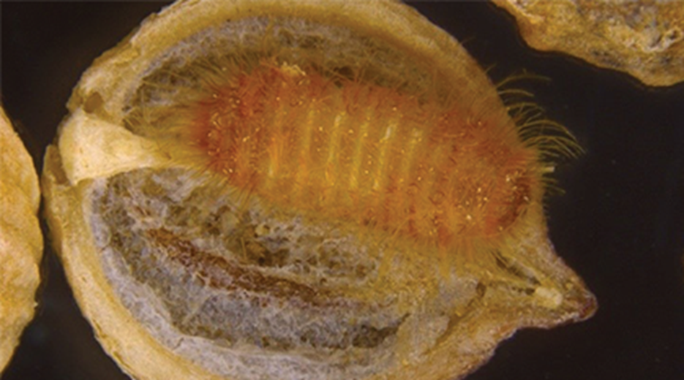
Khapra larvae against split coriander seed © Department of Agriculture, Water and the Environment

New Zealand pest risk assessment of khapra beetle imported in vehicles and machinery
Khapra beetle has been intercepted in New Zealand as early as March 1964 when adults and larvae were found in cargo arriving in Dunedin, New Zealand from South Africa (Ward 1965). In 2007, an import risk analysis of vehicles and machinery (Biosecurity New Zealand 2007) assessed the biosecurity risk of importing new and used vehicles and machinery, including the risk of introducing khapra beetle. This assessment found 2–4 per cent of vehicles entering New Zealand were contaminated with Dermestid beetles, this is expected to be an underestimate because specimens are not always identified to the species level. Between 1994 and early 2006 only one intercept was recorded for live khapra beetle larvae and pupae in used vehicles from Japan. In 2006, sixty specimens taken from used imported vehicles from Japan revealed that 95% were Anthrenus verbasci, the already established varied carpet beetle. The ease at which khapra beetles could enter vehicles and machinery, the difficulty of detection and identification as well as the potential country-wide movement, resulted in this import pathway being considered high risk.

Conduct a pest risk assessment
A new pest risk assessment of khapra beetle will consider these issues and will aim to ensure that import measures are appropriate to manage the changing risk of this pest. A risk assessment needs to clearly identify risks within both the import and export pathways and how or where intervention (for example, awareness, surveillance, decontamination) should occur.
Where data and risk assessment indicate legislative changes are needed to address the risk, a contingency plan may be needed as changes to legislation may take a long time to come into force.
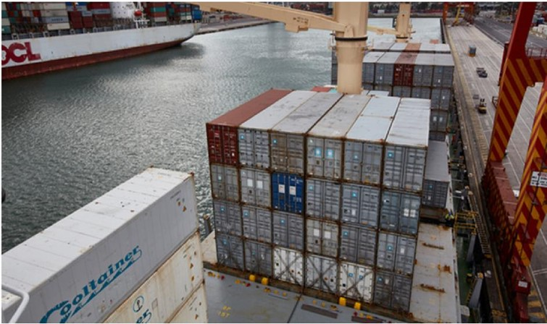
Shipping containers on board the deck of a ship © Department of Agriculture, Water and the Environment

Maintain appropriate regulation at the Australian border to minimise the risk of introduction into Australia
We are progressing the review of import conditions for rice, and the list of countries that are known to have khapra beetle. The risk of this pest will change over time with changes in trade and the potential spread of the pest. Consequently, the risk will need to be reviewed on an ongoing basis to maintain appropriate measures for risk management as information becomes available.
The sharing of border interception data through specific ports with jurisdictions and industry where applicable (through Plant Health Australia), ideally including the intended post border destination of container movements associated with interceptions, would greatly assist with post border surveillance/pathway analysis for early detection. Information on post border movement of containers from likely source ports or containing known host commodities from pack/unpack sites under approved arrangements, volumes and destinations would be valuable to increase the possibility of early detection for post border surveillance.
We are implementing urgent actions to address the risk of khapra beetle on a range of plant products that are hosts of this pest. These are being implemented in phases, as listed below. Further information is available on our website.

- Phase 1 commenced on 3 September 2020 (Import industry advice notice 134/2020). From this date, high-risk plant products from all countries are not permitted entry into Australia within: unaccompanied personal effects; or low value (less than $1,000) air and sea freight (lodged through self-assessed clearance).
- Phase 2 commenced on 15 October 2020 (Import industry advice notice 153/2020). In this phase, the ban on high-risk plant products was extended to international travellers and mail articles.
- Phase 3 planned to commence in August 2021 had been put on hold while higher priority work on sea containers was completed. It will introduce requirements for high-risk plant products imported via commercial pathways, excluding seeds for sowing and goods for research purposes coming as low value freight. We will consider transitional arrangements to accommodate consignments in transit closer to the implementation. These requirements will differ depending on the country of origin or export. We are engaging with trading partners to ensure they are aware of their requirements under these changes.
- Phase 4 has been put on hold while higher priority work on sea containers is completed. It will introduce requirements for other risk plant products (excluding seed for sowing) and goods imported for research purposes as low value freight. We will consider transitional arrangements to accommodate consignments in transit closer to the implementation. These requirements will differ depending on the country of origin or export. We are engaging with trading partners to ensure they are aware of their requirements under these changes.
- Phase 5 has been put on hold while higher priority work on sea containers is completed. We will consider transitional arrangements to accommodate consignments in transit closer to the implementation. It will require all imported seeds for sowing (excluding seeds imported for research purposes as low value freight; and those banned in phases 1 and 2) from all countries via commercial pathways, to be accompanied by a phytosanitary certificate that includes Additional Declaration B.
- Phase 6A will introduce mandatory offshore treatment requirements for target risk sea containers. The start date for these requirements depends on the type of target risk container, with implementation for certain containers from 12 April 2021. See our khapra beetle sea containers webpage for detail on these measures.
- Phase 6B is expected to commence in late 2021 and will introduce measures to a broader range of containers (i.e. all high-risk containers). Further information about these measures, including details on consultation, will be made available on our website.

Action 1.2: The Cargo Compliance Verification program can be used to inform the biosecurity risk profile for khapra beetle.
Cargo Compliance Verification is an important tool, which can be used to provide evidence of the robustness of the findings of the pest risk profile.
Shipping containers arriving in Australia are risk assessed. Containers that are assessed to have very low or negligible risk of carrying exotic pests meet Australia’s Appropriate Level of Protection (ALOP) and are allowed to enter Australia without further intervention. Around 90% of the estimated three million shipping containers that arrived in Australia in 2017–18 entered without further intervention. The Cargo Compliance Verification (CCV) program perform random verification inspections for about 0.5% of consignments to monitor that the biosecurity import controls are operating effectively for the full container load (FCL) containerised sea cargo pathway.

These verification inspections are applied to consignments that would not normally be directed for inspection or treatment. Biosecurity officers will look for biosecurity risk material—contamination with soil, animal or plant material—and also check the paperwork presented to us for the consignment. The goods and packing materials will be inspected, as well as the cleanliness of the internal and external surfaces of the container (Department of Agriculture, Water and the Environment 2020b).
In order to increase the efficiency of biosecurity investment and to identify opportunities for improvement, the contribution of each activity and control measure towards biosecurity effectiveness needs to be reviewed regularly. Feedback loops need to leverage the information available from compliance verification inspection result data to improve system performance. Policy areas can consider this data to review performance of biosecurity controls, for example, documentation for container cleanliness.
The CCV program can be leveraged to inform enhanced data collection to assist risk owners make policy decisions. An example of this is where the business-as-usual process of the compliance verification program was used to provide data on khapra beetle contamination of containers. A trial was conducted using enhanced sampling by vacuuming the inside of the empty container at the completion of each compliance verification inspection.

Action 1.3: Assurance activities to ensure compliance following ‘prohibition’.
We continue to implement a compliance-based regulatory model to assist in the management of imported cargo. This approach means we will direct resources to the commodities, pathways and entities (companies and individuals) that pose the greatest biosecurity risk.
We undertake a range of assurance activities as part of testing controls to manage biosecurity risks. This range of activities may include targeted operations. The results gained from assurance activities could be used to intercept further consignments likely to contain prohibited material that could have long-term negative impacts on Australia’s agricultural industries and environment. We will consider the need for targeted operations to ensure compliance with the urgent actions introduced in 2020–21 to address the risk of khapra beetle on a range of plant products that are hosts of this pest.

Action 1.4: Improve hygiene of shipping containers imported into Australia.
Recent border detections of khapra beetle in Australia and New Zealand strongly indicate that contaminated shipping containers are a significant biosecurity risk pathway.
Improved shipping container hygiene to target khapra beetle and other biosecurity risks is needed. The knowledge we now have about the risk presented by khapra as a hitchhiker pest (through non-host pathways) indicates that there are some critical areas such as hygiene of shipping containers that need to be addressed.
In Australia and other countries, khapra beetle has been detected as a hitchhiker in containers, hiding in cracks and crevices, under floors, and in consignment packaging; for example, on the Canadian and US-border khapra beetle larvae were detected in a sea container being hauled into the USA carrying a shipment of rain ponchos from China (Day and White 2016). Figure 3 shows an infestation of khapra beetle in a shipping container’s flooring.

Figure 3 Lifted floor boards of shipping container with an infestation of khapra beetle in the shipping container flooring cavity
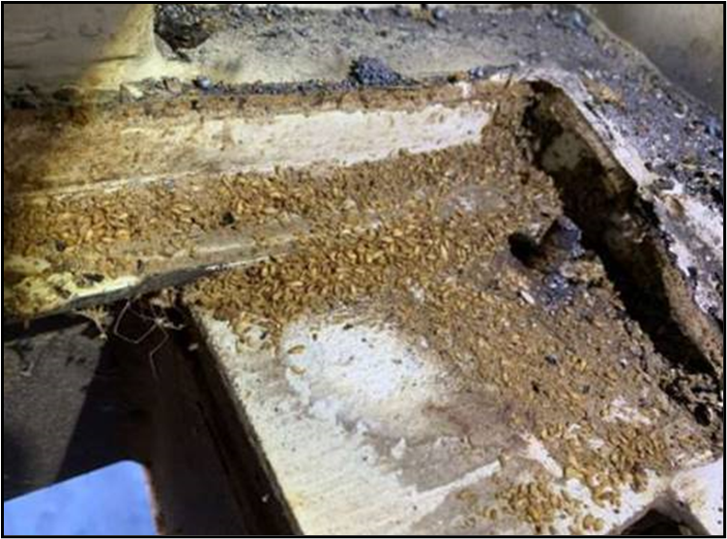
© Department of Agriculture, Water and the Environment
There is a high risk of potential trade implications if a contaminated food grade container from Australia (especially in this case transporting rice) was infested with khapra beetle at arrival in the importing country. One option to reduce this risk may be to give consideration to a ‘food stuff’ category for shipping containers whereby measures are implemented to prevent or limit the times that containers are re-used for other purposes after carrying foodstuffs. That would identify a new ‘class’ of high-risk containers that only deal in host material. This would be further strengthened in conjunction with the identification of ‘load source country risk’ based on climate and pest biology in that environment.
Australia must continue efforts to overcome the problem of container contamination by engaging in national and international joint initiatives as a matter of priority. The Commission of Phytosanitary Measures (CPM) of the International Plant Protection Convention has indicated a desire to create more commodity class and conveyance-specific phytosanitary standards to supplement the existing suite of phytosanitary standards. Such standards have international benefits, particularly where there are generic phytosanitary risks and also widely accepted international phytosanitary measures. In recent years, the development of a phytosanitary standard for shipping containers has been on the agenda for the International Plant Protection Convention Standards Committee, which progresses the development of International Standards for Phytosanitary Measures (ISPM). The International Plant Protection Convention has established a special Sea Containers Task Force to look at this issue. It is working on implementing the Complimentary Action Plan (developed by the Convention of Phytosanitary Measures) and other complimentary actions to minimise the phytosanitary risks associated with the movement of sea containers in the global supply chain. The Quadrilateral Security Dialogue countries (QUAD—comprising Australia, New Zealand, Canada and the USA) Sea Container Working Group is working on identifying collaborative opportunities for jointly managing containers destined for QUAD countries.

Other initiatives include: the International Maritime Organization’s Code of Practice for Packing Cargo Transport Units; the World Shipping Council Joint Industry Guidelines for Cleaning of Containers; and the North American Sea Container Initiative. New container design should be considered, including containers without installed floors for potential inclusion in the Code of Practice.
The CTU code is a non-mandatory global code of practice for the handling and packing of cargo transport units, including shipping containers, for transportation by land and sea, designed to promote best practice and assist all actors involved in the global supply chain. Greater awareness and adherence to the CTU code would help to minimise the phytosanitary risks associated with international trade. The Quick Guide to the Code has specific instruction when it comes to carrier, shipper and packer responsibilities for ensuring that containers and their cargoes are free from visible pest contamination, reflected also in a checklist. These therefore complement, and support, the IPPC’s Sea Container Task Force (SCTF)’s ‘Sea container supply chains and cleanliness: an IPPC best practice guide on measures to minimize pest contamination’ and related leaflet ‘Reducing the spread of invasive pests by sea containers’ (IPPC 2021).
Strong ties already exist through bilateral, regional and multilateral forums. Commonwealth government departments can use these forums to strengthen hygiene requirements for shipping containers imported into Australia, irrespective of the cargo that is carried.
Consideration should be given to further supporting inspection by:
- reviewing khapra beetle resource material to provide up to date resource materials including training manuals
- align phytosanitary certification requirements on commercial pathways (Less Container Load with Full Container Load)
- training providers who deliver training courses for ‘dry box inspection’ in Australia undertaking training every three years in effective khapra beetle detection methods for shipping containers. This training should reflect the benefits that our knowledge and experience can bring to creating training resources to assist surveillance staff
- specific khapra beetle focused guidelines for inspection of containers by authorised officers of companies receiving containers into country areas with the intention of repacking them with khapra beetle susceptible commodities.

Action 1.5: Reduce incidental contamination and use data to inform risk management decisions.
Engaging with trading partners and the Australian supply chain to reduce contamination of conveyances, shipping containers or other non-commodity related risk pathways will assist to reduce the risk of khapra beetle and inform risk management decisions.
Australia has regular engagement with international trading partners on biosecurity issues. Trade and market access issues often dominate the agenda for these meetings owing to the impact of phytosanitary measures on trade in commodities. Other issues such as incidental contamination of conveyances, shipping containers, or other non-commodity related pathways are rarely included on the bilateral meeting agenda.
There are a number of pest-specific issues, including khapra beetle as a hitchhiker as well as other hitchhikers that could be included in the bilateral dialogue to encourage regular exchange of information about emerging pest concerns. Given the significance of khapra beetle as a pest, increasing bilateral dialogue on this pest would assist Australia in preventing the entry of the pest into Australia and potentially other pests.
Similar issues around shipping were identified in previous actions. International standard—ISPM13: Guidelines for the notification of non-compliance and emergency action—provides a framework for Australia to engage with trading partners on khapra beetle detections in imported goods to reduce the likelihood of entry, establishment and spread of khapra beetle in Australia.
Action 1.4 supports this action. Information on incidental contamination found at inspection, approved arrangements, etc. should also be used to increase the efficiency of biosecurity interventions and to inform review of pathway risks as well as to inform discussion with international trading partners.
We are progressing a survey to estimate the approach rate of khapra in sea containers using eDNA. The data created could be used to inform the identification of high-risk containers and the approach to interventions. We are also developing and implementing measures to minimise the risk of khapra beetle, with initial focus on specific containers arriving from countries with khapra beetle before expanding the measures to other high-risk containers. Additionally, the Centre of Excellence for Biosecurity Risk Analysis (CEBRA) has been engaged on a project to establish the residual risks of khapra and developing key performance indicators (KPIs) for containers.

Action 1.6: Review and evaluate methyl bromide alternative phytosanitary treatments.
Reviewing and evaluating effective treatments for products and situations will reduce the risk of khapra beetle entering Australia.
Research is needed to develop an effective alternative to pre-shipment treatment for khapra beetle (as well as other pests) due to the phasing out of the commonly used methyl bromide treatment.
Australia is a signatory to the Montreal Protocol and is committed to its obligations and commitments to phase out ozone-depleting agents like methyl bromide. Methyl bromide for quarantine and pre-shipment use is excluded from the Montreal Protocol. However, because methyl bromide has been identified as an ozone-depleting agent, there is an urgent need to find equally effective chemical or non-chemical alternative phytosanitary treatments. The plan will be updated to reflect any research on new and effective means of applying eradication treatments in urban environments where non-chemical treatments may be available.
Research into methyl bromide treatment alternatives needs to consider and mitigate against the cryptic nature of khapra beetle biology, deal with all life stages and prevent chemical resistance. As this will need to consider the treatment, the pest and the situation, this research will be a long-term process. The cost and practicality of treatment methods for different products and infrastructure, from mail and small articles to factory buildings also need to be addressed.
We are progressing work to identify and evaluate methyl bromide alternative phytosanitary treatments currently available for use in plant commodities, and to implement those practical for operational use in on-arrival and pre-shipment situations in Australia. For example, heat can be an effective treatment for some commodities, but cannot currently be used on bulk containers owing to the lack of capability. Extreme cold also needs to be investigated as a treatment (-27 degrees Celsius). Comments on heat and insecticide treatment of surfaces are made in Action 3.3.

Action 1.7: Improve detection of at-risk containers.
Detecting high-risk containers following the direct importation pathway requires data describing a container’s current load port and contents. Detecting high-risk containers following the indirect pathway requires data describing the load port and contents carried by the container over the last five years on journeys that did not touch Australia.
A shipping container contaminated with khapra beetle can arrive in Australia through two generic pathways:
- direct—the container is packed with high-risk goods containing khapra beetle in a high-risk country and then travels to Australia
- indirect—the container becomes contaminated prior to its most recent journey to Australia.
Identifying and finding relevant container data to assist future targeted interventions and offshore control measures are a high priority. Initial investigations on the availability of relevant data indicate the data will need to be sought from multiple sources for biosecurity track and trace purposes. In order to find the best source of global container data, we sought advice from the World Customs Organization, who advised that the European Union’s (EU) Anti-Fraud Office had established a global container tracking system.
We have worked with the EU on a pilot to ascertain the utility of the data. The pilot has shown promise for managing khapra and other hitchhiker threats, by identifying shipping and container routes for an estimated 90% (according to the EU) of container movements globally. This data has the potential to assist in identifying high-risk containers, as well as offshore intervention points which most at risk containers traverse (see Figure 4).

Figure 4. Shipping movements around Australia
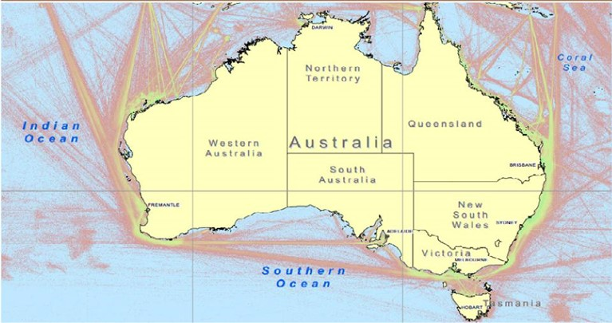
© Department of Agriculture and Water Resources
We will explore mechanisms to obtain the EU data that is not currently shared with Australia (ideally this would include historical data) through industry/government agreements or legislative means. The EU system does not contain commodity related information, and therefore for a full view of container related risk, would need to be complemented by other sources of data related to commodities. We are engaging with the Department of Home Affairs on obtaining relevant commodities data, an approach that potentially could streamline efforts by substantially reducing the data-cleansing task.
Table 3 Summary table of Action area 1: Prevention
Priority area | 1: Prevention | Priority | Timeframeª
Action 1.1 | Conduct a new pest risk assessment of khapra beetle and maintain appropriate regulation at the Australian border to minimise the risk of introduction into Australia. | High | Short term
Action 1.2 | The Cargo Compliance Verification program can be used to inform the biosecurity risk profile for khapra beetle. | High | Short term
Action 1.3 | Targeted operations to acquire assurance following ‘prohibition’. | High | Short term
Action 1.4 | Improve hygiene of shipping containers imported into Australia. | High | Long term†
Action 1.5 | Reduce incidental contamination and use data to inform risk management decisions. | High | Medium term
Action 1.6 | Review and evaluate methyl bromide alternative phytosanitary treatments. | High | Long term
Action 1.7 | Improve detection of at-risk containers. | High | Short term
ª Indicative timeframes: Short, up to 3 years; Medium, 4 to 8 years; Long, up to 10 years. † Timeframe to be assessed for earlier completion.

Action area 2: Detection
Detection is focused on ensuring that the right tools and strategies are in place to find and identify khapra beetle, and to enhance national diagnostic and surveillance capability in the field.
These actions are summarised in Table 4.

Action 2.1: Build and strengthen national diagnostic capability.
Appropriate diagnostic capability is essential to ensure accurate diagnosis of khapra beetle and to enable a rapid biosecurity response.
Khapra beetle is challenging to identify. Reliance on morphological identification raises difficulties because detection of adults is infrequent, meaning initial diagnosis mostly relies on examination of mature larvae (or their cast skins). Conclusive identification can be problematic if there are few specimens and/or larvae are early instars. One of the other issues of larval morphology is that the larvae do not have a defined number of instars; so it is not possible to be truly confident what larval stage is being examined (unlike many other insects). Morphological examination, consistent with international standards—ISPM27, Annex 3: Diagnostic protocol for Trogoderma granarium—should be followed up with molecular analyses to confirm identification.
Australia has a diverse range of endemic and established species of Trogoderma, which increases the complexity of accurately diagnosing khapra beetle. There is currently limited expertise in Australia to identify species of Trogoderma. Ways to strengthen diagnostic capability could include developing and implementing triage systems, pooling national expertise, and training more scientists, both in-house and in universities.
Cast skins and hairs, etc. infesting stored products lend themselves to eDNA analysis. The Department of Primary Industries and Regional Development (DPIRD) Western Australia has developed a molecular test that offers a quick ‘first pass’ screen for suspect khapra beetle specimens. The polymerase chain reaction (PCR) test takes a few hours and needs only a small fragment of an insect to produce enough DNA for testing and follow-up sequencing. The PCR test can be used on all life-stages of the beetle and provides a quick diagnostic response. It has been ‘road tested’ against khapra beetle samples from around the world, along with thousands of native Australian insect relatives which could be mistaken for khapra beetle.
The protocol includes a real-time PCR (qPCR) method for the species-specific detection of Trogoderma granarium. A multiplex qPCR assay is included for the detection and differentiation of Trogoderma granarium and Trogoderma variabile (warehouse beetle). The protocol also describes Universal PCR methodology for mitochondrial cytochrome c oxidase subunit I (COI) gene region as well as Universal PCR amplification of arthropod mitochondrial 16S rRNA gene. Destructive and non-destructive methods for DNA extraction from larvae, adults and skin casts are described in the protocol. The test is available to external stakeholders upon request: https://www.agric.wa.gov.au/livestock-biosecurity/ddls-animal-pathology-laboratory-services
The draft National Diagnostic Protocol (NDP) for khapra beetle has been submitted to Plant Health Committee’s Subcommittee on Plant Health Diagnostics (SPHD) for review, validation and endorsement. This NDP is currently being reviewed and validated and the subcommittee is awaiting the results of these activities to determine next steps in the endorsement process. The draft protocol is available to external stakeholders upon request. The endorsed protocol, once completed, will be available to the public via the National Plant Biosecurity Diagnostic Network website.
Current work being undertaken to resolve the taxonomy of native Trogoderma species is essential to enable accurate detection and identification of khapra beetle. This will use characters of the larvae, adults and multilocus nucleotide sequence data to provide morphological and molecular diagnostic information on native Trogoderma species. This work supports implementation of this action, and related actions. This work will also develop a comprehensive identification tool to help diagnose ‘Dermestidae of biosecurity interest’.
DPIRD has progressed the development of this identification tool, which currently houses a national Dermestid reference collection of several thousand Australian native Trogoderma specimens, as well as other Dermestids and Trogoderma granarium haplotypes. In-house BLAST analysis of 16S gene sequences is available to help identify otherwise unknown/suspect Dermestid specimens providing additional confidence of the absence of khapra beetle and other pestiferous Trogoderma species in Australia.
DPIRD held a specialised workshop in early 2020 to upskill diagnosticians in the identification of khapra beetle, with ongoing capability development required. Further regular training is needed to maintain skills in all jurisdictions.

Action 2.2: Review field-based surveillance, trapping, and diagnostic methods and tools.
Reliable and affordable surveillance, trapping and diagnostic methods and tools, which can be deployed in the field will assist rapid and accurate identification of khapra beetle.
A review of field-based surveillance, trapping, and diagnostic methods, which incorporates learnings and data on efficacy collected during our current implementation of urgent actions to address the risk of khapra beetle, will provide a baseline for development and validation of new, cost-effective methods and tools.

Field based surveillance
The development, endorsement and implementation of more consistent and coordinated surveillance methods and tools across all jurisdictions would be beneficial for early detection. Additionally, a comparison and evaluation of methods used in Australian jurisdictions and in other countries particularly, New Zealand, would also be beneficial.
Surveillance may concentrate on cities and towns with a concentration of businesses with higher volumes of shipping container movements—imports and exports; for example, southern Queensland and northern New South Wales—Toowoomba, Dalby, Goondiwindi, Kingaroy, Moree.
This could also include potential surveillance of specialist food shops that import higher risk food products from countries known to have khapra beetle. Stakeholder engagement strategies to educate the community about its general biosecurity obligation is important, as members of the public have reported the most recent detections of khapra beetle.
Targeted visual surveillance is another method of detecting khapra beetle. The cryptic nature of khapra beetle, which will hide in cracks and crevices, means that particular attention should be directed to stored produce, especially oilseeds and oilseed products, pulses, cereals and gums. Packaging which may have been used to store produce including new and used hessian sacks are important visual surveillance targets. Close examination of cracks and crevices in walls, pillars, beams, cartons, sacks, debris, woodwork, loose plaster, loose paint, rodent bait stations and any other such hiding places in premises or shipping containers is essential. Targeted visual surveillance should be employed at high-risk sites such as the border, owing to the intensive nature of the surveillance that requires a number of staff and substantial amounts of time. Training and operational procedures may need to be reviewed and updated.

Small hand-held vacuums or dustpan and brushes are used when conducting surveillance in warehouses to collect larvae, larval skins and adult dermestids. This type of work lends itself to eDNA, LAMP assay, etc. where samples are tested for khapra beetle DNA. eDNA refers to DNA present in environmental samples such as soil or sediments. Organisms release DNA into their environment through secretions and discharges such as saliva, shed skin cells, faeces, gametes, hair or bodily remains. The technology offers a sensitive and cost-efficient alternative to traditional methods of species monitoring which can be expensive and challenging.
In April 2021, Australia set up the world’s first survey using eDNA and eRNA to detect khapra beetle in sea containers. eDNA is DNA that is left behind by an insect in the environment. The DNA can be obtained from insect parts including skin, urine, hair or other secretions left behind by an insect. By testing samples of dirt and dust vacuumed from sea containers, eDNA technology could be used to rapidly detect whether khapra beetle has been, or is present, in a sea container. The results of the survey will allow us to identify the frequency of containers contaminated with khapra beetle arriving in Australia and as a result, will inform its assessment of the risk posed by containers. It may result in changes to our khapra beetle urgent actions and is a tool that could enable more highly focused surveillance for and more rapid detection of khapra beetle at the border.

Diagnostics
Current work being undertaken to resolve the taxonomy of native Trogoderma species is essential to enable accurate detection and identification of khapra beetle. This will use characters of the larvae, adults and multilocus nucleotide sequence data to provide morphological and molecular diagnostic information on native Trogoderma species. This work supports implementation of this action, and related actions. This work will also develop a comprehensive identification tool to help diagnose Dermestidae of biosecurity interest.
A greater range of validated diagnostic and surveillance tools and procedures will enhance capacity for detecting khapra beetle in the field and laboratory. Rolling out the recently developed khapra beetle LAMP assay diagnostics to our laboratories and relevant regional locations will further improve surveillance and diagnostic capability.
Training workshops on identification of storage pests could be developed for selected businesses—including how to identify Trogoderma species, where to send samples for confirmation and how to report/escalate suspect positive detections. Some of these businesses may participate in the development/field-testing of cost-effective Trogoderma species trapping/surveillance methods.

Lures and Traps
Lures and traps that are not specific to khapra beetle may attract high numbers of non-target species, which poses a resource issue for diagnostic laboratories. There are commercial trap types available that are used to capture khapra beetle or a range of dermestid beetles. Research to understand the effectiveness of current trapping and baiting systems is needed for khapra beetle in Australian conditions. Assessing whether crevice traps are useful and whether baiting or other treatments can be used to break diapause (which can last for significant periods) is critical for effective surveillance. Adult khapra beetle may not be restricted to lower parts of walls, so the placement of wall traps at height should not be discounted. Khapra beetle larvae are very mobile and may move upwards at maturity. They have been trapped at wall heights anywhere between 15 cm to 7.3 m. Traps placed on walls may also trap the closely related warehouse beetle, which is a strong flyer, and other dermestids. Aerial traps can also be used to capture warehouse beetle adults. These strong fliers, if abundant, may overwhelm wall and dome traps for khapra beetle. The use of aerial traps to divert adult warehouse beetles away from wall and dome traps will reduce the amount of non-target organisms in these and consequentially support more rapid diagnostics.

Action 2.3: Develop and implement national surveillance using best practice tools and methods.
National surveillance needs to focus on high-risk areas and consider the potential for khapra beetle to enter Australia on non-commodity pathways, such as shipping containers and personal effects.
Surveillance is an integral part of biosecurity risk management. Surveillance relies on being able to detect and correctly identify both the pest and the high-risk pathways into Australia. A best practice surveillance system is transparent and defensible, aligned across all jurisdictions and enables effective resource allocation based on risk and fosters shared responsibility. There is potential to use some of Australia’s national plant health surveillance risk models, but the target areas (inside businesses, etc.) would present a different requirement to existing plant surveillance programs such as the national plant health surveillance program (NPHSP).
The potential risk of loss of export markets if khapra beetle were to establish in Australia and infest commercial storage areas and premises is high. Focus surveillance efforts at high-risk sites, including the border on the import supply chain owing to the high costs and difficulty in eradicating and containing khapra beetle after establishment. Give particular attention to environments where khapra beetle might survive (e.g. inside heated warehouses where grain products are stored. This is different to current surveillance under NPHSP, as generally this surveillance is external to buildings. This would be a major change to standard operating procedures and current strategies and may be significantly more difficult to implement.
It is important to consider the appropriate employment of an approved methodology, combining targeted visual surveillance and trapping methods, to ensure thorough and targeted surveillance is also cost effective. Choose surveillance sites based on thorough statistical analysis of high-risk pathways and use this analysis to determine how much surveillance is needed and the confidence level of this surveillance.
The Subcommittee on National Plant Health Surveillance would guide the development, endorsement, and implementation of any national surveillance protocols, as well as guide the development of surveillance design processes to provide nationally agreed benefits. For lower risk sites and locations, it is important to consider the development of a national survey similar to the Western Australian Department of Primary Industries and Regional Development’s Pantry Blitz in 2016 and 2017. This survey engaged households in Perth and used sticky traps that contained pheromones to attract pantry pests that included khapra beetle. No evidence of khapra beetle was found, although other related beetle species were. This could potentially be expanded to include warehouses or factories and other places that may be of concern. However, it is a very different approach to current surveillance approaches, but its usefulness should not be discounted.
Guidelines for surveillance and data storage from lower risk sites are needed where industry could be conducting its own surveillance. Evidence and data gained through surveillance activities, including negative data, underpin Australia’s claim for freedom from khapra beetle, or can be used to support regional freedom in the event of detection within Australia. It is important that surveillance data, collected by governments, industry and third parties through general or targeted surveillance, is readily available and accessible to support Australia’s plant health status for this pest. The collection of surveillance data needs statistical rigour supporting the data. Statistical robustness in the number of surveillance points is needed to be confident the pest is not present. Information on sample collection, inspection, trapping, preliminary identification in the field and sending samples to the designated laboratory or persons must also be rigorous.

National Border Surveillance at Approved Arrangements, First Points of Entry and Regional Ports
Where exotic detections are identified as part of National Border Surveillance (NBS) activities, reporting is completed as per the Biosecurity Pest and Disease Notification system―including our internal reporting. Responses also require liaison with Approved Arrangement/First Point of Entry staff, state/territory staff, delimiting surveillance, and preparation of situation reports (SitRep). For responses that are only on Commonwealth land, we will lead response operations, including preparation of plans (e.g. Surveillance Plan, Treatment Plan) when the Consultative Committee on Emergency Plant Pests or the National Biosecurity Management Consultative Committee requests. This process also entails targeted and general surveillance of First Points of Entry and Approved Arrangements as well as in the environment.

External Territories Plant Health Surveillance program
This program provides early detection of pests entering the External Territories. A recent review of import pathways also helped to identify alternate pathways into Australia. We deliver surveys and provide our front-line officers with exposure to and opportunities to identify pests not yet present on the Australian mainland. We will seek to continue community and stakeholder engagement to ensure future sustainability of the external territories’ surveillance program as well as broader biosecurity management.
This program provides early warning of pests entering our near neighbour countries (Papua New Guinea and Timor-Leste). A recent review of import pathways also helped to identify alternate pathways into Australia. We deliver the international surveys and provide our front line officers with exposure to and opportunities to identify pests not yet present in Australia. The program also works closely with local biosecurity authorities.
Table 4 Summary table of Action area 2: Detection
Priority area | 2: Detection | Priority | Timeframe^{b}
Action 2.1 | Build and strengthen national diagnostic capability. | High | Short term
Action 2.2 | Review field-based surveillance, trapping, and diagnostic methods and tools. | High | Short term
Action 2.3 | Develop and implement national surveillance using best practice tools and methods. | Medium | Short term
^{b} Indicative timeframes: Short, up to 3 years; Medium, 4 to 8 years; Long, up to 10 years.

Action area 3: Response
To maximise the chance of successful eradication, a response to khapra beetle detection within Australia requires efficient tracing capability, effective treatments and advanced planning. In the event that eradication is not achievable, Australia should be sufficiently prepared to be able to minimise impact through effective management of this pest.
These actions are summarised in Table 5.

Action 3.1: Improve management of post-border detection responses.
The knowledge we now have about the risk presented by khapra as a hitchhiker pest (through non-host pathways), means that there are some critical areas that require reviewing to address gaps.
Khapra beetle has been detected on imported cargo and containers at the border and post-border. It has recently been found in a container of white goods (refrigerators) and baby highchairs imported by major retailers.
We appoint a case manager role for high priority pest detections. This role provides a coordination point for response activities associated with a post-border detection and also involves reviewing response guidelines to improve future response planning, coordination and communication. There is a need to consider the risk of establishment and spread, as well as the potential consequences associated with a post-border detection of khapra beetle that may not be able to be eradicated.
Consideration of the current khapra beetle detections show that risk assessment or profiling of premises are an important consideration in improving the management of post-border detections. This builds on the risk assessment considered under the Prevention section and, more specifically, looks at the risk of establishment, spread and potential consequences associated with a post-border detection of khapra beetle not managed appropriately.

Action 3.2: Improve capability to trace shipping containers and to access their history.
Effective tracking of goods and shipping containers following a detection of khapra beetle is vital to reduce biosecurity risk.
As noted previously, containers may harbour persistent and potentially large, cryptic khapra beetle infestations from previously carrying infested goods. An understanding of the history of shipping containers, including what goods they have contained previously, where they have been opened, cleaned and treated, what countries were visited and when visited, climatic conditions experienced (temperature and humidity) and food sources available during transit at sea will assist in understanding the risk that individual containers pose when imported into Australia.
The rapid turnaround time for reuse, often within a matter of days, combined with the current limitations to easily track container movements increases the biosecurity risks associated with them. Containers can in general be traced, including the countries they have visited and the goods they have carried. A container’s history can be traced for up to five years, although tracing involves a time-consuming manual process. It also relies on external parties who may not have an interest in providing timely or accurate answers.
Improving container and goods tracking to target the movement of khapra beetle, and other similar hitchhiker pests, is essential for an effective response. Close cooperation from the shipper in providing shipping information is vital for expediency and minimising the threat. Consideration of the development or enhancement of technology is important to address these issues.
This action should be progressed concurrently with Actions 1.2 and 1.3 and will require engagement with businesses in Australia as well as trading partners. Similar tracing ability is required within Australia to trace the movement of potentially contaminated container(s) and their goods as part of operations within an emergency response.
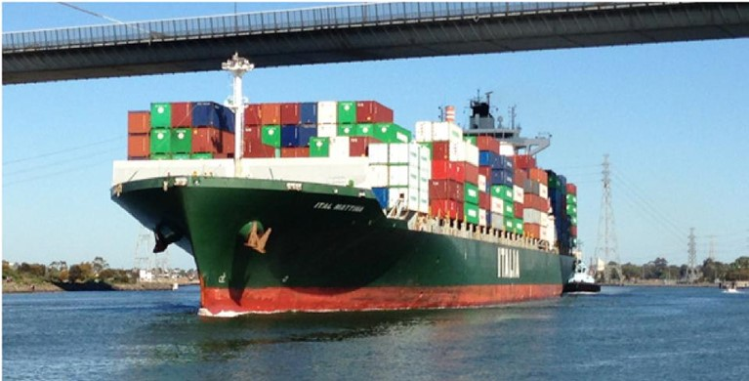
Container ship at Port Melbourne © Cheryl Grgurinovic

Action 3.3: Identify and assess effective eradication treatment methods for buildings, goods and shipping containers.
Identification and assessment of effective treatments for responding to khapra beetle in buildings, goods and shipping containers will assist in reducing the likelihood of khapra beetle establishing and spreading in Australia.
Related to Action 1.6, there is a need for effective treatments for the eradication and control of khapra beetle in buildings, goods and shipping containers. There is currently no single treatment that fits all products and situations. Treatments need to be varied according to the scale of contamination; i.e. was khapra beetle detected in small food packets, packaging materials, shipping containers, or factory buildings. Fumigation or alternative treatment(s) may need to be adapted to kill khapra beetle in infested goods, or to provide a surface treatment with a residual insecticide to prevent infestation.
Fumigation effectiveness may be limited as khapra beetle populations may be resistant to some fumigant treatments such as phosphine and methyl bromide. Other issues include: the high concentration of methyl bromide required; the ability of small beetles and larvae to hide in cracks or crevices; and the capacity of larvae to enter diapause when food is scarce, or temperature is suboptimal. Understanding the appropriate treatment for a particular consignment or detection will reduce the risk of khapra beetle establishment and spread. Australia has many experienced researchers who could test various fumigation protocols with gas such as phosphine, sulfuryl fluoride, or a combination of gases.
Insecticidal treatments using synthetic pyrethroids; for example, deltamethrin, as well as other pesticides such as pyriproxyfen, novaluron and chlorfenapyr are also appropriate in some circumstances. Permits for specified onshore use of these have been issued by the Australian Pesticides and Veterinary Medicines Authority (APVMA) for off-label use.
Identifying and validating treatment methods as effective in advance of a detection will reduce time delays for treatment, and further reduce the risk of khapra beetle establishing and spreading within Australia. This needs to include (APVMA) chemical use permits and their applications and limitations to use, and ensuring sufficient stock is available during response. Heat treatment is also an option for the management of khapra beetle and will depend on surfaces and volumes of sites/conveyances treated. In shipping containers, it is 60 degrees Celsius for three hours if dry heat is applied. When steam treatment is applied to surfaces, these should be exposed to at least 70 degrees Celsius steam treatment for at least one minute (or, if the equipment used to apply steam treatment can consistently apply steam at higher temperatures than 70 degrees Celsius, then shorter time may be appropriate).
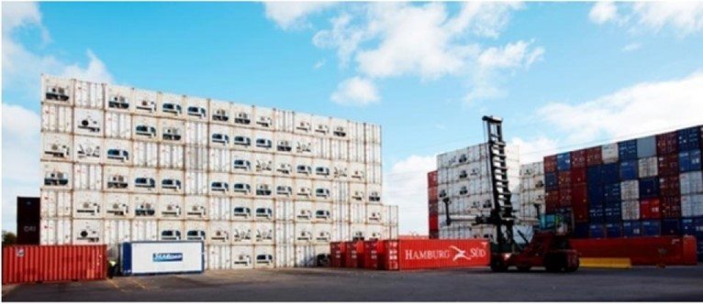
Shipping containers and forklift on dock © Department of Agriculture and Water Resources

Action 3.4: Develop comprehensive national contingency plans and supporting operational procedures. Validate these measures using a national simulation exercise.
Planning potential incursion scenarios and having national processes and procedures in place before they are needed, are key to being prepared for plant pests
Contingency planning is a pre-emptive preparedness activity that improves readiness for an exotic pest incursion. Plant Health Australia, industries or governments develop contingency plans before an incursion, and aim to consolidate information on a particular pest or pest group, vectors, biology, and available control measures. The United States Department of Agriculture (USDA) has prepared the New Pest Response Guidelines: Khapra Beetle 2009. The Department of Agriculture Western Australia prepared a contingency plan for eradication – Threat Specific Contingency Plan for Khapra Beetle in 2005. A national exercise to test the application of the contingency plan has not been undertaken, although it is likely the plan needs to be reviewed.
It is important that contingency plans draw on lessons learnt from previous post-border detections and expand in scope to include all potentially affected industry sectors, including the nut and dried fruit industries. A national contingency plan, and any supporting operational procedures, need to be developed collaboratively and tested through national simulation exercises. Regular updating and testing of plans and procedures is required to maintain currency.
As well as simulation exercises covering a khapra beetle incident in Australia, ensure that one exercise covers the pre-border and border scenarios.

Table 5 Summary table of Action area 3: Response
Priority area | 3: Response | Priority | Timeframe^{c}
Action 3.1 | Improve management of post-border detection responses. | High | Short term
Action 3.2 | Improve capability to trace shipping containers and to access their history. | High | Medium term†
Action 3.3 | Identify and assess effective eradication treatment methods for buildings, goods and shipping containers. | High | Long term
Action 3.4 | Develop comprehensive national contingency plans and supporting operational procedures. Validate these measures using a national simulation exercise. | High | Medium term
^{c} Indicative timeframes: Short, up to 3 years; Medium, 4 to 8 years; Long, up to 10 years. † Timeframe to be assessed for earlier completion.

Action area 4: Cross-cutting issues
Several cross-cutting issues relating to governance, communication and engagement, and research and development are relevant across more than two priority areas.
These actions are summarised in Table 6.

Action 4.1: Develop an overarching communication and engagement strategy and deliver targeted activities relevant to each stakeholder group (industry, traveller, community, government).
There is a need for national awareness and understanding of the risks posed by khapra beetle, and to encourage reporting.
Education and awareness are needed to motivate individuals to report exotic pests and diseases. Providing enough information to help people identify a potential pest such as khapra beetle will be challenging, noting that many infestations are detected through larvae and cast skins rather than adults.
The presence of superficially similar species in Australia, such as the introduced warehouse beetle and some native species, will lead to some level of misidentification (Day and White 2016). It is critical that individuals and businesses are encouraged to report any suspect beetles, even if they are uncertain if it is khapra beetle, to avoid a potential delayed response or no response. Those who unpack containers and major importing companies are particularly important in this respect.
Biosecurity is everyone’s responsibility, and the strategy will need to address the significant issue of non-reporting of suspect khapra beetle through fear of job loss or a detrimental impact on the business. Providing sufficient incentive to report suspect exotic pests and diseases is a challenge. It is important that the communication strategy:
- uses a number of different motivators to encourage the maximum amount of reporting from individuals, businesses and industries
- encourages people to report through a moral perspective of the right thing to do
- motivates people who previously would not be motivated to report.
All businesses in the import supply chain should be targeted for communication activities, with messages customised for particular sectors. Interactive training on recognising exotic pests, including khapra beetle, may also be mandated for importers receiving consignments from high-risk pathways and for Approved Arrangements.
Businesses in the export supply chain are a key communication target in relation to at risk commodities. They need to understand the consequences for their business as well as for the industry if khapra beetle is detected in a shipment from their facility.
It is important that reporting is easy for individuals and businesses and they receive feedback on their submissions. Reporting should also include activities targeting the import supply chain, production industries, the general public and international travellers. Also, reporting volumes and feedback mechanisms between the reporter and assessment should be included.

Action 4.2: Establish governance arrangements to coordinate and monitor national actions.
Clear governance arrangements would guide implementation of the plan and coordinate national effort to ensure Australia is as prepared as possible for a post border detection or incursion.
A high level of preparedness for khapra beetle requires commitment and collaboration between all stakeholders to support appropriate governance arrangements and drive the national work agenda on khapra beetle preparedness.
Any governance arrangement should include all relevant stakeholders and technical, industry, policy and communications expertise. Collaboration with New Zealand and other regional neighbours to align prevention and preparedness activities would be beneficial. Consideration should be given to establishing an information repository on khapra beetle that is regularly updated and accessible in real-time.
Determining priorities and deciding on ownership of each action through consultation across governments and industry promotes a structured and collaborative approach to khapra beetle preparedness and will aid in implementing the plan. The Plant Health Committee’s working group on plant biosecurity preparedness’s Terms of Reference includes monitoring implementation of the pest-specific national action plans.
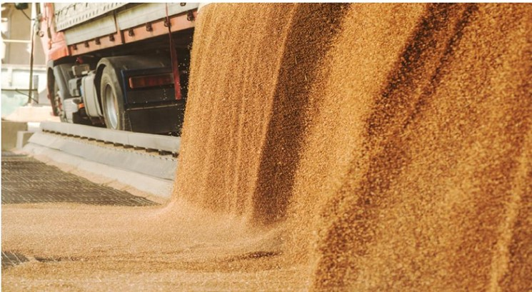
Grain being emptied from semi-trailer © Shutterstock


Ship at transfer station
© Department of Agriculture, Water and the Environment

Action 4.3: Identify research and development priorities for investment and support national and international collaboration.
Research and development, delivered in collaboration with national and international experts, is an important means to provide Australian governments and industries with the information, skills and tools they need to prevent entry of khapra beetle or to effectively respond, if it were detected in Australia.
An assessment is needed to identify gaps in our understanding around pest biology, ecology, diagnostics and surveillance, and treatment and control options—as outlined in several other actions, and to identify key priorities for research investment.
Research investment priorities should be informed by a stocktake of all khapra beetle research being conducted or completed overseas and nationally, to consider gaps in research needed for Australia—including those components identified in this plan. There will be a need to collaborate with national and international experts, and to engage local providers through relevant research and development corporations, to deliver relevant research for Australia in the medium term. Research priorities should be promoted for funding within the relevant research and development corporations, and the Plant Biosecurity Research Initiative.
Preparedness for khapra beetle would benefit from partnership with any other relevant agencies (national or international), as well as science-based organisations to help build capacity and capability with significant work carried out before the plan undergoes a major review in five years.
Table 6 Summary table of Action area 4: Cross-cutting issues
Priority area | 4: Cross-cutting issues | Priority | Timeframe^{d}
Action 4.1 | Develop an overarching communication and engagement strategy and deliver targeted activities relevant to each stakeholder group (industry, traveller, community, government). | High | Short term
Action 4.2 | Establish governance arrangements to coordinate and monitor national actions. | High | Short term
Action 4.3 | Identify research and development priorities for investment and support national and international collaboration. | Medium† | Medium term
^{d} Indicative timeframes: Short, up to 3 years; Medium, 4 to 8 years; Long, up to 10 years. † Timeframe to be assessed for earlier completion.

6. Implementation
The success of the plan depends on a high level of cooperation between plant and other industries, supply chain businesses, all levels of government, relevant non-government organisations and individuals, experts and research agencies. A clear understanding of participants’ roles and responsibilities, and ensuring adequate resources are allocated to protect Australia’s primary producers and export industries from khapra beetle are paramount.
The plan is supported by an implementation schedule which will be used to record the progress of actions; set out key performance indicators, roles, responsibilities and funding mechanisms; and to communicate with stakeholders on progress. It is anticipated investment in khapra beetle preparedness related activities is guided by the plan, drawing on new or existing funding mechanisms such as research and development corporations.
The Plant Health Committee’s proposed working group on plant biosecurity preparedness would oversee implementation of the plan on behalf of governments as the relevant national committee for plant biosecurity. Updates and reports on progress against the actions will be provided to stakeholders through the Department of Agriculture, Water and the Environment’s website.
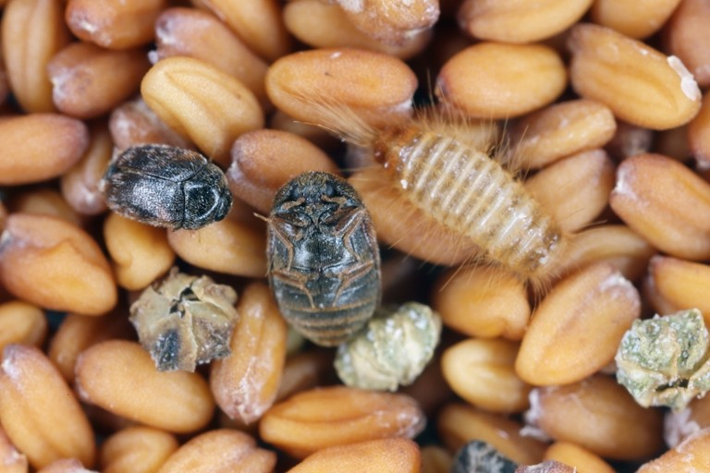
Khapra beetle and larvae on stored grains © Shutterstock

7. Monitoring, evaluation and review
The Plant Health Committee will undertake an annual review of progress on the plan’s implementation, potentially through the plant biosecurity preparedness working group, in collaboration with industry and other stakeholders reporting to the committee; which in turn reports to the National Biosecurity Committee. Relevant industry bodies will be responsible for communicating outcomes to their members.
The plan will undergo a major review after five years, using a monitoring and evaluation framework. The actions set out in the plan may evolve after annual reviews and as knowledge is gained through research and international response experience.
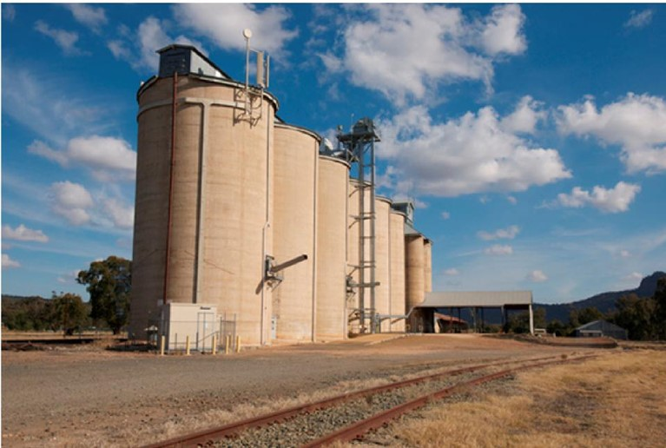
Silos near railway track © Department of Agriculture, Water and the Environment

8. Relevant sources of information
Department of Agriculture, Water and the Environment (2020a) Khapra beetle countries. https://www.agriculture.gov.au/import/arrival/pests/khapra_beetle, accessed 28 August 2020.
Department of Agriculture, Water and the Environment (2020b) Cargo Compliance Verification frequently asked questions. https://www.agriculture.gov.au/import/arrival/clearance-inspection/compliance-verification/brochure, accessed 28 August 2020.
Banks J (2019). Methyl bromide and alternative treatments against T. granarium. Presentation at the National Khapra Beetle Preparedness Workshop, 13 and 14 June 2019, Melbourne.
Biosecurity New Zealand (2007) Import Risk Analysis: Vehicle and Machinery. Ministry of Agriculture and Forestry Wellington New Zealand. Import Risk Analysis—Vehicles and Machinery (mpi.govt.nz).
Burges, HD (1959) Studies on the dermestid beetle Trogoderma granarium Everts—II The occurrence of diapause larvae at a constant temperature and their behaviour. Bulletin of Entomological Research 50:407–412.
Byrne OB, Hair S, Guthrie N, Farmer K, Szito A, Emery RN (2018) Khapra beetle diagnostics. Proceedings of the 12th International Working Conference on Stored Product Protection (IWCSPP), Berlin, Germany, 7–11 October, 2018, No.463 pp. 252–260.
Channaiah LH, Subramanyam B, McKinney LJ, Zurek L (2010) Stored-product insects carry antibiotic-resistant and potentially virulent enterococci. FEMS Microbiological Ecology 74:464–471.
Daglish, G. (no date) Storage pests beat around the bush. GRDC Research Code NPB00004 (CRCNPB50089). https://storedgrain.com.au/wp-content/uploads/2013/06/Grain-Storage-Supplement-Nov_Dec-2010-7.pdf, accessed 28 August 2020.
Day C, White B (2016) Khapra beetle, Trogoderma granarium interceptions and eradications in Australia and around the world. SARE Working paper 1609, University of Western Australia, DOI: 10.13140/RG.2.2.23786.31682.
Department of Agriculture, Water and the Environment (2020) Khapra beetle countries, accessed 2 February 2020.
Department of Agriculture, Water and the Environment (2020). Wheat, accessed 28 July 2020.
Global Invasive Species Database (2020) Species profile: Trogoderma granarium. Invasive Species Specialist Group, accessed 2 February 2020.
Grains Industry (2005) Industry biosecurity plan for the grains industry: threat-specific industry plan. Plant Health Australia, accessed 31 January 2020.
Hayward L (1955) Losses associated with groundnuts infested with Trogoderma granarium Everts. Journal of the Science of Food & Agriculture 6:337–340.
Honey SF, Bajwa B, Mazhar MS, Wakil W (2017) Trogoderma granarium (Everts) (Coleoptera: Dermestidae), an alarming threat to rice supply chain in Pakistan. Indian Journal of Entomological Research 5:23–31.
Hosseininaveh V, Bandani A, Azmayeshfard P, Hosseinkhani S, Kazzazi M (2007) Digestive proteolytic and amylolytic activities in Trogoderma granarium Everts (Dermestidae: Coleoptera). Journal of Stored Products Research 43(4):515–522.
International Plant Protection Convention (2012) Diagnostic protocol 3: Trogoderma granarium Everts. International Standards for Phytosanitary Measures 27 Annexe 3 FAO, accessed 11 November 2019.
International Plant Protection Convention (2021) Taking adoption of the CTU Code to the next level. Taking adoption of the CTU Code to the next level - International Plant Protection Convention (ippc.int), accessed 26 May 2021.
Inspector-General of Biosecurity (2019) Pest and disease interceptions and incursions in Australia. Review report No. 2018-19/05, Department of Agriculture and Water Resources, accessed 11 November 2019.
Invasive Species Compendium (2020) Trogoderma granarium (khapra beetle). CABI International, accessed 2 February 2020.
Myers SW, Ghimire M, Arthur F, Phillips T (2013) Development of new treatments for khapra beetle, in 2014 Annual International Research Conference. Presented at the Methyl Bromide Alternatives and Emissions Reductions, Methyl Bromide Alternatives Outreach, United States.
Myers SW, Hagstrum DW (2012). Quarantine, pp. 297–304, in Stored Product Protection. Kansas State University.
Noon ZB Jr (1958) Habits of the khapra beetle larva. Journal of Economic Entomology 51:465–467.
Pasek JE (1998) Khapra Beetle (Trogoderma granarium Everts): Pest-Initiated Pest Risk Assessment. USDA APHIS, accessed 11 November 2019.
Pasek JE (1998) USDA Pest Risk Assessment; Khapra beetle Trogoderma granarium. USDA APHIS Center for Plant Health Science and Technology, New Castle USA.
Rees DP (2004) Insects of stored products. CSIRO publishing.
Stibick JNL (2007) New pest response guidelines. Khapra beetle. USDA-APHIS-PPQ-Emergency and domestic programs, accessed 2 November 2019.
United States Department of Agriculture (2012) Restrictions on certain products imported from countries where khapra beetle is known to occur. APHIS Factsheet March 2012, accessed 31 January 2020.
Ward, A., 1965. The khapra beetle, Trogoderma granarium and two other species of Trogoderma Coleoptera; Dermestidae) intercepted entering New Zealand. New Zealand Entomologist 3: 39–41.
Wilches DM, Laird RA, Floate KD, Fields PG (2017) Effects of acclimation and diapause on the cold tolerance of Trogoderma granarium. The Netherlands Entomological Society Entomologia Experimentalis et Applicata 165:169–178.

9. Acronyms and abbreviations
Acronym | Abbreviation
DAWE | Department of Agriculture, Water and the Environment
EPPRD | Emergency Plant Pest Response Deed
NPBDN | National Plant Biosecurity Diagnostic Network (through SPHD)
PBRI | Plant Biosecurity Research Initiative
PPDPSR | Priority Pest and Disease Planning and Surveillance and Response Program (DAWE)
PHA | Plant Health Australia
PHC | Plant Health Committee
SDQMA | Subcommittee on Domestic Quarantine and Market Access (under PHC)
SNPHS | Subcommittee on National Plant Health Surveillance (under PHC)
SPHD | Subcommittee on Plant Health Diagnostics (under PHC)

10. Definitions/glossary
Term | Definition
Asset based protection/ management | The asset-based protection approach is to manage the species only where reducing its adverse effects provides the greatest benefits by achieving protection and restoration outcomes for specific highly valued assets.
Biological control | The control of a species by introducing a natural predator or pathogen.
Biosecurity activity | An activity that mitigates the risks and impacts to the economy, the environment, social amenity or human health associated with pests and diseases.
Biosecurity continuum | An integrated approach to prevent, detect, contain, eradicate and/or lessen the impact of a pest or disease through complementary biosecurity activities undertaken offshore (in other countries), at the border and onshore (within Australia.
Biosecurity risk | The likelihood of a disease or pest entering Australian territory or a part of Australian territory; or establishing itself or spreading in Australian territory or a part of Australian territory; and the potential for any of the following: the disease or pest to cause harm to human, animal or plant health; the disease or pest to cause harm to the environment; economic consequences associated with the entry, establishment or spread of the disease or pest.
Containment | Restricting a detection of an invasive species/emergency plant pest to a defined area without the goal of eradication.
Conveyance | A means of transport such as an aircraft, vessel, vehicle or train.
Detection | Finding the species through inspection and/or surveillance.
Eradication | Eliminating a pest or disease from an area. Eradication is indicated by the pest or disease no longer being detectable.
Established | A pest or disease that, for the foreseeable future, is perpetuated within any area and which it is deemed not feasible (either technically or as a result of a benefit:cost analysis) to eradicate.
Exotic | A species that is not present in Australia, or is present but under official control.
Native | A species, subspecies, or lower taxon, occurring within its natural range (past or present) and dispersal potential (i.e. within the range it occupies naturally or could occupy without direct or indirect introduction or care by humans).
Prevention | Stopping the introduction of a species into Australia.
Response | The management actions undertaken when an invasive species/emergency plant pest is detected. The response may be formalised through a national agreement or response plan.
Surveillance | The systematic investigation, over time, of a population or area to collect data and information about the presence, incidence, prevalence or geographical extent of a pest or disease. Surveillance includes active and passive approaches.


ABIO320.1121

https://www.agriculture.gov.au/pests-diseases-weeds/plant/national-priority-plant-pests-2019.
See International Standards for Phytosanitary measure No 27. Diagnostic Protocol No 3. Trogoderma granarium Everts https://www.ippc.int/static/media/files/publication/en/2016/01/DP_03_2012_En_2015-12-22_PostCPM10_InkAmReformatted.pdf.

