Let’s keep khapra beetle out!
Khapra is a serious agricultural pest that poses a major threat to our grains industry. This exotic pest comes in second on Australia's most unwanted plant pest list, and we need your help to keep it out.

What to look for
- Adults beetles (1.6-3mm long) are reddish dark brown, oval-shaped with faint dark lines and do not fly.
- Larvae (1.6-4.5mm long) typically appear very hairy and are golden brown.
- Cast larval skins are the most obvious indicator of infestation.
Adult Khapra beetle
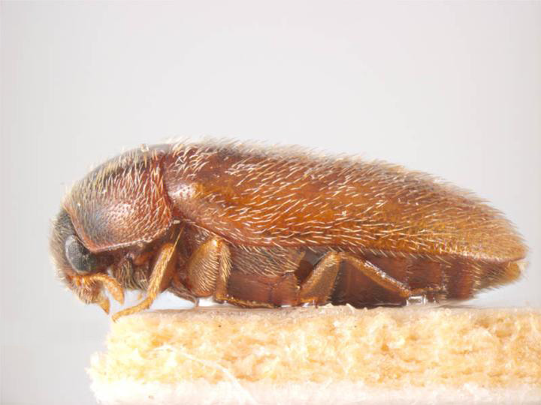
Khapra beetles with larvae
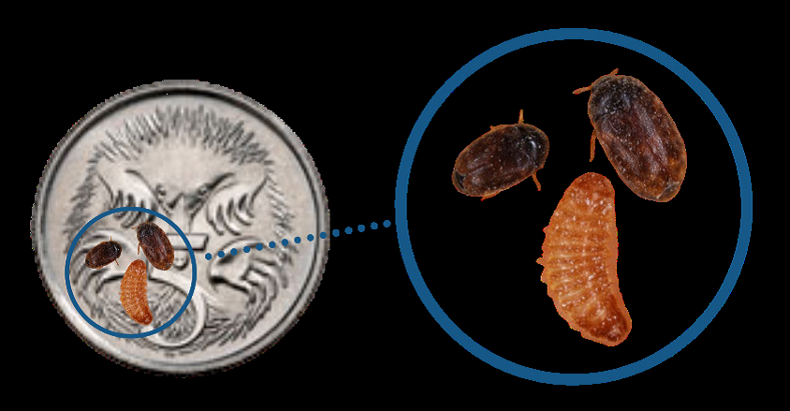

Cast Khapra larval skins

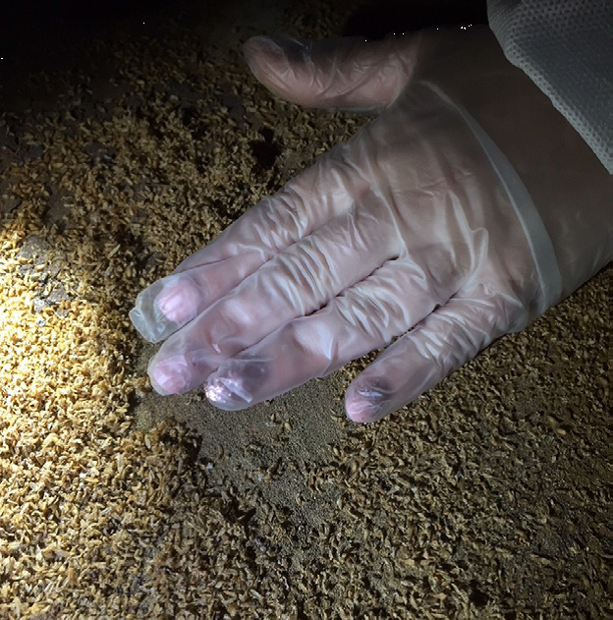

Where to look
Khapra can enter Australia:
- In grains and food stuffs
- As a hitchhiker in a wide range of cargo including machinery, nuts and bolts, timber doors and fridges
- As a hitchhiker on imported shipping containers
- In personal effects

Think you've seen khapra beetle?

Call the See. Secure. Report Hotline on 1800 798 636.
For more information on how to protect Australia from Khapra beetle, go to the following website: agriculture.gov.au/khapra-urgent-actions
Facebook: Australian Biosecurity

