# Keep khapra beetle out of Australia!

Adult khapra beetles (1.6-3mm) and a larvae (1.6-4.5mm)

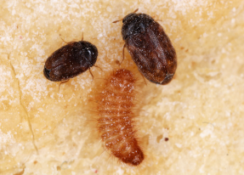

Adult khapra beetle

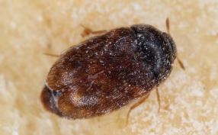

Adult khapra beetle

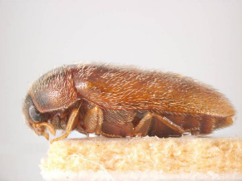

Khapra beetle is not present in Australia. It is a highly invasive pest that poses a major threat to Australia’s grains industry. It destroys grain quality making it unfit for consumption. An outbreak could cost $15.5 billion over 20 years.

**Do your part to help stop the spread of khapra beetle.**

The following plant products are not permitted into Australia when brought in for personal use via low value sea and air freight or as unaccompanied personal effects, as they could be carrying khapra beetle. Some exclusions apply for certain products. For further information, visit [**agriculture.gov.au/bicon**](https://bicon.agriculture.gov.au/BiconWeb4.0/).

Rice

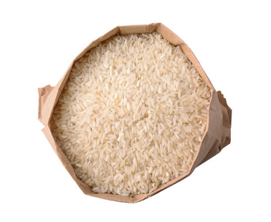

Nuts

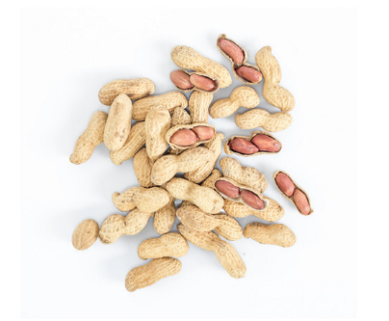

Pulses

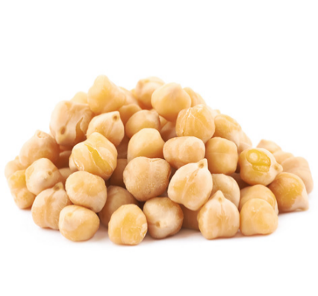

Beans

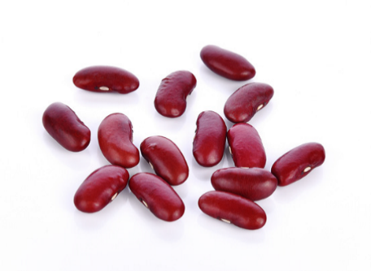

Wheat

Dried chilli

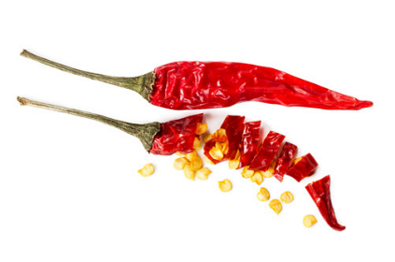

Powdered seeds and grains

Seeds

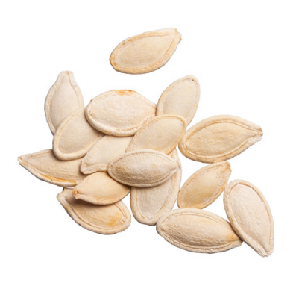

Learn more at: [agriculture.gov.au/khapra-urgent-actions](http://www.agriculture.gov.au/khapra-urgent-actions)