RECOVERY PLAN FOR THE
KANGAROO ISLAND DUNNART (SMINTHOPSIS AITKENI)

July 2011

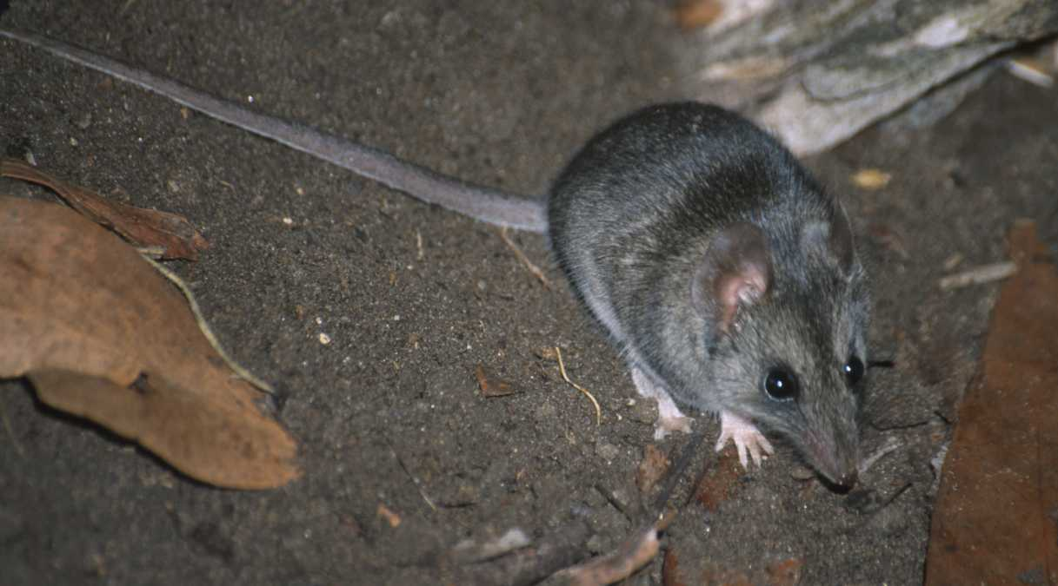



Prepared by Jody Gates, Department of Environment and Natural Resources, South Australia. July 2011.

ISBN: 978-0-9806503-0-3

© Department of Environment and Natural Resources, South Australia
This publication is copyright. Apart from any use permitted under the copyright Act 1968, no part may be reproduced by any process without prior written permission from the Government of South Australia. Requests and enquiries regarding reproduction should be addressed to:

Department of Environment and Natural Resources
GPO Box 1047
ADELAIDE, SA, 5001

Note: This recovery plan sets out the actions necessary to stop the decline of, and support the recovery of, the listed threatened species or ecological community. The Australian Government is committed to acting in accordance with the plan and to implementing the plan as it applies to Commonwealth areas.

The plan has been developed with the involvement and cooperation of a broad range of stakeholders, but individual stakeholders have not necessarily committed to undertaking specific actions. The attainment of objectives and the provision of funds may be subject to budgetary and other constraints affecting the parties involved. Proposed actions may be subject to modification over the life of the plan due to changes in knowledge.

This plan should be cited as follows: Gates, J.A. (2011). Recovery Plan for the Kangaroo Island Dunnart Sminthopsis aitkeni. Department of Environment and Natural Resources, South Australia.

Copies of the plan are available at:
http://www.environment.gov.au/biodiversity/threatened/recovery.html

Acknowledgements
Cover photograph: Kangaroo Island Dunnart Sminthopsis aitkeni by Jody Gates.
Table of Contents Page

SUMMARY i
SPECIES INFORMATION 1
Description 1
Population Information 1
Habitat 3
Habitat Use and Home Range Size 4
Diet 5
Reproductive Biology 5
Life History 5
DECLINE AND THREATS 8
Degree of Decline 8
Causes of Past Decline 8
Current Threats 8
RECOVERY INFORMATION 11
Current Conservation Actions 11
Program Implementation and Evaluation 12
Recovery Objectives 12
Recovery Objectives, Actions, Performance Criteria and Responsibilities – Summary 14
Cost of the Recovery Plan 17
Benefits to other species/ecological communities 17
Affected Agencies and Stakeholders 17
Role and Interests of Indigenous People 18
Social and Economic Impacts 19
Management practices 19
ACKNOWLEDGEMENTS 20
REFERENCES 21
Priority, Feasibility and Estimated Costs of Recovery Actions by Recovery Objectives 24

List of Figures
Figure 1. The locations of (a) past records and (b) current sites with Kangaroo Island Dunnarts Sminthopsis aitkeni. 2
Figure 2. Extent of potential habitat of the Kangaroo Island Dunnart Sminthopsis aitkeni based on the vegetation associations and structural formations in which dunnarts have been recorded. 7
Figure 3. Distribution of Phytophthora cinnamomi on western Kangaroo Island. 10

SUMMARY
The Kangaroo Island Dunnart (Sminthopsis aitkeni) is endemic to Kangaroo Island, South Australia. Its current distribution on Kangaroo Island is unknown, although all recent records (since 1990) have come from sites on the western end of the island, within Flinders Chase National Park and the Ravine des Casoars Wilderness Protection Area. Extensive survey work has failed to locate the species elsewhere; and although early records came from the eastern end of the Island, clearance or modification of the habitat in these areas has reduced the likelihood of dunnarts still occurring there.

Studies have indicated that the Kangaroo Island Dunnart is a habitat generalist, occupying a range of floristic vegetations types and post-fire seral stages. Within its range, the species is known from only 35 records and it is likely that the population is fewer than 500 dunnarts. Major threats include wildfire and inappropriate fire regimes; Phytophthora cinnamomi dieback; land clearing, degradation and fragmentation of suitable habitat; and predation by Feral Cats and native predators.

The Kangaroo Island Dunnart is currently listed as ‘Endangered’ under both the Commonwealth Environment Protection and Biodiversity Conservation Act 1999 and South Australian National Parks and Wildlife Act 1972. This Recovery Plan for the Kangaroo Island Dunnart is the first Recovery Plan for the species. The plan details the species’ distribution and biology, conservation status, threats, and recovery objectives and actions necessary to ensure its long-term survival.

SPECIES INFORMATION

Description
The Kangaroo Island Dunnart (Sminthopsis aitkeni) (herein referred to as the KI Dunnart), also known as the ‘Sooty Dunnart’, is characterised by its dark sooty grey coloured dorsal pelage, and light grey ventral pelage (Strahan 1998). It has a paler, faintly patterned head and a distinctive, slender pointed muzzle. The thin tail is always longer than the body and clearly bicoloured (Menkhorst and Knight 2004). Adults of this species grow between 80–90 mm long and weigh up to 25 g (Strahan 1998). The KI Dunnart was distinguished from the Common Dunnart, S. murina, in the 1980s, when morphological and biochemical studies identified four new species within the S. murina complex (Baverstock et al. 1984; Kitchener et al. 1984). The species is easily identified in surveys as it is the only dasyurid species that is found on Kangaroo Island.

Distribution
The KI Dunnart is endemic to Kangaroo Island, South Australia. Its current distribution on Kangaroo Island is unknown, although all recent records (since 1990) have come from sites on the western end of the island, within Flinders Chase National Park (NP) and the Ravine des Casoars Wilderness Protection Area (WPA) (Figure 1). Extensive survey work has failed to locate the species elsewhere; however, it is likely that dunnarts occur at other sites within Flinders Chase NP and Ravine des Casoars WPA, and in some of the surrounding remnants of native vegetation. Although early records came from the eastern end of the Island (Figure 1), clearance or modification of the habitat in these areas has reduced the likelihood of dunnarts still occurring there.

Population Information
The current population size is unknown, and difficult to estimate due to the elusive habits of the species. Despite extensive survey work since 1990, including over 17,800 pitfall trap nights and 20,400 Elliott trap nights (Herbert 1996; Gates 2001; Robinson and Armstrong 2000; Jones et al. 2010) the dunnart is only known from a total of 35 records and six current locations, all of which occur within Flinders Chase NP and the Ravine des Casoars WPA. It is not known if animals move between the known populations.

Twelve of the 28 captures since 1990 have come from one site alone. At this main site 10 dunnarts were captured during some of the more recent and intensive survey work (Gates 2001; Jones et al. 2010) and all were individually marked, however, no recaptures were recorded. The difficulties associated with locating new populations, and estimating the number of animals within these populations confound our ability to estimate population size. Based on existing knowledge it is likely that the population is fewer than 500 dunnarts.

Figure 1. The locations of (a) past records and (b) current sites with Kangaroo Island Dunnarts Sminthopsis aitkeni.

(a)
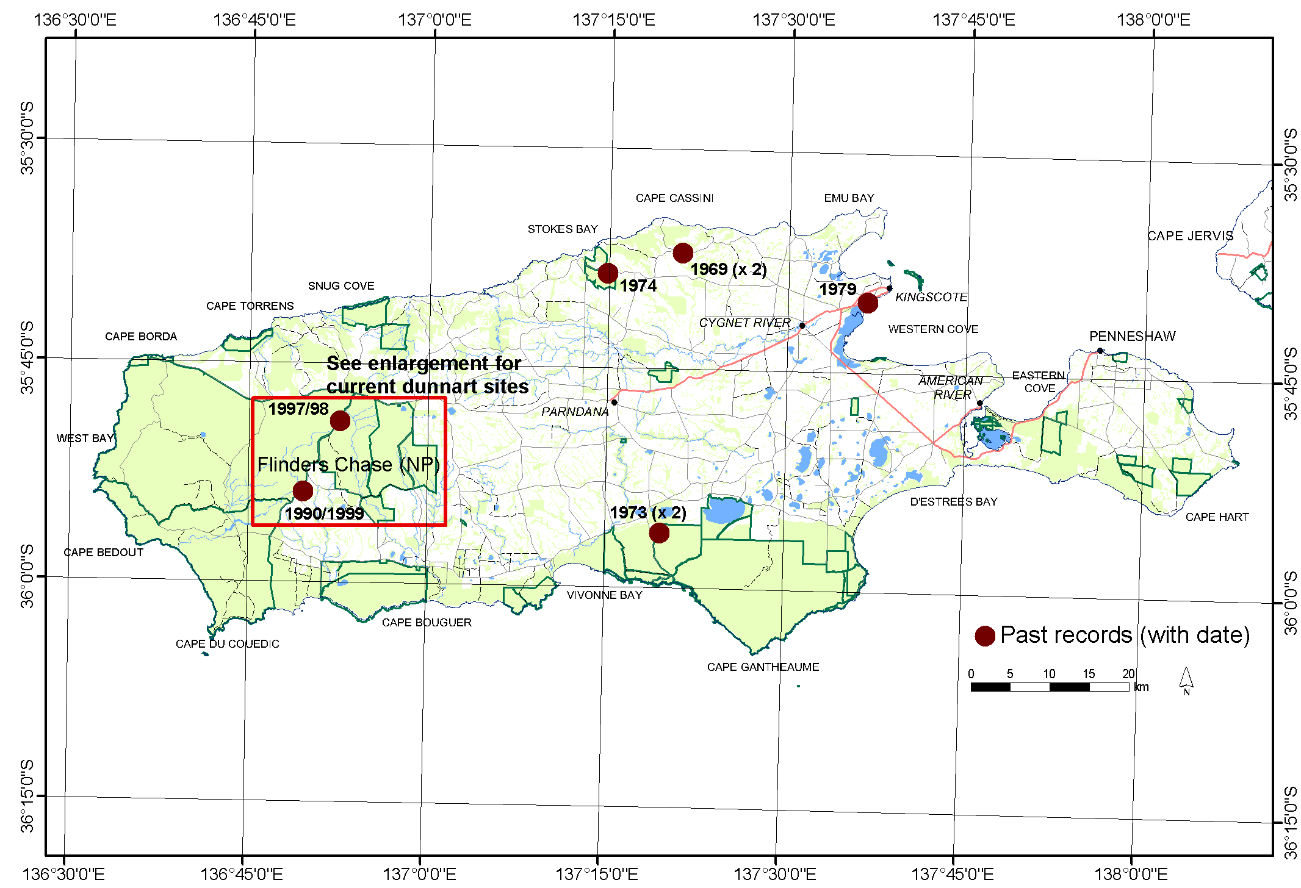
(b)

Habitat
The KI Dunnart shows no obvious preference for any particular vegetation or habitat type within the area where it is known to occur. This is consistent with observations of the closely related Common Dunnart, which occurs in a wide range of habitat types including forest, woodland, mallee scrub and dry heath, with sites characterised by sparse shrub and ground cover (Morton et al. 1980; Menkhorst 1995). Several studies have shown that Sminthopsis species appear to prefer sites with open, patchy ground cover (Lunney and Ashby 1997; Monamy and Fox 2005). Gates (2001) found that dunnarts occurred within five mapped vegetation communities on Kangaroo Island, as defined by Ball and Carruthers (1998), in agreement with similar findings by Herbert (1996).

The six sites where dunnarts are currently known to occur fall within the higher rainfall areas of the Island. The major vegetation associations within this area consist of open low mallee (Kangaroo Island Mallee-ash Eucalyptus remota) and low woodland (Brown / Messmate Stringybark E. baxteri / E. obliqua) and dunnarts have been recorded within both associations. There is considerable variation within these associations, with a variety of secondary overstorey species, and varying floristics and densities within the understorey species.

The main site, where almost 50% of recent records have come from, is open low mallee with an overstorey of Kangaroo Island Mallee-ash. The understorey is sparse and variable and includes Desert Banksia (Banksia ornata), Silver Banksia (Banksia marginata), Guinea-flowers (Hibbertia species), Yaccas (Xanthorrhoea semiplana subsp. tateana), Beaked Hakea (Hakea rostrata), rushes (Lepidosperma species), Bearded-heath (Leucopogon concurvus), Kangaroo Island Cone-sticks (Petrophile multisecta) and Common Fringe-myrtle (Calytrix tetragona). The KI Dunnart is also known to occur in Coastal Mallee (E. diversifolia) communities along the south coast and Sugar Gum (E. cladocalyx) woodland along the north coast of Kangaroo Island (Herbert 1996; Gates 2001).

Based on the types of vegetation and structural formations present at sites with dunnarts, the potential habitat for the species is widespread (Figure 2). However, much of this habitat particularly on the eastern end of the Island occurs in small remnants that have been degraded by stock grazing, weeds and other processes associated with fragmentation.

Habitat Use and Home Range Size
Limited radio-tracking data showed that a range of micro-habitats are selected for day shelters (Gates 2001). The dunnarts sheltered under Yaccas where the fronds were continuous to ground level (n=4), in leaf litter under Desert Banksias (n=4), in holes/burrows (n=3) and inside a dead Yacca trunk (n=1). At the major site there appeared to be a preference for sheltering under Yaccas, including ones that had succumbed to Phytophthora cinnamomi dieback. The dunnarts also spent periods of up to four hours using these shelters at night.

The home range dynamics and patterns of movement of the species are poorly known (Gates 2001). Radio-tracking of a few individuals indicated that range lengths are in the order of 200-300 m, however, seasonal patterns of home range use and differences between sexes in use of habitat and space are not clear. The dispersal patterns of juveniles from their natal range are also not known. The capture of dunnarts over a period of 11 years at one site suggests that some areas provide core habitat, and dunnarts continually occupy such areas for relatively long periods of time (Gates 2001; Jones et al. 2010). The use of the spool-and-line tracking technique (Miles et al. 1981; Kearney et al. 2007) in future surveys may assist in clarifying some of this information.

Diet
Dunnarts are primarily nocturnal, opportunistic foragers, predominantly feeding on insects, spiders and other terrestrial arthropods (Strahan, 1998). One preliminary study using scat analysis (Gates 2001) from 14 captured individuals has shown that spiders and ants were the most common food groups recorded in the diet of the KI Dunnart, occurring in 59% and 56% of scats (n=25), respectively. Beetles and scorpions were also commonly consumed, being recorded within 36% of scats. The remains of a centipede and grasshopper were recorded in only one scat. These results were indicative of the expected diet for this species, with all food groups recorded being ground-dwelling invertebrates.

Reproductive Biology
Little is understood about the reproductive cycle of KI Dunnarts. Most dunnart species have been found to be polyoestrous, i.e. capable of breeding several times a year (Lee and Cockburn 1985), with rapid maturation of young that require minimal parental care. Fox and Whitford (1982) concluded that polyoestry has a survival advantage for the closely related Common Dunnart in the unpredictable and short-lived conditions that categorise early-mid stage post-fire habitat with which it is frequently associated.

All recent captures occurred between January and May, with over half being juveniles/sub-adults (<16 g). No adult females were caught during this survey (Gates 2001). Of note is the fact that at one site juveniles of less than 11 g were captured in January, and then again in March in the same year. The most likely explanation for the two cohorts of juveniles is that the females are polyoestrous, which is consistent with reproductive cycles observed for Common Dunnarts (Fox and Whitford 1982). Based on the growth and development of Common Dunnart young (Fox and Whitford 1982), these juveniles were estimated to be approximately 65-115 days old. Considering a gestation length of approximately 12 days (Fox and Whitford 1982), mating is estimated to have occurred in mid-September to early October and in November to December.

Life History
The period of juvenile dependency is unknown, although studies on the similar Common Dunnart have shown this period to be approximately 65 days (Fox and Whitford 1982). As outlined above most recent captures occurred post-breeding season in late summer and autumn (Gates 2001). Although no data exist, females may survive to breed in a second year, whereas males are less likely to survive beyond one breeding season. The predominance of captures of juveniles in summer and autumn provides circumstantial evidence to support this.
Figure 2. Extent of potential habitat of the Kangaroo Island Dunnart Sminthopsis aitkeni based on the vegetation associations and structural formations in which dunnarts have been recorded.
Potential habitat was determined by selecting all vegetation sub-groups and structural formations in which records of KI Dunnarts were located. Vegetation sub-groups and structural formations are defined in Ball and Carruthers (1998). The accuracy of past locations is not known, and the habitat at these locations is likely to have changed since the records were obtained (i.e. >20 years ago). Also the suitability of many of the patches highlighted as potential habitat is likely to be influenced by patch size, the state of the vegetation and degree of isolation. However, the map provides a useful starting point for future survey work.
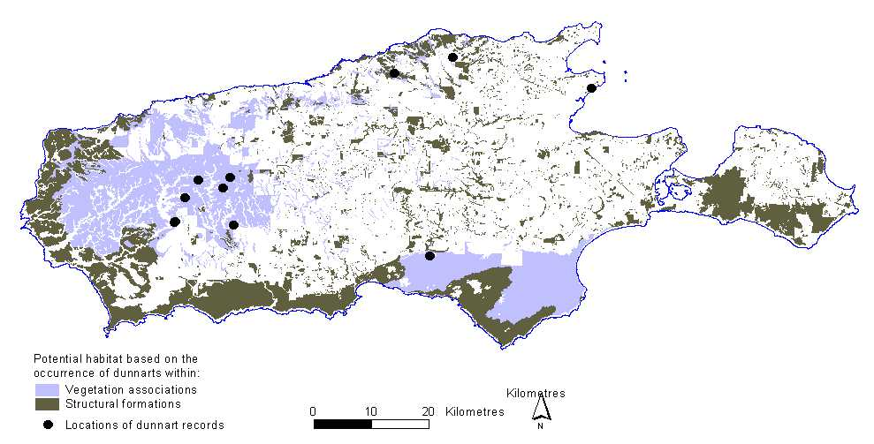



DECLINE AND THREATS

Degree of Decline
This species is restricted to Kangaroo Island, and in an Australian context, has always had a limited distribution and population size. Limited data suggest that whilst the species appeared to be widespread across Kangaroo Island in the past, its range has contracted to the western end of the Island. However, difficulties associated with detecting the species mean that this can not currently be confirmed. Therefore, while insufficient data are available to precisely determine the degree of decline, given the apparent lack of preference for any particular vegetation types it is likely that the species’ decline has been concurrent with the clearance of nearly 50% of natural vegetation on Kangaroo Island.

Causes of Past Decline
Habitat loss is thought to be the main reason for the apparent decline of the KI Dunnart. The first records of this species were obtained as a direct result of vegetation clearance, with animals being captured by dogs as they fled from felled Yaccas. Land clearance for agriculture is therefore directly implicated as an agent of decline. Ongoing modification to remaining habitat, as a result of stock and native animal grazing, is also likely to have contributed to the effects of habitat loss.

The effects of an altered fire regime are likely to have potentially contributed to decline. All current dunnart sites occur within vegetation that has not been burnt for a considerable time (at least 20 years), and frequent and/or extensive wildfires are likely to have caused the extirpation of the species from some sites. Unlike other causes of decline, the effects of fire are also prevalent within the large areas of intact remnant vegetation, such as Flinders Chase NP and Ravine des Casoars WPA.

Current Threats
The KI Dunnart is considered endangered because its known range is very limited, leaving it at risk from catastrophes such as extensive wildfires. Because specific threats are not well defined a precautionary approach is clearly justified. Key threats are summarised as follows:

Habitat Degradation/Alteration
Wildfire and Inappropriate Fire Regimes
Uncontrolled bushfires and associated back-burns are likely to cause the extirpation of local KI Dunnart populations and the short-medium term loss of habitat. Inappropriate fire regimes pose the single greatest threat to long term survival of the KI Dunnart.

The typical practice of back-burning around a bushfire perimeter to secure its boundaries may contribute significantly to the severity and extent of fires. Such events are not uncommon in Flinders Chase NP and Ravine des Casoars WPA where 50% of the parks area was burnt in consecutive years in 1990-91 and the majority of the park was burnt in December 2007 (DEH, 2009).

All six of 1999-2001 dunnart capture sites had not been burnt for at least 11 years, and WEH04, where 10 captures occurred, had not been burnt for 24 years. While most sites were located near the edges of fire scars, site WEH04 was surrounded by vegetation that had not burnt for at least 40 years, potentially providing core habitat for the species (Jones et al. 2010). The extensive wildfire of December 2007 burnt three of these six dunnart capture sites, a fourth site had been burnt in 2006 and the remaining two sites were burnt in an earlier extensive wildfire in 2002. The capture of dunnarts in the 2009 study at site WAL01, burnt in 2002 (one capture) and at WEH04, burnt in 2007 (two captures) indicates that some dunnart populations survived these fires, although the status of post-fire populations is unknown (Jones et al. 2010). The dunnart population at site WEH04 presumably survived in the unburnt vegetation strip between the West End Highway and the 2007 fire ground. This 50-100 metre wide strip had been stick-raked in 1995-96 to reduce fuel load and is separated from 2007 fire ground by a hydro-axed vehicle track (DEH 2009).

For dunnarts to survive bushfires, patches of habitat where they occur must remain unburnt, but the rarity of the species means that the chance of this occurring is probably low, particularly in extensive fires (Jones et al. 2010). The proximity of unburnt remnants, even narrow strips, may be a key factor in the survival of dunnart populations. While the 2007 wildfire burnt almost the whole area of Flinders Chase NP and Ravine des Casoars WPA west of the West End Highway, post-fire mapping revealed scattered, often linear, unburnt remnants associated with drainage lines and other topographical features (DENR Fire Management Branch). It is possible that small populations of the KI Dunnart have survived in these unburnt refuges.

Phytophthora cinnamomi Dieback
The impacts of Phytophthora dieback are evident at the major site where most dunnarts have been captured. This fungal disease is widespread across western Kangaroo Island, including many areas within Flinders Chase NP and Ravine des Casoars WPA (Vickery 1997; Mooney and MacPhee 2007; Figure 3). A wide range of understorey plant species are susceptible, with Yaccas and Desert and Silver Banksias being indicator species because of their acute susceptibility (Mooney et al. 2009). The dunnarts are known to use the cover at the base of Yaccas and Desert Banksias for shelter, both during the day and night. At the major known dunnart site Yaccas, including those already killed by Phytophthora, provided the preferred day shelter. Clearly whilst dead plants can also provide habitat, this cover is only available in the short-term and will be removed by fires. It is therefore possible that the loss of susceptible plants from the habitat will reduce the value of that habitat to the dunnarts. There is no known cure for this disease, with control primarily focusing on removing the potential for its spread via soil attached to vehicles, machinery or footwear.

Figure 3. Distribution of Phytophthora cinnamomi on western Kangaroo Island.

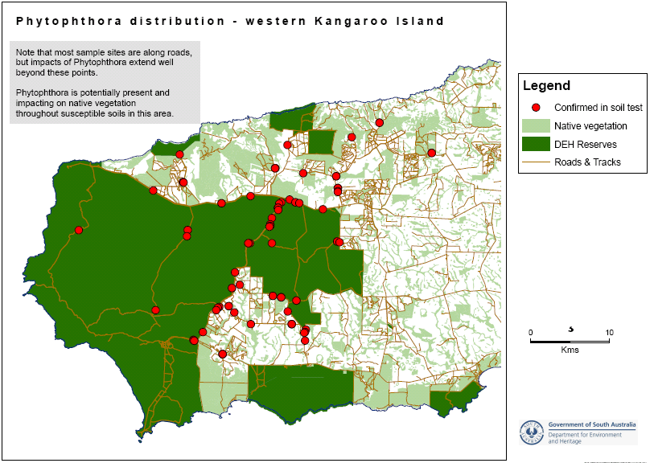

Land Clearance and Patch Size
Fortunately approximately 50% of the natural vegetation on Kangaroo Island remains, and over half of this is conserved within National Parks and Wildlife South Australia (NPWSA) reserves. However, all of the early records of the KI Dunnart originated from the eastern end of the Island, where the majority of vegetation clearance occurred. It is therefore probable that the population of the dunnart declined commensurately with this clearance of vegetation. In this area the remaining habitat occurs in small and isolated patches (Figure 2), which may no longer be suitable for the dunnarts. Illegal vegetation clearance still occurs, and legal clearance, for example along fencelines, continues to degrade the already small and isolated patches of vegetation on the eastern end of the Island, as well as impacting on larger patches elsewhere. Combined with the effects of inappropriate use of fire, weed invasion, tree dieback etc. the loss of potential habitat of the KI Dunnart is still occurring.

Predation
Foxes are absent from Kangaroo Island, however, Feral Cats Felis catus are widespread and therefore potentially pose a threat. There is no direct evidence of predation of the KI Dunnart by cats, although this is not surprising given the elusive nature of both dunnarts and cats. Evidence suggests that cat densities are lower within large areas of contiguous vegetation, such as Flinders Chase NP (D. Paton pers. comm.). Feral Cats are regularly observed along roads where they feed on road kills, and they have been observed on the road adjacent to the major dunnart site (J. Gates pers. obs.). The relatively high abundance of other small mammals in these areas, such as Bush Rats (Rattus fuscipes), House Mice (Mus musculus) and Pygmy-Possums (Cercartetus spp.), may deflect the predation pressure away from the dunnart. In particular, cats may preferentially take Bush Rats, which are relatively abundant, and much larger, thereby providing a better return for effort.

There are relatively few native predators, although Southern Boobooks Ninox novaeseelandiae halmaturina are common on Kangaroo Island and could potentially capture dunnarts. Other potential native predators include Heath Goannas Varanus rosenbergi, although this species will generally not be active at the same time as dunnarts, and Tiger Snakes Notechis scutatus which may be able to detect dunnarts within day shelters.

RECOVERY INFORMATION

Current Conservation Actions
Existing conservation measures are limited, but include:
- known dunnart populations occur within NPWSA reserves;
- permanent survey sites were established in 1997 to undertake some monitoring at the known dunnart sites. Survey work was undertaken from 1996-1997 and 1999-2001. Recently, two trapping surveys were conducted, in late summer (Jan-Feb) and in spring (Oct-Nov) 2009. Of the nine survey sites that were selected at the western end of Kangaroo Island, these included Gates’ (2001) six capture sites, as well as sites that had been sampled in the biological survey in 1990 and several sites within close proximity of previous capture sites;
- The Fire Management Plan for Flinders Chase (DEH 2009) includes Flinders Chase NP and Ravine des Casoars WPA as well as dedicated Crown land, Crown land under the care and control of the Minister for Environment and Conservation and participating Heritage Agreements. This plan has been developed to provide direction for fire management activities, through the inclusion of strategies for risk minimisation and bushfire suppression considerations within the planning area and on threatened species such as the KI Dunnart; and
- The Ecological Fire Management Strategy for the KI Dunnart (DENR 2011) focuses on fire management for the KI Dunnart, identifying a number of issues that should be considered before, during and after fire.

Program Implementation and Evaluation
The Recovery Plan is intended to run for five years from the time of adoption. Implementation will be the responsibility of the SA Department of Environment and Natural Resources (DENR), supported by other agencies, educational institutions and community groups as appropriate. A Recovery Team will be formed with representatives from each organisation to coordinate implementation and exchange information. The Recovery Team will be responsible for preparing work plans and monitoring progress towards recovery. The Recovery Plan is intended to run for five years from the date of its adoption under the EPBC Act, and will be reviewed and revised within five years of the date of its adoption.

Recovery Objectives
The Long-term Objectives of recovery are to:
- protect known populations of dunnarts from threats, in particular wildfires;
- obtain the information necessary to develop and implement management strategies to achieve Objective 1; and
- downlist the KI Dunnart from ‘Endangered’ to ‘Vulnerable’.

Within the life span of this Recovery Plan, the Specific Objectives of recovery are to:
- Develop and implement management prescriptions to protect and conserve all known sites with populations of KI Dunnarts;
- Enhance protection of dunnart habitat and investigate the impacts of fire on the species;
- Implement a research and monitoring program to gain an improved understanding of KI Dunnart ecology, biology and potential threats;
- To continue to raise community awareness and support for the KI Dunnart recovery program; and
- To ensure that the Recovery Plan is implemented as efficiently and effectively as possible.

The key to achieving these objectives will be to protect sites and habitat with known populations; maintain current survey and monitoring practices; and undertake further research to gain an improved understanding of the species ecology, biology and clarify potential threats. The Recovery Plan provides for the amelioration of current threats to known populations/sites with dunnarts through the strategic management of these sites. With regards to threats such as wildfire, active management provides the only means to ensure that known sites with dunnarts are protected (DEH 2009; DENR 2011).

Recovery Objectives, Actions, Performance Criteria and Responsibilities – Summary
Action | Description | Performance Criteria | Responsibility
Objective 1: Develop and implement management prescriptions to protect and conserve all known sites with populations of KI Dunnarts.
1.1 | Clearly define and map the known KI Dunnart population sites. | - Map of sites produced within one year. | - DENR.
1.2 | Complete a management plan to document specific management prescriptions for protecting known KI Dunnart sites. | - Management plan completed within 18 months. | - DENR, Conservation Programs Unit (CPU), Kangaroo Island.
1.3 | Continue to implement standard Phytophthora hygiene practices when undertaking all fieldwork activities. | - All DENR staff, contractors and volunteers are educated about how to recognise the presence of Phytophthora and hygiene practices as part of their induction  - All people entering Phytophthora infected areas employ hygiene practices. | - DENR CPU, Kangaroo Island  - DENR Field Staff, Flinders Chase NP and Ravine des Casoars WPA.
Objective 2: Enhance protection of dunnart habitat and investigate the impacts of fire on the species.
2.1 | Reduce the likelihood of contiguous remnants of significant dunnart habitat burning in their entirety during a single fire event. | - Bushfire risk and suppression activities consider prevention of potential dunnart population or habitat loss due to fire. | - DENR CPU, Kangaroo Island  - DENR, Fire Management  - Local Country Fire Service (CFS) Brigades.
2.2 | Reduce the likelihood of fire suppression activities including prescribed burning and fire suppression, impacting upon the long term viability of KI Dunnart populations. | - Fuel is reduced at strategic locations to minimize the extent of a bushfire burning an entire patch of suitable habitat. | - DENR CPU, Kangaroo Island  - DENR, Fire Management  - Local CFS Brigades.
2.3 | Ensure that sufficient KI Dunnart habitat is maintained by implementing appropriate fire regimes across known habitat areas. | - Ensure occupied habitat is not deliberately burnt without appropriate dunnart specific management considerations  - Promote a habitat mosaic consisting of a range of post-fire age-classes. | - DENR CPU, Kangaroo Island  - DENR, Fire Management  - Local CFS Brigades.
2.4 | Improve knowledge of how KI Dunnart populations respond to fire, by filling in knowledge gaps. | - Monitor the fire response of dunnarts (e.g. target surveys in a range of fire ages-classes, particularly unsurveyed fire age-classes, within the known distribution (past and current) of dunnarts and monitor the response of dunnarts to changes in successional stages of habitat). | - DENR CPU, Kangaroo Island  - DENR, Fire Management  - Contract Biologist.
Objective 3: Implement a research and monitoring program to gain a better understanding of KI Dunnart ecology, biology and potential threats.
3.1 | Continue to trial different capture and detection methods to maximise capture rates of KI Dunnarts. | - Different trapping methods are trialled and compared for at least 20 trap-nights within four years  - Suitability of the spool-and-line tracking technique for assessing microhabitat use determined. | - DENR CPU, Kangaroo Island  - Contract biologist.
3.2 | Clarify the influence of habitat type and patch size on the distribution of the KI Dunnart. | - Survey program initiated within one year and at least 20 survey sites trapped over 15+ nights during summer/autumn annually  - Map of ‘known and potential habitat’ updated as often as required based on the location of new populations of dunnarts. | - Contract biologist  - DENR CPU, Kangaroo Island.
3.3 | Radio-track all dunnarts captured under Action 3.1 to obtain more information on home range sizes, movements and record details of shelter sites. | - Radio-transmitter attachment methods are refined to ensure that each dunnart captured is radio-tracked for at least five days  - Shelter sites are documented through the course of radio-tracking and spool-and-line technique (if suitable). | - Contract biologist  - DENR CPU, Kangaroo Island.
3.4 | Undertake a mark and recapture pitfall trapping program at the major known site with dunnarts and record details of all dunnarts captured to determine sex ratios, longevity of individuals and population dynamics. | - At least four 100 m pitfall traplines, each with 10 pitfall traps, established at the site (see Gates 2001) within 18 months  - Pitfall trapping undertaken for at least 25 nights each year. | - Contract biologist  - DENR CPU, Kangaroo Island.
3.5 | Document breeding condition of all dunnarts captured through Action 3.1. | - All captured animals are sexed, weighed and breeding condition recorded, and related to prevailing environmental conditions. | - Contract biologist  - DENR CPU, Kangaroo Island.
3.6 | Investigate and determine the impact of Phytophthora on the distribution of KI Dunnarts. | - Survey program implemented as for Action 3.2 (and targeting areas with and without Phytophthora)  - Map of ‘Distribution of Phytophthora on Kangaroo Island’ updated based on survey results. | - Contract biologist  - DENR CPU, Kangaroo Island.
3.7 | Investigate the potential threat of predation and/or spread of toxoplasmosis by feral cats and implement threat abatement strategies as necessary. | - At least 50 feral cat scats/ stomach contents are analysed annually  - Threat abatement strategies implemented (as necessary). | - Contract biologist  - DENR CPU, Kangaroo Island  - DENR Field Staff.
3.8 | Undertake an assessment of the need to establish a captive colony. | - Recovery Team discusses the issue and develops a brief position statement within one year. | - DENR CPU, Kangaroo Island.  - Recovery Team  - Zoos SA.
Objective 4: To continue to raise community awareness and support for the KI Dunnart recovery program.
4.1 | Continue to educate the community in the recognition of the KI Dunnart, and its ecology, by disseminating information through the local media | - New dunnart population(s) are located as a result of discoveries made by community members  - At least two requests from school or community groups are received for presentations annually. | - DENR CPU, Kangaroo Island  - Contract biologist  - DENR Field Staff.
4.2 | Advertise planned activities and target local community groups for assistance with on-ground site management and research works. | - Members of at least one community group are involved with on-ground site management and research works at least twice a year  - Other community members regularly assist with on-ground site management and research works at least once each year. | - DENR CPU, Kangaroo Island  - Contract biologist  - DENR Field Staff.
4.3 | Obtain ‘shelter’ boxes from Rotary’s Native Bird Nestbox Project Inc. (ROBIN), or similar sources, and trial at known KI Dunnart sites as a method for catching individuals. | - Completion of trials of the effectiveness of ‘shelter’ boxes over two breeding seasons. | - DENR CPU, Kangaroo Island  - Contract biologist  - DENR Field Staff.
Objective 5: To ensure that the Recovery Plan is implemented as efficiently and effectively as possible.
5.1 | Seek the involvement of suitable personnel and establish a Recovery Team. | - Recovery Team established, inaugural meeting held within one year, and future meeting dates determined. | - DENR CPU, Kangaroo Island  - DENR Threatened Species Unit.
5.2 | Hold Recovery Team meetings as necessary, and at least annually, to assess the progress towards performance criteria. | - Recovery Plan discussed and revised annually. | - DENR CPU, Kangaroo Island  - Recovery Team.

Cost of the Recovery Plan
The estimated cost of the recovery program is $592,249 over five years.
 | Year 1 | Year 2 | Year 3 | Year 4 | Year 5 | Total
Totals | $ 138,083 | $ 126,083 | $ 116,083 | $ 106,000 | $ 106,000 | $ 592,249

Benefits to other species/ecological communities
The implementation of recovery actions for the KI Dunnart will directly benefit a number of species also found within its range. Further survey work undertaken to clarify the range of the species will contribute to the understanding of the distribution of similar fauna species on Kangaroo Island.

Fire management planning and fire ecology research for the KI Dunnart may also benefit a number of other threatened species occurring within its range. These include the nationally endangered Southern Brown Bandicoot (Isoodon obesulus obesulus), the nationally vulnerable Heath Mouse (Pseudomys shortridgei), spiral sun-orchid (Thelymitra matthewsii), downy star-bush (Asterolasia phebalioides), and the Kangaroo Island endemic and nationally vulnerable Kangaroo Island logania (Logania insularis) and twining finger flower (Cheiranthera volubilis).

Affected Agencies and Stakeholders
A number of people and groups have been identified as current and potential stakeholders in the management of the KI Dunnart. There are many opportunities for these stakeholders to be involved in the recovery actions of this plan.

Stakeholders in the KI Dunnart Recovery Program:
Kangaroo Island Community
Commercial tour operators on Kangaroo Island
Friends of the Dudley Peninsula
Friends of Parks, KI Western District
Country Fire Service (Kangaroo Island group)
Eco-Action Landcare Group
General Kangaroo Island community
Kangaroo Island Community Seed Bank
Kangaroo Island Council
Kangaroo Island Flora and Fauna Club
Kangaroo Island Private Landholders
Local Indigenous Community
Kangaroo Island Natural Resources Management Regional Board

State
Conservation Council of South Australia
Department of Environment and Natural Resources
Department for Water
Friends of Parks South Australia
General Public
Indigenous community
Natural Resource Management Council
Zoos SA
Country Fire Service
South Australian Museum
Transport South Australia
Forestry SA
SA Water

National Stakeholders
Department of Sustainability, Environment, Water, Populations and Communities
General public
WWF – Australia

Role and Interests of Indigenous People
Archaeological remnants of Aboriginal existence can be found on Kangaroo Island. The Aboriginal Partnerships section of SA DENR undertook indigenous consultation for this plan in April 2003. No specific comments were made regarding this species and the recovery plan; however a general comment was made that the recognition of Aboriginal names for species would be beneficial. Kaurna and Ngarrindjeri peoples have cultural connections with the Kangaroo Island, believing that the souls of dead people travel to this location. The Ngarrindjeri creation story of Ngurunderi also travels through Kangaroo Island.

Social and Economic Impacts
This recovery plan will have minimal social and economic impacts on Kangaroo Island. Over time it may have social benefits such as increasing awareness of the natural heritage values of areas where the KI Dunnarts have been recorded and also of the species. The research stage may also provide social benefits for volunteers who may be involved in the research.

Management practices
The KI Dunnart is currently only known to occur in Flinders Chase NP and Ravine des Casoars WPA, on Kangaroo Island. However, as indicated by earlier records of the species during the 1960s and 1970s, potentially suitable habitat for this species is much more extensive and includes most of the major Eucalyptus formations on the Island (see Figure 2).

Potential habitat occurs on NPWSA reserves, on private land, and on land owned by the Kangaroo Island Council. Existing processes for assessing vegetation clearance applications, or the suitability of developments (such as tourism infrastructure), will need to specifically consider direct and indirect impacts on both the KI Dunnart and its habitats.

Wildfires are the single major concern with respect to the protection of KI Dunnarts and their habitats, particularly as the timing and location of wildfires are generally beyond human control. There is therefore an urgent need to reduce the extent and severity of all wildfires, particularly on western Kangaroo Island. This will be addressed by DENR in conjunction with the South Australian CFS, Kangaroo Island Council and South Australia’s Native Vegetation Council. In particular, fire management and suppression strategies need to be developed to ensure that practices employed are not detrimental to the long-term survival of the KI Dunnart. Specifically, on-ground works are required to limit the need for extensive back-burning operations, as these often contribute significantly to the extent of fires.

In addition, soil hygiene practices will need to be implemented during all fire prevention and fire suppression works and road works to minimise the risk of spreading the root rot fungus, Phytophthora cinnamomi. The day to day management and maintenance of farms, and electricity and telecommunications infrastructure also requires the implementation of these practices. Ongoing research into the effects of Phytophthora, and improved techniques in managing its spread, are also crucial.

Community awareness programs about the dunnarts, their habitats and the threats to their survival will need to underpin each of the planning issues raised above.

Weed control may be necessary to protect the integrity of potential habitat. In particular, the various stake-holders must ensure that invasive weeds such as bridal creeper do not become established on western Kangaroo Island, which is relatively free of such pest plants.

The major pest animal of concern is the feral cat, which is distributed across the whole Island, and potentially preys on a wide range of indigenous species. Eliminating cats from the Island is probably unachievable, at least in the short-medium term. However, any attempt to do so must begin with tight controls on domestic cats and Kangaroo Island would be an ideal location to introduce a ‘last cat’ policy as a first step towards cat control.

ACKNOWLEDGEMENTS
Pip Masters and Graeme Moss contributed significantly to discussions on the survey and research projects that culminated in this Recovery Plan.

Peter Copley, Graeme Moss, Pip Masters, Jason van Weenen, Anthelia Bond, Julia Ross, Anthea Howard, Erin Sautter and Trish Mooney provided comments and discussion on this plan.

Fiona Gill and Kylie Moritz assisted with proof reading of the document.

Funding for the preparation of this plan was provided by the Australian Government.

REFERENCES
Ball, D. and Carruthers, S. (Ed.) (1998). ‘Kangaroo Island Vegetation Mapping.’ Technical Report. Department for Transport, Urban Planning and the Arts, Adelaide.

Baverstock, P.R., Adams, M. and Archer, M. (1984). Electrophoretic resolution of species boundaries in the Sminthopsis murina complex (Dasyuridae). Australian Journal of Zoology 32, 823-832.

DEH (2009). Flinders Chase Fire Management Plan 2009-2014. Department for Environment and Heritage, South Australia.

DENR (2011). Ecological Fire Management Strategy for the Kangaroo Island Dunnart (Sminthopsis aitkeni). Department of Environment and Natural Resources, South Australia.

Fox, B.J. and Whitford, D. (1982). Polyoestry in a predictable coastal environment: reproduction, growth and development in Sminthopsis murina (Marsupialia: Dasyuridae). In ‘Carnivorous Marsupials’. (Ed. M. Archer.) pp 39-48. Royal Zoological Society of New South Wales, Sydney.

Gates, J.A. (2001). ‘The Distribution and Ecology of the Kangaroo Island Dunnart Sminthopsis aitkeni.’ Unpublished report. National Parks and Wildlife, South Australia, Kingscote.

Herbert, T. (1996). ‘Distribution, Habitat Preference and Status of the Kangaroo Island Dunnart (Sminthopsis aitkeni).’ Nature Conservation Society of South Australia, Adelaide.

Jones, S., Mooney, P., Ross, J. and Pisanu, P. (2010). ‘The distribution and ecology of threatened small mammals on Kangaroo Island.’ Department for Environment and Heritage, Kingscote.

Kearney, N., Handasyde, K., Ward, S. and Kearney, M. (2007). Fine-scale microhabitat selection for dense vegetation in a heathland rodent, Rattus lutreolus: Insights from intraspecific and temporal patterns. Austral Ecology 32, 315-25.

Kitchener, D.J., Stoddard, J. and Henry, J. (1984). A taxonomic revision of the Sminthopsis murina complex (Marsupialia, Dasyuridae) in Australia, including descriptions of four new
species. Records of Western Australian Museum 11, 201-48.

Lee, A.K. & Cockburn, A. (1985). Evolutionary Ecology of Marsupials. Oxford University Press, Cambridge.

Lunney, D. & Ashby, E. (1987). Population changes in Sminthopsis leucopus (Gray) (Marsupialia: Dasyuridae), and other small mammal species, in forest regenerating from logging and fire near Bega, New South Wales. Australian Wildlife Research 14, 275-284.

Menkhorst, P.W. (1995). ‘Mammals of Victoria. Distribution, Ecology and Conservation.’ Oxford University Press, Melbourne.

Menkhorst, P.W. & Knight, F. (2004). A Field Guide to the Mammals of Australia. Oxford University Press, Melbourne.

Miles , M.A., De Souza, A.A. and Povoa, M. M. (1981). Mammal tracking and nest location in Brazilian forest with an improved spool-and-line device. Journal of Zoology 195, 331-47.

Monamy, V. & Fox, B.J. (2000). Small mammal succession is determined by vegetation density rather than time elapsed since disturbance. Austral Ecology 25, 580-587.
Mooney, P. & Macphee, A. (2007). ‘The distribution of Phytophthora cinnamomi and its relationship to native vegetation dieback Kangaroo Island.’ Unpublished Report. Department for Environment and Heritage, Kingscote.

Mooney, P., Sandow, D. and Ross, J. (2009). ‘Kangaroo Island vegetation dieback assessment method – measuring impacts of drought on native vegetation.’ Department for Environment and Heritage, Kingscote.

Morton, S.R., Wainer, J.W., & Thwaites, T.P. (1980). Distributions and habitats of Sminthopsis leucopus and Sminthopsis murina (Marsupialia: Dasyuridae) in south eastern Australia. Australian Mammalogy 3, 19-30.
Robinson, A. and Armstrong, D. (2000). ‘A Biological Survey of Kangaroo Island South Australia.’ Department for Environment and Aboriginal Affairs, Adelaide.

Strahan, R. (1998). The Mammals of Australia (2nd ed.). The Australian Museum & Sydney: Reed Books.

Vickery, F.J. (1997). The distribution of Phytophthora cinnamomi on Kangaroo Island. PhD Thesis. Armidale, University of New England.

Priority, Feasibility and Estimated Costs of Recovery Actions by Recovery Objectives
Action | Description | Priority | Cost estimate ($)
 |  |  | Year 1 | Year 2 | Year 3 | Year 4 | Year 5 | Total
1 Site protection and management of known populations
1.1 | Define and map known population sites | High | 1,000 | 0 | 0 | 0 | 0 | 1,000
1.2 | Complete a management plan | High | 10,000 | 0 | 0 | 0 | 0 | 10,000
1.3 | Undertake small-scale planned burns to establish fire breaks around sites | High | 9,000 | 9,000 | 0 | 0 | 0 | 18,000
1.3 | Continue to implement standard Phytophthora cinnamomi hygiene practices | High | 500 | 500 | 500 | 500 | 500 | 2,500
2 Enhance protection of habitat and investigate impacts of fire
2.1 | Reduce likelihood of remnant habitat burning | High | 53, 583 | 53, 583 | 53, 583 | 48,000 | 48,000 | 256,749
2.2 | Reduce likelihood of fire suppression activities impacting on populations | High | Funded under Action 2.1
2.3 | Implement appropriate fire regimes across known habitat areas | High | Funded under Action 2.1
2.4 | Improve knowledge of fire response | High | Funded under Action 2.1
3 Research and monitoring program
3.1 | Capture and detection methodology | High | 60,000 | 60,000 | 60,000 | 55,500 | 55,500 | 291,000
3.2 | Clarify influence of habitat type and patch size on distribution | High | Funded under Action 3.1
3.3 | Radio-tracking | High | Funded under Action 3.1
3.4 | Mark and recapture pitfall trapping program | High | Funded under Action 3.1
3.5 | Document breeding condition | High | Funded under Action 3.1
3.6 | Determining impact of Phytophthora on distribution | High | Funded under Action 3.1
3.7 | Investigate predation threats and implement threat abatement strategies | Medium | Funded under Action 3.1
3.8 | Assess need to establish captive colony | High | 500 | 0 | 0 | 0 | 0 | 500
4 Community awareness and engagement
4.1 | Community education | High | 500 | 500 | 500 | 500 | 500 | 2,500
4.2 | Community assistance with management | Medium | 500 | 500 | 500 | 500 | 500 | 2,500
4.3 | ‘Shelter’ box acquisition and trials | Medium | 1,000 | 1,000 | 0 | 0 | 0 | 2,000
5 Recovery Planning
6.1 | Establish Recovery Team | High | 500 | 0 | 0 | 0 | 0 | 500
6.2 | Recovery Team meetings | High | 1,000 | 1,000 | 1,000 | 1,000 | 1,000 | 5,000
 |  | Totals | 138,083 | 126,083 | 116,083 | 106,000 | 106,000 | 592,249

