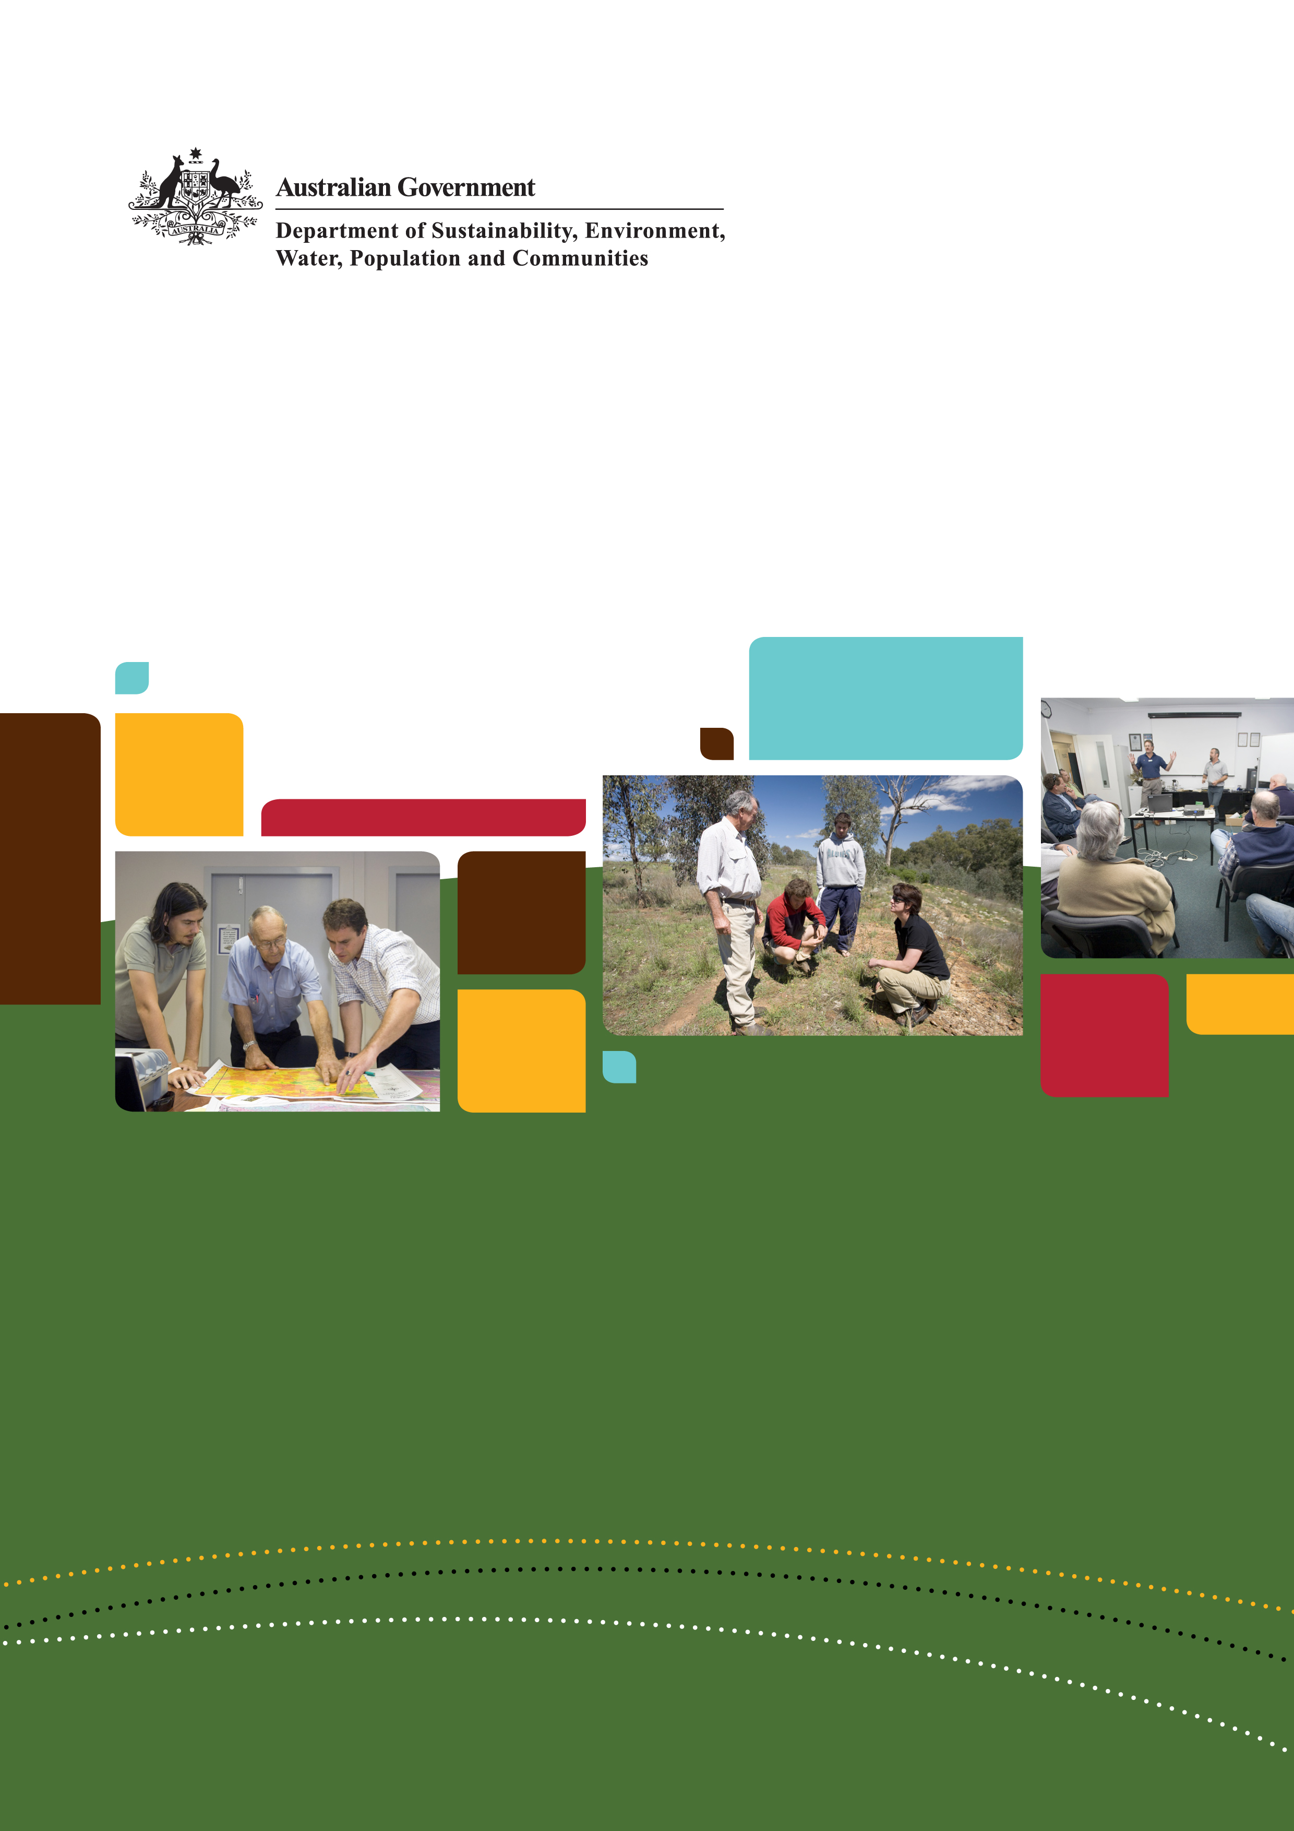

Knowledge for Purpose
Managing research for uptake — a guide to a knowledge and adoption program
National Library of Australia Cataloguing-in-Publication entry
2012 Commonwealth of Australia
Knowledge for Purpose: Managing research for uptake—a guide to a knowledge and adoption program
Bibliography
ISBN 978-921733-23-9
1 Applied research
© Commonwealth of Australia 2012
This work is copyright. You may download, display, print and reproduce this material in unaltered form only (retaining this notice)
for your personal, non-commercial use or use within your organisation. Apart from any use as permitted under the Copyright Act 1968,
all other rights are reserved. Requests and inquiries concerning reproduction and rights should be addressed to: Commonwealth Copyright Administration Attorney General’s Department, Robert Garran Offices, National Circuit, Barton ACT 2600 or posted at
www.ag.gov.au/cca
Disclaimer
The views and opinions expressed in this publication are those of the authors and do not necessarily reflect those of the Australian Government or the Minister for Sustainability, Environment, Water, Population and Communities.
While reasonable efforts have been made to ensure that the contents of this publication are factually correct, the Commonwealth does not accept responsibility for the accuracy or completeness of the contents, and shall not be liable for any loss or damage that may be occasioned directly or indirectly through the use of, or reliance on, the contents of this publication.
Author Credit
This document was written by Kate Andrews and covers and builds on several years of work with Land & Water Australia (LWA).
Citation
Andrews, Kate (2012) Knowledge for Purpose: Managing research for uptake—a guide to a knowledge and adoption program,
Department of Sustainability, Environment, Water, Population and Communities, Canberra.
Photo Credits
Front Cover
Left to right: Fire management using maps, QLD (K. Trapnell), Discussion of native grass restoration, NSW (J. Baker), Presentation to workshop participants, WA (M. Marriott)
Back Cover
Left to right: Roundtable discussion, VIC (J. Baker), Water quality testing, ACT (J. Baker), Planning meeting, QLD (L. Radford)

Contents
Executive summary iii
Understanding knowledge adoption iii
Managing knowledge for adoption iv
Building organisational capacity and culture vi
1. Introduction 1
2. Understanding knowledge for adoption 2
2.1
Defining adoption 2
What informs knowledge and adoption? 3
2.2
The role of R&D organisations in adoption 4
Impediments and incentives in research 5
2.3
A continuum of adoption methods—from engagement to information provision 6
Where does communication fit in? 7
2.4
Factors influencing adoption and barriers to adoption 8
Information and the practice change cycle 9
Adoptability: Characteristics of innovations that influence uptake 11
3. Managing knowledge for adoption 13
3.1
Strategic planning 13
3.2
The research life cycle—scoping, planning, implementation and legacy 14
3.3
Targeted adoption—of what, by whom and how? 15
3.4
Monitoring and evaluation 17
3.5
Developing program and project adoption plans 19
3.6
Implementation and methods 21
Mapping and understanding your stakeholders 24
3.7
Legacy 25
Synthesis—making it relevant and useful 26
Information and knowledge management 27
4. Building organisational capacity and culture 28
4.1
Organisational systems 29
4.2
Procedures 29
4.3
Tools and capacity building 30
4.4
Culture 30
Building a K&A team 31
5. Conclusion 32
References and further reading 33
Appendixes 35
Appendix A: Knowledge and adoption planning template 35
Appendix B: Land & Water Australia’s Knowledge and Adoption Policy 36
Appendix C: The knowledge bazaar—a new way of finding information 39
Appendix D: Legacy case study—The National Riparian Lands R&D Program 40
Executive summary
Knowledge for Purpose is a practical guide for those working to improve the adoption of publicly funded applied research. It addresses the question—how do you manage research in research and development organisations, or research funding organisations, to increase the likelihood of uptake?
In this context the term knowledge adoption means the uptake of information, concepts, tools or practices (innovations) that have been generated predominantly through research.
The guide contains three major sections:
- Understanding the process of knowledge adoption or uptake
- Managing research for adoption
- Building the organisational capacity and culture to achieve this.
Managing knowledge for adoption is a fundamentally different approach to that of transfer of technology, conventional communication or knowledge diffusion. Managing knowledge for adoption is iterative not linear and active rather than passive. It is contextualised—we adapt and modify information to suit, thereby also creating knowledge. It is driven by need rather than just curiosity, so is pull more than push.
The role research organisations or funders play in uptake and their level of accountability for uptake of the research will differ. It will depend on the organisation’s strategic objective, sources of funding, and the type of research that is funded. This document addresses applied research. There is no intent to diminish the fundamental importance of basic or curiosity-driven research.
Many factors influence research uptake and how practices are changed. The role an R&D organisation plays in the process is circumscribed yet crucial. An R&D organisation is not responsible for undertaking or supporting every stage of practice change, but should establish adoption pathways and partnerships for those who will use the research outcomes and ensure these outputs are relevant, targeted, useful and accessible.
Understanding knowledge adoption
Information and knowledge are fundamental factors in practice change, however, they sit within a much larger and more complex system of psychological, social, biophysical, political and economic factors. All of these influence behaviour and practice change. Adoption of knowledge is part of a larger change and development process. It doesn’t start when we have research outcomes to deliver nor end when the research funding is finished. Understanding adoption as a process helps us to realistically influence it, and to know how to apply methods to help achieve it.
To properly understand adoption, knowledge needs to be seen as information in context, not as an unchanging entity. Knowing is an act of participation and managing knowledge for adoption therefore becomes managing relationships and assisting learning.
Managing knowledge for adoption ideally starts before the research does, with building partnerships, identifying needs, scoping, and jointly developing research questions (unlike communication, the planning of which tends to begin after the research question and methodology are determined). The approach of managing knowledge for adoption addresses how we create and share knowledge, conventional communications only address how we transfer it.
Managing knowledge for adoption
Investment in applied research should be driven by the following questions:
- What issue or need are we trying to address?
- Is this issue constrained by a lack of knowledge?
- What impact or outcome are we seeking?
- How can we achieve this?
- Who do we need to work with to help make this happen?
Various processes are required to create the best likelihood of uptake. These range from engagement at one end to information provision at the other. Communication sits in the middle of this continuum. Engagement includes practices such as participatory research methodologies; communication includes practices such as tailored workshops for a targeted stakeholder group; and information provision includes mechanisms such as media releases or a website. All of the practices in this spectrum are important. If, however, we focus solely on information provision, or even good communication, we are not as likely to influence uptake.
Participation by end-users in the management of the R&D and/or the research itself helps ensure research is relevant. It can create greater ownership and understanding of research outcomes thereby diminishing the need for an adoption pathway. Participation also engages other sources and forms of knowledge, such as Indigenous knowledge or local knowledge.
Barriers to adoption may not come solely from characteristics of the stakeholders, such as education level. Characteristics of the innovation itself play an equally important role. Characteristics of a research outcome that affect its uptake include its relevance to end-users, its adaptability, the risks involved in adopting it and the scale it can be applied at. Together such characteristics can be called the ‘adoptability’ of the innovation. At the organisational and project level a number of steps can be applied to improve adoptability. These include stakeholders participating in scoping the research program or end-users contributing to and testing the tools produced. Research programs that develop knowledge and adoption plans can help identify such steps.
Knowledge and adoption planning begins by asking questions—adoption of what, why, by whom and how? These questions can be used at a project and program level, and across a complex and heterogeneous research portfolio. Asking these questions at the planning stage assists with priority setting and resource allocation. This also simplifies reporting on adoption activities and outcomes, and establishes a consistent approach across an organisation.
A knowledge and adoption plan can identify the issue the research is addressing, the project stakeholders, how stakeholders will be engaged, and possible barriers to adoption and ways to address them. The plan can be adapted over the life of the project, particularly if monitoring and evaluation is effective and as more is known about likely outputs.

Legacy
Outputs of publicly funded applied research should be publicly available, and available past the life of the research itself. Adoption may occur many years after the research is finished. Managing research to establish a legacy, and then managing the legacy itself, is fundamental if we are to improve the uptake or impact of research.
The legacy of research can be made up of very different elements. These may include:
- Research data including spatial data
- Innovations and concepts contained in published research papers
- Communication, training and education products such as publications, websites, curricula, and decision support systems
- Technical infrastructure, for example, water gauging stations which may need to be passed on, such as to a state agency
- Social capital such as groups, networks or skills that have developed outside the research community.
Synthesis
The way in which we manage the actual research may bear little resemblance to the needs of the next or end-user. Producing information on a project-by-project basis can be confusing, irrelevant, or even contradictory. Synthesis can provide a new level of insight for researchers and stakeholders. Here synthesis is used to mean more than an aggregation of material from various sources. It includes a step of further analysis that adds another level of meaning to the collected research outputs. The multiple sources may include projects, programs, organisations, disciplines or even different forms of knowledge. Drawing together traditional or local knowledge with scientific knowledge can build an even more relevant and useful outcome. Ideally this is done with researchers and stakeholders together.
Knowledge should be synthesised with a particular purpose or target in mind. It should be made into forms suitable for uptake by policy makers, land managers and/or practitioners, and tailored to the relevant scale of application.
The type of process or product is determined by what is most appropriate for the target stakeholder or next-user. For example, it may be a workshop tailored for a group in a specific location drawing upon a wide range of research, or a booklet that addresses a policy question, or a decision support system.

Building organisational capacity and culture
To achieve this a systematic whole-of-organisation approach is required. The elements include:
- providing enabling organisational systems, such as a content management system and contacts database
- establishing appropriate procedures, such as contractual obligations for knowledge and adoption planning
- developing useful and efficient tools and/or capacity building for staff and researchers such as knowledge and adoption training supported by a knowledge and adoption toolkit
- inspiring and leading organisational cultural change.
Without a culture that supports managing knowledge for adoption, building the first three elements would amount to little actual change. Individuals would not be supported to spend time on relevant activities and milestones would become simply a rubberstamping affair and so on. Responsibility for managing research for adoption needs to be shared by those involved in the research rather than just specific personnel.
Creating cultural change requires support from the top of an organisation or funding body and sufficient resourcing and time. Identifying the necessary elements—organisational systems, procedures, capacity and culture—provides a framework for building organisational capacity for successfully managing knowledge for adoption.
1. Introduction
Knowledge for Purpose is a practical guide for improving the adoption of publicly funded applied research. It addresses how research is managed in research and development or research funding organisations and how to increase the likelihood of uptake.
The document draws on work undertaken in Land & Water Australia (LWA), findings from the Tropical Rivers and Coastal Knowledge research hub, and other workshops and literature. It presents and builds on concepts and organisational processes developed over that time. It will be useful for people working in R&D organisations or funding agencies trying to increase the uptake of research outcomes. This document does not cover all the various ways to manage knowledge for adoption.
The growth in the number of knowledge broker or related positions in R&D organisations and programs shows a growing acknowledgement that communications activities, although vital, are not enough to achieve uptake. Managing for uptake needs to be embedded in the entire research life cycle and across the entire organisation.
Using the term ‘managing knowledge for adoption’ rather than ‘managing adoption’ acknowledges that R&D organisations often don’t manage adoption directly and can’t guarantee uptake. Managing knowledge for adoption also recognises how many factors influence uptake or practice change other than the provision of information, including political, economic and social factors. An R&D organisation can, however, improve the likelihood of its research being adopted by the way it manages research, relationships with stakeholders and the resulting outputs. Accordingly this document focuses on organisational practices to help research organisations or funders better manage knowledge for adoption outcomes. It does not provide detailed ‘how to’ information for those working directly with stakeholders. This information is available from many other sources and some relevant references are supplied.
Knowledge for Purpose is written in the context of applied research as opposed to basic research. It highlights the importance of investing in research and uptake to produce more than research outputs. Discovery or basic research is vital, and can provide the basis for applied research. They should not be competitors. Establishing links to applied research helps ensure that basic research eventually informs policy and practice and justifies public expenditure.
2. Understanding knowledge for adoption
2.1 Defining adoption
In this context the term adoption means the uptake of information, concepts, tools or practices (innovations) that have been generated predominantly through research.
In practice adoption is a process and part of a much bigger picture. It doesn’t start when we have research outcomes to deliver nor end when the research funding is finished. Adoption is a part of a larger change and development process. Understanding adoption as a process helps us to realistically influence it, and know how to use the sweep of methods that help achieve it.
Managing knowledge for adoption is different to transfer of technology, conventional communication or knowledge diffusion.
We have moved away from the idea that the recipients of our research, whether farmers or policy makers, are empty vessels for which we only need to find the correctly-shaped nozzle to fill them with the knowledge generated by sound scientific method.
The process of adoption is:
- iterative not linear
- active not passive
- contextualised (adapting and modifying information to suit, thereby also creating knowledge)
- needs based rather than curiosity-driven, or pull more than push.
Terms abound to describe knowledge adoption. For example the term knowledge transfer has been used to represent the approach of managing knowledge for adoption. However, as the word transfer implies a one-way transaction, it is less accurate. The term knowledge exchange better represents the process.
Knowledge here should be seen as information in context rather than an unchanging entity. Wenger explains that ˝knowing is an act of participation in complex ‘social learning’ systems˝ (Wenger 2003).

With the understanding that knowing is an act of participation, managing knowledge for adoption becomes more than managing conduits and what travels through them; it becomes about managing relationships and assisting learning.
Managing knowledge for adoption ideally starts before the research does with building partnerships, identifying needs, scoping, and jointly developing research questions. This is opposed to communication which is often planned after the research question and methodology are determined. This level of partnership with stakeholders is rare for most research, and may not be appropriate for some, but it does highlight the distinction between managing for adoption as opposed to traditional communication—˝I’ve done the research, would you now produce a brochure/factsheet/book˝.
This leads to another distinction between managing knowledge for adoption and conventionally defined communication. Adoption processes need to be embedded across the research organisation in research management processes, and responsibility needs to be shared. It will not work if it is allocated only to specific people. For example, a research manager needs to ask the relevance of the research to stakeholders at the program/project scoping stage; a research officer needs to take into account adoption when providing feedback on project milestones; and a research coordinator needs to build an allocation for legacy into the program budget. A dedicated team needs to support all of this work. Until adoption is fully embedded and a part of an organisation’s culture a dedicated team is essential for managing the change process, and for ensuring that it does not return to the default approach of brochures at the end of the research life and funding.

The approach ‘managing knowledge for adoption’ addresses how we create and share knowledge; conventional communications address only how we transfer it.
What informs knowledge and adoption?
The concepts and practice of knowledge and adoption draw on a wide range of related literature from such diverse fields as marketing, knowledge management, agricultural extension and health. The diagram below captures a number, but not all, of these areas. Opinion varies on which are the most important.
Each of these areas provides theory and lessons that contribute to the foundations of adoption. There is more to learn and we should continue to draw on all of these areas as they progress.
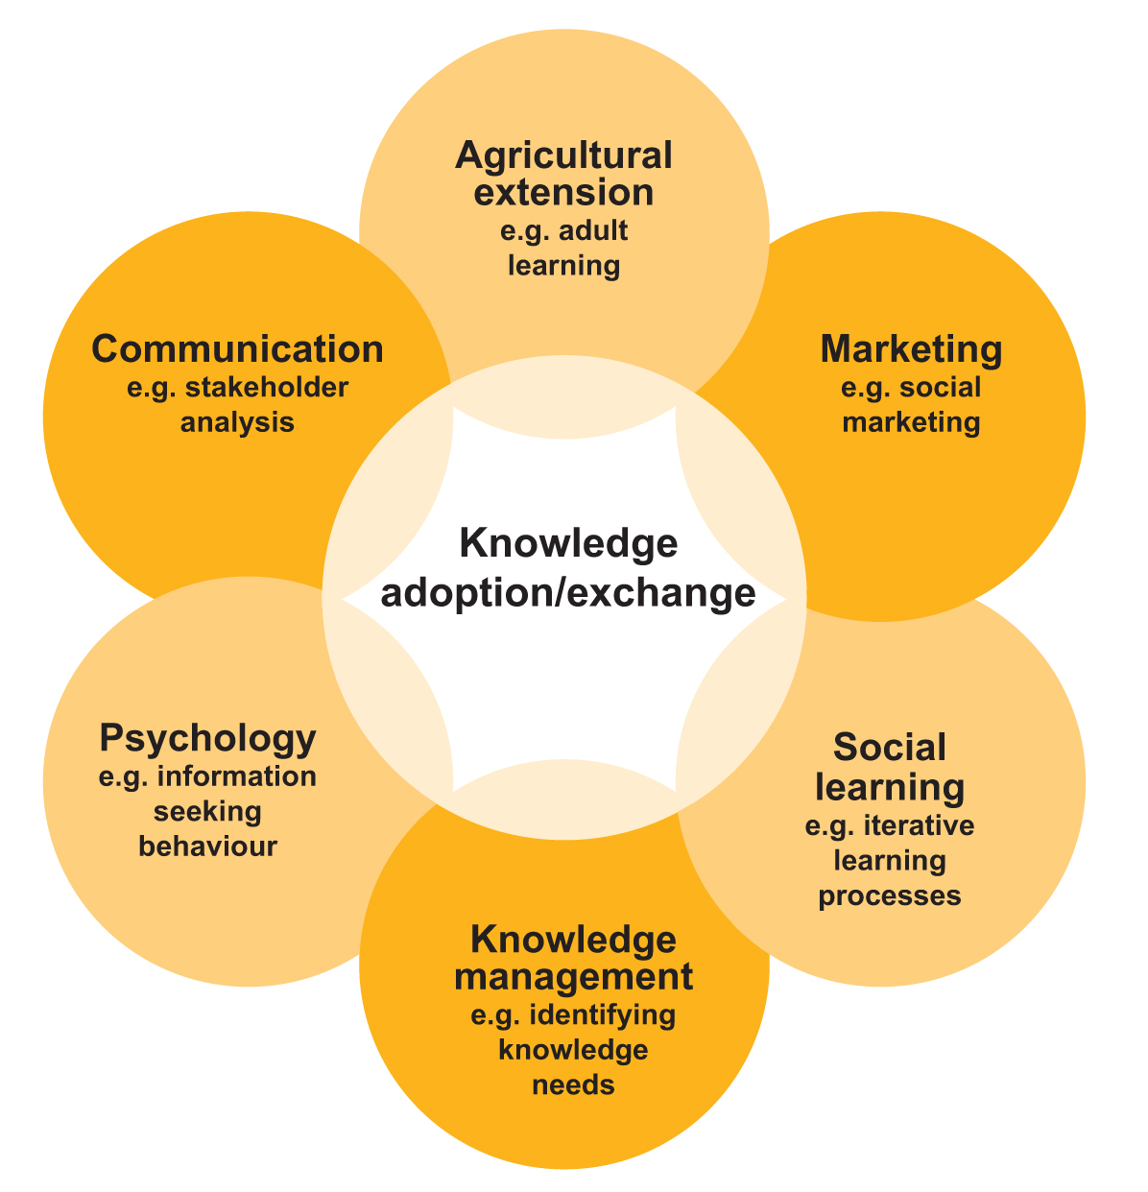
Figure 1 Disciplines and literature that inform knowledge adoption
2.2 The role of R&D organisations in adoption
One of the most contested areas of knowledge and adoption is who is, or should be, responsible for the ‘D’ in R&D, the ‘E’ for extension or the ‘A’ for adoption. What role should research organisations or funders play in this and how accountable should they be for the uptake (or not) of the research that they fund or undertake?
The extent of this responsibility will differ according to a number of factors. These include the organisation’s strategic objective and source of funding, and therefore the type of research that is funded. Using the definitions of the Australian and New Zealand Standard Research Classification 2008 there are four categories of research—pure basic research, strategic basic research, applied research and experimental development. These fall across a spectrum from pure to applied and from generating new knowledge to using existing knowledge to generate new products.
Basic or curiosity-driven research across all fields of science is of fundamental importance. The national research agenda for natural resource management (NRM) and agriculture should not be set entirely by stakeholders as they may miss invisible, emerging, or revolutionary research issues. It is an interesting strategic question how research funds should be divided up between the different modes of research and how should this allocation differ between research bodies—universities, CSIRO, state agencies, and Rural Research and Development Corporations (RRDCs)?
In contrast to other research organisations RRDCs are paid levies from their respective industries. This may put them in a position of being more responsive to stakeholders and place them at the more developmental and applied end of the research spectrum. A tension that exists here is that the Australian Government is also a stakeholder, contributing an appropriation alongside the levy payers.
The following diagram comes from a study about ‘knowledge transfer’ commissioned by the Department of Education, Science and Training (as it was then known). Here John Howard, the consultant, distinguishes between basic and applied research and development, and broadly maps out the different responsibilities or emphases of various R&D organisations (host institutions). Looking at all types of roles helps us position our organisation within a larger system and to distinguish between various roles. Inefficiencies in the NRM knowledge system, including R&D are exacerbated by the lack of clarity of organisations’ roles and their contribution to the whole system, the blurring between these roles, and the lack of functional relationships between them.
There is an additional complexity not dealt with in this diagram. This is the distinction between public and private good research and outcomes. This can influence whether private host institutions such as industry and businesses are willing to invest in, or undertake, public good R&D. This affects investment in, and the uptake of, natural resource management and environment-related R&D, rather than production-related agricultural R&D.
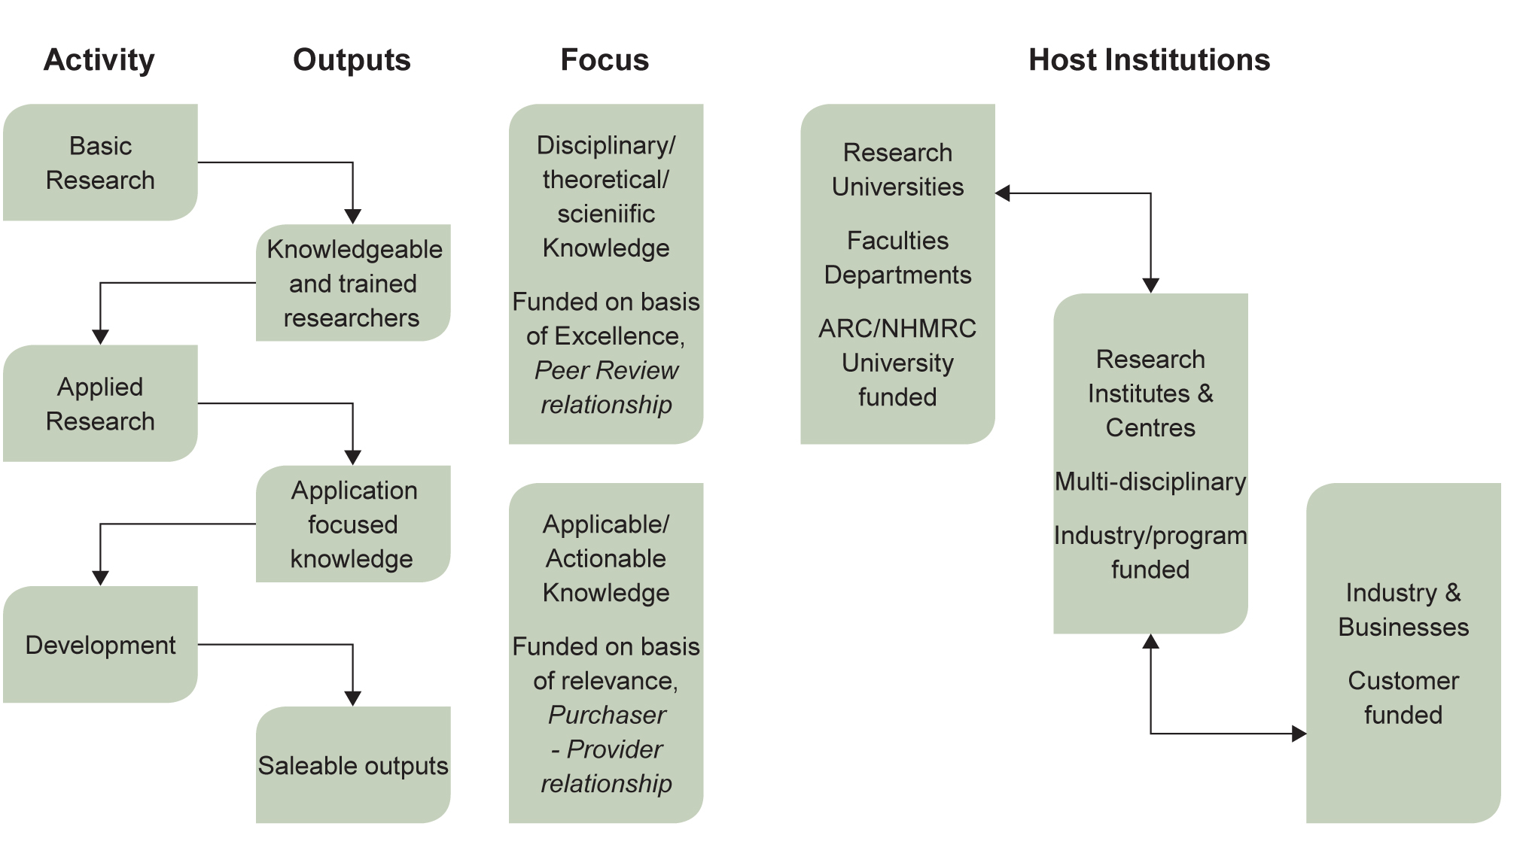
Figure 2 Research institutes and centres: between disciplinary and applicable research (Howard 2005)
Impediments and incentives in research
Characteristics of the culture and practice of research may impede uptake of research outcomes.
Research careers, particularly in universities, are driven by peer-reviewed publications. There is little incentive for researchers to undertake work that diverts time and effort away from publishing, particularly if it has higher costs and risks, or is less cutting-edge. In general this predicates against the type of research methodologies and activities that encourage adoption and achieve greater impact.
In a cross-sectoral analysis of research about best practice evidence-based policy and practice, Walter et al (2005) articulated the barriers to creating partnerships between researchers, practitioners and policy makers. These included the time and energy required to establish working relationships, and issues of project control. The authors also discussed differences in culture, timescales and language. At a cross-sectoral workshop, ‘Knowledge into policy and practice’, held in Melbourne in October 2007, language was regularly raised by participants as a major barrier for knowledge exchange, both between researchers and other groups, and across sectors.
There is also a lack of opportunities and incentives for researchers to build their capacity in this type of work, from participatory research methodologies to presenting to a community group. This is not to suggest that all researchers should be obliged to gain these skills (or will have the capacity to gain them). Applied research groups could endeavour to include researchers with those skills, seek to develop them, or access them from elsewhere (either within or outside their organisations).
Disciplinary boundaries and specialisation can inhibit adoption. This may be reflected in a lack of integration across the social and biophysical sciences.
2.3 A continuum of adoption methods—from engagement to information provision
Various processes are required to create an environment most conducive to adoption. These range from engagement at one end to information provision at the other (Figure 3). Communication sits in the middle of the spectrum. Engagement includes practices such as participatory research methodologies or including stakeholders in research governance; communication includes practices such as tailored workshops for a targeted stakeholder group; and information provision includes mechanisms such as media releases or a website. All of the practices are important. If, however, we focus solely on information provision, or even good communication, we are not as likely to influence uptake.
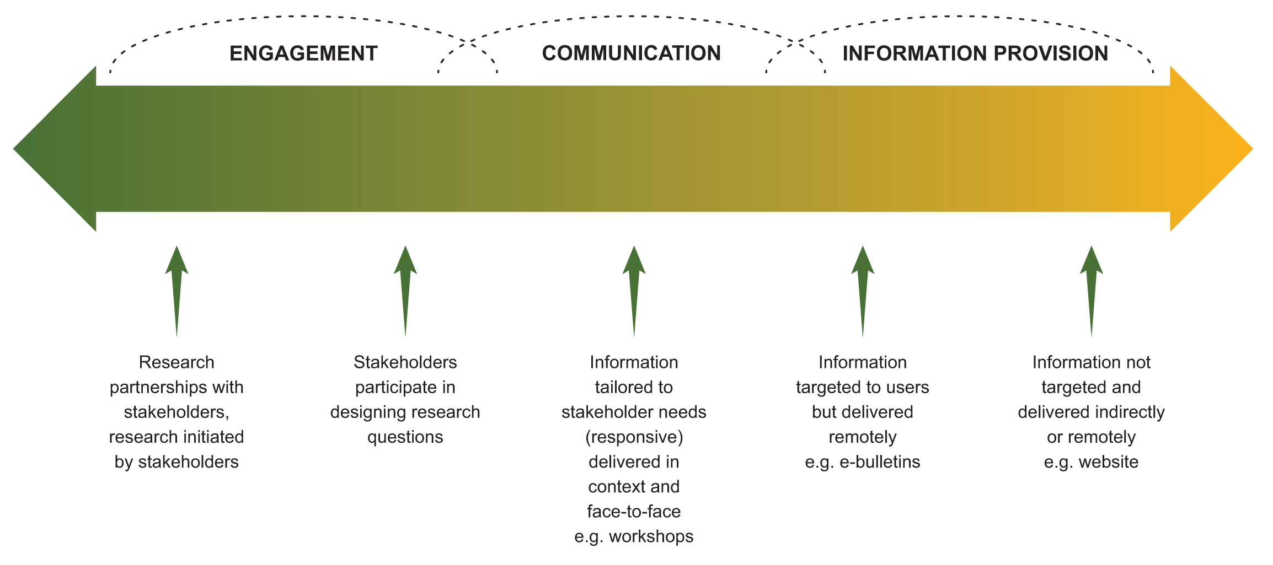
Figure 3 Continuum of adoption methods
Within each category on the spectrum there is a range of activities that move towards the next category. Being a continuum, the boundaries between the categories are blurred. The demarcation is not important, rather it is the mix of approaches, and the appropriate selection of adoption tools, that are significant. The usefulness of the continuum comes from understanding the range of processes and the appropriateness of each. This helps in making an informed decision on the methods to be applied. The table below summarises the nature of the categories across the spectrum.
Table 1 The nature of categories in the continuum
Categories in continuum | Nature of process
Engagement | Co-learning | - Stakeholders participate  - Addresses identified needs/  problem solving  - Stakeholders input to decisions  - Builds participants capacity (including researchers) | Face-to-face
Communication | Two-way | - Stakeholders targeted  - Mechanism tailored to stakeholder  - Stakeholders may inform decisions | Includes face-to-face
Information provision | One-way | Stakeholders not targeted | Not face-to-face

Where does communication fit in?
It is tempting to oversimplify the complex challenge of adoption by falling back on the comfort of traditional communications, or public affairs. We have always been rewarded for producing the measureable and tangible—media releases, publications and brochures.
Although the current generation of communicators regard communication as a two-way activity, research culture and actual practice have not quite caught up. As a result we still regularly fall back to the default of undertaking communication activities for profile building, information dissemination and/or managing political and reputational risk. This work is necessary but not enough and, by itself, is unlikely to result in improved uptake.
2.4 Factors influencing adoption and barriers to adoption
Working in a research or research funding organisation it is easy to believe that information and knowledge are the key drivers for changing practice, and that good research will lead to good uptake. This is despite many years of experience to the contrary. We tend to work with the assumption that once someone has the appropriate information they will act upon it and change their behaviour.
Information and knowledge are fundamental factors in practice change. However, they sit within a much larger and more complex system of personal, social, biophysical, political and economic factors, all of which influence behaviour and practice change (Figure 4).

What drives uptake or practice change may not be obvious. We can assume that a new technology or practice will be adopted for the economic or environmental benefits it brings and discover that the motivation for adoption is entirely different. One example is a water use efficiency measure that was developed for irrigated farms. It was assumed this would be adopted for its economic and environmental benefits but it was actually adopted for lifestyle reasons—it saved time and effort, and most importantly it saved farmers getting up in the night to check the water levels. This type of example improves our understanding of these other factors, for which we need to be undertaking social, economic and institutional research. How can market-based instruments be used to create water use efficiency? What social impacts might this have? And so on.
Although the figure below shows the range and number of factors influencing practice change, it does not capture the complexity of the relationships between the factors themselves and how important these are. For example, if we provide information that is counter to a value that an individual holds then it is highly unlikely that information will be acknowledged, let alone applied (Siebentritt 2007 and LWA 2009). Timing is also an underlying factor that interacts with and influences all of the rest. Given this complexity, the role an R&D organisation plays in the process of achieving practice change is crucial yet circumscribed.
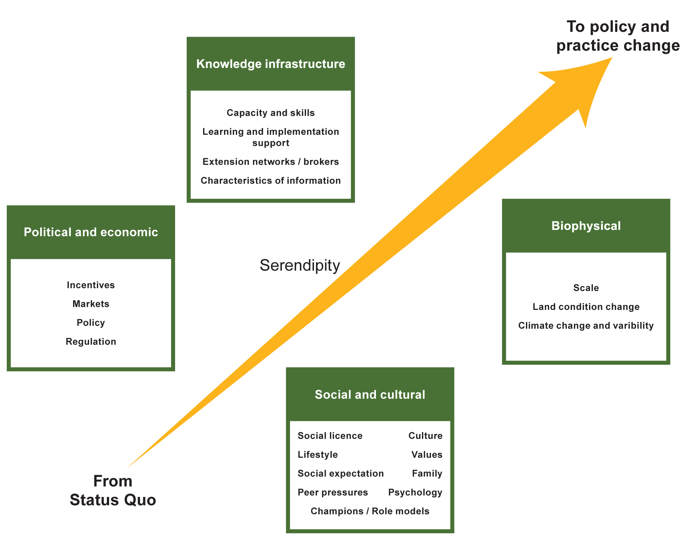
Figure 4 Factors that influence policy and practice change
(Adapted from Land & Water Australia’s Knowledge and Adoption Strategy, 2005)
Information and the practice change cycle
Another factor relevant to adoption is the ‘practice change cycle’. People do not leap from being newly aware of an innovation to fully adopting it in one go. They are more likely to move through a succession of stages—from awareness and motivation, to exploration and trialling, to action and implementation, to evaluation and assessment. Sometimes they may move backwards and forwards between a couple of stages before moving on again to the next. This concept is most applicable when working with individual practitioners and less so when working with policy makers. Forming policy is often a reactionary process resulting from external, time-dependent drivers. However, evidence-based policy making makes the practice change cycle more relevant.
Our understanding of the role of information and knowledge in practice change becomes even more complex when we apply it the practice change cycle. As we see in Figure 5 below, different types of information are required at different parts of the cycle, as are different methods for sharing that information.
This does not apply only to natural resource management. For example, if you are raising awareness about the health hazards of smoking then a shocking advertisement is appropriate—simple strong messages in public media. Someone wishing to progress to the next step of quitting will need to identify where to find help, for example the Quit helpline, peer groups and their GP, and what the available methods are, for example nicotine patches, hypnotherapy, and prescription drugs. When they take the step of trying to quit they then require advice tailored to their specific needs taking into account age, lifestyle and health. This may be through a discussion with their GP. If their first attempt fails they will need to go back to the GP to discuss why it failed and find a more appropriate alternative.
The knowledge people require, and the most appropriate method for accessing it, changes according to where they are in the practice change cycle. Brochures and media (information provision) are great for the awareness stage but not particularly helpful when someone is trying to test an innovation, such as a new farming practice. At that stage they may require far more detailed information and tailored advice, or peer group assistance.
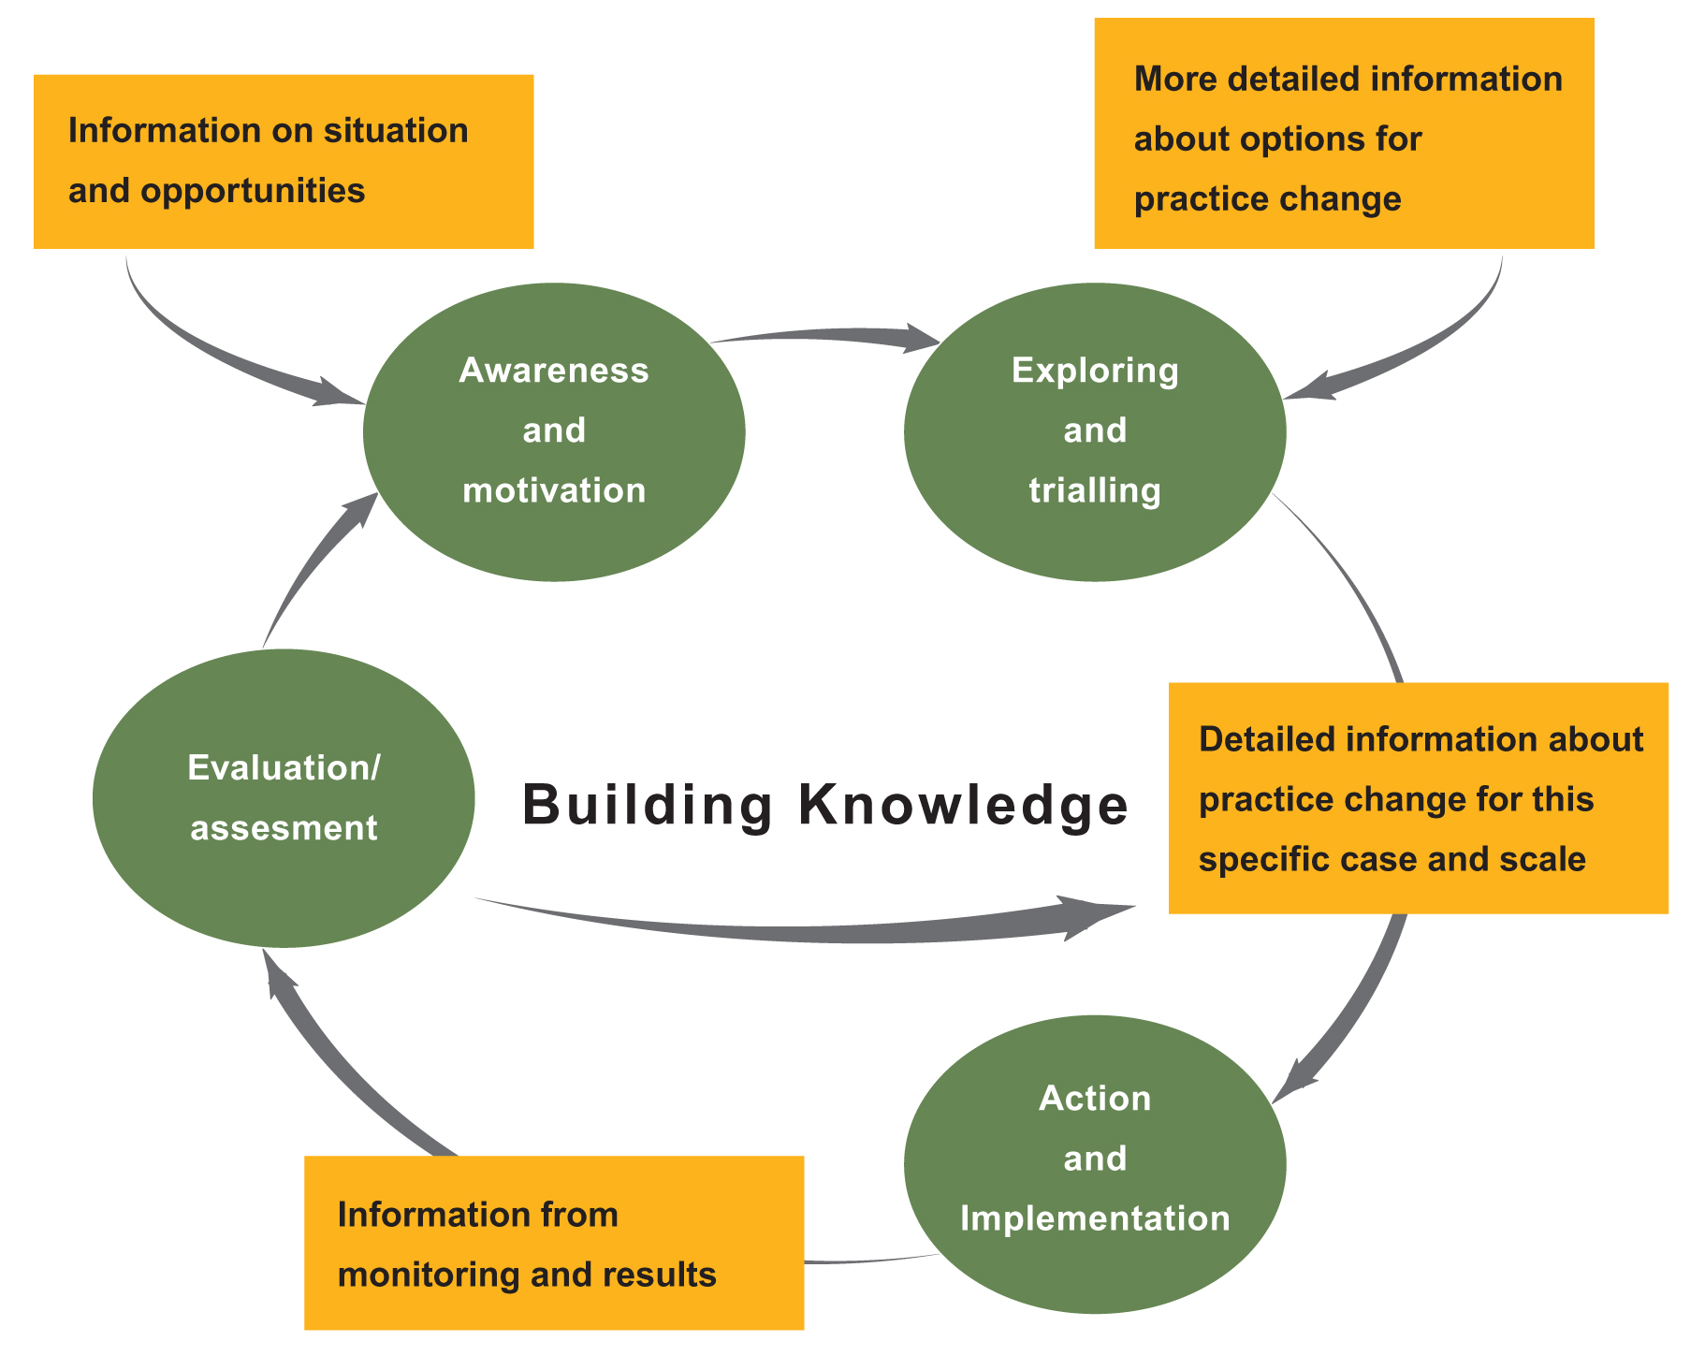
Figure 5 Information and the practice change cycle
(From Land & Water Australia’s Knowledge and Adoption Strategy, 2005)
This does not mean to suggest that an R&D organisation responsible for the innovation must be responsible for undertaking or supporting each and every stage of practice change. Working to establish adoption pathways and partnerships with next-users (such as private agricultural consultants or government extension agencies), or ensuring that the research outputs are relevant, targeted, useful and accessible, is appropriate. Some would say this is an obligation for a public good R&D organisation.
Unfortunately it is too easy to get caught up in the early stages of the cycle, only providing material (such as glossy brochures) that builds awareness not change.
Adoptability: Characteristics of innovations that influence uptake
There are two main reasons why certain information, concepts, tools or practices (innovations) may or may not be taken up. Only one reason is frequently acknowledged—the characteristics of the stakeholders themselves, such as age and education. The other, equally important factor is the characteristics of the innovation itself (Barr and Carey 2000).
In a multi-disciplinary article on the adoption of conservation practices, Pannell et al (2006) highlighted the characteristics of innovation that affect uptake. They presented the two broad characteristics as: relative advantage, a perceived superiority to what the innovation replaces; and trialability, ease of testing. Within these characteristics they identified a large number of factors such as input costs and risk.
Drawing upon Pannell et al (2006), Greenhalgh et al (2004) and other work the following list presents additional factors. In some cases they are subsets of the above or distinct factors:
- Need or relevance—what do people want or need to know? Is it useful for them?
- Adaptability—can it be adapted to suit the local context?
- Scale—is the scale appropriate? Paddock, catchment, national?
- Level of input required—are new skills required? What is the capital outlay?
- Level of risk and uncertainty—what risks are there? What is the certainty of the desired outcome?
- Accessibility—how is it accessed? What do you need to access it? Who can access it?
- Credibility of the source—is the source of the innovation trusted? What is their reputation or track record?
No characteristics, either of the innovation or of the potential adopters, will guarantee adoption. And of course both sets operate in a broader context (as shown in Figure 4) and all interact.
At the organisational level there are a number of possible steps that may be applied which take into account adoptability.
Program and project funding proposals can be asked to specify how these characteristics have been factored in. Relevance is probably the most straightforward of these. For example, some research funding bodies ask whether stakeholders have ‘signed on’ to a proposal, indicating at least some relevance and initial support for the research. The next step would be to use adoptability as one of the criteria for selecting projects (along with the standard criteria including the track record of the researcher and the quality of the proposal).
Programs and projects can also be asked to address adoptability in their planning and throughout the life of the work. Mechanisms to help do this could include input and feedback from potential users regarding the factors listed above (such as relevance and complexity). For example, if the geographical scale of the work is seen as too broad is it appropriate or possible for the researchers to indicate how the outcomes might be relevant at a smaller scale (perhaps from sub-catchment to paddock?) If taking up the innovation requires an additional set of skills, can some resources be allocated to building those skills in users? This may require a partnership with another organisation whose role is to undertake this, along with a contribution of time from the researchers for workshops or training. These suggestions are discussed further in the section on developing program and project adoption plans.
We did canvas the idea of an adoptability index at LWA as a possible internal measure of whether our efforts in embedding adoption were resulting in improving the overall adoptability of research proposals, and whether in the long term this could be linked to improved uptake of the research. Understanding adoptability, whether it can be measured or predicted, is a difficult exercise given the countless variables discussed earlier. Encouraging researchers and funders to think about and improve the characteristics which improve adoptability is potentially more useful. The Future Farm Industries CRC is developing an adoptability planning tool.
3. Managing knowledge for adoption
3.1 Strategic planning
Any strategic planning process needs to be implemented on a number of levels. These range from strategic to operational, with each level becoming more specific and fulfilling a different requirement.
In the case of Land & Water Australia we developed several nested levels for knowledge and adoption. The corporation had:
- an overarching five-year R&D strategic plan (a legislative obligation which outlined three strategies including knowledge and adoption)
- a five-year knowledge and adoption strategy
- annual implementation plans for the knowledge and adoption team.
The five-year knowledge and adoption strategy outlined an approach for the corporation as a whole with little specific detail. It presented a basic understanding of adoption processes which established a starting point for people to work from.
Over time plans were developed for particular components of corporate work, such as media and electronic business (internet and intranet), which sat beneath the knowledge and adoption strategy. A three-year time span was useful for these.
Each year the knowledge and adoption team developed an annual implementation plan which captured the tasks required to meet the objectives set out in the knowledge and adoption strategy, and the specific longer-term plans above. Annual performance agreements with team members could then address the requirements of the team and organisation, linking individual duties up each level to the knowledge and adoption objectives, and the organisation’s mission as a whole.
This planning was done for a functional reason not for its own sake. Planning helps ensure that activities are aligned with organisational objectives and strategic intent, and that they are prioritised within the available budget. Otherwise it is easy to get trapped into ‘busyness’ for its own sake, with activities not generating any useful outcomes.
Knowledge and adoption planning is also required on the research side. Parallel levels exist in the knowledge and adoption planning components of the research, with each research program and its projects expected to develop knowledge and adoption plans. The knowledge and adoption team’s work then supports the implementation of these plans and corporate level activities.
When a diversity of research is funded—wide ranging topics, budgets, researchers, locations and methodologies—specific knowledge and adoption requirements should not, and in fact cannot, be dictated. The LWA Knowledge and Adoption Strategy presented a targeted adoption model which was used to create a very simple template for program and project level plans that could be adapted and built on. This is discussed further below and a version of the template is included in Appendix A.

Some planning tips
As with any planning process certain fundamentals apply:
- Those who the plan affects should participate in developing them
- Plans are iterative—if rigid they are unresponsive to the changing conditions around them and can quickly become irrelevant, or even damaging
- Plans require monitoring and evaluation from the start to ensure we can learn as we go and evaluate outcomes
- Plans should not become an end in themselves but should always be targeted towards what we are actually trying to achieve

3.2 The research life cycle—scoping, planning, implementation
and legacy
The LWA approach was built around the concept of a research life cycle shown in Figure 6.
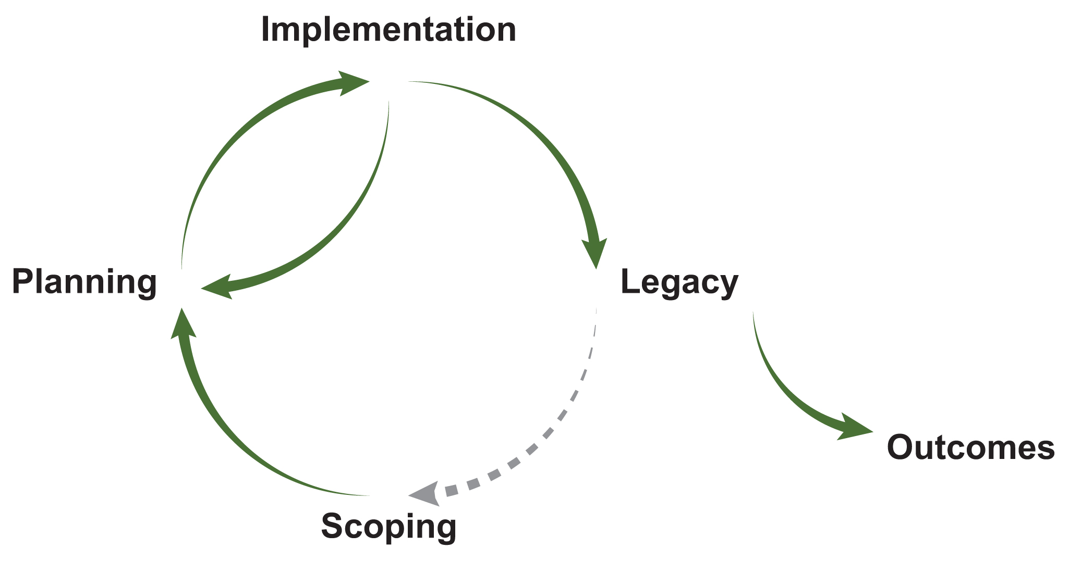
Figure 6 Research life cycle
Most simply we can picture it as scoping, planning, implementation and legacy. This then feeds back into the next round of scoping.
Representing research as a life cycle helps us to move away from the simplistic linear models of technology transfer (although in some instances this may still be the most appropriate method for achieving uptake).
In developing the knowledge and adoption strategy we asked the question—what is required at each stage of the research life cycle to improve the likelihood of adoption? These interventions may be small (such as an additional criteria in project selection) or large (the requirement that every project will undertake an adoption plan). The life cycle is an important means of showing that adoption must be considered from the scoping stage onwards. It also introduces the concept of managing legacy—adoption does not stop when the research stops. It also shows that the legacy of previous research should feed into the new.
There are knowledge and adoption elements required throughout the entire life cycle—managing relationships and partnerships, communication, monitoring and evaluation, and, of course, adaptive responses to each of these.
Examples of interventions for each stage include:
- Scoping—include stakeholders and take into account their priority needs
- Planning—each project has a knowledge and adoption plan. Planning should include budgeting for the legacy stage
- Implementation—undertake specific processes as outlined in the project’s knowledge and adoption plan. Include milestones for reporting on implementation, and updating of, knowledge and adoption plans
- Legacy—establish a harvest year in the last year of the program when the research projects are complete. Ensure ongoing access to project outputs.
The stages of the research life cycle are all standard other than the legacy stage. Surprisingly this stage tends to be neglected. Managing the research legacy well can provide important opportunities for improving the uptake and impact of the research. Legacy is discussed in more detail in section 3.7.
Responsibility for managing research for adoption needs to be shared by those involved in the research rather than just specific personnel (such as those in communications or capacity building). This responsibility lies with the organisation as a whole, including making uptake part of the design of research and its intended outputs

Lessons from this process include:
Managing knowledge for adoption must be embedded in research processes across the research life cycle—from scoping to legacy
It should be planned from the start, fitting it in later is rarely as successful
Establishing a regular and responsive monitoring and evaluation process from the start creates the opportunity to learn and improve as we go.
3.3 Targeted adoption—of what, by whom and how?
When investing in applied research there are fundamental questions that should drive this investment. These include:
- What issue or need are we trying to address?
- Is this issue constrained by a lack of knowledge?
- What impact or outcome are we seeking?
- How can we achieve it?
- Who do we need to work with to help make this happen?
In developing the LWA knowledge and adoption strategy we began from first principles, asking the questions adoption of what, why, by whom and how? From this we developed a targeted adoption model (LWA 2005). The model can be used at a project and program level, and across a complex and heterogeneous research portfolio. It assists with priority setting and resource allocation when used at the planning stage and is intended to simplify reporting on adoption activities and outcomes, establishing a consistent approach across an organisation.
Applied R&D organisations often have a broad mandate that extends beyond informing practice directly. For example the broadest categories of stakeholders for natural resource management are:
- policy—such as government agencies
- practice (on-ground)—such as land-managers or industries such as the wool industry
- planning—such as regional natural resource management organisations and local government
Making a distinction between the targeted sectors helps identify stakeholders and the methods or pathways to be used. It is then necessary to identify target participants or audience. Examples of these could be ‘leading woolgrowers’ or state government water planners. Usually it will be a combination of several. For further information on identifying stakeholders see Section 3.6 on mapping and understanding your stakeholders.
The adoption continuum, discussed earlier, can be applied to classify these groups as first, second or third order targets according to the level of engagement, communication or information provision required. Asking certain questions will help classify these groups. Questions might include:
- Do these stakeholders need to be actively engaged in the research or its governance?
- Do they simply need to be well briefed?
- Or is it sufficient to ensure that information is accessible for them if they come looking?
Very different methods will be required depending on the stakeholder. For example, the way you engage with policymakers will be different from the way you engage with farmers. It is best to plan with stakeholders the methods most appropriate for them, and to understand their needs. This will improve the likelihood of success.
The health sector has been exploring and implementing knowledge into policy and practice and similar principles have emerged. For example in John Lavis’s work about knowledge transfer to policy makers he presents the five step approach (Lavis 2003):
- what (of knowledge transfer)
- to whom
- by whom
- how
- with what effect
Finally, you need to identify how the outputs and outcomes will be measured.

3.4 Monitoring and evaluation
There are a series of steps in the monitoring and evaluation of adoption in natural resource management that range from measuring only outputs through to actual resource condition.
Outputs
What has been produced (for example technical guidelines), or what activities have been undertaken (for example training workshops). Outputs are a straightforward list collected during the project or program.
Example: How many CDs were produced with the research outputs?
Distribution
Where do the research outputs such as guidelines end up, and who attends the workshops? This requires more information which takes more effort to collect. Distribution tends to continue after the lifetime of research projects or programs, and sometimes demand for the outputs increases once research is complete.
Example: Where did the CD’s go? Which stakeholders ordered them?
Uptake and application (now things are getting tricky)
Who read the guidelines or attended the workshop? Are they now applying any of the research findings? The timeframe for this may be well past the life of the research. Work shows that adoption can occur many years after the ‘innovation’ is produced.
Example: Who has used the CD and applied anything they learnt in their own practices?
Improvement in resource condition (the holy grail of monitoring and evaluating)
Did the fact that people applied what they learnt make a difference on the ground?
Example: If they did apply what they learnt from the CD did this make a difference? Did it have an impact on resource condition?
These steps can be roughly equated with the program logic hierarchy of outputs, impact and outcome (see the sweep of work on program logic and evaluation). It is also important to ensure that the processes themselves are being evaluated.
As you progress between these steps they become harder to measure, take longer to achieve and attribution becomes more difficult, complex and tenuous. As a result most organisations measure the first, many the second, few the third, and very occasionally an output from a research organisation is directly linked to actual improvement in resource condition. Once again it is harder for these connections to be made in the field of natural resource management. If you are developing a new breed of grain, for example, it is more straightforward to use a commercial route to measure uptake, and to therefore determine the likely increase in yield and return on investment. Where responsibility should fall for monitoring each of these steps is highly dependent on scale. It is unlikely to be the responsibility of a research organisation to track actual resource condition.
Some of the difficulties that confront us when undertaking monitoring and evaluation of research uptake are:
- attribution
- accounting for multiple delivery mechanisms
- adoption timeframes
- the cost and methods for measuring anything more than activities or outputs
- applying the lessons we learn
- encouraging researchers and research managers to collect the information.
Monitoring and evaluation (M&E) of adoption should serve several purposes. These include:
- to improve work throughout a program or project’s life
- to evaluate the impact of this work
- to inform future investments.
Distinguishing between M&E per se and M&E of knowledge and adoption is difficult and ideally it should be integrated within a program or project.
The distribution of responsibility at a project, program and organisational level for M&E should correspond to the time scale, cost and complexity of the research, each of which increases over time. Due to the shorter life spans and smaller budgets of projects it is often not feasible for them to evaluate uptake. This responsibility needs to be taken up at the organisational level. As shown in return on investment work (such as Chudleigh et al 2007), adoption may occur many years after the completion of a research project.
With regard to organisational level monitoring and evaluation LWA made progress in several areas. The annual stakeholder survey was carefully revised to find out more about adoption (originally this focused on the organisational profile). New survey questions addressed what uptake was occurring, and what processes people preferred for sharing information. The knowledge and adoption team’s knowledge broker brought the messages from the survey back to the respective areas of the organisation through tailored briefings which included only findings relevant for that program. This was a useful way of ‘closing the loop’ and ensuring that the organisation was learning from the survey.
Applying what has been learnt from monitoring and evaluation back to a project is challenging, and often not well done. It requires time for analysis and reflection, and a willingness to change.
Much can be gained from investing in evaluation of previous work. This can be expensive but it can be done selectively and strategically to provide valuable lessons. The knowledge and adoption team funded an evaluation of the use of the National Dryland Salinity Program (NDSP) harvest products and the process of developing them. We had been promoting these as a wonderful example of a research program legacy yet were uncertain who had used them and, if so, why.
The evaluation of the NDSP harvest products reinforces a number of the points made in this document. Critical success factors presented in the evaluation report included the following lessons:
- Create ownership and engagement—by partners (R&D organisations), end-users and stakeholders.
- Establish a planned communication and adoption process early in the R&D cycle.
- Plan for adequate funds and resources to be available for a holistic communication process.
- Be clear about the identity, needs and drivers of the target audiences.
3.5 Developing program and project adoption plans
One approach is to establish the requirement that each research program and project develop a knowledge and adoption plan at the research planning stage. Begin with something not onerous, that would be appropriate or adaptable across a diverse portfolio and range of budget scales, and that could be built on over time as commitment and capacity improved.
A simple template was developed in LWA (Appendix A) to capture the most crucial elements of a project impact plan. The knowledge and adoption officers further developed each plan with researchers, simplifying requirements as necessary. This formed a basic starting point for projects and programs.
The template included the following requirements:
Identify the issue the research is addressing and the identified need (and whether more research is needed to meet this need).
Identify project stakeholders (before the research is initiated) and identify which stakeholders should be partners, should participate and should be kept informed.
Identify how stakeholders will be engaged and what methods will be used to involve or inform them.
Identify a budget and approximate timelines.
Identify how progress will be measured so processes can be improved through the life of the research and evaluated at the end.
Identify the possible legacy of the project and how this might be managed once the research is finished.
This approach is minimal and logical and similar to many processes used for communications, community education, and other planning processes. There are, however, a couple of points of difference. Most importantly is identifying the need that the research intends to address. Further to that is the requirement to distinguish between where stakeholders are placed on the adoption continuum (that is engagement, communication or information provision), therefore influencing the methods that will be used. The plan also reflects the research life cycle approach encouraging people to plan and budget for the legacy as much as possible from the start.
Building on the above approach, the following is a more extensive list of questions, grouped into the areas of scoping, targeting, implementation, barriers and adoptability, legacy and monitoring and evaluation.

A number of elements can be added to increase the usefulness of the planning. This includes building further understanding about the stakeholders, identifying possible barriers and ways to address the barriers, and identifying and addressing the characteristics of the research outputs that will increase the likelihood of uptake.

Scoping
What issue does the program/project intend to address?
Has a need been clearly identified? Why is this issue a priority and who is it a priority for?
Is progress in this issue constrained by a lack of knowledge? How can you tell?

Targeting
What impact does your project seek to have?
What are the possible outputs?
Who are your stakeholders? What do you need to understand about them?
Who needs to participate? Who needs to be informed?²

Implementation
How will you engage or communicate with your stakeholders? What methods will you use?
When does this need to happen in the research life cycle?

Barriers and adoptability
What are the possible barriers to uptake?
How might these be addressed by you or others?
A number of characteristics increase the likelihood of research outcomes being adopted including relevance, relative advantage, trialability and compatibility. How could these characteristics be taken into account or increased in your research outputs?

Legacy
What is the possible legacy of your work—innovation, networks, community capacity?
How might the legacy be managed?
Have resources been allocated for this?

Monitoring and evaluation
How will you measure the success of activities and outputs and improve them as you go?
How might you measure adoption?

The plan should change over the life of the project, particularly if the monitoring and evaluation is effective, and as more is known about likely outputs and legacy.
3.6 Implementation and methods
Step 3 of the planning process above asks what methods you will use to involve or inform stakeholders.
So what do you actually do to encourage adoption?
Choosing methods is very individual as it is related to specific project or program characteristics such as budget, skills, likely impact and outputs, and location. It also very much depends on the stakeholders and
their requirements.
Within each of the three broad categories of the continuum of adoption (discussed in Section 2.3) there are many methods that can be applied. Several of these are listed below. Some of these methods, such as one-on-one extension, are more likely to be used in larger, well-funded programs where the major stakeholders are land managers, and the major impact sought is on-ground.
The methods available are only limited by the imagination. For example, an opportunity for research organisations to have a few hours at a national regional NRM workshop led us to develop the concept of a ‘knowledge bazaar’. This involved guided tours addressing particular themes visiting the booths of relevant R&D organisations with researchers primed to discuss the theme. This helped tailor and target participants’ access to information, to researchers, and to each other’s expertise and experiences. It also created useful networks and peer learning.
Table 2 categorises a selection of methods according to where they sit on the adoption continuum, from engagement to information provision. It provides some examples to illustrate categories and, where available, references for sourcing further information.

Table 2 Range of adoption and communication methods
Continuum of adoption | Categories | Examples and references
Engagement | Participatory or action research methodologies.Stakeholder initiated research | ‘Learning together by doing together’ (HarmoniCOP 2003)  ‘Empowering stakeholder R&D’ project, Fisheries RDC
 | Partnerships and collaboration | Grain & Graze Program with NRM regional bodies and farmer groups www.grainandgraze.com.au (accessed 16/12/2011)
 | Methodologies incorporating stakeholder or local knowledge | Indigenous values and River Flows Project 2.2, Tropical Rivers and Coastal Knowledge Research Initiative  www.track.gov.au/publications (accessed 16/12/2011)
 | User groups | Wool grower groups (Land, Water & Wool Program)
 | Capacity building and learning | Master Tree Growers www.mastertreegrower.org.au (accessed 16/12/2011)  Mentoring, training and employment opportunities
 | Stakeholder involvement in research governance | Stakeholders on research management committees (Many RRDCs)
 | One-on-one extension | Often undertaken by next-users/intermediaries. Now increasingly NGOs such as Greening Australia and private agricultural consultants as state agencies’ extension funding reduced.
 | Knowledge brokering3 and networks | Canadian Health System Research Foundation  CRC for Freshwater Ecology (First to employ knowledge brokers in Australia)  Better Knowledge Better Bush Program CSIRO
Communication | Tailored training | National Riparian Lands R&D Program workshops
 | Tailored interactive activities in relevant context | Field days, field trips, workshops  (countless examples)
Table 2 Range of adoption and communication methods (cont…)
Continuum of adoption | Categories | Examples and references
 | Tailored communication activities | Policy briefings, conference presentations/papers  LWA Science in the Paddock breakfast briefings for senior government officials
 | Decision support systems designed with, and for, specific stakeholders | SedNet (constructs sediment and nutrient budgets for regional scale river networks and can assist targeting of catchment actions) eWater CRC
 | Detailed publications targeted to specific stakeholders | National Dryland Salinity Program Synthesis reports and CDs, Riparian Technical guidelines (industry or catchment specific such as The Riparian management guidelines for the wool industry)
Information provision | Targeted, less detailed publications | Articles in industry magazine or stakeholders’ publications, hard copy and e-newsletters
 | Non-targeted, general information | Brochures, posters (often distributed at events), publication catalogues. A web address or reference point for further information is crucial.
 | Electronic—general and targeted (searchability crucial here) | Websites  www.firenorth.org.au (accessed 16/12/2011)  This website displays satellite information on the location of current fires (hotspots) in close-to-real-time across the whole of north Australia
 | Mass media | Media releases, coverage at events

Communications and the publications pyramid
Research and development organisations are often tempted to produce final reports for research projects, place them on the web or print some copies, and consider the communication job complete. Even if a research project is directly relevant to the needs of stakeholders it is rare that everyone will need, or comprehend, the same level of detail or information. It is therefore important to ensure that a communications/publications plan addresses these different requirements.
The publications in Figure 7 shows the concept of having a range of material available, from the detailed technical material such as research reports or peer-reviewed journal articles to summary material which may simply raise awareness of what is available. This relates back to the practice change cycle and the understanding of the differing needs of stakeholders.
Two characteristics of this pyramid are worth noting. Firstly it shows that the less detailed material is developed from a foundation of detailed research outputs, providing accountability and credibility. Secondly each level should provide a pathway to the next level up or down ensuring that the user can find the level of detail they require. For example, if you find the summary brochure at a conference but require more information, the brochure should refer you to the next level of detail available, such as published guidelines, and where to access them. This requires an R&D organisation to have a functional information management system, or access to one, to ensure information is stored and accessible.
Mapping the research stakeholders in the knowledge and adoption plan should help build an understanding of the level of information required and how this can be provided.
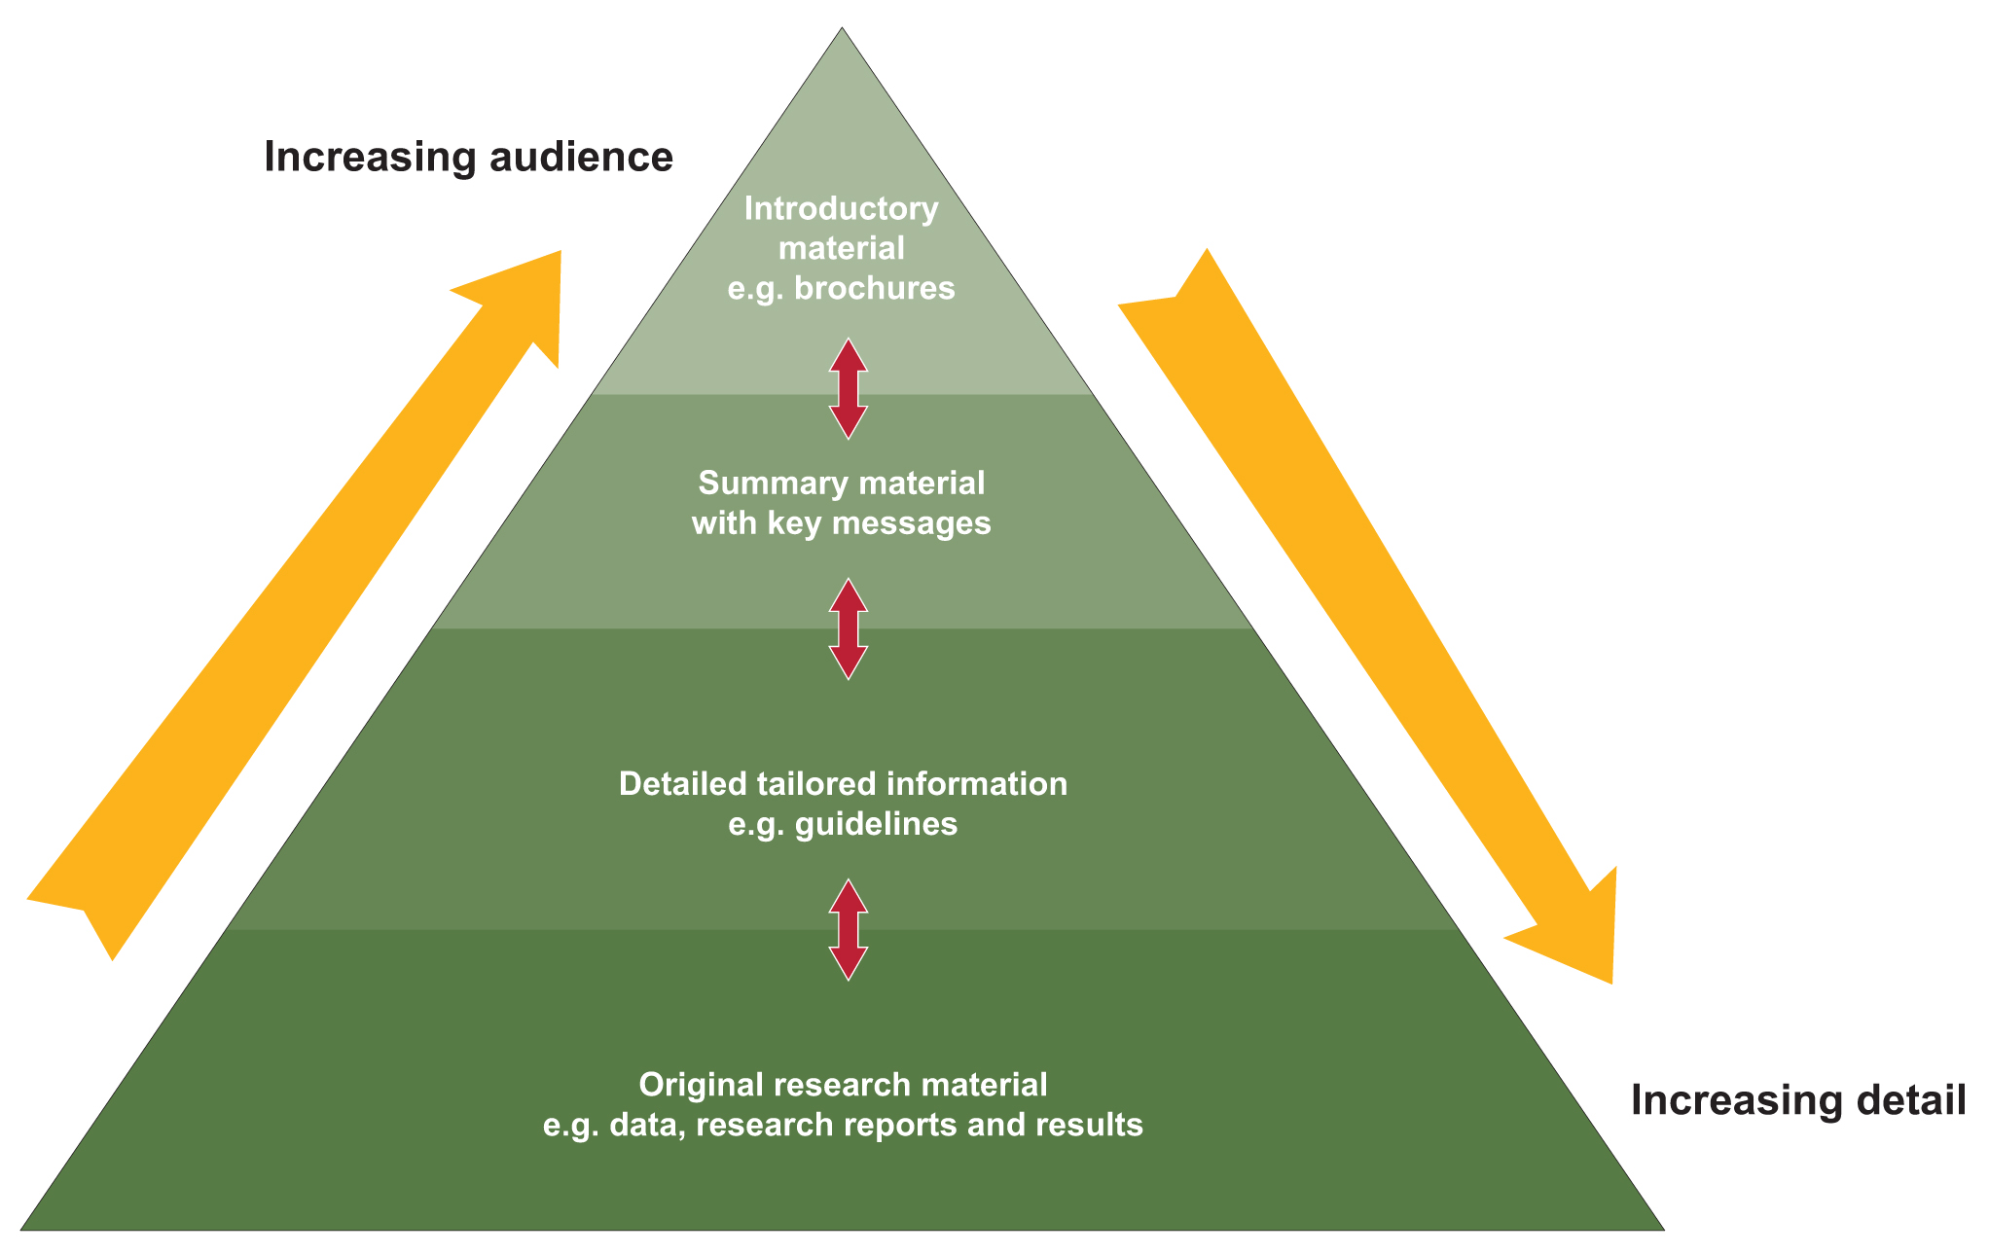
Figure 7 The communication pyramid
Mapping and understanding your stakeholders
Mapping and understanding your stakehoders is a very important element of knowledge and adoption planning. It is also a key element of good communication planning and therefore should be an assumed part of planning for any applied research program or project. There are many methods available for stakeholder analyses in communications planning and for other participatory processes that have been developed by consultants, government agencies and research groups. Given the earlier discussion about adoptability of research innovations, it is worthwhile when undertaking this part of the planning process to begin to build an understanding of your stakeholders and their values. A detailed understanding can only be achieved through dialogue and will grow through the life of the project/program. In the case of tightly defined biophysical research this may not be required. You could establish a partnership with social researchers who will develop this element, or with next-users who will engage with researchers and end-users to build this interaction and understanding. The Tropical Rivers and Coastal Knowledge research initiative (TRaCK) is an example of a multi-disciplinary program that includes and integrates a range of disciplinary research. Public or private extension networks are other obvious examples. The idea of a next-user taking research outputs through to the end-users comes from the concept of an adoption pathway. Literature is available on the theory and practice of impact pathways.
3.7 Legacy
Although we are funding or undertaking applied research to make a difference, it is still the exception to plan for the life of the work once the research is complete. R&D organisations rarely actively manage legacy. Publicly funded applied research outcomes should be publicly available beyond the life of the research itself. Adoption may occur many years after the research is finished. If we are trying to improve the uptake or impact of research, managing for legacy, and managing the legacy itself, is fundamental.
A legacy can be made up of different elements. There are the straightforward communication outputs such as publications, websites, CDs and published research papers. These contain the technical information resulting from the research. The research may have also resulted in technical infrastructure which may need to be passed on, perhaps to a state agency or a community group.
There are also the networks that may have been established, or enhanced, during the research. There may be training programs or curriculum that has been developed and should continue. Perhaps the research process improved the capacity of those involved to understand the science (or the stakeholders) and to undertake aspects of the research, apply the outcomes and access other research and networks. This may have also resulted in social infrastructure —new organisations or stronger networks. Siwan Lovett has written on legacy for the Knowledge and Adoption toolkit (Appendix D).
Custodianship of, and possible ongoing access to, data is another fundamental legacy issue that is best dealt with early on in the life of the research. There are ways of making data accessible and useful for a broader range of people through interactive websites or decision support systems. An example of such a tool can be found on the website Gapminder.
The research legacy may include:
- research data, including spatial data
- innovations and concepts contained in published research papers
- communication, training and education products such as publications, websites, curricula, decision
support systems
- technical infrastructure for example, water gauging stations which may need to be passed on, such as to a state agency
- social capital such as groups, networks or skills that have developed outside
the research community
Synthesis—making it relevant and useful
Synthesis is essential. Synthesis is used here to mean more than an aggregation of material from multiple sources. It includes a step of further analysis that adds another level of meaning to the collected research outputs. The multiple sources may be across projects, programs, organisations, disciplines and even across forms of knowledge. Drawing together local knowledge with scientific knowledge can build a more relevant outcome that is in context for users. Ideally this is done with researchers and stakeholders together.
The means by which we manage research and the units we manage it in (such as projects) may bear little resemblance to the needs of the next or end-user. Producing information on a project by project basis can miss the point, be confusing, irrelevant, or even contradictory. Synthesis can provide a new level of insight for researchers and stakeholders.
Various ‘cuts’ can be applied to produce targeted synthesis work. It can be done on the basis of geographic area, stakeholder or industry, issue or question. For example, an analysis of project outcomes can be undertaken on the basis of relevance to a sub-catchment, to rice farmers, or on a specific issue, such as the use of local provenance seeds in re-vegetation. Or it could be to answer a stakeholder question. For example, how wide do buffer strips need to be along streams to improve water quality—under what conditions, with what vegetation and what land use regime?

The synthesis ‘cut’ can be defined by an:
issue or question
stakeholder or industry
geographic area.

Synthesising knowledge into forms suitable for uptake by different stakeholders and tailored to the relevant scale of application or communications pathway is more likely to result in the use of the findings. In other words, run the synthesis process with purpose and target in mind. How is this going to be of use? What need does it address? Who is it for?
After the ‘cut’ for the synthesis work has been established you need to work out the type of process or product. This is determined by what is most appropriate for the target stakeholder. It may be a workshop tailored to a particular group in a specific location using a wide range of research. It may be a booklet that looks across a field of work or issue and provides an analysis, such as A review of the focal species approach in Australia (Huggett, 2007). Perhaps a decision support system is the most appropriate synthesis output.
Synthesis work can also be undertaken at different stages of the research life cycle. An analysis of research to date may inform the scoping stage of a research program. Have any research outcomes been contradictory? Is there a clear question that has emerged from across the previous work? How does this inform future work? Or, more usually, synthesis work can be undertaken towards the end of research programs.
A good example of this type of approach is the synthesis reports and CDs from the National Dryland Salinity Program (Australia) that synthesise hundreds of research reports and target them to three different groups—policy makers, catchment managers and farmers. This work was also captured in CDs that contain a search engine and allow a user to access easy to understand summary material or highly technical reports depending on their needs or capacity. These products were tested and modified. They were then rolled out with relevant training sessions. An evaluation of the uptake of this work highlighted the importance of having market testing and the roll-out phase. Uptake would have benefited by further investment in the roll out stage.
Information and knowledge management
The term knowledge management conjures up many definitions and responses. Negative responses may stem from bad experiences of black-box technology, incomprehensible jargon, or evangelical technologists that, despite exciting claims, don’t deliver. The definition used by Australian Standards encapsulates the approach used in developing LWA’s Knowledge for regional NRM program. This captured the importance and interconnection of people, processes and technology, and the complexities involved.
A trans-disciplinary approach to improving organisational outcomes and learning, through maximising the use of knowledge. It involves the design, implementation and review of social and technological activities and processes to improve the creating, sharing, and applying or using of knowledge.
(AS 5037—2005 Australian Standard™ Knowledge management—a guide, p. 2)
The European guide to good practice in knowledge management also highlights the need for the ‘soft’ areas to be addressed with technology in the role of enabler, rather than the more dominant ‘technology-push’ approach.
For any program that invests in knowledge creation and the application of that knowledge, ensuring that the knowledge assets produced in the research are stored and publicly accessible should be an obligation. This does not necessarily require a large investment by a single organisation as there may be appropriate existing national knowledge bases or repositories.
Through the Knowledge for Regional NRM Program the Australian Government invested in developing the Natural Resource Management Toolbar, which became the NRM Navigator. It provided NRM and agricultural professionals with access to a good search engine, tagged relevant sites, knowledge brokers and librarian support, communities of practice and search tools based on individual preferences. This is one example of an initiative that worked to make R&D material more widely available and to support evidence-based decision making.
It can be counterproductive to invest in overly complex, or technology-dependent, knowledge management systems. These systems can become an end in themselves. It is useful to run a process with program staff and researchers to identify straightforward methods to achieve the above. If appropriate vehicles are not available for a research program or organisation to piggyback on then it can support access through a website at the minimum.
4. Building organisational capacity and culture
In establishing knowledge and adoption within an organisation little is achieved with an ad hoc approach or a list of activities for the organisation to undertake. Organisational change requires a coherent, whole of organisation approach for:
- providing enabling organisational systems, such as a content management system
- establishing appropriate procedures, a combination of organisational processes and behaviour, such as new contractual obligations, knowledge and adoption plans for the first contract milestone
- developing useful and efficient tools and/or capacity building such as knowledge and adoption training supported by a knowledge and adoption toolkit with templates
- inspiring cultural change.
Identifying these elements creates a framework for determining the required investment of resources to build the organisation’s capacity to manage knowledge for adoption (Figure 8).

Most importantly these elements interact within a larger context—the culture of the organisation. Without a culture that supports managing knowledge for adoption, building these elements would amount to little actual change. Individuals would not be supported to spend time on relevant activities and milestones would become simply a rubberstamping affair. Creating cultural change requires support from the top of the organisation, and acknowledgement that this work is important. This includes providing sufficient resourcing and acknowledging responsibilities in staff position descriptions and performance agreements.
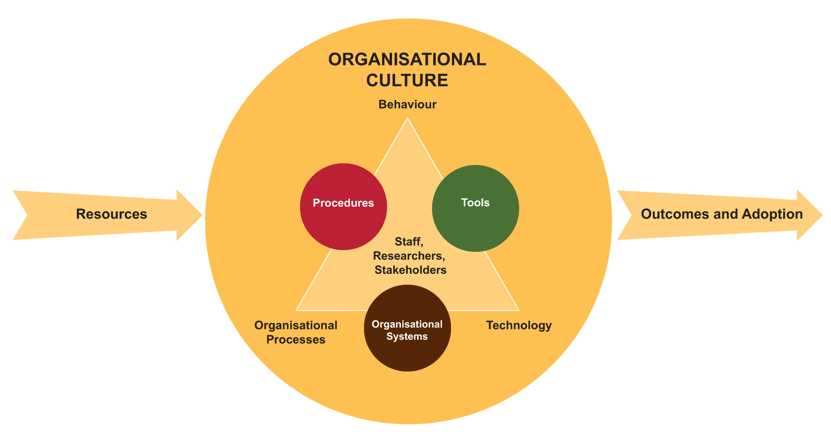
Figure 8 Organisational change
4.1 Organisational systems
In this context organisational systems are defined as the fundamental systems required for people to do their job. If these systems are working well then they will be taken for granted. Without them, however, even simple tasks can’t happen.
An obvious and essential system is the contacts database. Knowledge and adoption work relies upon a functional and regularly updated contacts system, whether it is for general mail outs, targeted e-newsletters or invitations to policy briefings or engagement activities.
The importance of keeping such a database up-to-date should never be underestimated. It can very quickly become irrelevant and useless. Responsibility for a contacts database needs to be allocated and needs to be supported by a budget.
Another essential organisational system particularly relevant to knowledge and adoption work is the content management system. Establishing a standardised easy-to-use content management system and an intranet is a priority for enabling knowledge and adoption work, particularly if an organisation runs multiple websites (for example corporate and program).
A vital function for a content management system should be its ‘searchability’. Dealing with several sites, each using different software, can be very difficult. Standardising the content management system and sites allows a user to enter in one place and find what they need from anywhere.
An example of an organisational system that can be outsourced to make it efficient, freeing up staff time and organisational storage space, is to contract a publications storage and distribution system.
4.2 Procedures
One of the most obvious procedures that can be modified to assist managing knowledge for adoption is the contractual obligations of programs and projects. For example making the development of knowledge and adoption plans part of the first contract milestone and reporting on and updating plans in subsequent milestones. If these requirements are built in then support must be provided to those undertaking them, as discussed in tools and capacity building below.
Establishing a consistent and clear identity for an organisation’s outputs (such as publications, websites or presentations) through branding is important for more than just profile. Appropriate branding should portray the culture of the organisation and build its credibility as an information provider (remembering that credibility of the information source is a factor in uptake). Branding requirements can get very complicated in multiple partnerships and procedures. There should be a protocol for branding according to an organisation’s level of investment in the program or project and who is managing it.
Branding can also get in the way. A bombardment of logos all seeking attention can be counter-productive, or, alternatively, may indicate a wide-range of support and therefore acceptability. It may be most appropriate to identify only one organisation if their identity is most likely to encourage use of the research outputs.
The use of secondary design elements can be a help, particularly for an organisation that is relying on a government logo. They provide a more creative and flexible way of achieving branding recognition. In LWA’s case the feedback when we introduced secondary designs was immediate and positive. People felt that products were recognisable but diverse, and credible but not too staid.
Incorporating knowledge and adoption activities into people’s position descriptions and/or performance agreements is another way to share responsibilities across the organisation and to encourage behaviour change. For example, program coordinators may have a responsibility to ensure that a program uptake plan is completed and that legacy is budgeted for. It may be specified in senior managers’ agreements that they are required to work across programs to seek opportunities for integration.
Imposing additional responsibilities on staff will not be successful without a clear commitment from the organisation’s leaders, and without support to build staff capacity. Educating new staff about managing knowledge for adoption can assist with this.
4.3 Tools and capacity building
Induction programs provide an opportunity for building the understanding and skills of staff, and building a commitment to the principles and culture of the organisation. Unfortunately in a constantly busy environment inducting staff in anything but the basic necessities of their job can regularly fall to the bottom of the list. Once again this requires a conscious effort with clearly allocated responsibility, accountability and leadership.
A branding and style guide can provide tools to help create a coherent organisational identity across diverse products and programs. These can include templates for anything from letterhead to newsletters to power point presentations or technical publications. Providing easy to use templates and making them as accessible as possible encourages coherent branding and makes the organisation more efficient.
A knowledge and adoption toolkit developed by LWA outlined requirements for researchers and consultants seeking LWA funding at each stage of a research program. It included ‘how to’ advice and templates and is supported by knowledge and adoption training, either through workshops or one-on-one assistance from K&A officers. Although it was not intended that the toolkit be used ‘cold’ (without training) this did happen and good verbal feedback from researchers was still received.
4.4 Culture
The European guide to good practice in knowledge management (CEN 2004) explains the importance of organisational culture in the context of improving knowledge management.
Since most knowledge processes are on a more or less voluntary basis and knowledge is to a large degree personal, there needs to be within an organization a culture of motivation, a sense of belonging, empowerment, trust and respect before people really start to engage themselves in developing, sharing and using knowledge. (CEN 2004, p. 15)
Many equivalent comments can be found in organisational management literature. Motivation, belonging, empowerment, trust and respect are not just required for successful knowledge management but are fundamental for any healthy functional organisation. Establishing organisational systems and procedures, and providing tools and capacity building, will all fail if these characteristics are not modelled by an organisation’s leaders and part of the organisation’s culture.
Building a K&A team
While it is necessary for the responsibility of managing knowledge for adoption to be embedded across the organisation it is also essential to have a team that advocates for adoption, provides the skilled advice and assistance required, and undertakes knowledge and adoption activities at a corporate level.
There is often a culture surrounding research funding that pushes for ‘efficient ‘ research, that is involving as few staff as possible for as little cost as possible. This approach can result in the efficient production of research outputs but little in the way of research outcomes or impact through uptake. Ultimately this is a low return on investment. This makes advocating managing for adoption necessary. Program teams and planning processes need to have someone involved who is dedicated to asking the ‘so what’ and ‘how’ questions, and who is able to push for budget allocations for knowledge and adoption activities.
Establishing a knowledge and adoption team, or the equivalent, is not straightforward as individuals with the combination of skills and personality required can be hard to find. This means that in-house capacity building and a long-term investment in team members is vital. The more valued people feel and the more opportunity for development they have, the more likely they will be to stay. Another important reason for retaining people is that, as discussed, knowledge and adoption work is essentially about relationships—with researchers, stakeholders and colleagues. Every time a team member leaves, relationships and networks are lost.
5. Conclusion
Managing knowledge for adoption is a fundamentally different approach from the more traditional approaches of ‘transfer of technology’ or ‘science communication’. It acknowledges that although a research and development organisation cannot manage all the factors that influence adoption, or employ its own extension network, it can manage research to increase the likelihood of uptake. This means managing knowledge for adoption rather than managing adoption itself. This is about how we create and share knowledge, not just how we transfer it.

Importantly this work takes time. It is primarily an investment in longer-term results, occasionally producing shorter-term ones. Organisational and individual skills and capacity need to be developed—it is rare to find a ready-skilled knowledge broker. Organisational culture needs to change and be sustained for a sufficient period of time with realistic support from the top. Adoption is a long-term process.

To understand adoption, knowledge needs to be seen as information in context, not as an unchanging item. Knowing is an act of participation and managing knowledge for adoption therefore becomes managing relationships and assisting learning.
Establishing knowledge and adoption in an organisation requires a number of elements. Firstly it requires an understanding of adoption or uptake as a process that is iterative, proactive, contextualised, needs-based and long-term. Managing knowledge for adoption ideally starts before the research does with building partnerships, identifying needs, scoping, and jointly developing research questions. This is unlike conventional communications which is usually planned after the research question and methodology are determined, or at worst when the research is actually complete.
Managing knowledge for adoption requires providing appropriate organisational systems and procedures, tools and capacity building, and, most importantly, supporting cultural change. Adoption processes need to be embedded across the research organisation, both in research management and the research. It also needs to be embedded at all levels from the project to the program and on to the organisation. It needs to be undertaken throughout the duration of the research life cycle—from scoping to legacy. It must be planned from the start and adapted throughout. All of this cannot happen without commitment and leadership from the top of the organisation, appropriate resourcing, and an ongoing and sustained effort. This is difficult work, and we should not underestimate the time and resources required by research organisations and research funding bodies to make these changes.
With the challenges we still face in natural resource management, investing in adoption to increase the return on investment in research seems a pragmatic approach. Investing in adoption to increase evidence-based decision making in natural resource management is vital.
References and further reading
Barr, NF and Cary, JW, Influencing improved natural resource management on farms: a guide to understanding factors influencing the adoption of sustainable resource practices, Bureau of Rural Sciences, Canberra, 2000.
Black, AW, ‘Extension theory and practice: a review’, Australian Journal of Experimental Agriculture, vol. 40, pp. 493–502, 2000.
Campbell, A, The Australian natural resource management knowledge system, Land & Water Australia, ACT, 2006.
Campbell, A & Schofield, N, The getting of knowledge: a guide to funding and managing applied research, Land & Water Australia, ACT, 2007.
Canadian Health Services Research Foundation www.chsrf.ca/knowledge_transfer/tools_adapt_e.php, 2007.
CEN European Guide to good Practice in Knowledge Management—Part 1: Knowledge Management Framework, European Committee for Standardization, Brussels, 2004.
Chamala, S, Coutts, J & Pearson, C, Participation methodologies in innovation management for sustainable agriculture: resource book, funded by Land & Water Resources Research and Development Corporation, Canberra, 2000.
Chudleigh P, S Simpson, N Schofield, A methodology for evaluating return on investment from natural resource management research and development, Land and Water Australia, Canberra, 2007.
Greenhalgh, T, Robert, G, MacFarlane, F, Bate, P & Kyriakidou, O, ‘Diffusion of innovations in service organisations: systematic review and recommendations’, The Milbank Quarterly, vol. 82, no. 4, 2004.
HarmoniCOP, Social Learning in river basin management, HarmoniCOP WP2 reference document, 2003.
Howard, J, The emerging business of knowledge transfer: creating value from intellectual products and services, a report of a study commissioned by the Commonwealth Department of Education, Science and Training, 2005.
Huggett, A, A review of the focal species approach in Australia, Land & Water Australia, Canberra, 2007.
Keen, M, Brown, V & Dyball, R (eds) Social learning in environmental management: towards a sustainable future, Earthscan, 2005.
Knuckey, I, Calogeras, C & McShane, P, Empowering Stakeholders to Initiate and Advance R&D Projects in the Seafood Industry, Fisheries Research and Development Corporation, Canberra, 2008.
Land & Water Australia, Knowledge and Adoption Strategy—managing information and knowledge for adoption outcomes, Land & Water Australia, Canberra, ACT, 2005.
Land & Water Australia, Improving the NRM Knowledge System for Regions, Land & Water Australia, 2006.
Land & Water Australia, Knowledge and Adoption Strategy—managing information and knowledge for adoption outcomes, Land & Water Australia, Canberra, ACT, 2005.
Land & Water Australia. 2009. Knowledge Synthesis for Watering Wetlands. [Online] (Updated July 30th, 2009) Available at: http://lwa.gov.au/node/3493
Lavis, J, Robertson, D, et al., ‘How can research organizations more effectively transfer research knowledge to decision makers?’, Milbank Quarterly, vol. 81, pp. 221–248, 2003.
Norgaard, RB & Baer, P, ‘Collectively seeing complex systems: the nature of the problem’, Bioscience, vol. 55, pp. 953–960, 2005.
Nutley, S, ‘Bridging the policy/ research divide—reflections and lessons from the UK’, keynote paper presented at Facing the future: engaging stakeholders and citizens in developing public policy, National Institute of Governance Conference, Canberra, 23–24 April, 2003.
Pannell, DJ, Marshall, GR, Barr, N, Curtis, A, Vanclay, F, & Wilkinson, R, ‘Understanding and promoting adoption of conservation practices by rural landholders’, Australian Journal of Experimental Agriculture, vol. 46, no. 11, pp. 1407–1424, 2006.
Pascoe, C, & More, E, ‘The communication audit: tried and true, but now let’s use it for something new—examining organisational knowledge sharing, in B Trezzine, P Lambe, & S Hawamdeh (eds), 1st iKMS international conference on knowledge management, People, Knowledge and Technology: What have we learnt so far?, 13–15 December, World Scientific Publishing Co. Pty Ltd, pp. 210–221, 2004.
Rogers, EM, Diffusion of innovations, 5th edn, Free Press, New York, 2003.
Schofield N, P Chudleigh, S Simpson, Land & Water Australia’s Portfolio Return on Investment & Evaluation Case Studies 3rd Edition, 2007.
Siebentritt, M.A. Watering wetlands: Impediments and challenges to the transfer of knowledge between wetland managers and scientists. Land & Water Australia, 2007.
Standards Australia, Knowledge management—a guide, AS5037-2005, Australian and New Zealand Standard Research Classification, 2008.
Walter, I, Nutley, S, & Davies, H, ‘What works to promote evidence-based practice? A cross-sector review’, Evidence & Policy, vol. 1, no. 3, pp. 335–631, 2005.
Wenger, E, ‘Communities of practice and social learning systems’, in Knowing in organizations: a practice-based approach, D Nicolini, S Gherardi & D Yanow (eds), Sharpe, London, 2003.
World Health Organization World Report on Knowledge for Better Health, 2004.

Appendices
Appendix A: Knowledge and adoption planning template
Problem or research focus:
Intended impact of your project (objectives):
 | Who (Target) | Type of engagement/how (Method) | Monitoring and evaluation (engagement & impact) (Measure) | Timing | Budget
Engagement
Communication

Information Provision
 | What should be done to manage the legacy of the project/program and by whom?

Appendix B: Land & Water Australia’s Knowledge and Adoption Policy
The Corporation’s functions in relation to the management of land, water and vegetation resources in Australia include improving the adoption of existing and new knowledge by farmers, rural industries, intermediaries, catchment managers and policy makers with the aim of meeting the specified objectives of the Primary Industries and Energy Research and Development Act 1999.
The Corporation will achieve this by encouraging a culture that understands and values adoption as an outcome of the Corporation’s work.
The Corporation will have a Knowledge and Adoption strategy and will support the implementation of the strategy by:
ensuring programs and projects address managing knowledge for adoption in their planning phase and develop knowledge and adoption plans
ensuring that programs address the need for managing the program legacy
ensuring that resources are invested into synthesising knowledge across projects and programs
providing sufficient staff in the knowledge and adoption team to support the work of the programs as well as at the corporate level
providing tools and training to staff and researchers for managing knowledge for adoption and ensuring it is incorporated into staff induction
embedding requirements of the strategy into procurement and staff performance processes through:
the contracting of research
staff performance agreements.
monitoring and evaluating the adoption processes and outcomes to continuously improve the work and impact of the Corporation.
The Corporation will contribute to the better management of the national knowledge system for NRM through working with the regional NRM framework, and across the RDCs and other national knowledge providers.
The Corporation will support the improvement of existing, and the development of new, adoption pathways including working with facilitator, extension and advisory networks— government, non-government and private sector.
The Corporation will ensure that the organisational systems required to support managing knowledge for adoption are in place and maintained including:
a functional content management system for the internet and intranet
regular training for the content management system.
The Board requires that the Corporation have and maintain a corporate style guide and branding hierarchy that is applied to all products produced by the Corporation and its programs and to the Corporate and program websites to provide a consistent and credible profile for the Corporation.
The style guide will be distributed to all program coordinators, consultants and contractors and other relevant staff.
Training and advice will be provided to ensure people have the ability to comply.
The Corporation will provide and maintain a quality assured project management information system to manage research and development projects and programs which will:
ensure that governance requirements are upheld including controlled access and risk management
manage milestones, financials, deliverables and knowledge
interface with all other necessary corporate systems, specifically finance, content management system and contacts database
provide the ability to interrogate information across the entire portfolio at a project, program and arena level and provide a high level search function
provide the capacity to manage information post project or program completion
provide the capacity to fulfil compliance and reporting requirements in a timely, efficient and effective manner.
The PMIS will be supported by a staff training plan to ensure continual improvement in staff competency and will be a compulsory component of staff induction.
With regard to intellectual property the Corporation requires as far as practicable that:
the Corporation’s rights to any intellectual property are identified and protected in accordance with the Corporation’s IP Policy
the Corporation maintains an intellectual property register and monitors protection of the Corporation’s rights in accordance with the Corporation’s IP Policy.
The Board requires that the Corporation comply with the following legislation, and establish and implement effective operational arrangements to ensure this:
Commonwealth Privacy Act 1988—when collecting, storing, using and disclosing personal information
Spam Act 2003
Freedom of Information Act 1982
Archives Act 1983—when storing and maintaining records and information.
Appendix C: The knowledge bazaar—a new way of finding information
Finding the natural resource management information you need can be difficult. There is an overwhelming amount out there, with so many different organisations undertaking research. How do you know who is doing what and where? And it’s not always at the scale you need.
To help address this problem, a ‘knowledge bazaar’ was held at the first National Natural Resource Management Workshop. The workshop was held in November 2006 on the Gold Coast and was the first time that practitioners from all 56 NRM regions were brought together to learn from each other. The workshop was hosted by the QLD Regional Groups Collective, on behalf of the National Chairs Working Group, with the assistance of Land & Water Australia, and with the support of the Australian Government.
The purpose of the knowledge bazaar, organised by Land & Water Australia, was to provide tailored information and contacts to people in a stimulating environment, linking users with providers. It was designed to help people deal with the overwhelming amount of information and number of research providers by connecting them through their areas of interest, in an enjoyable way. The bazaar was in the style of a Middle Eastern market with street performers, silk draped stalls, and food.
Rather than just having an expo with a room full of stalls the bazaar had guided tours on a range of topics which led people through the bazaar to relevant stalls. There were 12 tour topics in all, ranging from socio-economic issues to climate variability and water management. Each tour was led by someone with expertise in the topic, took about 20 minutes and ran several times over the three-hour duration of the bazaar. Scheduling the tours was as challenging as drawing up a city bus timetable.
The tailored, topic specific tours were designed to give participants:
- a better understanding of the topic
- some products to take away with them
- contacts for further information (such as websites and people)
- further regional contacts with others who share their interest or responsibilities
- an opportunity to share some of their own knowledge and experience.
The bazaar was a great example of cooperation across research agencies and funders with participation from most of the Rural Research and Development Corporations, CSIRO, the Australian Bureau of Statistics, Greening Australia, Queensland state agencies and a couple of Cooperative Research Centres.
The knowledge bazaar was a fun and useful way for people to learn more about their specific areas of concern in natural resource management, and where to go for more information. Positive feedback has been received from many participants. We have learnt some lessons from this first experience and are keen to adapt the idea and use it again in the future.

Appendix D:
Legacy case study—The National Riparian Lands
R&D Program
By Siwan Lovett, former Program Coordinator
The National Riparian Lands R&D Program undertook 13 years of research into how riparian areas function, how they can be better managed, and how to engage local communities in protecting, maintaining and rehabilitating these important parts of the landscape. The program had a strong focus on knowledge and adoption activities. Publications were developed for audiences at a range of levels, as well as innovative CDs, web-based products and magazines such as RipRap.
Planning for the legacy of the program began halfway through its second phase (2004) when a series of activities were developed to signal to stakeholders that the program was ending, but that all the information it had produced was available in a variety of different forms suitable for different audiences (technical and non-technical). Key activities are discussed below.
Working with industry to translate science for different commodity groups
Different agricultural industries across Australia have different cultures, norms and ways of doing things. This was recognised by the National Riparian Lands R&D Program when it worked with the sugar, cotton, dairy and wool industries to tailor information for their stakeholders. It became apparent that a sugar grower would not read anything written for a wool grower and visa versa. This meant that considerable effort was made to ‘get inside’ each of these agricultural industries to ensure that the information produced was relevant and meaningful to that particular audience. Colloquial language was used to describe local river and riparian management issues so that it was easily understood and could slot into day-to-day production of the particular commodity being focused on. Case studies were used widely to show how the science that was being recommended could be put into practice. Oral histories showing how families over generations had managed their rivers and streams were used to foster community spirit and demonstrate the importance of waterways to the region’s history. Out of this work has come a series of guidelines, CDs and oral histories that are valued by the industry concerned because they were written for them, with considerable input from them to ensure that they ‘hit the mark’. The ongoing legacy is that these guidelines are now drawn on in the sugar, cotton, dairy and wool industries for recommended codes of practice and environmental accreditation processes.
Taking researchers into the regions—national series of workshops
At the end of both phases of the riparian program (2000 and 2005–06) workshops were run in each state and territory. Researchers who had undertaken work on the program presented their research findings to people invited by the hosts of the workshop to attend.
Demand for these workshops was very high, with the 2005–06 series resulting in all states and territories visited requesting more be organised. Each workshop had between 25 and 35 participants, drawn from government NRM departments or Catchment Management Authorities and equivalent organisations. Workbooks and a CD that had all the presentations on it were provided so that people could refresh their memories when they returned back to their offices. Land & Water Australia facilitated and managed the workshops, as well as paying for the researchers to attend. The host state and territory organised participants, venue and catering.
Qualitative responses highlighted the value participants place on being able to talk directly to the researchers who did the work, as well as the professionalism and organisation of the workshops. As a model of knowledge and adoption, taking researchers out to the regions is clearly a good approach as people feel they can access science but have it placed within their local context.
Principles of Riparian Land Management—synthesis publication
At the end of phase one of the National Riparian Lands R&D Program a two volume publication was produced called the ‘Riparian lands management technical guidelines’. This document brought together all the science that had been undertaken into a handy reference document. As the second phase of the National Riparian Lands R&D Program came to an end an updated scientific publication was produced to provide people with access to the current thinking and literature on various riparian lands management processes.
Principles for Riparian Lands Management had chapters written by all of the scientists that worked on the program, as well as others who were involved in riparian research. This made the publication an excellent reference document for those involved in river and riparian management and who wanted to understand in detail the science behind recommended management practices.
National Riparian Lands R&D Program—legacy CD
This CD brought together all of the research, publications, tools and key scientific references from thirteen years of work in the program onto one handy, easy to access product. The material is organised in eight management issues for those users that want to understand a particular riparian issue and how the science that has been undertaken supports the recommended practical guidelines. For those users that don’t want to access the information by management issue, alternatives are provided so that the CD also works like a website, containing all the information produced by the program.
Tier 1 focuses on management issues identified by landholders and catchment management groups as being important. It provides a practical introduction to the topic with a PowerPoint presentation that can be modified and used to present applied management information for landholders to use on the farm.
Tier 2 enables the user to access those publications and tools that provide the scientific data and principles that underpin the recommended management practices for each objective. It has a complete set of all the publications and CDs produced by the program, with some broken up into easy to use smaller ‘chunks’ of information.
Tier 3 takes the user to the relevant scientific papers published in refereed journals and books, providing confidence that the recommended management actions are underpinned by high quality, peer-reviewed science.
The idea behind the CD was to enable end-users to access the information from the program at a number of different levels and to continue disseminating findings to audiences across Australia. Putting the research into the hands of those who will use it and continue to build on and develop better ways of managing riparian lands has always been important to this program. The legacy CD is a good example of how this can be done even after the program has finished.

Establishing, valuing and maintaining relationships
The National Riparian Lands R&D Program has placed a high value on taking time to establish and maintain relationships between researchers, stakeholders, people working on the program, and the general public. This has required, above all, taking the time to listen to people and understand what it is that they need in terms of information about riparian lands management. The RipRap magazine has been used to keep everyone in touch with the latest findings in river and riparian management, as well as being a vehicle for others to feature their work and activities. Workshops have meant that people can get together with the scientists and talk about issues affecting their riparian management. Informal BBQs and dinners, celebrating achievements, and generally having a good time have kept the research team close-knit and happily working together. Allocating resources for relationships is fundamentally important to any successful project or program. It is important to make people feel valued and special as this is what makes people feel good about the work they are doing and want to pass on what is learnt to others even when the project or program has finished.
Acknowledgements
This document was written by Kate Andrews and covers and builds on several years of work with Land & Water Australia (LWA). I thank Andrew Campbell for the opportunity to establish the knowledge and adoption team and strategy. He and the late Peter Cullen (former Board director of LWA) were both ahead of their time in understanding the importance of this work. Thanks to the Tropical Rivers and Coastal Knowledge team for the opportunity to build further on this. For useful and encouraging comments on a shorter version of this document I would like to thank John Childs of Bush Business Consulting, Chair of the Tropical Rivers and Coastal Knowledge management committee and ex-director of LWA, and Kirstin Kenyon, Principal Scientist, Community and Integration Sciences of the then Queensland Department of Natural Resources and Water. Thanks to the many others who provided positive feedback on drafts of the document and to Sue McKell, previously with CRC for National Plant Biosecurity, who questioned and encouraged as we applied some of these concepts to biosecurity research. Most importantly thanks and much appreciation to the old Knowledge and Adoption team of LWA who worked with me to develop these concepts and to put what we could into practice. Publication of this document has been made possibe by Charlie Zammit, Assistant Secretary, Biodiveristy Conservation Branch, DSEWPaC and Robert Gale, Director, Conservation Incentives and Design Section within the Branch.

^{1.} This sequence from participation to communication to information dissemination relates to the ‘continuum of adoption’ in the LWA knowledge and adoption strategy that helps identify which methods are appropriate for each of the research stakeholders.

