

Knowledge report
Monitoring and management of subsidence induced by coal seam gas extraction
This report was commissioned by the Department of the Environment on the advice of the Independent Expert Scientific Committee on Coal Seam Gas and Large Coal Mining Development (IESC). The review was prepared by Coffey Geotechnics Pty Ltd and revised by the Department of the Environment following peer review.
October 2014

Copyright
© Copyright Commonwealth of Australia, 2014.

Monitoring and management of subsidence induced by coal seam gas extraction,Knowledge report is licensed by the Commonwealth of Australia for use under a Creative Commons By Attribution 3.0 Australia licence with the exception of the Coat of Arms of the Commonwealth of Australia, the logo of the agency responsible for publishing the report, content supplied by third parties, and any images depicting people. For licence conditions see: http://creativecommons.org/licenses/by/3.0/au/
This report should be attributed as:
Commonwealth of Australia 2014, Monitoring and management of subsidence induced by coal seam gas extraction, Knowledge report, prepared by Coffey Geotechics for the Department of the Environment, Commonwealth of Australia, Canberra.
The Commonwealth of Australia has made all reasonable efforts to identify content supplied by third parties using the following format ‘© Copyright, [name of third party] ’.
Enquiries concerning reproduction and rights should be addressed to:
Department of the Environment, Public Affairs
GPO Box 787 Canberra ACT 2601
Or by email to: public.affairs@environment.gov.au
This publication can be accessed at: www.iesc.environment.gov.au
Acknowledgements
This project was commissioned by the Department of the Environment on the advice of the Independent Expert Scientific Committee on Coal Seam Gas and Large Coal Mining Development. The review was prepared by Coffey Geotechnics Pty Ltd with input from Mr Ross Best, Dr Ben Rotter, Mr Antony Orton, Ms Ingrid Geng, Mr Mahdi Zoorabadi and Mr Paul Tammetta. It was revised by the Department of the Environment following peer review by Professor Joan Esterle (University of Queensland) and Professor Derek Elsworth (Pennsylvania State University), and relevant Queensland, New South Wales and South Australian Government departments.
Disclaimer
The views and opinions expressed in this publication are those of the authors and do not necessarily reflect those of the Australian Government or the Minister for the Environment or the Independent Expert Scientific Committee on Coal Seam Gas and Large Coal Mining Development (IESC).
While reasonable efforts have been made to ensure that the contents of this publication are factually correct, the Commonwealth and IESC do not accept responsibility for the accuracy or completeness of the contents, and shall not be liable for any loss or damage that may be occasioned directly or indirectly through the use of, or reliance on, the contents of this publication.

Contributors
A workshop held during the review of modelling approaches was attended by representatives from the Australian Government, the coal seam gas industry and regional groundwater modelling experts. Appendix A provides details of the workshop. The following list acknowledges those who attended the workshop and contributed to this work:
Dr Sanjeev Pandey ^{A}
Mr John Ross ^{B}
Mr Simon Gossmann ^{C}
Mr St. John Herbert ^{C}
Mr John Grounds ^{D}
Mr Daniel de Verteuil ^{D}
Mr Todd Gilmer ^{E}
Dr Kumar Narayan ^{E}
Mr Glenn Toogood ^{E}
Dr Noel Merrick ^{F}
Dr Frans Kalf ^{G}
Dr Ken Mills ^{H}
Dr Winton Gale ^{H}

^{A} Queensland Water Resources Commission
^{B} AGL Energy Limited
^{C} Arrow Energy Pty Ltd
^{D} QGC Pty Limited
^{E} Santos Ltd
^{F} Heritage Computing Pty Ltd
^{G} Kalf and Associates Pty Ltd
^{H} Strata Control Technology Operations Pty Ltd

Contents
Contents iv
Summary vi
Abbreviations x
Glossary xii
1 Introduction 1
2 What is coal seam gas? 3
2.1 Coal seams and gas 3
2.2 Gas extraction 6
2.3 Hydraulic fracturing 10
2.4 Water and gas yield 12
2.5 Injection 13
3 Typical coal seam gas regional environment 15
4 Physical processes of coal seam gas production 21
4.1 Dual porosity 21
4.2 Dual phase flow and unsaturated flow 22
4.3 Geomechanical effects 23
4.4 Hydraulic fracturing 24
4.5 Solute transport 24
4.6 Surface water and groundwater interaction 25
4.7 Anisotropic nature of coal 25
5 Development of subsidence 27
5.1 Mechanism 27
5.2 Compaction of the target coal seam 27
5.3 Drawdown zone of influence 28
6 Subsidence - international experience 29
6.1 Subsidence and groundwater extraction 29
6.2 Subsidence case histories 29
6.3 Subsidence and agriculture 31
6.4 Subsidence and mining 33
6.5 Subsidence and oil and conventional gas extraction 34
6.6 Subsidence and coal seam gas extraction 36
7 Subsidence - predictions and experience relating to Australian coal seam gas projects 38
7.1 Impact assessment study observations 39
7.2 Impact assessment predictions of subsidence 40
7.3 Impact assessment monitoring recommendations 42
7.4 Summary of predicted subsidence impacts 42
8 Potential impacts of subsidence 45
8.1 Impacts on water resources 45
8.2 Impacts on rivers and flooding 46
8.3 Impacts on buildings and similar structures 46
8.4 Impact on pipelines and utilities 49
8.5 Impact on sewer pipelines 50
8.6 Impact on roads and highways 50
8.7 Impact on railways 50
8.8 Impact on dams 51
8.9 Impact on levees 51
8.10 Impact on drainage channels 52
8.11 Impact on ground permeability and cracking of the ground 52
8.12 Impact on electrical infrastructure 54
9 Subsidence assessment approaches 55
9.1 Subsidence due to coal seam degassing 56
9.2 Closed form solutions - compaction 58
9.3 Subsidence modelling approaches: compaction 59
9.4 Examples of modelling approaches 64
10 Selection of material parameters for numerical models 82
10.1 Young’s modulus (E) 82
10.2 Poisson’s ratio (ν) 84
10.3 Coefficient of volume compressibility (m_{v}) 85
10.4 Hydraulic conductivity 85
10.5 Specific storage (S_{s}) 88
11 Subsidence monitoring techniques 90
11.1 Measurable effects of subsidence 90
11.2 Description of techniques 91
11.3 Monitoring plan and instrument selection 109
11.4 Framework for subsidence monitoring 115
12 Subsidence management strategies 118
12.1 Risk assessment approach 118
12.2 Subsidence thresholds 120
12.3 Subsidence monitoring 121
12.4 Subsidence management responses 122
12.5 Example development of subsidence management strategy 122
13 Conclusions and summary 125
14 Knowledge gaps and critical research requirements 127
15 References 128
Appendix A - Coal seam gas workshop 137

Summary
This report presents the outcomes of a project undertaken to build understanding of water-related impacts associated with subsidence induced by coal seam gas production.
Main points
Coal seam gas production involves the extraction of groundwater to depressurise (lower the water pressure in) the target coal seam. Land subsidence occurs when soil, coal or rock (geological units) compacts due to changes in ground pressure induced by groundwater extraction and degassing of the coal.
Subsidence at the ground surface is some component of the total compaction occurring within (potentially) multiple geological units. It is dependent on the groundwater withdrawal, the degassing of the coal, the depth and depth-interval over which compression occurs, and the geotechnical properties of the geological units throughout the vertical profile.
Currently there are very limited subsidence data available for Australian coal seam gas developments, although subsidence monitoring is being trialed across coal seam gas developments in Queensland.
No reference to adverse impacts of subsidence due to coal seam gas production has been identified in a review of literature.
Subsidence models can be used to predict the magnitude and extent of subsidence. The outcomes of such assessments can then be used to inform subsidence monitoring schemes and, where required, to manage or mitigate the potential impacts of subsidence on assets.
Predictive subsidence modelling approaches provide estimates of both compaction of hydrogeological units due to changes in groundwater pressure and compaction of the coal seam due to degassing.
Subsidence monitoring can provide an early warning of subsidence approaching levels that pose a risk to infrastructure and the environment. A range of instrumentation and monitoring techniques are available for subsidence monitoring.
Subsidence management strategies aim to identify, monitor and mitigate the potential impact of CSG-induced subsidence on infrastructure and the environment. These strategies should predict the extent and magnitude of potential subsidence, identify sensitive assets (infrastructure, water resources and ecosystems), and assess the potential impact of predicted subsidence against impact criteria relevant to the type of asset.
Subsidence management strategies should also include an assessment of potential risks, a review of monitoring data on a periodic basis, mitigation measures to reduce the expected impact, or other alternative courses of action such as modification of the coal seam gas production design.

Coal seam gas production
Coal seam gas is a type of natural gas produced from coal seams at depth (generally more than 200 m below the ground surface). It is an increasing source of natural gas around the world and Australia possesses substantial deposits. Coal seam gas production involves the extraction of groundwater to depressurise (lower the water pressure in) the target coal seam.
Coal seam gas developments in Australia are predominantly located in rural areas with established groundwater abstraction regimes (such as for agricultural, mining or domestic use). Existing and proposed developments lie within the Sydney, Bowen, Surat, Galilee, Clarence Morton, Gloucester, Otway, Gippsland and Cooper Basins, in Queensland, New South Wales, Victoria and South Australia. The geological conditions in these basins typically comprise surficial alluvial soil systems underlain by consolidated sedimentary rock units (e.g. sandstone, siltstone, mudstone) with coal seams interbedded in layered sedimentary rock.
Development of subsidence
Land subsidence occurs when soil, coal or rock (geological units) compact due to changes in ground pressure. Coal seam gas production involves withdrawal of groundwater to reduce the pressure in a gas-bearing formation and liberate the gas. The reduction in pressure results in compaction of the geological units in which depressurisation occurs. In addition, the liberation of gas from coal seams results in compaction of the coal.
Subsidence at the ground surface is some component of the total compaction occurring within (potentially) multiple geological units. It is dependent on the magnitude and direction of compression (which is dictated by pressure changes from groundwater withdrawal and desorption of gas from coal seams), the depth and depth-interval over which compression occurs, and the geotechnical properties of the geological units throughout the depth profile.
Impacts of subsidence
Land subsidence may affect a variety of assets, including infrastructure (such as buildings, roads, railways, pipelines, dams, water channels, levees and electrical infrastructure) and environmental assets (such as aquifers, groundwater dependent ecosystems, streams, lakes, springs, and other surface water resources).
Impacts of subsidence on infrastructure could include structural damage to buildings, buried pipes and sewers, and reduction in stability of buildings and electrical transmission lines and towers/poles. The serviceability of roads and railways may be affected by distortion of the road surface and rail foundation. Depressions in the ground surface due to subsidence may increase exposure to flooding, overflowing levees or storm surges in areas near the coast. The stability, storage and effectiveness of dams and drainage channels may also be affected by subsidence.
Impacts of subsidence on environmental assets could include the formation of ground fissures and partial or complete loss of surface water drainage to deeper strata, stream bed and bank erosion, development of subsidence troughs and ponding of water, disruption to hillside groundwater springs and sensitive wetlands or swamps, and potential shearing of groundwater supply wells.

Subsidence experience
Currently there are very limited subsidence data available for Australian coal seam gas developments, although subsidence monitoring is widely proposed. No reference to adverse impacts arising from subsidence due to coal seam gas production has been identified in a review of the literature. This may be due to the diffuse nature of the induced subsidence or may be a function of the largely rural setting where coal seam gas production has been carried out. The lack of documented adverse impacts may also be due to the uniformity of subsidence, since it is the surface distortion that results in damage. Surface distortion could become noticeable at locations where faults intersect a coal seam and the surface, where uniform subsidence may be altered to step-subsidence if the fault is reactivated.
Predicting subsidence
Subsidence models are often developed to predict the magnitude and extent of subsidence. Model outputs may then be used to manage or mitigate the potential impacts of subsidence on assets, or to inform subsidence monitoring schemes.
Modelling to predict potential subsidence may be undertaken by either:
extrapolation of the results of experience
analysis of the compression (and resulting compaction) within the vertical profile due to changes in groundwater pressure from coal seam gas production, and due to changes in the coal matrix arising from coal seam gas production.
Extrapolation from experience has been successfully employed in relation to the assessment of the magnitude, distribution and impacts of subsidence associated with underground coal mining. However, this approach will not be effective at predicting subsidence from coal seam gas operations until a sufficient database of experience is developed. At present there is a paucity of monitoring records of subsidence from coal seam gas production, and therefore an analysis of the physical processes must be used to predict settlement or surface subsidence.
Subsidence from coal seam gas production is intrinsically more straightforward to evaluate (and more reliable estimates may be made) than for underground coal mining, since the large displacement gradients that develop at the panel edges in underground coal mining are not likely in the coal seam gas case. The exception is where coal seam gas production is occurring in previously mined areas, where this type of subsidence will already have occurred. Such large displacements are difficult to accurately represent due to poorly-constrained failure criteria.
Predictive subsidence modelling approaches provide estimates of both the compaction of geological units due to changes in groundwater pressure, and the compaction of the coal seam due to degassing. These two components are combined for all geological units experiencing a pressure change to provide an estimate of the surface subsidence. Adding the components together will give a conservative estimate of the maximum possible subsidence, but the observed subsidence at the surface will depend on the geotechnical properties of the various layers throughout the depth profile.
Various modelling approaches may be adopted when undertaking an analysis of subsidence. The simplest approach assumes the ground possesses uniform geotechnical and hydraulic properties (e.g. rock stiffness) both laterally and throughout its depth-profile. Models increase in sophistication as they account for the heterogeneity of geotechnical and hydraulic properties, and complex models consider the interaction between groundwater flow (due to coal seam gas well pumping) and geomechanical effects (movement of soil/rock) such as compaction and settlement.
The suitability of a modelling approach to predict subsidence accurately will depend on the local conditions of each development, and the level of detail required for the assessment (e.g. general screening for potential impacts to assets or detailed analysis of impacts to a specific asset).
Obtaining accurate predictions of the magnitudes and extent of subsidence requires an appropriate selection of geotechnical and hydraulic properties of the geological units that experience depressurisation.
Subsidence monitoring techniques
Subsidence monitoring is primarily undertaken to gain an understanding of the threat that subsidence poses to key assets such as infrastructure and the environment. It can provide an early warning of subsidence approaching levels that pose a risk. Monitoring is also a means of testing actual subsidence against modelling predictions. Data obtained from monitoring may be used to predict future subsidence extents and magnitudes.
A monitoring program should commence prior to coal seam gas production. The first phase is to establish the ground profile and identify any movements occurring that are related to sources other than coal seam gas production. As coal seam gas production commences, monitoring may be undertaken over the project area at time intervals decided from predictive modelling or other means.
Monitoring may be carried out with a range of instrumentation and techniques, including visual observation, conventional levelling, Global Positioning System (GPS), Synthetic Aperture Radar (SAR), Light Detection and Ranging (LiDAR) or Airborne Laser Survey (ALS), Time Domain Reflectometry, and use of borehole extensometers or strain gauges or tiltmeters. Each technique possesses different advantages and disadvantages in terms of coverage, accuracy, resolution, expense and installation requirements.
Subsidence management strategies
Subsidence management strategies are developed to identify, monitor and mitigate the potential impact of coal seam gas induced subsidence on infrastructure and the environment. Assessments should predict the extent and magnitude of potential subsidence, identify sensitive assets (e.g. infrastructure, water resources and ecosystems), and assess the potential impact of predicted subsidence against impact criteria relevant to the type of asset.
The management strategy adopted will depend on the risk of the potential impact and may comprise a review of monitoring data on a periodic basis, mitigation measures to reduce the expected impact, or other alternative courses of action such as modification of the coal seam gas production design.

Abbreviations
General abbreviations | Description
ALS | Airborne laser survey
CBM | Coalbed methane
CSG | Coal seam gas
ECSG | Enhanced coal seam gas
EIS | Environmental impact statement
GPS | Global positioning system
IESC | Independent Expert Scientific Committee On Coal Seam Gas And Large Coal Mining Development
InSAR | Interferometric synthetic aperture radar
LiDAR | Light detection and ranging
NSW | New South Wales
OGIA | Office of Groundwater Impact Assessment
PRBCGA | Powder River Basin controlled groundwater area
Qld | Queensland
QWC | Queensland Water Commission
SAR | Synthetic aperture radar
TAC | technical advisory committee
TDS | total dissolved solids
US | United States of America

Units, chemicals and symbols | Description
Barrel (bbl) | A measure of volume which when used for oil or gas equals 42 US gallons (159 L or 0.159 m³). The term barrel when used for other substances represents a different volume. For example, one barrel of dry substances (e.g. cereal grains) equals 115.6 L.
CH₄ | Methane
C₂H₆ | Ethane
C₃H₈ | Propane
C₄H₁₀ | Butane
CO₂ | Carbon dioxide
g | Gram (commonly used as mg and kg)
ha | Hectare
H₂S | Hydrogen sulfide
J | Joule (commonly used as MJ, GJ, PJ and TJ)  A cubic metre of methane (at standard temperature and pressure) releases 39 MJ during combustion. The volume of methane (at standard temperature and pressure) with an energy content of 1 PJ is 25.6x10⁶ m³ .
L | Litre (commonly used as mL, ML and GL)
m | Metre (commonly used as mm, cm and km)
M | Magnitude
microstrain | 1 mm per 1000 m depth stratigraphic unit
N | Nitrogen
N₂ | Dinitrogen (nitrogen gas)
nanoradian | 10⁻⁶ mm/m
Pa | Pascals (commonly used as kPa and GPa)
psi | Pound-force per square inch

Glossary
Term | Description
Adsorption | The adhesion in an extremely thin layer of molecules (as of gases, solutes, or liquids) to the surfaces of solid bodies or liquids with which they are in contact.
Anisotropy | A term used to describe the directional dependence of a material property (e.g. vertical and horizontal permeability may be different).
Aquifer | A term used to refer to a water-bearing geological unit.
Aquitard | A relatively low-hydraulic conductivity geological unit.
Biocides | A chemical substance or microorganism which can deter, render harmless, or exert a controlling effect on any harmful organism by chemical and biological means.
Borehole | A narrow shaft bored into (and through) the ground. In this report, it is considered distinct from a well.
Cleats | Cleats are natural fractures in coal. They usually occur in two sets that are perpendicular to one another and perpendicular to bedding. The cleats in one direction form first and exhibit a high level of continuity. These are called ‘face cleats’. Cleats in perpendicular to face cleats are called ‘butt cleats’.
Coefficient of volume compressibility | A measure of the compressibility of a material.
Compaction | When used in a geological context, is the process by which geological strata under pressure reduce in thickness and porosity, and increase in density (see Compression).
Compressibility | A parameter that determines the potential for compaction. Compressibility is typically high for soft clays, intermediate for sands, low (but variable) for coals, very low for consolidated sedimentary rocks such as sandstones and mudstone, and extremely low for competent rocks such as granites and other intrusions.
Compression | A system of geomechanical forces or stresses that tend to decrease the volume or shorten a substance, or the change of volume produced by such a system of forces. In the context of this report, compression is a result of both the shrinkage of the coal due to gas desorbing from the coal matrix, and geomechanical compression due to depressurisations associated with gas and groundwater extraction.
Darcy’s Law | A constitutive equation that describes the flow of a fluid through a porous medium (e.g. groundwater through an aquifer).
Depressurisation | Reduction in ground pressures due to the removal of groundwater.
Dewatering | The removal or draining of groundwater by pumping.
Drawdown | Groundwater drawdown is the fall in the groundwater pressure (or groundwater table) from a pre-existing level.
Dual phase flow | Fluid flow characterised by the flow of multiple fluid phases (e.g. a liquid and a gas).
Dual porosity | A feature of soil/rock whereby fluids may be present within the open fractures (which possess a certain storage capacity or ‘primary porosity’) and within porous matrix blocks (which possess a different storage capacity or ‘secondary porosity’). The secondary porosity is the principal conduit for flow and transport.
Elastic | The physical property of a material that returns to its original shape.
Fick’s Law | Typically referring to Fick’s first law, a mathematical law that describes diffusion (the movement of a substance from regions of high concentration to regions of low concentration).
Geological unit | A volume of soil or rock of identifiable geological origin and age that is defined by distinctive and recognisable mineral and textural detail, physical characteristics, and (potentially) fossil content.
Geomechanical | Relating to the mechanics (movement/compression/expansion) of soils or rock.
Guar | The legume from which guar gum is derived. Guar gum is a substance used to increase the viscosity of fluids.
Henry’s law | The physical law that describes how the solubility of a gas in a liquid is directly proportional to the partial pressure of the gas above the liquid.
Heterogeneous | A substance that is not uniform in composition or in a particular character.
Horizon | A geological bedding surface where there is a change in lithology, or a layer with a characteristic lithology within a sequence of layers.
Hydraulic conductivity | A measure of the rate or velocity of groundwater flow through a material (such as soil/rock).
Hydraulic fracturing (frac’ing, fraccing, fracking) | A technique used to increase the permeability of geological strata in the vicinity of a coal seam gas well by injecting a fluid slurry into a well under pressure.
Hydrogeological unit | A geological unit that bears groundwater.
Interbedded | Geological beds (rock layers) of one lithology lie in alternating layers with beds of another lithology.
Laminar flow | A water flow regime characterised by the flow of parallel streamlines with no disruption (such as eddies, cross flow, swirling or pulsing flow) between these streamlines.
Langmuir isotherm | A physical relationship describing the mass or volume of a substance covering by adsorption to a solid surface in relation to gas pressure or substance concentration.
Lithology | A description/characterisation of the physical characteristics of a rock mass.
Matrix (rock matrix) | The finer grained mass of rock material in which larger grains/crystals are embedded.
Overburden | In coal seam gas/coal mining, the soil/rock that lies above the coal seam.
Permeability | The measure of the ability of a rock, soil or sediment to yield or transmit a fluid. The magnitude of permeability depends largely on the porosity and the interconnectivity of pores and spaces in the ground.
Pore (water) pressure | The pressure of groundwater held within a soil or rock, in the space (pores) between soil/rock particles.
Preferential flow | Preferential flow refers to the uneven and often rapid and short-circuiting movement of water and solutes through porous media (typically soil) characterised by small regions of enhanced flux (such as faults, fractures or high permeability pathways) which contributes most of the flow, allowing much faster transport of a range of contaminants through that pathway.
Rank, coal | A classification system that distinguishes the physical and chemical properties of different qualities of coal (from peat, through lignite and bituminous coal, to anthracite). Higher rank coals possess a higher sorptive capacity for methane gas, and tend to have higher carbon content, and decreased moisture content and volatile matter.
Recharge | Groundwater recharge is the process whereby surface water (such as from rainfall runoff) percolates through the ground to the water table.
Saturated flow | Flow through a porous medium (such as soil or rock) in which the void space within the porous medium is entirely occupied by water (as opposed to water and gas).
Sedimentary rock | Rock formed by deposition of material at the Earth’s surface and within water bodies.
Settlement | The vertical, downward displacement of strata in response to compaction or removal of underlying strata.
Sorption | Physical/chemical process whereby one substance becomes attached to another.
Strain | A proportional change in length or volume of a mass.
Stratum | A layer of sedimentary rock or soil within distinctive characteristics that distinguish it from other layers (plural: strata).
Subsidence | Usually refers to vertical displacement of a point at or below the ground surface. However, the subsidence process actually includes both vertical and horizontal displacements. Subsidence is usually expressed in units of millimetres (mm) or metres (m).
Unsaturated flow | Flow through a porous medium (such as soil or rock) in which the void space within the porous medium is occupied by both water and gas (rather than water only).
Well | Borehole in which casing (e.g. steel piping) has been placed to restrict connection to specific ground horizons/depths.
Well field | The area over which wells are distributed to extract groundwater and coal seam gas.
Young’s modulus | A measure of the stiffness of an elastic material. Also known as the tensile modulus or elastic modulus.

Introduction
Coal seam gas production often involves the extraction of groundwater to facilitate depressurisation of the target coal seam. The disposal or reuse of this collected water is an area of great public interest, as depressurisation results in compaction of the ground and leads to settlement of the ground surface (described as surface subsidence).
This report presents the outcomes of a project undertaken to build the scientific understanding of water-related impacts associated with subsidence induced by coal seam gas production. It was one of a number of projects commissioned by the Department of the Environment on the advice of the Independent Expert Scientific Committee on Coal Seam Gas and Large Coal Mining Development (IESC). Collectively, the projects aim to capture the state of knowledge on the water-related impacts of coal seam gas and large coal mining development, and build on the evidence base by documenting the results of monitoring and field surveys, detailing an analysis and evaluation of methods for identifying and managing impacts, developing improved models to help predict impacts, and providing guidance to help improve the management of unavoidable impacts.
The aim of this project was to conduct an analysis of potential subsidence impacts from coal seam gas production activities, and to better predict the effects on water resources and land use. A desk-based analysis of subsidence impacts was undertaken by a review of case studies, subsidence modelling tools to assist with predicting subsidence impacts, the performance of subsidence modelling tools against observed subsidence impacts, and a discussion of subsidence monitoring tools. The criteria for assessment, and the uncertainty associated with assessments, were also delineated.
Information available in the public domain was reviewed, including:
journal articles
conference proceedings
scientific text books
government department reports
industry and consulting reports.
This report provides a synthesis and assessment of the management and monitoring of subsidence induced by coal seam gas production from Australian and international experiences, including:
the different causes and environmental contexts of subsidence from coal seam gas production
existing predictions and experiences relating to coal seam gas subsidence in Australia and overseas
the potential impacts of subsidence
approaches to subsidence assessment
a review of models to predict the scale and extent of subsidence
monitoring and management options and key knowledge gaps.
World-wide experience in coal seam gas induced subsidence is limited, and so a large component of this review pertains to more widespread experience in subsidence from coal mining as well as oil and water extraction.
This report first describes the hydrogeological settings under which coal seam gas production takes place, the extraction systems and their impacts on groundwater. Issues related to extraction are then identified. A review of modelling tools and approaches is also provided in the context of the issues identified.

What is coal seam gas?
Coal seam gas, also referred to as coalbed methane (CBM) is a type of natural gas extracted from coal seams. It is an increasing source of natural gas around the world and Australia possesses substantial deposits.

Coal seams and gas
Coal seams are typically interbedded between low permeability rock units (strata) and are of low thickness relative to overlying and underlying strata. Coal seam gas comprises predominantly methane (CH₄), with quantities of ethane (C₂H₆), propane (C₃H₈), butane (C₄H₁₀), nitrogen (N₂), carbon dioxide (CO₂) and other gases. Coal seam gas does not contain significant quantities of hydrogen sulfide gas (H₂S) and, for this reason, is often referred to as ‘sweet gas’.
Coal seams possess both natural fractures and porous matrix blocks. The fractures are called ‘cleats’. They usually occur in two sets that are perpendicular to one another and perpendicular to bedding. The cleats in one direction form first and exhibit a high level of continuity. These are called ‘face cleats’. Cleats in the other direction are called ‘butt cleats’. They are discontinuous and frequently truncated by face cleats. Due to their continuity, face cleats are more permeable than butt cleats, though both provide enhanced permeability compared with the permeability of the intact coal (Laubach et al. 1998).
Figure 1 shows cleat orientation within a mass of coal. The cleats divide individual porous matrix blocks that contain pores of varying size (ranging from a few nanometres to over one micrometre). The nature of the coal structure means that coal exhibits a ‘dual porosity’ (‘dual region’) system, whereby fluids may be present within the open fractures (which possess a certain storage capacity or ‘primary porosity’) and within porous matrix blocks (which possess a different storage capacity or ‘secondary porosity’). The orientation of cleats (face and butt) means that coal also exhibits anisotropy: the permeability of face cleats is typically five times that of butt cleats (Massarotto et al. 2003).

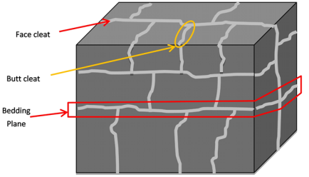
Figure 1 Cleat orientation in coal mass
Coal seam gas exists in three forms (Rightmire et al. 1984; Rice 1993; Shi & Durucan 2005):
free gas within the pores and fractures
adsorbed to coal surfaces
adsorbed within the molecular structure of the coal.
However, the vast majority of gas held in the coal is adsorbed to the coal surface and is the gas that is exploited in coal seam gas production.
Unlike conventional gas reservoirs, gas within coal seams is predominantly (90 per cent to 98 per cent of all gas) adsorbed to the coal (i.e. adhered to the surfaces of the coal) within the coal matrix, and is in a compressed state (i.e. condensed similar to a liquid). The surface area of the fractures is comparatively small in comparison to that in the matrix, where it is anticipated that the majority of the gas storage is present. Because most of the gas in the coals is stored by adsorption in the coal matrix, the pressure versus volume relationship for the gas is defined by the desorption (or adsorption) isotherm and not by real gas law (Aminian 2003). A sorption isotherm relates the gas storage capacity of a coal to pressure and depends on the rank, temperature and moisture content of the coal.
Gas content in the coal tends to increase with quality of the coal (i.e. rank, grade and type), with the depth of the coal seam, and with the groundwater pressure. For example, the maximum volume of methane and carbon dioxide that can be adsorbed to Bowen Basin coals is shown in Figure 2, based on laboratory testing (Saghafi 2005). Figure 2 also shows the amount of gas generated according to coal rank, also based on laboratory testing (Saghafi 2005).
Depending on the geological setting and history, the gas content of coal can vary from zero to the capacity governed by relationships like those illustrated in Figure 2. Figure 3 illustrates variability of methane content for coal samples from the Bowen Basin and the Hunter Valley (Esterle et al. 2006). The dashed line shown in Figure 3 shows the maximum volume of methane that can be stored per tonne of coal for a representative coal grade. The actual content obtained from testing is below this limit (excluding a few outlying results).
Coal seam gas production is typically undertaken in coals of mid-rank (i.e. low- to high-volatile bituminous coals), since desorption of coal seam gas from high rank coals such as anthracite is very slow (Levine 1993; Rice 1993).
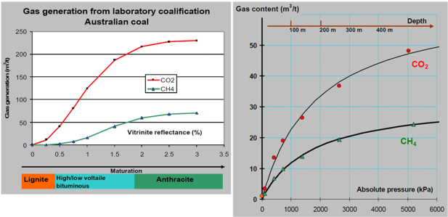
Figure 2 Methane (CH₄) and carbon dioxide (CO₂) adsorbed to Bowen Basin coals, and the amount of gas liberated according to coal rank (© Copyright, Saghafi 2005)

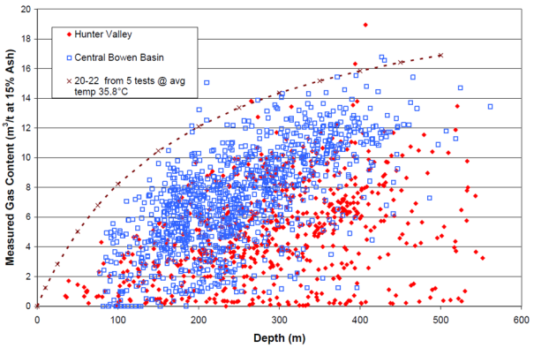
* The dashed line is the methane gas isotherm at the boundary of medium and low volatile rank coal at a volatile matter dry ash free content of 20 to 22 per cent.
Figure 3 Variation of coal seam gas content against depth for Bowen Basin and Hunter Valley coals (© Copyright, Esterle et al. 2006)

Gas extraction
Extraction of methane gas may be achieved by introducing a more adsorbable gas (such as carbon dioxide), decreasing the methane partial pressure or decreasing the reservoir pressure. Most coal seam gas extraction in the world is undertaken by reducing reservoir pressure, which is achieved by pumping groundwater out of the coal formations. The groundwater level may remain unchanged above the coal seam, but the reduction in water pressure associated with the groundwater removal within the seam causes the coal seam gas to desorb from the coal (i.e. detach from the surfaces of the coal).
Enhanced coal seam gas (ECSG) extraction is an emerging technology that uses inert gas stripping (i.e. use of nitrogen to flush out methane) or displacement resorption (i.e. use of carbon dioxide to displace adsorbed methane). Carbon dioxide (high affinity) and nitrogen (slight affinity) adsorb to coal, so injecting those gases into the coal bed can displace the methane and allow coal seam gas to be collected. Nitrogen is lower sorbing than methane, and carbon dioxide is more sorbing than methane (see Figure 2). Various studies trialing ECSG extraction have been conducted in the US and China (Saghafi 2005) and Australia (Pini et al. 2011).
Groundwater is pumped from the coal formations using groundwater wells. Well construction first involves drilling a borehole to the depth of the coal seam (or seams) from which extraction will take place. Target coal seam depths are typically 300 to 1000 m below ground surface. A steel casing (tube) is cemented in place within the borehole and access to the coal seam is obtained through fibreglass intervals along the length of the casing. The construction details vary from place to place according to industry practice and regulatory requirements, but in Australia are completed in accordance with The minimum construction requirements for water bores in Australia (National Uniform Drillers Licensing Committee 2012). Horizontal bores drilled in the target coal seam can be used as an alternative to the vertical bores. A submersible pump is installed at the base of the well and water is pumped from there to the surface. Note that the goal of pumping is to reduce the water pressure within the coal seam, rather than fully dewater it.
An example conceptual diagram of a coal seam gas production well in the Surat Basin is shown in Figure 4.
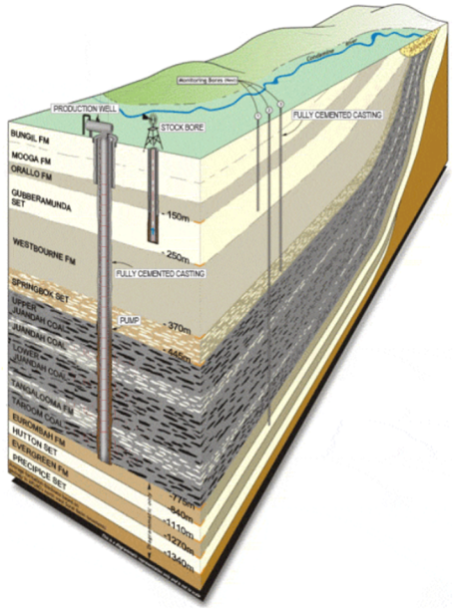
* This graphical representation of stratigraphy within the Surat Basin is the work of Origin and remains the possession of Origin. The use of this imagery is provided by courtesy of Origin. Any reproduction of this imagery is not to be undertaken without permission of Origin.
Figure 4 Conceptual coal seam gas production well in the Surat Basin’s Walloon Coal Measures (© Copyright, Origin Energy Limited 2012)
Under coal seam gas extraction, gas migrates through fractures in the coal matrix, by desorbing from coal cleat surfaces and by diffusion through the coal matrix to the cleats (Gas Research Institute 1996).
The gas extraction process undergoes three distinct stages (McKee & Bumb 1987):
Water is pumped from the coal seam to reduce the pressure. During this time the predominant fluid flowing within the coal cleats is water, with minor amounts of dissolved and free gas. This stage is characterised by single-phase saturated laminar water flow from the coal seam to the well.
After sufficient depressurisation of the coal seam (i.e. lowering the hydraulic head within the target coal seam to within 35 to 40 m of the top of the coal seam), gas desorbs from coal surfaces and diffuses from the coal matrix to the cleats. Individual gas bubbles form—similar to the way bubbles form in bottles of carbonated beverages when the cap is first released—but remain immobile due to their isolation. The immobile gas bubbles partially impede the flow of water in the coal seam. This stage is characterised by single-phase unsaturated flow of water (only) in the coal seam.
Further depressurisation results in increased gas desorption such that a continuous gas flow pathway of coalesced bubbles develops allowing gas to flow to the extraction well. This stage is characterised by dual-phase flow in the coal seam (i.e. separate water and gas phases may both flow).
These regimes occur in spatial sequence (McKee & Bumb 1987), progressing outward from the well and into the coal seam (i.e. two-phase flow occurs near the well, unsaturated water flow at some distance from the well and saturated water flow at greater distance from the well). The flow occurring in the saturated zone within the seam is laminar and obeys Darcy’s Law. Figure 5 illustrates these regimes.
The gas separates from the groundwater naturally by desorption (Henry’s law) and then by buoyancy, either in the well casing and/or well head (preferable), or by compression at a compressor station at the surface, before being sent to gas pipelines. Figure 5 displays a cross section through a typical production well.
Coal seam gas extraction site usually comprise multiple wells, referred to as a ‘well field’. Well spacing over a well field can vary widely depending on local conditions. For example, Arrow Energy Pty Ltd proposes to install production wells for the Surat Basin Gas Project on an 800 m grid spacing, though those wells may be spaced as far apart as 1500 m in an irregular (non-grid-based) pattern (Arrow Energy 2012a). This equates to an indicative density of one well per 65 ha. In contrast, the typical well spacing for production in the Powder River Basin is approximately one well per 16 ha (US Department of Energy 2002); although this may vary over the region – e.g. Wheaton and Metesh (2002) quote one well per 311 ha over the Tongue River Member in the Powder River Basin in Montana.
Table 1 provides a list of the well density for some coal seam gas developments in Australia and the US. Well spacing is selected to obtain the target groundwater depressurisation required over the well field to release the coal seam gas. The required depressurisation will depend on the properties of the aquifers and the gas-bearing coal seams. Additional wells may be installed over the lifetime of the development. There is no direct correlation between subsidence and the density of wells, since the induced subsidence depends on other factors such as the rate of dewatering and the geological characteristics.

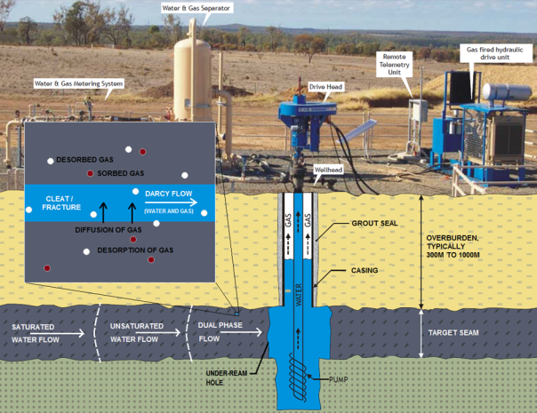
* The background graphical representation of stratigraphy and the well infrastructure is the work of Origin and remains the possession of Origin. The use of this imagery is provided by courtesy of Origin. Any reproduction of this imagery is not to be undertaken without permission of Origin.
Figure 5 Flow to well within coal seam (© Copyright, image adapted from Origin Energy Limited 2012)
Table 1 Density of coal seam gas wells in well fields
Well field | Approximate well density (number of wells per 100 ha) | Reference
Arrow Surat Basin gas project Australia | 1.5 | Arrow Energy 2012a
QGC Surat Basin Australia | 1.8 | Golder Associates 2009b
Camden gas project (stage 1) Australia | 1.5 | AGL Energy Pty Ltd 2012
Camden gas project (stage 2) Australia | 8.2 | AGL Energy Pty Ltd 2012
Powder River Basin US | 3.1 to 6.2 | US Department of Energy 2002
Tongue River Member, Powder River Basin US | 0.3 | Wheaton & Metesh 2002
Groundwater extracted during coal seam gas production is called ‘produced water’ (or ‘coal seam water’, ‘associated water’ or ‘co-produced water’). The volumes of produced water under coal seam gas production are large relative to those extracted from conventional gas reservoirs. Produced water typically possesses elevated salinity and may require treatment (such as reverse osmosis) prior to disposal or being used for other purposes, including agricultural use. Produced water that has been treated may be injected into the ground (either in the vicinity of the well field or elsewhere).

Hydraulic fracturing
Hydraulic fracturing (also referred to as hydraulic stimulation, hydrofracking, hydrofrac’ing, hydrofraccing, or simply fracking, frac’ing or fraccing) is a technique used to increase the permeability of geological strata in the vicinity of a well. Increasing the permeability of coal seams by hydraulic fracturing can enhance gas productivity and reduce the number of wells required.
The hydraulic fracturing process involves pumping a slurry down a well under sufficient pressure to cause existing narrow coal fractures to dilate. The slurry comprises a proppant (i.e. a material that keeps a fracture open; typically sand) and a hydraulic fracturing fluid. The hydraulic fracturing fluid may be water-, oil-, acid- or multiphase-based and is designed to transport and distribute the proppant into the fractures. To achieve this, gelling agents (such as cellulose) that increase the viscosity of the slurry are added. Conventional gels include cellulose derivatives or guar derivatives, although other gels may be used. Figure 6 illustrates the process of hydraulic fracturing.
Much of the hydraulic fracturing fluid is then recovered by a return flow to the well, while the proppant material remains in the open fractures, thereby maintaining increased permeability of the factures. The Queensland Government (2013) advise that 1.5 times (150 per cent of) the volume of fluid used in hydraulic fracturing must be removed from a well, and monitoring for quality and quantity must be undertaken following a fracturing event. To prevent the proppant being extracted from the formation when the fluid is recovered, a breaker is also included to reduce the fluid’s viscosity. pH buffers may also be added to maintain the viscosity of the fluid, or to break down the gel at the conclusion of hydraulic fracturing. Biocides (such as sodium hypochlorite, i.e. bleach) may be added to reduce the growth of microorganisms that may clog the coal seam and well.
Hydraulic fracturing can unintentionally cause fracture penetration into shallower strata, thereby creating hydraulic connection (groundwater flow paths) between the target coal seams and shallower formations. The presence of such connections may lead to draining of groundwater from shallower aquifers when dewatering of coal seams for gas production occurs. Such connections would result in increased produced water without additional gas extraction and would reduce the efficiency of gas production, a result which is disadvantageous for the proponent. The additional dewatering required in this scenario would also contribute to further risk of subsidence.
A number of fracture diagnostic techniques are used to assess the length, width and hydraulic characteristics of fracture propagation from hydraulic fracturing (US EPA 2004). Direct techniques include tiltmeter and microseismic mapping, in which instruments are placed within boreholes to measure ground deformation and vibrations from hydraulic fracturing. Indirect techniques include modelling of pressures, production (injection) data analyses, use of geological information to estimate the shape and dimensions of fracture propagation, and use of radioactive tracers.
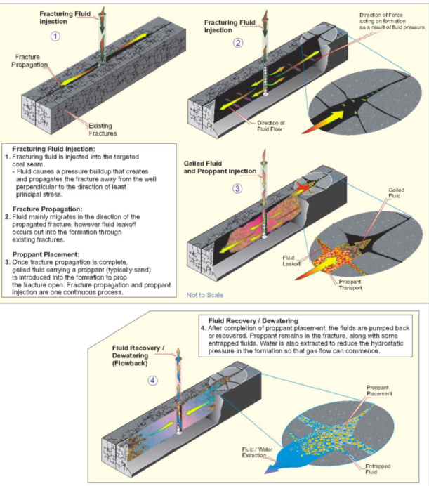
Figure 6 Hydraulic fracturing process (© Copyright, US EPA 2004)
The use of radioactive tracers involves adding a radioactive tracer to the proppant fluid. The tracer is selected for its chemical properties, its half-life and toxicity level, to minimise potential contamination. The movement of the tracer through fractures is then tracked and an assessment of the geometry and extent of hydraulic fractures is made.
Microseismic monitoring involves the installation of geophones to measure minor seismic events (movements) that occur during hydraulic fracturing. The movements are the result of changes in stress and fluid pressure along natural (existing) fractures, bedding planes and areas of rock weakness. By tracking the movements that occur during hydraulic fracturing, the propagation of fractures from the hydraulic fracturing process can be mapped.
Johnson et al. (2010) analysed tiltmeter and microseismic monitoring data for hydraulic fracturing tests conducted in the Walloon Coal Measures in the Surat Basin of Queensland. The majority of data suggested vertical fracture heights of between 50 and 130 m at depths of approximately 600 to 700 m below ground surface. Other Australian data on the extent of hydraulic fracturing are not available in the public domain.
Overseas measurements of fracturing extent are more numerous. Based on seismic data, Davies et al. (2012) found that hydraulic fracturing caused 80 per cent of existing fractures within US shales to propagate vertically upwards between approximately 30 m and 80 m.
Flewelling et al. (2013) reported that the observed vertical extent of microseismicity during hydraulic fracturing stimulations in sedimentary basins across North America was generally constrained by a simple function of the fluid volume used in a hydraulic fracturing event. They concluded that the results suggest that maximum fracture heights and fault movements are ultimately constrained by the volume of hydraulic fracturing fluid used. The vast majority of hydraulic fracturing jobs used by Flewelling et al. (2013) in their analysis were for depths greater than 100 m. Thus, they indicated that the derived function for the height of microsesimicity is likely to be valid for deeper formations (where the least principal stress is typically horizontal and fractures propagate vertically), but may not be appropriate at shallower depths (where the least principal stress tends to be vertical).
Further, data relating to the potential (natural) hydraulic connection between coal beds and overlying or underlying aquifer is limited. National Research Council (2010) cited only one study (Riese et al. 2005) that explored this phenomenon in US coal seam gas fields, and stated that this is a key information gap.

Water and gas yield
During the initial depressurisation stage of production, groundwater is extracted at a constant and relatively high rate and the volume of gas extracted is low. Following depressurisation, water production reduces markedly and gas production increases. After the gas production rate peaks, water production is relatively low and gas production continues at a gradually reducing rate. These trends are illustrated in Figure 7.
Some coal seams possess free gas within the coal cleats (fractures), allowing early gas production prior to major depressurisation; for example, the Anderson, Canyon and Wyodak seams within the Fort Union Coals of the Powder River Basin (US Department of Energy 2002). However, this is not common in Australia.
The extracted gas and produced water volumes vary widely between different well fields. For example, the range of production was between 0.004 and 78.0 (mean 3.9) petajoule (PJ) gas per megalitre (ML) water per coal seam gas operational facility in Queensland for financial year 2010/11 (Queensland Government 2012).
A typical coal seam gas field in the Surat Basin contains approximately 5.1 PJ/km² of recoverable gas (Origin Energy 2012).
Gas fields for the Arrow Energy Pty Ltd Surat Basin gas project are expected to achieve peak production of approximately 1050 terajoule (TJ) per day (1.05 PJ/day) estimated 4-5 years after commencement, after which production at a declining rate is expected to continue for a further 20 years (Arrow Energy 2012a).

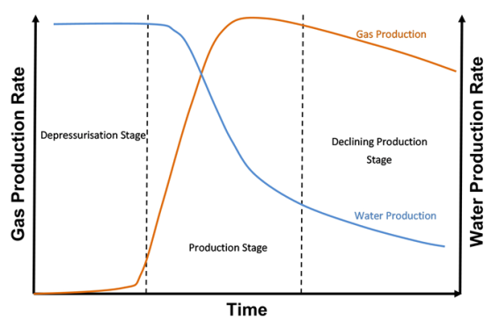
Figure 7 Conceptual gas and water extraction rates with time (© Copyright, Queensland Water Commission 2012)

Injection
Injection of produced water can replenish depleted aquifers, potentially raising the groundwater table and thereby permitting improved accessibility to groundwater relative to the drawdown conditions.
Injection to either shallower or deeper aquifers may be undertaken. Deeper aquifers are often more saline than shallower aquifers and, due to the relative salinity of produced water, may therefore present a preferred injection target.
Injection pressure must be limited to reduce the risk of fracturing aquitards and causing a potential hydraulic connection between aquifers not previously connected. The Australian guidelines for water recycling (NRMMC 2009) note that the injection pressure should not exceed the dry overburden pressure (at the base of the aquitard) to avoid this. Injection design should also consider the impact of injection pressure on other wells.
Injection of water into compressible soils is a well known approach to reduce subsidence due to groundwater pressure changes in response to temporary engineering works such as construction dewatering. Injection is subject to the effects of clogging as suspended solids within the injected water are forced into the receiving ground. Chemical precipitation can also result in clogging. To reduce the risk of clogging, periodic groundwater extraction from injection wells can be employed. Degraded injection wells may need to be replaced over time.
Injection of produced water into strata may cause induced seismicity. Ellsworth (2013) reported that micro-earthquakes (i.e. those with magnitudes below two) are routinely produced as part of the hydraulic fracturing process used to stimulate the production of oil. The mechanism responsible for inducing these events appears to be the process of weakening of a pre-existing fault by elevating the fluid pressure. However, only those wells that dispose of large volumes of water, and/or communicate pressure perturbations, directly into basement faults appear to be problematic (Ellsworth 2013). Ellsworth noted that earthquakes with magnitude (M) ≥ 3 in the US midcontinent occurred at a steady rate of around 21 events per year between 1967 and 2001. Since 2001, the occurrence of these events began increasing, peaking at 188 events in 2011. Ellsworth proffered that human induced earthquakes are partially responsible for this increase.

Typical coal seam gas regional environment
In Australia, coal seam gas developments are predominantly located in rural areas with established groundwater use for agriculture and domestic purposes. Existing and proposed developments lie within the Sydney, Bowen, Surat, Galilee, Clarence Moreton, Gloucester, Otway, Gippsland and Cooper Basins in the states of Queensland, New South Wales (NSW), Victoria and South Australia. Figure 8 shows the Australian sedimentary basins with existing and proposed coal seam gas developments.
The coal seam gas lease areas of different companies are often located adjacent to each other in each basin, as shown in Figure 9. In some proposed and existing development areas there is existing coal mining activity.
The geological conditions in these basins typically comprise surficial alluvial aquifer systems (such as in sands or clays), underlain by consolidated sedimentary geological units (such as sandstone, siltstone, mudstone), with coal seams interbedded within the sedimentary units. The target gas-bearing coal seams are typically at depths greater than 200 m below ground surface.
Coal measures are the geological sedimentary unit in which potentially multiple coal seams are interbedded within a sedimentary profile. The coal seams themselves can range between centimetres and many metres in thickness, and may be laterally continuous or may pinch out frequently, resulting in laterally discontinuous seams. For example, the Gloucester Coal Measures of the Gloucester Basin contain multiple continuous and relatively thick coal seams, while coal within the Walloon Coal Measures of the Surat Basin is in the form of discontinuous and relatively thin seams. Figure 10 and Figure 11 shows the geological profile in the vicinity of coal seam gas developments in the Camden and Surat Basins, respectively.
The geological units are generally layered, but may exhibit geological features such as faults and intrusions that may penetrate multiple geological units within the sequence, and features such as folds, slides and other anomalies that may buckle or warp depositional surfaces.
Although datasets are relatively limited for the alluvial and sedimentary geological units in the areas of (proposed) coal seam gas developments, available data indicate that these geological materials exhibit wide ranging hydraulic parameters. Nevertheless, broad characterisation of the hydraulic characteristics of each sedimentary basin is possible. The hydraulic characteristics are dependent on the local and regional (hydro)geological conditions, which are the result of the tectonic setting and structural history of the basin.
For example, the Gunnedah Basin experienced a higher contribution of quartzose sediment during its formation, resulting in relatively high permeability sedimentary units, whereas the Sydney, Bowen and Gloucester Basins received higher clay content contributing to the sandstone matrix, which reduced porosity and permeability (Holmes & Ross 2009). In addition, regional shale and tuffaceous claystones in these latter basins form low permeability horizons that limit vertical groundwater movement.
Generally, sedimentary basins formed in the Permian to Triassic geologic periods (such as the Sydney, Gunnedah and Bowen Basins) tend to possess lower permeability geological units, while younger sedimentary basins formed in the Jurassic to Cretaceous geologic periods (such as the Surat Basin) tend to possess higher permeability geological units.
Figure 8 Sedimentary basins of eastern Australian under existing and proposed coal seam gas development
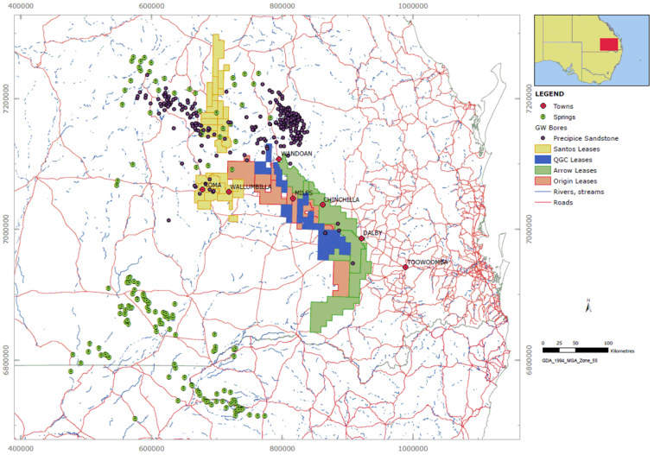
Figure 9 Example of adjacent coal seam gas lease areas in the Surat Basin (© Copyright, University of Southern Queensland 2011)

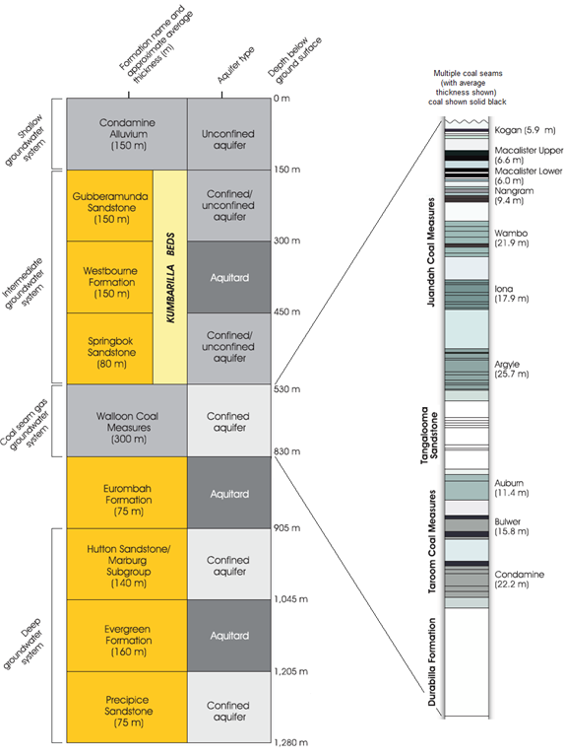
Figure 10 Geological profile in vicinity of coal seam gas development for Surat Basin (© Copyright, Arrow Energy 2012b)
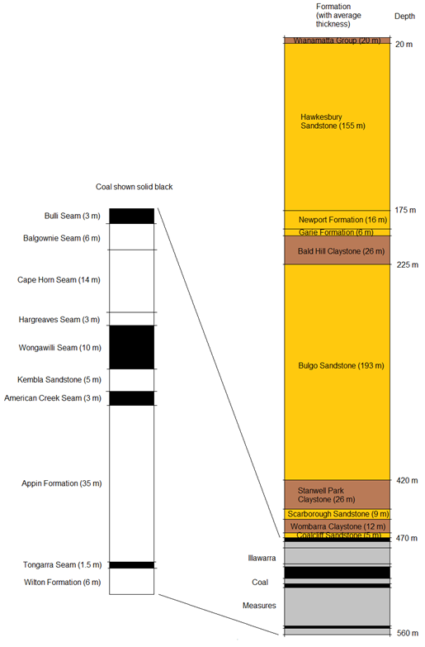
Figure 11 Geological profile in vicinity of coal seam gas development for the Camden Basin (© Copyright, adapted from AGL Energy Pty Ltd 2012)
As a result of these geologic histories, the coal permeability in the Gloucester, Sydney and Bowen Basins is relatively low and sufficient groundwater depressurisation can be attained in a coal seam gas well field to produce gas within days or weeks. The produced gas and water volumes are relatively low, and commercially viable production requires a greater number of wells per square kilometre. In contrast, the relatively high permeability coals of the Surat Basin have higher water and gas production rates, and commercially viable production is possible with lower density well spacing, but it can take months for target depressurisation levels to be attained (Holmes & Ross 2009). The greater time required is also a function of coal rank and the gas/water saturation.
Groundwater quality (chemistry) is affected by geological conditions, recharge characteristics (proximity to recharge zones, recharge rates and groundwater flows) and groundwater residence time in the host geological units. In general, groundwater is relatively fresh in shallow geological formations and more saline at greater depth.
The quality of water extracted from the coal seam varies depending on its specific characteristics and whether chemicals are used (SKM 2011; Commonwealth of Australia 2014). Co-produced water typically contains variable but often elevated concentrations of salts as part of the total dissolved solids (TDS). Salinity levels in the Walloon Coal Measures in the Surat Basin range from 250 to 16 000 mg/L with a median concentration of around 1463 mg/L (WorleyParsons 2010b). This is generally elevated compared to the overlying and underlying aquifers. A similarly wide range in TDS has been found in other coal seams such as those in the Bowen Basin (WorleyParsons 2010b).

Physical processes of coal seam gas production
This section discusses the physical processes relevant to modelling the potential impacts of coal seam gas developments on groundwater.
Groundwater flow near a coal seam gas well field is known to be influenced by the following physical phenomena:
three distinct fluid flow process stages experienced during coal seam gas extraction, each stage propagating spatially from the well into the coal seam:
- saturated single-phase water flow
- unsaturated single-phase water flow
- dual-phase (water and gas) flow
coal seams exhibit a ‘dual porosity’ system in which the coal material possesses both micropores (primary porosity, within the coal matrix) and macropores (fracture porosity, comprising the coal cleats). These structures affect fluid flow. The dual porosity nature of the system imparts a similar bimodal nature to the hydraulic conductivity distribution of the system
gas liberation from the coal, which affects fluid flow.
These phenomena have distinct effects on the groundwater drawdown and produced water volumes.
De Vertuil et al. (2013) developed a regional dual-phase flow model for assessment of far-field impacts. Initial results suggest that gas liberation plays a key role in controlling drawdown in the liquid groundwater phase at large distances. Development of these hybrid models is in a very early stage; however, results are encouraging and may provide a more reliable platform for coal seam gas impact assessment. The work suggested that it is preferable to use a multi-phase flow modelling platform for coal seam gas development.

Dual porosity
Coal seams exhibit a ‘dual porosity’ system in which the coal material possesses both micropores (primary porosity, within the coal matrix) and macropores (fracture porosity, comprising the coal cleats). These structures affect fluid movement by creating non-uniform flow fields with widely different velocities. Such phenomena are often referred to as preferential flow. Preferential flow leads to a non-equilibrium situation with respect to the pressure head or the solute concentration. In coal seams, flow occurs more readily along cleats and bedding partings. Water contained within pore spaces within the coal blocks between cleats takes time to migrate to join flow along the preferred flow paths.
This can be problematic for groundwater analysis as the process of gradual drainage from the coal blocks is not captured in the groundwater modelling tools in general use for flow modelling. The significance of this effect depends upon the time scale for migration of water (or gas) from within the coal matrix blocks to the cleats. Where changes in groundwater level are slow in comparison with this time scale, the behaviour can be modelled by assuming water is fully released from within the blocks. The validity of this assumption depends on the hydrogeological conditions and requires assessment on a case-by-case basis. This would typically be the case away from the pumping wells, where groundwater level changes would occur gradually with time. Where changes in groundwater level are rapid compared with the time scale for release of water from the blocks, this release can be disregarded in the short term as the water from within the blocks does not have time to contribute to the flow process. For the intermediate situation, such simplified treatment may be inadequate to address important aspects of groundwater response.
A method for modelling of flow in dual porosity systems was developed by Warren and Root (1963). The method considers movement of water from the primary porosity (within the blocks) to the secondary porosity (fracture system). A series of charts was provided illustrating the impacts on pressure change resulting from dual porosity effects. Gerkhe and Van Genuchten (1993) provided a discussion of approaches to modelling of dual porosity systems and presented a finite element approach.
Implementation of a dual porosity model carries computational overheads and complexities and it is not generally incorporated into general purpose groundwater modelling tools used for regional modelling. One difficulty in the use of models that address dual porosity behaviour directly is that knowledge of the parameter values for parameters that control the process (such as fracture spacing, matrix permeability, matrix and fracture porosity and permeability) are often not available. This lack of data leads to uncertainty associated with model predictions. Use of a dual porosity conceptualisation is possible however, and is further discussed below.
To accurately model groundwater flow in the near-field, models need to account for the dual porosity nature of coal. Methods for modelling dual porosity flow and transport and coupled geomechanics have been available since the mid-1990s. This would be important for the design of well fields. In regional modelling of groundwater flow, however, the scale over which dual porosity effects are important is not typically considered. Although laboratory results are available, the extrapolation of these results to the field scale involves scaling issues and other difficulties. This represents an implicit assumption that is not tested in relation to the prediction of groundwater impacts from coal seam gas extraction. The groundwater drawdown and produced water volumes predicted by the model may differ depending on whether a dual porosity system is or is not modelled.

Dual phase flow and unsaturated flow
As previously discussed, gas extraction involves three distinct flow process stages that propagate spatially from the well into the coal seam: saturated single-phase water flow, unsaturated single-phase water flow, and dual-phase (water and gas) flow.
To accurately model groundwater flow in the near-field, models need to account for multi-phase flow (i.e. either single or dual phases may be present) and variably saturated water flow (i.e. water flow may be saturated or unsaturated). Modelling regional groundwater impacts (i.e. in the far-field) may not require such behaviour to be modelled if the influence of dual phase flow and unsaturated flow are limited over the regional scale.

Geomechanical effects
During production, the permeability of coal may be modified in the following ways:
reduction of reservoir pressure (by pumping) causes reduction to the effective overburden stress and consequent closure of matrix fractures (matrix compaction), resulting in a reduction in the permeability of open fractures (cleats) within the coal (injection of water can result in the reverse phenomenon). Fracture apertures are typically sub-millimetre in scale.
desorption of coal seam gas causes the coal matrix to shrink (re-adsorption causes it to expand). The shrinkage of the matrix results in increased fracture openings thereby increasing the permeability of open fractures (cleats). The amount of shrinkage depends on the volume of coal but is typically several millimetres or more.
Of the two permeability modification mechanisms, matrix compaction tends to dominate during the early stages of production (when large reductions in reservoir pressure yield small removal of gas), whereas matrix shrinkage tends to dominate during later stages of production (when large gas removal is associated with relatively small continuing reductions in reservoir pressure). Thus, the permeability of the coal typically reduces during the early stages of production, followed by a subsequent increase during later stages of production. Although early-stage dewatering contributes to a reduction in permeability and later-stage gas desorption contributes to an increase in permeability, both result in compaction of the coal seam and may contribute additively to ground subsidence.
Increased stress within coal seams (and other geological units) occurs as a result of a reduction in groundwater level as the load previously carried by water pressure is transferred to the solid matrix. These increased stresses tend to close fractures, joints and cleats, resulting in a reduced permeability. Later stage desorption of methane also results in an increase in these effective stresses but the permeability increase that accompanies desorption is typically much larger than the overprinted permeability decrease due to effective stresses. Thus, a net permeability increase typically results during gas desorption at lower pressures (Izadi et al. 2011).
Wu et al. (2011) discussed these processes of this desorption response, reviewed background literature and presented a model for analysis of methane recovery that incorporates the effects of shrinkage of coal from gas desorption, changes in permeability due to stress changes, dual phase flow, and stress changes in the coal. Wu et al. (2011) only dealt with gas pressure effects (not water); however, the effects are analogous to those where water is present. Capturing these processes in a model substantially increases the complexity of the model formulation and application is restricted to the behaviour in the vicinity of an individual extraction well.
Figure 12 (after Robertson & Christiansen 2006) illustrates the modification in coal permeability due to pore pressure changes based on three different models. As depressurisation progresses (i.e. pore pressure decreases), a decrease in coal permeability occurs, after which the coal permeability rises. Of the models illustrated in Figure 12, only the Robertson-Christiansen model incorporates the influence of effective stresses in the process of decreasing permeability with a decrease in gas or water pressure. The detail of the relationships illustrated in Figure 12 would change according to the modulus (stiffness) of the coal, its structure (cleating), its porosity, initial gas content and gas sorption properties. In addition, these simple models of permeability increase with desorption depend on the initial gas pressure in the seam; at high initial gas pressures relative to the Langmuir pressure, a reduction in pressure may result in a decrease in permeability.

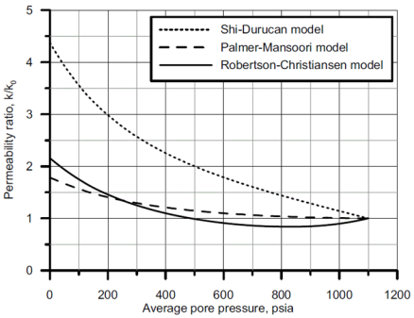
* k/k0 is the ratio of the current permeability to the initial permeability at a pore pressure of 1100 psi.
Figure 12 Permeability modification of coal due to pore pressure changes predicted by three different models (© Copyright, Robertson & Christiansen 2006)

Hydraulic fracturing
The purpose of hydraulic fracturing is to increase the permeability of, and the extent of hydraulic connection within, target coal seams. Hydraulic fracturing is typically undertaken prior to production, but is sometimes conducted during the production phase in an attempt to increase production. Modelling should take into account permeability changes induced by hydraulic fracturing, as such changes to permeability may both increase groundwater flow within the aquifer system and cause hydraulic connection between the coal seam and over- or underlying stratigraphic units.

Solute transport
It can be important to predict the transport of dissolved substances (solutes) within groundwater (such as salts) under coal seam gas operations. Transport (migration) of solutes under coal seam gas operations may be useful in the following contexts:
the groundwater extracted from aquifers under coal seam gas production may be saline, rendering it unsuitable for certain uses. Predicting the groundwater quality of produced water can be useful for assessing potential uses or likely treatment options for produced water
if there is hydraulic connection between aquifers adjacent to that under which coal seam gas extraction takes place, groundwater quality in those adjacent aquifers may be impacted by the water quality in aquifers undergoing extraction (e.g. saline water drawn into shallow aquifers due to coal seam gas operations). Impact assessment may include prediction of the potential impact of operations on the groundwater quality of adjacent aquifers.
hydraulic fracturing fluids may include additives whose migration is of concern. Impact assessment may include prediction of the potential migration of contaminant compounds within hydraulic fracturing fluids.
injection of untreated produced water may alter the groundwater quality of aquifers in the vicinity of the points of injection. For example, untreated produced water may possess higher salinity than native groundwater.

Surface water and groundwater interaction
Due to the extraction of groundwater during coal seam gas production, coal seam gas operations may impact surface water resources by modifying the interaction between surface waters and groundwater. Interaction between surface water and groundwater involves any interaction between aquifers and rivers, streams, lakes, seas, wetlands, marshes, swamps, estuaries and so on.
When surface waters are not substantially affected by groundwater flow exchange, models that represent surface waters by standard boundary conditions are expected to be sufficient to adequately model behaviour. However, when surface waters are affected by groundwater flow exchange (e.g. changing from a gaining to a losing stream), a coupled surface water-groundwater modelling approach may be required. The Australian groundwater modelling guidelines (Barnett et al. 2012) provide guidance on suitable modelling approaches for surface water-groundwater interaction. Rassam et al. (2012), Rassam and Werner (2008) and Rassam et al. (2008) also provide useful guidance.

Anisotropic nature of coal
Coal is anisotropic due to the orientation of the cleats. The face cleats are aligned in one direction and typically have higher permeability than the butt cleats. The horizontal permeability in the direction of face cleats (Kf) is typically five to ten times higher than the horizontal permeability in the direction of butt cleats (Kb), as shown in Figure 13. Further, the vertical permeability (bedding-perpendicular, Kv) is typically lower than the horizontal permeability (bedding-parallel, in either horizontal direction) (Massarotto et al. 2003). Coal therefore exhibits both horizontal and vertical anisotropy. Anisotropy is also present in other fractured rock media and is mainly controlled by the geometry of the fracture population.
Modelling of groundwater flow through coal seams therefore requires consideration of both the horizontal and vertical anisotropic nature of coal. The modelling tools widely used for regional groundwater impact assessment are capable of routinely accounting for the anisotropic nature of coal.
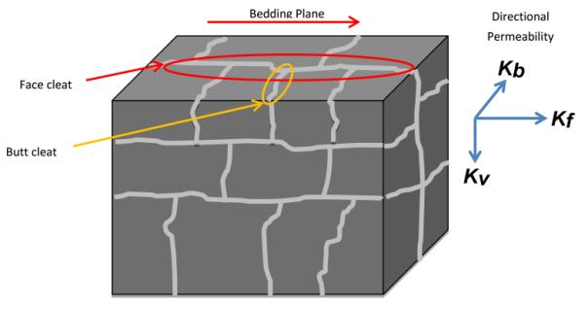
* Kf = horizontal permeability in the direction of face cleats; Kb = horizontal permeability in the direction of butt cleats; Kv = vertical permeability (bedding-perpendicular).
Figure 13 Permeability anisotropy of coal

Development of subsidence

Mechanism
Subsidence due to fluid withdrawal occurs when fluid pressures in a geologic unit decrease. The fluid can be water and/or gas, and the geologic units affected can be aquifers or aquitards. When a decrease in fluid pressure occurs, compression may result in compaction via the following processes:
the load carried by the aquifer skeleton increases, causing compaction of the skeleton (a mechanical process)
for some aquifer types (such as coal), solid phase material can transform to gaseous phase and escape, thereby shrinking the aquifer skeleton (a thermodynamic process).
The total observed compaction is a sum of these two processes and mostly occurs in a vertical direction. The subsidence seen at ground surface is some component of the total compaction in each layer, and depends on:
the depth and interval over which compression resulting in compaction occurs
the spatial extent and distribution of this compression resulting in compaction
the geotechnical properties of the materials throughout the depth profile (which determine response to compression)
the total amount and direction of compaction.
Subsidence can be both reversible (elastic) and irreversible (non-elastic), depending on the material and structure, and the amount of deformation that occurs during compression. Response to compression is heavily dependent on the history of the geologic unit (over geologic time).

Compaction of the target coal seam
A coal seam is an aquifer that is prone not only to mechanical compression, but also to changes in volume due to changes in phase (gas/liquid/solid) of its constituents. Coal seam gas production involves extraction of methane gas that was previously sorbed to the solid phase in the coal, and results in shrinkage of the coal seam. Shrinkage from this process is highly variable but can reach in excess of one per cent vertically, which translates to a subsidence of 30 mm at the top of a 3 m thick coal seam. The coal seam also undergoes mechanical compaction and so the total subsidence (at the top of the coal seam) is the sum of the shrinkage due to gas withdrawal and the mechanical compaction from fluid drawdown.
Field scale measurements of desorption-induced strain are not known, however laboratory measurements are common (see Figure 24). Sorption-induced compaction has been measured in laboratory studies at around one per cent (for carbon dioxide and methane combined) (Robertson 2005).

Drawdown zone of influence
When aquifer fluid depressurisation occurs due to coal seam gas production, the amount of depressurisation is greatest within the coal seam, and decreases moving away (vertically and laterally) from the zone of depressurisation. The difference between the initial (pre-pumping) pressure distribution in the subsurface and the pressure distribution at some time after pumping starts is known as the drawdown. The three-dimensional drawdown pattern (zone of influence) for layered sedimentary rock sequences (for example from pumping over a finite well screen interval at depth) is similar to an elliptical shape (in plane-view), with the exact shape and size of the zone of influence generally controlled by aquifer and aquitard permeability. The hydraulic storage characteristics of the subsurface also influence the amount of drawdown. In general, for a continuous groundwater system the drawdown at the water table is influenced by the specific yield and is generally much less than the drawdown in the interior of the subsurface, which is influenced by the specific storage (which is usually much smaller than the specific yield). The centre of the zone of influence occurs at the point of pumping. All material within the drawdown zone of influence will experience compression of some kind but some materials (generally high porosity materials such as clays and silts) are more susceptible to compaction than others.
The groundwater drawdown zone of influence can extend far beyond the well location in the coal seam, in both horizontal and vertical directions. The zone of influence continues increasing until the rate of pumping equals the rate of recharge to the zone of influence from other sources. In typical Australian coal seam gas settings, the strata undergoing most compaction within the zone of influence are typically sandstones and claystones; however, unconsolidated materials (soil) at the surface are very common and igneous rocks may also be present. However, in typical Australian coal seam gas scenarios, the target coal seams typically underlie unlithified sediments.
Compaction will occur to some degree in any geologic unit that is depressurized in the zone of influence, but is greatest in high porosity materials. If there is sufficient hydraulic connection between the target coal seam(s) and the overlying and/or underlying geological units, then those units may also be depressurised, leading to additional compaction of strata overlying and/or underlying the target coal seam(s).
In cases where coal seam gas production is located in the vicinity of (previous) longwall coal mining, the ground may be in a pre-disturbed condition, resulting in higher permeabilities and compressibilities that may amplify the amount of subsidence.

Subsidence - international experience

Subsidence and groundwater extraction
The development of subsidence in response to groundwater extraction is well known. The importance of groundwater withdrawal in inducing ground surface settlement is clearly illustrated by a review of available case histories of subsidence.
Subsidence may be related to:
groundwater extraction due to agriculture
groundwater extraction associated with oil, gas and coal seam gas extraction
groundwater extraction due to mining.
Subsidence related to the withdrawal of fluids from the subsurface is typically substantially less disruptive than that due to mining itself. The following sections discuss each of these individually.
There are numerous examples of substantial settlements associated with long-term groundwater extraction. These examples of subsidence assess conditions that are quite different from those occurring in the vicinity of coal seam gas developments. These examples are included firstly because a number of them are well known, and secondly so that the differences between these examples and the potential for coal seam gas related subsidence can be clarified.
The examples discussed in this section relate to conditions typically characterised by very deep soil profiles with groundwater level changes within these soils. The process of subsidence development is similar to that which would occur in relation to coal seam gas extraction, but the magnitudes of settlement are far greater due to either or both of the following:
the more compressible nature of the soil profile involved compared with the mainly sedimentary rock profile typically overlying coal seams targeted for coal seam gas extraction in Australia
the large depth and large thicknesses of the depressurised strata in the examples.

Subsidence case histories
Poland (1984) summarised 42 subsidence areas worldwide recorded from 1975 to 1978. That database lists subsidence in areas of wide ranging geological settings. Table 2 lists selected examples from cases reported by Poland (1984). These examples have varying drivers for groundwater withdrawal, such as irrigation and industrial water demand, and mine dewatering. Subsidence at Ravenna in the Po Delta ,Italy, was also influenced by conventional onshore gas withdrawal. Various authors have undertaken assessments to determine the respective influences of groundwater withdrawal and gas removal to the total subsidence (for example, Gambolati et al. 1991). The examples involve depressurisation of unlithified sediments. These sediment types are provided for some examples in Table 2.
The range of recorded subsidence in that database varies from minor casing protrusion in Bangkok (Thailand) to 0.15 m in Venice (Italy), to 15 m in the Cheshire district (Great Britain). In terms of the areal extent of subsidence, recorded data ranges from 10 km² in San Jacinto Valley to 13 500 km² in the San Joaquin Valley, both in California (US).
Subsidence due to groundwater withdrawal develops under two main contrasting classes of geological condition (Poland 1984). Carbonate rocks overlain by unconsolidated deposits or old sinkholes filled with unconsolidated deposits are two cases that are grouped in Poland’s (1984) first class of geological condition. In both cases, unconsolidated deposits receive buoyant support from the groundwater body. With decreasing groundwater level, the buoyant support reduces and the unconsolidated material may move downward. Young unconsolidated or semi-consolidated clastic sediments with high porosity laid down in alluvial, lacustrine or shallow marine environments belong to Poland’s (1984) second class of geological condition of land subsidence occurrence.
Table 2 Summary of subsidence case histories (Poland 1984)
Location | Depositional environment and geological age | Depth range of compacting beds (m) | Maximum subsidence (m) and year | Area of subsidence (km²) | Time of principal occurrence (year)
Australia: Latrobe Valley | Lacustrine and fluviatile; early Tertiary (sand, clay and brown coal seams). | 10-300 | 1.6 (1977) | 100 (> 0.2 m) | 1961-78
China: Shanghai | Alternating freshwater and marine; Quaternary (sand, gravel and stiff clay) | 3-300 | 2.63 (1965) | 121 | 1921-65
Taiwan: Taipei Basin | Alternating freshwater and marine; Quaternary (clay, silt, sand and gravel) | 10-240 | 1.9 (1974) | 235 | 1955-74
Great Britain: London | London Clay of Eocene age overlying chalk aquifer of Cretaceous age. | 50-100 | 0.35 (1976) | 450 | 1865-1932
Great Britain: Cheshire district | Sandstone, marl and rock salt; Triassic | 100-300 | 15 (1977) | 1500 | 1533-1977
Hungary: Debrecen | Fluviatile; Quaternary | 50-250 | 0.42 (1975) | 40 | 1961-75
Italy: Visconta | Fluviatile and swampy; late Cenozoic | 20-100 | 0.5 (1975) | 40 | 1961-1975
Italy: Po Delta | Alluvial, lagoonal and shallow marine; Quaternary | 100-600 | 3.2 (1973) | 2600 | 1951-66
Italy: Ravenna | Alluvial, lacustrine and shallow marine; Neozoic (fine and medium sands with occasional shells, occasional clayey or silty sands) | 80-500 | 1.2 (1977) | About 600 | 1955-77
Italy: Venice | Alluvial, lacustrine and shallow marine; Neozoic (sand, silt and clay) | 70-350 | 0.15 (1976) | About 400 | 1952-70
Japan: Aomori | Alluvial and lacustrine; late Cenozoic | 0-600 | 0.45 (1977) | 65 | 1958-78
Japan: Sendai | Alluvial and shallow marine; late Cenozoic | 0-300 | 0.57 (1977) | 90 | 1966-78
US: San Joaquin Valley | Lacustrine and Fluviatile; late Quaternary to early Tertiary (sand, gravel, silt and clay) | 0-600 | 9 (1977) | 13,000 | 1930-77

Subsidence and agriculture
The San Joaquin Valley is one of the largest alterations of land surface attributed to humankind. In 1970, comprehensive surveys of land subsidence in this area indicated that subsidence in excess of 30 cm had affected more than 13 000 km² of irrigable land. Figure 14 shows the level of land surface in 1925, 1955 and 1977 (Ireland et al. 1984).
Figure 14 Signs showing approximate elevation of land surface over the period 1925 to 1977 in the San Joaquin Valley, California (© Copyright, Ireland et al. 1984)
In this case, groundwater pumping for agricultural needs and irrigation altered the groundwater flow direction. Prior to development for agriculture, groundwater flowed from the mountains toward the centre of the valley. Groundwater withdrawal changed the flow direction toward pumping centres. The geological environment comprises Corcoran Clay distributed throughout the central and western valley, confining a deeper aquifer system that comprises fine-grained aquitards interbedded with coarser aquifers, as shown in Figure 15. Most of the developed subsidence has been associated with water level reduction within the deep confined aquifer system.
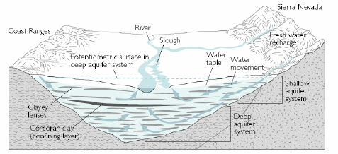
Figure 15 Groundwater movement and aquifer conditions in the San Joaquin Valley prior to agricultural development in the area (© Copyright, Darini 2007)

Subsidence and mining
The Gippsland Basin covers the Latrobe Valley in Victoria, Australia. Within the Latrobe Valley depression, some 700 m of Tertiary sediments named the Latrobe Valley coal measures (including brown coal material, as well as some volcanic material towards the base) was deposited over predominantly lower cretaceous sandstones and shales. Unconfined groundwaters are present over most of the area, as shown in Figure 16.
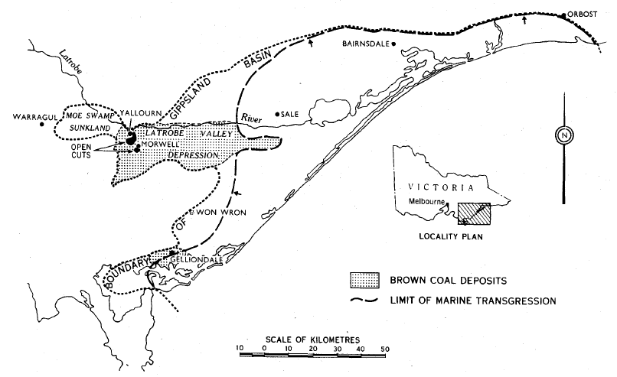
Figure 16 Location of Latrobe Valley, Gippsland Basin (© Copyright, Poland 1984)
To provide safe operating conditions for coal extraction, the artesian pressure of underlying aquifers was reduced. The resulting increased effective stress induced consolidation of strata and caused land subsidence. Surface movements have occurred since excavation commenced. By 1977, when the open cut had reached its full depth and was being developed to the west, horizontal movements had reached as much as 2.25 m and vertical movement had reached 1.68 m at the top of the northern and eastern batters, as shown in Figure 17. These movements are attributed to a combination of the following:
effects of stress relief from mine excavation and from lowering of groundwater pressures within the coal as a result of drainage to the excavated face
as a result of pumping to control potential uplift of the floor of the mine as a result of groundwater pressure.
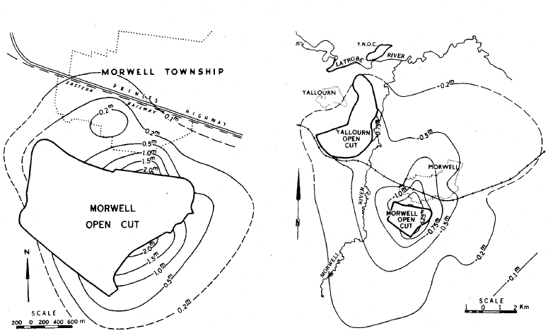
Figure 17 Horizontal and vertical movement adjacent to Morwell Open Cut (© Copyright, Poland 1984)
Apart from the geometry of the cut and the geological structure, the major factors influencing movements in the area around Morwell Open Cut are pressure relief and reduction in groundwater pressures.

Subsidence and oil and conventional gas extraction
Of the case histories listed in Table 2, two are related to gas extraction: Po Delta (Italy) and Niigata (Japan). The Niigata case history is summarised in this section.
The Niigata case history relates to the Niigata Plain, a large coastal plain along the Sea of Japan coast. It is bounded to the east by mountains, to the south and west by hills, and to the north by the Sea of Japan. The area possessed abundant methane gas. The major gas reservoirs in the Niigata Gas Field belong to the Uonuma geological group of Pleistocene age, which is characterised by alternation of clay, sand and gravel beds. Confined aquifers consisting of sand and gravel act as gas reservoirs, filled with brackish to saline water. Large quantities of saline ground water containing dissolved gas were pumped from wells as deep as 1000 m below ground surface. The recorded long-term subsidence between 1898 and 1970 is shown in Figure 18. Natural gas production began about 1947 and increased rapidly in the 1950s. Figure 18 shows that accelerated subsidence coincided with gas production.

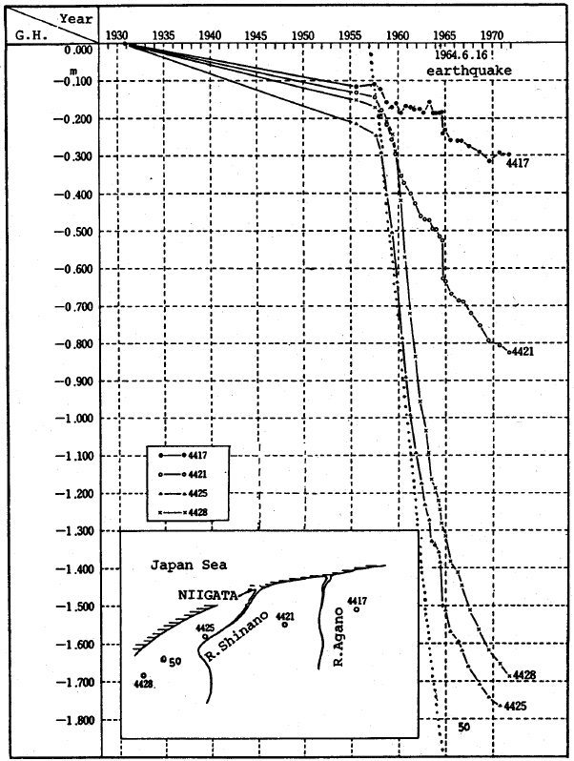
Figure 18 Recorded subsidence in Niigata Plain Gas Field, Japan (© Copyright, Poland 1984)

Subsidence and coal seam gas extraction
This section discusses examples of subsidence related to coal seam gas (coal bed methane) outside of Australia.
Measurements of subsidence associated with coal seam gas production are available from the US. Grigg (2012) reported that in the Powder River Basin of Wyoming (US), groundwater has been extracted by coal seam gas development at rates greater than 350 ML/day. Land subsidence in the Powder River Basin has been measured using interferometric synthetic aperture radar (InSAR). InSAR data collected from 1997 to 2000 and 2004 to 2007 indicated several centimetres of subsidence. In the east-central part of the study area, the largest subsidence values of 4 cm and 6 cm were correlated to large clusters of coal seam gas wells. Other subsidence in the area might be related to oil production and other groundwater use. Target coal seam average depths ranged from 140 m to 460 m. Coal seams are relatively thick, ranging from 7 m to 22 m, with an average of about 11 m.
In contrast, predictions made by Case et al. (2000) suggested a total subsidence of less than 13 mm in the Gillette area of the Powder River Basin, using a simplistic formula for subsidence and an aquifer storage coefficient of 1×10⁻⁴ for the coal seam. It was also estimated that only a part of this compaction would be seen at the surface. Compaction of overburden was not included in the assessment. This would give a lower bound to the predicted subsidence.
A technical advisory committee (TAC) was established to oversee the groundwater characterisation, monitoring and evaluation requirements of the Powder River Basin Controlled Groundwater Area (PRBCGA). The TAC consists of five members selected by DNRC for their expertise in hydrogeology, water quality and coal seam gas extraction systems and operations (DNRC 1999). Two additional ex-officio members represent the coal seam gas industry and the water user and conservation interests. In addition to overseeing monitoring and reporting requirements for individual coal seam gas fields, the TAC is assigned to review groundwater data and scientific evidence related to the PRBCGA and make recommendations regarding the mitigation of impact.
The Montana Bureau of Mines and Geology produces annual groundwater monitoring reports for coal seam gas production areas in the Powder River Basin (Meredith et al. 2010). Coal reserves in the Powder River Basin have been previously mined by underground methods, creating substantial drawdown and large vertical hydraulic head gradients. Figure 19 shows an example of the change in the pressure head profile (i.e. the drawdown) within the area of influence of coal seam gas production (ibid.). The drawdown is greatest closest to the target seam and decreases towards the surface.
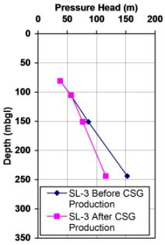
Figure 19 Example of the change in the pressure head profile due to coal seam gas production in the Powder River Basin (© Copyright, Meredith et al. 2010)

Katzenstein (2012) recognised the concern associated with the potential for subsidence resulting from groundwater withdrawal during coal seam gas development. A study (ibid.) of subsidence associated with coal seam gas production in the San Juan Valley of New Mexico (US) used InSAR data to quantify the surface response to aquifer drawdown in the vicinity of coal seam gas production in the San Juan Basin. Results showed that there had been enough groundwater extraction to result in measurable subsidence (several centimetres). Estimates of both the magnitude and aerial extent of the subsidence resulting from coal seam gas production in the San Juan Basin have been derived but are as yet unpublished (Katzenstein 2012).

Subsidence - predictions and experience relating to Australian coal seam gas projects
Eastern Australia possesses major sedimentary basins comprising Permian to Jurassic-age sedimentary sequences that typically contain coal seams at depth. These coal seams are frequently methane-bearing.
In Queensland, coal seam gas projects are currently targeting the Walloon Coal Measures (or equivalent) within the Surat Basin, Clarence-Moreton Basin and Bowen Basin. The Surat Basin projects are further advanced than those in the Bowen Basin, with three major projects underway and the fourth at advanced stages in the Environmental Impact Statement (EIS) approval process. These projects and relevant groundwater impact assessment reports include:
Surat Gas Project (Arrow Energy) – Coffey Environments (2012)
Australia Pacific Liquefied Natural Gas Project (APLNG Project, APLNG Consortium) – WorleyParsons (2010a)
Gladstone Liquefied Natural Gas Project (GLNG Project, Santos):
- URS (2009) - shallow aquifer modelling
- MatrixPlus Consulting (2009) - deep aquifer modelling
- Golder Associates (2009a) - supplementary information
Queensland Curtis Liquefied Natural Gas Project (QCLNG Project, Queensland Curtis Gas Consortium) – Golder Associates (2009b, 2009c) (supplementary information).
In NSW, underground and open cut mining of coal seams in and around the Illawarra (southern coalfield) and Hunter regions has been ongoing for well over 100 years. As in Queensland, the potential for extraction of coal seam gas is recognised, with some exploration and pilot studies underway. Mining in the Sydney-Gunnedah Basin targets the Illawarra Coal Measures to the south of Sydney, the Newcastle and Greta Coal Measures in the Newcastle/Hunter region, and the Late Permian Black Jack Group and Early Triassic Digby Formation in the northern Gunnedah Basin. Preliminary investigation of coal seam gas in a smaller basin, the Gloucester-Stroud Basin (containing coal in the Gloucester Coal Seam), has also commenced. Relevant exploration and feasibility projects are confined to the AGL Camden Gas Project (targeting the Illawarra Coal Measures) and Gloucester Gas Project (targeting the Gloucester Coal Measures). Further information on the geological setting is included in Table 3.
Currently there are very limited publicly available subsidence data for Australian coal seam gas developments, though subsidence monitoring is widely proposed for Australian coal seam gas developments.
This section provides a summary of the publicly available findings of studies assessing the potential impacts of coal seam gas extraction on subsidence.

Impact assessment study observations
The reviewed studies did not contain direct measurements of subsidence relating to existing coal seam gas extraction, despite the fact that some projects had commenced preliminary operations some years ago.
Subsidence is a consequence groundwater withdrawal, the degassing of the coal, the depth and depth-interval over which compression occurs, and the geotechnical properties of the geological units throughout the depth profile. (Golder Associates 2009a, 2009b, 2009c; MatrixPlus Consulting 2009; URS 2009; WorleyParsons 2010a; Coffey Environments 2012).
Historic groundwater drawdown values have been assessed in some cases. Arrow Energy’s Daandine coal seam gas operations resulted in up to 30 m of drawdown within the Walloon Coal Measures between 2005 and 2008 (Coffey Environments 2012). The project areas are predominantly located in agriculturally productive areas, particularly those in the Surat Basin. Groundwater extraction for irrigation has caused appreciable drawdown (values are unavailable), especially within shallow aquifers (Coffey Environments 2012).
Predictions regarding drawdown magnitudes have been made, typically based on numerical modelling of groundwater behaviour, both during operations and subsequent recovery. Models are regional or field-based, and are not sufficiently detailed to provide information at the individual well-scale. Similarly, drawdown is assessed at a regional or field-based scale, with detailed vertical profiles beyond the scope of the studies.
Prior to coal seam gas developments, the groundwater may have been in a pre-existing condition of depressurisation due to existing groundwater users in the region (e.g. groundwater extraction for irrigation) or mining activities (e.g. coal seam gas production is frequently undertaken in areas previously mined for coal by underground methods, predisposing the gas-bearing formations to greater gas extraction). Adjacent coal seam gas extraction will have an additive effect on falling groundwater levels. It is therefore important for groundwater modelling and subsidence assessment to consider the cumulative impacts (i.e. the combined stresses on groundwater levels) to accurately predict subsidence impacts. It is also important to have legislative decisions based on cumulative impacts so that subsequent users understand their liability. In the US, Cumulative Hydrologic Impact Assessments (CHIA) are used to define rights and liabilities of the chain of users.
Available subsidence predictions are:
Coffey Environments (2012) indicated that the Surat Gas Project alone will result in maximum drawdown of 75 m within the coal measures. These values are based on the estimated rates of coal seam water extraction increasing from the current rate of 11 ML/day to a maximum of 120 ML/day (equating to nearly 49 000 ML/year some 20 years after production commences). In nearby sandstone aquifers, associated drawdown will be a maximum of 30 m; however, cumulative maximum drawdown (i.e. considering the effects of the nearby QCLNG, GLNG and APLNG projects) is anticipated to be more than double the sole-operator drawdown, with predictions of over 150 m in the coal measures and between 60 m and 75 m in the sandstone aquifers.
WorleyParsons (2010a) noted that, for the Australia Pacific LNG Project, hydrostatic pressure within the coal seams must be reduced to around 350 kPa (equating to a groundwater level of about 35 m above the top of the coal seam) through groundwater extraction over a 50 year timeframe, to allow desorption of methane from the coal. Maximum drawdown is assumed to occur 30 years after commencement of production. Drawdown is anticipated to be greatest where the coal seams are at their greatest depths. Maximum drawdown in the sandstone aquifers is anticipated to be 15 m in the Springbok Sandstone, and 7 m to 8 m other sandstone aquifers. Cumulative impacts are anticipated to be greater, but have not been quantified.
MatrixPlus (2009) assessed drawdown differently from other studies, predominantly calculating amalgamated drawdown values rather than individual values for different aquifers. The study indicates that the Gladstone LNG Project will require a threshold operating pressure of about 500 kPa, requiring drawdown to about 70 m above the top of the Bandanna Formation (Walloon Coal Measures). The amalgamated drawdown cone is predicted to be up to 1000 m deep in isolated areas (in the east of the Fairview field), and generally up to 600 m deep. Drawdown in the Precipice Sandstone is anticipated to be a maximum of 65 m after 20 years. Recovery periods are dependent on aquifer properties, with some areas anticipated to recover relatively rapidly (e.g. 80 per cent of pre-production levels after twice the operating period), whereas drawdown in the Hutton Sandstone is predicted to continue for many hundreds of years.
Golder Associates (2009b) indicated that depressurisation prior to gas extraction for the Queensland Curtis LNG Project will have a pressure head some 70 m above the top of the Walloon Coal Measures. The study predicts that drawdown will be greatest beneath the depressurisation area, and within the Springbok Sandstone, due to discontinuous contact with the Walloon Coal Measures (allowing inter-aquifer depressurisation). The project area was split into three different fields and modelled separately. Maximum drawdown was predicted for the Central Development Area, with up to 85 m drawdown near the centre of depressurisation in the Springbok Sandstone. These predictions were matched against QGC information that initially 1300 wells will be drilled, extracting over 30 000 ML of groundwater. Within 20 years, around 6000 wells will be drilled, extracting around 65 000 ML per year of groundwater at peak production (with non-coal seam gas extraction estimated at an additional 11 000 ML per year).
Public reports of drawdown predictions in the NSW coal seam gas fields were not available at the time of writing.
Geoscience Australia and Habermehl (2010) reviewed numerous coal seam gas groundwater modelling studies for the Surat and Bowen Basins. Their review indicated that all models have inherent uncertainty related to the capacity of the model to predict the system response to drawdowns in the Walloon Coal Measures of several hundred metres. This raises questions regarding the capability of such models to satisfactorily predict impacts of such large perturbations. Therefore, the recommendation was made that audits of the model should be made at five year intervals, comparing monitoring results with model predictions. In addition, cumulative impact modelling is considered to be inadequate as a result of the inability of different proponents to exchange commercially confidential relevant data (such as groundwater pumping rates).

Impact assessment predictions of subsidence
The potential for land subsidence impacts are mentioned in the majority of Australian coal seam gas EIS groundwater studies; however, detailed modelling of this subsidence is generally not reported. Subsidence impacts are addressed and discussed in the following variety of ways in Australian coal seam gas EIS reports:
subsidence is mentioned as a possible impact of depressurisation, but no further discussion is presented (e.g. URS 2009)
available coal seam gas-related subsidence literature is reviewed and the results used to assess the likely impacts within the relevant project areas (e.g. MSEC 2007a; MatrixPlus Consulting 2009; Coffey Environments 2012). The most comprehensive literature review was presented in Coffey Environments (2012), but this review acknowledged that there was limited to no quantitative or qualitative data or information reporting measured or predicted coal seam gas-related subsidence. Available literature focuses on impacts to coal seam gas production rather than subsidence. The findings of the literature reviews indicated that:
- subsidence can occur almost instantaneously or over long time periods (Coffey Environments 2012), although the reasons for this difference is not explained in the study
- surface subsidence is only likely in unconsolidated aquifer systems comprising compressible sedimentary sequences (MatrixPlus Consulting 2009; WorleyParsons 2010a). Aquifers in the Great Artesian Basin subject to historical drawdown of 100 m have thinned by less than 0.1 per cent (Hillier 2000, reviewed in WorleyParsons 2010a); however, the total depressurised reservoir thickness is important in this case, but is not well known (subsidence of 0.1 per cent is consistent with a hydraulic head change of 100 m and an overburden with a modulus of 1 GPa). These aquifers are typically characterised by consolidated, porous sandstones, which are not prone to compaction as a result of depressurisation
- strain values in depressurised coal seams are typically low (MSEC 2007a, based on literature from NSW and Japan) and are not sufficient to cause large volume reductions; although Coffey Environments (2012) notes that MSEC (2007a) only appear to consider the effect of gas desorption on the coal seam thickness, and do not seem to include depressurisation due to dewatering or the potential effects of hydraulic fracturing on geological structure. From a literature review of historical tests, Robertson (2005) estimated sorption-induced strains in coal of about 1.0 per cent for carbon dioxide and about 0.3 per cent for methane. From experimental work, Robertson (2005) found that longitudinal strain is generally about one-third the value of volumetric strain
- damage to surface structures is more likely if differential settlement occurs (WorleyParsons 2010a). However, anecdotal evidence by MSEC (2007a) indicated that coal seam depressurisation has been carried out beneath urban areas with negligible surface impact.
MatrixPlus Consulting (2009) estimated subsidence based on decreases in porosity and coal seam thickness. The assessment assumed a coal porosity of five per cent and a cumulative coal seam thickness of 10 m. The assessment assumed that if the porosity reduced to nil, the maximum deformation would be 0.5 m. The assumption of reduction of porosity to zero is extreme and is not supported by test data. Resultant surface subsidence was considered unlikely (despite large depressurisation predictions) due to the competence of the overlying sandstones and shales.
WorleyParsons (2010a) estimated the decrease in storage capacity (i.e. the volume of water expelled from aquifer storage per unit area) due to decompression and the change in pressure head to calculate aquifer compaction. Compaction of the coal seams was conservatively estimated to be less than 0.5 m. However, deformation of the overburden (and consequent surface subsidence) is not thought to be likely given the depth of the coal seam and competence of overlying rock.
Golder Associates (2009a, 2009b, 2009c) estimated the elastic response of depressurised coal seams assuming a coal modulus of 2 GPa and taking the coal seam thickness and assumed/calculated depressurisation into consideration. Depressurised coal measures were considered to be the most susceptible to subsidence (Golder Associates 2009a). Only the vertical contraction of the coal seam from mechanical (elastic) effects was considered, without desorption-induced contraction. Sorption-induced compaction can be greater than elastic compaction. For a typical scenario comprising a coal seam with modulus of 2 GPa at 700 m depth, with 650 m depressurisation, the elastic compaction is around 0.3 per cent, whereas the sorption-induced compaction has been measured in laboratory studies at around 1 per cent (for carbon dioxide and methane combined) (Robertson 2005).

Impact assessment monitoring recommendations
Direct monitoring of subsidence was recommended by Coffey Environments (2012) and Golder Associates (2009a). Golder Associates (2009a) indicated that ground surface surveying should be part of a monitoring programme. Coffey Environments (2012) indicated that satellite data (from the Advanced Land Observation Satellite) would be useful in establishing a baseline Digital Elevation Model (DEM), with continued satellite monitoring of ground levels during and following coal seam gas-extraction operations inferred but not directly recommended. That study also mentions that the major Surat Basin proponents (i.e. Arrow Energy, QGC, Santos and Origin Energy) are designing a framework for cumulative subsidence impacts, although details of this framework are not provided. Coffey Environments understands that this framework is likely to be based on Differential Synthetic Aperture Radar (DifSAR) analysis, a satellite-based radar method. This is consistent with the recommendation of Geoscience Australia and Habermehl (2010), that subsidence monitoring should include baseline and ongoing geodetic monitoring in consultation with state government agencies. This monitoring should be carried out from the mining tenement scale to the wider regions across which extraction is occurring.
The potential for subsidence can also be monitored indirectly, using groundwater level monitoring to infer depressurisation, particularly in areas deemed susceptible to subsidence (WorleyParsons 2010a).
Likewise, specific subsidence management measures were not proposed, other than re-injection of coal seam gas water to reduce aquifer depressurisation (Golder Associates 2009a, 2009b; WorleyParsons 2010a).

Summary of predicted subsidence impacts
Table 3 provides a summary of the predicted subsidence impacts from proposed Australian coal seam gas developments.

Table 3 Summary of predicted subsidence impacts from Australian coal seam gas projects
Development and proponent | Geological setting | Predicted subsidence | Basis of prediction | Monitoring plans
Surat Gas Project,  Arrow Energy (Coffey Environments 2012) | Shallowly dipping Jurassic sedimentary formations overlying Palaeozoic basement rock. Numerous thin gas-bearing seams occur within the Walloon Coal Measures, the overall thickness of which varies from 100 m to 500 m. For modelling purposes, the two major coal-bearing units (the Juandah Coal Measures and Taroom Coal Measures) have been estimated at a uniform 250 m and 75 m thick respectively. The Walloon Coal Measures outcrops in the north and northeast of the study area (at over 500 m AHD), dipping to around 250 m AHD in the west. | Qualitatively predicted to be unlikely, due to the depth of the target seams and large spatial extent of depressurisation. | Review of qualitative results in available appropriate literature. | Satellite monitoring using ALOS ground-level data is inferred, but a detailed monitoring programme is not specified.
APLNG Project,  Australia Pacific LNG (WorleyParsons 2010a) | The Surat Basin is up to 2500 m deep, comprising four Jurassic sedimentary sequences (sandstone aquifers) overlain by Cretaceous transgressive marine sequences (fine-grained aquitards). The 500 m thick Walloon Coal Measures have two major coal layers: the Juandah Coal Measures comprising six seams, and the Taroom Coal Measures comprising three seams. The coal deposits are concentrated along the north-eastern margin of the basin, dipping to the south and west and cropping out along the north and southeast margins, but found at depths of up to 1600 m in the west. | Aquifer compaction calculated to be less than 0.5 m, and would not be expected to be expressed at the surface. | Subsidence is inferred from aquifer compaction calculations, which use the product of the storage coefficient and change in pressure head. | No direct monitoring of subsidence is recommended. Subsidence will be inferred from drawdown monitoring measurements in sensitive areas.
Gladstone LNG Project,  Santos Ltd (MatrixPlus 2009) | The Surat Basin is characterised by interbedded Jurassic sandstones and marine sediments. The 100 m to 460 m thick coal-bearing Birkhead Formation (the Surat Basin equivalent of the Clarence-Moreton Basin Walloon Coal Measures) is found at depths ranging from 170 m to 933 m deep. The coal seams are separated by silt and dense sand, which restricts vertical connectivity. Faulting and folding is present within the coal seam gas field areas. | Subsidence is mentioned as a possible impact in the EIS. In the EIS, estimates of coal seam (i.e. subsurface) subsidence are calculated to be between 30 mm and 115 mm, depending on the depth and thickness of the seam. | The EIS uses predictions based on depressurisation values, the rock mass modulus and known coal seam depths/thicknesses. | Monitoring is recommended in the EIS, but plans are not specified, other than inference from drawdown monitoring. Drawdown trigger levels are recommended.
Queensland Curtis LNG,  QGC Pty Ltd (Golder Associates 2009b) | The Surat Basin lies within the Great Artesian Basin. The Surat Basin primarily comprises faulted and folded Jurassic-Cretaceous-age fluvial quartzose sandstones. Within the project area, the Walloon Coal Measures range from 100 m to 460 m thick, at depths of 170 m to 933 m. An unconformable contact between the Springbok Sandstone and the Walloon Coal Measures may bring higher permeability layers into contact. | Estimates of coal seam subsidence are calculated to be between 30 mm to 100 mm where the seam is at average depths, and 200 mm to 300 mm where the seam is at its deepest. This may not be expressed at the surface. | The EIS uses predictions based on depressurisation values, the rock mass modulus and known coal seam depths/thicknesses. | Monitoring is recommended in the EIS, but plans are not specified, other than inference from drawdown monitoring and surface surveys. Drawdown trigger levels are recommended.
Gloucester  AGL(Holmes & Ross 2009) | The Gloucester-Stroud Basin lies to the northeast of Newcastle in NSW. Target coal seam depths are between 200 m and 1000 m deep. | Project is not advanced enough to include subsidence predictions. | N/A | N/A
Camden  AGL (AGL Energy Pty Ltd 2012) | Camden lies within the Southern Coalfield, in the southern section of the Permo-Triassic Sydney Basin. Coal is contained within the Illawarra Coal Measures, which are overlain by up to 725 m of interbedded sandstones, shales and claystones. | Compaction of the target coal seams is predicted to be on the scale of millimetres. Surface subsidence is predicted to be negligible, due to the competence of overlying rock. | Predictions are qualitative, based on strain values following gas extraction at analogous sites. | No monitoring is proposed.

Potential impacts of subsidence
No reference to adverse impacts arising from subsidence due to coal seam gas extraction has been identified in a review of literature. This may be due to the diffuse nature of the induced subsidence (i.e. small amounts of subsidence over very large areas) or may be a function of the largely rural setting where coal seam gas extraction has been carried out. Identification of potential impacts of subsidence has drawn upon the experience of subsidence associated with coal mining and dewatering associated with irrigation and mining.
Land subsidence can impact a variety of assets, including infrastructure (such as buildings, roads, railways, pipelines, dams, water channels, levees and electrical infrastructure) and environmental assets (such as aquifers, streams, lakes, springs and other surface water resources). The following sections discuss potential impacts and, where data are available, provide criteria against which impacts might be expected to occur.

Impacts on water resources
Subsidence due to groundwater withdrawal can cause environmental impacts relating to surface land use (including crop production and grazing), and hydrological impacts to aquifers, streams, lakes, springs and other surface water resources.
Land subsidence can affect water resources in the following ways:
cause the formation of ground fissures, which may connect either directly or indirectly to surface water (e.g. streams, lakes, ponds), potentially resulting in partial or complete loss of surface water by drainage to deeper strata
cause stream bed and bank erosion, substantially impacting the stability of streams
modify the drainage patterns of streams, potentially causing water flow out of the original channel. This is likely to occur where subsidence troughs bisect stream channels and travel in directions other than those of the stream
result in ponding of water within subsidence troughs, or deepening and widening of pools in streams, can lead to alteration of riparian ecosystems and geomorphological stability
modify the location and flow rate of hillside groundwater springs (Dawkins 2003). This is likely to occur where springs overlie aquitards that limit vertical (downward) migration of rainfall recharge. If the aquitard is disturbed due to subsidence, rainfall recharge may migrate deeper into the ground profile, reducing the spring discharge rate
change groundwater baseflow to streams, as well as delay groundwater response to recharge and/or discharge
reduce water availability in sensitive wetlands or swamps by compromising underlying horizons upon which the water perches.
depressure and dewater aquifers undermined by high extraction mining such as longwall mining together with the potential shearing of groundwater supply wells affected by severe mining-induced subsidence.

Impacts on rivers and flooding
Subsidence causes a reduction in elevation of an area. This may lead to increased exposure to flooding or storm surges in areas near the coast. Lowering of the ground level may lead to levees overflowing, especially in low lying coastal regions. In the Houston area, more than 80 km² of low lying coastal land has been permanently inundated due to subsidence, forcing houses to be abandoned. In addition, low-lying parts of the coast are now subject to more frequent and severe flooding during high tides and storm surges associated with tropical cyclones. Contributions of subsidence to inland flooding are suspected but poorly documented. However, flooding caused by subsidence has been documented near the shores of Koehn Lake, California (Holzer & Galloway 2005), and at the Terminal Island Naval Shipyard in Long Island, California (Gilluly & Grant 1949). Extreme subsidence at the Ekofisk Norwegian North Sea oilfield (Agarwal et al. 2000) required drilling platforms to be raised.
Subsidence may also cause fissures or cracking of the ground surface. Fissures may intercept surface water flows and lead to the creation of new, steep gullies. Fissures may also lead to erosion at or near the fissure (Holzer & Galloway 2005). Cracking of the ground may modify the location and flow of groundwater springs. This may occur where springs overlie low permeability hydrogeological units (aquitards) that limit the vertical movement of rainfall recharge. If the low permeability hydrogeological units are disturbed due to subsidence, rainfall recharge may infiltrate deeper into the ground profile through cracks (rather than emerging at the spring), leading to a reduction in the spring discharge rate (Dawkins 2003).
A decline in the groundwater table may also lead to the loss of water from lakes, ponds and swamps, as these features often represent the intersection of the groundwater table with ground surface.

Impacts on buildings and similar structures
Guidelines for assessment of settlement impacts upon buildings have been developed to provide a means for assessment of the significance of settlement for tunnelling and other construction activities. These provide a useful basis for assessment of potential impacts due to subsidence.
If the foundation of a building changes its slope uniformly by a small amount over its length, then the building will not distort and there will be no impact on the structure. If the changes in the slope vary, then the structure will flex and the fabric of the structure will be affected. Convex ground curvature, or hogging, caused by subsidence is one of the major causes of damage to structures related to subsidence (MSEC 2007b). Relative deflection (∆), as shown in Figure 20, is the displacement of a point relative to the line connecting two reference points on either side (Burland 2012). The deflection ratio, defined as (∆ / L), is a measure of differential settlement and can be used to measure the effect of differential settlement on building structures.
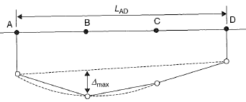
Figure 20 Deflection ratio (∆ / L) (© Copyright, Burland 2012)
If the ground surface is following a radius of curvature, R, it can be shown that the deflection ratio is given by L / 8R, as depicted in Figure 21.
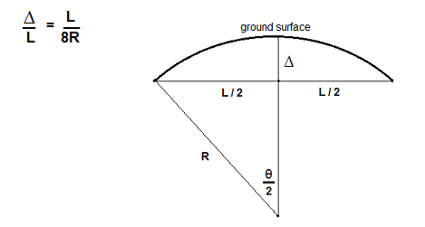
Figure 21 Deflection ratio and radius of curvature (© Copyright, Burland 2012)
Assessment of the degree of building damage can be highly subjective and may be conditioned by several factors, including local experience, the attitude of building owners/insurers, market value and other factors. Most buildings experience a certain degree of cracking, often unrelated to ground movement, which may be dealt with during routine maintenance.
Published guidelines, such as those collated by Burland (2012) in Chapter 26 of the Institution of Civil Engineers (ICE 2012) Manual of geotechnical engineering, provide maximum building slope or settlement to assess risk of damage. While these guidelines are useful, the ability of a structure to tolerate total and differential movements is heavily dependent on the nature of the building (i.e. age, type, façade, support type, length, etc.). The impacts of movements on any building that is considered to be particularly vulnerable to damage (e.g. heritage buildings or buildings that include glass façades) should receive further detailed consideration as the general published guidelines may not be applicable. Figure 22, sourced from Burland (2012), provides a guide for assessment of building damage under the influence of horizontal strain and deflection ratio. It applies to buildings with the ratio Length/Height = 1.
Figure 22 Relationship of damage category to deflection ratio and horizontal strain for hogging (© Copyright, Burland 2012)
The damage categories referred to in Figure 22 are described in Table 4, following the classification system presented by Burland et al. (2004).
Table 4 Classification of visible damage to walls, with particular reference to ease of repair of plaster, brickwork or masonry
Category of damage | Normal degree of severity | Description of typical damage  (ease of repair is underlined)
0 | Negligible | Hairline cracks less than 0.1 mm.
1 | Very slight | Fine cracks that are easily treated during normal decoration. Damage generally restricted to internal wall finishes. Close inspection may reveal some cracks in external brickwork or masonry. Typical crack widths up to 1 mm.
2 | Slight | Cracks easily filled. Re-decoration probably required. Recurrent cracks can be masked by suitable linings. Cracks may be visible externally and some repointing may be required to ensure weather-tightness. Doors and windows may stick slightly. Typical crack widths up to 5 mm.
3 | Moderate | The cracks require some opening up and can be patched by a mason. Repointing of external brickwork and possibly a small amount of brickwork to be replaced. Doors and windows sticking. Service pipes may fracture.  Weather-tightness often impaired. Typical crack widths are 5 mm to 15 mm or several >3 mm.
4 | Severe | Extensive repair work involving breaking-out and replacing sections of walls, especially over doors and windows.  Windows and door frames distorted, floor sloping noticeably. Walls leaning or bulging noticeably, some loss of bearing in beams. Service piped disrupted. Typical crack widths are 15 mm to 25 mm, but also depends on the number of cracks
5 | Very severe | This requires major repair work involving partial or complete rebuilding. Beams lose bearing, walls lean badly and require shoring. Windows broken with distortion. Danger of instability. Typical crack widths are greater than 25 mm, but depends on the number of cracks.

Impact on pipelines and utilities
Buried pipes and well casings may be subjected to large bending and tensile loads due to ground movements. Soil movement can be taken as the upper bound of pipe displacement. Subsidence leads to displacements that are typically monotonic and do not influence the fatigue life. Thus, a strain or deformation criterion is considered, accounting for inelastic pipe behaviour.
Strain limits are typically used to guard against localised wrinkling or tensile fracture at girth welds while allowing for some controlled level of pipe steel yield. Appropriate deformation limits such as strain or curvature limits can be established based on testing and detailed analysis. American Lifelines Alliance (2001) proposed the acceptance criteria for steel pipes as shown in Table 5.
Table 5 Acceptance criteria for deformation due to ground subsidence in steel pipes (© Copyright, American Lifelines Alliance 2001)
Loading condition | Allowable deformation or strain
Longitudinal strain from ground movement | Operable limits | Pressure integrity limits
 | Tension strain limit 2% | Tension strain limit 4%
Bracegirdle et al. (1996) gave empirical criteria for limiting slopes of utilities at which damage would occur. These are shown in Table 6.
Table 6 Empirical criteria for limiting slope of utilities for damage to occur (© Copyright, Bracegirdle et al. 1996)
Description of utility type | Induced slope limitation
Relatively rigid pipes, more than 200 mm diameter | Less than 1/140
Relatively flexible pipes less than 200 mm | 1/140 to 1/40
The categorisation developed by Bracegirdle et al. (1996) is specifically for cast iron pipes but provides a useful preliminary method of distinguishing utility types which are more at risk than others.

Impact on sewer pipelines
Tilt, induced by subsidence, may lead to a reduction in gradient in sewer pipelines so that pipe self-cleansing does not occur. However, observations of longwall mining-induced subsidence in Tahmoor NSW found that changes in grade of 0.4 per cent did not cause any observable effects to sewer pipelines (MSEC 2008b).

Impact on roads and highways
The effects of subsidence may have an impact on the serviceability of roads. Vertical settlement, horizontal strain, horizontal compaction, tilt and ground curvature may all cause damage to roads. Damage may be in the form of compression humps, tension cracks, distortion of the road surface and ponding of water on the road surface.
Recently, Wong and Summerell (2012) discussed guidelines for settlement criteria for design of highways. Project specifications for limits on allowable change in grade of road pavements are typically 0.3 per cent in 40 years for concrete pavements and 0.5 per cent in 20 years for flexible pavements. The results of experience on a number of projects quoted by Wong and Summerell (2012) are summarised below:
Mittagong Bypass - localised settlement of 20 mm over a 15 m wave length occurred before cracking became evident
records of settlement and intervention by Roads and Maritime Service (NSW) indicated that settlement in excess of 200 mm on bridge approaches were repaired using asphaltic cement correction layers.
The following criteria were suggested as reasonable specifications for acceptable settlement:
0.3 per cent in 40 years for concrete pavements measured over 10 m half cord length
0.5 per cent in 20 years for flexible pavements measured over 10 m half cord length.
A review of the literature has not found any guidelines for maximum horizontal strains or compaction before a road will need repair. The following cases from MSB (1997a) illustrate damage that has occurred along with measured horizontal strain, horizontal compaction and subsidence:
Freemans Drive, Cooranbong NSW - tension cracks and compression humps on road surface, and some ponding of water on road surface (horizontal strain – 14 mm/m, horizontal compaction – 20 mm/m, subsidence – 1200 mm)
Pacific Highway, Catherine Hill Bay NSW - tension cracks and compression humps on road surface, and road surface considered very rough (horizontal strain – 12.3 mm/m, horizontal compaction – 6.3 mm/m, subsidence – 1300 mm).

Impact on railways
Predicting the impact of subsidence on railway infrastructure is an emerging field of research in the Australian context, although a number of groups are now investigating this issue. Australian experience to date is limited to underground coal mining but the issue may apply to any measured subsidence caused coal seam gas extraction if it is found to be significant.
Holt et al. (1984) attempted to quantify subsidence under the Great Western Railway near Bell, NSW (Western Coalfield). They reported a subsidence to seam height ratio of about 0.11 for mining under in the railway line, demonstrating the stability of 24 m square pillars with 6 m wide roadways until extraction. Maximum strain values recorded were 0.2 per cent.
Under the Main Southern Railway at the Tahmoor Colliery in the southern coalfield of NSW MSEC (2008b) reported maximum total observed surface subsidences (after each longwall) of 12 mm, 52 mm, and 89 mm for longwalls LW22, LW23A/B, and LW24B, respectively,(after 1100 m of coal mining). These observed values exceeded that predicted MSEC (2009) also undertook predictive subsidence research in this area, estimating that the Main Southern Railway in Area 9 of the BHP Bulli Seam Operations in the Southern Coalfield would experience a maximum total subsidence of 1600 mm, based on the specific orientation of longwalls present.
Gao and Gong (2012) highlight the importance of reliably estimating subsidence underneath ballastless tracks for high speed railways. The issue of subsidence under high speed railways is a significant one as these trains can reach speeds in excess of 350 km per hour and rail line design tolerances are small. Geab et al. (2010) monitored subsidence under the Beijing–Tianjin high-speed railway line using differential radar interferometry (PSInSAR and differential InSAR techniques using SAR data collected by ENVISAT ASAR and ALOS PALSAR sensors). They found that over-extraction of groundwater resulted in a maximum subsidence under the railway line of 100 mm per year, which was strongly correlated between their investigative techniques.

Impact on dams
General criteria for assessment of the effect of subsidence on the performance of dams are not available.
McNally and Evans (2007) noted that undermining of a small coal washery storage dam (Brennans Creek Dam) by longwall panels of the Westcliff Colliery resulted in uplift of 35 mm, and 80 mm of abutment closure, without affecting the performance of the structure.
Straubaar et al. (2009) provided observed settlements for rockfill dams, indicating that the settlement generally varies between one and three per cent of the dam wall height, for dam wall heights varying between 30 m and 300 m, with settlement typically greater than 0.1 per cent. Based on this result it would seem unlikely that subsidence of less than 0.1 per cent of the height of a rockfill dam wall, induced in strata below the dam wall, would be problematic to the dam wall. Nevertheless, major dams within areas affected by subsidence should be assessed independently to ascertain their sensitivity to subsidence.
Large tilts in ground surface, induced by subsidence, may potentially affect the storage capacity of dams, causing them to overflow, or may affect the stability of the dam wall (MSEC 2008a). For example, a tilt of 1 mm/m may result in a loss of freeboard of up to 1 m for a dam with a 1 km lateral extent perpendicular to the dam wall.
Horizontal strains may potentially cause cracking to dam walls, leading to loss of water (MSEC 2008a).

Impact on levees
Levee integrity can be adversely affected by levee subsidence, or the subsidence of land immediately adjacent to the levee. Areas previously unexposed to flooding may be exposed to flood events after subsidence of a levee. Levees subjected to ground curvature or differential settlement may suffer cracking and lose strength. For example, some of the areas of New Orleans levee failure due to Hurricane Katrina were those areas where subsidence due to groundwater withdrawal was highest (Science Daily 2006).
Monitoring will provide important information that can be used to develop efficient and timely design solutions for levee rehabilitation and maintenance.

Impact on drainage channels
A change in ground surface tilt may reduce the gradient on a drainage channel. If tilt is large enough, it may be possible that drainage gradients are reduced in some areas to below minimum levels. Urban stormwater systems may require inspection on a case by case basis, especially where tilt is above 4 mm/m (1 in 250).

Impact on ground permeability and cracking of the ground
Subsidence over longwall coal mines is well known to result in cracking of strata overlying the coal deposit, leading to drainage and de-saturation of the ground above the void formed by coal extraction. The impacts of the overlying strata reduce with increasing height above the mined coal seam. If the mine is sufficiently deep, the impacts upon the water carrying capacity of shallow strata are minimal.
British practice for longwall mining beneath aquifers is summarised by Farmer (1985), as quoted by McNally and Evans (2007): “subsidence-induced tensile strains should not be more than 6 mm/m at the base of the lowest major aquifer above the workings, and the workings should be more than 45 m below the aquifer”. There is no known (agreed upon) strain threshold, or similar type of benchmark, for mining in Australia.
An approach for assessment of the drainage of strata above coal mines developed for conditions in the United Kingdom by Whittaker and Reddish (1989) was discussed in relation to Australian conditions by Strata Engineering (2003). Whittaker and Reddish (1989) developed the relationship illustrated in Figure 23, which shows the extent to which strata above longwall mines were cracked to the degree that allowed full drainage of groundwater to the coal mine. This relationship can be interpreted to indicate that for horizontal strain less than 30 mm/m, development of a network of interconnected cracks would not occur. Based on a review of Australian experience, Strata Engineering (2003) concluded that the relationship developed by Whittaker and Reddish (1989) was not conservative for Australian conditions.
Strata Engineering (2003) developed a more elaborate relationship, taking into account the width of the longwall panel. This relationship indicated a 95 per cent confidence that horizontal strain of less than 3 mm/m at the surface would not result in development of interconnected fractures leading to the coal horizon. Strata Engineering warned that further calibration work needs to be carried out to test the results of the relationship developed. This assessment does not readily translate to impacts from subsidence due to coal seam gas extraction, but it does provide an indication of the magnitude of surface horizontal strain where interconnected cracking propagates from the coal horizon to the ground surface. It is this magnitude that is the main issue between the different types of mining industries.
Figure 23 Development of fractures in subsided ground (© Copyright, Whittaker & Reddish 1989)
McNally and Evans (2007) reported that studies carried out by the Dam Safety Committee involved extensive monitoring of relatively shallow partial coal extraction (panel and pillar workings) with cover depths of 230 m to 320 m in Bulli Colliery. The coal extraction resulted in surface subsidence of 114 mm, with surface tensile strains generally less than 1 mm/m not having a noticeable effect on shallow piezometers in Hawkesbury Sandstone located 300 m above the seam (though standing water in deeper piezometers only 150 m above the seam experienced falls of 40 m in groundwater level during pillar extraction).
McNally and Evans (2007) reported that a similar trial by the Dam Safety Committee at the Wongawilli Colliery, at the head of the Avon Reservoir, was carried out where cover rock was between 80 m and 100 m thick and was disturbed by igneous dykes and a sill. Water inflows during the first working were not excessive but during pillar extraction groundwater inflows increased to a rate which led to abandonment of the mine.
Elsworth and Liu (1995) undertook non-linear ground deformation modelling and concluded that topography also influences the zonation of ground deformation above mined longwall panels.

Impact on electrical infrastructure
Horizontal displacements and tilt induced by subsidence may affect the alignment and tension of transmission lines and lead to a reduction in clearance of the transmission line to neighbouring structures or the ground (MSB 1997b). Large tilt at the base of power poles may lead to a reduction in stability of the poles. In the past, problems have been observed where tilting occurs to poles connected to residential dwellings, due to a reduction in bay length. It is generally accepted that tilts of below 20 mm/m in the areas of the poles will not pose significant problems to the powerlines or poles (MSEC 2008b).

Subsidence assessment approaches
Modelling approaches for assessment of the magnitude and significance of subsidence arising from extraction of coal seam gas can be divided into the following two categories.
extrapolation of the results of experience – this is the approach which has been successfully employed in relation to the assessment of the magnitude, distribution and impacts of subsidence associated with underground coal mining. Well established databases of responses to a range of mining configuration and geological settings exist and these are used to predict subsidence response to coal mining. Emphasis in these assessments has been on the assessment of potential damage to buildings and roads. In the case of predictions for coal seam gas operations, this approach will not be effective until a sufficient database of experience is developed. At present there is a paucity of monitoring records of subsidence arising from coal seam gas extraction.
analysis of compression and resulting compaction in the vertical profile due to changes in groundwater and gas pressure arising from coal seam gas extraction. In the absence of a database of measurements of subsidence, it is necessary to follow this approach.
Due to the paucity of subsidence data for coal seam gas projects in Australia, assessment of potential subsidence is undertaken by predictive modelling.
Predictive subsidence modelling approaches provide:
estimates of compaction of hydrogeological units due to changes in groundwater pressure
estimates of compaction of the coal seam due to degassing.
These two components together with their distributions are combined to provide an estimate of the total ground subsidence. Adding the components together will give a conservative estimate of the maximum possible subsidence, but the observed subsidence at the surface will depend on the geotechnical properties of the various layers throughout the depth profile. The two components will be discussed separately in the following sections of this report.
Coal seam gas-related subsidence is induced by compression due to groundwater and gas extraction, and resulting compaction is potentially greater at locations of greater reduction in groundwater pressures (depressurisation). Subsidence is therefore greatest in the vicinity of a coal seam gas extraction well, and reduces gradually at increasing distance from the well, similar to the profile shown in Figure 24. The exact shape of the subsidence profile at the surface may not be smooth or regular due to heterogeneous underground conditions. By accounting for decreasing depressurisation with distance from coal seam gas wells, and possibly accounting for variable underground conditions, subsidence modelling can predict the shape of potential subsidence as well as the magnitude.
By considering the potential compaction of all depressurised geologic units, including the target coal seam as well as geological strata overlying and underlying the target coal seam, modelling can capture subsidence throughout the vertical profile.
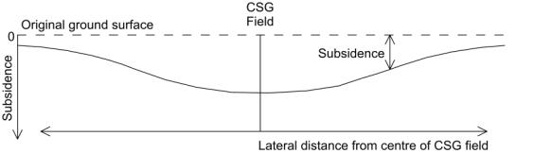
Figure 24 Cross-section of a typical subsidence profile

Subsidence due to coal seam degassing
This section discusses modelling approaches to predict the compaction of hydrogeological units due to degassing of coal seams.
Coal seams undergo compaction due to changes in groundwater pressure, as governed by geomechanical compressibility, and similar to any other geological unit. Unlike other geological units, however, the desorption (removal) of gas from coal seams causes additional compaction.
Coal beds can adsorb increasing volumes of gas (primarily methane, carbon dioxide and nitrogen) with increasing pore pressure. The adsorption or desorption of gas molecules causes the length of the matrix block to either increase or decrease, respectively. Degassing (desorption) therefore leads to a decrease in the length of the matrix blocks resulting in compaction of the coal. This component of compaction is solely a function of the method of reduction in the coal and is not dependent on changes in overburden pressure (Robertson & Christiansen 2006). However, this process may not hold where in situ stresses change due to rotation of the principal stresses from, say, a non-uniform distribution of depressurisation.
The sorption behaviour of coal seam gas conforms to a Langmuir isotherm (Robertson & Christiansen 2005, 2006) and a Langmuir relationship describes the behaviour of the coal under compression or expansion. Assuming that geological materials are significantly constrained in the horizontal direction, compaction may be estimated considering the vertical compression of the coal. The linear vertical strain (i.e. change in height of a coal block) due to desorption of coal seam gas (degassing) is defined as:
$$ε_{sh}=\frac{S_{max}P_{p}}{P_{L}+P_{p}}$$
where $ε_{sh}$ is desorption-induced strain, S_{max} is the strain at infinite pore pressure, $P_{p}$is the current pore pressure, and $P_{L}$is the pore pressure at which the strain is equal to one-half the value of $S_{max}$.
These parameter values are measured by conducting laboratory tests on coal samples. The parameter values can vary widely for different coal quality (coal rank) and coal seam depth. Parameter data for Australian coal seam gas developments are not available in the public domain. However, some data from coal bed methane developments in the US are available. For example, Robertson and Christiansen (2005) reported the laboratory results (Figure 25 and Table 7) for three different pure gases (N₂, CH₄, CO₂) and two types of coal from the Powder River Basin, Wyoming (Gilson-bituminous and Anderson-subbituminous coal). Wang (2012) provided published measured strains for a range of coal ranks under conditions of varying pressure, mostly for CH₄ and CO₂.
For a change in pore pressure over an elapsed time period (e.g. after a period of coal seam gas production), the linear strain caused by desorption of gases, $ε_{ls}$, can be estimated based on the relationship:
$$ε_{sh,t}=\frac{S_{max}P_{p}}{P_{L}+P_{p}}-\frac{S_{max}P_{p0}}{P_{L}+P_{p0}}$$
$$ε_{sh,t}=\frac{S_{max}P_{L}}{{(P}_{L}+P_{p})(P_{L}+P_{p0})}(P_{p}-P_{p0})$$
Where ε_{sh,t} is the linear strain after a given time, t, and P_{p0} is the initial pore pressure in the coal. Since the pressure change is controlled by the removal of groundwater from the coal, the pressure change (P_{p0} - P_{p}) is equal to the change in pore water pressure in the coal (γ_{w}Δh_{t}):
P_{p0} - P_{p} = γ_{w}(h₀ – h_{t}) = γ_{w}Δh_{t}
Where γ_{w} is the unit weight of water, h₀ is the initial groundwater head, and h_{t} is the groundwater head at time t. Thus:
$$ε_{sh,t}=\frac{S_{max}P_{L}}{{(P}_{L}+{γ_{w}h}_{t})(P_{L}+{γ_{w}h}_{0})}(γ_{w}∆h_{t})$$

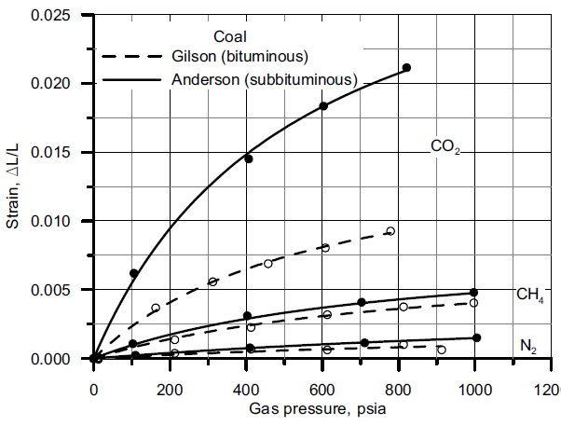
Figure 25: Coal strain curves for two different coals subjected to three different pure gases at various pressures at 27ºC (© Copyright, Robertson & Christiansen 2005).

Table 7 Langmuir strain constants for sorption-induced strain for subbituminous and Gilson Coals at 27ºC (© Copyright, Robertson & Christiansen 2005)
Gas | Coal | Langmuir strain constant | Langmuir strain constant
 |  | S_{max} | P_{L} (kPa)
CO₂ | Subbituminous | 0.0345 | 3.6
CO₂ | Bituminous | 0.0160 | 4.0
CH₄ | Subbituminous | 0.0078 | 4.3
CH₄ | Bituminous | 0.0089 | 8.0
N₂ | Subbituminous | 0.0043 | 13.0
N₂ | Bituminous | 0.0011 | 2.4

Closed form solutions - compaction
Closed form solutions are a particular kind of mathematical solution that may be used to assess subsidence due to groundwater depressurisation.
Closed form solutions for point extraction of groundwater from an elastic half space (i.e. deformation of an object that returns to its original shape in planar space) have been developed by Booker and Carter (1984, 1987). The solutions provide a means of calculating the horizontal and vertical movement in a uniform profile due to point extraction of groundwater at nominated times after the commencement of groundwater withdrawal. The results can be extended by superposition to assess the effects of multiple points of extraction as would be the case for a coal seam gas well field. The methods are limited to uniform ground conditions and do not take account of layering of the soil or variations of hydraulic and mechanical properties with depth. Lu and Lin (2006) also presented the results of analytical methods for calculation of horizontal and vertical movement in response to point groundwater extraction.
Integral transformation methods are used for the derivation of the solutions presented. Booker and Carter provided simple expressions for long-term settlement and horizontal movement, but the results for other times require use of a numerical inversion process. Lu and Lin (2006) presented expressions for surface settlement and radial movement, which can be evaluated at nominated times. Lu and Lin provided guidance regarding the rate at which settlement response approaches the long-term condition.
Figure 26 provides the surface settlement, horizontal movement and horizontal strain under long term conditions for uniform elastic ground (with Young’s modulus E, Poisson’s ratio ν, and hydraulic conductivity k) assuming no change in groundwater level at the surface under the effects of groundwater extraction (at rate Q) at depth h. The long term surface settlement directly above the point extraction, S₀ is given by (γ_{w} is specific unit weight of water):
$$S_{0}=\frac{Q γ_{w} (1+ν)(1-2ν)}{2πkE}$$
Surface settlement and radial inward movement in the long term as a fraction of the surface settlement above the point extraction obtained from the expressions provided by Booker and Carter are illustrated below in Figure 26. In this figure horizontal strain is also normalised by dividing by the maximum surface settlement and multiplying by the depth of the point of groundwater extraction.
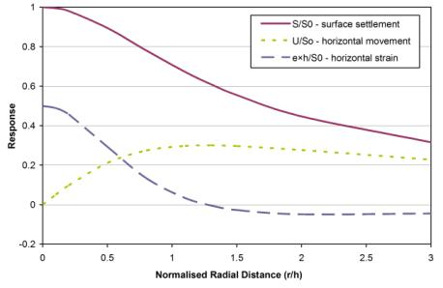
Figure 26 Settlement, radial movement and radial strain for point extraction (© Copyright, Booker & Carter 1984, 1987)
As may be expected, the maximum settlement occurs above the point of extraction. The radial lateral movement reaches a maximum value of about 30 per cent of the vertical settlement at a distance of approximately 1.3 times the depth of the point of groundwater extraction. Horizontal strain at the surface is compressive within a radius 1.3 times the depth of the point of extraction and tensile beyond that distance. The magnitude of tensile strain is small in comparison with maximum compressive strain. The results presented by Lu and Lin show that settlement and horizontal movement take time to develop and that the long-term values represent the maximum values at any particular location. These results change when the effects of anisotropy and time are taken into account.
The long-term results provide a useful measure of potential horizontal movement and horizontal strain. If surface soil cover is present, horizontal strains on the soil surface would be much lower than the values predicted from the analytical solutions. The effects of subsidence at the surface are greatly enhanced by the heterogeneity of soils in terms of thickness, shallow faults and washouts in channels.

Subsidence modelling approaches: compaction
This section discusses modelling approaches to predict the compaction of hydrogeological units due to changes in ground pressure. The analysis methods involve two stages:
prediction of the change in pressure (due to dewatering) within the affected ground
prediction of compaction associated with predicted changes in pressure.
Approaches that predict the changes in pressure associated with coal seam gas extraction involve a selection of:
hydraulic properties – the profile may be considered uniform (e.g. with the hydraulic properties uniform throughout the profile), or may be considered heterogeneous and/or anisotropic
temporal approach – a steady state approach to groundwater flow may be considered (for which pressure does not vary with time), or a transient approach to groundwater flow may be considered (for which pressure varies with time). Results obtained from a steady state approach are equivalent to results obtained from a transient approach at infinite time (i.e. in the long-term) and tends to over-predict the magnitude (and extent) of potential subsidence.
Approaches that predict compaction associated with pressure changes from coal seam gas extraction vary depending on the following considerations:
ground conditions may be considered uniform (for which the geomechanical properties of the entire vertical profile are identical) or may be considered heterogeneous (e.g. multiple hydrogeological units possessing different geomechanical properties). For example, a heterogeneous approach permits the representation of individual coal seams interbedded within sandstone units
compaction may be assumed to be one-dimensional or deformation may be considered in more than one dimension (e.g. where compression occurs in a vertical direction, the rock mass may expand in the horizontal direction). Multi-dimensional analyses may also consider the potentially anisotropic nature of hydrogeological units.
Compaction may be linear (i.e. the rate of compaction depends directly on the magnitude of the change in ground pressure) or may be non-linear (i.e. the rate of deformation varies for a given change in pressure, depending on the magnitude of the pressure). In coal seam gas production environments, it is generally sufficient for modelling approaches to consider linear elastic ground compaction. Linear elastic ground compaction means that deformation at a particular location is directly proportional to the change in pressure at that location. However, non-linear compaction is known to be very important in the large strains created in longwall mining subsidence (especially for accommodating the large relative displacements at the edges of the subsidence trough).
Since geological units in coal seam gas environments are constrained horizontally (by surrounding ground) and effective stress changes are due to groundwater abstraction, linear elastic models may generally be sufficient to capture compaction behaviour adequately. However, steep displacements, and large relative displacements, may be present for coal seam gas development depending on the distribution of wells and the presence of flow barriers and seam offsets. In addition, coal seam compression is non-linear due to the Langmuir strain, therefore linearised compaction may not be appropriate as a boundary condition for the overburden.
In environments where weak surficial soils (e.g. alluvial clays) predominate, it is possible that non-linear modelling of soil behaviour may become important. Where drawdown in soil strength materials does occur this can lead to settlement. This can be addressed by taking account of drainage from the soil horizon into the underlying rock as a result of coal seam gas operation. Non-linear modelling is beyond the scope of this discussion. However, an assessment would generally require some form of analysis or modelling of the groundwater flow within the saturated soil horizons.
The simplest subsidence model considers a uniform profile and long-term pressures (i.e. steady state conditions). Analytical models are sufficient to assess potential subsidence when adopting such simplifications and may provide a useful screening tool.
Modelling approaches increase in their complexity with inclusion of hydrogeological heterogeneity (i.e. adopting different hydraulic or geomechanical properties for different geological units), accounting for geological anisotropy and considering changes in groundwater pressure with time.
Analytical modelling approaches may be utilised to model heterogeneous hydrogeological conditions with varying degrees of complexity, but are generally limited to considering one-dimensional compaction.
Numerical analysis software may be used to model groundwater flow, compaction or the coupled interaction of both. A numerical groundwater flow model (developed using commercially available software such as MODFLOW, FEFLOW or SEEP/W) may be used to calculate groundwater pressure changes, with complex geometry, variable hydraulic properties and transient groundwater flow. The model outputs may then be used in an analytical one-dimensional assessment of compaction.
Commercially available programs such as PLAXIS (finite element) and FLAC (finite difference), couple groundwater flow and compaction processes. These software packages can model the ground in three dimensions with transient groundwater flow. These more complex approaches may be used to provide a more detailed assessment of potential subsidence and take account of mechanical processes, which may be relevant in the vicinity of individual extraction wells.
Table 8 presents four different modelling approaches of increasing complexity (from left to right). The four approaches demonstrate differing treatments of geomechanical properties, hydraulic properties and temporal considerations.
The four approaches are:
Uniform geology model: one-dimensional analytical approach that considers uniform hydraulic and geomechanical properties and a long-term (steady state) groundwater condition.
Variable permeability model (long-term): one-dimensional analytical approach that considers uniform geomechanical properties with variable hydraulic properties and long-term (steady state) groundwater pressures.
Variable ground model (long-term): one-dimensional analytical approach that considers variable geomechanical and hydraulic properties and long-term (steady state) groundwater pressures.
Transient groundwater flow model: a numerical groundwater flow model (under transient flow conditions) to calculate changes in groundwater pressure and adopts those calculated groundwater pressures in a one-dimensional analysis of compaction.
Each approach is illustrated with an example for equivalent conditions (i.e. hydraulic properties and ground geometry) to permit comparison of the different approaches. For the presentation of these examples, it is assumed that the reader has an understanding of the principles of effective stress and the distinction between total head and pressure head. Discussion of these matters is provided by Craig (2004) and Fetter (2001).
Conditions typical of Australian coal seam gas well fields were reviewed for the Gloucester, Gunnedah, Surat and Sydney Basins and the example model conditions were selected to be representative of typical conditions in Australian regions of coal seam gas production for a relatively shallow coal seam.
For the example case, compaction is considered to occur due to elastic deformation of the geological materials. This approach is considered reasonable given that coal seam gas developments in Australia are present in environments that host substantial depths of sedimentary rocks. Geological materials are expected to be constrained in the horizontal direction. Provided that appropriate geomechanical parameter values are adopted for geological units (e.g. coefficient of volume compressibility values relevant to the range of effective stress values experienced by those geological units), compaction in the vertical direction may be calculated based on the methods described in the following sections.

Table 8 Summary of modelling approaches to predict compaction due to changes in groundwater pressure (in order of increasing complexity, from one to four)
Model characteristics | Model 1: Uniform geology (long term) | Model 2: Variable hydraulic conductivity (long term) | Model 3: Variable ground (long term) | Model 4: Transient groundwater response
Groundwater model | Analytical, uniform properties | Analytical, variable properties | Analytical, variable properties | Numerical with variable properties and transient flow (e.g. MODFLOW, FEFLOW, SEEP/W)
Material compression model | Analytical, uniform properties | Analytical, uniform properties | Analytical, variable properties | Analytical, variable properties
Ground profile and groundwater pressure distribution
Dimensionality | Fully one dimensional | Fully one dimensional | Fully one dimensional | Radial (in vicinity of well) or fully three dimensional groundwater flow  One dimensional ground compression
Time: | Long-term | Long-term | Long-term | Can be long-term or may consider progressive development.
Usage | Screening tool | Screening tool | Screening tool | Detailed assessment
Notes: K = hydraulic conductivity, m_{v} = coefficient of volume compressibility, t = time. * Interbedded coal seams allowable.

Examples of modelling approaches
This section provides examples of each of the modelling approaches shown in Table 8. The examples include prediction of compaction due to both changes in groundwater pressure and degassing of coal seams. Figure 27 illustrates the model domain and vertical profile adopted for the examples.
The profile comprises horizontally layered strata, including alluvium and sedimentary geological units underlying and overlying a coal bearing formation (coal measures). The alluvium extends from ground surface to a depth of 60 m (with the water table at 20 m depth), and is underlain by six sedimentary rock units, each of 100 m thickness. One of the rock units is the coal bearing formation, which extends from 360 m to 460 m depth below ground level (refer to Figures 28, 29 and 30). The coal bearing formation is considered to include (potentially numerous) coal seams interbedded with sedimentary units, but the coal seams themselves are not explicitly represented. Instead, the hydraulic and geotechnical properties of the coal seams and sedimentary units in the coal bearing formation have been combined into an amalgamated geological unit. Young’s Modulus for the coal bearing formation in Figure 27 (interbedded sedimentary rock and coal seam units) is 14 GPa and is calculated assuming the vertical thickness of this formation consists of five per cent coal (with the drained Young’s modulus (E) of 2 GPa) and 95 per cent sandstone (with E of 20 GPa).
The coal seam gas production well is considered to depressurise the coal bearing formation to a groundwater head level equal to 35 m above the top of the gas producing (coal bearing) formation. This is typical of the degree of groundwater depressurisation required for gas production to occur (State of Queensland Department of Natural Resources and Mines 2012).
The following sections provide examples of each of the modelling approaches shown in Table 8 based on the above model setting. In these examples, the rock units overlying the coal bearing formation are assumed to remain saturated. Under some circumstances, unsaturated conditions can develop (e.g. where pore pressure falls to zero or becomes negative). Unsaturated conditions would require special treatment, though this would typically indicate the presence of a low hydraulic conductivity horizon, which tend to constrain upward migration of depressurisation impacts and consequently limit subsidence contribution from overlying strata.
For all cases, compaction is assumed to not occur below the base of Sedimentary Rock Unit 5 (Layer 7), which forms the effective base of the model, at a depth of 660 m. Below this depth (not shown on the conceptual diagrams), the pressure head reverts to the undisturbed case and the underlying rock is considered to have very low compressibility.
Table 9 provides a summary of the results of the analyses conducted for the examples.
Table 9 Results of analytical assessment of subsidence for the example cases
Case | Dewatering compaction (mm) | Degassing compaction (mm) | Total compaction (mm)
Uniform Geology (Long Term) | 73 | 24 | 97
Variable Permeability (Long Term) | 62 | 24 | 86
Variable Ground (Long Term) | 48 | 24 | 72
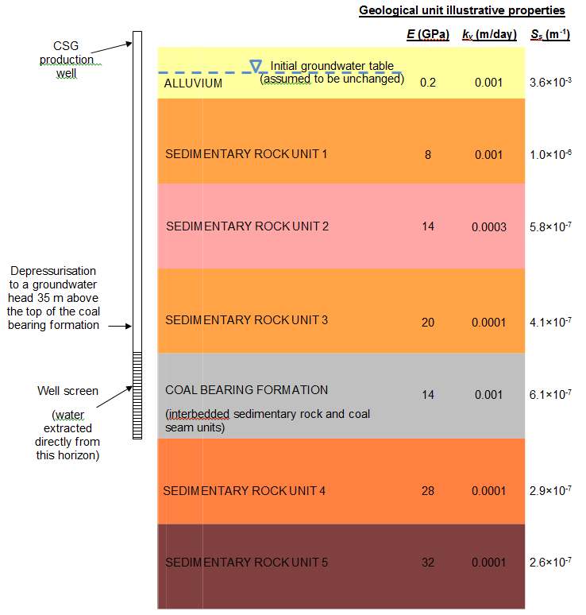
K_{v} is the vertical hydraulic conductivity, E is the drained Young’s Modulus, and S_{s} is the specific storage.
Figure 27 Model domain adopted in examples

Uniform geology model (steady state, one-dimensional)

Approach
Uniform geology models are one dimensional models that calculate potential subsidence at a particular location, as if the geological profile and the change in groundwater pressure distribution are constant over a wide area.
This approach is one of the simplest and least time consuming and provides an estimate of the average subsidence in the long term. Due to the simplifications made by this approach, it may over-estimate potential subsidence over the time scale of the development. It is, however, considered appropriate for screening-level assessment.

Requirements
This approach requires data relating to:
groundwater drawdown over a uniform ground profile (typically considering the longer term)
coefficient of volume compressibility of the uniform ground profile.

Limitations
This approach:
ignores ground heterogeneity and may not be practical for use in environments with varying geological or hydraulic conditions
disregards lateral variations in conditions but is applicable where conditions do not change markedly in the horizontal direction
does not account for interaction between groundwater flow (due to coal seam gas well pumping) and geomechanical effects such as horizontal compression
assumes that at depth, Young’s modulus is high enough and pore pressure change is low enough, that compression is negligible.

Example
The geological profile under consideration is shown in Figure 27. Figure 28 provides an illustrative example of assessment of potential subsidence based on this approach, with the associated calculations presented in Table 10.
The initial groundwater level is 20 m below the ground surface. The groundwater levels in the alluvium are assumed to remain constant during depressurisation. There may, however, be a groundwater seepage loss from the alluvial hydrogeological unit into underlying units.
An average drawdown to 35 m above the top of the coal seam gas bearing formation is assumed, equating to a drawdown to 305 m within the coal seam gas bearing formation. This drawdown is assumed to apply to the full thickness of the coal seam gas bearing formation. The drawdown distribution with depth above the coal bearing formation is assumed to vary linearly from 0 m at the base of the alluvial aquifer to 305 m at the top of the coal bearing formation and be uniform beneath the coal bearing formation.
To compare the result of this example with those from other modelling approaches, a depth-averaged coefficient of volume compressibility has been calculated for the ground profile.
Comparing the subsidence models for the different illustrative examples, this modelling approach may over-estimate or under-estimate predicted subsidence relative to other models due to its simplification of the hydraulic and geomechanical properties of the geological materials. Nevertheless, it provides a relatively simple approach to calculating subsidence that may be used for screening-level assessment.

Ground profile |  |  | Groundwater pressure
 | Groundwater
 | level (mbgl)*
 | 20
 | 325
 | Δϕ_{T} = 305

* denotes metres below ground level
Figure 28 Uniform geology model example

Table 10 Conceptual model calculation table for the uniform geology model approach example shown in Figure 28. The total compaction due to groundwater pressure changes (S) is 72.4 mm.
Geological unit | Depth to bottom of unit (mbgl)* | Thickness (m) | m_{v}  (MPa⁻¹) | Initial pressure head at base of unit (m) | Final pressure head at base of unit (m) | Change in pressure head at base of Unit (m) | Average change in pressure head in Unit (m) | Compression of unit, S_{i} (mm)
Alluvium (unsaturated) | 20 | 20 | - | 0 | 0 | 0 | 0 | 0.0
Alluvium (saturated) | 60 | 40 |  | 40 | 40 | 0 | 0 | 0.0
Sedimentary Rock Unit 1 | 160 | 100 | 5.38x10⁻⁵ | 140 | 38 | -102 | 51 | 2.7
Sedimentary Rock Unit 2 | 260 | 100 | 5.38x10⁻⁵ | 240 | 37 | -203 | 153 | 8.0
Sedimentary Rock Unit 3 | 360 | 100 | 5.38x10⁻⁵ | 340 | 35 | -305 | 254 | 13.4
CSG Bearing Formation | 460 | 100 | 5.38x10⁻⁵ | 440 | 135 | -305 | 305 | 16.1
Sedimentary Rock Unit 4 | 560 | 100 | 5.38x10⁻⁵ | 540 | 235 | -305 | 305 | 16.1
Sedimentary Rock Unit 5 | 660 | 100 | 5.38x10⁻⁵ | 640 | 335 | -305 | 305 | 16.1
* denotes metres below ground level

Variable permeability model (steady state, one-dimensional)

Approach
One step toward reducing the simplifications of the uniform geology model is to account for the variable hydraulic conductivity of hydrogeological units.
This modelling approach is one dimensional and assumes uniform properties for the geological units, but considers that each geological unit may possess a different hydraulic conductivity.
The accuracy of the potential subsidence assessment may be improved by inclusion of hydraulic information. However, this method remains relatively simplified and may not be appropriate beyond screening-level assessment.

Requirements
This approach requires data relating to:
thickness of each geological unit
hydraulic conductivity of each geological unit
coefficient of volume compressibility of the uniform profile.

Limitations
This approach:
ignores heterogeneity with respect to compaction and is not relevant to environments where the compaction characteristics of geological units vary substantially
disregards lateral variations in conditions but is applicable where conditions do not change substantially in the horizontal direction
does not account for interaction between groundwater flow (e.g. due to coal seam gas well pumping) and geomechanical effects such as compression.

Example
Figure 29 provides an example of potential subsidence assessment based on this approach, with the associated calculations presented in Table 11.
Geomechanical properties are consistent with the example for the uniform ground model. However, hydraulic properties are considered variable. The groundwater levels in the alluvium are assumed to remain constant during depressurisation. There may, however, be groundwater seepage loss from the alluvial hydrogeological unit into underlying units. The seepage (denoted q) is calculated for the example. For conservatism (that is, to obtain the maximum subsidence), the seepage is assumed not to reduce the fall in pressure in underlying rock.
The groundwater head changes across the geological units overlying the coal bearing formation therefore vary depending on the hydraulic conductivity of those units. The pressure/depth gradient steepens with depth of the coal due to the reduction in vertical permeability with depth.
Compaction due directly to groundwater pressure changes is calculated for each geological unit. The geomechanical properties are considered identical for all units. The sum of compaction of all the geological units, plus the compaction of the coal due to degassing, yields the total subsidence.
Comparing the predicted subsidence values for the different examples, this example demonstrates that potential subsidence assessed by this model approach may over or under estimate subsidence relative to models that consider more detailed hydraulic and geomechanical conditions (such as the variable ground model; see also the numerical example below), but may predict subsidence of lower magnitude relative to simpler models (such as the uniform geological model).
Ground profile |  |  |  | Groundwater pressure
 | Groundwater
 | level (mbgl)*
 | 20
 | 325
 | Δϕ_{T} =305
* denotes metres below ground level
Figure 29 Variable permeability model example

Table 11 Conceptual model calculation table for the variable permeability model approach example shown in Figure 29. The total compaction due to groundwater pressure changes (S) is 62.3 mm.
Geological unit | Depth to bottom of unit (mbgl)* | Thick-ness (m) | E (GPa) | υ  (-) | m_{v}  (MPa⁻¹) | k_{v}  (m/day) | H_{i}/k_{i}  (day⁻¹) | Total head change, Δϕ, across unit (m) | Initial pressure head at base of unit (m) | Final pressure head at base of unit (m) | Change in pressure head at base of unit (m) | Average change in pressure head in unit (m) | Com-pression of unit, S_{i} (mm)
Alluvium (unsaturated) | 20 | 20 | 0.2 | 0.3 | - | 1.0E-03 | 0.0E+00 | 0 | 0 | 0 | 0 | 0 | 0.0
Alluvium (saturated) | 60 | 40 | 0.2 | 0.3 |  | 1.0E-03 | 4.0E+04 | 0 | 40 | 40 | 0 | 0 | 0.0
Sedimentary Rock Unit 1 | 160 | 100 | 8 | 0.25 | 5.38E-05 | 1.0E-03 | 1.0E+05 | 21 | 140 | 119 | -21 | 11 | 0.6
Sedimentary Rock Unit 2 | 260 | 100 | 14 | 0.25 | 5.38E-05 | 3.0E-04 | 3.3E+05 | 71 | 240 | 148 | -92 | 57 | 3.0
Sedimentary Rock Unit 3 | 360 | 100 | 20 | 0.25 | 5.38E-05 | 1.0E-04 | 1.0E+06 | 213 | 340 | 35 | -305 | 199 | 10.5
CSG Bearing Formation | 460 | 100 | 14 | 0.23 | 5.38E-05 | 1.0E-03 | 1.0E+05 | 0 | 440 | 135 | -305 | 305 | 16.1
Sedimentary Rock Unit 4 | 560 | 100 | 28 | 0.25 | 5.38E-05 | 1.0E-04 | 1.0E+06 | 0 | 540 | 235 | -305 | 305 | 16.1
Sedimentary Rock Unit 5 | 660 | 100 | 32 | 0.25 | 5.38E-05 | 1.0E-04 | 1.0E+06 | 0 | 640 | 335 | -305 | 305 | 16.1
* denotes metres below ground level

Variable ground model (steady state, one-dimensional)

Approach
The simplifications of the uniform geology model may be further reduced by accounting for both the variable hydraulic conductivities and the variable coefficients of compressibility of hydrogeological units.
The accuracy of the potential subsidence assessment may be improved by inclusion of both compaction and hydraulic information. This method is therefore considered an improvement on the variable permeability model approach. However, due to its limitations (listed below) this method may not be appropriate beyond screening-level assessment.

Requirements
This approach requires data relating to the:
thickness of each geological unit
hydraulic conductivity of each hydrogeological unit
coefficient of volume compressibility of each hydrogeological unit.

Limitations
This approach:
disregards lateral variations in conditions but is applicable where conditions do not change substantially in the horizontal direction
does not account for interaction between groundwater flow (e.g. due to coal seam gas well pumping) and geomechanical effects such as compression.

Example
Figure 30 provides an example of potential subsidence assessment based on this approach, with the associated calculations presented in Table 12.
Both geomechanical properties and hydraulic properties vary in this example. The values adopted are consistent with the previous examples. The compaction due directly to groundwater pressure changes is calculated for each geological unit, and is different from unit to unit because both the geomechanical and hydraulic properties are different in each unit. The sum of compaction of all the geological units, plus the compaction of the coal due to degassing, yields the total ground subsidence.
Comparing the example models for the different illustrative examples, this modelling approach may over-estimate or under-estimate predicted subsidence (settlement) relative to other models due to its simplification of the hydraulic and geomechanical properties of the geological materials.
For example, the variation in coefficient of volume compressibility values adopted in this approach provides a more accurate representation of the material properties, thus resulting in a potentially more accurate estimate of subsidence.

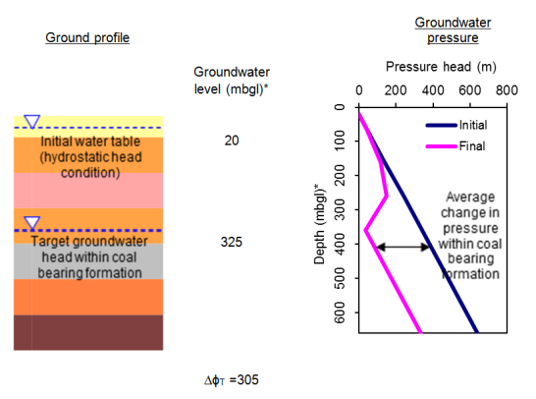
* denotes metres below ground level
Figure 30 Variable ground model example

Table 12 Conceptual model calculation table for the variable ground model approach example shown in Figure 30. The total compaction due to groundwater pressure changes (S) is 47.7 mm
Geological unit | Depth to bottom of unit (mbgl)* | Thick-ness (m) | E  (GPa) | υ  (-) | m_{v}  (MPa⁻¹) | k_{v}  (m/day) | H_{i}/k_{i}  (day⁻¹) | Total head change, Δϕ, across unit (m) | Initial pressure head at base of unit (m) | Final pressure head at base of unit (m) | Change in pressure head at base of unit (m) | Average change in pressure head in geological unit (m) | Compr-ession of unit, S_{i} (mm)
Alluvium (unsaturated) | 20 | 20 | 0.2 | 0.3 | 3.71E-03 | 1.0E-03 | 0.0E+00 | 0 | 0 | 0 | 0 | 0 | 0.0
Alluvium (saturated) | 60 | 40 | 0.2 | 0.3 | 3.71E-03 | 1.0E-03 | 4.0E+04 | 0 | 40 | 40 | 0 | 0 | 0.0
Sedimentary Rock Unit 1 | 160 | 100 | 8 | 0.25 | 1.04E-04 | 1.0E-03 | 1.0E+05 | 21 | 140 | 119 | -21 | -11 | 1.1
Sedimentary Rock Unit 2 | 260 | 100 | 14 | 0.25 | 5.95E-05 | 3.0E-04 | 3.3E+05 | 71 | 240 | 148 | -92 | -57 | 3.3
Sedimentary Rock Unit 3 | 360 | 100 | 20 | 0.25 | 4.17E-05 | 1.0E-04 | 1.0E+06 | 213 | 340 | 35 | -305 | -199 | 8.1
CSG Bearing Formation | 460 | 100 | 14 | 0.23 | 6.16E-05 | 1.0E-03 | 1.0E+05 | 0 | 440 | 135 | -305 | -305 | 18.4
Sedimentary Rock Unit 4 | 560 | 100 | 28 | 0.25 | 2.98E-05 | 1.0E-04 | 1.0E+06 | 0 | 540 | 235 | -305 | -305 | 8.9
Sedimentary Rock Unit 5 | 660 | 100 | 32 | 0.25 | 2.60E-05 | 1.0E-04 | 1.0E+06 | 0 | 640 | 335 | -305 | -305 | 7.8

* denotes metres below ground level

Transient groundwater response model (transient flow)

Approach
This modelling approach considers the transient (temporal) groundwater pressure response due to water extraction under coal seam gas production.
Detailed numerical modelling of the changes in groundwater pressure in the vicinity of proposed coal seam gas operations take account of the hydraulic properties of the profile and the details of the coal seam gas extraction development (such as well spacing). The modelling approach explicitly models a series of hydrogeological layers with adopted parameters, which represent real geological strata.
Modelling of potential subsidence in the vicinity of a well field is carried out using a localised groundwater flow model (using numerical modelling software such as ECLIPSE and SEEP/W). The flow and pressure regime in the vicinity of a single well may be modelled as representative of wells in the well field, for which a radial flow model may be adopted.
Modelling of wider regional impacts is carried out using three-dimensional regional groundwater flow models (using numerical modelling software such as MODFLOW or FEFLOW). The coal seam gas extraction process is typically represented by either a specified rate of water extraction or a specified pressure change in the target coal seam.
Calculation of the compaction of geological strata typically considers one dimensional compaction, based on the groundwater pressure changes predicted by the groundwater flow model, and the variability of material compressibility.

Requirements
This approach requires data relating to the:
geometry of each geological unit
hydraulic properties (permeability, storativity) of each geological unit
coefficient of volume compressibility of each geological unit.

Limitations
This approach:
does not account for interaction between groundwater flow (e.g. due to coal seam gas well pumping) and geomechanical effects such as horizontal movement
disregards lateral variations in conditions but is applicable where conditions change very slowly in the horizontal direction
some groundwater models over-predict groundwater depressurisation, thereby over-predicting subsidence, in the immediate vicinity of the production well(s).

Example
This example illustrates transient groundwater flow and associated subsidence in the vicinity of a coal seam gas production well. The groundwater flow in a coal seam gas well field is explicitly modelled using numerical groundwater flow software.
A well spacing of 800 m is considered, which lies within the range of spacings typical of Australian coal seam gas well fields. Wells in the well field are assumed to be maintained such that consistent extraction is carried out across the well field. Thus, there is no net groundwater flow at the mid-point between two wells (i.e. at 400 m distance from the well in this example).
The numerical model domain is shown in Figure 31. The domain is axisymmetric (about the left hand side) and considers transient groundwater flow (flow may change with time) radially towards a single coal seam gas production well. As shown in Figure 31, the adopted model domain extends 400 m in the lateral direction, with no flow at the right-hand extremity, and a well is located at the left-hand extremity of the domain.
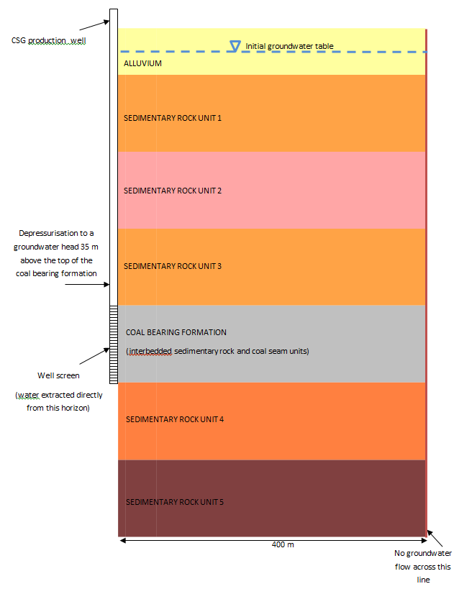
Figure 31 Transient groundwater response model example
In this example, as in the other examples, groundwater was assumed to be depressurised to a groundwater head level 35 m above the top of the coal seam gas bearing unit.
The groundwater pressure within the Alluvium geological unit is considered to remain constant, consistent with the other examples discussed here. In cases where soils are potentially subject to groundwater pressure changes due to coal seam gas production, this should be accounted for and the compaction of the soils assessed (including non-linear compaction).
As pumping of groundwater from the production well progresses with time, dewatering causes a reduction in the groundwater pressure. Figure 32 displays model results showing the pore water pressure reduction over the full ground profile modelled after three months and after one year of pumping for the ground profile shown in Figure 32.
Subsidence can be calculated based on those pressure changes in the ground predicted by the numerical groundwater flow model. One dimensional (vertical) compaction is calculated in the same way as detailed in the above model examples, with the changes in pore water pressure taken from the groundwater model used in the calculation. By calculating the vertical compaction for all geological units in the profile at various distances from the well, a subsidence profile (i.e. magnitude of subsidence with distance from the well) can be produced at any given time (i.e. duration since dewatering began).
Figure 33 shows the calculation process for equating subsidence directly due to groundwater depressurisation over the vertical profile at a single location (specific distance) from the well.
The compaction directly due to groundwater pressure changes, S, for the geological unit, i, is:
where m_{v} is the coefficient of volume compressibility, Δσ'_{i} is the change in vertical effective stress and H_{i} is the thickness of geological unit i, n is the total number of geological units experiencing a change in ground pressure.
By dividing each geological unit into a number of layers (as shown in Figure 33) can provide improved accuracy in the calculation of subsidence, because the vertical variation in pressure change across each geological unit is accounted for.
Figure 34 shows the predicted subsidence profile with distance from the well for this example, based on the subsidence calculated at each of those horizontal distances, after various periods of coal seam gas extraction.
Figure 34 presents a three dimensional orthographic projection of the predicted ground profile after five years of operation in the vicinity of two production wells (for this example case). Subsidence is greatest near to the wells, where ground depressurisation is greatest. The ground profile was obtained by superposition of two solutions calculated by an axisymmetric two-dimensional model.
In the previous modelling approaches, the specified pressure within the coal seam gas bearing formation was assumed to be identical vertically across that unit. This provides consistency with the previous examples, permitting comparison. In reality, however, the pressure may vary across the unit. Applying a constant head boundary condition uniformly over the coal seam gas bearing formation may yield different predicted groundwater pressures and therefore different subsidence estimates relative to applying a varying head condition over the coal seam gas bearing formation.

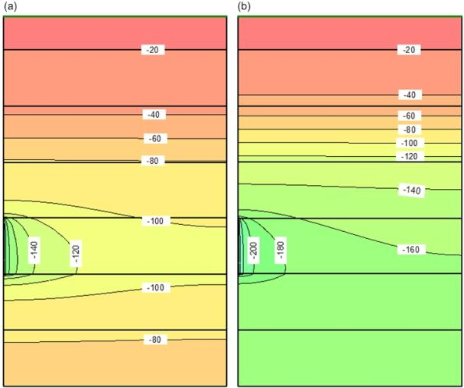
Figure 32 Transient groundwater response model results: groundwater drawdown (in m) after (a) three months of pumping, and (b) two years of pumping

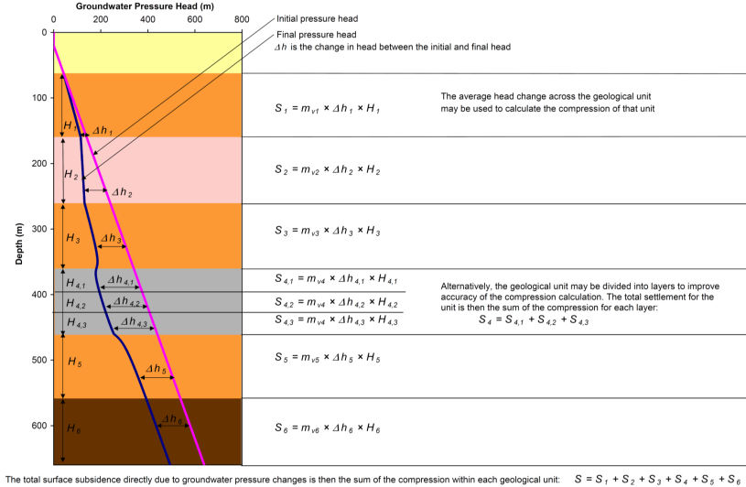
Figure 33 Illustration of the calculation process for compaction due directly to groundwater pressure changes at a specific location
Figure 34 Example predicted subsidence with distance from production well after various periods of coal seam gas extraction

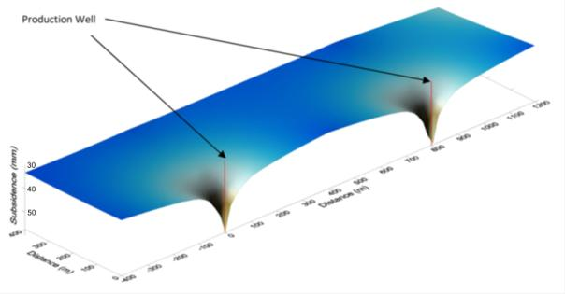
Figure 35 Example of long-term predicted ground subsidence in the vicinity of two production wells (© Copyright, Gray et al. 2013; Rotter & Best 2013)

Selection of material parameters for numerical models
To accurately model the behaviour of the ground, numerical models require various parameters describing the mechanical and hydrogeological properties throughout the profile.
For an elastic analysis, the parameters required include Young’s modulus, Poisson’s ratio and hydraulic conductivity. There will often be some degree of uncertainty in assigning values for material parameters, due to the difficulty in their measurement and the variability of the ground. Often a sensitivity analysis will be undertaken to understand how model outcomes respond to changes in the values of the various input parameters. In some cases, conservative values of certain input parameters may be selected to provide upper or lower bound model results to a particular problem.

Young’s modulus (E)
Young’s modulus is an elastic property of rock and soil. It is also known as the deformation modulus or the elastic modulus. For fractured rock masses, the Young’s modulus represents the combination of intact rock and fracture deformability. Normal stress applied to rock fractures increases the stiffness of the fracture as the aperture reduces, which in turn results in the Young’s modulus itself increasing. Under ideal conditions, the closure of fractures will increase the Young’s modulus of a rock mass to a maximum value, which is equal to that of the intact rock.
Young’s modulus values may be selected based on published data for a range of Australian rock types and depths. Gale and Fabjanczyk (1993) provide an overview of the range of Young’s modulus values and unconfined compressive strengths (q_{u}) for a range of Australian rock types, shown in Figure 36, with lines indicating ratios of E/q_{u}. In Figure 36, no differentiation is made between values for intact rock and values for a fractured rock mass.
Brown and Windsor (1990) provide a table of 146 measurements of the modulus of elasticity (E) from a number of locations, depths and rock types in Australia. Of these, three are derived from laboratory tests, two are derived from other tests, and three are averages from several values. The origin of the remaining 138 measurements is not explicitly stated but they are believed to have been made during in situ stress measurements.
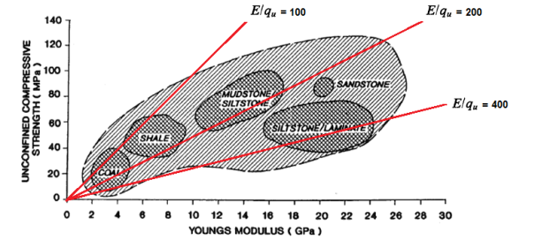
Figure 36 Young’s modulus and unconfined compressive strength for Australian rock types (© Copyright, Gale & Fabjanczyk 1993)
From Figure 36, as a first estimate for subsidence calculations, an E value of 200 q_{u} represents a typical value for Australian sandstones, siltstones, shales and coals.
Alternatively, Young’s modulus may also be calculated from a formula relating the unconfined compressive strength (q_{u}) and Geological Strength Index (GSI) from, respectively, the intact rock and rock mass. The Young’s modulus may be calculated by the formula, based on the Hoek Brown rock mass strength criterion (Galera et al. 2007):
$$E_{m}\left(GPa\right)= \sqrt{\frac{q_{u (MPa)}}{100}} . {10}^{\frac{(GSI-100)}{40}}$$
Using this formula, Table 13 shows how E varies with varying q_{u} and GSI.
Table 13 Young’s modulus (E) calculated from unconfined compressive strength (q_{u}) and geological strength index (GSI)
q_{u} (Mpa) | GSI 80 | GSI 60 | GSI 40 | GSI 20
100 | 56.2 | 17.8 | 5.6 | 1.8
80 | 50.3 | 15.9 | 5.0 | 1.6
50 | 39.8 | 12.6 | 4.0 | 1.3
20 | 25.1 | 8.0 | 2.5 | 0.8

A hydrogeological unit may consist of numerous layers or regions with differing moduli. Based on the theory of elasticity, the equivalent Young’s modulus of a horizontally layered unit undergoing vertical compression, with total thickness D, containing n layers each with thickness d_{i} and Young’s modulus E_{i} is given by the equation shown in Figure 37.
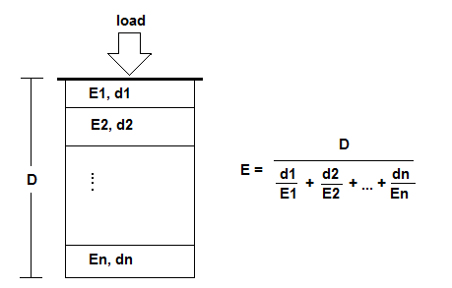
Figure 37 Equivalent Young’s modulus for a horizontally layered unit (© Copyright, Gale & Fabjanczyk 1993)

Poisson’s ratio (ν)
Axial compression of a substance produces a lateral strain. The ratio of axial compression to lateral strain is called Poisson’s ratio. Poisson’s ratio for rocks is often assumed to be 0.25 (Goodman 1989). Table 14 shows Poisson’s ratio, unconfined compressive strength, and Young’s modulus divided by unconfined compressive strength for a variety of rocks in the US. Poisson’s ratio can be seen to vary between 0.11 and 0.46 for the rock samples in the table. A Poisson’s ratio of 0.5 is an upper limit and signifies isotropic compressibility of the substance.
Table 14 Unconfined compressive strength (q_{u}), modulus ratio (E/q_{u}) and Poisson’s ratio (ν) for some rock types, as measured in the US (© Copyright, Goodman 1989)
Description | q_{u} (MPa) | E/q_{u} | ν
Berea sandstone | 73.8 | 261 | 0.38
Navajo sandstone | 214.0 | 183 | 0.46
Tensleep sandstone | 72.4 | 264 | 0.11
Hackensack siltstone | 122.7 | 214 | 0.22
Solenhofen limestone | 245.0 | 260 | 0.29
Bedford limestone | 51.0 | 559 | 0.29
Tavernalle limestone | 97.9 | 570 | 0.30
Flaming Gorge shale | 35.2 | 157 | 0.25
Micaceous shale | 75.2 | 148 | 0.29

Coefficient of volume compressibility (m_{v})
It can be shown that, for elastic deformation, where rock is constrained laterally and thus compression is one dimensional, the coefficient of volume compressibility, or constrained modulus, m_{v,} is related to the Young’s modulus and Poisson’s ratio of the hydrogeological unit by the formula:
$$m_{v}=\frac{(1-2ν)(1+ν)}{E(1-ν)}$$
Thus, for a Poisson’s ratio of 0.20, m_{v} = 0.9 / E. This formula permits exploration of the sensitivity of m_{v} to Poisson’s ratio for a fixed Young’s modulus. This is shown in Figure 38 and it can be observed that calculated m_{v} values for Poisson’s ratios between 0.1 and 0.3 vary by less than 30 per cent.
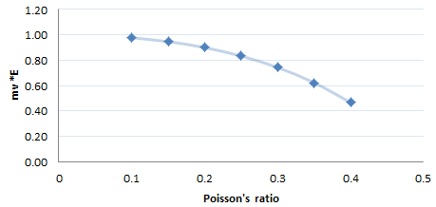
Figure 38 Sensitivity of m_{v} to Poisson’s ratio for a fixed Young’s modulus

Hydraulic conductivity
Hydraulic conductivity is a measure of the rate at which groundwater moves through soil or rock. The hydraulic conductivity of soils depends on soil texture and structure and generally varies between 10 m/s (clean gravel) to 10⁻¹¹ m/s (homogeneous clay). Rock masses also exhibit a broad range of hydraulic conductivities. The hydraulic conductivity of a rock mass is controlled by fractures which provide flow paths for water and the hydraulic conductivity of the intact rock. For rock formed by sedimentary processes, the hydraulic conductivity in the horizontal direction is usually higher than the hydraulic conductivity in the vertical direction, due to the layering associated with the geological development of the material. Depth also plays a role and, as a general rule, the hydraulic conductivity of soil and rock declines with depth, due to the fact that increasing stress (pressure) reduces the secondary (fracture) porosity of the material. This effect can be seen in Figure 39.
A hydrogeological unit may contain many sub-units of differing hydraulic conductivity (Table 15). For example, the Condamine alluvium in the Surat Basin contains sub-units with horizontal hydraulic conductivity varying between 3x10⁻² m/day (3.5x10⁻⁷ m/s) and 8.6 m/day (1x10⁻⁴ m/s). Figure 40 displays measured values of horizontal hydraulic conductivity in different formations within the Surat Basin, based on assessments provided in published coal seam gas-related studies. A relatively wide range of hydraulic conductivity is reported for of each formation. In selecting a value for modelling, judgement is required if field-measured or calibrated magnitudes are unavailable.
For the Surat Basin, University of Southern Queensland (2011) provided discussion of horizontal and vertical hydraulic conductivity values for each hydrogeological unit.

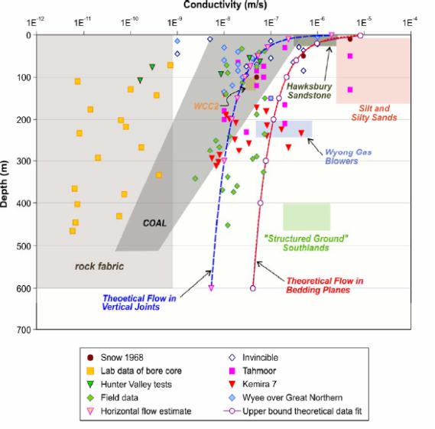
Figure 39 Reduction in hydraulic conductivity with depth (© Copyright Aquaterra Consulting 2009)
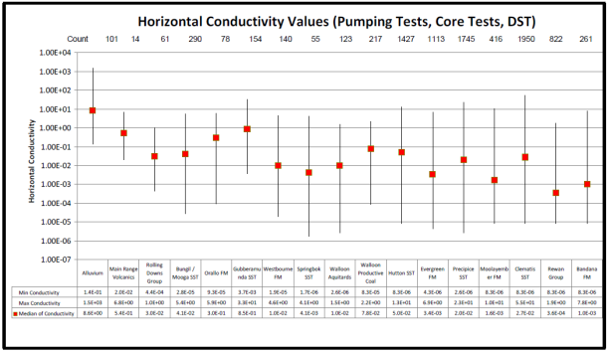
Figure 40 Measured horizontal hydraulic conductivity for formations in the Surat Basin (Queensland Water Commission 2012)

Table 15 Hydraulic conductivity of formations in the Surat Basin (Coffey Environments 2012)
Hydrogeological unit | Horizontal hydraulic conductivity (m/day) | Kv:Kh ratio | Specific storage (m⁻¹)
Condamine River Alluvium | 5 (0.01 - >30) | 1:10 | 0.05 (0.04 - 5x10⁻⁸
Gubberamunda Sandstone | 0.5 (0.1 - 5) | 1:10 | 5x10⁻⁶ (1x10⁻⁴ - 10⁻⁷)
Kumbarilla Beds | 0.1 | 1:50 | 5x10⁻⁶
Westbourne Formation | 0.001 | 1:100 | 5x10⁻⁶
Springbok Sandstone | 0.5 | 1:10 | 5x10⁻⁶
Juandah Coal Measures | 0.001 (0.0001 - 1) | 1:100 | 5x10⁻⁶ (6x10⁻⁶ - 6x10⁻⁷)
Tangalooma Sandstone | 0.1 | 1:50 | 5x10⁻⁶
Taroom Coal Measures | 0.001 (0.0001 - 1) | 1:100 | 5x10⁻⁶
Durabilla/Eurombah Formation | 0.05 (0.03 - 0.14) | 1:50 | 5x10⁻⁶
Hutton Sandstone | 0.1 (0.05 - 1.25) | 1:50 | 5x10⁻⁶ (3x10⁻⁶ - 1x10⁻⁸)
Evergreen Formation | 0.001 (0.008) | 1:100 | 5x10⁻⁶
Precipice Sandstone | 1 (0.1 - 4) | 1:10 | 5x10⁻⁶ (5x10⁻⁸ - 1x10⁻⁷)
Triassic (upper 200m) | 0.0001 | 1:50 | 5x10⁻⁶

Specific storage (S_{s})
The specific storage, for a saturated material, is the amount of water expelled per unit volume, due to compaction of the solid skeleton and expansion of water, resulting from a unit decline in hydraulic head. Specific storage is usually expressed in m⁻¹.
Specific storage, S_{s}, for a porous medium is described by:
$$S_{s}= ρ_{w }g(α+nβ)$$
where:
Ρ_{w} is the density of water (M/L³)
g is the acceleration due to gravity (L/T³)
α is the compressibility of the aquifer skeleton (LT²/M) and is equal to m_{v}, the coefficient of one dimensional consolidation
n is the porosity of the material (dimensionless)
β is the compressibility of water (LT²/M).
For the case of fractured rock media, the specific storage of representative elementary volume of the medium has a non-linear contribution from fractures. The storativity (unitless) for a fracture is given by (Elsworth & Doe 1986):
$$S= ρ_{w }(1/k_{n}+bβ)$$
where:
b is the average fracture aperture (L)
k_{n} is the fracture normal stiffness (M/LT²)
Younger (1993) provides a table with specific storage values for various soil types which is reproduced as Table 16.
Table 16 Values of specific storage for given values of aquifer compressibility, assuming porosity of 15 per cent (© Copyright, Younger 1993)
Typical lithologies | Aquifer compressibility  (α) m s²/kg | Specific storage  (m⁻¹)
Clay | 10⁻⁶ | 9.81 x 10⁻³
Silt, fine sand | 10⁻⁷ | 9.82 x 10⁻⁴
Medium sand, fine gravel | 10⁻⁸ | 9.87 x 10⁻⁵
Coarse sand, medium gravel, highly fissured rock | 10⁻⁹ | 1.05 x 10⁻⁵
Coarse gravel, moderately fissured rock | 10⁻¹⁰ | 1.63 x 10⁻⁶
Unfissured rock | 10⁻¹¹ | 7.46 x 10⁻⁷

It is important to recognise the relationship between specific storage and the coefficient of one dimensional compressibility of a water bearing formation. These quantities are typically among the data requirements in commercial software programs for analysis of groundwater flow and geomechanical deformation. The software may contain implicit assumptions; for example, water is often considered to behave as an incompressible fluid. It is important to recognise such simplifications so that appropriate parameters can be selected.

Subsidence monitoring techniques
Subsidence monitoring is conducted to gain an understanding of the threat subsidence poses to assets and the environment. It can provide early warnings of subsidence approaching levels that pose a risk to the environment or assets such as infrastructure; however, in many cases it is difficult to define triggers or thresholds for action, since subsidence is a slow, displacement-controlled process. Monitoring is also a means of testing subsidence predictions from numerical modelling. Data obtained from monitoring may be used to predict future subsidence extents and magnitudes.
Changes to the ground surface that may be measured include changes in elevation, horizontal tensile strain, changes in tilt and an increase in ground curvature. Most importantly, subsurface or groundwater impacts may not be definable from surface monitoring or displacements alone; for example, groundwater level measurements and water quality analyses may also be needed.
A monitoring program must commence prior to coal seam gas extraction if it is to provide appropriate baseline conditions. The first phase is to establish the existing ground profile and identify existing ground movements (if occurring). As coal seam gas extraction commences, monitoring may be undertaken over the project area at time intervals to be decided from predictive modelling or other means.
Monitoring may be carried out with a range of instrumentation. A variety of monitoring techniques are discussed below, and indications of the accuracy, methods of use and suitability for subsidence monitoring, are provided.
Following the section on instrumentation, a detailed framework for monitoring subsidence using specific methods is provided.

Measurable effects of subsidence
Subsidence induced by groundwater withdrawal may be observed and monitored, either by sight or with a planned monitoring program using selected equipment.
Visually observable effects of subsidence include surface cracking and rock falls. Cracking of buildings may also occur as a result of subsidence.
The following effects are not always observable by sight but may be measured using instrumentation:
vertical displacement of the ground surface
widening of cracks in ground at the surface
changes to the angle of tilt or slope of the ground surface
changes in strain of the ground surface
changes in groundwater pressure at specified locations below ground (this is a cause of subsidence and not an effect)
deformation, movement or tilt at locations below the ground surface.
Figure 41 illustrates these effects.
Another important parameter, used to measure the magnitude of differential settlement between two points, is the Deflection Ratio. The Deflection Ratio is defined as the departure of the ground surface from an initially straight segment over a nominated distance.

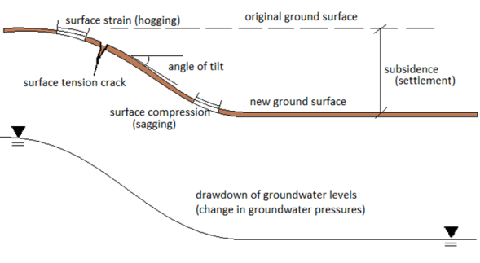
Figure 41 Measurable effects of subsidence

Description of techniques
The techniques which can be used for monitoring and measuring surface subsidence are:
visual Observation
conventional Levelling
campaign and permanent Global Positioning System (GPS)
Interferometric Synthetic Aperture Radar (InSAR)
Light Detection and Ranging (LiDAR) or Airborne Laser Survey (ALS)
borehole extensometers
tiltmeters
time domain reflectometry
piezometers (for measuring changes to groundwater pressure and for sampling water quality)
strain gauges (for measuring horizontal strain).
Discussion of each of these measurement techniques is provided below.

Visual observations
Visual observations may be used as a first tool to monitor the effects of surface subsidence. In particular, any newly formed tension cracks or fracturing in rocks and soil at the surface can indicate ground curvature or horizontal strain resulting from subsidence. This means of observing the effects of subsidence does not provide knowledge of the actual magnitude of vertical displacement and other possible causes of the observed effect may be responsible. GSS Environmental (2012) describes visual monitoring of the effects of longwall mining induced subsidence at the Dendrobium mine, NSW. Although the ground response to coal seam gas extraction is likely to be more subtle than the substantial deformation that accompanies longwall mining, the monitoring techniques described in GSS Environmental (2012) are relevant to the visual monitoring of subsidence due to coal seam gas extraction. Particular attention was paid to any new fractures in rock outcrops, to rock falls, to changes in water levels in ponds or creeks and to any signs of gas emissions at the surface. Figure 42 illustrates cracking observed in a natural sandstone exposure. A high level of interpretation may be required to distinguish between naturally occurring cracks and those due to subsidence.
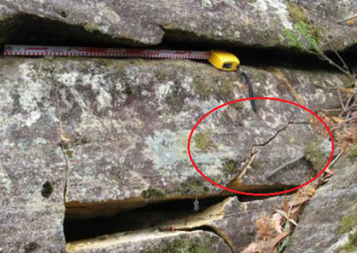
Figure 42 Tension crack in rock outcrop caused by longwall mining induced subsidence (© Copyright, GSS Environmental 2012)

Conventional levelling
Conventional levelling refers to the measurement of ground elevation and position using traditional surveying equipment. Levelling is usually carried out with an optical level and a graduated measuring staff. Ground elevation may also be measured using a theodolite. Elevations are referenced to precisely surveyed locations called benchmarks. The network of benchmarks is known as the Australian National Levelling Network (ANLN). These benchmarks have a measured height above mean sea level or Australian Height Datum (AHD). Australian National Levelling Network benchmarks are often found at the side of roads.
Over long distances, conventional levelling can produce accurate results but can be time consuming. Accuracy for standard conventional levelling is 8 mm times the square root of the distance in kilometres. This gives accuracies of about 25 mm over 10 km distance from the benchmark and 80 mm over 100 km distance (ICSM 2012). In some areas it may be difficult to achieve theses accuracies, such as in heavily forested, hard to access or very steep terrain. Standard accuracy requires a good line of sight between observing stations and skilled survey staff.
For subsidence induced by coal seam gas production, especially in areas with readily available benchmarks, conventional levelling may provide a simple approach to accurately monitoring subsidence. Conventional levelling results may be combined with Global Positioning Systems (GPS) levelling to provide a clearer picture of the magnitude and extent of subsidence.
Benchmarks must be located at positions that are not subject to movement from the subsidence processes. The establishment of stable benchmarks may pose practical difficulties where subsidence impacts are widespread. Global Positioning Systems may be used to calibrate benchmarks that are disturbed by subsidence if a time history of elevation is recorded.

Global positioning system
The GPS is a constellation of orbiting satellites, which provide navigational data to users with GPS receivers. The GPS satellites orbit the earth every twelve hours, emitting continuous navigation signals. Users with GPS receiving equipment can receive these signals to calculate time, location and velocity.
A single GPS receiver, regardless of its quality, can now estimate its position to an accuracy of 10 to 15 m horizontally and 30 m vertically. By using two GPS receivers tracking the same satellites simultaneously, it is possible to determine their relative difference to millimetre accuracy (Surveyor-General Victoria 2006). If one receiver is placed on a known survey benchmark, the position of the other receiver can thus be determined to high accuracy. This arrangement is shown in Figure 43.

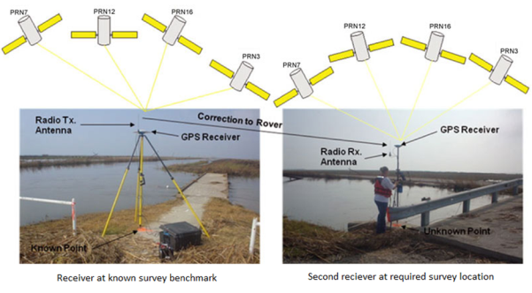
Figure 43 Using two GPS receivers to obtain accurate survey data (USGS 2012)
A static GPS survey involves both receivers being held in position for a fixed amount of time, from 10 minutes to 6 hours, until achieving a desired accuracy. With this technique, a base vertical accuracy of 10 mm is achieved with a further reduction in accuracy of 1 mm per km distance from the chosen survey benchmark. For example, a survey 20 km away from a reference location may achieve a vertical accuracy of 10 mm + 20 mm = ± 30 mm. Greater accuracies are possible for horizontal positioning (USGS 2012).
GPS has many advantages over conventional surveying techniques. GPS does not require line of site between observing stations and can be used day or night and in low visibility conditions. It must be noted however, that GPS receiving stations require a relatively clear view of sky to receive transmitted satellite signals. Care must also be taken in merging GPS elevation data (which uses a mathematical representation of the Earth’s surface as a datum - WGS84 datum) with other elevation data (which may make use of other survey reference datum).

Interferometric Synthetic Aperture Radar
Interferometric Synthetic Aperture Radar (InSAR) uses radar signals emitted from satellites orbiting the earth. The phase component of reflected radar signals is used to measure apparent changes in the distance to the land surface. Ordinary radar on a typical satellite has poor ground resolution (about 5 to 6 km) because of the restricted size of the antenna on the satellite. Synthetic Aperture Radar (SAR) takes advantage of the motion of the spacecraft along its orbital track to mathematically simulate a larger antenna to produce a high-resolution scan or image.
Radar waves are reflected from the Earth’s surface and returned to the satellite, as shown in Figure 44. Interferometric processing of the phase information received by the satellite provides topographic information, with SAR images taken at the same location but acquired at different times yielding information on ground movement. Differential interferograms (DifSAR) are created by subtracting the topography recovered from a first pass with that from a subsequent pass, with the result showing the change in elevation of the ground surface between image times. A conceptual interferogram is shown in Figure 44.

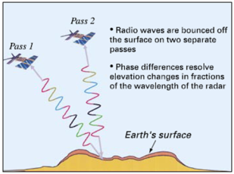
Figure 44 Schematic illustration of how InSAR works (USGS 2005)
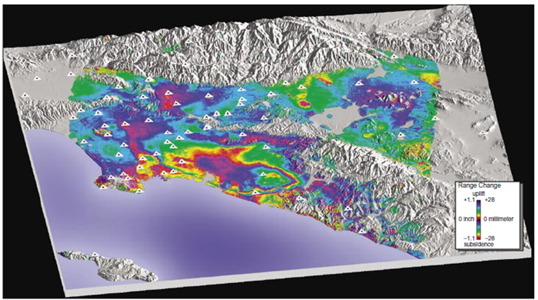
Figure 45 Interferogram showing deformation in the Los Angeles Basin from April 1998 to May 1999 (USGS 2005)
Different wavelengths may be used in DifSAR. X-, C- and L- band radar have 30 mm, 56 mm and 235 mm wavelengths, respectively. The shorter wavelengths are more sensitive to changes in the ground surface but also suffer greater attenuation and noise from vegetation or atmospheric effects (Ge et al. 2007). Typical phase accuracy is about one-fifteenth of a wavelength, which is 2 mm for the most sensitive X-band radar. However, deformation accuracy is generally a factor of two to five times less than phase accuracy because of signal delays due to lateral variations in atmospheric moisture (Amelung et al. 1999).
In areas where the atmosphere is dry and surface vegetation is sparse, DifSAR has been shown to produce results that agree closely with conventional or GPS levelling techniques; with DifSAR and GPS levelling agreeing to within 5 to 10 mm, for total subsidence of 40 mm where subsidence was surveyed at a number of fixed benchmarks (Youden et al. 2004). In areas of steep topography (Colesanti & Wasowski 2006) and dense vegetation (Marghany 2012), DifSAR is less accurate. Inaccuracies are also present where changes occur to the ground surface between satellite observations (for example, construction of new buildings or removal of vegetation) (Carnec & Delacort 2000). Another potential problem in some areas is that the use of DifSAR may be restricted by a lack of available satellites.
DifSAR technology has grown rapidly in recent years in its applicability and sophistication. When combined with GPS or conventional levelling, in urban or non-vegetated areas without steep terrain, DifSAR can be used to measure ground deformation problems, such as subsidence, over large areas and to a high degree of accuracy. For example, a 5 to 10 mm agreement with GPS levelling may be possible (Youden et al. 2004). DifSAR has been successfully used in Australia to detect small ground deformation over large areas (Ge et al. 2003). For measurement of subsidence due to coal seam gas production, it may be possible to use cleared zones or built up areas as fixed reference points where DifSAR can be used to produce results to a high degree of accuracy without noise effects due to vegetation. Radar reflectors may also be used to provide a number of stable reference points (Youden et al. 2004).
Industry representatives and coal seam gas experts attending Coffey Geotechnics Pty Ltd’s workshop held on 24 August 2012 (see Appendix A) considered DifSAR one of the most effective and practical subsidence monitoring methods for coal seam gas production projects.

LiDAR or ALS monitoring
LiDAR (Light Detection and Ranging) or ALS (Airborne Laser Survey) are different names for the same technique. In Australia, ALS is the most commonly used term. ALS uses pulsed light emitted in a swathe, generally from an aerial laser system mounted beneath an aircraft or helicopter. The laser pulses are reflected by the ground surface back to a receiver, enabling topographic data to be calculated by measuring the time taken for the pulses to return. Typically, the data is at a resolution of between 0.5 and 10 points per square metre, depending on the monitoring medium (with helicopter surveys generally giving the greatest density of points).

Borehole extensometers
Borehole extensometers are deeply anchored benchmarks installed to measure ground settlement. To construct an extensometer, a hole is drilled to a depth where strata mark the base of the area to be investigated. The hole is then lined with a steel casing with slip joints, which allows the casing to settle in concert with the ground. The borehole annulus is then grouted. Inside the steel casing, an inner pipe rests on a concrete plug at the bottom of the borehole, or is anchored (with a solid metal stub or cylinder) at a fixed depth in the borehole, and extends to the top. The inner pipe transfers the stable elevation at the concrete plug or fixed anchor to the surface. It is possible for many anchors to be placed in the same borehole to measure displacement down the depth profile. A measurement from the top of the pipe to the surrounding land surface gives the amount of settlement that has occurred, as shown in Figure 46 (Harris Galveston Subsidence Districts 2012).
The length of the inner measuring pipe must be invariant. The borehole must be as straight and as vertical as possible to minimise downhole friction of the casing with the measuring pipe, as this may cause deformation of the measuring pipe and lead to inaccurate measurement of subsidence. With careful design and construction, borehole extensometers may achieve strain resolutions finer than one in a million over depths of 200 m to 1000 m (yielding a resolution of 0.2 mm over 200 m and 1 mm over 1000 m) (Riley 1986).
The use of borehole extensometers permits direct measurement of the amount of settlement that occurs as a result of subsidence due to coal seam gas production. For example, a resolution to one in a million (Riley 1986) over a 100 m thick uniform stratigraphic unit enables the measurement of settlement to an accuracy of better than ± 1 mm. Borehole collars can be benchmarked and resurveyed to provide relative vertical displacement throughout the section. Surveying can be completed by conventional methods or by GPS. The information provided by this type of monitoring is restricted to the response at the selected location.
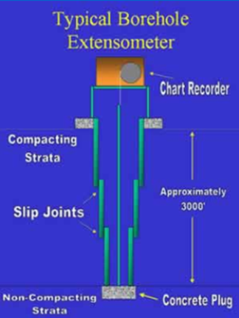
Figure 46 Borehole extensometer (© Copyright, Harris Galveston Subsidence Districts 2012)

Tiltmeters
Tiltmeters measure changes in the slope of the ground on two orthogonal axes. Tilt is specified in terms of degrees or radians or vertical displacement over horizontal distance (for example, in units of mm/m).
Tiltmeters only measure effects at the ground surface. The tiltmeter is mounted on a plate fixed to rock or another firm stable surface. Rapid measurements can be made and it is relatively straightforward to set up and make observations (Wyllie & Mah 2004). Very high resolution tiltmeters are now available, which can detect changes in tilt of one nanoradian (Davis et al. 2000). Slope Indicator (2012a) offers tiltmeters with a repeatability of ±3 arc seconds, or 0.015 mm/m (the repeatability of an instrument is its ability to obtain consistent results when measuring the same part, many times over).
For subsidence assessment, an array of tiltmeters at different positions may be used to send continuous signals measuring the change in slope of the ground surface. The data can then be integrated to show the relative change in position of the ground surface. The integration constant can be chosen to specify the height of a reference point with known elevation. Figure 47 illustrates this process for a two dimensional case. If the reference point is not affected by subsidence, a measurement of vertical subsidence can be inferred at any point within the tiltmeter array by comparing the new ground surface with the original ground surface, using the reference point as a fixed elevation for both cases. If the reference point is affected by subsidence, calibration with GPS or conventional levelling will be required to find the elevation of the (subsided) reference point.
Tiltmeter arrays have been successfully used to monitor oil field subsidence in the US (Davis et al. 2000) and to monitor hydraulic fracturing operations.
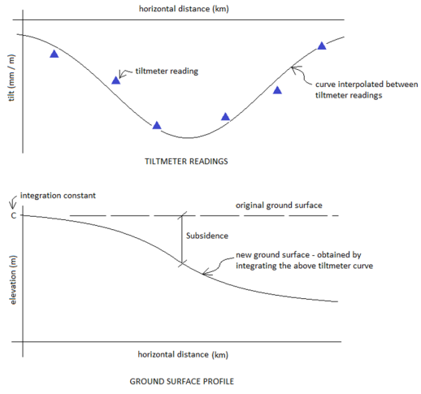
Figure 47 Using tiltmeter readings to establish a ground surface profile (© Copyright, Davis et al. 2000)
Using tiltmeters, it may be possible to obtain an accurate measurement of the deflection ratio. The deflection ratio is a useful parameter in estimating the potential damage caused to structures as a result of subsidence, in particular where subsidence causes hogging (refer to Figure 41).
Very high tilt measurements have been observed in coal mining areas of Australia. Tilt of more than 80 mm/m (about 4.6 degrees) has been observed as a result of longwall mining-induced subsidence at Hunter Coalfield, NSW (MSEC 2012). Tilt of around 40 mm/m per meter of subsidence was observed by Ashton Coal as a result of longwall mining (Mining Research & Consulting Group 2009). Tilt associated with coal seam gas extraction is expected to be much smaller than this.

Time domain reflectometry
Time Domain Reflectometry (TDR) is a form of RADAR in which voltage pulses are transmitted along a coaxial cable and reflections are created at every location where the cable is deformed, such as the crimp shown in Figure 48. The distance to each location is determined by the pulse travel time and the magnitude of deformation at each location is determined by the magnitude of its TDR reflection pulse. The cable is grouted into a borehole, not necessarily vertically, and linked to a monitoring device which can send pulses to test the cable. TDR cables may also be installed in trenches backfilled with granular material (O’Connor et al. 2004).
When ground movement is sufficient to fracture the grout, the cable is deformed and this can be measured by the reflection sent back to the cable testing device. A greater deformation to the cable will create a larger magnitude reflection.

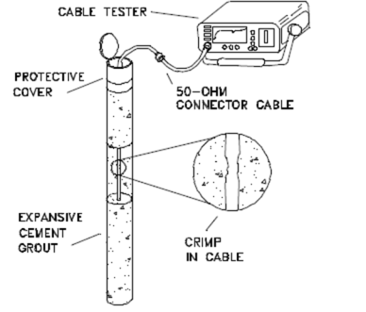
Figure 48 Time domain reflectometry cable, grouted into a borehole (© Copyright, O’Connor et al. 2004)

Time Domain Reflectometry has been used to monitor subsidence and ground movement at a United States Gypsum Company site in the US. It was found that the rate of subsidence measured using TDR was consistent with the rate measured using conventional levelling. A limitation is that TDR only measures ground movement that deforms the TDR cable. If the TDR cable settles uniformly, no movement will be detected by the TDR monitoring device (O’Connor et al. 2004).

Piezometers
A piezometer is any device designed to measure the groundwater pressure at a specified depth below ground. Piezometers are usually installed in boreholes and may be installed in two different ways. They may be embedded in a granular filter zone, allowing water to pass from the hydrogeological unit to the piezometer tip. This is then sealed (usually with a 1 m layer of bentonite) and the borehole annulus filled with grout.
Alternatively, piezometers may be surrounded entirely with grout in the borehole. This method is known as a fully grouted installation. With a fully grouted installation, piezometers are able to measure the pore water pressure through the grout, with virtually no flow of water required. This form of installation can be used in rock where the hydraulic conductivity is low. Pore pressure is measured in the immediate vicinity of the piezometer tip.
Measurement of pore pressures is useful for monitoring subsidence induced by coal seam gas production, as a change in pore pressure is the primary mechanism of subsidence. A reduction in pore pressure leads to an increase in pressure on the soil or rock structure, which in turn results in vertical compaction of the soil or rock structure and may lead to surface subsidence.

Standpipe piezometers
A standpipe piezometer, also known as a monitoring bore or ‘Casagrande’ piezometer, consists of a casing (standpipe) with a screen interval embedded in a granular filter, which is sealed from above. The borehole annulus (i.e. the void between the casing and surrounding ground) above the filter is filled with grout. The standpipe diameter is kept as small as possible to allow the standpipe to fill with water as quickly as possible, especially in low permeability hydrogeological units. Figure 49 shows a standpipe piezometer. They are accurate, low cost, simple to construct, able to recover water quality samples and have a long, satisfactory performance record (Fell et al. 2005).

Water level indicators
In a standpipe piezometer, the depth from the top of the borehole to the top of the water level (in the borehole) may be measured by a water level indicator. This consists of a cable with marked graduations and a cable reel attached to a probe. The probe is lowered into the borehole and generates an electrical response on the cable reel as soon as water is encountered. The elevation of the water surface level in the borehole is then known and is used to calculate the pore pressure at the screened interval. Water level indicators can achieve accuracies of ± 10 mm for a 100 m cable length (StevensWater 2012) or ± 0.01 per cent of full scale.

Groundwater data loggers
Alternatively, a groundwater data logger may be used. The pressure (pore pressure plus atmospheric pressure) is recorded by a transducer on the tip of the data logger and a correction made for atmospheric pressure. Groundwater data loggers are able to store upwards of 100 000 readings in memory. Data loggers offer an accuracy of ± 0.05 per cent of full scale (Solinst 2012).

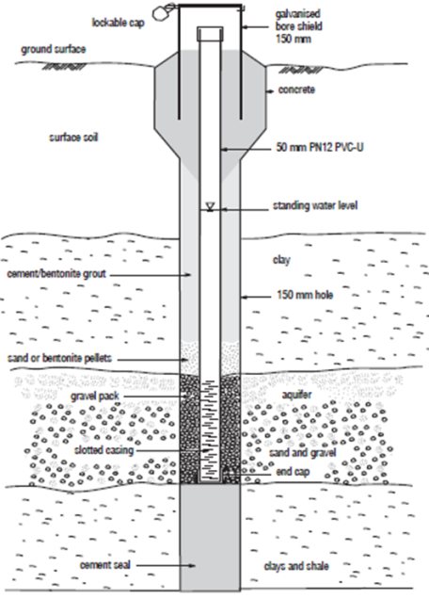
Figure 49 Standpipe piezometer or monitoring bore (© Copyright, National Uniform Drillers Licensing Committee 2012)

Multi-point piezometers (standpipe)
Where piezometer readings are required at multiple depths, potential cost savings may be achieved by installing multiple piezometers within a single borehole. Multiple screened casings may be installed in a single borehole with each screen embedded in a granular filter and sealed from above. This construction is shown in Figure 50. The use of this method is limited by the difficulty of construction and the care required in placing the screen intervals and granular filter zones in correct position. It may be difficult to adequately seal multiple filter zones around rigid standpipes.
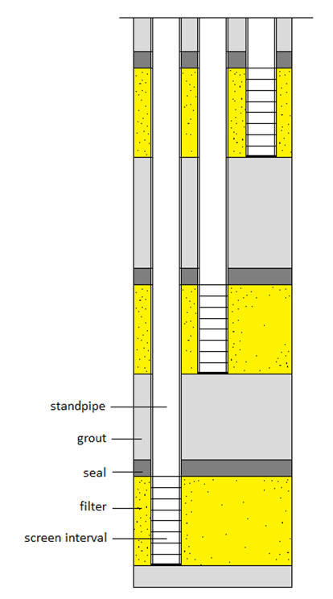
Figure 50 Multi-point piezometers (standpipe)

Vibrating wire piezometers
A vibrating wire piezometer (VWP) is a pressure measuring device that converts the frequency of vibration of a tensioned wire into pore pressure readings. The wire is connected to a diaphragm, which responds to pore pressure changes. Figure 51 shows a vibrating wire piezometer. A change in pore pressure causes a change in tension in the wire as the diaphragm responds to pore pressure. The wire is excited by an electromagnet and its natural frequency of vibration generates a signal that is recorded by the electromagnet. This is then converted to a pressure reading on the diaphragm as the amount of tension in the wire is related to its natural frequency of vibration. The measurement is transferred to a convenient terminal point by an electrical cable.
Vibrating wire piezometers may be installed by fully grouting them into a borehole. This installation method is simpler and easier, with quicker pore pressure response times, compared to the construction of a standpipe piezometer. Considerable field time and cost may be saved. Fully grouted installation may also facilitate the installation of multiple piezometers in a single borehole (Mikkelsen & Green 2003).
Vibrating wire piezometers provide easily repeatable readings. Potential issues can include damage by lightning strike, particularly during construction when cables are exposed. This has been overcome by shielding cables, earthing and provision of overvoltage protection (Fell et al. 2005). Vibrating wire piezometers may experience drift (e.g. the gradual change of an instrument’s reading, under identical conditions) and require re-calibration over time. Such piezometers cannot be used to obtain water quality samples.
Vibrating wire piezometers provide an accuracy of ± 0.1 per cent of full scale (Slope Indicator 2012a).
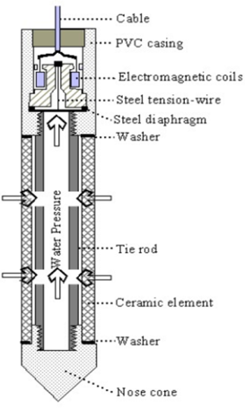
Figure 51 Vibrating wire piezometer (© Copyright, Slope Indicator 2011).

Pneumatic piezometers
A pneumatic piezometer is a pressure measuring device which uses a flexible diaphragm connected to pressurised gas. The tip consists of a porous stone which allows pore water pressure to be detected by the diaphragm. Two tubes lead from one side of the diaphragm to a measuring point. Pressurised gas is applied and when this pressure is larger than the pore pressure, the diaphragm will move and allow gas out of the outlet tube. Applied gas pressure is reduced until gas stops exiting the outlet tube. The applied gas pressure then equals the pore pressure. Alternatively, pressure may be increased until gas starts exiting the outlet tube, giving the same result (after calibration for any mechanical effects). Figure 52 shows the principal of a pneumatic piezometer.
Pnuematic piezometers may be installed fully grouted into a borehole, similarly to vibrating wire piezometers (Mikkelsen & Green 2003).
Pnuematic piezometers provide fast response times and have the advantage of being free from drift (Slope Indicator 2011). The disadvantages are the risk of damage to the inlet and outlet tubes, either during construction or operation, and the need to maintain a calibrated readout unit (Wyllie & Mah 2004). Such piezometers cannot be used to recover water quality samples.
Pnuematic piezometers can provide a precision of ± 0.25 per cent of full scale (Slope Indicator 2012a).
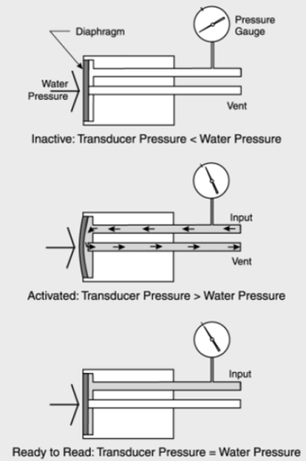
© Copyright, Canterbury City Council 2001
Figure 52 Principle of a pneumatic piezometer
Table 17 provides a comparison of the features of standpipe (‘Casagrande’), pneumatic and vibrating wire pieozmeters.
Table 17 Comparison of piezometers (© Copyright, Slope Indicator 2012b)
Characteristics | Type: casagrande | Type: pneumatic | Type: vibrating wire
Response | Slow | Fast | Fast
Accuracy | High | Medium | High
Repeatable readings | Need technique | Need patience | Easy
Obtain readings remotely | No | Yes | Yes
Connect to data logger | No | No | Yes
Potential for lighting damage | No | No | Yes
Main expense | Drilling borehole | Drilling borehole | Drilling borehole

Multi-point piezometers (VWP or pneumatic)
Multiple vibrating wire or pneumatic piezometers may be installed (fully grouted) into a borehole (Figure 53). This method may eliminate the difficulties inherent in sealing multiple granular filters around rigid standpipes and may provide a cost-effective method of obtaining multi-level pore pressure readings from a single borehole (Mikkelsen & Green 2003).
A disadvantage is that the grout pressure will be felt by the piezometer for as long as it takes for the grout to set and for the excess grout pressures to dissipate. Care must be taken in selecting piezometers with appropriate measurement scales so that the grout pressure may also be measured and accounted for, if required.
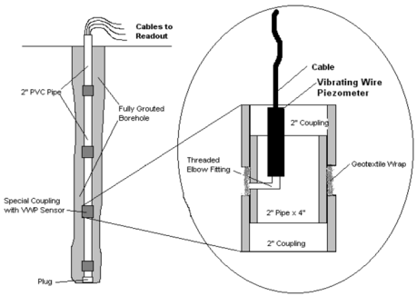
© Copyright, Mikkelsen & Green 2003
Figure 53 Multi-point (fully grouted) vibrating wire piezometers)

Spring actuated multi-point piezometers
Geokon (2010) offered an alternative that removed the need for sand or gravel filter zones. Piezometer filters are pressed against the borehole wall by the activation of a spring device. The borehole can then be grouted without the grout blocking the piezometer filters, as shown in Figure 54. The main benefit is that installation is much easier. The piezometers and cables are lowered into position, starting with the lowest. When they are in position, a spring is activated which fixes the piezometer filter to the borehole. After all the piezometers are in position the borehole is filled with cement grout.
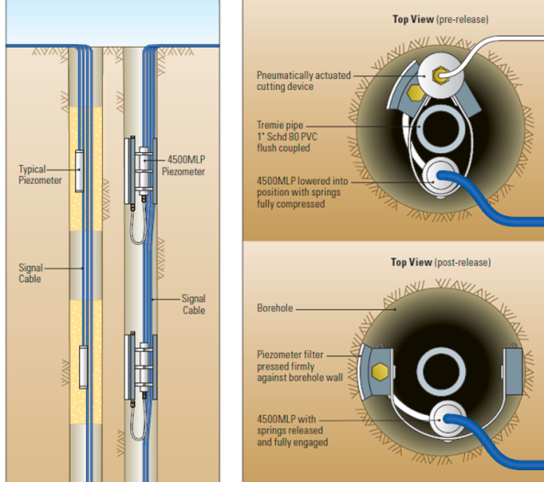
Figure 54 Geokon multi-level piezometer with spring-loaded mechanism (© Copyright, Geokon 2010)

Piezometer installation and monitoring
The following summarises important points to consider when monitoring pore pressures using piezometers.
The depth to coal seam aquifers can be quite deep (often > 300 m). Consequently, the installation of piezometers may be more expensive and accurate results harder to obtain.
In the sedimentary basins of eastern Australia, groundwater is present in numerous sandstone or coal seam aquifers, which are interspersed with lower permeability confining layers. To obtain accurate measurements of pore pressure, it is necessary that piezometers are carefully installed in each hydrogeological unit.
The orientations of dominant joint sets in rock can lead to different pore pressure readings due to water flowing through the joints. If the joint sets are intersected by the piezometer, a higher reading is obtained as opposed to where the piezometer does not intersect the dominant joint sets.
Rainfall or other groundwater recharge events must be taken into account as they may influence results. High rainfall or flooding may cause a short term increase in pore pressures, especially in unconfined aquifers near the surface. Seasonal changes in groundwater levels are important in areas where groundwater responds to seasonal rainfall.
The use of spring activated piezometers requires that the borehole remain open, which could allow vertical migration of groundwater via the borehole from one geological unit to another. This could potentially result in a degree of drainage of a shallow water bearing horizon and, for this reason, use of spring loaded piezometers is considered inappropriate.

Strain gauges
Strain gauges may be installed to monitor horizontal strain at the ground surface. A strain gauge is shown in Figure 55. Strain gauges do not provide any information on vertical displacement. Optical fibre strain gauges have been installed to monitor strains induced by subsidence on the Hume Highway road shoulder near Appin, NSW (MSEC 2012). Strain gauges may also be installed on railway lines and water pipelines. However, it may be difficult to find a suitable road, railway line or other firm surface on which to install the gauges. Steel weldable, vibrating wire strain gauges provide an accuracy of ±1.5 με, where ε is defined as change in length per unit length (ITM Soil 2012). Calibration with temperature is required to achieve accurate results.
For subsidence assessment, strain gauges may show significant lateral strains in areas of hogging. Lateral strain is of importance in assessing the likelihood of damage to buildings.
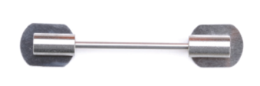
Figure 55 Steel weldable, vibrating wire strain gauge (© Copyright, ITM Soil 2012)

Preliminary appraisal of different subsidence monitoring techniques
Table 18 presents the advantages and disadvantages of different subsidence monitoring techniques.

Table 18 Appraisal of various subsidence monitoring techniques
Monitoring technique | Advantages | Disadvantages
Conventional levelling | - Inexpensive if used for small study areas.  - Vertical accuracy of 8 mm times the square root of the distance in kilometres to benchmark (ICSM 2012). | - Not practical or cost-effective over large study areas.  - May be restricted by access issues.  - Requires line-of-sight between survey points.  - Requires stable survey benchmarks.  - Error increases with distance from survey benchmark.
Global Positioning System (GPS) | - Inexpensive over small study areas.  - Vertical accuracy of 10 mm + 1 mm per kilometre away from survey benchmark (USGS 2012). | - Restricted resolution/accuracy.  - May be restricted by access issues.  - Requires stable survey benchmarks.  - Error increases with distance from survey benchmark.
Interferometric Synthetic Aperture Radar (InSAR)  Uses differences in radar wave phase and amplitude to assess changes in elevation. | - Data can date back to the early 1990s.  - Data covers large areas: some satellites can capture areas of up to 100 km by 100 km. Advanced Land Observing Satellite (ALOS) has a swathe width of 70 km and overpasses areas every 46 days.  - Accurate to 5 to 10 mm (USGS 2005).  - Reflective markers may be placed within the survey area to reduce de-correlation due to changes in ground surface between images. | - Results can be subjective, depending on the accuracy to which the start of phase changes are measured.  - InSAR is sensitive to variations in moisture (e.g. seasonal variations in groundwater levels and vegetation growth/removal). Long wavelength signals (i.e. ALOS data) are less prone to moisture-related scatter.  - Atmospheric variability (i.e. temperature, pressure and water vapour) can cause radar wave scatter, resulting in image artefacts and localised phase variations of up to 0.5 phase cycles. This can often be visually identified as they appear different to variations associated with ground displacement.  - The differential interferogram is produced in conjunction with a digital elevation model (DEM) to remove topographic effects from the output image. Magnitude of topographic phase errors is a function of the DEM quality.  - Positioning errors can occur, causing large-scale orbital phase trends across the interferograms.  - It is advantageous to analyse as many DifSAR pairs as possible (tens of pairs, particularly where precise (millimetric) ground movement change is required). If just a few are assessed, it is difficult to differentiate between phase changes associated with ground movement and phase changes associated with artefacts.  - Ground shrink-swell behaviour (e.g. where clay layers expand and contract in accordance with seasonal water availability) can confound results.  - Inaccurate where a change to the ground surface (such as ploughing or building construction) occurs between radar observations. This increases in likelihood with increasing duration between observations.
Airborne Laser Survey (ALS)  Measures the return time of pulsed light to provide high-resolution topographic data. | - High resolution data over a defined area.  - Can be supplied with corresponding high resolution aerial photographs.  - Overflights can be commissioned whenever required (subject to weather conditions). | - Requires independent survey overflights.  - Expensive.  - Prone to localised distortion if effective algorithms to remove vegetation are not applied.
Borehole Extensometers  Measures settlement using a rigid measuring rod attached to a deeply anchored benchmark. | - Accurate to 1 microstrain, or 1 mm per 1000 m depth stratigraphic unit. | - Relatively expensive to install.  - Requires telescoping casing.  - Requires an anchor to be installed at a depth where strata are stable. This depth may be over 500 m below the ground surface.
Tiltmeters  Measure changes in tilt of the ground surface. | - Can be connected to computer and integrated to provide continuously updating ground elevation contours.  - Accurate to 1 nanoradian or 10⁻⁶ mm/m. | - Requires a stable surface for installation, free from ground shrink–swell behaviour, erosion or vandalism.

Monitoring plan and instrument selection
Successful monitoring plans are the result of logically designed monitoring programmes in which the objectives and benefits of monitoring are clearly defined. Specific monitoring instruments target specific measurement types and criteria. An unbiased assessment of each of the instruments can only be achieved if cost is not the dominating factor. Reliability, simplicity and necessity are the three most important factors to consider when selecting instruments and designing a monitoring plan. Dunnicliff (1993) provided a systematic guide for designing a monitoring plan which is followed below.
Prior to development of a monitoring plan, it is necessary to develop an assessment of the likely extent and magnitude of subsidence. This enables appropriate selection of monitoring locations and monitoring equipment. It is also important to develop an assessment of the magnitude of subsidence that would result in adverse impact and the locations that would have the highest sensitivity to subsidence.
The discussion below illustrates the development of a monitoring plan for a hypothetical situation.

Benefits of monitoring
To provide an understanding of initial site conditions; in particular, groundwater levels, their variability and identification of existing ground movements occurring in the area
To quantitatively assess the effects of groundwater withdrawal for coal seam gas production on the ground surface
To provide reassurance to the public that subsidence risks to properties and the environment will be monitored.

Project conditions
Type: monitoring of the effects of subsidence due to groundwater withdrawal for coal seam gas production
Scale: this should encompass coal seam gas production areas. Zones of maximum drawdown may occur over areas with diameters ranging between 5 km and 20 km. Coal seam gas production areas with multiple well zones may result in significant drawdown over areas with diameters up to 50 km
Stratigraphy: the target coal seams are typically at 300 m to 1000 m in depth. Sedimentary formations overlie the coal seams, with alluvial units near the surface
Engineering properties: the two most compressible units are the alluvial units and the coal seams. The sedimentary formations will also compact to some degree due to their thickness (more than 300 m above the coal seam)
Groundwater: present throughout all geological units in the ground profile, and includes: an unconfined surficial aquifer; an intermediate confined aquifer system above the coal measures; a confined aquifer system within the coal measures; and a deep confined aquifer system below the coal measures.

Controlling mechanisms
Subsidence occurs due to a decrease in pore water pressure resulting in an increased effective stress in hydrogeological units. The increase in effective stress results in compaction of the affected hydrogeological units.
Groundwater withdrawal from the deeper coal seam aquifers may induce depressurisation, on a smaller scale, on upper level aquifers.

Purpose of geotechnical monitoring
To quantify the magnitude and extent of depressurisation in each of the hydrogeological units above and including the geological unit targeted for coal seam gas extraction.
To measure subsidence, tilt, horizontal strain and ground curvature, caused by groundwater withdrawal for coal seam gas production, at various points in the project area.
To understand the risks posed to building structures by groundwater withdrawal for coal seam gas production.

Purpose of instrumentation
To gauge risks and provide early warnings of damage to infrastructure and properties.
To provide data to help in planning future coal seam gas projects.
To validate or confirm predictions from numerical modelling.
To provide assurance to the public.

Parameters to be measured
Groundwater pressure: to be measured in various aquifers and at various locations.
Surface settlement: a regional picture and a localised picture are required. The use of different methods and instrumentation may help in validating settlement measurements.
Tilt may be measured at the fringes of drawdown zones. Measurements can be integrated to show surface settlement.
Horizontal strain.
Ground curvature.
Surface cracking, changes to river courses, loss of wetland environments.

Most important parameters
Surface settlement and ground surface profile.
Depressurisation in target coal seam and aquifers near the surface.
Tilt.

Number of measuring points required
Surface settlement: two or three traverse lines into affected regions, when using GPS or conventional levelling. This will allow multiple comparisons with subsidence predictions and with other measurement techniques.
Groundwater pressure: for each measurement point, pore pressure may be measured at various depths. One measurement location above a formation which is anticipated to provide a restriction on vertical groundwater seepage (an aquitard), one in the coal measures, and one below the coal measure rocks. The number of points required will be determined on a case-by-case basis, making use of available information for each specific area.
Tilt: Davis et al. (2000) discussed the use of 52 tiltmeters to successfully monitor subsidence over a 2.5 square kilometer area. Coal seam gas subsidence areas may extend over far greater areas and thus a tiltmeter based monitoring program may only be applicable over a small part of the project area.

Planning field data collection using predictive estimates
Prediction permits appropriate selection of the location of measurement points. Potential levelling traverses can be selected targeting areas of high predicted ground curvature. The traverses can exploit existing highways and roads where survey benchmarks may be more readily available or easily installed. One or more traverse(s) should extend to where subsidence due to coal seam gas production is expected to be negligible.

Selection of instruments
Table 19 provides a summary of factors relevant to the selection of a method of subsidence monitoring.

Selection of instrument locations
Locations for instruments may be selected taking account of the predicted extent and timing of subsidence development, and recognising areas or facilities which are sensitive to subsidence.

Unusual factors that may influence results
Expansive soils (see below).
Seasonal variability in groundwater head.
Extremes in temperature.
Large-scale flooding affecting groundwater head or causing erosion.
Changes to ground surface between measurements, such as ploughing or building construction.
Groundwater withdrawal from non-coal seam gas related activities.
Non-systematic or local effects, such as river valleys, dykes and fault zones.

Expansive soils
Soils which undergo substantial volume change as they experience cycles of wetting and drying are referred to as expansive soils. Wetting and drying cycles can be due to seasonal changes in moisture, or factors such as irrigation, removal of trees or burst water pipes. Vertical movements of expansive soils of 60 mm to 100 mm due to irrigation was seen in Adelaide in the 1970s. Later, the growth of trees and large shrubs reversed the problem, and now settlements of up to 150 mm caused by tree roots drying the soil are encountered (Considine 1984). Vertical movements of this magnitude caused by soil expansion are large enough to form a substantial part of any measured settlement or heave on coal seam gas project sites.
Roughly 20 per cent of Australia is covered with expansive soils (Considine 1984) and this includes large areas of the Surat Basin (Queensland Government 2000). In measuring subsidence in areas covered by expansive soils, a correction must be made for any vertical movement caused by wetting and drying cycles of expansive soils.

Table 19 Aspects of monitoring method selection
Characteristics | Method: conventional levelling | Method: GPS levelling | Method: DifSAR | Method: borehole extensometer | Method: Ttiltmeter array
Reliability and past performance record | Very widely used with good performance record. | Very widely used with good performance record. | Becoming increasingly popular, performance record varies but can be good. |  | Not widely used but has performed well in monitoring oil field subsidence.
Required skill | Experienced land surveyor required. | Experienced land surveyor required. | Skill required in processing data and knowing where DifSAR can be applied. | Experienced installers required for the installation of an anchor and telescoping casing into a grouted borehole. Minimal skill required for monitoring. | Installation must be precise as instruments are extremely sensitive.
Vertical accuracy | To 25 mm (at 10 km from benchmark). | To 20 mm (at 10 km from benchmark). | May agree with conventional or GPS to within 5 mm to 10 mm. | To 1 mm for a 100 m thick compacting unit. | With adequately positioned tiltmeters, accuracy of 5 mm to 10 mm is achievable (see Davis et al. 2000).
Access | May require access to private properties. Requires line-of-sight between observation points. Requires a hard ground surface and survey benchmarks. Traverse lines may be public roads. | As for conventional levelling but does not require line-of-sight. Requires an open view of sky to obtain satellites. | No access requirements. | Access required for installation and monitoring. | For installation and monitoring, may require access to private properties. May be monitored remotely, once installed.
Durability | Survey benchmarks are durable if installed on hard ground such as road shoulders. | Survey benchmarks are durable if installed on hard ground such as road shoulders. | Radar reflectors may be damaged by erosion or vandalism. | High durability. | Durable if installed on a hard stable surface. May be damaged by vandalism.
Applicability | May be used to calculate elevation changes on certain selected lines, up to 10 km long, preferably along public roads. | May be used to calculate elevation changes on certain selected lines, up to 10 km long, preferably along roads. | May provide a general picture of elevation change over the entire project area, assuming the ground surface is not modified between observations. Not applicable in areas of dense vegetation. | May provide accurate results at one or two points. May be more applicable to measure the settlement of the upper alluvial units only, due to the lesser thickness of these units. | If installed in a dense enough array, may provide elevation changes over all or part of the project area.
Cost | A cost is incurred each time a levelling traverse is undertaken. Cost is proportional to the number of kilometres traversed or number of points surveyed. Too expensive to survey the entire project area. | As for conventional levelling. | The main costs are incurred in acquiring satellite data and also in the processing of data. Installation and maintenance of radar reflectors may be expensive. | Installation is expensive and proportional to the depth of borehole. | Installation may be expensive, where numerous tiltmeters are required. The required monitoring and data processing is relatively inexpensive.
Maintenance | n/a | n/a | Radar reflectors may need maintenance. | n/a | n/a
Verification of results | Verification by comparison with GPS levelling and/or borehole extensometers. | Verification by comparison with conventional levelling and/or borehole extensometers. | Digital elevation models used to reference DifSAR data. Verification by comparison with conventional or GPS levelling. | Verification by comparison with levelling. | Verification by integrating results and comparing with levelling and/or DifSAR.

Procedures to ensure correctness of readings
Groundwater drawdown may be compared with subsidence observed from levelling and DifSAR to provide a partial verification. Duplicate readings with small temporal separation may be taken, to test repeatability of measurements. Predictive modelling may provide a first estimate and an approximate range for expected measurements. The ground profile indicated by a tiltmeter array may be checked for any inconsistent readings from individual tiltmeters.
Records of seasonal variability in groundwater levels and of seasonal shrink swell behaviour of expansive soils, where applicable, help to ensure that other factors contributing to subsidence are accounted for.

Framework for subsidence monitoring
This section illustrates how some of the above methods may be used to monitor subsidence. The methods described are:
Conventional and/or GPS Levelling
DifSAR
Tiltmeter Arrays.
A combination of methods provides some redundancy and a mechanism for cross checking results.

Prediction
A predicted maximum settlement of 100 mm is expected. An expected peak gradient of 100 mm in 3 km is expected, which is a tilt of 0.033 mm/m. Local soil and rock heterogeneities may have localised effects that are larger than the average effect. It may be important to pick up any such sharp effect from the surveillance.
Settlements differing from the normal pattern may occur in river valley areas or where faults and/or dykes are present.

Method A – GPS and/or conventional levelling

Initial baseline surveys
GPS or conventional levelling traverses of up to 20 km from reference benchmarks, in the direction of predicted main coal seam gas subsidence areas, may be undertaken. Two or more surveys may be undertaken prior to commencement of coal seam gas production to establish an accurate model of existing ground elevation and to test for uncertainties in surveys and for any ground movement currently occurring. Additional benchmarks may be installed in areas where they are required, especially in areas near and just outside the predicted subsidence zone.

Subsidence surveys
Levelling traverses of up to 20 km (preferably not more than 10 km) from benchmarks may be undertaken some years into coal seam gas production. The aim of these surveys will be to compare actual subsidence against modelling predictions.

Important points regarding GPS or conventional levelling surveys
Baseline surveys must be undertaken to establish accuracies and to identify existing ground movements.
Access permission will be required where levelling points are located on private property.
Survey benchmarks inside the zone of subsidence will not be stable and cannot be used to establish elevation. Only benchmarks outside the subsidence zone may be used for this. Benchmarks inside the zone of subsidence may be used as reference points for secondary surveys and to measure differential settlement.
Attention must be paid to areas of expected extraordinary settlement, if these areas are known beforehand.
Survey traverses are to be kept as close as possible to known ANLN (Australian National Levelling Network) benchmarks, due to the loss of accuracy, which occurs when surveying more than about 10 km away from benchmarks.
Soil shrink-swell between surveys may introduce non-coal seam gas settlement into results.
Erosion or flooding between surveys may introduce non-coal seam gas settlement into results.

Method B – DifSAR

Installation of radar reflectors
To aid with temporal correlation, three or more radar reflectors may be installed in the survey area, perhaps at specified coal seam gas wells or near survey benchmarks. The coordinates of the radar reflectors is to be recorded. Radar reflectors are intended to provide a stable point free from vegetation or ground surface changes between SAR measurements (Youden et al. 2004).

Initial baseline surveys
Satellite data may be obtained for periods prior to coal seam gas extraction. This data is to be processed to produce DifSAR images of the project area. Initial images will be used to test for accuracies in the method and to identify any existing ground movements occurring in the project area. The results may be aligned with a Digital Elevation Model and with the levelling survey where applicable.

DifSAR surveys
After coal seam gas production begins, additional satellite data may be obtained and processed to create DifSAR images. The time difference between images that is adopted to create DifSAR images must be kept to a maximum of one year to avoid possible de-correlation due to ground surface changes or settlements greater than the radar wavelength that occur between successive passes. DifSAR images may be compared with the levelling surveys undertaken in Method A.

Important points regarding DifSAR
DifSAR should be undertaken with consideration of the following:
baseline surveys must be undertaken to establish accuracies and to identify existing movements
loss of correlation between surveys is possible due to changes to ground surface or vegetation
soil shrink-swell between surveys may introduce non-coal seam gas settlement into results
erosion or flooding between surveys may introduce non-coal seam gas settlement into results.

Method C – tiltmeter arrays

Installation
High resolution tiltmeters may be installed over part of the project area. In particular, both areas expected to subside and areas not expected to be affected should be covered. Cost will partially dictate the density of the tiltmeter array. However, it is advisable that there be sufficient tiltmeters in areas where ground curvature is expected. For example, five tiltmeters in a 10 km line should be sufficient to capture localised ground curvature and subsidence, if positioned in an appropriate area. It is necessary that each tiltmeter is installed on a firm hard surface, such as rock, a road surface or a building. Results from the tiltmeter array may provide a further comparison and/or verification of levelling and DifSAR results.
Local factors unrelated to coal seam gas activities may influence individual tiltmeters so sufficient redundancy would need to be allowed to identify and allow for anomalous results.

Monitoring
The tiltmeters may be monitored periodically and information processed to provide an accurate picture of the subsided ground surface. It may also be possible to monitor the tiltmeters remotely. After the tiltmeter array is installed, the cost in monitoring and processing the results is low.

Important points regarding tiltmeter arrays
The method should be undertaken with consideration of the following:
installation must be on a firm hard surface not exposed to soil shrink-swell or erosion
permission must be granted if tiltmeters are to be installed on private property
tiltmeter accuracy must be high enough to easily detect predicted changes in ground tilt
the area where the tiltmeter array is to be installed must be carefully selected beforehand, based on predictions of maximum subsidence and maximum ground tilt
there are no restrictions on the time between tiltmeter observations.

Subsidence management strategies
Management of subsidence arising from underground coal mining is well established in the coalfields areas of Australia. The NSW Department of Mineral Resources (2003) provides guidelines for subsidence management in relation to coal mines. Much of the emphasis has been placed on impacts to manmade structures, though in recent decades impacts on water depleted environmental assets (including rivers and wetlands) has attracted attention. Management of subsidence from coal seam gas extraction has very limited history in Australia.
Management of subsidence arising from coal seam gas extraction differs from management of subsidence arising from underground coal mining, because coal mining involves substantial ground loss and major mechanical dislocation of strata at the level of the mined coal seam. Nevertheless, the methods used to manage subsidence due to coal mining provide an approach that has relevance to the management of subsidence associated with coal seam gas extraction. Management of subsidence arising from coal seam gas extraction has some similarities with management of subsidence due to dewatering arising from engineering projects, such as tunnels and deep excavations. Groundwater seepage to the tunnel or excavation results in lowering of groundwater levels and causes compaction.
One aspect of subsidence development which is problematic is the fact that the subsidence will not develop instantly but may take many years to develop. As a result, it is important that prediction and early monitoring (for consistency with predicted development of subsidence) be undertaken. Once underway, the process of subsidence development due to coal seam gas extraction is difficult to arrest and, as a result, management needs to take account of the rate of subsidence growth in comparison with expectations.
The process of subsidence management involves the following stages:
- prediction of the extent, magnitude and timing of subsidence impacts
- identification of assets (natural and manmade) within the zone of subsidence influence
- identification of thresholds below which risk to particular categories of asset will be at very low risk of adverse impact
- measurement of groundwater drawdown and ground movement response
- comparison of the predicted subsidence impact with the thresholds for the assets present within the zone of subsidence influence
- implementation of mitigation or control measures to address potential adverse impacts.

Risk assessment approach
The Australian Standard risk management – principles and guidelines (AS/NZS ISO 31000:2009) defines risk assessment as the:
‘…overall process of risk identification, risk analysis and risk evaluation.’
Risk assessment of the potential impacts of predicted subsidence on assets may adopt an approach that considers the importance and value of the asset, and the risk of impact for various severity levels. Risk criteria may consider the causes and consequences of impacts, the method of measurement of those impacts, the timeframe(s) of the likelihood and/or consequence(s), the definition of likelihood and level of risk, the threshold levels at which risk becomes unacceptable, and the potential for development of measures to respond to subsidence.
Thresholds for acceptable degrees of subsidence should be established for specific types of asset. Predictions and subsidence monitoring measurements would be compared to the thresholds to assess the potential for subsidence to impact assets.
A common approach to risk assessment involves the development and use of a risk matrix tool that assesses both the likelihood and consequence of potential impacts. Tables 20, 21 and 22 provide an example of a risk management strategy matrix, indicating the management strategy approach that might be adopted given the severity of impact (considering the particular value and importance of an asset and the damage/harm to that asset) and the likelihood of impact.
The importance and value of an asset may be defined in a quantitative sense according to the financial, community, heritage and environmental value of the asset. The importance, value and fragility of the asset would need to be assessed. High value assets might include major state infrastructure such as major dams, or protected ecosystems; whilst low value assets might include minor roads.
Where there was assessed to be a high value asset and/or high severity impact to an asset, a management strategy would be adopted. The management strategy adopted may comprise monitoring potential subsidence and review of monitoring data on a periodic basis, or management of the expected impact itself.
Table 20 Example risk assessment matrix
Likelihood |  |  | Impact
 | 1  (Insignificant) | 2  (Minor) | 3  (Moderate) | 4  (Major) | 5  (Catastrophic)
A (Certain) | Moderate | High | Extreme | Extreme | Extreme
B (Likely) | Moderate | Moderate | High | Extreme | Extreme
C (Possible) | Low | Moderate | Moderate | High | Extreme
D (Unlikely) | Low | Low | Moderate | Moderate | High
E (Not Expected) | Low | Low | Low | Moderate | Moderate

Table 21 Example risk rating descriptors, for those shown in Table 20
Control action rating | Qualitative risk action description
Extreme | Measures must be taken to reduce the (future) impact.
High | Measures must be taken to reduce expected impact to acceptable criteria.
Moderate | Monitoring of subsidence must be undertaken and review of monitoring data must be undertaken on a regular basis.
Low | Monitoring and review of subsidence may be undertaken on long-term basis.
Table 22 Example descriptors for the severity of impact and likelihood categories shown in Table 20
 | Severity of impact
5 | Catastrophic | Irreversible environmental harm, major national infrastructure irreparably impacted, significant financial loss.
4 | Major | Severe permanent harm to the environment, significant environmental damage with wide spread impact, disruption in serviceability of infrastructure.
3 | Serious | Considerable damage to the environment, minor damage to high value infrastructure.
2 | Minor | Temporary harm to environment, minimal damage to the environment, minor damage to low value infrastructure.
1 | Insignificant | Negligible environmental harm/damage, negligible impact to infrastructure.
 | Likelihood
A | Certain | Impact has occurred or cannot be avoided.
B | Likely | Impact is predicted to occur based on subsidence impact modelling and/or review of existing monitoring data.
C | Possible | It is possible impact may occur.
D | Unlikely | Impact is not expected to occur under expected future conditions/operations.
E | Not expected | Impact is not expected to occur under any foreseeable circumstances.

Subsidence thresholds
The level of subsidence that might give rise to adverse impacts is discussed in Section 8 Potential Impacts of Subsidence of this report. This section addresses several manmade and natural assets. For many asset types, an accepted set of threshold values is not available. Table 23 provides example thresholds. Where recognised thresholds are available, these have been nominated, and in other cases values based on the nature of the threat are proposed.
If initial assessment based upon closed form solutions or simplified conservative analysis indicates that the thresholds listed in Table 23 would not be exceeded, no further assessment would be required. Where analysis reveals the possibility that those thresholds would be exceeded, closer examination of the assets involved would be appropriate.

Table 23 Example of subsidence thresholds for specific assets
Asset category | Relevant Response | Proposed Threshold | Justification
Flood levees  River banks  Farm dams  Flood prone land  Shorelines  Wetlands | Settlement | 100 mm | Construction tolerance for flood level would be of the order of 100 mm so that subsidence of this value would be unlikely to affect performance during flooding.
Residential buildings  Civic buildings  Pipelines | Horizontal tensile strain | 0.05% | Burland (2012) indicates that tensile strain of less than 0.05% would be unlikely to cause more than negligible damage to sensitive structures.  Curvature (hogging) is considered unlikely to be relevant.
Rocky streams  Rivers with rock beds  Rocky springs  Wetlands over rock | Horizontal tensile strain | 0.05% | The risk to rocky water courses would be through cracking of the rock beds though tensile strain.  The proposed threshold is lower than the value of 6 mm/m (0.6%) proposed by Farmer (1985).
Major dams | Settlement  Tensile strain  Curvature | Specific assessment | The consequences of dam failure can be severe and result in loss of life. A specific assessment of major dams is proposed.

Subsidence monitoring
Subsidence monitoring would be conducted wherever there is the potential for subsidence to occur.
Subsidence monitoring regimes need to consider the type and distribution of monitoring techniques/equipment (as discussed in section 11.3 Monitoring Plan and Instrument Selection of this report) such that monitoring regimes are suited to capturing expected subsidence behaviour in their records. In many cases, installation of piezometers to measure hydraulic head changes may also be required, to monitor for impacts on groundwater resources.
Priority subsidence monitoring locations may be considered over areas where there is potential for impact, such as in relatively close proximity to coal seam gas production wells.

Subsidence management responses
Management of potential impacts to assets may include the following response measures:
modification of well field design (e.g. reduced number of wells/pumping over selected areas) to reduce subsidence in sensitive areas. This would likely require more elaborate subsidence assessment than screening assessment
repair/make-good any damage to assets as they arise. This approach is likely to be most suitable for built infrastructure. It may be possible to make-good loss of water resources (e.g. damaged dams, damaged river routing) by provision of the lost resource to its users, but this approach is unlikely to be appropriate where subsidence causes damage to ecosystems
injection of produced water into shallow or deep aquifer systems to reduce the depressurisation in localised areas of injection, thereby reducing the subsidence experienced in those areas
engineering measures (such as ground improvement methods to increase the stiffness of the ground) prior to coal seam gas production, to reduce expected differential subsidence movement over sensitive areas
acquisition of sensitive assets by the coal seam gas proponent/operator, for some (restricted) assets. Careful location of the coal seam gas well field, to place sensitive areas on the barrier between adjacent well tributary areas (remote from well), may be used to reduce differential settlements.
In developing a management response strategy, the following should be considered:
the reasons for selection of a particular management measure(s)
whom is responsible for implementing the management measures(s)
proposed actions for the management measures(s)
resource requirements, including contingencies
performance measures and constraints for implementation of the management measures(s)
reporting and review
timing and schedule.

Example development of subsidence management strategy
This section provides an example of a broad approach to assess subsidence impacts, to classify those impacts, and to select a subsidence management approach in response to classified predicted impacts. Thresholds nominated in the example should be treated as illustrative.
The sequence of assessment tasks is summarised below.
- Assessment of the depressurisation of the ground due to groundwater drawdown and coal seam degassing using suitable methods, such as those described in section 9 Subsidence Assessment Approaches.
- Assessment of ground subsidence due to ground depressurisation using suitable methods, such as those described in section 9 Subsidence Assessment Approaches, including:
  - assessment of the subsidence of saturated alluvial (compressible) sediments, if present, in the depressurised area. This may be achieved using the following method:
    - calculation of the groundwater flow, q, from the alluvium to the underlying units, using methods discussed in section 9 Subsidence Assessment Approaches of this report (screening level adequate initially)
    - if q is greater than 1 per cent of mean annual rainfall, carry out groundwater assessment of drawdown in alluvial sediments in the long term. Otherwise, make nominal allowance for subsidence due to compaction of alluvial sediments of 12.5 mm. (this nominal allowance is based upon 0.25 m drawdown within a soil profile of 50 m saturated thickness and a typical modulus for a loose sand of 10 MPa)
    - assess the compaction of alluvial sediments if drawdown exceeds the greater of 0.5 m or 50 per cent of annual groundwater level variation. Otherwise, make nominal allowance of 25 mm for compaction of alluvial sediments (this nominal allowance is based upon 0.5 m drawdown within a soil profile of 50 m saturated thickness and a typical modulus of 10 MPa for loose sand).
  - assess subsidence of rock units underlying alluvium, using suitable methods, such as those described in section 9 Subsidence Assessment Approaches of this report. Initially, the screening level assessments would be appropriate.
  - combine the subsidence components attributed to the alluvial soils, rock profile and degassing to estimate the magnitude of total land subsidence. Adding the components together will give a conservative estimate of the maximum possible subsidence, but the observed subsidence at the surface will depend on the geotechnical properties of the various layers throughout the depth profile.
- Classify the subsidence predicted in the area affected by ground depressurisation and nominate the subsidence management strategy response for each class:
  - Class 1 – subsidence less than 50 mm – minimal risk: monitoring of subsidence and groundwater level in alluvial aquifer at selected locations where subsidence assessed as likely to be largest (e.g. near individual wells at centre of coal seam gas well field and at locations of deepest alluvial soils) to confirm assessment during operation. Review monitoring annually. Should monitoring trends indicate that subsidence or drawdown expectations would be exceeded, treat as for Class 2
  - Class 2 – subsidence between 50 and 100 mm – low risk: identify locations of assets (environmental and anthropogenic) that are highly sensitive to subsidence. Monitor subsidence and groundwater level at locations where subsidence assessed as likely to be largest (e.g. near individual wells at centre of coal seam gas well field and at locations of deepest alluvial soils) and at locations of selected sensitive assets to confirm assessment during operation (priority locations). Review monitoring annually and compare monitoring results against nominated subsidence thresholds for specific assets. Should monitoring trends indicate that subsidence or drawdown expectations would be exceeded, treat as for Class 3
  - Class 3 – subsidence between 100 and 200 mm – moderate risk: assess the extent of long-term groundwater impact and assess subsidence within this area identifying predicted subsidence zones. Prepare an inventory of assets (environmental and anthropogenic) within the area assessed to be affected at Class 2 level or higher. Monitor subsidence in a way that allows development of contours of subsidence at annual intervals, including monitoring of groundwater level and subsidence at priority locations on a monthly basis. Review six monthly until trends become clear, then at annual intervals. Make assessments of the impacts on subsidence sensitive assets within Class 3 zones. Should monitoring indicate the presence of Class 4 impact zones, then treat as for Class 4. If anticipated subsidence of sensitive assets indicates potential for adverse impacts, then management of these impacts is to be carried out.
  - Case 4 – subsidence of 200 mm or more – high risk: assess the extent of long-term groundwater impact and assess subsidence within this area identifying predicted subsidence zones. Prepare an inventory of assets (environmental and anthropogenic) within the area assessed to be impacted at Class 2 level or higher. Monitor subsidence in a way that allows development of contours of subsidence at annual intervals, including monitoring of groundwater level and subsidence at priority locations on a monthly basis. Review six monthly until trends become clear, then review at annual intervals. Make assessments of the impacts on subsidence-sensitive assets within Class 3 and Class 4 zones. If anticipated subsidence of sensitive assets indicates potential for adverse impacts, then management of these impacts would need to be carried out. Subsidence management responses such as injection of produced water would need to consider longer term impacts beyond the decommissioning of the coal seam gas operation when produced water would no longer be available.

Conclusions and summary
Coal seam gas is a type of natural gas extracted from coal seams at depth (generally more than 200 m below the ground surface). It is an increasing source of natural gas around the world and Australia possesses substantial deposits. Coal seam gas production involves the extraction of groundwater to facilitate depressurisation (i.e. lowering of the water pressure) of the target coal seam. Coal seam gas developments in Australia are predominantly located in rural areas with established groundwater abstraction (such as for agricultural, mining or domestic use). The geological conditions in these environments typically comprise surficial alluvial soil systems (such as in sands or clays), underlain by consolidated sedimentary rock units (such as sandstone, siltstone, mudstone), with coal seams interbedded within layered sedimentary rock.
A typical coal seam gas extraction site comprises multiple coal seam gas extraction (production) wells, collectively referred to as a well field, where groundwater is extracted to lower the pressure in the target coal formations to release the coal seam gas.
Surface subsidence occurs when soil, coal or rock (geological units) compact due to changes in pressure induced by groundwater extraction and degassing of the coal. Subsidence at the surface is the sum of the compaction occurring within (potentially) multiple geological units. It is dependent on the groundwater withdrawal, the degassing of the coal, the depth and depth-interval over which compression occurs, and the geotechnical properties of the geological units throughout the depth profile.
Surface subsidence may affect a variety of assets, including infrastructure (such as buildings, roads, railways, pipelines, dams, water channels, levees and electrical infrastructure) and environmental assets (such as aquifers, streams, lakes, springs and other surface water resources).
Subsidence models are developed to predict the magnitude and extent of subsidence. The outcomes of such assessments may then be used to inform subsidence monitoring schemes and, where required, to manage or mitigate the potential impact of subsidence on assets.
Modelling may be undertaken to predict potential subsidence by either:
extrapolation of the results of experience
analysis of the compression (and resulting compaction) within the vertical profile due to changes in groundwater pressure arising from coal seam gas extraction, and due to changes in the coal matrix arising from coal seam gas extraction.
Currently there are very limited subsidence data available for Australian coal seam gas developments. As such, the first method will not be effective until a sufficient database of experience is developed, and the second method will need to be adopted.
Predictive subsidence modelling approaches provide estimates of both the compaction of hydrogeological units due to changes in groundwater pressure and the compaction of the coal seam due to degassing. These two components may be added together for all geological units experiencing a pressure change to provide a conservative estimate of the maximum possible surface subsidence, although the subsidence observed at the surface is likely to be less than such an estimate.
Different modelling approaches consider different assumptions and treatments of geological complexity within the ground. The suitability of a modelling approach to predict subsidence accurately will depend on the conditions local to the development under assessment, and the level of detail required for the assessment (e.g. general screening for potential impacts to assets or detailed analysis of impacts to a specific asset). Accurate prediction of the magnitudes and extent of subsidence requires the appropriate selection of geotechnical and hydraulic properties of the geological units undergoing depressurisation.
Subsidence monitoring is primarily undertaken to gain an understanding of the threat subsidence poses to infrastructure and the environment due to ground movement. It can provide an early warning of subsidence approaching levels that pose a risk to infrastructure and the environment. Monitoring is also a means of testing subsidence against subsidence modelling predictions. Data obtained from monitoring may be used to predict future subsidence extents and magnitudes.
A range of instrumentation and monitoring techniques are available to undertake subsidence monitoring. Each monitoring technique possesses different advantages and disadvantages with respect to performance, coverage, reliability, applicability/durability, maintenance, cost and installation requirements.
Subsidence management strategies are developed to identify, monitor and mitigate the potential impact of coal seam gas induced subsidence on infrastructure and the environment. To assess an appropriate management strategy, assessments should predict the extent and magnitude of potential subsidence, identify sensitive assets (infrastructure, water resources and ecosystems), and assess the potential impact of predicted subsidence on sensitive assets against impact criteria relevant to the type of asset.
The management strategy adopted will depend on the risk of the potential impact, and may comprise review of monitoring data on a periodic basis, mitigation measures to reduce the expected impact, or other alternative courses of action such as modification of the coal seam gas production design.

Knowledge gaps and critical research requirements
The following list identifies knowledge gaps relating to monitoring and management of subsidence due to coal seam gas extraction, and critical research requirements to address those knowledge gaps.
There is no/limited subsidence monitoring data for existing coal seam gas developments in Australia. Collation of such data across Australian coal seam gas developments, including the magnitude of subsidence, and its relationship to geological and groundwater extraction conditions, and observed impacts (if any), would provide useful review of critical conditions and the potential for validation/improvement of subsidence prediction models.
Coal mining subsidence data offer one potential data set to calibrate the much smaller effects of coal seam gas extraction. These historic data are a valuable resource for calibration. Importantly, they can be used to examine both surface and subsurface effects of deformation, and the effects on migration of fluids. Damage to water resources and well integrity are also observations that may be scaled to coal seam gas applications.
There is limited geotechnical and hydrogeological data for deep sediments (> 200 m below ground surface) in the public domain. Since target coal seam gas bearing formations are typically at great depth, these data are of importance in accurately estimating subsidence. Where data are not available for specific coal seam gas developments, data in the public domain must be used. The more detailed those data, the better constrained subsidence models can be.
Records of the magnitude of subsidence at which damage occurs to various assets (subsidence thresholds) are limited. As such, it is difficult to develop subsidence thresholds against which subsidence monitoring data should be compared to assess impacts.

References
ABS 2011, Australian standard geographical classification (ASGC) digital boundaries, Australian Bureau of Statistics (ABS), July 2011.
Agarwal, B., H. Hermansen, J. Sylte, L. Thomas, 2000. Reservoir Characterization of Ekofisk Field: A Giant, Fractured Chalk Reservoir in the Norwegian North Sea - History Match. SPE Reservoir Evaluation & Engineering, Volume 3, Issue 6, p. 534-543.
AGL Energy Pty Ltd, 2012. Camden Gas Project Proposed Expansion of Stage 2, Report on the Potential for Coal Seam Methane Gas Extraction to Result in Subsidence at the Surface, Report Number MSEC305, Revision C, April 2007, Report Prepared by Mine Subsidence Engineering Consultants Pty Ltd.
Amelung, F., D.L. Galloway, J. Bell, H. Zebker, and R.J. Laczniak, 1999, Sensing the Ups and Downs of Las Vegas: InSAR Reveals Structural Control of Land Subsidence and Aquifer-System Deformation, Geology, 27(6), p. 483-486.
American Lifelines Alliance, 2001, Guidelines for the design of buried steel pipe, www.americanlifelinesalliance.com/pdf/Update061305.pdf, accessed 13 November 2012.
Aminian, K., 2003, Coalbed Methane – Fundamental Concepts. West Virginia University, Petroleum and Natural Gas Department. http://www.karl.nrcce.wvu.edu/regional/coalbedmethane_aminian_paper_1.pdf , accessed 16 April 2014.
Aquaterra Consulting 2009. An integrated Hydrogeological and Geotechnical Modelling Approach to Predicting Groundwater and Surface Water Impacts of Subsidence above Longwall Mines in the Hunter Valley. http://www.3pillarsnetwork.com.au/kb/1-dundon-p---integrated-hydrogeotechnical-modelling-approach.pdf, accessed 28 July 2014
Arrow Energy Pty Ltd, 2012a. Surat Gas Project Environmental Impact Statement, Report No. CR 7040_4_v3. http://www.arrowenergy.com.au/page/Community/Project_Assessment_EIS/Surat_Gas_Project_EIS/#item-3 accessed 27 August 2014.
Arrow Energy Pty Ltd, 2012b. Surat Gas Project Environment Impact Statement, Chapter 14, http://www.arrowenergy.com.au/page/Community/Project_Assessment_EIS/Surat_Gas_Project_EIS/#item-3 accessed 27 August 2014.
Barnett, B., L.R. Townley, V. Post, R.E. Evans, R.J. Hunt, L. Peeters, S. Richardson, A.D. Werner, A. Knapton, and A. Boronkay, 2012. Australian Groundwater Modelling Guidelines, Waterline report, National Water Commission, Canberra.
Booker, J.R., and J.P. Carter, 1984. Analysis of a Point Sink Embedded in a Porous Elastic Half Space. International Journal for Numerical and Analytical Methods in Geomechanics, Vol 10, pp 137-150.
Booker, J.R., and J.P. Carter, 1987. Analysis of a Compressible Pore Fluid from a Point Sink in an Isotropic elastic Half Space with Anisotropic Permeability. International Journal Solids Structures Vol 23, No 3 pp 369 -385.
Borissova, I 2000, Sedimentary basins of Australia – basin outlines and basement relief image (National Geoscience Dataset), catalogue number 31243, Geoscience Australia, 8 December 2008.
Bracegirdle, A., R.J. Mair, and R.N. Taylor, 1996.A methodology for evaluating potential damage to cast iron pipes induced by tunnelling.Proceedings of Geotechnical Aspects of Underground Construction.
Brown, E.T., and C.R. Windsor, 1990, Near Surface In situ Stresses in Australia and Their Influence on Underground Construction, Institute of Engineers Australia Tunnelling Conference, Sydney, 11-13 September, 1990.
Burland, J.B., R.J. Mair, and J.R. Standing, 2004. Advances in Geotechnical Engineering: The Skempton Conference, Thomas Telford, London.
Burland, J.B., 2012 Building response to ground movements. Chapter 26 of ICE Manual of Geotechnical Engineering.
Canterbury City Council, 2001, The Management of Coastal Erosion - Report 2, Canturbury City Council, UK.
Carnec, C., and C. Delacourt, 2000, Three years of mining subsidence monitored by SAR interferometry, near Gardanne, France, Journal of Applied Geophysics, 43(1), p. 43-54.
Case, J.C., T.V. Edgar, and R.H. De Briun, 2000. Subsidence potential related to water withdrawal in the Powder River basin: Wyoming State, Geological Survey Wyoming Geo-notes No.68, p. 19-20.
Coffey Environments, 2012, Surat Gas Project EIS: Appendix G Groundwater Impact Assessment, prepared for Arrow Energy, Report Ref: ENAUBRIS107040AC-GW EIS-RPT6.
Colesanti, C., and Wasowski, J., 2006, Investigating landslides with space-borne Synthetic Aperture Radar (SAR) interferometry, Engineergin Geology, 88, p.173-199.
Commonwealth of Australia, 2014. Co-produced water - Risks to aquatic ecosystems, Background Review. Department of the Environment, Canberra.
Considine M.L., 1984, Soils Shrink, Trees Drink, and Houses Crack, ECOS Magazine 1984, CSIRO Publishing, http://www.ecosmagazine.com/?act=view_file&file_id=EC41p13.pdf, accessed 28 November 2012.
Craig, R.F., 2004. Craig’s Soil Mechanics, Seventh Edition, Spon Press, New York.
Darini, G 2007. Land subsidence due to groundwater withdrawal: the case of Bologna, PhD thesis, Università Degli Studi Di Cassino Cassino, p42.
Davis, E., C. Wright, S. Demetrius, J. Choi, and C. Craley, 2000, Precise Tiltmeter Subsidence Monitoring Enhances Reservoir Management, Society of Petroleum Engineers, Paper 62577.
Davies, R.J., S.A. Mathias, J. Moss, S. Hustoft, and L. Newport, 2012. Hydraulic fractures: How far can they go?, Marine and Petroleum, Geology 37:1-6.
Dawkins, A., 2003, Potential Management and Rehabilitation Requirements of Environmental Effects From Longwall Subsidence on Streams, Lakes and Groundwater Systems, in Aziz, N (ed), Coal 2003: Coal Operators' Conference, University of Wollongong & the Australasian Institute of Mining and Metallurgy, 2003, p. 117-124.
De Vertuil D, Howell S, Campbell L, Guiton S, and Ryan D. 2013. Introducing dual phase to integrated regional groundwater numerical modelling of large scale coal seam gas development. IAH Congress, Perth, 2013.
DNRC 1999, Memorandum of ground water assessment, monitoring and reporting recommendations for coalbed methane operations, Department of Natural Resources and Conservation (DNRC), http://www.dnrc.mt.gov/wrd/water_rts/cgwa/powder_riverbasin/memorandum.asp, accessed 23 June 2014.
Dunnicliff, J., 1993, Geotechnical Instrumentation for Monitoring Field Performance, John Wiley and Sons, New York
Ellsworth, W.L., 2013. Injection-Induced Earthquakes. Science 341, DOI: 10.1126/science.1225942.
Elsworth, D., and J. Liu. 1995. Topographic Influence of Longwall Mining on Ground-Water Supplies. Groundwater, Volume 33, Issue 5, pages 786–793.
Elsworth, D. and T.W. Doe. 1986. Application of non-linear flow laws in determining rock fissure geometry from single borehole pumping tests. International Journal of Rock Mechanics and Mining Sciences & Geomechanics Abstracts, Volume 23, Issue 3, p. 245–254.
Esterle, J.S., Williams, R., Sliwa, R., Malone, M., 2006.Variability in coal seam gas parameters that impact on fugitive gas emission estimations for Australian black coals. 36th Sydney Basin Symposium: Advanced in the study of the Sydney Basin. University of Wollongong, Wollongong, Australia.
Farmer, I.W., 1985. Coal mine structures. Chapman and Hall, London.
Fell, R., P. MacGregor, D. Stapledon, and G. Bell, 2005, Geotechnical Engineering of Dams, A.A. Balkema Publishers, London, UK.
Fetter, C.W., 2001, Applied Hydrogeology, Fourth Edition, Prentice Hill Inc, New Jersey.
Flewelling, S. A., M. P. Tymchak, and N. Warpinski. 2013. Hydraulic fracture height limits and fault interactions in tight oil and gas formations. Geophysical Research Letters, Volume 40, Issue 14, p. 3602–3606.
Gale, W.J., and M.W. Fabjanczyk, 1993, Design Approach to Assess Coal Mine Roadway Stability and Support Requirements, VIII Australian Tunnelling Conference, The Australian Institute of Mining and Metallurgy, p. 153-159.
Galera, J.M., M. Alvarez, Z.T. Bieniawski, 2007, Evaluation of the Deformation Modulus of Rock Masses Using RMR. Comparison with Dilatometer Tests, Comunicaciónpresentada en el Congreso “Underground Works under Special Conditions” organizado en Madrid el 6 de julio de 2007, por ISRM.
Gambolati, G., G. Ricceri, W. Bertoni, G. Brighenti, and E. Vuillermin. 1991. Mathematical Simulation of the Subsidence of Ravenna. Water Resources Research, Volume 27, Issue 11, p. 2899–2918.
Gao S and Gong Z. 2012. The Problem and Strategy on Subsidence Assessment of Construction Projects under Ballastless Track in Chinese High-Speed Railway. Proceedings of the 1st International Workshop on High-Speed and Intercity Railways. Lecture Notes in Electrical Engineering Volume 147, 2012, pp 483-488.
Gas Research Institute, 1996. A guide to coalbed methane reservoir engineering, Chicago, Illinois, USA, GRI 94/0397.
Ge, L., H.C.Chang, L. Qin, M. Chen, and C. Rizos, 2003. Differential Radar Interferometry for Mine Subsidence Monitoring, Proceedings of the 11th FIG Symposium on Deformation Measurements, Santorini, Greece.
Ge, L., H.C. Chang, and C. Rizos, 2007, Mine Subsidence Monitoring Using Multi-source Satellite SAR Images, Journal of Photogrammetric Engineering and Remote Sensing 73(3), p. 259-266.
Geab L, Lia X, Changa H, Nga AH, Zhanga K, and Hua Z. 2010. Impact of ground subsidence on the Beijing–Tianjin high-speed railway as mapped by radar interferometry. Annals of GIS, Volume 16, Issue 2. p. 91 – 102.
Geokon, 2010, Model 4500 MLP, Datasheet, Geokon Incorporated, Lebanon, NH, USA, http://www.geokon.com/piezometers, accessed 12 November, 2012.
Geosciences Australia (GA) and M.A. Habermehl, 2010. Advice in Relation to the Potential Impacts of Coal Seam Gas Extraction in the Surat and Bowen Basins, Queensland. Phase 1 Final Report, prepared for the Australian Government Department of the Environment, Water, Heritage and the Arts, Canberra.
Gerkhe H.H. and Van Genuchten M.T. 1993. A dual-porosity model for simulation the preferential movement of water and solutes in structured porous media. Water Resources Research 29(2) 305-319.
Gilluly, J., and Grant, U. S., 1949. Subsidence in the Long beach Harbour Area, California. Geological Society of America Bulletin, v. 60, no. 3, p. 461-530.
Golder Associates, 2009a, Santos GLNG Project Part 3, D2 - Arcadia, Fairview, Roma CSG Fields. Groundwater and Associated Water Management Impact Assessment, prepared for Santos, Report Ref: 087636015-019-R-RevB.
Golder Associates, 2009b, Coal Seam Gas Field Component for Environmental Impact Statement. Appendix 3.4 QGC Groundwater Study, Surat Basin, Queensland, prepared for Santos, Report Ref: 087633050 016 R Rev2.
Golder Associates, 2009c, Queensland Curtis LNG Supplementary EIS, Appendix 3.2: Groundwater Study - Northwest Development Area, prepared for Santos, Report Ref: 097626104-001.
Goodman R.E., 1989, Introduction to Rock Mechanics, John Wiley and Sons, New York.
Gray, B.J., Rotter, B.E., Best, R.J., and Baker, P. 2013. Subsidence Impacts and Coal Seam Gas Extraction. Conference Presentation, APPEA Onshore Gas Conference and Exhibition.
1-2 October, 2013. Adelaide, Australia.
Grigg, K.M., 2012. Using InSar technology and groundwater pumping data to model land subsidence from coal bed methane production in the Power River Basin, Wyoming, Geological Society of America Rocky Mountain Section, 64th Annual Meeting (9–11 May 2012), Paper No. 21-5 (Unpublished). Abstracts with Programs, Vol. 44, No. 6, p. 67.
GSS Environmental, 2012, Six Monthly Monitoring Report (August 2011 – January 2012), Subsidence Landscape Monitoring and Management Program – Area 3, Dendrobium Mine, GSS Environmental, Hamilton, NSW.
Harris Galveston Subsidence District, 2012, Borehole Extensometers, http://www.hgsubsidence.org/frequently-asked-questions/measurement-faqs, accessed 27 August 2014.
Holmes, C., and J. Ross, 2009. CSG Reservoirs – The Importance of Geological Setting in Understanding Hydrogeological Regimes, Proceedings of the NSW IAH Symposium 2011 – Hydrogeology in NSW – The Challenge of Uncertainty, ed. McLean, W. and W. Milne-Home, 5-6 September, Sydney.
Holt, GE; Mildon, AD and Fletcher, KL. 1984. Monitoring the Effects of Coal Extraction under the Great Western Railway near Bell, New South Wales. Proceedings of the 5th Australian Tunnelling Conference, Sydney, Australia. p 170-175.
Holzer, T.L., and D.L. Galloway, 2005, Impacts of land subsidence caused by withdrawal of underground fluids in the United States, in Ehlen, J., W.C. Haneberg, and R.A. Larson, (Eds), Humans as Geologic Agents: Boulder, Colorado, Geological Society of America Reviews in Engineering Geology, v. XVI, p. 87–99.
ICE 2012, Manual of geotechnical engineering, Volumes 1 and 2, Institute of Civil Engineers (ICE), Scotland.
ICSM, 2012, Surveying for Mapping — Section 3, Surveying Heights, Intergovernmental Committee on Surveying and Mapping, Canberra, ACT, http://www.icsm.gov.au/mapping/surveying3.html, accessed 12 November, 2012.
Ireland, R.L., Poland, J.F. and Riley, F.S., 1984, Land Subsidence in the San Joaquin Valley, California, as of 1980, US Geological Survey Professional Paper 437-1.
ITM Soil, 2012, ST1 Vibrating Wire Spot Weldable Strain Gauge, Datasheet, ITM Soil Group Ltd, Uckfield, East Sussex, UK, http://www.itmsoil.com/pages/vibrating+wire+spot+weldable+strain+gauge, accessed 12 November, 2012.
Izadi, G., Wang S., Elsworth, D., Liu, J., Wu, Y., Pone., D, 2011, Permeability evolution of fluid-infiltrated coal containing discrete fractures. International Journal of Coal Geology, 85, 202-211.
Katzenstein, K.W., 2012. InSAR identifies subsidence resulting from coalbed methane production in the San Juan Basin, Colorado and New Mexico, Geological Society of America Rocky Mountain Section, 64th Annual Meeting (9–11 May 2012), Paper No. 34-14 (Unpublished). Abstracts with Programs, Vol. 44, No. 6, p. 95 https://gsa.confex.com/gsa/2012RM/finalprogram/abstract_203599.htm, accessed 27 August 2014.
Johnson, R.L.Jr., M.P. Scott, R.G. Jeffrey, and Z. Chen, 2010. Evaluating Hydraulic Fracture Effectiveness in a Coal Seam Gas Reservoir from Surface Tiltmeter and Microseismic Monitoring, SPE Annual Technical Conference and Exhibition, 19-22 September 2010, Florence, Italy.
Laubach S.E., R.A. Marrett, J.E. Olson, and A.R. Scott, 1998. Characteristics and origins of coal cleat: A review. International Journal of Coal Geology 35: 175-207.
Levine, J.R., 1993. Coalification: the evolution of coal as source rock and reservoir rock for oil and gas, in Law, B.E. and D.D. Rice, eds., Hydrocarbons from Coal: AAPG Studies in Geology #38, Chapter 3, p. 39-77.
Lu, J.C.C., and F.T. Lin, 2006. The Transient Ground Surface Response due to a Pont Sink/Heat Source in an Elastic Half-Space. ASCE Conference on Advances in Unsaturated Soil, Seepage and Environmental Geotechnics, Shanghai, pp 210-218.
Marghany, M., 2012, Simulation of 3-D Coastal Spit Geomorphology Using Differential Synthetic Aperture Interferometry (DInSAR), Recent Interferometry Applications in Topography and Astronomy, Dr Ivan Padron (Ed.), ISBN: 978-953-51-0404-9.
Massarotto, P., V. Rudolph, S.D. Golding, 2003. Anisotropic Permeability Characterisation of Permian Coals, http://espace.uq.edu.au/eserv/UQ:99658/ICBM2Anisotropy0359May03.pdf, accessed 8 August 2012.
MatrixPlus Consulting, 2009. GLNG Project EIS, Appendix P2: GLNG Environmental Impact Statement - Groundwater: Deep Aquifer Modelling, prepared for Santos, Report Ref: SAN801.
McNally, G., and R. Evans, 2007. Impacts of longwall mining on surface water and groundwater, Southern Coalfields NSW. Report for NSW Department of Environment and Climate Change.
Meredith, E., S. Kuzara, J. Wheaton, S. Bierbach, K. Chandler, T. Donato, J. Gunderson, and C. Schwartz, 2010. Annual Coalbed Methane Regional Groundwater Monitoring Report: Powder River Basin, Montana. MBMG Open File Report 600, Montana Bureau of Mines and Geology.
McKee, C.R. and A.C. Bumb, 1987. Flow-testing coalbed methane production wells in the presence of water and gas, SPE Formation Evaluation, 2:4, 599-608.
Mikkelson, P.E., and G.E. Green, 2003. Piezometers in Fully Grouted Boreholes, Symposium on Field Measurements in Geomechanics, FMGM, Oslo, Norway.
MSB (Mine Subsidence Board), 1997a. Guidelines for Coal Mining and Roads with Respect to Subsidence, Mine Subsidence Board, Newcastle West, NSW.
MSB (Mine Subsidence Board), 1997b. Guidelines for Coal Mining and Transmission Lines with Respect to Subsidence, Mine Subsidence Board, Newcastle West, NSW.
MSEC (Mine Subsidence Engineering Consultants), 2007a. Camden Gas Project Proposed Expansion of Stage 2: The Potential for Coal Seam Methane Gas Extraction to result in Subsidence at the Surface, Report Ref: MSEC305 Revision C.
MSEC (Mine Subsidence Engineering Consultants), 2007b. Mine Subsidence Damage to Building Structures, Mine Subsidence Engineering Consultants, Rev A.
MSEC (Mine Subsidence Engineering Consultants), 2008a. The Prediction of Subsidence Parameters and the Assessment of Mine Subsidence Impacts on Natural Features and Surface Infrastructure Resulting from the Proposed Extraction of Longwalls 705 to 710 at Appin Colliery in Support of the SMP Application, Report no. MSEC342.
MSEC (Mine Subsidence Engineering Consultants), 2008b. Tahmoor Colliery Longwall 24B, End of Panel Subsidence Monitoring report for Tahmoor Colliery Longwall 24B, Report no. MSEC272-06.
MSEC (Mine Subsidence Engineering Consultants), 2009. The prediction of subsidence parameters and the assessment of mine subsidence impacts on natural features and surface infrastructure resulting from the Bulli Seam Operations in support of the Part 3A Application. Bulli Seam Operations Subsidence Assessment. Report MSEC404 prepared for BHP Billiton Illawarra Coal.
MSEC (Mine Subsidence Engineering Consultants), 2012. The Management of Mine Subsidence, Effects, Impacts and Consequences, Caroona Coal Project, Community Consultative Committee Presentation.
Mining Research and Consulting Group, 2009. Multi Seam Subsidence Assessment for Ashton Coal Mine Logwalls 5 to 8, Appendix 4 Subsidence Assessment, Report No. ASH3584.
National Research Council, 2010. Management and Effects of Coalbed Methane Produced Water in the United States, Committee on Management and Effects of Coalbed Methane Development and Produced Water in the Western United States, The National Academies Press, Washington D.C., ISBN 0309154321.
NRMMC 2009. National Water Quality Management Strategy, Australian Guidelines for Water Recycling: Managing Health and Environmental Risks (Phase 2) - Managed Aquifer Recharge, Document No. 24, Natural Resource Management Ministerial Council (NRMMC), ISBN 1921173475.
National Uniform Drillers Licensing Committee, 2012. Minimum construction requirements for water bores in Australia, 3rd edition, ISBN 978-0-646-56917-8
NSW Department of Mineral Resources, 2003. Guideline for Applications for Subsidence Management Approvals, Revision 2, http://www.resources.nsw.gov.au/__data/assets/pdf_file/0008/427049/edg17-Applications-for-Subsidence-Management-Approvals.pdf, accessed 17 April 2013.
O’Connor K.M., J. Crawford, K. Price, and R. Sharpe, 2004. Real Time Monitoring of Subsidence Over an Active Mine in Virginia Using TDR, Transportation Research Record, Journal of the Transportation Research Board, no. 1874, p. 147-154.
Origin Energy Limited, 2012. Spring Gully Project Investor Analyst Handout, http://www.originenergy.com.au/files/Investor_07_Analyst_Visit_Handout.pdf, accessed 16 August 2012.
Pini, R, Marx, D, Burlini, L, Giuseppe, S & Mazzotti, M 2011. ‘Coal characterization for ECBM recovery: gas sorption under dry and humid conditions, and its effect on displacement dynamics’, Energy Procedia, vol. 4, pp. 2157-61.
Poland, J.F., 1984. Guidebook to studies of land subsidence due to groundwater withdrawal, United Nations Educational, Scientific and Cultural Organization. http://wwwrcamnl.wr.usgs.gov/rgws/Unesco/, accessed 16 April 2014.
Queensland Government, 2000, Soils of Western Queensland, Technical Note WQ32, Western Queensland Best Practice Guidelines, http://www.tmr.qld.gov.au/~/media/busind/techstdpubs/Western%20Queensland%20Best%20Practice%20Guidelines/WQ32.pdf, accessed 28 November 2012.
Queensland Government, 2012.Queensland’s coal seam gas overview (February 2012), Document No.CC12-PET018, Department of Employment, Economic Development and Innovation, Geological Survey of Queensland.
Queensland Government 2013, Disposal of fraccing fluid, Department of Environment and Heritage Protection (DEHP), http://www.ehp.qld.gov.au/management/non-mining/disposal-fraccing-fluid.html, accessed 18 June 2014.
Queensland Water Commission, 2012. Draft underground water impact report, Surat Cumulative Management Area, consultation draft, State of Queensland. Queensland Water Commission.
Rassam, D.W., I. Jolly, and T. Pickett, 2012. Guidelines for modelling groundwater-surface water interactions in eWater Source: Towards best practice model application, eWater Cooperative Research Centre, ISBN 978-1-921543059-3.
Rassam, D.W., and A.D. Werner, 2008. Review of groundwater–surfacewater interaction modelling approaches and their suitability for Australian conditions. eWater Technical Report. eWater Cooperative Research Centre, Canberra.
Rassam, D., G. Walker, and B. Barnett, 2008. Recommendations for modelling surface–groundwater interactions based on lessons learnt from the Murray-Darling Basin Sustainable Yields Project. A report to the Australian Government from the CSIRO Murray-Darling Basin Sustainable Yields Project. CSIRO, Australia.
Rice, D.D., 1993. Compositions and origins of coalbed gas, in D.D., Rice and Law, B.E., eds., Hydrocarbons from coal: Tulsa, OK, American Assoc. of Petroleum Geologists, AAPG Studies in Geology 38, p. 159-184.
Riese, W.C., W.L. Pelzmann, and G.T. Snyder, 2005. New insights on the hydrocarbon system of the Fruitland Formation coal beds, northern San Juan Basin, Colorado and New Mexico, USA. Geological Society of America Special Papers, 387:73-111, doi: 10.1130/0-8137-2387-6.73.
Rightmire C.T., G.E. Eddy, and J.N. Kirr, 1984.“Coalbed Methane Resource of the United States”.The American Association of Petroleum Geologists.
Riley, F.S., 1986. Developments in Borehole Extensometry, Land Subsidence, A. I. Johnson, L. Carbognin& L. Ubertini (Eds), Proc. Venice Symp., March 1984, IAHS Publ. no. 151, p. 169-186.
Robertson, E. P., 2005. Measurement and Modeling of Sorption-Induced Strain and Permeability Changes in Coal. Idaho National Laboratory, Idaho Falls, Idaho 83415. Report INL/EXT-06-11832 prepared for the U.S. Department of Energy through the INL LDRD Program under DOE Idaho Operations Office, Contract DE-AC07-05ID14517. Doctorate Dissertation, Colorado School of Mines, Golden (CO).
Robertson, E.P., and R.L. Christiansen, 2005. Modelling permeability in coal using sorption-induced strain data: 2005 Society of Petroleum Engineers Annual Technical Conference and Exhibition, Dallas, Texas, SPE Paper Number 97068.
Robertson, E.P., and R.L. Christiansen, 2006. A Permeability Model for Coal and Other Fractured, Sorptive-Elastic Media, Idaho National Laboratory, Document No. INL/CON-06-11830.
Rotter, B.E. and Best, R.J. 2013. Analytical Modelling of Subsidence Due to Coal Seam Gas Extraction. Conference Presentation, International Association of Hydrogeologists 40th International Congress. 15-20 September, 2013. Perth, Australia.
Saghafi, A., 2005. Enhanced Coal Bed Methane (ECBM) and CO₂ storage in Australian coals, Coal Seam Methane and Greenhouse Gas Research, CSIRO Energy Technology. Presentation at the Australian Institute of Energy, 17 October 2005.
Science Daily, 2006. Sinking Levees: New Report Maps Subsidence, Addresses Flooding in New Orleans. http://www.sciencedaily.com/releases/2006/06/060601092002.htm, accessed 13 November 2012.
Shi, J.Q., and Durucan, S., 2005. CO₂ Storage in Deep Unminable Coal Seams. Oil & Gas Science and Technology Rev. IFP 60(3):547–558.
SKM, 2011. CSG associated water quality risk characterisation. Report prepared by Sinclair Knight Merz for the NSW Government Office of Environment and Heritage.
Slope Indicator, 2011. Pneumatic Piezometer, Datasheet, Durham Geo Slope Indicator, Mukilteo, WA, USA. http://www.slopeindicator.com/pdf/pneumatic%20piezometer%20datasheet.pdf, accessed 12 November, 2012.
Slope Indicator, 2012a. Geotechnical and Structural Instrumentation – Volume VI, Durham Geo Slope Indicator, Mukilteo, WA, USA, http://www.slopeindicator.com/pdf/catalog-slope-indicator-2011-color.pdf, accessed 12 November 2012.
Slope Indicator, 2012b. Piezometers, Durham Geo Slope Indicator, Mukilteo, WA, USA, http://www.slopeindicator.com/instruments/piezo-comparison.php, accessed 3 December 2012.
Solinst, 2012. New Levelogger Edge, Solinst Canada Ltd, Georgetown, ON, Canada, http://www.solinst.com/About/about.html, accessed 12 November, 2012.
State of Queensland Department of Natural Resources and Mines 2012., Forecasting Coal Seam Gas Water Production in Queensland’s Surat and Southern Bowen Basins Technical Report, Healthy HeadWaters Coal Seam Gas Water Feasibility Study, Prepared by Klohn Crippen Berger, September 2012.
StevensWater, 2012. Contact Meter Datasheet, http://www.stevenswater.com/catalog/products/water_level_sensors/datasheet/contactmeter.pdf, accessed 12 November 2012.
Strata Engineering (Australia), 2003. Review of Industry Subsidence Data in Relation to the Influence of Overburden Lithology on subsidence and an Initial Assessment of a Sub-surface Fracturing Model for Groundwater Analysis. Australian Coal Association Research Program Report (Project C10023).
Straubaar, R., E. van Gunsteren, and S. Moll, 2009. Design Considerations of a High Rockfill Dam Nam Ngum 2 CFRD, Lao PDR.1st International Symposium on Rockfill Dams, Chengdu, China.
Surveyor-General Victoria, 2006. Guidelines for Cadastral Surveying using Global Navigation Satellite Systems (GNSS), Survey Practice Handbook, Melbourne, Victoria.
US Department of Energy, 2002. Powder River Basin Coalbed Methane Development and Produced Water Management Study, U.S. Department of Energy Office of Fossil Energy and National Energy Technology Laboratory, Document No. DOE/NETL-2003/1184.
US EPA, 2004. Evaluation of Impacts to Underground Sources of Drinking Water by Hydraulic Fracturing of Coalbed Methane Reservoirs Study, Appendix A - Department of Energy - Hydraulic Fracturing White Paper, Available at http://water.epa.gov/type/groundwater/uic/class2/hydraulicfracturing/wells_coalbedmethanestudy.cfm
USGS, 2005. Monitoring ground deformation from space. United States Geological Survey (USGS). http://pubs.usgs.gov/fs/2005/3025/2005-3025.pdf, accessed 6 December 2012.
USGS, 2012. United States Geological Survey (USGS) Global Positioning Application and Practice, http://water.usgs.gov/osw/gps/index.html, accessed 12 November, 2012.
University of Southern Queensland, 2011. Preliminary Assessment of Cumulative Drawdown Impacts in the Surat Basin Associated with the Coal Seam Gas Industry - Investigation of parameters and features for a regional model of Surat Basin Coal Seam Gas developments.
URS, 2009.GLNG Project EIS, Appendix P1: GLNG Environmental Impact Statement - Shallow Groundwater, prepared for Santos, Report Ref: 42626229.
Wang, S. 2012. Gas Transport, Sorption, and mechanical Response of Fractured Coal. Doctoral Dissertation, Graduate School College of Earth and Mineral Sciences, Pennsylvania State University, USA.
Warren, J.E. and Root P.J., 1963.The behaviour of naturally fractured reservoirs. Society of Petroleum Engineers Journal, September 1963, 245-255.
Wheaton, J., and J. Metesh, 2002. Potential Ground-Water Drawdown and Recovery from Coalbed Methane Development in the Powder River Basin, Montana. Open-File Report MBMG 458, Montana Bureau of Mines and Geology, Montana Tech of The University of Montana, May.
Whittaker, B.N., and D.J. Reddish. 1989.Subsidence, Occurrence, Prediction and Control. Developments in Geotechnical Engineering, 56, Elsevier.
WorleyParsons, 2010a. Australia Pacific LNG Project, Volume 5: Gas Fields, Attachment 21: Groundwater Technical Report - Gas Fields, prepared for Australia Pacific LNG, http://www.aplng.com.au/pdf/eis/Volume_5/Vol5_Att_21-GroundWater_Gasfields.pdf
WorleyParsons, 2010b. Spatial analysis of coal seam water chemistry. Task 1: Literature review. Report prepared by WorleyParsons for the Department of Environment and Resource Management, Queensland.
Wong, P.K., and S. Summerell, 2012. Guidelines on Settlement Criteria for Design of Highways, Australian Geomechanics Society Sydney Chapter Symposium, October 2012.
Wu Y., Liu J., Chen Z., Elsworth D. and Pone D., 2011. A dual poroelastic model for CO₂ enhanced coalbed methane recovery. International Journal of Coal Geology 86 177-189.
Wyllie, D.C., and C.W. Mah, 2004. Rock Slope Engineering Civil and Mining, 4th Edition, Spon Press, New York, NY.
Younger, P.L., 1993. Simple Generalized Methods for Estimating Aquifer Storage Parameters, Quarterly Journal of Engineering Geology, 26, pp. 127-135.
Youden, J., D. Power, and C. Randell, 2004. Differential lnSAR Measurement of Ground Movement along Pipeline Right-of-Ways, North Belridge, California, Final Report, C-CORE Report R-01-39552 for Gas Research Institute, Des Plaines, IL.

Appendix A - Coal seam gas workshop
On 24 August 2012, Coffey Geotechnics Pty Ltd held a workshop on modelling the impacts of coal seam gas on water resources and land subsidence. The workshop was attended by groundwater modelling specialists and representatives from the coal seam gas industry. The attendees are listed below. The workshop provided an opportunity for industry and expert opinion to be considered in the development of this report.
A summary of comments provided by the attendees is shown below.
Table A1 Coal seam gas workshop notes
Item | Details or discussion
Project name | Coal seam gas comparison of groundwater modelling approaches  Subsidence impacts from coal seam gas extraction
Meeting time | 10:00 to 16:00, 24 August 2012
Venue | Coffey Chatswood (Sydney) Office
Attendees | - Office of Water Science: Dr Geraldine Cusack, Bruce Gray  - Qld Water Resources Commission: Dr Sanjeev Pandey  - AGL Energy: John Ross  - Arrow Energy: St. John Herbert, Simon Gossmann  - QGC: John Grounds, Daniel de Verteuil  - Santos: Glenn Toogood, Todd Gilmer, Dr Kumar Narayan  - Kalf and Associates: Dr Frans Kalf  - Heritage Computing: Dr Noel Merrick  - Strata Control Technology: Dr Ken Mills, Dr Winton Gale  - CoffeyEnvironments: Michael Blackam  - Coffey Geotechnics: Ross Best, Paul Tammetta, Dr Ben Rotter
Meeting subject | Gathering input from industry and specialist experts on issues relevant to subsidence impacts from coal seam gas and modelling the impacts of coal seam gas extraction on water resources.
Chair person | Ross Best
Characteristics of coal | - Characteristics of coal vary, including anisotropy and direction. Strong horizontal anisotropy has been observed at one location in the Bowen Basin.  - Cleats are part of the coal fabric and are an intrinsic property of the coal. Increase in depth and the rank of coal is usually associated with smaller cleats.  - Coal exhibits full range of porosity (dependent on rank).  - If significant CO₂ is present, cleats can become clogged with calcite.  - Typically, (reservoir) models consider that the matrix has no pore volume (no water storage). In reality, there may be contributing water within the matrix.  - How the coal is distributed in the coal bearing formation is important (in Surat coal is only 10% of thickness).  - Representation of coal properties is scale dependent, and can be a function of micro level molecular pore investigations through to macro-level regional reservoir analyses.
Sorption behaviour | - Data for Australian coals in the context of coal seam gas are not in the public domain.  - It may be prudent to assess sorption behaviour separately for each development.  - Gas carrying capacity of water is not sufficient to carry useful gas volumes.  - Reservoir history matching can be useful for assessment of permeability changes due to gas desorption.
Stress related changes | - Parameters are generally derived from lab scale tests (tests typically conducted on matrix to assess permeability, porosity, modulus, etc). Work conducted by Dr John Seidel (US) may be of use.  - Industry derived parameters are generally not in the public domain, but parameter values may be found in Society of Petroleum Engineers Journal and similar publications.  - Permeability reduces with depth. Increase in depth and increase in temperature both increase in capacity to store methane.
Hydraulic fracturing | - As natural horizontal stresses in the coal seam are lower than in the overlying and underlying units, fracturing tends to be vertical and propagate horizontally parallel to the principal stress directions within the coal.  - Hydraulic fraccing is required in Camden but not generally required in Surat (about 10-15% of wells are fracced in parts of the Surat).  - Assessment of fracture propagation may be undertaken using micro-seismic sensors, and or the inclusion of a radioactive isotope within the proppant fluid.  - Micro-seismic monitoring can provide a useful tool for identifying the position and depth of fracturing.  - Tilt meters are commonly used to assess the direction of fractures in coal mining. Back analysis can indicate how fracture is growing.  - Groundwater temperature profiling may be used to assess aquifer connectivity (between two wells).  - Useful data may be found in Powder River study by Mark Zoback and from the University of Wollongong’s research on fracture flow.
Flow processes near wells and well operation | - High pressure stream of gas and water (mixed) is present – gas and water are not spatially separated.  - There is a time lag for water (i,e. water continues to be released after initial depressurisation).  - Depressurisation potentially propagates up through the overlying strata and such effects are more likely to be witnessed in the vicinity of localised features (such as where a low hydraulic conductivity unit pinches out).  - A single well in Surat/Bowen Basin has an average working lifespan of about 5 or 6 years, whereas the well field has a lifespan of about 30 or more years.  - Gas and water are at the same pressure. Gas concentration dictates the type of flow (bubbles/slugs/etc). Gas bubbles up but meets capillary resistance.  - Gas flows in the gas phase and is not significantly spatially separated from liquid (water) phase.  - Gas field operators manage the well field system to avoid dead spots between wells. In the Powder River Basin, additional wells were installed during production to reduce well spacing to eliminate dead spots formed by the intersection of the cones of depression from each bore.  - Horizontal wells are not used at present in the Surat and Bowen Basins – the coal seams not thick enough for them there – but they are used in the Southern Sydney Basin.  - Qld Water Resources intend to obtain vertical groundwater pressure profile measurements from coal seam gas well fields. Results available 2013/2014.
Settlement considerations | - It is useful to consider cumulative impacts (including impacts from other coal seam gas operations and irrigation). Presence of disturbed ground (e.g. in vicinity of previous long wall mining) should also be noted.  - Subsidence expression at the surface depends on the directional pressure distribution and ground deformation/deflection.  - Accurate baseline measurements are helpful.  - Multiple groundwater pressure monitoring points (in coal measures, coal matrix, aquifers and aquitards) within the well field would allow better understanding of the vertical propagation of pore pressure changes.  - It is useful to conduct assessments in the context of what magnitudes are critical in different environments and whether settlement is differential/localised or widespread and uniform.  - Differential settlement can be induced by geological features (e.g. dykes). None of the participants present reported differential settlement associated with groundwater level reduction near faults.  - Different measurement techniques may predict differential settlement with varying adequacy.  - Accurate baseline data is required to determine what is causing subsidence and to quantify the changes  - Need to distinguish between uniform subsidence and non-uniform subsidence
Settlement monitoring and measurements | - Australian developments have proposed monitoring but currently there is no/very limited data available.  - The San Juan Basin and Powder River Basin developments may provide useful overseas data. Nelson (2007) may provide useful data for international cases of general (non-coal seam gas related) subsidence.  - InSAR is an effective technique for measuring large settlements over large areas but may be confounded by (and analysis may require correction for) vegetation, ploughed fields, shrink/swell responses and movements greater than one satellite signal wavelength between satellite pass-overs.  - Monitoring considered desirable when significant subsidence is expected.  - Seismic methods for sensing changes in stress with depth may have significant limitations.  - Potential impacts to swamps and wetlands may be worthy of consideration.
Modelling approaches – purpose of modelling | - It is useful to consider cumulative impacts (including impacts from other coal seam gas operations and irrigation). The presence of disturbed ground (e.g. in vicinity of previous long wall mining) can be important.  - Substitution (mitigation) by using production water for irrigation is relevant in the context of beneficial use.  - Modelling can be used to drive groundwater monitoring choices that reduce model uncertainty.  - Modelling can be used to assess the significance of ground disturbance associated with hydraulic fracturing.  - Different models may be helpful in undertaking different impact assessments (e.g. assessment of regional groundwater impact may use different model to assessment of impact to springs).
Modelling approaches - considerations | - Biggest constraint is data.  - There are scale issues with modelling in both time and space.  - The full recovery period may be important (potentially 100s of years).  - Reservoir models can be split into single phase flow models and dual phase flow models.  - Injection can be to: the coal seam, deeper underlying aquifers, or to shallower overlying aquifers.  - Data on aquitards is very important and is typically very limited.  - Flow under injection of viscous brines may not obey Darcy’s Law – cement grout may be a more relevant surrogate.  - The potential presence of poorly constructed bores (that potentially hydraulically connect aquifers) may be relevant. Bore integrity and connectivity could be important.  - It would be useful for comparison of modelling approaches to review of how different models communicate with each other (e.g. surface water models’ coupling groundwater models).  - Discretisation/resolution is relevant to the context of modelling purpose.  - Density-dependent flow may be relevant (e.g. where injection of low saline production water is of lower density than native groundwater).  - Types of models:  conceptual, analytical, sectional, regional, parameter estimation, numeric.
Modelling approaches adopted by industry | - QGC are developing a coupled reservoir and regional groundwater model. This is at a research level and some time off being used for design or impact assessment.  - QGC are working with the CSIRO and John Doherty on up-scaling of reservoir models in ECLIPSE to regional groundwater flow models in MODFLOW.  - Santos conducted 2D analytical modelling for the Surat for assessing volumes of produced water.
Modelling approaches - guidelines | - Highly prescriptive guidelines would tend to suppress creativity and dynamic exploration of new modelling tools.  - Fit for purpose modelling is essential.  - Ground and surface water models (and how they link) are required.  - Repeatable, transparent and well documented models are required.  - Assumptions need to be comprehensive and clear.  - Errors need to be estimated.  - Chemistry of water and mixing would be useful.  - Long term modelling to assist monitoring and evaluation (M&E).  - Existing guidelines cover a wide range of modelling issues relevant to coal seam gas.  - It would be useful for new coal seam gas modelling guidelines to cover topics that existing guidelines do not address in relation to coal seam gas specific issues.  - Workshop attendees would like the opportunity to review a draft of the modelling approaches guidelines.  - Factors considered relevant include:  distinguishing between operating sites and ‘greenfield’ sites  degree of model parameterisation  complexity of model vs stage of project/complexity of task.  - Different versions of the one model e.g. do different versions of MODFLOW impact the comparison of results
Uncertainty in modelling | - Factors considered relevant include:  data limitations and data availability  conceptual models  parameters for field validation  pareto analysis in assessing uncertainty  likelihood analysis  cluster analysis  Bayesian and Monte Carlo analysis  validation.

Crack width is only one factor in assessing category of damage and should not be used on its own as a direct measure of it.
Local deviation of slope, from the horizontal or vertical, of more than 1/100 will normally be clearly visible. Overall deviations in excess of 1/150 are undesirable.

