

EPBC Act referral guidelines for the vulnerable koala

(combined populations of Queensland, New South Wales and the   
Australian Capital Territory)

Acknowledgements

The Department of the Environment would like to thank the following people for their participation at the expert workshop in Brisbane, September 2012, and/or for their valued advice and input into the development of these guidelines following the workshop: Christine Adams-Hosking, Lindsay Agnew, Chris Allen, Doug Binns, John Callaghan, Frank Carrick, Jane DeGabriel, Deidré deVilliers, Cathryn Dexter, David Dique, William Ellis, Sean FitzGibbon, Liz Gould, Darryl Jones, Rod Kavanagh, Dan Lunney, Clive McAlpine, Alistair Melzer, Steve Phillips, Kevin Roberts, Jonathan Rhodes, Liza Shaeper, Josie Stokes, Steven Ward and many representatives of Commonwealth and State Government organisations. The Department of the Environment would also like to thank all persons and organisations who provided comments on the draft version of these guidelines.

© Copyright Commonwealth of Australia, 2014.

The ‘EPBC Act Referral Guidelines for the vulnerable koala’ is licensed by the Commonwealth of Australia for use under a Creative Commons By Attribution 3.0 Australia licence, with the exception of the Coat of Arms of the Commonwealth of Australia, the logo of the agency responsible for publishing the report, content supplied by third parties, and any images depicting people. For licence conditions see: http://creativecommons.org/licenses/by/3.0/au/

This report should be attributed as ‘EPBC Act Referral Guidelines for the vulnerable koala (combined populations of Queensland, New South Wales and the Australian Capital Territory), Commonwealth of Australia, 2014’.

The Commonwealth of Australia has made all reasonable efforts to identify content supplied by third parties using the following format ‘© Copyright, [name of third party]’.

Disclaimer

The views and opinions expressed in this publication are those of the authors and do not necessarily reflect those of the Australian Government or the Minister for the Environment.

While reasonable efforts have been made to ensure that the contents of this publication are factually correct, the Commonwealth does not accept responsibility for the accuracy or completeness of the contents, and shall not be liable for any loss or damage that may be occasioned directly or indirectly through the use of, or reliance on, the contents of this publication.

# Table of Contents

Koala Referral Guideline Summary 3

Preamble 8

Section 1: What does the koala need to survive and recover? 12

Section 2: Could the impacts of your action occur within the modelled distribution of the koala? 13

Section 3: In what geographic context are you proposing your action? 16

Section 4: Could the impact(s) of your action affect koala habitat? 19

Section 5: Have you surveyed for the koala and koala habitat? 20

Section 6: Could your impact area contain habitat critical to the survival of the koala? 26

Section 7: Will your action adversely affect habitat critical to the survival of the koala? 30

Section 8: Could your action interfere substantially with the recovery of the koala? 32

Section 9: Could your action require a referral to the Minister for significant impacts on the koala? 41

Attachment 1: Structural forms of vegetation in Australia 43

Attachment 2: Worked examples of habitat appraisals 44

# Koala Referral Guideline Summary

The koala has one of the largest distributions of any terrestrial threatened species listed under the *Environment Protection and Biodiversity Conservation Act 1999* (EPBC Act). It occupies a variety of vegetation types across this large distribution, is capable of moving long distances and is variably affected by a range of threats. Determining significant impacts on the koala is therefore complex and varies between cases.

These koala referral guidelines (the guidelines) aim to address this complexity and provide guidance that can be applied consistently across the entire distribution of the listed koala. The guidelines break down the significant impact decision and guide proponents on important requirements, particularly on information expectations, survey planning, standards for mitigating impacts and guidance on significant impact. This is provided in the context of long term recovery planning for the koala. The guidelines should be read in their entirety in order to make a robust EPBC Act assessment of impacts on the koala; however the following points and the diagram in Figure 1 summarise the guidelines:

• Impacts on ‘habitat critical to the survival of the species’ and impacts that ‘substantially interfere with the recovery of the species’ are the focus of assessing significance.

• Habitat protection and impact mitigation is focused on areas of habitat that are large and well-connected. This habitat is considered to be habitat critical to the survival of the species as it is the most likely to remain viable in the medium to long-term.

• The loss of 20 hectares or more of high quality habitat critical to the survival (habitat score of ≥ 8) is highly likely to have a significant impact for the purposes of the EPBC Act.

• Loss of habitat that is not habitat critical to the survival of the species is highly unlikely to have a significant impact on the koala for the purposes of the EPBC Act.

• The loss of two hectares or less of marginal quality habitat critical to the survival (habitat score of 5) is highly unlikely to have a significant impact on the koala for the purposes of the EPBC Act.

• The loss of between 2 and 20 ha of habitat critical to the survival may have a significant impact on the koala for the purposes of the EPBC Act. Whether this is more likely or unlikely depends on the characteristics of your action.

• Actions with indirect impacts on the koala may constitute a significant impact, particularly where they occur in habitat critical to the survival of the koala, are new impacts or exacerbate an existing impact. Mitigation measures are available to reduce the impact of such actions.

• Mitigation measures must be monitored and maintained for the duration of the impact (this often means in perpetuity). If this standard is not met, the proposed mitigation will not be considered effective for reducing impact.

• Urban areas are not likely to contain habitat critical to the survival of the koala, as the existing effects of habitat loss, fragmentation, vehicle strike, dog attack and other threats are likely to continue to degrade these areas over the medium to long-term. These existing threats are best addressed by local remedial action, rather than through regulation under the EPBC Act.

In most cases, avoiding impacts to habitat critical to the survival of the koala and implementing the mitigation measures outlined will help you reduce the risk of a significant impact and therefore the need to refer the action for EPBC Act approval. If you believe your action is likely to have a significant impact, considering and conforming with these guidelines should help to streamline the assessment of your action.

Figure 1: Summary of the EPBC Act referral guidelines for the koala.

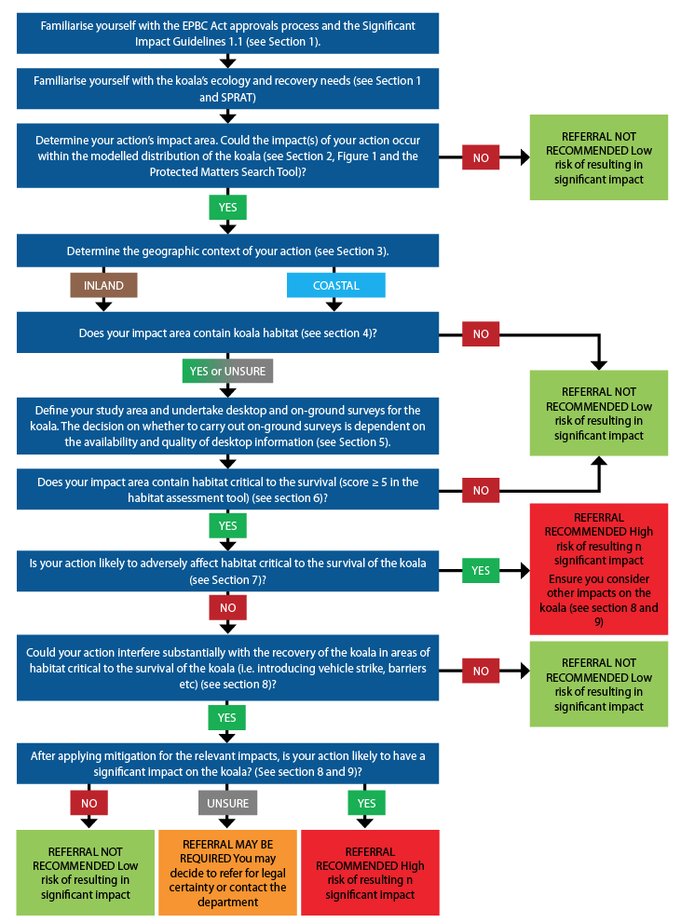

Glossary (terms appear in bold for their first occurrence in the main text)

***Barrier:*** A feature (natural or artificial) that is likely to prevent the movement of koalas. Natural barriers may include steep mountain ranges (cliffs), unsuitable habitats, major rivers / water bodies or treeless areas more than 2 km wide. Artificial barriers may include infrastructure (such as roads, rail, mines, large fences etc.) without effective koala passage measures, or developments that create treeless areas more than 2 km wide.

***Breeding:*** Koalas are considered to be breeding if mating is observed during on-ground surveys, or one or more female koalas with back young or pouch young are present.

***Contiguous landscape:*** An area of koala habitat that is greater than 300 ha in the coastal context, or greater than 500 ha in the inland context, which encompasses no barriers but is bounded by barriers (see ***Barrier*** definition above).

***Forest:*** A vegetation community which conforms to the structural form of tall or low forest (including all sub-forms) in Australia, as defined by Specht (1970) (see Attachment 1).

***Food tree:*** Species of tree whose leaves are consumed by koalas. Koala food trees can generally be considered to be those of the following genus: Angophora, Corymbia, Eucalyptus, Lophostemon and Melaleuca. Note that food tree species may vary spatially and temporally and information specific to the local area is likely to be most accurate. Also note that ‘primary’ and ‘secondary’ food trees (as defined by some resources) are all considered to be ‘food trees’ for the purposes of assessment using these guidelines. For some lists of koala food tree species, refer to the scientific literature, or the:

• NSW Office of Environment and Heritage koala habitat web page: www.environment.nsw.gov.au/animals/koalahabitat.htm

• QLD Department of Environment and Heritage protection koala habitat webpage: www.ehp.qld.gov.au/wildlife/koalas/koala-ecology.html

• New South Wales Recovery Plan for the Koala: www.environment.nsw.gov.au/resources/threatenedspecies/08450krp.pdf

***Habitat critical to the survival of the koala:*** Koala habitat that is considered to be important for the species’ long-term survival and recovery. An impact area that scores five or more using the habitat assessment tool for the koala in Table 4 of these guidelines is highly likely to contain habitat critical to the survival of the koala.

***Impact area:*** The area in which direct, indirect and facilitated impacts on the koala will, are likely to, or may occur[1].

***Koala habitat:*** any forest or woodland containing species that are known koala food trees, or shrubland with emergent food trees. This can include remnant and non- remnant vegetation in natural, agricultural, urban and peri-urban environments. Koala habitat is defined by the vegetation community present and the vegetation structure; koalas do not necessarily have to be present.

***Micro-siting:*** The considered arrangement or placement of infrastructure or works in a manner that avoids impacts on areas of highest ecological value or in a manner that avoids fragmentation of habitat.

***Residual impact(s):*** Unavoidable impact(s) that remain after avoidance and mitigation measures have been applied to an action.

***Salvage translocation:*** The relocation of animals or plants from an area adversely affected by development to an area reserved or protected from ongoing impacts.

***Shelter tree:*** Any tree that koalas use primarily for shelter, rather than food. Shelter trees may be used for refuge, sheltering or resting. A broad range of trees are known to be utilised as shelter trees.

***Shrubland:*** A vegetation community which conforms to the structural form of shrubland (including all sub-forms) in Australia, as defined by Specht (1970) (see Attachment 1).

***Study Area:*** An area that includes the impact area and any other areas that are, or may be, relevant to the assessment of the action. When determining the study area, consideration should be given to the extent of koala habitat, koala records, likely koala home range, connectivity of the habitat, control sites, comparison sites etc. (where this information is known or relevant). In some circumstances the study area may be confined to the impact area. It may be necessary to revise the study area during the assessment process if the need for additional information becomes apparent.

***Translocation:*** The human-mediated movement of living organisms from one area with release in another; either to sites where the organism now occurs, once occurred, or has never occurred.

***Woodland:*** A vegetation community which conforms to the structural form of woodland (including all sub-forms) in Australia, as defined by Specht (1970) (see Attachment 1).

***You/Your:*** To be interpreted in these guidelines as ‘a person taking an action’ or ‘a person proposing to take an action’ for the purposes of the EPBC Act. A person taking (or proposing to take) an action may be an individual, a company, an incorporated association or a government agency. This is also used in a synonymous manner with ‘the proponent’ of an action in these guidelines.

# Preamble

Important notice

The combined populations of the koala (*Phascolarctos cinereus*) in Queensland, New South Wales and the Australian Capital Territory were determined to be a species, for the purposes of the *Environment Protection and Biodiversity Conservation Act 1999* (EPBC Act), under the provisions of section 517 of the EPBC Act. The listed species, hereafter referred to in these guidelines as “the koala”, was listed as Vulnerable under the EPBC Act on 2 May 2012 (a listing event) and is therefore a Matter of National Environmental Significance (MNES). For further information on the listing of this species, please refer to the Commonwealth listing advice on the Department’s website.

These guidelines are general in nature and do not remove your obligation to consider whether you need to make a referral to the Commonwealth Environment Minister (the Minister) under the EPBC Act. Although these guidelines provide information to help you decide whether to refer your action, the possible impacts of your proposed action will depend on the particular circumstances of that action. These circumstances may include the proximity of the action to habitat, indirect impacts, and impact avoidance and mitigation measures.

Although these guidelines are developed based on the most up-to-date scientific information available at the time of writing, a referral will be assessed by the Department on the basis of the most up-to-date scientific information available at the time of referral, which may build upon the information reflected in these guidelines. These guidelines will also be reviewed once a national recovery plan for the koala has been completed. You should ensure that you have the most current version from the Department’s website before using them.

Relationship to Local and State Government Frameworks

These guidelines do not provide guidance on requirements under state and local government laws. Information on Queensland, New South Wales (NSW) and Australian Capital Territory (ACT) and local government legislative requirements can be obtained from the Queensland Department of Environment and Heritage Protection (QLD DEHP), NSW Office of Environment and Heritage (NSW OEH), the ACT Environment and Sustainable Development Directorate and local government agencies.

Wherever possible, these guidelines have been prepared in a manner that allows for alignment of definitions and assessment processes with those required under the relevant state/territory and local Government frameworks. This should allow the information gathered for local and state/territory assessment purposes to be appropriate for decision-making under the EPBC Act, with little or no modification. Despite best efforts, the Department recognises that some inconsistency may occur due to differences in jurisdictions’ decision-making processes.

The objectives of these guidelines

The objectives of these referral guidelines are to:

• Promote avoidance and mitigation of impacts on the koala

• Promote a clear, consistent and transparent approach for making decisions on whether an action is likely to result in a significant impact on the koala

• Promote streamlined decision-making and approval processes

• Promote the recovery of the koala.

How to use these guidelines

These guidelines are designed to be read from the perspective of a person proposing to take an action that may have a significant impact on the koala. Many parts of the guidelines contain information that requires a developed understanding of the EPBC Act assessment process, the ecology of the koala, as well as broader ecological concepts. Some proponents may need to seek assistance from suitably qualified or experienced people when applying them to a particular action. There is an expectation that the self-assessment process would be carried out by (or be informed by) people with a reasonable level of knowledge and experience in these matters.

Prior to reading these guidelines, you must be familiar with the *Significant Impact Guidelines 1.1—Matters of National Environmental Significance*, which explain the concept of a ‘significant impact’.

These koala referral guidelines apply in areas that the koala, or koala habitat, occurs in Queensland, NSW and the ACT. If you propose to take an action that has, will have or is likely to have a significant impact on the koala, you must refer the proposed action to the Minister prior to commencing the action. The Minister will then decide within 20 business days whether assessment is required under the EPBC Act. When making a decision on whether a proposed action requires assessment, the Minister must consider all relevant information and act in a manner consistent with natural justice and procedural fairness obligations.

An action that has, will have or is likely to have a significant impact on the koala must not commence until the Minister makes an approval decision. Substantial penalties apply for undertaking such an action without Commonwealth approval (civil penalties up to $8.5 million or criminal penalties including up to seven years imprisonment). More information on the referral, assessment and approval process is available at www.environment.gov.au/epbc/assessments/index.html. Information on compliance and enforcement of the EPBC Act can be found at www.environment.gov.au/epbc/compliance/index.html.

If you are uncertain about the need to refer, you may refer your proposed action for legal certainty, or contact the Department to discuss your proposed action by emailing epbc.referrals@environment.gov.au.

Possible exceptions to the need to refer

Certain actions are exempt from the requirement for assessment and approval under the EPBC Act. These include lawful continuations of land use that started before 16 July 2000 or actions that were legally authorised before 16 July 2000 (Sections 43A and 43B of the EPBC Act).There are a number of criteria that must be satisfied to rely on any such exemptions. More information on exemptions under the EPBC Act is available at www.environment.gov.au/epbc/publications/exemptions.html.

Actions already underway at the time a species is listed may still require approval under the EPBC Act, depending on a number of factors. Advice is available at www.environment.gov.au/resource/guidance-note-1-listings-made-after-section-75-controlled-action-decision-section-158a-epbc.

Part 3 of the EPBC Act—“Environmental Approvals”—does not apply to forestry operations undertaken in a Regional Forestry Agreement (RFA) Region, where an RFA is in place, unless the operation is being undertaken in a property on the World Heritage List, in a Ramsar wetland, or is incidental to another action whose primary purpose does not relate to forestry. There are clauses within RFAs regarding continuous improvement in threatened flora and fauna management, taking recovery plans into account and establishing a comprehensive, adequate and representative (CAR) reserve system that are intended to meet the objectives of the EPBC Act. Persons carrying out forestry operations outside of an RFA region must consider their obligations under the EPBC Act.

Where to get more information

The species profile for the koala in the Department’s Species Profile and Threats (SPRAT) database provides the biological and ecological context for survey information, significant impact guidance and impact-mitigation measures. It can be accessed at www.environment.gov.au/cgi-bin/sprat/public/sprat.pl. Other EPBC Act policy statements and guidelines are available to help you understand the EPBC Act and your obligations. These are available from the Department’s website at www.environment.gov.au/epbc/guidelines-policies.html or by contacting the community information unit by email: ciu@environment.gov.au or by phone: 1800 803 772.

There may be other MNES to consider when assessing your proposed action, including, but not limited to, other threatened species, threatened ecological communities or heritage places. The Protected Matters Search Tool, available on the Department’s website at www.environment.gov.au/epbc/pmst/index.html, is a good starting point for determining the likelihood of other MNES occurring in the proposed action’s impact area. State and Territory government agencies may also hold relevant information including species distribution and habitat information.

Although offsets are not a relevant consideration at the referral stage of an action, they may be relevant if a referral receives a ‘controlled action’ decision and moves into the assessment stage. The EPBC offsets policy is the key document for guiding proponents and decision-makers on identifying suitable offsets.

# Section 1: What does the koala need to survive and recover?

Since European arrival, the size of the koala population and the area it occupies have declined significantly. This has mainly been due to habitat loss and fragmentation, but also as a result of historic hunting practices. In some parts of the species’ range the koala has either become locally extinct or only remains in small, isolated groups.

Today, the impacts of this legacy of clearing and fragmentation are being compounded by further habitat loss and fragmentation, which increases the species’ susceptibility to direct mortality and injury from vehicle strikes, dog attacks, debilitating diseases and the effects of climate change. For the koala to survive and recover, the effects of these threats must be addressed. Further loss, fragmentation and degradation of habitat critical to the survival of the koala must be avoided and measures implemented to mitigate and manage impacts that are likely to interfere with the recovery of the koala.

For further information on the koala’s survival and recovery needs as well as important information on the biology and ecology of the koala, refer to the species’ profile in the Department’s SPRAT database.

# Section 2: Could the impacts of your action occur within the modelled distribution of the koala?

The listed koala’s current range extends from tropical north Queensland, through sub-tropical central Queensland to northern NSW, south through the temperate regions of NSW and the ACT to the Victorian border (see Map 1). Due to natural and artificial **barriers** to koala dispersal, it is not continuous across this range.

The map of the koala’s modelled distribution (Map 1) is provided for illustrative purposes only. When making an assessment, it is expected that an EPBC Act Protected Matters Search Tool search is performed as part of the desktop survey process, as this spatial tool is regularly updated based on new information. If the listed koala is identified in the Protected Matters Search Tool, then you must make an assessment of the likely impact of the proposed action on the species. These guidelines assist in making that assessment.

The koala’s modelled distribution in Map 1 is based on the best available information at the time of publication. The modelled distribution is for indicative purposes only and the Protected Matters Search Tool must be used to generate a report at the resolution of an individual action. Proponents are not limited by this mapping and in instances where mapping has been carried out at a finer resolution by reputable sources (i.e. local government, state/territory government, species experts), such mapping should be given more weight in the decision-making process.

Map 1: The modelled distribution of the listed koala species.

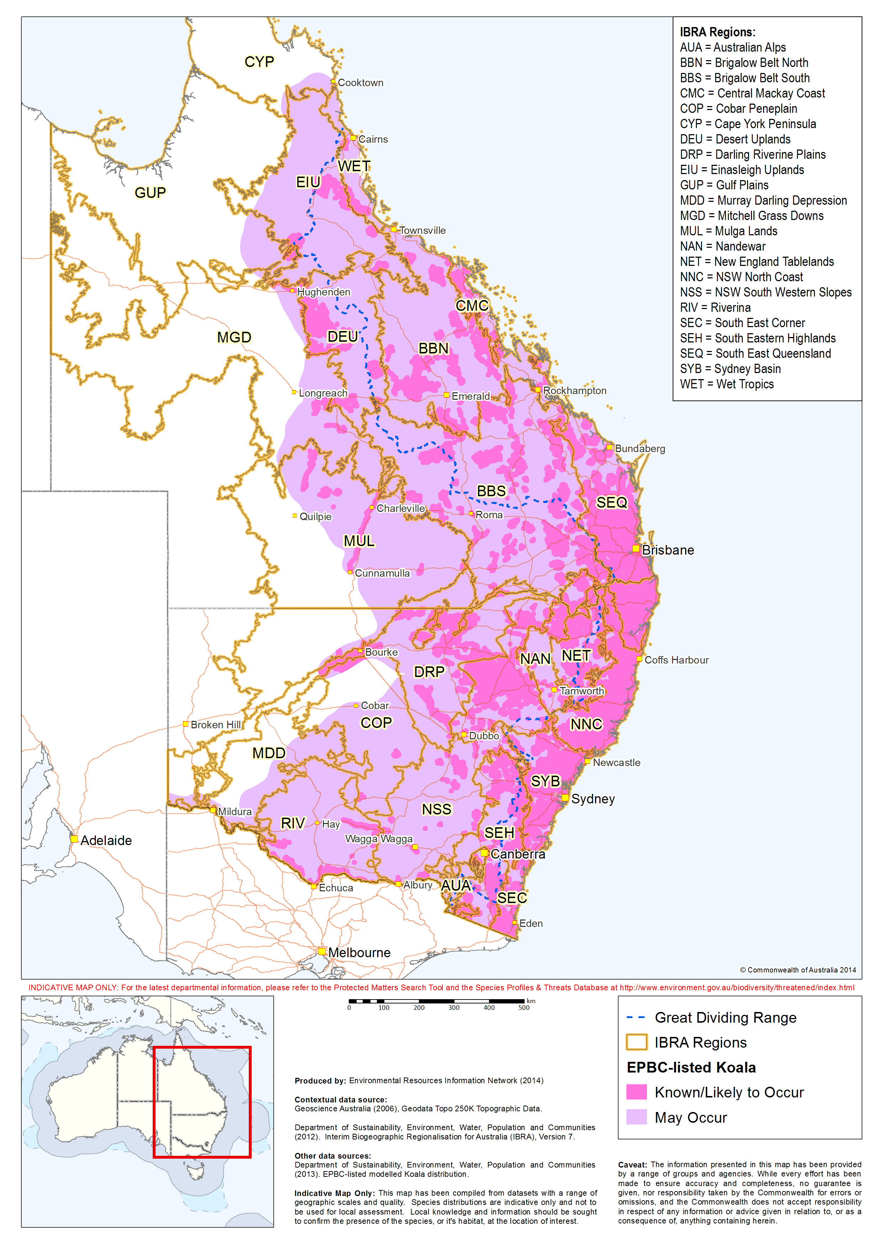

# Section 3: In what geographic context are you proposing your action?

The ecology of the koala and the threats it faces vary across the species’ range and different geographic contexts affect the assessment of a site’s value for the long-term conservation of the koala. For the purposes of determining significant impacts under the EPBC Act, the listed koala’s distribution has been split into two contexts: the inland and the coastal (see Map 2). **Habitat critical to the survival** of the koala is defined differently in these contexts because of their different climatic and ecological attributes.

The 800 mm per annum rainfall isohyet is used to separate the coastal and inland geographic contexts. The Protected Matters Search Tool will not tell you which context your proposed action occurs in; you need to obtain average rainfall data from the nearest Bureau of Meteorology (BOM) weather station to determine which context applies. For proposed actions that occur in an area with an average of exactly 800 mm, or the impact area extends over the 800 mm isohyet, the coastal context criteria are to be used when determining whether habitat is critical to the survival of the koala. Table 1 describes some key attributes of the two geographic contexts as well as some interim recovery objectives for each context. These objectives should assist you with your overall project planning.

Map 2: The inland and coastal contexts of the koala’s distribution

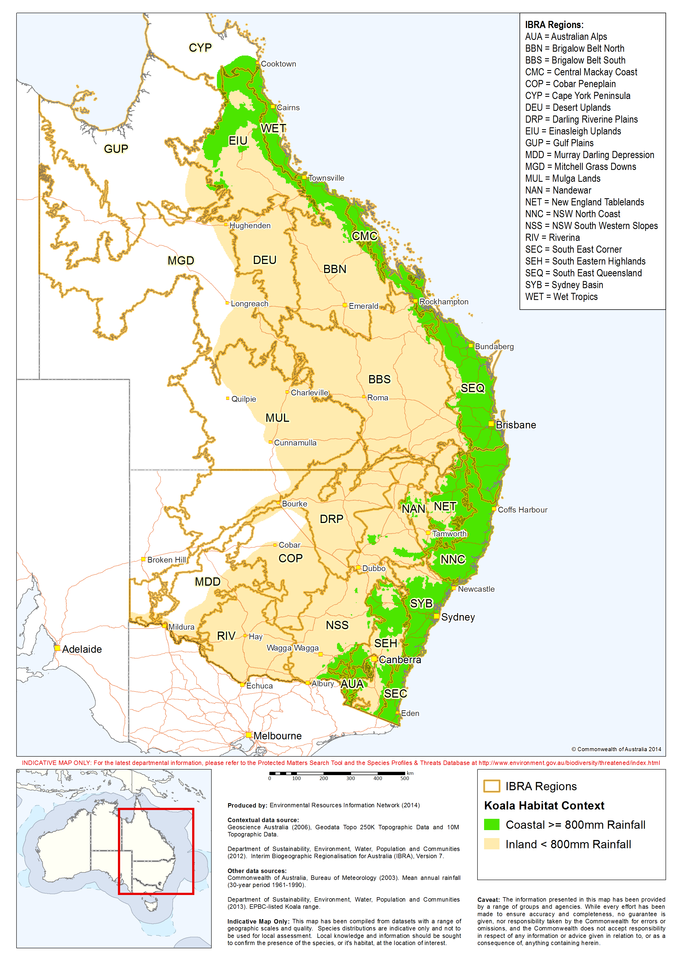

Table 1: Koala context attributes

|  |  |  |
| --- | --- | --- |
| Attributes | Inland (< 800 mm) | Coastal (≥ 800 mm) |
| Koala habitat | • Habitat includes:  – **woodlands** and **forests** (where koala **food trees** have reliable access to soil moisture)  – box gum or red gum woodlands on heavier soils in remnant or regrowth vegetation patches particularly riparian zones  – small, patchy and sparsely distributed woodlands, **shrublands** and forest in highly modified, agricultural-grazing landscapes or in and around rural towns (although there are some large, connected areas of habitat also). | • Habitat includes:  – large, connected areas of native vegetation, including in forests and woodlands where logging has altered tree species composition; these areas may be remnant, regrowth or plantation vegetation  – small, isolated patches of native vegetation in rural, urban or peri-urban areas  – windbreaks and narrow areas of native vegetation along riparian areas or linear infrastructure  – isolated food and/or **shelter trees** (i.e. on farm lands, in suburban streetscapes, parks and yards). |
| Primary threats | • Loss, fragmentation and degradation of habitat, including dispersal habitat.  • Predicted increase in the frequency and severity of droughts, periods of extremely high temperatures and increased frequency of fire.  • Lack of access to refuges from climatic extremes.  • Mortality due to vehicle strikes and dog attack. | • Loss, fragmentation and degradation of habitat, including dispersal habitat.  • Mortality due to vehicle strikes, dog attacks and disease.  • High-intensity fire. |
| Interim recovery objectives | • Protect and conserve the quality and extent of habitat refuges for the persistence of the species during droughts and periods of extreme heat, especially in riparian environments and other areas with reliable soil moisture and fertility[2].  • Maintain the quality, extent and connectivity of large areas of koala habitat surrounding habitat refuges. | • Protect and conserve large, connected areas of koala habitat[3], particularly large, connected areas that support koalas that are:  – Of sufficient size to be genetically robust / operate as a viable sub-population **or**  – free of disease or have a very low incidence of disease **or**  – **breeding**.  • Maintain corridors and connective habitat that allow movement of koalas between large areas of habitat. |

# Section 4: Could the impact(s) of your action affect koala habitat?

Koalas are leaf-eating specialists and inhabit a range of vegetation communities; predominantly those dominated by *Eucalyptus* species, or closely-related genera (including *Corymbia* and *Angophora* species), as well as *Lophostemon* and *Melaleuca* species.

In the coastal context, koalas inhabit forest and woodland mostly dominated by Eucalyptus species (or those of related genera) and also those dominated by Melaleuca or Casuarina species (with emergent food trees).

In the inland context, koalas inhabit eucalypt forests and woodlands, as well as acacia woodlands (with emergent food trees) in both riparian and non-riparian environments.

In the dry, subtropical to semi-arid west of the inland context, koalas inhabit eucalypt (and related genera) forests and woodlands, particularly in the vicinity of riparian environments, and acacia-dominated forest, woodland and **shrubland** (with emergent food trees).

|  |
| --- |
| **Koala habitat:** any forest or woodland containing species that are known koala food trees, or shrubland with emergent food trees. This can include remnant and non- remnant vegetation in natural, agricultural, urban and peri-urban environments. Koala habitat is defined by the vegetation community present and the vegetation structure; the koala does not necessarily have to be present. |

A habitat assessment tool is provided in Section 6 to assist in identifying whether your impact area contains habitat that is critical to the survival of the koala. It is this habitat that the Department is primarily focused upon protecting to recover the koala.

Some koala habitat may also represent threatened ecological communities which are separately protected under the EPBC Act and relevant state/territory legislation. Further information on koala habitat is provided in the SPRAT database and information regarding listed ecological communities is provided on the Department website at www.environment.gov.au/biodiversity/threatened/communities.html.

# Section 5: Have you surveyed for the koala and koala habitat?

This section provides guidance on appropriate survey techniques for gathering information about koala habitat and koala occurrence in the **study area**. The Department strongly encourages proponents to engage qualified specialists to carry out surveys prior to making an assessment of their action or submitting a referral, to provide adequate information on the following habitat attributes:

• Koala presence (and potentially abundance or density)

• Vegetation composition

• Habitat connectivity

• Existing threats to koalas

• Recovery value.

This information will greatly assist you and the Department in assessing the significance of the impacts on the koala. The survey methods and level of survey effort required in your study area will depend on the size and nature of your action and the availability and quality of information already available.

The general survey design principles detailed in the Department’s *Survey Guidelines for Australia’s Threatened Mammals* are highly relevant to surveying for koalas, although the species is not specifically referred to in the policy. In some cases, a state or local government guideline may provide an equally robust framework for carrying out koala surveys for the purposes of impact assessment.

Desktop survey

A desktop survey is required to assess the quality of existing information and should indicate whether on-ground surveys for the koala are required to fill any information gaps.

A desktop survey should include searches of koala presence records in State, Territory and non-government databases, a review of the scientific literature, a review of koala strategies or management plans relevant to the region and a review of current vegetation mapping and aerial photographs. Some useful starting points for gathering data on koala occurrence are:

• The Atlas of Living Australia

• NSW BioNET

• QLD Wildlife Online

• ACTMAPi.

Records of koala occurrence should be confirmed, and/or any initial knowledge gaps addressed, by consulting with relevant stakeholders. This is likely to include local government agencies and experts, State and Territory government agencies, local koala experts, koala conservation organisations, private landholders, local ecological consultants, veterinarians, wildlife carers, local field naturalists and local indigenous groups. At this stage, information should also be sought about the intensity of threats to the koala in the area.

This review of all available information and consultation with local stakeholders should help to inform you about the accuracy and adequacy of local knowledge about the koala. If there are knowledge gaps, or if key pieces of information are missing, to the extent that an assessment of impacts on the species cannot be confidently made, on-ground surveys should be carried out. The absence of records in online databases is not necessarily sufficient evidence that the koala is not present, particularly if habitat is present.

On-ground surveys

On-ground surveys may be undertaken to ground-truth desktop data, address knowledge gaps identified in the desktop survey process, or to gather data that cannot be obtained via desktop analysis (i.e. koala abundance or density data). Ground-truthing vegetation data is often an important first step for on-ground surveys. This may include an assessment of the species/communities present (and their abundance across the study area), categorisation of vegetation condition and structure and assessment of fine-scale variation within broadly mapped vegetation groups. Surveys must be conducted by a suitably qualified specialist (tertiary educated/trained in ecology or environmental science), with demonstrated skill and experience in conducting vegetation and/or koala surveys.

Koalas are difficult to detect and occur at low densities in many parts of their range. The most appropriate survey method and design depends on the type of data that is desired (i.e. presence/absence, abundance, habitat preference, density, tree species preference) and the size/complexity of the site. Gathering more complex data (i.e. density) or surveying larger, more complex sites will generally require more time and resources. The benefits of more thorough surveys are a higher level of confidence in the assessment and more information on which to plan and make decisions. The habitat assessment tool (Table 4) has been designed using criteria that can be adequately addressed with a basic survey methodology; desktop survey, high level vegetation/habitat ground-truthing and koala presence/absence data. However, for assessing significance where there is some uncertainty, gathering information for planning complex actions or for determining offset liability, more detailed investigation (potentially spatially and temporally replicated baseline surveys) will be required.

For actions with a large footprint, or landscape-scale impacts, baseline monitoring which evaluates koala abundance, movement and habitat preferences in the area proposed to be affected by the project will be necessary. This may involve a combination of direct and indirect survey methods in the study area, particularly if there is limited desktop data available. These surveys will be important for effective design and implementation of mitigation measures to minimise the action’s impacts (see section 9). Referral of the project after these studies will improve the likelihood that it will be considered in a timely fashion, without the need to request further information. The Department recommends early dialogue with koala experts, local and state government environmental agencies, experienced consultants and other relevant institutions prior to developing and implementing this program.

Survey effort

These guidelines do not prescribe survey effort standards for koala surveys, due to the high level of variation in environmental variables across the koala’s range. Survey effort must be determined on a case-by-case basis. However, the following key principles (where relevant) underpin the design and implementation of koala surveys:

i. Sampling is only considered appropriate for moderate or large study areas (i.e. several hectares or more); census (surveying the entire site) is relevant for small sites and improves confidence in the data.

ii. Surveys for animals (direct observation) or signs (scats, scratches etc.), for the purposes of gathering presence/absence data, must be undertaken in a manner which maximises the chance of detecting the species.

iii. Failure to detect animals or sign in a single survey does not necessarily mean the koala is absent; spatial and temporal replication of the survey is required in order to infer true absence.

iv. The strengths and limitations of different methods must be acknowledged and considered when designing the survey.

v. The species’ ecology varies across its range; it is not appropriate to extrapolate ecological findings to different communities or bioregions.

vi. Care must be taken not to violate the assumptions of the statistical or methodological analyses used when making comparisons between sites or strata (not relevant to census surveys).

Direct observation methods

Direct observation methods (Table 2) may be appropriate where animals are being captured (i.e. for radio/satellite collaring or mark-resight methods), where abundance or density data is desired, or where koala density is likely to be high. Because of the species’ cryptic nature, however, direct observation often yields little data, which leads to large error estimates for the results obtained. This can be addressed by significantly increasing the survey effort, but costs rise accordingly.

Direct observation surveys should be undertaken between August and January. This is the period when koala activity is generally at a peak, and resident breeding females with back-young are most easily observed. Direct observation surveys conducted outside of this period must take into account the potential for lower koala activity (reduced detectability) and other relevant seasonal considerations.

In the inland context, there may be seasonal variation in koalas’ use of different habitat types. Presence/absence surveys in the inland context, conducted during dry periods, should be centred on riparian areas, upper/mid-slope areas and other dry-period refugia in order to maximise detectability.

Indirect survey methods (signs)

Due to the difficulty in observing koalas and the variable density of koalas across the landscape, indirect methods are often the most effective for gathering presence/absence data. With robust survey design, they can also be effective in gathering relative abundance and relative density data. Scat surveys have been used to gather absolute abundance data, however, this approach requires a more complex methodology. Indirect survey method design must take into account the effects of various factors on sign detectability (i.e. heavy leaf litter known to reduce detectability of pellets) and sign persistence (i.e. flooding and rainfall known to affect scat decay). Table 3 outlines some indirect observation methods which may be used for on-ground koala surveys.

Other techniques not listed here may also be used, however their effectiveness should have been demonstrated, and ideally published in a peer-reviewed publication. Novel survey techniques may be developed following the finalisation of these guidelines.

Table 2: Direct observation methods

|  |  |  |
| --- | --- | --- |
| Direct observation method | General comments | Limitations |
| Strip transects | • Daytime transects relevant when koala activity and density is high.  • Useful census method for small to medium sites.  • Use in a standardised design for absolute density (survey effort will affect confidence interval of estimate).  • Can be used for distance sampling methodology. | • Unlikely to provide sufficient data where koalas occur at moderate to low density.  • May require significant resources.  • May not be ideal for presence/absence when employed in a standardised manner, as this approach does not maximise detectability. |
| Nocturnal spotlighting | • Eye shine may increase detectability over daytime surveys at lower density sites or when koala activity is lower.  • Useful census method for small sites.  • Use in a standardised design for absolute density (survey effort will affect confidence interval of estimate).  • Can be used for distance sampling methodology. | • Unlikely to provide sufficient data where koalas occur at moderate to low density.  • May require significant resources.  • May not be ideal for presence/absence data only, as the method does not maximise detectability.  • Ethics approval required. |
| Call playback | • Optimal during the breeding season (which can vary across the species’ range).  • Useful for gathering presence/absence data.  • Suitable for standardised gathering of abundance/density data if individuals responding can be differentiated. | • May not be appropriate in areas with a particularly vulnerable local aggregation of koalas, as it can disrupt natural behaviour patterns (should be considered by the relevant ethics committee). |
| Remote sensor activated cameras | • Strategically place in locations where fresh sign (scratching/scats) has been detected.  • Presence will have already been confirmed by preliminary sign survey. Cameras useful for identifying breeding (back young), movement (i.e. use of road crossings) and other specific types of study. | • May not provide sufficient data where koalas occur at low density.  • Camera locations need to be informed by preliminary sign surveys.  • May require significant resources.  • Preliminary sign surveys will confirm presence; cameras may not substantially value-add to survey data obtained. |
| Mark-resight or mark-recapture | • Likely to be more effective in areas with a high density of koalas and during periods when koalas are most active.  • Use in a standardised design for absolute abundance/density (survey effort will affect confidence interval of estimate). | • Unlikely to provide sufficient data where koalas occur at moderate to low density.  • May require significant resources.  • May not be ideal for presence/absence data only, as the method does not maximise detectability.  • Ethics approval required. |
| Detection dogs | • Emerging method for gathering presence/absence data.  • May improve detectability, particularly where koalas occur at moderate to low densities. | • Method not widely tested for koalas or published in peer-reviewed literature.  • Difficult to standardise the movement and decision of the detection dog—unlikely to generate anything further than presence/absence data.  • Few trained detection dogs are available. |
| Radio or satellite collars | • Most appropriate for longer-term, baseline studies where home-range, habitat preference or medium to large scale movement data are required. | • Resource intensive and time consuming.  • Unlikely to provide a large sample size; confidence in inferences may be limited.  • Ethics approval required. |

Table 3: Indirect survey methods

|  |  |  |
| --- | --- | --- |
| Indirect observation method | General comments | Limitations |
| Scratchings | • Scratchings are relatively identifiable and persist for a reasonable period.  • Difficult to accurately age scratchings. | • Useful for presence/absence data only;  • Only detectable on smooth-barked trees.  • Care must be taken not to obtain false presence data (due to misidentification of scratchings). |
| Scats— Spot Assessment Technique (SAT)[4] | • Tree-based sampling methodology that provides presence/absence data.  • Method can be used to gather comparative data regarding habitat usage/preference. | • ‘Focal trees’ must be chosen using a transparent and evidence-based method.  • The method must be standardised across sites and strata in order for a comparison to be valid.  • Different detectability of scats between sample sites and strata must be considered. |
| Scats— Regularised Grid Based Spot Assessment Technique  (RGB-SAT)[5] | • Utilises grid intersect points to identify the centre of each SAT plot, rather than selection of a ‘focal tree’.  • Method can be used to gather comparative data regarding habitat usage/preference. | • Different detectability of scats between sample sites or strata must be considered. |
| Scats— Koala optimised Rapid Assessment Methodology (KRAM)[6] | • Pre-determined, standardised sampling methodology.  • Does not require judgements to be made in regards to selection of ‘focal trees’.  • Method is relevant for presence/absence data and comparative density/habitat preference. | • Different detectability of scats between sample sites or strata must be considered.  • Authors suggest increasing survey effort for each point in a manner that is proportional to scat detectability. |
| Faecal standing crop assessment[7] | • Utilises a model incorporating scat counts and assumptions regarding scat production (or site-specific scat production data).  • Can provide absolute abundance data. | • Resource intensive.  • Requires site-specific data regarding scat production and age to remove assumptions/surrogate figures.  • Requires robust vegetation and environmental variable data in order to extrapolate results. |

# Section 6: Could your impact area contain habitat critical to the survival of the koala?

These guidelines encourage the assessment of significant impacts on the koala primarily through the assessment of habitat critical to the survival of the koala and actions that interfere substantially with the recovery of the koala. This approach aims to avoid and address habitat loss*—*a key threat to the koala, as well as promote a streamlined assessment and approval process.

The Department’s Significant Impact Guidelines 1.1 include a number of generic significant impact assessment criteria that refer to ‘important populations’. The concept of ‘important populations’ has not been used in these koala referral guidelines. Sufficient information was not available at the time of writing to adequately identify and separate the nature of any important populations throughout the range of the listed species.

This may be reviewed when the national recovery plan for the koala is finalised, particularly if it contains information on delineating important populations and provides further information on habitat critical to the survival of the koala.

The koala habitat assessment tool

The koala habitat assessment tool in Table 4 will assist you in determining the sensitivity, value and quality of the impact area and, therefore, whether it contains habitat critical to the survival of the koala. From a national recovery perspective, this is koala habitat that is considered to be important for the long-term survival and recovery of the koala.

The habitat assessment tool categorises five primary koala habitat attributes: koala occurrence, vegetation composition, habitat connectivity, existing threats and recovery value. Each habitat attribute is scored between zero and two and the scores are added together to give a total out of 10, providing an indication of the overall value of habitat in the impact area.

The first two attributes—koala occurrence and vegetation composition—account for the importance of the habitat where a koala occurs, for example, valuing the presence of koalas at a particular location and the trees they forage on.

The other three attributes*—*habitat connectivity, existing threats and recovery value*—*account for the value of the habitat from both a regional and recovery planning perspective, for example valuing habitat that is part of a large contiguous patch of koala habitat which is free from threats and important for koala recovery. Recovery value depends on the interim recovery objectives for the koala in each context, as outlined in Table 1. In most cases, the value of these three attributes in urban areas is likely to be zero as the existing effects of habitat loss, fragmentation, vehicle strike, dog attack and other threats have and are likely to continue to degrade these areas over the medium to long-term.

How do I use the habitat assessment tool?

The habitat assessment tool is to be applied once to the entire impact area of your proposed action. It is your responsibility to define the impact area and consider downstream or facilitated impacts on the koala and include these areas in the definition of your impact area.

On a case by case basis there is potential for users of the tool to over- or under-value habitat in the impact area. To support your habitat score, you should provide an overall appraisal of the habitat to justify and complement the score (Attachment 2 contains worked examples).

If you have insufficient evidence to determine what score a particular habitat attribute meets, you should either:

• Carry out further ecological surveys (see section 6 of these guidelines) **OR**

• Give that attribute the highest score **OR**

• Apply the precautionary principle and assume that the impact area contains habitat critical to the survival of the koala.

Does your impact area contain habitat critical to the survival of the koala?

|  |
| --- |
| Impact areas that score **five or more** using the habitat assessment tool for the koala contain habitat critical to the survival of the koala. Impact areas that score **four or less** using the koala habitat assessment tool do not contain habitat critical to the survival of the koala. |

The habitat assessment tool and the offset calculator

As well as identifying habitat critical to the survival of the koala, the habitat assessment tool for the koala has been developed to assist with the *EPBC Act Environmental Offsets Policy*. It can help you determine ‘habitat quality’ referred to in the offset calculator. The habitat assessment tool below may be used instead of the three generic habitat quality categories found in the Offsets Assessment Guide and be applied once to the entire area of habitat being offset. Table 4 can also be used to calculate the starting quality of a proposed offset site and to estimate the future quality, with and without the proposed offset/management intervention. As mentioned in Section 1 of these guidelines, offsets are not a relevant consideration at the referral stage of an action; the above advice is provided for use in the case of a ‘controlled action’ decision on a referral.

Table 4: Koala habitat assessment tool

| Attribute | Score | Inland | Coastal |
| --- | --- | --- | --- |
| Koala occurrence | +2 (high) | Evidence of one or more koalas within the last 5 years. | Evidence of one or more koalas within the last 2 years. |
| +1 (medium) | Evidence of one or more koalas within 2 km of the edge of the impact area within the last 10 years. | Evidence of one or more koalas within 2 km of the edge of the impact area within the last 5 years. |
| 0 (low) | None of the above. | None of the above. |
| Vegetation composition | +2  (high) | Has forest, woodland or shrubland with emerging trees with 2 or more known koala food tree species, **OR**  1 food tree species that alone accounts for >50% of the vegetation in the relevant strata. | Has forest or woodland with 2 or more known koala food tree species, **OR**  1 food tree species that alone accounts for >50% of the vegetation in the relevant strata. |
| +1  (medium) | Has forest, woodland or shrubland with emerging trees with only 1 species of known koala food tree present. | Has forest or woodland with only 1 species of known koala food tree present. |
| 0 (low) | None of the above. | None of the above. |
| Habitat connectivity | +2  (high) | Area is part of a contiguous landscape ≥ 1000 ha. | Area is part of a contiguous landscape ≥ 500 ha. |
| +1  (medium) | Area is part of a **contiguous landscape** < 1000 ha, but ≥ 500 ha. | Area is part of a contiguous landscape < 500 ha, but ≥ 300 ha. |
| 0  (low) | None of the above. | None of the above. |
| Key existing threats | +2  (high) | Little or no evidence of koala mortality from vehicle strike or dog attack at present in areas that score 1 or 2 for koala occurrence.  Areas which score 0 for koala occurrence and have no dog or vehicle threat present | |
| +1  (medium) | Evidence of infrequent or irregular koala mortality from vehicle strike or dog attack at present in areas that score 1 or 2 for koala occurrence, **OR**  Areas which score 0 for koala occurrence and are likely to have some degree dog or vehicle threat present. | |
| 0  (low) | Evidence of frequent or regular koala mortality from vehicle strike or dog attack in the study area at present, **OR**  Areas which score 0 for koala occurrence and have a significant dog or vehicle threat present. | |
| Recovery value | +2 (high) | Habitat is likely to be important for achieving the interim recovery objectives for the relevant context, as outlined in Table 1. | |
| +1 (medium) | Uncertain whether the habitat is important for achieving the interim recovery objectives for the relevant context, as outlined in Table 1. | |
| 0 (low) | Habitat is unlikely to be important for achieving the interim recovery objectives for the relevant context, as outlined in Table 1. | |

# Section 7: Will your action adversely affect habitat critical to the survival of the koala?

The Significant Impact Guidelines 1.1 state that actions are likely to have a significant impact on a vulnerable species if they adversely affect habitat critical to the survival of the species. Habitat destruction is recognised as the primary adverse effect on habitat critical to the survival of the koala. Whether or not there are other impacts, the loss of habitat critical to the survival of the koala can be sufficient to trigger a significant impact. Figure 2 helps you to determine whether the habitat loss associated with the action is likely to adversely affect habitat critical to the survival of the koala and so require referral to the Department.

When designing your action, your principal aim should be to avoid areas that contain known koala food trees. You could do this by choosing an alternative location for your action or **micro-siting** infrastructure to avoid koala habitat. While this can reduce the risk of adversely affecting habitat critical to the survival of the koala, you will still need to consider indirect impacts on the koala that may interfere with its recovery (section 8).

Figure 2 identifies the upper and lower limits of adversely affecting habitat critical to the survival of the koala and provides guidance on the need to refer an action. In the uncertain area between these upper and lower limits, Figure 2 provides guidance on the characteristics that are likely to contribute to your decision whether or not to refer your action. It is important to remember that it is your responsibility to make the decision to refer and each action is considered on a case-by-case basis.

Some examples of how to apply the guidance in Figure 2 are provided at Attachment 2. If you still remain uncertain, you may refer your proposed action for legal certainty, or contact the Department to discuss your proposed action.

Figure 2: Assessing adverse effects on habitat critical to the survival of the koala

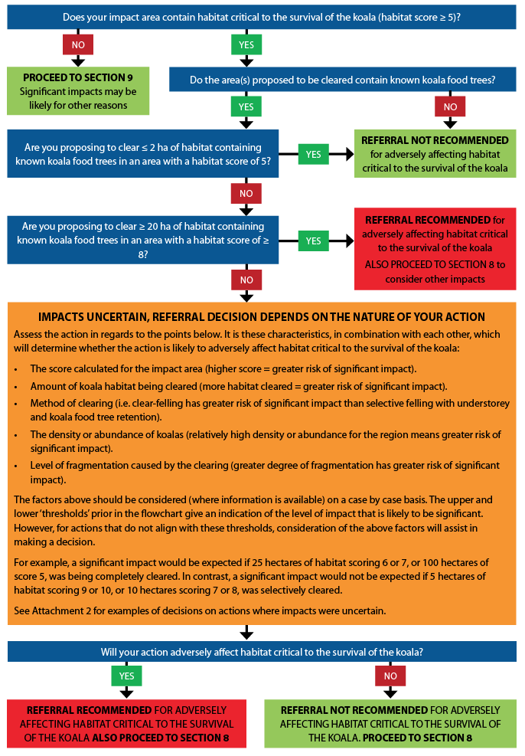

# Section 8: Could your action interfere substantially with the recovery of the koala?

In addition to considering adverse affects on habitat critical to the survival of the koala, you need to consider the potential for your action to interfere substantially with the recovery of the koala.

Impacts which are likely to substantially interfere with the recovery of the koala may include one or more of the following:

• Increasing koala fatalities in habitat critical to the survival of the koala due to dog attacks to a level that is likely to result in multiple, ongoing mortalities.

• Increasing koala fatalities in habitat critical to the survival of the koala due to vehicle-strikes to a level that is likely to result in multiple, ongoing mortalities.

• Facilitating the introduction or spread of disease or pathogens for example Chlamydia or *Phytophthora cinnamomi*, to habitat critical to the survival of the koala, that are likely to significantly reduce the reproductive output of koalas or reduce the carrying capacity of the habitat.

• Creating a barrier to movement to, between or within habitat critical to the survival of the koala that is likely to result in a long-term reduction in genetic fitness or access to habitat critical to the survival of the koala.

• Changing hydrology which degrades habitat critical to the survival of the koala to the extent that the carrying capacity of the habitat is reduced in the long-term.

Where such impacts are likely to occur, avoidance and mitigation measures should be put in place to minimise the **residual impact** of the action. This should be done at the planning stage of a project. Appropriate monitoring and maintenance arrangements should be put in place so that mitigation measures are effective for the life of the impacts. Evaluating the mitigation measures over time may also allow for better and more cost-effective mitigation measures to be pursued in the future.

|  |
| --- |
| **Important note:** The mitigation of impacts which may interfere with the recovery of the koala only applies to impact areas which score ≥ 5 using the habitat assessment tool, as these areas are habitat critical to the survival of the koala. |

Tables 5–9 provide guidance on the mitigation of these impacts and whether residual impacts are likely to be significant and therefore require referral to the Department. Each table includes mitigation standards for various mitigation measures. Not all measures will be relevant for all types of actions; their appropriateness should be considered on a case-by-case basis. For example, dog-proof fencing may be more effective than a dog control strategy in some locations. Multiple mitigation measures may be relevant and proponents should consider whether a combination of measures will be necessary.

The mitigation measures rated high in Tables 5–9 are considered the most desirable for mitigating the particular impact. Without one or some of the standards, mitigation measure may not be considered effective. For example, koala fencing that is installed along a road to minimise koala fatality must be maintained and monitored in perpetuity for it to be an effective mitigation measure.

The effectiveness of some mitigation measures is unproven so their effectiveness is considered low. These measures may still be important in contributing to the overall reduction of impacts on the koala.

If proponents wish to apply mitigation measures other than those identified here, evidence that they are equally effective in achieving the mitigation objectives should be provided.

Bushfire hazard reduction techniques conducted in accordance with state or territory law are typically exempt from EPBC Act approval requirements. National environmental law generally does not restrict responses required to manage bushfire emergencies, nor does it regulate measures taken to fight fires[8].

A new action that increases the risk of high-intensity fire causing koala mortality in habitat critical to the survival of the koala may have a significant impact. For example, a new mine development next to or within koala habitat could increase the risk of high-intensity fire in the habitat. This could be mitigated by the adoption of a fire prevention plan which is implemented for the life of the action. Such a plan should also include a workforce and community education component.

|  |
| --- |
| **Important information about the assessment of measures proposed to compensate for adverse impacts on the koala**  The EPBC Act does not allow for compensatory measures (such as translocating individuals) or positive impacts (such as offsets) to be considered at the referral stage. At the referral stage, significance is based on the residual impact of the proposed action only.  Furthermore, the Department does not consider **translocation** or **salvage** **translocation** of koalas, to be an effective measure to mitigate the impact of an action, as it is unlikely to result in positive conservation outcomes for the species.  Although it is likely to be required under local or state government permits/approvals, translocation will be considered as a loss of the translocated individuals, for the purposes of assessing impacts of an action under the EPBC Act. Where translocation is being proposed, its potential detrimental impacts, such as introducing a disease to the recipient site, also need to be considered. |

Impact Mitigation Tables

Table 5: Dog attack

|  |  |  |
| --- | --- | --- |
| Likely significant impact | | |
| An action leads to an increase in dog attacks in habitat critical to the survival of the koala to a level that is likely to result in multiple, ongoing koala mortalities. | | |
| Mitigation measures | Mitigation standards | Effectiveness[9] |
| Dog proof and koala proof fencing | • Fencing that is both dog proof and koala proof along boundaries; or dog proof fencing with koala furniture to allow koalas to escape yards, **AND**  • Fences are a minimum 3m high (dog proof), **and**  • Have a minimum 50cm wide scratch panelling installed along the length of the outer side of the fence (for koala proof fencing), **and**  • A fully-funded agreement is in place with a relevant organisation or authority for the maintenance and monitoring of the fencing in perpetuity. | High |
| Dog control strategy | • Dog control carried out using a method that is known to be effective in comparable circumstances (i.e. may include shooting, poison baiting etc.) and by a qualified professional, **and**  • The timing and level of effort of dog control is appropriate to the circumstances and the desired outcomes, **and**  • Dog control is carried out for the duration of the impact. | Moderate |
| Signage and education | • A community engagement program involving interpretive signs, social media, fact sheets and community presentations, to raise awareness, minimise threats and encourage reporting of dog threats in the local area. | Low |
| Residual impact likely to require referral | | |
| • Dog attacks in habitat critical to the survival of the koala increase to a level that is likely to result in multiple, ongoing koala mortalities.  • The standards of the mitigation measure are not met.  • The action involves the use of other, unproven mitigation measures and or standards.  • There is significant loss of habitat critical to the survival of the koala (section 7). | | |

Table 6: Vehicle strike

|  |  |  |
| --- | --- | --- |
| Likely significant impact | | |
| An action leads to an increase in vehicle-strikes in habitat critical to the survival of the koala to a level that is likely to result in multiple, ongoing koala mortalities. | | |
| Mitigation measures | Mitigation standards | Effectiveness |
| Koala proof fencing[10] | • Koala proof fencing along entire extent of infrastructure, **and**  • Be a minimum 1.8m high, **and**  • Be 3m from any retained trees or plantings and be clear of all overhanging branches, **and**  • Have a minimum 50cm wide scratch panelling installed along the length of the fence, **and**  • A fully-funded agreement is in place with a relevant organisation or authority for the maintenance and monitoring of the fencing in perpetuity, **and**  • Be used in conjunction with fauna underpasses/overpasses, **and** | **High** |
| Koala land bridge | • Designed in a manner equivalent to or better than that described below, **and**  • Placed at appropriate and regular locations, based on an understanding of local koala movements, **and**  • Designed with an appropriately deep soil bed, vegetated and enhanced with habitat features (e.g. logs, rocks), **and**  • Fencing in place to guide koalas to the land bridge(s) (at least 100 m either side of the land bridge entrance), **and**  • A fully-funded agreement is in place with a relevant organisation or authority for the maintenance and monitoring of the land bridge in perpetuity. | **Moderate**  (**High** if including *Research* measure) |
| Koala underpasses | • Placed at appropriate and regular locations, based on an understanding of local koala movements, **and**  • Include above water, dry longitudinal benches, **and**  • Designed according to best practice principles, **and**  • Ideally be no more than 40m in length, **and**  • Be a minimum 2.4m in height and width, **and**  • Have a low-flow channel incorporated in the design, **and**  • Fencing in place to guide koalas to the underpass(es) (at least 100 m on either side of the underpass entrance), **and**  • A fully-funded agreement is in place with a relevant organisation or authority for the maintenance and monitoring of the infrastructure in perpetuity. | **Moderate**  (**High** if including *Research* measure) |
| Mitigation measures | Mitigation standards | Effectiveness |
| Road design | • Priority given to road tunnelling maintaining natural overpasses, **and**  • Viaducts and bridges, **and**  • Inclusion of escape mechanisms i.e. climbing poles along road corridor, **and**  • Wide breakdown lane buffers, **and**  • There is significant loss of habitat critical to the survival of the koala (section 7). | **Low** |
| Speed limits and signage | • 60 km/h on all roads through or adjacent to habitat critical to the survival of the koala during dawn and dusk and at night, **and**  • Road signage to alert drivers of koala crossings. | **Low** |
| Research | • Improve understanding of the effectiveness of mitigation infrastructure designed to avoid or minimise the risk of koala vehicle strike. | **Low** |
| Residual impact likely to require referral | | |
| • Vehicle-strikes in habitat critical to the survival of the koala increase to a level that is likely to result in multiple, ongoing koala mortalities.  • The standards of the mitigation measure are not met, **or**  • The action involves the use of other, unproven, mitigation measures and or standards. | | |

Table 7: Facilitating the introduction or spread of disease or pathogens

|  |  |  |
| --- | --- | --- |
| Likely significant impact | | |
| An action facilitates the introduction or spread of disease or pathogens to habitat critical to the survival of the koala, for example *Chlamydia* or *Phytophthora cinnamomi*, which are likely to significantly reduce the reproductive output of koalas or reduce the carrying capacity of the habitat. | | |
| Mitigation measures | Mitigation standards | Effectiveness |
| Translocation quarantine procedure for Chlamydia and Koala retrovirus | • All koalas to be translocated must initially be kept separate from others and must undergo a standardised and thorough veterinary health examination to detect any clinical evidence of communicable disease or infection, **and**  • A procedure must be in place for koalas which are found to be affected by disease (i.e. treatment prior to release), **and**  • Monitoring of the release site during and after translocation in order to detect disease outbreaks, **and**  • Quarantine and biosecurity procedures are maintained throughout the life of the action’s impact. | **High** |
| Biosecurity and hygiene procedure for *Phytophthora cinnamomi* and Myrtle Rust | • Enforce biosecurity procedures for all persons and vehicles that may carry vegetation pathogens known to affect koala food trees, **and**  • Monitor the adjacent habitat in order to identify disease occurrence, **and**  • Quarantine and biosecurity procedures are maintained throughout the life of the action’s impact. | **High** |
| Community education program | • Program targets communities near koala habitat and includes information about koala and vegetation diseases and how to reduce the risk of accidental spread. | **Low** |
| Residual impact likely to require referral | | |
| • The action is still likely to facilitate the spread of or introduce disease or pathogens to habitat critical to the survival of the koala, which is likely to significantly reduce the reproductive output of koalas, or reduce the carrying capacity of the habitat.  • The standards of the mitigation measure are not met, **OR**  • The action involves the use of other, unproven, mitigation measures and or standards  • There is significant loss of habitat critical to the survival of the koala (section 7) | | |

Table 8: Barriers to dispersal and fragmentation

|  |  |  |
| --- | --- | --- |
| Likely significant impact | | |
| An action creates a barrier to movement to, from or within habitat critical to the survival of the koala that is likely to result in a long-term reduction in genetic fitness or access to habitat critical to the survival of the koala. | | |
| Mitigation measures | Mitigation standards | Effectiveness |
| Koala underpasses | • Placed at appropriate and regular locations, based on an understanding of local koala movements, **and**  • Include above water, dry longitudinal benches, **and**  • Designed according to best practice principles, **and**  • Be no more than 40m in length, **and**  • Be a minimum 2.4m in height and width, **and**  • Have a low-flow channel incorporated in the design, **and**  • Fencing in place to guide koalas to the underpass(es) (at least 100 m on either side of the underpass entrance), **and**  • A fully-funded agreement is in place with a relevant organisation or authority for the maintenance and monitoring of the infrastructure in perpetuity. | **Moderate** |
| Koala land bridge | • Designed in a manner equivalent to or better than that described below, **and**  • Placed at appropriate and regular locations, based on an understanding of local koala movements, **and**  • Designed with an appropriately deep soil bed, vegetated and enhanced with habitat features (e.g. logs, rocks, water body), **and**  • Fencing in place to guide koalas to the land bridge(s) (at least 100 m either side of the land bridge entrance), **and**  • A fully-funded agreement is in place with a relevant organisation or authority for the maintenance and monitoring of the land bridge in perpetuity. | **Moderate** |
| Vegetation retention | • Retention of the structure and floristic diversity of middle and understorey vegetation (where trees must be removed), **OR**  • Retention of koala food trees, **and**  • Retention of corridor(s) of at least 100m width. Corridors greater than 300 m wide can be considered to have a higher effectiveness. | **Moderate** |
| Residual impact likely to require referral | | |
| • A barrier is created to, from or within habitat critical to the survival of the koala that is likely to result in a long-term reduction in genetic fitness or access to habitat critical to the survival of the koala.  • The standards of the mitigation measure are not met.  • There is significant loss of habitat critical to the survival of the koala (section 7). | | |

Table 9: Degradation of habitat critical to the survival of the koala through hydrological change

|  |  |  |
| --- | --- | --- |
| Likely significant impact | | |
| An action results in a change to water quality or quantity that degrades habitat critical to the survival of the koala to the extent that the carrying capacity of the habitat is reduced in the long-term. | | |
| Mitigation measures | Mitigation standards | Effectiveness |
| Water Management Plan | • The action has a Water Management Plan (WMP), **and**  • The WMP meets the following criteria (as relevant):  – decisions are based on a detailed and thorough understanding of the surface and subsurface water catchment(s), **and**  – appropriate limits are set for aquifer or surface water drawdown, **and**  – procedures are in place to ensure that any drilling or hydraulic fracturing fluids that will be used are unlikely to cause significant chemical contamination of groundwater, **and**  – engineering design minimises the risk that the quantity of water available to habitat critical to the survival of the koala will not be significantly outside the range of natural variation, **and**  – controls are in place to minimise the risk of affecting recharge of groundwater (i.e. creating impermeable surfaces), **and**  – engineering design and controls are in place to minimise the risk of increasing the height of groundwater where groundwater poses a salinity risk, **and**  – a monitoring program is detailed for the life of the action for surface and/or groundwater, with triggers for management intervention and corrective actions. | **Moderate** |
| Residual impact likely to require referral | | |
| • The carrying capacity of habitat critical to the survival of the koala is still likely to be reduced in the long-term.  • There is significant loss of habitat critical to the survival of the koala (section 7). | | |

# Section 9: Could your action require a referral to the Minister for significant impacts on the koala?

As the person proposing to take an action, it is your responsibility to decide whether or not to refer your action. If your action will have or is likely to have a significant impact on the koala, you are legally obliged to refer the action to the Minister. If you remain uncertain as to whether your action will have a significant impact on the koala you may decide to refer your action for legal certainty or contact the Department to discuss your uncertainty.

Your decision as to whether your proposed action will have or is likely to have a significant impact on the koala will come down two key considerations outlined in these guidelines:

• Adversely affecting habitat critical to the survival of the koala (section 7) **and/or**

• Interfering substantially with the recovery of the koala through the introduction or exacerbation of key threats in areas of habitat critical to the survival of the koala (section 8).

Avoiding these impacts and implementing mitigation to reduce them will help you reduce your risk of a significant impact and therefore your need to refer your action. Generally speaking, conformance with these guidelines will ensure that you are best placed for a streamlined assessment of your action, and for achieving the assessment decision and outcomes you are seeking if you choose to refer your action. Conformance with the principles within these guidelines will also help minimise your offset obligations under the EPBC Act if assessment is required.

If you decide a referral is required for a significant impact on the koala, you should provide adequate information to the department so that a timely and well-informed decision can be made on the referral. Notwithstanding the requirement to adequately complete all questions on the Department’s referral form, the following information is considered desirable in the initial referral package to the Department:

i. detailed map/s defining the impact area, study area and habitat critical to the survival of the koala in the study area

ii. information from the desktop and on-ground surveys undertaken

iii. calculations of total habitat critical to the survival of the koala in the impact area and study area in hectares

iv. a koala habitat appraisal responding the relevant attribute criteria and habitat score in the koala habitat assessment tool (see Attachment 2)

v. detailed information on impact avoidance, as well as the design, management and monitoring of proposed mitigation measures

vi. an analysis and forecast of the magnitude and duration of impacts associated with road strike, dog attack or fragmentation

vii. detailed assessment of the significance of impacts on any other relevant MNES, such as other threatened species, ecological communities, heritage places, etc.

# Attachment 1: Structural forms of vegetation in Australia

The information below is based on Specht (1970) and is available online from the Australian National Herbarium (URL: http://www.anbg.gov.au/aust-veg/veg-map.html).

There have been various attempts to devise a classification to accommodate the distinctive vegetation of Australia. The system most widely recognised at present was drawn up by Specht (1970) and defines structural forms of vegetation in terms of the dominant plant form and the percentage of foliage cover of the tallest plant layer. The use of foliage cover rather than canopy cover takes special account of the open nature of eucalypt crowns.

|  |  |  |  |  |
| --- | --- | --- | --- | --- |
| Plant form and height of tallest stratum | Percentage foliage cover of tallest plant layer | | | |
| Dense (70-100%) | Mid-dense (30-70%) | Sparse (10-30%) | Very sparse (<10%) |
| Trees > 30 m | Tall closed-forest | Tall open-forest | Tall woodland | Tall open-woodland |
| Trees 10-30 m | Closed-forest | Open-forest | Woodland | Open-woodland |
| Trees <10 m | Low closed-forest | Low open-forest | Low woodland | Low open-woodland |
| Shrubs 2-8 m | Closed-scrub | Open-scrub | Tall shrubland | Tall open-shrubland |
| Shrubs 0-2 m | Closed-heath | Open-heath | Low shrubland | Low open-shrubland |

**Reference**: Specht R.L. (1970). ‘*Vegetation*’, In: *The Australian Environment. 4th edition* (G.W. Leeper ed.), p. 44–67. CSIRO, Melbourne University Press, Melbourne.

# Attachment 2: Worked examples of habitat appraisals

These worked examples of habitat appraisals supplement the koala habitat assessment tool in the referral guidelines for the koala. A habitat appraisal form should be completed to assist in the decision-making process, and is recommended to be submitted with any referral where the koala is one of the matters of national environmental significance identified.

The worked habitat appraisals aim to:

• provide proponents with an understanding of the information required to make a confident assessment of the likelihood of having habitat critical to the survival of the koala in their impact area

• indicate the information expectations relating to determining habitat critical to the survival of the koala

• orovide proponents with guidance on what is considered a desirable habitat appraisal

• assist in the decision-making process where it is uncertain whether a significant impact is likely

• assist proponents with record keeping when deciding not to refer their action.

Example 1

**Action:** Residential development in south-east QLD. Context: Coastal.

**Associated infrastructure:** Low-density housing, access roads, bushfire protection zones.

**Primary impacts:** Habitat loss (clearing), habitat fragmentation, habitat degradation and dog attack.

**Impact area size:** 55 ha.

| Attribute | Score | Example habitat appraisal | |
| --- | --- | --- | --- |
| Koala occurrence | +2 | Desktop | • EPBC PMST report identified the koala as ‘known to occur’ in the study area.  • QLD Wildlife online point buffer search identified a koala record in the impact area.  • The Atlas of Living Australia has a koala record approximately 1 km north of the impact area from 2008.  • The Council Koala Records map has two records (date unknown) to the west of the impact area. |
| On-ground | • Scat surveys and nocturnal spotlighting were carried out in the impact area over three days in September, covering approximately 10 ha. Eight koala scats were found and two adult koalas were directly observed. |
| Vegetation structure and composition | +2 | Desktop | • The Queensland Regional Ecosystem (RE) map identifies “Open forest with *Corymbia citriodora, Eucalyptus siderophloia* and *E. major* on metamorphics (RE12.11.5) and “*Eucalyptus tereticornis* open forest on metamorphics” (RE12.11.9) within the impact area. |
| On-ground | • On-ground surveys revealed the northern portion of the impact area is mainly cleared land and the southern portion comprises *E. tereticornis* forest, with *Lophostemon* *confertus* and *Melealeuca quinquenervia* also present in the middlestorey and canopy. |
| Habitat connectivity | +1 | • The contiguous landscape patch was defined by the following barriers: > 2 km cleared rural land with few trees (north), 100 km/h, 4-lane road with median concrete barriers and no over/underpasses (east), > 2km cleared rural land (south and west).  • There are no forested riparian zones or other corridors of suitable width connecting the patch to other, larger patches.  • The size of the contiguous landscape defined by this polygon is 455 ha (see provided map and GIS shapefile). | |
| Key existing threats | 0 | Desktop | • Discussions with a local wildlife carer revealed two records of koalas killed by vehicle collisions adjacent to the road approximately 1.8 km to the north-east. |
| On-ground | • Discussions with local RSPCA and wildlife carers identified that vehicle strike is a known issue in the study area. There have been at least 4 confirmed koala deaths due to vehicles in the last 12 months in the study area.  • Discussions with council confirmed reports of koala deaths on existing properties from domestic/farm dog attack. This is considered to currently be an unmanged threat to koalas in the study area.  • Predator scat surveys were incorporated into the scat surveys and dog scats were analysed for koala hair. Koala hair was identified in three of the nine scat samples obtained. |
| Recovery value | +1 | • At a broader spatial scale, the habitat forms part of a semi-contiguous range system and, although it is surrounded by barriers, there is the potential that the patch could serve as an important corridor or stepping stone between the larger woodland areas to the north-east and south-west (which are known to contain koalas), if habitat linkages were established.  • The Queensland state planning policy (2/10) (Koala conservation in SEQ), Koala habitat values, identifies the patch as having medium value and the habitat extents to the north-east and south-west as having high value.  • The genetic and disease status of the koalas present in the study area is not known and no evidence of breeding was gathered during on-ground surveys (although it is noted that births are not likely to commence for the year until October). | |
| **Total** | **6** | **Decision: Habitat critical to the survival of the koala—assessment of significance required (sections 7 and 8).** | |

Example 2

**Action:** Quarry development, central NSW. Context: Inland.

**Associated infrastructure:** Quarry, administration facility, access road.

**Primary impacts:** Vegetation clearing, vehicle strike.

**Impact area size:** 200 ha.

| Attribute | Score | Example habitat appraisal | |
| --- | --- | --- | --- |
| Koala occurrence | +2 | Desktop | • The EPBC PMST report identified the koala as ‘known to occur’ in the study area.  • NSW BioNET map revealed 12 koala records in a 20 km radius of the site, the closest being 1 km from the impact area.  • The Atlas of Living Australia did not have any koala records in the study area. |
| On-ground | • Koala Survey Pty Ltd carried out targeted surveys using a transect scat search approach. Surveys were undertaken within the study area, with equal effort allocated within the impact area and outside the impact area.  • On-ground surveys confirmed the occurrence of koalas in the impact area and throughout the associated contiguous landscape. Nocturnal transects identified koala scats in 15 transects in the 80 ha impact area, as well as koala scats in 20 transects in the surrounding contiguous habitat. |
| Vegetation structure and composition | +2 | Desktop | • No vegetation mapping was available for the study area. Aerial photography for the site reveals the impact area encompasses a woodland complex, including riparian woodland. |
| On-ground | • Habitat assessments undertaken during to the on-ground surveys revealed 85% of the trees in the impact area and contiguous koala habitat are koala food trees (*Eucalyptus camaldulensis*, *E. populnea* and *E. albens*). On-ground koala surveys identified koala occurrence in the forest of the impact area and contiguous habitat, with browsing damage and fresh scratch marks observed on the three identified food tree species. This indicates that the impact area and contiguous koala habitat is known koala habitat and multiple known food trees are present. |
| Habitat connectivity | +2 | • The area of koala habitat proposed to be cleared is part of approximately 1600 ha of contiguous koala habitat to the north and east of the impact area.  • The contiguous koala habitat offers reliable foraging resources, as it encompasses riparian systems and is one of the largest patches of koala habitat in a 20 km radius of the site.  • The barriers that define the contiguous habitat are a 4 lane highway (south), > 2 km exotic grasslands (west and north) and a major river (east). | |
| Key existing threats | +2 | Desktop | • Consultation with the Council and WIRES volunteers in the area indicate that koalas are rarely killed on the highway to the south (1 confirmed death in the past 18 months).  • Discussions with pastoral lease holders in the area also indicate that wild dogs are somewhat active in the study area. |
| On-ground | • No further investigation into the presence of threats was carried out. Threats may be present but data is not sufficient to demonstrate their regularity/magnitude. |
| Recovery value | +2 | • The impact area incorporates a water course and riparian vegetation (that will be diverted as part of the quarry works). This vegetation is likely to be important for refugia in dry conditions.  • The contiguous habitat surrounding the impact area also encompasses several watercourses and riparian vegetation. There is also a known lowland ‘soak’, where the water table occurs near the surface, supporting high quality stands of koala food trees. | |
| **Total** | **10** | **Decision: Habitat critical to the survival of the koala—assessment of significance required (sections 7 and 8).** | |

Example 3

**Action:** Road in northern NSW. Context: Coastal.

**Associated infrastructure:** Roadway, culverts and noise reduction fencing.

**Primary impacts:** Habitat clearing, potential barrier to dispersal, potential vehicle strike.

**Impact area size:** 75 ha.

| Attribute | Score | Example habitat appraisal | |
| --- | --- | --- | --- |
| Koala occurrence | +2 | Desktop | • EPBC PMST report identified the koala as ‘known to occur’ in the study area.  • The NSW BioNET map identifies 4 records within 5 km of the impact area (undated).  • The Atlas of living Australia has 6 records within 5 km of the impact area (undated). |
| On-ground | • Due to the linear nature of the impact area, transects were walked and pellet surveys and spotlighting observations were conducted in areas of koala habitat. Survey effort totalled 1.5 km of linear transects.  • 12 koala scats were identified and one individual was observed during spotlighting. |
| Vegetation structure and composition | +1 | Desktop | • A vegetation search on the NSW BioNET indicates that *Eucalyptus tereticornis* and *E. robusta* occur in vegetation approximately 4 km to the west. *E. microcorys* is known to occur 500 m to the north.  • Aerial imagery for the site indicates that the vegetation is a forest or woodland with a closed canopy structure. |
| On-ground | • Habitat ground-truthing was carried out during the on-ground surveys. The koala habitat within the impact area was found to be closed sclerophyll forest, with *E. microcorys* occurring in the canopy, along with *Corymbia* *intermedia* and *E. acmenoides.* The middle storey is primarily *Allocasuarina littoralis* and *Melaleuca decora.* The shrub layer is a relatively diverse and open layer.  • The North Coast koala food tree table provided by NSW OEH indicates that only one of the dominant/canopy tree species is a known koala food tree (*E. microcorys*). In addition, the scats identified during on-ground surveys were all associated with *E. microcorys. E. microcorys* accounted for approximately 35% of the trees in the canopy. |
| Habitat connectivity | 0 | • The patch of koala habitat that will be impacted by the proposed development is isolated from all other koala habitat and bounded on all sides by artificial and natural barriers (residential areas, cleared agricultural land and the coastline).  • The size of the contiguous habitat landscape is 38 ha (the impact area traverses primarily rural, cleared land and one small patch of forest vegetation). | |
| Key existing threats | +1 | Desktop | • A local government report indicated there have been two koala deaths resulting from vehicle collisions within 2 km. |
| On-ground | • Consultation was carried out with local WIRES group and wildlife carers. In the past 12 months they have rehabilitated 1 koala and recorded 1 death.  • The status of dog populations and level of predation is not known. |
| Recovery value | 0 | • Due to the size of the contiguous landscape (38 ha), vegetation composition and level of threats present the habitat is considered unlikely to be important for the recovery of the koala.  • Other, larger patches to the north-west are more likely to be important for the recovery of the koala, however, the habitat that will be impacted is not considered to effectively contribute to those areas, as it is isolated and unlikely to support a viable population of koalas.  • Consultation with WIRES and local wildlife carers identified that disease is known to be prevalent in the koalas found near the patch that will be impacted. | |
| **Total** | **4** | **Decision: Not habitat critical to the survival of the koala—assessment of significance not required.** | |

1. The impact area must be defined based on a broad and precautionary assessment of potential direct and indirect impacts. For example, the impact area of a road is not just limited to the footprint of the road reserve; if koala habitat exists on either side of the road, the impact area will extend into that habitat due to koalas from there being hit by vehicles, or from other habitat edge effects.
2. This may include habitat which occurs on a permanent aquifer, in a riparian zone, on upper or mid-slopes, on a fertile alluvial plain or where soil moisture/rainfall is reliable.
3. Large areas are more likely to support high numbers of koalas and koalas that are less exposed to anthropogenic threats. Large areas may contain a greater diversity of foraging resources and refugia, more readily facilitate dispersal and promote genetic exchange.
4. Phillips, S. & J. Callaghan, 2011. *The Spot Assessment technique: a tool for determining localised levels of habitat use by Koalas; Phascolarctos cinereus*. Australian Zoologist 35(3), p. 774-780.
5. Biolink Ecological Consultants, 2008. The utility of regularised, grid-based SAT (RGB-SAT) sampling for the purposes of identifying areas being utilised by koalas (Phascolarctos cinereus) in the south-east forests of NSW—a pilot study; Report to the NSW Department of Environment and Climate Change.
6. Woosnam-Merchez, O., R. Cristescu, D. Dique, B. Ellis, R. Beeton, J. Simmonds and F. Carrick, 2012. What faecal pellet surveys can and can’t reveal about the ecology of koalas Phascolarctos cinereus. Australian Zoologist 36(2), p. 192-200.
7. Sullivan, B., G. Baxter, A. Lisle, L. Pahl and W. Norris, 2004. Low-density koala (Phascolarctos cinereus) populations in the mulgalands of south-west Queensland. Abundance and conservation status. Wildlife Research 31, p. 19-29.
8. Further information is available in the factsheet ‘Bushfire management and national environmental law’ (www.environment.gov.au/resource/bushfire-management-and-national-environment-law).
9. The effectiveness rating of a particular mitigation measure is a reflection of the confidence that the department has in its ability to reduce the risk of a threat (generally). It is based heavily on the level of ‘demonstrated success’ of that measure in achieving the desired outcome(s) and its enforceability. It is noted that this may vary slightly in different regions and this is addressed via the broad categorisation.
10. The potential impacts of both vehicle strike and barriers to movement must be considered. This consideration will depend on the nature of the proposed action i.e. size and width of the linear infrastructure and the regularity and speed of vehicle travel. A fence proposed along an infrequently used two lane road may result in a barrier to koala movement but fencing alongside underpasses along a four lane carriageway through koala habitat may be viewed as essential mitigation to avoid mortality. In most cases, avoiding mortality due to vehicle strike will be the preferred option.