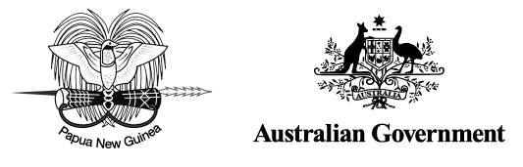

Kokoda Initiative

Annual Report 2013–14

The Kokoda Initiative is a partnership between Papua New Guinea and Australia on the Owen Stanley Ranges, Brown River Catchment and Kokoda Track region

© Copyright Commonwealth of Australia, 2015

Department of the Environment is licensed by the Commonwealth of Australia for use under a Creative Commons By Attribution 3.0 Australia licence with the exception of the Coat of Arms of the Commonwealth of Australia, the logo of the agency responsible for publishing the report, content supplied by third parties, and any images depicting people. For licence conditions see: http://creativecommons.org/licenses/by/3.0/au/

This report should be attributed as *The Kokoda Initiative Annual Report, 2013–14*, Commonwealth of Australia 2015.

The Commonwealth of Australia has made all reasonable efforts to identify content supplied by third parties using the following format ‘© Copyright, [name of third party]’.

**Disclaimer**

The views and opinions expressed in this publication are those of the authors and do not necessarily reflect those of the Australian Government or the Minister for the Environment.

While reasonable efforts have been made to ensure that the contents of this publication are factually correct, the Commonwealth does not accept responsibility for the accuracy or completeness of the contents, and shall not be liable for any loss or damage that may be occasioned directly or indirectly through the use of, or reliance on, the contents of this publication.

Table of Contents

Acronyms 4

Executive summary 5

About this report 7

About the Kokoda Initiative 8

Background 8

Vision and goals 8

Implementation 8

Location of the Kokoda Initiative interim protection zone 10

Partners and stakeholders 11

Government of Papua New Guinea 11

Government of Australia 11

Stakeholders 12

ACTIVITIES AGAINST GOALS 2013–14 13

Goal 1 A safe and well-managed Kokoda Track, which honours its wartime historical   
significance and protects and promotes its special values 13

Achievements for 2013–14 14

Goal 2 Enhanced quality of life for landowners and communities through improved delivery of   
 basic services, income generation and community development activities 15

Achievements for 2013–14 16

Goal 3 The wise use and conservation of the catchment protection area, including the Kokoda   
 Track and its natural and cultural resources and values 20

Achievements for 2013–14 21

Goal 4 Building national and international tourism potential of the Owen Stanley Ranges   
and Kokoda Track Region, supported by a possible future World Heritage nomination 24

Achievements for 2013–14 24

Goal 5 Working with communities, landowners, industry and all levels of government to   
ensure that activities established under the Kokoda Initiative are sustained into   
the future 25

Achievements for 2013–14 25

Kokoda Initiative 2013–14 expenditure 26

Australian Government expenditure, 1 July 2013 to 30 June 2014 26

Expenditure/income reported by Papua New Guinean partner agencies,   
1 July 2013 to 30 June 2014 29

**Maps**

Location of the Kokoda Initiative interim protection zone 10

Goal 1 Activities by location 13

Goal 2 Activities by location 15

Goal 3 Activities by location 20

**Features**

Kebera aid post 16

Community-based mentors 18

Oral history pilot project 22

Acronyms

|  |  |
| --- | --- |
| CBM | community-based mentor |
| DoE | Department of the Environment (Australian) |
| DEC | Department of Environment and Conservation (PNG) |
| DFAT | Department of Foreign Affairs and Trade (Australian) |
| DVA | Department of Veterans’ Affairs (Australian) |
| JU2 | Second Joint Understanding 2010¬–2015 between Papua New Guinea and Australia on the Owen Stanley Ranges, Brown River Catchment and Kokoda Track Region |
| KIDP | Kokoda Initiative Development Program, operating under DFAT (formerly KDP) |
| KIMC | Kokoda Initiative Ministerial Committee (PNG) |
| KTA | Kokoda Track Authority |
| NMAG | National Museum and Art Gallery (PNG) |
| PNG | Papua New Guinea |
| TPA | Tourism Promotion Authority (PNG) |
| VHV | Village Health Volunteer |

Executive summary

The Kokoda Initiative is a cooperative programme jointly run by the governments of Papua New Guinea (PNG) and Australia to sustainably develop and protect the Kokoda Track and surrounding areas.

This annual report provides an overview of the Kokoda Initiative’s activities and financial performance from 1 July 2013 to 30 June 2014. The following key outcomes were achieved against the five goals of the Kokoda Initiative during this period.

Goal 1: A safe and well-managed Kokoda Track, which honours its wartime historical significance and protects and promotes its special values

• The Kokoda Initiative continued to prioritise the safety of all people who use the Kokoda Track by supporting the Papua New Guinea Kokoda Track Authority (KTA) to maintain the track and associated infrastructure, keeping them safe for trekkers and the communities in the Kokoda Track corridor.

• Responses to a survey of Kokoda Track trekkers in 2013 showed a high degree of satisfaction with the KTA’s management of the track.

• The Australian Department of the Environment (DoE) supported the KTA to continue to develop its compliance and enforcement capacity in relation to track management and the trekking industry. Expert service providers worked with the KTA to train rangers and operational staff, standardise compliance and monitoring procedures and complete a rangers’ manual.

Goal 2: Enhanced quality of life for landowners and communities through improved delivery of basic services, income generation and community development activities

• The Kokoda Initiative Development Program continued to assist communities in the Kokoda Track region with access to better health, education, water and sanitation services.

• The KTA supported the third year of the community-based mentors programme. Twenty-nine mentors worked with communities along the Kokoda Track to assist them with increasing their capacity to generate income from the trekking industry.

Goal 3: The wise use and conservation of the catchment protection area, including the Kokoda Track and its natural and cultural resources and values

• A suite of natural and cultural values was identified in the Brown River catchment and Kokoda Track region in 2013–14, in preparation for the development of a management plan for the region.

• A workshop was held in Cairns to discuss standardised approaches to biodiversity survey, data analysis and species information management in PNG.

• The Australian Herbarium undertook a pilot data-capture project to investigate the timing and costs of digitising information about PNG plant specimens from the Kokoda Track corridor that are held in Australian herbarium collections.

• A pilot project to collect oral accounts of Papua New Guinean experiences during World War II was completed. More than 70 Papua New Guineans living in the Kokoda Track region were interviewed during the project.

• Capacity building at the Papua New Guinea National Museum continued through collection, conservation and management programmes.

• Work began on the development of cultural heritage management plans at two significant military sites in the Kokoda Track region.

Goal 4: Building national and international tourism potential of the Owen Stanley Ranges and Kokoda Track region, supported by a possible future World Heritage nomination

• The PNG Tourism Promotion Authority launched ‘Do Kokoda’ at the Melbourne Cricket Ground in April 2014. This web-based marketing campaign provides a forum for trekkers to share their Kokoda Track experiences, photographs and videos.

• The PNG Department of Environment and Conservation began developing a ‘road map’ with a consultancy to guide its World Heritage nomination process.

• The KTA tour operator forums, held twice a year in Australia and PNG, continued to provide an important avenue of communication between the KTA and the trekking industry on policy and operational matters.

Goal 5: Working with communities, landowners, industry and all levels of government to ensure that activities established under the Kokoda Initiative are sustained into the future

• DoE contracted a consultant to prepare an independent mid-term review of the Second Joint Understanding 2010–2015 between Papua New Guinea and Australia on the Owen Stanley Ranges, Brown River Catchment and Kokoda Track region, to be completed following the biannual joint planning meeting in August 2014.

• The PNG Kokoda Initiative Ministerial Committee was established in December 2013 to coordinate PNG’s management of Kokoda Initiative issues.

About this report

This annual report captures the achievements of the Kokoda Initiative in the period from 1 July 2013 to 30 June 2014.

In accordance with the commitment in the Second Joint Understanding 2010–2015 on the Owen Stanley Ranges, Brown River Catchment and Kokoda Track Region (JU2) to produce an annual report that communicates the outcomes of the initiative, the report focuses on achievements against the goals of the Kokoda Initiative as stated in the JU2.

This is the third report prepared during the period of the JU2.

The report is divided into the following sections:

• About the Kokoda Initiative: its historical background, its vision and goals, and how it is being implemented.

• Partners and stakeholders: the PNG and Australian government agencies (partners) involved in the Kokoda Initiative Taskforce and their roles in implementing the initiative; and the stakeholders who contribute to its success at local and regional levels.

• Activities against goals 2013–14: performance outcomes under each of the five goals set out in the JU2.

• Kokoda Initiative 2013–14 expenditure: Australian Government expenditure by department and by goal, PNG Government expenditure by agency, and Kokoda Track Authority income.

About the Kokoda Initiative

The Kokoda Initiative is an arrangement between the Australian and Papua New Guinean governments for the sustainable development of the Owen Stanley Ranges, Brown River catchment and Kokoda Track region and the protection of its special natural, cultural and historic values.

Background

The Kokoda Initiative symbolises the shared history and enduring relationship of PNG and Australia – a bond forged during World War II. In 1942 the track became a battleground as Australian soldiers fought to stem the Japanese advance across the PNG mainland. People of the Kokoda Track communities assisted wounded and ill Australian troops by guiding them through the dense rainforest to field hospitals. These courageous people who risked their lives to rescue soldiers became known as the ‘Fuzzy Wuzzy Angels’.

The friendship and mutual respect between PNG and Australia established during the Kokoda campaign continue today. Many Australians travel to PNG to trek the Kokoda Track, meet the people of the area and pay respect to those who lost their lives during World War II.

The initiative was first formalised in a joint understanding between the two governments covering the period 2008–10. The Second Joint Understanding 2010–2015 on the Owen Stanley Ranges, Brown River Catchment and Kokoda Track Region (the JU2), signed in 2010, extended the Kokoda Initiative until the end of 2015.

Vision and goals

The vision for the Kokoda Initiative as stated in the JU2 is:

Sustainable development of the Owen Stanley Ranges, Brown River Catchment and Kokoda Track Region and protection of its special natural, cultural and historic values.

The JU2 sets out five goals for the initiative:

1) A safe and well-managed Kokoda Track, which honours its wartime historical significance and protects and promotes its special values

2) Enhanced quality of life for landowners and communities through improved delivery of basic services, income generation and community development activities

3) The wise use and conservation of the catchment protection area, including the Kokoda Track and its natural and cultural resources and values

4) Building national and international tourism potential of the Owen Stanley Ranges and Kokoda Track region, supported by a possible future World Heritage nomination

5) Working with communities, landowners, industry and all levels of government to ensure that activities established under the Kokoda Initiative are sustained into the future.

Implementation

The PNG and Australian governments together fund the Kokoda Initiative and administer its implementation.

Activities under the five goals focus on the interim protection zone, an area covering parts of the Central and Northern provinces and encompassing the Kokoda Track, and the Brown, Naoro and Goldie rivers (see map on the following page). The Brown River catchment offers a number of opportunities for regional and national economic development, including as a source of water and hydro power for Port Moresby.

The Kokoda Initiative aims to support the sustainable development of the trekking industry, provide for the protection and maintenance of the track, and improve the health and education of local communities and help them gain an income through community development and tourism projects.

To achieve long-term sustainable development, the Kokoda Initiative also supports scientific research to build a case for the PNG Government’s claim that the Owen Stanley Ranges and Kokoda Track region possesses the ‘Outstanding Universal Values’ needed for World Heritage listing. A suite of studies are conducted under the Kokoda Initiative to identify and describe natural, historical and cultural values in the area. It is intended that the results of these studies will help the PNG Government plan, manage, protect and promote the region in a sustainable way for future generations.

Location of the Kokoda Initiative interim protection zone

The Kokoda Initiative focuses on an area of the Owen Stanley Ranges within the Central and Northern Provinces of Papua New Guinea. The Kokoda Initiative interim protection zone (IPZ) encompasses the Brown River water catchment and most of the Kokoda Track from Owers’ Corner to Kokoda Station. The PNG Government is working towards legal protection of the IPZ through a gazettal process.

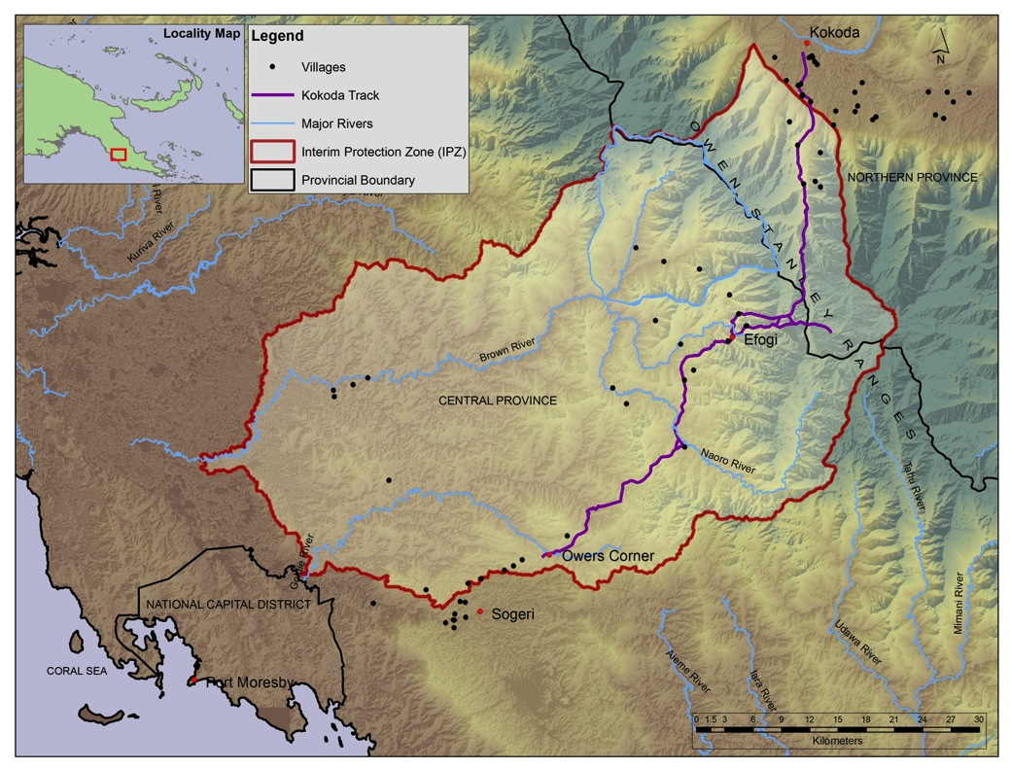

Partners and stakeholders

Government of Papua New Guinea

The following agencies are members of the PNG Kokoda Initiative Taskforce.

Department of Environment and Conservation (DEC): is the lead PNG agency for the Kokoda Initiative and is the secretariat for the PNG Kokoda Initiative Taskforce and the Kokoda Initiative Ministerial Committee as mandated by the PNG National Executive Council. DEC’s mission is to ensure that PNG’s ‘natural resources are managed to sustain environmental quality, human wellbeing and support improved standards of living’, which supports the vision of the Second Joint Understanding 2010–2015 on the Owen Stanley Ranges, Brown River Catchment and Kokoda Track Region.

Kokoda Track Authority (KTA): is a special purpose authority of the Koairi and Kokoda local-level governments commissioned to manage the Kokoda Track, collect trekking fees, regulate the trekking industry along the Kokoda Track and distribute benefits from tourism associated with the Kokoda Track to landowners in the region.

Tourism Promotion Authority (TPA): is responsible for marketing PNG, including the Kokoda Track region, as a tourist destination. Its mission is to enhance the development, marketing and sustainability of PNG tourism in partnership with industry, government and communities. The TPA is responsible for marketing the Kokoda Track as a premier trekking destination and is involved in the strategic development of tourism in the Kokoda Track and Owen Stanley Ranges region, which includes capacity building and training for local tourism businesses.

Provincial administrations: The interim protection zone falls within the Northern Province and Central Province, making the two provincial administrations natural partners to the Kokoda Initiative.

Department of Provincial and Local-level Government Affairs: coordinates and monitors national policies implemented at the provincial level and coordinates capacity building for provinces. It is the portfolio agency of the KTA.

Department of National Planning and Monitoring: has the primary role in development planning and administering the development budget.

National Museum and Art Gallery (NMAG): is PNG’s custodian of national historic and cultural heritage collections, and provides a cultural focal point for the Kokoda Initiative. NMAG administers the national legislation protecting World War ll military artefacts and houses the modern history collection, which includes objects from the Kokoda campaign.

Government of Australia

The following agencies are members of the Australian Kokoda Initiative Taskforce.

Department of the Environment (DoE): is the lead Australian agency for the Kokoda Initiative. The International Heritage Section (Wildlife, Heritage and Marine Division) is the secretariat for the Australian Kokoda Initiative Taskforce. DoE contributes to achieving the outcomes of the Kokoda Initiative through strategic building of PNG partner capacity and providing technical advice on biodiversity and heritage protection.

Department of Foreign Affairs and Trade (DFAT): is the lead Australian agency on the bilateral aspect of the Kokoda Initiative. Its role on the taskforce is to ensure that the Kokoda Initiative aligns with Australia’s pursuit of its global, regional and bilateral interests. DFAT also manages the Kokoda Initiative Development Program, which provides basic health, education, water and sanitation projects for communities living in the Kokoda Track region.

Department of Veterans’ Affairs (DVA): DVA’s mission is to support those who serve or have served in defence of Australia, to commemorate their service and sacrifice and to manage Australian war graves worldwide. DVA aims to protect the historic World War II values of the Kokoda region through the provision of expert advice, and helps DoE manage stakeholder issues relating to war veterans.

Department of the Prime Minister and Cabinet: provides policy advice to the Prime Minister and the Cabinet on Australia’s domestic and international affairs. The International Division works towards enhancing international government-to-government relationships through a range of bilateral agreements and participation in multilateral fora.

Department of Defence: contributes to the taskforce through international policy and the commemoration of World War II military heritage in PNG.

Stakeholders

The following important stakeholders also contribute to the success of the Kokoda Initiative:

• landowners and communities in the region, especially along the Kokoda Track

• local-level governments and wards along the Kokoda Track

• tour operators and trekkers

• churches

• the Returned Services League

• community development and aid organisations.

ACTIVITIES AGAINST GOALS 2013–14

Goal 1

activities by location

The location of Goal 1 activities undertaken between July 2013 to June 2014

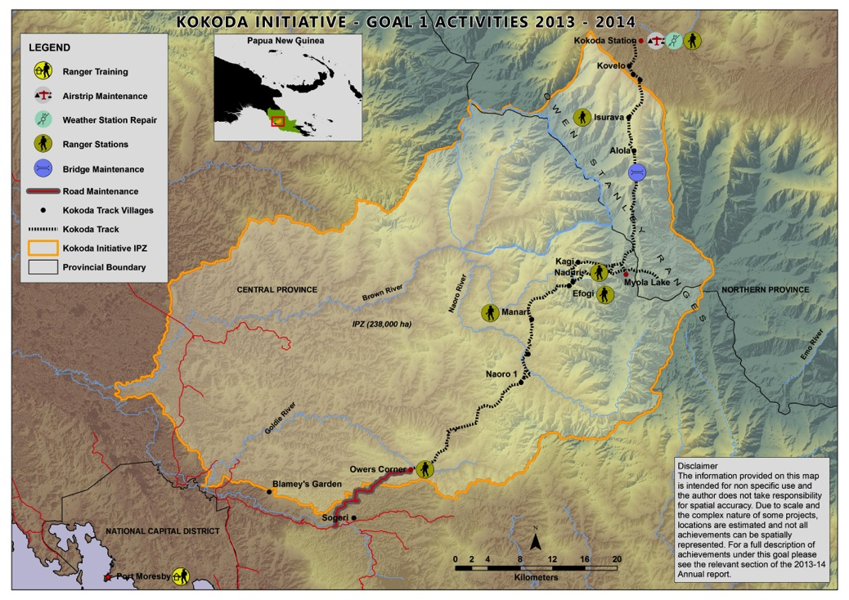

Goal 1: A safe and well-managed Kokoda Track, which honours its wartime historical significance and protects and promotes its special values

The objectives associated with Goal 1 are:

• Further supporting and enhancing the Kokoda Track Authority’s (KTA’s) management of the Track and trekking operations

• Working with local communities and tourism operators to improve the trekking experience and track facilities

• Working with regulatory authorities to improve safety for local communities living along the track and tourists visiting the region.

Achievements for 2013–14

• The KTA continued to manage ongoing maintenance of the Kokoda Airstrip and undertook procurement and completed works for the maintenance of Owers’ Corner Road to a two-wheel drive standard.

• The KTA began work on the development of a database to manage trekking information. The database will record information over time about the number of trekkers in a group, the number of trekking groups and the proposed locations of trekking groups. This will enable the KTA to locate trekking groups in case of an emergency and improve pre-trek logistics planning to manage the numbers of trekking groups at campsites.

• The KTA continued to work with local communities and tourism operators to improve the trekking experience and track facilities by undertaking regular maintenance activities.

• The Department of the Environment (DoE) contracted two service providers, hosted by the KTA, to work with operations staff to improve compliance and enforcement processes for the trekking industry. Activities undertaken include:

– a review of the tour operators licence handbook

– standardised compliance and monitoring procedures

– a three-day training programme for KTA rangers and operations managers to establish the compliance system in preparation for the 2014 trekking season

– completion of a rangers’ manual.

• The DoE adviser further assisted with building the capacity of KTA staff by providing day-to-day guidance to KTA senior management and officers on project and programme delivery and assessing training needs and opportunities.

• DoE contracted the Australian Bureau of Meteorology to repair and service a vandalised Kokoda automatic weather station. Repairs will be completed in early 2015.

Goal 2

activities by location

The location of Goal 2 activities undertaken between July 2013 to June 2014

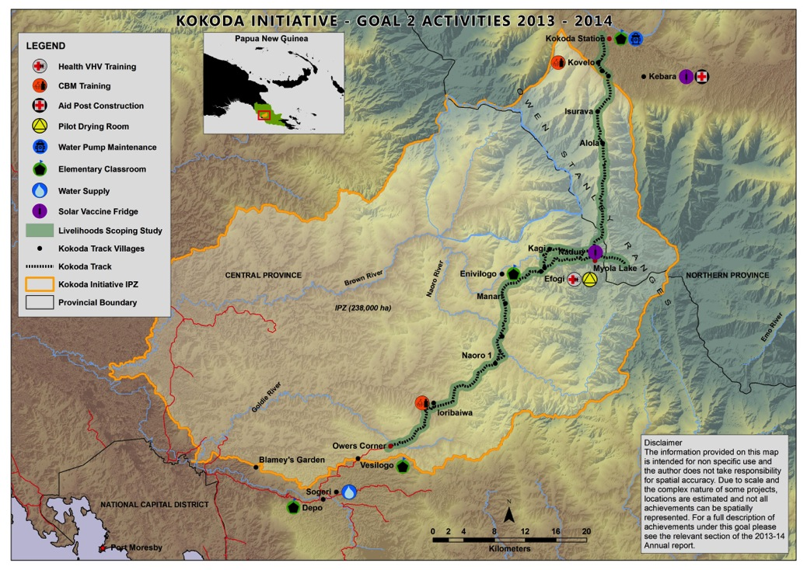

Goal 2: Enhanced quality of life for landowners and communities through improved delivery of basic services, income generation and community development activities

The objectives associated with Goal 2 are:

• Continuing to sustainably improve the standard of health, education, water, sanitation and infrastructure services for communities along the track

• Facilitating access to benefit streams, income generation and other community development projects for communities in the interim protection zone, including potential opportunities through development of renewable resources, particularly hydro power and water, forest carbon, and tourism

• Enabling communities and landowners to manage development opportunities and income streams generated through this initiative

• Nurturing the alliance between all levels of government, tourism operators and not-for-profit organisations to provide strong and coordinated support for the sustainable development of the region and the wellbeing of its people.

Kebera aid post

Kebara is located in Northern (Oro) Province, a two-hour walk from Kokoda village. More than 1,200 people live there and in the surrounding villages. With support totalling around PGK300,000 from the Oro provincial and Sohe district administrations, the KIDP supported the refurbishment of an aid post at Kebara in 2014. The facility includes a cook house, clean water systems, a new staff house, a patient waiting house and a new ablution block.

The Australian High Commissioner to Papua New Guinea, Ms Deborah Stokes, opened the Kebara aid post on 9 August 2014 at a ceremony attended by the member for Sohe, Ms Delilah Gore, MP and the Hon. Evatius Bori, Deputy Governor of Northern Province. The response from the community to the new facility was overwhelmingly positive, with over 3,000 community members attending the formal opening.

The facility is seen as a major contribution to Kebara and the surrounding community, providing high-quality health care.

Communities will now have access to better family planning; high-quality maternal and child health services; and improved management and prevention of HIV, tuberculosis and malaria.

Local contractors were engaged at the beginning of 2014 to construct the facility using local building materials. In May 2014, the Oro provincial Department of Public Works provided certification of the facility’s compliance with PNG and provincial construction standards.

Achievements for 2013–14

Health, water and sanitation

• The availability of qualified health advice to local communities across the region was improved with the addition of 63 village health volunteers (VHVs) in 91 villages within three key areas, including Sogeri, Mt Koiari and Kokoda. VHVs undertook health patrols across the region every six weeks, providing maternal and child health care, immunisations and access to early treatment, as well as general health promotion. To ensure compliance with PNG Government health standards, supervision was provided for the first six months (June to December 2013) in each of the three areas by an additional aid post.

• A quarterly review of the VHVs’ medical competencies demonstrated improved skills. The reviews were conducted by a Kokoda Initiative Development Program (KIDP) health team in collaboration with the provincial health administration.

• To improve diagnosis and early treatment of tuberculosis, 38 VHVs were trained to implement a tuberculosis training programme. Early diagnosis and treatment is important to increase the chance of survival. Of the 87 suspected tuberculosis cases presented during the past year, eight were confirmed, and patients received immediate and complete treatment.

• Access to life-saving vaccines was improved at the Naduri and Kebara health facilities, where two solar vaccine fridges were procured and installed to provide better storage capacity.

• To improve infection control, detergents, toiletries and cleaning supplies were distributed at all 17 aid post health facilities along the Kokoda Track.

• Access to medical services and clean water was improved for the 1,200 people of the Kebara community and surrounding local-level government areas of wards 6 and 7 of the Kokoda Track region with the completion of the Kebara aid post facility. A staff house, a cook house, two exterior toilets and showers and two water tanks were constructed. In addition, the existing incinerator was renovated to facilitate infection control through the burning of waste.

• Access to clean water was improved for the staff and community of the Sogeri Health Centre with the completion of a clean water supply to the six staff houses.

Education

Teacher training and school infrastructure development continued during 2013–14 through a community-based process. The KIDP supports communities to conduct construction activities by providing the materials and assisting with management. Infrastructure improvements included:

• construction of a classroom at Envilogo Elementary School

• renovation of an old health centre into classrooms for Kokoda Elementary School

• maintenance of pumps that feed water to the six staff houses in Kokoda, ensuring secure access to water for up to 50 permanent residents.

Other activities to support improved access to education included:

• agreements with communities inside the new work area to improve infrastructure

• support for training, registration and logistics costs for six teachers from the Rigo, Abau and Hiri districts to obtain a Certificate in Elementary Teaching and Trainer Directed Training.

Livelihoods

Progress of the Kokoda Initiative Livelihoods Project administered by the Kokoda Track Authority (KTA), which is designed to increase the capacity of communities along the Kokoda Track to generate income from tourism by adding value to the trekking experience, included the following activities:

• A review of the Livelihoods Project (2011–2014) evaluated the project’s design and implementation against its objectives. The KTA-commissioned review found that the project is highly relevant to all stakeholders of the Kokoda Initiative and made recommendations for further research, planning, design and implementation processes that could be undertaken with further significant investment.

• The community-based mentor (CBM) programme continued to expand and successfully deliver community-driven activities. During the third year of the programme, the number of CBMs grew to 29. The CBMs undertook group training to help increase their competence and confidence when providing advice to their communities on basic business management, bookkeeping and identification of potential business opportunities.

• A drying room pilot project was completed at Efogi Primary School. The enterprise is intended to raise funds for the school by enabling villagers to offer the service of drying wet trekking gear to visitors who stay overnight in the village.

• Twenty-three toilet bases were delivered to guesthouse and campground owners accredited by the 2012 guesthouse certification audit to improve ablution amenities for trekkers.

|  |
| --- |
| Community-based mentors |
| **Benson Gadova**, Kovelo village, Kokoda area, Oro province |
| What is most important for you about being a community-based mentor |
| The most important thing to me as a community-based mentor in my local village is seeing people improve their small businesses (i.e. trade store, vegetable sales etc.). Earning a bit more income to what they have previously been earning, as a result of being taught a basic knowledge of bookkeeping, how to manage income, and doing a stocktake for trade store goods. Another role which I see as important to being a mentor is community members look up to me as a leader to provide some strategic direction for the betterment of the local people. This gives me that challenge to take on an extra mile, and push for some local community development projects with our local development authorities in our district and the province. |
| What do you most enjoy about being a community-based mentor? |
| My most joyous moments are when communities respond positively by putting into use the basic knowledge/skills that we impart to them, and making it happen. |
| What’s your proudest moment as a community-based mentor? |
| My proudest moment was when I graduated from the community-based mentor training in June 2014. With additional basic business knowledge I know I can now be more useful than before. The presence of the different ward councillors in our local electorate was a blessing, as that paved the way for possible future development activities that I may have with them. I would like to see, in the near future, my community members being involved in some form of sustainable livelihoods activities, importantly giving them a healthy perspective to life. |
| What challenges do you face as a community-based mentor? |
| My challenge is to get my local people to effectively participate in some form of sustainable activities to improve our lives in our community. |
| Janet Elodo, Efogi village, Central province |
| What is most important for you about being a community-based mentor? |
| Being a community mentor gives me that special feeling of responsibility to my people. I feel my work is so important because I join efforts with our development partner the KTA for any tasks given to us to perform. |
| What do you most enjoy about being a community-based mentor? |
| My enjoyable moments are the group training that we had in June 2014, although my return trek from Efogi to Ioribaiwa was not the best. Part of the work I like doing is helping the local people to improve their wellbeing by engaging in activities that would maximise their life for the better. |
| What’s your proudest moment as a community-based mentor? |
| My proudest moments? Can’t think of any except for the training – and receiving the certificate has added value to my contribution to the village community-based mentoring work. |
| What’s your vision for your community? |
| My vision for my community? The local community in Efogi and those along the track need much input from the current Kokoda Initiative programme. |
| What challenges do you face as a community-based mentor? |
| My personal challenges are to get the local community to cooperate with plans for any development activities so that development outcomes are realised. |
| Jackson Luvila, Isurava |
| What is most important for you about being a community-based mentor? |
| The most important aspect for me about being a community-based mentor is helping people with organising their guesthouse and developing their crops. I’m really happy to work with different people in the community. |
| What do you most enjoy about being a community-based mentor? |
| I like to help them plant crops and after a few months seeing the plants grow. I also enjoy beautifying the garden. |
|  |
| What’s your proudest moment as a community-based mentor? |
| I’m proud to see the development of a guesthouse within the community and seeing the trekkers using them. I like to talk to the trekkers when they stop overnight. |
| What’s your vision for your community? |
| I would like to see the tour operators allow the community to use the available space in the backloads of the chartered flights. This would allow us to easily sell our vegetables in the Port Moresby market. |
| What challenges do you face as a community-based mentor? |
| It is a challenge to mentor the community about the things I have learnt in the training delivered through the KTA mentoring programme. Trying to work with all the community can be a challenge, especially when there are so many ideas. |
| Lisa Favave, Depo Depo ward (Sogeri to Vesulogo) |
| What is most important for you about being a community-based mentor? |
| To me the most important thing is about helping the communities to be productive in their local communities. |
| What do you most enjoy about being a community-based mentor? |
| My enjoyable moments are working directly with the community members in trying to help them promote useful activities to be involved in. |
| What’s your vision for your community? |
| My vision for my community is for them to be involved in a real-impact sustainable activity that has the potential to improve their livelihoods. |
| What challenges do you face as a community-based mentor? |
| To get the community members to cooperate with us, the community-based mentors, by engaging in self-sustaining activities to better their own livelihoods. |

Goal 3

Activities by location

The location of Goal 3 activities undertaken between July 2013 to June 2014

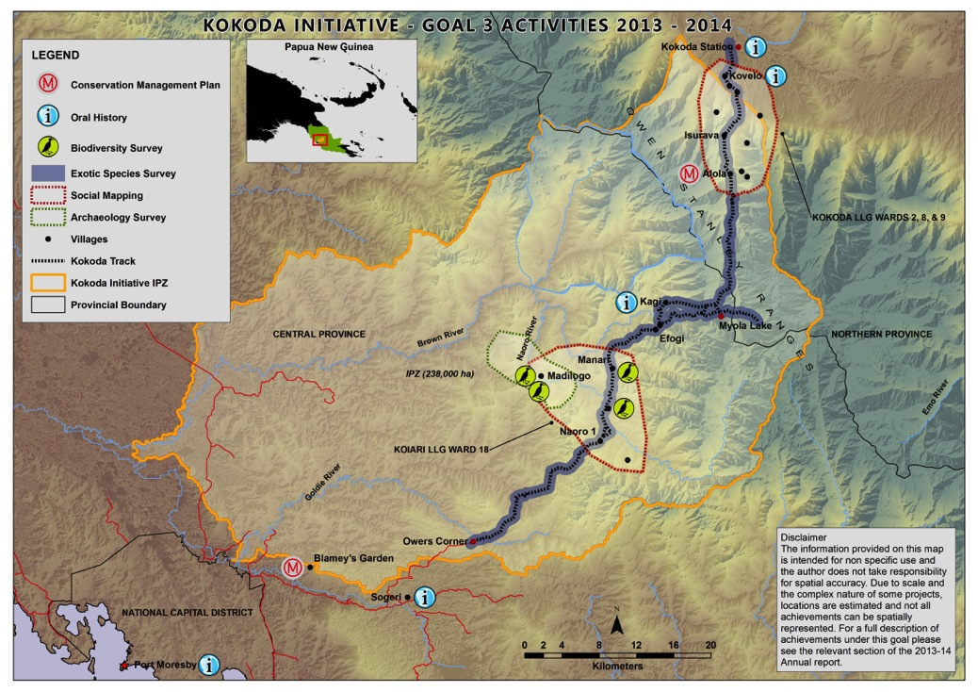

Goal 3: The wise use and conservation of the catchment protection area, including the Kokoda Track and its natural and cultural resources and values

The objectives associated with Goal 3 are:

• Developing an integrated land use plan for the catchment protection area in partnership with key National, Provincial and Local Government stakeholders which provides an effective balance between environment conservation and development.

• Identifying and conserving the key natural, cultural and historic values of the Owen Stanley Ranges for heritage conservation, protection and tourism and development purposes.

Achievements for 2013–14

Environment

The PNG Department of Environment and Conservation (DEC) with the support of the Australian Department of the Environment (DoE), continues to work towards protection of the Brown River catchment and Kokoda Track region through the initiative. Activities conducted throughout the year to facilitate environmentally sustainable management and protection with the support of landowners included the following:

• A biodiversity workshop was held in Cairns in July 2013 to discuss approaches to biodiversity survey, data analysis and species information management in PNG. Attendees were from PNG and Australian agencies, research institutions, non-government organisations and consultancy firms. The workshop provided a strong platform for the development of a biodiversity expert group to provide technical advice on these issues.

• A data-capture pilot project was undertaken by the Australian National Herbarium to digitise information about selected PNG plant specimens held in Australian herbarium collections and investigate the time scale and costs of this process. Data will be copied to DEC for inclusion in the PNG National Biodiversity Information System.

• A biodiversity gap analysis was undertaken by experts from the Bishop Museum in Hawaii to identify existing flora and fauna species occurring within the Owen Stanley Ranges area and guide the design of future field surveys. Over 300,000 records of existing plant specimens from PNG and international institutions were examined. The research will inform the development of the biodiversity management plan for the Owen Stanley Ranges and, importantly, contribute to a possible World Heritage listing of the region (linked to Goal 4).

• Field surveys to identify and record exotic flora and fauna species along the Kokoda Track were also conducted by Bishop Museum. The surveys were carried out along the track over 28 days. The study concluded that trekkers from foreign countries have not been responsible for introducing pest species to the Kokoda Track region. All the exotic species detected have been recorded previously elsewhere in PNG. Targeted fauna surveys also conducted along the track identified new species of frogs and lizards and recorded 12 different bird of paradise species at Isurava.

• A biodiversity survey began at Madilogo, an area that may be affected by the proposed PNG Power Naoro-Brown hydro power project. Biodiversity survey results will also contribute to conservation and sustainable resource use planning for the region.

In recognition of the extensive customary land ownership in PNG, protected areas of any type will be gazetted only after formal agreement, outlining management responsibilities, with customary landowners. DEC is leading the review and finalisation of PNG’s protected areas policy, which acknowledges various initiatives across the country to conserve nature for cultural and spiritual reasons while pursuing traditional economic activities in these landscapes and seascapes. The new policy outlines a systematic process for establishing different types of protected areas, tailored to the unique context of PNG, to guide communities, organisations and agencies to harmonise efforts on biodiversity conservation.

DoE continued to provide an in-country adviser to DEC to support ongoing capacity building and assist with the implementation of the Kokoda Initiative.

Heritage

• Archaeological investigations were undertaken in the same area to determine the impact of the proposed development on the archaeological evidence in the region. The work aimed to identify different site types within the Naoro Valley and improve the predictive model for the region. Over 100 artefacts, including stone axes, flakes and exotic-source stone were excavated, highlighting the richness of this archaeological landscape.

• Work continued in the vital area of social mapping throughout the region, with fieldwork commencing in June. Social mapping collects and records information about relationships between people’s settlement patterns, land use, land tenure and social organisation within an area. It is used to ensure that resource management negotiations are carried out with the right people. The two new social mapping projects built on a 2009 desktop study that developed detailed genealogies of families and documented the relationships of the more than 8,000 people who associate themselves with the region.

• The first stage of a larger longer-term project to record PNG peoples’ oral histories associated with World War II was carried out. The pilot project involved interviews with 72 PNG nationals about their own or their ancestors’ wartime experience in the Kokoda Track region. Interviews were conducted at nine locations along the Kokoda Track, beginning at the north coast, where the Japanese first landed in July 1942, then moving south along the Owen Stanley Ranges. Four of the interviews were first-hand accounts of direct involvement with the war; others were with people recollecting their parents’ experiences. A short film showcasing the oral histories will be completed by December 2014 for exhibition at the National Museum and Art Gallery (NMAG) of PNG as part of a military heritage display. The oral history recordings from the pilot study were officially presented to NMAG, and the lessons learned will inform the project’s extension to other parts of PNG.

• Work began on separate conservation management plans for the Lost Battlefield and Blamey’s Garden, in discussion with local landowners and community members. Blamey’s Garden was established in 1942 in the hope that at the cessation of the war it would become a national park. The site has special significance to the local communities, who refer to it as Namatubu. The conservation management plan will identify the area’s core values, outline management strategies to protect the core values, and explore the tourism potential of the site. The Lost Battlefield site has remained virtually untouched since 1942 as it is off-limits to trekkers. It continues to be a traditional hunting ground for the people of the nearby Alola village. The management plan will set out how this historic site can be opened to the public while also protecting its important values.

• NMAG owns a small but significant collection of World War II military artefacts. As the collection is sensitive to deterioration through heat and humidity, an international expert in military history has been working with the museum to develop a conservation management plan to protect them. The museum also invited military personnel attached to the Australian High Commission in PNG to assist in identifying over 200 items. As part of this work, modern history curatorial staff were trained in museum artefact preservation, identification and cataloguing.

Oral history pilot project

As an iconic battleground of World War II the Kokoda Track has become a place of pilgrimage for Australians. Yet after the war – perhaps because it was too close to home – Australians tended to forget about the wartime experiences of Papua New Guineans.

The Kokoda Initiative oral history pilot project has helped Papua New Guineans record their own memories of the war, many for the first time. More than 70 Papua New Guineans, men and women, have been interviewed about their own or their ancestors’ wartime experience around the Kokoda Track.

The project has been undertaken by historian Dr Jonathan Ritchie, a Senior Research Fellow at the Alfred Deakin Research Institute, working alongside Papua New Guinean historian Professor John Waiko and Dr Andrew Moutu, the Director of NMAG, and a team of other talented and enthusiastic Papua New Guineans. The material they have collected will be used to develop an oral history repository at the museum in Port Moresby.

‘This project has been about capacity building,’ Dr Ritchie explained. ‘There are a lot of people with experience in oral history in PNG. It has been a matter of facilitating the endeavour so that, we hope, the project can be expanded to cover a much larger area of Papua New Guinea.’

The interviews were conducted in nine different locations along the Kokoda Track and surrounding region, beginning at the north coast, where the Japanese first landed in July 1942, then moving south along the Owen Stanley Ranges. The team visited remote villages – one at an altitude of 1,524 metres (5000 feet) and only accessible by foot or air. Despite the 72-year time-lag, six interviewees had some lived experience of the war, two as children.

Dr Ritchie said:

One person was a medical orderly during the war, who witnessed some terrible things, including the aftermath of the Japanese occupation of the Northern District. Sadly, he died a month before the interviews, but he asked his daughter to pass on his written memories to the team.

Another, now an eighty-nine year-old man living in a village accessible only by small boat, helped to hide an Anglican minister in the jungle for many months.

There was a strong sense of sadness about these recollections and a reminder that war is terrible. Yet, in every interview we recorded there was great fondness for the association they had with Australians, even though many felt that they had been abandoned during the post-war years.

With the 75th anniversary of the outbreak of the war in the Pacific due in 2017, it is anticipated that the interviews will be used during a major exhibition at NMAG. A short film is also being made for display at the museum.

Goal 4

Goal 4: Building national and international tourism potential of the Owen Stanley Ranges and Kokoda Track region, supported by a possible future World Heritage nomination

The objectives associated with Goal 4 are:

• Promoting the natural, cultural and historic military values of the track

• Developing a strategic tourism plan and associated marketing activities

• Exploring the heritage conservation values and conducting a feasibility study for possible World Heritage nomination, consistent with its inclusion in the PNG Government World Heritage Tentative List (2006).

Achievements for 2013–14

• The PNG Tourism Promotion Authority (TPA), launched the marketing campaign ‘Do Kokoda’ at the Melbourne Cricket Ground in April 2014. ‘Do Kokoda’ is a web-based campaign that encourages trekkers to share videos, photos and comments on their Kokoda Track experience. Sam Newman and Garry Lyon, hosts of Australia’s Channel 9 Footy Show, and Papua New Guinea-born rugby union player Will Genia are the official celebrity ambassadors for the campaign. The campaign was aired on the Footy Show and the Today Show to an estimated 300,000 viewers.

• The TPA and the Kokoda Track Authority (KTA) have collaborated to enable Kokoda camp sites and guesthouses to join the voluntary national accommodation accreditation system. Community accreditation training is in progress, and a Kokoda campsite and guesthouse accreditation brochure has been developed.

• The 2014 trekkers’ and tour operators’ surveys were reviewed and made available online and in hard copy via field rangers.

• A report documenting the results of the 2013 trekker and tour operator surveys showed a high degree of satisfaction with the KTA’s management of the Kokoda Track.

• A training needs survey, collaboratively developed by the TPA and KTA, was distributed to local tour operators to inform future tourism industry training.

• The TPA scoped proposed tourism ventures in Central Province with the Central Province Tourism Office in the Hiri District.

• Activities (reported under Goal 3 above) continued to gather evidence to support the claim that the Owen Stanley Ranges and Kokoda Track region possesses the outstanding universal values required for nomination to the World Heritage List. The Department of Environment and Conservation began the process of seeking a consultancy to develop a ‘road map’ to guide the PNG Government through the World Heritage nomination process. This work is expected to commence in late 2014. The road map will outline the steps and resources needed to progress a nomination.

Goal 5

Goal 5: Working with communities, landowners, industry and all levels of government to ensure that activities established under the Kokoda Initiative are sustained into the future

The objectives associated with Goal 5 are:

• Maximising the delivery and maintenance of services and activities through the responsible PNG provincial and local-level governments

• Building capacity within key PNG and Australian Government agencies to ensure the goals of this initiative can be delivered and are sustainable.

Achievements for 2013–14

• The Australian Department of the Environment (DoE) contracted a consultant to prepare an independent mid-term review of the Second Joint Understanding on the Owen Stanley Ranges, Brown River Catchment and Kokoda Track Region (JU2). The objectives of the review were to assess the progress of the initiative from both Australian and PNG government perspectives, to consider the practical constraints of programme delivery in remote areas of a developing country, and to make recommendations on additional actions, timing or resources that may be necessary to achieve the objectives of the JU2 to the end of December 2015 (its expiry date). The review found that the initiative has made significant progress towards meeting the JU2 high-level goals and has successfully brought together the national interests of PNG and Australia.

• The Australian Government appointed a new Kokoda Initiative Senior Adviser, Mr William Farmer AO, in early 2014. Mr Farmer, a former diplomat and senior public servant, replaced Mr Howard Bamsey, who served as Senior Adviser from 2012 until mid–2013. The Senior Adviser provides high-level engagement with and support to the Kokoda Initiative by facilitating communication and planning and liaising with government ministers and agencies, Australian tour operators and other stakeholders with interests in the Kokoda Track.

• Kokoda Initiative forums – including the biannual joint planning meetings, monthly PNG project management committee meetings and the Australian Kokoda Initiative Taskforce meeting –occurred during the year. These meetings are critical for coordination of activities, cross-agency communication and agreed understanding of key programme objectives and goals.

• A gender snapshot was undertaken to make a rapid assessment of past and current practices in implementation of the Kokoda Initiative and recommend strategies and practical actions to improve gender mainstreaming and address gaps in knowledge, programming and monitoring. A key recommendation is to implement training of agency project personnel, stakeholders and partners both in Australia and in PNG to ensure consensus and collective commitment to gender equality.

• Strategic planning continued to ensure activities meet the needs of the region and the priorities of the PNG and Australian governments and to guide sustainable development of the Kokoda Track and Owen Stanley Ranges region.

• The PNG Government established the Kokoda Initiative Ministerial Committee (KIMC) in 2013. The committee is supported by the Technical Working Group comprising chief executive officers and secretaries of the key PNG Kokoda Initiative agencies; the Department of Environment and Conservation provides the secretariat. The Australian High Commission in PNG and the Kokoda Initiative Senior Adviser were invited to represent the Australian Government at one of the KIMC meetings in 2013.

Kokoda Initiative 2013–14 expenditure

Australian Government expenditure, 1 July 2013 to 30 June 2014

| **Department of the Environment (DoE) expenditure** | **PGK** | **AUD** |
| --- | --- | --- |
| Goal 1 A safe and well-managed Kokoda Track, which honours its wartime historical significance and protects and promotes its special values | | |
| DoE adviser to Kokoda Track Authority (KTA) | 990,467 | 432,933 |
| Operational support (KTA grant funding from 2012–13 funding agreement)* | 62,915 | 27,500 |
| Track management and safety (KTA grant funding from 2012–13 funding agreement)* | 108,671 | 47,500 |
| Contracts for KTA training and the review of trekking industry compliance and monitoring | 81,537 | 35,640 |
| Contract to Bureau of Meteorology for weather station repairs | 68,204 | 29,812 |
| Total | 1,311,794 | 573,385 |
| Goal 3 The wise use and conservation of the catchment protection area, including the Kokoda Track, and its natural and cultural resources and values | | |
| Identification of heritage values (contracts) | 586,808 | 256,494 |
| DoE adviser to Department of Environment and Conservation (DEC) | 976,102 | 426,654 |
| Support to DEC for biodiversity, spatial mapping and social mapping programme** | 297,415 | 130,000 |
| Total | 1,860,325 | 813,148 |
| Goal 4 Building national and international tourism potential of the Owen Stanley Ranges and Kokoda Track region, supported by a possible future World Heritage nomination | | |
| Tourism support | 301,450 | 131,764 |
| Goal 5: Working with communities, landowners, industry and all levels of government to ensure that activities established under the Kokoda Initiative are sustained into the future | | |
| Stakeholder engagement and communications | 151,974 | 66,428 |
| Twinning, training and exchanges | 136,722 | 59,761 |
| Programme review | 172,782 | 75,523 |
| Operating expenditure | 3,086,085 | 1,348,928 |
| Total | 3,547,563 | 1,550,640 |
| Total expenditure | 7,021,132 | 3,068,937 |

Note: Exchange rates calculated as per rates at 30/06/2014 (1AUD = 2.2878PGK or 0.4371AUD = 1PGK)

*Funds granted to the KTA under the 2012–13 grant agreement

**Expenditure of funds provided by DoE to DEC is detailed below under PNG DEC expenditure

| Department of Foreign Affairs and Trade expenditure on  Kokoda Initiative Development Program | PGK | AUD |
| --- | --- | --- |
| Goal 2: Enhanced quality of life for landowners and communities through improved delivery of basic services, income generation and community development activities | | |
| Health – infrastructure | 281,723 | 123,141 |
| Health – community-based health programmes | 369,089 | 161,329 |
| Education – infrastructure | 45,390 | 19,840 |
| Education – community-based education programmes | 43,317 | 18,934 |
| Adviser costs | 351,812 | 153,777 |
| Locally-engaged staff costs | 189,192 | 82,696 |
| Office costs | 161,826 | 70,734 |
| Unused cash returned from cash advances | – | – |
| Total expenditure | 1,442,350 | 630,451 |

Note: Exchange rates calculated as per rates at 30/06/2014 (1AUD = 2.2878PGK or 0.4371AUD = 1PGK)

Expenditure/income reported by Papua New Guinean partner agencies,   
1 July 2013 to 30 June 2014

| DEC expenditure** | PGK | AUD |
| --- | --- | --- |
| Heritage values identification | 454,077 | 198,477 |
| Oral history project | 20,784 | 9,085 |
| Participatory (social) mapping | 112,421 | 49,139 |
| Environmental management and protection | 38,979 | 17,038 |
| Spatial systems development | 15,685 | 6,856 |
| Programme development and capacity building | 98,984 | 43,266 |
| Stakeholder engagement and communications strategy | 18,782 | 8,209 |
| Office administration | 143,994 | 62,940 |
| Total expenditure | 903,705 | 395,009 |

Note: Exchange rates calculated as per rates at 30/06/2014 (1AUD = 2.2878PGK or 0.4371AUD = 1PGK)

**DEC receives funding from both the PNG and Australian governments. DoE provided $556,654 (AUD) in 2013–14 – see DoE expenditure table above.

| KTA income from trekking | PGK | AUD |
| --- | --- | --- |
| Local income | 8,837 | 3,863 |
| International income | 1,008,800 | 440,946 |
| Licence fee income | 42,350 | 18,511 |
| Short trek income | 4,130 | 1,805 |
| Total income* | 1,064,117 | 465,126 |

Note: Exchange rates calculated as per rates at 30/06/2014 (1AUD = 2.2878PGK or 0.4371AUD = 1PGK)

*KTA did not receive funds under a new Australian Government grant in 2013–14.

| Tourism Promotion Authority expenditure | PGK | AUD |
| --- | --- | --- |
| Accommodation classification (accommodation, plane hire, accommodation classification system consultant fees, brochures) | 11,443 | 5,002 |
| Travel to Kokoda tour operators forum | 3,000 | 1,311 |
| Total expenditure | 14,443 | 6,313 |