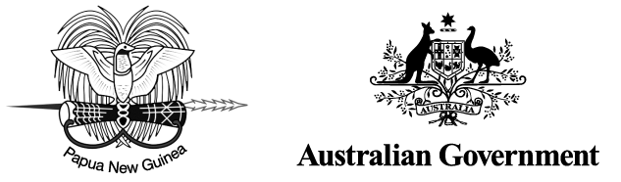

Kokoda Initiative

Annual Report 2014–15

The Kokoda Initiative is a partnership between Papua New Guinea and Australia on the Owen Stanley Ranges, Brown River Catchment and Kokoda Track region

© Copyright Commonwealth of Australia, 2015

Department of the Environment is licensed by the Commonwealth of Australia for use under a Creative Commons By Attribution 3.0 Australia licence with the exception of the Coat of Arms of the Commonwealth of Australia, the logo of the agency responsible for publishing the report, content supplied by third parties, and any images depicting people. For licence conditions see: http://creativecommons.org/licenses/by/3.0/au/

This report should be attributed as The Kokoda Initiative Annual Report, 2013–14, Commonwealth of Australia 2015.

The Commonwealth of Australia has made all reasonable efforts to identify content supplied by third parties using the following format ‘© Copyright, [*name of third party*]’.

Disclaimer

The views and opinions expressed in this publication are those of the authors and do not necessarily reflect those of the Australian Government or the Minister for the Environment.

While reasonable efforts have been made to ensure that the contents of this publication are factually correct, the Commonwealth does not accept responsibility for the accuracy or completeness of the contents, and shall not be liable for any loss or damage that may be occasioned directly or indirectly through the use of, or reliance on, the contents of this publication.

Table of Contents

Acronyms 4

Executive summary 5

About this report 7

About the Kokoda Initiative 8

Background 8

Vision and goals 8

Implementation 8

Location of the Kokoda Initiative Interim Protection Zone 10

Partners and stakeholders 11

Government of Papua New Guinea 11

Government of Australia 11

Stakeholders 12

ACTIVITIES AGAINST GOALS 2014–15 13

Goal 1— A safe and well-managed Kokoda Track, which honours its wartime historical   
significance and protects and promotes its special values 13

Activities by location 13

Achievements for 2014–15 13

Goal 2—Enhanced quality of life for landowners and communities through improved delivery of basic services, income generation and community development activities 15

Activities by location 15

Achievements for 2014–15 16

Goal 3— The wise use and conservation of the catchment protection area, including the Kokoda Track and its natural   
and cultural resources and values 19

Activities by location 19

Achievements for 2014–15 19

Goal 4— Building national and international tourism potential of the Owen Stanley Ranges and Kokoda Track region, supported by a possible future World Heritage nomination 24

Achievements for 2014–15 24

Goal 5— Working with communities, landowners, industry and all levels of government to ensure that activities established under the Kokoda Initiative are sustained into the future 26

Achievements for 2014–15 26

Kokoda Initiative 2014–15 Expenditure 27

Australian Government expenditure, 1 July 2014 to 30 June 2015 27

Expenditure/income reported By Papua New Guinean partner agencies,   
1 July 2014 to 30 June 2015 29

Maps

Location of the Kokoda Initiative Interim Protection Zone 10

Goal 1 activities by location 13

Goal 2 activities by location 15

Goal 3 activities by location 19

**Features**

Kokoda initiative – changing lives 17

Kokoda Initiative protects local species 22

Acronyms

CASA Civil Aviation Safety Authority (PNG)

CEPA Conservation and Environment Protection Authority (PNG)

CBM Community-based mentor

DFAT Department of Foreign Affairs and Trade (Australian)

Environment Department of the Environment (Australian)

GPS Global Positioning System

DVA Department of Veterans’ Affairs (Australian)

JU2 Second Joint Understanding 2010–2015 between Papua New Guinea and Australia on the Owen Stanley Ranges, Brown River Catchment and Kokoda Track Region

KIDP Kokoda Initiative Development Program, operating under DFAT (formerly KDP)

KIMC Kokoda Initiative Ministerial Committee (PNG)

KTA Kokoda Track Authority (PNG)

NMAG National Museum and Art Gallery (PNG)

NGO Non-government organisation

PNG Papua New Guinea

RBA Reserve Bank of Australia

QPWS Queensland Parks and Wildlife Service

TPA Tourism Promotion Authority (PNG)

UNESCO United Nations Environment, Scientific and Cultural Organisation

VHV Village Health Volunteer

Executive summary

The Kokoda Initiative is a cooperative programme jointly run by the governments of Papua New Guinea (PNG) and Australia to sustainably develop and protect the Kokoda Track and surrounding areas.

This annual report provides an overview of the Kokoda Initiative’s activities and financial performance from 1 July 2014 to 30 June 2015. The following key outcomes were achieved against the five goals of the Kokoda Initiative during this period.

**Goal 1: A safe and well-managed Kokoda Track, which honours its wartime historical significance and protects and promotes its special values**

• The Kokoda Track remained open throughout 2014–15 and experienced an increase in visitor numbers during the Centenary of ANZAC in April 2015 compared with those in April in previous years.

• The Kokoda Initiative continued to support the Kokoda Track Authority (KTA) to maintain the Track and associated infrastructure to minimise risks to trekkers and communities in the Kokoda Track region.

• The Australian Department of the Environment (Environment) engaged the Queensland Parks and Wildlife Service (QPWS) to undertake a GPS survey of the Track, collecting accurate location data on track conditions, infrastructure and points of interest.

• Environment supported the KTA, including through provision of business, operations and livelihoods advice, to further develop its capacity in relation to management of the Track, the trekking industry, supporting local communities and operations planning.

**Goal 2: Enhanced quality of life for landowners and communities through improved delivery of basic services, income generation and community development activities**

• The Kokoda Initiative Development Program (KIDP) continued to assist communities in the Kokoda Track region with access to better health, education, and water and sanitation services. It:

– constructed school classrooms and staff houses and installed water tanks and toilets

– supported teacher training, performance monitoring and distribution of reading books

– provided health worker training, administered vaccinations and distributed mosquito nets.

• The KTA further developed its community-driven livelihoods approach and supported a fourth year of the community-based mentors programme. Thirty-one mentors worked with communities to build capacity to generate income from the trekking industry.

**Goal 3: The wise use and conservation of the catchment protection area, including the Kokoda Track and its natural and cultural resources and values**

• The PNG Conservation and Environment Protection Authority (CEPA) progressed development of a framework for an Environmentally Sustainable Development Master Plan for the Brown River Catchment, and hosted a major land use planning workshop to consider alignment of protected area and land use policies.

• A biodiversity survey was completed at Madilogo, and a biodiversity expert group was established to advise CEPA on biodiversity issues in the Owen Stanley Ranges and Kokoda region.

• An archaeological survey of the Madilogo area was completed; work continued on development of conservation management plans for two military sites; and an expert workshop involving PNG and Australian stakeholders was held to progress a project to survey and record military heritage along the Kokoda Track.

• The Kokoda Oral History Pilot project, which recorded stories of PNG nationals’ wartime experience, was completed, and the PNG National Museum and Art Gallery (NMAG) hosted a workshop to identify directions for a national oral history project.

• Environment continued to provide ongoing capacity-building support to CEPA through an in-country adviser.

**Goal 4: Building national and international tourism potential of the Owen Stanley Ranges and Kokoda Track region, supported by a possible future World Heritage nomination**

• The success of the PNG Tourism Promotion Authority’s (TPA) ‘Do Kokoda’ campaign continued to grow, with personal stories from more than 200 trekkers now available online.

• PA and KTA progressed the establishment of a voluntary National Accommodation Classification Scheme across the Track and delivered accommodation accreditation training.

• TPA and Environment initiated a project to design and install a new heritage interpretative display at Owers’ Corner, due for completion in 2016.

• KTA hosted the biannual start- and end-of-season tour operator forums in PNG and Australia to engage with the trekking industry on policy and operational matters.

• CEPA commissioned the development of a ‘road map’ to guide the PNG Government through the World Heritage nomination process for the Owen Stanley Ranges and Kokoda Track region.

**Goal 5: Working with communities, landowners, industry and all levels of government to ensure that activities established under the Kokoda Initiative are sustained into the future**

• The Australian Government and PNG Government announced their intention to continue the Kokoda Initiative beyond the Second Joint Understanding 2010–2015 at the 23rd Australia–PNG Ministerial Forum in December 2014.

• The PNG Government Kokoda Initiative Ministerial Committee (KIMC) commissioned the development of a Kokoda Initiative Master Plan to provide a strategic framework for the programme into the future.

• Kokoda Initiative planning and technical forums were well attended and supported strong collaboration between government agencies in PNG and Australia.

• Capacity building within key PNG agencies continued to be supported through Environment advisers to CEPA and KTA; short-term deployments of Environment staff to work alongside staff in CEPA, KTA and TPA; and reciprocal visits by PNG agency representatives to Australia.

About this report

This annual report captures the achievements of the Kokoda Initiative in the period from 1 July 2014 to 30 June 2015.

In accordance with the commitment in the Second Joint Understanding 2010–2015 between Papua New Guinea and Australia on the Owen Stanley Ranges, Brown River Catchment and Kokoda Track Region (JU2) to produce an annual report that communicates the outcomes of the initiative, the report focuses on achievements against the goals of the Kokoda Initiative as stated in the JU2.

This is the fifth report prepared during the period of the JU2.

The report is divided into the following sections:

• **About the Kokoda Initiative:** its historical background, its vision and goals, and how it is being implemented.

• **Partners and stakeholders:** the PNG and Australian government agencies (partners) involved in the Kokoda Initiative Taskforce and their roles in implementing the Initiative, and the stakeholders who contribute to its success at local and regional levels.

• **Activities against goals for 2014–15:** performance outcomes under each of the five goals set out in the JU2.

• **Kokoda Initiative 2014–15 expenditure:** Australian Government expenditure by department and by goal, and PNG Government expenditure by agency.

About the Kokoda Initiative

The Kokoda Initiative is an arrangement between the Australian and Papua New Guinean governments for the sustainable development of the Owen Stanley Ranges, Brown River catchment and Kokoda Track region and the protection of its special natural, cultural and historic values.

Background

The Kokoda Initiative symbolises the shared history and enduring relationship of PNG and Australia – a bond forged during World War II. In 1942 the Track became a battleground as Australian soldiers fought to stem the Japanese advance across the PNG mainland. People of the Kokoda Track communities assisted wounded and ill Australian troops by guiding them through the dense rainforest to field hospitals. These courageous people who risked their lives to rescue soldiers were held in high esteem and became known as the ‘Fuzzy Wuzzy Angels’.

The friendship and mutual respect between PNG and Australia established during the Kokoda campaign continues today. Many Australians travel to PNG to trek the Kokoda Track, meet the people of the area and pay respect to those who lost their lives during World War II.

The Initiative was first formalised in a joint understanding between the two governments covering the period 2008–10. The Second Joint Understanding 2010–2015 between Papua New Guinea and Australia on the Owen Stanley Ranges, Brown River Catchment and Kokoda Track Region (the JU2), signed in 2010, extended the Kokoda Initiative until the end of 2015.

There is a strong ongoing commitment to the bilateral relationship between Papua New Guinea and Australia for the Kokoda region. In 2016 the Kokoda Initiative will move into its third phase of implementation, which will focus on three pillars: the Track, the People and the Environment.

Vision and goals

The vision for the Kokoda Initiative as stated in the JU2 is:

*• Sustainable development of the Owen Stanley Ranges, Brown River Catchment and Kokoda Track Region and protection of its special natural, cultural and historic values.*

The JU2 sets out five goals for the initiative:

*•* A safe and well-managed Kokoda Track, which honours its wartime historical significance and protects and promotes its special values

*•* Enhanced quality of life for landowners and communities through improved delivery of basic services, income generation and community development activities

*•* The wise use and conservation of the catchment protection area, including the Kokoda Track and its natural and cultural resources and values

*•* Building national and international tourism potential of the Owen Stanley Ranges and Kokoda Track region, supported by a possible future World Heritage nomination

*•* Working with communities, landowners, industry and all levels of government to ensure that activities established under the Kokoda Initiative are sustained into the future.

Implementation

The PNG and Australian governments together fund the Kokoda Initiative and administer its implementation.

Activities under the five goals focus on the Interim Protection Zone, an area covering parts of the Central and Northern provinces and encompassing the Kokoda Track, and the Brown, Naoro and Goldie rivers (see map on the following page). The Brown River catchment offers a number of opportunities for regional and national economic development, including as a source of water and hydro power for Port Moresby.

The Kokoda Initiative aims to support the sustainable development of the trekking industry, provide for the protection and maintenance of the Kokoda Track, improve the health and education of local communities and help them gain an income through community development and tourism projects.

To achieve long-term sustainable development, the Kokoda Initiative also supports scientific research to build a case for the PNG Government’s claim that the Owen Stanley Ranges and Kokoda Track region possesses the ‘outstanding universal value’ needed for World Heritage listing. A suite of studies are conducted under the Kokoda Initiative to identify and describe natural, historical and cultural values in the area. It is intended that the results of these studies will help the PNG Government plan, manage, protect and promote the region in a sustainable way for future generations.

Location of the Kokoda Initiative Interim Protection Zone

The Kokoda Initiative focuses on an area of the Owen Stanley Ranges within the Central and Northern provinces of Papua New Guinea. The Kokoda Initiative Interim Protection Zone (IPZ) encompasses the Brown River water catchment and most of the Kokoda Track from Owers’ Corner to Kokoda Station. The PNG Government is working towards legal protection of the IPZ through protected area gazettal.

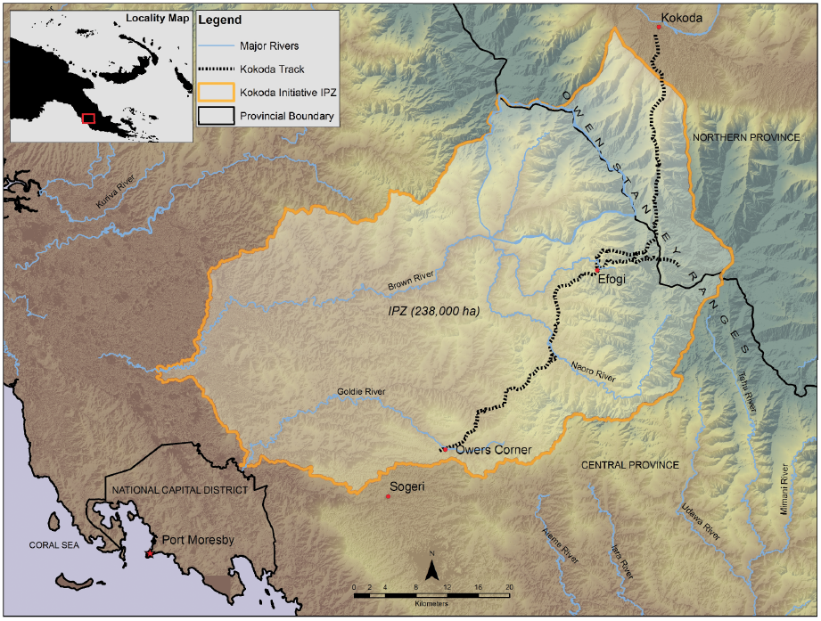

Partners and stakeholders

Government of Papua New Guinea

The following agencies are members of the PNG Kokoda Initiative Taskforce.

**Conservation and Environment Protection Authority (CEPA):** is the lead PNG agency for the Kokoda Initiative and is the secretariat for the PNG Kokoda Initiative Taskforce and the Kokoda Initiative Ministerial Committee as mandated by the PNG National Executive Council. CEPA’s mission is to ensure that PNG’s ‘natural resources are managed to sustain environmental quality, human wellbeing and support improved standards of living’, which supports the vision of the Second Joint Understanding 2010–2015 between Australia and Papua New Guinea on the Owen Stanley Ranges, Brown River Catchment and Kokoda Track Region.

**Kokoda Track Authority (KTA):** is a special purposes authority of the Koiari and Kokoda local-level governments commissioned to manage the Kokoda Track, collect trekking fees, regulate the trekking industry along the Track and distribute benefits from tourism associated with the Kokoda trekking industry to landowners in the region.

**Tourism Promotion Authority (TPA):** is responsible for marketing PNG, including the Kokoda Track region, as a tourist destination. Its mission is to enhance the development, marketing and sustainability of PNG tourism in partnership with industry, government and communities. The TPA is responsible for marketing the Kokoda Track as a premier trekking destination and is involved in the strategic development of tourism in the Kokoda Track and Owen Stanley Ranges region, which includes capacity building and training for local tourism businesses.

**Oro (Northern) Provincial and Central Provincial Administration:** are important partners to the Kokoda Initiative, as the two provincial administrations governing the area covered by the Interim Protection Zone.

**Department of Provincial and Local-level Government Affairs:** coordinates and monitors national policies implemented at the provincial level and coordinates capacity building for provinces. It is the portfolio agency of the KTA.

**Department of National Planning and Monitoring:** has the primary role in development planning and in administering the development budget through which PNG Government funds are made available.

**National Museum and Art Gallery (NMAG):** is PNG’s custodian of national natural history, historic and cultural heritage collections and provides a cultural focal point for the Kokoda Initiative. NMAG administers the national legislation protecting World War II military artefacts and houses the modern history collection, which includes objects from the Kokoda campaign.

Government of Australia

The following agencies are members of the Australian Kokoda Initiative Taskforce.

**Department of the Environment (Environment):** is the lead Australian agency for the Kokoda Initiative. The International Heritage Section (Wildlife, Heritage and Marine Division) is the secretariat for the Australian Kokoda Initiative Taskforce. Environment contributes to achieving the outcomes of the Kokoda Initiative through strategically building PNG partner capacity and providing technical advice on biodiversity and heritage protection.

**Department of Foreign Affairs and Trade (DFAT):** is the lead Australian agency on the bilateral aspect of the Kokoda Initiative. Its role on the Taskforce is to ensure that the Kokoda Initiative aligns with Australia’s pursuit of its global, regional and bilateral interests. DFAT also manages the Kokoda Initiative Development Program, which provides basic health, education, water and sanitation projects for communities living in the Kokoda Track region.

**Department of Veterans’ Affairs (DVA):** supports those who serve or have served in defence of Australia, commemorates their service and sacrifice and manages Australian war graves worldwide. DVA aims to protect the historic World War II values of the Kokoda region through the provision of expert advice, and assists Environment to manage stakeholder issues relating to war veterans.

**Department of the Prime Minister and Cabinet:** provides policy advice to the Prime Minister and the Cabinet on Australia’s domestic and international affairs. The International Division works towards enhancing international government-to-government relationships through a range of bilateral agreements and participation in multilateral forums.

**Department of Defence:** contributes to the Taskforce through international policy and the commemoration of World War II military heritage in PNG.

Stakeholders

The following important stakeholders also contribute to the success of the Kokoda Initiative:

• customary landowners and communities in the region, especially along the Kokoda Track

• local-level governments and wards along the Kokoda Track

• tour operators and trekkers

• churches

• the Returned Services League

• community development and aid organisations, including NGOs.

ACTIVITIES AGAINST GOALS 2014–15

Goal 1

Activities by location

Location of Goal 1 activities undertaken between July 2014 and June 2015

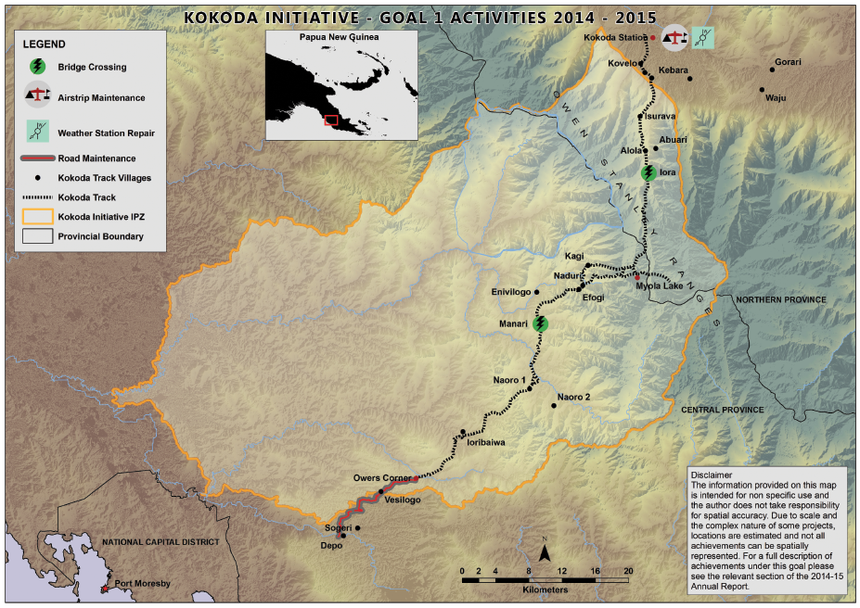

Goal 1: A safe and well-managed Kokoda Track, which honours its wartime historical significance and protects and promotes its special values

The objectives associated with Goal 1 are:

• Further supporting and enhancing the Kokoda Track Authority’s management of the Track and trekking operations

• Working with local communities and tourism operators to improve the trekking experience and track facilities

• Working with regulatory authorities to improve safety for local communities living along the Track and tourists visiting the region.

Achievements for 2014–15

• The Kokoda Track Authority (KTA) and the Department of the Environment (Environment) entered into a new funding agreement in January 2015 to support operational activities and safety projects.

• The Centenary of ANZAC in April 2015 attracted significantly more visitors than usual for that time of year. Around 800 trekkers walked the Track that month, the highest April numbers since 2008 and well above the six-year average of 543 trekkers.

• The Kokoda Initiative continued to support the KTA to manage the Track and associated infrastructure. For example:

– the grass on the Kokoda airstrip was slashed to PNG Civil Aviation Safety Authority (CASA) standard width, guided by GPS coordinates, and windsocks and marker cones were replaced

– the Kokoda Automatic Weather Station was assessed and serviced

– Owers’ Corner Road was maintained to two-wheel drive vehicle standard

– cane footbridges were maintained at Eora Creek and constructed at Vabiovi Creek, near Manari.

The KTA facilitated a management trek with the objective of undertaking operational/safety assessments of the Track and associated infrastructure. To assist with this trek, Environment contracted the Queensland Parks and Wildlife Service (QPWS) to undertake GPS surveys, collect information on track condition and identify areas requiring maintenance work. Subsequently, QPWS provided a report with a series of recommendations to improve track management and operational delivery. The length of the Track was also mapped using four GPS units, producing very accurate datasets.

The KTA continued to engage with key stakeholders – including with the trekking industry through tour operator forums in PNG and Australia, and with landowners through weekly ‘landowner days’ – to improve the trekking experience and track facilities.

The KTA developed a draft Annual Operations Plan to guide the implementation of routine annual activities and key projects.

Environment continued to support capacity building within the KTA by providing day-to-day guidance to senior managers and project officers and by assessing training needs and opportunities.

Goal 2

Activities by location

Location of Goal 2 activities undertaken between July 2014 and June 2015   
  
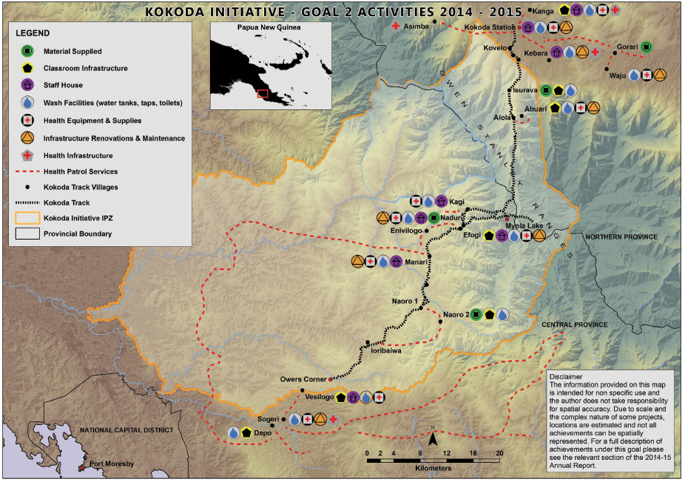

Goal 2: Enhanced quality of life for landowners and communities through improved delivery of basic services, income generation and community development activities

The objectives associated with Goal 2 are:

• Continuing to sustainably improve the standard of health, education, water, sanitation and infrastructure services for communities along the Track

• Facilitating access to benefit streams, income generation and other community development projects for communities in the Interim Protection Zone, including potential opportunities through development of renewable resources, particularly hydro power and water, forest carbon, and tourism

• Enabling communities and landowners to manage development opportunities and income streams generated through this initiative

• Nurturing the alliance between all levels of government, tourism operators and not-for-profit organisations to provide strong and coordinated support for the sustainable development of the region and the wellbeing of its people.

Achievements for 2014–15

Kokoda Initiative Development Program

In 2014–15 the Australian Government and Papua New Guinea Government continued to deliver services to over 14,000 people in the Kokoda Track region through the Kokoda Initiative Development Program (KIDP). The program focused on improving access to better education, health, and water and sanitation services. This type of support is critical to achieving sustainable livelihoods and basic living standards.

The KIDP continued to work in partnership with local governments in Northern and Central provinces, supporting planning, coordination and delivery of critical services in the district health and education divisions of Sohe and Hiri, and with the local governments of Koiari and Kokoda. This support enhanced the sustainable delivery of health and education services to the people in the region.

Major projects and services were delivered to communities in Kokoda, Edevu, Sogeri, Assimba, Kanga, Isurava, Abuari, Waju, Naoro 2, Kavovo, Efogi, Manari, Naduri, Depo and Vesulogo.

Infrastructure

Three new double classrooms and four staff houses were built, improving access to education for over 350 students. Twenty-six toilets and seven water tanks were installed, providing better water and health sanitation services to more than 1,000 local people.

A number of additional infrastructure works commenced during this period, including the construction of one health aid post, four double classrooms and two staff houses; and the installation of 10 toilets. These projects are expected to be completed in October 2015.

Education work

Eighty-eight elementary and primary school teachers in the region were trained and certified in creative phonics, school learning improvement planning, reading schemes, and classroom library management. This training is expected to improve learning for over 1,900 students.

The KIDP supported the visit of standard officers from the Central Provincial Education Department to 250 Koiari students in five schools. This was the first time in many years that standard officers had visited schools in the area. The visit allowed them to better monitor and track the performance of schools and to support teachers with the necessary reporting tools to better manage their schools.

The KIDP supported the delivery and distribution of 13 cartons of children’s reading books to nine schools in Mt Koiari, benefiting over 480 students. The books were donated by Rotary Port Moresby.

Health work

Ninety-six Village Health Volunteers (VHVs) were trained, certified and equipped to provide basic health services. This is expected to benefit over 14,000 people in the region. The VHVs also support health workers by undertaking quarterly maternal and child health (MCH) patrols to remote villages that do not have access to a health facility.

The KIDP enabled health workers to administer 2,467 vaccines to children under the age of five years and to treat over 3,200 outpatients for various illnesses.

Six health workers were trained and certified to prescribe Anti-Retroviral Treatment (ART) and treat HIV-positive patients. These health workers can now carry out HIV tests and prescribe medication for over 6,000 people. This technical skill is the first of its kind in the region and makes a significant contribution to the communities. The health workers identified 27 patients as HIV positive, and these patients are receiving treatment.

One hundred mosquito nets were delivered to four health centres in the Mt Koiari region, providing protection against malaria, especially for pregnant mothers. The mosquito nets were donated by Rotarians Against Malaria.

|  |
| --- |
| Kokoda initiative – changing lives |
| Melissa Jinga – Community Health Worker (Kokoda)  Melissa Jinga is a 30-year-old single mother from Kokoda in Northern Province. She started working as a Community Health Worker at the Kokoda Memorial Hospital in 2008 and has been serving her local community for the last seven years. Early this year she moved into the main town of Popondetta to serve a larger community, sharing her life-saving skills and knowledge to help many more patients.  *‘With the trainings that I have received funded by the Kokoda Initiative, I now have knowledge to help my people. I am not only helping people from Kokoda but people from all parts of Oro (Northern) Province,’* Melissa says.  Melissa also attended the Kokoda Initiative funded Anti-Retroviral Treatment (ART) training. She is now one of the few trained health professionals in Northern Province certified to prescribe treatment to HIV/AIDS patients.  *‘In the past, when individuals were tested and received positive results, they were referred to a district health centre to get medication, which could be a long way away. This is not the case anymore,’* she says.  Melissa can now use a rapid test kit to test for HIV and receive the results in 15 minutes. She can then provide immediate treatment with the ART drug. She is also a certified counsellor and, using skills gained from training funded under the Kokoda Initiative, is currently monitoring and treating three HIV/AIDS patients.  Loyd Gadova – Village Health Volunteer (Kovelo)  Loyd Gadova is a young father from Kovelo village, near Kokoda.  After completing his Grade 10 certificate, Loyd was unable to find any form of employment in town, so he decided to go back to his village. He heard of the Kokoda Initiative funded VHV programme, was nominated by his community leaders to take part, and was recruited as a VHV in 2012. He has attended various training courses on different health topics that have enabled him to not only help his community but also be a good role model for his fellow community members.  With the VHV programme, Loyd has seen a lot of changes in his village and in others along the Kokoda Track. He recalls that when he was growing up his village had a lot of malaria cases whereby many lives were lost.  *‘The village was really dirty with rubbish, there were no proper toilets, with people using nearby bushes, and households were not kept clean. All this lead to more diarrhoea cases in children and also adults,’* he says.  *‘After the introduction of the VHV programme in the village, there has been a big change in the general appearance of the village as well as in individual households in the village. People now see the importance of basic health and hygiene practices and are now taking more responsibility in looking after themselves.’*  Kovelo is now a much cleaner and healthier village, and the numbers of diarrhoea and malaria cases have also dramatically decreased over the years. |

Livelihoods

The Kokoda Initiative Livelihoods Project, administered by the Kokoda Track Authority (KTA), is designed to increase the capacity of communities along the Kokoda Track to generate income from tourism by adding value to the trekking experience.

The KTA has been developing a systematic approach to planning and delivering livelihoods activities along the Track. This includes the development, starting in 2014–15, of a draft Livelihoods Strategy to guide implementation. The strategy will take into consideration past studies and provide consistency through a ‘whole-of-track’ approach to considering proposed activities. A key aspect of the strategy is project proposal forms that support a community-driven and systematic approach to project planning and encourage communities to consider a range of factors when formulating their project proposals.

The KTA’s Community-based Mentors (CBMs) programme now includes 31 CBMs, with an even gender ratio, from 17 village areas along the Track. The CBMs help to facilitate livelihoods initiatives and advise their communities on basic business management. The CBMs continued in 2014–15 to work within their communities on peace-building exercises and community-driven initiatives, including participating in trialling the KTA’s new livelihood project proposal planning process. The KTA met with CBMs to discuss their community-driven projects during the ANZAC Day management trek.

Goal 3

Activities by location

Location of Goal 3 activities undertaken between July 2014 and June 2015  
  
  
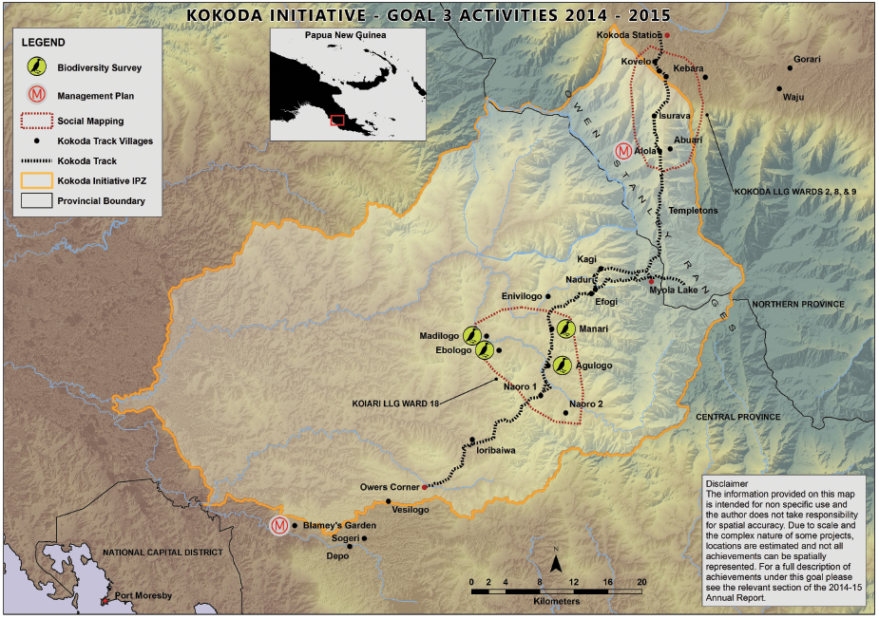

Goal 3: The wise use and conservation of the catchment protection area, including the Kokoda Track and its natural and cultural resources and values

The objectives associated with Goal 3 are:

• Developing an integrated land use plan for the catchment protection area in partnership with key National, Provincial and Local-level Government stakeholders which provides an effective balance between environment conservation and development

• Identifying and conserving the key natural, cultural and historic values of the Owen Stanley Ranges for heritage conservation, protection and tourism and development purposes.

Achievements for 2014–15

Environment

The PNG Conservation and Environment Protection Authority (CEPA), with the support of the Australian Department of the Environment (Environment), continues to work towards protection of the Brown River catchment and Kokoda Track region through the Kokoda Initiative. Activities conducted this year included

• In late 2014, CEPA engaged consultants to develop a framework for an Environmentally Sustainable Development Master Plan for the Brown River Catchment. It is anticipated that this will be completed in the second part of 2015. This plan will be a strategic document guiding growth and development in the Interim Protection Zone (IPZ). It will set out a vision for the future which acknowledges national resource needs together with conservation objectives and community requirements (such as revenue generation and livelihood opportunities).

• A Biodiversity Expert Group was formed and met to discuss the outcomes of the recently completed biodiversity gap analysis of the Owen Stanley Ranges and Kokoda Track region conducted by researchers at the Bishop Museum, Hawaii. This group is a valuable forum for experts to share their knowledge and experience to inform CEPA as it develops environmental planning and management strategies for the region.

• A biodiversity survey was completed at Madilogo, an area that may be affected by the proposed PNG Power Naoro-Brown hydro power project. Fieldwork undertaken in June 2014 included fauna and flora (aquatic and terrestrial) assessments using standard techniques, including trapping, active searches and vegetation transects. Residents of local villages were interviewed on various aspects of the biodiversity of the study area. Analysis of specimens and reporting were carried out between July and December 2014. Over 130 fauna species and over 200 flora species were recorded within the study area. The area was also found to support a number of International Union for Conservation of Nature (IUCN) red-listed species, including the Dwarf Cassowary (*Casuarius bennetti*), Pesquet’s Parrot (*Psittrichas fulgidus*) and Goodfellow’s Tree Kangaroo (*Dendrolagus goodfellowi*). Several exotic species were recorded, a number of which are regarded as weeds, but these were largely confined to areas of disturbance such as trails and abandoned gardens. The information informs an understanding of the area’s significance and future management as a protected area.

• The National Policy on Protected Areas was completed with separate donor support (from the Global Environment Fund), and has now been ratified by the PNG National Executive Council. CEPA is progressing work to identify legislative changes required to implement the new policy. Complementing the Kokoda Initiative, this work is fundamental for progressing gazettal of the IPZ. In association with the policy, workshops were conducted to develop an approach to a national biodiversity offsets mechanism.

• In June 2015, CEPA hosted a major land use planning workshop, supported through the Kokoda Initiative, with PNG agencies and conservation NGOs to consider how the new National Policy on Protected Areas aligned with the new National Sustainable Land Use Policy and other sector policies. The workshop also considered how participatory processes can be used to engage customary landowners and communities in land use and protected area planning. A key workshop outcome was recognising participatory land use planning as an approach which could be formally applied in establishing and managing a comprehensive, adequate, representative and resilient protected area network in PNG.

• The Bishop Museum, Hawaii, completed its final draft report on an exotic species survey conducted in the Kokoda Track area in March–April 2014. The data will inform the development of appropriate management strategies.

• Work continued in social mapping of Koiari Ward 18 and Kokoda Wards 2, 8 and 9 to inform land use planning and negotiations with customary landowners on gazettal of a protected area. Social mapping collects and records information about relationships between people’s settlement patterns, land use, land tenure and social organisation within an area. It is used to ensure that resource management negotiations are carried out with the right people.

• Environment continued to provide an in-country adviser to CEPA to support ongoing capacity building and assist with the implementation of the Kokoda Initiative.

Heritage

• An expert workshop was held in November 2014 with key PNG stakeholders, representatives from the Australian War Memorial and the Department of Veterans Affairs, and various experts (in conservation, cultural heritage, military history and tour operation) to discuss issues associated with a project to survey and record military heritage along the Kokoda Track.

• During the year the National Museum and Art Gallery (NMAG) together with the Kokoda Track Authority further consulted with trek operators to identify military sites being impacted by tourism. This work is intended to contribute to the development of a strategic management plan for military heritage along the Kokoda Track, using a values-based approach to conservation management.

• The Kokoda Oral History Pilot project was completed in September 2014, with a formal handover ceremony held at the NMAG. This project involved interviews with 72 PNG nationals about their own or their ancestors’ wartime experiences in the Kokoda Track region. A short film showcasing the oral histories has been completed and distributed to communities, and is available for viewing on Environment’s website. A community-oriented publication containing many of the stories, together with historic photos, will be launched in September 2015.

• Building on the success of the Kokoda Oral History Pilot Project, an oral history workshop was held in PNG in February 2015, hosted by NMAG. Practitioners of cultural heritage, oral history and history from PNG, Australia and Vanuatu, together with interested agencies, discussed the outcomes of three recent PNG oral history projects, and possible directions for a national oral history programme. This has led to a separate commitment by Australia to fund a national oral history programme, supported through the Department of Foreign Affairs and Trade.

• Archaeological material collected during excavations in the Madilogo area in June 2014 was analysed during the reporting period and reported to CEPA. Over 100 artefacts, including stone axes, flakes and exotic source stone, were excavated, highlighting the richness of this archaeological landscape. Preliminary analyses have identified the first lower montane (500m to 1,500m in elevation) stratified and open archaeological sites in PNG. At least two of these sites reflect village occupation contemporaneous with an arboriculture-based economy dated to around 2,800 years ago.

• Work continued on separate conservation management plans for the Lost Battlefield and Blamey’s Garden sites, in discussion with local landowners and community members.

– Blamey’s Garden, on Hombrum Bluff above the Laloki River, was established in 1942 in the hope that when the war ended it would become a national park. It is associated with General Thomas Blamey, and some suggest it was his wartime headquarters. The site has special significance to the local communities, who refer to it as Namanitabu. Consultants visited the site in August 2014 to map and record numerous wartime features including pathways and building platforms. The owners of the site were consulted and stories associated with the early 20th century and wartime occupation of the site were recorded. The archaeological recording and the oral histories will be included in the final management plan for the site.

– The Lost Battlefield site, located near the village of Alola, is currently not visited by trekkers. In August and November 2014, consultants visited the site to undertake further archaeological survey of specific features such as a Japanese-built road which may have been used by Japanese supply units. Evidence of a pack saddle, together with historical records, suggests that horses may have been used in this area to transport supplies. During these visits, artefacts in a small museum were inventoried and local people’s stories relating to the area were recorded. Discussions were also undertaken with community members about future management of the area, which will inform the final management plan.

|  |
| --- |
| Kokoda Initiative protects local species |
| Local community members and KTA rangers joined scientists from the Bishop Museum, Hawaii, and CEPA staff to carry out a study into exotic (non-native) plants and animals along the Kokoda Track. This was undertaken as part of the Kokoda Initiative’s environmental programme to ensure monitoring and protection of native plant and animal species in the region.  The survey was carried out from Kokoda to Owers’ Corner over 27 days in March–April 2014. Final identification of species and reporting was completed in 2014–15.  *‘We focused primarily on plants and collected specimens documenting the occurrence of at least 80 exotic species. We have identified all but a small fraction of these’* says Dr Allen Allison, Bishop Museum lead researcher for the project.  *‘The exotic plant species along the Track occur primarily in grasslands resulting from human activity that cover open areas along the Track and occupy clearings around villages. All the species that we documented were already known from Papua New Guinea. Many of them have been in Papua New Guinea for decades.’*  As well as evidence of pig damage in some locations, Rainbow Trout were identified in some of the streams. While this is a popular fish that local people eat, it can also compete aggressively with native species.  The team also recorded native plants and animals, including over 13 types of Bird of Paradise and the Doria’s Tree Kangaroo, which can be hard to find.  Dr Allison explains that exotic species are classified either as agricultural pests or invasive parasites that take over native plant species.  *‘We have found no evidence of any new-to-PNG exotic pest species having being introduced by trekkers along the Kokoda Track that may threaten local food crops and local native plants species’* he says.  The report recommended that the Track be monitored annually on a low-intensity basis for the introduction of exotic pest species to ensure ongoing effective management. A small number of potentially invasive species with limited distribution along the Track were recommended for removal. The report also suggested that a field guide be prepared to promote ecotourism along the Track. The guide could include details of native species of interest as well as photos of the major exotic species.  CEPA will continue to work with local communities and the KTA to protect the natural environment along the Kokoda Track. |

Reports produced on behalf of CEPA in 2014–15

Values Identification and Mapping

• Archaeological report on fieldwork in Madilogo 16–26 June 2014 (M Prebble, M Leavesley and A Kuaso (ANU Enterprise), 2014)

• Exotic species survey of the Kokoda Track (L Pratt, T Pratt, C Imada and A Allison (Bishop Museum) 2015)

• Biodiversity assessment report—Naoro-Brown River Biodiversity Study (Cardno, 2015)

• Distribution, Diversity and conservation status of the biota along the Kokoda Track with recommendations for its protection (A Allison and O Tallowin (Bishop Museum), 2015)

Land Use Planning

• CEPA land use planning workshop: ‘Collaborative and coordinated protected area land use planning approaches for sustainable development’. Port Moresby 9-12 June 2015 (D Mitchell, M Wolnicki and M Keako, 2015)

Social Mapping

• Subcatchment mapping Koiari Rural LLG Ward 18 (J Burton, ANUedge with assistance of E Kaitokai, J Onguglo and M Keako, 2015)

• Phase III social mapping: report on fieldwork in Kokoda Rural LLG, Wards 2, 8 & 9, June 22 July 6 2014 (l digim’Rina, B Sagir and V Kewibu (UPNG), 2015)

Reports produced on behalf of Environment in 2014–15

• Kokoda military heritage workshop: facilitators report. Australian National Botanic Gardens, Canberra 11 November 2014 (Stepwise Heritage and Tourism, 2014)

• The Kokoda oral history pilot study—Volumes 1 and 2 (J Ritchie (Alfred Deakin Research Institute), 2014)

Goal 4

Goal 4: Building national and international tourism potential of the Owen Stanley Ranges and Kokoda Track region, supported by a possible future World Heritage nomination

The objectives associated with Goal 4 are:

• Promoting the natural, cultural and historic military values of the Track

• Developing a strategic tourism plan and associated marketing activities

• Exploring the heritage conservation values and conducting a feasibility study for possible World Heritage nomination, consistent with its inclusion in the PNG Government World Heritage Tentative List (2006).

Achievements for 2014–15

• The PNG Tourism Promotion Authority’s (TPA) ‘Do Kokoda’ campaign continues to be successful, with over 200 personal stories and trekker experiences of the Track now shared online. ‘Do Kokoda’ is a web-based campaign that encourages trekkers to share videos, photos and comments on their Kokoda Track experience. In 2014–15, Laura Dundovic (former Miss Universe Australia) and Erin Holland (former Miss World Australia) joined Channel Nine Footy Show hosts Sam Newman and Garry Lyon as official Kokoda ambassadors. The pair took up the challenge to encourage more women to tackle the challenge of trekking Kokoda.

• TPA and KTA continue to work towards establishing the voluntary National Accommodation Classification Scheme across the Track. The system’s Category 6 (for campsites) is now ready for implementation. Presentations on the Scheme and Category 6 were conducted at the Tour Operator Forums held at the end of 2014 through to the end of 2015 trekking seasons. Community accreditation training continues and an awareness campaign for Kokoda Track communities is in progress. As part of that campaign, an information pamphlet on the Category 6 classification was distributed at Efogi and Kokoda.

• The Tourism Master Plan for Papua New Guinea is in its ninth year of implementation and is achieving high to medium success. The plan outlines the TPA’s approach to tourism and marketing, which includes the Kokoda region.

• TPA and Environment have collaborated to initiate the development of an interpretive display for installation at Owers’ Corner. The display will highlight the Track’s military history and focus on the stories and experiences of both PNG and Australia. It is expected to be completed in 2016.

• TPA is liaising with CEPA regarding the development of Varirata National Park, to explore linkages between potential birdwatching tourism within the park and birdwatching trips in the Kokoda region.

• TPA scoped proposed tourism ventures in Central Province with the Central Province Tourism Office in the Hiri District. The scoping identified six active projects and potential tourist sites in the province, including whitewater rafting on Brown River. This has the potential to broaden tourism options for visitors to the Kokoda region.

• As reported under Goal 3 above, CEPA continued to gather evidence to support the claim that the Owen Stanley Ranges and Kokoda Track region possesses the outstanding universal values required for nomination to the World Heritage List.

• CEPA engaged a consultant to develop a ‘road map’ to guide the PNG Government through the World Heritage nomination process. The road map outlines the steps and resources needed to progress a nomination under five themes: governance and capacity, heritage values, integrity of the area, life in the community, and sustainable tourism. It clearly indicates that progressing the World Heritage nomination is a long-term commitment, requiring many years and significant resources. Given the vast size of the area and the diverse population living within the proposed zone, the road map has identified that the consultation process will be particularly challenging.

• A review of the seven World Heritage Tentative List sites proposed for PNG, funded separately by the UNESCO World Heritage Centre, was undertaken. This has informed the approach to World Heritage listing of the Owen Stanley Ranges region. It found that the greater part of the heritage values of the area recognised at the time of nomination in 2006 still exist and that in a number of cases new heritage values have been identified and/or knowledge of known values has been enhanced. However, the range and magnitude of threats to these values has also increased and some important heritage values are seriously threatened. The report suggested that a well-resourced proactive programme of protection is needed, and that strong leadership at the national government level is vital.

Reports produced ON BEHALF OF CEPA in 2014–15

Potential World Heritage Nomination

• Draft road map for potential World Heritage nomination: Kokoda Track and Owen Stanley Ranges (R Mackay (GML Heritage Pty Ltd, Odonata House), 2015)

Goal 5

Goal 5: Working with communities, landowners, industry and all levels of government to ensure that activities established under the Kokoda Initiative are sustained into the future

The objectives associated with Goal 5 are:

• Maximising the delivery and maintenance of services and activities through the responsible PNG provincial and local-level governments

• Building capacity within key PNG and Australian Government agencies to ensure the goals of this initiative can be delivered and are sustainable.

Achievements for 2014–15

• The Australian and PNG governments announced their intention to continue the Kokoda Initiative beyond the Second Joint Understanding 2010–2015 (JU2) through the joint communiqué of the 23rd Australia–PNG Ministerial Forum in December 2014. The next cycle of the Kokoda Initiative will focus on keeping the Kokoda Track open and safe, on better economic and social development, and on environment and heritage protection. With this in view, strategic planning during 2014–15 turned towards completing activities under the JU2, managing the transition, and entering the next phase of the Kokoda Initiative.

• Kokoda Initiative forums—including the biannual joint planning meetings, PNG Government Kokoda Initiative Ministerial Committee (KIMC) meetings, KIMC Technical Working Group meetings and the Australian Kokoda Initiative Taskforce meeting—were well attended and strongly supported, providing essential collaboration between agencies.

• KIMC, led by the PNG Minister for Environment and Conservation and Climate Change, the Hon John Pundari MP, has driven strategic planning through enhanced coordination of activities and cross-agency communication. The PNG Government invited Australian Government representatives to the KIMC meetings, including representatives from the Australian High Commission and the Kokoda Initiative Senior Adviser, Mr William Farmer AO. Environment’s adviser to CEPA provided support to CEPA’s secretariat role, which included guiding the development of the Kokoda Initiative Master Plan commissioned by the KIMC. The master plan will provide a strategic development framework and road map for all Kokoda Initiative stakeholders and will guide PNG governance arrangements for the Kokoda Initiative.

• Environment’s advisers to CEPA and the KTA continued to provide operational support, build staff capacity, and facilitate high-level engagement with the PNG and Australian governments. The adviser to CEPA role will continue beyond June 2015; the role of the adviser to the KTA ended in December 2014. To complement the work of the advisers, Canberra-based departmental staff undertook an increased number of short-term deployments to work alongside staff from CEPA, the KTA and the TPA. The visits strengthened collaboration to achieve the outcomes of the Kokoda Initiative outlined in this report.

• Reciprocal visits from representatives from CEPA and the KTA to Australia were also undertaken. The visiting CEPA and KTA staff engaged with stakeholders, met with consultants, attended the World Parks Congress in Sydney in October 2014 and undertook training during the period. Continued capacity development and enhanced communication remained a priority during the year.

Kokoda Initiative 2014–15 Expenditure

Australian Government expenditure, 1 July 2014 to 30 June 2015

| **Department of the Environment (Environment) expenditure** | **PGK** | **AUD** |
| --- | --- | --- |
| **Goal 1 A safe and well-managed Kokoda Track, which honours its wartime historical significance and protects and promotes its special values** | | |
| Capacity building support and advice to the Kokoda Track Authority (KTA) | 679,596 | 322,542 |
| Organisational support (KTA grant funding from January 2015) | 316,931 | 150,418 |
| Track management and safety (KTA grant funding from January 2015) | 635,109 | 301,428 |
| Equipment and contracts to support KTA operations | 2,895 | 1,374 |
| Contracted services for track management and safety (including arrangements with the Australian Bureau of Meteorology for weather station repairs) | 54,276 | 25,760 |
| **Total** | **1,688,807** | **801,522** |
| **Goal 2 Enhanced quality of life for landowners and communities through improved delivery of basic services, income generation and community development activities\*** | | |
| KTA livelihoods activities, including micro-business and technical training and mentor support scheme (KTA grant funding from January 2015) | 19,595 | 9,300 |
| **Total** | **19,595** | **9,300** |
| **Goal 3 The wise use and conservation of the catchment protection area, including the Kokoda Track, and its natural and cultural resources and values** | | |
| Identification of heritage values (contracted services) | 288,330 | 136,844 |
| Technical and adviser support to the Conservation and Environment Protection Authority (CEPA) | 1,032,257 | 489,918 |
| Support to CEPA for biodiversity, spatial mapping and social mapping programme** | 276,017 | 131,000 |
| **Total** | **1,596,605** | **757,762** |
| **Goal 4 Building national and international tourism potential of the Owen Stanley Ranges and Kokoda Track region, supported by a possible future World Heritage nomination** | | |
| World Parks Congress | 670 | 318 |
| **Total** | **670** | **318** |
| **Goal 5 Working with communities, landowners, industry and all levels of government to ensure that activities established under the Kokoda Initiative are sustained into the future** | | |
| Stakeholder engagement and communications | 216,606 | 102,803 |
| Twinning, training and exchanges | 44,999 | 21,357 |
| Programme review | 47,098 | 22,353 |
| Operating expenditure | 2,867,090 | 1,360,745 |
| **Total** | **3,175,793** | **1,507,258** |
| **Total expenditure** | **6,481,874** | **3,076,160** |

Note: The Reserve Bank of Australia (RBA) exchange rate at 30 June 2015 was used for all expenditure conversions between AUD and PGK (1AUD = 2.1070PGK or 0.4746AUD = 1PGK).

*Expenditure of funds by DFAT for aid coordination under Goal 2 is detailed below under Department of Foreign Affairs and Trade expenditure on Kokoda Initiative Development Program.

**Expenditure of funds provided by Environment to CEPA is detailed below under PNG CEPA expenditure.

| **Department of Foreign Affairs and Trade expenditure on Kokoda Initiative Development Program** | **PGK** | **AUD** |
| --- | --- | --- |
| **Goal 2 Enhanced quality of life for landowners and communities through improved delivery of basic services, income generation and community development activities** | | |
| Outcome 1 – (Infrastructure*)* | 2,847,887 | 1,351,631 |
| Outcome 2 – (Training – skills and standards) | 821,334 | 389,812 |
| Outcome 3 – (Management and coordination) | 130,737 | 62,049 |
| Communications | 31,222 | 14,818 |
| Management travel and stakeholder meetings | 84,491 | 40,100 |
| Baseline study | 264,041 | 125,316 |
| Staff costs | 1,040,239 | 493,706 |
| Office costs | 553,317 | 262,609 |
| **Total expenditure** | 5,773,268 | 2,740,041 |

Note: The RBA rate at 30 June 2015 was used for all expenditure conversions between AUD and PGK (1AUD = 2.1070 PGK or 0.4746 AUD = 1PGK).

Expenditure/income reported By Papua New Guinean partner agencies, 1 July 2014 to 30 June 2015

| **Conservation and Environment Protection Authority expenditure\*** | | | | | | |
| --- | --- | --- | --- | --- | --- | --- |
|  | **Australian Government Funds** | | **PNG Government Funds** | | **Total Expenditure** | |
|  | PGK | AUD | PGK | AUD | PGK | AUD |
| Heritage values identification | 170,912 | 81,116 | 721,739 | 342,543 | **892,651** | **423,660** |
| Oral history project | 26,781 | 12,710 | 25,620 | 12,159 | **52,401** | **24,870** |
| Participatory (social) mapping | 37,215 | 16,332 | 507,199 | 240,721 | **544,414** | **257,053** |
| Environmental management and protection | 34,412 | 17,365 | 110,793 | 52,583 | **145,205** | **69,948** |
| Programme development, administration and capacity building (including KIMC Secretariat) | 99,798 | 47,364 | 1,295,845 | 615,019 | **1,395,643** | **662,384** |
| Stakeholder engagement and communications strategy | 48,973 | 23,243 | 122,922 | 58,340 | **171,895** | **81,583** |
| **Total expenditure** | 418,091 | 198,430 | 2,784,118 | 1,321,365 | **3,202,209** | **1,519,498** |

Note: The RBA rate at 30 June 2015 was used for all expenditure conversions between AUD and PGK and rounded (1AUD = 2.1070PGK or 0.4746AUD = 1PGK).

* CEPA receives funding from both the PNG and Australian governments. Environment provided $132,000 (AUD) in 2014–15 – see Goal 3 under Department of the Environment expenditure above. Unexpended Australian funds from 2013–14 were available for use in 2014–15.

| **Tourism Promotion Authority expenditure** | **PGK** | **AUD** |
| --- | --- | --- |
| National Accommodation Classification Scheme (accommodation, plane hire, consultant fees, brochures etc) | 12,923 | 6,133 |
| Stakeholder engagement | 10,099 | 4,793 |
| **Total expenditure** | **23,022** | **10,926** |

Note: The RBA rate at 30 June 2015 was used for all expenditure conversions between AUD and PGK and rounded (1AUD = 2.1070PGK or 0.4746AUD = 1PGK).

| **Kokoda Track Authority\*\*** | **PGK** | **AUD** |
| --- | --- | --- |
| Projects under the 2015 funding agreement | | |
| Safety | 532,211 | 252,591 |
| Organisational support | 92,493 | 43,898 |
| Salaries | 104,482 | 49,588 |
| **Total expenditure\*\*\*** | **729,186** | **346,077** |

** Information sourced from KTA 2015 Funding Agreement Financials

*** Total expenditure for the period 1 January - 30 June 2015

Note: The RBA rate at 30 June 2015 was used for all expenditure conversions between AUD and PGK and rounded (1AUD = 2.1070PGK or 0.4746AUD = 1PGK).

This report was funded through Australian Aid managed by the Kokoda Initiative on behalf of the Australian Government. The Kokoda Initiative is a joint agreement between the governments of Papua New Guinea and Australia working towards the sustainable development and ongoing protection of the Owen Stanley Ranges, Brown River Catchment and Kokoda Track Region.