# Labour use in Australian agriculture

Peter Martin, Lucy Randall & Tom Jackson

Research by the Australian Bureau of Agricultural and Resource Economics and Sciences

Research Report 20.20

December 2020



© Commonwealth of Australia 2020

**Ownership of intellectual property rights**

Unless otherwise noted, copyright (and any other intellectual property rights, if any) in this publication is owned by the Commonwealth of Australia (referred to as the Commonwealth).

**Creative Commons licence**

All material in this publication is licensed under a [Creative Commons Attribution 4.0 International Licence](https://creativecommons.org/licenses/by/4.0/legalcode) except content supplied by third parties, logos and the Commonwealth Coat of Arms.

Inquiries about the licence and any use of this document should be emailed to [copyright@awe.gov.au](mailto:copyright@awe.gov.au).



**Cataloguing data**

This publication (and any material sourced from it) should be attributed as: Martin, P, Randall, L & Jackson, T, 2020, *Labour use in Australian agriculture*, ABARES, Canberra, December, CC BY 4.0.

DOI: <https://doi.org/10.25814/gjyp-7g19>

ISSN 1447-8358

Australian Bureau of Agricultural and Resource Economics and Sciences (ABARES)

GPO Box 858 Canberra ACT 2601

Telephone 1800 900 090

Web [awe.gov.au](http://agriculture.gov.au/)

**Disclaimer**

The Australian Government acting through the Department of Agriculture, Water and the Environment, represented by the Australian Bureau of Agricultural and Resource Economics and Sciences, has exercised due care and skill in preparing and compiling the information and data in this publication. Notwithstanding, the Department of Agriculture, Water and the Environment, ABARES, its employees and advisers disclaim all liability, including liability for negligence and for any loss, damage, injury, expense or cost incurred by any person as a result of accessing, using or relying on any of the information or data in this publication to the maximum extent permitted by law.

**Professional independence**

The views and analysis presented in ABARES publications, including this one, reflect ABARES professionally independent findings, based on scientific and economic concepts, principles, information and data. These views, analysis and findings may not reflect or be consistent with the views or positions of the Australian Government, or of organisations or groups who have commissioned ABARES reports or analysis. More information on [professional independence](https://www.agriculture.gov.au/abares/about/research-and-analysis#professional-independence) is provided on the ABARES website.

## Labour use in Australian agriculture

### Summary

Labour is a key input to Australian agriculture, and there is significant interest in understanding the extent to which labour markets are currently meeting the needs of the Australian farm sector. This interest has recently been heightened by the COVID-19 pandemic, which has resulted in a reduction in the availability of farm workers from overseas and placed restrictions on the movement of Australian farm workers.

ABARES has been surveying farmers about their labour use for several years. Data describing the use of labour on farms and the profile of farm workers has been collected through surveys of broadacre, dairy, vegetable, fruit, grape and nut farms. Farms in scope for these surveys account for 93% of Australia's employing farm businesses.

Results from ABARES labour surveys for 2018–19 are presented in this publication using a [data visualisation product](https://www.agriculture.gov.au/abares/research-topics/labour). Users can select from a range of state and industry options to observe trends in labour use during 2018–19, and the profile of the agricultural labour force in that year. Monthly data on seasonal labour use at a finer regional scale is displayed through a map.

### The effects of COVID-19

The effects of COVID-19 on the Australian agricultural workforce have been most directly felt in the horticulture sector. A particular concern in the short term is the extent to which labour markets can adapt to the restrictions associated with COVID-19 and therefore whether horticulture producers will have access to sufficient workers to harvest crops and conduct other labour-intensive farm operations. The impact of potential increases in the cost of hired labour on horticulture farms is also of significant interest.

ABARES latest forecasts for horticulture production and prices are contained in the December edition of [*Agricultural Commodities*](https://www.agriculture.gov.au/abares/research-topics/agricultural-outlook/agriculture-overview). These forecasts reflect our current understanding of the agricultural labour market and the responses producers have made to the changed availability of farm workers during 2020–21, particularly those from overseas. In 2018–19, overseas workers accounted for more than half of the temporary workforce employed on horticulture farms. An important source of these workers were people on working holiday maker visas, and significantly fewer of these people are now currently in Australia.

To provide more insight into the potential effects of COVID-19 on the availability of farm workers, additional data on horticulture production and use of overseas labour on horticulture farms has been added to this report. The additional data focusses on the period from November 2018 to March 2019, a period during which many horticulture crops were harvested and seasonal labour demand increased significantly. The additional data include:

* change in the number of overseas workers on horticulture farms by region from November 2018 to February 2019 (when labour use peaked nationally)
* value and share of national horticulture production by region
* number of people on JobSeeker and Youth Allowance payments in each region as of September 2020
* horticulture crops harvested in each month from November to March in each region, and their contribution to the national value of that crop during 2015–16
* value of production for horticulture crops at relatively fine commodity and geographic scales.

### Key findings

#### Employment on Australian farms is significant and varies throughout the year

Australian farms employed 326,000 workers on average across 2018–19, including full-time, part-time, casual and contract employees. Total farm employment varied from 356,000 in February to 311,000 in June 2019, reflecting the timing of relatively labour-intensive operations such as planting and harvest. Variation in total employment on farms is driven by changes in the use of casual and contract labour on farms (often known as seasonal workers).

Broadacre farms are the largest employers in Australian agriculture, accounting for an average of 159,000 workers in 2018–19. Fruit grape and nut farms employed around 104,000 workers, vegetable farms employed 38,000 workers and dairy farms employed an average of 24,000 workers over the year.

Number of workers by type, all industries, 2018–19

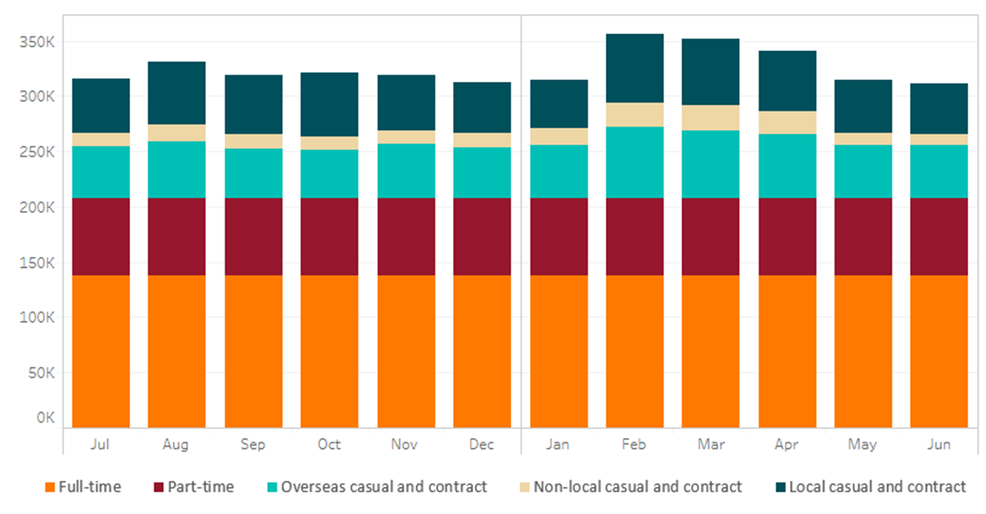Note: all industries refers to fruit, nut, grape, vegetable, broadacre and dairy farms

#### Casual and contract labour use exhibits significant seasonality and workers from overseas are an important source

Nationally, the total number of casual and contract workers employed on farms ranged from a high of around 149,000 in February 2019 to a low of 104,000 in June 2019. The number of casual and contract workers on farms increased by one third from September to February.

Of the total casual and contract workforce used on farms, 40% to 50% were from overseas in 2018–19 (in addition to those from New Zealand), including people in Australia on working holiday maker (WHM) visas and participants in the seasonal worker program. The total number of these workers ranged from 65,000 in February 2019 to 44,000 in October 2019.

#### Some industries rely on seasonal and overseas workers much more than others

Farms in particular industries use casual and contract labour quite differently throughout the year. Horticulture farms tend to use relatively large amounts of casual and contract labour at key times of the year and less in other months, while broadacre and dairy farms tend to use this kind of labour more consistently over time. Farms with greater variation in casual and contract labour use tend to rely more heavily on workers from overseas than others.

#### Casual and contract labour use varies significantly across states

There are significant differences across states in the use of casual and contract labour, and in the seasonal pattern of labour use, reflecting the areas of particular crop types present and the timing of relatively labour-intensive processes. Total casual and contract labour use appears to vary less throughout the year in New South Wales and Queensland than in Victoria, South Australia and Tasmania.

Number of casual and contract workers on farms in each month, by state, 2018–19

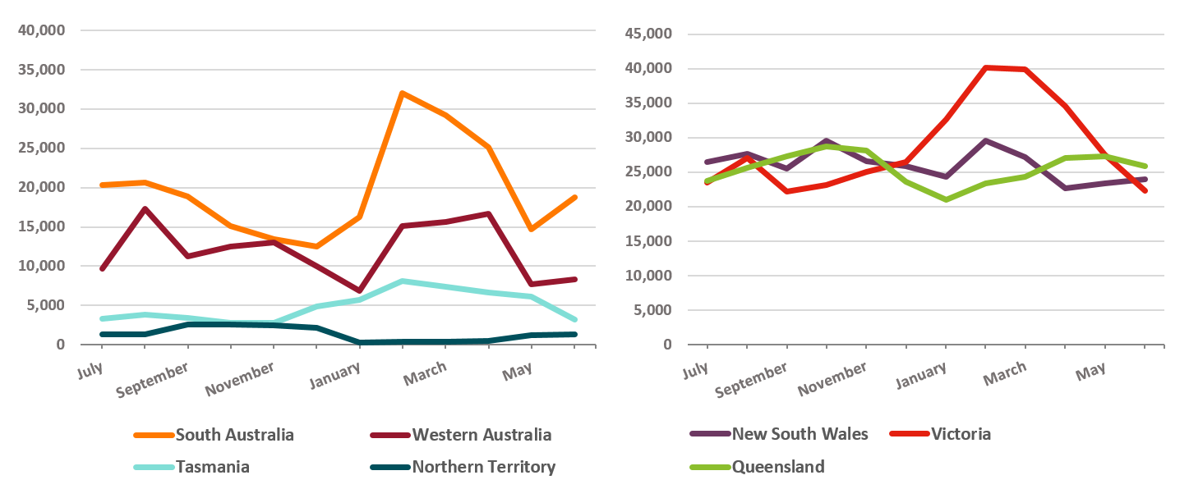

#### Casual and contract labour use is regionally concentrated

Reliance on casual and contract labour from overseas is highest in regions with high volumes of horticultural production and a range of seasonal crop types. This includes regions such as south-east Queensland, including the important vegetable producing regions of the Lockyer valley and Wide Bay as well as tropical fruit and strawberry production on the Sunshine Coast. The Sunraysia and Shepparton regions in northern Victoria are another with a range of vegetable crops, wine grapes, almonds, citrus and pome fruit and includes large areas of table grapes — a crop that requires large numbers of pickers and packers for relatively short periods.

#### Farms employ a range of worker types, depending on their circumstances and conditions in the labour market

Farm workers employed in 2018-19 were mainly Australians, particularly in the broadacre and dairy industries. In the vegetable and fruit and nut industries, around half of all workers employed at peak were Australians. Most workers on farms in the peak month were employed through casual and contract arrangements.

#### Workers from overseas are an important source of horticultural labour in peak times

Workers from overseas were a significant source of seasonal labour on horticulture farms throughout 2018–19 (around 50,000 workers from May to January), and were particularly important in February (around 63,000 workers), March (59,000 workers) and April (56,000 workers). Employment of Australian seasonal workers (locals and those from other regions) on horticulture farms ranged from 27,000 workers in October 2018 to 56,000 workers in February 2019.

The availability of relatively large numbers of workers for short periods is important for performing labour-intensive operations on many horticulture farms. A range of horticulture crops are harvested once a year, and in some regions harvest of particular crops occurs over a matter of weeks only. The relatively brief period for which labour-intensive activities occur on horticulture farms fits relatively well with the availability of workers from overseas in particular regions, which is often short term.

#### Demand for overseas workers from overseas shifts southward in late summer

The number of workers from overseas employed on horticulture farms increased significantly (by 31,000) in southern regions of Australia and declined slightly in northern regions (by 5,000) from November 2018 to February 2019. These shifts are largely explained by the timing of harvest for key crops in each region. For example, the peak harvest period for mangoes is November to December and occurs mainly in the Northern Territory and north Queensland. In contrast, cherries are mainly harvested from December to February in Tasmania and New South Wales.

#### Some regions are more reliant on overseas workers for horticulture than others

Regions differ significantly in the extent to which overseas workers are used throughout the year and during key harvest periods. For example, horticulture farms in Wide Bay (southern Queensland) consistently employ a relatively large number of overseas workers. This reflects the significant amount of horticulture production that occurs in this region (7% of national total horticulture value in 2018–19), the relatively wide range of crops produced in this region (and hence the relatively spread-out period during which key labour-using processes such as harvest are occurring) and the relatively large number of people from overseas that visit this region for tourism.

In contrast, while north-west Victoria also accounts for a relatively large share of national horticulture production value (12% in 2018–19), and is a major employer of overseas workers, the pattern of overseas labour use is quite different. Farms in this region primarily used workers from overseas in a relatively limited period from January to March in 2018–19, during the peak harvest period for crops such as table grapes and fruit. A similar situation applies in other regions in southern Australia that use a relatively large number of overseas workers for relatively short periods – such as Bunbury in Western Australia (where around a quarter of national avocado production occurs) and south east Tasmania (where approximately 30% of the national cherry crop is produced).

In many regions, the number of people receiving the JobSeeker and Youth Allowance payments as of September 2020 is greater than the increase in the number of overseas workers employed on horticulture farms that occurred from November 2018 to February 2019. In some cases, these people will be hired for seasonal work on horticulture farms. Horticulture producers have been adapting to the reduced availability of workers from overseas during 2020 in a number of ways, including employing more Australians, altering the number of hours worked per week, and by altering production systems.

### Key caveats and assumptions

These are ABARES best estimates of the use of labour on farms and the profile of farm workers, given the data presently available. The following caveats and assumptions should be noted:

* For most fruit and nut farms, survey data on the use of casual and contract labour was only available for the ‘peak’ month, and ABARES has drawn on other data and industry knowledge to inform a modelling process that was used to construct the estimates for other months. In contrast, data on monthly labour use for broadacre, dairy and vegetable farms was collected directly in farm surveys.
* The data presented here are for 2018–19. The use of labour on farms in particular regions and industries (and labour use from month to month) varies between years depending on seasonal and market conditions. As such, the estimates presented here should not be viewed as forecasts of labour use in 2020–21.
* In constructing these estimates, ABARES has used ABS data on farm numbers and the areas of particular agricultural activities present in each state, and ABARES farm survey data on the use of labour throughout the year.
* Disaggregating the data into particular industries and states reduces the number of surveyed farms underpinning the estimates, which increases the degree of uncertainty associated with these estimates.
* These estimates of the total number of casual and contract workers used in each month are not necessarily comparable to estimates of the total number of short term positions available, since workers can potentially have more than one position within a month.
* For casual and contract employees, estimates are provided for the number of local workers (i.e. those that live in the same district as the farm), non-local Australian and New Zealand workers, and overseas workers. To aid presentation, this disaggregation is not performed for full and part time workers. Nationally, the vast majority of these workers are local.