Lachlan River
Long Term Intervention Monitoring Project
Progress Report
1st October 2017 to 19th December 2017

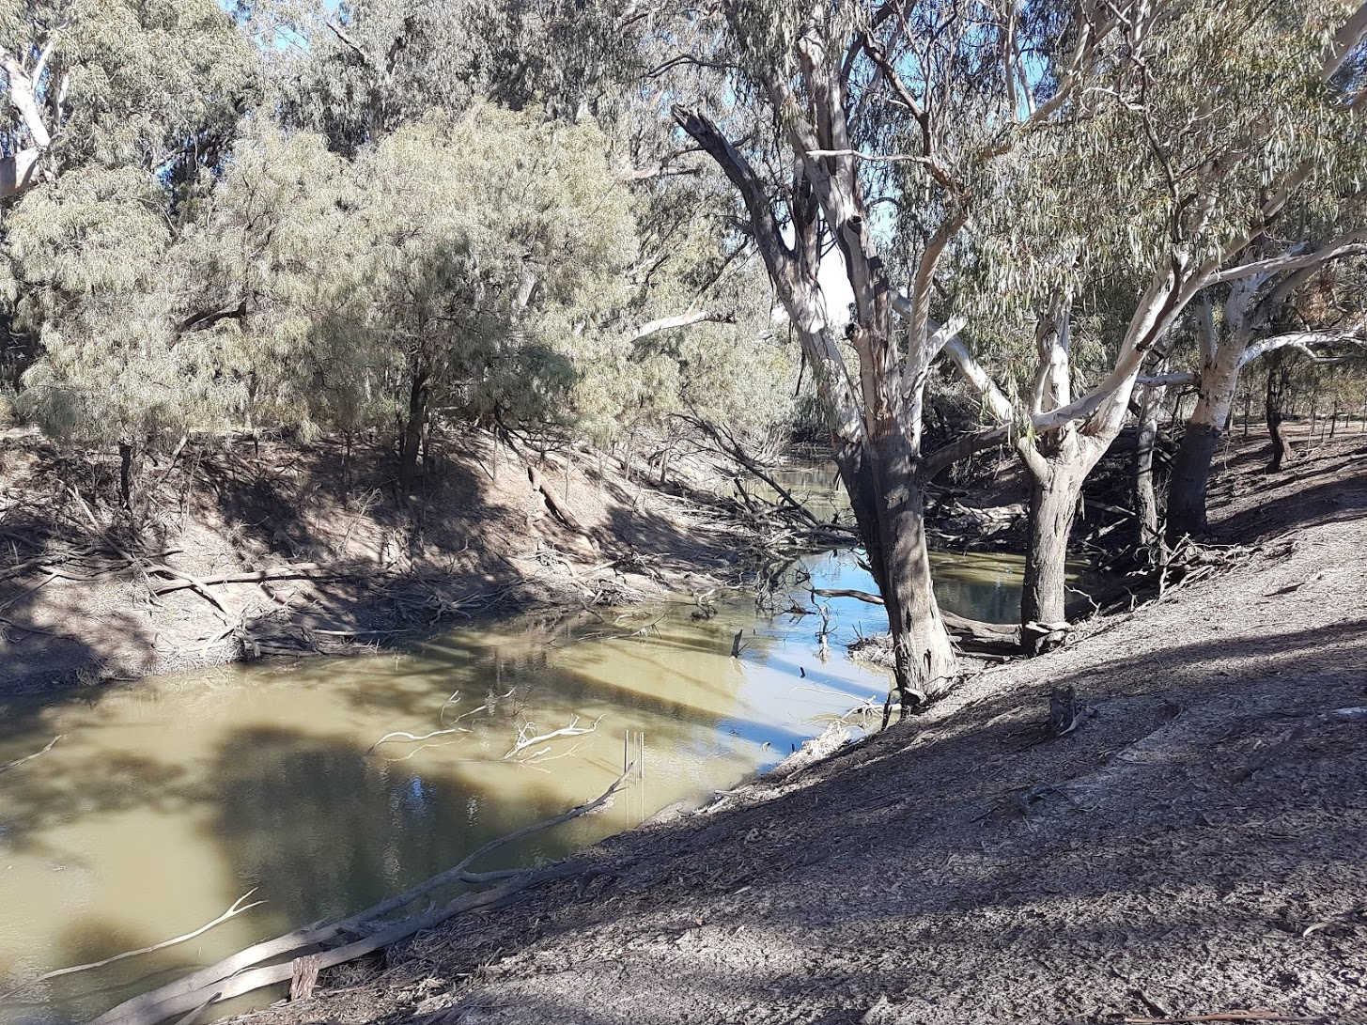

Inquiries regarding this document should be addressed to:
Dr Fiona Dyer
Phone: 02 6201 2452
e-mail: Fiona.Dyer@canberra.edu.au

This document was prepared by Ben Broadhurst with input from Ebony Mullin (CEWO) and Fiona Dyer (IAE-UC).
Cover Photo: Lachlan River at Cowl Cowl. Photo: Ugyen Llendhup (University of Canberra)
Document history and status
Version | Date Issued | Reviewed by | Approved by | Revision Type
Draft 1 | 19 December 2017 | Ben Broadhurst | Ben Broadhurst | Internal
FINAL | 5th February 2018 | Ebony Mullin/Damian McRae | Fiona Dyer | External

Distribution of copies
Version | Type | Issued to
FINAL | Electronic | Commonwealth Environmental Water Office

Copyright
© Copyright Commonwealth of Australia, 2016

‘Long term intervention monitoring project, Lachlan River system selected area, progress report’ is licensed by the Commonwealth of Australia for use under a Creative Commons By Attribution 3.0 Australia licence with the exception of the Coat of Arms of the Commonwealth of Australia, the logo of the agency responsible for publishing the report, content supplied by third parties, and any images depicting people. For licence conditions see: http://creativecommons.org/licenses/by/3.0/au/
Disclaimer
The views and opinions expressed in this publication are those of the authors and do not necessarily reflect those of the Australian Government or the Minister for the Environment. While reasonable efforts have been made to ensure that the contents of this publication are factually correct, the Commonwealth does not accept responsibility for the accuracy or completeness of the contents, and shall not be liable for any loss or damage that may be occasioned directly or indirectly through the use of, or reliance on, the contents of this publication.

- Conditions in the Lachlan River system September – December 2017
Monthly rainfall at Hillston was somewhat sporadic, with significant falls in October and December, and very low falls in September (Figure 1). Overall the total rainfall for the September - December 2017 period (131.4 mm) was slightly higher than the long term average (124.8 mm) well below long term averages for all months between September - December (Figure 1). The catchment has experienced a slightly warmer than average maximum and minimum temperatures than long term average from September – December 2017 (Figure 2).

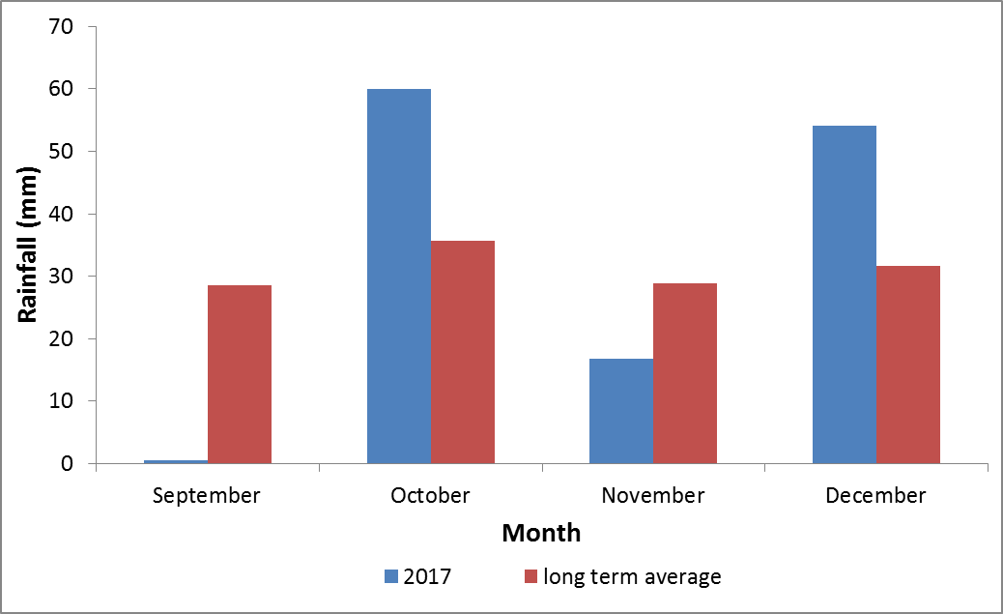
Figure 1. Rainfall at Hillston (075032) in the Lachlan River Catchment in September – December 2017 compared with the long term average monthly rainfall. Data from the Bureau of Meteorology.

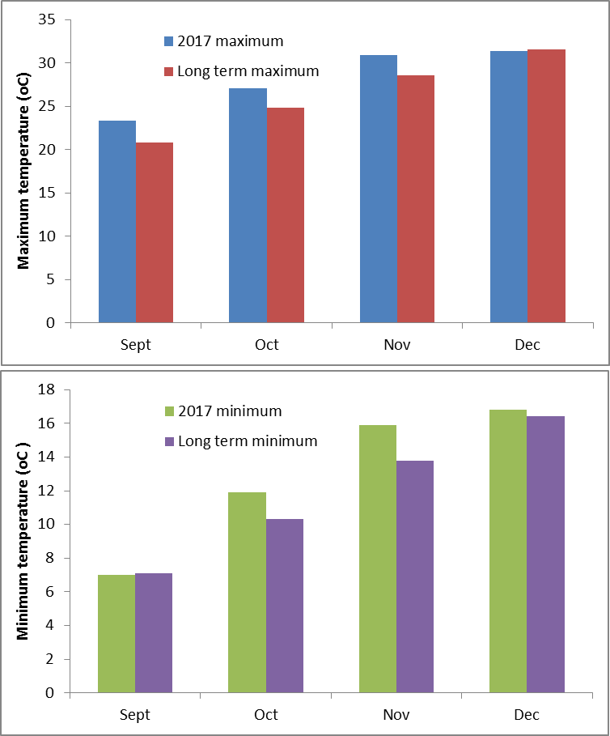
Figure 2. Spring and early summer mean monthly temperatures at Hillston in the Lachlan River catchment comparing 2017 mean temperatures with the long term mean temperatures. Data from the Bureau of Meteorology.

- Summary on progress against core monitoring and evaluation activities

ACTIVITIES | PROGRESS TO DATE | UPCOMING ACTIVITIES
Monitoring activities
Ecosystem type | - Data collection complete and suggested Australian National Aquatic Ecosystems (ANAE) types for all sites included in the Monitoring and Data Management System (MDMS). | - No more data collection required
Fish (river) | - 2016-17 data analysis and draft report completed | - None
Fish (larvae) | - 2016-17 data analysis and draft report completed | - Larval fish completed for 2017
Waterbird breeding (optional) | - Unlikely to be undertaken in 2017 / 2018 | - None
Water quality and stream metabolism | - 2016-17 data analysis and draft report completed  - Water quality samples | - Checking, calibrating and downloading logger data. This couldn’t be completed during the Sept – Dec period because of high water levels.
Vegetation diversity | - 2016-17 data analysis and draft report completed | - Spring vegetation completed
Frogs (optional) | - 2015-16 data analysis and draft report completed | - None
Evaluation activities
Monitoring data entry | - Data entry continuing as MDMS updated | - Data entry finalised and uploaded
Communication and engagement
Selected Area Working Group | - Selected Area working group has been replaced by active participation of the LTIM team at the Lachlan EWAG and relevant TAG meetings during the watering year | - Quarter 1 meeting 2018
Project team teleconference | - Project team meeting held in July via phone and at the annual forum | - None
Other Stakeholder Engagement | - Article on the Hillston Spectator on the larval fish component  - Meeting with CEWO staff during field work in November 2017 | - Quarterly progress report to be provided to landholders and other stakeholders

Note: for the Long-Term Intervention Monitoring Project, Lachlan River system selected area:

- Appendix A provides a summary of monitoring to be undertaken under the project from 2014-2019.

- Observations
  - Hydrology
Discharge of the Lachlan River downstream of Willandra weir has remained relatively elevated compared to predicted daily discharges of around 400 ML Day⁻¹ for the period September – December 2017 (Figure 3). Environmental water was released from Wyangala dam commencing in September 2017 and concluding in December 2017 targeting outcomes for fish in the mid-Lachlan (above the monitored reach) and in the lower Lachlan. The aim was to stabilise flows during the Murray cod nesting period, to avoid nest abandonment, and a further pulse to support the movement and dispersal of larvae. The environmental water in the river supported the maintenance of river heights during a drop in consumptive demand in late October 2017. Environmental water also contributed to the flow arriving at Hillston, with some contribution from the Brewster storage.

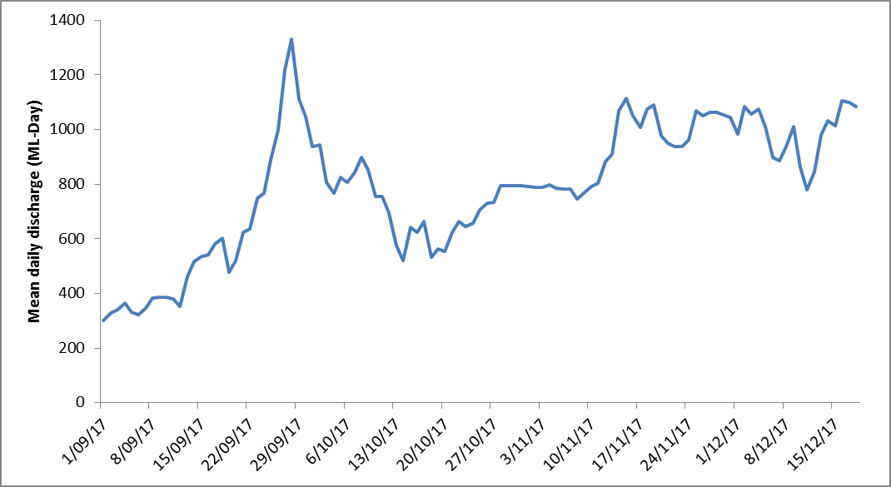
Figure 3. Flow at the gauge upstream of Willandra weir (412038).

  - Field observations
Larval fish monitoring
Fortnightly larval fish monitoring commenced on the 18th of October and the fifth and final trip was completed on the 14th of December. Currently the samples are being sorted and all larval fish removed for later identification and measurement (to be undertake in January / February 2018). Although formal identification and relative abundance estimates are not yet possible, field and laboratory observations indicate that small bodied native fish such as Australian smelt and flat-headed gudgeon (and likely carp gudgeon) were the most numerous across all trips to date. There have been a small number of Murray cod captured in the first three sampling trips (likely less than 20 for all three trips combined) and none in the fourth sampling trip. A moderate number of European carp (~50) were found in light traps at one site (Wallanthery) in the first trip, but have been largely absent from all other samples. The size of the fish being captured has generally increased each sampling trip suggesting that survival and growth is occurring.
The larval fish team had a visit from the Hillston Spectator newspaper editor who were interested in the project and its findings. An article on the larval fish component was published on the 13th December in the Hillston Spectator.
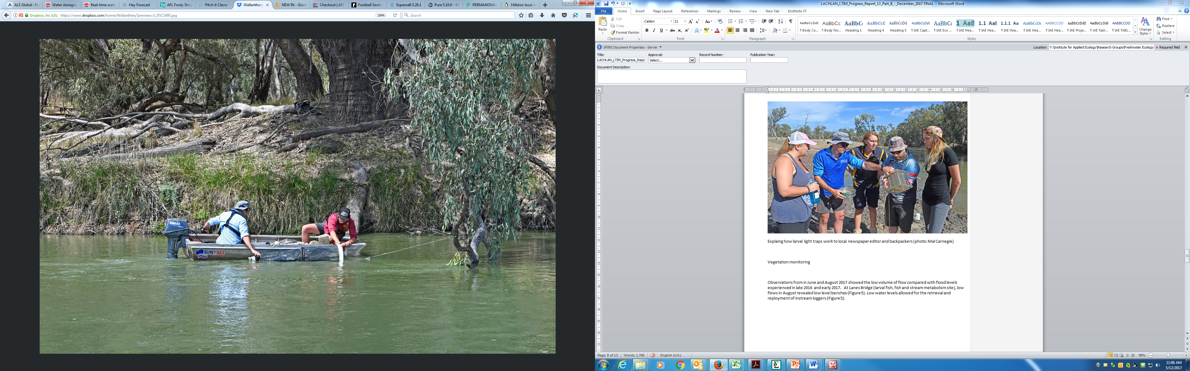
Figure 4. Deploying a larval fish drift net at Wallanthery (Photo: Mal Carnegie)

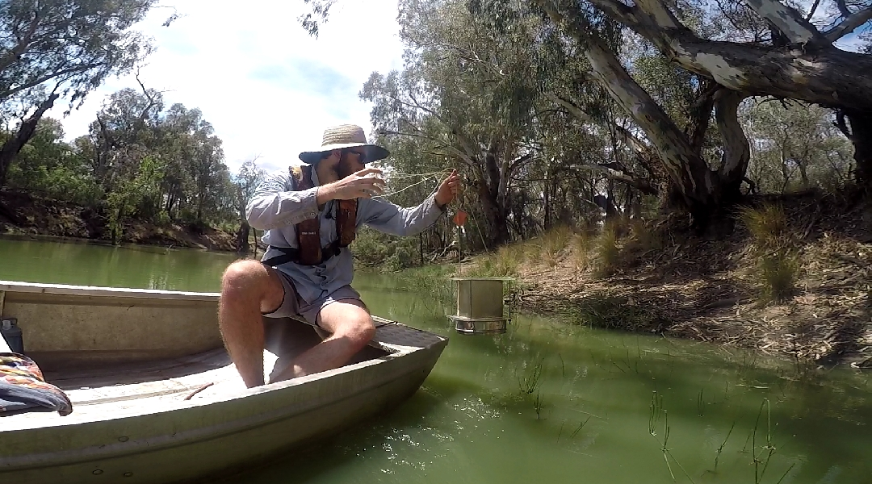
Figure 5. Deploying at light trap at Hunthawang (Photo: Ben Broadhurst)

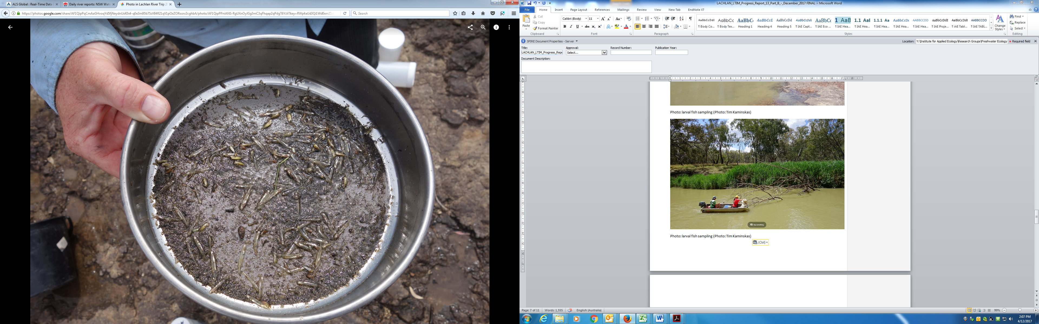
Figure 6. Light trap contents Wallanthery from sampling trip 3 (15/11/17) (Photo Tim Kaminskas)

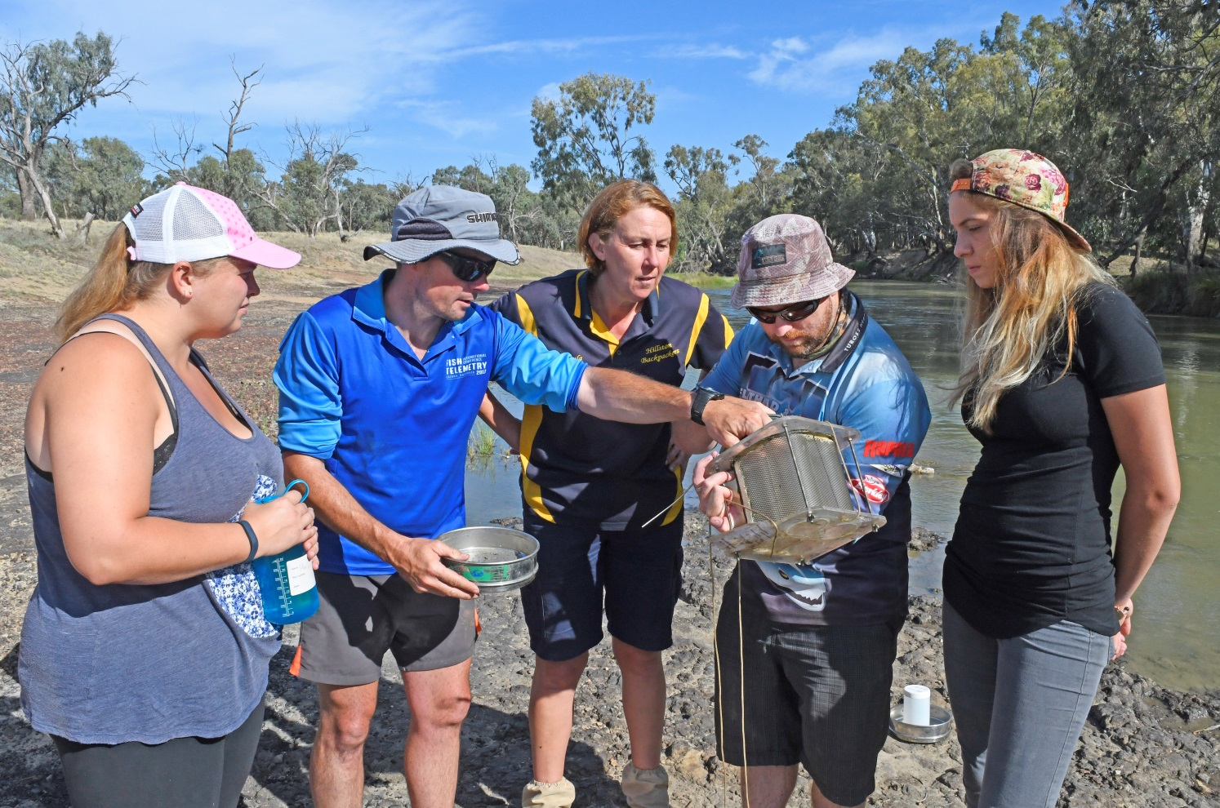
Figure 7. Explaining how larval light traps work to local newspaper editor and interested backpackers (photo: Mal Carnegie)

Vegetation monitoring
Vegetation monitoring was completed as of the 16th of December 2017. The earliest field trip undertaken at the end of September formed part of a University of Canberra field class where vegetation as well as some other indicators were measured (including reptiles and fish). All sites were completely dry, with the only water present being that at the Whealbah site where the channel contained water (though the monitored transect was dry). At Toms Lake, lignum coverage was ~75% and 55% which supported recruitment at this site (Figure 8). Moon moon was covered in Centipeda cunninghamii (Figure 9).

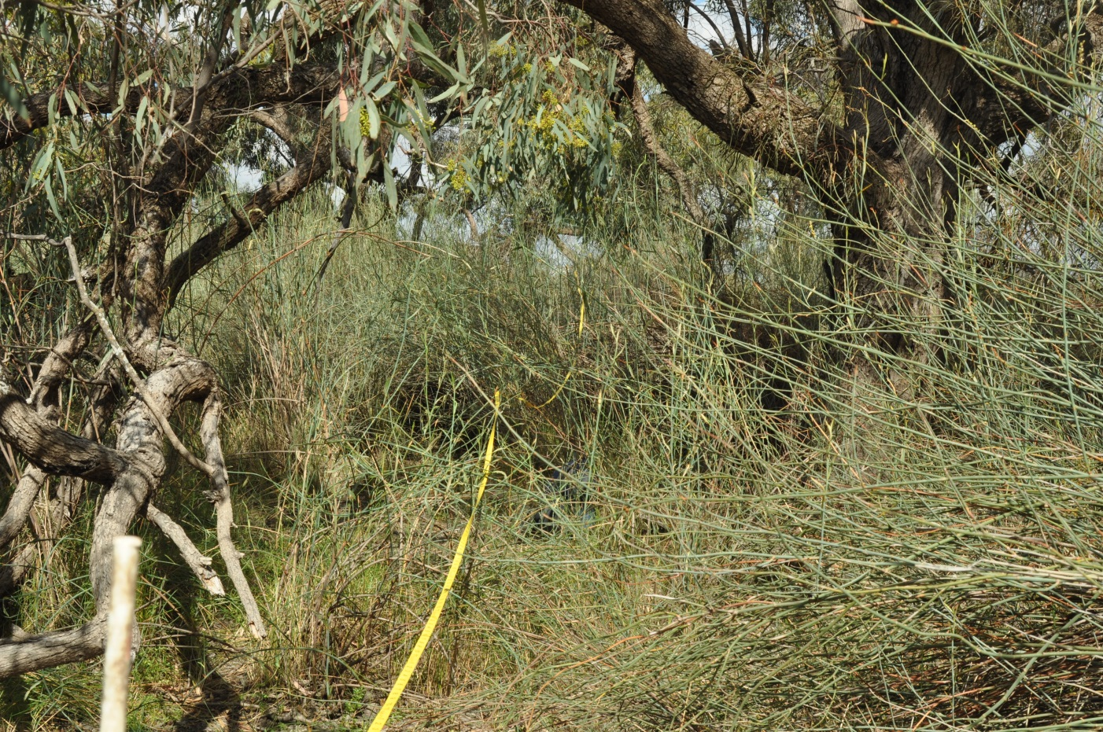
Figure 8. Lignum coverage at Toms Lake (Photo: Yasmin Cross)

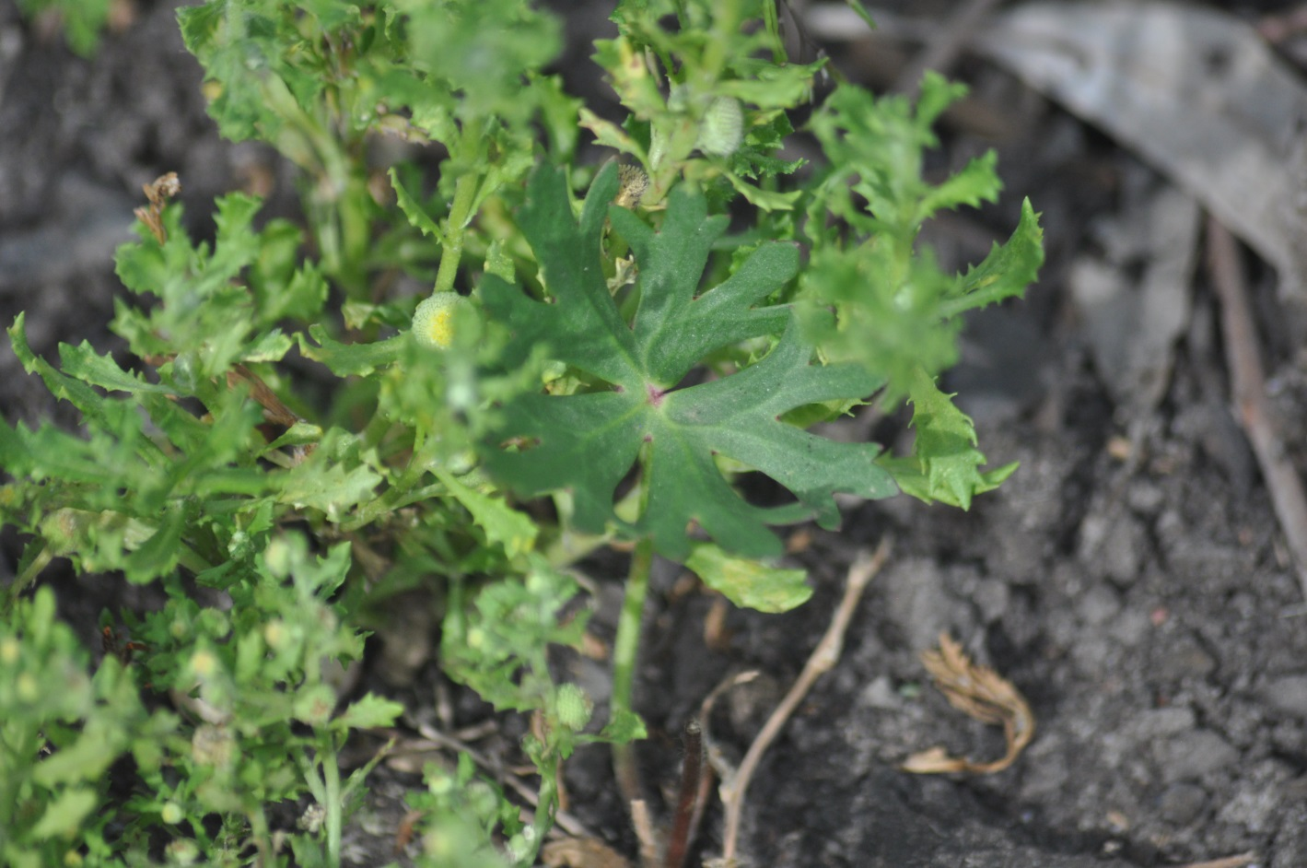
Figure 9. Centipeda cunninghamii at Moon Moon Swamp (Photo: Yasmin Cross)

Other monitoring
The larval fish team also collect benthic and pelagic microcrustaceans during each fortnightly trip. These will be stored at University of Canberra and hopefully processed by a professional practice student in the near future. Instream loggers were not able to be retrieved and downloaded during the larval fish monitoring because water levels were too high. This further justifies the decision to move away from the D-opto loggers to the miniDOT loggers as the D-opto loggers would have ran out of battery after 70 days, whilst the miniDOT will last for up to 12 months. The team is eagerly awaiting a water level drop to around 200 ML Day⁻¹ so that download and maintenance can be completed.

Appendix A: The Long-Term Intervention Monitoring Project for the Lachlan River system and its context in terms of ecological monitoring and evaluation within the Murray-Darling Basin.

The Long Term Intervention Monitoring (LTIM) Project for the Lachlan river system selected area is funded by the Commonwealth Environmental Water Office. The project is being delivered by a consortium of service providers lead by University of Canberra and includes NSW Office of Environment and Heritage, NSW Department of Primary Industries (Fisheries), NSW Department of Primary Industries (Office of Water), University of New South Wales and Charles Sturt University.
The LTIM project is based on a clear and robust program logic, as detailed in the Long-Term Intervention Monitoring Project Logic and Rationale Document. That document sets out the scientific and technical foundations of long-term intervention monitoring and is being applied to areas where LTIM projects are being undertaken. It also provides links between Basin Plan objectives and targets to the monitoring of outcomes from Commonwealth environmental watering actions. For more information, see Monitoring and evaluation for the use of Commonwealth environmental water.
Many different agencies play a role in the reporting on environmental outcomes, consistent with the Basin Plan (see figure 1 below). The Murray Darling Basin Authority is responsible for reporting on achievements against the environmental objectives of the Basin Plan at a basin-scale, which are broadly focussed on flows and water quality, fish, vegetation and birds across the whole of the Basin. State Governments are responsible for reporting on achievements against the environmental objectives of the Basin Plan at an asset-scale i.e. rivers, wetlands, floodplains. The Commonwealth Environmental Water Holder is responsible for reporting on the contribution of Commonwealth environmental water to the environmental objectives of the Basin Plan (at multiple-scales).
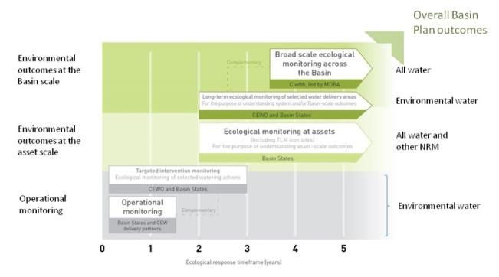
Figure 11. A summary of roles various agencies play a in the reporting on environmental outcomes, consistent with the Basin Plan.

Hydrological zones and monitoring sites of the lower Lachlan for the Long-Term Intervention Monitoring Project.
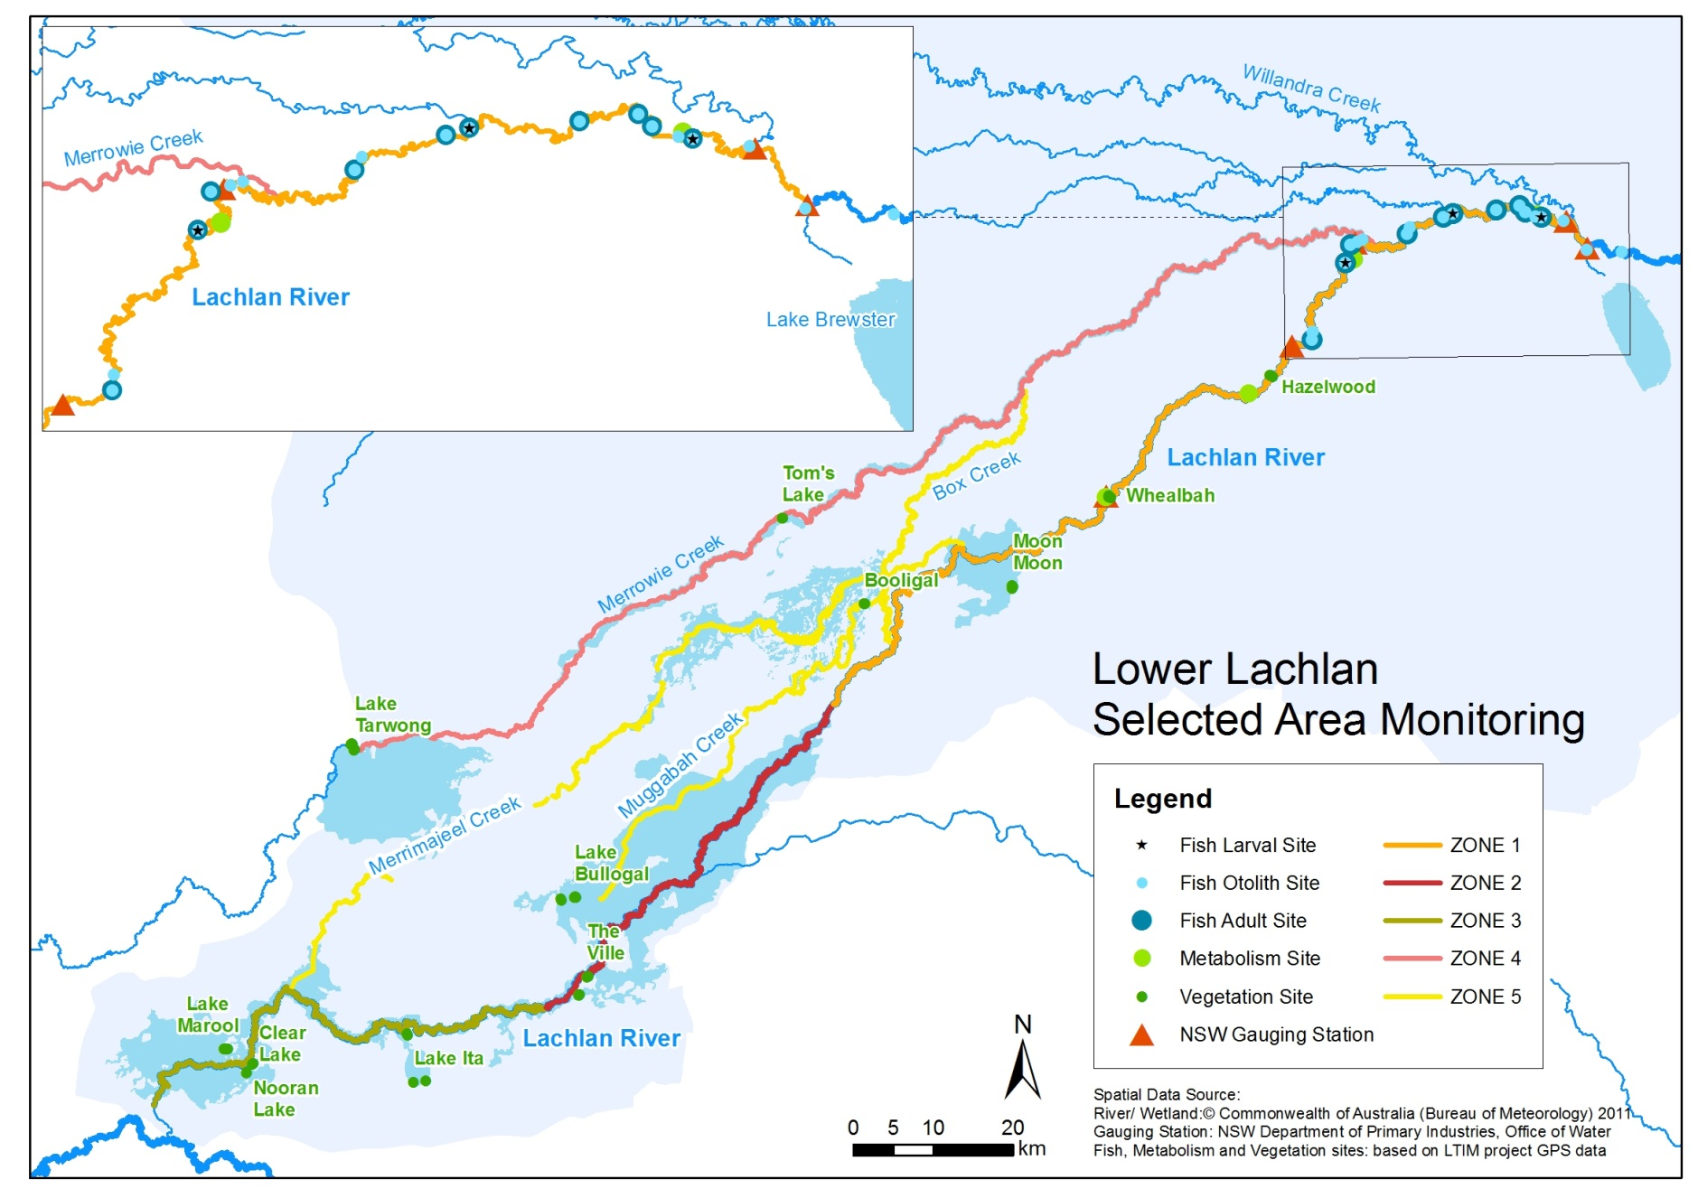
Figure 12. Lower Lachlan LTIM monitoring sites, hydrological zones and NSW gauging stations
Monitoring to be undertaken in the Lachlan system for the Long Term Intervention Monitoring Project from 2014-2019
The five year monitoring schedule has been based around the expected watering options and is focussed on the monitoring of Basin Indicators. Monitoring effort is consistent across the five years with the exception of monitoring Waterbird Breeding and Frogs which are options that can be implemented on request from the CEWO.
 | ZONE | Data contributes to the Evaluation of responses to Commonwealth environmental watering |  | monitoring frequency | sites | expected schedule
 |  | Selected Area | Whole of Basin Scale
Ecosystem type | All | ✓ | ✓ | Once only | All sites for other indicators | Establishment of ANAE type at the start of the LTIM Project. Expected August-December 2014
Riverine fish | 1 | ✓ | ✓ | ANNUAL | Basin Evaluation: 10 fixed sites within Zone 1 | Annual sampling between March and May
Larval fish | 1 | ✓ | ✓ | ANNUAL | 3 fixed riverine sites in Zone 1 | Annual sampling 5 times during breeding season (September to February)
Stream metabolism | 1 | ✓ | ✓ | CONTINUOUS  REGULAR | Four fixed sites matched to riverine fish sampling sites in Zone 1 | Continuous monitoring of dissolved oxygen and temperature.  6 weekly sampling of nutrients and water quality attributes.
Hydrology (River) | 1 | ✓ | ✓ | CONTINUOUS | Gauging sites
Vegetation diversity and condition | All | ✓ |  | ANNUAL & EVENT BASED | 12 fixed sites | Before and after watering (expected to be April/May and 3 months after first fill)
Waterbird breeding (Option) | 1 | ✓ |  | EVENT-BASED (on request from the CEWO) | One fixed site – Booligal wetland | Fortnightly surveys of bird breeding triggered by breeding events in Booligal wetland.
Frogs (Option) | All | ✓ |  | EVENT-BASED (on request from the CEWO) | 15 sites comprising 2 to 8 wetland sites and 2 to 7 riverine sites depending on watering targets | 3 sampling events between August and February (one sample in each of winter, spring and summer).
Hydrology (wetland – Option) |  | ✓ |  | EVENT-BASED (in conjunction with Waterbird Breeding or Frog monitoring) | Cameras at 6 roving wetland sites | Cameras installed prior to targeted watering each year and downloaded after the watering event has passed

