Lachlan River

Long Term Intervention Monitoring Project

Progress Report

1st January – 31st March 2018

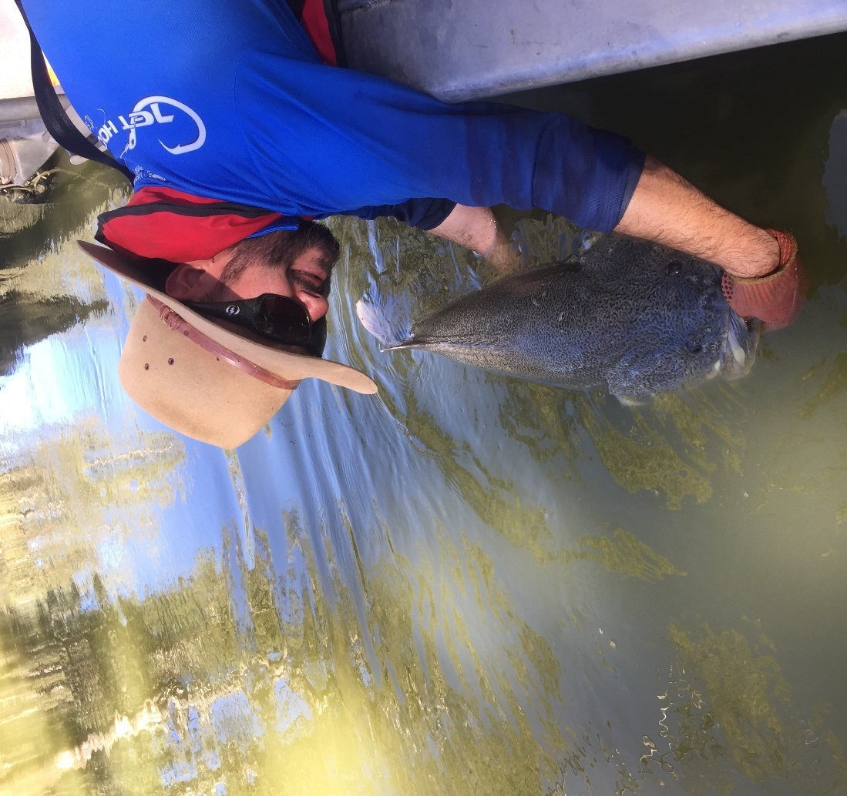

Inquiries regarding this document should be addressed to:

Dr Fiona Dyer  
Phone: 02 6201 2452  
e-mail: Fiona.Dyer@canberra.edu.au

This document was prepared by Fiona Dyer with input from Jason Thiem (NSW DPI Fisheries), Ben Broadhurst (IAE-UC), Joanne Lenehan (NSW OEH).

Cover Photo: Jason Thiem returning a Murray cod to the river during routine sampling. Photo: Martin Asmus

**Document history and status**

|  |  |  |  |  |
| --- | --- | --- | --- | --- |
| Version | Date Issued | Reviewed by | Approved by | Revision Type |
| Draft 1 | 28 March 2018 | Ben Broadhurst | Fiona Dyer | Internal |
| FINAL |  |  |  |  |

**Distribution of copies**

|  |  |  |
| --- | --- | --- |
| Version | Type | Issued to |
| FINAL | Electronic | Commonwealth Environmental Water Office |

**Copyright**© Copyright Commonwealth of Australia, 2018



‘Long term intervention monitoring project, Lachlan River system selected area, progress report’ is licensed by the Commonwealth of Australia for use under a Creative Commons By Attribution 3.0 Australia licence with the exception of the Coat of Arms of the Commonwealth of Australia, the logo of the agency responsible for publishing the report, content supplied by third parties, and any images depicting people. For licence conditions see: <http://creativecommons.org/licenses/by/3.0/au/>

**Disclaimer**

The views and opinions expressed in this publication are those of the authors and do not necessarily reflect those of the Australian Government or the Minister for the Environment and Energy. While reasonable efforts have been made to ensure that the contents of this publication are factually correct, the Commonwealth does not accept responsibility for the accuracy or completeness of the contents, and shall not be liable for any loss or damage that may be occasioned directly or indirectly through the use of, or reliance on, the contents of this publication.

1. Conditions in the Lachlan River system January – March 2018

Conditions were warm and dry in the first quarter of 2018, with only 27.8 mm of rain recorded at Hillston. Rainfall was particularly low in February and March (Figure 1). The total rainfall for January to March 2018 was approximately half of the long term median[1] rainfall (49.8 mm) and one third of the long term average (91.6 mm). Average daily maximum temperatures were 2-4 degrees warmer than the long term averages (Figure 2) and average daily minimum temperatures were just slightly warmer than the long term average (Figure 2).

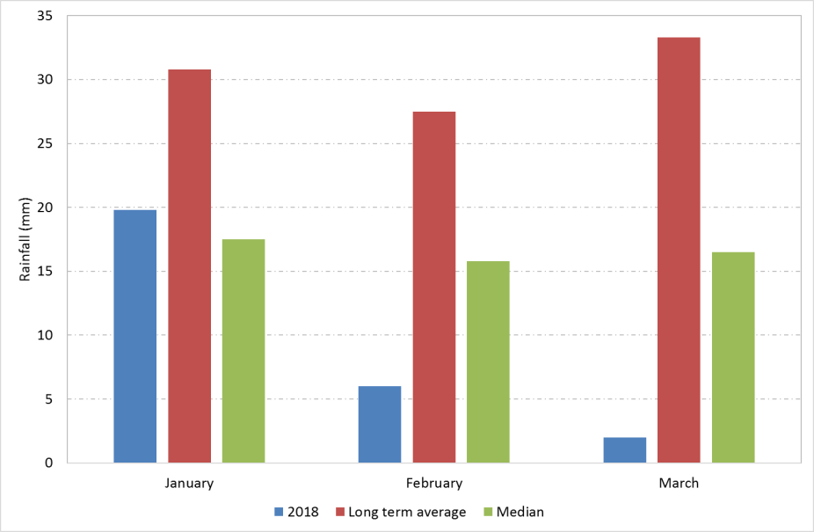

Figure . Rainfall at Hillston (075032) in the Lower Lachlan River Catchment in January to March 2018 compared with the long term average monthly rainfall and the long term median monthly rainfall. Data from the Bureau of Meteorology.

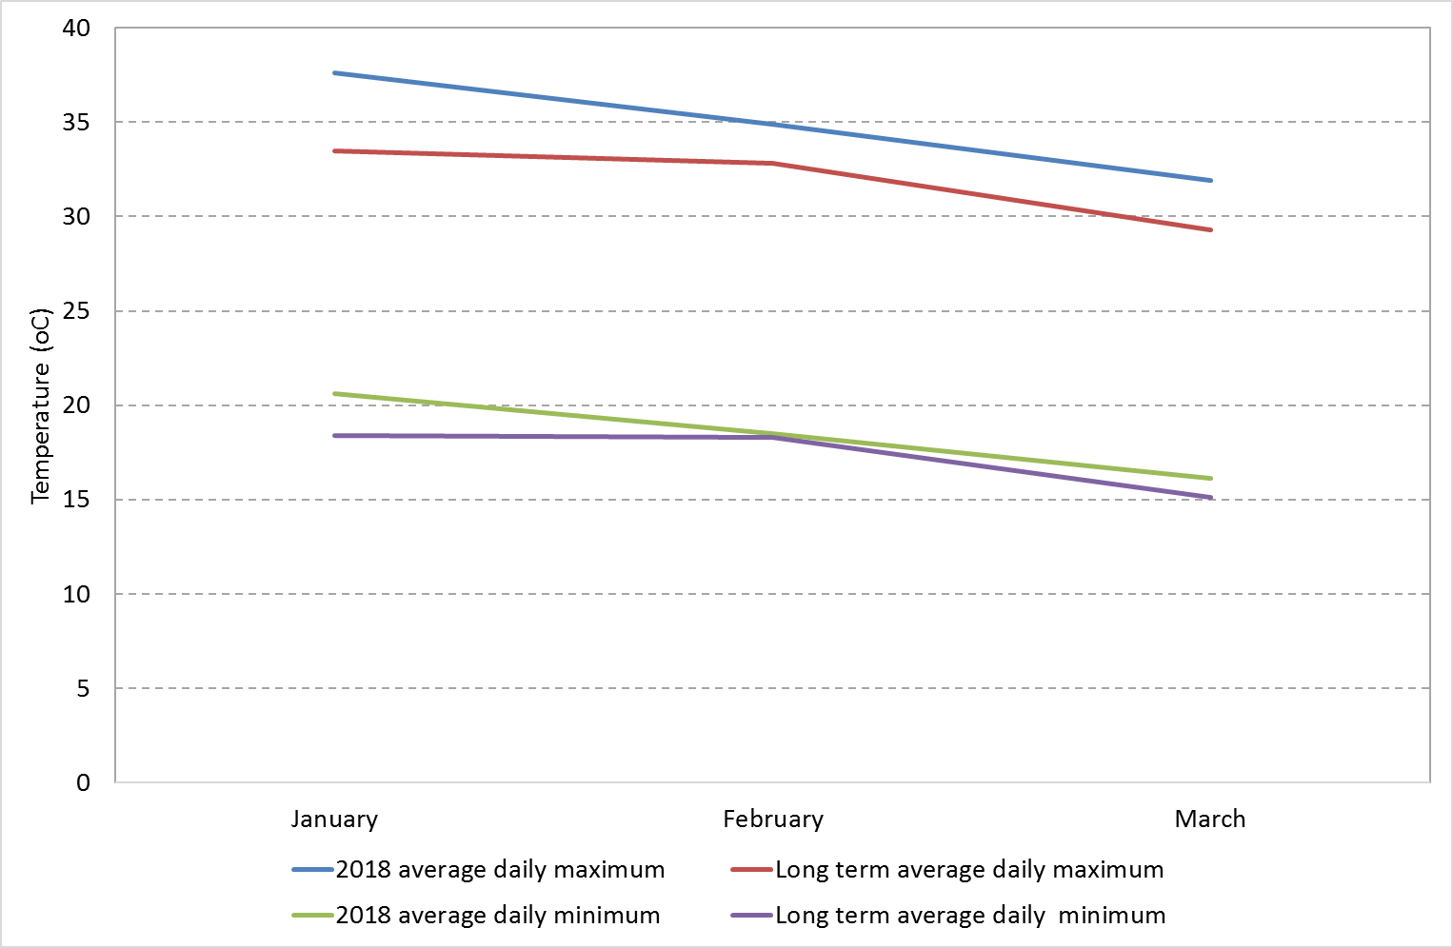

Figure . Maximum and minimum temperatures for the first quarter of 2018 at Hillston in the Lachlan River catchment comparing 2018 average daily temperatures with the long term average daily temperatures. Data from the Bureau of Meteorology.

1. Summary on progress against core monitoring and evaluation activities

|  |  |  |
| --- | --- | --- |
| ACTIVITIES | PROGRESS TO DATE | UPCOMING ACTIVITIES |
| *Monitoring activities* | | |
| Ecosystem type | * Data collection complete and suggested Australian National Aquatic Ecosystems (ANAE) types for all sites included in the Monitoring and Data Management System (MDMS). | * No more data collection required |
| Fish (river) | * 2017-18 fish sampling completed | * Data analysis and reporting |
| Fish (larvae) | * 2017-18 larval fish sampling completed | * Data analysis and reporting |
| Waterbird breeding (optional) | * Unlikely to be undertaken in 2017-18 | * None |
| Water quality and stream metabolism | * Logger data downloaded | * Checking, calibrating and downloading logger data. This will occur again in May in association with the vegetation sampling |
| Vegetation diversity | * Spring vegetation sampling completed | * Autumn vegetation sampling to commence in May |
| Frogs (optional) | * Unlikely to be undertaken in 2017-18 | * None |
| *Evaluation activities* | | |
| Monitoring data entry | * Data entry continuing | * Data entry continuing |
| *Communication and engagement* | | |
| Selected Area Working Group (EWAG and TAG meetings) | * Attended fish TAG meeting and sent information to the February Lachlan EWAG meeting | * Quarter 2 EWAG meeting |
| Project team teleconference | * None | * Project team meeting prior to annual report commencement |
| Other Stakeholder Engagement | * Presentations to Central Tablelands LLS, mid Lachlan Landcare, Lachlan EWAG and Fish flows TAG. * A draft report provided to the Booligal landholders who assisted with the bird breeding event | * To be developed in consultation with CEWO |

**Note:** for the Long-Term Intervention Monitoring (LTIM) Project, Lachlan River system selected area:

* **Appendix A** provides a summary of monitoring to be undertaken under the project from 2014-2019.

1. Observations
   1. Hydrology

Flow in the Lachlan River downstream of Willandra weir remained relatively high until the start of March as the demand for irrigation water remained high throughout the catchment. Flows dropped rapidly in late February when irrigation orders ceased and flows from Wyangala dam stopped (Figure 3).

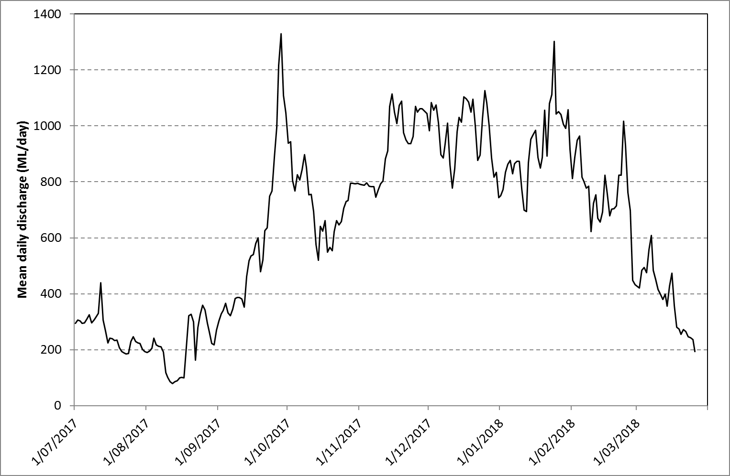

Figure 3. Flow at the gauge upstream of Willandra weir (412038).

Commonwealth environmental water targeted outcomes for native fish in the Lachlan River upstream of the LTIM sites. Those upstream sites, and the outcomes achieved from watering those sites, are not in scope for this LTIM project. Hence no observations from those upstream sites are included in this report.

The 2017-18 watering actions targeting native fish outcomes commenced with releases from Wyangala dam on 23 September 2017 and concluded with the commencement of Environmental Contingency Allowance releases on 13 November 2017. The watering actions were designed to generate opportunities for native fish larvae to disperse (a dispersal pulse) and to support this WaterNSW altered the operation of Jemalong weir gates during the dispersal pulse to create a wider opening to reduce stress on larvae in the water column. Environmental water was ordered for delivery to two accounting points to create the desired flow regime for native fish – one at Forbes and one at Hillston. Water from the Forbes environmental water order that was not required to meet the order at Hillston was reregulated into the Brewster outflow wetland. Between 27 November and 7 December 2017 the Booberoi regulator was opened to allow a proportion of the dispersal pulse to increase flows into Booberoi Creek. Planned actions for native fish in autumn were not progressed as the demand was met through operational delivery.

* 1. Field observations

*Adult fish monitoring*

Adult fish sampling is carried out in Autumn at 10 sites between Wallanthery and Hillston. We use several methods to sample fish, including boat-electrofishing, bait traps (unbaited), small and large fyke nets. The range of equipment used means that we capture as many species as possible and each site is sampled once during the field program. Each fish caught is identified, weighed and the length measured, before the fish is returned to the river.

In 2018, the adult fish sampling was undertaken in March. While the data are yet to be processed and checked, observations were that the usual suite of native fish (Murray cod, golden perch, bony herring etc) were caught in the sampling. Both adult and juvenile Murray cod were captured, including a number of large adult Murray cod (Figure 3). No freshwater catfish were caught in the sampling. Some juvenile carp were caught but in lower abundance compared with the 2017 monitoring.

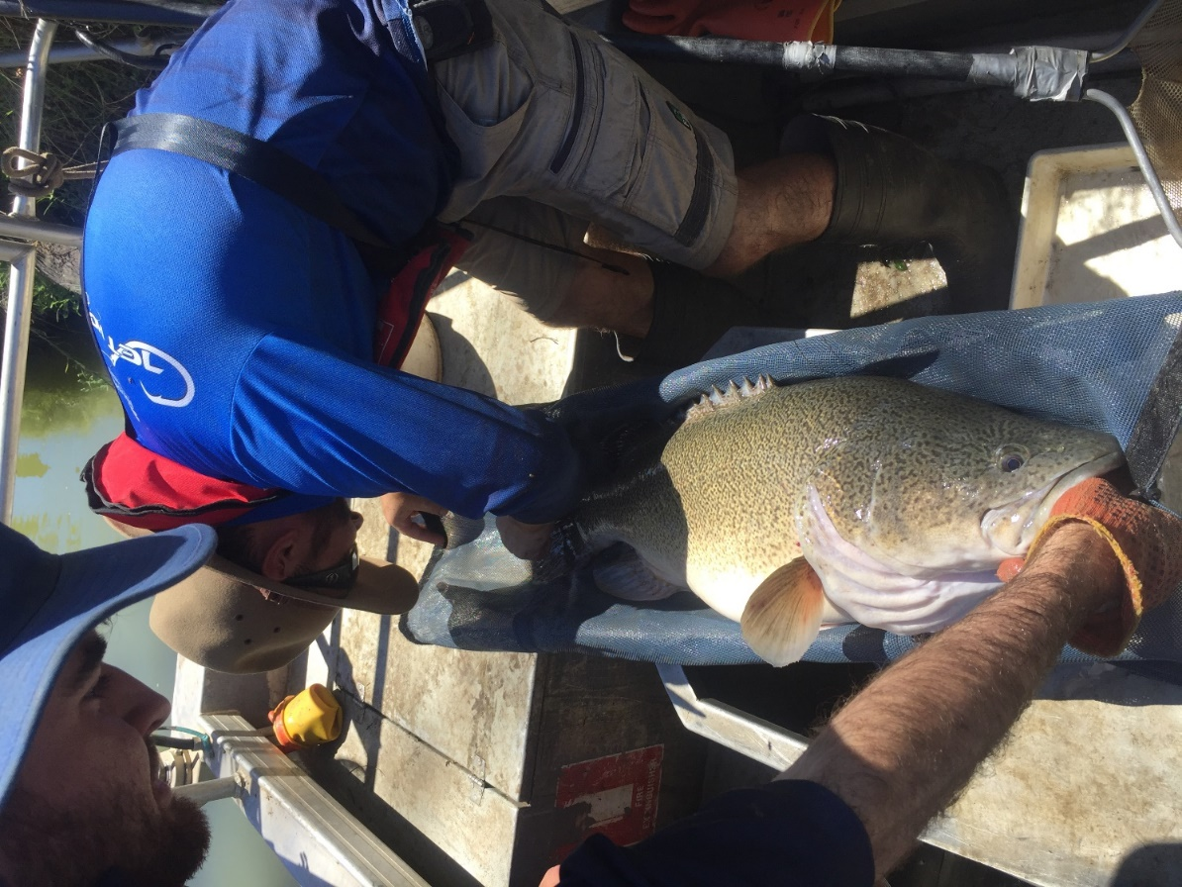

Figure 3. Measuring adult Murray cod during fish sampling (Photo: Martin Asmus)

*Larval fish monitoring*

Laboratory processing of the larval fish samples has been undertaken in February and March. Processing involves identifying the larval fish to species and measuring the length of each larval fish caught. The length of the larval fish gives us an estimate of the relative age of the larvae, i.e. larger larvae are likely to be older than smaller larvae.

The larval fish captured in spring - early summer 2017, were mainly Australian smelt. Flat headed gudgeon were the next most numerous native fish larvae. Small numbers of larval Murray cod were captured in October and while we are yet to analyse the data, the size variation of the larval Murray cod suggests that spawning may have occurred from October through into November. Carp larvae were caught again this year, but substantially fewer than in 2016 and low numbers of gambusia were captured.

*Vegetation monitoring*

The samples collected in Spring 2017 have been processed with some of the more tricky samples identified by the National Herbarium. Planning has commenced for Autumn vegetation monitoring with field visits likely to occur during May.

*Dissolved oxygen loggers.*

Instream loggers were retrieved and downloaded in early March when the water levels dropped below 200 ML Day-1. Data are currently being processed.

* 1. Communication and Engagement activities

LTIM-related communication products were circulated through extensive community and government networks during the first quarter of 2018. These included:

* Community Update #1 and #2: In response to community requests for information, the Office of Environment and Heritage (OEH) circulates a monthly update via community contacts and networks. The update focuses on recent environmental watering actions and outcomes, and also includes reference to LTIM related activities and reports.
* Short technical piece highlighting the successful use of NSW and Commonwealth for establishing and growing aquatic plants in Lake Brewster outflow wetlands, subsequently leading to improved water quality (reduced blue green algal blooms, turbidity and increased availability of oxygen in the water column).

In addition, the Lachlan LTIM Communications and Engagement officer provided presentations on LTIM and environmental water management at the following events:

* Central Tablelands Local Land Services Board and Staff Annual Team Meeting, December 2017.
* Mid Lachlan Landcare Education Seminar where discussed options for utilising more local research, data and case studies (e.g. LTIM Lachlan River and wetlands reports and Lake Brewster ABC Open vodcast <https://www.facebook.com/abcopen/videos/1559277950759050/>
* Lachlan Environmental Water Advisory Group (EWAG) and Fish Flows Technical Advisory Group (TAG) also met during this period, and key outcomes and learnings from the [2016-17 Monitoring and Evaluation Report: Lachlan River System](http://www.environment.gov.au/water/cewo/publications/ltim-lachlan-annual-report-2016-17) were summarised and discussed, and will inform future decision making around if there is a need for autumn fish flows. http://www.environment.gov.au/water/cewo/publications/ltim-lachlan-annual-report-2016-17
* Provided Draft Colonial Waterbird Breeding Events (2016–2017) Report to Booligal landholders who assisted environmental water managers to support the bird breeding event, and several bird field guides or books to Booligal children and landholders.

Appendix A: The Long-Term Intervention Monitoring Project for the Lachlan River system and its context in terms of ecological monitoring and evaluation within the Murray-Darling Basin.

The Long Term Intervention Monitoring (LTIM) Project for the Lachlan river system selected area is funded by the Commonwealth Environmental Water Office. The project is being delivered by a consortium of service providers lead by University of Canberra and includes NSW Office of Environment and Heritage, NSW Department of Primary Industries (Fisheries), NSW Department of Primary Industries (Office of Water), University of New South Wales and Charles Sturt University.

The LTIM project is based on a clear and robust program logic, as detailed in the [Long-Term Intervention Monitoring Project Logic and Rationale Document](http://www.environment.gov.au/water/cewo/publications/long-term-intervention-monitoring-project-logic-and-rationale-document). That document sets out the scientific and technical foundations of long-term intervention monitoring and is being applied to areas where LTIM projects are being undertaken. It also provides links between Basin Plan objectives and targets to the monitoring of outcomes from Commonwealth environmental watering actions. For more information, see [Monitoring and evaluation for the use of Commonwealth environmental water](http://www.environment.gov.au/topics/water/commonwealth-environmental-water-office/monitoring-and-evaluation).

Many different agencies play a role in the reporting on environmental outcomes, consistent with the Basin Plan (see figure 1 below). The Murray Darling Basin Authority is responsible for reporting on achievements against the environmental objectives of the Basin Plan at a basin-scale, which are broadly focussed on flows and water quality, fish, vegetation and birds across the whole of the Basin. State Governments are responsible for reporting on achievements against the environmental objectives of the Basin Plan at an asset-scale i.e. rivers, wetlands, floodplains. The Commonwealth Environmental Water Holder is responsible for reporting on the contribution of Commonwealth environmental water to the environmental objectives of the Basin Plan (at multiple-scales).

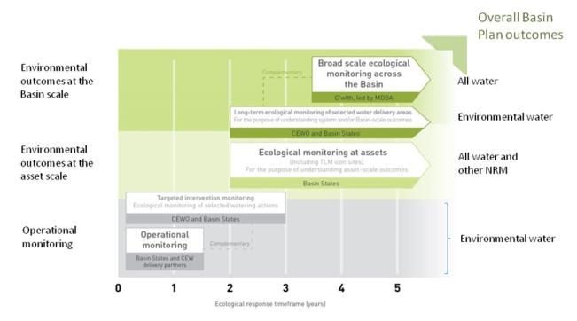

Figure 11. A summary of roles various agencies play a in the reporting on environmental outcomes, consistent with the Basin Plan.

Hydrological zones and monitoring sites of the lower Lachlan for the Long-Term Intervention Monitoring Project.

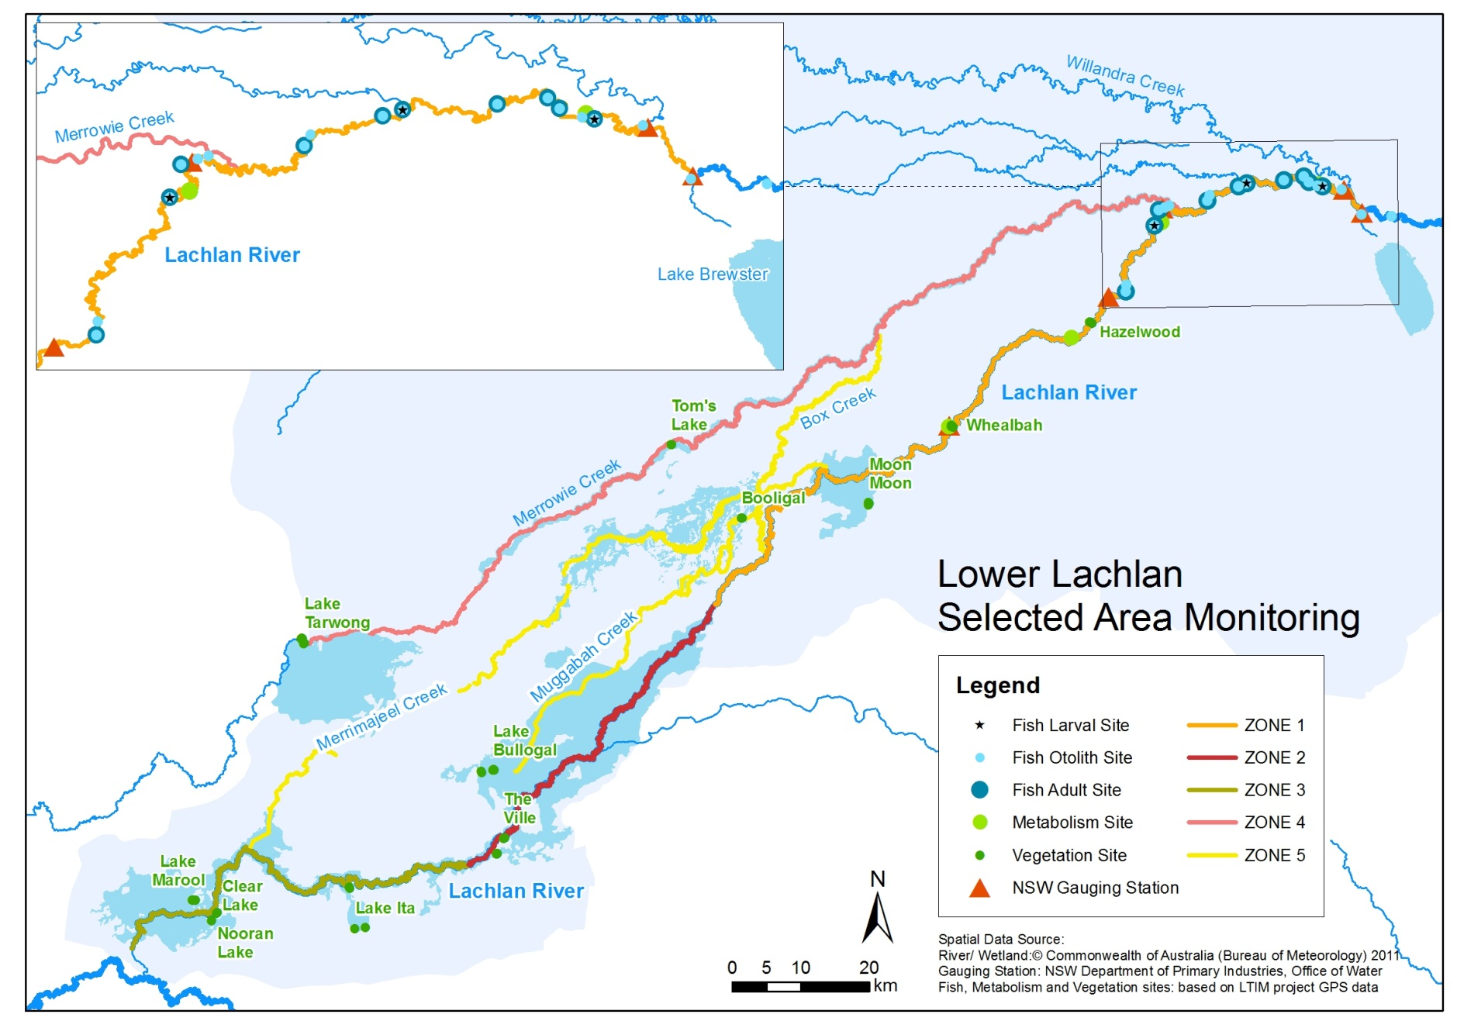

*Figure 12. Lower Lachlan LTIM monitoring sites, hydrological zones and NSW gauging stations*

Monitoring to be undertaken in the Lachlan system for the Long Term Intervention Monitoring Project from 2014-2019

The five year monitoring schedule has been based around the expected watering options and is focussed on the monitoring of Basin Indicators. Monitoring effort is consistent across the five years with the exception of monitoring Waterbird Breeding and Frogs which are options that can be implemented on request from the CEWO.

|  | ZONE | Data contributes to the Evaluation of responses to Commonwealth environmental watering | | monitoring frequency | sites | expected schedule |
| --- | --- | --- | --- | --- | --- | --- |
|  |  | Selected Area | Whole of Basin Scale |  |  |  |
| Ecosystem type | All | ✓ | ✓ | Once only | All sites for other indicators | Establishment of ANAE type at the start of the LTIM Project. Expected August-December 2014 |
| Riverine fish | 1 | ✓ | ✓ | ANNUAL | Basin Evaluation: 10 fixed sites within Zone 1 | Annual sampling between March and May |
| Larval fish | 1 | ✓ | ✓ | ANNUAL | 3 fixed riverine sites in Zone 1 | Annual sampling 5 times during breeding season (September to February) |
| Stream metabolism | 1 | ✓ | ✓ | CONTINUOUS  REGULAR | Four fixed sites matched to riverine fish sampling sites in Zone 1 | Continuous monitoring of dissolved oxygen and temperature.  6 weekly sampling of nutrients and water quality attributes. |
| Hydrology (River) | 1 | ✓ | ✓ | CONTINUOUS | Gauging sites |  |
| Vegetation diversity and condition | All | ✓ |  | ANNUAL & EVENT BASED | 12 fixed sites | Before and after watering (expected to be April/May and 3 months after first fill) |
| Waterbird breeding (Option) | 1 | ✓ |  | EVENT-BASED (on request from the CEWO) | One fixed site – Booligal wetland | Fortnightly surveys of bird breeding triggered by breeding events in Booligal wetland. |
| Frogs (Option) | All | ✓ |  | EVENT-BASED (on request from the CEWO) | 15 sites comprising 2 to 8 wetland sites and 2 to 7 riverine sites depending on watering targets | 3 sampling events between August and February (one sample in each of winter, spring and summer). |
| Hydrology (wetland – Option) |  | ✓ |  | EVENT-BASED (in conjunction with Waterbird Breeding or Frog monitoring) | Cameras at 6 roving wetland sites | Cameras installed prior to targeted watering each year and downloaded after the watering event has passed |

1. Median rainfall is the mid-point of all observed rainfall records when they are sorted in order of magnitude. The median is the preferred measure of 'typical' rainfall from a meteorological point of view. This is because of the high variability of rainfall; one extreme rainfall event will have less effect on the median than it will have on the arithmetic mean.