Lachlan River
Long Term Intervention Monitoring Project
Progress Report
1st of April – 30th June 2019

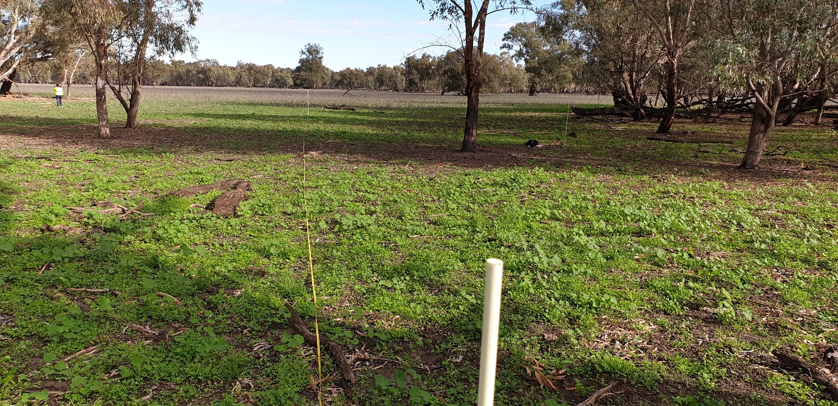

Inquiries regarding this document should be addressed to:
Dr Fiona Dyer
Phone: 02 6201 2452
e-mail: Fiona.Dyer@canberra.edu.au

This document was prepared by Fiona Dyer, Ben Broadhurst, Rheyda Ma Hinlo, Alica Tschierschke (IAE-UC), Will Higgisson (IAE UC), Jason Thiem (DPI Fisheries) and Joanne Lenehan (NSW OEH).
Cover Photo: Vegetation monitoring of Moon Moon Swamp taken following rainfall in June 2019 (Photo: Kyle McGrath).
Document history and status
Version | Date Issued | Reviewed by | Approved by | Revision Type
Draft 1 | 28/06/2019 | Ben Broadhurst | Fiona Dyer | Draft
FINAL | 08/08/2019 | CEWO | Fiona Dyer | FINAL

Distribution of copies
Version | Type | Issued to
FINAL | Electronic | Commonwealth Environmental Water Office

Copyright
© Copyright Commonwealth of Australia, 2019

‘Long term intervention monitoring project, Lachlan River system selected area, progress report’ is licensed by the Commonwealth of Australia for use under a Creative Commons By Attribution 3.0 Australia licence with the exception of the Coat of Arms of the Commonwealth of Australia, the logo of the agency responsible for publishing the report, content supplied by third parties, and any images depicting people. For licence conditions see: http://creativecommons.org/licenses/by/3.0/au/
Disclaimer
The views and opinions expressed in this publication are those of the authors and do not necessarily reflect those of the Australian Government or the Minister for the Environment and Energy. While reasonable efforts have been made to ensure that the contents of this publication are factually correct, the Commonwealth does not accept responsibility for the accuracy or completeness of the contents, and shall not be liable for any loss or damage that may be occasioned directly or indirectly through the use of, or reliance on, the contents of this publication.

- Conditions in the Lachlan River system April to June 2019
Conditions remained warm, but wetter across the catchment in the second quarter of 2019. Rainfall was above average in April and May 2019 (Figure 1), and for June up to 24th it was below average. The total rainfall accumulated for the period up to 19th of June is 94 mm, the same amount as the long-term average of 94.4 mm. With 70.5 mm as long term median rainfall, the 2019 rainfall for this period is above this. The 123.1 mm annual total until May, is already three times higher than last years value (39 mm), but similar to 2017, 2015 and 2014 (2016: 201.7 mm). In all 3 months the majority of the rainfall fell more or less in one big event; 39 mm on the 22nd April, 20.6 on the 3rd of May and 11.2 on the 13th of June.
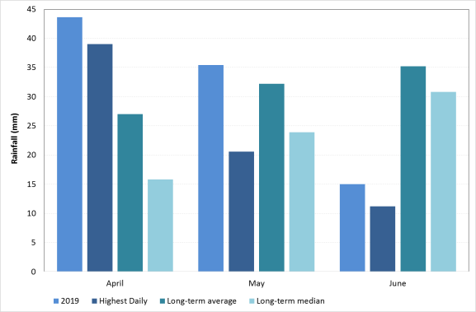
Figure 1. Rainfall at Hillston (075032) in the Lower Lachlan River Catchment for the second quarter of 2019 compared with the long term average monthly rainfall and the long term median monthly rainfall. Data from the Bureau of Meteorology.

Overall for this period monthly average daily maximum and minimum temperatures at Hillston were above average. Particularly April was warm, with an average temperature of 27 degrees which is 2.6 degrees warmer than the long term average (Figure 2). These daytime temperatures in April were accompanied by correspondingly higher minimums, with an average minimum temperature of 10.6 degrees (1.7 above average). June minimum temperatures are below average.
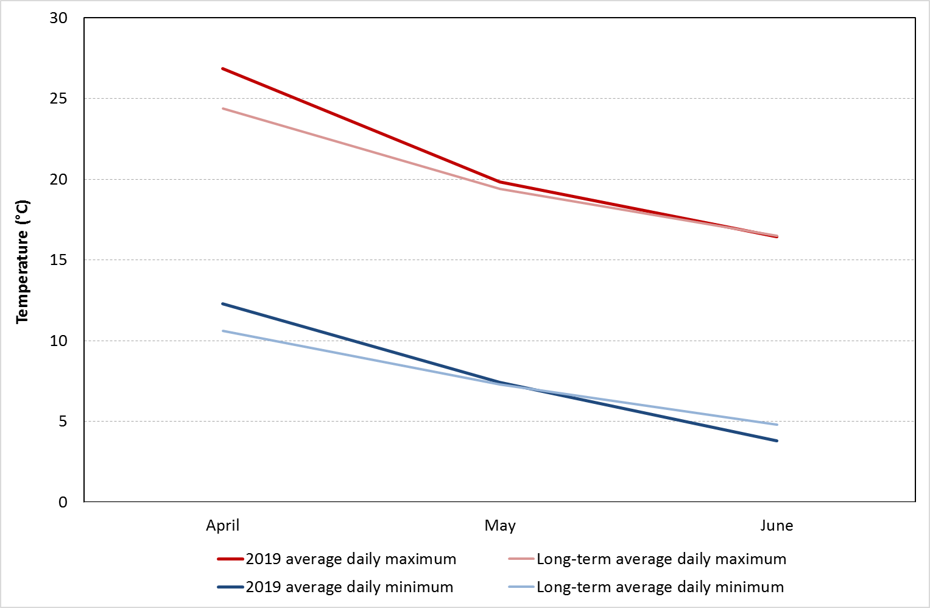
Figure 2. Average maximum and minimum temperatures for the second quarter of 2019 at Hillston (075032) in the Lachlan River Catchment compared with the long term average daily temperatures. Data from the Bureau of Meteorology.

- Summary on progress against core monitoring and evaluation activities

ACTIVITIES | PROGRESS TO DATE | UPCOMING ACTIVITIES
Monitoring activities
Ecosystem type | - Data collection complete and suggested Australian National Aquatic Ecosystems (ANAE) types for all sites included in the Monitoring and Data Management System (MDMS). | - Assign ANAE types for mid Lachlan sampling sites
Fish (river) | - 2018-9 fish sampling in the lower and mid Lachlan completed | - Data analysis and reporting
Fish (larvae) | - 2018-9 larval fish fish sampling completed | - Data analysis and reporting
eDNA | - All sampling completed | - Data processing, analysis and reporting
Waterbird breeding (optional) | - None | - None
Water quality and stream metabolism | - None | - Data analysis and reporting
Vegetation diversity | - 2019 Autumn vegetation surveys completed | - Data analysis and reporting
Frogs (optional) | - None | - None
Evaluation activities
Monitoring data entry | - Data entry continuing | - 2018-19 Data upload to commence
Communication and engagement
Selected Area Working Group (EWAG and TAG meetings) | - None | - EWAG meeting planned for August
Project team teleconference | - None | - None
Other Stakeholder Engagement | - Murrin Bridge Workshop | - As opportunities arise

Note: for the Long-Term Intervention Monitoring (LTIM) Project, Lachlan River system selected area:
- Appendix A provides a summary of monitoring to be undertaken under the project from 2014-2019.

- Observations
  - Hydrology
Flows in the mid-Lachlan River (Cottons Weir and the lower Lachlan River (Willandra weir) during April and June (19th)) ranged from 437 to 1616 ML/day (Figure 3) and 65 to 1210 ML/day (Figure 4), respectively. Flows were generally low throughout April and June as orders for irrigation have subsided as the weather cooled, with the exception of two flow pulses. A Commonwealth watering action targeting the Lower Lachlan to the Great Cumbung Swamp commenced with increasing flows out of Brewster in late May 2019. Flows at Booligal achieved a peak of 550 ML/day on 17-18 June, with this maximum reducing over the next 10 days back to normal operational flows of around 30 ML/day (Figure 5). This watering action required nearly 5,500 ML to complete with water from Wyangala Dam supplementing releases from Lake Cargelligo and Lake Brewster weir. This watering action follows on from an earlier non-CEW flow pulse which passed Booligal approximately 45 days prior to the CEW flow pulse.
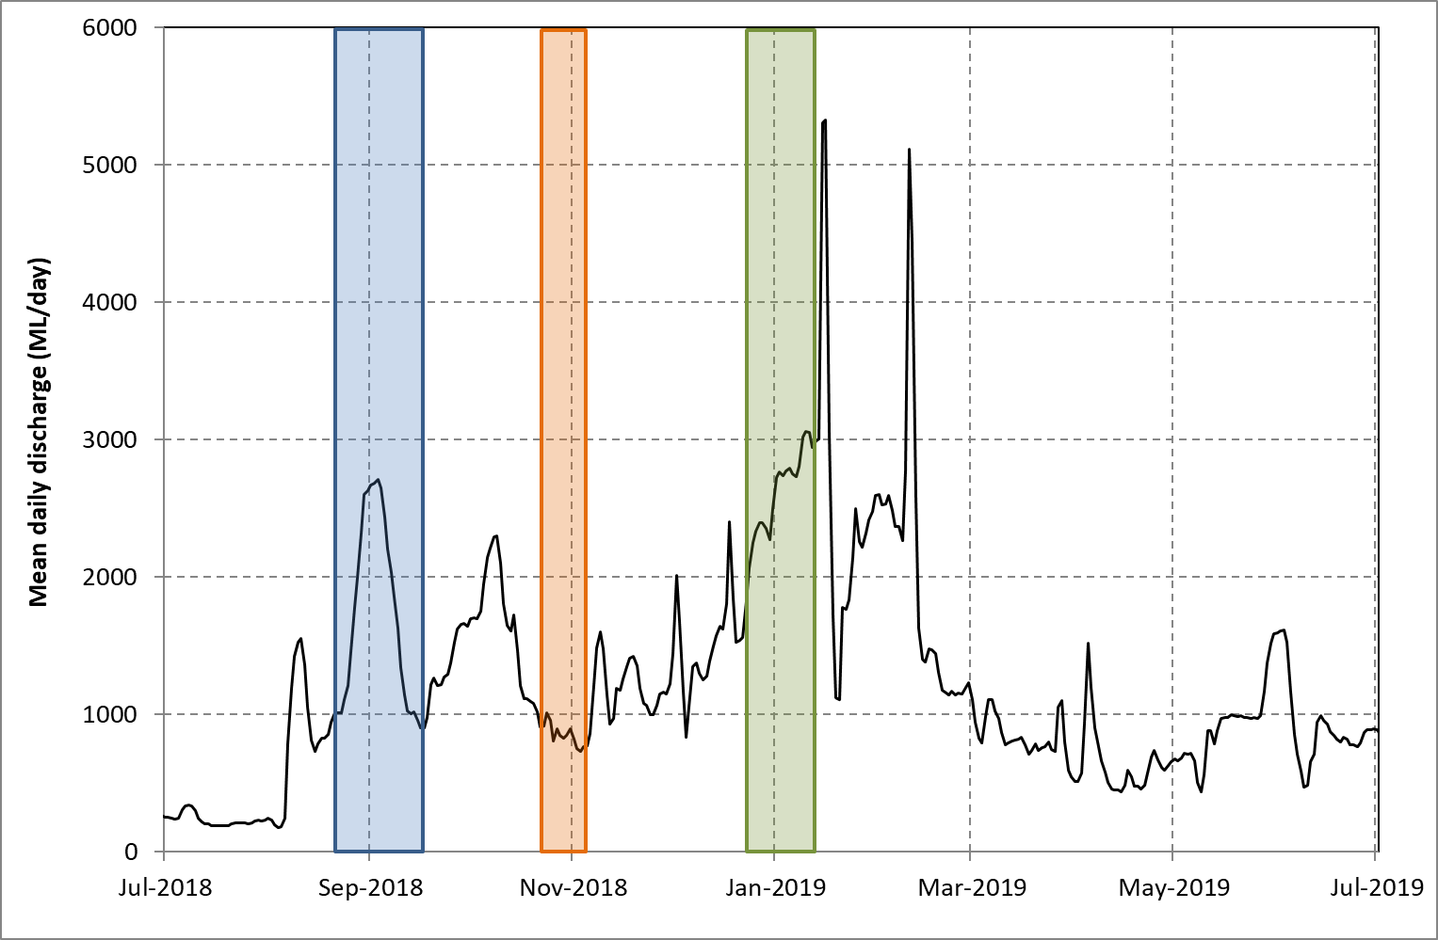
Figure 3. Flow in the Lachlan River recorded at the gauge at Cottons weir near Forbes (412004). Data from WaterNSW (http://waterinfo.nsw.gov.au/). The shaded regions show the timing of the use of Commonwealth and NSW environmental water: blue shows the spring pulse (Commonwealth environmental water), orange shows the use of water during the period (shown by the orange line) in which management of water levels aimed to support fish breeding (Commonwealth environmental water) and the green shows the protection of tributary flows to provide a small flow pulse (NSW Environmental water allowance).
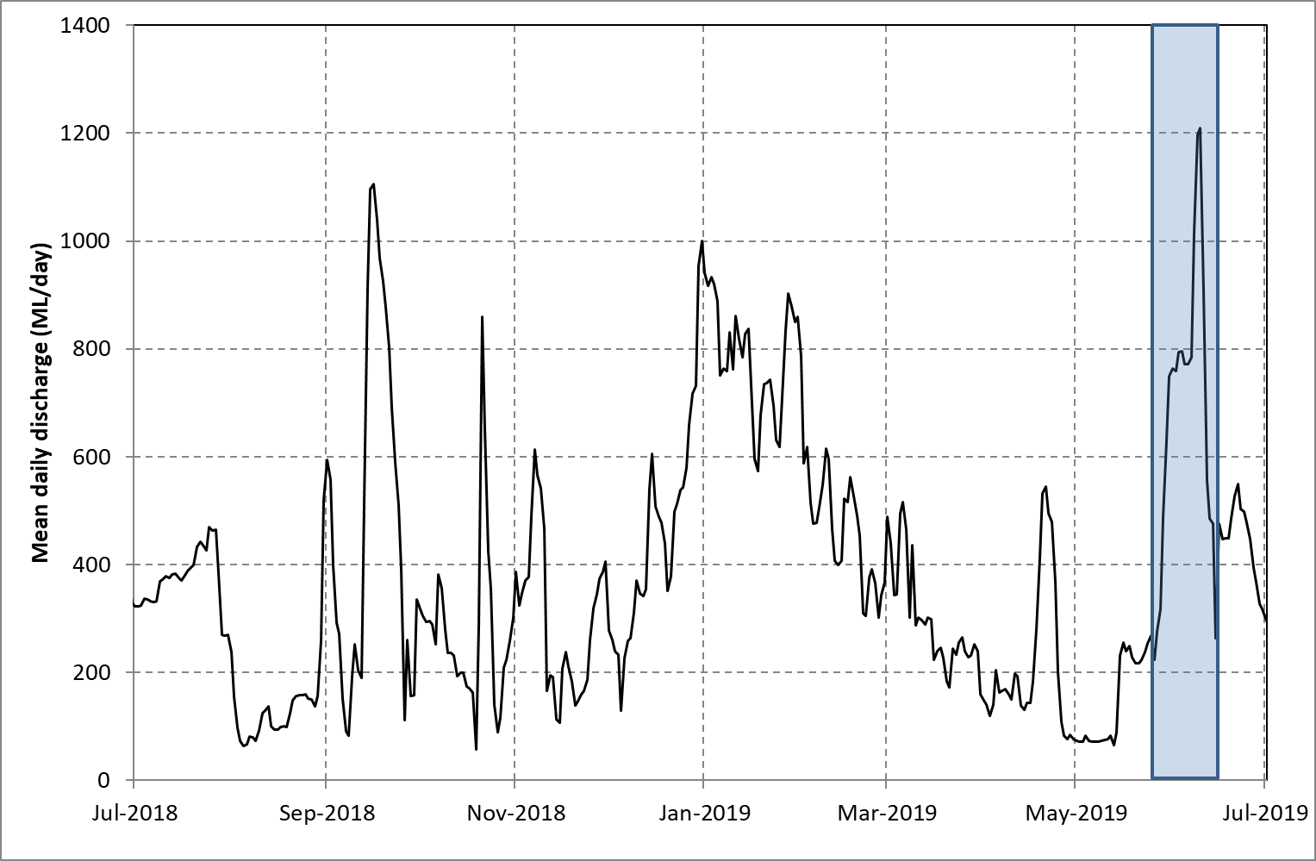
Figure 4. Flow in the Lachlan River recorded at the gauge upstream of Willandra weir (412038). Data from WaterNSW (http://waterinfo.nsw.gov.au/). The shaded region shows the release of water for the June Commonwealth pulse targeted the Lower Lachlan to the Great Cumbung Swamp. Note: this pulse also included stock and domestic replenishment flow.

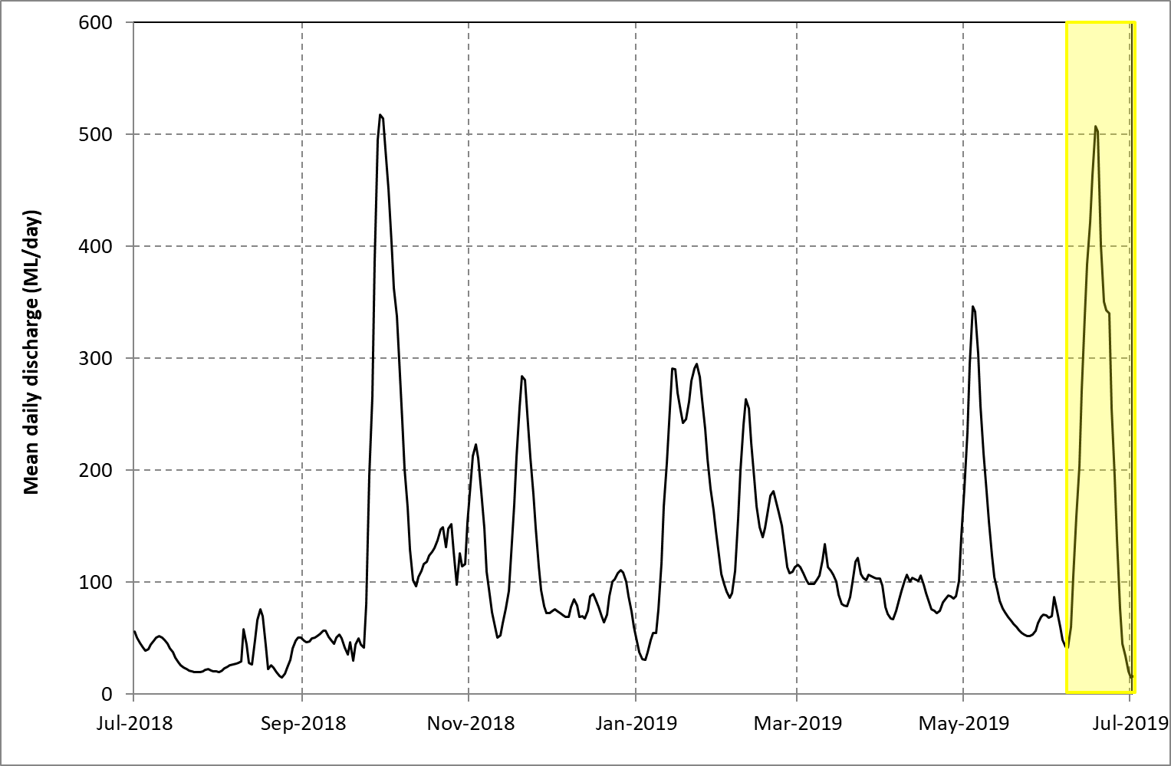
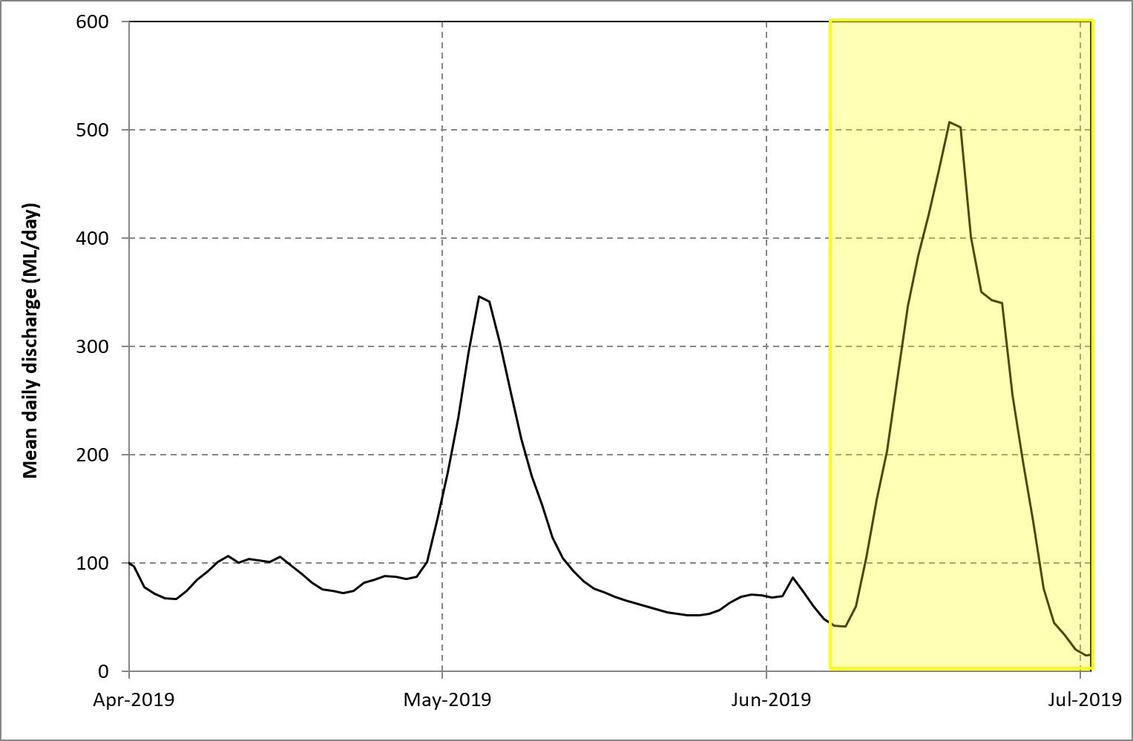
Figure 5. Flow in the Lachlan River recorded at Booligal (412005) for the past year (top) and the past three months (bottom). Data from WaterNSW (http://waterinfo.nsw.gov.au/). Yellow shading indicates the CEW June pulse which targeted the Lower Lachlan to the Great Cumbung Swamp.

  - Field observations
Hydrology
Sentinel imagery and hydrographs (generated from WaterNSW data) indicated that the earlier non-CEW pulse (3 May 2019 Booligal peak) reached the lower Lachlan Cumbung Swamp area mid-late May 2019 and persisted until the start of the recession in mid-June (Figure 6 – Figure 7). The wetting up of the area from this earlier event is likely to allow greater penetration of the CEW pulse (17-18 June 2019 Booligal peak) as it arrives in the Great Cumbung Swamp in July 2019.
The CEW watering action targeting the Lower Lachlan will deliver water to the Great Cumbung Swamp, which is listed on the Directory of Important Wetlands because it contains one of the largest remnant examples of Common Reed swamps. The Great Cumbung Swamp also provides refuge to many native plants and animals, particularly waterbirds, during dry times.

The watering action aims to:
- protect the core reed beds and other non-woody vegetation communities as the catchment continues into a dry period
- provide connectivity and variability to flows along the lower Lachlan during autumn-winter
- encourage native fish movement in the lower Lachlan River and improve the condition of native fish before winter
- limit the opportunity for carp breeding, particularly in the river channel (carp are spring-summer spawners)

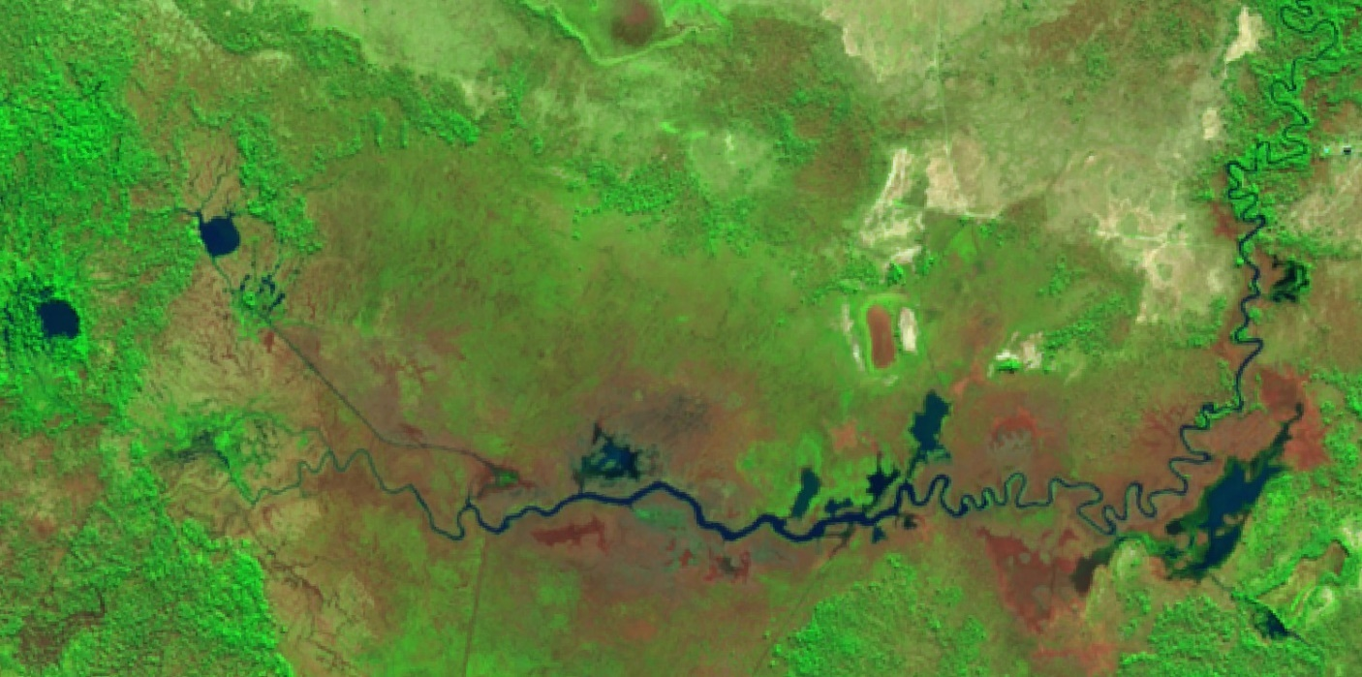
Figure 6 Sentinel image from 7 June 2019 Cumbung area near ‘Clear Lake, Maude’ (for Sentinel search area). Peak of earlier non-CEW pulse continues to arrive in region.

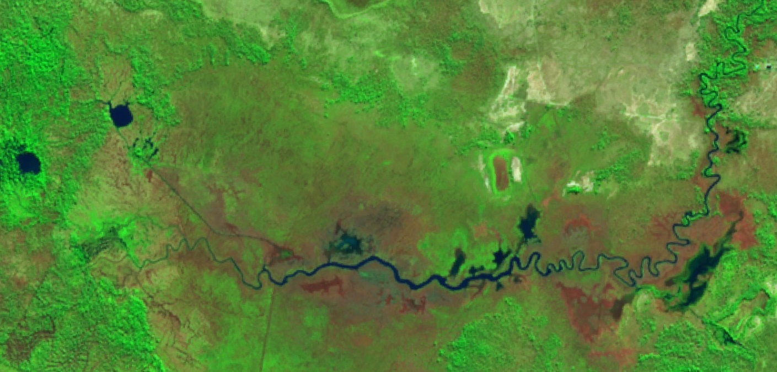
Figure 7 Sentinel image from 17 June 2019 Cumbung area near ‘Clear Lake, Maude’ (for Sentinel search area). Earlier non-CEW pulse appears to have started to slowly recede in region.

Larval fish
Larval fish have been sent off for otolith processing. Results will be used to interpret growth patterns across years and provide preliminary indications of relationships between growth and stream productivity. The analysis will focus on the larvae of two native fish species, Murray cod and Australian smelt collected each year from 2014 – 2019 (with the exception of 2016 where no larvae of these species were captured).
Fish community sampling
Fish community sampling in the mid-Lachlan is now complete. Initial observation from the field indicate that young-of-year Murray cod were present at most sites, which is consistent with the breeding event detected in the larval sampling. Silver perch were detected at two of the 10 sites monitored (Figure 8).
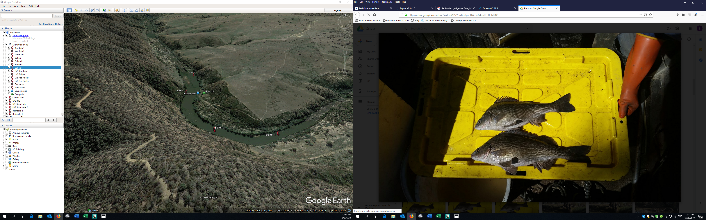
Figure 8 Two silver perch captured from the mid Lachlan River at Mulguthrie during community sampling in 2019 (Photo: Hugh Allan)

Vegetation monitoring
The majority of sites for the autumn vegetation monitoring had been surveyed between 8 and 13th of April. The 3 remaining sites were surveyed between the 16th and 19th of June. The sites monitored in April (those which occur below Booligal on the Lachlan River) were all dry, with lower than usual numbers of species present at most sites and groundcover was generally very low (Figure 9). Between vegetation monitoring in April and June, approximately 90 mm of rainfall occurred (at Hillston Airport), requiring two monitoring trips to be rescheduled. The three sites (Moon Moon, Whealbah, and Hazelwood) which were surveyed in June had an obvious response to the wetter conditions. A diverse range of both terrestrial and aquatic respondent annual species were present, and some species were in very high abundance (Figure 10). The vegetation monitoring team were assisted in the field for two days by CEWO members Adam Coterill and Dennis Ryan (Figure 11).

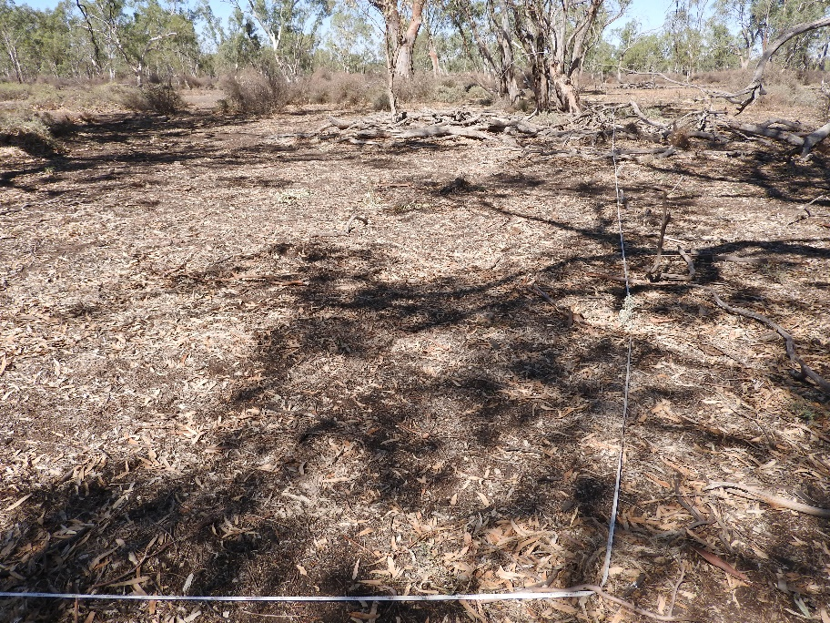
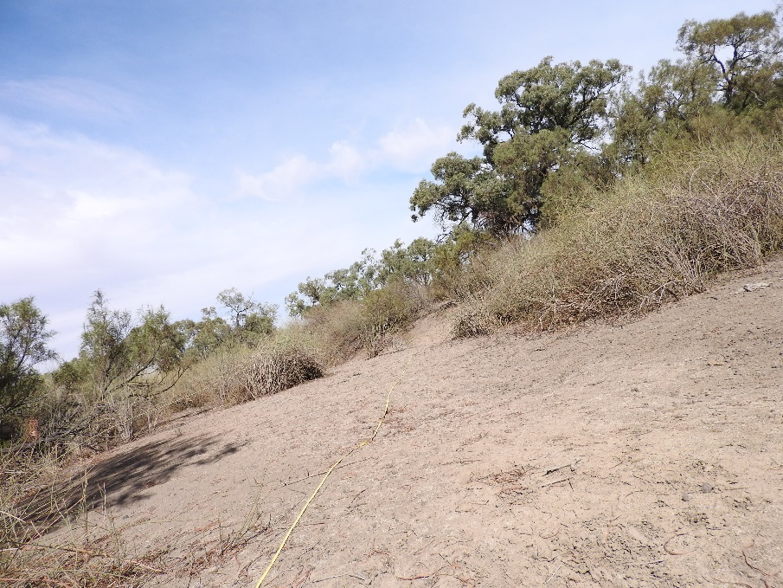
Figure 9 Vegetation sampling conducted in April 2019 at Nooran Lake in the Lower Lachlan Catchment (top) and Booligal in the lower Lachlan Catchment (bottom).
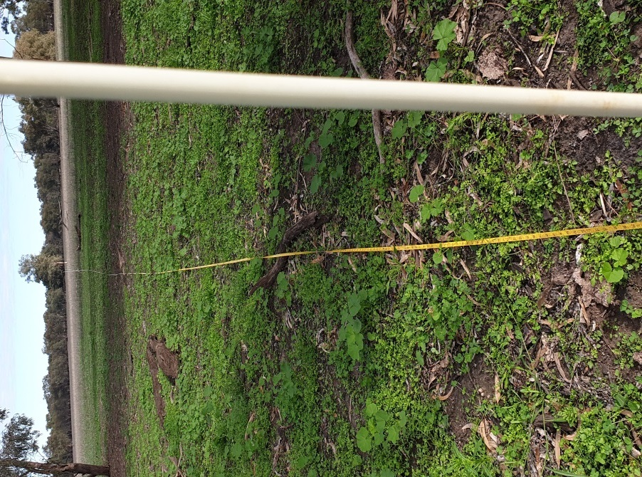
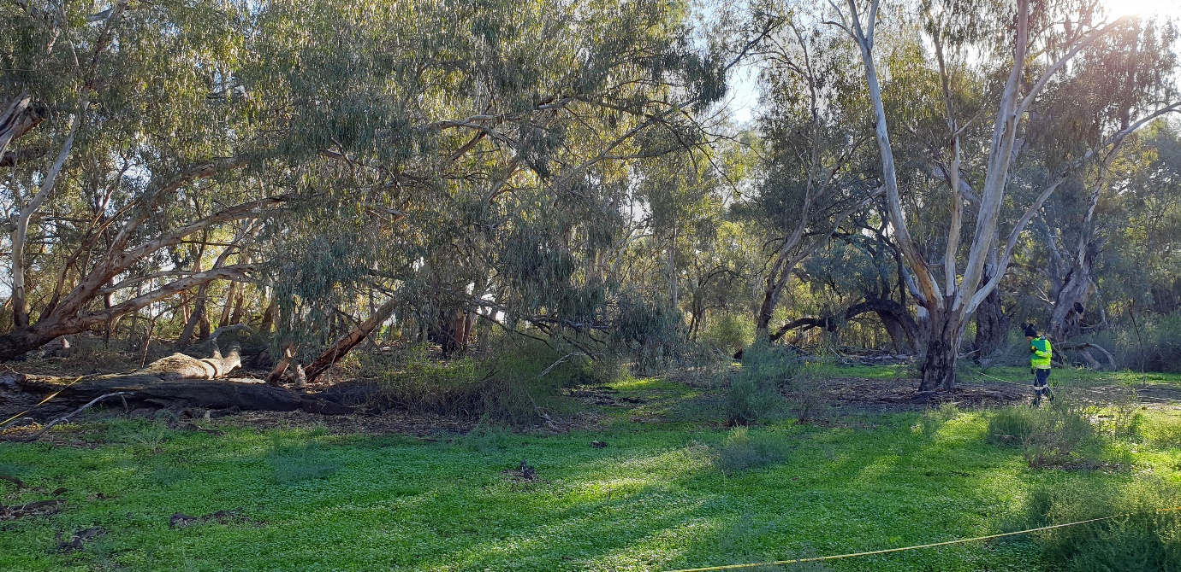
Figure 10 Vegetation sampling conducted in June at Moon Moon Swamp, North of Booligal in the lower Lachlan Catchment (top) and Whealbah Lagoon, in the lower Lachlan Catchment (bottom).

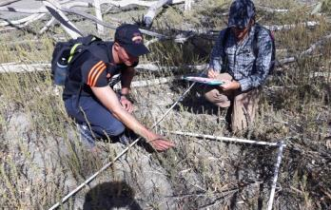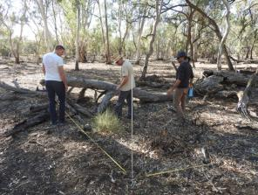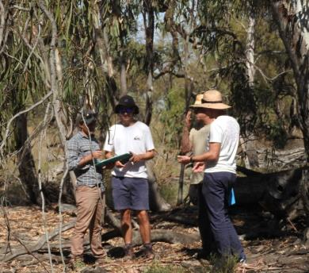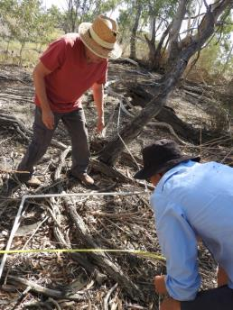
Figure 11 Vegetation survey at “The Ville” and “Lake Tarwong” in April 2019.

eDNA (environmental DNA)
In 2019, the LTIM team, in collaboration with colleagues from the University of Canberra, have been trialling an eDNA monitoring program as a complementary approach to the LTIM and STIM (Short Term Intervention Monitoring) fish monitoring in the Lachlan River reaches that receive environmental water. In the first quarter of 2019, water samples were taken from 18 sites in the mid and lower Lachlan River to analyse for eDNA. These samples have been taken from the same LTIM sites as the adult fish monitoring. DNA extraction is now complete, with the next stage in the process being metabarcoding (Metabarcoding is a rapid method of biodiversity assessment that combines two technologies: DNA based identification and high-throughput DNA sequencing).

  - Communication and Engagement activities
A two-day Waterwatch workshop was held in Murrin Bridge to introduce the community to the new WaterWatch and Waterbug team. Lake Cargelligo Local Landcare Coordinator Nicole O’Neill will assist the Community Development team for the area as well as Landholders to put their training into action over the next year. The workshop was very popular with all who attended. Data from the program will be available to contribute to the Commonwealth Environmental Water LTIM Lachlan River project.
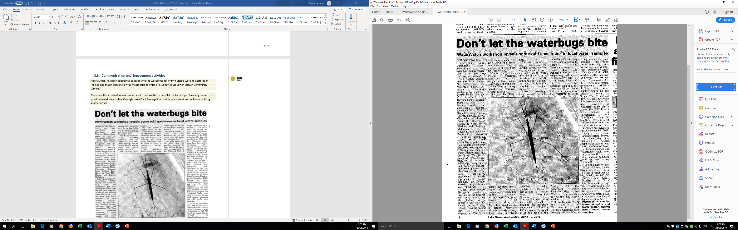
Figure 12 Lake News newspaper article from the 12th of June 2019.

Appendix A: The Long-Term Intervention Monitoring Project for the Lachlan River system and its context in terms of ecological monitoring and evaluation within the Murray-Darling Basin.

The Long Term Intervention Monitoring (LTIM) Project for the Lachlan river system selected area is funded by the Commonwealth Environmental Water Office. The project is being delivered by a consortium of service providers lead by University of Canberra and includes NSW Office of Environment and Heritage, NSW Department of Primary Industries (Fisheries), NSW Department of Primary Industries (Office of Water), University of New South Wales and Charles Sturt University.
The LTIM project is based on a clear and robust program logic, as detailed in the Long-Term Intervention Monitoring Project Logic and Rationale Document. That document sets out the scientific and technical foundations of long-term intervention monitoring and is being applied to areas where LTIM projects are being undertaken. It also provides links between Basin Plan objectives and targets to the monitoring of outcomes from Commonwealth environmental watering actions. For more information, see Monitoring and evaluation for the use of Commonwealth environmental water.
Many different agencies play a role in the reporting on environmental outcomes, consistent with the Basin Plan (see figure 1 below). The Murray Darling Basin Authority is responsible for reporting on achievements against the environmental objectives of the Basin Plan at a basin-scale, which are broadly focussed on flows and water quality, fish, vegetation and birds across the whole of the Basin. State Governments are responsible for reporting on achievements against the environmental objectives of the Basin Plan at an asset-scale i.e. rivers, wetlands, floodplains. The Commonwealth Environmental Water Holder is responsible for reporting on the contribution of Commonwealth environmental water to the environmental objectives of the Basin Plan (at multiple-scales).
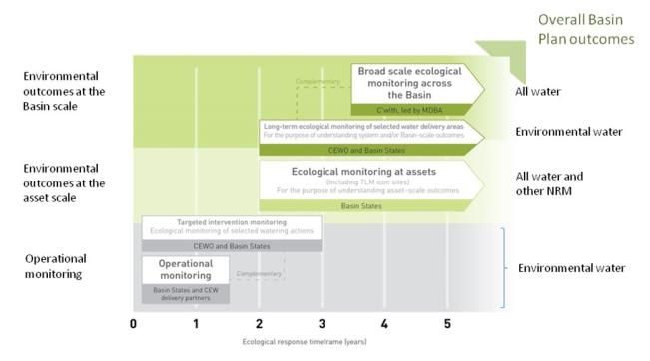
Figure 11. A summary of roles various agencies play a in the reporting on environmental outcomes, consistent with the Basin Plan.

Hydrological zones and monitoring sites of the lower Lachlan for the Long-Term Intervention Monitoring Project.
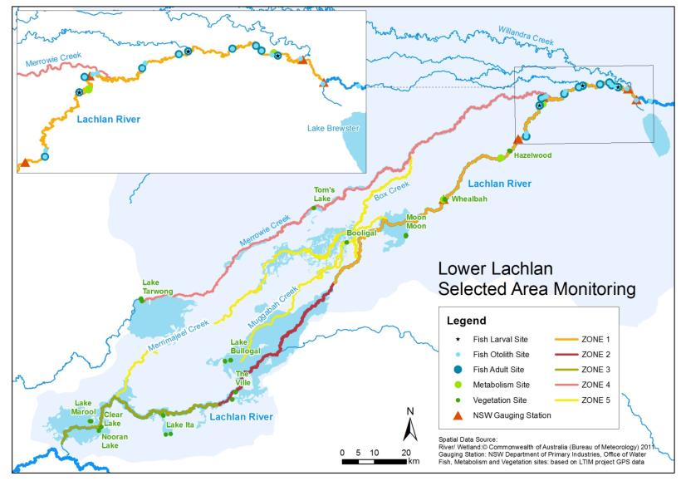
Figure 12. Lower Lachlan LTIM monitoring sites, hydrological zones and NSW gauging stations
Monitoring to be undertaken in the Lachlan system for the Long Term Intervention Monitoring Project from 2014-2019
The five year monitoring schedule has been based around the expected watering options and is focussed on the monitoring of Basin Indicators. Monitoring effort is consistent across the five years with the exception of monitoring Waterbird Breeding and Frogs which are options that can be implemented on request from the CEWO, and some additional fish monitoring sites in the mid Lachlan which is implemented in Year 5.
 | ZONE | Data contributes to the Evaluation of responses to Commonwealth environmental watering |  | monitoring frequency | sites | expected schedule
 |  | Selected Area | Whole of Basin Scale
Ecosystem type | All | ✓ | ✓ | Once only | All sites for other indicators | Establishment of ANAE type at the start of the LTIM Project. Expected August-December 2014
Riverine fish | 1  Mid Lachlan Year 5 | ✓ | ✓ | ANNUAL | Basin Evaluation: 10 fixed sites within Zone 1 | Annual sampling between March and May
Larval fish | 1  Mid Lachlan Year 5 | ✓ | ✓ | ANNUAL | 3 fixed riverine sites in Zone 1 | Annual sampling 5 times during breeding season (September to February)
Stream metabolism | 1  Mid Lachlan Year 5 | ✓ | ✓ | CONTINUOUS  REGULAR | Four fixed sites matched to riverine fish sampling sites in Zone 1 | Continuous monitoring of dissolved oxygen and temperature.  6 weekly sampling of nutrients and water quality attributes.
Hydrology (River) | 1  Mid Lachlan Year 5 | ✓ | ✓ | CONTINUOUS | Gauging sites
Vegetation diversity and condition | All | ✓ |  | ANNUAL & EVENT BASED | 12 fixed sites | Before and after watering (expected to be April/May and 3 months after first fill)
Waterbird breeding (Option) | 1 | ✓ |  | EVENT-BASED (on request from the CEWO) | One fixed site – Booligal wetland | Fortnightly surveys of bird breeding triggered by breeding events in Booligal wetland.
Frogs (Option) | All | ✓ |  | EVENT-BASED (on request from the CEWO) | 15 sites comprising 2 to 8 wetland sites and 2 to 7 riverine sites depending on watering targets | 3 sampling events between August and February (one sample in each of winter, spring and summer).
Hydrology (wetland – Option) |  | ✓ |  | EVENT-BASED (in conjunction with Waterbird Breeding or Frog monitoring) | Cameras at 6 roving wetland sites | Cameras installed prior to targeted watering each year and downloaded after the watering event has passed

Median rainfall is the mid-point of all observed rainfall records when they are sorted in order of magnitude. The median is the preferred measure of 'typical' rainfall from a meteorological point of view. This is because of the high variability of rainfall; one extreme rainfall event will have less effect on the median than it will have on the arithmetic mean.

