Lachlan River

Long Term Intervention Monitoring Project

Progress Report

1st of January – 31st March 2019

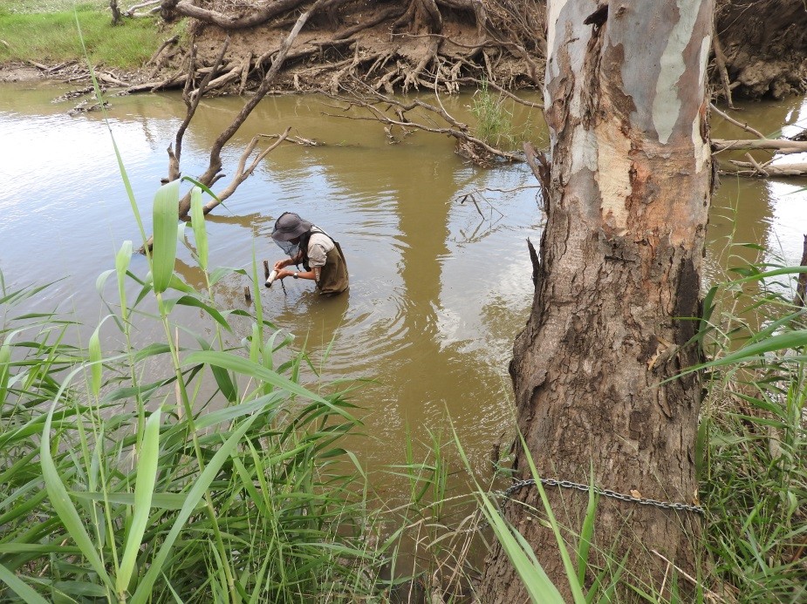

Inquiries regarding this document should be addressed to:

Dr Fiona Dyer  
Phone: 02 6201 2452  
e-mail: Fiona.Dyer@canberra.edu.au

This document was prepared by Fiona Dyer, Ben Broadhurst, Rheyda Ma Hinlo, Alica Tschierschke (IAE-UC), Jason Thiem (DPI Fisheries) and Joanne Lenehan (NSW OEH).

Cover Photo: Logger download from Ugyen Lhendup at a mid Lachlan River site at Mulgutherie (Photo: Alica Tschierschke).

**Document history and status**

|  |  |  |  |  |
| --- | --- | --- | --- | --- |
| Version | Date Issued | Reviewed by | Approved by | Revision Type |
| Draft 1 | 5/4/2019 | Ben Broadhurst | Fiona Dyer | Draft |
| FINAL | 9/5/2019 | CEWO | Fiona Dyer | FINAL |

**Distribution of copies**

|  |  |  |
| --- | --- | --- |
| Version | Type | Issued to |
| FINAL | Electronic | Commonwealth Environmental Water Office |

**Copyright**© Copyright Commonwealth of Australia, 2019



‘Long term intervention monitoring project, Lachlan River system selected area, progress report’ is licensed by the Commonwealth of Australia for use under a Creative Commons By Attribution 3.0 Australia licence with the exception of the Coat of Arms of the Commonwealth of Australia, the logo of the agency responsible for publishing the report, content supplied by third parties, and any images depicting people. For licence conditions see: <http://creativecommons.org/licenses/by/3.0/au/>

**Disclaimer**

The views and opinions expressed in this publication are those of the authors and do not necessarily reflect those of the Australian Government or the Minister for the Environment and Energy. While reasonable efforts have been made to ensure that the contents of this publication are factually correct, the Commonwealth does not accept responsibility for the accuracy or completeness of the contents, and shall not be liable for any loss or damage that may be occasioned directly or indirectly through the use of, or reliance on, the contents of this publication.

1. Conditions in the Lachlan River system January to March 2019

Conditions remained warm and dry across the catchment in the first quarter of 2019. Rainfall was below average from January till the end of March 2019 (Figure 1). The total rainfall accumulated for this period is 44.1 mm and was similar to the long term median[1] rainfall (49.6 mm), but less than half the long term average (91.4 mm). In January rainfall occurred as several days of light rain (<2 mm) whereas the majority of the February and March rainfall fell in two events; 9.2 mm on the 8th February and 13.6 mm on the 25th March.

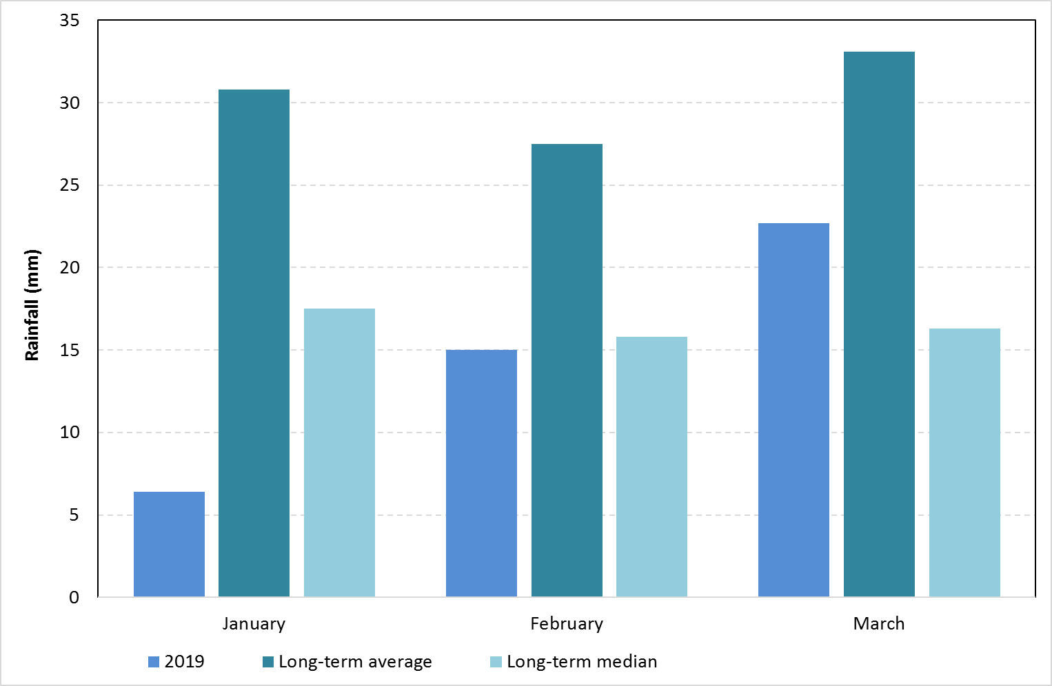

Figure 1. Rainfall at Hillston (075032) in the Lower Lachlan River Catchment for the first quarter of 2019 compared with the long term average monthly rainfall and the long term median monthly rainfall. Data from the Bureau of Meteorology.

Average daily maximum and minimum temperatures at Hillston for the first quarter of 2019 were above average. January was particularly hot, with an average temperature of 39.7 degrees which is 6 degrees warmer than the long term average (Figure 2). Hillston also had 18 days in January where the maximum temperature exceeded 40 degrees and recorded its hottest January day on record at 47 degrees on the 16th January. These high daytime temperatures in January were accompanied by correspondingly high minimums, with an average minimum temperature of 23.9 degrees.

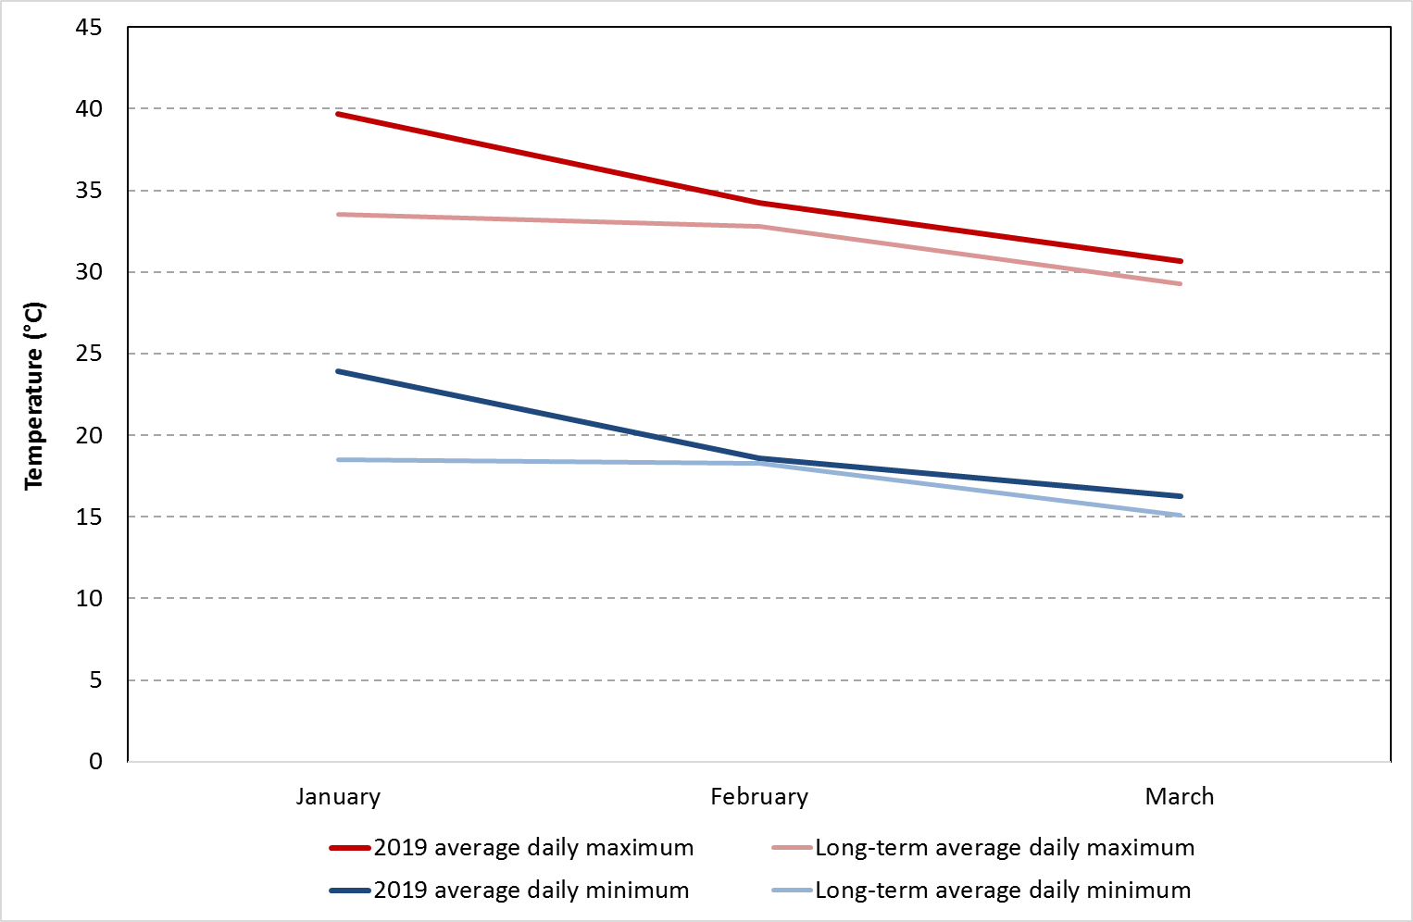

Figure 2. Average maximum and minimum temperatures for the first quarter of 2019 at Hillston (075032) in the Lachlan River Catchment compared with the long term average daily temperatures. Data from the Bureau of Meteorology.

1. Summary on progress against core monitoring and evaluation activities

|  |  |  |
| --- | --- | --- |
| ACTIVITIES | PROGRESS TO DATE | UPCOMING ACTIVITIES |
| *Monitoring activities* | | |
| Ecosystem type | * Data collection complete and suggested Australian National Aquatic Ecosystems (ANAE) types for all sites included in the Monitoring and Data Management System (MDMS). | * Assign ANAE types for mid Lachlan sampling sites |
| Fish (river) | * 2019 fish sampling in the lower Lachlan completed; mid Lachlan sampling commenced | * Complete mid Lachlan sampling * Data processing |
| Fish (larvae) | * 2018 larval fish data processed | * None |
| eDNA | * All sampling completed | * Data processing |
| Waterbird breeding (optional) | * None | * None |
| Water quality and stream metabolism | * Logger data downloaded from sites in the mid and lower reaches and from additional loggers at The Ville and Kalyarr * Water quality samples collected from mid and lower reaches and from additional sites at The Ville and Kalyarr | * Maintenance of loggers and downloading of data * Data processing |
| Vegetation diversity | * None | * 2019 Autumn sampling to commence in April |
| Frogs (optional) | * None | * None |
| *Evaluation activities* | | |
| Monitoring data entry | * 2017-18 Data upload finalised | * 2018-19 Data upload to commence |
| *Communication and engagement* | | |
| Selected Area Working Group (EWAG and TAG meetings) | * Lachlan EWAG attended on 15/3 * Teleconferences relating to the use of the Water Quality Allowance attended on 4/2, 22/2 and 25/3 | * Ongoing teleconferences relating to delivery of Water Quality Allowance |
| Project team teleconference | * None | * None |
| Other Stakeholder Engagement | * Mt Boorithumble Weekend | * As opportunities arise |

**Note:** for the Long-Term Intervention Monitoring (LTIM) Project, Lachlan River system selected area:

* **Appendix A** provides a summary of monitoring to be undertaken under the project from 2014-2019.

1. Observations
   1. Hydrology

Flow in the mid - Lachlan River between January and March ranged between 540 and 5320 ML/day at Cotton’s Weir (Figure 3) and in the lower Lachlan they ranged between 170 and 1000 ML/day at the gauge upstream of Willandra Weir (Figure 4). Flows were generally high throughout January and February as the river was used to meet the demands for irrigation water. Flows dropped rapidly in mid February as irrigation orders declined across the catchment.

High water temperatures and low flows, combined with a series of catastrophic fish kills in other parts of the Murray Darlin Basin triggered the use of the Water Quality Allowance (WQA) in this quarter to target water quality outcomes in the Lower Lachlan River. Around 3,200 ML was used between the 5th February and the end of March to prevent blue green algal blooms from developing and dissolved oxygen concentrations from dropping in the lower river system.

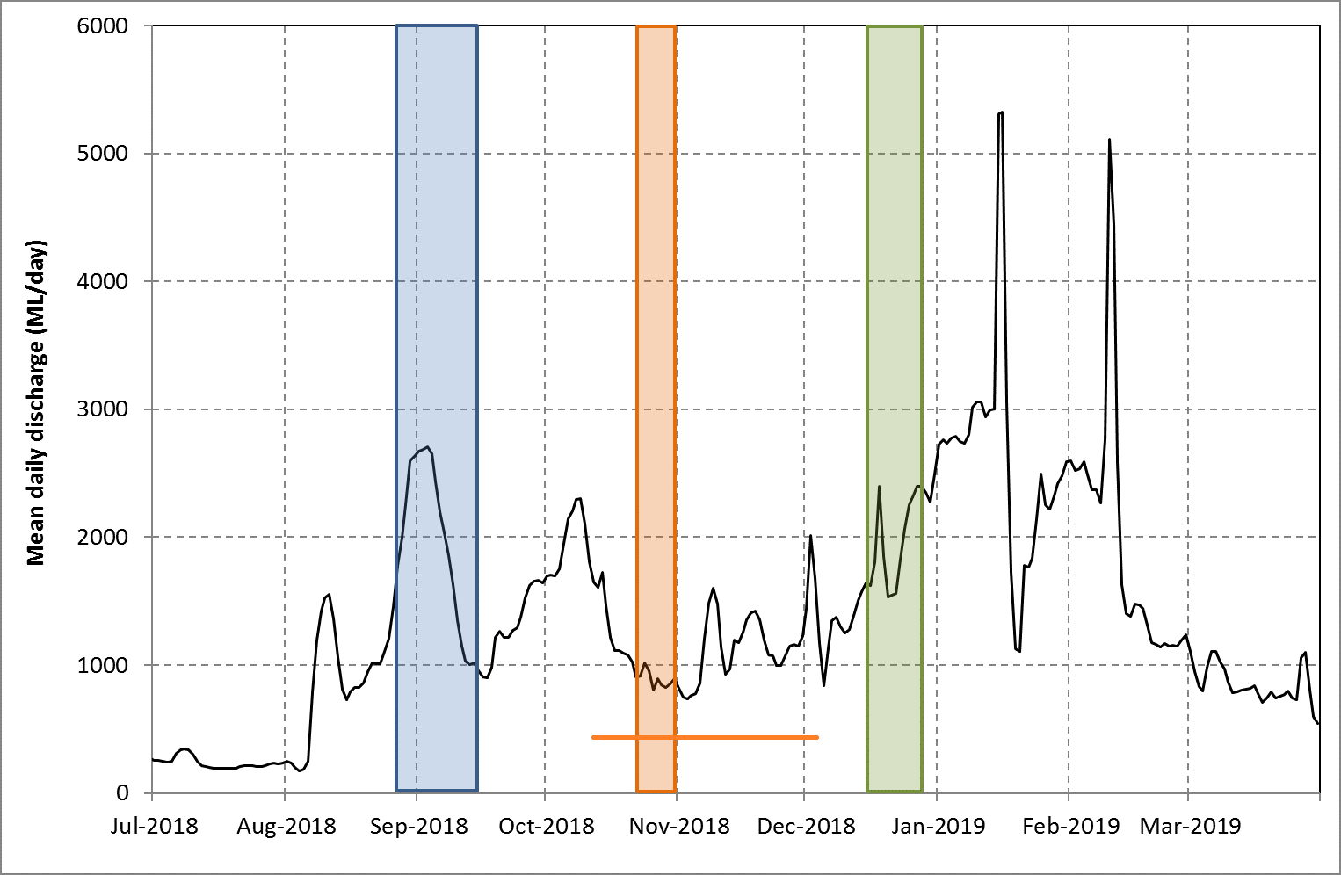

Figure 3. Flow in the Lachlan River recorded at the gauge at Cottons weir near Forbes (412004). Data from WaterNSW (<http://waterinfo.nsw.gov.au/>). The shaded regions show the timing of the use of Commonwealth and NSW environmental water: blue shows the spring pulse (Commonwealth environmental water), orange shows the use of water during the period (shown by the orange line) in which management of water levels aimed to support fish breeding (Commonwealth environmental water) and the green shows the protection of tributary flows to provide a small flow pulse (NSW Environmental water allowance).

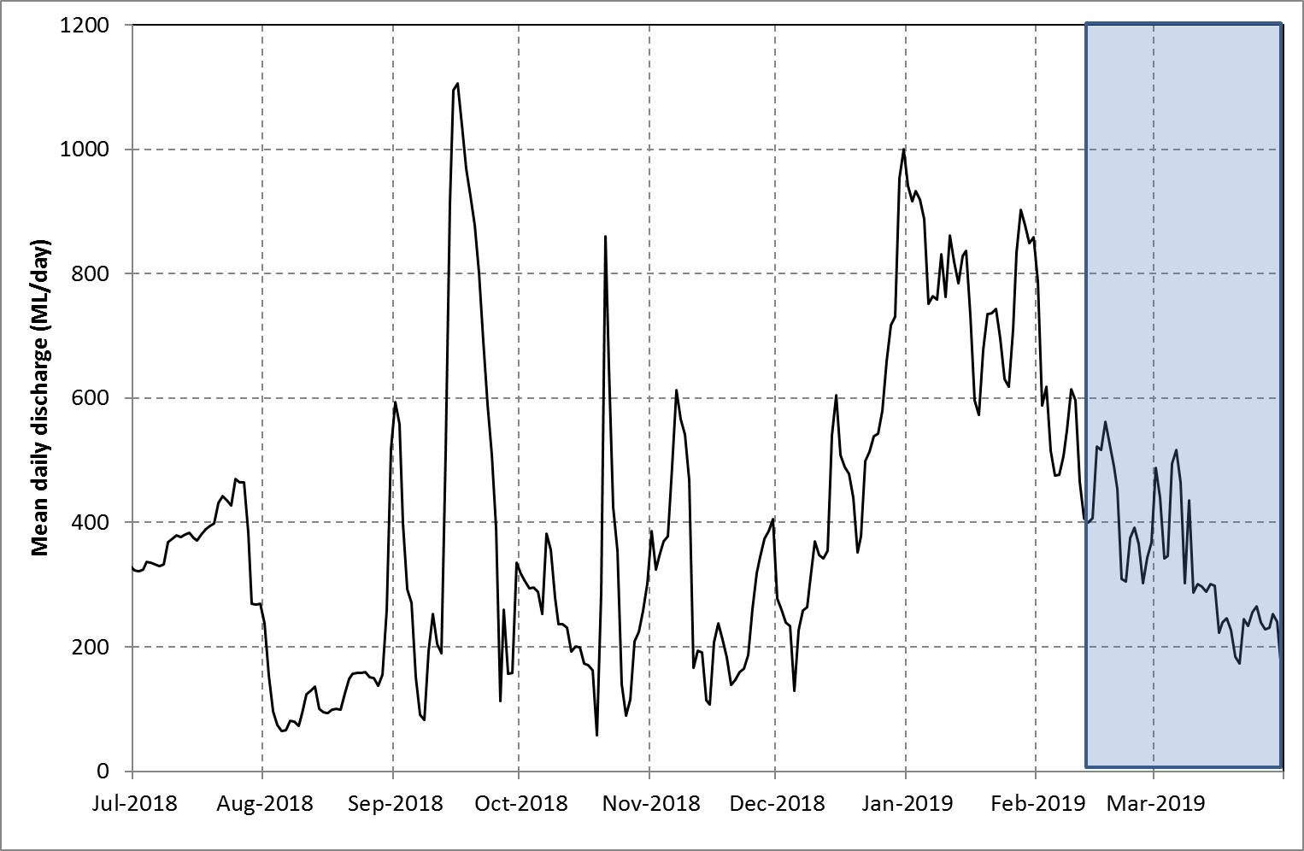

Figure 4. Flow in the Lachlan River recorded at the gauge upstream of Willandra weir (412038). Data from WaterNSW (<http://waterinfo.nsw.gov.au/>). The shaded region shows the timing of the use of the water quality allowance to provide flows to support water quality in the lower reaches of the river.

* 1. Field observations

*Water quality*

Observation and comments from local landholders suggest that the use of the WQA was successful in avoiding algal blooms and improving the quality of water in the lower Lachlan.

Water quality loggers were downloaded from sites between Forbes and Oxley in late February. Water temperatures were generally above 25 degrees along the river system, reaching 30 degrees in late January in response to the very hot conditions across the catchment (Figure 5, Figure 6, and Figure 7). Dissolved oxygen concentrations were generally above 5 mg/L in mid Lachlan and declined downstream. Dissolved oxygen concentrations, appear to have been maintained around 4-5 mg/L in the lower Lachlan sites with the provision of flow pulses in January and February (Figure 7).

It is noted that there is an increase in the amplitude of the diurnal dissolved oxygen concentrations associated with the flow pulse in January (Figure 7). A potential contributor to the DO patterns could be cyanobacterial growth, which can result in increased amplitudes of diurnal change. However we don’t have data on algal biomass and composition, which means that we can’t definitively attribute these patterns to changes in algal communities.

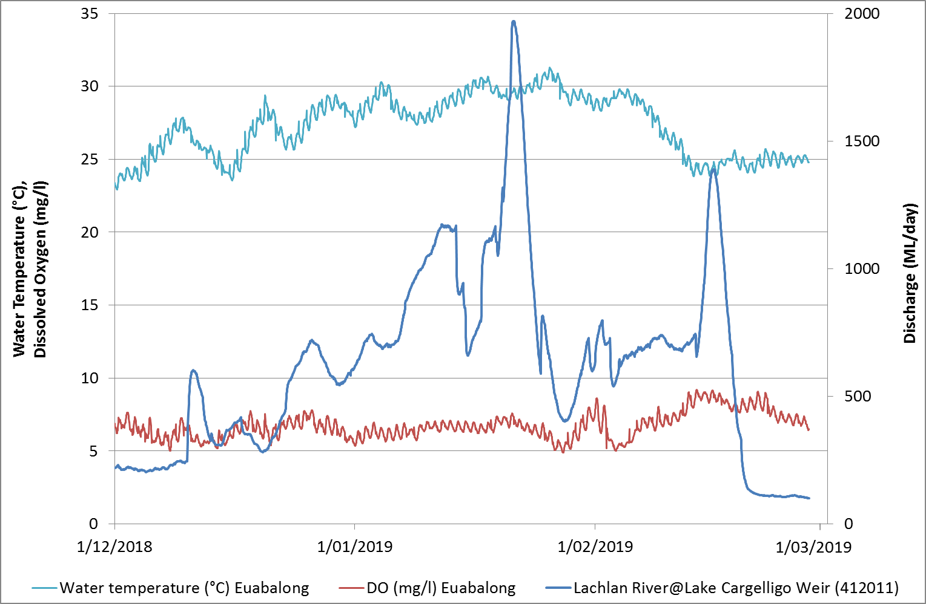

Figure 5 Temperature and dissolved oxygen concentrations in the first quarter of 2019 from the Lachlan River near Euabalong in the mid Lachlan River.

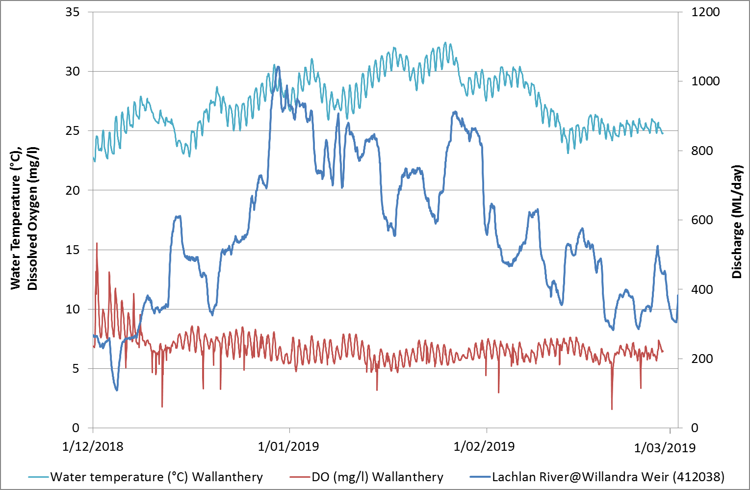

Figure 6 Temperature and dissolved oxygen concentrations in the first quarter of 2019 from the Lachlan River at Wallanthery (near Hillston).

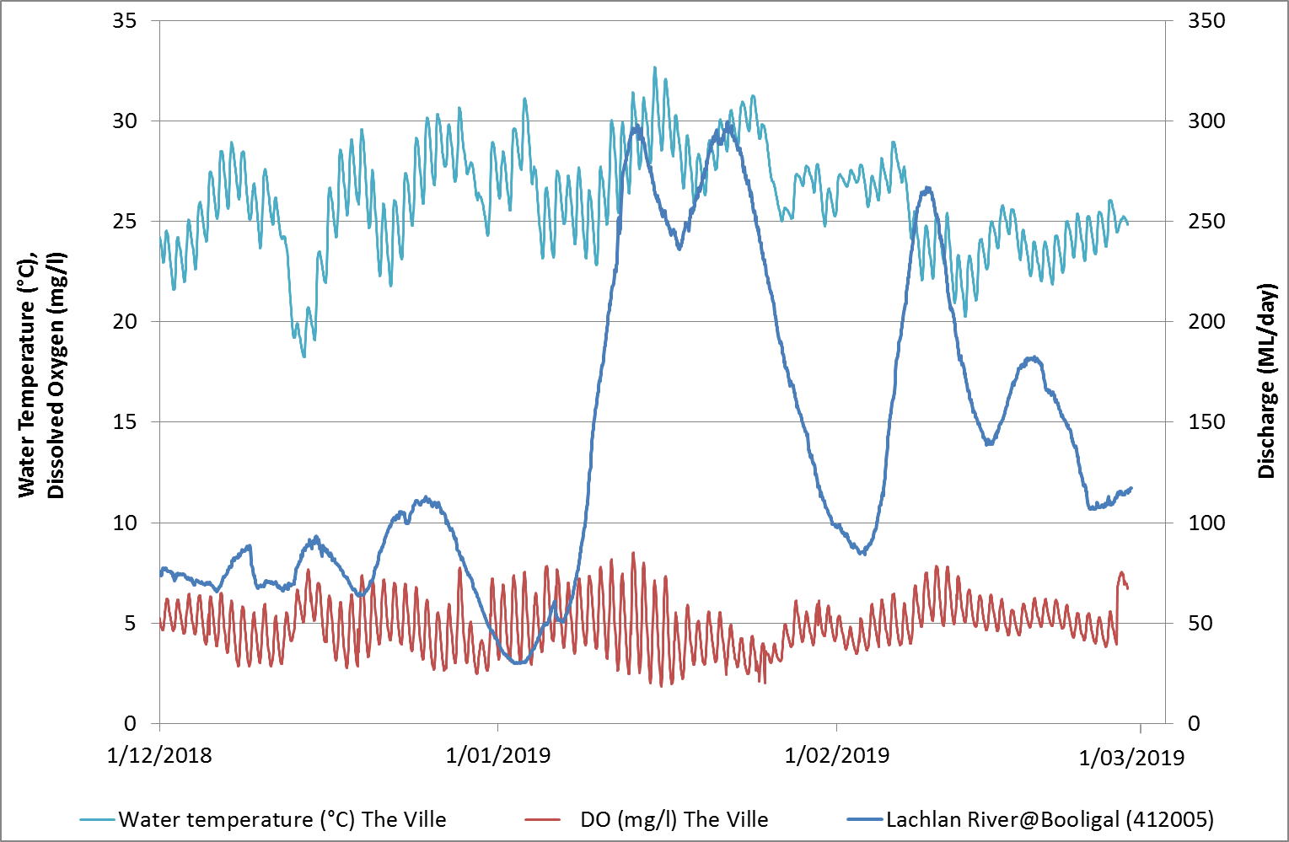

Figure 7 Temperature and dissolved oxygen concentrations in the first quarter of 2019 from the lower Lachlan River near Corrong (“The Ville”).

*Larval fish*

Processing of the larval fish collected in spring - summer 2018 has been completed for both the lower and mid Lachlan River reaches. Small bodied species (particularly Flatheaded gudgeon and Australian smelt) dominated the catches from the lower reach. Encouragingly, abundance of larval Murray cod also increased from last year in the lower reach, returning to similar abundances to that of the first year of monitoring (2014). Murray cod were the dominant species captured in the mid reach, with abundances similar to that of the lower reach. The team was pleased to find a number of Eel-tailed catfish larvae from one site in the mid reach.

*Fish community sampling*

Fish community sampling in the lower Lachlan was completed in late February and early March (Figure 8). While the data are yet to be processed and checked, observations were that the usual suite of native fish (Murray cod, golden perch, bony herring etc) were caught in the sampling. Both adult and juvenile Murray cod were captured.

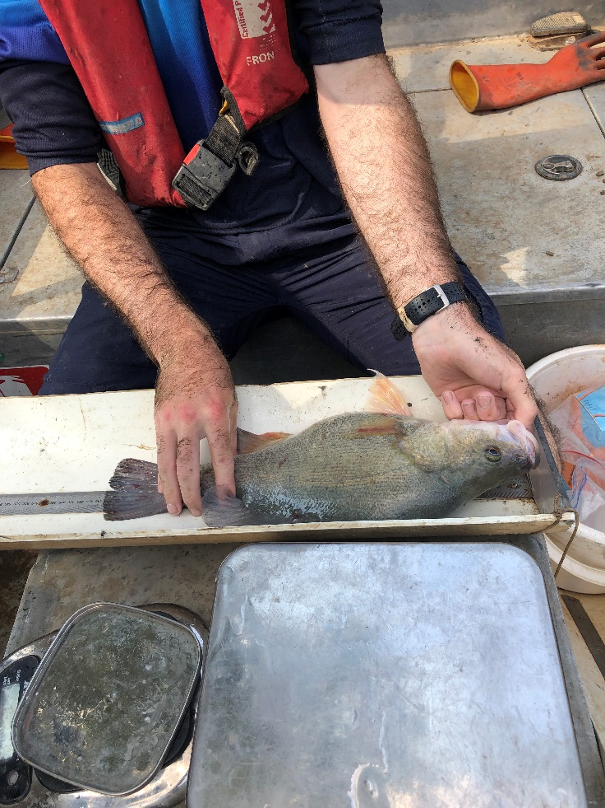 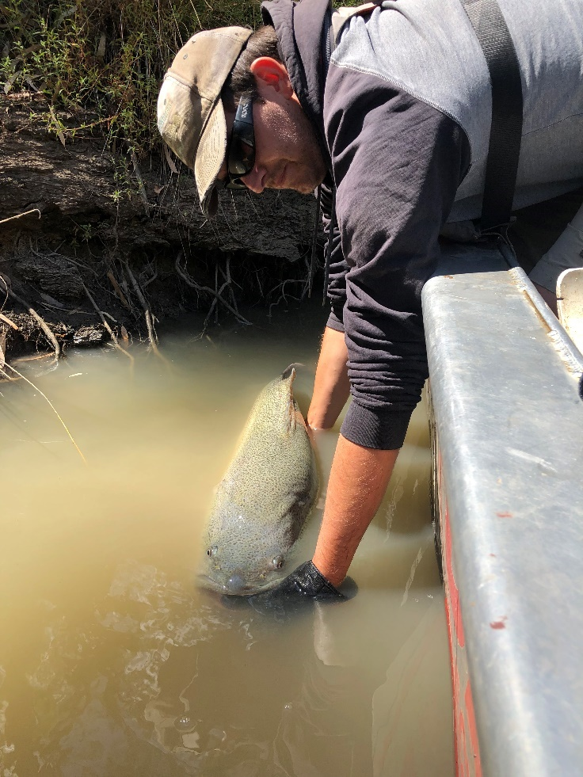

Figure 8. Golden perch (left) and Murray cod (right) captured during fish community sampling in the Lower Lachlan river system (Images: DPI Fisheries). Note that fish are returned to the river at the point of capture following measurement.

Community sampling across 10 sites in the mid Lachlan has commenced. At the time of reporting, three sites have been sampled and so far young-of-year Murray cod were present at all sites which is consistent with the breeding event detected in the larval sampling. The annual ageing of golden perch and Murray cod using otolithis (ear bones) will not be undertaken in the Lachlan catchment in 2018-19 to protect and assist with the recovery of broodstocks in the Lachlan River.

Also encouraging was the capture of the threatened silver perch at one of the sites (Figure 9 & 14).

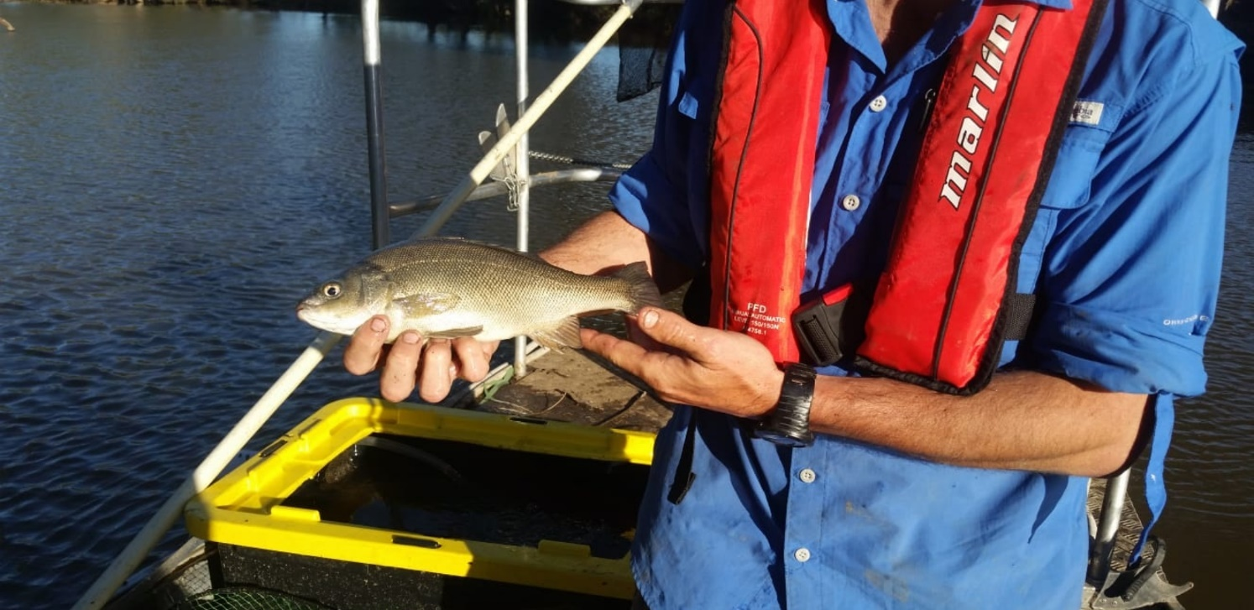

Figure 9 Silver perch captured from the mid Lachlan River reach during community sampling in 2019 (Photo: Hugh Allan)

*eDNA*

Traditional monitoring techniques for monitoring fish rely on physically capturing fish. While this provides valuable information it can be limited in the range of species detected. In recent years, the use of environmental DNA (i.e. DNA obtained from water samples) has become a powerful tool for monitoring the distribution of aquatic species. Researchers at the University of Canberra have been instrumental in leading the development of environmental DNA (eDNA) techniques for the detection of freshwater fishes. This has provided an opportunity for the Commonwealth Environmental Water Office to evaluate the use of eDNA as a monitoring tool for fish responses to environmental water in both the lower and mid Lachlan reaches.

In 2019, the LTIM team, in collaboration with colleagues from the University of Canberra, have been trialling an eDNA monitoring program as a complementary approach to the LTIM and STIM (Short Term Intervention Monitoring) fish monitoring in the Lachlan River reaches that receive environmental water. In the first quarter of 2019, water samples have been taken from 18 sites in the mid and lachlan river to analyse for eDNA (Figure 10 and Figure 11). These samples have been taken from the same sites as the adult fish monitoring. Samples have now been returned to the University of Canberra lab for DNA extraction and processing.

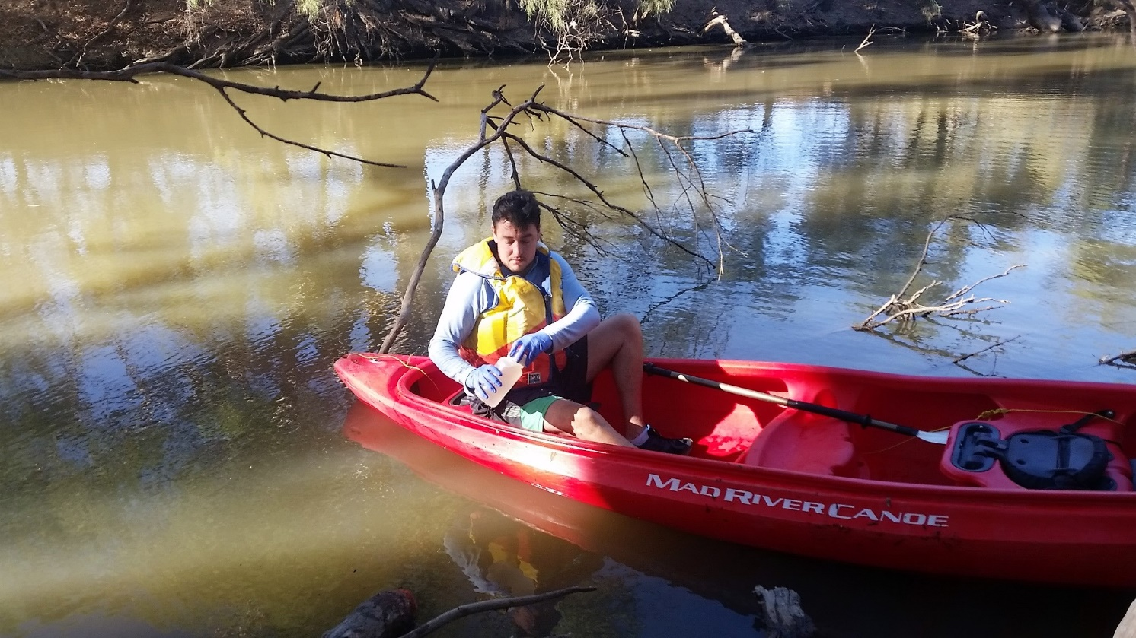

Figure 10. Water collection for eDNA analysis. Photo: Rheyda M. Hinlo University of Canberra

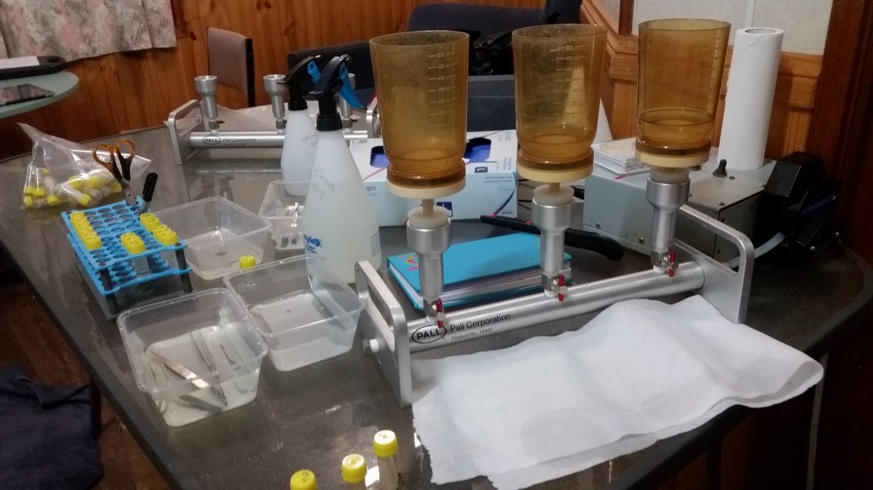

Figure 11. Sample filtration set up for sampling water for eDNA extraction. Photos Rheyda M. Hinlo, University of Canberra

* 1. Communication and Engagement activities

Landholders, traditional owners, scientists, environmental water managers and others with an interest in Booberoi Creek converged on the property Mt Boorithumble on Saturday the 23th of February to share their interest in, and local knowledge of, their creek (Figure 12).

Preliminary observations from the additional mid-Lachlan LTIM larval fish monitoring (October to December 2018) in the Lachlan River close by (Euabalong and Condobolin sites) were shared with landholders and the community – including the eel-tailed catfish larvae as catfish is an iconic and cultural species for Booberoi Creek. The local Lake News newspaper featured the engagement weekend (Figure 13) – and as there is great demand from all who attended (and those who wished they could have!) – the LTIM Communication and Engagement Team and OEH have discussed with landholders the option to do a similar event in future years.

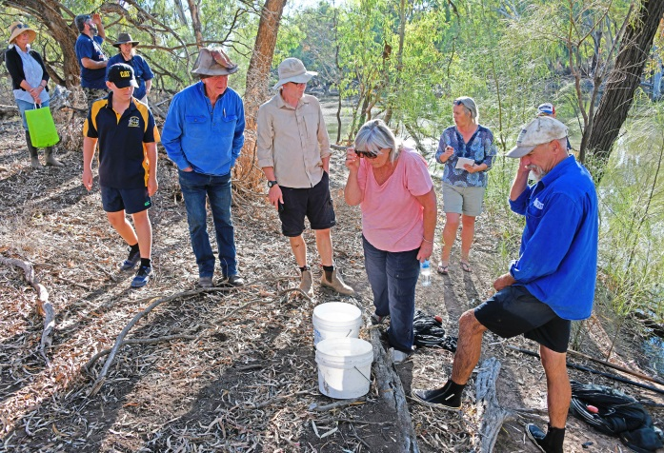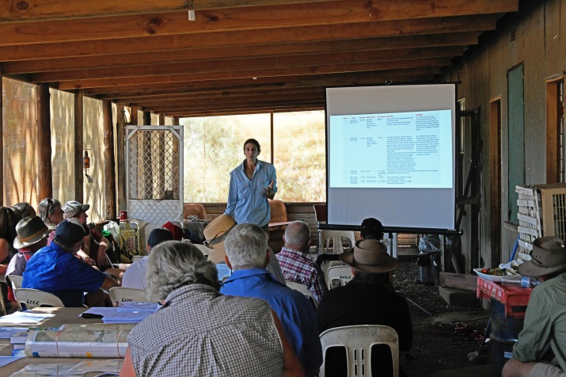

Figure 12 Big interest at the Mt Boorithumble Engagement Weekend (Photo: Mal Carnegie, Lake Cowal Foundation)

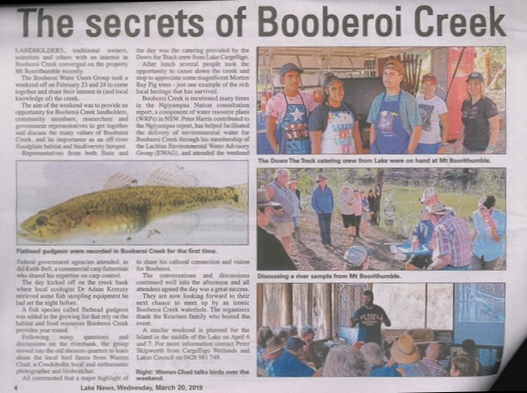

Figure 13 Lake News newspaper article from the 29th of March 2019

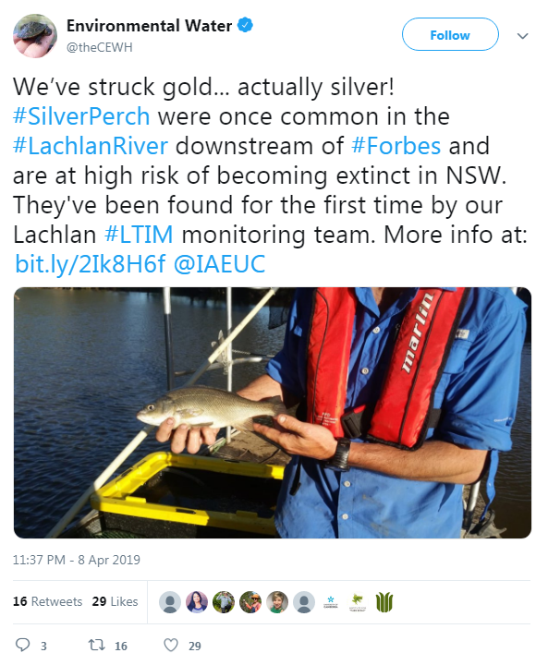

Figure 14 Tweet from @theCEWH noting the capture of the threatened silver perch at one of the LTIM sites

Appendix A: The Long-Term Intervention Monitoring Project for the Lachlan River system and its context in terms of ecological monitoring and evaluation within the Murray-Darling Basin.

The Long Term Intervention Monitoring (LTIM) Project for the Lachlan river system selected area is funded by the Commonwealth Environmental Water Office. The project is being delivered by a consortium of service providers lead by University of Canberra and includes NSW Office of Environment and Heritage, NSW Department of Primary Industries (Fisheries), NSW Department of Primary Industries (Office of Water), University of New South Wales and Charles Sturt University.

The LTIM project is based on a clear and robust program logic, as detailed in the [Long-Term Intervention Monitoring Project Logic and Rationale Document](http://www.environment.gov.au/water/cewo/publications/long-term-intervention-monitoring-project-logic-and-rationale-document). That document sets out the scientific and technical foundations of long-term intervention monitoring and is being applied to areas where LTIM projects are being undertaken. It also provides links between Basin Plan objectives and targets to the monitoring of outcomes from Commonwealth environmental watering actions. For more information, see [Monitoring and evaluation for the use of Commonwealth environmental water](http://www.environment.gov.au/topics/water/commonwealth-environmental-water-office/monitoring-and-evaluation).

Many different agencies play a role in the reporting on environmental outcomes, consistent with the Basin Plan (see figure 1 below). The Murray Darling Basin Authority is responsible for reporting on achievements against the environmental objectives of the Basin Plan at a basin-scale, which are broadly focussed on flows and water quality, fish, vegetation and birds across the whole of the Basin. State Governments are responsible for reporting on achievements against the environmental objectives of the Basin Plan at an asset-scale i.e. rivers, wetlands, floodplains. The Commonwealth Environmental Water Holder is responsible for reporting on the contribution of Commonwealth environmental water to the environmental objectives of the Basin Plan (at multiple-scales).

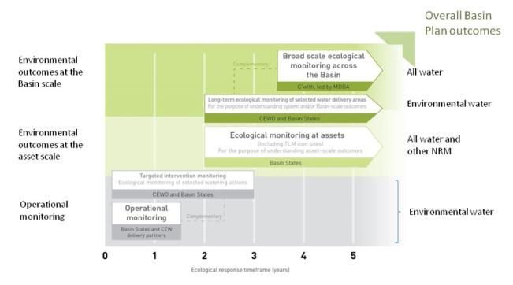

Figure 11. A summary of roles various agencies play a in the reporting on environmental outcomes, consistent with the Basin Plan.

Hydrological zones and monitoring sites of the lower Lachlan for the Long-Term Intervention Monitoring Project.

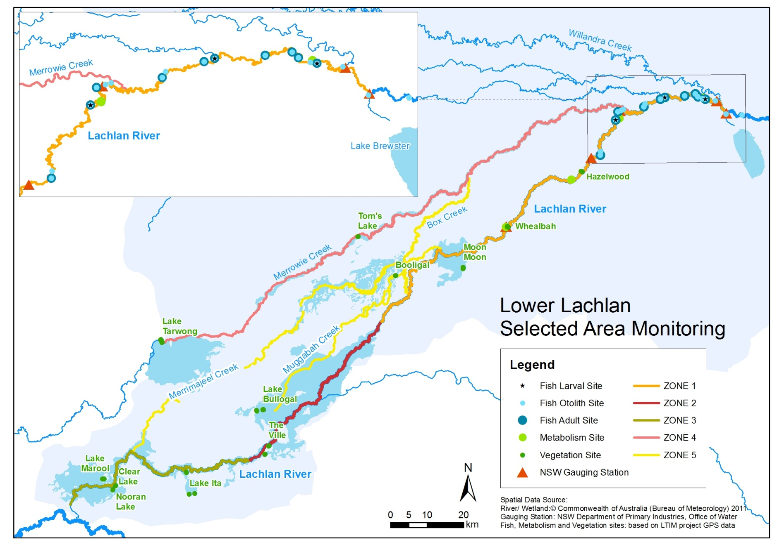

*Figure 12. Lower Lachlan LTIM monitoring sites, hydrological zones and NSW gauging stations*

Monitoring to be undertaken in the Lachlan system for the Long Term Intervention Monitoring Project from 2014-2019

The five year monitoring schedule has been based around the expected watering options and is focussed on the monitoring of Basin Indicators. Monitoring effort is consistent across the five years with the exception of monitoring Waterbird Breeding and Frogs which are options that can be implemented on request from the CEWO, and some additional fish monitoring sites in the mid Lachlan which is implemented in Year 5.

|  | ZONE | Data contributes to the Evaluation of responses to Commonwealth environmental watering | | monitoring frequency | sites | expected schedule |
| --- | --- | --- | --- | --- | --- | --- |
|  |  | Selected Area | Whole of Basin Scale |  |  |  |
| Ecosystem type | All | ✓ | ✓ | Once only | All sites for other indicators | Establishment of ANAE type at the start of the LTIM Project. Expected August-December 2014 |
| Riverine fish | 1  Mid Lachlan Year 5 | ✓ | ✓ | ANNUAL | Basin Evaluation: 10 fixed sites within Zone 1 | Annual sampling between March and May |
| Larval fish | 1  Mid Lachlan Year 5 | ✓ | ✓ | ANNUAL | 3 fixed riverine sites in Zone 1 | Annual sampling 5 times during breeding season (September to February) |
| Stream metabolism | 1  Mid Lachlan Year 5 | ✓ | ✓ | CONTINUOUS  REGULAR | Four fixed sites matched to riverine fish sampling sites in Zone 1 | Continuous monitoring of dissolved oxygen and temperature.  6 weekly sampling of nutrients and water quality attributes. |
| Hydrology (River) | 1  Mid Lachlan Year 5 | ✓ | ✓ | CONTINUOUS | Gauging sites |  |
| Vegetation diversity and condition | All | ✓ |  | ANNUAL & EVENT BASED | 12 fixed sites | Before and after watering (expected to be April/May and 3 months after first fill) |
| Waterbird breeding (Option) | 1 | ✓ |  | EVENT-BASED (on request from the CEWO) | One fixed site – Booligal wetland | Fortnightly surveys of bird breeding triggered by breeding events in Booligal wetland. |
| Frogs (Option) | All | ✓ |  | EVENT-BASED (on request from the CEWO) | 15 sites comprising 2 to 8 wetland sites and 2 to 7 riverine sites depending on watering targets | 3 sampling events between August and February (one sample in each of winter, spring and summer). |
| Hydrology (wetland – Option) |  | ✓ |  | EVENT-BASED (in conjunction with Waterbird Breeding or Frog monitoring) | Cameras at 6 roving wetland sites | Cameras installed prior to targeted watering each year and downloaded after the watering event has passed |

1. Median rainfall is the mid-point of all observed rainfall records when they are sorted in order of magnitude. The median is the preferred measure of 'typical' rainfall from a meteorological point of view. This is because of the high variability of rainfall; one extreme rainfall event will have less effect on the median than it will have on the arithmetic mean.