Lachlan River

Long Term Intervention Monitoring Project

Progress Report

1st July – 30th September 2018

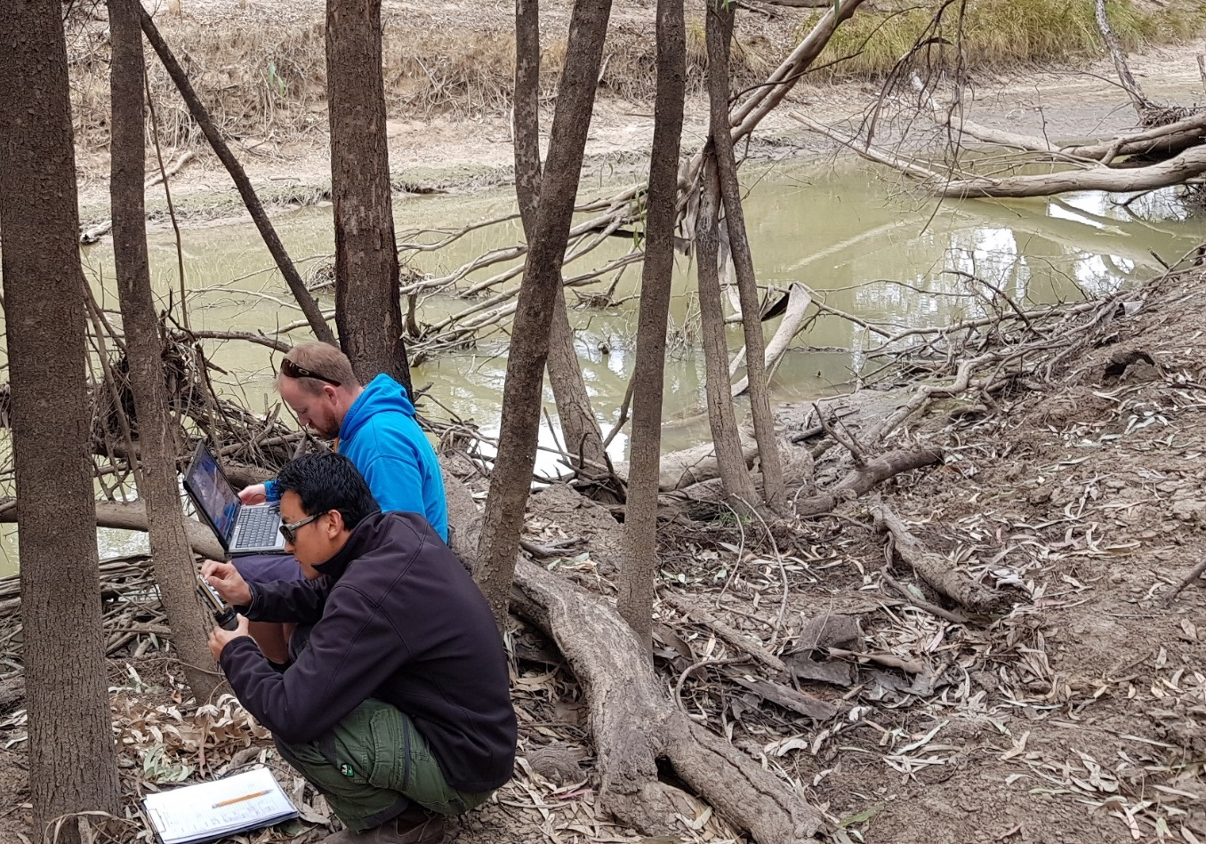

Inquiries regarding this document should be addressed to:

Dr Fiona Dyer  
Phone: 02 6201 2452  
e-mail: Fiona.Dyer@canberra.edu.au

This document was prepared by Ben Broadhurst, Alica Tschierschke (IAE-UC) and Joanne Lenehan (NSW OEH).

Cover Photo: Rhian Clear and Ugyen Lhendup downloading stream metabolism loggers at Lanes Bridge. Photo: Ben Broadhurst (IAE-UC).

**Document history and status**

|  |  |  |  |  |
| --- | --- | --- | --- | --- |
| Version | Date Issued | Reviewed by | Approved by | Revision Type |
| Draft 1 | 2 October 2018 |  | Ben Broadhurst |  |
| FINAL |  |  |  |  |

**Distribution of copies**

|  |  |  |
| --- | --- | --- |
| Version | Type | Issued to |
| FINAL | Electronic | Commonwealth Environmental Water Office |

**Copyright**© Copyright Commonwealth of Australia, 2018



‘Long term intervention monitoring project, Lachlan River system selected area, progress report’ is licensed by the Commonwealth of Australia for use under a Creative Commons By Attribution 3.0 Australia licence with the exception of the Coat of Arms of the Commonwealth of Australia, the logo of the agency responsible for publishing the report, content supplied by third parties, and any images depicting people. For licence conditions see: <http://creativecommons.org/licenses/by/3.0/au/>

**Disclaimer**

The views and opinions expressed in this publication are those of the authors and do not necessarily reflect those of the Australian Government or the Minister for the Environment and Energy. While reasonable efforts have been made to ensure that the contents of this publication are factually correct, the Commonwealth does not accept responsibility for the accuracy or completeness of the contents, and shall not be liable for any loss or damage that may be occasioned directly or indirectly through the use of, or reliance on, the contents of this publication.

1. Conditions in the Lachlan River system June – September 2018

Conditions remained warm and dry across the catchment between June and September (until 24th), completing 4 months of very dry conditions with only 31.8 mm of rainfall. Rainfall was particularly low from July onwards (Figure 1). The total rainfall for June to September 2018 was less than a quarter of the long term median[1] rainfall (125.8 mm) and less than a third of the long term average (109.1 mm).

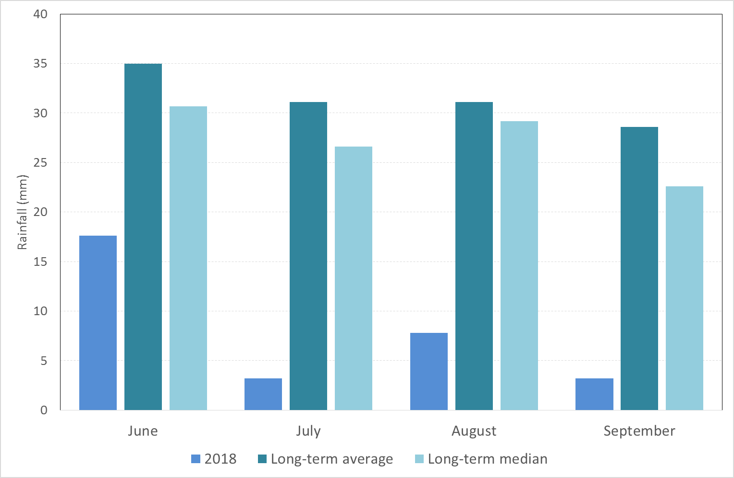

Figure 1. Rainfall at Hillston (075032) in the Lower Lachlan River Catchment for mid 2018 compared with the long term average monthly rainfall and the long term median monthly rainfall. Data from the Bureau of Meteorology.

Average daily maximum temperatures between June and September 2018 were slightly warmer than the long term averages (Figure 2). Whereas the average daily minimum temperatures were just slightly colder than the long term average (Figure 2), reflecting a greater diurnal range in temperatures often associated with dry conditions.

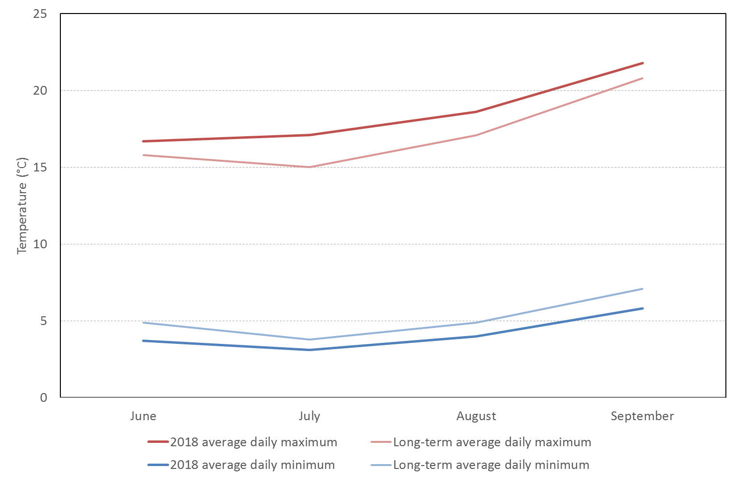

Figure 2. Maximum and minimum temperatures for mid 2018 at Hillston in the Lachlan River catchment comparing 2018 average daily temperatures with the long term average daily temperatures. Data from the Bureau of Meteorology.

1. Summary on progress against core monitoring and evaluation activities

|  |  |  |
| --- | --- | --- |
| ACTIVITIES | PROGRESS TO DATE | UPCOMING ACTIVITIES |
| *Monitoring activities* | | |
| Ecosystem type | * Data collection complete and suggested Australian National Aquatic Ecosystems (ANAE) types for all sites included in the Monitoring and Data Management System (MDMS) | * No more data collection required |
| Fish (river) | * 2017-18 fish sampling completed * Analysis completed * Fish community monitoring sites in the mid-Lachlan established | * Reporting |
| Fish (larvae) | * 2017-18 larval fish sampling completed * Larval fish sites in the mid-Lachlan established * Analysis completed | * Reporting * Monitoring of larval fish commences mid-October 2018 (at lower and mid reaches) |
| Waterbird breeding (optional) | * None | * None |
| Water quality and stream metabolism | * Logger data downloaded * Loggers downloaded and batteries changed August 2018 * Loggers deployed in mid-Lachlan at four sites | * Reporting * Maintenance of loggers and downloading of data |
| Vegetation diversity | * Data analysis | * Reporting * Spring Vegetation Sampling (November) |
| Frogs (optional) | * None | * None |
| *Evaluation activities* | | |
| Monitoring data entry | * Data entry continuing | * Data entry continuing |
| *Communication and engagement* | | |
| Selected Area Working Group (EWAG and TAG meetings) | * Annual forum attended * Attended Quarter 3 EWAG meeting in Forbes * Participated in several Fish flow TAG meetings - teleconferences | * Attend regular planning meetings |
| Project team teleconference | * Caught up with project team at annual forum | * None |
| Other Stakeholder Engagement | * The UC team (facilitated by OEH) contacted and met with landholders regarding the establishment of new monitoring sites in the mid-Lachlan * Two papers on LTIM research in the Lachlan were presented at conferences (Ecohydrology conference in Japan in August, AFSS conference in Australia in September) * LTIM funded activities and presenters for the NAIDOC Day celebrations in Hillston * LTIM information shared with anglers at the Hillston Hook Line and Sinker fishing festival | * To be developed in consultation with CEWO |

**Note:** for the Long-Term Intervention Monitoring (LTIM) Project, Lachlan River system selected area:

* **Appendix A** provides a summary of monitoring to be undertaken under the project from 2014-2019.

1. Observations
   1. Hydrology

Flow in the Lachlan River between April and the start of September was generally moderate, with the exception of extremely low flows in July at Cottons Weir (Forbes) and August around Willandra Weir downstream of Ganowlia Weir (Figure 3), associated with Jemalong Weir works (Figures 4, 5 and 6).

In spring 2018, Commonwealth environmental water was delivered to the Lachlan River, targeting outcomes for native fish and stream productivity in both the mid (Forbes) and the lower (Hillston) Lachlan River, and further on towards the end of system. The spring pulse passed Forbes in late August – early September, Hillston in mid-September and has just arrived at Booligal in late September (Figures 4, 5 and 6). Water from the Forbes environmental water order is being managed as a ‘run of river’ flow intended to reach the end of system.

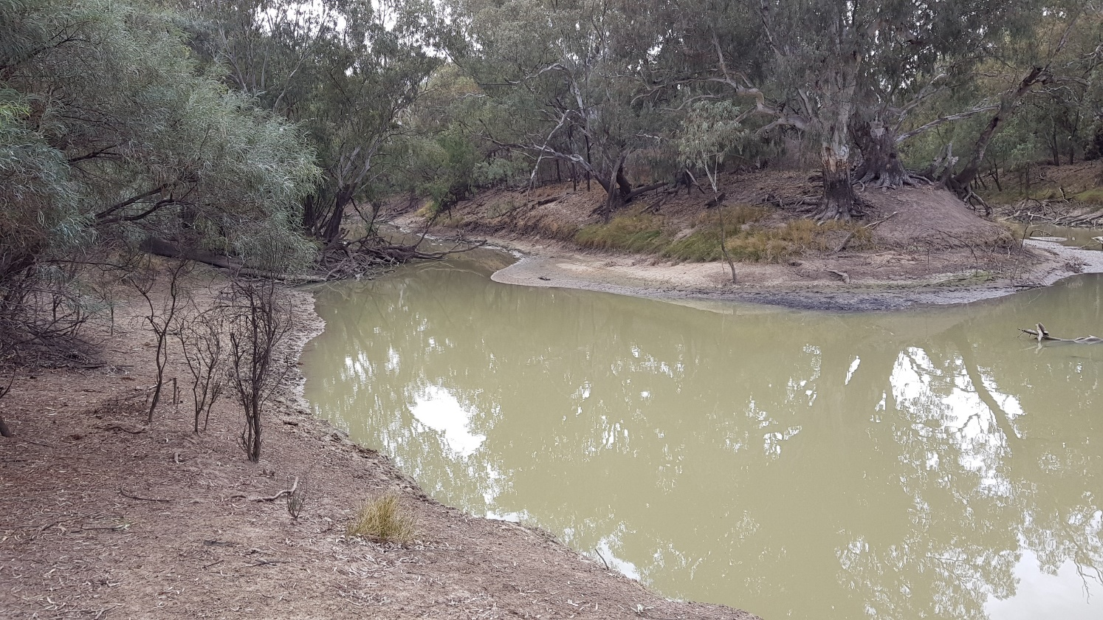

Figure 3. The Lachlan River downstream of Ganowlia Weir during a low flow period in July 2018 showing exposed benches with active algae growth (Photo: Ben Broadhurst).

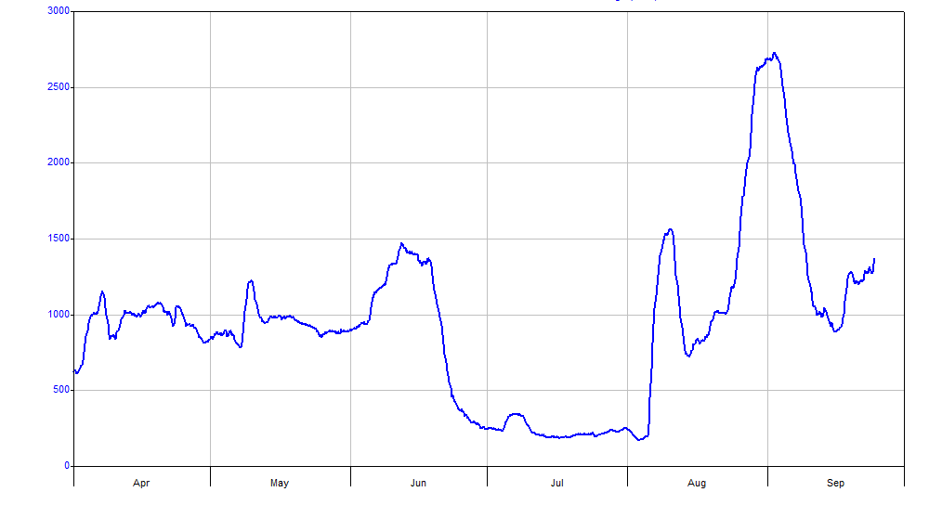

Figure 4. Flow in the Lachlan River recorded at the gauge at Cottons weir near Forbes (412004). Data from WaterNSW (<http://waterinfo.nsw.gov.au/>).

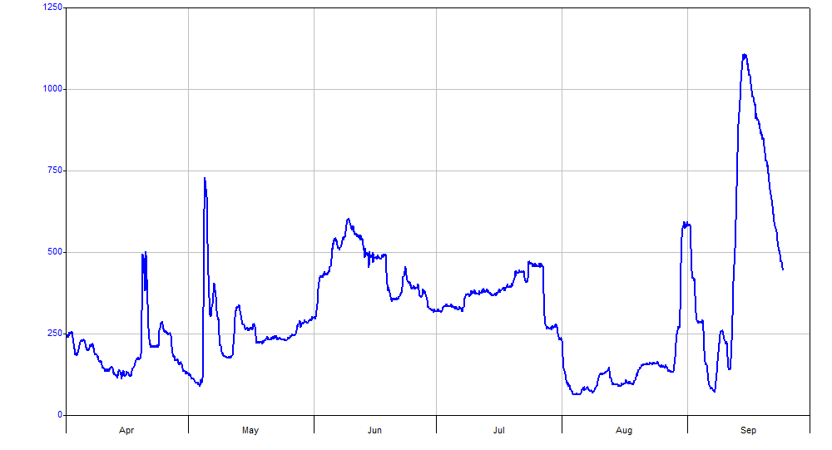

*Figure 5. Flow in the Lachlan River recorded at the gauge upstream of Willandra weir (412038). Data from WaterNSW (*[*http://waterinfo.nsw.gov.au/*](http://waterinfo.nsw.gov.au/)*).*

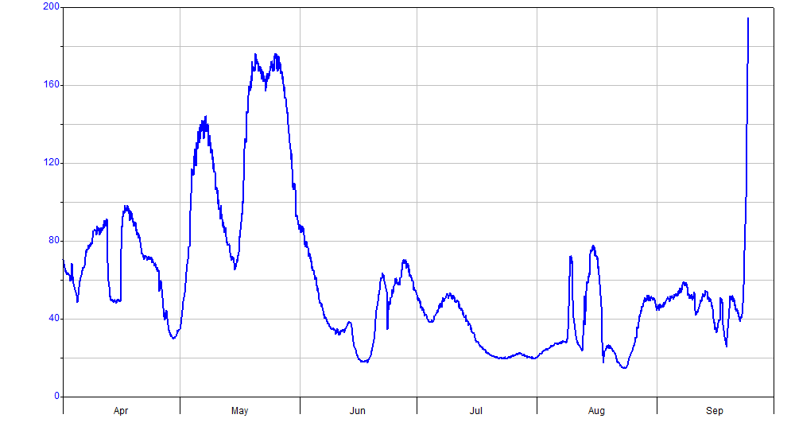

Figure 6. Flow in the Lachlan River recorded at the gauge at Booligal (412005). Data from WaterNSW (http://waterinfo.nsw.gov.au/).

* 1. Field observations

*Site establishment in mid-Lachlan*

As part of an extension of the LTIM monitoring activities into the mid-Lachlan River reach (between Forbes and Brewster Weir), 10 sites were inspected in August for their suitability as fish community, larval fish and stream metabolism monitoring sites for the 2018 – 2019 watering year. Stream metabolism logging stations (see Figure 7) were deployed at four sites.

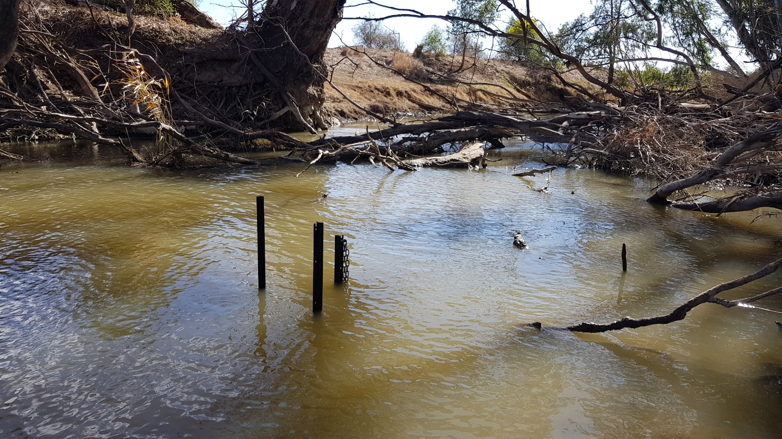

Figure 7. Stream metabolism logger newly deployed in the mid-Lachlan at Mulguthrie station (photo: Ben Broadhurst)

* 1. Communication and Engagement activities

Throughout July to September 2018, the lower Lachlan LTIM University of Canberra Team provided briefings and input into key planning environmental water forums, including the Lachlan Environmental Water Advisory Group (EWAG) meeting (19 September) and several Technical Advisory Group (TAG) teleconferences. This is the primary mechanism by which LTIM data and analysis informs real-time decision making or adaptive management in the Lachlan, and is also distributed to key stakeholders via the EWAG network.

These forums are organised by the Lachlan LTIM Communications and Engagement officer (C&E), who also promoted the LTIM project and outcomes so far at the following community events:

St Joseph's Primary School, Hillston, NAIDOC Day:

The LTIM project funded and organised activities and presenters for the 6th July NAIDOC Day celebrations. The C&E officer also ran a session on the parallels between traditional ecological knowledge and western science, and how they relate to the management of waterways for fish outcomes using examples from the LTIM project.

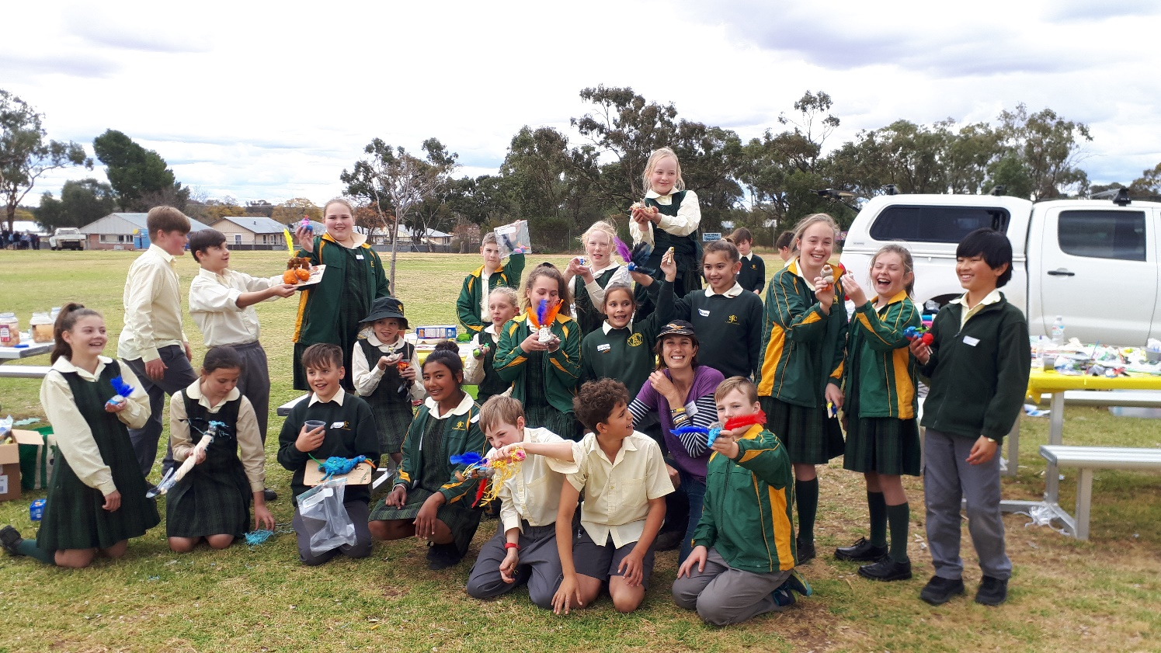

Figure 8. St Joseph’s Primary School, Condobolin, who hosted the Environment Day, proudly display the clay replica they made of their favourite waterbird in breeding plumage! (Photo: St. Joseph’s Primary School)

The LTIM project then worked with the Orange Cowra Cabonne Science Hub and Inspiring Australia to produce a 4 min Vodcast from the NAIDOC Day event which was well-received when shown during National Science Week community screenings of SCINEMA International Film Festival and on St Joseph’s Facebook page [https://vimeo.com/287378111] and [https://www.facebook.com/246801345763940/videos/ 225906861422636/].

25 Years Celebration of the Hillston Hook, Line and Sinker Fishing Festival:

As the majority of LTIM fish sampling sites were also within the fishing festivals geographical range, it was a great opportunity to highlight native fish values around Hillston, and how water for the environment (which is monitored by LTIM) has been used to support those values. Tanks displaying live native fish, such as freshwater catfish and olive perchlet, were very popular and had people asking lots of good questions! Larval catfish were caught by the LTIM team at Wallanthery and Hunthawang in November 2015.

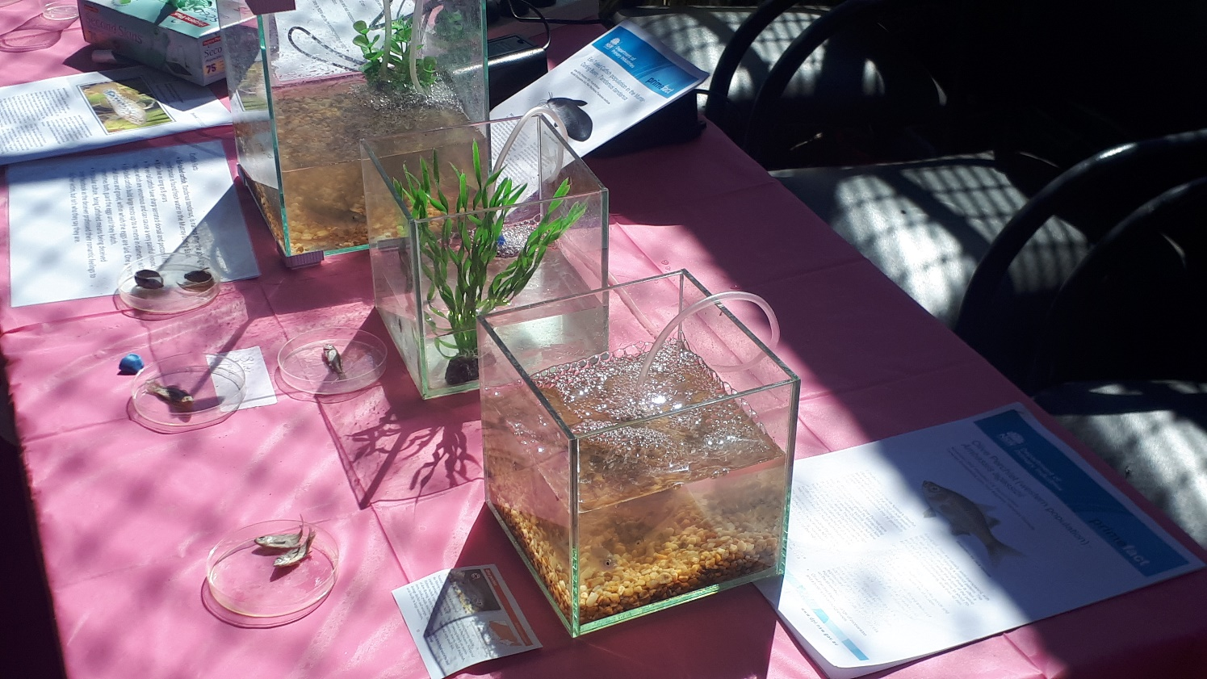

Figure 9. Hillston Hook Line and Sinker threatened species display, which featured species such as the olive perchlet (Ambassis agassizii) as the Hillston region has the only known population in the Lachlan, as well as freshwater catfish which LTIM confirmed breed in the area (Photo: Jo Lenehan).

Condobolin & Districts Primary Schools Environment Day

More than 240 students took part in Environment Day from 12 schools across the district including Tullamore, Tullibigeal, Bogan Gate, Trundle, Bedgerabong, Condobolin Primary and Condobolin MET School.  Being asked to run an activity entitled ‘Waterbirds, A Glorious and Gregarious Group’ provided another opportunity to engage primary school students in waterbird research and management using the LTIM’s monitoring of the largest straw-necked ibis breeding event recorded in the Lachlan (>100,000 nests) as a case study. https://www.facebook.com/stjosephscondobolin/photos /pcb.2342413589132409/ 2342413269132441/?type=3&theatre.

Booberoi Creek cultural-environmental flows

The LTIM’s support of the Booberoi Creek cultural–environmental flow has also continued to provide further opportunities for Ngiyaampaa Elders to reconnect with their country as they are the traditional owners of Booberoi Creek country. Similar to the experience on Toopuntul, the project has enabled family members of former owners to return to their family properties.

Research presentations

Research associated with LTIM activities was presented at two conferences on behalf of the LTIM team by selected area lead Fiona Dyer and by PhD students Will Higgisson and Foyez Shams. Fiona presented a paper entitled: *Wetland vegetation responses to environmental water and flooding: the lower Lachlan river system*, *Australia* at the Ecohydrology conference in Japan in August. Will presented a paper on the *Hydrological impacts of water resource development on floodplain vegetation communities of a boom and bust system*.

Fiona also presented a paper entitled: *Learning from Commonwealth environmental flows in the lower Lachlan: when no two years are the same* at the Australian Freshwater Sciences Society in September. The abstracts for these presentations are included at Appendix B.

Appendix A: The Long-Term Intervention Monitoring Project for the Lachlan River system and its context in terms of ecological monitoring and evaluation within the Murray-Darling Basin.

The Long Term Intervention Monitoring (LTIM) Project for the Lachlan river system selected area is funded by the Commonwealth Environmental Water Office. The project is being delivered by a consortium of service providers lead by University of Canberra and includes NSW Office of Environment and Heritage, NSW Department of Primary Industries (Fisheries), NSW Department of Primary Industries (Office of Water), University of New South Wales and Charles Sturt University.

The LTIM project is based on a clear and robust program logic, as detailed in the [Long-Term Intervention Monitoring Project Logic and Rationale Document](http://www.environment.gov.au/water/cewo/publications/long-term-intervention-monitoring-project-logic-and-rationale-document). That document sets out the scientific and technical foundations of long-term intervention monitoring and is being applied to areas where LTIM projects are being undertaken. It also provides links between Basin Plan objectives and targets to the monitoring of outcomes from Commonwealth environmental watering actions. For more information, see [Monitoring and evaluation for the use of Commonwealth environmental water](http://www.environment.gov.au/topics/water/commonwealth-environmental-water-office/monitoring-and-evaluation).

Many different agencies play a role in the reporting on environmental outcomes, consistent with the Basin Plan (see figure 1 below). The Murray Darling Basin Authority is responsible for reporting on achievements against the environmental objectives of the Basin Plan at a basin-scale, which are broadly focussed on flows and water quality, fish, vegetation and birds across the whole of the Basin. State Governments are responsible for reporting on achievements against the environmental objectives of the Basin Plan at an asset-scale i.e. rivers, wetlands, floodplains. The Commonwealth Environmental Water Holder is responsible for reporting on the contribution of Commonwealth environmental water to the environmental objectives of the Basin Plan (at multiple-scales).

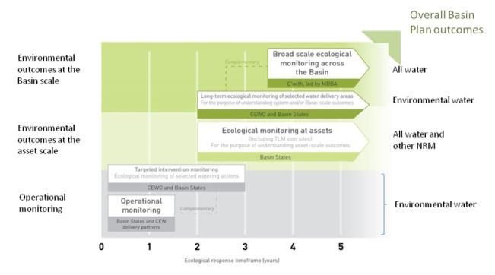

Figure 11. A summary of roles various agencies play a in the reporting on environmental outcomes, consistent with the Basin Plan.

Hydrological zones and monitoring sites of the lower Lachlan for the Long-Term Intervention Monitoring Project.

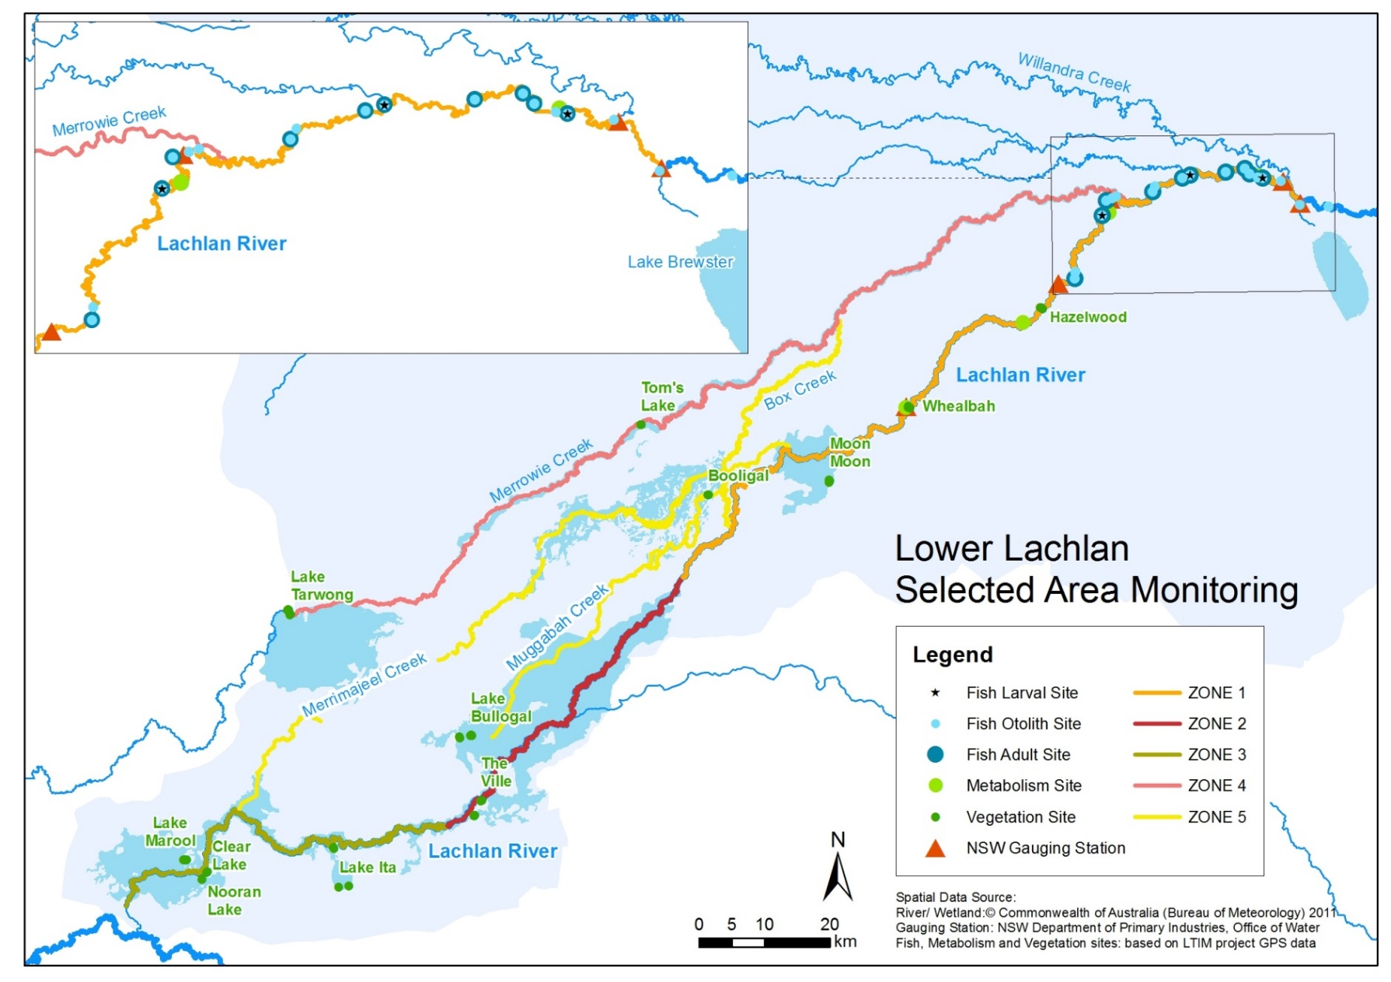

*Figure 12. Lower Lachlan LTIM monitoring sites, hydrological zones and NSW gauging stations*

Monitoring to be undertaken in the Lachlan system for the Long Term Intervention Monitoring Project from 2014-2019

The five year monitoring schedule has been based around the expected watering options and is focussed on the monitoring of Basin Indicators. Monitoring effort is consistent across the five years with the exception of monitoring Waterbird Breeding and Frogs which are options that can be implemented on request from the CEWO.

|  | ZONE | Data contributes to the Evaluation of responses to Commonwealth environmental watering | | monitoring frequency | sites | expected schedule |
| --- | --- | --- | --- | --- | --- | --- |
|  |  | Selected Area | Whole of Basin Scale |  |  |  |
| Ecosystem type | All | ✓ | ✓ | Once only | All sites for other indicators | Establishment of ANAE type at the start of the LTIM Project. Expected August-December 2014 |
| Riverine fish | 1 | ✓ | ✓ | ANNUAL | Basin Evaluation: 10 fixed sites within Zone 1 | Annual sampling between March and May |
| Larval fish | 1 | ✓ | ✓ | ANNUAL | 3 fixed riverine sites in Zone 1 | Annual sampling 5 times during breeding season (September to February) |
| Stream metabolism | 1 | ✓ | ✓ | CONTINUOUS  REGULAR | Four fixed sites matched to riverine fish sampling sites in Zone 1 | Continuous monitoring of dissolved oxygen and temperature.  6 weekly sampling of nutrients and water quality attributes. |
| Hydrology (River) | 1 | ✓ | ✓ | CONTINUOUS | Gauging sites |  |
| Vegetation diversity and condition | All | ✓ |  | ANNUAL & EVENT BASED | 12 fixed sites | Before and after watering (expected to be April/May and 3 months after first fill) |
| Waterbird breeding (Option) | 1 | ✓ |  | EVENT-BASED (on request from the CEWO) | One fixed site – Booligal wetland | Fortnightly surveys of bird breeding triggered by breeding events in Booligal wetland. |
| Frogs (Option) | All | ✓ |  | EVENT-BASED (on request from the CEWO) | 15 sites comprising 2 to 8 wetland sites and 2 to 7 riverine sites depending on watering targets | 3 sampling events between August and February (one sample in each of winter, spring and summer). |
| Hydrology (wetland – Option) |  | ✓ |  | EVENT-BASED (in conjunction with Waterbird Breeding or Frog monitoring) | Cameras at 6 roving wetland sites | Cameras installed prior to targeted watering each year and downloaded after the watering event has passed |

Conference Abstracts: Presented at the International Society for Ecohydraulics Conference, Tokyo, Japan August 2018

**wetland vegetation responses to environmental water and flooding: the lower Lachlan river system, Australia**

Fiona Dyer

*Institute for Applied Ecology, University of Canberra,   
Bruce, ACT, 2617, Australia*

Alica Tschierschke

*Institute for Applied Ecology, University of Canberra,   
Bruce, ACT, 2617, Australia*

Will Higgisson

*Institute for Applied Ecology, University of Canberra,   
Bruce, ACT, 2617, Australia*

Sharon Bowen

*Water, Wetlands and Coasts Science Branch, NSW Office of Environment and Heritage,  
Sydney, NSW, 2000 Australia*

Patrick Driver

*Water, Crown Lands and Water Division, NSW Department of Industry,  
Orange, NSW, 2800, Australia*

Jane Roberts

*PO Box 6191,  
Canberra, ACT, 2602, Australia*

**ABSTRACT**

Riparian and wetland plants have evolved within the context of the hydrological regimes they experience. They have developed specific reproductive characteristics, growth forms and dispersal mechanisms that enable them to flourish and persist within certain hydrological environments. As a result, the diversity, type and condition of riparian and wetland vegetation communities are strongly influenced by the frequency, duration and timing of inundation [1, 2]. The alteration of flow regimes, because of the combined effects of flow regulation and abstraction, have had widespread and significant effects on the health of riparian and wetland vegetation [3, 4], particularly in arid and semi-arid environments [5]. To address these effects, environmental flows are often used to try to improve vegetation condition and diversity [6].

The rivers of the Murray Darling Basin, Australia have been extensively regulated to provide water for human and economic needs. This has led to major changes in flow regimes with subsequent degradation of the ecological condition and character of rivers, floodplains and wetlands [7], including many significant floodplain and wetland vegetation communities [7, 8]. In response, Australian governments have invested in providing water to support environmental outcomes, including maintaining the extent and improving the condition of riparian and wetland vegetation [9].

The Lachlan river system, in semi-arid NSW, Australia, forms part of the Murray Darling basin. The river travels nearly 1400 km and, in most years, the river terminates in the Great Cumbung Swamp. The flow in the river is regulated using major dams, off stream storages and weirs which have significantly modified the hydrological regime [10]. The catchment of the Lachlan river contains many sites of high-value wetland plant communities and substantial areas of riparian fringing river red gum forest (*Eucalyptus camaldulensis*) and woodland, particularly in the lower reaches [10]. The Australian Government, through the Commonwealth Environmental Water Office (CEWO), use environmental flows to maintain and improve the riparian and wetland vegetation of the Lower Lachlan river system.

To evaluate the response to the provision of environmental water, as part of the CEWO’s Long Term Intervention Monitoring Project, we monitored the diversity and condition of riparian and wetland vegetation in spring and autumn from 2014 to 2017 at 13 sites in the Lower Lachlan Catchment. The vegetation monitoring sites were selected to provide a sample from the different vegetation communities distributed across wetlands and riparian zones with different environmental watering probabilities [11]. At each site, species abundance and cover were recorded as well as measures of stand and tree condition (basal area, canopy openness, canopy extent, live/dead limbs).

The climate conditions combined with water availability dictated the amount of environmental water used for vegetation outcomes in each year. The three years of monitoring encompass vastly different climate and hydrological conditions. In the first year (2014-15) conditions were dry and a small watering action was delivered to provide connection to support reed beds in the Great Cumbung Swamp. In 2015-16, a greater availability of water enabled the delivery of watering actions designed to support wetland vegetation. These were accompanied by other flows which raised water levels in the main channel and inundated a number of wetlands. In 2016-17, the river system experienced the fourth largest flood on record which meant that Commonwealth environmental water use was limited and all sites were inundated for extended periods of time. This paper reports observations of the vegetation responses to the range of different inundation conditions experienced.

The floodplain and wetland vegetation communities of the Lower Lachlan river system display sequences of dry and wet phases depending on regional climatic conditions. In 2014-15, conditions were dry and the sites were dominated by short, terrestrial vegetation species, mainly chenopods such as creeping saltbush (*Atriplex semibaccata*), brassicas such as smooth mustard (S*isymbrium erysimoides*) and grasses. In 2015-16, large numbers of annual species such as burr medic (*Medicago polymorpha*), fumitories (Fumaria sp) and common twinleaf (*Zygophyllum apiculatum*) responding to the wetter conditions. The short duration inundation of some sites resulted in the appearance of species which are more adapted to damp conditions such as native mint (*Mentha australis*), nardoo (*Marsilea drumondii*), lippia (*Phyla nodiflora*) and swamp daisy (*Brachyscome basaltica*). Sites that were inundated also displayed an improvement in the condition of the fringing tree community.

The major flooding in 2016-17 produced a distinct response in the vegetation and a strong interplay between the geomorphic template and the response of the vegetation to water was observed. The watering of sites that are periodically inundated to more than 0.4 m resulted in the appearance of new growth forms such as floating plant species such as azolla (*Azolla filiculoides*) and duck weed (*Lemna minor*), the elimination of all short and terrestrial species, and an improvement in the condition of the fringing river red gum woodland. At these sites, following recession of water a low diversity of amphibious species colonized the soil, dominated by common sneeze weed (*centipeda cunninghamii*) and damascisa (*Glinus lotoides*). These sites are generally low lying open water sites that are relatively easy to provide with environmental water but have a limited vegetation diversity response. In contrast, sites which are higher in the landscape showed a marked response to shallow (<0.4 m) flooding with the appearance of a large number of aquatic and amphibious plants such as common spike rush (*Eleocharis acuta*), small flower umbrella sedge (*Cyperus difformis*), marsh club-rush (*Bolboschoenus fluviatalis*), water ribbons (Triglochin spp.) and star fruit (*Damasonium minus*), as well as an improvement in tree condition. Many of these sites are unable to be watered with environmental water and require large natural floods for inundation.

These findings have important implications for the establishment of site based vegetation diversity objectives for environmental watering in the Lower Lachlan and similar catchments. The greatest opportunity to observe a vegetation diversity outcome is at sites that are able to receive a shallow watering with environmental water. These include some ecologically significant wetland sites for which we have very little historical hydrological or vegetation data that could be used to identify environmental watering needs. The challenge at these sites is to identify the duration of flooding and frequency of flooding required to support the vegetation community.

**Acknowledgments**

This research is funded by the Commonwealth Environmental Water Office through the Long Term Intervention Monitoring Project. The authors thank the owners and managers of the land on which the research has been conducted.

**references**

1. Brock, M. and Casanova, M. “Plant life at the edge of wetlands: ecological responses to wetting and drying patterns” In *Frontiers in Ecology: Building the Links*, (Eds N. Komp & I. Lunt) (1997) pp 181-192. Elsevier Science, Oxford.
2. Nilsson, C. and Svedmark, M. “Basic Principles and Ecological Consequences of Changing Water Regimes: Riparian Plant Communities” *Environmental Management*, Vol. 30, No. 4, (2002), pp 468-480.
3. Nilsson, C. and Berggren, K. “Alterations of Riparian Ecosystems Caused by River Regulation” *BioScience*, Vol. 50, No. 9, (2000), pp 783-792.
4. Horner, G.J., Baker, P.J., MacNally, R., Cunningham, S.C., Thomson, J.R. and Hamilton, F. “Mortality of developing floodplain forests subjected to a drying climate and water extraction” *Global Change Biology*,. Vol. 15, No. 9, (2009), pp. 2176-2186.
5. Busch, D.E. and Smith, S.D. “Mechanisms associated with decline of woody species in riparian ecosystems of the Southwestern U.S.” *Ecological Monographs*, Vol. 65, No. 3, (1995) pp 347-370.
6. Merritt, D.M., Scott, M.L., Poff, L.N., Auble, G.T. and Lytle, D.A. “Theory, methods and tools for determining environmental flows for riparian vegetation: riparian vegetation‐flow response guilds” *Freshwater Biology*, Vol. 55, No. 1, (2010), pp 206-225.
7. Kingsford, R.T., Ecological impacts of dams, water diversions and river management on floodplain wetlands in Australia. *Austral Ecology*, Vol. 25, No. 2, (2000), pp 109-127.
8. MacNally, R., Cunningham, S.C., Baker, P.J., Horner, G.J. and Thomson, J.R. “Dynamics of Murray‐Darling floodplain forests under multiple stressors: The past, present, and future of an Australian icon” *Water Resources Research*, Vol. 47, No. 12, (2011), doi:10.1029/2011WR010383
9. MDBA, “*Basin-wide Environmental Watering Strategy”* Murray-Darling Basin Authority, (2014) *https://www.mdba.gov.au/sites/default/files/pubs/Final-BWS-Nov14_0816.pdf*
10. Green, D., Petrovic, M., Moss, P. and Burrell, M. “*Water resources and management overview: Lachlan catchment*” NSW Office of Water, Sydney, (2011). *http://www.water.nsw.gov.au/__data/assets/pdf_file/0009/547884/catchment_overview_lachlan.pdf*
11. Dyer F., Broadhurst B., Thompson R., Jenkins K., Driver P., Saintilan N., Bowen S., Packard P., Gilligan D., Brandis K., Amos C., Hall A. and Lenehan J. “*Commonwealth Environmental Water Office Long Term Intervention Monitoring Project. Lachlan river system*” Commonwealth Environmental Water Office, University of Canberra, (2014).

**HYDROLOGICAL IMPACTS OF WATER RESOURCE DEVELOPMENT ON FLOODPLAIN VEGETATION COMMUNITIES OF A BOOM AND BUST SYSTEM**

WILLIAM HIGGISSON  
*Institute for Applied Ecology, University of Canberra,  
University Drive, Bruce, ACT, 2617, Australia*

BRIAN HIGGISSON  
*Private Consultant*

FIONA DYER   
*Institute for Applied Ecology, University of Canberra,  
University Drive, Bruce, ACT, 2617, Australia*

**1 ABSTRACT**

Floodplains and their associated wetlands are important features of semi-arid and arid riverine landscapes [1]. Floodplains are characterised by large changes in water availability driven by episodic flood pulses [2]. Inundation by flooding maintains the ecological integrity, form, and functioning of floodplains, by providing water to the floodplain. This facilitates the exchange of water, living organisms and resources (inorganic and organic matter) between the main channel of the river and the floodplain [3]. The flow regime of Australian rivers is neither annual nor wholly seasonal, but is related to unpredictable rainfall patterns and thus floodplain inundation is typically irregular and erratic in time and space [4]. Inundation varies spatially across floodplains with surface topography producing varied depths and duration of inundation [5]. This temporal and spatial variability in flooding, creates habitat heterogeneity on floodplains, and structures community assemblages [6]. This natural variability also creates more challenges with the detection of significant human-caused hydrological trends against this highly variable flow background.

The type of vegetation communities which occur on floodplains and in wetlands are related to variation in tolerance to the stresses of flooding and drought among floodplain plant species [2] and therefore also provide a logical basis for the definition of ecological types that are logical units for hydrological analysis. On the floodplains of the Murray Darling Basin, Australia, important floodplain communities include: open water wetlands, river red gum (*Eucalyptus camaldulensis*) forests, black box (*Eucalyptus largiflorens*) woodlands, and lignum (*Duma florulenta*) shrublands. These communities provide critical aquatic and riparian habitat in an otherwise arid-landscape [7], and species living in these floodplain communities require flooding for reproduction and survival [8, 9].

Water resource developments, such as damming, river regulation, and flow extraction have intensified across the Murray Darling Basin over the past century (Kingsford, 2000). These developments have reduced flow peaks in most rivers across the Murray Darling Basin [10], which has disrupted the natural flood regime of rivers and their associated floodplains, and reduced the frequency, extent and duration of floodplain inundation [11]. Changes in flooding regimes as a consequence of water resource development are unlikely to be uniform across the flow related gradients of flood frequency and duration.

The objectives of this study were to: (i) characterise the flooding regime of floodplain communities in the lower Lachlan Catchment, (ii) identify and compare changes in flooding characteristics that have occurred as a consequence of water resource development, and (iii) discuss the implications of these changes for floodplain wetland vegetation communities. This study focused on four floodplain community types (open water wetlands, river red gum forests, black box woodlands, and lignum shrublands).

Modeled flow data for the Lachlan River (from 1895 to 2015) were obtained from New South Wales Department of Primary Industries under current conditions and reference (without development) conditions. The current conditions include all water supply infrastructure and irrigation extractions while the without development conditions have all water management infrastructure and water extraction activities removed.

A total of 19 sites were assessed across the lower Lachlan Catchment, NSW. The Lachlan Catchment forms a part of the Murray Darling Basin. Floodplain vegetation communities in the lower reaches of the Lachlan River, were defined according to their dominant tree species and hydrological regime and GPS co-ordinates representing a 50 m X 20 m quadrate taken at each site. These were used to obtain a count of wetted pixel observations from all available landsat (satellite) images (1986-2016). This data was used to determine inundation thresholds which were used to generate inundated/non-inundated binary data. A detailed methodology of the data collection from satellite imagery can be found in Powell *et al.* [12]. Using these datasets and river gauge daily flow data for the Lachlan River from the nearest gauge to each site, commence to fill (being the reference flow at a gauge on the river at which a site starts to flood) was determined. These values were verified through communications with regional water managers and a review of the literature.

Floodplain communities of the lower Lachlan Catchment are flooded (i.e. commence to fill exceeded) less frequently under current flow conditions having been reduced by about half compared to flow conditions without development. The frequency of inundation events (i.e. average number of days between flooding events) has been reduced on average by 63% under current conditions. Vegetation communities on lower parts of the floodplain which naturally flood more frequently, such as open water wetlands, have been impacted to the greatest extent, with the largest reduction in flooding frequency, while communities (such as black box woodlands) which occur on the floodplain margins and naturally flood less frequently demonstrated the least change in flood frequency. We have used Moon Moon Swamp as an example to illustrate these changes. Moon Moon Swamp in the lower Lachlan Catchment is a river red gum forest, recognised as a regionally significant wetland for its contribution to the Lachlan landscape and biota [13]. Our results show that Moon Moon Swamp is flooded 43% less under current conditions (51 days per year) compared to natural conditions (89 days per year) (Figure 1). The frequency of inundation events at Moon Moon Swamp has been substantially reduced, occurring nearly three times less often under current conditions (every 210 days), compared with natural conditions (every 72 days).

Figure 1. Modelled flow of the Lachlan River at Whealbah gauging station without development (grey) and under current flow rates (black) between 2000 and 2010. Dotted horizontal line represents the river level required to commence to fill Moon Moon Swamp.

River regulation and flow extraction have reduced the occurrence and frequency of flood events on the floodplains of the lower Lachlan Catchment. This is particularly evident in communities which occur in lower lying areas of the floodplain. This is a consequence of the reduction in small and medium sized floods under current flow conditions, relative to large floods which have been affected to a lesser degree. These changes to the flooding regime put immense pressure on the community assemblages and may cause individual species to contract or expand on floodplains according to their inundation requirements [6]. This study used a pragmatic approach, combining the analysis of long-term data sets, aerial imagery and field surveys, to provide insight in to the implications of water resource development on the floodplain communities of the Murray Darling Basin. The results provide a valuable resource to water resource managers on the management of floodplain communities and in the allocation of environmental flows.

**2 REFERENCES**

1. Hughes, F., *The ecology of African floodplain forests in semi-arid and arid zones: a review.* Journal of Biogeography, 1988: p. 127-140.

2. Ward, J., K. Tockner, and F. Schiemer, *Biodiversity of floodplain river ecosystems: ecotones and connectivity.* Regulated Rivers: Research & Management, 1999. **15**(1): p. 125-139.

3. Amoros, C. and G. Bornette, *Connectivity and biocomplexity in waterbodies of riverine floodplains.* Freshwater Biology, 2002. **47**(4): p. 761-776.

4. Stanford, J.A. and J. Ward, *An ecosystem perspective of alluvial rivers: connectivity and the hyporheic corridor.* Journal of the North American Benthological Society, 1993. **12**: p. 48-60.

5. Scown, M.W., M.C. Thoms, and N.R. De Jager, *Floodplain complexity and surface metrics: Influences of scale and geomorphology.* Geomorphology, 2015. **245**: p. 102-116.

6. Roberts, J., M. Colloff, and T. Doody, *Riverine vegetation of inland south‐eastern Australia*, in *Vegetation of Australian Riverine Landscapes: Biology, Ecology and Management*, S. Capon, C. James, and M. Reid, Editors. 2016, CSIRO: Melbourne. p. 177-199.

7. Briggs, S., J. Seddon, and S. Thornton, *Wildlife in dry lake and associated habitats in western New South Wales.* The Rangeland Journal, 2000. **22**(2): p. 256-271.

8. Roberts, J. and F. Marston, *Water Regime for Wetland and Floodplain Plants: A Source Book for the Murray-Darling Basin*. 2011, Canberra, ACT, Australia: National Water Commission.

9. Rogers, K. and T.J. Ralph, *Floodplain wetland biota in the Murray-Darling Basin: water and habitat requirements*. 2011, Victoria: CSIRO.

10. Leblanc, M., et al., *A review of historic and future hydrological changes in the Murray-Darling Basin.* Global and Planetary Change, 2012. **80**: p. 226-246.

11. Kingsford, R.T., *Ecological impacts of dams, water diversions and river management on floodplain wetlands in Australia.* Austral Ecology, 2000. **25**(2): p. 109-127.

12. Powell, M., et al., *NSW Wetland Inventory: Pilot study mapping and classification method statement. Draft Report for NSW Office of Environment and Heritage.* NSW Wetland Inventory: Pilot study mapping and classification method statement, 2016. **2**: p. 3.

13. SEWPaC, *Environmental Water Delivery: Lachlan River. Prepared for Commonwealth Environmental Water, Department of Sustainability, Environment, Water, Population and Communities*. 2011: Commonwealth Environmental Water Holder for the Australian Government.

Conference Abstracts: Presented at the Australian Freshwater Sciences Society Conference, Adelaide, September 2018

Learning from Commonwealth environmental flows in the lower Lachlan: when no two years are the same.

**Fiona Dyer**, Ben Broadhurst, Ross Thompson, Alica Tschierschke, Joanne Lenehan, Jason Thiem, Sharon Bowen, Patrick Driver, Ebony Mullin and Damian MacRae

The lower Lachlan river system is one of seven selected areas monitored as part of the Commonwealth Government’s Long Term Intervention Monitoring (LTIM) program. The hydrology of the lower Lachlan is highly variable and unpredictable. In the four years of monitoring the lower Lachlan has experienced vastly different climate conditions and environmental water delivery. In the first year of monitoring (2014-15) conditions were dry and a small watering action was delivered to achieve modest environmental outcomes. In 2015-16, a greater availability of water enabled the delivery of three watering actions designed to achieve a broad suite of environmental outcomes. These were accompanied by translucent flows (planned environmental water) which provided water into a number of wetlands. In 2016-17, widespread flooding across the Lachlan river system meant that environmental water use was limited and focused on the protection of vulnerable populations, including supporting bird breeding. In the fourth year of monitoring (2017-18) Commonwealth environmental water use was used to support the recovery of native fish populations which had been adversely affected by blackwater associated with the 2016-18 flooding. The observed responses to natural flood events and translucent flows were far greater than those achieved with purchased environmental water. Environmental watering in the Lachlan has been successful in achieving modest site-based outcomes that differ on a yearly basis which clearly reflects the relative volumes of water used and a targeted delivery approach. In systems such as the lower Lachlan river system that experience highly variable flows, understanding the ecological significance of small and moderate sized flow events remains a challenge. Addressing this will help better optimize the use of environmental water for ecological outcomes.

Genetic variation and gene-flow patterns in *Duma florulenta* (tangled lignum) and *Acacia stenophylla* (river cooba) across a large inland floodplain

**William Higgisson** [1](https://members.asnevents.com.au/event/1550/abstract/55229/view#affiliation_90430) , Dianne Gleeson [1](https://members.asnevents.com.au/event/1550/abstract/55229/view#affiliation_90430) , Fiona Dyer [1](https://members.asnevents.com.au/event/1550/abstract/55229/view#affiliation_90430)

*Institute For Applied Ecology, University Of Canberra, Canberra, ACT - Australian Capital Territory, Australia*

Gene-flow is a key evolutionary driver of spatial genetic structure. Spatial patterns in genetic structure reflect demographic processes and dispersal mechanisms. Thus, understanding how genetic structure is maintained across a landscape can assist in setting conservation priorities. In Australia, floodplains naturally experience a highly variable flooding regime, which structures the vegetation communities. Temporal variability in flooding, and spatial variability in topography, means communities on floodplains are often spatially and temporally discrete. Flooding plays an important role, connecting communities on floodplains, through enabling dispersal via hydrochory. Water resource development has changed the lateral-connectivity of floodplain-river systems. One possible consequence of these changes is the reduced physical and subsequent genetic connections. This study aims to identify and compare the population structure and dispersal patterns of lignum (*Duma florulenta*) and river cooba (*Acacia stenophylla*), across a large inland floodplain using a landscape genetics approach. Both species are widespread throughout flood prone areas of arid and semi-arid Australia. Leaves were collected from 144 lignum plants across 10 sites and 84 river cooba plants across six sites, on the floodplain of the lower Lachlan Catchment, NSW. DNA was extracted and genotyped using DArTseq platforms. Genetic diversity and differentiation were compared with geographic distance and flooding frequency. It was found that genetic connectivity increased with increasing flooding frequency in lignum but not in river cooba. In lignum, sites that experience more frequent flooding had higher levels of genetic diversity and were more genetically homogenous. There was also an isolation by distance effect where increasing geographic distance correlated with increasing genetic differentiation in lignum, but not in river cooba. Waterbirds may play an important role in the dispersal of lignum, as water dispersal alone does not explain connectivity between patches. These data demonstrate how genetic patterns can highlight influential mechanisms over species distribution and persistence on floodplains.

Population Genetic Structure and Breeding Activity of Two Native Fish Species (Golden Perch and Murray Cod) From a Managed Catchment: A Case Study from the Lachlan River

**Foyez Ibn Shams**, Fiona Dyer, Ross Thompson, Richard Duncan, Jason Thiem and Tariq Ezaz

Email: foyez.shams@canberra.edu.au

Golden perch (*Macquaria ambigua*) and Murray cod (*Maccullochella peelii*) are two Australian native freshwater fish species widely distributed in the Murray Darling basin. Both of them are important angling fish but wild populations have been declining for the last few decades due in part to altered hydrologic regimes and construction of dams and weirs. Measures in the Murray Darling basin to conserve these species include widespread stocking of rivers from hatchery raised fish. The Lachlan river has a very dynamic flow regime due to altered hydrology, and large numbers of hatchery raised golden perch and Murray cod have been released into the river every year since 1984. It is now unclear whether a wild breeding population of these two species still occurs in the Lachlan river or whether the current population is maintained by stocking. In this study, we performed a genetic analysis of golden perch and Murray cod including population genetic structure and the contribution of stocking to populations in the Lachlan river. Our analysis suggests a low level of genetic diversity and limited evidence of breeding activity of golden perch in the catchment. Furthermore, genetic data of Murray cod form different sections of Lachlan catchment also showed limited structuring and marginal variation within individual from the catchment and between Lachlan and hatchery sourced fish. Based on the outcome of genetic analysis we are currently examining otolith microchemistry to evaluate natal origins of stocked fish.

Key words: Genetic structure, Relatedness, Murray Darling Basin.

1. Median rainfall is the mid-point of all observed rainfall records when they are sorted in order of magnitude. The median is the preferred measure of 'typical' rainfall from a meteorological point of view. This is because of the high variability of rainfall; one extreme rainfall event will have less effect on the median than it will have on the arithmetic mean.