Commonwealth environmental water office

Long term intervention monitoring project:

Lower Lachlan river system

2015-16 synthesis report

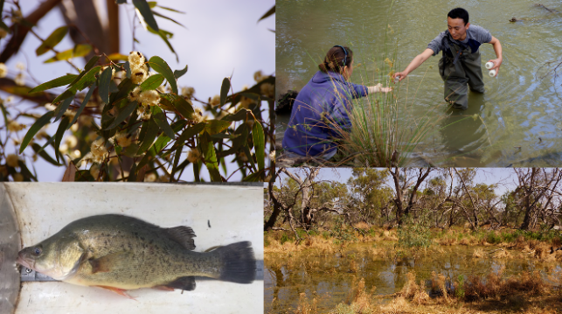

25 November 2016

**Commonwealth Environmental Water Office**

**Long Term Intervention Monitoring Project**

**Lower Lachlan river system 2015-16 Synthesis Report**

**Final November 2016**

This document has been co-ordinated by Dr Fiona Dyer and includes contributions from Mr Ben Broadhurst, Ms Alica Tschierschke, Professor Ross Thompson (University of Canberra); Dr Patrick Driver (NSW Department of Primary Industries, Water); Dr Joanne Lenehan, Dr Sharon Bowen and Mr Paul Packard (NSW Office of Environment and Heritage); Dr Jason Thiem and Mr Martin Asmus (NSW Department of Primary Industries, Fisheries), Dr Skye Wassens and Dr Amelia Walcott (Charles Sturt University).

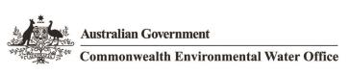 

C:\Users\s650370\AppData\Local\Microsoft\Windows\Temporary Internet Files\Content.Word\LLS logo colour rgb.jpg G:\Fishnet\Research Projects\Logos\DPI logo colour rgb.jpg http://data.nsw.gov.au/data/images/Office-of-Environment-and-Heritage.jpg



This monitoring project was commissioned and funded by Commonwealth Environmental Water Office with additional in-kind support from the University of Canberra, NSW Office of Environment and Heritage, and Department of Primary Industries.

**Copyright**© Copyright Commonwealth of Australia, 2016



**Commonwealth Environmental Water Office Long Term Intervention Monitoring Project: Lower Lachlan river system Selected Area** is licensed by the Commonwealth of Australia for use under a Creative Commons By Attribution 3.0 Australia licence with the exception of the Coat of Arms of the Commonwealth of Australia, the logo of the agency responsible for publishing the report, content supplied by third parties, and any images depicting people. For licence conditions see: <http://creativecommons.org/licenses/by/3.0/au/>

This report should be attributed as: Dyer, F., Broadhurst, B., Tschierschke, A., Thiem, J., Thompson, R., Driver, P., Bowen, S., Asmus, M, Wassens, S., and Walcott, A. (2016). Commonwealth Environmental Water Office Long Term Intervention Monitoring Project: Lower Lachlan river system Selected Area 2015-16 Monitoring and Evaluation Synthesis Report. Commonwealth of Australia, 2016.

The Commonwealth of Australia has made all reasonable efforts to identify content supplied by third parties using the following format ‘© Copyright, [name of third party] ’.

**Disclaimer**

The views and opinions expressed in this publication are those of the authors and do not necessarily reflect those of the Australian Government or the Minister for the Environment and Energy.

While reasonable efforts have been made to ensure that the contents of this publication are factually correct, the Commonwealth does not accept responsibility for the accuracy or completeness of the contents, and shall not be liable for any loss or damage that may be occasioned directly or indirectly through the use of, or reliance on, the contents of this publication.

Inquiries regarding this document should be addressed to:

Dr Fiona Dyer  
Phone: 02 6201 2452  
e-mail: Fiona.Dyer@canberra.edu.au

|  |  |  |  |  |  |
| --- | --- | --- | --- | --- | --- |
| **Document history and status** | | | | | |
| **Version** | **Date Issued** | **Issued to** | **Reviewed by** | **Approved by** | **Revision Type** |
| Draft for review | 10 Aug 2016 | Jane Roberts | Project Team | Fiona Dyer | Nil |
| DRAFT | 31 Aug 2016 | CEWO | Jane Roberts | Fiona Dyer | External |
| Penultimate | 30 Oct 2016 | CEWO | CEWO | Fiona Dyer | External |
| **FINAL** | 9 Feb 2017 | CEWO | CEWO | Fiona Dyer | External |

Front cover photos: Top left Redgum Murrumbidgil Swamp; Top right Water quality sampling; Bottom left Golden Perch; Bottom right: Murrumbidgil Swamp. Photos by Fiona Dyer and Jason Thiem

**TABLE OF CONTENTS**

1 Introduction 13

2 Lower Lachlan river system – Selected Area 14

3 Commonwealth environmental watering actions 2015‑16 15

3.1 Climate and water context 15

3.1.1 Catchment and climate conditions 15

3.1.2 Environmental water holdings 18

3.2 2015-16 Watering actions 18

3.2.1 Planned water use 18

3.2.2 Design and objectives 19

3.2.3 Implemented watering actions 19

3.2.4 Other environmental water use: Translucent releases 20

4 Evaluation of watering actions 24

4.1 Evaluation approach 24

4.2 Monitoring Sites & 2015-16 Monitoring activities 27

4.3 Hydrology 30

4.4 Stream metabolism and water quality 32

4.5 Fish 36

4.5.1 Fish Community 36

4.5.2 Spawning and larval fish 38

4.5.3 Golden perch 41

4.6 Frogs 44

4.7 Vegetation 46

5 Other relevant research: microinvertebrates 48

6 Evaluation of watering actions 49

7 Adaptive management 51

8 References 55

**LIST OF FIGURES**

Figure 1. The Lower Lachlan river system showing the region for the LTIM Project. 15

Figure 2. Hydrographs for the Lachlan River at Booligal illustrating the variability in flow in the river. 16

Figure 3. Monthly rainfall at Hillston Airport (075032, top) and Booligal (075007, bottom) during 2015 compared with the mean and median rainfall for the entire period of record. 17

Figure 4. Mean maximum monthly temperatures at Hillston (075032 top) for 2015. 17

Figure 5. Flow at the gauge Upstream of Willandra weir (412038) showing Commonwealth (green) and NSW (blue) environmental water delivery. 23

Figure 6. Map of monitoring sites for fish and stream metabolism in Zone 1. 28

Figure 7. Map of monitoring sites for vegetation and frogs in the Selected Area. 29

Figure 8. Wetland inundation at Clear Lake in the Great Cumbung Swamp caused by Watering Action 3. 31

Figure 9. Environmental water in Murrumbidgil Swamp. October 29th 2015. Photo by Fiona Dyer. 32

Figure 10. Gross Primary Production (blue lines) and Ecosystem Respiration (red lines) at the four sites in 2015-16 with the environmental watering actions shown (blue bars). 35

Figure 11. Catch per site (number of fish; mean ± SE) of each species in the target reach in Autumn 2015 and 2016. 37

Figure 12. Mean catch per unit effort of larval fish species captured in light traps (top) and drift nets (bottom) from spring – summer 2014 and 2015. 41

Figure 13. River discharge (black line) and hourly stream temperatures (green line) from Willandra Weir. 43

Figure 14. Giant banjo frog metamorphs (left) and Peron’s tree frog (right). 45

Figure 15. The difference in % foliage cover between 2014-15 and 2015-16 for river red gum and black box with watering. 47

Figure 16. Microinvertebrate abundance within the epibenthic and pelagic habitat and flow at Willandra Weir. 48

**LIST OF TABLES**

Table 1. Environmental water holdings in the Lachlan River Valley as at 1 July 2015. 18

Table 2. The 2015-16 Commonwealth environmental watering actions. 21

Table 3. Lower Lachlan river system Selected Area evaluation question and indicators. Questions have been defined as short or long term evaluation questions. 25

Table 4. Zones for the Lower Lachlan river system Selected Area relevant to fish and stream metabolism indicators. 27

Table 5. Evaluation questions and responses for the Lower Lachlan river system Selected Area. 49

**ACRONYMS AND ABBREVIATIONS**

|  |  |
| --- | --- |
| **Accepted Acronym** | **Standard Term (capitalisation as specified)** |
| ANAE | Australian National Aquatic Ecosystem |
| CEWH | Commonwealth Environmental Water Holder |
| CEWO | Commonwealth Environmental Water Office |
| CPUE | Catch per unit effort |
| GS | General Security |
| HS | High Security |
| IMEF | Integrated Monitoring of Environmental Flows |
| LLS | Local Land Services |
| LTIM Project | Long Term Intervention Monitoring Project |
| MDBA | Murray-Darling Basin Authority |
| M&E | Monitoring and Evaluation |
| MDMS | Monitoring Data Management System |
| SOP | Standard Operating Procedure |
| QA/QC | quality assurance / quality control |

**ACKNOWLEDGMENTS**

The project team as well as the Commonwealth Environmental Water Office respectfully acknowledge the traditional owners of the land on which this work is conducted, their Elders past and present, their Nations of the Murray-Darling Basin, and their cultural, social, environmental, spiritual and economic connection to their lands and waters.In particular, in the Lower Lachlan river system Selected Area we acknowledge the Wiradjuri peoples, traditional owners of the land on which this publication is focused.

The project team also thank the team of people who contributed to the project delivery including: Rhian Clear, Ebony Coote, Elizabeth Symes, Erin Lenon, Paul Packard, Simon Votto, Ugyen Lhendup, Will Higgisson, Laura Caffrey, Foyez Shams, Emily Belton, Sally Hatton, Katie Ryan, Daniel Wright, Pat Ross-Magee, Hugh Allen, Mark Lintermans, Andy Lowes, Hannah Belnick. Dr Jane Roberts is thanked for her insightful and constructive review of the draft report.

The landholders who granted us access to sites are thanked for their interest, cooperation and support.

The project was supported by a LTIM Reference Group for the Lower Lachlan river system consisting of Sam Davis (NSW DPI Fisheries), Paul Packard (NSW OEH), Patrick Driver (NSW DPI Water), Ebony Coote (CEWO), Damian McRae (CEWO), Bruce Campbell (CEWO) and Erin Lenon (CEWO).

Fish sampling was conducted under Fisheries NSW ACEC Research Authority Permit 14/10.

Larval fish sampling was conducted under NSW DPI permit No: P14/0022-1.0 and under approval from the University of Canberra Animal Ethics Committee (CEAE 14-12).

**EXECUTIVE SUMMARY**

Three environmental watering actions delivering a total of 48 027 ML of Commonwealth (36 020 ML) and NSW water (12 089 ML) was delivered to the Lower Lachlan river system in the 2015-16 water year. The Commonwealth contribution to the environmental watering actions consisted of:

1. 24 058 ML to Lachlan River, targeting the Great Cumbung Swamp. This action was expected to consolidate the benefits of inundation that occurred in 2013 and support the survival and growth of wetland vegetation and enhance habitat values for waterbirds and other water dependent species.
2. 1087 ML to Merrimajeel Creek targeting Murrumbidgil Swamp. 1497 ML of Commonwealth environmental water to Merrimajeel Creek to support waterbird habitat.
3. 9378 ML of to the Lachlan River, targeting flow cued native fish outcomes, specifically golden perch, but also to contribute to non-flow cued native fish outcomes for species such as Murray cod.

In addition to these watering actions, 72 000 ML of translucent flows were contributed to the Lower Lachlan river system under the Lachlan Regulated River Water Sharing Plan.

Stream flow (hydrology), stream metabolism and water quality (temperature, pH, dissolved oxygen, turbidity, conductivity, concentrations of nitrogen and phosphorus), fish (including larval fish), frogs and the condition and diversity of vegetation were monitored to evaluate the outcomes of Commonwealth environmental watering actions. Monitoring effort was largely focussed on the target reach (between Lake Brewster and Hillston) with the exception of monitoring of vegetation, which occurred at sites located across the Lower Lachlan river system.

The past five years in the Lachlan River catchment has seen the area emerge from the extremes of the Millennium drought (2001-2009) where the river ceased to flow, to current conditions where water has become more plentiful. In 2012 significant catchment-wide rain resulted in localised flooding and filling of floodplain wetlands and depressions. This was followed by whole of system flooding, dam spills, translucent releases following floods, and over-bank flows in the Lower Lachlan over a nine month period. The next eighteen months comprised below average rainfall accompanied by declining water in storage and flow in the river. The environmental watering action in 2014-15 was a single event of 5000 ML because of the dry conditions and limited tributary inflows. Good rainfall across the catchment from mid-2015 resulted in higher flows within the river system, but little in the way of localised flooding or the filling of wetlands. At the beginning of the 2015-16 water year the volume of Commonwealth environmental water held in accounts for the Lachlan River Valley was 40 400 ML.

The three watering actions delivered in 2015-16 connected in-channel habitats and wetlands, and provided flow to the end of the river system. These watering actions were expected to maintain hydrological connectivity, contribute to vegetation condition and diversity, provide habitat and access to habitat for frogs, fish and birds, trigger breeding and recruitment in frogs and generate movement and spawning of golden perch. The magnitude and timing of the watering actions could have reasonably been expected to deliver these outcomes.

While Commonwealth environmental water achieved hydrological connectivity at multiple scales, the dominant watering event in the river system was the translucent flows, delivered as part of the Lachlan Regulated River Water Sharing Plan. The translucent flows exceeded those able to be delivered with Commonwealth environmental water under existing policy constraints and were of sufficient magnitude to provide connection to a number of wetlands between Hillston and the Great Cumbung Swamp. Importantly, Commonwealth environmental water augmented the translucent flows, extending the duration of hydrological connection to the reed beds and lakes of the Great Cumbung Swamp in late winter/early spring and again in mid-summer as the third watering action (targeting fish) reached the end of the system. It was also used to modify the rate of fall of the translucent flows providing a more natural hydrograph shape. Commonwealth environmental water also extended flows in Merrimajeel Creek by 24 days and was the sole contributor of water to the channel sections of Murrumbidgil Swamp.

There was no clear or consistent response in gross primary production (GPP) and ecosystem respiration (ER) to the delivery of Commonwealth environmental water. GPP and ER provide an indication of the basal (primary) resources of the local food web. The translucent flows were associated with high concentrations of nitrogen and a peak in GPP and, at some sites, a peak in ER. GPP and ER increased moving into summer, which is a likely consequence of the observed marked increase in water temperatures. This suggests that spring environmental flows are likely to have smaller effects on GPP and ER than those in summer. This means that energy flowing from GPP into the food web and on to target consumers such as fish and birds are likely to be larger and more rapid when environmental flows are provided in summer. It appears that the mobilisation of nutrients and subsequent increase in algal productivity does not appear to be being triggered by the relatively small environmental flows, whereas there was some evidence of responses to the much larger translucent flow.

Riverine fish communities were surveyed at ten in-channel sites between Wallanthery and Hillston during autumn 2016. Seven native and three alien species were captured. The fish community was similar to that caught in 2015, the only exception being that with flat headed gudgeon were caught in 2016 whereas freshwater catfish were captured in 2015. The most abundant species were bony herring, eastern gambusia, carp gudgeon, common carp, golden perch and Murray cod.

New recruits (juveniles) were detected in two native longer-lived species at multiple sites (bony herring and Murray cod), and four native short-lived species (Australian smelt, carp gudgeon, flat headed gudgeon and un-specked hardyhead). Additional effort was invested to detect golden perch, yet no golden perch or freshwater catfish recruits were captured. New recruits of all alien species were captured.

The overall condition of the native fish community, calculated using three indices (Nativeness, Expectedness, Recruitment), improved marginally in 2016 compared with the previous year with improvements in Expectedness and Recruitment indices and no change in the Nativeness index. The role of Commonwealth environmental water in contributing to the improvement is difficult to determine but we expect that the combination of translucent flows and Commonwealth watering actions have contributed to the overall condition of the fish community. In spite of the improvement, the Overall Condition rating of the native fish community is still ‘Very Poor’. This is because a number of native species that historically occurred in the area are missing from the population and recruitment is generally very low.

Targeted monitoring of larval fish occurred at three sites between October and December 2015. Additional monitoring effort was invested by NSW DPI fisheries to detect golden perch eggs and larvae. Spawning was observed for non-flow dependent species (Murray cod, flat headed gudgeon, Australian smelt and carp gudgeon) but there was no evidence (eggs or larvae) of flow dependent species (golden perch) or bony herring spawning in 2015. Bony herring recruits were later captured in fish community sampling, but no golden perch recruits were detected.

Large numbers of Murray cod and flat headed gudgeon larvae were caught in 2015. In particular, there was a substantial increase in flat headed gudgeon caught in 2015 compared with 2014. This suggests that the flow conditions were better suited to spawning in 2015 compared to 2014 for this species. While the actual mechanisms for this are unclear it is likely that the flow conditions produced by the translucent releases and the delivery of Commonwealth environmental water will have made a contribution.

The numbers of gambusia and common carp larvae caught in 2015 were low compared with the number of native species in the section of the river between Hillston and Wallanthery. It was also noted that the numbers of juvenile carp caught in the fish community sampling were only slightly higher than the numbers caught in 2014. It is well known that inundation and connection of wetlands promotes carp spawning, and there is concern that environmental watering actions may simply promote carp spawning. The lack of a pulse in carp breeding in this reach of the river in 2015/16 suggests that the short duration of the translucent releases (causing short duration connection of wetlands) and subsequent environmental flows did not result in any significant alien fish recruitment events in this reach.

One of the specific objectives of the 2015-16 watering actions was to trial flows that would generate golden perch movement and spawning. There was no evidence of golden perch spawning, through either the larval fish sampling or efforts to detect young-of-year golden perch. The targeted flow release in the Lower Lachlan river system in 2015 delivered a change in water level of more than 0.5 m when water temperatures were above 23oC in a year when there were good flow pulses in winter and spring (produced by a combination of Commonwealth water and translucent releases). These appear to be optimal conditions for golden perch spawning based on information from other studies.

The reasons for the lack of golden perch spawning in 2015 is not clear at this stage and may be related to a number of factors. The most likely relates to antecedent flow conditions and water temperatures. Temperature is thought to be particularly important for golden perch recruitment and a combination of increasing flow with increasing temperatures following late winter/spring pulses seems to promote spawning. The unusually hot conditions across the catchment in early October increased water temperatures rapidly as the translucent flows dropped off. The provision of flows to promote golden perch spawning in November may have been too late after the increase in temperatures.

The frog community was surveyed at 14 sites in the Great Cumbung Swamp and Booligal Wetlands during spring and summer 2015-16. Four frog species, spotted marsh frog, barking marsh frog, eastern sign bearing froglet and the great banjo frog were commonly found across the catchment. The small flows that were delivered to the Booligal Wetlands were suited to breeding of these species with breeding activity observed for all species and successful recruitment of the spotted marsh frog and the great banjo frog occurred in Murrumbidgil Swamp. The lack of standing water in summer meant that the summer active species known to exist in the catchment did not breed in the Booligal Wetlands in 2015-16. To promote breeding of a broader range of frog species, a greater duration of watering is required, particularly in the Merrimajeel Creek system and Murrumbidgil Swamp to extend the availability of aquatic breeding habitats and provide drought refuge.

Vegetation health and diversity was surveyed at 13 sites across the Lower Lachlan river system. Nine of the 13 sites received water during the 2015-16 watering season through the translucent flows or a combination of Commonwealth environmental water and translucent flows. The vegetation responses are therefore to the combination of environmental water. The vegetation community within the catchment continued to be dominated by native terrestrial species, but there was a notable shift in the groundcover vegetation community with watering. An increase in species dependent on damp or inundated conditions was noted at sites that were either completely or partially inundated, which indicates that the vegetation community within the wetlands and floodplains are responsive to watering.

There was an improvement in tree condition between the two monitoring years with an improvement in foliage cover and a slight reduction in dead canopy in 2015-16. The response was greater at sites that were either completely or partially inundated by environmental water.

The key findings from the 2015-16 monitoring that can be used to inform future management of environmental water in the Lower Lachlan river system were:

* The translucent flows provided important late winter/spring freshes in the system that probably primed the ecological responses observed in the rivers and wetlands. While it is difficult to disentangle the relative effects of Commonwealth environmental water and the translucent releases, the responses observed are unlikely to have occurred with either watering event in isolation. Future flow releases should capitalise on the opportunities provided by translucent flows where possible.
* Translucent releases provide advantage in being linked to natural inflows and are of sufficient magnitude to inundate and connect wetlands to the main channel. The translucent flows were larger than those able to be delivered with Commonwealth environmental water under existing policy constraints.
* The use of Commonwealth environmental water to modify the recession of translucent release and potentially prime the channel prior to the translucent releases as occurred in 2015-16 is sound use of Commonwealth water.
* The Commonwealth environmental watering actions provided in 2015-16 were in-channel rises of up to 1.5 m. These rises are either not large enough to engage with in-channel features to mobilise nutrients and stimulate algal production, or there are not in-channel features (e.g. dry snags, perched benches with accumulated organic matter) in the target reach that would contribute nutrients. While the dynamics of this are complex, the lack of accumulated organic matter which is accessible to this flow may have been reduced by the translucent flow exporting material out of the reach. Recent high resolution habitat mapping in the target reach by NSW DPI Fisheries provides an opportunity to examine the water level rises in relation to the inundation of channel features, and may inform future flows targeting ecosystem responses through inundation of these features.
* Golden perch spawning was not observed in 2015-16 in spite of providing an environmental watering action that was expected to produce a response. It is suggested that the lack of golden perch spawning may be a result of the timing of the watering action in relation to water temperatures. It is recommended that the delivery of flows targeting golden perch spawning:
  + Make use of translucent releases to prime the fish to move and spawn (based on observations of ripe golden perch at the end of the 2015 translucent flows).
  + Use a temperature trigger (18 – 23 oC has been reported as suitable for golden perch spawning) for the delivery of water (dam releases in the absence of tributary inflows) and/or optimise tributary inflows to produce the designed flow pattern.
* Increased monitoring intensity may be required to monitor a golden perch spawning response as the current methods may be temporally too coarse.
* There is a need to develop a greater understanding of the golden perch populations that exist in the Lachlan. The source (stocked or wild) of the existing population and demographic details (male:female ratios as well as age) should be investigated to evaluate the hydrological events that may have contributed to spawning of this species in the Lower Lachlan river system.
* The short term connection between the wetlands and the main channel observed in 2015 as a consequence of the translucent releases only resulted in a low level of common carp spawning in the monitored reach. Restricting connections between wetlands and the main channel in warmer months is likely to continue to contribute to a low level of carp spawning.
* Calling by eastern sign bearing froglet, Perons tree frog, spotted marsh frog and the great banjo frog was strongly correlated with wetland inundation. Maintaining large areas of shallow inundated habitat is important for successful frog breeding, recruitment outcomes for summer breeding species including southern bell frogwill be improved if the inundation period is extended through summer with wetlands drying down in early autumn. Any extension of the inundation into summer periods should take into consideration the potential to promote carp breeding.
* The delivery of environmental water to the Merrimajeel Creek system (Zone 5) in late winter/ early spring triggered a strong and positive breeding response by spotted marsh frog. The volume of water delivered to the Merrimajeel creek system was adequate for short-term breeding (October-December) for spotted marsh frog and to some extent the great banjo frog*.* However, within the wetland itself the short duration of inundation may limit the value of this site as a refuge habitat for frogs. Higher number of individuals and greater breeding success was observed upstream within the more persistent areas Merrimajeel Creek system, suggesting that this area may play a key role in supporting frog populations within this zone.
* The health of the riparian and wetland trees has improved at sites that were either completely or partially inundated with environmental water. Sites that were not watered did not decline in health. To achieve broader catchment scale improvements for riparian and wetland trees, sites that were not watered in 2015-16 should be a priority for future watering.
* While the greatest benefit to riparian and wetland trees occurred with inundation or partial inundation, it appears there was also some benefit from watering adjacent wetlands. While data collected from future monitoring will enable us to determine if this pattern of response is widespread, there may be opportunity to benefit sites that are difficult to inundate, by providing water to adjacent wetlands.
* Community concerns have been raised regarding the timing of the delivery of environmental water, especially that environmental water promotes nuisance vegetation growth within the distributary channels. All of the sites monitored are either riparian or wetland sites and no monitoring of in-channel vegetation has been undertaken. Our monitoring activities indicate that only one of the monitored floodplain sites displayed an increase in exotic species with watering, but the current program of activities is limited to key riparian and wetland sites. To address the questions of in-channel plant growth associated with Commonwealth environmental water additional targeted monitoring is recommended.

# Introduction

Three environmental watering actions delivering a total of 48 109 ML of Commonwealth (36 020 ML) and NSW (12 007 ML) water was delivered to the Lower Lachlan river system in the 2015-16 water year. The Commonwealth environmental watering actions included:

1. 24 058 ML into the Lachlan River, targeting the Great Cumbung Swamp. This action was expected to consolidate the benefits of inundation that occurred in 2013 and support the survival and growth of wetland vegetation and habitat values for waterbirds and other water dependent species.
2. 1087 ML to Merrimajeel Creek targeting Murrumbidgil Swamp and 1497 ML to Merrimajeel creek to support waterbird habitat.
3. 9378 ML to the Lachlan River, targeting flow cued native fish outcomes, specifically golden perch, but also to contribute to non-flow cued native fish outcomes for species such as Murray cod.

These actions contribute to meeting the Basin Plan’s environmental watering objectives and 2015-16 annual watering priorities (Murray-Darling Basin Authority, 2015) which are to:

Improve the complexity and health of priority waterbird habitat to maintain species richness and aid future population recovery;

Protect native fish population and in-stream habitats, particularly drought refuges, in the northern Basin;

Maintain native fish populations by protecting and improving the condition of fish habitat and providing opportunities for movement;

Provide flow variability and longitudinal connectivity within rivers to support refuge habitats; and

Maintain and where possible improve the condition of in-stream riparian vegetation, through in-channel freshes.

The Long-Term Intervention Monitoring Project (LTIM Project) is the primary means by which the Commonwealth Environmental Water Office (CEWO) undertakes monitoring and evaluation of the ecological outcomes of Commonwealth environmental watering. Monitoring activities implemented within the LTIM Project to evaluate the outcomes of Commonwealth environmental watering actions in the Lower Lachlan river system in 2015-16 included the monitoring of stream flows (hydrology), stream metabolism and water quality (dissolved oxygen, temperature, pH, electrical conductivity, turbidity and nutrients), fish (including larval fish), frogs and the condition and diversity of vegetation.

This report documents the second of five years of monitoring and evaluation of Commonwealth environmental watering in the Lower Lachlan river system. It describes the context in which the water was delivered, the environmental objectives of the watering action, the monitoring activities undertaken, and evaluates the outcomes of the watering action. These are presented in separate sections (Sections 2 to 5) of the report. The results of the monitoring and evaluation are used to inform future management of watering actions in the Lower Lachlan river system (Section 6). Technical reports covering each of the six monitoring activities are provided as a separate document.

The volume of Commonwealth environmental water delivered in this second year of the five year program was almost an order of magnitude greater than in 2014-15. The analysis and interpretation draws on data from both years of monitoring as well as field observations.

# Lower Lachlan river system – Selected Area

The area of the Lower Lachlan river system (referred to as the Selected Area) identified as the focus for the LTIM Project is the western end of the Lachlan River, and extends from the outlet of Lake Brewster to the Great Cumbung Swamp (Figure 1). It encompasses anabranches, flood runners, billabongs and terminal wetlands, such as Merrowie Creek, Booligal Wetlands and Lachlan Swamp but excludes Middle Creek and other creeks to the north. The river system is complex, with a diversity of in-channel and floodplain features that provide a variety of habitats for the species in the region. Flows and water levels are naturally variable and unpredictable providing temporally complex habitats.

The Lachlan River catchment supports many flora and fauna listed as vulnerable or endangered under federal or NSW state legislation, including the Sloane’s froglet, Australian painted snipe, osprey, blue-billed duck and the fishing bat. The Selected Area comprises the majority of the Lachlan River endangered ecological community. In addition, the Great Cumbung Swamp is one of the most important waterbird breeding areas in eastern Australia, and supports one of the largest remaining stands of river red gums in NSW.

Like many rivers of the Murray Darling basin, flow regulation in the Lachlan river catchment has had a significant effect on the average annual flow as well as inter-annual and seasonal variability (Driver et al., 2004). This is believed to have been a key driver in a deterioration of the freshwater ecosystems within the catchment. The Lower Lachlan river system has previously been assessed as being in poor ecosystem health as part of the Murray-Darling Basin Authority’s Sustainable Rivers Audit (SRA) (Murray-Darling Basin Authority, 2012) (Davies et al., 2008). This assessment was primarily due to having an extremely poor native fish community (with low native species richness and poor recruitment) and poor hydrological condition. Macroinvertebrate communities were assessed as being in moderate condition whereas the physical form of the river and the vegetation were assessed as being in poor to moderate condition, respectively.

The millennium drought (2001-2009) resulted in large areas of river red gums becoming stressed, and in wetlands, vegetation became dominated by terrestrial, drought tolerant species (Thurtell L. et al., 2011). Some recovery of the wetlands and rivers has been observed since 2010, attributed to natural flow events and environmental watering actions.

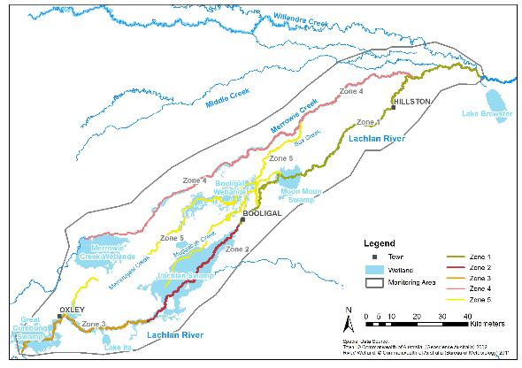

Figure 1. The Lower Lachlan river system showing the region for the LTIM Project.

# Commonwealth environmental watering actions 2015‑16

## Climate and water context

Environmental watering actions are determined by a combination of catchment and climate conditions as well as the volume of water holdings. Catchment condition also is the context for evaluating ecosystem responses to watering.

### Catchment and climate conditions

The Lower Lachlan River catchment experiences alternating periods of wet and dry conditions (Figure 2). The past five years has seen it emerge from the extremes of the Millennium drought when the river ceased to flow, to conditions when water has been more abundant (Figure 2, lower panels). In 2012 significant catchment-wide rain resulted in localised flooding and filling of floodplain wetlands and depressions. This was followed by whole of system flooding, dam spills, translucent releases following floods, and overbank flows, all within a nine month period. The next eighteen months of below average rainfall accompanied by declining water in storage and flow in the river meant that the environmental watering actions in 2014-15 were limited to a single event of 5000 ML because of the dry conditions and limited tributary inflows. Good rainfall across the catchment from mid-2015 resulted in higher river flows, but little in the way of localised flooding or the filling of wetlands.

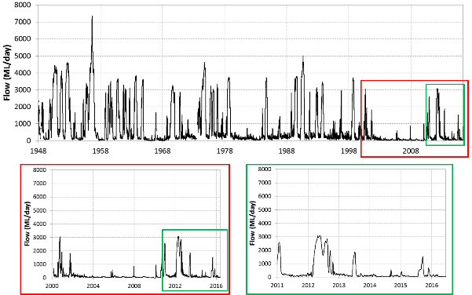

Figure 2. Hydrographs for the Lachlan River at Booligal illustrating the variability in flow in the river.

The long term continuous flow record is shown at the top, the period from 2000 to present is shown in the bottom left and the period from 2011 to present is show in the bottom right. Note that the delivery of Commonwealth environmental water past Booligal is constrained to 800 ML/day by the CEWO’s good neighbour policy.

Rainfall in the catchment was above average in 2015 with significantly higher than average rainfall in winter (Figure 3) producing noticeably wetter conditions and good vegetation growth across the catchment in early spring, but little in the way of localised runoff. High rainfall in January and November was caused by short duration, high intensity events. Temperatures followed normal seasonal patterns and were close to average temperatures for most of the year (Figure 4). The exceptions were in February and October, with temperatures well above average (Figure 4). High temperatures in October caused the catchment to dry out and the vegetation to ‘brown-off’ very quickly.

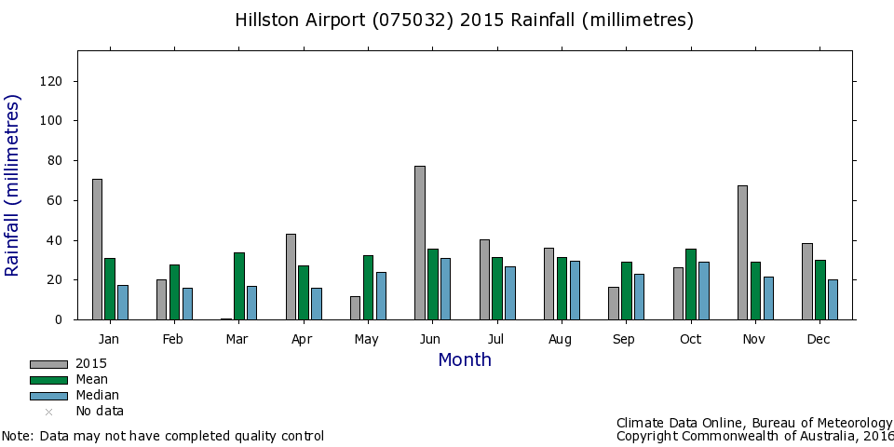

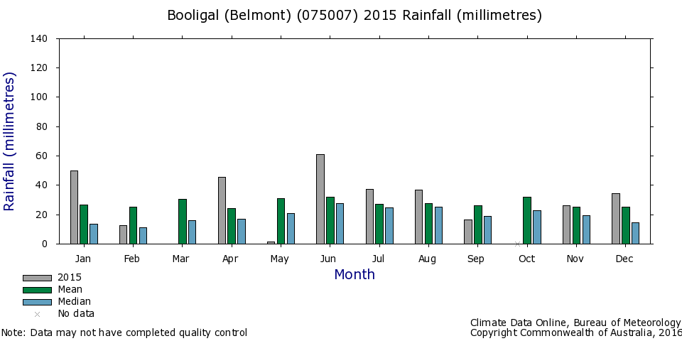

Figure 3. Monthly rainfall at Hillston Airport (075032, top) and Booligal (075007, bottom) during 2015 compared with the mean and median rainfall for the entire period of record.

Graphs sourced from Climate Data Online, Bureau of Meteorology.

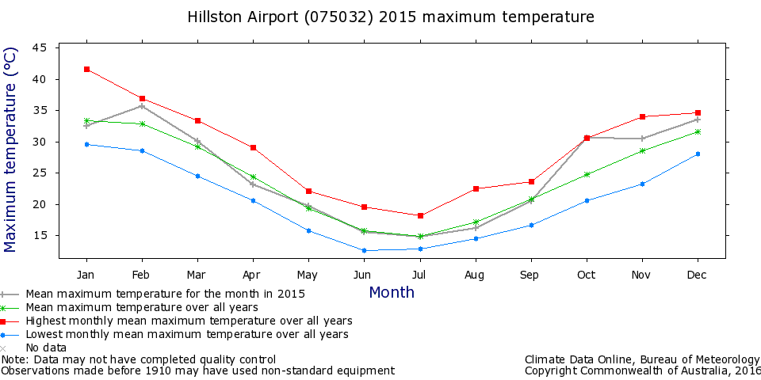

Figure 4. Mean maximum monthly temperatures at Hillston (075032 top) for 2015.

Graphs sourced from Climate Data Online, Bureau of Meteorology.

### Environmental water holdings

Environmental water has been allocated to the Lachlan River since 1992 (from NSW) and more recently the river system has received Commonwealth environmental water. Thus, environmental water for the Lachlan River comprises both Commonwealth government holdings of water entitlements (Commonwealth environmental water) and NSW government-held licensed environmental water (NSW environmental water holdings). At the beginning of the 2015-16 water year, the Commonwealth government held a total of almost 40 400 ML (Table 1).

Table 1. Environmental water holdings in the Lachlan River Valley as at 1 July 2015.

|  |  |  |  |
| --- | --- | --- | --- |
|  | **WATER HOLDINGS (ML) BY ENTITLEMENT TYPE** | | |
| **WATER HOLDER** | HIGH SECURITY | GENERAL SECURITY | **TOTAL** |
| **CEWH** | 933 | 39 462 | **40 395** |
| **NSW** | 1 795 | 36 569 | **38 364** |
| **TOTAL** | **2 728** | **76 031** | **78 759** |

## 2015-16 Watering actions

### Planned water use

The watering actions planned for the 2015-16 water year as described in two Water Use Minutes (WUM) were:

WUM 10039: At least 15 000 ML targeting the Great Cumbung Swamp. This action was expected to consolidate the benefits of inundation that occurred in 2013, and support the survival and growth of wetland vegetation and habitat values for waterbirds and other water dependent species

WUM 10033: Up to 25 000 ML for delivery to wetlands and floodplains (via Willandra Creek, Merrowie Creek, Merrimajeel Creek and Muggabah Creek) as well as the main channel of the Lachlan River (Water Use Minute WUM 10033-01). These actions were to:

* 1. Protect, maintain and improve riparian, wetland and floodplain vegetation diversity and condition; support habitat requirements for waterbirds, native fish and other water dependent vertebrates; and
  2. Provide opportunities for native fish movement, spawning and recruitment.

### Design and objectives

The portfolio of Commonwealth environmental watering actions proposed for 2015-16 was designed to contribute to the following 2015-16 Basin annual environmental watering priorities (Murray-Darling Basin Authority, 2015):

*Basin-wide waterbird habitat and future population recovery*: Improve the complexity and health of priority waterbird habitat to maintain species richness and aid future population recovery;

*Northern Basin fish refuges*: Protect native fish population and in-stream habitats, particularly drought refuges, in the northern Basin;

*Basin-wide native fish habitat and movement*: Maintain native fish populations by protecting and improving the condition of fish habitat and providing opportunities for movement

*Basin-wide flow variability and longitudinal connectivity*: Provide flow variability and longitudinal connectivity within rivers to support refuge habitats; and

*Basin-wide in-stream and riparian vegetation*: Maintain and where possible improve the condition of in-stream and riparian vegetation, through in-channel freshes.

### Implemented watering actions

The total environmental water delivery to the Lower Lachlan river system in 2015-2016 was 48 027 ML and was made up of 36 020 ML of Commonwealth environmental water and 12 007 ML of NSW water. Commonwealth environmental water and NSW water was delivered in three watering actions:

1. 24 058 ML of Commonwealth environmental water and 8 019 ML of NSW water targeting the Great Cumbung Swamp. This action was expected to consolidate the benefits of inundation that occurred in 2013 and support the survival and growth of wetland vegetation and habitat values for waterbirds and other water dependent species.
2. 1087 ML of Commonwealth environmental water and 363 ML of NSW water to Merrimajeel Creek targeting Murrumbidgil Swamp. 1497 ML of Commonwealth environmental water and 499 ML of NSW water to Merrimajeel Creek to support waterbird habitat at the Blockbank.
3. 9378 ML of Commonwealth environmental water and 3126 ML of NSW water targeting flow cued native fish outcomes, specifically golden perch, but also to contribute to non-flow cued native fish outcomes for species such as Murray cod.

The watering actions were delivered from storages between the 9th August and the 15th December. Watering action 1 was interrupted by a translucent release (see Section 3.2.4), and so was delivered in two parts. Details of the actions are summarized in Table 2 and the pattern of environmental water delivery at Willandra Weir (GS 412038) is shown in Figure 5.

### Other environmental water use: Translucent releases

Significant rainfall in the catchment in the first half of 2015 produced medium-large inflows to the Lachlan River, particularly from the Belubula and Boorowa Rivers. Between 1 January and 26 August 2015 these inflows totalled 268 000 ML which triggered the delivery of translucent releases from Wyangala Dam, as required under the Lachlan Regulated River Water Sharing Plan. Dam levels were such that translucent releases were between 3500 ML/day and 5156 ML/day. This translucent event lasted 16 days and contributed approximately 72 000 ML of flow passing Lake Brewster weir in August-September 2015.

Table 2. The 2015-16 Commonwealth environmental watering actions.

| **DESCRIPTION** | **DETAILS** | | | |
| --- | --- | --- | --- | --- |
| **Action** | 1 | 2 | | 3 |
| **Target Asset** | Great Cumbung Swamp | Booligal Wetlands – Merrimajeel and Muggabah Creek | | Lachlan River, main channel |
| **Reference** | WUM10039 | WUM10033 | | WUM10033 |
| **Accounting Location** | Lachlan River at Booligal and Upstream of Willandra Weir | Merrimajeel/Muggabah offtake | | Lachlan River Upstream of Willandra Weir |
| **Flow component** | Base flow; Fresh flow; Wetland inundation | Base flow; Fresh flow; Wetland inundation | Base flow; Fresh flow; Wetland inundation | Base flow; Fresh flow |
| **Volume (CEW) ML** | 24 058.5 | 1087.5 | 1497 | 9378.5 |
| **Volume (NSW) ML** | 8019.5 | 362.5 | 499 | 3126.5 |
| **Total Volume ML** | 32 078 | 1450 | 1996 | 12 505 |
| **Primary Objective** | To improve hydrological connectivity, contribute to ecosystem function, support vegetation condition (river red gum, lignum and aquatic macrophytes) and ecosystem resilience. | Contribute to hydrological connectivity in the Booligal Wetlands and   1. Protect the extent and condition of native riparian and vegetation communities 2. Maintain base flows into Booligal Swamp to support waterbird breeding to completion | Should a colonial waterbird breeding event commence, meet critical water needs to maintain water levels for up to 100 days to support waterbird breeding, fledging and recruitment | Contribute to supporting native riparian wetland and floodplain vegetation diversity and condition  Provide habitat to support, maintain condition of, and provide reproduction opportunities for native fish, waterbirds and other aquatic vertebrate species |
| **Secondary Objective** | Support the ongoing recovery and resilience of the Great Cumbung Swamp if dry conditions continue by providing drought refuge | Support the ongoing recovery and resilience of Murrumbidgil Swamp if dry conditions continue by providing drought refuge | Contribute to ecosystem resilience and the quality of drought refuge for both water dependent and woodland bird species.  Assist in the building of resilience of waterbird populations to endure future extended dry periods and capitalise on flooding periods | Trial the augmentation of flow to generate a golden and/or silver perch movement and spawning response.  Protect and maintain the health and extent of riparian floodplain and wetland native vegetation communities.  Contribute to hydrological connectivity and improved water quality. |
| **Basin Annual watering priorities 2015-16 (Murray-Darling Basin Authority, 2015)** | *Basin-wide in-stream and riparian vegetation*: Maintain and where possible improve the condition of in-stream and riparian vegetation, through in-channel freshes.  *Basin-wide flow variability and longitudinal connectivity*: Provide flow variability and longitudinal connectivity within rivers to support refuge habitats. | *Basin-wide flow variability and longitudinal connectivity*: Provide flow variability and longitudinal connectivity within rivers to support refuge habitats.  *Basin-wide waterbird habitat and future population recovery*: Improve the complexity and health of priority waterbird habitat to maintain species richness and aid future population recovery. | | *Northern Basin fish refuges*: Protect native fish population and in-stream habitats, particularly drought refuges, in the northern Basin.  *Basin-wide native fish habitat and movement*: Maintain native fish populations by protecting and improving the condition of fish habitat and providing opportunities for movement.  *Basin-wide flow variability and longitudinal connectivity*: Provide flow variability and longitudinal connectivity within rivers to support refuge habitats. |

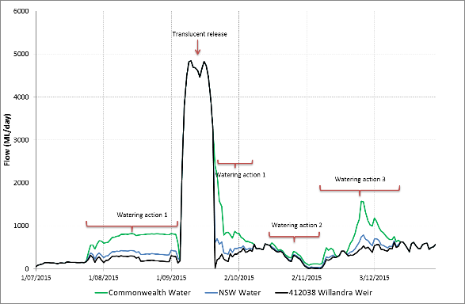

Figure 5. Flow at the gauge Upstream of Willandra weir (412038) showing Commonwealth (green) and NSW (blue) environmental water delivery.

River flows (including licensed delivery of water) is shown in black. Watering actions are numbered according to the delivered watering actions (Table 2)

# Evaluation of watering actions

The 2015-16 watering actions targeted wetlands and floodplains as well as the main channel of the Lower Lachlan river system. The aims, as described in Table 2 (above), were to improve hydrological connectivity, provide benefits for vegetation, fish and waterbirds, and to contribute to ecosystem function, landscape diversity and resilience.

## Evaluation approach

The LTIM Project has two levels of evaluation:

1. Basin evaluation which is conducted across seven catchments (known as Selected Areas) in the Murray Darling Basin. This evaluates the contribution of Commonwealth environmental watering to the objectives of the Murray-Darling Basin Authority’s Environmental Watering Plan (MDBA EWP); and
2. Selected Area which evaluates ecological outcomes of Commonwealth environmental watering at each of seven Selected Areas individually.

Basin evaluation is being led by Monitoring and Evaluation (M&E) Advisors and is designed to address a set of specific evaluation questions which are described in (Gawne et al., 2014). Selected Area evaluation is being led by M&E Providers. Evaluating outcomes at both scales involves monitoring a set of ecosystem attributes (e.g. vegetation condition), the response of which demonstrates the achievement (or otherwise) of an outcome. These attributes are known as indicators. While monitoring programs (and the indicators used) should be designed to be specific to each evaluation scale, in the Lower Lachlan river system, Basin evaluation needs have been prioritised and define the majority of the monitoring effort. To avoid designing parallel monitoring programs, the majority of the indicators used to evaluate ecological outcomes within the Selected Area of the Lower Lachlan river system are the same as used in the Basin evaluation.

The indicators that are monitored to inform both Basin and Selected Area evaluation for the Lower Lachlan river system Selected Area are:

* Fish (river).
* Fish (larvae).
* Stream metabolism.
* Vegetation condition and diversity.
* Hydrology (river).

Decapods and turtles (which are likely to be by-catch from riverine fish monitoring) are reported specifically for the Selected Area. In 2015-16 optional monitoring of frog populations was implemented at the request of the CEWO.

This evaluation assesses the achievements of Commonwealth environmental watering in relation to outcomes expected for the Lachlan river system Selected Area. This evaluation is in two parts. The first addresses the specific objectives of the watering actions (primary and secondary objectives, Table 2) and the second addresses specific evaluation questions defined in (Dyer et al., 2014) and summarised in Table 3.

Table 3. Lower Lachlan river system Selected Area evaluation question and indicators. Questions have been defined as short or long term evaluation questions.

| **Theme** | **EVALUATION QUESTIONS** | **SHORT- /LONG-TERM** | **INDICATORS** |
| --- | --- | --- | --- |
| Vegetation | What did Commonwealth environmental water contribute to vegetation community diversity? | Short  Long | Vegetation diversity  Hydrology (river and wetland) |
| What did Commonwealth environmental water contribute to vegetation species diversity? | Short  Long |
| What did Commonwealth environmental water contribute to populations of long-lived organisms? | Long | Tree community and extent  Hydrology (river) |
| What did Commonwealth environmental water contribute to condition of floodplain and riparian trees? | Short |
| What did Commonwealth environmental water contribute to vegetation condition and reproduction? | Short |
| Fish | What did Commonwealth environmental water contribute to fish community resilience and condition? | Long | Fish (species, abundance and size frequency in rivers)  Hydrology (river)  Water quality (temperature and dissolved oxygen) |
| What did Commonwealth environmental water contribute to native fish abundance and diversity? | Long |
| What did Commonwealth environmental water contribute to native fish populations in the Lower Lachlan River catchment? | Long |
| What did Commonwealth environmental water contribute to native fish survival? | Short |
| What did Commonwealth environmental water contribute to native fish reproduction? | Short |
| What did Commonwealth environmental water contribute to native fish abundance? | Short |
| What did Commonwealth environmental water contribute to native fish recruitment? | Short |
| What did Commonwealth environmental water contribute to maintenance of drought refugia for native fish? | Short |
| What did Commonwealth environmental water contribute to native larval fish growth and survival? | Short |
| What did Commonwealth environmental water contribute to fish community resilience? | Short |
| Waterbirds  (Option) | What did Commonwealth environmental water contribute to waterbird populations? | Long | Waterbirds – breeding (colonial nesting species)  Hydrology (wetlands)  Vegetation type and condition |
| What did Commonwealth environmental water contribute to waterbird chick fledging? | Short |
| What did Commonwealth environmental water contribute to waterbird survival? | Short |
| What did Commonwealth environmental water contribute to waterbird breeding? | Short |
| Stream Metabolism | What did Commonwealth environmental water contribute to patterns and rates of primary productivity? | Short  Long | Stream metabolism  Hydrology (river) |
| What did Commonwealth environmental water contribute to patterns and rates of decomposition? | Short  Long |
| Other Vertebrates (Option) | What did Commonwealth environmental water contribute to other vertebrate populations? | Long | Frogs  Turtles (species and abundance)  Decapods (species and abundance)  Hydrology (river) |
| What did Commonwealth environmental water contribute to other vertebrate species diversity? | Long |
| What did Commonwealth environmental water contribute to other vertebrate reproduction and recruitment? | Short |
| What did Commonwealth environmental water contribute to other vertebrate survival? | Short |
| What did Commonwealth environmental water contribute to refuges? | Short  Long |
| Hydrology | What did Commonwealth environmental water contribute to hydrological connectivity? | Short  Long | Hydrology (river) |
| What did Commonwealth environmental water contribute to sediment transport? | Long |
| What did Commonwealth environmental water contribute to biotic dispersal? | Long |

## Monitoring Sites & 2015-16 Monitoring activities

The Selected Area in the Lower Lachlan river system is partitioned into five zones. At the landscape-scale, these zones have geomorphologically and hydrologically distinct river channels (Table 4). These zones are used to monitor outcomes for fish and stream metabolism but could not be used to structure vegetation monitoring as the regional vegetation mapping is inadequate to determine if zones are different or the same. Hence vegetation monitoring is across the entire Selected Area and not just a single zone.

Stream metabolism and water quality, as well as the adult and larval fish community are only monitored in Zone 1. Zone 1 is chosen as it is the zone most likely to receive Commonwealth environmental water during the LTIM Project, and is most likely to produce a detectable response.

The watering of wetlands in the 2015-16 to support habitat requirements for native fish and other water dependent vertebrates triggered frog monitoring in Zones 3 and 5 of the Selected Area. The lack of bird breeding meant that the watering action implemented did not trigger the need to monitor waterbirds. The monitoring sites (Figure 6 and Figure 7) and timing of monitoring were specific to the indicators being monitored. Details of sites and timing of sampling are given in (see Dyer et al., 2014 for more details).

Table 4. Zones for the Lower Lachlan river system Selected Area relevant to fish and stream metabolism indicators.

|  |  |  |
| --- | --- | --- |
| **ZONE** | **LOCATION** | **CHARACTER** |
| **Zone 1** | Lachlan River channel between Brewster Weir and Booligal | This zone contains relatively high abundances of the required target species of fish (with potentially limited numbers of freshwater catfish). Situated in the upper reaches of the Selected Area, this zone is likely to receive Commonwealth environmental water every year of the LTIM Project. |
| **Zone 2** | Lachlan River channel between Booligal and Corrong | Located downstream of Booligal Weir. Similar to Zone 1 in geomorphology. This zone differs hydrologically because of water diversion and extraction above Booligal Weir. |
| **Zone 3** | Lachlan River channel between Corrong and its terminus in the Great Cumbung Swamp | This zone starts at the point at which the mid-Lachlan wetland system re-enters (drains into) the main Lachlan channel, providing an increase in riverine productivity, stimulating food webs. The fish assemblages are currently dominated by alien species. |
| **Zone 4** | Merrowie Creek | A distributary creek that receives intermittent regulated stock and domestic flows as well as targeted environmental flows at Tarwong Lake and Cuba Dam. No data exist on the fish assemblage present within Merrowie Creek. |
| **Zone 5** | Torriganny, Box, Merrimajeel and Muggabah Creek system | The largely ephemeral, effluent streams of the Merrimajeel and Muggabah system north of the Lachlan main channel and Merrowie creek. This complex system is fundamentally different to main channel zones acting more like linear wetlands that are likely to only retain water for limited periods, during and following environmental flow deliveries or deliveries for stock and domestic purposes. |

## 

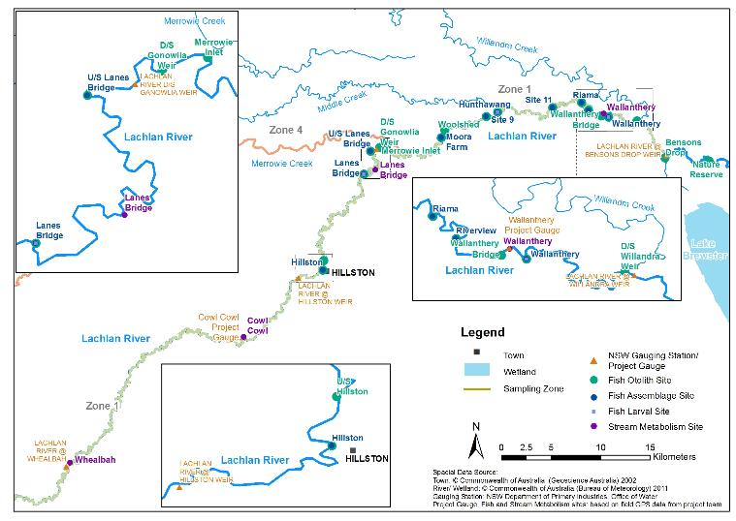

Figure 6. Map of monitoring sites for fish and stream metabolism in Zone 1.

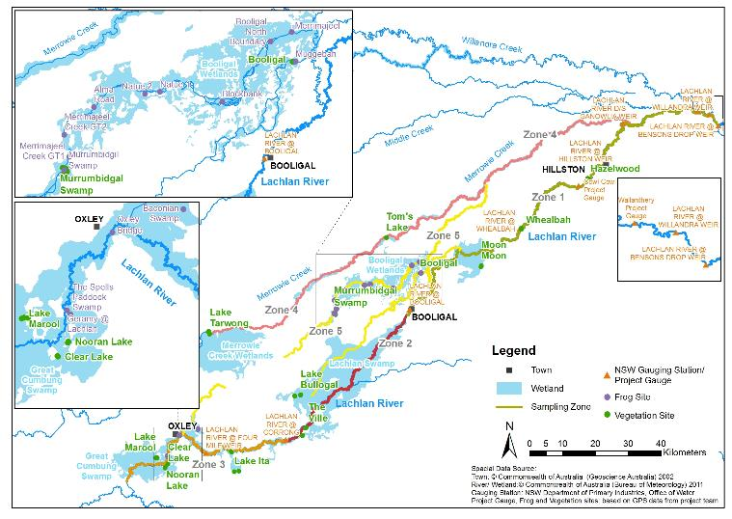

Figure 7. Map of monitoring sites for vegetation and frogs in the Selected Area.

## Hydrology

The total environmental water delivery to the Lower Lachlan river system in 2015-2016 was 48 027 ML and was made up of 36 020 ML of Commonwealth environmental water and 12 007 ML of NSW water. A further 72 000 ML of translucent flows were delivered under the Lachlan Regulated River Water Sharing Plan making a total of 120 027 ML of environmental water delivered to the Lower Lachlan river system. Commonwealth environmental water contributed approximately 16% of the flow in the river in 2015-16 (based on the flow at Willandra Weir which was 226 445 ML for the period 1 July 2015 to 30 June 2016).

To determine the contribution of Commonwealth environmental water to hydrological connectivity and habitat access in the Lower Lachlan river system, the following questions were addressed:

*Action specific questions:*

1. What did Commonwealth environmental water contribute to maintaining hydrological connectivity including end of system flows?
2. What did Commonwealth environmental water contribute to hydrological connectivity at Murrumbidgil Swamp?
3. What did Commonwealth environmental water contribute to habitat for native fish, waterbirds, and other aquatic vertebrate species?

*Selected area questions:*

1. What did Commonwealth environmental water contribute to hydrological connectivity

A combination of fixed point camera images, field observations, analysis of remotely sensed imagery (in-kind contribution from NSW OEH) and published commence to flow data was used to determine the inundation of wetlands and hydrological connectivity resulting from the Commonwealth environmental water. An example of the fixed point camera images from the Great Cumbung Swamp is shown in Figure 8.

Watering Actions 1 and 3 delivered water to the end of the Lower Lachlan river system, extending the magnitude and duration of flows to the Great Cumbung Swamp. These watering actions connected the main channel and central reeds beds of the Swamp as well as providing water to some of the lakes that make up the Great Cumbung wetland complex (such as Clear Lake and Nooran Lake). Watering Action 1 extended the duration of watering of the lakes for almost 30 days prior to the arrival of the translucent flows in mid-September. Watering from the translucent flows continued for another 45 days. Watering Action 3 also provided water to the main channels, central reed beds and lakes of the Swamp for a further 25 days from mid-December 2015 through to mid-January 2016.

The second part of Watering Action 1 was used to attenuate a rapid drop in flow in the river caused by the cessation of the translucent releases from the upstream storage. In a low gradient lowland river such at the Lachlan, rapid changes in water level do not commonly occur and can have adverse effects on the river banks and potentially result in stranding of biota. The use of Commonwealth environmental water to modify the tail of the translucent flow in 2015-16 moderated the flow recession over approximately 5 days at Willandra Weir. While this was shorter than the historically observed recession rate for similarly sized events and the effects were not directly monitored there were no reported adverse consequences.

1. 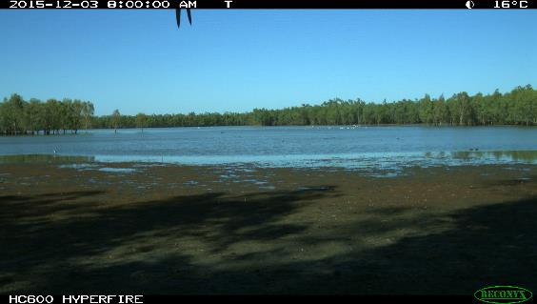
2. 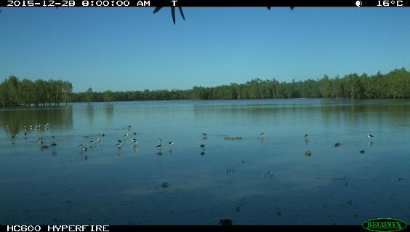

Figure 8. Wetland inundation at Clear Lake in the Great Cumbung Swamp caused by Watering Action 3.

A) prior to the arrival of Watering Action 3, B) the peak of Watering Action 3. The birds in the second image are black banded stilts, wading birds responding to the flow.

Watering Action 2 delivered water through Merrimajeel Creek to Murrumbidgil Swamp. It extended the duration of flow in Merrimajeel Creek by 24 days, and delivered water to the channels of Murrumbidgil Swamp (Figure 9). Without Commonwealth environmental water Murrumbidgil Swamp would have remained dry and disconnected from the rest of the river system. As a consequence, any benefit from watering Murrumbidgil Swamp may be solely attributed to Commonwealth environmental water.

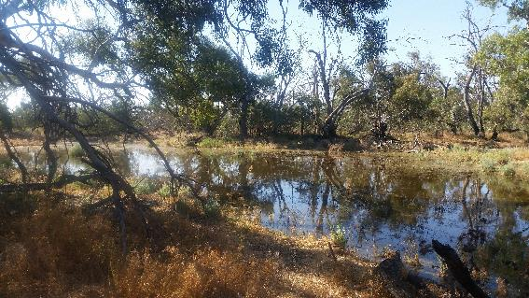

Figure 9. Environmental water in Murrumbidgil Swamp. October 29th 2015. Photo by Fiona Dyer.

Watering Action 3 provided two freshes to the main channel of the Lower Lachlan River. The first fresh raised the water level by around 0.75 m for 6 days and the second raised the water level in the main channel of the Lower Lachlan River by 1.0 to 1.5 m for 20 days. This connected in-channel habitats, providing access to additional habitat for fish as well as providing the water level rise of at least 0.5 m thought to be optimal to facilitate golden perch spawning (see Section 4.5.3).

The three watering actions delivered in 2015-16 connected in channel habitats and wetlands, and provided flow to the end of the river system. While Commonwealth environmental water achieved hydrological connectivity at multiple scales, the dominant watering event in the river system was the provision of 72 000 ML of translucent flows, delivered as part of the NSW water sharing rules. The translucent flows were of sufficient magnitude to inundate wetlands between Hillston and the Great Cumbung Swamp.

## Stream metabolism and water quality

The energetic base of food webs in freshwater systems is provided either by primary production (the energy fixed by photosynthesis occurring in plants and algae) or by breakdown of organic matter such as leaves, wood and organic carbon dissolved in the water. Those processes are both influenced by the availability of key nutrients, particularly nitrogen and phosphorus, and water temperature and light. Primary production (referred to as gross primary production, GPP) and organic matter processing or decomposition (known as ecosystem respiration, ER) can be measured through continuous monitoring of changes in the concentration of oxygen in the water (described as measurements of open channel stream metabolism).

The delivery of environmental flows has the potential to increase primary production and organic matter breakdown by mobilising carbon and nutrients off the floodplain or from upstream. To assess the contribution of Commonwealth environmental water to stream metabolism and water quality, the following evaluation questions are being addressed:

*Selected area questions*

1. What did Commonwealth environmental water contribute to patterns and rates of decomposition (ER)?
2. What did Commonwealth environmental contribute to patterns and rates of primary productivity (GPP)?

Water quality parameters (dissolved oxygen, temperature, pH, turbidity, conductivity, concentrations of nitrogen and phosphorus) were recorded using a combination of automatic loggers and manual point measures at four riverine sites (Figure 6) from the 25th June 2015 to the 25th March 2016.

There was considerable variability in rates of GPP and ER, even in the absence of major flow variability and no evidence that the environmental flows produced consistent responses in either GPP or ER (Figure 10). The large translucent flow was associated with increased concentrations of nutrients and there was evidence of increases in GPP and in ERR at sites. This indicates a potential algal response which is likely to be due to a combination of nutrient availability, increased wetted area of the bed and good light conditions due. The relatively rapid nature of the increase in both GPP and ER after the translucent flow, without any lag or temporary reduction, suggests that disruption of biofilms and removal of organic matter was likely not a major feature of this event

There were higher rates of GPP and ER moving into summer, likely as a consequence of increased water temperatures. The GPP and ER responses to environmental flows are strongly affected by in-stream temperatures, meaning that spring environmental flows are likely to have smaller effects on GPP and ER than those in summer. Energetic responses (energy flowing from GPP into the food web and on to target consumers such as fish and birds) are likely to be larger and more rapid when environmental flows are provided in summer. However, it is also clear that the mobilisation of nutrients and subsequent increase in algal productivity does not appear to be being triggered by the relatively small environmental flows, compared to the much larger translucent flows. There was no evidence of consistent increases in either dissolved organic carbon or reductions in pH associated with any flow event that would indicate black water generation. There is some evidence however that the second part of Commonwealth environmental Watering Action 1, which ‘piggy-backed’ on to the translucent flow, may have acted to prolong or potentially provide a second flush of GPP in the river. This is suggested by a prolonged GPP and ER response after the flow event, although observations of future, similar events are required to be conclusive.

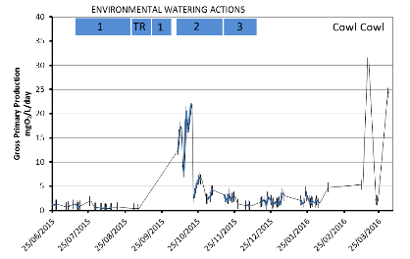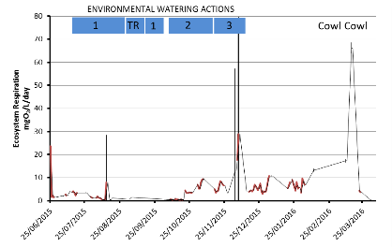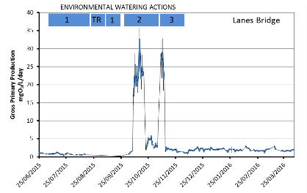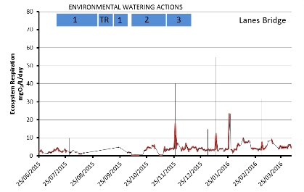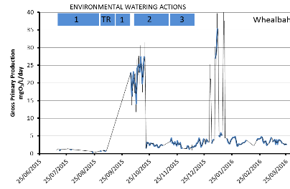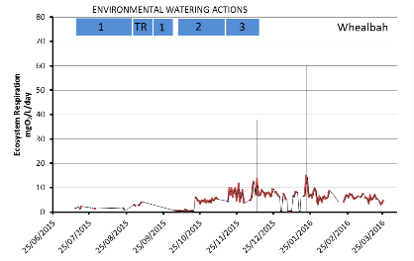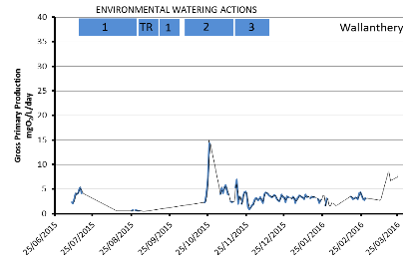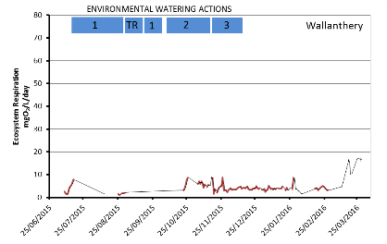

Figure 10. Gross Primary Production (blue lines) and Ecosystem Respiration (red lines) at the four sites in 2015-16 with the environmental watering actions shown (blue bars).

## Fish

Fish are an integral component of aquatic ecosystems. In Australian dryland rivers, fish have adapted to extreme hydrological conditions typical of these rivers, where long periods of low flow and drought are interrupted by extensive flooding. However, many species have undergone severe declines, largely as a result of altered flow regimes caused by river regulation. A common objective of many environmental flow actions is the maintenance and/or enhancement of the native fish community. This is based on the understanding that aspects of the flow regime are linked to key stages of the life history, such as pre-spawning condition and maturation, movement cues, spawning cues and behaviour, and larval and juvenile survival.

In 2015-16 Watering Action 3 aimed to provide habitat to support, maintain condition of, and provide reproduction opportunities for native fish, and to trial the augmentation of flow to generate a golden and/or silver perch movement and spawning response. The expected outcomes were the maintenance of fish condition, spawning of native fish including the movement and spawning of golden perch.

### Fish Community

To determine the contribution of Commonwealth environmental water to the fish community in the Lower Lachlan river system, the following (short term) evaluation questions were addressed:

*Selected area questions:*

1. What did Commonwealth environmental water contribute to native fish populations?
2. What did Commonwealth environmental water contribute to native fish community resilience?
3. What did Commonwealth environmental water contribute to native fish survival?

Fish community data were collected from 10 in-channel sites in Zone 1 (Figure 6, page 28) during March and April 2016 using a combination of electrofishing, trapping and netting techniques. A total of 4 917 fish comprising seven native and three alien species were captured across all the sampling sites. In order of abundance these were bony herring (*Nematolosa erebi*), eastern gambusia (*Gambusia holbrooki*), carp gudgeon (*Hypseleotris* spp.), common carp (*Cyprinus carpio*), golden perch and Murray cod (*Maccullochella peelii*) (Figure 9). As for the 2015 monitoring, the fish species making the biggest contribution to total biomass in 2016 were, in decreasing order: Murray cod, common carp, golden perch and bony herring.

Seven native species of fish were captured in 2015-16 compared with six in 2014-15. The additional species caught in 2015-16 was flat headed gudgeon. Freshwater catfish were not captured in 2016 despite additional sampling using large fyke nets to target this species. Murray-Darling rainbowfish and silver perch, although presumed to have been historically common in lowland sections of the Lachlan River system are now rarely encountered within the target reach and were not detected in the current study. Consistent with results from the 2015 assessment, four native fish species (flat head galaxias, olive perchlet, southern purple spotted gudgeon and southern pygmy perch) which were historically present were not detected in 2016. Of these, olive perchlet is the only species to have been recently detected. Despite the absence of a number of native species, the native species richness in the sampled Zone is generally higher than in other parts of the Lower Lachlan River system.



Figure 11. Catch per site (number of fish; mean ± SE) of each species in the target reach in Autumn 2015 and 2016.

New recruits (juveniles) of two native long lived species (bony herring and Murray cod) and four native short-lived species (Australian smelt, carp gudgeon, flat headed gudgeon and un-specked hardyhead) were detected at multiple sites. No golden perch new recruits were captured. New recruits of all alien species were capture: common carp, goldfish and eastern gambusia.

Recent recruits of Australian smelt, bony herring, carp gudgeon, Murray cod and un-specked hardyhead were captured in 2015-16. This was the same group of species as in 2014-15, but with the addition of flat headed gudgeon in 2016. New recruits of all three alien species were captured in both 2015-16 as in 2014-15. None of the species with recent recruits are considered species for which flow is a critical cue for spawning, however all require flows to provide appropriate habitat and food resources to enable the survival and growth of larvae. Thus, the flow regime provided over the past two years has been suitable for the spawning and survival of native fish that don’t rely on flow to spawn but may still benefit from the flows provided for other outcomes such as food resources and access to habitat.

Concepts of resilience are complex, but at its most basic resilience is the ability to resist external forces, shocks and return to a normal state. For the purposes of this evaluation (given the monitoring design was driven by Basin Scale evaluation) we consider elements of resilience to be captured in the fish condition sub-indices of Expectedness, Nativeness, and Recruitment and the overall Fish Condition Index. Based on these metrics, the Overall Condition of the fish community is considered “Very Poor” in the sampled zone. This is because a number of native species that historically occurred in the area are missing from the population and recruitment is generally very low. This is similar to what is observed across the Murray Darling Basin and has been caused by a combination of factors such as river regulation, water quality changes, over-fishing and invasive species. There was a slight improvement in the native fish community composition in 2015-16 compared with 2014-15, caused by higher scores for Expectedness and Recruitment indices, but they are still classed as Poor and Very Poor respectively. The Nativeness index for the sampled zone remained “Good”. The role of Commonwealth environmental water in the fish community changes is unclear at this stage because the monitoring design was defined by basin evaluation needs rather than the needs of the selected area. Future years of monitoring may assist in greater understanding.

### Spawning and larval fish

To assess the contribution of Commonwealth environmental water to native fish spawning and recruitment the following short term evaluation questions were addressed:

*Selected area short-term questions:*

1. What did Commonwealth environmental water contribute to native fish reproduction in the Lower Lachlan river system?
2. What did Commonwealth environmental water contribute to native larval fish growth in the Lower Lachlan river system?

Larval fish were sampled fortnightly from mid-October to mid-December 2015 using drift nets and light traps set at three sites, Wallanthery, Hunthawang and Lane’s Bridge in Zone 1 (Figure 6). Sampling was timed to follow the delivery of Commonwealth environmental water and to coincide with the known spawning windows of six target native fish species. The larvae of four native species (Murray cod, flat headed gudgeon, Australian smelt and carp gudgeon) and two alien fish species (eastern gambusia and common carp) were captured during this spring-early summer sampling.

Spawning was observed for native species whose spawning is not believed to be cued by flow (Murray cod, flat headed gudgeon, Australian smelt and carp gudgeon)[1]. There was no evidence (eggs or larvae) of spawning in spring / summer 2015 of the two species present which rely on flows as cues for spawning (golden perch or bony herring), although young-of-year of the latter were captured in fish community sampling (Section 4.5.1). Some changes in the length-frequency of larval fish species between sampling events suggests growth and survival of larvae occurred for some species, though without size-independent aging of larval fish, it is difficult to accurately determine growth within and between years.

Murray cod larvae dominated the raw counts in 2015 (as they did in 2014). Murray cod were captured at all three sites and were especially abundant during the first sampling (mid-October). Estimates of peak spawning dates were the first week of October 2015, which was a week or so earlier than spring 2014. Water temperatures for peak spawning times in both these years were around 17 – 20 °C, though flow conditions were very different. It is likely that this species is responding to factors such as day length and water temperature to spawn rather than responding to flow. Freshwater catfish larvae were detected at the same two sites as in spring 2014 (Wallanthery and Hunthawang) which suggests that conditions were suitable for spawning for this species. No individuals were captured in the community monitoring in 2015-16 (see Figure 11) and therefore survival to recruitment for catfish could not be assessed. Although counts of larval freshwater catfish were low, their occurrence is a positive result, as the western population of this species is endangered. This population has bred in successive years of the monitoring program thus far, although larval survival is unknown.

More than twice as many larvae were captured in 2015 as in 2014, and this was due to the large numbers of Murray cod and flat headed gudgeon caught in 2015 (Figure 12). The exceptionally high numbers of flat headed gudgeon captured in light traps at Hunthawang in mid – late November were probably the result of a localised spawning event. The size of flat headed gudgeon in the larval fish samples increased over the sampling period indicating that in-channel conditions were suitable to growth and development.

As for monitoring conducted in 2014, larvae of bony herring were not detected in spring 2015. This is somewhat unexpected given that recruits were detected at the majority of sites in the fish community monitoring in early 2016 (see section 4.5.1). In the Lower Murray River, this species has been found to spawn in December and January when water temperatures reach 21-23°C. These temperatures were attained in the Lachlan River at the start of the larval fish monitoring in spring 2015. The lack of larval bony herring in spring larval sampling but the presence of recruits in the autumn sampling suggests that spawning of bony herring occurred outside the temporal or spatial range of the sampling program.

The numbers of eastern gambusia and common carp larvae captured in 2015 were low compared with numbers of native species at the monitored sites. There was a small increase in the proportion of young-of-year carp detected in the community fish monitoring in early 2016 compared to early 2015 indicating a slightly larger spawning of carp had occurred than was detected with the larval fish monitoring. The translucent flows resulted in extensive inundation of the floodplain wetlands in 2015, providing conditions and connectivity known to promote carp spawning. However, the duration of the translucent flows in the target reach was short (see section 3.2), and is possibly the reason there was only a small increase in carp spawning.

Specific objectives for watering action 3 were partially met. In terms of delivery, the augmented flow release was a success (see section 4.3). In terms of ecological responses, the results suggest that objectives were largely unmet (i.e. no detectable spawning response from golden perch – see section 4.5.3 below). Estimated spawning dates of other non-flow cued native fish species indicate that no additional spawning took place as a result of watering action 3.

Commonwealth environmental water released in 2015 provided suitable conditions for six native fish to reproduce in the targeted reach (five non-flow cued species and one flow-cued species), based on larvae detected from larval fish monitoring, complimentary NSW DPI larval fish monitoring and recruits detected in fish community monitoring. Without daily aging of larvae (to facilitate age:length ratio analysis), it is not possible to accurately determine growth of larval fish in response to Commonwealth environmental flow releases in the targeted area. However, the increase of size of larvae between sampling events, along with the presence of larger again 0+ individuals in the fish community monitoring, provides a rudimentary indication that growth is occurring.

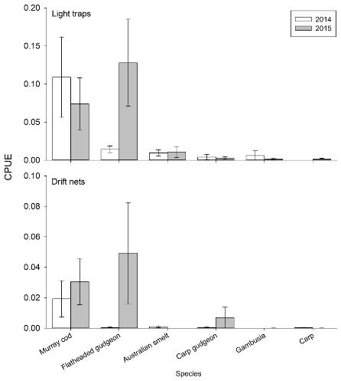

Figure 12. Mean catch per unit effort of larval fish species captured in light traps (top) and drift nets (bottom) from spring – summer 2014 and 2015.

Error bars are ± standard error. CPUE for light traps = catch-per-hour) and for drift nets (CPUE = individuals capture per m3 of water sampled)

### Golden perch

A specific objective of the 2015-16 watering actions was to trial the augmentation of flows in the expectation that this would trigger a golden perch movement and spawning response. To determine the outcomes of this action, the following action specific evaluation question was addressed:

*Action specific question:*

1. What did Commonwealth environmental water contribute to the movement and spawning of golden perch?

Evaluation of this question was addressed by combining information from three efforts: the routine adult and larval fish sampling (Section 4.5.1 and 4.5.2); additional larval fish monitoring (sampling on alternate weeks to the LTIM monitoring by NSW DPI); and adult fish community sampling in Zone 1 in Autumn 2016 (provided by NSW DPI).

There was no evidence of golden perch spawning in September to December 2015 in response to the targeted flow releases, and no young-of-year sampled in the standard LTIM fish community surveys in 2015–16. Additional targeted sampling by NSW DPI also failed to detect either larval or young-of-year golden perch. This means that it is unlikely that spawning of golden perch occurred in response to the 2015-16 water delivery. This was in spite of observations by researchers from the University of Canberra that golden perch captured at Wallanthery on the 19th of October were running ripe and expressed milt, indicating that these individuals were primed for spawning.

Golden perch spawning in other parts of the Murray-Darling Basin is linked to rising water temperatures combined with increases in flow. The scientific literature suggests that golden perch require water temperatures greater than 19 oC in the southern Murray-Darling Basin to spawn, and temperatures of 23 oC are often quoted as optimal. It is also thought that water level rise of 0.5 m would be sufficient to trigger migration prior to spawning, though golden perch have also been found to have spawned in the Murray River without a rise in water level (but this is less common). There is some evidence that the flow pulses in late winter and early spring are important to spawning.

The augmented flow to the Lower Lachlan river system in 2015 delivered an increase in water level of more than 0.5 m when water temperatures were above 23oC in a year when there had already been multiple flow pulses in winter and spring (produced by a combination of Commonwealth water and translucent releases). These appear to be optimal conditions for golden perch spawning.

The reason for the lack of golden perch spawning in 2015 is not clear at this stage but the two most likely factors are flow conditions and water temperatures. Record high temperatures in the catchment in October 2015 resulted in rapid increase of water temperatures during this month. Water temperatures in the river were below 19oC until the start of October, then increased rapidly over 10 days to 23 oC (Figure 13). This increase in stream temperatures coincided with declining flows in the river. The watering action was delivered when water temperatures had exceeded 25 oC and were fluctuating between 23 oC and 30 oC. It is possible that the translucent release (early to late September) triggered a movement and aggregation cue for golden perch in the Lachlan River. The recession of the translucent release was followed by low flows for 35-40 days, and this may have caused the fish to cease spawning activities and begin to resorb their eggs.

It is also possible that the lack of golden perch spawning may be caused by not having suitable hydraulic conditions for spawning. There is a growing belief that hydraulics, and in particular flow velocity, is important in native fish spawning and recruitment. However, relationships are at this stage are not well established. Thus, there is a degree of uncertainty around the lack of spawning response of golden perch in the Lachlan River in spring / summer 2015. Experience in other catchments within the Basin indicates that it may be necessary to trial a number of flows, covering the full life stages of golden perch (not just spawning), before outcomes specifically for golden perch from the use of environmental water are realised.

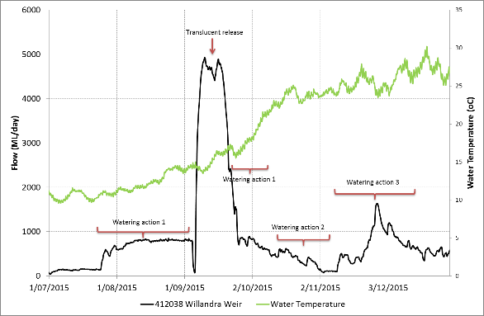

Figure 13. River discharge (black line) and hourly stream temperatures (green line) from Willandra Weir.

## Frogs

Watering actions is targeting wetland complexes in 2015-16 targeted outcomes for frogs. The specific objectives were to: provide drought refuge in the Great Cumbung Swamp and Booligal Wetlands; to maintain aquatic habitat for frogs; and support breeding and recruitment. To determine the contribution of Commonwealth environmental water to the provision of aquatic habitat for frogs, their breeding and recruitment in the Lower Lachlan river system, the following questions were addressed:

*Action specific question:*

1. What was the effect of Commonwealth environmental water on refuge for frogs in the Great Cumbung Swamp and Booligal Wetlands?

*Selected area questions:*

1. What did Commonwealth environmental water contribute to frog diversity and populations?
2. What did Commonwealth environmental water contribute to breeding and recruitment of frog species?

Assessments of frog communities were undertaken at 14 sites across the Great Cumbung Swamp (4 sites) and Booligal Wetlands (10 sites) in spring - summer 2015-16 (Figure 7). All of the monitored sites had been inundated and the sampling coincided with high, receding and low/dry water levels. Commonwealth environmental water was the main contributor to water at the Booligal wetland sites and a combination of Commonwealth environmental water and translucent flow inundated the Great Cumbung Swamp sites.

Four frog species were detected: spotted marsh frog (*Limnodynastes tasmaniensis),* Peron’s tree frog *(Litoria peronii),* eastern sign-bearing froglet *(Crinia parinsignifera)* and giant banjo frog (*Limnodynastes interioris).* Of these species, the spotted marsh frogwas the most widespread and abundant observed at all 14 sites. The eastern sign-bearing froglet and the giant banjo frogoccurred at seven of the sites and Peron’s tree frogwas detected at six. Three other species previously recorded in the region*,* Sudell’s frog *(Neobatrachus sudelli),* Fletcher’s frog *(Limnodynastes fletcheri)* and the southern bell frog (*Litoria raniformis)*, were not observed during the sampling.

The inundation of the Great Cumbung Swamp from a combination of Commonwealth environmental water and translucent flows provided refuge and habitat for the four frog species detected during the monitoring. The duration of inundation and persistence of aquatic habitat into January supported breeding attempts by all four species. In contrast, the inundation of the Merrimajeel Creek and Murrumbidgil Swamp in the Booligal Wetlands was of a much shorter duration. Two species, spotted marsh frog and giant banjo frog were recorded at sites within Murrumbidgil Swamp, with calling by both species in October when part of the Swamp contained low levels of water. Assessment across years is required to determine whether this wetland acted as a drought refuge for frogs, however, drying of several sites along the Merrimajeel creek as well as the short hydroperiod of Murrumbidgil Swamp (dry by the December surveys) indicates that greater volumes of water would be required to create refuge for frog populations through summer.

The species observed in these surveys were similar to those of past surveys in the same area suggesting that a similar diversity of frog populations has been maintained with the watering regimes provided over the past two years. One noticeable difference was that Fletcher’s frog was not detected in the 2015-16 surveys when it had been commonly detected in previous studies.

Watering Action 2 triggered a strong and positive breeding response by the spotted marsh frog with tadpoles and metamorphs occurring at nearly all sites surveyed in the Booligal Wetlands. Some successful recruitment was also observed (indicated by the presence of metamorphs) for the giant banjo frog in response this watering action (Figure 14). Most sites in the Booligal Wetlands were drying during December and dry by late January and therefore the lack of standing water during summer did not cater to the breeding requirements of summer active species such as Peron’s tree frog, Fletcher’s frog and the southern bell frog. Calling by Peron’s tree frog and spotted marsh frog during the December and January surveys continued to occur at the few sites where water persisted.

In comparison, the combination of Watering Actions 1 and 3 and the translucent flow produced aquatic habitat in the Great Cumbung Swamp extending through to January. This allowed for sustained breeding attempts of all of the frog species observed including by Peron’s tree frog (Figure 14) and southern bell frog which are known to be summer active species.

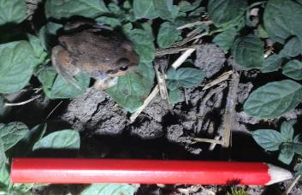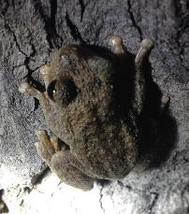

Figure 14. Giant banjo frog metamorphs (left) and Peron’s tree frog (right).

Giant banjo frog metamorphs were observed indicating successful recruitment in response to the water delivery. Peron’s tree frog adults called throughout each of the surveys in the Great Cumbung Swamp where water persisted

## Vegetation

The condition, type and diversity of riparian and wetland vegetation communities are strongly influenced by the frequency and duration of inundation. The three watering actions delivered to the Lower Lachlan river system in 2015-16 were expected to deliver outcomes for riparian and wetland vegetation communities (Table 2, page 21). To determine the contribution of Commonwealth environmental water to riparian and wetland vegetation the following evaluation questions were addressed:

*Selected area questions:*

What did Commonwealth environmental water contribute to:

1. vegetation species diversity?
2. vegetation community diversity?
3. the condition of floodplain and riparian trees?
4. populations of long-lived organisms?

In addressing these questions we also examine the outcomes in relation to the objectives of the 2015-16 watering actions (outlined in Table 2).

The condition and diversity of vegetation within tree communities and non-tree communities was surveyed at 13 sites across the Selected Area (Figure 7) in spring 2015 and autumn 2016. These data are used in combination with data from spring 2014 and autumn 2015 to address the specific evaluation questions.

The combination of translucent releases and environmental watering meant that 9 of the 13 sites received water during 2015-16. Of these 5 received a combination of Commonwealth water and translucent flows and 4 received only translucent flows. This means that the relative contribution of the different sources of environmental water to vegetation responses are unable to be disentangled. The responses discussed refer to the combined ‘types’ of environmental water. It is expected that learning from these and future watering actions will enable greater understanding of the relative contributions.

There was an increase in the number of groundcover plant species recorded in 2015-16 compared with 2014-15 and the species were dominated by native terrestrial species. Complete inundation of sites with environmental water in 2015-16 reduced the groundcover diversity whereas sites that remained dry or were only partly inundated retained a relatively high diversity. The reduction in diversity was the result of the few completely inundated sites becoming dominated by a particular species (for example, sneeze weed, *Centipeda cunninghamii* atMoon Moon Swamp) in response to the watering.

All 13 sites had a reasonably high degree of ‘nativeness’ with more than 60 % of the identified groundcover species being native. This is likely to be an overestimate because the sampling does not identify grasses to species but the effect is considered small as few grass species were observed at the majority of sites. Only one of the sites showed a noticeable change in the proportion of native species with a drop in native species and increase in exotic species with complete inundation. The proportion of native and exotic species at sites that remained dry or were only partially watered was reasonably constant.

The groundcover vegetation was dominated by terrestrial species, most of which are adapted to dry conditions. Very few species dependent on damp or inundated conditions were observed in the groundcover vegetation in 2014-15. This was not unexpected given the infrequent watering of sites over the past 15 years. Following the 2015-16 watering there was a noticeable increase in the proportion of species dependent on damp or inundated conditions at sites that were either partially or completely inundated. This indicates that the vegetation community within the catchment is responsive to watering.

There was a catchment wide improvement in tree condition in 2015-16 with increases in the percentage foliage cover and a slight reduction in dead canopy observed. The response appears to be greater at sites that were either completely or partially inundated by environmental water (Figure 15) indicating a positive response to the provision of water. Given the positive responses of the floodplain and riparian trees to watering of sites, it is inferred that Commonwealth environmental Watering Action 2 in the Booligal Wetlands (which was the majority of the watering action in these wetlands) made a significant contribution to the improved condition of the trees in the Booligal wetlands.

There was a marked response to environmental watering in Moon Moon Swamp and Whealbah Billabong with a large number of red gum recruits recorded following site flooding.

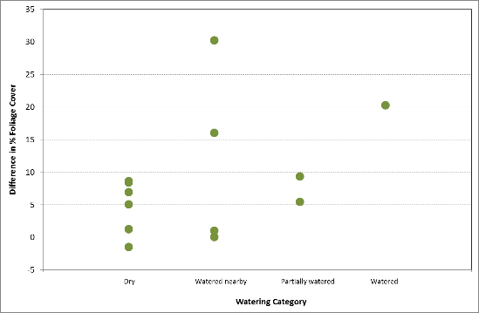

Figure 15. The difference in % foliage cover between 2014-15 and 2015-16 for river red gum and black box with watering.

# Other relevant research: microinvertebrates

Microinvertebrate samples were collected during the 2015-16 larval fish sampling and later analysed as part of a 3rd year student project at the University of Canberra by Nikki van der Weyer, under the supervision of Ben Broadhurst and Fiona Dyer. The objectives of this project were to determine if there were changes in the microinvertebrate community associated with Watering Action 3 at Lane’s Bridge.

Microinvertebrate samples were collected from the channel bottom (epibenthic samples) and from the water column (pelagic samples) at fortnightly intervals from 20th October 2015. Microinvertebrate abundance and flow is shown in Figure 16. A peak in microinvertebrate abundance both in the channel bottom and in the water column followed the second flow peak from Watering Action 3. This indicates a positive ecosystem responses as a consequence of the Commonwealth enviornmental watering action, with microinvertebrates being a primary food resource for larval fish.

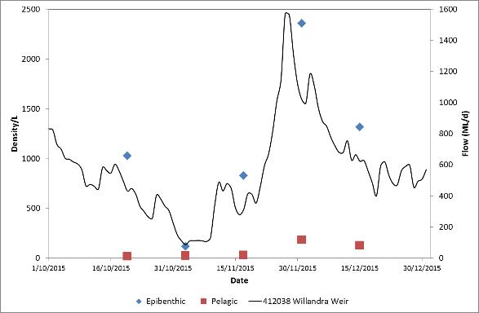

Figure 16. Microinvertebrate abundance within the epibenthic and pelagic habitat and flow at Willandra Weir.

The increase in microinvertebrate abundance following the flow peak was accompanied by an increase in nutrient concentrations but was not accompanied by a clear increase in primary production (See Section 4.4). Such an increase in per unit volume secondary productivity without a corresponding increase in primary productivity may suggest a) the inability to model primary production responses at the highest flows is obscuring productivity peaks at this time or b) that secondary productivity is being driven primarily by organisms entering the reach from upstream. It is important to note that total reach productivity may have increased because there was more water and wetted sediment during environmental flows.

# Evaluation of watering actions

This was the second of a five-year program established to answer specific questions about ecological responses to environmental watering. The three watering actions delivered in 2015-16 were designed to produce a broad suite of environmental outcomes. Stream flow (hydrology), stream metabolism and water quality (temperature, pH, dissolved oxygen, turbidity, conductivity, concentrations of nitrogen and phosphorus), fish (including larval fish), frogs and the condition and diversity of vegetation were monitored to evaluate the outcomes of Commonwealth environmental watering actions. For all responses except vegetation and frogs, monitoring focussed on the target reach in Zone 1: vegetation and frogs were monitored across the entire Lower Lachlan river system.

The 2014-15 monitoring data was used as baseline because the watering action in 2014-15 was small and did not seek to achieve a broad suite of outcomes. The combination of rain in the catchment and translucent flows in early spring make it difficult to attribute the observed responses to specific Commonwealth watering actions, particularly where the number of monitoring sites are limited and monitoring is not tied to particular events.

Responses for the indicators are summarised in Table 5.

Table 5. Evaluation questions and responses for the Lower Lachlan river system Selected Area.

| **INDICATOR** | **EVALUATION QUESTION**  **What did Commonwealth environmental water contribute** | **RESPONSE** |
| --- | --- | --- |
| **Hydrology** | to maintaining hydrological connectivity including end of system flows | Watering actions 1 and 3 provided hydrological connectivity to the Great Cumbung Swamp and Murrumbidgil Swamp.  Watering Actions 1 and 3 extended the duration of hydrological connectivity to the Great Cumbung Swamp by around 55 days. |
| to providing access to habitat for fish. | Watering Action 3 raised in channel water levels by up to 1.5 m connecting in-channel habitats and providing additional habitat for fish. Water levels would have been relatively stable without the provision of flows.  Watering action 3 increased the water level in the channel by more than 0.5 m which is considered optimal for golden perch migration and spawning. |
| **Water Quality and Stream Metabolism** | to patterns and rates of decomposition? | Watering Actions 1, 2 and 3 did not appear to mobilise nutrients and subsequent primary production did not appear to be triggered by any of the watering actions.  The larger translucent flows mobilised nutrients and triggered a change in primary production. |
| to patterns and rates of primary productivity? |
| **Fish - community** | *Short-term (one year)* |  |
| to native fish community resilience? | The native fish community composition improved in 2016 but the role of Commonwealth water is not clear. |
| to native fish survival? | Recent recruits of both native and exotic species were captured. None of the species captured have specific flow needs for spawning. Their recruitment indicates that flow conditions provided appropriate habitat and food resources to enable the survival and growth of larvae. |
| *Long-term (five years)* |  |
| to native fish populations? | Indeterminate – data contributes to the longer term data set and Basin evaluation. |
| to native fish diversity? |
| **Fish - reproduction** | *Short-term (one year)* |  |
| to native fish reproduction in the Lower Lachlan river system? | Spawning of non-flow dependent fish species detected.  No spawning of flow dependent species detected but recruitment of bony herring was detected which indicated that spawning had occurred. |
| to native larval fish growth in the Lower Lachlan river system? | Crude positive determinations of larval growth observed for some native fish species. |
| *Long-term (five years)* |  |
| to native fish populations in the Lower Lachlan river system? | Larval numbers in 2015 were double those of 2014. |
| to native fish species diversity in the Lower Lachlan river system? | No detectable change in fish diversity |
| **Frogs** | to frog diversity and populations | Spawning facilitated for two frog species. Changes in diversity not undertaken as only single year assessed thus far. |
| to breeding and recruitment of frog species? | The watering actions were timed to suit the breeding and recruitment of 4 of the 7 frog species observed in the region. |
| to the maintenance of refuge habitats for frogs? | The three watering actions achieved a persistent aquatic habitat at one of the target refuge sites, the Great Cumbung Swamp. Water was retained at this site for the duration of the surveys (October 2015 until January 2016), providing key frog habitat in an otherwise drying system. |
| **Vegetation** | *Short-term (one year) and long-term (five years)* |  |
| to vegetation species diversity? | Complete inundation of sites with environmental water in 2015-16 reduced the groundcover diversity whereas sites that remained dry or were only partly inundated retained a relatively high diversity. |
| to vegetation community diversity? |
| *Short-term (one year)* |  |
| to condition of floodplain and riparian trees? | The Commonwealth watering actions in combination with translucent flow improved the condition of floodplain and riparian trees in 2015-16 |
| *Long-term (five years)* |  |
| to populations of long-lived organisms? | Future monitoring will enable a greater understanding of the responses observed. |

# Adaptive management

The key findings from the 2015-16 monitoring that can be used to inform future management of environmental water in the Lower Lachlan river system were:

* The translucent flows provided important late winter/spring freshes in the system, which potentially primed the ecological responses observed in the rivers and wetlands. Thus while it is difficult to disentangle the relative effects of Commonwealth environmental water and the translucent releases, the responses observed are unlikely to have occurred with either of them on their own. Future flow releases should capitalise on the opportunities provided by translucent flows where possible.
* Translucent releases provide advantage in being linked to natural inflows and are of sufficient magnitude to inundate and connect wetlands to the main channel. As such they provide flows that are unlikely to be able to be delivered through Commonwealth environmental watering. The use of Commonwealth water to modify the recession of translucent release and potentially prime the channel prior to the translucent releases as occurred in 2015-16 makes good use of Commonwealth water.
* The environmental watering actions provided in 2015-16 were in-channel rises of up to 1.5 m. These rises were either not large enough to engage with in-channel features and mobilise nutrients and stimulate algal production, or there are insufficient in-channel features (e.g. dry snags, perched benches with accumulated organic matter) in the target reach that would contribute nutrients. While the dynamics of this are complex, the lack of accumulated organic matter which is accessible to this flow may have been reduced by the translucent flow exporting material out of the reach. Recent high resolution habitat mapping in the target reach by NSW DPI Fisheries provides an opportunity to examine the water level rises in relation to the inundation of channel features, and may inform future flows targeting ecosystem responses through inundation of these features.
* Golden perch spawning was not observed in 2015-16 in spite of providing an environmental watering action that was expected to produce a response. It is suggested that the lack of golden perch spawning may be a result of the timing of the watering action in relation to water temperatures. It is recommended that the delivery of flows targeting golden perch spawning:
  + Make use of translucent flows to prime the fish to move and spawn (based on observations of ripe golden perch at the end of the 2015 translucent flows). Depending on the duration of the translucent flows, provide subsequent releases to give the second peak of the hydrograph expected to result in spawning.
  + Where possible, use a combination of tributary inflow triggers and temperature triggers to define the timing of the flows. These inflow triggers may include unregulated flow events from tributaries further upstream in the catchment (i.e. upstream of Forbes) and may more accurately reflect local climatic conditions reflective of a natural regime.
  + Use a temperature trigger for the delivery of water (in the absence of tributary inflows) and/or optimise tributary inflows to produce the designed flow pattern
* Increased monitoring intensity may be required to monitor a golden perch spawning response as the current methods may be temporally too coarse.
* There is a need to develop a greater understanding of the golden perch populations that exist in the Lachlan. Investigate the source (stocked or wild) of the existing golden perch population to evaluate the recent hydrological events that may have led to wild-spawning and recruitment (if any). For example, the current sampling program has indicated a substantial population of golden perch within the focal reach. Results have indicated golden perch from the 1+ age category in 2016 were from stockings were identified. However, it is currently unknown whether the remainder of the population is a result of natural spawning and recruitment. Further investigation of the origin of this population (stocked or wild), while not within the scope of the current program, would assist in retrospectively assigning hydrological conditions that previously promoted spawning or recruitment within this population and thus providing suitable delivery targets for future years of water delivery.
* The short term connection between the wetlands and the main channel observed in 2015 as a consequence of the translucent releases only resulted in a low level of common carp spawning being observed in the target reach (noting that the target reach has a different fish community from the rest of the Selected Area). Restricting connections between wetlands and the main channel in warmer months is likely to continue to contribute to a low level of carp spawning.
* It is not possible to confidently answer the second short-term evaluation question (What did Commonwealth environmental water contributes to native larval fish growth in the Lower Lachlan river system?). Daily aging of at least a sub set of species is strongly recommended to be able to calculate age: length ratios (to be able to determine and compare growth and survival between years) and to accurately estimate spawning date. Daily aging was initially excluded from the monitoring program due to budgetary restrictions. Samples from the first two years of monitoring have been stored so that they can be used for aging should resources become available. The Lachlan project team also has complimentary microinvertebrate abundance and diversity data which would value add to the growth data determined from otolith analysis.
* Spawning of non-flow cued species was observed in 2015-16, but the only flow cued species observed to spawn was bony herring. The evidence for bony herring spawning was from the detection of young-of-year in the Adult fish monitoring and the suggestion is that they spawned in January/ February, which is outside the current scope of monitoring. This means that the role of flow in the spawning of bony herring is not clear. To provide a link between flow and spawning biology of Bony Herring on the selected area, sampling (and daily aging) of Bony Herring during January and February is recommended. Alternatively, assessing recruitment to the community and flow components across the 5 years of the monitoring program may also provide some Insight into the relationship between flow and recruitment success for this species.
* Small bodied native fish species tend to receive less attention than the more charismatic larger species such as Murray cod and golden perch. Fish such as bony herring play an important role in dryland river food webs and are an important dietary item for larger fish species as well as water birds. At present our understanding of bony herring responses to flow delivery is limited and as part of maintaining or enhancing fish populations in the system, it is worth some focus on improving our understanding and how water might be delivered to benefit them.
* Calling by eastern sign bearing froglet, Perons tree frog, spotted marsh frog and the great banjo frog was strongly correlated with wetland inundation. Maintaining large areas of shallow inundated habitat is important for successful frog breeding, recruitment outcomes for summer breeding species including the southern bell frogwill be improved if the inundation period is extended through summer with wetlands drying down in early autumn.
* The delivery of environmental water to the Merrimajeel Creek system (Zone 5) in late winter/early spring triggered positive breeding response by spotted marsh frog. The volume of water delivered to the Merrimajeel Creek system was adequate for short-term breeding (October-December) for the spotted marsh frog and to some extent the great banjo frog*.* However, within the wetland itself the short duration of inundation may limit the value of this site as a refuge habitat for frogs. Higher number of individuals and greater breeding success was observed upstream in the more persistent areas Merrimajeel Creek system, suggesting that this area may play a key role in supporting frog populations within this zone.In order to provide drought refuge for frog communities, higher volumes of water need to be delivered, particularly to the Merrimajeel Creek system and Murrumbidgil Swamp (Zone 5).
* The environmental water delivered to Zone 3, targeting the Great Cumbung Swamp provided as a refuge habitat for frogs for summer active species with Perons tree frog continuing to call in January in this zone. While the provision of aquatic habitat during summer presents the risk of being conducive to carp spawning, the majority of frog species actively breed during this time (late spring and summer) necessitating persistence during this time.
* The health of the riparian and wetland trees has improved at sites that were either completely or partially inundated with environmental water. Sites that were not watered did not decline in health. To achieve broader catchment scale outcomes for riparian and wetland trees, sites that were not watered in 2015-16 should be a priority for future watering.
* While the greatest benefit to riparian and wetland trees occurred with inundation or partial inundation, it appears there was also some benefit from watering adjacent wetlands. While data collected from future monitoring will enable us to determine if this pattern of response is widespread, there may be opportunity to benefit sites that are difficult to inundate, by providing water to adjacent wetlands.
* There are currently community concerns that the timing of the delivery of environmental water promotes nuisance vegetation growth within the distributary channels. All of the sites monitored are either riparian or wetland sites and no monitoring of in-channel vegetation has been undertaken. Our monitoring activities indicate that only one of the monitored floodplain sites displayed an increase in exotic species with watering, but our current program of activities is unable to usefully inform this debate and it would be worth considering future monitoring targeted at answering specific questions associated with in-channel plant growth.

# References

Davies, P.E., Harris, J.H., Hillman, T.J., Walker, K.F., 2008. Sustainable Rivers Audit 1: A report on the ecological health of Rivers in the Murray-Darling Basin, 2004-2007. Prepared by the Independent Sustainable Rivers Audit Group for the Murray–Darling Basin Ministerial Council. Murray Darling Basin Commission, Canberra.

Driver, P.D., Chowdhury, S., Hameed, T., Lloyd-Jones, P., Raisin, G., Ribbons, C., Singh, G., Wettin, P., 2004. Natural and modified flows of the Lachlan Valley wetlands. Resource Analysis Unit, Central West Region, NSW Department of Infrastructure, Planning and Natural Resources, Forbes.

Dyer, F.J., Broadhurst, B., Thompson, R., Jenkins, K.M., Driver, P.D., Saintilan, N., Bowen, S., Packard, P., Gilligan, D., Thiem, A., Asmus, M., Amos, C., Brandis, K.J., Martin, F., Hall, A., Lenehan, J.R., 2014. Long term intervention monitoring and evaluation plan Lachlan river system. Commonwealth Environmental Water Office, Canberra.

Ebner, B., 2006. Murray cod an apex predator in the Murray River, Australia. Ecology of Freshwater Fish 15 (4), 510-520.

Gawne, B., Hale, J., Butcher, R., Roots, J., Cottingham, P., Stewardson, M.J., Everingham, P., 2014. Commonwealth Environmental Water Office Long Term Intervention Monitoring Project: Evaluation Plan. , Final Report prepared for the Commonwealth Environmental Water Office. The Murray-Darling Freshwater Research Centre, Albury.

Harris, J.H., Gehrke, P.C., 1997. Fish and Rivers in Stress: The NSW Rivers Survey. New South Wales Fisheries and the Cooperative Research Centre for Freshwater Ecology, Cronulla, NSW.

Murray-Darling Basin Authority, 2012. Sustainable Rivers Audit 2: The ecological health of rivers in the Murray–Darling Basin at the end of the Millennium Drought (2008–2010). Summary.

Murray-Darling Basin Authority, 2015. 2015-16 Basin Annual Environmental Watering Priorities. Murray-Darling Basin Authority, Canberra, Australia.

Thurtell L., Wettin, P., Barma Water Resources, Commonwealth Environmental Water (Australia), 2011. Environmental Water Delivery: Lachlan River, in: Commonwealth Environmental Water, D.o.S., Environment, Water, Population and Communities (Ed.), Canberra, p. 123.

1. For this group of fish, the flows provided may have contributed to creating preferred habitat or food resources.