Commonwealth environmental water office

Long term intervention monitoring project:

Lower Lachlan river system

2017-18 Summary report

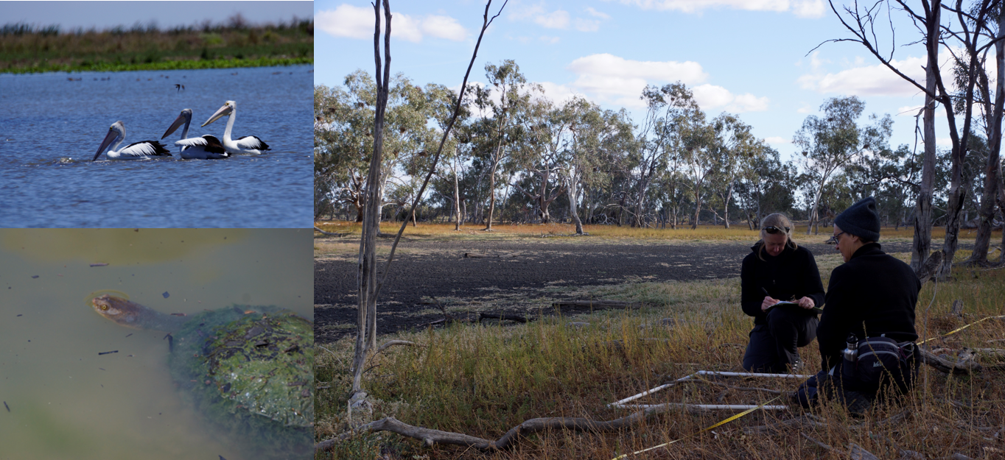

March 2019

**Commonwealth Environmental Water Office**

**Long Term Intervention Monitoring Project**

**Lower Lachlan river system 2017-18 Summary Report**

**November 2018**

This document has been co-ordinated by Dr Fiona Dyer and includes contributions from Mr Ben Broadhurst, Ms Alica Tschierschke, Professor Ross Thompson (University of Canberra); Dr Patrick Driver and Dr Sharon Bowen (NSW Department of Primary Industries, Water); Dr Joanne Lenehan, and Mr Paul Packard (NSW Office of Environment and Heritage); and Dr Jason Thiem (NSW Department of Primary Industries, Fisheries).

 

G:\Fishnet\Research Projects\Logos\DPI logo colour rgb.jpg http://data.nsw.gov.au/data/images/Office-of-Environment-and-Heritage.jpg

This monitoring project was commissioned and funded by Commonwealth Environmental Water Office with additional in-kind support from the University of Canberra, NSW Office of Environment and Heritage, and Department of Primary Industries.

**Copyright**© Copyright Commonwealth of Australia, 2018



**Commonwealth Environmental Water Office Long Term Intervention Monitoring Project: Lower Lachlan river system Selected Area** is licensed by the Commonwealth of Australia for use under a Creative Commons by Attribution 3.0 Australia licence with the exception of the Coat of Arms of the Commonwealth of Australia, the logo of the agency responsible for publishing the report, content supplied by third parties, and any images depicting people. For licence conditions see: <http://creativecommons.org/licenses/by/3.0/au/>

This report should be attributed as: Dyer, F., Broadhurst, B., Tschierschke, A., Thiem, J., Thompson, R., Driver, P., Bowen, S. (2018). Commonwealth Environmental Water Office Long Term Intervention Monitoring Project: Lower Lachlan river system Selected Area 2017-18 Monitoring and Evaluation Summary Report. Commonwealth of Australia, 2018.

The Commonwealth of Australia has made all reasonable efforts to identify content supplied by third parties using the following format ‘© Copyright, [name of third party] ’.

**Disclaimer**

The views and opinions expressed in this publication are those of the authors and do not necessarily reflect those of the Australian Government or the Minister for the Environment and Energy.

While reasonable efforts have been made to ensure that the contents of this publication are factually correct, the Commonwealth does not accept responsibility for the accuracy or completeness of the contents, and shall not be liable for any loss or damage that may be occasioned directly or indirectly through the use of, or reliance on, the contents of this publication.

Inquiries regarding this document should be addressed to:

Dr Fiona Dyer  
Phone: 02 6201 2452  
e-mail: Fiona.Dyer@canberra.edu.au

|  |  |  |  |  |  |  |
| --- | --- | --- | --- | --- | --- | --- |
| **Document history and status** | | | | | | |
| **Version** | **Date Issued** | **Issued to** | **Reviewed by** | **Approved by** | **Revision Type** |
| Draft | 22/11/18 | Internal review | Ross Thompson | Ross Thompson | Editorial |
| Draft 2 | 5/12/2018 | CEWO | CEWO | Fiona Dyer | External review |
| FINAL | 26/3/2019 | CEWO | Nick Bond | Fiona Dyer | External review |
|  |  |  |  |  |  |

Front cover photos: Top left: Pelicans at Nooran Lake (Fiona Dyer); Bottom left: Turtle at The Ville (Fiona Dyer); Right: Vegetation surveys at Lake Ita (Alica Tschierschke)

**TABLE OF CONTENTS**

1 Monitoring and Evaluation of Environmental Water in the Lower Lachlan river System 7

2 Environmental watering in the Lower Lachlan River system in 2017-18 8

3 Key outcomes from environmental water use 10

3.1 Watering action 1: Supporting native fish Recruitment 10

3.2 Watering action 2: Providing hydrological variability 14

3.3 Evaluation Questions 15

4 Implications for future management of environmental water 16

4.1 Priorities 17

4.2 The design of watering actions 17

4.3 Delivering environmental water 18

4.4 Informing future monitoring 18

5 References 20

**LIST OF FIGURES**

Figure 1. The Lower Lachlan river system showing the monitoring sites for the LTIM Project. 7

Figure 2. Water level at Hillston Weir (top) and Cotton’s Weir, Forbes (bottom) for the period 1 July 2017 to 30 June 2018 showing Watering Action 1 and estimated spawning dates for Murray cod. Commonwealth (green) and NSW (blue) environmental water are shown along with estimates of the water level in the absence of environmental water (grey). Estimated Murray cod spawning time is also shown (orange), along with peak spawning time in the Lower Lachlan (yellow in top figure). 12

Figure 3. Fixed point camera image from Clear Lake in December 2017 and January 2018 showing the filling of the lake and use by Pelicans. 14

**LIST OF TABLES**

Table 1. The 2017-18 Commonwealth environmental watering actions. 10

Table 2. Evaluation questions and responses for the Lower Lachlan river system Selected Area. 15

**ACRONYMS AND ABBREVIATIONS**

|  |  |
| --- | --- |
| **Accepted Acronym** | **Standard Term (capitalisation as specified)** |
| ANAE | Australian National Aquatic Ecosystem |
| CEWH | Commonwealth Environmental Water Holder |
| CEWO | Commonwealth Environmental Water Office |
| CPUE | Catch per unit effort |
| GS | General Security |
| HS | High Security |
| IMEF | Integrated Monitoring of Environmental Flows |
| LLS | Local Land Services |
| LTIM Project | Long Term Intervention Monitoring Project |
| MDBA | Murray-Darling Basin Authority |
| M&E | Monitoring and Evaluation |
| MDMS | Monitoring Data Management System |
| SOP | Standard Operating Procedure |
| QA/QC | quality assurance / quality control |

**ACKNOWLEDGMENTS**

The project team as well as the Commonwealth Environmental Water Office (CEWO) respectfully acknowledge the traditional owners of the land on which this work is conducted, their Elders past and present, their Nations of the Murray-Darling Basin, and their cultural, social, environmental, spiritual and economic connection to their lands and waters.In particular, in the Lower Lachlan river system Selected Area we acknowledge the Wiradjuri peoples, traditional owners of the land on which this publication is focused.

The project team also thank the team of people who contributed to the project delivery including: Rhian Clear, Ebony Mullin, Paul Packard, Damian McRae Ugyen Lhendup, Will Higgisson, Hugh Allen, Mark Lintermans, Patricia Murray, Kate Reid, Yasmin Cross, Sam McElvenny, Sam Davis, Daniel Scherrer and the students of the second year Ecology class from the University of Canberra. The following DPI Fisheries staff assisted with field data collection and laboratory processing: Martin Asmus, Chris Bowen, Tom Butterfield, Wayne Houghton, Jarryd McGowan, Nicholas O’Brien, Rohan Rehwinkel, Chris Smith, Sarah Talbot.

The landholders who granted us access to sites are thanked for their interest, cooperation and support.

Fish sampling was conducted under Fisheries NSW ACEC Research Authority Permit 14/10 and NSW DPI scientific collection permit P01/0059(A)-3.0.

Larval fish sampling was conducted under NSW DPI permit No: P14/0022-1.2 and under approval from the University of Canberra Animal Ethics Committee (AEC 17-23).

# Monitoring and Evaluation of Environmental Water in the Lower Lachlan river System

The Lower Lachlan river system extends from the outlet of Lake Brewster to the Great Cumbung Swamp (Figure 1). It encompasses anabranches, flood runners, billabongs, distributaries and terminal wetlands, such as Merrowie Creek, Booligal Wetlands and Lachlan Swamp. The river system is complex, with a diversity of in-channel and floodplain features that provide a variety of habitats for the species in the region. Flows and water levels are naturally variable and unpredictable providing temporally complex habitats.

The Lachlan River catchment supports many flora and fauna listed as vulnerable or endangered under federal or NSW state legislation. The Great Cumbung Swamp, at the terminus of the Lachlan River, is one of the most important waterbird breeding areas in eastern Australia and supports one of the largest remaining stands of river red gums in NSW.

A close up of a map

Description generated with high confidence

Figure 1. The Lower Lachlan river system showing the monitoring sites for the LTIM Project.

Like many rivers of the Murray Darling basin, flow regulation in the Lachlan river catchment has had a significant effect on the average annual flow as well as inter-annual and seasonal variability (Driver et al. 2004). This is believed to have been a key driver in a deterioration of the freshwater ecosystems within the catchment and the Lower Lachlan river system has previously been assessed as being in poor ecosystem health on the basis of an extremely poor native fish community, highly modified flow regimes (hydrology), and a physical form and vegetation community that is in poor to moderate condition (Murray-Darling Basin Authority 2012). The Millennium Drought (2001-2009) resulted in large areas of river red gums becoming stressed, and a further decline in the condition of wetland vegetation. Some recovery of the wetlands and rivers has been observed since 2010, attributed to natural flow events and environmental watering actions. In 2016, the Booligal wetlands supported the largest and most successful breeding colony of straw-necked ibis in the Murray Darling basin since 1984.

Commonwealth environmental water has been delivered in the Lachlan catchment since 2010 and more than 205 GL of Commonwealth environmental water has been delivered to date to achieve a wide range of outcomes. Within the main channel environmental flows have sought outcomes ranging from hydrological connectivity and variability, dissolved oxygen, providing cues for native fish spawning and providing refuge habitat. A number of significant wetlands have also received environmental flows including Booligal swamp, Lake Tarwong and the Great Cumbung Swamp. These wetland flows have sought to achieve waterbird breeding, vegetation condition and fish dispersal outcomes.

The Long-Term Intervention Monitoring Project (LTIM Project) is the primary means by which the Commonwealth Environmental Water Office (CEWO) undertakes monitoring and evaluation of the ecological outcomes of Commonwealth environmental watering. Monitoring activities implemented within the LTIM Project to evaluate the outcomes of Commonwealth environmental watering actions in the Lower Lachlan river system in 2017‑18 included the monitoring of stream flows (hydrology), stream metabolism and water quality (dissolved oxygen, temperature, pH, electrical conductivity, turbidity and nutrients), fish (including larval fish) and the condition and diversity of vegetation. Monitoring of stream metabolism and fish outcomes focussed on the stretch of river between Lake Brewster and Whealbah (Figure 1, known as Zone 1) and the monitoring of hydrological and vegetation outcomes occurs across the entire Selected Area (Figure 1). The evaluation uses monitoring data to assess the achievements of Commonwealth environmental watering in relation to the outcomes expected for the lower Lachlan river system.

This report summarises the outcomes from the fourth of five years of monitoring and evaluation of Commonwealth environmental watering in the Lower Lachlan river system. It is focussed on key outcomes from the four years of environmental watering and the associated learning that informs the future management of environmental water. It is accompanied by a technical report (Dyer et al. 2018) which provides more details of the watering actions, the monitoring activities and the evaluation of the outcomes.

# Environmental watering in the Lower Lachlan River system in 2017-18

The record rainfall and widespread flooding of 2016-17 was followed with much drier conditions in 2017-18. While some wetlands remained inundated until well into 2017, river flows had returned to regulated conditions and the environmental watering actions focussed on supporting the recovery of instream biota following the floods and hypoxic blackwater events of 2016-17.

Two Commonwealth environmental watering actions were delivered to the Lachlan river system in 2017-18 (Table 1). Releases from Wyangala dam for the first action commenced on the 23rd September 2017 and concluded on the 13th November 2017, targeting outcomes for native fish in the mid (Forbes) and lower (Hillston) Lachlan. Water from the Forbes environmental water order that was not required to meet the order at Hillston was reregulated into the Brewster outflow wetlands to establish aquatic vegetation and support a pelican breeding event. At the conclusion of the first watering action there was a residual of environmental water (1665 ML) held in the Brewster Weir. This was used at the end of May to achieve a small fresh in the river at Booligal. The small fresh passed Booligal between the 22nd May and the 2nd June.

The aim of the first Commonwealth watering action was to prevent the water level in the river from dropping during the Murray cod nesting period, to avoid nest abandonment. This action was followed by a release of Environmental Water Allowance (EWA) to provide a small fresh to support the movement and dispersal of larvae.

The aim of the second Commonwealth watering action was to use the re-regulated volume held in Brewster Weir to contribute to hydrological (flow) variability by providing a small fresh in the Lower Lachlan during a period of low flow in late autumn-early winter. This was preceded by a small fresh of NSW water which also contributed to hydrological variability.

By providing flows to support breeding, and the movement and dispersal of larvae, the watering actions in the Lachlan draw on the watering priorities of the Murray-Darling Basin Authority for threatened fish to focus on maintaining and improving existing populations of fish.

While the 2017-18 watering actions targeted the channel of the Lower Lachlan river system to explicitly provide benefits for fish, implied within the watering actions are outcomes for stream metabolism and hydrological connectivity. Outcomes for vegetation were not specifically targeted but the passage of this flow to the end of the system was expected to wet the central reed beds of the Great Cumbung Swamp and thus provide benefit.

Table 1. The 2017-18 Commonwealth environmental watering actions.

| **Description** | **Details** |  |
| --- | --- | --- |
| **Action** | 1 | 2 |
| **Target Asset** | Mid Lachlan River, main channel and Lower Lachlan River, main channel | Lower Lachlan River, main channel below Lake Brewster terminating in Great Cumbung Swamp |
| **Reference** | WAR 10053-02 | WAR 10053-02 |
| **Accounting Location** | Lachlan River at Forbes (Cotton’s Weir), Hillston (Hillston Weir) | Lachlan River at Booligal |
| **Flow component** | Base flow and fresh flow | Fresh flow |
| **Volume (CEW)** | 32 572 ML (accounted at Forbes)  951 ML (accounted at Hillston) |  |
| **Volume (NSW)** | 8,400 ML Wyangala Environmental Water Allowance (EWA) | 805 ML Lake Brewster Adaptive Environmental Water |
| **Total Volume (ML)** | 40 923 ML | 805 ML |
| **Re-use** | 30 204 ML re-regulated from the Forbes flow and accounted at Hillston | 1,665 ML re-regulated from the Forbes Flow and accounted at Booligal |
| **Objectives** | To inundate areas of the river channel containing large woody habitat (snags) which is the preferred spawning habitat for nesting native fish such as Murray cod, River blackfish and Freshwater catfish.  Avoid rapid drops in water level from late September to early December to prevent nest abandonment by native fish. | To create and maintain refugia as the Lachlan River enters the winter operational base (low) flow period.  To flush fine sediment and organic material from the river bed, encourage mixing, improve water quality, and increase available habitat for water bugs and fish species.  To provide a rise in flow (increased river height) to cover benches in the river channel, creating more food, access to more habitats and better breeding opportunities. |
| **Basin Annual watering priorities 2017-18** | Supporting viable populations of threatened native fish, maximising opportunities for range expansion and establishing new populations.  Supporting lateral and longitudinal connectivity | Supporting lateral and longitudinal connectivity |

# Key outcomes from environmental water use

The watering actions delivered in 2017-18 were designed to modify the flow regime to create in-channel hydrological conditions that would benefit native fish and stream productivity. The first action aimed to prevent the water level in the river from dropping during the Murray cod nesting period, to avoid nest abandonment. This was followed by a release of Environmental Water Allowance (EWA) to provide a small fresh to support the movement and dispersal of larvae. The second watering action aimed to provide flow variability in the river. In combination the two watering actions used 33,523 ML of Commonwealth environmental water and 9,205 ML of NSW environmental water.

The mid Lachlan is not monitored as part of the LTIM program. Evaluation of the outcomes is focussed on the lower Lachlan and where possible, the expected outcomes for the mid Lachlan are inferred from the responses observed in the Lower Lachlan.

## Watering action 1: Supporting native fish Recruitment

The first watering action served to maintain water levels from the start of October to mid-November in the mid Lachlan and from mid-October to early December in the lower Lachlan. Murray cod are estimated to have spawned in the Lower Lachlan between the 19th September and the 31st October 2017. Two peaks in spawning were observed; the first occurred between the 24th September and the 3rd October 2017 and the second occurred between the 18th and 31st October 2017. It is likely that spawning would have occurred at a similar time in the mid Lachlan based on proximity and comparable water temperatures.

The environmental watering action prevented the river from dropping sharply during the latter part of the breeding season in the Lower Lachlan (Figure 2), but retained variability in flow during the early part of the breeding season. It is likely that water levels were maintained for a large part of the Murray cod breeding season in the mid-Lachlan (Figure 2) with only a small drop in water level in the early part of the breeding season.

The first watering action protected Murray cod nests from abandonment or desiccation because of rapid declines in water level while eggs and early larvae were present. It is possible that the freshes that occurred in the early part of the breeding season in the Lower Lachlan (in early October), and which resulted in water level drops of up to 0.6 m at some sites (not shown), placed some nests at risk.

While hydrological conditions in the river likely improved the opportunities for Murray cod spawning and contributed to the success of the early larval stages, the relative abundance of Murray cod larvae detected in 2017-18 was low compared with 2014 and 2015. While it is possible that this variation in water level in the early part of the breeding season may have played a minor role, the likely driver behind the reduced larval abundance in 2017-18 (and indeed 2016-17) is the low relative abundances of adult Murray cod in the monitored reach. Fish community monitoring undertaken in autumn 2017 indicated that Murray cod adult stock had been significantly reduced, most likely as a result of deaths from hypoxic flood waters in late 2016, and/or emigration from the study reach (see Dyer et al. 2017). It is likely that that reduced adult stock resulted in a reduced number of females spawning and hence an associated reduced number of larval Murray cod in 2017.

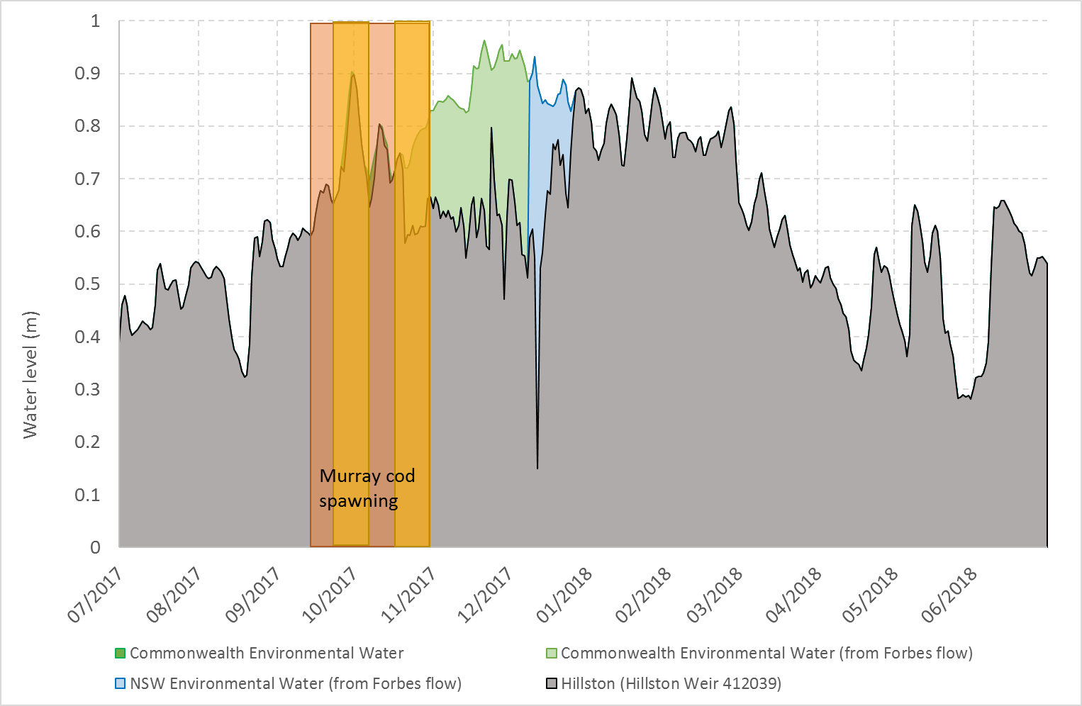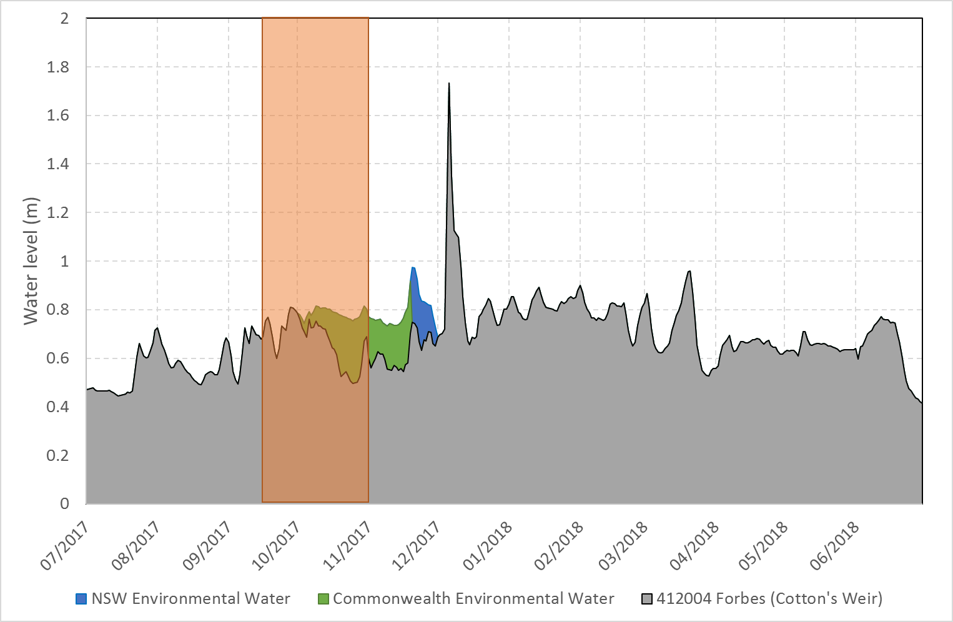

Figure 2. Water level at Hillston Weir (top) and Cotton’s Weir, Forbes (bottom) for the period 1 July 2017 to 30 June 2018 showing Watering Action 1 and estimated spawning dates for Murray cod.  
Commonwealth (green) and NSW (blue) environmental water are shown along with estimates of the water level in the absence of environmental water (grey). Estimated Murray cod spawning time is also shown (orange), along with peak spawning time in the Lower Lachlan (yellow in top figure).

Commonwealth environmental Watering Action 1 was followed by a small fresh using NSW water which was designed to provide opportunities for Murray cod larvae to disperse. While not explicitly stated, this fresh was also expected to produce a pulse in primary productivity in the river as wetted area increased. The small fresh was only evident in the mid-Lachlan and a corresponding fresh did not occur in the Lower Lachlan (Figure 2). Monitoring of stream metabolism only occurs in the Lower Lachlan where the two components of watering action 1 generated a prolonged period of relatively high flows through spring and early summer and did not appear to produce significant effects on water quality or metabolism. There was evidence of a small, short lived, peak in GPP in early October associated with delivery of environmental water, but this was difficult to attribute to environmental water.

Watering Action 1 also provided an end of system flow contributing to longitudinal hydrological connectivity and inundating in-channel habitats along the lower Lachlan river system. As Watering Action 1 passed downstream, the inundation of in channel habitats became more significant. By the time the watering action reached Corrong on the edge of the great Cumbung Swamp in December and January, it resulted in a marked rise (>1m) in the river. This water then passed into the Great Cumbung Swamp, providing water to the central reed beds and near channel wetland habitats during December and January. Fixed point cameras at Clear Lake (Figure 3) show the use of the aquatic habitat by waterbirds.

## Watering action 2: Providing hydrological variability

The second watering action used a combination of re-regulated Commonwealth environmental water (from Watering Action 1) that had been stored in Lake Brewster and NSW environmental water to achieve two small freshes in the river at Booligal during May. This watering action contributed hydrological variability in the lower reaches of the river at a time when operational baseflows would have been steady and low (<30ML/day). It also provided longitudinal hydrological connectivity, with water from this action reaching the Great Cumbung Swamp in June, contributing water to Spell Paddock, Nooran Lake, Clear Lake and the open water bodies near the river channel in the reed beds, including the open water area near Lake Marrool.

These freshes were expected to inundate in-channel habitats and provide food in-stream. There was some evidence for increased GPP and strong evidence for increased ER as a consequence of this flow. This met one of the objectives for the flow which was to create food in-stream through inundation of in-channel benches. This is particularly interesting as the relatively cooler water temperatures in May would normally be expected to mute productivity responses. The relatively larger response in ER suggests that mobilisation of carbon off in-channel benches may be an important mechanism driving this response. Emerging from this result is the hypothesis that autumn pulses may generate in-channel productivity and effectively ‘prime’ ecosystems for positive responses to spring flows.

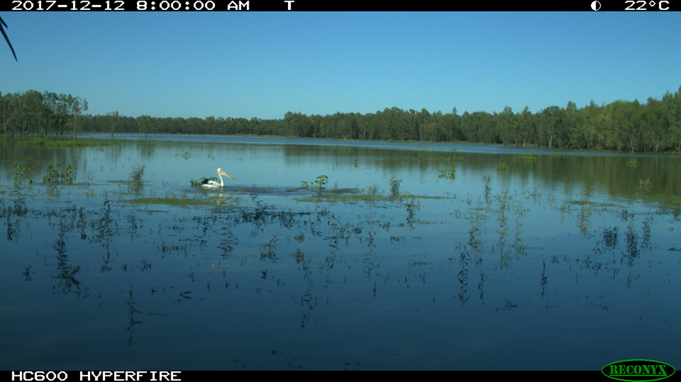

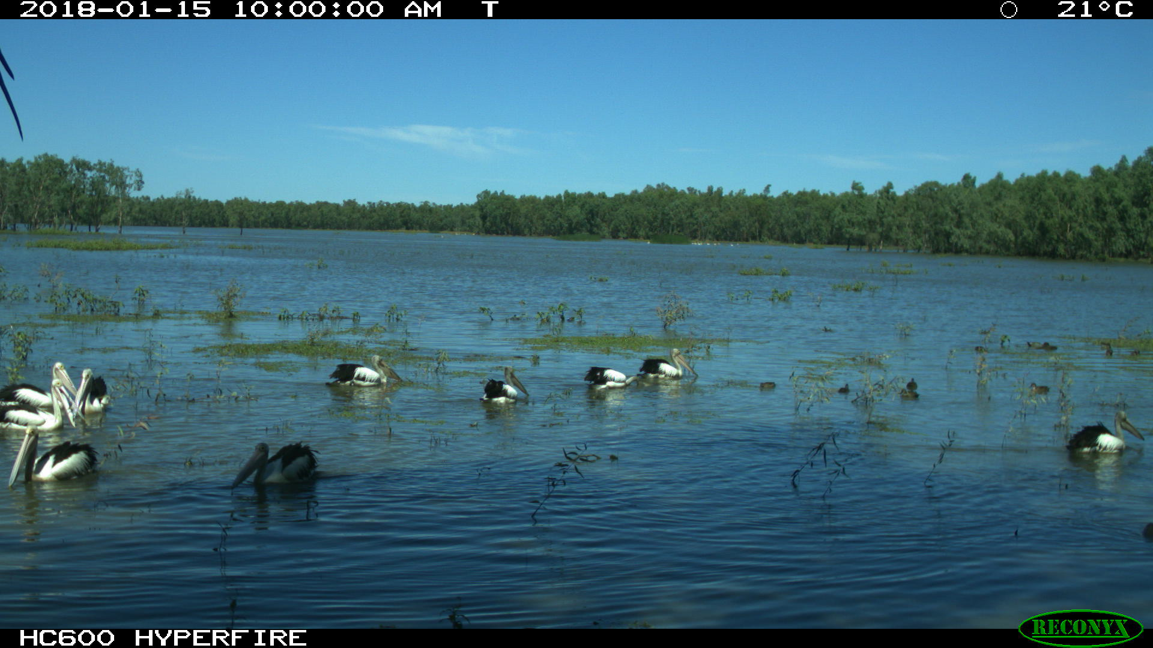

Figure 3. Fixed point camera image from Clear Lake in December 2017 and January 2018 showing the filling of the lake and use by Pelicans.

## Evaluation Questions

This was the fourth of a five year program established to answer specific questions about ecological responses to environmental watering in the Lower Lachlan river system. Stream flow (hydrology), stream metabolism and water quality (temperature, pH, dissolved oxygen, turbidity, conductivity, concentrations of nitrogen and phosphorus), fish (including larval fish) and the condition and diversity of vegetation were monitored to evaluate the outcomes of Commonwealth watering actions. The evaluation questions and responses for the monitored indicators are summarised in Table 2.

Table 2. Evaluation questions and responses for the Lower Lachlan river system Selected Area.

| **INDICATOR** | **EVALUATION QUESTION**  **What did Commonwealth environmental water contribute …..** | **RESPONSE** |
| --- | --- | --- |
| **Hydrology** | to maintaining hydrological connectivity including end of system flows? | Watering actions 1 and 2 provided (longitudinal) hydrological connectivity to the Great Cumbung Swamp providing water during both summer and early winter.  Watering Action 1 maintained in-channel water levels during part of the key spawning time for Murray cod, limiting the potential for next abandonment and desiccation of eggs and early stage larvae. |
|  | to providing hydrologic variability. | The fresh at the end of Watering Action 1 provided a small rise in river level in the mid Lachlan, but not in the Lower Lachlan.  Watering action 1 provided a significant rise in the river in the lower reaches of the river during December and January.  Watering Action 2 provided two small freshes in the river when river levels would otherwise have been constant and low. |
| **Water Quality and Stream Metabolism** | to patterns and rates of decomposition? | Watering actions 1 and 2 resulted in short pulses of production and respiration in the river channel. This was more pronounced for Watering Action 2 and appears likely to be the result of mobilising carbon. |
| to patterns and rates of primary productivity? |
| **Fish - community** | *Short-term (one year)* |  |
| to native fish community resilience? | The native fish community composition was unchanged from previous years but there were small increases in abundance of Murray cod and golden perch observed, suggesting that the community demonstrated a post flood response. |
| to native fish survival? | Recent recruits of both native and exotic species were captured. None of the species captured have specific flow needs for spawning. Their recruitment indicates that flow conditions provided appropriate habitat and food resources to enable the survival and growth of larvae. |
| *Long-term (five years)* |  |
| to native fish populations? | Indeterminate – data contributes to the longer term data set and Basin evaluation. |
| to native fish diversity? |
| **Fish - reproduction** | *Short-term (one year)* |  |
| to native fish reproduction in the Lower Lachlan river system? | Spawning of non-flow dependent fish species detected.  No spawning of flow dependent species detected but recruitment of bony herring was detected which indicated that spawning had occurred. |
| to native larval fish growth in the Lower Lachlan river system? | Impossible to answer definitively with current analysis, though length frequency of larval fish indicated that sizes were increasing for some small bodied fish as each sampling trip was undertaken suggesting growth was occurring. |
| *Long-term (five years)* |  |
| to native fish populations in the Lower Lachlan river system? | Large number of Australian smelt were caught in 2017 compared with previous years, but generally lower numbers of other fish species than 2014 or 2015 |
| to native fish species diversity in the Lower Lachlan river system? | No detectable change in fish diversity. |
| **Vegetation** | *Short-term (one year) and long-term (five years)* |  |
| to vegetation species diversity? | Patterns in site scale vegetation diversity appear to be more strongly related to prevailing weather conditions than watering history. |
| to vegetation community diversity? |
| *Short-term (one year)* |  |
| to condition of floodplain and riparian trees? | Watering actions did not target floodplain and riparian trees and the condition remained unchanged from 2016-17 |
| *Long-term (five years)* |  |
| to populations of long-lived organisms? | Future monitoring will enable a greater understanding of the responses observed. |

# Implications for future management of environmental water

The 2017-18 monitoring and evaluation completes four years of the LTIM program in the Lower Lachlan river system. Collectively, monitoring and evaluation information from the four years can be used to guide the future management of environmental water. In the following sections, the learnings from 2017-18 are combined with those of the previous years to provide a set of recommendations.

## Priorities

Some improvements in individual native fish community metrics were observed between 2016-17 and 2017-18, but the adult fish community in the Selected Area remains in a very poor condition[1]. While there has been variation in population metrics over the four years of the LTIM project, these reflect temporal patterns in response to the range of flow regimes and do not demonstrate a trajectory of either improvement or decline. The very poor condition of the fish community suggests that they should remain a high priority as a target for environmental water in the Lachlan Catchment.

The widespread inundation of all floodplain and wetland sites in 2016-17 provided benefits to the vegetation across the catchment. The long duration of flooding in some locations meant that environmental water was not used to target vegetation outcomes in 2017-18, allowing them to follow a natural drying cycle. The data collected as part of the LTIM project enables the temporal patterns of vegetation in response to weather and flow conditions to be documented. At the end of 2017-18 a greater proportion of amphibious and aquatic species were present than had been observed at the commencement of monitoring in 2014-15 and tree condition remains unchanged throughout the catchment. This would suggest that there is not a great urgency to water to prevent an on-going decline in vegetation condition but that priorities should focus on catchment wide improvements and natural cues may provide a suitable trigger to direct watering actions at vegetation sites in the short term. On-going monitoring of vegetation condition will be used to evaluate this approach and determine the need to deliver water for vegetation outcomes.

## The design of watering actions

Flows and resultant river water levels changes experienced during the 2017 Murray cod spawning season highlight the challenges of managing a working river with multiple demands. A minimum water level was set (using Commonwealth environmental flows), however flow during the spawning and nesting time was influenced by fluctuations in operational flows. There is some evidence that this may have influenced spawning and larval survival, at least conceptually, but it is difficult to generalise on the basis of a single year of data from one zone within a large river system. While it may be tempting to recommend that such fluctuations are minimised to prevent nest abandonment or desiccation during Murray cod spawning, flow variability is a natural part of the flow regime of these rivers in spring. The concept of setting a minimum water level to prevent nest abandonment remains a sound approach and the results of refining this approach in 2018-19 will provide greater insight as to the design of future watering actions.

Carp are an issue for the fish community in the Lachlan catchment and typically watering actions are designed to minimise the inundation of preferred habitat for carp spawning, i.e. floodplain and wetland habitats when temperatures are above 16 degrees. In 2017-18 carp were observed to spawn at a single site in response to an in-channel rise in water level in October. It is likely that the rise in water level was a cue for localised spawning activity, perhaps with the inundation of suitable spawning habitat in-channel. Access to habitat mapping may better inform the water level rises that would be optimal for carp spawning and inform future watering actions.

The use of Commonwealth environmental water in 2017-18 appeared to generate a pulse of in-stream productivity that is likely to have benefited higher consumers. The magnitude of the productivity response given that the flow was delivered in the cooler months exceeded expectations. Trialling small pulses in the cooler months would provide additional insight into the generality of this response. There is the potential that flows at this time of year may ‘prime’ the system for a stronger productivity to spring flows, and this potential could be explored in future watering programs to provide a useful management approach to improving system condition.

The vegetation monitoring noted that sites which had been inundated for a long period of time had a very low number of exotic plants present as they dried. Sites which had been watered for shorter periods of time in 2015-16 had a very high number of exotic plants present. A better understanding of the relationship between watering duration and native/exotic plants communities in the Lachlan is required to inform watering duration. On-going monitoring will contribute to this, but targeted studies may be required.

The objectives for vegetation outcomes within the catchment are not specific and have been based on ‘providing water’. It is recommended that specific outcomes for flows provided to vegetation sites be developed that include details on intended timing, duration and depth of inundation and how these elements are required for the vegetation outcomes being targeted. This can be incorporated into the existing ‘river run’ approach to annual hydrograph planning. It would also enable discussions and related decision making at forums, such as Technical Advisory Group (TAG) meetings, to become multiple outcome in focus, rather than the current single outcome focus (e.g ‘fish TAG’ and/or ‘fish flow’) approach.

## Accounting for the use of environmental water

The style of environmental water management employed in the Lachlan catchment in 2016-17 and again in 2017-18 is responsive and benefits from using a single parcel of water to achieve multiple benefits throughout the river system. While such an approach is an efficient and effective use of water it presents substantial challenges for evaluating the watering actions. Documentation of the watering actions improved in 2017-18 from 2016-17, but some difficulties, particularly with the accounting of water, remained. Watering actions that are targeted in one reach and then ‘reused’ in other parts of the river presents accounting challenges that have significant scope for improvement throughout the watering year. This approach to water delivery may also prove to be essential to achieve the outcomes being targeted at multiple points along the river channel within the same timeframe or season. The water available for Watering Action 2 was a surprise to the water managers and a more regular review of the water account would ensure that such events are not surprises.

In addition, obtaining water accounting data for 2017-18 and getting agreement on volumes between agencies has been inordinately difficult. It is recommended that better mechanisms for reviewing and agreeing on accounting data would facilitate more timely evaluation and learning from watering actions. It is suggested that quarterly accounts be prepared rather than annual accounts to assist with this.

## Informing future monitoring

The current LTIM program for the Lower Lachlan river system only monitors the river system below Lake Brewster. There are no data to evaluate watering actions upstream. While, the fish community in the monitored reach contains a number of important native species the native fish community between Wyangala Dam and Lake Brewster is different (Sam Davis, DPI Fisheries pers comm.). Thus the response observed downstream of Lake Brewster is unlikely to be representative of the upstream reaches. Future monitoring programs should consider monitoring the target reach of environmental water (e.g. Wyangala to Lake Brewster) so that the outcomes might better be evaluated.

Watering actions in the Lachlan in 2017-18 have delivered water to the central reed beds and nearby open water areas of the Great Cumbung Swamp. Vegetation monitoring has not been set up to capture the outcomes of these actions. Access is difficult and costly. Initial forays into the use of drone technology to monitor vegetation outcomes as part of this project have been piecemeal and not particularly effective (Dyer et al. 2017). However, drone technology is likely to provide the most cost effective options for monitoring of the central reed beds and it is recommended that methods be developed in a systematic and rigorous fashion to assist in future monitoring.

# References

Driver, P. D., S. Chowdhury, T. Hameed, P. Lloyd-Jones, G. Raisin, C. Ribbons, G. Singh, and P. Wettin. 2004. Natural and modified flows of the Lachlan Valley wetlands. Resource Analysis Unit, Central West Region, NSW Department of Infrastructure, Planning and Natural Resources, Forbes.

Dyer, F., B. Broadhurst, A. Tschierchke, J. Thiem, R. Thompson, P. Driver, and S. Bowen. 2018. Commonwealth Environmental Water Office Long Term Intervention Monitoring Project: Lower Lachlan river system Selected Area 2017-18 Monitoring and Evaluation Technical Report. . Commonwealth of Australia, 2018.

Dyer, F., B. Broadhurst, A. Tschierschke, J. Thiem, R. Thompson, S. Bowen, M. Asmus, K. Brandis, M. Lyons, J. Spencer, C. Callaghan, P. D. Driver, and J. R. Lenehan. 2017. Commonwealth Environmental Water Office Long Term Intervention Monitoring Project: Lower Lachlan river system Selected Area 2016-17 Monitoring and Evaluation Synthesis Report. Canberra.

Murray-Darling Basin Authority. 2012. Sustainable Rivers Audit 2: The ecological health of rivers in the Murray–Darling Basin at the end of the Millennium Drought (2008–2010). Summary.

1. Based on standard metrics, see Dyer et al. (2018) for more details.