Commonwealth environmental water office

Long term intervention monitoring project:

Lachlan river system

2018-19 Summary report: FINAL

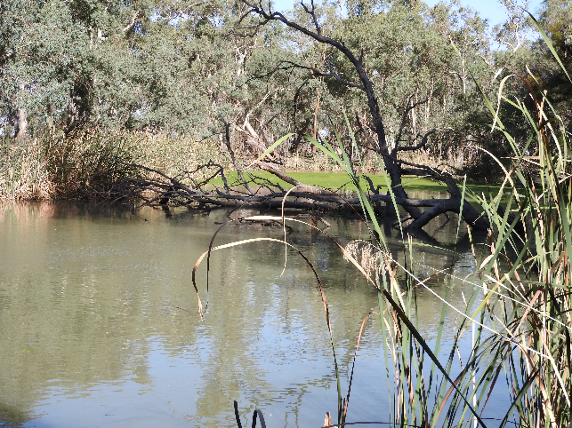

February 2020

**Commonwealth Environmental Water Office**

**Long Term Intervention Monitoring Project**

**Lachlan river system 2018-19 Summary Report**

**February 2020**

This document has been co-ordinated by Dr Fiona Dyer and includes contributions from Mr Ben Broadhurst, Dr Will Higgisson, Ms Alica Tschierschke, Mr Hugh Allan, Professor Ross Thompson (University of Canberra); Dr Patrick Driver and Dr Sharon Bowen (NSW Department of Primary Industries, Water); Dr Joanne Lenehan, (NSW Department of Planning, Industry and Environment); and Dr Jason Thiem and Dr Daniel Wright (NSW Department of Primary Industries, Fisheries).

 

G:\Fishnet\Research Projects\Logos\DPI logo colour rgb.jpg http://data.nsw.gov.au/data/images/Office-of-Environment-and-Heritage.jpg

This monitoring project was commissioned and funded by Commonwealth Environmental Water Office with additional in-kind support from the University of Canberra, NSW Office of Environment and Heritage, and Department of Primary Industries.

**Copyright**© Copyright Commonwealth of Australia, 2019



**Commonwealth Environmental Water Office Long Term Intervention Monitoring Project: Lower Lachlan river system Selected Area** is licensed by the Commonwealth of Australia for use under a Creative Commons by Attribution 3.0 Australia licence with the exception of the Coat of Arms of the Commonwealth of Australia, the logo of the agency responsible for publishing the report, content supplied by third parties, and any images depicting people. For licence conditions see: <http://creativecommons.org/licenses/by/3.0/au/>

This report should be attributed as: Dyer, F., Broadhurst, B., Tschierschke, A., Higgisson, W., Allan, H., Thiem, J., Wright, D., Thompson, R. (2019). Commonwealth Environmental Water Office Long Term Intervention Monitoring Project: Lachlan river system Selected Area 2018-19 Monitoring and Evaluation Summary Report. Commonwealth of Australia, 2019.

The Commonwealth of Australia has made all reasonable efforts to identify content supplied by third parties using the following format ‘© Copyright, [name of third party] ’.

**Disclaimer**

The views and opinions expressed in this publication are those of the authors and do not necessarily reflect those of the Australian Government or the Ministers for the Department of Agriculture, Water and the Environment.

While reasonable efforts have been made to ensure that the contents of this publication are factually correct, the Commonwealth does not accept responsibility for the accuracy or completeness of the contents, and shall not be liable for any loss or damage that may be occasioned directly or indirectly through the use of, or reliance on, the contents of this publication.

Inquiries regarding this document should be addressed to:

Dr Fiona Dyer  
Phone: 02 6201 2452  
e-mail: Fiona.Dyer@canberra.edu.au

|  |  |  |  |  |  |  |
| --- | --- | --- | --- | --- | --- | --- |
| **Document history and status** | | | | | | |
| **Version** | **Date Issued** | **Issued to** | **Reviewed by** | **Approved by** | **Revision Type** |
| Draft | 31 October 2019 | CEWO | Ben Broadhurst | Fiona Dyer | DRAFT |
| FINAL Draft | 7 February 2020 | CEWO | CEWO | Fiona Dyer | FINAL draft |
|  |  |  |  |  |  |
|  |  |  |  |  |  |

Front cover photo: The Lachlan River at Oxley, April 2019. Photo by Alica Tschierschke, University of Canberra

**TABLE OF CONTENTS**

1 Monitoring and Evaluation of Environmental Water in the Lachlan river System 7

2 Environmental watering in the Lower Lachlan River system in 2018-19 9

3 Key outcomes from environmental water use 12

3.1 Supporting native fish recruitment 12

3.1.1 Stimulating in-stream production to support larval fish 12

3.1.2 Maintaining river levels to support nesting fish 16

3.2 Providing aquatic habitat 17

3.3 Evaluation questions 20

4 Implications for future management of environmental water 24

4.1 Priorities 24

4.2 The design of watering actions 24

4.3 Accounting for the use of environmental water 26

4.4 Informing future monitoring 26

5 References 28

**LIST OF FIGURES**

Figure 1. The Lachlan river system showing the monitoring zones for the 2018-19 LTIM program. 7

Figure 2. Flow in the Mid Lachlan at Condobolin (bottom) showing the delivery of Commonwealth environmental water (green) and the response of Gross Primary Productivity (GPP – top). Water temperatures at the monitoring site are shown as the red line in the upper figure. 13

Figure 3. Estimated water level at Forbes (Iron Bridge) for the period 1 July 2018 to 30 June 2019 showing Watering Actions 1 and 2 and estimated spawning dates for Murray cod (orange) and three small bodied native fish (yellow). 14

Figure 4. Flow in the Lower Lachlan at Whealbah (bottom) showing the estimated delivery of Commonwealth environmental water (green) and the response of Gross Primary Productivity (GPP – top). Water temperatures at the monitoring site are shown as the red line in the upper figure. 15

Figure 5. Water level at Hillston Weir for the period 1 July 2018 to 30 June 2019 showing Watering Actions 1 and 2 and estimated spawning dates for Murray cod (orange) and three small bodied native fish (yellow). 16

Figure 6. Sentinel imagery from the Great Cumbung Swamp as the autumn/ winter pulse arrived (30th June 2019, upper image), at maximum extent of inundation (10th July 2019, middle image) and once the water had receded (17th August 2019, lower image). 19

**LIST OF TABLES**

Table 1. The 2018-19 Commonwealth environmental watering actions. 10

Table 2. Evaluation questions and responses for the Mid and Lower Lachlan river system Selected Area. 20

**ACRONYMS AND ABBREVIATIONS**

|  |  |
| --- | --- |
| **Accepted Acronym** | **Standard Term (capitalisation as specified)** |
| ANAE | Australian National Aquatic Ecosystem |
| CEWH | Commonwealth Environmental Water Holder |
| CEWO | Commonwealth Environmental Water Office |
| CPUE | Catch per unit effort |
| GS | General Security |
| HS | High Security |
| IMEF | Integrated Monitoring of Environmental Flows |
| LLS | Local Land Services |
| LTIM | Long Term Intervention Monitoring |
| MDBA | Murray-Darling Basin Authority |
| M&E | Monitoring and Evaluation |
| MDMS | Monitoring Data Management System |
| SOP | Standard Operating Procedure |
| QA/QC | quality assurance / quality control |

**ACKNOWLEDGMENTS**

The project team as well as the Commonwealth Environmental Water Office (CEWO) respectfully acknowledge the traditional owners of the land on which this work is conducted, their Elders past and present, their Nations of the Murray-Darling Basin, and their cultural, social, environmental, spiritual and economic connection to their lands and waters.In particular, in the Lower Lachlan river system Selected Area we acknowledge the Wiradjuri peoples, traditional owners of the land on which this publication is focused.

The project team also thank the team of people who contributed to the project delivery including: Rhian Clear, Damian McRae, Francis Horacek, Paul Packard, Joanne Lenehan, Ugyen Lhendup, Hugh Allen, Mark Lintermans, Yasmin Cross, Kyle McGrath, Joseph O’Connell, Adam Cotterill, Dennis Ryan, Patrick Driver, Sharon Bowen, Joel Honeysett and Daniel Scherrer. Hugh Allan, Max Mallett, Tim Kaminskas, Karl Moy, Max Clear, Liam Allan, Emily Belton, Sally Hatton, Pat Ross-Magee, Blake Galley, Emily Sprague, Kat Cheshire, Nickey Van Der Meyer, Jackie O'Sullivan, Chris Keogh, Jessica Sharpe, Andy Lowes, Hannah Belnick, Katie Ryan, Laura Caffrey and Daniel Wright.. The following DPI Fisheries staff assisted with field data collection and laboratory processing: Allen Brooks, Tom Butterfield, Jonathan Doyle, Jarryd McGowan, Nicholas O’Brien, Rohan Rehwinkel, Bridget Smith, Christopher Smith, and Sarah Talbot.

The landholders who granted us access to sites are thanked for their interest, cooperation and support.

Vegetation sampling was conducted under NSW Scientific License SL 102011. Fish sampling was conducted under Fisheries NSW Animal Care and Ethics permit 14/10 and scientific collection permit P01/0059(A)-4.0. Larval fish sampling was conducted under NSW DPI permit No: P14/0022-2.0 and under approval from the University of Canberra Animal Ethics Committee (AEC 17-23).

# Monitoring and Evaluation of Environmental Water in the Lachlan river System

The headwaters of the Lachlan River are located on the Breadalbane Plain in New South Wales (NSW) between Yass and Goulburn. The river flows west for approximately 1,400 km and in most years, it terminates at Great Cumbung Swamp. In years of high flows, water from the Lachlan River can pass through the swamp to the Murrumbidgee River.

The focus of the LTIM Project has been the Lower Lachlan river system which extends from the outlet of Lake Brewster to the Great Cumbung Swamp (Figure 1). It encompasses anabranches, flood runners, billabongs, distributaries and terminal wetlands, such as Merrowie Creek, Booligal Wetlands and Lachlan Swamp. The river system is complex, with a diversity of in-channel and floodplain features that provide a variety of habitats for the species in the region. Flows and water levels are naturally variable and unpredictable providing temporally complex habitats. In 2018-19, monitoring was extended to the Mid Lachlan river system which encompasses the reach between Forbes and Lake Brewster (Figure 1).

The Lachlan River catchment supports many flora and fauna listed as vulnerable or endangered under federal or NSW state legislation. The Great Cumbung Swamp, at the terminus of the Lachlan River, is one of the most important waterbird breeding areas in eastern Australia and supports one of the largest remaining stands of river red gums in NSW.

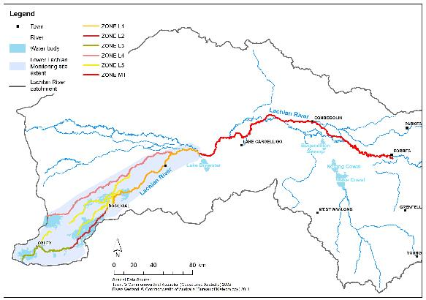

Figure 1. The Lachlan river system showing the monitoring zones for the 2018-19 LTIM program.

*The blue inset southwest of Oxley, shows the area of the Great Cumbung Swamp (see Figure 6, p. 19).*

Like many rivers of the Murray Darling basin, flow regulation in the Lachlan river catchment has had a significant effect on the average annual flow as well as inter-annual and seasonal variability (Driver et al. 2004). This is believed to have been a key driver in a deterioration of the freshwater ecosystems within the catchment and the Lower Lachlan river system has previously been assessed as being in poor ecosystem health on the basis of an extremely poor native fish community, highly modified flow regimes (hydrology), and a physical form and vegetation community that is in poor to moderate condition (Murray-Darling Basin Authority 2012). The Millennium Drought (2001-2009) resulted in large areas of river red gums becoming stressed, and a further decline in the condition of wetland vegetation. Some recovery of the wetlands and rivers has been observed since 2010, attributed to natural flow events and environmental watering actions. In 2016, the Booligal wetlands supported the largest and most successful breeding colony of straw-necked ibis in the Murray Darling basin since 1984.

Commonwealth environmental water has been delivered in the Lachlan catchment since 2010 and more than 205 GL of Commonwealth environmental water has been delivered to date to achieve a wide range of outcomes. Within the main channel environmental flows have sought outcomes ranging from hydrological connectivity and variability, dissolved oxygen, providing cues for native fish spawning and providing refuge habitat. A number of significant wetlands have also received environmental flows including Booligal swamp, Lake Tarwong and the Great Cumbung Swamp. These wetland flows have sought to achieve waterbird breeding, vegetation condition and fish dispersal outcomes.

The Long-Term Intervention Monitoring Project (LTIM Project) is the primary means by which the Commonwealth Environmental Water Office (CEWO) undertakes monitoring and evaluation of the ecological outcomes of Commonwealth environmental watering. Monitoring activities implemented within the LTIM Project to evaluate the outcomes of Commonwealth environmental watering actions in the Lower Lachlan river system in 2018‑19 included the monitoring of stream flows (hydrology), stream metabolism and water quality (dissolved oxygen, temperature, pH, electrical conductivity, turbidity and nutrients), fish (including larval fish) and the condition and diversity of vegetation (Dyer et al. 2014). Monitoring of stream metabolism and fish outcomes focussed on the stretch of river between Lake Brewster and Whealbah and the monitoring of hydrological and vegetation outcomes occurs across the entire Selected Area (Figure 1). The evaluation uses monitoring data to assess the achievements of Commonwealth environmental watering in relation to the outcomes expected for the Lower Lachlan river system.

At the request of the CEWO, additional monitoring activities were undertaken in the Mid and Lower Lachlan river system in 2018-19. This included the monitoring of stream flows (hydrology), stream metabolism and water quality (dissolved oxygen and temperature) and fish (including larval fish) in the Mid Lachlan river system, and a trial of eDNA for monitoring fish populations in both the Mid and Lower Lachlan river systems.

This report summarises the outcomes from the final of five years of monitoring and evaluation of Commonwealth environmental watering in the Lower Lachlan river system. It is focussed on key outcomes from the five years of environmental watering and the associated learning that informs the future management of environmental water. It is accompanied by a technical report (Dyer et al 2019) which provides more details of the watering actions, the monitoring activities and the evaluation of the outcomes.

# Environmental watering in the Lower Lachlan River system in 2018-19

Planning for environmental watering in 2018-19 was undertaken with rapidly declining water resource availability and the knowledge that the widespread flooding in 2016-17 had sustained tree health well into 2018. This provided opportunities to build on the investment of previous years to continue to support the recovery of native fish populations, maintain core reed beds in the terminal wetlands and to build the resilience of populations and ecosystems.

Four watering actions involving Commonwealth environmental water were delivered to the Mid and Lower Lachlan river system in 2018-19 (Table 1), all of which were designed to support lateral and longitudinal connectivity. The first two actions targeted outcomes for native fish in the main channel of the mid (Forbes) and lower (Hillston) Lachlan River, the third targeted aquatic habitat outcomes in Yarrabandai Lagoon (mid Lachlan River) and the fourth action targeted the Great Cumbung Swamp at the end of the system. Water from these actions was regulated and re-regulated to achieve outcomes at multiple locations.

The first watering action was designed to provide a spring pulse in the mid Lachlan to support native fish outcomes. This watering action was used to provide a small flow into Booberoi Creek and part of it was also re-regulated through Lake Brewster and used to provide flow variability in river height in the lower Lachlan. Both elements of this watering action provided flow to the central reed beds of the Great Cumbung Swamp to create longitudinal connectivity.

The second watering action was designed to prevent rapid drops in river level and potentially exposing native fish nesting sites. Water was used to keep the river above 800 ML/day in the mid Lachlan (Forbes). This water was also passed through the system to provide variability in water levels in the lower reaches of the river and provided flow to the central reed beds of the Great Cumbung Swamp to create longitudinal connectivity.

The third watering action targeted Yarrabandai Lagoon and involved the transfer of 412 ML into the wetland to prevent it from drying out. In doing so, it aimed to generate lateral connectivity and provide habitat for a range of water dependent species.

The fourth watering action was designed to provide water to the central reed beds in the Great Cumbung Swamp, and thus provide connectivity and variability in flows along the lower Lachlan during late autumn and winter.

Table 1. The 2018-19 Commonwealth environmental watering actions.

| **Description** | **Details** |  |  |  |
| --- | --- | --- | --- | --- |
| **Action** | 1 | 2 | 3 | 4 |
| **Target Asset** | Mid Lachlan River, main channel and Booberoi Creek, main channel | Mid Lachlan River, main channel | Yarrabandai (formerly Burrawang West) Lagoon | Lower Lachlan River, main channel below Lake Brewster terminating in Great Cumbung Swamp |
| **Reference** | WUM10081-01 | WUM10081-01 | WUM10081-02 | 10081-03 |
| **Accounting Location** | Lachlan River at Forbes (Cotton’s Weir)  Booberoi Creek off take | Lachlan River at Forbes (Cotton’s Weir) | Yarrabandai (formerly Burrawang West) Lagoon | Lachlan River at Booligal |
| **Flow component** | Fresh flow | Base flow | Wetland watering | Fresh flow |
| **Volume (CEW)** | 10 391 ML (accounted at Forbes) and includes 761 delivered to Booberoi Creek, 6,355 system flow and 1,820 held and re-released from Brewster Weir | 2 032 (accounted at Forbes) | 412 ML | 5 338 (accounted at Booligal) |
| **Total Volume (ML)** | 10 391 ML | 2 032 ML | 412 ML | 5 338 ML |
| **Re-use** | 761 ML re-regulated from the Forbes flow and accounted at the Booberoi Creek Offtake |  |  |  |
| **Objectives** | To support the movement of native fish prior to the spawning season and support the ability of native fish to achieve good pre-spawning condition.  To be of short duration to prevent early nesting at higher river level.  To mobilise carbon from the riverbank and benches to stimulate primary productivity (i.e. create food)  To support spawning success of native fish that may have spawned early, such as Australian smelt.  To provide a gradual recession to periods of high flow.  To provide flows into distributary Creeks, including Booberoi Creek.  To provide early spring watering for areas of riparian native vegetation along the river channel that may not have been watered since March or June 2018 | To inundate areas of the river channel containing large woody habitat (snags) which is the preferred spawning habitat for nesting native fish such as Murray cod, River blackfish and Freshwater catfish.  Avoid rapid drops in water level from late September to early December to prevent nest abandonment by native fish.  Promote the dispersal of larval/juvenile Murray cod, River blackfish and Freshwater catfish with a short rise in flows at the end of November as fish leave their nest site within days-weeks post-hatching. It may also provide an additional productivity boost and hence replenish food sources for larvae as they begin to feed on their own.  Recede flows towards the end of this period to extend duration of downstream dispersal by larval and juvenile fish and extend upstream movement opportunities for adolescents and adult fish |  | Protect the core reed beds and other non-woody vegetation communities as the catchment continues into a dry period  Provide connectivity and variability to flows along the lower Lachlan during autumn-winter  Encourage native fish movement in the lower Lachlan River and improve the condition of native fish before winter.  Limit the opportunity for carp breeding, particularly in the river channel (carp are spring-summer spawners) |
| **Basin Annual watering priorities 2018-19** | Support viable populations of threatened native fish, maximise opportunities for range expansion and establish new populations.  Support opportunities for lateral connectivity between the river and adjacent low-lying floodplains and wetlands to reinstate natural nutrient and carbon cycling processes.  Maintain and improve the condition and promote recruitment of forests and woodlands.  Support lateral and longitudinal connectivity. | Support viable populations of threatened native fish, maximise opportunities for range expansion and establish new populations.  Support lateral and longitudinal connectivity. | Support opportunities for lateral connectivity between the river and adjacent low-lying floodplains and wetlands to reinstate natural nutrient and carbon cycling processes  Support lateral and longitudinal connectivity. | Support viable populations of threatened native fish, maximise opportunities for range expansion and establish new populations.  Support opportunities for lateral connectivity between the river and adjacent low-lying floodplains and wetlands to reinstate natural nutrient and carbon cycling processes.  Support lateral and longitudinal connectivity. |

# Key outcomes from environmental water use

The four environmental watering actions delivered in 2018-19 were modest, using a third of the Commonwealth’s available volume in the Lachlan River system. In combination, the volumes delivered contributed approximately 4% of the flow in the river at Forbes, 11% at Hillston and 24% at Booligal in 2018-19. While Commonwealth environmental water made an almost negligible contribution to the mid Lachlan (4% of the flow at Forbes), it provided almost one quarter (24%) of the flow at Booligal illustrating the relative importance of Commonwealth water in the lower reaches of the river.

The four watering actions delivered in 2018-19 were designed to:

1) benefit native fish and stream productivity by modifying the flow regime to create specific in-channel hydrological conditions (Actions 1 and 2); and

2) provide aquatic habitat by generating lateral and longitudinal connectivity (Actions 1 to 4).

In combination these watering actions used 18,173 ML of Commonwealth environmental water. By focussing on maintaining and improving existing populations of fish, and providing longitudinal and lateral connectivity that support natural nutrient and carbon cycling processes, these watering actions contributed to the watering priorities for the Murray Darling Basin Authority.

The Commonwealth watering actions were complemented by the use of 17,958 ML of NSW environmental water which was used across 6 watering actions to achieve a variety of outcomes.

## Supporting native fish recruitment

The first watering action provided early spring freshes in the mid and lower Lachlan river system that were designed to support the movement of native fish and stimulate primary productivity, priming the system for positive native fish spawning outcomes during spring and early summer. This was followed by the second watering action which prevented the water level in the river from dropping below 800 ML/day in the mid Lachlan during the Murray cod nesting period (mid-October to early December), supporting any spawning outcomes generated by the first watering action.

### Stimulating in-stream production to support larval fish

The first watering action provided an early spring fresh in the mid Lachlan river system reshaping the operational hydrograph, increasing the peak by 0.2 m (in total the river rose almost 0.4 m at Cotton’s Weir and 1.4 m in the free flowing river) and achieving a smooth recession. This watering action was delivered in the first few weeks of September when water temperatures were between 13 and 17 ⁰C and rising rapidly (Figure 2). The expectation was that the small fresh would produce an increase in stream productivity. Our stream metabolism data shows that the spring fresh mobilised nutrients (including carbon) generating an increase in basal resources and productivity (Figure 2). The first watering action was followed by a fresh of similar magnitude from operational deliveries which also showed a similar pulse in basal resources and productivity.

The first watering action and corresponding productivity pulse coincided with the estimated peak spawning season of Australian smelt and the tail of the carp gudgeon spawning season (Figure 3). This is likely to have been beneficial to these small bodied larval fish by increasing food resources.

The first watering action was ideally timed to support spawning movements of Murray cod. Murray cod have been found to migrate immediately prior to spawning, most likely to find a mate or suitable spawning habitat. The enhancement of the flow peak approximately 4 weeks prior to Murray cod spawning (Figure 3) would have increased connectivity between habitats, producing opportunities for fish to move that would not have occurred in the absence of Commonwealth Water.

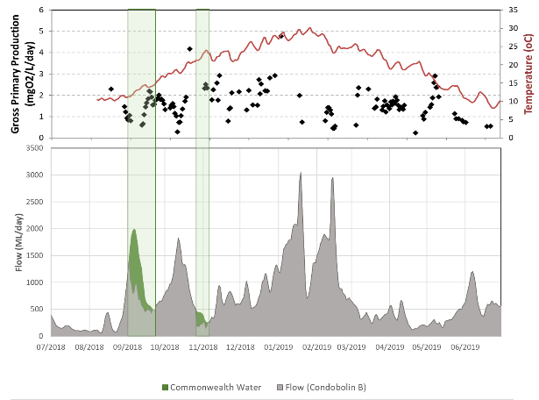

Figure . Flow in the Mid Lachlan at Condobolin (bottom) showing the delivery of Commonwealth environmental water (green) and the response of Gross Primary Productivity (GPP – top). Water temperatures at the monitoring site are shown as the red line in the upper figure.

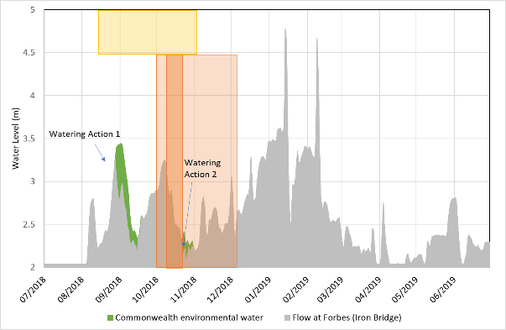

Figure . Estimated water level at Forbes (Iron Bridge) for the period 1 July 2018 to 30 June 2019 showing Watering Actions 1 and 2 and estimated spawning dates for Murray cod (orange) and three small bodied native fish (yellow).

Commonwealth (green) environmental water is shown along with estimates of the water level in the absence of environmental water (grey). Estimated peak Murray cod spawning time is shown (darker orange), along with the spawning window for Australian smelt, carp gudgeons and flat-headed gudgeons (yellow).

As the first two watering actions passed through the river systems as a ‘run of river’, they were re-regulated at Brewster Weir to provide three small freshes into the Lower Lachlan between mid September and mid November (Figure 4). The expectation was that these would provide instream flow variability and pulses in productivity during the spring period. While there is some evidence of productivity pulses in the river during these freshes, particularly the first pulse, the response is not consistent across the monitoring sites and in-stream production appears to be more closely linked to stream temperatures than changes in flow during this period (Figure 4).

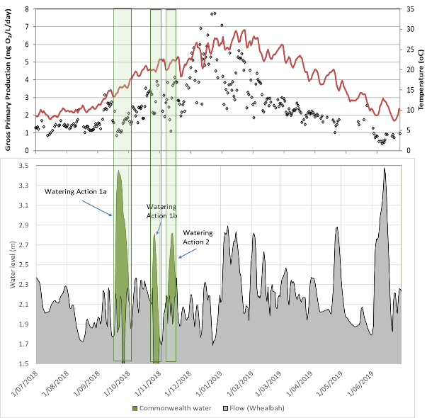

Figure . Flow in the Lower Lachlan at Whealbah (bottom) showing the estimated delivery of Commonwealth environmental water (green) and the response of Gross Primary Productivity (GPP – top). Water temperatures at the monitoring site are shown as the red line in the upper figure.

The freshes delivered to the Lower Lachlan from Watering Actions 1 and 2 were delivered during the spawning period for the four native fish species that were observed to spawn during the spring of 2018 (Figure 5). The first of these freshes occurred during and just after the peak estimated spawning of flatheaded gudgeon and Australian smelt, respectively, resulted in a river rise of greater than 1 m. Such a change would have inundated new habitat (potentially spawning habitat for flatheaded gudgeon) and likely boosted food resources at an ideal time for these two species. The first peak was also delivered immediately prior to the peak of Murray cod spawning, which would have proved ideal for increasing river connectivity for spawning related movements of this species.

The second fresh was delivered immediately following the estimated spawning peak of Murray cod. While it was not clear that there was a pulse in production associated after this second fresh any increases in production would likely result in increases to food availability for larval Murray cod. Furthermore, it is likely that the second spring pulse provided opportunities for larval Murray cod to disperse.

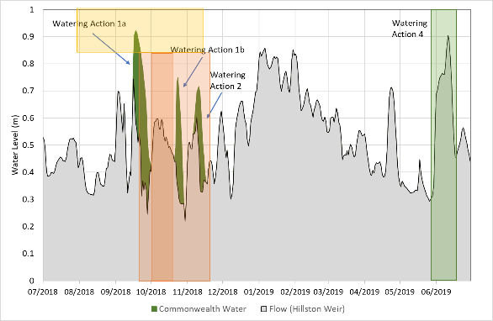

Figure . Water level at Hillston Weir for the period 1 July 2018 to 30 June 2019 showing Watering Actions 1 and 2 and estimated spawning dates for Murray cod (orange) and three small bodied native fish (yellow).

Commonwealth environmental water (green) is shown along with estimates of the water level in the absence of environmental water (grey). Estimated peak Murray cod spawning time is shown (darker orange), along with the spawning window for Australian smelt, carp gudgeons and flat-headed gudgeons (yellow).

The spring pulse delivered in spring 2018 appears to have driven a large spawning response in flatheaded gudgeon, with larval abundances in 2018 nearly 8-fold the next most abundant year. This follows a relatively large spawning response in 2015 (a year where high spring flows were also observed). Although flatheaded gudgeon are not recognised as a species that is a flow dependent spawner, increased food resources that accompany increases in flow during spring look to be a likely driver of spawning and early recruitment intensity in the lower Lachlan River selected area.

### Maintaining river levels to support nesting fish

The second watering action aimed to maintained a stable water level by keeping the river above 800 ML/day at Forbes (Cotton’s Weir) between the 17th October and the 3rd December. During this period, Commonwealth water was used for 8 days at the end of October prevent a water level drop of up to 0.25 m in height (Figure 3). This was timed ideally as the watering action was delivered immediately following the estimated peak spawning period for Murray cod in the mid Lachlan, which was in mid October (Figure 3).

In contrast, in the lower Lachlan, watering action 2 was used in combination with watering action 1 to provide a series of pulses in the river to stimulate productivity. These produced water level changes of between 0.20 m (Figure 5) and 1.2 m (Figure 4) during peak Murray cod spawning period. In spite of the variable water levels, good numbers of larval Murray cod were present in the lower Lachlan.

In 2017-18, Commonwealth environmental water was used in the lower Lachlan to maintain water levels and in doing prevented rapid drops in water level of more than 0.2 m during peak Murray cod spawning period. Numbers of larval Murray cod were considerably lower in 2017-18 than in 2018-19 in the lower Lachlan and we do not have data for the mid-Lachlan for 2017-18. Differences in larval numbers between years cannot be solely attributed to water level management. Adult fish populations were low in 2017-18 following the black water effects of the 2016-17 floods. This would likely result in low numbers of larval fish, irrespective of water management activities.

It is difficult to disentangle the effects of the two different water level strategies in the mid and lower Lachlan River for Murray cod spawning as we have only a single year of data for the mid Lachlan and there are numerous confounding factors. It is quite unlikely that preventing the river from dropping up to 0.25 m in height would have made any difference to spawning in the mid Lachlan. It would also appear that the spawning in the lower Lachlan was not adversely affected by water level changes of around 1 m, some of which were quite rapid. Future strategies for managing water levels should revisit the concept of a fixed floor in light of understanding critical nesting habitat in relation to water level and consider modifying rates of change rather than, or in addition to, fixed water levels. These would need to be informed by additional data from the mid Lachlan River.

## Providing aquatic habitat

The four watering actions delivered in 2018-19 connected in-channel habitats and provided flow to the end of the river system.

The first watering action provided an early spring fresh in the mid Lachlan river system reshaping the operational hydrograph, increasing the peak by 0.2 m (in total the river rose between 0.4 m and 1.4 m) and achieving a smooth recession. As the watering action passed downstream, a portion of the water was delivered to Booberoi Creek. The remainder was then re-regulated and combined with watering action 2 to provide three small freshes to the lower river (which raised water levels by 0.5 – 1.4 m). By leveraging operational flows and actively managing the passage of water these watering actions provided an efficient approach to connecting in-channel habitats, providing opportunities for short term movement of fish prior to spawning in both the mid and lower Lachlan, and providing habitat for other water dependent species.

The contribution of Commonwealth environmental water to habitat was most significant in the lower river, with around 24% of the flow in the river at Booligal in 2018-19 provided by Commonwealth environmental water. The four small to very small freshes[1] provided at Booligal (three in spring and a fourth in early winter) more than doubled the number of freshes at Booligal that exceeded 200 ML/day during 2018-19 and provided the only freshes to reach 500 ML/day for the watering year. These freshes were maintained along the river to the edge of the Great Cumbung Swamp, inundating in-channel habitats. Under natural conditions there would have been 2 medium freshes and 4 small freshes passing Booligal during the same period (Figure 6).

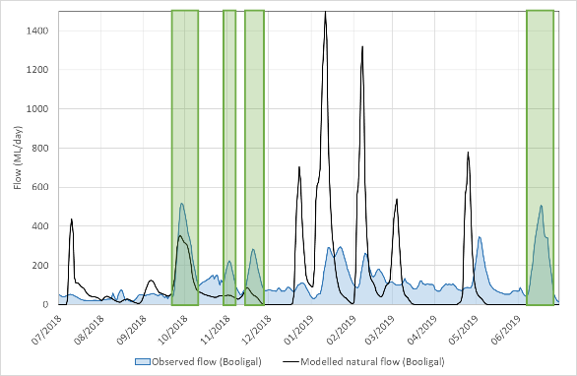

Figure . Flow at Booligal for the period 1 July 2018 to 30 June 2019 (blue) and modelled natural flow (black).

The timing of the four freshes provided using Commonwealth environmental water is shown in green.

Commonwealth environmental water was delivered into the Great Cumbung Swamp in mid to late spring and again during mid-winter. This provided almost 6 weeks of inundation to side channels and low lying areas in the Swamp in mid to late spring and a further 6 weeks in winter (Figure 6). This generated opportunities for water birds to access habitat and provided water to the aquatic vegetation.

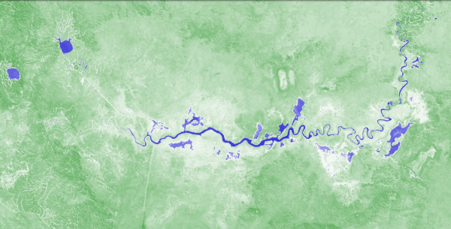

A 2019-06-30

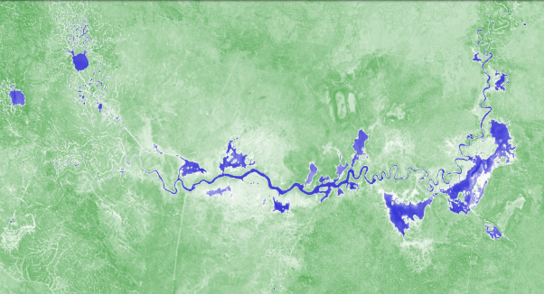

B 2019-07-10

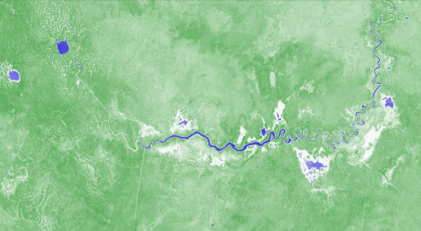

C 2019-08-17

Figure . Sentinel imagery from the Great Cumbung Swamp as the autumn/ winter pulse arrived (A  30th June 2019), at maximum extent of inundation (B 10th July 2019) and once the water had receded (C 17th August 2019).

Images sourced from https://www.sentinel-hub.com/explore/sentinel-playground

## Evaluation questions

This was the fifth of a five-year program established to answer specific questions about ecological responses to environmental watering in the Lower Lachlan river system. Stream flow (hydrology), stream metabolism and water quality (temperature, pH, dissolved oxygen, turbidity, conductivity, concentrations of nitrogen and phosphorus), fish (including larval fish) and the condition and diversity of vegetation were monitored to evaluate the outcomes of Commonwealth watering actions. The evaluation questions and responses for the monitored indicators are summarised in Table 2.

Table 2. Evaluation questions and responses for the Mid and Lower Lachlan river system Selected Area.

| **INDICATOR** | **EVALUATION QUESTION**  **What did Commonwealth environmental water contribute …..** | **RESPONSE** |
| --- | --- | --- |
| **Hydrology** | to habitat for native fish and other water dependent vertebrate species? | Watering action 1 provided small freshes in the mid and lower Lachlan River generating access to in-channel habitats and providing opportunities for short term movement of fish prior to spawning.  Part of watering action 1 also provided water to Booberoi Creek providing habitat for fish and other water dependent species. |
|  | to hydrological variability in the Lower Lachlan during periods of low flow? | In the mid reaches, a single fresh was provided at Forbes in early spring. This fresh provided one of few (4) pulses to exceed 2,000 ML/day and one of 3 pulses that exceeded a river height of 0.9 m during the 2018-19 watering year at Forbes.  In the lower reaches (Booligal), the watering actions resulted in four small to very small freshes: three in spring and a fourth in early winter. These more than doubled the number of freshes at Booligal that exceeded 200 ML/day during 2018-19 and provided the only freshes to reach 500 ML/day for the watering year. |
|  | to hydrological connectivity? | Watering actions 1, 2 and 4 provided (longitudinal) hydrological connectivity to the Great Cumbung Swamp providing water during both late spring 2018 and winter 2019. |
| **Water Quality and Stream Metabolism** | to primary production in the mid and lower Lachlan River? | Watering action 1 resulted in a pulse of production in the mid Lachlan River channel.  Watering actions 1, 2 and 4 results in short pulses of production in the lower Lachlan River channel, with the greater effect observed during warmer months. |
|  | to water quality outcomes? | There is evidence that watering events can alter water quality parameters, particularly through increasing carbon and nutrients, although these effects appear to be relatively transient and can be highly variable in magnitude in both space (site to site) and time. These effects are much smaller than those observed during large natural flows. |
|  | to patterns and rates of ecosystem respiration (decomposition - ER) and primary productivity (GPP)? | Watering events generated short pulses of GPP and ER, with GPP responses being larger in warmer conditions. |
|  |
| **Fish - community** | *Short-term (one year)* |  |
| to native fish community resilience? | The native fish community composition was unchanged from previous years but there were small increases in abundance of Murray cod observed, suggesting that the community is continuing to recover post flood. |
| to native fish survival? | Recent recruits of both native and exotic species were captured. None of the species captured have specific flow needs for spawning. Their recruitment indicates that flow conditions provided appropriate habitat and food resources to enable the survival and growth of larvae. Based on captures of juveniles, 2018 was a significant recruitment year for Murray cod in the mid Lachlan. |
| *Long-term (five years)* |  |
| to native fish populations? | The Lower Lachlan native fish population was most affected by fish kills in 2016–2017 during LTIM years, which reduced the biomass of large-bodied Murray cod in 2017 and promoted the spawning and subsequent recruitment of common carp. This significant event likely drowned out other effects on the fish community over the study period. Commonwealth environmental watering actions may have contributed to the post-kill recovery of native fish populations in 2018 and 2019, however it is unknown if this recovery would have differed without it. |
|  | to native fish diversity? | There has been a slight decline in the diversity of the Lower Lachlan native fish community from 7 species detected in 2015–2017 to 6 species in 2018–2019, with changes to the suite of species observed. This may relate to the hypoxia-linked fish kills in 2016–2017 or the opportunistic detection of rare species (e.g. freshwater catfish) between 2015 and 2017. It is notable that this pattern has not been observed in the larval fish data.  The role of Commonwealth water in the changes to native fish diversity is unable to be determined, but it is more likely that the changes in diversity are the consequences of year to year variation in flow regime than the use of Commonwealth Water. |
| **Fish - reproduction** | *Short-term (one year)* |  |
| to native fish reproduction in the Lower Lachlan river system? | Spawning of non-flow dependent fish species was detected.  The coincidence of a strong spawning response from flatheaded gudgeon and the first watering action suggests that this watering action may have been a strong contributor. |
| to native larval fish growth in the Lower Lachlan river system? | Impossible to answer definitively with current analysis, though length frequency of larval fish indicated that sizes were increasing for some small bodied fish as each sampling trip was undertaken suggesting growth was occurring. This is also supported by presence of young-of-year fish in the fish community sampling, |
| *Long-term (five years)* |  |
| to native fish populations in the Lower Lachlan river system? | Large numbers of larval flatheaded gudgeon were observed in multiple years (2015 and 2018), likely in response to eflow releases. |
| to native fish species diversity in the Lower Lachlan river system? | There has been no evidence of a reduction or improvement in native fish diversity in the larval fish community since the program commenced in 2014 as a result of Commonwealth environmental water. The potential of Commonwealth environmental water to increase native species diversity in the lower Lachlan River is limited with factors such as barriers to movement (caused by weirs) and regional extirpation of species likely to be greater factors in contributing to native species diversity change. |
| **Vegetation** | *Short-term (one year) and long-term (five years)* |  |
| to vegetation species diversity? | The greatest number of native amphibious species occurs at the one site which has received regular Commonwealth environmental water. In the absence of Commonwealth environmental water, these species would have occurred less frequently. Thus, Environmental water is providing the hydrological conditions which maintain these amphibious flood respondent species in the landscape.  The patterns in site scale diversity suggests that it is a combination of recent watering history and weather conditions that defines the response of site scale diversity to environmental water. |
| to vegetation community diversity? |
| to condition of floodplain and riparian trees? | Watering actions did not target floodplain and riparian trees and the condition remained unchanged from 2016-17.  The condition of floodplain and riparian trees increased markedly with the wetter conditions and environmental water use (both planned environmental water and translucent flows) of 2015-16 indicating the capacity for significant amounts of environmental water to improve tree condition. A further increase in the condition of red-gums across the catchment was observed in response to the floods of 2016-17 and condition of the red gums has generally been maintained since the floods.  The response of black box tree condition was not easily interpreted, with some areas maintaining condition through the floods of 2016-17 until present and others declining in condition in response to the floods. |
| *Long-term (five years)* |  |
| to populations of long-lived organisms? | The combination of environmental water and translucent flows in 2015-16 resulted in the germination of a small number of red-gum seedlings. The floods of 2016-17 resulted in large numbers of seedlings across the landscape. The ability for these seedlings to persist within the landscape is far more strongly related to landuse than to environmental watering with sites that are grazed losing almost all of the tree seedlings compared with sites that are managed as reserves. |

# Implications for future management of environmental water

The 2018-19 monitoring and evaluation completes five years of the LTIM program in the Lower Lachlan river system. Collectively, monitoring and evaluation information from the five years can be used to guide the future management of environmental water. In the following sections, the learnings from 2018-19 are combined with those of the previous years to provide a set of recommendations.

## Priorities

Some improvements in individual native fish community metrics were observed in the years following the floods of 2016-17, but the adult fish community in the Selected Area remains in a very poor condition[2]. Population metrics over the five years of the LTIM project have varied and reflect temporal patterns in response to the range of flow regimes and do not demonstrate a trajectory of either improvement or decline. The very poor condition of the fish community suggests that they should remain a high priority as a target for environmental water in the Lachlan Catchment. As the catchment continues to dry and the availability of environmental water declines, the primary focus should be to prevent any further decline in native fish populations through the provision of refuge habitat where possible.

The widespread inundation of all floodplain and wetland sites in 2016-17 provided benefits to the vegetation across the catchment. The long duration of flooding in some locations meant that environmental water was not used to target vegetation outcomes in 2017-18, allowing them to follow a natural drying cycle. At the end of 2017-18, the condition of the riparian and wetland trees in the catchment and the groundcover vegetation communities suggested that there was not great urgency to provide Commonwealth environmental water to prevent a decline in vegetation condition. Monitoring of the vegetation community in 2018-19 has observed a small decline in red gum condition at some sites, but overall tree condition has remained reasonably consistent. This suggests that tree condition may need to be watched reasonably carefully over the coming 12 months as conditions continue to dry as there may be a need to provide water to prevent decline. On-going monitoring of vegetation condition will be used to determine the need to deliver water for vegetation outcomes.

## The design of watering actions

Over the past two years of the program there have been watering actions targeted at supporting the spawning and recruitment of Murray cod and providing increased instream productivity that would support native fish communities. While the adult fish community remains in poor condition, the watering actions have provided conditions that have been suitable for increases in spawning and subsequent recruitment of Murray cod in both 2017-18 and 2018-19. In 2017-18, Commonwealth environmental water was used in the lower Lachlan to maintain water levels at 1400 ML/day in the mid Lachlan and 450 ML/day in the lower Lachlan. This was part of a strategy of minimising water level fluctuations during the key Murray cod breeding season to prevent nest abandonment or possible exposure of nests. While there was some evidence that the water management strategy may have influenced spawning and larval survival, the limited data (no data were collected from the mid Lachlan) meant it was difficult to attribute outcomes to water use. In 2018-19, the watering strategy was refined. Commonwealth environmental water was used to prevent water levels dropping below 800 ML/day in the mid Lachlan and were re-regulated to provided flow variability in the lower Lachlan. The strategy employed in 2018-19 (a hydrological ‘floor’) is far less water intensive than the strategy employed in 2017-19 (a hydrological ‘roof’). Murray cod spawned in both 2017-18 and in 2018-19 in the lower Lachlan and also in 2018-19 in the mid Lachlan. Numbers of larval Murray cod caught in 2018-19 in the lower Lachlan were greater than in 2017-18. Both strategies have supported Murray cod spawning and recruitment to juveniles.

While there are a number of confounding factors that prevent direct comparison of the approaches in the mid Lachlan, it would appear that spawning in the lower Lachlan was not adversely affected by the series of small freshes in 2018-19 compared with the more stable water levels in 2017-18. The additional productivity benefit from the small freshes in the lower Lachlan would suggest that providing small freshes has benefits to more than Murray cod and is therefore a better use of environmental water than keeping the water level more constant. These small freshes may also have provided opportunities for movement prior to spawning. Given the improvements in Murray cod populations over the past 2 years, these watering actions should be considered exemplars for facilitating the movement of pre-spawning fish and maintaining spawning habitat during nesting periods to prevent rapid water level drops and nest abandonment or desiccation in the lower Lachlan.

While the small freshes that were delivered in the lower Lachlan appear to have been beneficial for Murray cod spawning and recruitment, caution should be exercised in directly translating the regime to the mid Lachlan. The water level changes that occur as a consequence of operational deliveries in the mid Lachlan are often considerably more rapid than would have occurred under natural conditions. Thus, there is sound conceptual basis for preventing rapid water level drops to prevent nest abandonment or dessication. However, it is unlikely that the small water level drops (between 0.08 and 0.25 m) prevented by the 800 ML/day ‘floor’ in 2018-19 would have made any difference to spawning in the mid Lachlan and we lack data for 2017-18 to be able to compare outcomes. It is therefore recommended that future strategies for managing water levels in the mid Lachlan should revisit the concept of a fixed floor in light of understanding critical nesting habitat in relation to water level and consider modifying rates of change rather than, or in addition to, fixed water levels. These would need to be informed by additional data from the mid Lachlan River.

In 2018-19, the watering actions contributed to pulses of instream productivity at the same time that small bodied native fish and Murray cod were spawning. Flatheaded gudgeon appear to have responded well to these conditions in the lower river suggesting that the strategy of managing Commonwealth environmental water to generate a number of small freshes has had benefit and should be considered in future years to continue to support native fish recruitment. Further, the strategy of providing flows to generate productivity responses to support fish larvae and to improve food availability is realistic and will generate the greatest responses when associated with warmer water conditions.

Later smaller flows under cooler conditions have yielded detectable, but more transient and spatially variable pulses in production in both 2017-18 and 2018-19. While providing environmental flows during cooler periods does not produce a large productivity response, providing resources at this time may ‘prime’ ecosystems and contribute to fish condition (particularly early spawners such as Australian smelt), allowing for more rapid and larger responses to spring flows in the subsequent year.

Despite an intentional watering action (in 2015) and apparently suitable conditions for spawning in 2018, a spawning or recruitment event for golden perch has not been detected in the lower Lachlan River during this five-year monitoring program. Watering actions to support golden perch are likely only possible during years of good water availability. Given that the 5 years of the LTIM program have identified a range of conditions that DON’T result in the golden perch spawning, it would be valuable in a year of high water availability to design watering actions for golden perch based on learning to date to see if spawning can be triggered in the lower Lachlan river system.

The objectives for vegetation outcomes within the catchment are not specific and have been based on ‘providing water’. It is recommended that specific outcomes for flows provided to vegetation sites be developed that include details on intended timing, duration, depth of inundation, risk of gap interval exceedance (multi-year planning) and how these elements are required for the vegetation outcomes being targeted. This will require some investment to clearly define the outcomes desired at a range of scales and the watering actions required to achieve them. Once completed, this can be incorporated into the existing ‘river run’ approach to annual hydrograph planning. It would also enable discussions and related decision making at forums, such as Technical Advisory Group (TAG) meetings, to become multiple outcome in focus, rather than the current single outcome focus (e.g ‘fish TAG’ and/or ‘fish flow’) approach.

## Accounting for the use of environmental water

The style of environmental water management employed in the Lachlan catchment for the past three years is responsive and uses a single parcel of water to achieve multiple benefits throughout the river system. While such as approach is an efficient and effective use of water it has presented substantial challenges for evaluating the watering actions. Documentation of the watering actions improved considerably in 2018-19, but there remain some difficulties, particularly with the timely provision of accounting data. There are differences in the operational accounting and the accounting using quality controlled publicly available hydrographic data which causes problems also. It remains a recommendation that more regular accounts be prepared to support the reporting requirements.

## Informing future monitoring

The original LTIM program for the Lower Lachlan river system only monitors the river system below Lake Brewster. During the five years of the LTIM program, there have been numerous watering actions that have targeted outcomes between Wyangala Dam and Lake Brewster. There have been no data to evaluate these watering actions and it has been recommended in a number of previous years, that future monitoring programs should consider monitoring the target reach of environmental water (e.g. Wyangala to Lake Brewster) so that the outcomes might better be evaluated. 2018-19 was the first year in which stream metabolism and fish were monitored in the mid Lachlan as part of the LTIM program. This enabled data to be collected that has shown that the conditions provided in 2018-19 resulted in a significant Murray cod recruitment event in the mid-Lachlan river. They also appear to have provided suitable conditions for flatheaded gudgeons, but not for Australian smelt or golden perch. The spring pulse in the mid Lachlan was shown to increase basal food production (gross primary productivity and ecosystem respiration) which may have resulted in the observed spawning and recruitment of both Murray cod and flatheaded gudgeons. While a single year of data limits our ability to interpret responses to the environmental water, the data collected in the 2018-19 year in the mid Lachlan provides a valuable baseline against which to compare any future data and will enable stronger evaluation of the use of Commonwealth environmental water.

It is possible that watering actions aimed at facilitating the movement and re-distribution of long lived fish species contributed to the small increase in abundances in 2018-19, although this cannot be tested as fish movement is not a monitored indicator in the Lachlan Selected Area. To better understand the outcomes from using environmental water to generate movement in fish species, it is recommended that some targeted monitoring of movement is undertaken. This would require some co-design of the monitoring to obtain data from a season’s watering actions that would inform future actions.

Watering actions in the Lachlan across the 5 years of the LTIM program have delivered water to the central reed beds and nearby open water areas of the Great Cumbung Swamp. Vegetation monitoring has not been set up to capture the outcomes of these actions. Access is difficult and costly. Initial forays into the use of drone technology to monitor vegetation outcomes as part of this project have been piecemeal and not particularly effective (Dyer et al. 2017). The development of drone based methods for monitoring the reedbeds would be a useful investment given the significance of the vegetation community in the Great Cumbung Swamp and it is recommended that methods be developed in a systematic and rigorous fashion to assist in future monitoring.

One of the 2018-19 annual watering priorities of the Murray Darling Basin was to enable growth and maintain the condition of lignum shrublands. While lignum occurs and forms part of the vegetation community at some of our monitoring sites, we do not explicitly monitor any lignum shrublands as part of the Lachlan catchment monitoring program. It is recommended that sites within Lignum Shrublands which are targets for environmental watering as well as non-target sites for environmental watering be included as part of the monitoring program over the subsequent MER program. This will allow us to detect the response to and benefits of environmental watering as well as develop information on the requirements and tolerances to drying and wetting in tangled lignum. This would underpin the development of flow recommendations that include details on intended timing, duration and depth of inundation and how these elements are required for the vegetation outcomes being targeted.

A number of the vegetation monitoring sites, which have been monitored in the lower Lachlan River Catchment over the past five years of the LTIM have not, and it is very unlikely that they will, receive environmental water. In contrast, very few sites that have received environmental water more than once in the five year period have been monitored. It is recommended that as part of the MER program, the sites are revised to include those which are likely to be more frequently watered and thus will provide more useful data on the response of the vegetation to watering. Choosing sites which have some level of environmental protection and away from sites heavily influenced by sheep and cattle grazing may also improve our ability to detect a response to watering. However, one must be mindful of the ability to infer responses at a greater scale in doing so.

# References

Driver, P. D., S. Chowdhury, T. Hameed, P. Lloyd-Jones, G. Raisin, C. Ribbons, G. Singh, and P. Wettin. 2004. Natural and modified flows of the Lachlan Valley wetlands. Resource Analysis Unit, Central West Region, NSW Department of Infrastructure, Planning and Natural Resources, Forbes.

Dyer, F., B. Broadhurst, A. Tschierchke, J. Thiem, R. Thompson, P. Driver, and S. Bowen. 2018. Commonwealth Environmental Water Office Long Term Intervention Monitoring Project: Lower Lachlan river system Selected Area 2017-18 Monitoring and Evaluation Technical Report. . Commonwealth of Australia, 2018.

Dyer, F., B. Broadhurst, A. Tschierschke, J. Thiem, R. Thompson, S. Bowen, M. Asmus, K. Brandis, M. Lyons, J. Spencer, C. Callaghan, P. D. Driver, and J. R. Lenehan. 2017. Commonwealth Environmental Water Office Long Term Intervention Monitoring Project: Lower Lachlan river system Selected Area 2016-17 Monitoring and Evaluation Synthesis Report. Canberra.

Murray-Darling Basin Authority. 2012. Sustainable Rivers Audit 2: The ecological health of rivers in the Murray–Darling Basin at the end of the Millennium Drought (2008–2010). Summary.

1. The Lachlan Long Term Water Plan describes a small fresh at Booligal as a flow of greater than 150 ML for 14 days, and a large fresh as a flow greater than 650 ML/day for five days.
2. Based on standard metrics, see Dyer et al. (2018) for more details.