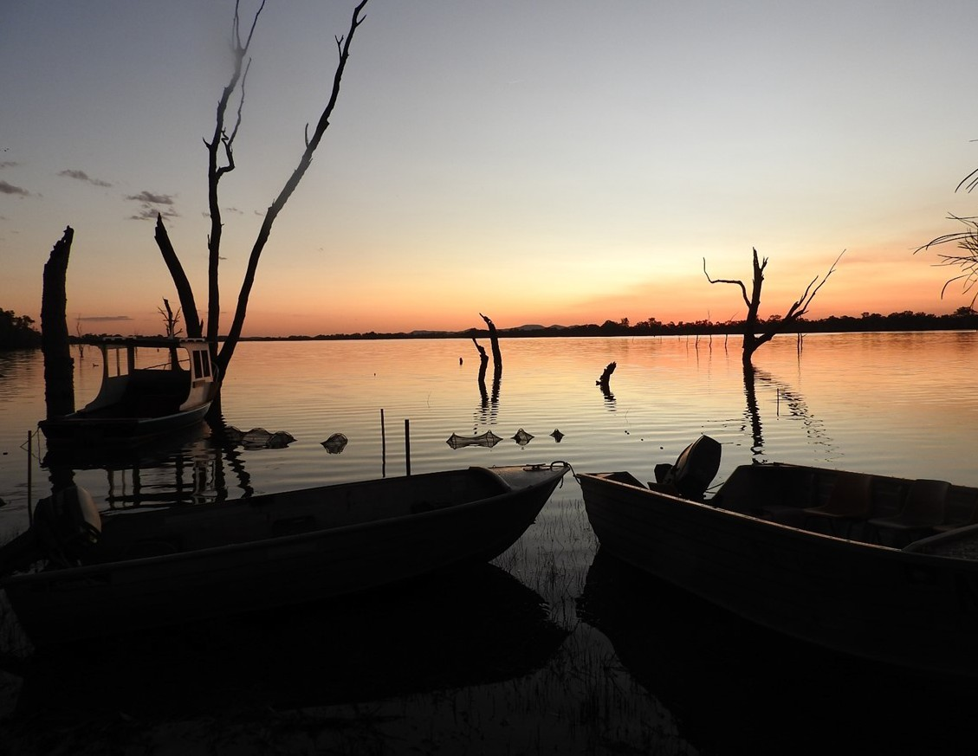

# LACHLAN RIVER

## MONITORING, EVALUATION AND RESEARCH

**QUARTERLY OUTCOMES NEWSLETTER | JANUARY—MARCH 2021**

1



# LACHLAN RIVER

## MONITORING, EVALUATION AND RESEARCH

Welcome to the March 2022 quarterly newsletter of the Lachlan Monitoring, Evaluation and Research (MER) Program. This newsletter forms part of the reporting activities undertaken in the Lachlan river system under the MER Program and provides a regular update on our moni- toring activities and observations.

In this newsletter we put a spotlight on the engagement activities in the lower Lachlan during the first quarter of 2022. We firstly highlight the recent and unique river conditions observed in the Lachlan. We describe a weekend at Lake Cargelligo with the Down the Track Program. We then look at the weather conditions and watering actions that have been delivered in the first quarter of 2022. We finish this newsletter with the Lachlan Diaries by Adam Kerezsy, which de- scribes a community event in Lake Cargelligo with NSW fisheries.

We hope you enjoy the read!

*The Lachlan MER Team*

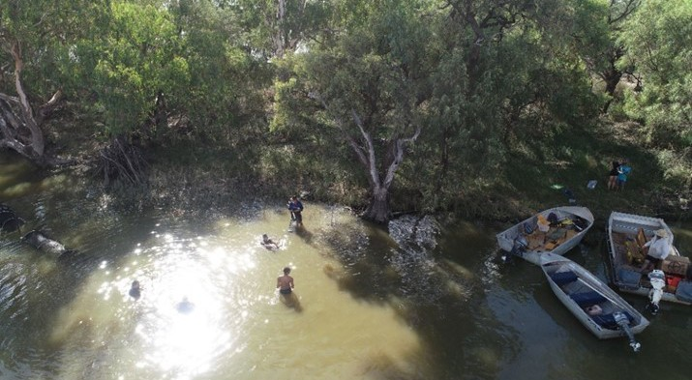

*Setting fyke nets with Down the Track participants (Photo: Will Higgisson)*



**The SPILLS and THRILLS of 2021-22**

It is hard to believe that only two years ago Wyan- gala Dam held less than 15% of its capacity follow- ing the driest 3-year period on record. Today,

Wyangala Dam sits at 98% full and has been at or

close to full capacity since the end of August 2021.

The Lachlan catchment is no stranger to dry times – as one of the landholders from the region explained to us that “*every day it doesn’t rain is the first day of the next drought*”. It’s also no stranger to floods, with the dry times interspersed by large floods that make it the epitome of Dorothea Mackellar’s “*land of droughts and flooding rains.*” The amount of wa- ter in Wyangala Dam reflects these wet and dry times, with high water levels from the mid 1980s through to the 1990s, very low water levels through the Millennium drought and alternating high and low water levels from 2010 onwards.

In 2021, good rains across the upper catchment saw water levels in Wyangala Dam increase rapidly and air space releases commenced in late August 2021. Ongoing rainfall and consistent moderate to high inflows have meant that there have been on-going airspace releases and spills from the Dam.

*Water levels (as %full) in Wyangala Dam from 1976 to present.*

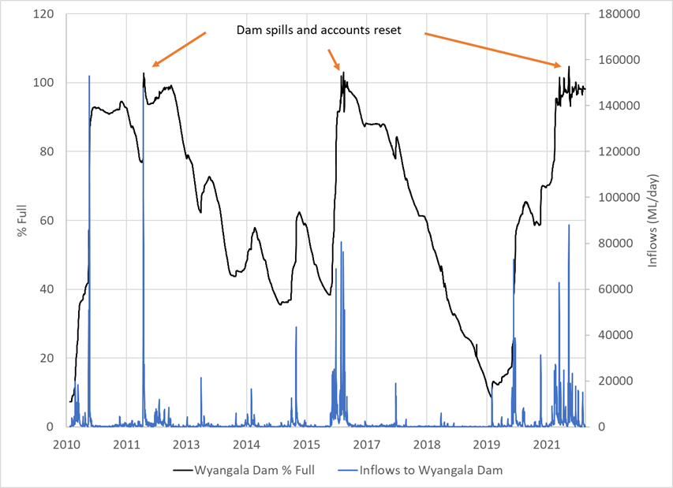

*Water levels (as % full) and inflows to Wyangala Dam from 2010*

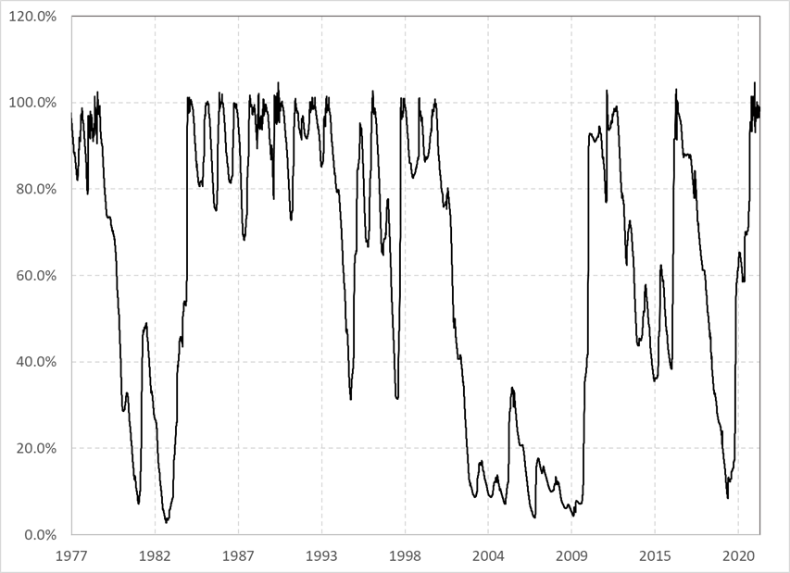*to present. Data from Water NSW* [*(http*](http://waterinfo.nsw.gov.au/))*:*[*//waterinfo.nsw.gov.au/).*](http://waterinfo.nsw.gov.au/))



**The Water Sharing Plan for the Lachlan Regulated River Water Source was established in 2003 and re- vised in 2016 (*https://legislation.nsw.gov.au/view/whole/html/inforce/current/sl-2016-0365#sec.12*). The plan sets out the arrangements for the sharing of water from the Lachlan River from Wyangala Dam to the junction of the Lachlan River with the Murrumbidgee River. It includes rules that define the way water is allocated to license holders each year (known as the Available water determina-**

**tions). The water that is allocated to license holders is held in a water account. As water is used by a license holder it is debited from their account.**

**The reset of water accounts is a rule under the Water Sharing Plan for the Lachlan Regulated River that was established in 2004. It occurs when Wyangala Dam spills or water is released from Wyangala Dam to maintain airspace and means that water held in accounts is withdrawn and a new allocation is provided to license holders. There have been spills from the Dam in 2012, 2016 and 2021 with associ- ated account resets. The 2020-21 water year is the first time there have been two account resets with- in the year.**



**ENGAGEMENT SPOTLIGHT**

### Training the next generation of fresh- water scientists

The Down the Track Program works with disengaged and potentially at-risk youth at Lake Cargelligo, in the mid-Lachlan, in central-western NSW. The Program is

run by Lana Masterson and Katy Quinn and has become an important fixture within the local community. Partic- ipants engage in a range of activities, from farming and shearing to training in hospitality, first-aid and driving. These activities aim to promote engagement and self-

esteem and provide the participants with skills that give them a better chance of getting paid work. Most of the participants are Indigenous and are from Lake Cargelligo or nearby Murrin Bridge.

Will Higgisson and Alica Tschierschke from the Centre for Applied Water Science, University of Canberra, joined the Down the Track participants in February 2022 for another weekend of learning about the envi-

ronment, the importance of freshwater, plants and fish, and how and why we monitor, as well as swimming, fishing and camping.

This weekend was the first of these environmental

weekends in 12 months, as a result of restrictions relat- ed to COVID-19. The Lachlan Selected Area team have been involved in the planning and running of these en- vironmental weekends since their inception in 2019,

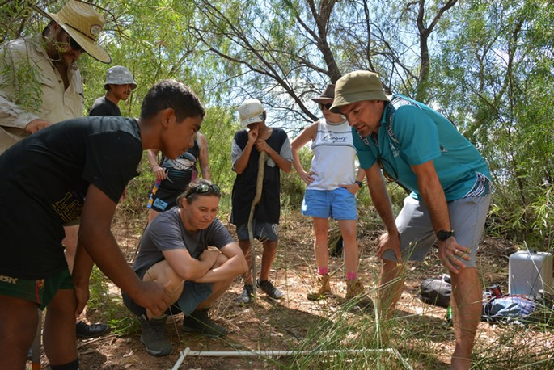

*Will Higgisson and Alica Tschierschke explain how scientists count plants. (Photo: Adam Kerezsy).*

and it’s great to see the relationship between Flow MER and Down the Track grow and evolve. Central to the success of these weekends is fish biologist Adam Kerezsy, a local resident, who as well as being part of the Lachlan Selected Area Team, is a relief teacher at the local school and the owner of the property on

which we set up camp.

As usual, once everyone arrived at Adam’s property, we jumped in the boats and headed for Robinson Cru- soe Island – about three kilometres away in the centre of Lake Cargelligo. The sun was out, and it was a great day on the Lake.

Once we arrived on the Island, vegetation experts Will

and Alica talked about the local plants and the im- portance of freshwater and aquatic vegetation, high- lighting some of the strategies that plants employ to

survive, grow and reproduce. They then described how and why we measure vegetation diversity and condi- tion, and stepped the participants through some moni- toring techniques, including identifying and counting plants in a 1 X 1m quadrat. The participants measured tree condition of some river red gums by measuring

tree height, canopy cover and extent, and counted the number of hollows. A highlight was flying the drone – a newer technique used to measure vegetation condi- tion.

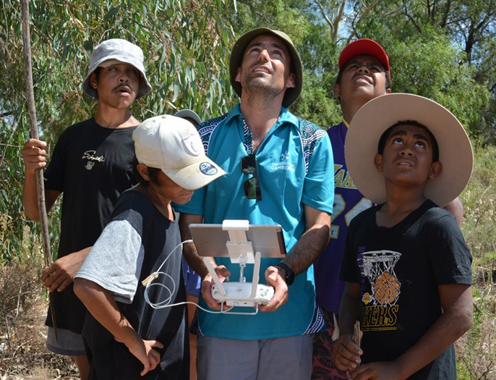

*No shortage of future drone pilots. (Photo: Adam Kerezsy).*

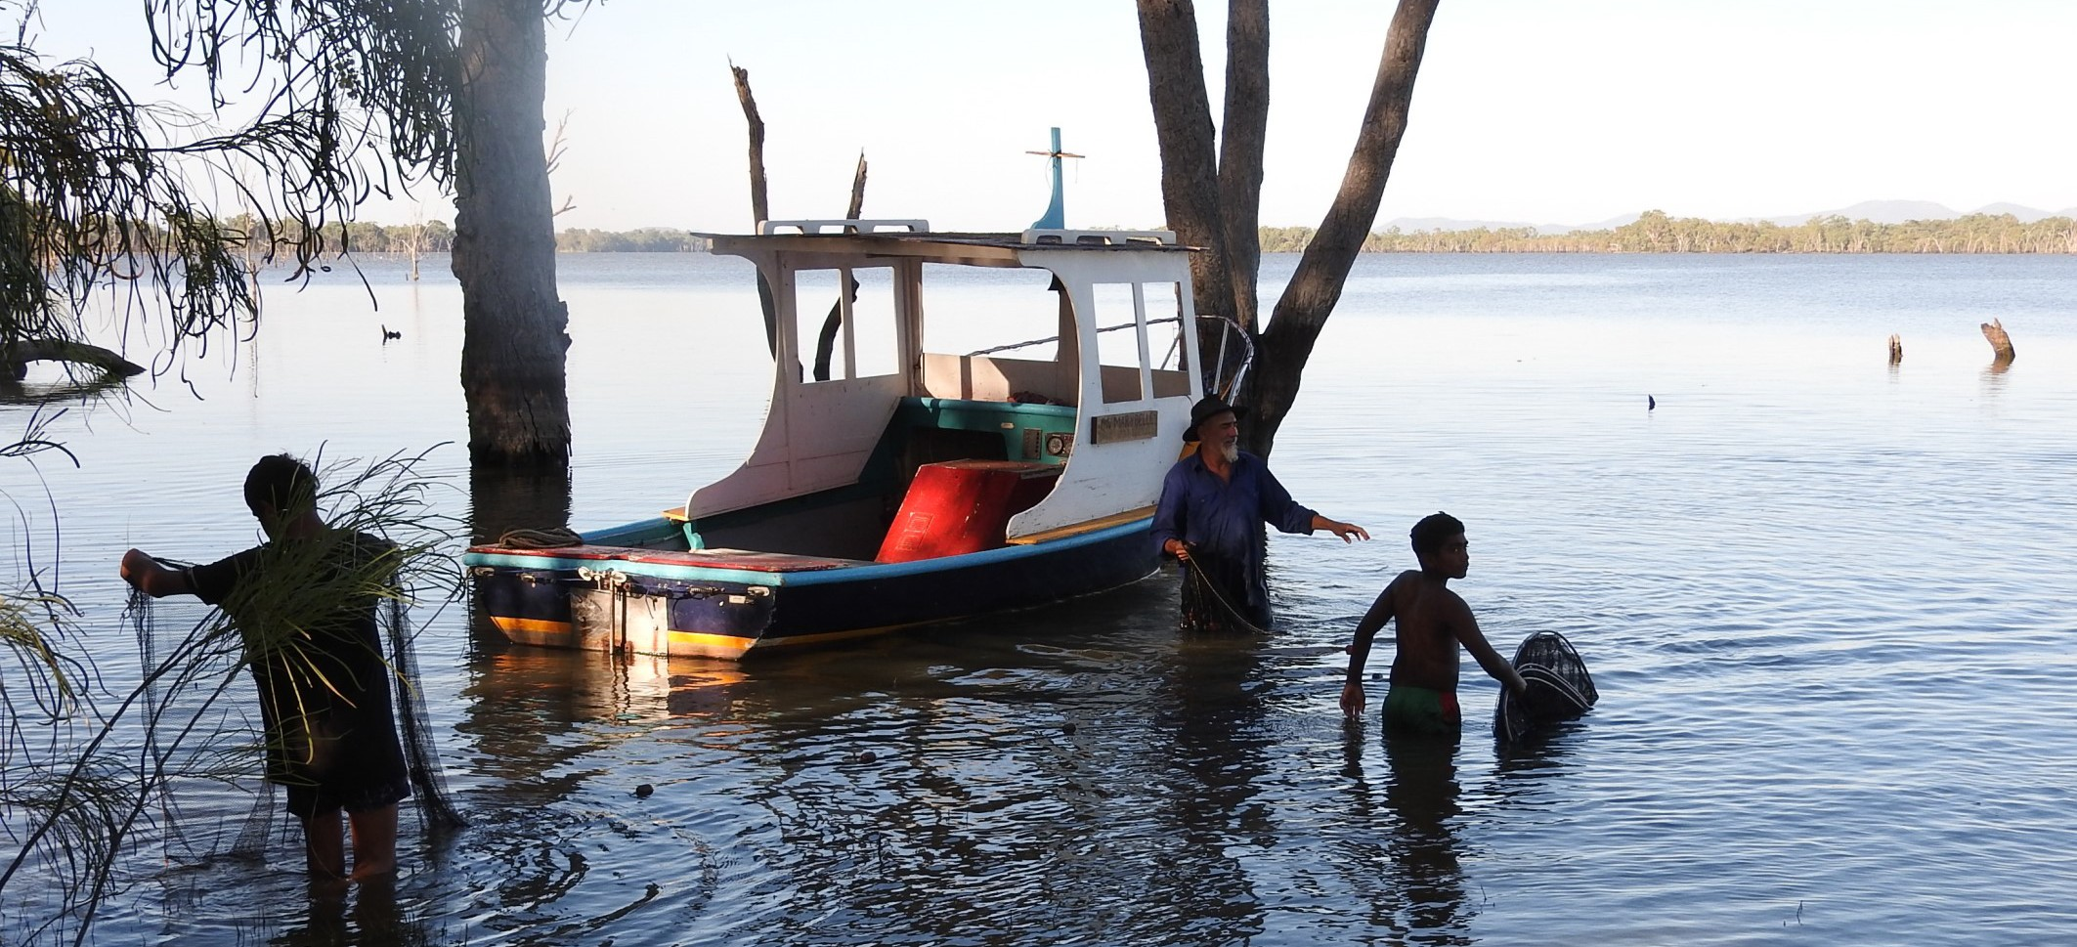

*Getting in the fyke nets in next morning (Photo: Alica Tschierschke).*

We then headed back to the boats, and Adam - with some help - set up a series of fyke nets in order to de- tect any changes in the composition of the fish and tur- tle populations around the Island.



**These weekends are a perfect way to engage these young adults as they involve practical experience within their local natural environment as well as an active demonstration of the importance of a functioning river ecosystem.**

We finished the day by sitting around the fire, eating some Down the Track dinner and playing some sing- along songs. The nets were cleared in the morning and all fish and turtles were identified, counted and meas- ured while Adam discussed the impacts of carp and

role of the native fish species in the ecosystem.

These weekends are a perfect way to engage these young adults as they involve practical experience within their local natural environment as well as an active

demonstration of the importance of a functioning river ecosystem. The participants get a first-hand look at

what ecologists do and why they do it, and realise why catchments need environmental water. Down The

Track weekends are also a great way for current scien-

tists and academics to become actively involved in

training the next generation of freshwater ecologists, and there is no better way to develop a more personal relationship with the Lachlan River than by getting to know the people that live along it.



**We finished the day by sitting around the fire, eating some Down the Track dinner and playing some sing-along songs.**

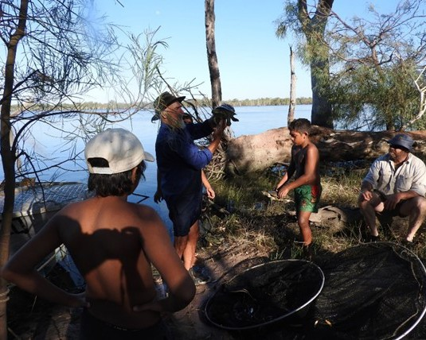

*Lots of Longneck turtles are captured, Adam Kerezsy explains how to hold them best (Photo: Alica Tschierschke).*



**OBSERVATIONS AND OUTCOMES**

### Catchment conditions between January and March 2022

This year began with very high rainfall for January, with one third falling on a single day at the end of the month at Hillston. Rainfall was also well above average at Ox- ley (Walmers Down) in January and again half of the monthly rainfall - exactly 30 mm - fell on a single day on the 29th. February in comparison was very dry, with

below rainfall recorded at both stations. In March, Hill- ston experienced similar rainfall to the long-term aver- age, while Oxley received nearly four times the average rainfall for the month. This station normally receives a substantial amount less than Hillston, for example last year it got only half of the annual rainfall (310.6 mm vs

613.3 mm). With that in summary, the rainfall for the first quarter of 2022 in Hillston has exceeded the long- term rainfall median (50.7 mm) for these three months by two times. For Oxley the quarterly rainfall summary is almost three times the median for these three months (36.8 mm).

The conditions were accompanied by similar to long- term average daily maximum and minimum tempera- tures within a 1°C range, only January’s average mini- mum temperatures had been 2°C above the average.



**February in comparison was very dry, with below rainfall recorded at both stations. In March, Hillston experienced similar rainfall to the long-term average, while Oxley received nearly four times the average rainfall for the month.**

**Hillston**

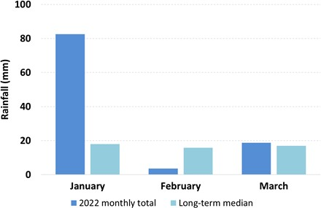

**Oxley**

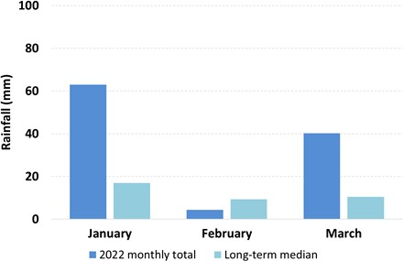

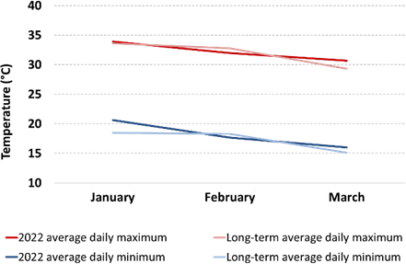

*Graphs showing rainfall and maximum and minimum tem- peratures for the first quarter of 2022. Data are for the Hill- ston (Airport) weather station number 075032 and Oxley (Walmer Downs, 49055) are sourced from the Bureau of*

*Meteorology.*

### Hydrology Observations

The high flows experienced in the second half of 2021 continued through the first quarter of 2022 with vol- umes in the Lachlan River remaining very high with wa- ter levels overbanking across the lower Lachlan.

No environmental water was used in the first quarter of 2022, however an environmental watering strategy has been taking place to maintain Lake Brewster stor- age at around 103% rather than the 117% to 124% maximum surcharge range, in order to maintain water levels for a large (>20,000) pelican breeding colony.

Commonwealth and EWA water has been planned as part of this watering strategy, however so far it has not been needed. This environmental watering strategy has already led to positive outcomes for the Pelicans in- cluding reducing chick mortality and increasing availa- ble nesting habitat, and many of the chicks have now fledged. This action will be described in more detail in an upcoming newsletter.

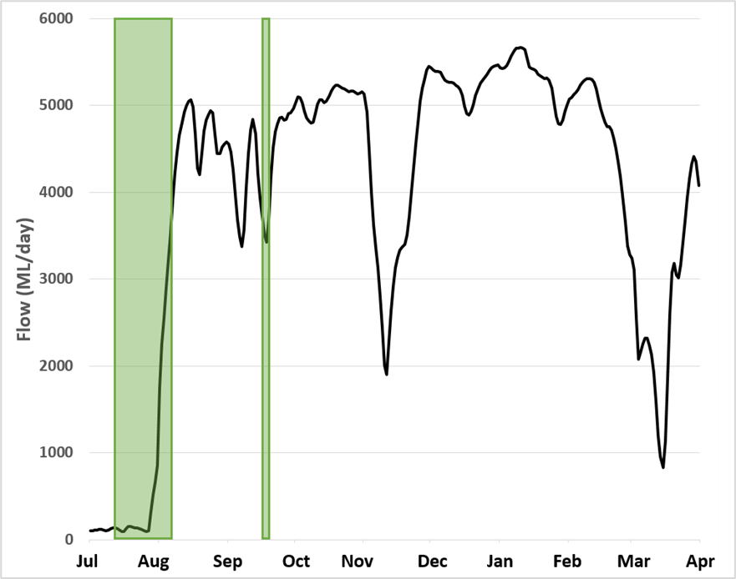

*Flow in the Lachlan River at Hillston Weir (412039) between 1st of July and 31st of March 2022. No environmental water was used in the first quarter of 2022. Green shading shows approximately the periods of*

*environmental water use over the watering year. Note that the period from late July onwards includes when much larger volumes of translu- cent flows and airspace releases were moving through the river sys-*

*tem. Data from Water NSW (*[*http://waterinfo.nsw.gov.au/*](http://waterinfo.nsw.gov.au/)*).*

*Pelican breeding colony on Lake Brewster (Photo: Adam Kerezsy).*

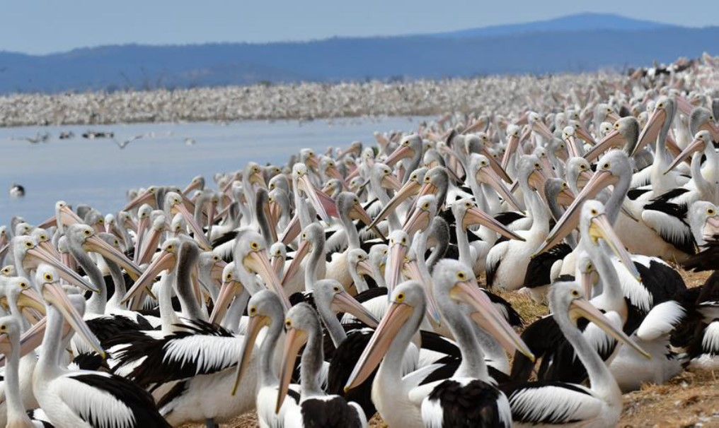

**This environmental watering strategy has already led to positive outcomes for the Pelicans including reducing chick mortality and increasing available nesting habitat.**



**THE LACHLAN DIARIES**

### Stories from monitoring and community events in the Lachlan catchment

*Adam Kereszy, fish biologist at large*

***Fish Info Day at Lake Cargelligo***

On a sunny autumn Saturday about 40 enthusiastic ‘fish people’ converged on the Boat Club for a Lake Cargelligo Landcare-sponsored fish info day smack- bang in the middle of the Lachlan.

There’s no better place than the Boat Club in Lake Cargelligo for such an event – a building perched only 10 metres from the shore. Fish people come in many shapes and sizes, and also plenty of what-may-be-

termed ‘sub-species’.

The majority of attendees were local and regional an- glers – people who work all week and chase cod and yellowbelly on the weekends. Most were keen to find out the latest on the rules and regulations relating to their hobby from a second sub-species – officers from NSW Fisheries, who regularly patrol the catchment.

Terry Steele and his son Lachlan were the Fisheries officers on this occasion, and Terry gave an interesting ‘formal’ talk as well as fielding plenty of one-on-one questions.

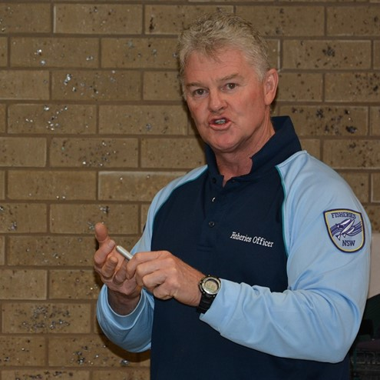

*NSW Fisheries officer Terry Steele presenting to the group (Photo: Adam Kerezsy).*

Terry showed some graphic images of drowned water rats and turtles, undersize fish and illegal equipment such as drum nets, gill nets and set lines in order to illustrate just how destructive illegal fishing continues to be in certain areas of inland New South Wales.

However, perhaps more interesting was the realisation that people like Terry and Lachlan do a lot more than just patrol river banks. He mentioned their work moni- toring seafood (in order to determine where it comes from) and checking in on aquaculture facilities as two

relevant examples.

Another sub-species that turned up were four or five members of ANGFA NSW – the Australia and New

Guinea Fishes Association. These fish people are best- described as hobbyists: they love keeping fish, talking fish they’re basically fish-obsessed.

The ANGFA crew – who had turned up from every-

where from Holbrook to Sydney - were on their way to the weirpool at Lake Brewster for a camp-out and

heard about the info morning on the fish-grapevine.

To represent all the Flow MER and NSW DPE research that is going on in the Lachlan catchment I’d set up some fish tanks with a few different native and intro- duced species, and also brought along some large and small-meshed fyke nets.

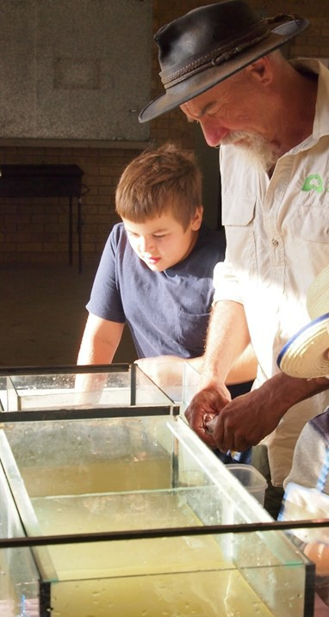

*Adam Kerezsy showing the group some of native and introduced fish species common in the Lachlan (Photo: Alison Wheeler).*

There was no shortage of volunteers who were keen on getting wet and helping to set the nets, as all were the sons and daughters of the afore- mentioned anglers.

We had set the nets prior to the talks and presenta- tions, so at about 11am it was time to retrieve them. Even though the gear had only been set for a com- paratively short time, there was no shortage of bio- logical material for the assembled crew of budding scientists to identify and measure.

Everyone who attended the Lake Cargelligo Fish Info Day commented that it was a worthwhile experience, that they learnt something new and that we should hold similar events in the future. The success of the day was definitely due to a combination of practical ‘doing’ activities (such as setting and retrieving sam- pling gear) as well as more formal discussion of the

river, the animals that live within the catchment and the rules and regulations surrounding catching and interacting with them.



**The success of the day was defi- nitely due to a combination of practical ‘doing’ activities ... as well as more formal discussion.**

There’s a good chance that we may run similar

events in other towns and places up and down the

river, as its certainly a great way to get people - who share similar interests - to turn up and have a chat. And there’s obviously nothing better than fish for attracting the fish people.

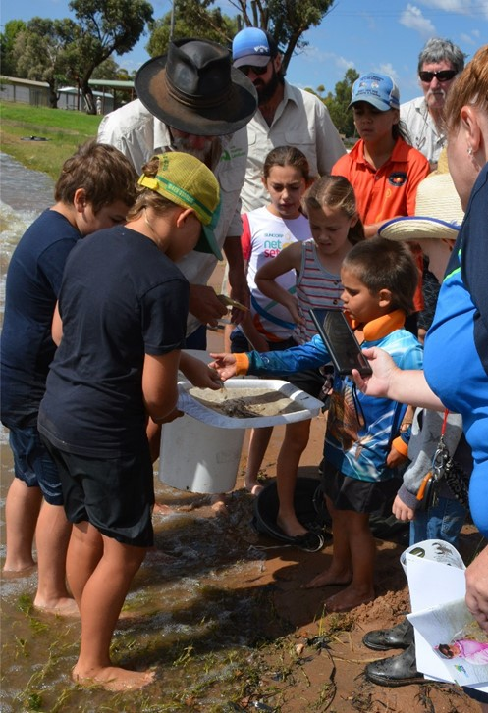

*Looking at the catch from the fyke nets (Photo: Alison Wheeler).*

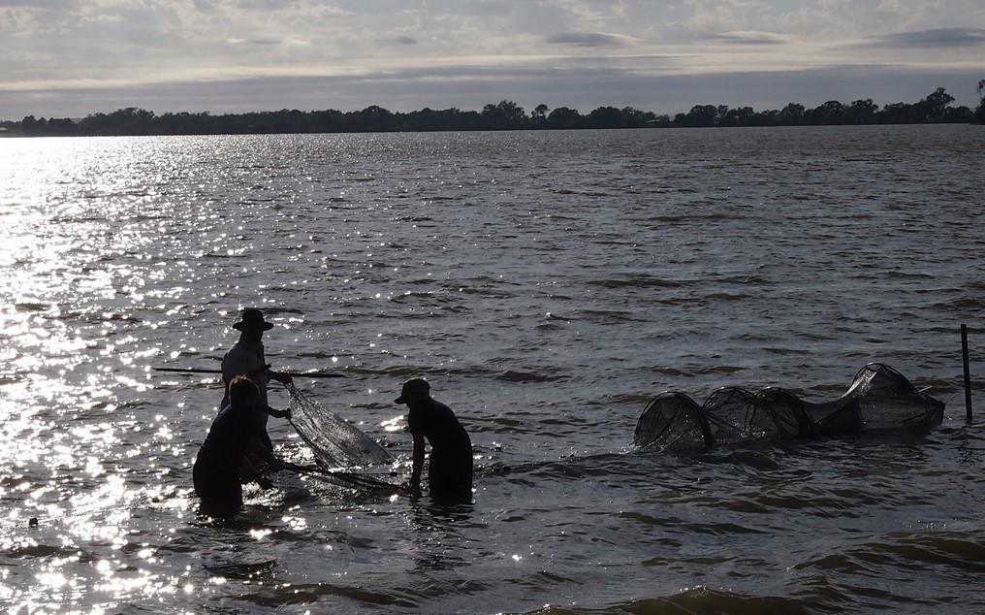

*Setting fyke nets in Lake Cargelligo (Photo: Alison Wheeler).*



**ABOUT THIS DOCUMENT**

The Commonwealth Environmental Water Holder (CEWH) is responsible under the *Water Act 2007* (Cth) for managing Commonwealth environmental water holdings. These holdings amount to more than 2,700 gigalitres (as at July 2019) of water entitlements across the Murray-Darling Basin. The hold- ings must be managed to protect or restore the environmental assets of the Murray-Darling Basin, and other areas where the Commonwealth holds water, to give effect to relevant international agree-

ments.

Monitoring and evaluation are critical for supporting effective and efficient use of Commonwealth en- vironmental water. Monitoring and evaluation also provides important information to ensure the CEWH meet their reporting obligations. Between 2014 and 2019, the Commonwealth Environmental Water Office (CEWO) has undertaken monitoring and evaluation of the ecological outcomes of envi-

ronmental watering through the Long Term Intervention Monitoring Project (LTIM Project). At the same time, the CEWO has undertaken research which seeks to improve the science available to sup- port environmental water management in the Murray-Darling Basin through the Murray-Darling Basin Environmental Water Knowledge and Research Project (EWKR Project).

The Monitoring, Evaluation and Research Program (MER Program) builds on the work of the LTIM and EWKR Projects to undertake monitoring, evaluation and research activities within seven Selected Are- as and at the Basin-scale between 2019 and 2022. One of the seven Selected Areas is in the Lachlan

river system and a team of researchers, agency staff and contractors led by the Centre for Applied Wa- ter Science at the University of Canberra are monitoring, evaluating and conducting research in the catchment.

This newsletter forms part of the reporting activities undertaken in the Lachlan river system under the MER Program. It will be produced quarterly and highlights the activities, observations and outcomes that have occurred in the river system in relation to environmental water.

In conducting the monitoring evaluation and research project in the Lachlan river system, the project team as well as the Commonwealth Environmental Water Office respectfully acknowledge the tradi- tional custodians of the land on which this work is conducted, their Elders past and present, their Na- tions of the Murray-Darling Basin, and their cultural, social, environmental, spiritual and economic connection to their lands and waters. The Lachlan River flows through the lands of the Nari Nari, Ngiyampaa, Waradjuri and Yita Yita Nations, and we acknowledge these people as the traditional own- ers of the land on which this publication is focused.

More information can be found at:

<https://www.environment.gov.au/water/cewo/monitoring/ltim-project>

<https://www.environment.gov.au/water/cewo/monitoring/ewkr> <https://www.environment.gov.au/water/cewo/monitoring/mer-program>

**INQUIRIES REGARDING THIS DOCUMENT SHOULD BE ADDRESSED TO:**

11

|  |  |
| --- | --- |
| Damian McRae  Commonwealth Environmental Water Office  Phone: 02 6274 2524  e-mail: [damian.mcrae@awe.gov.au](mailto:damian.mcrae@awe.gov.au) | Dr Fiona Dyer  University of Canberra  Phone: 02 6201 2452  e-mail: [Fiona.Dyer@canberra.edu.au](mailto:Fiona.Dyer@canberra.edu.au) |

This document was prepared by Will Higgisson, Alica Tschierschke, Lea Knight, Fiona Dyer, Adam Kerezsy (Dr Fish).

**Cover Photo:** Sunset over Lake Cargelligo after an action packed day with the Down The Track crew (Photo: Alica Tschierschke)

### Document history and status

|  |  |  |  |  |
| --- | --- | --- | --- | --- |
| **Version** | **Date Issued** | **Reviewed by** | **Approved by** | **Type** |
| **Draft 1** | 08 April 2022 | Lachlan MER Team | Fiona Dyer | DRAFT |
| **FINAL** | 13 April 2022 | CEWO | Fiona Dyer | FINAL |

**Distribution of copies**

|  |  |  |
| --- | --- | --- |
| **Version** | **Type** | **Issued to** |
| **FINAL** | Electronic | Commonwealth Environmental Water Office |

**Copyright**

© Copyright Commonwealth of Australia, 2020



‘Lachlan River, Monitoring, Evaluation and Research, Quarterly Outcomes Newsletter’ is licensed by the Commonwealth of Australia for use under a Creative Commons By Attribution 3.0 Australia licence with the exception of the Coat of Arms of the Commonwealth of Australia , the logo of the agen- cy responsible for publishing the report, content supplied by third parties, and any images depicting people. For licence con ditions see: [http://](http://creativecommons.org/licenses/by/3.0/au/) [creativecommons.org/licenses/by/3.0/au/](http://creativecommons.org/licenses/by/3.0/au/)



**Disclaimer**

The views and opinions expressed in this publication are those of the authors and do not necessarily reflect those of the Australian Government or the Minister for the Environment and Energy. While reasonable efforts have been made to ensure that the contents of this publicati on are factually cor- rect, the Commonwealth does not accept responsibility for the accuracy or completeness of the contents, and shall not be liable for any loss or damage that may be occasioned directly or indirectly through the use of, or reliance on, the contents of this publication.