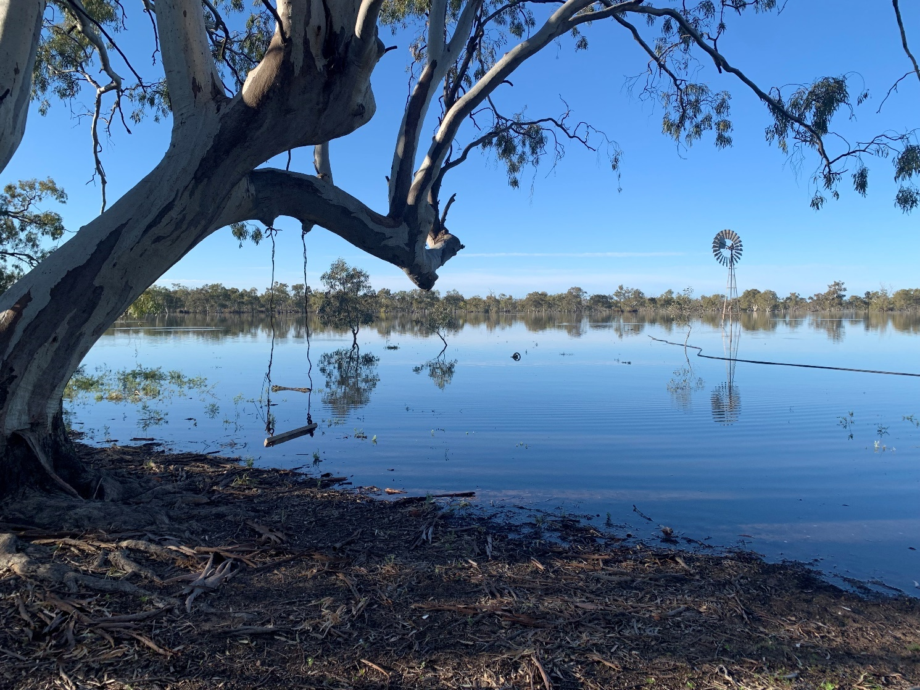

**LACHLAN RIVER**

**MONITORING, EVALUATION AND RESEARCH**

**QUARTERLY OUTCOMES NEWSLETTER | July – September 2021**

**LACHLAN RIVER**

**MONITORING, EVALUATION AND RESEARCH**

Welcome to the September 2021 quarterly newsletter of the Lachlan Monitoring, Evaluation and Research (MER) Program. This newsletter forms part of the reporting activities undertaken in the Lachlan river system under the MER Program and provides a regular update on our monitoring activities and observations.

In this newsletter we put a spotlight on the watering of isolated and distant wetlands in the lower Lachlan catchment, like Lake Tarwong (front cover). We then take a look at the weather conditions experienced in the lower Lachlan during the quarter and the watering actions that have been delivered. We also include the Lachlan Dairies by fish biologist Adam Kerezsy which this issue is on Bony Herring.

We hope you enjoy the read!

The Lachlan MER Team

*Murrumbidgil Swamp (aka Angora Clump) (Photo by Mal Carnegie for EES)*

**Getting water to Lake Tarwong**

**WATERING ACTION FOCUS**

The wet conditions in mid-2021 provided the right backdrop for water managers to get environmental water to some of the more isolated and distant wetlands in the lower Lachlan. The floodplain of the lower Lachlan has some wetlands located on ephemeral channel systems, often at very long distances from the main Lachlan River. Some of these floodplain creek systems rely on unregulated flood and/or ‘Translucent flows’ and remain dry most years unless significant local rainfall occurs, for example, Middle Creek. There are generally no control structures at the off-take to these creeks and the height at which they start to flow from the Lachlan River are too high for water managers to target efficiently.

Other floodplain creek systems have control structures that enable them to receive a regulated annual stock and domestic replenishment flow both at the offtake from Lachlan River and along the creek itself. There is also a maximum volume and specified end delivery point that doesn’t include some important wetlands. Merrowie Creek is such a creek, with the offtake controlled by Gonowlia Weir near Hillston and the replenishment ending at Cuba Dam, some 150 kilometres downstream.

One of these wetlands is Lake Tarwong, more than 35 km further downstream from Cuba Dam. Delivery is through the section where Merrowie Creek is no longer a singular defined creek channel – but spreads out into lots of braided fingers or shallow flood runners, before finally reconverging above Lake Tarwong. Lake Tarwong, has always been considered to be one of the more challenging end-of-system wetlands to target with environmental water, being a very long way from the Lachlan River, and has not been watered since natural flooding occurred in early 2017.

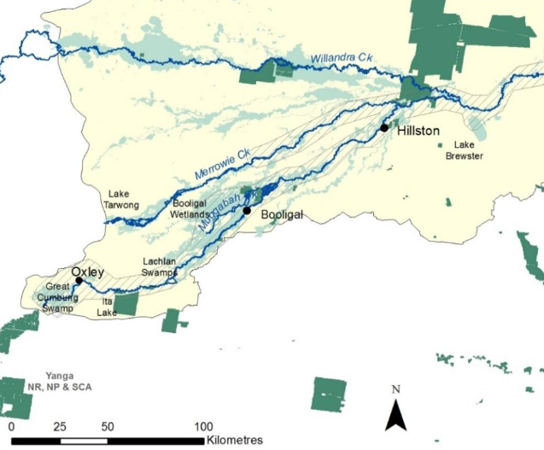

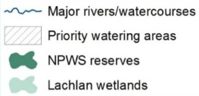

*Map of annual priority watering targets in the Lachlan Catchment (modified from: NSW DPIE-EES)*

*https://www.environment.nsw.gov.au/topics/water/water-for-the-environment/lachlan*

**Breakout box: What is important about Lake Tarwong?**

The Lake Tarwong complex of wetlands comprise a large shallow open ephemeral lake surrounded by channel mound wetlands and black box swamps. The channel mound sections of these wetland complexes are quite unusual in the Murray-Darling Basin, comprising a set of reticulated channels separated by mounds on which there are red-gum woodlands. They tend to be found adjacent to open lakes and they provide habitat for a range of wildlife. Other examples of these channel mound wetlands are Lake Bullogal and Murrumbidgil Swamp (aka Angora Clump). They appear to be particularly important for cormorant breeding during wetter times and there are often cormorant nests to be seen in the redgums. They also have a highly diverse vegetation community, and these are the only places we’ve recorded some of the rarer amphibious plant species in the lower Lachlan system. This makes these types of wetland complexes important to support using environmental water.

*Navigating the channel mound wetland at Lake Bullogal in November 2020 (Photo by Will Higgisson).*

One of the challenges for water managers has been having to wait until the stock and domestic replenishment flow has finished before starting the environmental order. In most years, WaterNSW wait for substantial tributary inflows before starting replenishments in mid-Winter. Given the distance water must travel and the weirs along the creek to facilitate landholders taking their stock and domestic rights, it is often too late for “piggybacking” environmental water to be efficient or effective. It has to move slowly over the creek structures and through that braided, flat floodplain upstream of Tarwong, and built up litter and debris, there are high evaporative losses as well as substantial amounts of water that soaks down large, deep cracks in the cracking black clay soils. Thus, significant local rainfall was also considered a pre-cursor for targeting Tarwong.

While there was no contribution from local rainfall to initiate the Tarwong watering action, there was widespread above average rainfall and cooler temperatures across most of the Lachlan Catchment. Replenishment flows started exceptionally early (31 March) and were forecast to finish mid-June (13 June). Department of Planning, Industry and Environment - Environment, Energy and Science (NSW DPIE–EES) had access to the Environmental Water Allowance (EWA) accounts and Commonwealth Environmental Water (CEW), and while Translucent flows were not guaranteed, inflows into Wyangala Dam were approaching the required 250 gigalitre trigger value. While local antecedent conditions were not ideal and system behaviour including losses below Cuba Dam unknown, DPIE–EES environmental water managers seized the opportunity and approached the Merrowie Creek landholders and trustees with a Tarwong proposal. Over the following months, there was ongoing communication and collaboration around the management of delivery infrastructure to increase the rate of delivery to Tarwong and have a freer-flowing creek. The early replenishment, lack of build-up of course litter and debris on the lower Merrowie braided floodplain, and landholder cooperation were key to the success of this watering action.

*Lake Tarwong filling on the 10th September (Photo by Mal Carnegie for EES).*

The joint NSW and the Commonwealth watering action commenced at Merrowie Creek offtake on the 13 June 2020 and was just starting to enter Lake Tarwong by 5 August 2021. This action provided a diversity of refugia and instream and floodplain habitat across large areas of the floodplain on its way to Lake Tarwong, which was around 80% full by the 20 August. DPIE–EES estimate from landholder observations and field inspections that >70% of the Tarwong objective to fill the main River Red Gum lake the top two Black Box lakes was achieved through use of NSW EWA and CEW for <7,500 megalitres (volumes to be confirmed). Translucent flows are estimated to have arrived at Tarwong main lake around 16 September and will continue in October, enhancing the outcomes of the licensed environmental water delivery when it is often the other way around. This was the first-time environmental water has been used to water Lake Tarwong since 2011 post-floods, and was achieved through being strategic in the use of environmental water in combination with other sources of water, frequent communication, unprecedented cooperation, and building on the wet conditions.

*Tarwong upper lake on the 10th September (Photo by Mal Carnegie for EES).*

**Break out box: Watering redgums at Lake Tarwong**

We water river red gums to promote seedling recruitment, water the older trees and recharge the groundwater as rainfall alone is not adequate to sustain river red gums. The trees in Lake Tarwong were definitely due a good drink. However, we may also use environmental water to drown out river red gums which have encroached into open wetlands. Encroachment has the potential of changing the wetland community from one that is open and devoid of trees to more of a woodland community if these seedlings are left unchecked. Natural flooding regimes would have maintained the character of the shallow open wetlands, providing important habitat for waterbirds. Once redgum seedlings reach a few metres, it is difficult to use floods to drown them out. In early 2021, our field teams observed a large number of redgum seedlings across the bed of the open lake at Lake Tarwong, suggesting that a good flood would be needed to prevent the lake from completely changing in character.

*Lake Tarwong in May 2021 with encroachment of river red gums (Photo by AlicaTschierschke).*

**Catchment conditions between July and September 2021**

**OBSERVATIONS AND OUTCOMES**

The wetter than average conditions observed in June 2021 continued into July, with slightly above average rainfall. August was very dry, with only 5 mm rainfall recorded at Hillston. In contrast Oxley (Walmers Down) received 20.4 mm rainfall which was close to average rainfall for August. Rainfall events at the start and end of September rainfall resulted in above average, rainfall for the month.

The quarterly rainfall for Hillston was 413.5 mm and is a cracking 214 mm above the long-term median for this period (199.5 mm). A similar story is played out at Oxley where 46.1 mm more than the long-term median (153.5 mm) was recorded.

The conditions were accompanied by daily maximum and minimum temperatures which were similar to the long-term mean.

|  |  |
| --- | --- |
| Hillston | Oxley |
|  | Graphs showing rainfall and maximum and minimum temperatures for the third quarter of 2021. Data are for the Hillston (Airport) weather station number 075032 and Oxley (Walmer Downs, 49055) are sourced from the Bureau of Meteorology. |

**Hydrology Observations**

Two watering actions using CEW were delivered during the third quarter of 2021. The first of these actions was to partner with NSW to complete the Lake Tarwong watering action from 1 July to 30 July 2021. The watering action was started by DPIE–EES using NSW EWA in the previous water year (13 June 2021). Approximately 2,174 ML of CEW and 2,174 ML of EWA (volumes to be confirmed) was used over 30 days in 2021–22 water year of the 48-day event for the Lake Tarwong component. As part of this watering action, additional CEW was also ordered from 13 September to start filling Murphy’s Lake Black Box wetland in the mid-Merrowie Creek. This action aimed to address the following [2021−22 Basin annual environmental watering priorities](https://www.mdba.gov.au/sites/default/files/pubs/e-water-priorities-2021-22.pdf): increase lateral and longitudinal connectivity along over 180-km of a floodplain creek system; improve the condition and promote recruitment of River Red Gum and Black Box woodland and wetlands; and improve the abundance and maintain the diversity of the Basin’s waterbird population.

The second of these actions was an equal partnership with NSW DPIE–EES to fill in any short-term gaps in the hydrograph at Lake Brewster Weir between translucent events. The primary objective was to maintain continuous lateral connectivity with the floodplain to maximise inundation extent and duration for important wetlands such as Lake Bullogal and Baconian Swamp, and lignum shrublands. More specifically, to contribute to meeting the Lachlan Long Term Water Plan (LTWP) large wetland inundation (WL3) environmental watering requirement (EWR) for multiple planning units, including the Great Cumbung Swamp. The 60-day minimum flow target of >1,200 ML/day Booligal gauge (412005) provides for at least 2–3 months of habitat inundation.

Flow in the Lachlan River downstream of Willandra Weir (412038) between 1st of January and 30st of September 2021. Green shading shows approximately the periods of environmental water use between July and September. Note that the period from late July onwards includes when much larger volumes of translucent flows were also moving through the river system. Data from Water NSW (<http://waterinfo.nsw.gov.au/>).

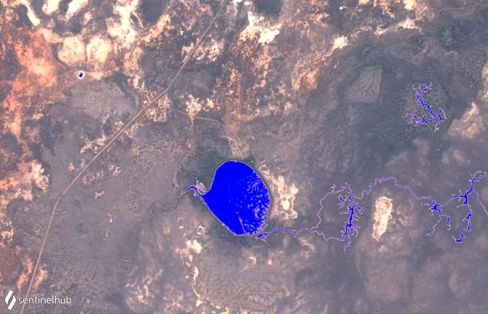

*Water reaching Lake Tarwong at the start of August via Box Creek diverting from Merrowie Creek (Imagery from Sentinel-2; top row 08/08 and 28/08/2021, bottom row 02/09 and 22/09/2021).*

Further information about the watering actions can be found at: <http://www.environment.gov.au/water/cewo/catchment/lachlan/water-use>

**Stories from monitoring and community events in the Lachlan catchment**

**THE LACHLAN DIARIES**

*Adam Kerezsy, fish biologist at large*

***All The Small Things – Part 5***

**Bony herring**

About 10 years ago I described bony herring (previously always called ‘bony bream’) as the engine-room that drives Australia’s inland aquatic ecosystems, and indicated that without bonies entire catchments would grind to a halt: after a decade and a few more hundred-thousand fish sampled that view has only been reinforced.

Bonies, as the common name suggests, are a laterally-compressed herring, complete with shiny, flaky scales, an elongated first ray on their dorsal fin, and a strong and deeply-forked tail. Bonies are obviously designed for speed and minimum resistance to the water through which they glide.

A large sample of small bony herring from Lake Cargelligo (Photo by Mal Carnegie)

Unlike the other small native fishes of the Lachlan River and wider Murray-Darling Basin, bonies actually grow fairly large – up over 30 cm long in the bigger lakes and wider stretches of the river. However, the ‘bony’ part of their common name gives a clue, as to why they’ve never really caught on as an eating fish. Recently I was chatting to a lower-Lachlan resident of German descent about all things bony herring and we concluded that they would possibly make very good roll-mops – the northern European delicacy created by wrapping a herring fillet around a dill gherkin and dunking the result in vinegar. There was talk of vodka too. However, if bony herring Aussie roll-mops have even been invented I haven’t heard of it, and I’m pretty sure the only culinary purpose bonies have ever served, was as canned rations during one of the wars.

Bonies share the middle and top areas of the water column with hardyhead and smelt discussed in the last issue of The Lachlan Diaries, and like them, are silvery on the back and sides and white underneath. Unlike their pelagic neighbours, however, bony herring feed on algae and detritus, and have a purpose-designed tiny mouth with which to do so. This means they can’t be caught on a line, which consequently means that many people – and even anglers – never see the most common fishy inhabitant of the Murray-Darling rivers (and many more around the country).

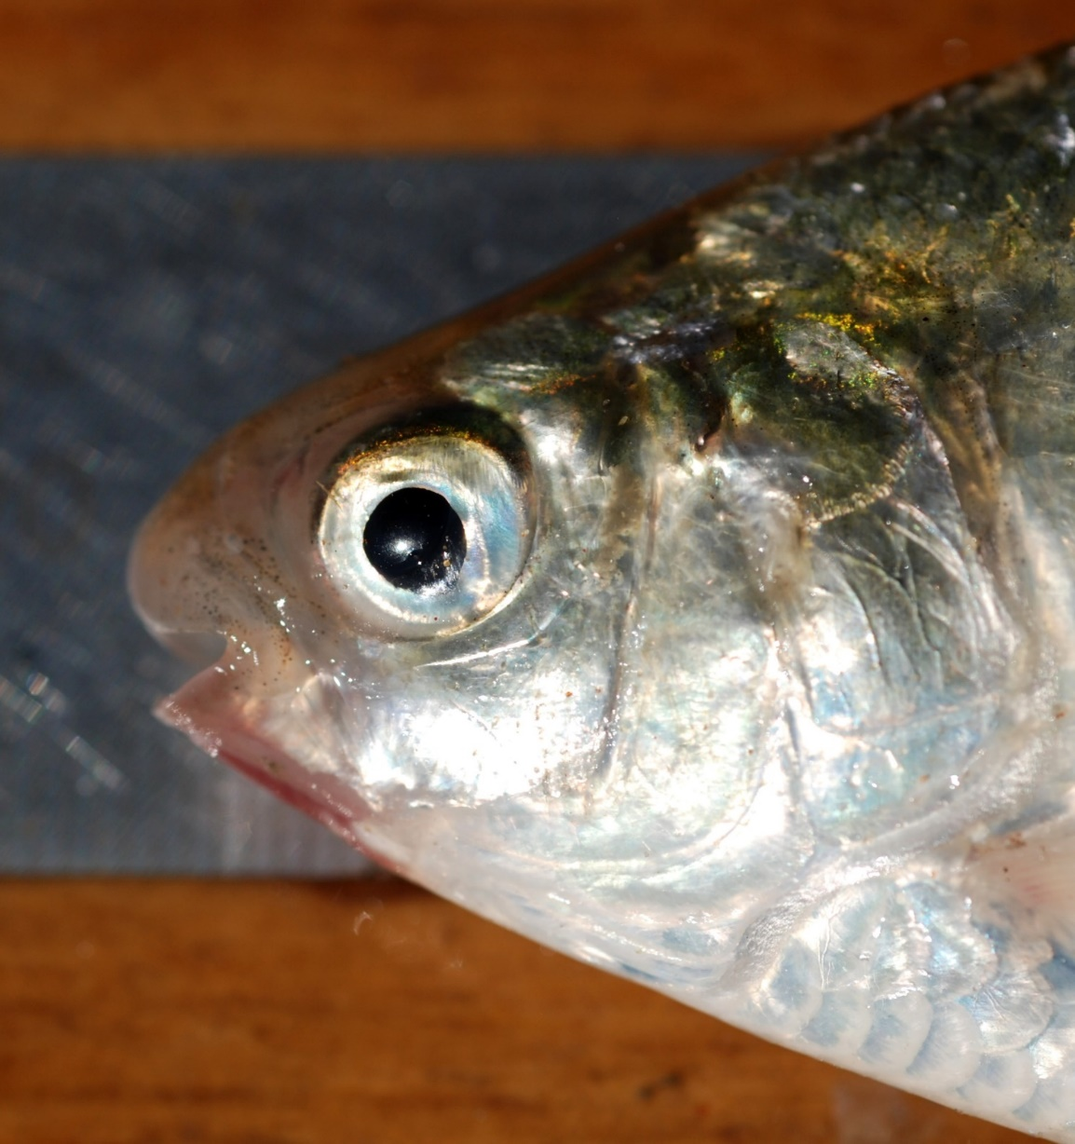

Bony herring head detail showing the tiny mouth (Photo by Adam Kerezsy).

Bonies are perfectly suited to the shallow areas of Australia’s inland, where long, hot days mean there is always plenty of algae. They breed year-round – even when conditions aren’t perfect (for example times of prolonged low-water levels or colder-then-average temperatures), but really boom when floods and flows inundate previously-dry areas.

Recent fish-sampling in the mid-Lachlan area has often yielded many hundreds of bony herring ranging from 40 to 300 millimetres long, particularly in ponded areas like the Brewster weir pool and the Lake Cargelligo system. This makes sense given bonies basically get around in big schools: anywhere big, broad and shallow enough to allow light penetration to grow plants is likely to be their preferred habitat.

In terms of ‘ecosystem services’, great, big, multi-size schools of an herbivorous fish basically equate to a smorgasbord for anything that might enjoy feeding on them, and it wouldn’t be a stretch to say that bonies in the Murray-Darling are similar to wildebeest on the Serengeti.

In spring, when fish-eating birds such as little black cormorants congregate and nest in the low branches of trees along creek lines, the adults harvest small bonies from the water beneath to regurgitate to their growing youngsters. When flows – either natural or human-engineered – move down rivers like the Lachlan, pelicans and other fish-eaters congregate at choke-points (weirs, channels and bends) to pick off hapless bonies as they drift by.

Unfortunately, a long life-span probably remains out of reach for the majority of bonies that survive the onslaught from aerial predation, because carnivorous fish – native Murray cod and golden perch, as well as introduced redfin – are also lurking in many river bends and/or schooling in dangerous packs.

Bony herring sit squarely at the bottom of both the fishy and vertebrate food chains within Australia’s inland rivers. They are not the most widely known fish (despite being one of the most widely distributed), and they are not the most spectacular.

But they are still the most important: without bonies, Australia’s rivers, creeks, billabongs and floodplains would almost certainly grind to an ecological halt.

The Commonwealth Environmental Water Holder (CEWH) is responsible under the *Water Act 2007* (Cth) for managing Commonwealth environmental water holdings. These holdings amount to more than 2,700 gigalitres (as at July 2019) of water entitlements across the Murray-Darling Basin. The holdings must be managed to protect or restore the environmental assets of the Murray-Darling Basin, and other areas where the Commonwealth holds water, to give effect to relevant international agreements. Commonwealth holdings are managed in partnership with NSW environmental water holdings by DPIE–EES and takes all sources of water into consideration.

**ABOUT THIS DOCUMENT**

Monitoring and evaluation are critical for supporting effective and efficient use of Commonwealth environmental water. Monitoring and evaluation also provides important information to ensure the CEWH meet their reporting obligations. Between 2014 and 2019, the Commonwealth Environmental Water Office (CEWO) has undertaken monitoring and evaluation of the ecological outcomes of environmental watering through the Long Term Intervention Monitoring Project (LTIM Project). At the same time, the CEWO has undertaken research which seeks to improve the science available to support environmental water management in the Murray-Darling Basin through the Murray-Darling Basin Environmental Water Knowledge and Research Project (EWKR Project).

The Monitoring, Evaluation and Research Program (MER Program) builds on the work of the LTIM and EWKR Projects to undertake monitoring, evaluation and research activities within seven Selected Areas and at the Basin-scale between 2019 and 2022. One of the seven Selected Areas is in the Lachlan river system and a team of researchers, agency staff and contractors led by the Centre for Applied Water Science at the University of Canberra are monitoring, evaluating and conducting research in the catchment.

This newsletter forms part of the reporting activities undertaken in the Lachlan river system under the MER Program. It will be produced quarterly and highlights the activities, observations and outcomes that have occurred in the river system in relation to environmental water.

In conducting the monitoring evaluation and research project in the Lachlan river system, the project team as well as the Commonwealth Environmental Water Office respectfully acknowledge the traditional custodians of the land on which this work is conducted, their Elders past and present, their Nations of the Murray-Darling Basin, and their cultural, social, environmental, spiritual and economic connection to their lands and waters.The Lachlan River flows through the lands of the Nari Nari, Ngiyampaa, Wiradjuri and Yita Yita Nations, and we acknowledge these people as the traditional owners of the land on which this publication is focused.

More information can be found at:

<https://www.environment.gov.au/water/cewo/monitoring/ltim-project>

<https://flow-mer.org.au/selected-area-lachlan/>

<https://www.environment.gov.au/water/cewo/monitoring/ewkr>

<https://www.environment.gov.au/water/cewo/monitoring/mer-program>

Inquiries regarding this document should be addressed to:

|  |  |
| --- | --- |
| Damian McRae Commonwealth Environmental Water Office Phone: 02 6274 2524 e-mail: damian.mcrae@environment.gov.au | Dr Fiona Dyer University of Canberra Phone: 02 6201 2452 e-mail: Fiona.Dyer@canberra.edu.au |

This document was prepared by Will Higgisson, Alica Tschierschke, Lea Knight, Fiona Dyer, Adam Kerezsy (Dr Fish) and Joanne Lenehan (DPIE‒EES).

Cover Photo: Lake Tarwong (Photo by Nathan McGrath)

**Document history and status**

|  |  |  |  |  |
| --- | --- | --- | --- | --- |
| Version | Date Issued | Reviewed by | Approved by | Type |
| Draft 1 | 01/10/2021 | Lachlan MER Team | Fiona Dyer | DRAFT |
| FINAL | 07/10/2021 | CEWO | Fiona Dyer | FINAL |

**Distribution of copies**

|  |  |  |
| --- | --- | --- |
| Version | Type | Issued to |
| FINAL | Electronic | Commonwealth Environmental Water Office |

**Copyright**© Copyright Commonwealth of Australia, 2021



‘Lachlan River, Monitoring, Evaluation and Research, Quarterly Outcomes Newsletter’ is licensed by the Commonwealth of Australia for use under a Creative Commons By Attribution 3.0 Australia licence with the exception of the Coat of Arms of the Commonwealth of Australia, the logo of the agency responsible for publishing the report, content supplied by third parties, and any images depicting people. For licence conditions see: <http://creativecommons.org/licenses/by/3.0/au/>

**Disclaimer**

The views and opinions expressed in this publication are those of the authors and do not necessarily reflect those of the Australian Government or the Minister for the Environment and Energy. While reasonable efforts have been made to ensure that the contents of this publication are factually correct, the Commonwealth does not accept responsibility for the accuracy or completeness of the contents, and shall not be liable for any loss or damage that may be occasioned directly or indirectly through the use of, or reliance on, the contents of this publication.