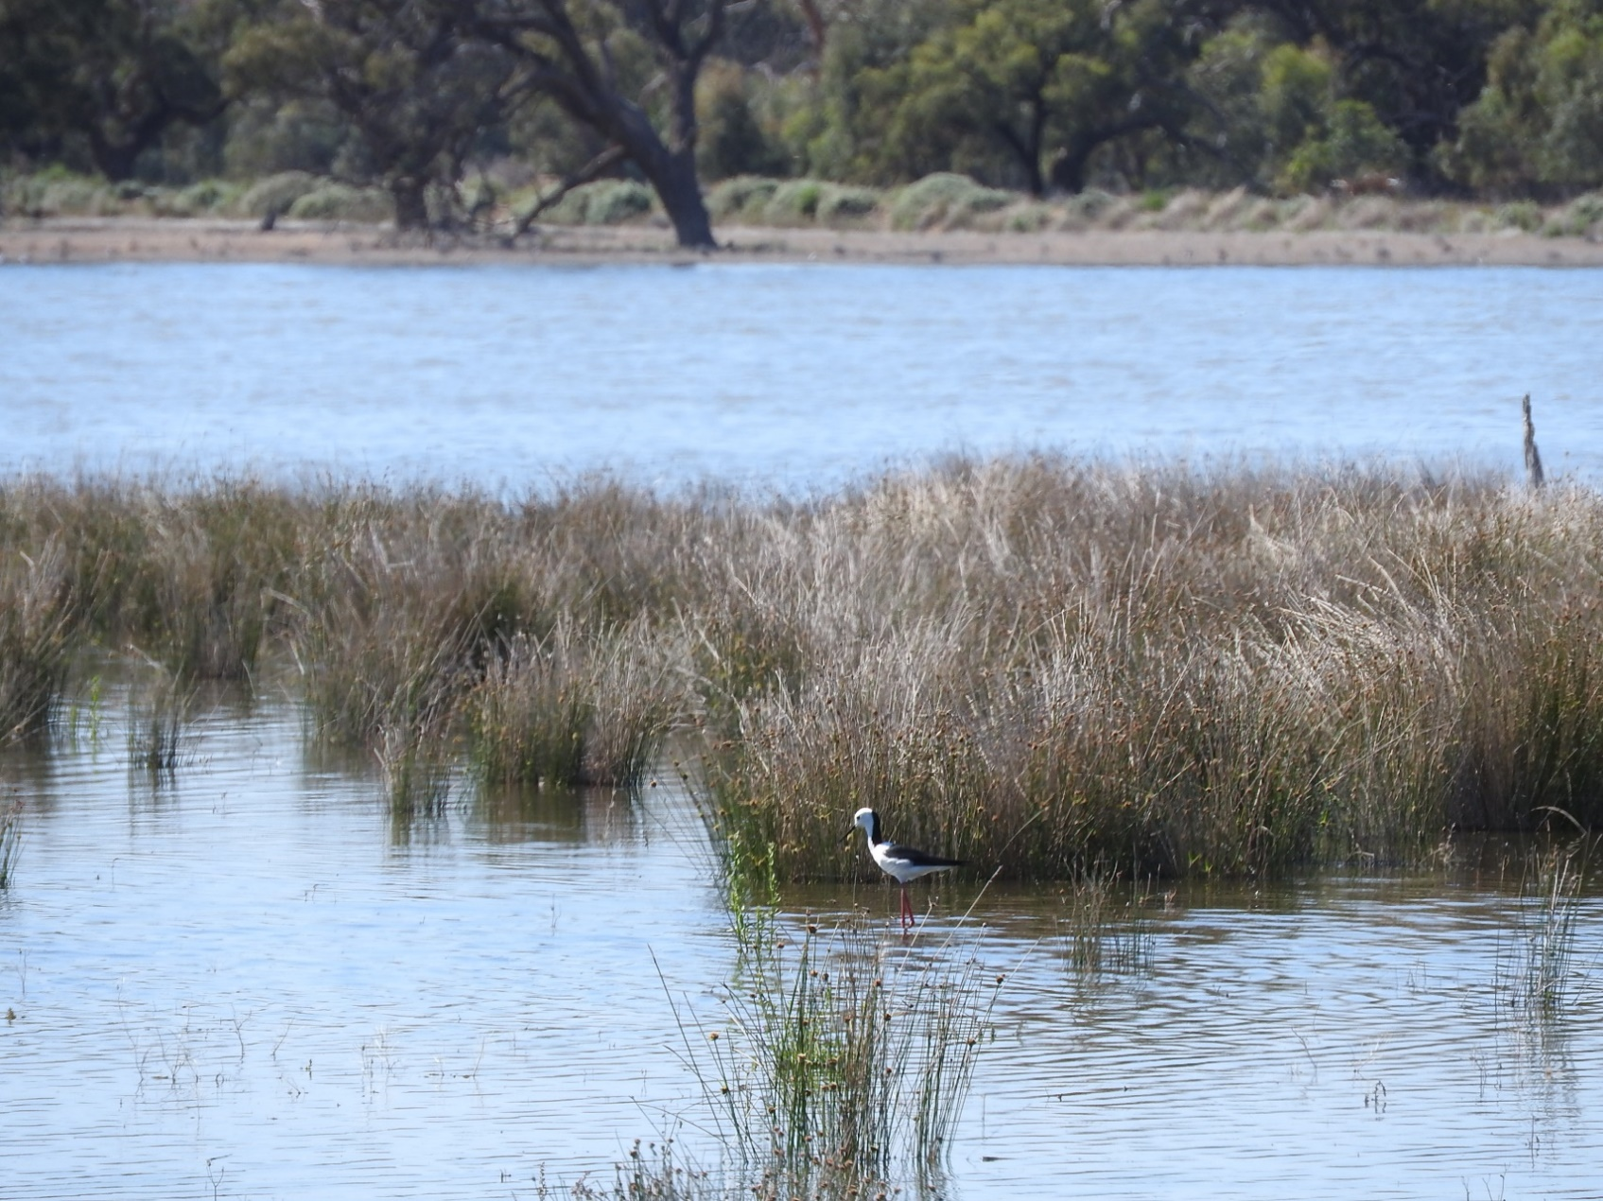



LACHLAN RIVER
MONITORING, EVALUATION AND RESEARCH
QUARTERLY OUTCOMES NEWSLETTER | October – DECEMBER 2021


LACHLAN RIVER
MONITORING, EVALUATION AND RESEARCH

Welcome to the December 2021 quarterly newsletter of the Lachlan Monitoring, Evaluation and Research (MER) Program. This newsletter forms part of the reporting activities undertaken in the Lachlan river system under the MER Program and provides a regular update on our monitoring activities and observations.
In this newsletter we put a spotlight on the waterbirds in the lower Lachlan. We describe a citizen science driven Flow-MER Waterwatch program, which has provided valuable insights into the water quality of the Bundaburra System. We then look at the weather conditions and watering actions, that have been delivered in the last quarter of 2021. We finish this newsletter with the Lachlan Diaries by Adam Kerezsy, with a focus on the turtles of the Lachlan.
We hope you enjoy the read!
The Lachlan MER Team
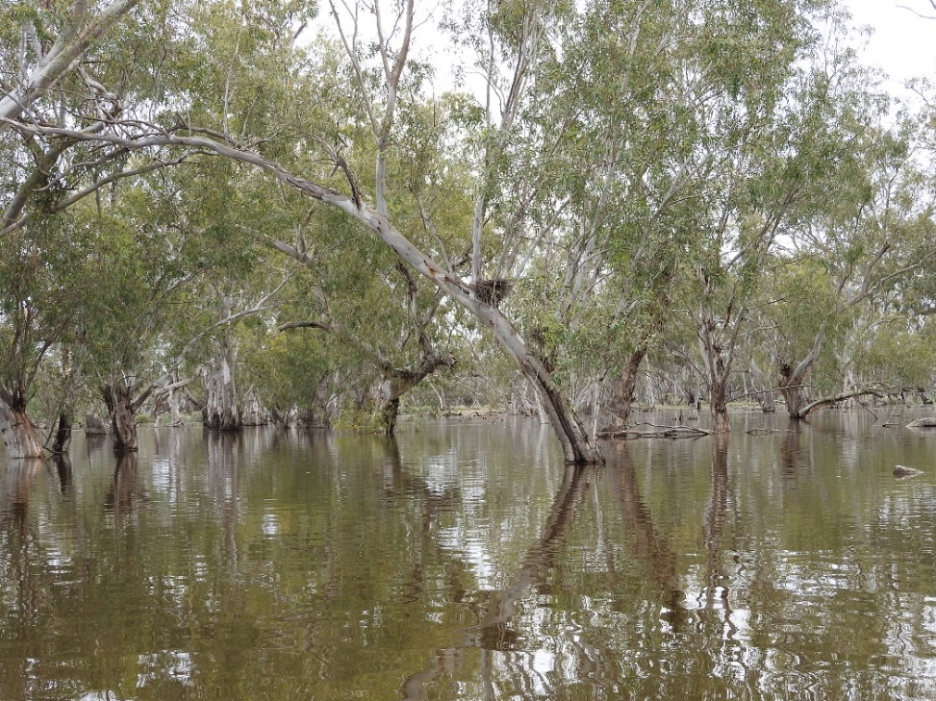

Lake Bullogal. Photo by Alica Tschierschke.

DABU YARRA MURUN
Bundaburra Creek monitoring: “Dabu Yarra Murun” (Give life, Revive!)
Fish are among the few vertebrates that can breathe underwater. Like us, fish also need to take in oxygen and expel carbon dioxide in order to survive, it’s just that they get what they need from the oxygen dissolved in water rather than in the air. Too little oxygen spells trouble for our finned friends, which have to move or else suffer ill effects.
In September 2021, NSW DPI Fisheries staff reported a thick carpet of Azolla (or duckweed fern) throughout the Bundaburra system below Forbes. Given the extent, there were potential implications for reduced dissolved oxygen levels, and the possibility of fish kills as warmer seasonal conditions developed.
However, there was no formal monitoring program in the Bundaburra system and dissolved oxygen levels were unknown! The Flow MER Waterwatch Team responded to the call to action. Local Forbes Wiradyuri man, David Acheson, answered the call to join the Team. David went out with DPIE–EES environmental water manager, Dr Jo Lenehan, in October to be trained up and establish monitoring sites at several locations along Bundaburra south of Forbes. David then took over the fortnightly monitoring and provided data and photographs to DPIE–EES and DPI Fisheries.
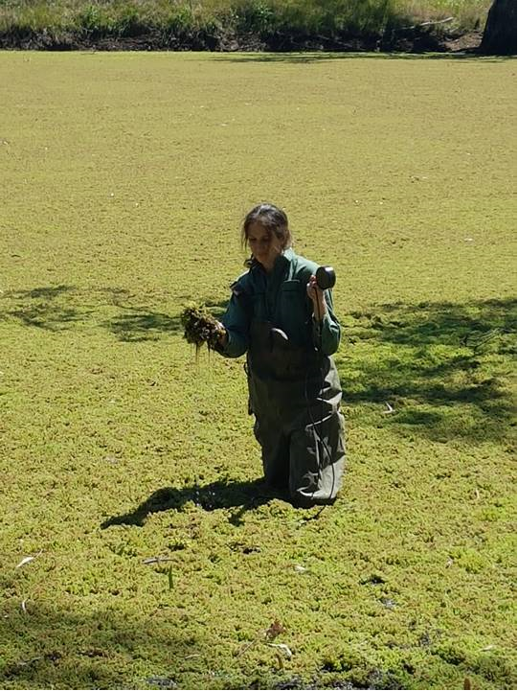
Dr Joanne Lenehan wading through a thick cover of Azolla at Bundarra. Photo by David Acheson.
“As do many other locals, I’ve had an interest in Bundaburra and its plants and animals for a long time. Our local FishCare Education Officer, Brett Smith confirmed reports of native fish species, such as Murray Cod (gugabul), Yellow Belly (bidyan) and Freshwater Catfish (dhandaang) being caught in the Bundaburra and connected Jemalong Creek–Lachlan River system in the last 2 years. I learnt information from being involved in the Flow MER Waterwatch program that I could then relay to others, such as while in general, fish may be able to tolerate low levels of dissolved oxygen (2 mg/L) for short periods (a few hours) – prolonged exposure to sub lethal levels (<3 mg/L) can reduce growth and stress fish. I also hadn’t realised before that large accumulations of Azolla can also contribute to low dissolved oxygen levels through blocking light available for photosynthesis by other aquatic plants and algae, and through microbial processes when decaying. It was good to be involved in better understanding what was happening in my own back yard in Bundaburra, and relay that back to fisheries and water managers who couldn’t always get out there to have a look themselves.” Forbes Wiradjuri cultural/language advisor, David Acheson.
During the first October sampling run, the average water temperature was around 20°C and consistent between sites. Dissolved oxygen, however, varied markedly between the three Bundaburra Creek sites below Forbes and the two reference sites, Lake Forbes and Caragatel Lagoon. As suspected, dissolved oxygen was at critically low levels (<2 mg/L) at the three Bundaburra Creek sites from Lenlong Lane to Wallah Wallah Lane. The comparison sites at Lake Forbes and Caragatel Lagoon were above critical levels (5.9 mg/L and 4.1 mg/L). No evidence of fish kills was found at any site. This raises interesting questions around fish movement on earlier higher flows.

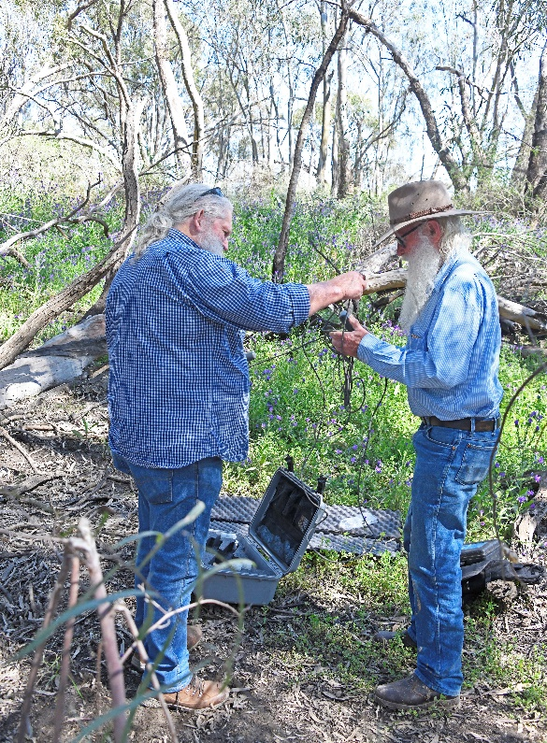
Ed Vagg and David Acheson collecting water quality data. Photo by Joanne Lenehan.
Azolla established in the Bundaburra system when it became disconnected from the Lachlan River and water became stagnant in the creek. The system became reconnected again with a flushing fresh arriving in late November. David Acheson (also a FishCare volunteer), headed out again with Brett Smith (NSW DPI Fisheries) on the 2nd of December to see if the higher flows had flushed the large Azolla accumulations and improved dissolved oxygen. While water temperatures had now increased to around 26°C, there was a small improvement in dissolved oxygen at all sites. Flow MER Waterwatch will continue to monitor Bundaburra throughout summer.
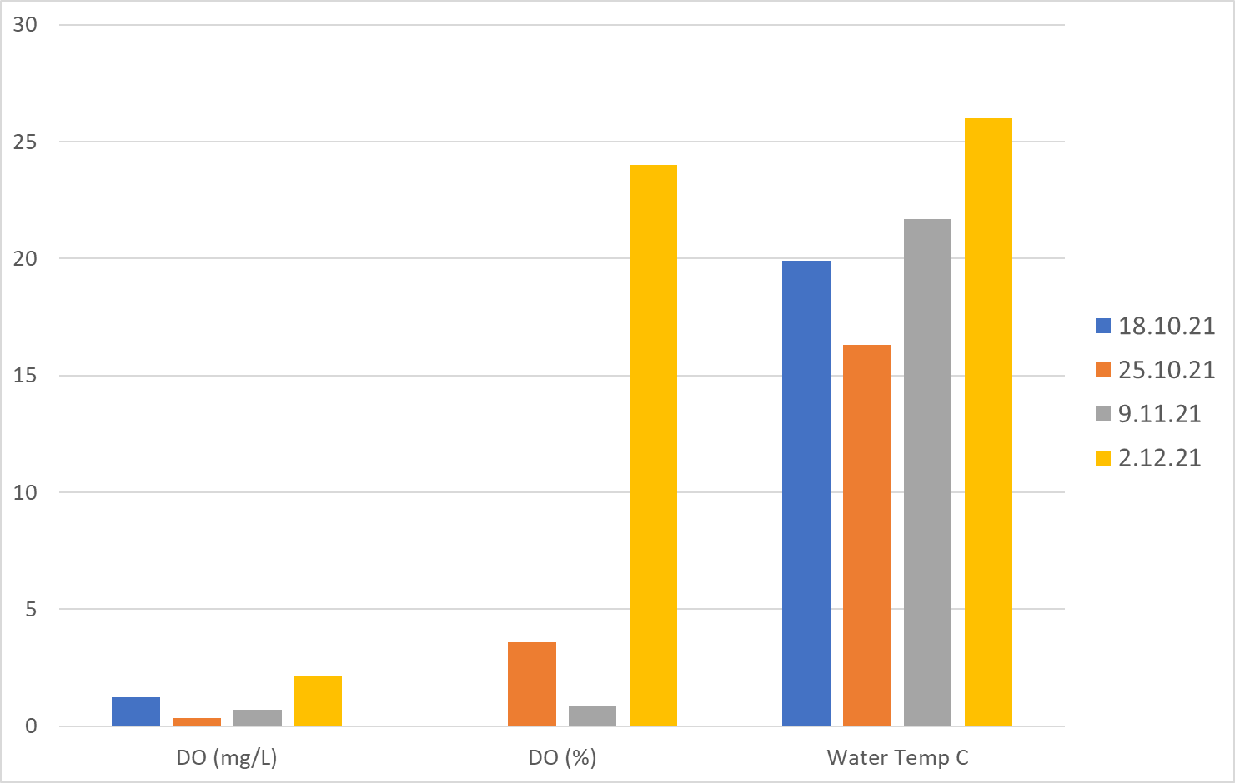
Water quality data collected at Lenlong Lane between 18th October and 2nd December 2021.
Bundaburra is an ephemeral, high-flow anabranch (returning) creek of the Lachlan River near Forbes NSW. It relies on a natural cycle of both wet and dry periods to contribute to landscape-scale functions and productivity (eg. movement of fish in and out of breeding and nursery areas, waterbird breeding and provision of food). The Wiradyuri know the Lachlan River as Galari, and places such as it and Bundaburra were the Wiradyuri people’s supermarket, classroom and hardware store.

To quote Pastor Ceil Grant (Wongomar)
Nga-nga-dha garray-gu bila galang-gu.Yandhu garray-bu bila-galang-bu nga-nga-girri nginyalgir.
Look after the land and the rivers. Then the land and the rivers will look after you all.

WATERBIRDS SPOTLIGHT

The wet conditions experienced across south-eastern Australia over the past 12 months or so has resulted in wide-scale flooding across much of the floodplain of the lower Lachlan. Our spring monitoring campaign coincided with a full river and flooded wetlands. These conditions brought us unique challenges while we collected our larval fish, vegetation and water quality data. However, seeing dryland floodplain wetlands during a flood is something very special, which few get to do, and our field staff felt very privileged for the experience. In November 2021, the wetlands were alive with the sound of birds.
Flood events transform dry wetlands into viable and productive habitats for waterbirds. Waterbird abundance and breeding activity can fluctuate year to year related to the climate and hydrological regime, and the distribution of waterbirds often reflect patterns in droughts and floods. Waterbird species are dependent on wetland inundation for breeding and large breeding events are often triggered by widespread flooding that can inundate the floodplain for many months. Some species of waterbirds move great distances, following cues provided by rainfall and river flows that drive food availability.
Waterbirds species have a range of food sources, including aquatic vegetation, invertebrates, frogs and fish, and as such their presence can be a guide to the overall health of a river system. Long-term monitoring led by the University of New South Wales has shown the numbers of waterbirds in Eastern Australia have been declining over the past four decades (for more details: https://www.ecosystem.unsw.edu.au/research-projects/rivers-and-wetlands/waterbirds/eastern-australian-waterbird-survey). This has coincided with declines in total wetland area related to increased water resource development and drought conditions. The importance of water to waterbirds, seems an obvious statement, but as most of the major rivers in the Murray Darling Basin, including the Lachlan are regulated and managed for multiple uses, water managers have objectives for supporting feeding and breeding areas for waterbirds in key parts of the system.
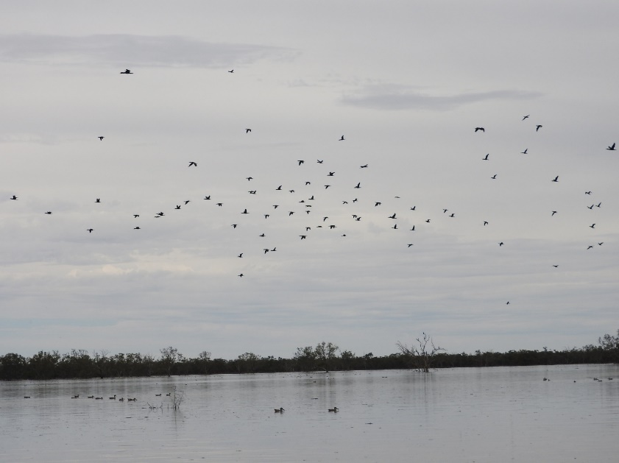
Great cormorants and little cormorants circling a temporary wetland in the lower Lachlan November 2021. Photo by Alica Tschierschke.
The Lachlan provides habitat for birds listed under international migratory bird agreements such as sharp-tailed sandpipers and Latham snipe, as well as threatened waterbirds including the nationally endangered Australasian bittern, and vulnerable blue-billed duck and freckled duck listed in NSW. During bird surveys in late 2016 during the last major flood in the Lachlan, more than 40 wetland-dependent bird species were observed in the Booligal complex of wetlands. These waterbirds have turned up in flocks once again in the lower Lachlan to make use of the increased habitat and productivity.
In the lower Lachlan, a common occurrence on open wetlands, is the great cormorant which is all black with yellow facial skin (see image below). They are a colonial nesting species, meaning they gather and nest in large colonies. Other species of colonial nesting waterbirds in the lower Lachlan include straw-necked ibis, glossy ibis and royal spoonbill. Great cormorants nest in low lying branches often overhanging water, and a single river red gum can support large numbers of nests.
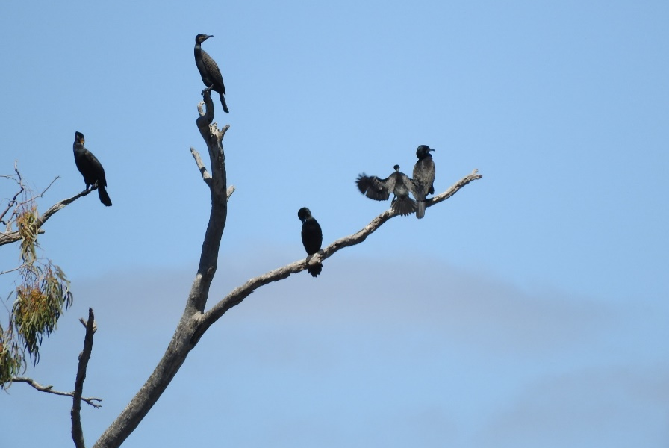
Great cormorants perched on a dead branch at Moon Moon Swamp, near Booligal November 2021. Photo by Alica Tschierschke.

White-necked heron are one of the larger waterbirds observed in the lower Lachlan, distinguished by their white neck and head, back and wings are a sooty-black. White-necked herons breed in wetlands that remain flooded for several months, and nest in tall trees such as river red gum, near or over standing water.
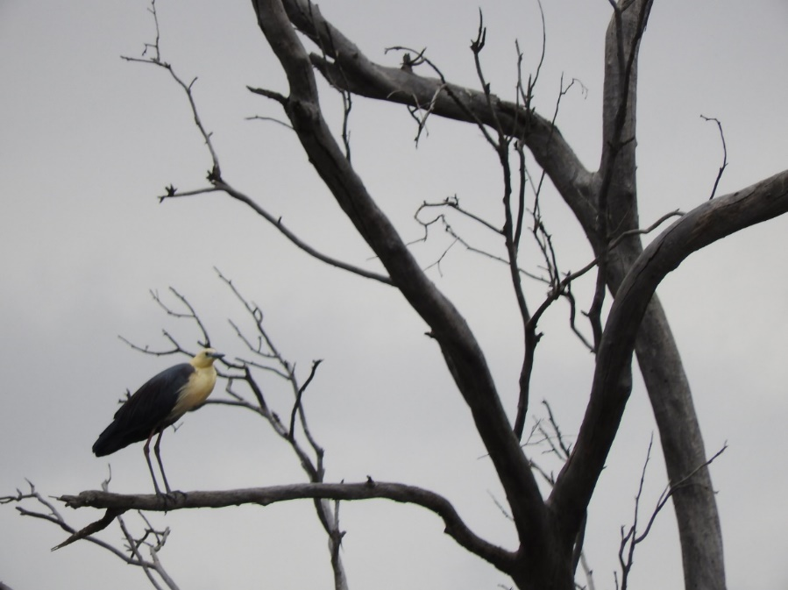
White-necked heron perched on a dead river red gum at Lake Bullogal. Photo by Alica Tschierschke.
Whiskered terns (or Mash terns) are an unusual species of tern preferring freshwater habitats. They are 25 cm in height and have an appearance somewhat of a bird you would see on the coast. The species are migratory and nomadic, and breed in large temporary wetlands during flood.
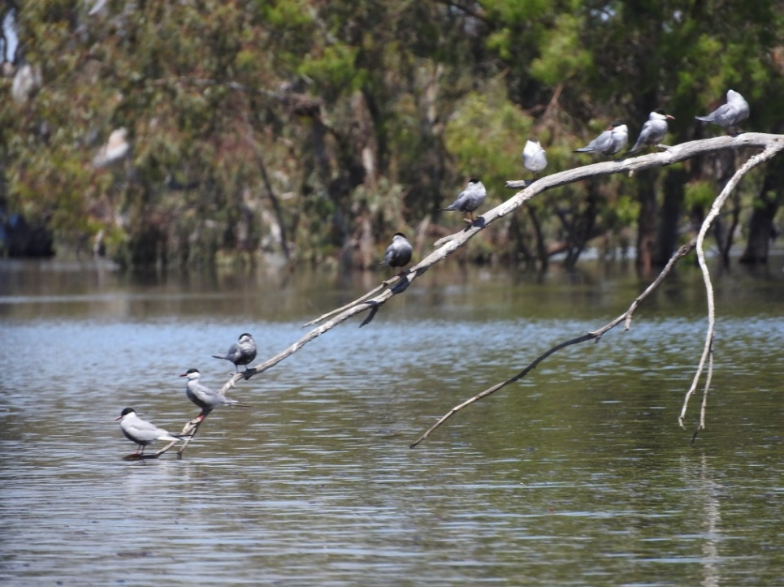
Whiskered Terns perched on a dead tree in Lake Tarwong. Photo by Alica Tschierschke.
OBSERVATIONS AND OUTCOMES
Catchment conditions between October and December 2021
The very high rainfall at the end of last quarter in September didn’t continue into October. However, November was another record month with 125 mm – or more than 6 times the rainfall for Hillston, and 62 mm (nearly 4 times) for Oxley (Walmers Down). October and December in comparison were dry, with below or just above median rainfall recorded at both stations. Rainfall fell throughout November, in contrast to the two single heavy rainfall events in September.
The annual rainfall 2021 for Hillston was 613.3 mm and is a cracking 341.7 mm above the long-term annual median of 271.3 mm. A similar story occurred at Oxley where 127.7 mm more rain than the long-term annual median (213.8 mm) was recorded.
The conditions were accompanied by on average 1.5°C below daily maximum and 1°C below minimum temperatures.
Hillston  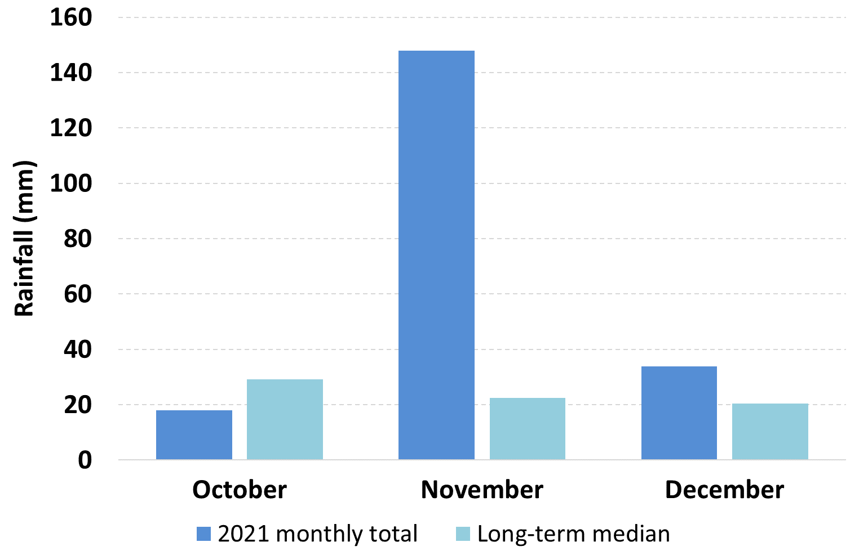 | Oxley  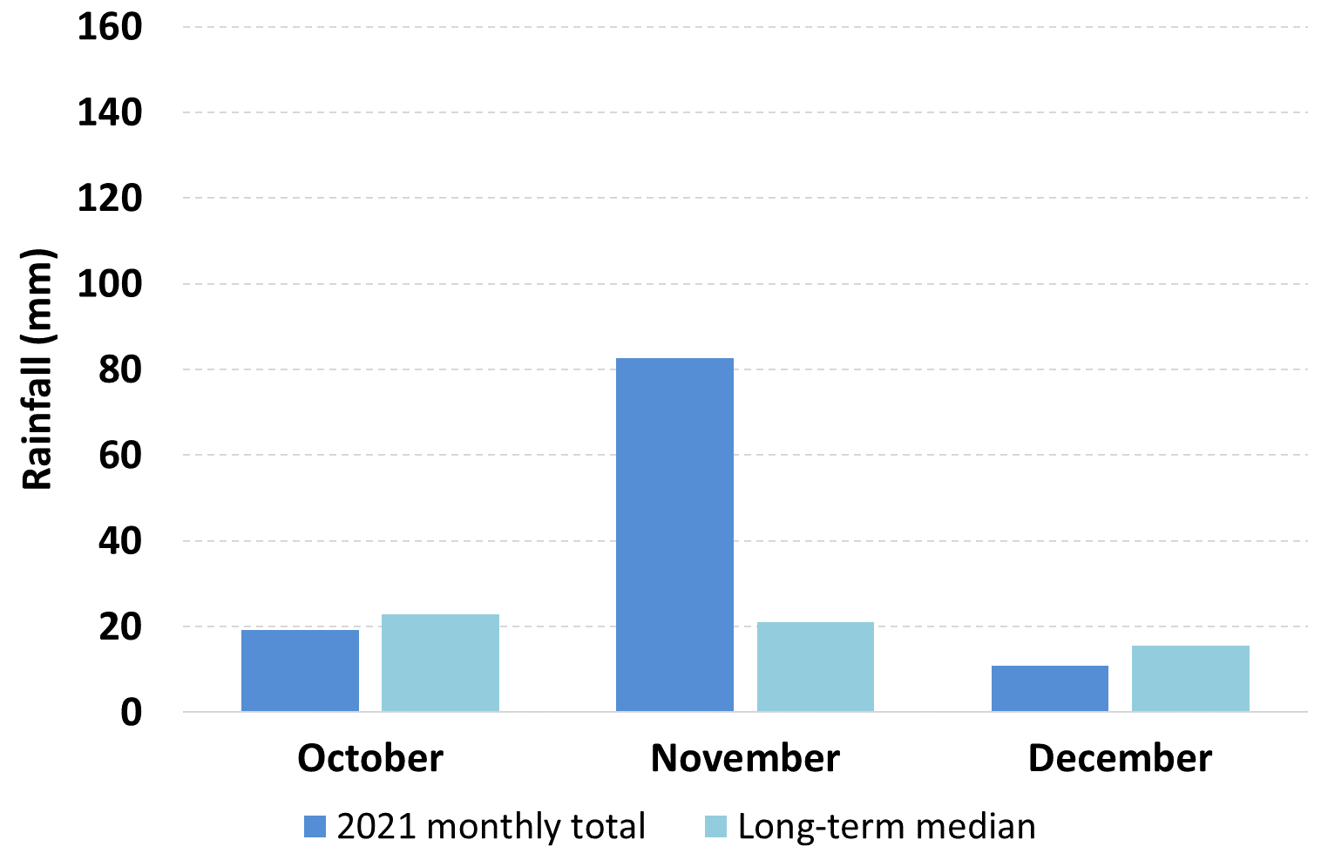
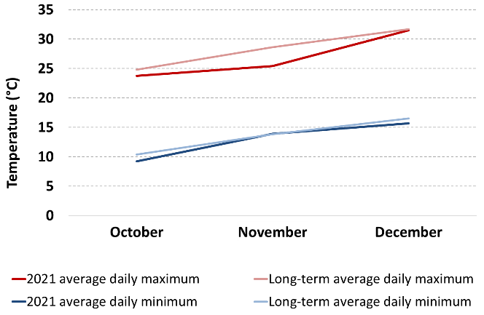 | Graphs showing rainfall and maximum and minimum temperatures for the last quarter of 2021. Data are for the Hillston (Airport) weather station number 075032 and Oxley (Walmer Downs, 49055) are sourced from the Bureau of Meteorology.

Hydrology Observations
No environmental watering actions occurred in the last quarter of 2021. This was a period of above average rainfall in the catchment and high inflows into the Lachlan’s major reservoirs. Water managers were kept busy attempting to reduce the impacts of dam spills and unregulated floods through airspace releases and managed flooding. Water volumes in the Lachlan River remained very high, with levels consistently exceeding overbank flooding across the lower Lachlan.
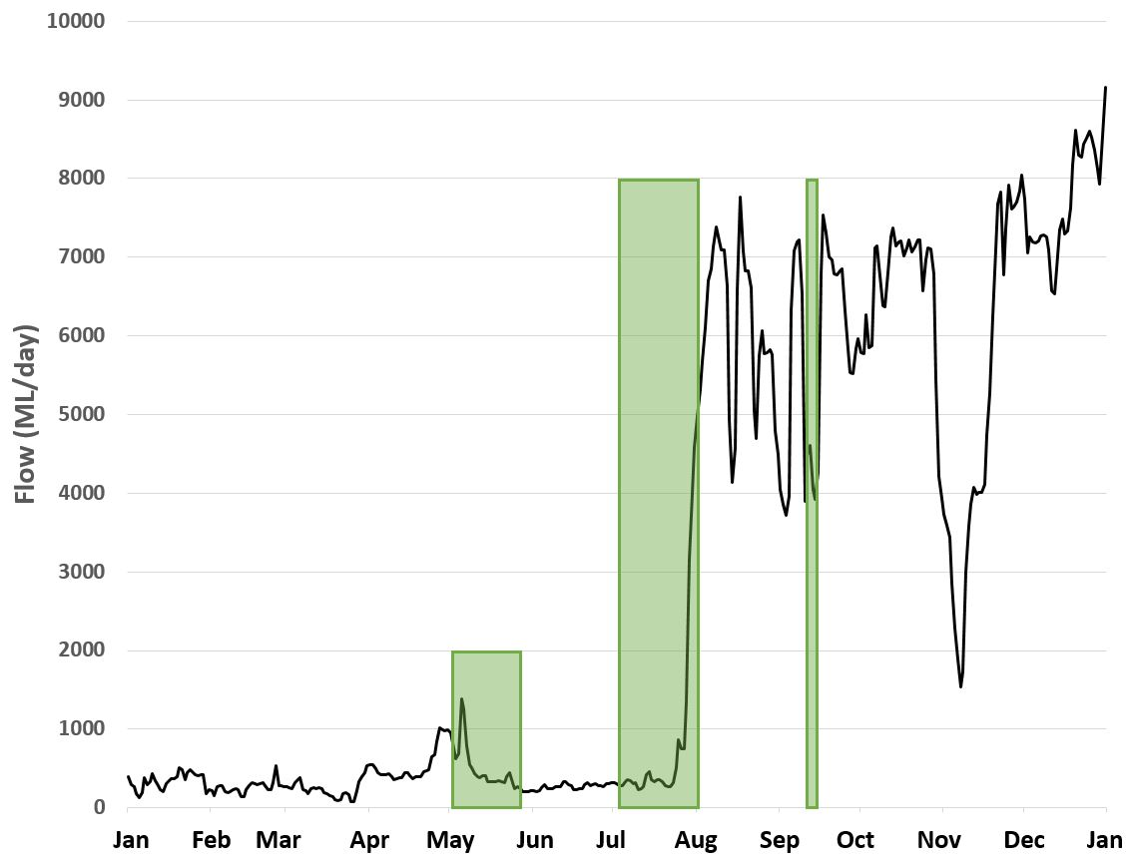
Flow in the Lachlan River downstream of Willandra Weir (412038) between 1st of January and 31st of December 2021. No environmental watering actions occurred in the last quarter of 2021. Green shading shows approximately the periods of environmental water use. Note that the period from late July onwards includes when much larger volumes of translucent flows and airspace releases were moving through the river system. Data from Water NSW (http://waterinfo.nsw.gov.au/).

THE LACHLAN DIARIES
Stories from monitoring and community events in the Lachlan catchment
Adam Kerezsy, fish biologist at large
Turtle heaven – the aquatic reptiles of the Lachlan
For people – like me – who grew up in the 1970s and 1980s, freshwater critters with shells were always called ‘tortoises’. The general idea was that turtles had flippers and lived in the ocean, whereas anything else – particularly if it had legs and could get around on land - was a ‘tortoise’.
Shortly thereafter, herpetologically-inclined people with an interest in such things, obviously broadened the turtle definition and narrowed the idea of a tortoise to wholly terrestrial creatures: to get an idea of a tortoise the best way is to think of the giant, lumbering, prehistoric beasts that amble slowly around islands in the Galapagos munching on flowers.
What this means is that – in Australia’s rivers – we have turtles, not tortoises.
Continent-wide, there are more than 20 species of turtles, but within the Murray-Darling Basin rivers there are three: the common snake-neck turtle, the Macquarie turtle and the broad-shell turtle.
As the name indicates, snake-neck turtles have long necks that they can withdraw sideways beneath their shell to avoid predation. These turtles usually get up to about 25 cm long, and these are the ones that release a pungent smell if they are handled (therefore also known as Stinkers). These are also the turtles that – following rain – frequently cross roads as they move from pond to dam and creek to river. Unfortunately, this strategy often ends in disaster, because as the fables and fairy tales remind us, turtles aren’t exactly nimble away from the water, and are certainly no match for cars, trucks, birds, foxes, cats and larger reptiles.
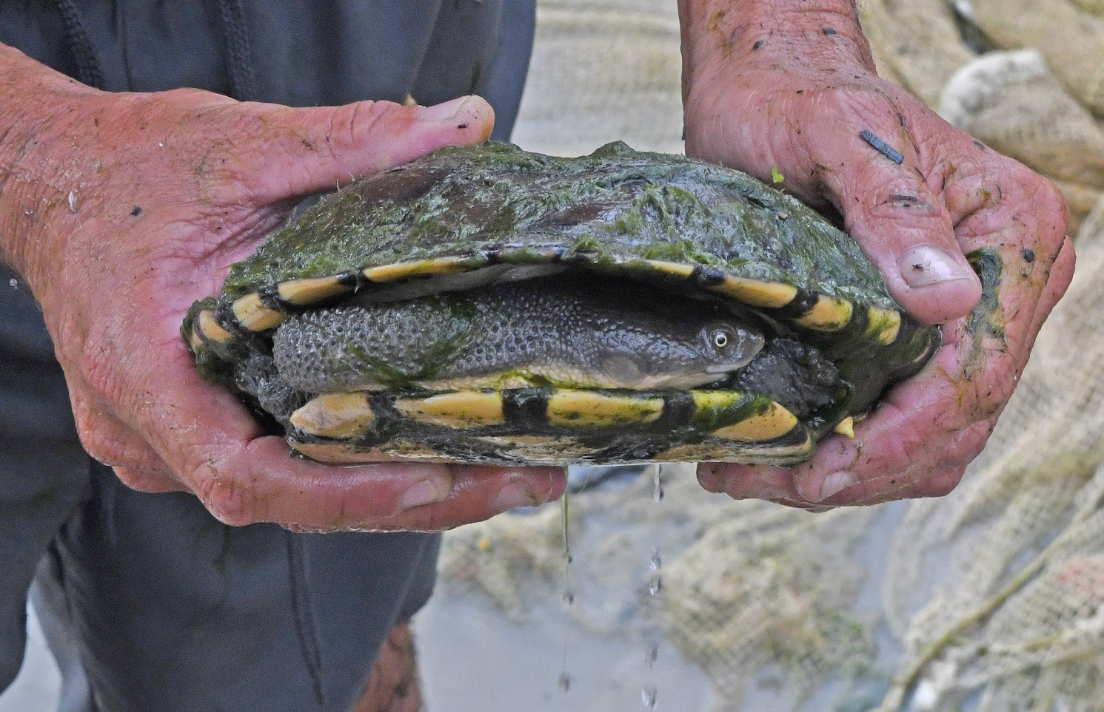
A common snake-neck turtle from Booberoi Creek. Photo by Mal Carnegie.
Macquarie turtles get larger – shells up to 40 cm long – and have short necks. Macquarie turtles have greenish shells and a yellow stripe on both sides of their heads. The body depth of all turtles increases as they get older, so a 50 year old Macquarie turtle can be a fairly solid animal. Macquarie turtles prefer large areas of water like the big lakes in the mid-Lachlan. In contrast, snake-neck turtles are usually more common in creeks and the river.
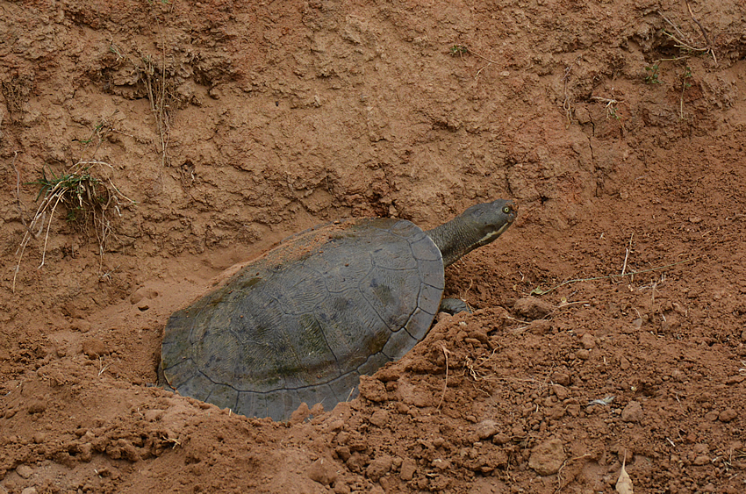
A Macquarie turtle nesting at Lake Cargelligo. Photo by Adam Kerezsy.
Both common snake-neck turtles and Macquarie turtles nest in spring. They dig shallow nests in river banks and paddocks and then deposit and bury the oval eggs that are usually about 4 cm long. The nests are frequently raided by foxes, cats and native predators like goannas and pythons. If they’re lucky, the juveniles hatch over summer, and if they’re even luckier they make it back to the safety of the water before being picked off by birds.
Although common snake-neck and Macquarie turtles are the two most widespread and abundant species, there is concern amongst turtle researchers, that the on-going impacts of feral species, river regulation and human impacts may be having negative effects on the populations of all Australian turtle species.
Unlike common snake-neck and Macquarie turtles, the third species of Murray-Darling Basin turtle - the largest long-necked turtle in Australia - is uncommon in the Lachlan and is known as the broad-shelled turtle. These have been found in the lower reaches of the Lachlan (down towards Oxley and the Great Cumbung Swamp), and also in Lake Cowal. It’s possible that broad-shelled turtles also occur in other areas of the Lachlan, so river-dwellers are urged to keep an eye out (and a camera handy).
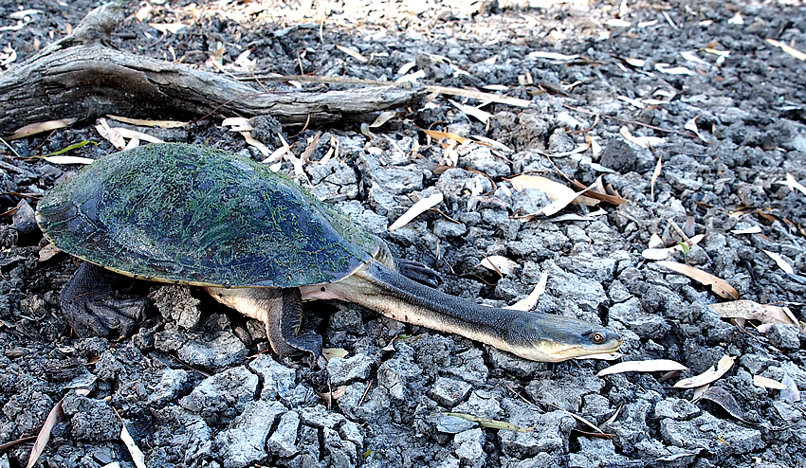
A broad-shell turtle from the lower Lachlan near Oxley. Photo by Adam Kerezsy.
Broad-shell turtles have a noticeably long neck which is the longest of any turtle in the world. Their shells can be up to 50 cm long and a large female can weigh as much as five kilograms. They can be distinguished from common snake-neck turtles as they do not have black lines on their plastrons (the underside of the shell) and their legs and neck cannot be fully retracted beneath their shells.
All turtles that occur in the Lachlan can be considered opportunistic scavengers and predators: they basically eat anything they can find or overpower, and a long neck certainly comes in handy as a striking tool for catching slow-moving fish. Given that turtle body-shapes haven’t changed very much since they evolved in the late Permian and early Triassic, they can rightly be considered one of the most successful – and persistent – groups of reptiles.

ABOUT THIS DOCUMENT
The Commonwealth Environmental Water Holder (CEWH) is responsible under the Water Act 2007 (Cth) for managing Commonwealth environmental water holdings. These holdings amount to more than 2,700 gigalitres (as at July 2019) of water entitlements across the Murray-Darling Basin. The holdings must be managed to protect or restore the environmental assets of the Murray-Darling Basin, and other areas where the Commonwealth holds water, to give effect to relevant international agreements. Commonwealth holdings are managed in partnership with NSW environmental water holdings by DPIE–EES and takes all sources of water into consideration.
Monitoring and evaluation are critical for supporting effective and efficient use of Commonwealth environmental water. Monitoring and evaluation also provides important information to ensure the CEWH meet their reporting obligations. Between 2014 and 2019, the Commonwealth Environmental Water Office (CEWO) has undertaken monitoring and evaluation of the ecological outcomes of environmental watering through the Long Term Intervention Monitoring Project (LTIM Project). At the same time, the CEWO has undertaken research which seeks to improve the science available to support environmental water management in the Murray-Darling Basin through the Murray-Darling Basin Environmental Water Knowledge and Research Project (EWKR Project).
The Monitoring, Evaluation and Research Program (MER Program) builds on the work of the LTIM and EWKR Projects to undertake monitoring, evaluation and research activities within seven Selected Areas and at the Basin-scale between 2019 and 2022. One of the seven Selected Areas is in the Lachlan river system and a team of researchers, agency staff and contractors led by the Centre for Applied Water Science at the University of Canberra are monitoring, evaluating and conducting research in the catchment.
This newsletter forms part of the reporting activities undertaken in the Lachlan river system under the MER Program. It will be produced quarterly and highlights the activities, observations and outcomes that have occurred in the river system in relation to environmental water.
In conducting the monitoring evaluation and research project in the Lachlan river system, the project team as well as the Commonwealth Environmental Water Office respectfully acknowledge the traditional custodians of the land on which this work is conducted, their Elders past and present, their Nations of the Murray-Darling Basin, and their cultural, social, environmental, spiritual and economic connection to their lands and waters. The Lachlan River flows through the lands of the Nari Nari, Ngiyampaa, Wiradjuri and Yita Yita Nations, and we acknowledge these people as the traditional owners of the land on which this publication is focused.
More information can be found at:
https://www.environment.gov.au/water/cewo/monitoring/ltim-project
https://flow-mer.org.au/selected-area-lachlan/
https://www.environment.gov.au/water/cewo/monitoring/mer-program
Inquiries regarding this document should be addressed to:
Damian McRae  Commonwealth Environmental Water Office  Phone: 02 6274 2524  e-mail: damian.mcrae@environment.gov.au | Dr Fiona Dyer  University of Canberra  Phone: 02 6201 2452  e-mail: Fiona.Dyer@canberra.edu.au

This document was prepared by Will Higgisson, Alica Tschierschke, Lea Knight, Fiona Dyer, Adam Kerezsy (Dr Fish), Joanne Lenehan (DPIE‒EES) and David Acheson (Forbes Wiradjuri cultural/language advisor).
Cover Photo: Black wing stilt wading through spiny flat-sedge, at Lake Bunumburt (Photo by Alica Tschierschke)
Document history and status
Version | Date Issued | Reviewed by | Approved by | Type
Draft 1 | 04/01/2022 | Lachlan MER Team | Fiona Dyer | DRAFT
FINAL | 0/01/2022 | CEWO | Fiona Dyer | FINAL

Distribution of copies
Version | Type | Issued to
FINAL | Electronic | Commonwealth Environmental Water Office

Copyright
© Copyright Commonwealth of Australia, 2022

‘Lachlan River, Monitoring, Evaluation and Research, Quarterly Outcomes Newsletter’ is licensed by the Commonwealth of Australia for use under a Creative Commons By Attribution 3.0 Australia licence with the exception of the Coat of Arms of the Commonwealth of Australia, the logo of the agency responsible for publishing the report, content supplied by third parties, and any images depicting people. For licence conditions see: http://creativecommons.org/licenses/by/3.0/au/
Disclaimer
The views and opinions expressed in this publication are those of the authors and do not necessarily reflect those of the Australian Government or the Minister for the Environment and Energy. While reasonable efforts have been made to ensure that the contents of this publication are factually correct, the Commonwealth does not accept responsibility for the accuracy or completeness of the contents, and shall not be liable for any loss or damage that may be occasioned directly or indirectly through the use of, or reliance on, the contents of this publication.

