**Healthy rivers are vital for community wellbeing, agriculture and our native plants and animals.**

As dry conditions continue across the Murray—Darling Basin, water managers are working together to keep river systems healthy including the Lachlan.

During spring, water for the environment will add to flows in the Lachlan River to help provide food for fish and give native plants a drink.

This flow will also provide benefits for communities along the full length of the river through improved water quality and amenity.

It’s important to deliver the flows during spring when they can help get native plants, fish and other animals as healthy as possible before summer arrives.

We have been working with local communities and scientists to closely monitor the benefits of the flow to the environment.

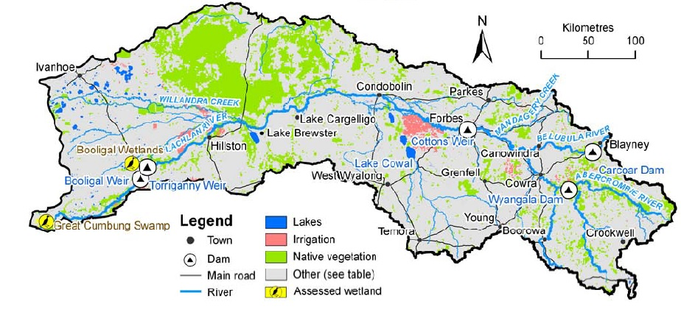Key facts

This flow will travel more than 1,000 kilometres from Wyangala Dam to The Great Cumbung Swamp and will target six priority sites.

* Starting at Wyangala Dam in mid-September, a short pulse (about 3 weeks) to improve native fish, plant and animal health. The flow will peak at around 2,600 megalitres/day for five days at Forbes.
* This flow will enable the river to be linked to other key sites that will also be watered including Booberoi Creek, Yarrabandai Lagoon and sites in and near The Great Cumbung Swamp.
* About 22 gigalitres of Commonwealth environmental water has been made available for the spring pulse (carried over from last year). Under the [NSW Extreme Events Policy](https://www.industry.nsw.gov.au/water/what-we-do/legislation-policies/eep), a further 16 gigalitres of Commonwealth environmental water is inaccessible for use until conditions improve.

Why is the water being released?

Even in dry times like we are currently experiencing, natural flows would have replenished the Lachlan River, flowing through the many creeks and low lying wetlands through to the end of the river system.

Today the Lachlan River is highly modified, with water captured and regulated in dams and weirs. These changes have decreased the size and variability of natural flows in winter and spring, and interrupted the triggers plants and animals rely on to survive, feed and breed.

Timely releases of water are critical to restoring these triggers and help native fish, waterbirds and wetland refuges better cope with the drying conditions. At a multi-catchment scale, the need to do what can be done to protect the health of the Lachlan River is heightened by the devastating conditions further north in the Basin where there will be very little refuge or habitat until the drought breaks.

The need for water varies along the Lachlan River. Some sites, such as reed beds of The Great Cumbung Swamp, need water nearly every year.

The spring pulse has also been planned to compliment other watering actions to be undertaken later in the year by the NSW Department of Planning Industry and Environment.

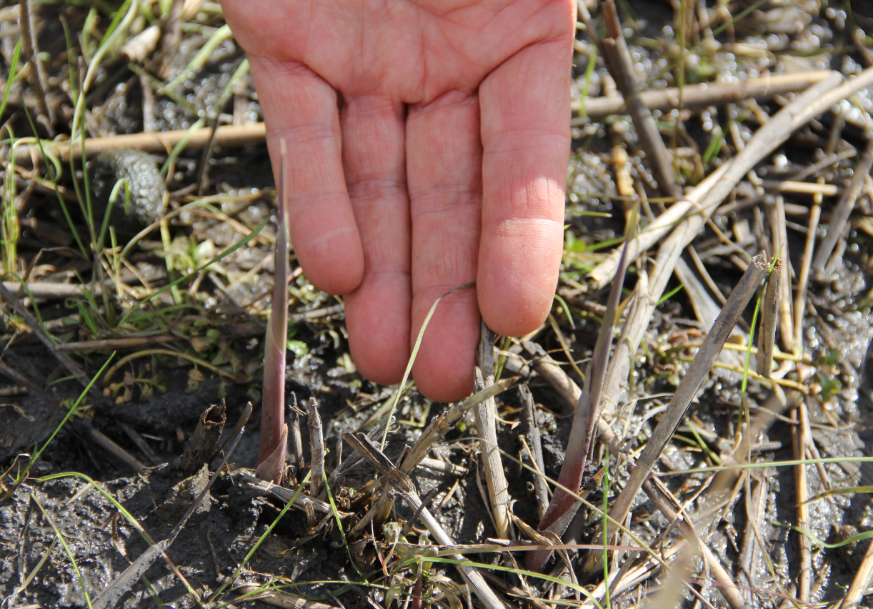

**Photo: Newly emerged reeds (known as phragmites, highlighted in yellow circles) in The Great Cumbung Swamp will benefit from a drink in spring. Damian McRae/CEWO.**

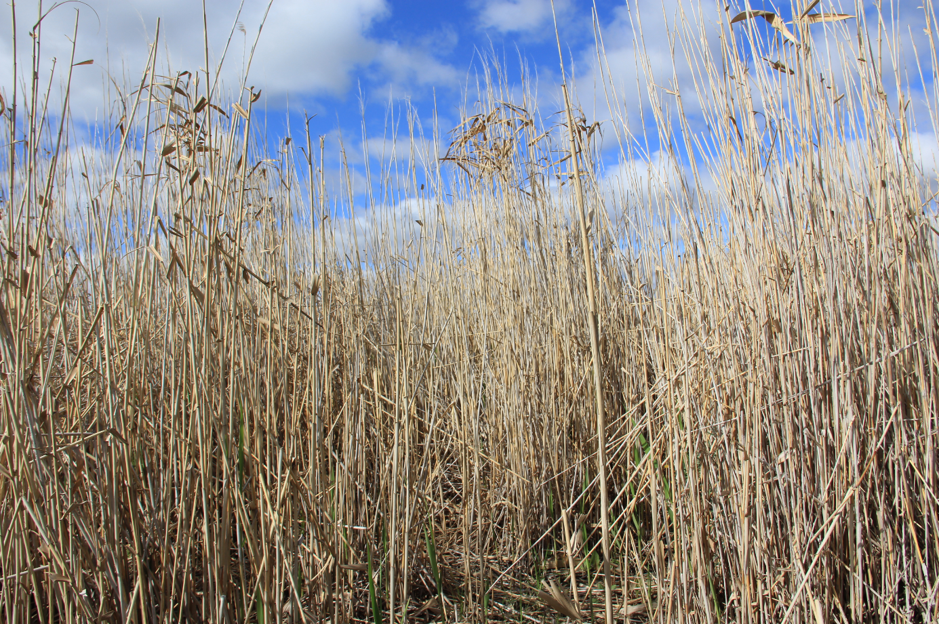

**Photo: The reeds (phragmites) can grow to over 180 cm tall (about 6 feet) and form dense beds. This photo shows the wheat-coloured dead stalks from last spring-summer and the new green growth starting to emerge at ground level. Damian McRae/CEWO.**

For further information

We are collaborating with the NSW Department of Planning, Industry and Environment and WaterNSW. This includes drawing on the advice and guidance provided by the [Lachlan Environmental Water Advisory Group](https://www.environment.nsw.gov.au/topics/water/water-for-the-environment/lachlan/environmental-water-advisory-group) and key water planning documents, including the [draft Lachlan Long Term Water Plan](https://www.environment.nsw.gov.au/topics/water/water-for-the-environment/planning-and-reporting/long-term-water-plans/lachlan-consultation), to guide the development of the spring pulse.

Contact the Commonwealth Environmental Water Office for further information:

**Hilton Taylor**  
 02 6274 2906 or 0447 221 896

[hilton.taylor@environment.gov.au](mailto:hilton.taylor@environment.gov.au)

**Bruce Campbell**  
 02 6274 2845 or 0459 848 916

[bruce.campbell@environment.gov.au](mailto:bruce.campbell@environment.gov.au)

**Damian McRae**  
 02 6274 2524

[damian.mcrae@environment.gov.au](mailto:damian.mcrae@environment.gov.au)

Image Credit: Map sourced from CSIRO (2008). Water availability in the Lachlan. A report to the Australian Government from the CSIRO Murray-Darling Basin Sustainable Yields Project. CSIRO, Australia. 133pp.