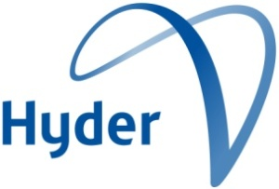
Department of Sustainability, Environment, Water, Population and Communities
Landfill Ban Investigation
FINAL REPORT
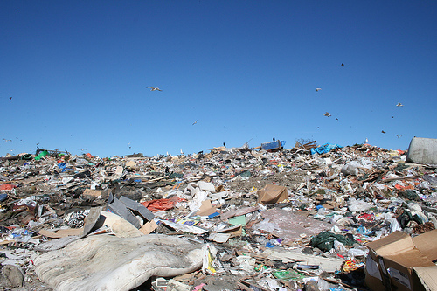

Hyder Consulting Pty Ltd

ABN 76 104 485 289

Level 16, 31 Queen Street
Melbourne VIC 3000
Australia
Tel: +61 3 8623 4000
Fax: +61 3 8623 4111

www.hyderconsulting.com

Department of Sustainability, Environment, Water, Population and Communities
Landfill Ban Investigation
FINAL REPORT
Authors | Eleanor Dawkins  Peter Allan
Checker | Paul Randell
Approver | Paul Randell
Report no. | 1
Date | 16 November 2010
This report has been prepared for the Department of Sustainability, Environment, Water, Population and Communities in accordance with the terms and conditions of appointment dated 8 June 2010. Hyder Consulting (ABN 76 104 485 289) cannot accept any responsibility for any use of or reliance on the contents of this report by any third party. Sources of the report were current up to August 2010.
The views and opinions expressed in this publication are those of the authors and do not necessarily reflect those of the Australian Government or the Minister for Sustainability, Environment, Water, Population and Communities or the Minister for Climate Change. While reasonable efforts have been made to ensure that the contents of this publication are factually correct, the Commonwealth does not accept responsibility for the accuracy or completeness of the contents, and shall not be liable for any loss or damage that may be occasioned directly or indirectly through the use of, or reliance on, the contents of this publication.

CONTENTS
Executive summary 3
1 Introduction 5
2 Project method 6
3 Forms of landfill bans 7
4 International jurisdictions: review and analysis 9
4.1 Motivations 10
4.2 Types of bans 11
4.3 Complementary instruments 12
4.4 Implementation elements 12
4.5 Timing 13
4.6 Compliance and enforcement 13
4.7 Public support and stakeholder consultation 14
4.8 Results in diversion 14
4.9 Other outcomes 15
5 Australian jurisdictions: review and analysis 16
5.1 Motivations 16
5.2 Types of bans 16
5.3 Complementary instruments 17
5.4 Timing 18
5.5 Implementation elements 18
5.6 Compliance and enforcement 18
5.7 Public support and stakeholder consultation 19
5.8 Results in diversion 19
6 Considerations for Australia 21
References 23
Appendix A 24

Front page image: http://sustainableslump.files.wordpress.com/2009/04/landfill.jpg
Shortened forms

HDPE high density polyethylene
LDPE low density polyethylene
NEPM National Environment Protection Measure
PIW prescribed industrial waste
PP polypropylene
PET polyethylene terephthalate
PVC polyvinyl chloride
TOC total organic carbon
MSW municipal solid waste

Executive summary
The purpose of this review is to:
- identify key jurisdictions across the developed world that have introduced landfill bans
- tabulate the scope of the bans in each centre and, where possible, obtain data on the waste generation and diversion outcome that has occurred in each jurisdiction
- where possible, outline the implementation method and provide any detail on key motivations for action, stakeholder support, or issues encountered during implementation.
Landfill bans are defined as a range of measures to prevent or restrict the disposal of waste to landfills. This includes outright exclusions and requirements for pre-sorting or pre-treatment. The bans may apply to all waste, to particular streams (such as municipal waste), or to individual products or materials.
Landfill bans and their results can be complex; they can apply to a range of different wastes, or to different ways of classifying waste. They are also never the only instrument of waste management. They are tailored to meet each jurisdiction’s complexity of goals, environments (for example social, political, waste management policies, available technologies and diversion rates), stakeholder support, and enforcement options.
A desktop review of landfill bans around the developed world is summarised in Table A-1 in Appendix A. Some of the findings are described and briefly analysed in Section 4.
Many of the landfill bans in Europe have been in existence for a decade and therefore offer a strong guide to how landfill bans affect waste outcomes. All the cases examined with combinations of bans and other instruments demonstrated good results in reducing waste sent to landfill.
Bans also take a number of different forms and have been introduced into different circumstances, covering unsorted waste or wastes determined by their organic content, by their sources or by their type, such as e-waste, liquid wastes, batteries, packaging, vehicles, timber, paper and biodegradable wastes.
The motivation for introducing landfill bans varied across jurisdictions. For some the purpose related primarily to material recovery, while for others the aim was to reduce the environmental impact of landfills on air, land, and water.
A desktop review of landfill bans within Australia is summarised in Table A-2 in Appendix A. Some of the findings are described and briefly analysed in Section 5.
There are a range of different landfill bans in place in the different states and territories of Australia. They are supported by a range of federal and state regulations and programs. Each jurisdiction uses a different set of tools to control wastes.
Motivations for waste management in Australia are slightly different from those overseas. In Europe there are pressures to move away from landfill for capacity reasons. With few exceptions jurisdictions within Australia do not have this problem, so capacity concerns do not always apply.
In Australia landfill bans are mostly based on properties of waste, and are identified by either property or type. Examples are contaminated soil, banned by virtue of its chemical properties and characterised by its chemical properties (Victoria); and medical waste, banned by virtue of its potentially infectious properties but characterised by type (South Australia). This may be changing. Orange City Council has in place rules regarding landfill disposal that have an effect similar to a ban on untreated/sorted waste.
Considerations for Australia are elaborated in Section 6.
Analysis of international and national use of landfill bans indicates that there are some significant opportunities within Australia for improving the way we manage waste, and clearly shows that landfill bans could be used to a greater extent in Australia.
International and national examples show that the planning for and implementation of landfill bans needs to include:
- analysis of environmental and financial outcomes and technologies
- local involvement and implementation
- clear responsibilities and cooperation between government levels
- juridical and financial instruments
- transparency and clear communication to the public
- clarity in establishing timelines for compliance.
There are many elements to consider in choosing a landfill ban as a waste management instrument. Successful implementation requires clarity around the goals of the ban. Each jurisdiction will have its own motivations. For example, Australia as a whole aspires to the waste hierarchy (avoidance and minimisation, re-use, recycling, recovery and disposal), but each state or local government have their own approach towards achieving it. Other important elements are the development of an understanding of where waste will be diverted by the bans and the development of programs or regulations to ensure that waste will be diverted into the preferred alternative treatments.
A pre-sort condition on waste destined for landfill is in place in a number of countries in Europe. It was found to provide, and be magnifier of, a positive result in the Waste and Resources Action Programme cost-benefit analysis for the United Kingdom. And the application of a pre-sort condition is within Australia’s technological capabilities. This is equivalent to South Australia’s ban on waste not subjected to resource recovery in metropolitan Adelaide, which could be extended to all areas of large population, and potentially entire states.
With excellent planning and suitable complementary instruments, landfill bans could offer Australia good hazard control/reduction, as they already do in a number of states, and deliver good diversion outcomes in a cost-efficient manner.
- Introduction
There is a growing debate within the waste and recycling community about the next substantial step in improved waste management. It is widely regarded that recycling based on council contracted services and financially attractive commercial collections is now largely mature, and that further gains will have to come from increasing landfill levies (to drive investment in technology changes) and regulatory measures (including landfill bans).
Landfill bans or restrictions have been introduced in a number of developed countries (or their provinces) in Europe and North America. These include Germany, the Netherlands, Austria, Sweden, Denmark, France, Norway, Belgium and various US states and Canadian provinces (See Table A-1 in Appendix A).
The UK is now actively developing plans for implementation. Within Australia, South Australia has legislated to introduce a range of bans over the next few years.
This review endeavours to assemble and examine the information available on landfill bans within Australia and around the world.
The purpose of this review is to:
- identify key jurisdictions across the developed world that have introduced landfill bans
- tabulate the scope of the bans in each centre and, where possible, obtain data on the waste generation and diversion outcome that has occurred in each jurisdiction
- where possible, outline the implementation method and provide any detail on key motivations for action, stakeholder support, or issues encountered during implementation.
The focus covers all waste streams, and includes both hazardous and non-hazardous wastes. It examines mostly nationwide bans overseas, and state level bans within Australia.
The scope and budget for this project allowed for an overview of the above from information sources that are readily available to the public but did not allow for stakeholder consultation.
- Project method
The review was undertaken in three stages: desktop review, analysis, and determination of conclusions.
- Desktop review: The desktop review is reported in sections 4 and 5 as well as in Appendix A. A desktop investigation collated available information on the key jurisdictions with landfill bans across the developed world. The scope of bans in each centre, the generation and diversion outcomes, and the implementation methods and difficulties were tabulated where found. Within Australia phone calls were made to a number of states to verify information.
- Analysis: The key differences associated with jurisdictional approaches to the application of landfill bans were analysed where possible to identify how many of the following applied in each jurisdiction:
- clear signals that there will be a ban or restriction
- sufficient lead times
- a simple compliance system
- a clear view of the overall objectives of a ban or restriction
- effective complementary instruments
- resources to enforce
- public support
- Conclusions: The analysis in Section 4 and Section 5 offers a series of observations which provide the basis for the opportunities within Australia outlined in Section 6 of this report.
- Forms of landfill bans
The review of Australian and international landfill ban types (or restrictions) detailed in the tables in Appendix A highlight that there are three typical ways of defining a ban or restriction. It may be based on:
- Waste source
Where the source or waste stream is used as the basis to define the ban. For example, landfill bans could apply to waste from household or municipal solid waste, commercial and industrial or construction and demolition sources.
International: Some countries, such as Germany, Belgium (Flanders) and the Netherlands, have some specification of the source of banned waste streams. In Germany it is municipal waste that is the target of landfill bans.
Australia: In Australia there are no state bans based on waste source (for example municipal waste), though there are bans in South Australia which apply only to waste produced in metropolitan areas.
- Waste type
Where a specific waste type is identified, often accompanied by a defined level of material ‘recoverability’ or level of ‘waste treatment’ that will have a direct influence on the potential for material recovery of the waste.
International: A number of countries in Europe have bans on waste by type. Denmark has a ban on the landfilling of waste suitable for incineration, Germany has a ban on municipal waste that is recoverable, and the Flanders region of Belgium has a ban on the landfilling of separately collected materials (that is, recyclables).
Australia: Australia has a small number of bans by waste type. In Victoria there is a ban on the landfilling of whole tyres and used oil filters. And, on a larger scale, South Australia has a ban on the landfilling of waste that has not been subjected to resource recovery and was produced in a metropolitan area. This came into force (with exceptions) in September 2010.
- Waste properties
Where the ban is based on particular physical or biological properties of the waste, which may include combustibility, biodegradability or total organic carbon (TOC) value.
International: Many countries in Europe ban their waste based on its combustibility, biodegradability, hazard posed to humans or the environment, or TOC value. This includes Sweden, where both combustibles and waste with more than 10 per cent TOC are banned.
Australia: In Australia a number of jurisdictions ban wastes because of their properties, but usually not their properties of combustibility, biodegradability or TOC value. The properties used to ban waste from landfill are various but mostly relate to levels of hazard to the environment or to humans, such as clinical waste (banned in some states) or automotive batteries (directly banned in both South Australia and Victoria).
A ban can be applied to waste defined by one or a combination of these classifications, and a country can have a number of different bans based on different types of classifications. The choice of definition can be determined by the availability of an economically viable option for the recovery of what is to be banned, or by the other motivations behind the ban (such as hazard).
- International jurisdictions: review and analysis
Many of the landfill bans in Europe have been in existence for a decade and most offer a strong guide to how landfill bans affect waste outcomes. It should be noted that most jurisdictions with bans also have introduced other complementary measures, such as landfill levies, and therefore it is not possible to say definitively what changes relate to the introduction of bans. However, all of the cases examined with these combinations of bans and other instruments have produced strong results in the increased diversion of waste. Examples of this are shown in the table below. The results are derived from diversion numbers before and after the bans came into effect.
Table 4-1: Landfill ban results
Country/state | Waste to landfill before the ban(s) | Waste to landfill after the ban(s) | Time between measurements (years)
Austria | 29% | 4% | 7
Belgium—Flanders | 25% | 3% | 10
Germany | 27% | 1% | 6
Netherlands | 35% | 10% | 11
Sweden | 23% | 4% | 6
Massachusetts | 25% | 22% | 2
Results of diversion are from the Green Alliance report for Defra (2009)
Figure 4-1: Percentage of waste going to landfill before and after landfill bans
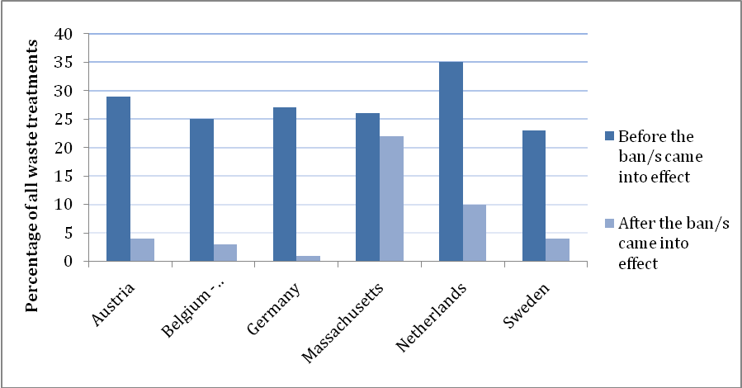
A graphical representation of the results of diversion from the Green Alliance report for Defra (2009)
Bans also take a number of different forms and have been introduced into different circumstances (for example, varying levels of existing diversion).
Also the motivation for introducing landfill bans varied across jurisdictions. For some the purpose related primarily to material recovery, while for others the aim was to reduce the environmental impact of landfill, on both land and water and in relation to emissions. For example, both the Netherlands and Sweden were motivated by reducing the environmental impact of landfill, and material recovery; but the Netherlands was also concerned with reducing dependency on landfills, while Sweden was concerned with recovering energy from waste. Thus Sweden’s bans are more aligned towards combustibility and TOC content.
Bans can cover unsorted waste or wastes determined by their organic content, by their sources or by their type, such as e-waste, liquid wastes, batteries, packaging, vehicles, timber, paper and biodegradable wastes.
A summary of landfill bans in developed nations can be found in Appendix A. It provides a good picture of landfill bans across Europe and the US.
In all cases examined there was a clear view of the overall objectives of a ban.
Some research was conducted into non-European non-English-speaking developed nations, such as Japan, but no landfill bans were found. This is not to say that these countries do not have waste management instruments in place, just that they do not appear to take the form of landfill bans.
  - Motivations
There are a range of motivations leading countries to implement landfill bans. There are a number of common motivations but the distribution and presumably significance differs between countries and between collections of countries/states—notably between European countries and North American states.
The Green Alliance report for Defra (2009) in the UK identified four main motivations for implementing landfill bans in the jurisdictions they investigated:
- reducing the environmental impact of landfill
- reducing dependency on landfill as a waste treatment option
- recovering energy from waste
- improving material recovery.
They also found that:
Countries such as Germany with relatively high levels of material recovery before the introduction of bans tended to focus on residual waste, whereas those with lower levels of material recovery such as Massachusetts focussed bans on separately collected recyclable or compostable materials. (Green Alliance, 2009, page 3)
Aside from those identified by the Green Alliance, motivations include:
- promoting a shift of waste management up the waste hierarchy
- promoting upstream changes in material use
- shifting waste management from landfill to incineration (similar to recovering energy from waste)
- controlling greenhouse gas emissions.
European countries have a much higher population density than Australia and North America. This leads to different pressures on waste disposal relating to capacity, environmental impact and amenity.
One motivation for all European Union (EU) members is the targets set by EU Council Directive 1999/31/EC of 26 April 1999 on the landfilling of waste which states:
- not later than 2006, biodegradable municipal waste going to landfills must be reduced to 75 per cent of the total amount (by weight) of biodegradable municipal waste produced in 1995
- not later than 2009, biodegradable municipal waste going to landfills must be reduced to 50 per cent of the total amount (by weight) of biodegradable municipal waste produced in 1995
- not later than 2016, biodegradable municipal waste going to landfills must be reduced to 35 per cent of the total amount (by weight) of biodegradable municipal waste produced in 1995.
Cost-benefit analyses of landfill bans have been undertaken in some countries. Australia can examine and learn from these studies but it needs to be remembered that each jurisdiction that undertakes a cost-benefit analysis has its own array of community behaviours, motivations and waste profiles, and the kinds of bans considered also vary. Thus comparison is not straightforward.
The Waste and Resources Action Programme (WRAP) completed a cost-benefit analysis in its investigation of the feasibility of landfill bans in the UK. The conclusion of the WRAP report was that the kinds of bans it found would deliver climate change benefits and resource efficiency gains with net benefits to society were those based around organics (paper/card, food, textiles, wood, green waste), metals and glass. The cost-benefit analysis suggested that restricting these materials from both landfill and other residual waste treatment (such as incineration) would provide a net benefit to society of a median value over the period 2009 to 2024 of £8246 million (WRAP, 2010, page 1).
  - Types of bans
There are a startling variety of bans operating in the developed world. They fall under three broad definitions of a ban waste by source, waste by type and waste by property.
In Europe there have been a number of bans on, for example, unsorted waste, untreated waste, treated and/or untreated organic wastes (with specific properties) and combustible waste. The bans are defined by a mixture of all three waste categories.
In North America, bans are more often defined by waste type than by properties or source.
In addition to comprehensive bans on waste streams to landfill, a large number of jurisdictions have banned specific products, materials or waste types from landfill. An example of this is the banning of tyres which has occurred throughout the EU, in many parts of the US and Canada and, in some form, in a number of states in Australia.
All of the bans discovered in this exercise are shown in Table A-1.
It is also interesting that some countries enact bans and others impose restrictions that basically operate as bans. Austria and Germany both have landfill ‘restrictions’.
  - Complementary instruments
There are many complementary or supporting instruments in Europe and the US, which makes it difficult to discover the precise impact of a landfill ban. Examples of complementary instruments in place are:
- permit systems for landfills
- targets for avoidance, reduction and diversion
- landfill levies
- incineration levies
- incineration bans/restrictions
- producer responsibility measures
- mandatory separate collection
- ‘pay as you throw’ / variable charging
- waste sorting.
There may be other instruments in place, such as education programs and training.
In its investigation of the feasibility of landfill bans in the UK, WRAP found that the climate change benefits and resource efficiency gains were greatest where landfill bans were coupled with a requirement to sort, and that blanket bans on landfilling of certain materials without a requirement to sort would be unwieldy and difficult to implement.
The impact of landfill bans varied with the complementary instruments applied (see Section 4.8: Results in diversion).
Management of exemptions to landfill bans can be difficult. There are a number of ways to make this easier. One of the simplest solutions is to implement landfill levies, which act as a disincentive to seeking exemptions.
  - Implementation elements
All landfill bans appear to have been implemented in a similar way:
- identification of objectives (targets, hazard reduction et cetera)
- stakeholder consultation
- regulation
- transition period
- enforcement.
Important components of the implementation of landfill bans were:
- lead times to allow stakeholders and government agencies to prepare
- exemptions used in the transition period between the introduction of the bans and the deadline for total compliance.
  - Timing
In all cases bans were foreshadowed some time in advance of implementation. This time period varied from two to 12 years, with an acknowledgement that 12 years was excessive. The 12-year transition time (in Germany), combined with differential application, led to inconsistent implementation and in some cases abuse.
The primary reason for foreshadowing the bans was to ensure adequate alternative disposal options were in place. The time period gave the opportunity for infrastructure to be developed with an assurance that material would be diverted away from landfill. This was crucial to gaining investment for capital expenditure.
There appear to have been sufficient lead times in all cases, though where technology was not available or there were short lead times (such as in the Netherlands and Flanders) exceptions were made.
  - Compliance and enforcement
In most cases in Europe and North America compliance effectively rested with landfill operators.
While bans affect waste generators and collection contractors, the major enforcement role has tended to lie with landfill operators (that is, enforcement of the ban by regulators at the landfills to ensure they do not receive the banned waste). This has not proved problematic in any jurisdiction but does require attention to how sites are audited for compliance.
Putting in place a ban with exceptions permitted is used to allow for a lack of alternative treatment. Even if alternative waste treatments are available, if the cost of landfill is less than that of alternative treatments there can be a financial incentive in seeking an exemption. If measures are taken to make the cost of landfill the same as alternative treatments this removes that incentive. The Netherlands increased the landfill levy sharply in 2000 for this reason.
There are different ways of enforcing a ban. To enforce a ban there must be a way to identify the banned waste. It could be identified at source or at the landfill. There is also a need to identify who will be responsible for enforcing the ban: generators, collectors or landfill operators.
In the Netherlands a startling array of wastes are banned by type. However, at the landfill the identification of banned waste is done by weight. This is crude and open to some leakage (banned waste entering the landfill), but it is simple.This study found a discussion of a few of the ways in which bans were bypassed in Europe. Transport of materials out of the country, mostly into Germany, occurred in the Netherlands. This caused a delay in Dutch alternative capacity.
In Finland there was an unclear definition of what was covered by the ban, which has made it difficult to enforce.
Massachusetts has a very complex compliance system due to the nature of its landfill bans, with landfill operators expected to have (with exceptions):
- ongoing waste stream monitoring
- comprehensive load inspections.
In Sweden landfill operators must develop their own systems and report to the environmental protection agency. Landfill operators now mostly enforce the rule that waste requiring further sorting will be sorted on site and incur higher gate fees.
In Germany landfill operators are not allowed to accept waste that does not meet the standards. Each load of waste must be accompanied by documentation of compliance with appropriate criteria, and visually inspected. If the waste does not meet the criteria, it will be stored on site and the authorities contacted.
In Belgium’s Flanders region landfills are inspected by the environment control department. Local authorities may also complete inspections. Landfill operators are expected to complete a visual inspection of each load and register the load if it passes the inspection. Financial penalties apply to any landfill found to be noncompliant. Municipalities and commercial waste generators are responsible for the correct sorting of their waste.
In Austria the landfill operator and the head of the acceptance inspection department of the landfill are liable for noncompliance, and external auditors are responsible for reporting any noncompliance. Interestingly denouncements from competitors are also a factor in enforcement.
It is interesting to note the conclusion of the Green Alliance report:
The main commonality was that while in theory responsibility for complying with landfill bans and restrictions rests with all parties involved in the generation, transfer and disposal of waste, in practice compliance rests largely on landfill operators: it is at the landfill site that loads are either accepted or rejected, and it is generally the landfill operators’ records which are inspected for evidence of compliance. (Green Alliance, 2009, page 28)
Landfill bans are often utilised as an incentive tool to drive recovery markets and in some cases can be effective in removing virtually the entire waste stream. For wastes that arise from very diffuse sources, such as household wastes, bans can be effective to drive the development of the infrastructure to recover the waste but it is usually understood that removing 100 per cent of such waste streams is unlikely, no matter how strict a compliance program is applied to landfills.
  - Public support and stakeholder consultation
In all known cases there was stakeholder consultation about the introduction of bans and other complementary measures. This was seen as crucial to the success of the implementation in all the cases examined by the Green Alliance. Their report highlighted that the introduction of bans has been implemented in consultation with stakeholders but this has not extended to widespread community consultation. The documents examined in the process of this review gave no indication of why there has not been more widespread consultation. It could be that the general community is thought to be supportive or less directly affected by bans than other stakeholders, so consultation time is better spent with local government, industry or waste service providers.
  - Results in diversion
An analysis of the changes that have occurred shows that bans, in various combinations with complementary instruments, have been highly successful in diverting waste from landfill (See Table 4-1).
The Green Alliance report examined the percentage of waste generated that went into five waste treatment areas: landfill, incineration, material recovery, biological treatment and other treatments (mechanical biological treatment, thermal recovery).
Germany is the prime example, as its landfill rate went from 27 per cent to 1 per cent of waste treatment options over six years. This was accompanied by a 9 per cent increase in incineration and a 25 per cent increase in materials recovery.
In some cases the ban on landfilling of waste was accompanied by a similar ban on the incineration of waste. Where this took place the result was a major increase in recycling and composting. An example of this is the Flanders region of Belgium, which put in place an incineration ban on unsorted waste and on selectively collected waste fit for material recovery or recycling. Flanders had a 66 per cent increase in materials recovery over 10 years, with incineration rates unchanged. Massachusetts had a similar result, with a 60 per cent increase in materials recovery over two years and a reduction in incineration of 18 per cent.
Where incineration was not regulated, the diversion from landfill resulted in increases in both materials recovery and incineration (for example Sweden had a 24 per cent increase in incineration and a 32 per cent increase in materials recovery over six years) or just in incineration (for example Austria had a 300 per cent increase in incineration over seven years).
The WRAP report on its cost-benefit analysis of landfill bans being considered for the UK concluded that:
- bans or restrictions do have the potential to deliver net benefits (environmental and financial) to society
- a restriction on unsorted waste—introducing a requirement to sort—would provide the greatest environmental and resource efficiency benefits
- there is a strong case for restricting the landfilling of paper and card, textiles, metals and wood
- there is a strong case for restricting the landfilling of food waste.
  - Other outcomes
Aside from waste diversion and treatment changes, landfill bans and complementary instruments such as landfill levies created changes to the landfills themselves. These changes were in the number of landfills, which went down; and in the technology utilised by landfills, which increased in importance.
In Austria there was an increased rate of technological change at landfill sites. In Sweden there was a sharp drop in the number of landfills, but the remaining landfills are becoming sites for sorting, recycling, storing and treatment of waste.
The closing of landfills had another, perhaps unexpected, result in Germany. In a push for business before closure and to offset competition, landfill operators offered low prices on landfill space. This price competition led to a lower than expected uptake of alternative treatments.
- Australian jurisdictions: review and analysis
A summary of landfill bans in Australia can be found in Table A-2 in Appendix A.
There are a range of different landfill bans in place in the different states and territories of Australia. They are supported by a range of federal and state regulations and programs. Each jurisdiction uses a different set of tools to control wastes.
South Australia and Victoria are the most active states/territories when it comes to applying landfill bans. Other states may rely on different tools for managing these wastes. Available alternative technologies for waste diverted by a landfill ban may vary from state to state also.
  - Motivations
Motivations in Australia are slightly different from those overseas. On the whole Australia does not have the same space concerns as in Europe, nor the infrastructure for or drive towards incineration of waste.
Examples of the motivations of local councils and state governments that implement bans in Australia are:
- reducing the impact of waste on human health
- reducing the impact of waste on the environment
- promoting resource recovery / improving resource efficiency
- meeting waste diversion targets
- managing hazardous materials
- promoting the waste hierarchy
- economic and/or financial considerations.
  - Types of bans
In Australia landfill bans are based on properties of waste, and are identified by either property or type. Examples are contaminated soil, banned by virtue of its chemical properties and characterised by its chemical properties (Victoria); and medical waste, banned by virtue of its potentially infectious properties but characterised by type (South Australia).

South Australia
Recently South Australia has introduced and passed its Environmental Protection (Waste to Resources) Regulations. Flagged as of November 2008, the bans are being rolled out over three years from September 2010. They will be implemented over the Adelaide metropolitan area and the remainder of the state in a series of stages, with bans on cardboard, glass, metals and polyethylene terephthalate (PET) and high density polyethylene (HDPE) packaging, together with a range of hazardous wastes. This will be extended over the next few years to include vehicles, e-waste, whitegoods and other electrical equipment. South Australia already has amongst the highest levels of waste diversion in Australia and it is anticipated that diversion of waste will increase based on experience in other countries.

Victoria
Victoria has a range of hazard based bans in place, covering a variety of wastes including whole tyres, automotive batteries, small batteries (in large quantities), used oil filters and rigid packaging over 200 litres contaminated with prescribed industrial waste (PIW).

Remaining states and territories
The ACT has landfill bans on computers, televisions, tyres and whole mattresses.
New South Wales, Tasmania and Western Australia also have some bans in place on a range of waste items. New South Wales bans tyres and clinical waste, Tasmania contaminated soil for remediation (with restrictions on other wastes), and Western Australia tyres.

Local councils
State regulation is not the only level at which waste can be banned. Landfills themselves can control what they accept. And local councils/governments, which often run the local landfills, may put their own bans in place.
Many local councils in Australia have landfill bans in place on a variety of waste types such as e-waste and tyres. The project scale did not allow for a detailed review of local government bans; however, it might be useful to investigate the variability and possibilities in the future.
Local councils leading the way on e-waste landfill bans ahead of federal legislation include Pittwater Council, Mosman Council, Manly Council, and Warringah Council. Each of these councils has restricted the disposal of e-waste at council facilities. This approach is also taken by many councils with building materials such as concrete.
Orange City Council has in place rules regarding landfill disposal that have an effect similar to a ban on untreated/sorted waste. Waste must go through certain pathways before it reaches the landfill, resulting in the sorting of kerbside waste and only bound (baled) residual waste from the sorting process being accepted at the landfill.
  - Complementary instruments
Instruments such as product stewardship or residential hazardous waste collection can play a big role in managing particular waste streams.
In Australia some of the more important complementary/supporting mechanisms are:
- landfill levies
- waste and recycling targets
- product stewardship schemes
- waste management strategies
- residential hazardous waste collection
- source separation
- community/business education.
They can also influence the setting up of landfill bans. The ACT, South Australia, Pittwater Council, Mosman Council, Manly Council, and Warringah Council have or will have e-waste bans in place when product stewardship measures are introduced nationally.
  - Timing
Landfill bans in Australia have always, at least at the state level, been clearly signalled, and the states with the most bans conducted stakeholder consultation before each ban was implemented.
It is hard to know whether overall lead times have been sufficient with regard to bans in Australia, given the small number of bans in place. The most ambitious bans are yet to be tested. The outcomes of South Australia’s bans should be informative.
However, a rush of exceptions under the South Australian bans—a good indicator of insufficient lead times—has not been encountered by Hyder in its research.
  - Implementation elements
All landfill bans appear to have been implemented in a similar way:
- identification of objectives (targets, hazard reduction etc.)
- analysis of environmental and economic outcomes, and analysis of available alternative treatments
- stakeholder consultation
- regulation
- transition period
- enforcement.
The Victorian Waste Management Policy (Siting, Design and Management of Landfills) specifically requires that when proposing a ban the technological, logistical and financial considerations must be integrated into decision-making processes.
  - Compliance and enforcement
Both South Australia and Victoria have the ability to add products and materials to their banned list under existing legislation. The ACT can also act to ban products and materials.
Compliance and enforcement within Australia are similar to the experience overseas, and enforcement and scrutiny fall mostly on landfill operators. Records and documents can usually be inspected by state regulatory bodies. These bodies have the ability to enforce compliance.
In South Australia licensee conditions and auditing of paperwork were chosen instead of landfill disposal certificates as initially planned. Penalties apply for noncompliance.
Victoria operates a system of permits and waste tracking, with compliance monitoring and penalties for noncompliance.
An important consideration in enforcement is control of illegal dumping, the transport of waste interstate or overseas and the movement of banned waste into a less preferable (by some measure such as the waste hierarchy) form of treatment.
It should be noted that bans are generally self-regulating, with very high levels of compliance by waste generator and disposal sites.
  - Public support and stakeholder consultation
There appears to be public support for landfill bans in place in Australia. Businesses and local governments were consulted and draft policies were issued for comment in all known cases of bans at state level.
  - Results in diversion
Waste diversion resulting from landfills bans as they are currently applied in Australia is very difficult to quantify. The wastes targeted by landfill bans make up a small fraction of overall waste disposal, and Hyder was unable to find any published quantification of diversion results. However, the Environment Protection Authority Victoria (EPA Victoria) provided data on PIW contaminated containers over 200 litres, which can be used to make some statements about the effectiveness of the pertinent ban).

Victorian example: contaminated rigid packaging over 200 litres
A useful example of landfill bans in Australia is the banning of the disposal of rigid packaging over 200 litres contaminated with Prescribed Industrial Waste (PIW to landfills within Victoria. It is useful because the effect of the ban is somewhat quantifiable.
In 2006, EPA Victoria released a draft classification for rigid containers, and two months later it published a final classification allowing industry approximately 12 months implementation time. This classification required that rigid steel and plastic containers with an original volume greater than or equal to 200 litres be re-used or recycled to recover valuable metal and plastic resources. EPA Victoria estimated that up to 2000 tonnes of containers would be diverted from landfill to re-use and recycling options, ensuring the recovery of resources and reducing waste volumes disposed to landfill. The result, as calculated from numbers provided by EPA Victoria, appears to have exceeded expectations by 50 per cent, with approximately 3000 tonnes diverted from landfill.
The movement of the PIW contaminated large containers (as identified by their waste code) before and after the implementation of the ban is shown in Table 5-1. The containers were identified in two ways to reduce any errors in documentation: first by the number of certificates issued for transport (split by destination), and second by tonnage as identified on the certificates (split by destination).
Table 5-1 shows the diversion outcomes of the landfill ban. It can be seen that the ban led to two key changes:
- an approximately 94 per cent drop in drums going to landfill
- a drop in the number of contaminated containers being transported to other treatment facilities or sites (approximately 7 per cent by number of certificates and 18 per cent by tonnage). This decrease indicates a change in behaviour upstream of the treatment companies—that is, industry generating fewer waste containers requiring treatment.
Table 5-1: PIW contaminated containers over 200 litres in Victoria (extracted by EPA Victoria 1 September 2010)
 | Tonnes |  |  |  |  | Certificates/consignments
Year | 05–06 | 06–07 | 07–08 | 08–09 | 09–10 | 05–06 | 06–07 | 07–08 | 08–09 | 09–10
Landfill | 3432 | 3101 | 122 | 163 | 180 | 510 | 499 | 42 | 25 | 40
Treatment facility or other | 4048 | 4184 | 4268 | 2892 | 2994 | 6261 | 6780 | 6859 | 5755 | 5630
Total | 7480 | 7285 | 4390 | 3055 | 3174 | 6771 | 7279 | 6901 | 5780 | 5670
Assuming that prior to the ban most of the PIW contaminated containers sent to landfill were from secondary sites such as treatment facilities, there was a resulting shift in treatment outcomes, with landfill as a ‘treatment’ option declining from approximately 80 per cent to approximately 5 per cent by tonnage. This is graphically appreciable in Figure 5-1Error: Reference source not found.
Figure 5-1: Tonnes of PIW contaminated containers over 200 litres transported to landfill and other facilities before and after the ban
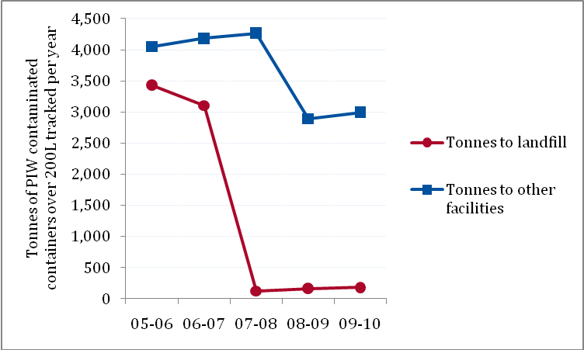
It can be assumed that the changes are due at least in part to an increase in re-use and recycling, and potentially also a reduction in activity that leads to difficult-to-treat contaminations, such as ignoring a container until the contaminated waste dries out or becomes otherwise intractable. It does not appear too bold to conclude that the reduction in containers being sent to other treatment facilities or locations other than landfills also shows that processes which previously led to contaminated containers are now also being re-examined to avoid the difficulty and cost of treatment.
For a complete and thorough analysis of the results of and changes in resource recovery and re-use, a more in-depth study needs to be completed, but this preliminary analysis shows the bans to have been a success.

- Considerations for Australia
Analysis of international and national use of landfill bans indicates that there are some significant opportunities within Australia for improving the way we manage waste, and clearly shows that landfill bans could be used to a greater extent in Australia.
Countries throughout the developed world have implemented landfill bans with good results. Australian jurisdictions could apply bans similar to those found in Europe or some American states. Australian jurisdictions could apply bans similar to those in South Australia and Victoria, and Australia could apply bans consistently across jurisdictions. It would not be effortless and each potential scenario would need to be judged on its merit. There would be many factors to consider, and this would require clarity around goals regarding the waste hierarchy on the part of any government considering them. For example, the infrastructure, population density, market drivers and geography of much of Australia differs from some European and Northern American situations. With excellent planning and suitable complementary instruments landfill bans could offer good hazard control/reduction, as they already do in a number of states, and deliver good resource diversion outcomes.
This study found that in Europe where incineration was not regulated the diversion from landfill resulted in increases in both materials recovery and incineration (for example Sweden had a 24 per cent increase in incineration and a 32 per cent increase in materials recovery over six years) or just in incineration (for example Austria had a 300 per cent increase in incineration over seven years). In the Netherlands waste was transported into the incinerators of Germany.
The Victorian example presented above of bans on PIW contaminated containers over 200 litres shows that where there are alternative behaviours and technologies for treatment there are positive diversion outcomes.
These outcomes show the need for understanding of where waste will be diverted by the bans, and programs or regulations in place to ensure that waste will be diverted into the preferred alternative treatments.
Having alternative treatments in place before a ban takes effect can make the implementation run smoothly. One of the ways this can be achieved is by announcing the ban before it takes effect, allowing companies to develop the capacity to accept and treat the waste that is guaranteed to be diverted. It is also beneficial to have measures such as product stewardship schemes, levies, diversion targets and waste management strategies in place when bans are introduced. In some cases (such as with waste oil infrastructure), financial assistance may support the implementation of the ban or restriction.
Before a ban or restriction is implemented there may need to be consideration of the stability of the markets for that material type. This can be particularly significant for states and territories with distance to markets or vulnerabilities to price fluctuations.
Risks that need to be considered include wastes being illegally dumped or moved interstate, overseas or into another form of treatment such as incineration. And preferences need to be determined regarding alternative treatments from an environmental, regulatory, logistical and financial perspective.
International and national examples show that the planning for and implementation of landfill bans needs to include:
- analysis of environmental and financial outcomes and technologies
- local involvement and implementation
- clear responsibilities and cooperation between government levels
- juridical and financial instruments
- transparency and clear communication to the public
- clarity in establishing timelines for compliance.
A pre-sort condition on waste destined for landfill is in place in a number of countries in Europe. It was found to provide a positive result in the Waste and Resources Action Programme’s cost-benefit analysis for the UK. The application of a pre-sort condition is within Australia’s technological capabilities. This is equivalent to South Australia’s ban on waste not subjected to resource recovery in metropolitan Adelaide, which could be extended to all areas of large population, and potentially entire states.

References

International
European Environment Agency, Diverting waste from landfill: Effectiveness of waste-management policies in the European Union, EEA Report No 7/2009.
European Topic Centre on Sustainable Consumption and Production, table of instruments: http://scp.eionet.europa.eu/facts/factsheets_waste/Instruments#, accessed 17 August 2009.
European Union, Council Directive 1999/31/EC of 26 April 1999 on the landfill of waste: http://europa.eu/legislation_summaries/environment/tackling_climate_change/l21208_en.htm, accessed 6 August 2009.
European Union, Report from the Commission to the Council and the European Parliament on the national strategies for the reduction of biodegradable waste going to landfills pursuant to Article 5(1) Of Directive 1999/31/EC on the landfill of waste: http://euro-lex.europa.eu/LexUriServ/LexUriServ.do?uri=CELEX:52005DC0105:EN:NOT, accessed 6 August 2009.
Green Alliance, Landfill bans and restrictions in the EU and US: A Green Alliance project for Defra, August 2009.
North Carolina Department of Environment and Natural Resources website: http://wastenot.enr.state.nc.us/, accessed 6 August 2009.
Oregon Department of Environmental Quality website: http://www.deq.state.or.us/lq/sw/disposal/index.htm, accessed 6 August 2009.
United States Environmental Protection Agency website: http://www.epa.gov/wastes/conserve/materials/tires/basic.htm, accessed 5 August 2009.
Waste and Resources Action Programme (WRAP), Landfill bans: Feasibility research, March 2010.

Australian
Allen Consulting Group, National Waste Policy: Regulatory impact statement, October 2009.
Environment Protection Authority (South Australia), Response to submissions on the Draft Environment Protection (Waste to Resources) Policy, August 2009.
Environment Protection Authority (Victoria), Draft Environment Protection (Industrial Waste Resource) Regulations: Regulatory impact statement, March 2009.

Appendix A
Desktop review of jurisdictional landfill bans

Desktop review of jurisdictional landfill bans
Desktop research led to the compilation of these two tables: international and Australian landfill bans.
References are in the main body of this report.
Where time and language barriers permitted, the international figures were double-checked on applicable state websites.
Australian figures were found on state/territory websites, in publications and, time permitting, though phone calls to relevant state authorities.
Table A-1: International landfill bans by jurisdiction
Jurisdiction |  | When did/do landfill bans begin? | What is covered by the ban(s)? |  |  |  |  |  | Objectives (motivation/rationale) | Complementary instruments including | Stakeholder support? | Waste diversion from landfill |  | Time frame for implementation | Enforcement?
 |  | When did/do landfill bans begin? | Wastes/materials |  |  |  |  | Areas
Europe |  | 1999 | Council Directive 1999/31/EC of 26 April 1999 on the landfill of waste:  - Whole (from 2003) and shredded tyres (from 2006)  - Liquid wastes  - Wastes which are explosive, corrosive, oxidising, flammable or infectious  - Wastes which have not been pre-treated |  |  |  |  | All of European Union | - Prevent or reduce the adverse effects of the landfill of waste on the environment  - Landfill directive for member countries to reduce amount of biodegradable municipal waste going to landfill:  - to 75% of 1995 level by 2006  - to 50% of 1995 level by 2009  - to 35% of 1995 level by 2016 | - Permit systems for landfills  - Targets for the reduction of biodegradable waste to be met in 2006, 2009 and 2016, with the option to delay by 4 years | — | — |  | Ban on landfilling whole tyres by 2003  Ban on landfilling shredded tyres by 2006 | - Reporting every 3 years to the European Commission
Austria |  | 1997 | - Untreated organic waste |  |  |  |  | Country wide | - Reduce environmental impact of landfill  - Recover energy from waste | - Landfill levy  - Incineration levy  - Producer responsibility measures  - Mandatory separate collection  - ‘Pay-as-you-throw’ / variable charging  - Waste sorting / separate collection | ✓ | - 29% of waste treatments in 1999 to 4% in 2006  - 86% reduction over 7 years  - 3% increase in materials recovery |  | Announced 1996, introduced 1997, total compliance by 2004 | - Landfill operator has to carry out waste acceptance inspections, including retained waste samples  - Landfill operator has to maintain serial documentation on the proper landfill operation; the documentation has to be submitted to the competent supervisory authority upon request  - Landfill supervisor examines the documentation and verifies proper landfill operation  - Penalties  - Landfill supervisor reports any non-compliance with the landfill ordinance to the competent authority
 |  | 2008 | - Wastes with TOC > 5%  - Exception for mechanical-biological treatment waste with a calorific value > 6.600 kj/kg dry substance, mechanically treated waste with a calorific value > 6.600 kj/kg dry substance and TOC > 8% |  |  |  |  |  |  |  |  |  |  | Total compliance by 2009
Belgium—Flanders |  | 1998 |  | - Unsorted wastes  - Landfill and incineration bans on separately collected material |  |  |  |  | — | - Reduce environmental impact of landfill  - Reduce dependency on landfill  - Material recovery | - Landfill levy  - Incineration bans/restrictions  - Incineration levy  - Producer responsibility measures  - Mandatory separate collection  - ‘Pay-as-you-throw’ / variable charging | ✓ | - 25% of waste treatments in 1997 to 3% in 2007  - 88% reduction over 10 years  - 66% increase in materials recovery | Total compliance by 2006 for household wastes and 2015 for other wastes | - Penalties  - Monitored by controllers
 |  | 2000 |  | - Combustible residual waste  - Also incineration ban on unsorted waste
Belgium—Wallonie |  | 2004 | - Source-separated household wastes  - Liquid wastes  - Hazardous wastes  - Animal by-products  - Class B1 and B2 hospital wastes  - Whole tyres |  |  | - Metallic wastes  - Spent batteries  - Packaging  - Textile wastes  - Medication wastes |  | — | — | - Landfill levy | — | — |  | Announced 2004 with rollout over 6 years | —
 |  | 2006 | - Shredder residues  - End-of-life vehicles  - Shredded tyres, incineration residues, inert concrete, brick, tile and ceramic wastes |  |  |  |  | — | — | - Landfill levy | — | — |  | Announced 2004 with rollout over 6 years | —
 |  | 2007 | - Plastics waste  - Paper recycling residues  - Electrical and electronic appliances |  |  | - Sewage sludge  - Slags and drosses from metal production  - Fly and bottom ash from coal-fired power plants
 |  | 2008 | - Dust from steelworks and blast furnaces  - Untreated household wastes |  |  | - Non-crushed bulky wastes  - Class A hospital wastes
 |  | 2009 | - Foundry salts
 |  | 2010 | - Crushed bulky waste  - Biodegradable wastes.
Canada—  Nova Scotia |  | 1996 | - Organic waste including food scraps, yard waste and soiled paper  - Beverage containers  - Glass containers  - Metal cans  - Cardboard and newsprint |  |  | - Car batteries  - Antifreeze  - Plastic containers  - Polyethylene bags and packaging  - Used paint  - Tyres |  | Province wide | — | — | — | — |  | Until 2008 | —
 |  | 2008 | - Televisions  - Computer equipment |  |  | - Computer monitors  - Computer printers |  |  |  |  |  |  |  | — | —
 |  |  | - Computer scanners  - Audio-video playback and recording devices |  |  | - Telephones and fax machines  - Cell phones and other wireless devices
Denmark |  | 1997 | - Waste suitable for incineration |  |  |  |  | Country wide | - Move waste from landfill to incineration  - Ease the capacity demand on landfills | - Landfill levy | — | — |  | — | - Fine and prison
Estonia |  | 2008 | - Unsorted waste |  |  |  |  | Country wide | - Reduce the quantity of waste or the hazard arising from it to environment and human health | - Landfill levy | — | — |  | Introduced 2004 | —
Finland |  | 2011 | - Biodegradable waste |  |  |  |  | Country wide | - Implement the targets set in the national bio-waste strategy and the directive 1999/31/EC  - Reduce landfilling of organic waste  - Direct deposit wastes in such a way that, even over a long period of time, no hazard or harm is caused to health or the environment | - Landfill levy | — | — |  | Announced 2005, transition period from 2011 | - Landfill operator has a general duty to monitor that all waste transported to the landfill fulfils quality requirements  - Every transport is checked  - Bookkeeping and a reporting obligation for the operator  - Regional environment centres (which are the permit authorities for landfills) also have an annual reporting obligation  - Landfill operator may lose the environmental permit if serious infringements take place, and may have to pay fines for infringements
France |  | 2002 | - Everything but ‘residual’ wastes |  |  |  |  | Country wide | - Divert critical waste flows from landfills | - Landfill levy increasing until 2015 | — | — |  | — | —
Germany |  | 1993 (not legally binding) | - Any municipal waste that can be recovered  - Untreated municipal waste  - All biodegradable municipal waste to be separately collected and composted  - Waste wood |  |  |  |  | Country wide | - Reduce environmental impact of landfill  - Material recovery  - Preserve natural resources | - Producer responsibility measures  - Mandatory separate collection  - ‘Pay-as-you-throw’ / variable charging | ✓ | - 27% of waste treatment in 2000 to 1% in 2006  - 96% reduction over 6 years  - 25% increase in materials recovery |  | - Total compliance by 2005 | - Reporting obligations of the landfill operator  - Noncompliance is an administrative offence and can incur fines up to EUR€50 000
 |  | 2001
Hungary |  | 2003 | - Tyres |  |  |  |  | Country wide | - Achieve the proper ratio and composition of the waste landfilled  - Comply with the values given as the standards of the EU  - Implement sustainable waste management  - Move from landfill to incineration and recovery | - Landfill levy | — | — |  | — | - Monitoring program (Act 20/2006): sample analyses in accredited laboratory  - Environmental reviews are to be periodically performed by landfill operators (supervised by inspectorate)  - Penalties
 |  | 2006 | - Rubber scrap
 |  | 2015 | - Non pre-treated waste
Italy |  | 2007 | - Waste measured by biodegradability and other criteria |  |  |  |  | — | — | - Landfill levy | — | — |  | Announced 2003 | - Administrative and penal sanctions
Netherlands |  | 1995 | - Combustible and biologically decomposable waste  - Recoverable separated C&D waste |  |  |  |  | Country wide | - Reduce environmental impact of landfill  - Reduce dependency on landfill  - Material recovery | - Landfill levy  - Moratorium on landfill  - Producer responsibility measures  - Mandatory separate collection  - ‘Pay-as-you-throw’ / variable charging | ✓ | - 35% of waste treatment in 1995 to 10% in 2006  - 71% reduction over 11 years  - 27% increase in recovery |  | Landfill bans first announced 1992 | ✓
 |  | 1998 | - 35 categories of waste |  |  |  |  |  |  |  |  |  |  | — | ✓
Norway |  | 2009 | - All waste with > 10% TOC |  |  |  |  | Country wide | — | - Landfill levy | — | — |  | — | —
Sweden |  | 2002 | - Sorted combustible waste |  |  |  |  | Country wide | - Reduce environmental impact of landfill  - Recover energy from waste  - Material recovery | - Landfill levy  - Incineration levy  - Producer responsibility measures  - Mandatory separate collection  - ‘Pay-as-you-throw’ / variable charging | Critical of lead time | - 23% of waste treatment in 2001 to 4% in 2007  - 82% reduction over 6 years  - 32% increase in materials recovery |  | Landfill ban announced 1999 | ✓
 |  | 2005 | - Organic waste (including plastics) > 10% TOC |  |  |  |  | Country wide |  |  | Acceptance |  |  | Landfill ban announced 1999 | ✓
United Kingdom |  | — | Under discussion |  |  |  |  | Under discussion | — | - Landfill levy | — | — |  | — | —
USA | Massachusetts | Pre-1991 | - Lead batteries |  |  |  |  | State wide | - Reduce environmental impact of landfill  - Reduce dependency on landfill  - Material recovery | - High disposal fees  - Incineration bans/restrictions  - Moratorium on incineration  - Producer responsibility measures  - ‘Pay-as-you-throw’ / variable charging  - Waste targets | ✓ | - 26% of waste treatment in 2004 to 22% in 2006  - 15% reduction over 2 years  - 60% increase in materials recovery |  | 2–4 years | ✓
USA | Massachusetts | 1991 | - Leaves  - Whitegoods |  |  | - Tyres
USA | Massachusetts | 1992 | - Glass and metal containers  - Garden waste
USA | Massachusetts | 1994 | - Single-polymer plastics  - Recycled paper
USA | Massachusetts | 2000 | - Cathode ray tubes
USA | Massachusetts | 2006 | - Wood  - Asphalt  - Pavement brick |  |  | - Concrete  - Metal
USA | Michigan | 2004 | - Recyclable MSW components |  |  |  |  | — | — | — | — | — |  | — | —
USA | North Carolina | — | - Used oil  - Most yard trash  - Antifreeze  - Aluminium cans |  |  | - Whole scrap tyres  - Lead acid batteries  - Oyster shells |  | — | — | — | — | — |  | — | —
USA | North Carolina | 2009 | - Plastic bottles |  | - Oil filters |  | - Wooden pallets | — | — | — | — | — |  | — | —
USA | North Carolina | 2011 | - Television and computer equipment |  |  |  |  | — | — | — | — | — |  | — | —
USA | Oregon | — | - Discarded or abandoned vehicles  - Large home or industrial appliances |  |  | - Used oil  - Tyres  - Lead acid batteries |  | — | — | — | — | — |  | — | —
USA | Oregon | 2010 | - Covered electronic devices (CEDs): computers, televisions, monitors
USA | Wisconsin | 1993 | - Yard waste |  |  |  |  | — | — | — | — | — |  | — | —
USA | Wisconsin | 1995 | - Aluminium containers  - Corrugated paper  - Plastics foam PS packaging  - Glass containers  - Magazines |  |  | - Newspaper  - Office paper  - Steel containers  - Bi-metal containers  - Waste tyres |  | — | — | — | — | — |  | — | —
USA | Other states |  | - Tyres (38 states ban whole tyres and 11 states ban all tyres)  - Various other waste types and streams |  |  |  |  | — | — | — | — | — |  | — | —
Figures A-1 to A-6 are based on numbers from the Green Alliance report to Defra (2009).
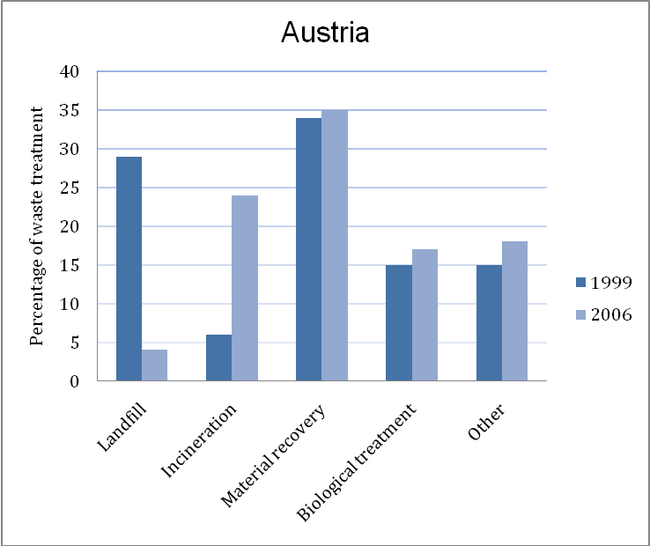  Figure A-1: Percentage of waste treatment in Austria before and after landfill bans | 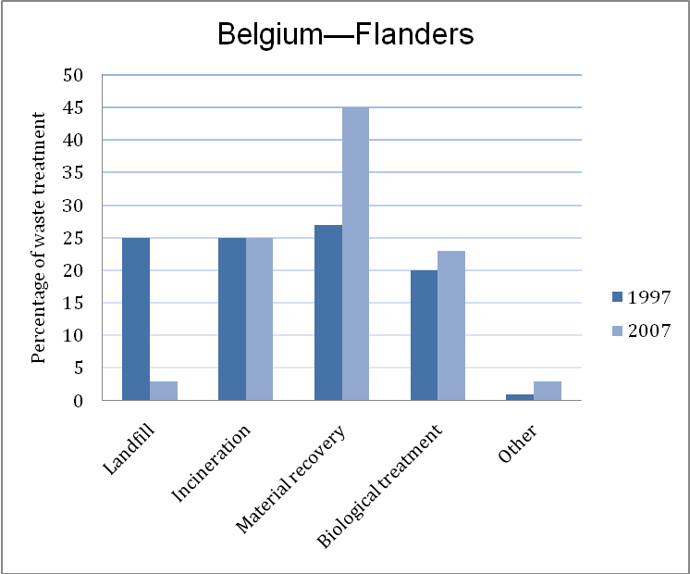  Figure A-2: Percentage of waste treatment in Belgium (Flanders) before and after landfill bans | 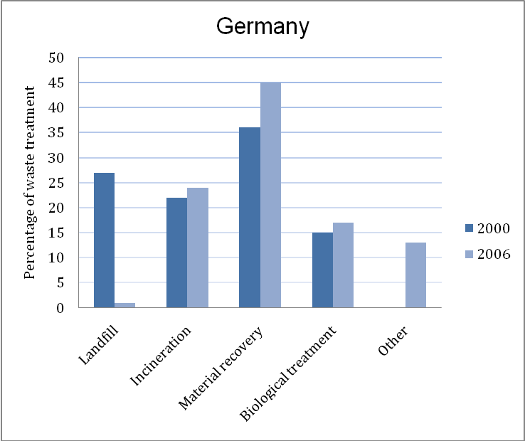  Figure A-3: Percentage of waste treatment in Germany before and after landfill bans
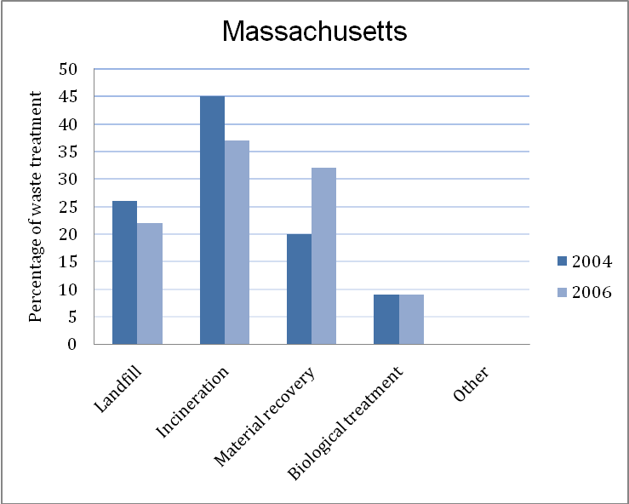  Figure A-4: Percentage of waste treatment in Massachusetts before and after landfill bans | 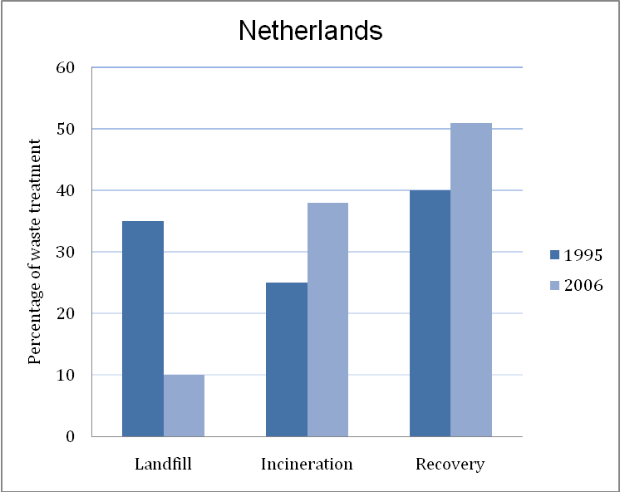  Figure A-5: Percentage of waste treatment in the Netherlands before and after landfill bans | 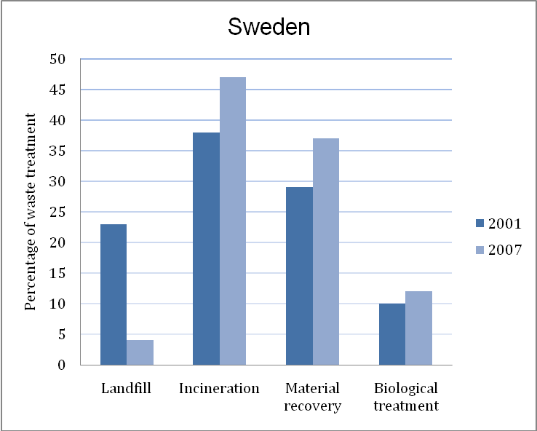  Figure A-6: Percentage of waste treatment in Sweden before and after landfill bans

Table A-2: Australian landfill bans by state/territory
State | When did/do landfill bans begin? | What is covered by the ban(s)? |  |  | Objectives (motivation/rationale) | Complementary instruments |  |  |  |  | Stakeholder support? | Time frame for implementation | Enforcement?
State | When did/do landfill bans begin? | Wastes |  | Areas | Objectives (motivation/rationale) | Landfill levy | Waste and recycling targets | Product stewardship | Waste management strategy | Residential hazardous waste collection | Stakeholder support? | Time frame for implementation | Enforcement?
South Australia | Unclear | - Hazardous waste  - Lead acid batteries  - Liquid wastes | - Medical waste  - Oil  - Whole tyres (with exceptions) | Landfill licence condition | - Support South Australia’s Strategic Plan 2007 target of reducing waste to landfill by 25% by 2014  - Achieve sustainable waste management by applying the waste management hierarchy consistently with the principles of ecologically sustainable development  - Promote resource recovery  - Divert waste from landfill | ✓ | ✓ | Beverage containers | ✓ | ✓ | ✓ | Environment Protection (Waste to Resources) Policy draft released for comment November 2008, authorised February 2010 | ✓
South Australia | September 2010 | - Metropolitan produced waste not subject to resource recovery (exemptions)  - Hazardous waste  - Lead acid batteries  - Liquid waste  - Medical waste  - Oil | - Whole tyres  - Vegetative matter collected by councils  - Aggregated: cardboard and paper  - Glass packaging  - Metals  - PET or HDPE plastic packaging | State wide
South Australia | September 2011 | - Vehicles  - Whitegoods | - PP or LDPE plastic packaging | State wide
South Australia | September 2012 | - Fluorescent lighting  - Computer monitors | - Televisions | Adelaide metro
South Australia | September 2012 | - Whole earthmover tyres | - PVC or PS packaging | State wide
South Australia | September 2013 | - Fluorescent lighting  - Computer monitors  - Televisions | - Other electrical or electronic equipment | State wide
Victoria | 2000 | - Grease interceptor trap waste |  | State wide | - Improve resource efficiency  - Reduce hazardous waste  - Conserve PIW landfill airspace | ✓ | ✓ | Batteries, computers and paints | ✓ | ✓ | ✓ | Effective 2000 | ✓
Victoria | 2004 | - Liquid wastes  - Automotive batteries, small batteries (in large quantities)  - Nightsoil | - Whole pneumatic tyres  - Radioactive substances (exceptions) |  |  |  |  |  |  |  |  | Effective 2004 | ✓
Victoria | 2007 | - Category A hazardous wastes  - Rigid packaging > 200 litres contaminated with PIW  - Used oil filters | - Category B contaminated soils with certain petrochemical contaminants (pending gazettal once technology providers are established) |  |  |  |  |  |  |  |  | Effective 2007 | ✓
New South Wales | — | - Tyres |  | Local councils | — | ✓ | ✓ | Legislation allows for extended producer responsibility | ✓ | ✓ | — | — | ✓
New South Wales | — | - Clinical waste |  | State wide
ACT | 2005 | - Computers |  | Territory wide | - Operational rather than legislative bans | ✓ | ✓ | Χ | ✓ | Χ | — | — | ✓
ACT | 2010 | - Televisions  - Tyres | - Whole mattresses
Queensland | — | — |  | — | — | ✓ | ✓ (U) | Χ | ✓ (U) | Χ | — | — | —
Western Australia | — | - Tyres |  | Metro areas only | — | ✓ | ✓ | Legislation allows for it | ✓ | ✓ | — | — | —
Northern Territory | — | — |  | — | — | Χ | ✓ | U/planned | U | Χ | — | — | —
Tasmania | 2009 | - Contaminated soil for remediation  - Restrictions (approval required for) apply to tyres | - Clinical and related wastes  - Radioactive wastes (excluding smoke detectors) | State wide | - Reduce the impact of waste on human health and the environment | V | U | Χ | Regional | Χ | ~ | Best practices guide released 2004 | ~
U: Under consideration
V: Voluntary uptake by local councils

http://eur-lex.europa.eu/LexUriServ/LexUriServ.do?uri=COM:2005:0105:FIN:EN:PDF
Response to Submissions on the Draft Environment Protection (Waste to Resources) Policy August 2009, p. 29.
Draft Environment Protection (Industrial Waste Resource) Regulations—RIS, 2009, p. 36.

