

**Analysis of landfill survey data**

**Final report**

**prepared for**

**Waste Management Association of Australia**

**20 June 2013**

**Analysis of landfill survey data**

**Final report: P398**

**20 June 2013**

**Disclaimer**

This report has been prepared for Waste Management Association of Australia in accordance with the terms and conditions of appointment dated 22 April 2013, and is based on the assumptions and exclusions set out in our scope of work. Information in this document is current as of 2008 or 2010 (the dates of the surveys). This report has been compiled based on secondary information and data provided by other parties; as such it relies on the accuracy of the provided material. Although the data has been reviewed, the information provided was assumed to be correct unless otherwise stated.

While all professional care has been undertaken in preparing this report, Blue Environment Pty Ltd cannot accept any responsibility for any use of or reliance on the contents of this report by any third party.

© WMAA and Blue Environment

**Blue Environment prints on 100% recycled content paper**

**Author**

Joe Pickin

**Reviewer**

Grace Davis Williams

Blue Environment Pty Ltd

ABN 78 118 663 997

Suite 212B, 757 Bourke Street, Docklands Vic 3008 email: [blue@blueenvironment.com.au](mailto:blue@blueenvironment.com.au) web: [www.blueenvironment.com.au](http://www.blueenvironment.com.au/) Phone +61 3 8102 9372

+61 3 5426 3536

**CONTENTS**

**1. Introduction ..................................................................................................................1**

1.1 About this project .....................................................................................................................1

1.2 A brief introduction to landfilling in Australia ..........................................................................1

**2. The data set and its management ..................................................................................3**

2.1 Data cleansing and verification.................................................................................................3

2.2 Data manipulations and categorisations ..................................................................................3

2.3 Overview of the final data set...................................................................................................4

**3. Data analysis .................................................................................................................6**

3.1 Landfill sizes and distributions ..................................................................................................6

3.2 Tonnages and distributions ......................................................................................................7

3.3 Other landfill characteristics .....................................................................................................8

**Appendix**

Tabulated results from the data analysis

**Tables**

Table 1: Assumed densities of waste delivered, by type .......................................................................3

Table 2: Size classifications .....................................................................................................................4

Table 3: Number of landfills by jurisdiction & size class.......................................................................13

Table 4: Millions of tonnes received per year by jurisdiction & landfill size class ...............................13

Table 5: Proportion of all the recorded waste received per year by jurisdiction & landfill size class..13

Table 6: Numbers of landfills by characteristic ....................................................................................14

Table 7: Site area ..................................................................................................................................15

Table 8: Site type ..................................................................................................................................15

Table 9: Major waste streams received ...............................................................................................15

Table 10: Minor waste streams received ...............................................................................................15

Table 11: Landfill controls ......................................................................................................................15

Table 12: Site infrastructure ...................................................................................................................16

Table 13: Environmental controls ..........................................................................................................16

Table 14: Resource recovery – non-problem wastes .............................................................................16

Table 15: Resource recovery – problem wastes.....................................................................................17

Table 16: Rehabilitation..........................................................................................................................17

Table 17: Monitoring ..............................................................................................................................17

**Figures**

Figure 1: Reported numbers of Australian landfills by size class.............................................................6

Figure 2: Reported numbers of Australian landfills by jurisdiction .........................................................6

Figure 3: Reported number of Australian landfills by size class and jurisdiction ....................................7

Figure 4: Reported tonnes of waste deposited by landfill size class .......................................................7

Figure 5: Reported tonnes of waste deposited by landfill size class and jurisdiction .............................8

Figure 6: Reported proportional tonnes by jurisdiction ..........................................................................8

**1. Introduction**

**1.1 About this project**

Periodically, the Waste Management Association of Australia (WMAA) undertakes surveys of landfills in

Australia. Blue Environment understands that surveys were undertaken in 2006-07; in 2008; and in

2010. The surveys were similar but extra questions were added each time. Response rates have varied. The 2008 survey had a high response rate but the 2010 survey was unable to match this rate.

The Department of Sustainability, Environment, Water, Population and Communities (DSEWPaC) needs to have the best possible data on landfills for its 2013 National Waste Report. DSEWPaC therefore commissioned WMAA to:

• compile a single database comprising 2010 survey data where available, or otherwise 2008 survey data where available

• analyse the resultant database to determine the key characteristics of landfills and landfilling in

Australia.

WMAA arranged for the two databases to be merged and commissioned Blue Environment to undertake the analysis. Blue Environment’s method for undertaking the analysis comprised three steps:

1. Data preparation, involving cleansing, verification, manipulation and categorisation. This is reported in Section 2.

2. Numerical analysis of the results for all key questions relevant to DSEWPaC’s needs. The results are

tabulated in the appendix.

3. Interpretation and presentation of key results. This is given in Section 2.

**1.2 A brief introduction to landfilling in Australia**

Landfilling has been the most common pathway for waste management in Australia since the demise of urban incineration in the 1940s and 50s. Landfill siting, design, operation and post-closure management have undergone major changes during this period, especially since the 1990s, driven by tightening environmental regulation and economic pressures. As a result, the number of landfills has fallen, their average size has grown, their operational sophistication is greatly improved, and they are increasingly owned and operated by large private companies.

Except for small rural operations, landfills mostly operate under the close regulatory control of jurisdictional environmental regulators. These generally control siting and design through some kind of works approval process, and control operation through a licensing process. The pre-operational approval would ensure, for example, that buffer distances and access are appropriate or that the cells containing the waste are designed to minimise environmental risks through, for example, lining the cell walls and draining the cell floor to collection points. The licence would ensure that the site is managed to minimise environmental and amenity impacts through, for example, covering waste daily and

monitoring and reporting of key environmental conditions. It would also ensure that the site is filled and rehabilitated to an agreed landform, and is monitored post-closure.

As the required environmental standards increased, the financial viability of smaller operations has been eroded and many have been replaced by transfer stations, from which waste is shipped to larger facilities. Transfer stations also allow recyclables to be removed, and mean that smaller vehicles do not

need to go to the tip face. This means access roads do not need to be maintained to as high a standard, and also reduces the risk of injury. These changes have resulted in many small companies and local governments, at least in the larger centres, withdrawing from landfilling and ceding the responsibility to large companies, including multinationals such as SITA and Veolia.

Another significant change since the early 1990s has been the increase in materials recovery through recycling, composting and, to a lesser extent, energy recovery. Initially driven by public demand, these alternatives have gradually developed efficient systems for collecting wastes and processing them into valuable product streams. Most solid wastes in Australia are now recovered, rather than disposed in landfill.

Landfills are typically developed in old quarries. For quarry owners, a landfill provides a cost-effective means of rehabilitating their site. A new landfill is not popular with locals, and siting, planning and appeal processes may be lengthy. Including the additional time for design and construction, the time between a decision to seek to open a new landfill and the first waste accepted is typically several years.

Australia quarries more materials than it discards, so quarry space is being created quicker than waste could fill it. However, scarcity of capacity exists in some cities, including in Sydney and Perth, due to geographical and geological constraints. In other locations, too, landfill space is effectively scarce due to the social difficulty in obtaining approval for a new site, and because new sites are typically in more inconvenient locations than existing sites.

Landfill operators need to manage odour, leachate, fire risks, litter, traffic management and problem wastes (discussed in section 2). They need to engage with regulators, auditors and often neighbours, and to transfer collected landfill levies to the state. They need strong engineering capabilities or a relationship with consulting engineers to help with their design and construction work. They need financial planning that ensures they charge sufficiently to rehabilitate the site and pay for post-closure liabilities such as monitoring for up to 30 years. Other current issues for landfill operators include:

• *Landfill gas management –* landfill gas comprises about 50% methane, which can be explosive at some concentrations and which is also a greenhouse gas having a warming effect 25 times that of carbon dioxide (over the standard 100-year assessment timeframe). Methane leakage from a now closed landfill in Cranbourne, Melbourne in the late 2000s resulted in temporary advice to abandon scores of houses, leading to a greater regulatory focus on gas management across Australia. In addition, larger landfills are subject to the Carbon Pricing Mechanism and may be able to also generate credits through the Carbon Farming Initiative. This has improved the financial viability of gas collection and burning, and demand for the services of landfill gas companies such as EDL and LMS has greatly increased. The regulatory framework for carbon pricing has proven complex, and many landfill operators have struggled to come to terms with the implications for pricing and reporting.

• *Resource recovery* – landfills need to meet community expectations and commercial opportunities for resource recovery, including the operation of resource recovery centres, tip shops and waste pre-processing. The large waste companies are seeking opportunities to offer an integrated waste management package that gives preference to resource recovery, with landfills as a ‘last resort’.

• *Climatic variation* – wet weather in Melbourne during 2010 and 2011 resulted in major problems with odour and very high leachate volumes. In Queensland, landfillers have needed to cope with sudden very large volumes of waste due to disasters, especially Cyclone Yasi and the Brisbane floods.

• *Hazardous waste* – it is increasingly difficult to obtain approval for a landfill accepting wastes with higher levels of hazard classification.

**2. The data set and its management**

WMAA provided Blue Environment with a Microsoft Excel file with separate worksheets containing the results of the 2008 and 2010 surveys, and the combined results. The combined results were generated by using the 2008 data as the base year and replacing all entries where the 2010 data were 80% or more complete. The resulting database contained information about 517 sites.

**2.1 Data cleansing and verification**

The data were cleansed and verified through a range of processes.

Sites were identified that appeared to be duplicates (1 site), error entries (3), closed landfills (2) or transfer stations (13). These nineteen facilities were deleted from the database. A range of other tests of the database were carried out to check for consistency or realism. Anomalies were adjusted where

reasonable assumptions could be made; otherwise the relevant entries were deleted. Examples of these adjustments and deletions included:

• not accepting a report that a site compacted waste when it services only 300 people (regular compaction would not be feasible)

• assuming a small site with a recorded area of 36,000 ha meant to report 36,000m3, or 3.6 ha

• adjustments so that the quantity of the various waste types added to 100% of the total. These adjustments are recorded in the Microsoft Excel analysis workbook submitted to WMAA.

**2.2 Data manipulations and categorisations**

Various manipulations and categorisations were undertaken to prepare the data for analysis. These are fully documented in the workbook submitted to WMAA.

Where waste was reported in cubic metres (mainly at small sites), the figures were converted to tonnage figures using the assumed densities tabulated below.

**Table 1: Assumed densities of waste delivered, by type**

|  |  |
| --- | --- |
| **Waste type** | **Density (t/m3)** |
| MSW and C&I | 0.4 |
| C&D | 0.8 |
| asbestos | 0.6 |
| sludge | 0.7 |
| soil | 1.1 |
| hazardous waste | 0.8 |
| clinical waste | 0.4 |

Responses to some questions were grouped to a single response. For example, various questions about the type of cell liner were grouped to derive a single answer to the question ‘does your site have a cell liner’?

Sites were classified into size groups through reference to their reported annual inputs or, where those figures were not provided, through reference to the population serviced. Threshold values for population serviced that are commensurate with each tonnage threshold were determined through reference to the average tonnes per person, calculated at all sites where both data categories were available (see Table 2).

**Table 2: Size classifications**

|  |  |  |  |  |
| --- | --- | --- | --- | --- |
| **Size class** | **Annual tonnes** | **OR** | **Population serviced** | **Av. t/person in size class based on known data** |
| Very small | ≤1,000 |  | ≤250 | 0.19 |
| Small | 1,001 to 20,000 |  | 250 to 5,000 | 0.18 |
| Medium | 20,001 to 100,000 |  | 5,000 to 50,000 | 0.56 |
| Large | ≥100,000 |  | ≥50,000 | 0.48 |

In considering resource recovery, waste types were grouped according to whether they are ‘problem wastes’ or ‘non-problem wastes’. Problem wastes were defined, for the purpose of this report, as those materials for which the primary motivation for resource recovery is to avoid problems in landfill. Problem wastes comprise oil, paint, mattresses, tyres and gas bottles. Oil and paint are liquids and are generally banned from landfill disposal due to environmental risks; mattresses and tyres are operationally problematic because they obstruct compaction by ‘floating’ in landfills; gas bottles represent and occupational health and safety risk. For the remaining non-problem wastes, the motivation for resource recovery is for the financial and environmental benefits of recirculating the materials back into the economy.

**2.3 Overview of the final data set**

The resultant data set covers 498 landfills, comprising 141 for which the 2010 data set was used and 357 for which the 2008 set was used. On average, each survey question received no response from 19% of landfills (97), and even the question with the highest net response rate had 15% non-respondents (77).

A significant number of entries in the 2008 database were apparently landfills that were identified and contacted but did not formally respond. Most of these are likely to be small.

The comprehensiveness of the survey’s coverage could be considered from the perspective of the proportion of landfills covered or the proportion of waste covered.

Assessing the proportion of landfills covered is likely to be less useful since there is a large number of very small sites and marginal problems with the definition of what should be counted as a landfill. It is noted that GeoScience Australia reports a considerably larger number of landfills than the 498 included in the survey data.

The proportion of waste covered by the survey could be assessed by comparison with the reported tonnages with those reported in the draft report *Waste and Recycling in Australia 2012.* In all, 334 surveyed sites reported receiving 16.74 million tonnes. The draft *Waste and Recycling in Australia 2012* report estimates waste to landfill in Australia in 2009/10 at 21.27 million tonnes, suggesting that the WMAA landfill database covers about 79% of the total waste to landfill. The WMAA survey team reported confidence that their coverage of overall waste to landfill was higher that this proportion, based on their successful targeting of larger sites. It is noted that 164 sites did not report waste quantities but these are likely to be accepting only small waste quantities (58 of these sites reported the population they service, the average of which was around 3,000 people, representing a small or very

**blue** @vi**ron**me !

small site). The voluntary nature of the WMAA survey data may have led to inaccurate reporting of tonnages.

Despite the uncertainties about the comprehensiveness ofthe data, the results of the analysis provide a good snapshot of landfilling and landfill practices in Australia .

**3. Data analysis**

The data were analysed in a Microsoft Excel workbook that was submitted to WMAA. This workbook contains information that is commercial-in-confidence, and is therefore not available for publication. Collated responses to individual questions are given in the appendix.

**3.1 Landfill sizes and distributions**

The bulk of Australia’s landfills are small or very small. Thirty-eight sites (8%) are known to be large and

78 (16%) are known to be medium. The 21% of unknown size are likely to be mostly small or very small

(see Figure 1).

**Figure 1: Reported numbers of Australian landfills by size class**

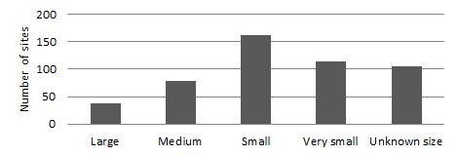

Queensland reports the most sites, followed by NSW and Western Australia (see Figure 2). This is consistent with the size and population distribution in each of these jurisdictions.

**Figure 2: Reported numbers of Australian landfills by jurisdiction**

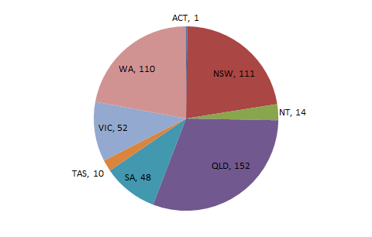

Queensland, Western Australia and South Australia have relatively high proportions of small sites. This matches their highly dispersed populations (see Figure 3). Victoria and Tasmania have a high proportion of large and medium sites. NSW has the most large sites, matching its relatively large population (see Figure 3).

**Figure 3: Reported number of Australian landfills by size class and jurisdiction**

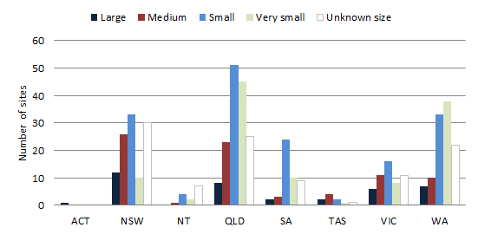

Only 84 landfills reported the year they opened and 79 reported the year they expect to close. The average year of opening was 1982 and average year of closing was 2025. The average medium and small site is older than the average large site. In most jurisdictions, the average large site is less than 10 years old.

**3.2 Tonnages and distributions**

The 8% of Australia’s landfills that are classified as large accept 75% of the waste (see Figure 4). These are the sites servicing the major cities. Medium-sized landfills accept 20% of the waste, small sites receive 5% and the very small sites accept only 0.2%.

**Figure 4: Reported tonnes of waste deposited by landfill size class**

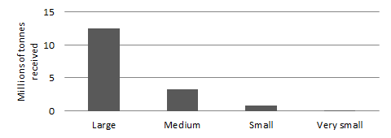

Similar patterns can be observed in every jurisdiction (see Figure 5).

**Figure 5: Reported tonnes of waste deposited by landfill size class and jurisdiction**

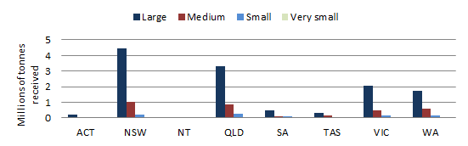

NSW generated more waste to landfill than the other jurisdictions, corresponding with its status as the most populous state. Queensland, surprisingly, generated much more waste to landfill than Victoria (4.5Mt compared with 2.7Mt). This is inconsistent with the draft results of *Waste and Recycling in Australia 2012*, which put the 2009/10 tonnages at 4.2Mt for Queensland and 4.4Mt for Victoria (see Figure 6).

**Figure 6: Reported proportional tonnes by jurisdiction**

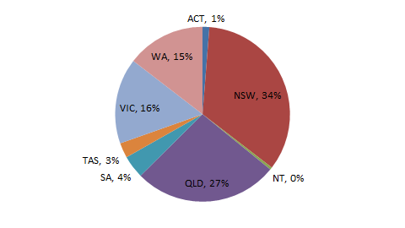

**3.3 Other landfill characteristics**

• 388 sites said they accepted MSW; only 30 said they did not.

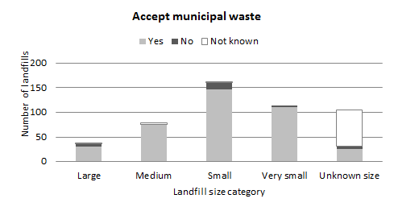

• Those not accepting MSW would mostly be

inert sites, which exist in several

jurisdictions and accept mostly construction and demolition waste. These sites generally operate under less onerous regulatory controls.

• NSW also has a category of site that accepts

only commercial waste.

• 38 sites stated that they accepted hazardous waste; 377 said they did not.

• Large and medium sites represented about

2/3 of the sites accepting hazardous waste.

• Separate questions were asked about the acceptance of clinical waste and low level contaminated soil, so it is anticipated that most respondents would not have answered affirmatively for only those wastes.

• 172 sites said they had a weighbridge; 248 said they did not.

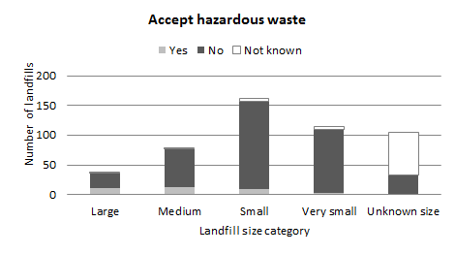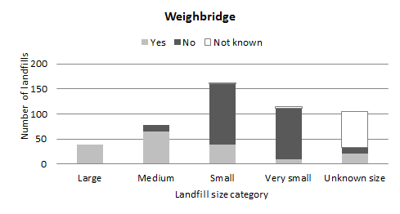

• Possession of a weighbridge is strongly

linked with site tonnage receipts. All the larger sites; 83% of medium sites; but less than 25% of small sites said they had one.

• Weighbridges are important for data

collection, which is linked in many jurisdictions to landfill levy receipts.

• Some jurisdictions have provided funding

for regional landfills to install weighbridges.

• 153 respondents stated that their sites had cell liners; 266 said they did not.

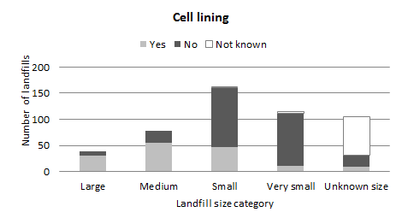

• Like weighbridges, cell lining is linked to

landfill size. More than 80% of large sites and 70% of medium sites are lined, but only a minority of smaller sites are lined.

• Cell lining is important for protecting

groundwater from leachate intrusion and helps prevent migration of landfill gas.

• Most jurisdictions require lining of new

landfills, but there may be exemptions for small sites where the cost is prohibitive.

• 232 respondents said they covered their waste daily; 187 said they did not.

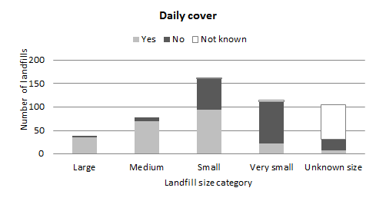

• Daily cover is standard practice at modern

landfills to reduce odour, litter and vermin.

• The majority of large, medium and small sites said they cover waste – it is surprising that any do not.

• Most large sites obtain their cover on-site.

Where this is not the case, obtaining cover material can represent a significant cost.

• Small sites may be unstaffed or have only

periodic access to machinery for covering waste.

• 50 respondents said they collected landfill gas; 363 said they did not.

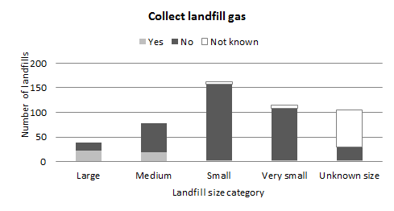

• Again, this practice is strongly linked to

landfill tonnage receipts. 61% of large sites;

24% of medium sites; but only 2% of small sites collect gas.

• Gas recovery has been viable at large sites

that generate electricity and renewable energy certificates.

• The practice became common between the

mid-1990s and mid-2000s.

• Carbon policy is now driving additional investment in gas recovery.

• 222 respondents – including a majority of large, medium and small sites – said they had recycling centres. 196 said they did not.

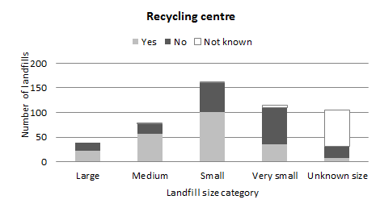

• Recycling centres provide several benefits:

o capturing useful materials for recycling

o providing a location for small vehicles to unload in a safe and accessible location

o reducing the need to maintain access roads suitable for smaller vehicles.

• Some jurisdictions have provided grants for

developing recycling or drop-off facilities at regional landfills.

• 294 respondents said they recovered some of the materials classified by Blue Environment as ‘problem wastes’ (see section 2.2). 122 said they did not.

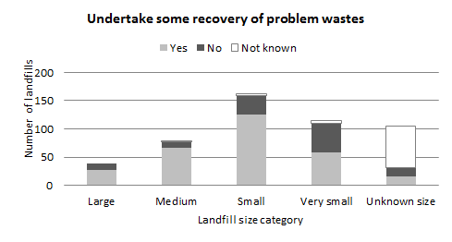

• A majority of the sites answered in the

affirmative in each size class.

• Many sites would recover these materials to provide for their disposal while not allowing them in landfill for compliance with licence or other conditions.

• It is likely that many sites not recovering

these wastes do not accept them at all.

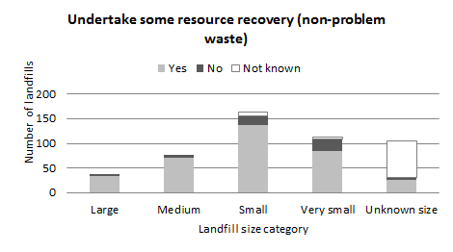

• An even stronger majority of 357 sites said they recovered ‘non-problem wastes’ (Blue Environment definition see section 2.2). Only 58 sites said they did not.

• The most common materials recovered, in

descending order, are steel, bottles & cans, paper & cardboard, aluminium, concrete & bricks, green waste (on-site) and timber.

• It is often profitable to recover steel using a

large magnet mounted on an excavator.

• 139 sites run a tip shop to sell collected items.

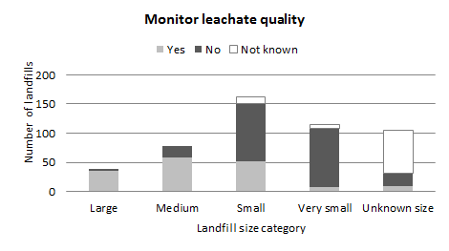

• 164 sites said they monitored leachate quality. 242 said they did not.

• Leachate monitoring (quality and depth) is

generally a licence requirement applied to larger sites – only two of the 38 large sites that responded to this question did not monitor leachate quality.

• 226 sites said they monitored groundwater quality, while 180 said they did not.

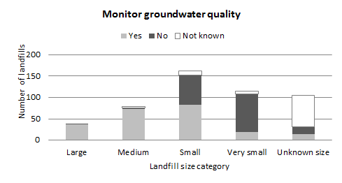

• Monitoring of groundwater is more

environmentally significant than leachate, since it looks for leachate leakage.

• All but three of the 113 large and medium-

sized sites responding to this question said they monitor groundwater. This is generally undertaken as a licence requirement.

• Most sites would have several bores

upstream and downstream of the site, and a regular monitoring program managed by specialist consultants.

• 80 respondents said they monitor landfill gas; 328 said they did not.

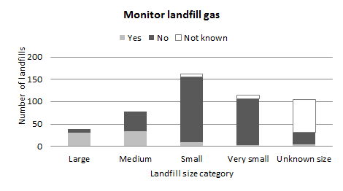

• Gas monitoring and management has

become more strongly regulated, especially in Victoria, since the Cranbourne landfill problem of 2008-10.

• Traditionally the problem associated with

landfill gas was odour, but the explosion risk is now more widely recognised.

• The greenhouse impacts of landfill gas are

more commonly estimated through modelling than monitoring or measurement.



**Appendix**

**Tabulated results from the data analysis**

**Table 3: Number of landfills by jurisdiction & size class**

|  |  |  |  |  |  |  |
| --- | --- | --- | --- | --- | --- | --- |
|  | **Large** | **Medium** | **Small** | **Very small** | **Unknown size** | **All sizes** |
| ACT | 1 | 0 | 0 | 0 | 0 | 1 |
| NSW | 12 | 26 | 33 | 10 | 30 | 111 |
| NT | 0 | 1 | 4 | 2 | 7 | 14 |
| QLD | 8 | 23 | 51 | 45 | 25 | 152 |
| SA | 2 | 3 | 24 | 10 | 9 | 48 |
| TAS | 2 | 4 | 2 | 1 | 1 | 10 |
| VIC | 6 | 11 | 16 | 8 | 11 | 52 |
| WA | 7 | 10 | 33 | 38 | 22 | 110 |
| All jurisdictions | **38** | **78** | **163** | **114** | **105** | **498** |

**Table 4: Millions of tonnes received per year by jurisdiction & landfill size class**

|  |  |
| --- | --- |
|  | **Very**  **Large Medium Small small All sizes** |
| NSW & ACT NT QLD SA TAS VIC WA | 4.68 1.05 0.21 0.00 5.93  0.00 0.07 0.00 0.00 0.07  3.33 0.87 0.26 0.01 4.47  0.47 0.12 0.11 0.00 0.71  0.29 0.17 0.01 0.00 0.46  2.07 0.45 0.13 0.00 2.65  1.72 0.58 0.13 0.01 2.44 |
| All jurisdictions | **12.6 3.3 0.8 0.0 16.7** |

**Table 5: Proportion of all the recorded waste received per year by jurisdiction & landfill size class**

|  |  |
| --- | --- |
|  | **Very**  **Large Medium Small small All sizes** |
| NSW & ACT NT QLD SA TAS VIC  WA | 28% 6% 1% 0% 35%  0% 0% 0% 0% 0%  20% 5% 2% 0% 27%  3% 1% 1% 0% 4%  2% 1% 0% 0% 3%  12% 3% 1% 0% 16%  10% 3% 1% 0% 15% |
| All jurisdictions | **75% 20% 5% 0% 100%** |

**Table 6: Numbers of landfills by characteristic**

|  |  |
| --- | --- |
|  | **Large Medium Small V. small Unknown All sizes** |
| Av. age  Reported age Yes  No | 19 28 28 33 30 27  11 32 26 12 3 84  27 46 137 102 102 414 |
| Yes  Accept municipal  waste No  Not known | 31 74 147 110 26 388  6 1 13 4 6 30  1 3 3 0 73 80 |
| Yes  Accept hazardous  waste No  Not known | 11 13 10 3 1 38  26 64 148 107 32 377  1 1 5 4 72 83 |
| Yes  Weighbridge No  Not known | 38 65 39 9 21 172  0 13 121 102 12 248  0 0 3 3 72 78 |
| Yes  Cell lining No  Not known | 31 55 47 11 9 153  7 23 113 100 23 266  0 0 3 3 73 79 |
| Yes  Collect landfill gas No  Not known | 23 19 3 3 2 50  15 59 155 106 28 363  0 0 5 5 75 85 |
| Yes  Recycling centre No  Not known | 23 56 101 35 7 222  15 21 60 75 25 196  0 1 2 4 73 80 |
| Yes  Daily cover No  Not known | 36 70 95 23 8 232  2 8 65 88 24 187  0 0 3 3 73 79 |
| Yes  Flare or power  generation No  Not known | 24 15 0 1 2 42  14 63 159 110 30 376  0 0 4 3 73 80 |
| Undertake some Yes resource recovery No (non-problem waste) Not known | 35 72 138 85 27 357  3 6 19 25 5 58  0 0 6 4 73 83 |
| Undertake some Yes recovery of problem No wastes Not known | 27 67 126 58 16 294  11 10 33 52 16 122  0 1 4 4 73 82 |
| Yes  Monitor leachate  quality No  Not known | 36 58 52 8 10 164  2 20 99 100 21 242  0 0 12 6 74 92 |
| Yes  Monitor groundwater  quality No  Not known | 37 73 83 19 14 226  1 2 69 90 18 180  0 3 11 5 73 92 |
| Yes  Monitor landfill gas No  Not known | 30 33 10 2 5 80  8 45 145 104 26 328  0 0 8 8 74 90 |

**Table 7: Site area**

**Licensed area (ha)**

**Capped area (ha)**

**Filling area (ha)**

Sites reporting info 335 98 98

Average ha. 35.3 4.1 9.4

**Table 8: Site type**

|  |  |  |  |  |  |  |  |
| --- | --- | --- | --- | --- | --- | --- | --- |
|  | | | | | **Excavate** |  |  |
| **& fill** | **Small** |
|  | **Hard rock** | **Clay/shale** | **Sand/gravel** | **Valley** | **above** | **trench &** |
|  | **quarry** | **quarry** | **pit** | **fill** | **ground** | **fill** | **Balefill** |
| Yes | 48 | 38 | 62 | 46 | 180 | 169 | 3 |
| No | 325 | 330 | 316 | 326 | 212 | 200 | 358 |
| No response | 125 | 130 | 120 | 126 | 106 | 129 | 137 |

**Table 9: Major waste streams received**

|  |  |  |  |
| --- | --- | --- | --- |
|  | **MSW** | **C&I** | **C&D** |
| Yes | 388 | 347 | 344 |
| No | 30 | 68 | 68 |
| No response | 80 | 83 | 86 |
| Sites reporting % of this waste type received | 284 | 275 | 273 |
| Average % (not weighted by tonnes) | 65% | 25% | 19% |
| Sites accepting only this material type | 12 | 4 | 5 |

**Table 10: Minor waste streams received**

|  |  |  |  |  |  |
| --- | --- | --- | --- | --- | --- |
|  | | | **Low level contaminated** |  | |
|  | **Asbestos** | **Sludge** | **soil** | **Hazardous** | **Clinical** |
| Yes | 217 | 73 | 120 | 38 | 36 |
| No | 201 | 343 | 298 | 377 | 376 |
| No response | 80 | 82 | 80 | 83 | 86 |
| Sites reporting t | 146 | 48 | 72 | 23 | 26 |
| Total t | 161,292 | 53,026 | 669,574 | 30,943 | 2,218 |
| Average t | 1,105 | 1,105 | 9,300 | 1,345 | 85 |

**Table 11: Landfill controls**

|  |  |  |  |  |  |  |  |
| --- | --- | --- | --- | --- | --- | --- | --- |
|  |  | **Dozer or** |  | **Dump** |  | **Litter** | **Road** |
| **Compacter** | **loader** | **Excavator** | **trucks** | **Water cart** | **truck** | **sweeper** |
| Yes | 169 | 327 | 176 | 167 | 178 | 105 | 73 |
| No | 248 | 89 | 220 | 242 | 232 | 299 | 342 |
| No response | 81 | 82 | 102 | 89 | 88 | 94 | 83 |

**Table 12: Site infrastructure**

|  |  |  |  |  |  |  |  |  |  |  |  |  |  |  |  |  |
| --- | --- | --- | --- | --- | --- | --- | --- | --- | --- | --- | --- | --- | --- | --- | --- | --- |
|  | **Leachate collection** | **Leachate storage** | **LFG**  **collection** | **Weigh- bridge** | **Security fence** | **Sealed roads** | **Wheel wash** | **Liner** | **Clay liner** | **HDPE**  **liner** | **GCL** | **Stormwater ponds** | **Evap. ponds** | **Transfer station** | **Recycling centre** | **Visual screening** |
| Yes | 160 | 118 | 50 | 172 | 307 | 156 | 58 | 153 | 138 | 43 | 33 | 169 | 85 | 136 | 222 | 209 |
| No | 257 | 288 | 363 | 248 | 111 | 265 | 360 | 266 | 278 | 372 | 374 | 243 | 327 | 271 | 196 | 210 |
| No response | 81 | 92 | 85 | 78 | 80 | 77 | 80 | 79 | 82 | 83 | 91 | 86 | 86 | 91 | 80 | 79 |
|  | **ML/yr** | **ML** | **m3/mth** |  | | | | | | | | | | | | |
| Sites reporting info | 58 | 63 | 32 |
| Average | 138 | 45 | 330,519 |

**Table 13: Environmental controls**

|  |  |  |  |  |  |  |  |  |  |  |  |  |
| --- | --- | --- | --- | --- | --- | --- | --- | --- | --- | --- | --- | --- |
|  | **Fire control** | **Flare**  **09/10** | **Flare**  **08/09** | **Electricity generation** | **Waste inspection** | **Compaction** | **Daily cover** | **Litter nets** | **Leachate treatment** | **Odour control** | **Stormwater controls** | **Vermin control** |
| Yes | 283 | 13 | 29 | 35 | 318 | 283 | 232 | 235 | 64 | 67 | 247 | 215 |
| No | 136 | 117 | 336 | 378 | 102 | 135 | 187 | 185 | 349 | 345 | 172 | 188 |
| No response | 79  **# fires** | 368  **m3/mth** | 133  **m3/mth** | 85  **MWh/mth** | 78 | 80 | 79 | 78 | 85 | 86 | 79 | 95 |
| Sites reporting info | 199 | 23 | 32 | 43 |  | | | | | | | |
| Average | 2.0 | 68,133 | 83,957 | 61,665 |
| Total no. fires | 404 |  |  |  |

**Table 14: Resource recovery – non-problem wastes**

|  |  |  |  |  |  |  |  |  |  |  |  |
| --- | --- | --- | --- | --- | --- | --- | --- | --- | --- | --- | --- |
|  | **Steel** | **Bottles &**  **cans** | **Paper &**  **cardboard** | **Non- ferrous metals** | **Reusables /**  **tip shop** | **Green waste compost on- site** | **Green waste recovery offsite** | **Timber** | **Concrete**  **& bricks** | **W**  **tr** | **ste pre- eatment** |
| Yes | 338 | 258 | 230 | 215 | 139 | 145 | 119 | 133 | 165 |  | 9 |
| No | 77 | 155 | 182 | 195 | 270 | 266 | 274 | 264 | 242 |  | 398 |
| No response | 83 | 85 | 86 | 88 | 89 | 87 | 105 | 101 | 91 |  | 91 |
| **On-site Off-site** | | | | | | | | | | | |
| Sites reporting t | 200 | 137 | 134 | 95 |  | 88 | 81 | 69 | 106 | 22 | 22 |
| Total t recovered | 111,790 | 23,738 | 37,150 | 9,202 |  | 386,407 | 486,354 | 48,404 | 555,096 | 30,452 | 6,400 |
| Average t | 559 | 173 | 277 | 97 |  | 4,391 | 6,004 | 702 | 5,237 | 1,384 | 291 |

**a**

**Table 15: Resource recovery – problem wastes**

|  |  |  |
| --- | --- | --- |
|  | **Mattresses Tyres Gas bottles Waste oil Paint** | |
| Yes  No No response Sites reporting L  Total L recovered  Average L Sites reporting units Total units recovered  Average units | 64 189 137  343 221 265  91 88 96  52 116 71  37,870 80,829 20,158  728 697 284 | 257 57  156 345  85 96  150 44  1,825,362 97,275  12,169 2,211 |

**Table 16: Rehabilitation**

|  |  |  |  |  |  |  |  |  |  |  |
| --- | --- | --- | --- | --- | --- | --- | --- | --- | --- | --- |
|  | | | | **Evapotransp.** | **Subsurface** | **Stormwater** | **Progressive** |  |  | **Erosion** |
|  | **Clay cap** | **HDPE cap** | **GCL cap** | **cap** | **drains** | **control** | **rehab.** | **Revegetation** | **Reuse** | **control cover** |
| Yes | 191 | 10 | 12 | 17 | 68 | 217 | 189 | 203 | 67 | 159 |
| No | 213 | 377 | 374 | 373 | 323 | 175 | 207 | 190 | 319 | 215 |
| No response | 94 | 111 | 112 | 108 | 107 | 106 | 102 | 105 | 112 | 124 |

**Table 17: Monitoring**

|  |  |  |  |  |  |  |  |  |  |  |  |
| --- | --- | --- | --- | --- | --- | --- | --- | --- | --- | --- | --- |
|  | | | **Annual** |  |  |  |  |  | | | |
|  | **Waste** | **Waste** | **volumetric** |  | **Leachate** | **Groundwater** | **Groundwater** |
|  | **tonnage** | **type** | **survey** | **Settlement** | **quality** | **quality** | **bores** | **Stormwater** | **LFG** | **Odour** | **Dust** |
| Yes | 237 | 271 | 197 | 97 | 164 | 226 | 238 | 167 | 80 | 86 | 124 |
| No | 178 | 143 | 212 | 313 | 242 | 180 | 180 | 242 | 328 | 325 | 286 |
| No response | 83 | 84 | 89 | 88 | 92 | 92 | 80 | 89 | 90 | 87 | 88 |