National recovery plan for the
Large-eared Pied Bat Chalinolobus dwyeri

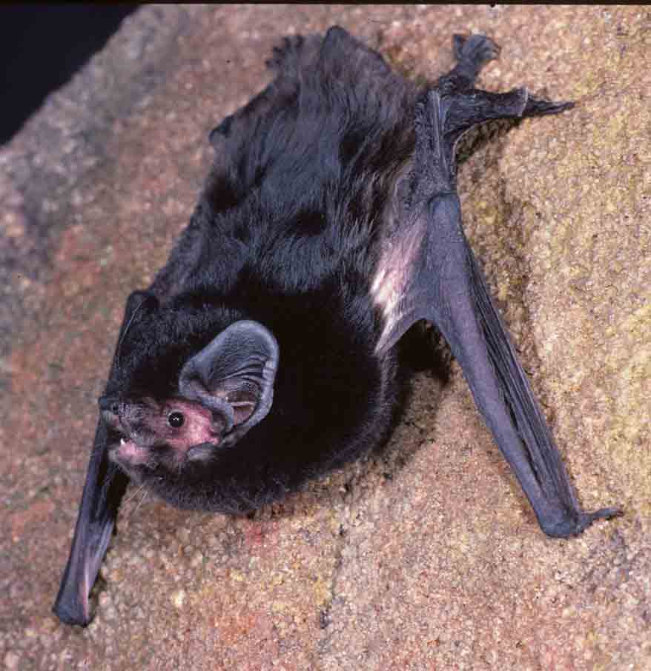




National recovery plan for the large-eared pied bat Chalinolobus dwyeri

Prepared by: Department of Environment and Resource Management

Cover photo: Large-eared pied bat © Antics Film & Photographic Productions

© The State of Queensland, Department of Environment and Resource Management 2011

Copyright protects this publication. Except for purposes permitted by the Copyright Act, reproduction by whatever means is prohibited without the prior written knowledge of the Department of Environment and Resource Management. Inquiries should be addressed to PO Box 15155, CITY EAST, QLD 4002.

Copies may be obtained from the:
Executive Director
Threatened Species Partnerships
Department of Environment and Resource Management
GPO Box 2454
Brisbane QLD 4001

Disclaimer
The Australian Government, in partnership with the Queensland Department of Environment and Resource Management and the New South Wales Office of Environment and Heritage, facilitates the publication of recovery plans to detail the actions needed for the conservation of threatened native wildlife.

The attainment of objectives and the provision of funds may be subject to budgetary and other constraints affecting the parties involved, and may also be constrained by the need to address other conservation priorities. Approved recovery plans may be subject to modification due to changes in knowledge and changes in conservation status.

Publication reference:
Department of Environment and Resource Management. 2011. National recovery plan for the large-eared pied bat Chalinolobus dwyeri. Report to the Department of Sustainability, Environment, Water, Population and Communities, Canberra.

Explanation of terms
CMAs Catchment Management Authorities
DSEWPaC Department of Sustainability, Environment, Water, Population and Communities (Commonwealth)
Qld DERM Department of Environment and Resource Management (Queensland)
LO Landowners
NRM Natural Resource Management body
NSW OEH Office of Environment and Heritage (New South Wales)

Contents
Executive summary 4

1.0 General information 5
1.1 Conservation status 5
1.2 International obligations 5
1.3 Affected interests 5
1.4 Consultation with Indigenous people 5
1.5 Benefits to other species or communities 6
1.6 Social and economic impact 7

2.0 Biological information 7
2.1 Species description 7
2.2 Life history and ecology 7
2.3 Distribution 8
2.4 Habitat critical to the survival of the species 9
2.5 Important populations 11

3.0 Threats 12
3.1 Biology and ecology relevant to threats 12
3.2 Identification of threats 12
3.3 Areas under threat 14
3.4 Populations under threat 14

4.0 Recovery objectives, actions and performance criteria 15
4.1 Overall objective 15
4.2 Specific objectives, performance criteria and actions 15

5.0 Management practices 23

6.0 Evaluation of recovery plan 22

7.0 Costs of recovery 22

Acknowledgements 25

References 25

Executive summary
Species status
The large-eared pied bat Chalinolobus dwyeri is listed as ‘Vulnerable’ under the Commonwealth Environment Protection and Biodiversity Conservation Act 1999, on the basis of population decline. It is also listed as ‘Vulnerable’ under the New South Wales Threatened Species Conservation Act 1995 and under the Queensland Nature Conservation Act 1992.

Distribution summary
The distribution of the large-eared pied bat is discontinuous and ranges from Shoalwater Bay in Queensland through to Ulladulla in New South Wales. The species has been found roosting in caves, overhangs, abandoned mine tunnels and disused fairy martin nests (Hoye & Dwyer 1995; Schulz 1998). No evidence exists of the large-eared pied bat roosting in tree hollows.

Threat summary
The lack of detailed information regarding the distribution, abundance and ecological requirements of the large-eared pied bat makes an assessment of threats difficult. The main known cause of decline in the species is the destruction of, and interference with maternity and other roosts. Information presented in this recovery plan and in Schulz et al. (1999) identifies other probable threats as: mining of roosts; mine induced subsidence of clifflines; disturbance from human recreational activities; habitat disturbance by introduced animals, including livestock; predation by introduced pests; vegetation clearing in the proximity of roosts; and fire in the proximity of roosts.

Recovery Plan objective
The overall objective of this recovery plan is to ensure the persistence of viable populations of the large-eared pied bat throughout its geographic range.

Summary of actions
Actions required for the recovery of the large-eared pied bat include reviewing all available species information; identifying, mapping and modelling bat colonies; identifying priority colonies for conservation management; surveying the species to clarify distribution and abundance to inform management; protecting known roosts and associated foraging habitats; managing threats through installation of bat gates, establishing fire management plans and control of introduced species; initiating public education and extension programs to encourage the public to be involved in the recovery process; developing press releases to promote the recovery program; conducting further research into the biology and ecology of the species; and analysing population genetics.

1.0 General information

1.1 Conservation status
The large-eared pied bat Chalinolobus dwyeri is listed as ‘Vulnerable’ under the following legislation:
- Commonwealth Environment Protection and Biodiversity Conservation Act 1999 (EPBC Act).
- New South Wales Threatened Species Conservation Act 1995 (TSC Act).
- Queensland Nature Conservation Act 1992 (NCA).

1.2 International obligations
Actions within this recovery plan are consistent with Australia’s international obligations.

1.3 Affected interests
The tenure of land on which the large-eared pied bat occurs includes both national and state lands, including national parks, nature reserves, state forests and crown land, in addition to privately owned land. Organisations that may be affected by the actions proposed in this recovery plan include the following:
- Australian Government Department of Defence;
- Queensland Department of Environment and Resource Management (DERM);
- New South Wales Office of Environment and Heritage (NSW OEH);
- New South Wales Catchment Management Authorities (Southern Rivers, Murrumbidgee, Hawkesbury Nepean, Hunter/Central Rivers, Northern Rivers, Border Rivers/Gwydir, Namoi, Central West, Sydney Metro and Lachlan);
- Queensland Natural Resource Management regional bodies (Fitzroy Basin Association, Queensland Murray-Darling Committee, Burnett Mary Regional Group and Condamine Alliance);
- Indigenous Land Councils and the groups they represent;
- Private landholders, leaseholders and Landcare Groups;
- Non-government reserve management and covenanting organisations; and
- Non-government organisations such as bat clubs, field naturalists clubs and speleological clubs (caving).
This list of stakeholders covers the main bodies, but it should not be considered exhaustive. There may be other interest groups, which need to be considered when particular tasks need to be undertaken.

1.4 Consultation with Indigenous people
The large-eared pied bat occurs across an area from Shoalwater Bay, north of Rockhampton, Queensland (Qld), through to the vicinity of Ulladulla in southern New South Wales (NSW). As a consequence of this broad distribution implementation of components of this recovery plan will require assistance and input from a range of Indigenous people who either have management responsibility for affected lands or have a cultural connection to lands critical for the conservation of the large-eared pied bat. Indigenous organisations consulted and identified during the drafting this plan are provided in Table 1.

Traditional owners will be encouraged throughout the life of this plan to be involved in further consultation and implementation of recovery actions. All activities will be undertaken in a manner that respects the cultural traditions of Indigenous groups throughout the species’ range.

Table 1. Indigenous people representative organisations consulted in the development of this plan.
Indigenous Language Groups@ | Affected Areas | Representative Body
Darumbal, Gangulu, Gayiri, Wadjigu, Garingbal,  Gungabula, Yiman, Wuli-wuli, Gureng Gureng | Central Queensland | Gurang Land Council Corporation
Barunggam, Waka Waka,  Gubbi Gubbi, Bigambul,  Yuggera | Southern Queensland | Queensland South Representative Body Aboriginal Corporation
Bundjalung, Gumbainggir | North Coast NSW | Far North Coast Regional Aboriginal Land Council
Ngarabal, Kamilaroi, Nganyaywana | Northern NSW | Northern Tablelands Regional Aboriginal Land Council & Far North Coast Regional Aboriginal Land Council
Wailwan, Wiradjuri | Central-West NSW | Central Regional Aboriginal Land Council & Wiradjuri Regional Aboriginal Land Council
Dainggatti, Biripi, Worimi | Central Coast NSW | Central Coast Regional Aboriginal Land Council
Geawegal, Wonnarua, Awabakal, Darkinung | Central NSW | Northern Regional Aboriginal Land Council & Wiradjuri Regional Aboriginal Land Council
Kuring-gai, Dharug, Eora,  Tharawal | Sydney Region | Sydney Newcastle Regional Aboriginal Land Council & Western Metropolitan Regional Aboriginal Land Council
Gundungurra, Ngunawal,  Ngarigo, Yuin | Southern NSW | Far South Coast Regional Aboriginal Land Council & Wiradjuri Regional Aboriginal Land Council & South Coast Regional Aboriginal Land Council
@ Indigenous language groups derived from Encyclopaedia of Aboriginal Australia (Horton 1994)

1.5 Benefits to other species or communities
Fire management and introduced predator control will benefit threatened vertebrates that live in, or near, large-eared pied bat habitat, including brush-tailed rock-wallaby Petrogale penicillata and the spotted-tailed quoll Dasyurus maculatus. Other threatened species that live in the same region as the large-eared pied bat will benefit less directly through protection of important areas of their habitat, and this may include yellow-footed rock-wallaby Petrogale xanthopus celeris, Underwoodisaurus spp., and the golden-tailed gecko Strophurus taenicauda (C. Clague pers. comm. 2006).

Some populations of the large-eared pied bat depend in part on nationally-listed threatened ecological communities, particularly forest and woodlands along fertile river valleys near suitable roost sites (usually sandstone caves or cliff overhangs). These communities include: Cumberland Plain Shale Woodlands and Shale-Gravel Transition Forest; Shale/Sandstone Transition Forest; Turpentine-Ironbark Forest in the Sydney Basin Bioregion; Brigalow (Acacia harpophylla dominant and co-dominant); White Box-Yellow Box-Blakely's Red Gum Grassy Woodland and Derived Native Grassland; Weeping Myall - Coobah - Scrub Wilga Shrubland of the Hunter Valley; and Temperate Highland Peat Swamps on Sandstone. Protecting and managing bat habitat in these areas should also improve the conservation of the relevant patches of these threatened ecological communities.

1.6 Social and economic impact
The implementation of this recovery plan is unlikely to cause significant adverse social and economic impacts. Potential restrictions on mining under known or potential habitat of the large-eared pied bat may have some impact on these activities, however consultation and involvement of industry groups will seek to minimise any significant adverse impacts.

2.0 Biological information

2.1 Species description
The large-eared pied bat is a medium-sized insectivorous bat measuring approximately 100mm including the head and tail and weighing 7-12 g (Hoye and Dwyer 1995). It has shiny, black fur on the body and a white stripe on the ventral side of the torso where it adjoins the wings and tail. The ears are large and lobes of skin adorn the lower lip and between the corner of the mouth and the bottom of the ear. Its relatively short, broad wings suggest it flies comparatively slowly and with considerable manoeuvrability.

2.2 Life history and ecology
Much of the information on the ecology of the large-eared pied bat comes from studies of the population at the type locality at Copeton, NSW during the early 1960s (Dwyer 1966). Breeding at the site was recorded during two summers with no breeding recorded for the following two years. Females were pregnant in October and by early December they had all given birth and were lactating. Females most often had two young with the ratio of males to females being 1:1.8. The nursery colony was established in September by both adult females and males with the majority of adult males leaving by the time the young were born in early summer. During late February and March the juveniles had left the roost. The adult females left the roost after the juveniles and the site was abandoned during the winter months. Females were able to breed at one year of age. The males had enlarged testes during autumn and winter. Swelling of the muzzles of males and females during the mating period is believed to serve a secondary sexual function through the exuding of scent from glands.

Information on breeding has also been recorded from several sites in sandstone caves near Coonabarabran, NSW in more recent years. One such cave visited in mid November over several years had between 15 and 40 adult females and their young (Pennay 2008). Another small group of lactating females and dependent young were found in a disused gold mine near Barraba, NSW (P. Spark pers. comm. 2011)

Diet has not been examined in the large-eared pied bat. Wing morphology suggests that it is a relatively slow-flying maneuverable species that forages predominantly below the canopy. Almost all records are within several kilometres of cliff lines or rocky terrain. It is likely that critical foraging resources are also located in these areas, although this requires confirmation.

Over most of its range, the large-eared pied bat appears to roost predominantly in caves and overhangs in sandstone cliffs and forage in nearby high-fertility forest or woodland near watercourses (Pennay 2002; DECC 2007; Pennay 2008). The presence of suitable caves or overhangs may be more important than the precise geology, as bats have also been captured near rhyolite cliffs in south-east Queensland (M. Mathieson pers. comm. 2011; I. Gynther pers. comm. 2011). This species has been recorded foraging in a range of vegetation types, including dry and wet sclerophyll forest, grassy woodland, Callitris dominated forest, tall open eucalypt forest with a rainforest sub-canopy, sub-alpine woodland and sandstone outcrop country (Hoye & Dwyer 1995; Pennay 2002; DECC 2007). The occurrence of high-fertility forest or woodland near suitable roosting habitat is rare in the landscape, which implies that the species may always have been uncommon; however preferential clearing of fertile forests and woodlands has almost certainly reduced the amount of available habitat considerably (DECC 2007; Pennay 2008).
Effects of reduced genetic diversity including inbreeding depression and reduced evolutionary adaptability makes the species more vulnerable.

2.3 Distribution
The large-eared pied bat is known from Shoalwater Bay, north of Rockhampton, Qld, south to the vicinity of Ulladulla in NSW (Figure 1 and Figure 2). In Shoalwater Bay it is known from a single individual, and the size and number of populations in this area is unknown. Further records are known in Qld from sandstone escarpments in the Carnarvon and Expedition Ranges and Blackdown Tablelands. It is likely that these areas support a high proportion of the Qld populations of this bat, although estimates of the number of individuals present and their distribution in these areas has not been established. Additional records exist in the Scenic Rim near the NSW/Qld border. Given their location in the geological landscape, the populations in this area appear to be reliant on the presence of roosts in volcanic rock types. The most recent record from this area was an adult female captured adjacent to rhyolite cliffs at Springbrook in August 2004 (M. Mathieson pers. comm. 2011).
Much of the known distribution of the large-eared pied bat occurs in NSW. In the north east of the state at Coolah Tops, Mt Kaputar and Warrumbungle National Park it is present in areas of volcanic strata. It is more widely distributed, but still uncommon and patchy within its distribution, in the sandstone areas of the Sydney Basin and the western slopes and plains including Pilliga Nature Reserve. It has tentatively been recorded from echolocation calls further west at Tottenham west of Narromine (Shelley 2001).
Conservation reserves on which species occurs:
New South Wales:
Bouddi National Park, Big Scrub Flora Reserve, Blue Mountains National Park, Bungonia Nature Reserve, Coolah Tops National Park, Goulburn River National Park, Mt Kaputar National Park, Morton National Park, Munghorn Gap Nature Reserve, Pilliga Scrub Nature Reserve, Richmond Range National Park, Royal National Park, Warrumbungle National Park, Wollemi National Park, Yengo National Park.

Queensland:
Carnarvon National Park, Lamington National Park, Main Range National Park, Blackdown Tableland National Park, Cania Gorge National Park, Taunton National Park (Scientific), Expedition (Limited Depth) National Park, Presho Forest Reserve.

Other public lands on which species occurs:
New South Wales:
Bingara State Forest, Bourbah State Forest, Giro State Forest, Irrigapa State Forest, Kerringle State Forest, Montrose State Forest, Olney State Forest, Pilliga East State Forest, Pilliga West State Forest, Ruttley State Forest, Yarrigan State Forest, Watagan State Forest, Yalcogrin State Forest.

Queensland:
Blackdown Tableland State Forest, Gambubal State Forest, Belington Hut State Forest, Western Creek State Forest, road reserves in the Wivenhoe Dam, Lake Moogerah and west of Mt Barney areas.

Other land on which species occurs:
Commonwealth estate: Shoalwater Bay, Queensland.
New South Wales: Crown Land near Ulan.

Queensland: Private land adjacent to Mt Mistake.

2.4 Habitat critical to the survival of the species
The large-eared pied bat is dependent on the presence of diurnal roosts for shelter. Roosts are utilised during the day and also at night when not feeding, as well as for the raising of young. This bat has been known to roost in disused mine shafts, caves, overhangs and abandoned fairy martin Hirundo ariel nests (Schulz 1998). The value of mine shafts and disused fairy martin nests as roost sites has not been evaluated to date. From the type locality it would appear that mines may offer important roost sites, particularly in areas where natural roosts are uncommon or absent. Fairy martin nests may also provide roosting resources in these areas, allowing the large-eared pied bat to penetrate otherwise unsuitable areas and enabling individuals to disperse across areas lacking cave roosts.

The number of known breeding sites is limited. The type locality at Copeton was used for breeding until flooded by dam waters (Dwyer 1962). A maternity roost has been observed in a sandstone cave near Coonabarabran, NSW (Pennay 2008), and another nearby in the Pilliga sandstone (M. Pennay pers. comm. 2010). Small groups of females and young bats have been observed in the Pilliga Scrub and lactating females have been captured adjacent to sandstone cliffs near Ulan, NSW (Fly By Night 2005). Young have also been noted in a small group of females in a disused gold mine near Barraba, NSW (P. Spark pers. comm. 2011). Any maternity roosts must be considered habitat critical to the survival of the species.

The structure of maternity roosts appears to be very specific (arch caves with dome roofs). Caves need to be high and deep enough to allow juvenile bats to learn to fly safely inside and have indentations in the roof. Roosting bats cluster in these indentations, presumably to allow the capture of heat. These physical characteristics are very uncommon in the landscape and their scarcity presumably poses an important limiting factor in the distribution of the large-eared pied bat (Pennay 2008; M. Pennay pers. comm. 2010).

Almost all records of the species are within several kilometres of clifflines or rocky terrain, although extensive trapping and call data indicates that bats do not usually forage in sandstone habitat. Modelling based on presence-only data indicates that bats forage in fertile valleys and plains, as well as areas with moderately-tall to taller trees along water courses. The majority of records are from canopied habitat, suggesting a sensitivity to clearing, although narrow connecting riparian strips in otherwise cleared habitat are sometimes quite heavily used (DECC 2007).

Sandstone cliffs and fertile wooded valley habitat within close proximity of each other should be considered habitat critical to the survival of the large-eared pied bat (DECC 2007). Records from south-east Queensland suggest that rainforest and moist eucalypt forest habitats on other geological substrates (viz. rhyolite, trachyte and basalt) at high elevation are of similar importance for the species (I. Gynther pers. comm. 2011 and M. Mathieson pers. comm. 2011).

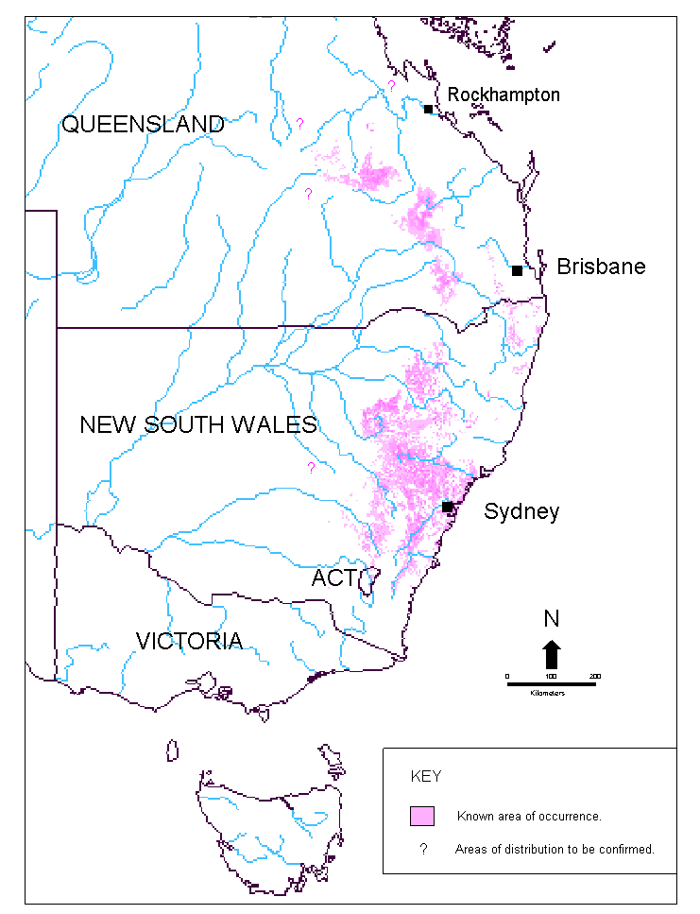
Potential areas of occurrence
Potential areas of occurrence requiring further investigation

Figure 1. Modelled distribution of the large-eared pied bat in Australia (source: Fly by Night Surveys Pty Ltd 2005).

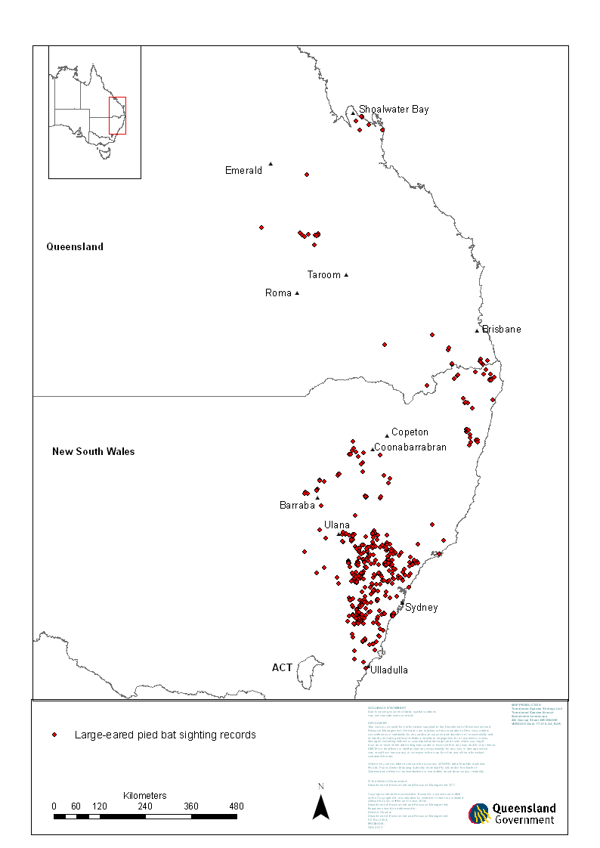

Figure 2. Known distribution of the large-eared pied bat (source: Qld DERM & NSW OEH 2011).

2.5 Important populations
The largest known populations of the large-eared pied bat occur in those areas dominated by sandstone escarpments. Within the Qld part of its distribution, a targeted survey has not been undertaken to determine the size or distribution of populations. Substantial areas of sandstone escarpments occur in Carnarvon National Park, Blackdown Tableland National Park, Expedition National Park and Isla Gorge National Park. If sufficiently large populations occur in these reserves, this would form an important area to target recovery actions in the shorter term.

While only one record of the bat is documented from its northern known limit within Commonwealth estate at Shoalwater Bay, this would be an important population to investigate and monitor, being on the edge of the known species’ range.

Within NSW, based on available records, the largest concentration of populations appears to be in the sandstone escarpments of the Sydney basin and northwest slopes of NSW. Much of this habitat occurs within state reserves and should be the subject of recovery actions. The species has also been recorded from a few locations in the sandstone escarpments of the Morton National Park at the southern end of its range. Further survey is required throughout its known range to determine the size and distribution of existing populations.

3.0 Threats

3.1 Biology and ecology relevant to threats
Several facets of the known behaviour and ecology of the large-eared pied bat make it vulnerable to threats affecting other cave-roosting bat species. Individuals congregate to roost and raise young. This can place a reasonable proportion of a local population at a single locality. Most cave roosts observed are in shallow caves or in the outer reaches of deeper mines or caves. This places individuals at risk from factors that can impact these areas, including heat and smoke during fires as well as predators sheltering within the caves.

Sandstone escarpments provide many of the known populations with diurnal roosts and sites for raising young and other associated activities. In some areas these coincide with underground coal mining operations where cliffs can be destabilised through subsidence.

3.2 Identification of threats
The major threatening processes for the large-eared pied bat have not been clearly established. Destruction of, or interference with, subterranean roosts and maternity sites is a confirmed threat but other threats are yet to be clearly identified. Increased knowledge on the large-eared pied bat’s roosting and foraging requirements is required to provide a basis for management. The only targeted scientific study of this species was undertaken during the 1960s (Dwyer 1966). Additional information has been collected since this time; however large gaps still exist in knowledge about the ecology of this bat. Based on current knowledge potential threats include:
Destruction of and interference with maternity and other roosts
Due to its dependence on roost sites for shelter and breeding, the large-eared pied bat is particularly vulnerable to threats that impact these sites. Up to 100 individuals may be present at such roosts, possibly representing a substantial proportion of a local population.

Mining of roosts
The large-eared pied bat was originally described from a population roosting within a disused diamond mine at Copeton, NSW (Ryan 1966). One of the two known breeding sites occurs in a disused gold mine at Barraba, NSW. Such roosts may be important, particularly where caves are uncommon or not suitable for roosting. Disused mines are often re-mined as they become economical or are filled in for safety reasons.

Mine induced subsidence of cliff lines
Portions of the range of the large-eared pied bat occur in conjunction with mine leases for underground coal in both NSW and Qld. Alteration of habitat following subsidence due to longwall mining has been listed as a key threatening process in NSW (Hughes 2005). Much of the habitat of the large-eared pied bat occurs in sandstone escarpments, large parts of which are underlain by coal seams and potentially at risk of collapse from underground mining. This could be particularly problematic if a nursery roost collapsed, especially during the breeding season, as this could cause large losses to local population. The timing of this type of collapse cannot be controlled (M. Pennay pers. comm. 2010).
Disturbance from human recreational activities
Recreational activities such as bushwalking, caving and abseiling are potential threats to the large-eared pied bat. The main threat lies in the disturbance of bats within cave or mine roosts. Repeated disturbance could potentially lead to bats abandoning roosts as well as possible mortality from the burning of winter fat stores during arousal from torpor (Speakman et al. 1991). This is most relevant where roosts occur in easily accessible situations.
Habitat disturbance by other animals, including livestock and feral animals
Large-eared pied bats increasingly share their roosts with feral goats. This is particularly the case in sandstone escarpment areas where caves are used as shelter by feral goats. Goats would likely disturb bats in situations when they roost on the ceilings of low caves. As mentioned above, regular disturbance may lead to bats abandoning roosts and mortality from the burning of winter fat stores during arousal from torpor (Speakman et al. 1991). Bats were observed to abandon one of the few known nursery cave roosts after it was disturbed by macropods.
Predation by introduced predators
Predation by introduced predators such as cats, foxes and rats on the large-eared pied bat has not been investigated. It is possible that mortality is a factor particularly where roosts are limited and bats are forced to roost close to the ground. At several known roosts, individuals roost within 1.5m of the ground, which would appear to make them vulnerable to attack from cats, foxes and possibly rats.
Vegetation clearance in the proximity of roosts
Clearing or harvesting of vegetation in or around roosts has the potential to affect foraging resources through habitat loss and fragmentation of the surrounding vegetation. This is likely to be particularly detrimental in the vicinity of maternity roosts where pregnant and lactating females require sufficient food resources to raise young. The microclimate within roosts may also be altered through adjacent clearing and logging altering solar radiation levels and groundwater levels.
Fire in the proximity of roosts
As this species often roost in relatively shallow caves, they are potentially susceptible to direct mortality from heat and smoke. Mortality can be expected to be higher during high intensity fires or where fires occur on a regular basis.

The longer term impacts of fire frequency and intensity on the large-eared pied bat are unknown. Foraging resources may be impacted through changes in vegetation composition and structure. Factors potentially impacting prey species include changes in floristics, invasion of weed species and loss of a mosaic of vegetation of different age classes.
Loss of genetic diversity
Small, fragmented sub-populations of the large-eared pied bat may be at a greater risk of extinction from random events as a result of a loss of genetic variability, which can lead to inbreeding depression and / or decreased evolutionary potential to adapt to environmental changes.
To date, there have been no genetic studies undertaken on the large-eared pied bat. Movement of this species between areas has not been recorded and its dispersal ability and habits are not known. This bat has relatively short, broad wings suggesting high manoeuvrability and relatively slow flight. Species with these characteristics typically forage below the canopy (Hoye & Dwyer 1995). Short broad wings also suggest that its dispersal ability may be significantly less than another, better studied cave roosting species, the eastern bent-wing bat Miniopterus schreibersii oceanensis. Significant clearing of vegetation in the range of the large-eared pied bat since European settlement is likely to have further decreased the ability of individuals to move between areas of suitable habitat.

3.3 Areas under threat
The proposed surveys to identify populations within the range of the large-eared pied bat will help to clarify the issues affecting this species. With specific threats to populations more clearly identified, management strategies can be devised to reduce threats in the proximity of essential areas, such as major roost sites.

3.4 Populations under threat
It has not been determined if specific populations of the large-eared pied bat are at higher threat levels than others. A better understanding of distribution, population size, roost preference and threats is required before particular populations can be identified as being under greater threat than others. Proposed surveys and research will better identify the populations under direct threat and allow management plans to be developed in order to target a reduction in pressure to these populations.

4.0 Recovery objectives, actions and performance criteria

4.1 Overall objective
To ensure the persistence of viable populations of the large-eared pied bat throughout its geographic range.

4.2 Specific objectives, performance criteria and actions

Specific Objective 1: Identify priority roost and maternity sites for protection

Action 1.1 Undertake a review of all existing information on the large-eared pied bat.

Methodology: All current information on the species including museum specimens, published data, personal records and observations to be collated and reviewed to facilitate the identification and mapping of priority sites for the conservation of the large-eared pied bat.
Performance criterion: All known data on the large-eared pied bat is collated and stored at appropriate locations in both NSW and Qld.
Potential contributors: Qld DERM, NSW OEH, Museums, other partner organisations.

Action 1.2 Identify and map known colonies within New South Wales and Queensland to develop habitat models.

Methodology: Data derived from Action 1.1 to be used to produce a distributional model to identify areas of potential occurrence to target conservation efforts and subsequent field surveys.
Performance criterion: Distribution maps and habitat models are produced.
Potential contributors: Qld DERM, NSW OEH, Universities, other partner organisations.

Action 1.3 Identify priority colonies and sites for conservation management and protection.

Methodology: The results of Actions 1.1 and 1.2 to be reviewed to prioritise existing known colonies and sites for immediate implementation of protective measures and conservation management. This process would also serve to clarify jurisdictional roles and priorities.
Performance criterion: A report is produced identifying priority colonies and relevant conservation recommendations for each.
Potential contributors: Qld DERM, NSW OEH, Southern Rivers, Murrumbidgee, Hawkesbury Nepean, Hunter/Central Rivers, Northern Rivers, Border Rivers/Gwydir, Namoi, Central West, Sydney Metro and Lachlan Catchment Management Authorities (CMAs), Fitzroy Basin Association (FBA), Burnett Mary Regional Group (BMRG), Queensland Murray-Darling Committee (QMDC), Condamine Alliance (CA), other partner organisations.

Action 1.4 Identify and locate roost structures such as cave systems, old mine sites and geological formations that require surveying.

Methodology: Speleological publications, geological maps and mining records to be reviewed to identify likely roost sites. This data may be of a sufficient standard to enable spatial models to be developed to identify potential roost habitats.
Performance criterion: Report is produced listing potential roosting sites to be surveyed.
Potential contributors: Qld DERM, NSW OEH, Speleological societies, Universities, other partner organisations.

Action 1.5 Undertake targeted surveys for the species to clarify distribution and abundance to identify priority roost sites for management prescriptions.

Methodology: Survey work is required to validate mapping and modelling undertaken in Actions 1.1 – 1.4. This would initially involve a period of two nights survey at each identified site using echolocation call detection and harp trap survey. Echolocation call detection should be undertaken throughout the night at sites (taking care to differentiate between Beccari's freetail bat Mormopterus beccarii and the large-eared pied bat in the northern extent of its range) (C. Clague pers. comm. 2006). Where the presence of populations is established, further surveys will be undertaken to estimate the size of the populations present where this is feasible. Selected large-eared pied bats captured will be fitted with radio transmitters and tracked back to their roosts over the life of the transmitter. The roost site will then be assessed for stability and the immediacy and nature of any threats present. A standardised survey methodology will be developed and utilised at each site. Survey methods will comply with existing EPBC survey guidelines and DERM procedures and where possible align with existing proven methods for similar species.
Performance criteria: (i) Surveys undertaken and; (ii) Progress reported on annually.
Potential contributors: Qld DERM, NSW OEH, CMAs, FBA, BMRG, QMDC, CA, other partner organisations.

Action 1.6 Produce revised distribution and habitat model and report on findings with recommendations for conservation and threat abatement.

Methodology: Collation of all the data gained through activities under Objective 1 to provide the basis for a revised distribution and habitat model that will provide information for future conservation and management decisions.
Performance criteria: (i) Revised map and model produced and; (ii) A report detailing conservation recommendations for important sites is completed.
Potential contributors: Qld DERM, NSW OEH, other partner organisations.

Specific Objective 2: Implement conservation and management strategies for priority sites

Action 2.1 Protection of known roosts and associated foraging habitats and management of threats.

Methodology: Roost and maternity sites, together with foraging habitat, not already located within protected areas, (identified from Actions 1.1-1.5) to be protected under relevant legislation and/or other options such as conservation covenants and voluntary agreements to ensure protection.
Performance criterion: Information on the protection of habitat reported in an annual report.
Potential contributors: Qld DERM, NSW OEH, Australian Bush Heritage Fund (ABHF), Australian Wildlife Conservancy (AWC), CMAs, FBA, BMRG, QMDC, CA, landholders, other partner organisations.

Action 2.2 Installation of bat gates and remedial works at sites where required.

Methodology: The introduction of a strategy to install bat gates to protect populations of the large-eared pied bat to be implemented with the cooperation of landholders and/or relevant land management agencies. Sites which are unstable, e.g. old mines, may need to be stabilised at the entrance. These may also need to be protected from visitation by the installation of bat gates if deemed suitable. Any installation of gating or grilling would require a trial to be undertaken to assess its impact on the colony present.
Performance criteria: (i) Development of an implementation strategy and; (ii) Progress reported on annually.
Potential contributors: Qld DERM, NSW OEH, other partner organisations.

Action 2.3 Establish fire prescriptions for areas around each identified priority roost or maternity site.

Methodology: Fire prescriptions will be set for priority areas based on the information and recommendations derived from the targeted survey program described in Action 1.5. These will be subject to review according to the monitoring results for each site.
Performance criteria: (i) Fire management plans developed and implemented for all priority sites and; (ii) Progress reported on annually.
Potential contributors: Qld DERM, NSW OEH, Rural Fires, Qld Department of Primary Industries and Fisheries (Forestry), other partner organisations.

Action 2.4 Conduct a program to control introduced species, such as goats, where necessary.

Methodology: Coordinated programs to control populations of introduced animals will be undertaken in areas surrounding protected large-eared pied bat locations, as recommended. The Threat Abatement Plan for the competition and land degradation by unmanaged goats (DEWHA 2008) will help guide and coordinate a response to the impact of goats on large-eared pied bat locations. The selection of control strategies will be influenced by the pest species involved and site specific factors.
Performance criteria: (i) Pest management strategies developed for priority sites and; (ii) Progress reported on annually.
Potential contributors: Qld DERM, Qld DNR&W, NSW OEH, CMAs, FBA, BMRG, QMDC, CA, landholders, other partner organisations.

Action 2.5 Undertake monitoring to assess the impact of prescribed management strategies.

Methodology: Conservation measures undertaken at priority sites (as identified in Action 1.3) for the large-eared pied bat, including non-breeding populations, roost and maternity sites need to be monitored to assess the efficacy of the strategies. The monitoring of such sites will evaluate the impact of actions on the specific populations and contribute to measuring the effectiveness of the recovery program. It is important that on-ground works do not interfere with the ability of the bats to function normally within their environment. This information will be made publicly available.
Performance criteria: A consistent and coordinated monitoring and reporting process implemented across the relevant states through the development of (i) A monitoring plan and; (ii) Annual progress reporting system.
Potential contributors: Qld DERM, NSW OEH, CMAs, FBA, BMRG, QMDC, CA, other partner organisations.

Specific Objective 3: Educate the community and industry to understand and participate in the conservation of the large-eared pied bat

Action 3.1 Initiate education and extension programs to increase the awareness and participation in the recovery plan.

Methodology: The preparation of information kits is to be undertaken detailing the known ecological and biological knowledge of the large-eared pied bat. The information kits will be utilised to facilitate education programs within affected communities to increase awareness, general knowledge and acceptance of the issues affecting the large-eared pied bat and its survival.
Performance criteria: (i) An awareness strategy produced incorporating information on target audience and distribution of information; (ii) Information kits are produced and; (iii) Progress reported on annually.
Potential contributors: Qld DERM, NSW OEH, CMAs, FBA, BMRG, QMDC, CA, other partner organisations.

Action 3.2 Encourage and assist community and industry groups to be involved in the recovery process.

Methodology: Significant areas of private land within the range of the large-eared pied bat are owned or managed by private interests including Indigenous groups and private agricultural interests. A strong focus on these groups will ensure that potential priority populations are identified and protected on private land. Contact with relevant community groups including Indigenous groups, landcare groups, speleogical clubs and environmental groups will be initiated to encourage involvement in the recovery program. Affected industry groups such as the mining industry will also be approached to be involved.
Performance criteria: (i) A community involvement strategy is produced and; (ii) Progress reported on annually.
Potential contributors: Qld DERM, NSW OEH, CMAs, FBA, BMRG, QMDC, CA, landholders, other partner organisations.

Action 3.3 Develop press releases for media and stakeholder groups to increase awareness and advise of progress.

Methodology: News releases should be prepared and interviews provided to the media as appropriate. One of the threats identified as potentially affecting the large-eared pied bat is public access to roost sites. Education of local communities together with the promotion of protective measures will assist the recovery process.
Performance criteria: (i) Press releases distributed each year and; (ii) Progress reported on annually.
Potential contributors: Qld DERM, NSW OEH, CMAs, FBA, BMRG, QMDC, CA, other partner organisations.

Specific objective 4: Research the large-eared pied bat to augment biological and ecological data to enable conservation management

Action 4.1 Develop and implement a research strategy that covers the following:
- Investigate habitat requirements and determine factors responsible for the patchy distribution of the species;
- Investigate roost and maternity sites to determine factors influencing selection and management;
- Investigate diet and foraging strategy; and
- Identify threatening processes.

Methodology: Research directed at enhancing the current dearth of data should be undertaken as a priority in the recovery process.

Telemetry studies would be used to determine foraging habits and roosting preferences. Where a roost or maternity site was located, it would be evaluated for the presence of any threatening processes.

Individual sites will be assessed to determine the population present, its use of the site at the time (e.g. breeding), the stability of the site and the nature of any threats which might be present.

Faecal samples will be collected during the first two years of targeted surveys for subsequent analysis. Samples collected during survey would be analysed to establish the range and proportion of various items in the diet. The analysis would provide information on the diet of the large-eared pied bats captured. The collation of all survey data will reveal the current occurrence of the large-eared pied bat and further data on the diet and foraging characteristics of this species will broaden the information available and should reveal specific vegetation types and prey preferences for this bat.
Performance criteria: (i) A research strategy is developed and implemented, and (ii) Progress reported on annually.
Potential contributors: Qld DERM, NSW OEH, Universities, Traditional owners, conservation organisations, other partner organisations.

Specific objective 5: Determine the meta-population dynamics throughout the distribution of the large-eared pied bat

Action 5.1 Collect and analyse genetic material from individuals across geographic range of large-eared pied bat to facilitate analysis of population genetics.

Methodology: Tissue sampling to be undertaken during the first two years of targeted surveys without sacrificing animals. Large-eared pied bats captured will have wing membrane punctures taken for DNA sequencing. This method will not be undertaken if it places any unacceptable stress on the bats or disturbance to roost sites. Tissue samples collected will be analysed using microsatellite and mitochondrial DNA sequencing. Analyses will enable delineation of populations and provide information on interactions with other known populations to guide decisions with regards to the protection of key habitats and important dispersal corridors in the landscape.
Performance criterion: Report produced detailing results of DNA work.
Potential contributors: Qld DERM, NSW OEH, Museums, Universities, other partner organisations.
4.3 Table 2. Summary Table
Priority levels: 1 = High Priority; 2 = Medium Priority; 3 = Low Priority.
Specific objectives | Recovery Action | Performance criteria | Potential  contributors | Priority
- Identify priority roost and maternity sites for protection. | 1.1 Undertake review of all existing information on the large-eared pied bat. | All known data on the large-eared pied bat is collated and stored at appropriate locations in both New South Wales and Queensland. | Qld DERM, NSW OEH, Museums | 1
 | 1.2 Identify and map known colonies within New South Wales and Queensland to develop habitat models. | Distribution maps and habitat models are produced. | Qld DERM, NSW OEH, Universities | 1
 | 1.3 Identify priority colonies and sites for conservation management and protection. | A report is produced identifying priority colonies and relevant conservation recommendations for each. | Qld DERM, NSW OEH, CMAs, NRM regional bodies | 1
 | 1.4 Identify and locate roost structures such as cave systems, old mine sites and geological formations that require surveying. | Report is produced listing potential roosting sites to be surveyed. | Qld DERM, NSW OEH, Speleological societies, Universities | 2
 | 1.5 Undertake targeted surveys for the species to clarify distribution and abundance to identify priority roost sites for management prescriptions. | (i) Surveys undertaken and; (ii) Progress reported on annually. | Qld DERM, NSW OEH, CMAs, NRM regional bodies | 1
 | 1.6 Produce revised distribution and habitat model and report on findings with recommendations for conservation and threat abatement. | (i) Revised map and model produced and; (ii) A report detailing conservation recommendations for important sites is completed. | Qld DERM, NSW OEH | 2
- Implement conservation and management strategies for priority sites. | 2.1 Protection of known roosts and associated foraging habitats and management of threats. | Information on the protection of habitat reported on in an annual report. | Qld DERM, NSW OEH, ABHF, AWC, CMAs, NRM regional bodies, landholders | 1
 | 2.2 Installation of bat gates and remedial works at sites where required. | (i) Development of an implementation strategy and; (ii) Progress reported on annually. | Qld DERM, NSW OEH | 2
 | 2.3 Establish fire prescriptions for areas around each identified priority roost or maternity site. | (i) Fire management plans developed and implemented for all priority sites and; (ii) Progress reported on annually. | Qld DERM, NSW OEH, Rural Fires, Qld Department of Primary Industries and Fisheries (Forestry) | 1
 | 2.4 Conduct a program to control introduced species, such as goats, where necessary. | (i) Pest management strategies developed for priority sites and; (ii) Progress reported on annually. | Qld DERM, Qld DNR&W, NSW OEH, CMAs, NRM regional bodies, landholders | 1
 | 2.5 Undertake monitoring to assess the impact of prescribed management strategies. | A consistent and coordinated monitoring and reporting process implemented across the relevant states through the development of (i) A monitoring plan and; (ii) Annual progress reporting system. | Qld DERM, NSW OEH, CMAs, NRM regional bodies | 1
- Educate the community and industry to understand and participate in the conservation of the large-eared pied bat. | 3.1 Initiate education and extension programs to increase the awareness and participation in the recovery plan. | (i) An awareness strategy produced incorporating information on target audience and distribution of information; (ii) Information kits are produced and; (iii) Progress reported on annually. | Qld DERM, NSW OEH, CMAs, NRM regional bodies | 2
 | 3.2 Encourage and assist community and industry groups to be involved in the recovery process. | (i) A community involvement strategy is produced and; (ii) Progress reported on annually. | Qld DERM, NSW OEH, CMAs, NRM regional bodies | 2
 | 3.3 Develop press releases for media and stakeholder groups to increase awareness and advise of progress. | (i) Press releases distributed each year and; (ii) Progress reported on annually. | Qld DERM, NSW OEH, CMAs, NRM regional bodies, other partner organisations. | 3
- Research the large-eared pied bat to augment biological and ecological data to enable conservation management. | 4.1 Develop and implement a research strategy. | (i) A research strategy is developed and implemented and; (ii) Progress reported on annually. | Qld DERM, NSW OEH, Universities, Traditional owners, conservation organisations | 2
- Determine the meta-population dynamics throughout the distribution of the large-eared pied bat | 5.1 Collect and analyse genetic material from individuals across geographic range of large-eared pied bat to facilitate analysis of population genetics. | Report produced detailing results of DNA work. | Qld DERM, NSW OEH, Museums, Universities | 3

5.0 Management practices
In Qld, management of large-eared pied bat habitat will be subject to the Nature Conservation Act 1992. Within NSW, management will be subject to the Threatened Species Conservation Act 1995. As the species is listed under the Commonwealth Environment Protection and Biodiversity Conservation Act 1999 any action which may have a significant impact on the large-eared pied bat must be referred to the Department of Sustainability, Environment, Water, Population and Communities to determine whether approval is required (http://www.environment.gov.au/epbc/publications/pubs/assessment-process.pdf ).
Management practices that will protect large-eared pied bat populations include:
- Regulation of underground or open cut mining in the vicinity of known or potential roosts;
- Management of recreational activities such as bushwalking, caving and abseiling in the vicinity of known or potential roosts;
- Management practices aimed at reducing the impacts of grazing by sheep, cattle or goats in the vicinity of known or potential roosts;
- Regulation of vegetation clearing or logging within the vicinity of known or potential roosts;
- Feral animal control; and
- Fire management regimes designed to maintain a variety of habitat types within mosaics.
Development proposals and management programs should be assessed with due regard for the potential impact of the above activities on local large-eared pied bat populations.

6.0 Evaluation of recovery plan
The progress of implementation of the recovery plan will be evaluated at yearly intervals, and management practices will be adapted as needed. Reports summarising modelling, surveying and research results will be produced each year. This information will be used to produce newsletters that will keep landowners and interested community groups informed about the recovery and progress. An independent reviewer will review the recovery plan 5 years from adoption with assistance from Qld DERM and NSW OEH.

7.0 Costs of recovery
Table 3: Estimated Recovery Costs (A$/year)
Actions | Year 1 | Year 2 | Year 3 | Year 4 | Year 5 | Total
1.1 Undertake review of all existing information on the large-eared pied bat.  1.2 Identify and map known colonies within New South Wales and Queensland to develop habitat models.  1.3 Identify priority colonies and sites for conservation management and protection  1.4 Identify and locate roost structures such as cave systems, old mine sites and geological formations that require surveying. | 15,000 | 0 | 0 | 0 | 0 | 15,000
1.5 Undertake targeted surveys for the species to clarify distribution and abundance to identify priority roost sites for management prescriptions. | 100,000 | 100,000 | 100,000 | 0 | 0 | 300,000
1.6 Produce revised distribution and habitat model and report on findings with recommendations for conservation and threat abatement. | 10,000 | 0 | 0 | 0 | 0 | 10,000
2.1 Protection of known roosts and associated foraging habitats and management of threats.2.2 Installation of bat gates and remedial works at sites where required.  2.3 Establish fire prescriptions for areas around each identified priority roost or maternity site.  2.4 Conduct a program to control introduced species, such as goats, where necessary.  2.5 Undertake monitoring to assess the impact of prescribed management strategies. | 50,000 | 50,000 | 50,000 | 50,000 | 0 | 200,000
3.1 Initiate education and extension programs to increase the awareness and participation in the recovery plan.  3.2 Encourage and assist community and industry groups to be involved in the recovery process.  3.3 Develop press releases for media and stakeholder groups to increase awareness and advise of progress. | 5,000 | 2,000 | 2,000 | 2,000 | 2,000 | 13,000
4.1 Develop and implement a research strategy. | 50,000 | 50,000 | 50,000 | 20,000 | 0 | 170,000
5.1 Collect and analyse genetic material from individuals across geographic range of large-eared pied bat to facilitate analysis of population genetics. | 10,000 | 10,000 | 10,000 | 20,000 | 0 | 50,000
Total | 240,000 | 212,000 | 212,000 | 92,000 | 2,000 | 758,000

Acknowledgements
Glenn Hoye of Fly By Night Bat Surveys Pty Ltd prepared an early draft of the recovery plan. Geoff Lundie-Jenkins, Tim Holmes, Sara Williams, Hannah Venz and Anna Muscat of the Queensland Department of Environment and Resource Management assisted in the preparation of this recovery plan and provided useful comments.

Michael Mathieson, Michael Pennay, Phil Spark, Chris Clague, Ian Gynther and Darren Shelly kindly provided their observations and details of records of the large-eared pied bat.

References
Catling P.C., Mason I.J., Richards G.C., Schodde R. and Wombey J.C. 1994. Research Report 4: The land vertebrate fauna of the eastern dunefields and tidal zone. Pp. 117-172 in, Commonwealth Commission of Inquiry Shoalwater Bay, Capricornia Coast, Queensland. Report No.5 Volume A. Australian Government Publishing Service, Canberra.
Clague C. 2006. Personal communication by email - recovery plan draft comment, October, 2006, Department of Environment and Resource Management, Queensland.
Coles R.B. 1995. Results of bat survey for the NW Cypress Pine-Ironbark FIS. Report to State Forests NSW, Dubbo (unpublished).
Department of Environment and Climate Change (DECC) 2007. Terrestrial vertebrate fauna of the Greater Southern Sydney region: Volume 2 Species of conservation concern and priority pest species. A joint project between the Sydney Catchment Authority and the Parks and Wildlife Division of the Department of Environment and Climate Change by the Information and Assessment Section, Metropolitan Branch, Climate Change and Environment Protection Group, Department of Environment and Climate Change (NSW).
Department of Environment, Water, Heritage and the Arts (DEWHA) 2008. Threat Abatement Plan for competition and land degradation by unmanaged goats. Available online at: http://www.environment.gov.au/biodiversity/threatened/publications/tap/goats08.html
Dwyer P.D. 1966. Observations on Chalinolobus dwyeri (Chiroptera: Vespertilionidae) in Australia. Journal of Mammalogy 47, 716-718.
Fly By Night Bat Surveys. 2002. Bat grill trial at disused mine workings at Leconfield, near Branxton, New South Wales. A Report to the Department of Mineral Resources. February 2002.
Fly By Night Bat Surveys Pty Ltd. 2004. Monitoring of the Bat Fauna of Ulan Underground Coal Mine Lease and Rehabilitation Areas of Ulan Open Cut Coal Mine during 2004. Report to Mount King Ecological Surveys. December 2004.
Gynther I. 2011. Personal communication by email - recovery plan draft comment, June, 2011, Department of Environment and Resource Management, Queensland.
Hall L.S. and Richards G.C. 1979. Bats of Eastern Australia. Queensland Museum Booklet No. 12. Queensland Museum, Brisbane.
Hall L.S. and Richards G.C. 1998. Issues concerning bat distribution on minesites in Australia. Pp 125-137 in C.J.Asher and L.C.Bell (Eds) Fauna Habitat Reconstruction after Mining Workshop. Australian Centre for Mining Environmental Research, Kenmore.
Hall L., Richards G.C., McKenzie N. L. and Dunlop N. 1997. The importance of abandoned mines as habitat for bats. Pp 326-334 in P. Hale and D. Lamb (Eds) Conservation Outside Nature Reserves. Centre for Conservation Biology, University of Queensland, Brisbane.
Horton, D. 1994 (ed). Encyclopaedia of Aboriginal Australia, Aboriginal Studies Press, Canberra.
Hoye G.A. and Dwyer P.D. 1995. Large-eared pied bat Chalinolobus dwyeri. Pp. 510-511 in R. Strahan (Ed.) The Mammals of Australia. Reed Books, Chatswood, NSW.
Hughes, L. 2005. Alteration of habitat following subsidence due to longwall mining - key threatening process declaration. NSW National Parks and Wildlife Service, Sydney.
Lumsden, L.F. 1998. The negative impact of various designs of bat gates at the exit of a mine in Victoria containing Common Bent-wing Bats Miniopterus schreibersii. Poster paper at the 8th Australasian Bat Conference. Rockhampton, Queensland. April 1998.
Mathieson, M. 2011. Personal communication by email - recovery plan draft comment, June, 2011, Department of Environment and Resource Management, Queensland.
NSW National Parks and Wildlife Service. 1994. Fauna of north-east NSW forests. North East Forests Biodiversity Study Report No.3. NSW National Parks and Wildlife Service, Sydney.
Parnaby, H.E. 1984. A review of the significance of the bat fauna of rainforest and associated eucalypt forest in New South Wales. N.S.W. National Parks and Wildlife Service, Sydney.
Parnaby H. and Hoye G. 1997. Bat survey of the Pilliga Nature Reserve, Coonabarabran, NSW. Unpublished report prepared for NSW National Parks and Wildlife Service, Hurstville.
Pennay, M. 2002. “Large Pied Bat Chalinolobs dwyeri”. Brigalow Belt South Stage 2 Vertebrate Fauna Survey, Analysis and Modelling Projects. Appendix 2 pages 38 -39. Resource and Conservation Division, Planning NSW, Sydney.
Pennay M. 2008. A maternity roost of the large-eared pied bat Chalinolobus dwyeri (Ryan) (Michrochiroptera: Vespertilionidae) in central New South Wales Australia. Australian Zoologist 34, 564-569.
Pennay M. 2010. Personal communication by email to Patricia Reardon (DSEWPaC), January 2010, NSW Office of Environment and Heritage.
Ryan R.M. 1966. A new and imperfectly known Australian Chalinolobus and the taxonomic status of African Glauconycteris. Journal of Mammalogy 47, 86-91.
Schulz M. 1998. Bats and other fauna in disused Fairy Martin Hirundo arial nests. Emu 98, 184-191.
Schulz M., Hannah D., Eyre T. and Hogan L. 1998. Significant results from the Comprehensive Regional Assessment fauna surveys in the south-eastern Queensland bio-geographic region. 8th Australasian Bat Conference Abstracts. Australasian Bat Society, Rockhampton.
Schulz M., Coles R., Hoye G. and Hall L. 1999. Large-eared pied bat in The Action Plan for Australian Bats. Edited by Anne Duncan, G.B. Baker and N. Montgomery. Natural Heritage Trust.
Shelly, D. 2001. Flora and Fauna of the Tottenham/Bobadah District. Department of Land Water Conservation, Dubbo. July 2001.
Spark, P 2011. Personal communication by email – recovery plan draft comment. June 2011. North West Ecological Services.
Speakman, J.R., Webb, P.I. and Racey, P.A. 1991. Effects of disturbance on the energy expenditure of hibernating bats. Journal of Applied Ecology 28,1087-1104.

