Levies Online User Guide
Table of Contents
How to register 2
How to log in 4
How to reset your password 5
How to submit a return 6
Entering a return with levy payer data via file upload 6
Entering a return with levy payer data manually 9
Entering a NIL return 11
Primary producer lodging on their own behalf 12
How to amend a return via manual entry 14
How to amend a return via file upload 15
How to pay 16
Unallocated Funds 16
EFT 16
Cheque or Money Order 16
How to request a refund 17
How to check if a return has been amended 18
How to update your account details 18
How to turn automatic reminders on or off 19
How to view your return history 19
How to view your payment history 19
How to add return types to your account 20
How to download a statement 20
Troubleshooting 21
Contact Us 22
Glossary 22

Please Note: only industries who have a Levy Payer Register (LPR) are required to provide levy payer data.
Research & Development Corporation | Return type | Frequency | First return period with LPR
Sugar Research Australia (SRA) | Sugar Cane | Monthly | 1 - 30 June 2019  (Due on or before 28 July 2019)
Grains Research & Development Corporation | Grains | Quarterly | 1 July – 30 September  (Due on or before 28 October 2019)
Wine Australia | Grape Research | Annually | 1 July 2018 – 30 June 2019  (Due on or before 30 September 2019)

How to register
NB: If you do not have a LRS Account Number, please contact the department.
1 | Navigate to Levies Online.
2 | Click ‘Levies Online Registration’. | 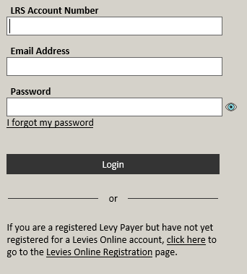  
3 | Enter your LRS account number, ABN (if applicable), registered email address and click ‘Register’.
4 | Enter the 6 digit security code sent to your registered email address or mobile.  Click ‘Submit’.  If you close the security code entry page the security code becomes invalid.  Security codes may be delayed during peak periods or when sent to remote locations.
5 | Enter a new password,  enter it again in the verify password field.  Click ‘Reset Password’.
6 | Click ‘Continue to Login’. | 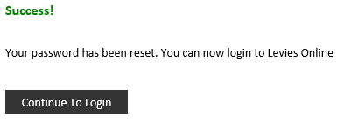
7 | Login to Levies Online. | See How to log in to Levies Online
8 | Update contact details and click ‘Save Changes’. | 

How to log in

1 | Navigate to Levies Online.
2 | Enter your LRS Account Number, registered email address, password and click ‘Login’.
3 | Enter the 6 digit security code sent to your registered email address or mobile and click ‘Submit’.  If you close the security code entry page the security code becomes invalid.  Security codes may be delayed during peak periods or when sent to remote locations.

How to reset your password

1 | Navigate to Levies Online.
2 | Click ‘I forgot my password’. | 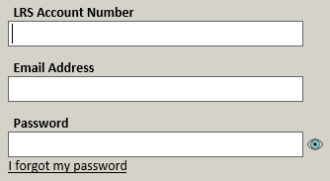
3 | Enter your LRS account number, registered email address and click ‘Submit’.
4 | Enter the 6 digit code sent to your registered email or mobile phone and click ‘Submit’.  If you close the security code entry page the security code becomes invalid.  Security codes may be delayed during peak periods or when sent to remote locations.
5 | Enter your new password,  re-enter your new password to verify. Click ‘Reset Password’.
6 | Click ‘Continue to Login’. | 

How to submit a return

Entering a return with levy payer data via file upload

1 | Click ‘My Returns’ on the left side of the screen. | 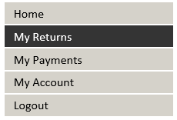
2 | Click ‘New Return’. | 
3 | Select your return type & period.  Click ‘Continue’. | 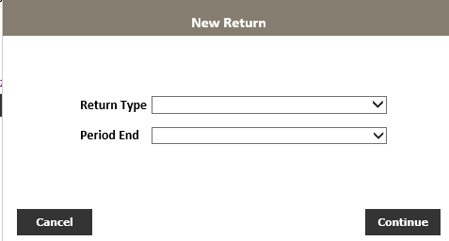
4 | Click the ‘Click here’ hyperlink to open the upload template.  Please download a new template from here each time you submit a new return to ensure that you are using the most up to date template | 
5 | Copy levy payer data from your system into the template. | See the ‘How to use the levy payer register upload template’ document specific to your industry, for more information on how to fill the template.
6 | In Levies Online, click ‘Upload File’. | 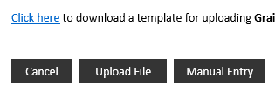
7 | Click Browse to find the .csv file you saved to your computer.
8 | Click on the file and click ‘Open’.  This may be different for MAC users | 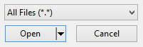
9 | Select your name from the Declaration Officer dropdown menu.  If your name is not available, click ‘Save and Exit’, and go to the My Account screen to add yourself as a contact.
10 | Click ‘I Declare’. | 
11 | Click ‘Upload File’. | 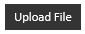
12 | You should see this popup on your screen, click ‘OK’.  If you receive an error message, refer to the Troubleshooting section of this document before contacting the department.
13 | You will be returned to the My Returns screen, the return should have the status Processing | 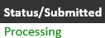
Proceed to How to pay.
Your file may take up to 24 hours to process. Once processed, you will receive an email confirming whether your return has been submitted or failed due to errors. (Email will be sent to the Declaration Officer selected)
14 | If submission has failed due to errors, log into Levies online. Click My Returns, click on the Red Error in the Status/Submitted column next to the return to download Error details. | 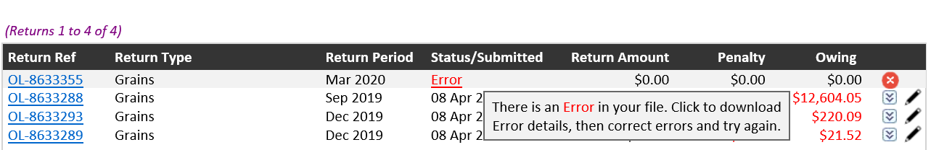
15 | If a popup appears, click ‘Open’.  This may be different for MAC users | 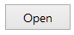
16 | To re-upload, update your original file or:  - update/fix all cells highlighted in red  - delete the Error Line No column  - delete rows below the bottom line of data  - save file as CSV  Refer to the Troubleshooting section in this document if you require assistance. | 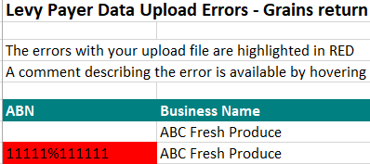
17 | Go back to step 7 and try again. If you continue to experience errors, please contact us for assistance.

Entering a return with levy payer data manually

1 | Click ‘My Returns’ on the left side of the screen.
2 | Click ‘New Return’.
3 | Select your return type & period.  Click ‘Continue’.
4 | Click ‘Manual Entry’. | 
5 | Enter the levy payer ABN, Business Name, Phone, Email and Address. Click ‘Save Levy Payer’. | 
6 | Select commodity type from the Levy/Commodity dropdown menu. | 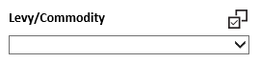
7 | Enter values (as required) of the commodity and click ‘Save Data’ to save.  Select the ‘Save Data’ button to save your Levy/Commodity data. The ‘Save Levy Payer’ button applies to the Levy Payer data only. It does not save the Levy/Commodity data. | 
8 | Repeat steps 6-7 for all transactions relating to this levy payer.
9 | Click ‘New Levy Payer’ to add details for any additional levy payer.  Repeat steps 5-7. | 
10 | When all data has been entered and saved click ‘Next Step’. | 
11 | Review return details.  Click the declaration tick-box.  Click ‘Submit Return’. | 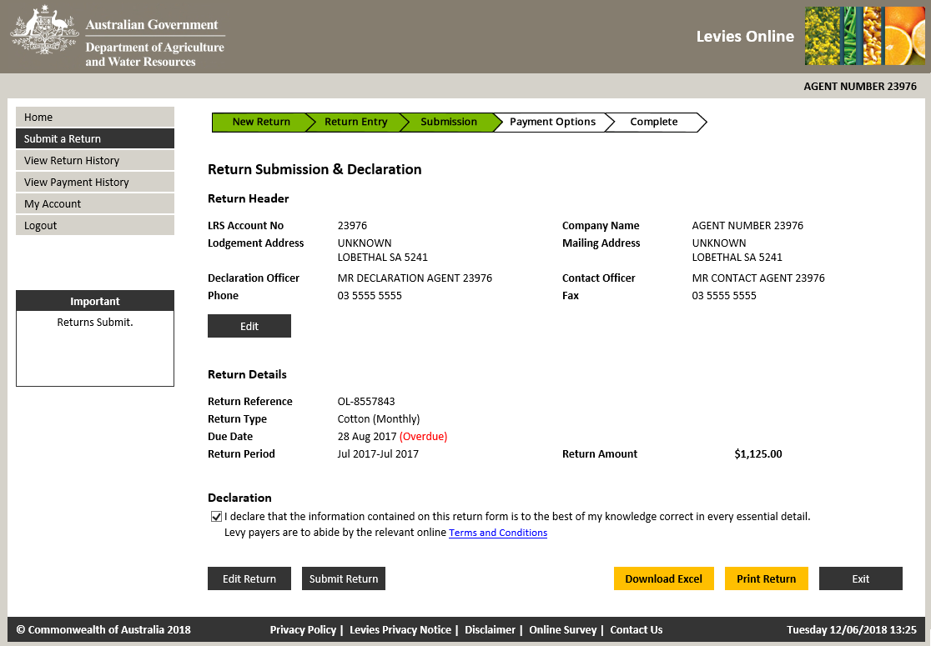
12 | Click ‘Ok’. | 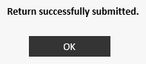
Proceed to How to pay. You will receive an email confirming your return has been successfully submitted.
(Email will be sent to the Online Administrator of the account)

Entering a NIL return
1 | Click ‘My Returns’ on the left side of the screen.
2 | Click ‘New Return’.
3 | Select your return type & period.  Click ‘Continue’.
4 | Click ‘Nil Return’ | 
5 | Click the declaration tick-box.  Click ‘Submit Return’.
6 | Click ‘Ok’.
You will receive an email confirming your return has been successfully submitted.
(Email will be sent to the Online Administrator of the account)

Primary producer lodging on their own behalf
1 | Click ‘My Returns’ on the left side of the screen.
2 | Click ‘New Return’.
3 | Select your return type & period.  Click ‘Continue’.
4 | Click ‘Manual Entry’.
5 | Enter your ABN, Business Name, Phone, Email and Address. Click ‘Save Levy Payer’.
6 | Select commodity type from the Levy/Commodity dropdown menu.
7 | Enter values (as required) of the commodity and click ‘Save Data’ to save.  Select the ‘Save Data’ button to save your Levy/Commodity data. The ‘Save Levy Payer’ button applies to the Levy Payer data only. It does not save the Levy/Commodity data.
8 | When all data has been entered, click ‘Save Data’ then click ‘Next Step’.
9 | Review return details.  Click the declaration tick-box.  Click ‘Submit Return’.
10 | Click ‘Ok’.
Proceed to How to pay. You will receive an email confirming your return has been successfully submitted.
(Email will be sent to the Online Administrator of the account)

How to amend a return via manual entry

1 | Click the ‘My Returns’ menu item on the left side of your screen.
2 | Click the pencil icon next to the return you wish to edit.
3 | Click Yes. | 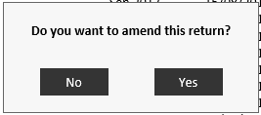
4 | Edit return amounts as required. | Click arrow to expand the row  Click the pencil icon to edit row  After you edit select Save Data   Click red cross to delete row of data
5 | Click Next Step. | 
6 | Review return details.  Click the declaration tick-box.  Click ‘Submit Return’.
7 | Click ‘Ok’.
If you amended the return to include additional figures, proceed to How to pay.
You will receive an email confirming your return has been successfully submitted.
(Email will be sent to the Online Administrator of the account)

How to amend a return via file upload

1 | Click the ‘My Returns’ menu item on the left side of your screen.
2 | Click the pencil icon next to the return you wish to edit.
3 | Click Yes.
4 | Click Browse to find the new file.
5 | Click on the file and click ‘Open’.  *This may be different for MAC users
6 | Select your name from the Declaration Officer dropdown menu.
7 | Click ‘I Declare’.
8 | Click ‘Upload File’.
9 | You should see this popup on your screen, click ‘OK’.  If you receive an error message, refer to the Troubleshooting section of this document before contacting the department.
10 | You will be returned to the My Returns screen, the return should have the status Processing
If you amended the return to include additional figures, proceed to How to pay.
Your file may take up to 24 hours to process. Once processed, you will receive an email confirming whether your return has been submitted or failed due to errors. (Email will be sent to the Declaration Officer selected)

How to pay

Unallocated Funds
1 | On the Return Summary screen, unallocated funds will default to selected.  The Adjusted Owing Balance will reflect return amount remaining to be paid.
2 | Click ‘Confirm’. | 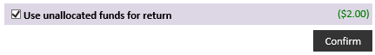
3 | The page will reload.  If you have penalty owing on the return and additional unallocated funds, it will default to selected.
4 | Click ‘Confirm’.

EFT
Deposit levy payment into the following account: | Bank: RESERVE BANK  Branch No: 092009  Account Number: 111700  Account Name: DAFF Official Administered Receipts  Payment Reference: Your LRS Account Number

Cheque or Money Order
1 | Navigate to the Return Summary screen and Click ‘Download Remittance’.
2 | Attach cheque or money order to the remittance and mail to: | Department of Agriculture, Water and the Environment - Levies  Locked Bag 4488  KINGSTON ACT 2604

How to request a refund
You will be able to request a refund if your account meets the following criteria:
- An unallocated amount (a credit)
- No debt
- No missing returns
1 | Click the ‘My Payments’ menu item on the left side of your screen. | 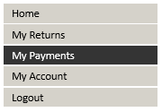
2 | Click the ‘Refund Request’ button at the bottom of the screen. (If this button is not available, contact us) | 
3 | If there is more than one receipt, use the tick boxes on the right side to select which ones you would like included.
4 | Click the ‘Next Step’ button. | 
5 | Enter your contact and banking details.  All fields are mandatory  BSB lookup function will populate your Bank Name
6 | Click the declaration tick-box.
7 | Click the ‘Submit Request’ button. | 
8 | You will be returned to the My Account screen.  To check your refund status; click the My Payments menu option on the left side of your screen.
9 | Click the ‘Refund Request’ button.
Your refund should have the status Refund Pending.

How to check if a return has been amended
1 | Click ‘My Returns’ on the left side of the page.
2 | Click the Return reference number. | 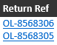
3 | Click ‘View Return’. | 
4 | Amended figures will be shown in red.  Hover over red figures to view amendment.

How to update your account details
1 | Click ‘My Account’ on the left side of your screen. | 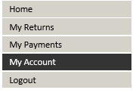
2 | Click ‘Edit Account Details’. | 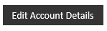
3 | Update the required fields.  Click ‘Save Changes’. | 

How to turn automatic reminders on or off
NB: If you registered for Levies Online AFTER May 2018, the automatic reminder option will have defaulted to On.
1 | Click ‘My Account’ on the left side of your screen.
2 | Click ‘Edit Account Details’.
3 | Click ‘On’ or ‘Off’ in the Return Reminders section. | 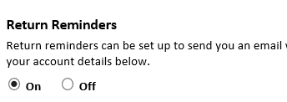
4 | Click ‘Save Changes’.

How to view your return history
Click the ‘My Returns’ menu item on the left side of your screen.

How to view your payment history
Click ‘My Payments’ on the left side of your screen.

How to add return types to your account
1 | Click ‘My Account’ on the left side of your screen.
2 | Scroll to the bottom of the page. Click ‘Add Return Type’ | 
3 | Select a return type from the drop down menu.  Click ‘Add New Return Type To Account’. | 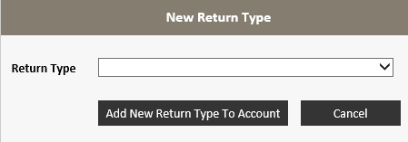

How to download a statement
1 | Click ‘My Returns’ on the left side of your screen.
2 | Click ‘Download Statement’.
3 | Click ‘Open’ when a popup appears on your screen, click ‘File’ in the top left of the screen, click ‘Print’. | 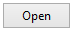

Troubleshooting
 | Problem | Solution
1 | The upload template will not upload. Upload Error message is displayed.  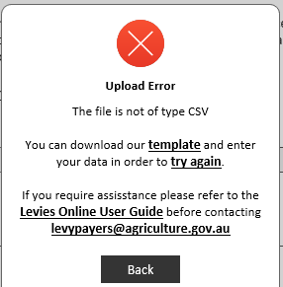 | Please check the following:  - If the template you are using was not downloaded from Levies Online it may not upload. Download a new template if required.  - The template must include correct column headings at the top of the document.  - The example data must be removed from the template prior to upload.  - The template must be saved as a CSV (Comma delimited) (*.csv) file.  - Contact the Levies team on 1800 022 384 or email your file to leviesonline@agriculture.gov.au if you require assistance.
2 | The upload template has uploaded successfully but it has errors | - Amend the return by uploading a corrected file.  - You can view more information about the error:  - select ‘My Returns’ from the menu  - select ‘Error’ in the Status/Submitted column to download Error File. Cell that are in error will be highlighted in red.  Please note that all fields are mandatory except for ABN. If the levy payer does not have a phone number this field can be left blank only if a valid email address is provided and vice versa.  - The phone number must be a 10 digit number and start with 0.  - The state must be in any of the following valid formats:  - ACT  - NSW  - NT  - QLD  - SA  - TAS  - VIC  - WA  - The file will not be accepted if the item tag field does not contain a valid item tag (specific to the return). The spelling and spacing must be exact, however the field is not case-sensitive. To view the item tag list please refer to the ‘How to use the levy payer register upload template’ document specific to your industry.

Contact Us
Free call 1800 022 384
Email leviesonline@agriculture.gov.au
Mail Department of Agriculture, Water and the Environment – Levies
Locked Bag 4488
KINGSTON ACT 2604

Glossary
CSV file Comma Separated Value file, created through excel
The Department The Department of Agriculture, Water and the Environment
Levies Online The online portal used to lodge levy returns to the Department
LRS Account Number Five digit number identifying your Levies account
Registered Email Address The email address provided to the Department

