## GENERAL SITUATION in November and OUTLOOK to February 2022

### Australian Plague Locust *Chortoicetes terminifera*

The locust population in inland eastern Australia likely remained at low levels except for the Riverina district of New South Wales where small Band-density nymphs and Low-Density Swarm adults were identified.

Limited surveys in mid-November detected only Isolated-density adults in parts of the Central West, Upper Western and Lower Western New South Wales, however several Band-density late-instar nymphs and Low-Density Swarm fledglings identified in the Jerilderie-Coleambally-Four Corners-Conargo areas of the Riverina district. A report of locusts swarming in the Hartwood area (between Conargo and Jerilderie) on 5 December was later (8 Dec) confirmed by one of NSW Local Land Service staff as Medium-Density Swarms with some individuals developing 2 mm eggs, and most November reports of locust bands assessed by LLS staff were also from the Riverina and surrounding areas.

The light-trap in White Cliffs captured 120 and over 1000 on the two consecutive nights of 5 – 6 November with zero captures on all other nights, reflecting some localised population activity. However, the light-trap in Fowlers Gap did not capture any locusts so far.

No surveys were conducted in Queensland, South Australia, and Victoria due to adverse weather, access and COVID constraints, but Agriculture Victoria staff confirmed low numbers of late instar nymphs and fledglings present in the Echuca-Cohuna-Bendigo areas in early December.

November Rainfall ranged from 25 mm to 270 mm over inland eastern Australia, with less in the arid interior. The monthly total is above average up to the highest on record, and rainfall events occurred in either early or late November. Monthly mean temperatures ranged from average to below average, mainly due to the below average to very much below average of the maximum temperatures although minimum temperatures were average over the majority of the inland. The higher amount of rainfall and lower temperature were driven by the established La Niña event in the tropical Pacific. The La Niña phenomenon is likely to be short-lived and may only persist until late summer or early autumn 2022. December rainfall is likely to be average for the north-western half but above average for the south-eastern half of the inland and therefore much wetter in NSW. Above average rainfall is forecast for the eastern part for January and the whole inland for February. Accordingly, maximum temperatures are forecast to be below average over the majority of NSW and adjacent Queensland areas for December, but above average for the western half of the inland for January, and average overall for February. Warmer minimum temperatures are likely except for averages over the eastern part of the inland. More rain is forecast for inland eastern Australia with habitat conditions continuing to improve for locust breeding.

The outlook for the summer of 2021-2022 is for an increase in the overall population level, with medium to high densities persisting in the NSW Riverina district and adjacent areas, but low densities with limited localised medium densities in other parts of inland eastern Australia.

It is likely that swarm formation will continue in the Riverina district with bands of summer generation developing from late December onwards. Under suitable weather conditions, some swarms may migrate/redistribute to adjacent districts. With sufficient November rainfall and a wetter summer forecast, a larger summer generation is likely following successful migration and breeding.

There is a moderate likelihood of region-wide infestations developing in the NSW Riverina and surrounding areas during summer but unlikely over the remainder of the inland eastern Australia.

**10 December 2021**

### Spur-throated Locust *Austracris guttulosa*

Limited surveys in mid-November identified occasional adults in Western New South Wales. However, based on previous survey findings of up to Concentration-density adults in the Central West and Central Highlands of Queensland, and more than 50 mm rainfall over most parts of Queensland inland (100 mm to over 200 mm were received in the southeast) in November, successful breeding must have occurred already, and this is evident after fully developed eggs were confirmed to be present in adults in the Longreach region in early December.

With more rainfall forecast for tropical and sub-tropical Queensland, successful breeding is likely to continue and result in more localised medium – high-density nymphs.

There is a medium risk of a widespread low-medium density infestation, and localised high-density infestations may develop in subtropical Queensland during summer.

### Migratory Locust *Locusta migratoria*

No surveys were conducted in Queensland in November and no migratory locusts were identified from surveys in New South Wales. However, both nymphs and adults were previously detected in the Central Highlands and surrounding areas of Queensland and breeding should have already occurred and continue following favourable November rainfall and the forecast wetter summer. Nevertheless, high-density gregarisation is unlikely to result from the current very low population level.

There is a very low risk of a widespread infestation developing during late spring and summer.

**It is important that any locust activity be reported as soon as possible to your local biosecurity authority, primary industries department or to the commission. A toll-free call to the APLC hotline can be made on 1800 635 962. An answering machine is attached to this phone for after-hours calls. Reports can also be emailed to APLC via** [**aplc@agriculture.gov.au**](mailto:aplc@agriculture.gov.au) **or made through the website at** [**https://www.agriculture.gov.au/pests-diseases-weeds/locusts/landholders/reporting_locusts**](https://www.agriculture.gov.au/pests-diseases-weeds/locusts/landholders/reporting_locusts)**.**

### Locust distribution map—*Chortoicetes terminifera*

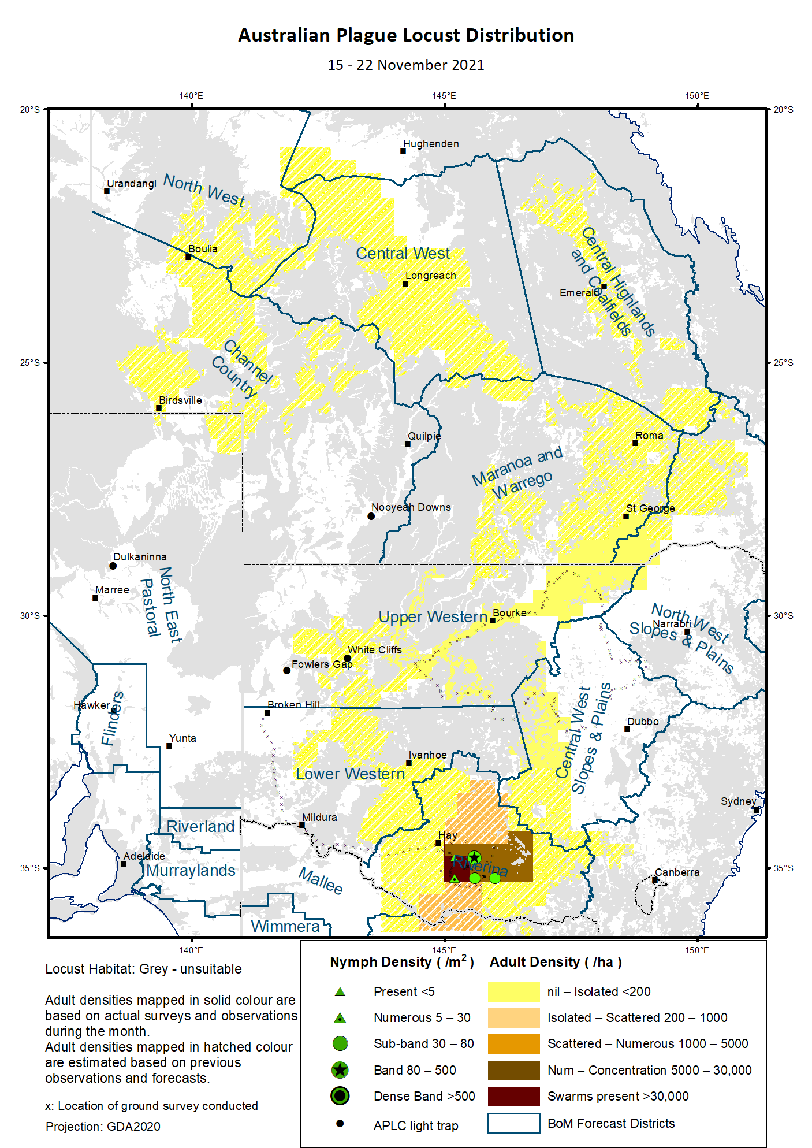

# Australian Plague Locust (*Chortoicetes terminifera*)

## SITUATION in November and OUTLOOK to February 2022

#### NEW SOUTH WALES

##### NORTH WEST SLOPES & PLAINS

###### Northwest Local Land Services

Locusts and conditions

* No surveys were conducted in this district in November.
* No further locust reports were received from this district in November.
* This region received 100 – 300 mm rainfall in November, ranging from very much above average to highest on record.

Forecast

* Under very wet conditions, only limited localised breeding is possible. The general population density is expected to be at low levels.
* There is a low probability of any significant migration during summer.

Risks

* There is a low risk of a widespread regional infestation developing during summer.

##### CENTRAL WEST SLOPES & PLAINS

###### Central West Local Land Services

Locusts and conditions

* Surveys in mid-November only identified occasional Isolated-density adults in the Nyngan area.
* No locust reports were received from this district in November.
* This region received 100 – 200 mm rainfall in most parts in November, ranging from very much above average to highest on record.

Forecast

* Localised breeding is possible, but general population level is likely to remain low.
* There is a low probability of any significant migration during summer.

Risks

* There is a low risk of widespread regional infestations developing during summer.

##### RIVERINA

###### Riverina, Murray, and part of Western Local Land Services

Locusts and conditions

* Surveys mid-November identified localised Band-density late instar nymphs and up to Low-Density Swarm newly fledged adults in the Jerilderie-Coleambally-Four Corners-Conargo areas. Hatchlings and early instar nymphs were also present, indicating continuous hatching occurred.
* A report of locusts swarming in the Hartwood area (between Conargo and Jerilderie) on 5 December was later (8 Dec) confirmed by one of LLS staff with 2 mm eggs in development among some adults sampled from several Medium-Density Swarms.
* Thirteen more locust reports were investigated/are under investigation by LLS officers in November, with confirmed bands and swarms in the Jerilderie-Four Corners and the Deniliquin-Mathoura areas.
* The UNSW insect monitoring radar in Hay did not detect any locust migration.
* November rainfall ranged from 40 mm in the western part to more than 200 mm in the eastern part of this district, at very much above average to highest on record levels.

Forecast

* Undetected and uncontrolled locust populations could multiply rapidly under favourable habitat conditions. As no evidence showed any significant emigration had occurred, summer generation could start to hatch from late December onwards in this district.
* Swarm formation will be visible under clear warmer weather, and swarms can travel 20-30 km at daytime regardless wind direction but most likely under light winds.
* There is a moderate to high probability of redistribution/migration within the district and to adjacent regions under suitable weather patterns. A successful nocturnal migration could cover a distance of 50 km to 200 km, by the adults from both solitary and gregarious (swarm) populations.

Risks

* There is a moderate risk of a widespread infestation developing during summer.

##### UPPER and LOWER WESTERN

###### Western Local Land Services

Locusts and conditions

* Surveys in mid-November identified only occasional Isolated-density adults in the eastern part of Upper Western district. No locusts were detected in the south-western part of Lower Western district.
* No locust reports were received from this district in November.
* The light trap at White Cliffs captured 120 and over 1000 on the two consecutive nights of 5 – 6 November with zero capture on all other nights, reflecting the occurrence and movement of some local populations. The light trap at Fowlers Gap, on the other hand, did not capture any locusts in November.
* November rainfall ranged from just above 20 mm in the north-western corner to over 100 mm in the eastern part of this district, above average to highest on record.

Forecast

* Locust numbers are likely to be low in this district, but some localised medium density populations could develop.
* There is a moderate likelihood of some immigration from the Riverina district during summer.

Risks

* There is a low risk of a widespread infestation developing during summer.

**All locust activity should be reported to your** [**Local Land Services**](https://www.lls.nsw.gov.au/) **(1300 795 299) or the** [**Department of Primary Industries**](https://www.dpi.nsw.gov.au/climate-and-emergencies/locusts)**. A toll-free call to the APLC hotline can be made on 1800 635 962. An answering machine is attached to this phone for after-hours calls. Reports can also be emailed to APLC via** [**aplc@agriculture.gov.au**](mailto:aplc@agriculture.gov.au) **or sent through the web page at** [**https://www.agriculture.gov.au/pests-diseases-weeds/locusts/landholders/reporting_locusts**](https://www.agriculture.gov.au/pests-diseases-weeds/locusts/landholders/reporting_locusts)**.**

#### QUEENSLAND

##### CENTRAL HIGHLANDS AND COALFIELDS

###### Isaac and Central Highlands Regional Councils; Banana Shire

Locusts and conditions

* No surveys were conducted in this district in November.
* No reports of locust activity were received from this district.
* November rainfall ranged from 50 mm to 270 mm, with most of the district receiving more than 100 mm. The rainfall distribution was not even, from average in the north-eastern corner to highest on record in the southern part.

Forecast

* Localised breeding was possible, but the population is likely to be at low levels based on previous low background population.
* There is a low probability of migration during summer.

Risks

* There is a low risk of a widespread infestation developing in summer.

##### DARLING DOWNS AND GRANITE BELT

###### Western Downs and Goondiwindi Regional Councils

Locusts and conditions

* No surveys were conducted in this district in November.
* No locust reports were received from this district.
* November rainfall ranged from 100 mm to nearly 250 mm, at very much above average to highest on record.

Forecast

* Sporadic breeding was possible, but only a low-density population is expected.
* There is a low probability of migration in summer.

Risks

* There is a low risk of a widespread infestation developing during summer.

##### CENTRAL WEST

###### Barcaldine, Longreach, and Blackall-Tambo Regional Council; Flinders and Winton Shires

Locusts and conditions

* No surveys were conducted in this district in November.
* No locust reports were received from this district.
* November rainfall ranged from 50 mm to nearly 250 mm with heavy falls in the eastern part of this district, with most parts receiving very much above average.

Forecast

* Sporadic breeding may result in development of some low-density populations.
* There is a low probability of redistribution and migration in summer.

Risks

* There is a low risk of a widespread infestation in summer.

##### MARANOA AND WARREGO

###### Maranoa Regional Council; Murweh, Paroo, and Balonne Shires

Locusts and conditions

* No surveys were conducted in this district in November.
* No locust reports were received from this district.
* November rainfall ranged from 250 mm down to 50 mm, generally in the NE-SW gradient but all at very much average levels historically.

Forecast

* Locust numbers are likely to remain low with some localised breeding possible.
* There is a low probability of migration in summer.

Risks

* There is a low risk of a widespread infestation in summer.

##### NORTH WEST

###### Mt Isa, Cloncurry, McKinlay, Boulia, and Winton Shires

Locusts and conditions

* No surveys were conducted in this district in November.
* No locust reports were received from this district.
* November rainfall ranged from 40 mm to 80 mm, ranging from above average to very much above average levels.

Forecast

* Locust numbers are likely to remain at low levels, but sporadic localised breeding may occur in some areas.
* There is a low probability of migration activity during summer.

Risks

* There is a low risk of a widespread infestation developing during summer.

##### CHANNEL COUNTRY

###### Boulia, Diamantina, Barcoo, Quilpie, and Bulloo Shires

Locusts and conditions

* No surveys were conducted in this district in November.
* No locust reports were received from this district.
* November rainfall ranged from 20 mm to 80 mm, at average – above average levels historically.

Forecast

* Locust numbers are likely to remain at low level during summer. Some sporadic localised breeding is possible.
* There is a low probability of significant migration activity in summer.

Risks

* There is a low risk of a widespread infestation developing during summer.

**All locust activity should be reported the** [**Biosecurity Queensland (Department of Agriculture and Fisheries)**](https://www.daf.qld.gov.au/business-priorities/biosecurity) **via the** [**Customer Service Centre**](https://www.daf.qld.gov.au/contact/customer-service-centre) **on 13 25 23. A toll-free call to the APLC hotline can be made on 1800 635 962. An answering machine is attached to this phone for after-hours calls. Reports can also be emailed to APLC via** [**aplc@agriculture.gov.au**](mailto:aplc@agriculture.gov.au) **or sent through the website at** [**https://www.agriculture.gov.au/pests-diseases-weeds/locusts/landholders/reporting_locusts**](https://www.agriculture.gov.au/pests-diseases-weeds/locusts/landholders/reporting_locusts)**.**

#### SOUTH AUSTRALIA

##### NORTH EAST PASTORAL and FLINDERS

Locusts and conditions

* No surveys were conducted in this district in November.
* The Dulkaninna light-trap did not capture any locusts.
* No locust reports were received from this district.
* November rainfall ranged from 20 mm to over 100 mm, at above average to very much above average levels historically.

Forecast

* Locust numbers are likely to remain low, although some sporadic breeding may occur.
* There is a low probability of migration during summer.

Risks

* There is a very low risk of a widespread infestation developing during summer.

##### RIVERLAND and MURRAYLANDS

Locusts and conditions

* No surveys were conducted in this district in November.
* No locust reports were received from this district.
* November rainfall ranged from 20 mm to 60 mm, which were at the historic average to very much above average levels.

Forecast

* The locust population is likely to remain at very low densities.
* There is a low probability of migration during summer.

Risks

There is a very low risk of a widespread infestation developing during summer.

**Locust activity should be reported to** [**Biosecurity SA (Primary Industries and Regions South Australia)**](https://www.pir.sa.gov.au/biosecurity) **via the Plant Health Hotline on 1300 666 010.** **A toll-free call to the APLC hotline can be made on 1800 635 962. An answering machine is attached to this phone for after-hours calls. Reports can also be emailed to APLC via** [**aplc@agriculture.gov.au**](mailto:aplc@agriculture.gov.au) **or sent through the website at** [**https://www.agriculture.gov.au/pests-diseases-weeds/locusts/landholders/reporting_locusts**](https://www.agriculture.gov.au/pests-diseases-weeds/locusts/landholders/reporting_locusts)**.**

#### VICTORIA

##### MALLEE

**Mildura and Swan Hill Rural Cities; Yarriambiack and Buloke Shires**

Locusts and conditions

* No surveys were conducted in this district in November.
* No locust reports were received from this district.
* November rainfall ranged from 20 mm to 80 mm, at average to very much above average levels.

Forecast

* Locust numbers are likely to remain at low levels with some sporadic localised breeding possible.
* There is a low-medium probability of immigration during early summer, most likely from the NSW Riverina district.

Risks

* There is a low risk of a widespread infestation developing during summer.

##### WIMMERA

**Hindmarsh and West Wimmera Shires**

Locusts and conditions

* No surveys were conducted in this district in November.
* No locust reports were received from this district.
* November rainfall ranged from 20 mm to over 100 mm, varying from below average to very much above average levels historically.

Forecast

* Locust numbers are likely to remain at low levels with possible localised breeding.
* There is a low probability of migration during summer.

Risks

* There is a low risk of a widespread infestation developing during summer.

**Locust activity should be reported to the** [**Agriculture Victoria**](https://agriculture.vic.gov.au/)[**Customer Contact Centre**](https://agriculture.vic.gov.au/about/contact-us) **on 136 186. Alternatively, you can make a report via the online form at**[**https://forms.bio.vic.gov.au/2020**](https://forms.bio.vic.gov.au/2020)**.  Please include photos where possible. A toll-free call to the APLC hotline can be made on 1800 635 962. An answering machine is attached to this phone for after-hours calls. Reports can be emailed to APLC via** [**aplc@agriculture.gov.au**](mailto:aplc@agriculture.gov.au) **or sent through the website at** [**https://www.agriculture.gov.au/pests-diseases-weeds/locusts/landholders/reporting_locusts**](https://www.agriculture.gov.au/pests-diseases-weeds/locusts/landholders/reporting_locusts).

# Glossary of locust terms and density categories used in the Locust Bulletin

**Locust biology and behaviour**

|  |  |
| --- | --- |
| **Term** | **Definition** |
| adult | A fully winged, mature locust capable of breeding and migrating |
| band | Dense aggregation of nymphs, usually moving forward together |
| diapause | Period of dormancy induced in anticipation of unfavourable environmental conditions |
| egg bed | An area of soil containing many egg pods (hundreds per square metre) |
| fledge | Final nymphal moult to a soft-bodied adult incapable of long-distance flight |
| instar | Discrete stages of nymphal development each separated by a moult |
| laying | Female locusts depositing clutches of 20 – 60 eggs into the ground in froth-lined egg pods |
| nymph | Juvenile wingless locust. Often referred to as the hopper stage |
| swarm | Dense aggregation of adults, milling at the same spot or flying closely together |

###### Locust density categories

Where higher densities occur, a large proportion of the regional population is concentrated in very small areas with lower densities elsewhere, so the higher densities cannot be extrapolated over the area of an entire region. A range of density classes is usually found within a surveyed region.

|  |  |  |
| --- | --- | --- |
| **Nymph Densities** | **Number per m2** |  |
| Present | 1 – 5 |  |
| Numerous | 6 – 30 |  |
| Sub-band | 31 – 80 |  |
| Band | 81 – 500 |  |
| Dense Band | >500 |  |
|  |  |  |
| **Adult Densities** | **Number per m2** | **Number per 250 m2** |
| Isolated | – 0.02 | 1 5 |
| Scattered | 0.024 – 0.1 | 6 – 25 |
| Numerous | 0.104 – 0.5 | 26 – 125 |
| Concentration | 0.504 – 3 | 126 – 750 |
| Low Density Swarm | 4 – 10 | 751 – 2,500 |
| Medium Density Swarm | 11 – 50 | 2,501 – 12,500 |
| High Density Swarm | >50 | >12,500 |
|  |  |  |
| **General density classes** | **Nymph densities** | **Adult densities** |
| very low, occasional | Nil – Present | Nil – Isolated |
| low | Present – Numerous | Isolated – Scattered |
| medium | Numerous – Sub-band | Scattered – Numerous |
| high | Bands | Concentration – Swarms |

###### Reporting locust infestations

It is important that all locust activity is reported as soon as possible to your nearest state agriculture agency office or to the Australian Plague Locust Commission.

|  |  |
| --- | --- |
| **State** | **Authority for reporting locusts** |
| New South Wales | Local Land Services (LLS) or Department of Primary Industries |
| Queensland | Biosecurity Queensland, Department of Agriculture and Fisheries |
| South Australia | Biosecurity SA, Department of Primary Industries & Regions |
| Victoria | Biosecurity and Agriculture Services, Department of Jobs, Precincts and Resources |

Reports to the **Australian Plague Locust Commission** can be made by:

Free call (Canberra): 1800 635 962 (24 hours)

Fax (Canberra): (02) 6272 5074

Email: [aplc@agriculture.gov.au](mailto:aplc@agriculture.gov.au)

Website: <https://www.agriculture.gov.au/pests-diseases-weeds/locusts/landholders/reporting_locusts>