## GENERAL SITUATION in November and OUTLOOK to February 2024

### Australian Plague Locust *Chortoicetes terminifera*

Locust populations remained at very low levels across inland eastern Australia. Surveys conducted in November identified Isolated-density adults in the Central West and North West Queensland. Sporadic Isolated-density adults were also identified in New South Wales and South Australia with occasional Scattered/Low-Numerous density adults detected in SA Flinders. No nymphs were detected by November survey. The light-trap at Nooyeah Downs, Thargomindah of Queensland, captured 8 adults on the night of 2-3 December, reflecting some localised locust activities. There were no captures recorded on other APLC light traps in NSW (Fowlers Gap and White Cliffs) and SA (Dulkaninna), nor any significant flights detected by the UNSW insect monitoring radar in Hay, NSW. There were also no reports of locust activities received in November.

The rainfall totals in November were 50-200 mm, ranging above average to very much above average levels, over the eastern part of inland eastern Australia, and less than 10 mm at average to below average levels over the arid interior. The mean temperatures in November were 1-3 degrees above averages, ranging above average to very much above average levels, over much of the inland eastern Australia except the Central Highlands of Queensland where temperatures were at average levels. The mild El Niño event is likely to continue to early autumn 2024. Thus, slightly below average rainfall and warmer temperatures are expected for summer.

The outlook for summer is for overall low-level populations across inland eastern Australia, with possible localised population increases to low-medium levels under favourable habitat conditions as a result from November rains. Summer generation nymphs are likely to hatch from early December onwards, but majority may appear after mid-December. It is unlikely that any significant bands or swarms will develop during summer, nor are any significant migrations likely to occur.

There is a very low likelihood of widespread infestations developing during summer.

**07 December 2023**

### Spur-throated Locust *Austracris guttulosa*

The overall population remained at low levels. Surveys in early November identified widespread Isolated–Scattered-density and occasional Low-Numerous density adults in the Central West and North West Queensland. Surveys in mid-November also identified occasional Isolated-density adults in New South Wales and South Australia. No nymphs were detected by survey, reflecting no early breeding occurred under continuous drought conditions. No captures were recorded on APLC light traps at Nooyeah Downs (Qld), Dulkaninna (SA), White Cliffs (NSW) and Fowlers Gaps (NSW). Habitat conditions would have improved significantly where November rainfall totals were more than 50 mm (much of the eastern part of inland), breeding was likely to have been undergoing in favourable habitats and nymph hatching is likely to commence from mid-December onwards.

There is a low risk of a widespread infestation developing during summer. However, a moderate population increase is expected with some localised high densities of nymphs hatching during summer.

### Migratory Locust *Locusta migratoria*

The overall population was likely to have remained at very low levels. No locusts were detected in areas surveyed in November. The usual occurrence area of southeastern Queensland had heavy rainfalls in November, and breeding was likely to have been occurring in these areas.

Localised breeding is possible under favourable habitat conditions produced from heavy November rains. However, high-density infestations are unlikely to result from currently very low background population levels.

There is a very low risk of a widespread infestation developing during summer.

**It is important that any locust activity be reported as soon as possible to your local biosecurity authority or to the Australian Plague Locust Commission. A toll-free call to the APLC hotline can be made on 1800 635 962. An answering machine is attached to this phone for after-hours calls. Reports can also be emailed to APLC via** [**aplc@agriculture.gov.au**](mailto:aplc@agriculture.gov.au) **or made through the website at** [**https://www.agriculture.gov.au/pests-diseases-weeds/locusts/landholders/reporting_locusts**](https://www.agriculture.gov.au/pests-diseases-weeds/locusts/landholders/reporting_locusts)**.**

### Locust distribution map—*Chortoicetes terminifera*

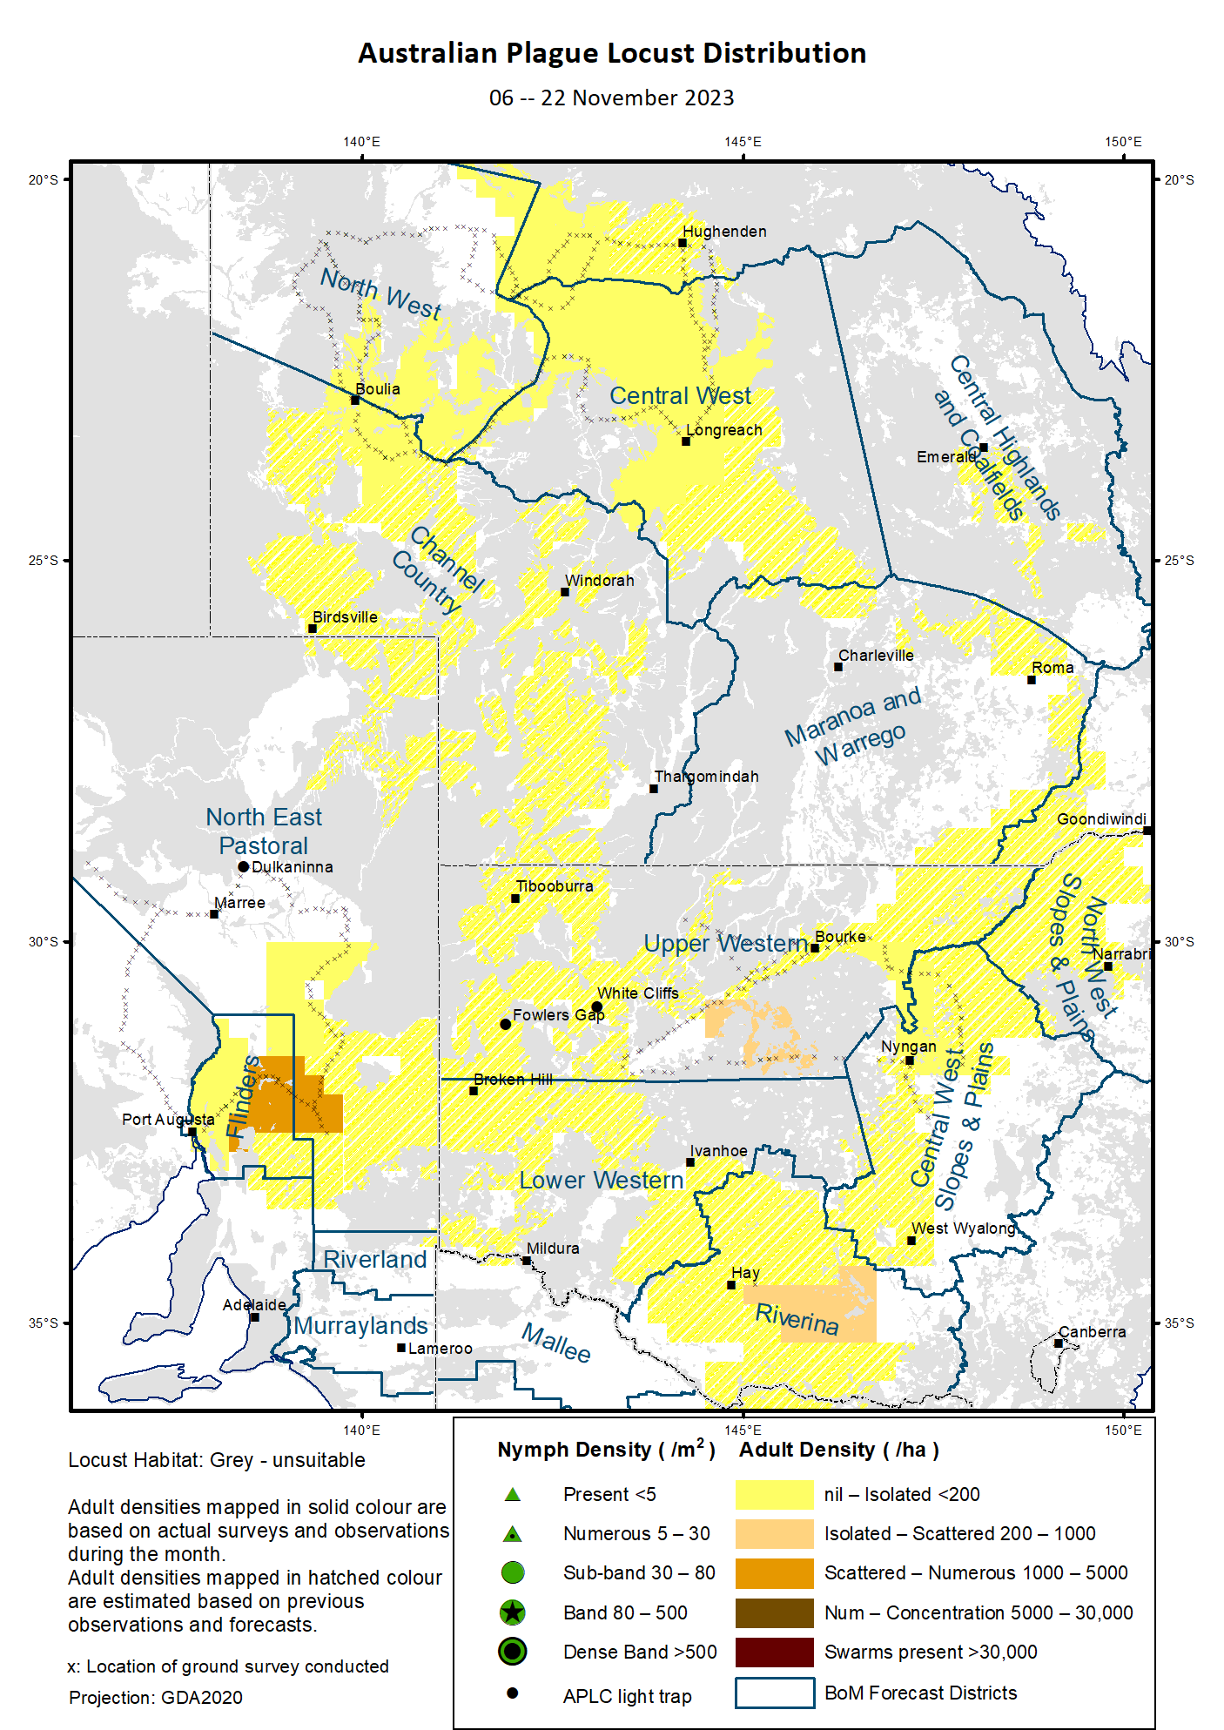

# Australian Plague Locust (*Chortoicetes terminifera*)

## SITUATION in November and OUTLOOK to February 2024

#### NEW SOUTH WALES

##### NORTH WEST SLOPES & PLAINS

###### Northwest Local Land Services

Locusts and conditions

* No surveys were conducted in this district in November.
* No locust reports were received from this district in November.
* This district received 60–150 mm of rainfall in November, ranging from average to very much above average levels.

Forecast

* Limited breeding is likely underway but unlikely to result into high-density populations from currently very low background levels. Nymphs are likely to hatch from early December onwards.
* There is a very low probability of any significant migrations during summer.
* The general population density is expected to remain at low levels during summer.

Risks

* There is a very low risk of a regional infestation developing during summer.

##### CENTRAL WEST SLOPES & PLAINS

###### Central West Local Land Services

Locusts and conditions

* Surveys in mid-November identified occasional Isolated-density adults in this district with no nymphs detected.
* No locust reports were received from this district in November.
* This district received 40–125 mm of rainfall in November, ranging generally from above average to very much above average levels.

Forecast

* Limited breeding is likely to occur but unlikely to be widespread or result into high numbers.
* There is a very low probability of any significant migrations during summer.
* The general population density is expected to remain at low levels during summer.

Risks

* There is a very low risk of regional infestations developing during summer.

##### RIVERINA

###### Riverina, Murray Local Land Services

Locusts and conditions

* Limited surveys in November identified occasional Scattered-density adults in this district with no nymphs detected.
* No reports of locust activity were received from this district in November.
* The UNSW insect monitoring radar in Hay did not detect any significant overflight locusts in November.
* This district received from 25 to over 100 mm of rainfall in November, ranging from average to very much above average levels.

Forecast

* Limited breeding is likely to occur under favourable habitats, but bands or swarms are unlikely to form during summer. Nymph hatching may commence from late December.
* There is a very low probability of any significant migration/dispersal events during summer.
* The population level is likely to be low for summer.

Risks

* There is a low risk of regional infestation developing during summer.

##### UPPER and LOWER WESTERN

###### Western Local Land Services

Locusts and conditions

* Surveys in the Upper Western district in mid-November identified occasional Isolated-Scattered density adults with no nymphs detected. No surveys were conducted in the Lower Western district in November.
* No reports of locust activity were received from these two districts in November.
* The light traps at White Cliffs and Fowlers Gap did not capture any locusts in November.
* These two districts received nearly nil rainfall in the northwest to over 100 mm of rainfall in the northeast in November, ranging from average to very much above average levels.

Forecast

* Some localised sporadic breeding is possible under favourable habitat conditions, but any resulting population is likely to remain at low levels. Summer nymphs may hatch from mid-December onwards.
* There is a low probability of any significant migration/dispersal events during summer.
* Bands and warms are unlikely to form during summer. Population level is likely to remain low.

Risks

* There is a low risk of regional infestations developing during summer.

**All locust activity should be reported to your** [**Local Land Services**](https://www.lls.nsw.gov.au/) **(1300 795 299) or the** [**Department of Primary Industries**](https://www.dpi.nsw.gov.au/climate-and-emergencies/locusts)**. A toll-free call to the APLC hotline can be made on 1800 635 962. An answering machine is attached to this phone for after-hours calls. Reports can also be emailed to APLC via** [**aplc@agriculture.gov.au**](mailto:aplc@agriculture.gov.au) **or sent through the web page at** [**https://www.agriculture.gov.au/pests-diseases-weeds/locusts/landholders/reporting_locusts**](https://www.agriculture.gov.au/pests-diseases-weeds/locusts/landholders/reporting_locusts)**.**

#### QUEENSLAND

##### CENTRAL HIGHLANDS AND COALFIELDS

###### Isaac and Central Highlands Regional Councils; Banana Shire

Locusts and conditions

* No surveys were conducted in this district in November.
* No reports of locust activity were received from this district in November.
* This district received from 50 mm to over 200 mm of rainfall in November, ranging from average to very much above average levels.

Forecast

* Localised breeding was likely to have been occurring under favourable habitat conditions and nymph hatching may commence from early December onwards, but any resulting population is likely to remain at low levels.
* There is a very low probability of any significant migration events during summer.

Risks

* There is a very low risk of a regional infestation developing during summer.

##### DARLING DOWNS AND GRANITE BELT

###### Western Downs and Goondiwindi Regional Councils

Locusts and conditions

* No surveys were conducted in this district in November.
* No locust reports were received from this district in November.
* This district received from 60 mm to over 150 mm of rainfall in November, ranging generally above average to very much above average levels.

Forecast

* Sporadic breeding was likely to have been occurring and nymph hatching may commence from early December onwards, but any resulting population is likely to remain at low levels.
* There is a very low probability of any significant migration events during summer.

Risks

* There is a very low risk of a regional infestation developing during summer.

##### CENTRAL WEST

###### Barcaldine, Longreach, and Blackall-Tambo Regional Council; Flinders and Winton Shires

Locusts and conditions

* Surveys in early November identified some Isolated-density adults in this district with no nymphs detected.
* No locust reports were received from this district in November.
* This district received 30–200 mm of rainfall in November with higher volume in the east, ranging above average to very much average levels.

Forecast

* Some sporadic breeding was likely to have been occurring and nymph hatching may commence from early December onwards, but any resulting population is likely to remain at low levels.
* There is a very low probability of any significant migration events during summer.

Risks

* There is a very low risk of a regional infestation developing during summer.

##### MARANOA AND WARREGO

###### Maranoa Regional Council; Murweh, Paroo, and Balonne Shires

Locusts and conditions

* No surveys were conducted in this district in November.
* No locust reports were received from this district in November.
* This district received 50 mm to over 150 mm of rainfall over much of this district in November, ranging generally above average to very much above levels.

Forecast

* Sporadic breeding is possible, and nymphs may start to appear from early December onwards. However, any resulting population is likely to remain at low levels.
* There is a very low probability of any significant migration events during summer.

Risks

* There is a very low risk of a regional infestation developing during summer.

##### NORTH WEST

###### Mt Isa, Cloncurry, McKinlay, Boulia, and Winton Shires

Locusts and conditions

* Surveys in early November identified some Isolated-density adults in this district with no nymphs detected.
* No locust reports were received from this district in November.
* This district received 15 mm to over 100 mm of rainfall in November with higher volume in the northwest, ranging from average to very much above average levels.

Forecast

* Sporadic breeding is possible in suitable habitats, but locust population is likely to remain at low levels.
* There is a very low probability of any significant migration/redistribution events during summer.

Risks

* There is a low risk of a regional infestation developing during summer.

##### CHANNEL COUNTRY

###### Boulia, Diamantina, Barcoo, Quilpie, and Bulloo Shires

Locusts and conditions

* Limited surveys in early November identified some Isolated-density adults in the northern border region of this district. No nymphs were detected by survey.
* No locust reports were received from this district in November.
* This district received 5–70 mm of rainfall in November, generally at above average levels with parts at average or very much above average levels.

Forecast

* Sporadic breeding is possible along drainages and under favourable habitat conditions, but any resulting population is likely to remain at low levels.
* There is a very low probability of migration/redistribution events during summer.

Risks

* There is a low risk of a regional infestation developing during summer.

**All locust activity should be reported the** [**Biosecurity Queensland (Department of Agriculture and Fisheries)**](https://www.daf.qld.gov.au/business-priorities/biosecurity) **via the** [**Customer Service Centre**](https://www.daf.qld.gov.au/contact/customer-service-centre) **on 13 25 23. A toll-free call to the APLC hotline can be made on 1800 635 962. An answering machine is attached to this phone for after-hours calls. Reports can also be emailed to APLC via** [**aplc@agriculture.gov.au**](mailto:aplc@agriculture.gov.au) **or sent through the website at** [**https://www.agriculture.gov.au/pests-diseases-weeds/locusts/landholders/reporting_locusts**](https://www.agriculture.gov.au/pests-diseases-weeds/locusts/landholders/reporting_locusts)**.**

#### SOUTH AUSTRALIA

##### NORTH EAST PASTORAL and FLINDERS

Locusts and conditions

* Surveys in mid-November identified occasional Isolated-density adults in the North East Pastoral district and consistent Isolated-density and occasional Low-Numerous density adults in the Flinders district. No nymphs were detected by survey.
* No locust reports were received from this district in November.
* The light-trap at Dulkaninna did not capture any locusts in November.
* November rainfall totals were less than 25 mm over much of northern North East Pastoral and Flinders districts while the southern part received 25–50 mm of rainfall, generally at average levels but with parts below average or above average levels.

Forecast

* Limited sporadic breeding is possible under favourable habitats, but any resulting population is likely to remain at low levels.
* Locust bands and swarms are unlikely to develop during summer.
* There is a low probability of any significant migration/dispersal events during summer.

Risks

* There is a low risk of a regional infestation developing during summer.

##### RIVERLAND and MURRAYLANDS

Locusts and conditions

* No surveys were conducted in the two districts in November.
* No locust reports were received from these two districts in November.
* These districts received 30–70 mm of rainfall in November, ranging above average to very much above average levels.

Forecast

* Limited sporadic breeding is possible, but any resulting population is likely to remain at low levels.
* There is a very low probability of any significant migration/dispersal events during summer.

Risks

* There is a very low risk of a regional infestation developing during summer.

**Locust activity should be reported to** [**Biosecurity SA (Primary Industries and Regions South Australia)**](https://www.pir.sa.gov.au/biosecurity) **via the Plant Health Hotline on 1300 666 010.** **A toll-free call to the APLC hotline can be made on 1800 635 962. An answering machine is attached to this phone for after-hours calls. Reports can also be emailed to APLC via** [**aplc@agriculture.gov.au**](mailto:aplc@agriculture.gov.au) **or sent through the website at** [**https://www.agriculture.gov.au/pests-diseases-weeds/locusts/landholders/reporting_locusts**](https://www.agriculture.gov.au/pests-diseases-weeds/locusts/landholders/reporting_locusts)**.**

#### VICTORIA

##### MALLEE

**Mildura and Swan Hill Rural Cities; Yarriambiack and Buloke Shires**

Locusts and conditions

* No surveys were conducted in this district in November.
* No reports were received from this district in November.
* This district received 30–60 mm of rainfall in November, ranging above average to very much above average levels.

Forecast

* Localised breeding is possible under favourable habitats, but any resulting population is likely to remain at low levels. Nymphs may start to appear from late December onwards.
* It is unlikely that any bands or swarms develop during summer.
* There is a low probability of any significant migration events during summer.

Risks

* There is a low risk of a regional infestation developing during summer.

##### WIMMERA

**Hindmarsh and West Wimmera Shires**

Locusts and conditions

* No surveys were conducted in this district in November.
* No locust reports were received from this district in November.
* This district received 30–70 mm of rainfall in November, ranging from average to above average levels.

Forecast

* Limited sporadic breeding is possible under suitable habitat conditions, but any resulting population is likely to remain at low levels.
* It is unlikely that any bands or swarms develop during summer.
* There is a low probability of any significant migration events during summer.

Risks

* There is a very low risk of a regional infestation developing during summer.

**Locust activity should be reported to the** [**Agriculture Victoria**](https://agriculture.vic.gov.au/)[**Customer Contact Centre**](https://agriculture.vic.gov.au/about/contact-us) **on 136 186. Alternatively, you can make a report via the online form at**[**https://forms.bio.vic.gov.au/2020**](https://forms.bio.vic.gov.au/2020)**. Please include photos where possible. A toll-free call to the APLC hotline can be made on 1800 635 962. An answering machine is attached to this phone for after-hours calls. Reports can be emailed to APLC via** [**aplc@agriculture.gov.au**](mailto:aplc@agriculture.gov.au) **or sent through the website at** [**https://www.agriculture.gov.au/pests-diseases-weeds/locusts/landholders/reporting_locusts**](https://www.agriculture.gov.au/pests-diseases-weeds/locusts/landholders/reporting_locusts).

# Glossary of locust terms and density categories used in the Locust Bulletin

**Locust biology and behaviour**

|  |  |
| --- | --- |
| **Term** | **Definition** |
| adult | A fully developed, mature locust capable of breeding and migrating |
| band | Dense congregation of nymphs, usually marching together |
| diapause | Period of dormancy induced in anticipation of unfavourable environmental conditions |
| egg bed | An area of soil containing many egg pods (hundreds per square metre) |
| fledge | Final nymphal moult to a soft-bodied adult (fledgling) incapable of long-distance flight |
| hatch | A young nymph (hatchling) newly emerged from an egg |
| instar | Discrete stages of nymphal development each separated by a moult |
| laying | Female locusts depositing clutches of 20–60 eggs into the ground in froth-lined egg pods |
| nymph | An immature locust. Often referred to as the hopper stage |
| swarm | Dense congregation of adults, milling at the same spot or flying closely together |

###### Locust density categories

Where higher densities occur, a large proportion of the regional population is concentrated in very small areas with lower densities elsewhere, so the higher densities cannot be extrapolated over the area of an entire region. A range of density classes is usually found within a surveyed region.

|  |  |  |
| --- | --- | --- |
| **Nymph Densities** | **Number per m2** |  |
| Present | 1 – 5 |  |
| Numerous | 6 – 30 |  |
| Sub-band | 31 – 80 |  |
| Band | 81 – 500 |  |
| Dense Band | >500 |  |
|  |  |  |
| **Adult Densities** | **Number per m2** | **Number per 250 m2** |
| Isolated | – 0.02 | 1 5 |
| Scattered | 0.024 – 0.1 | 6 – 25 |
| Numerous | 0.104 – 0.5 | 26 – 125 |
| Concentration | 0.504 – 3 | 126 – 750 |
| Low Density Swarm | 4 – 10 | 751 – 2,500 |
| Medium Density Swarm | 11 – 50 | 2,501 – 12,500 |
| High Density Swarm | >50 | >12,500 |
|  |  |  |
| **General density classes** | **Nymph densities** | **Adult densities** |
| very low, occasional | Nil – Present | Nil – Isolated |
| low | Present – Numerous | Isolated – Scattered |
| medium | Numerous – Sub-band | Scattered – Numerous |
| high | Bands | Concentration – Swarms |

###### Reporting locust infestations

It is important that all locust activity is reported as soon as possible to your nearest state agriculture agency office or to the Australian Plague Locust Commission.

|  |  |
| --- | --- |
| **State** | **Authority for reporting locusts** |
| New South Wales | Local Land Services (LLS) or Department of Primary Industries |
| Queensland | Biosecurity Queensland, Department of Agriculture and Fisheries |
| South Australia | Biosecurity SA, Department of Primary Industries & Regions |
| Victoria | Biosecurity and Agriculture Services, Department of Energy, Environment and Climate Action |

Reports to the **Australian Plague Locust Commission** can be made by:

Free call (Canberra): 1800 635 962 (24 hours)

Fax (Canberra): (02) 6272 5074

Email: [aplc@agriculture.gov.au](mailto:aplc@agriculture.gov.au)

Website: <https://www.agriculture.gov.au/pests-diseases-weeds/locusts/landholders/reporting_locusts>