GENERAL SITUATION in November and OUTLOOK to February 2026

Australian Plague Locust Chortoicetes terminifera
The overall locust population declined to low levels across inland eastern Australia due to low rainfall. Some medium-density adults persisted in southern parts of the Channel Country and some parts of central New South Wales. Surveys identified very low numbers of adults in South Australia and occasional adults and nymphs in the northwest Victoria. Low numbers of adults were identified in the Upper Western district of NSW and the Central Highlands district of Queensland. No locust captures were recorded by any light traps in Dulkaninna of South Australia, Fowlers Gap and White Cliffs of NSW. The UNSW insect monitoring radar in Hay did not detect any significant migration of locust. Several reports from the Central Highlands were assessed by the Queensland Department of Primary Industries and confirmed to be Migratory Locust.
Much of the arid/semi-arid interior of eastern Australia received less than 5 mm of rainfall in November, while the inland had monthly rainfall totals of less than 25 mm except for northern and north-eastern parts, ranging from very much below average to very much above average levels. November temperatures were from two degrees below averages in the southwest to two degrees above averages in the northeast inland, varying from below average to very much above average levels. With the forecast for below average rainfall and warmer temperatures for December and about average rainfall for January, habitats will likely remain unfavourable for locust breeding over much of inland eastern Australia this summer. With continuous increase of sea surface temperatures in the tropical Pacific Ocean, the El Niño–Southern Oscillation indicate a weak La Niña pattern developing.
The overall outlook is for low-density populations across inland eastern Australia, with possible localised higher densities developing in inland Queensland and parts of NSW if sufficient rainfall is received.
There is a low likelihood of widespread infestations developing in late spring and early summer.

09 December 2025

Locust distribution map—Chortoicetes terminifera

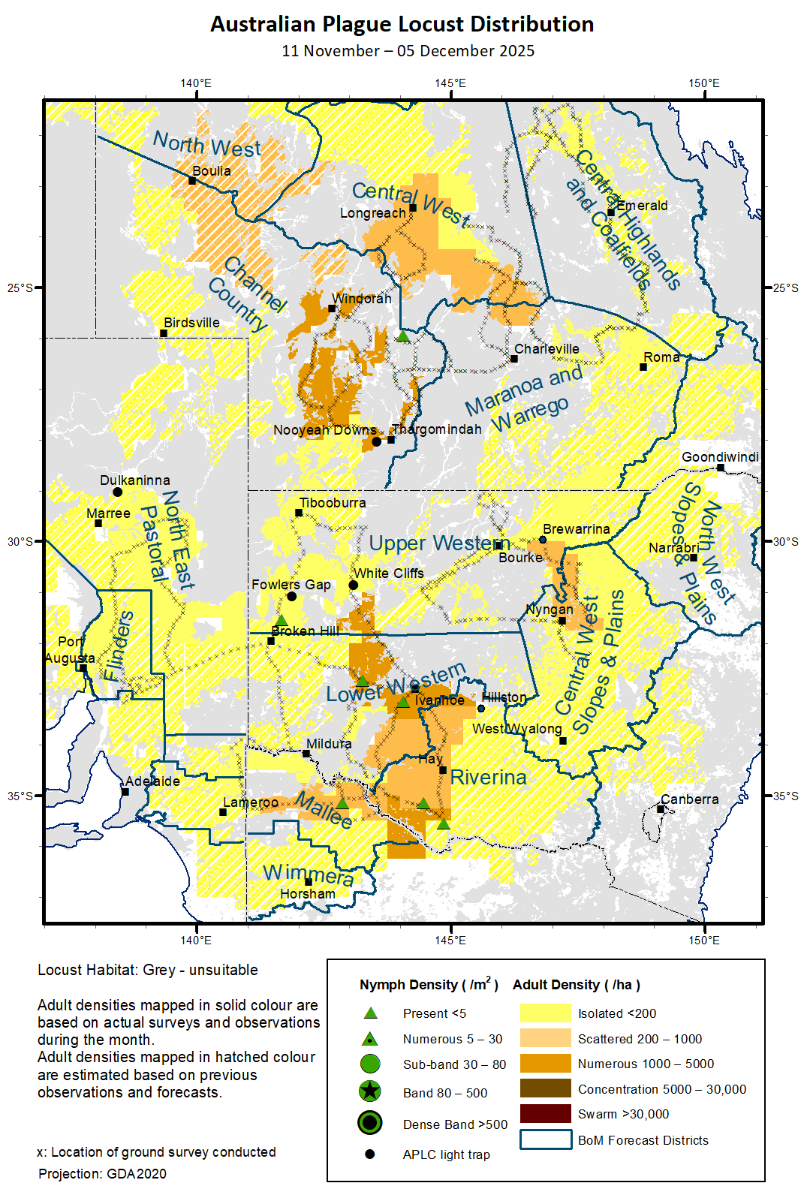

Spur-throated Locust Austracris guttulosa
The overall population remained at low-medium levels across inland eastern Australia with consistent medium-density adults detected in Central Highlands, Central West of Queensland and adjacent regions. Low-density adults were occasionally identified in surveyed areas of NSW. No capture was recorded by any light traps in White Cliffs and Fowlers Gap of NSW, and Dulkaninna of South Australia. With good November rainfall received by the Central Highlands and Darling Downs districts and adjacent regions, and the forecast of above average rainfall in parts of eastern Queensland, some habitats should remain favourable for locust survival and breeding.
There is a low-moderate risk of a regional infestation in Central Highlands, North West and Central West of Queensland. However, a widespread infestation is less likely to occur this summer.

Migratory Locust Locusta migratoria
The population continued to decrease and persisted only in some parts of the Central Highlands of Queensland and adjacent regions where several localised high-density populations (swarms or bands) were identified or reported. The Queensland Department of Primary Industries confirmed several reports from the Central Highlands in late November. With the good background population and heavy November rainfall, sufficient summer rainfall will encourage locust breeding and produce some localised high-density populations.
There is a low-moderate risk of a regional infestation developing in the Central Highlands and a low risk in the Central West and Darling Downs this summer.

It is important that any locust activity be reported as soon as possible to your local biosecurity authority or to the Commission. A toll-free call to the Commission can be made on 1800 635 962. An answering machine is attached to this locust hotline for after-hours calls. Reports can also be emailed to the Commission at locust.report@agriculture.gov.au or sent through the web page at https://www.agriculture.gov.au/pests-diseases-weeds/locusts/landholders/reporting_locusts.

Australian Plague Locust (Chortoicetes terminifera)

SITUATION in October and OUTLOOK to January 202

NEW SOUTH WALES

NORTH WEST SLOPES & PLAINS

Northwest Local Land Services

Locusts and conditions
- No surveys were conducted in this district in November.
- No locust reports were received from this district in November.
- This district received 25 – 100 mm of rainfall for November, generally at average levels with some parts above average levels. Some habitats should remain favourable for locust breeding.

Forecast
- Locust breeding is possible under favourable habitat conditions.
- There is a low probability of any large bands/swarms developing or significant migrations occurring this summer.
- The general population density is expected to be at low levels with possible localised higher densities developing under favourable habitat conditions this summer.

Risks
- There is a low risk of a regional infestation developing this summer.

CENTRAL WEST SLOPES & PLAINS

Central West Local Land Services

Locusts and conditions
- Surveys conducted in November identified Isolated to Scattered-density adults in the western part of this district with no nymphs detected.
- No locust reports were received from this district in November.
- This district received 5 – 25 mm of rainfall for November, generally at below average levels. Some habitats could have remained in good condition from localised rains.

Forecast
- Locust breeding is possible under favourable habitat conditions produced from localised rains.
- There is a low probability of any large bands/swarms developing or significant migrations occurring this summer.
- The general population is expected to be at low levels with possibly localised higher densities developing this summer.

Risks
- There is a low risk of regional infestations developing this summer.

RIVERINA

Riverina, Murray Local Land Services

Locusts and conditions
- Surveys conducted in early December identified occasional Present-density nymphs with some Isolated to Low-Numerous density adults detected in western parts of this district.
- No reports of locust activities were received from this district in November.
- The UNSW insect monitoring radar in Hay did not detect any significant locust migrations in November.
- This district received 10 – 25 mm of rainfall for November by much of this district, ranging from below average to average levels. Habitat conditions had worsened in November.

Forecast
- Limited breeding is possible under favourable habitats conditions produced by localised rains.
- There is a low probability of any significant bands/swarms developing or migrations occurring this summer.
- The population is likely to be at low levels for this summer.

Risks
- There is a low risk of regional infestation developing this summer.

UPPER and LOWER WESTERN

Western Local Land Services

Locusts and conditions
- Surveys identified Isolated to Scattered-density adults in the Upper Western district, and frequent Scattered to Numerous-density adults in the Lower Western district with some Present-density nymphs detected. Much lower numbers of locusts were identified in the western part of these two districts.
- Light traps at White Cliffs and Fowlers Gap did not capture any locusts in November.
- No locust reports were received from these two districts in November.
- Much of the Upper Western district received less than 5 mm of rainfall, and the Lower Western district had 5 – 25 mm of rainfall totals for November, ranging from very much below average to average levels. Habitat conditions continued worsening for locust breeding.

Forecast
- Sporadic breeding is possible under favourable habitat conditions produced from localised rains.
- There is a low probability of any significant bands/swarms developing or migrations occurring this summer.
- The overall population is likely to remain at low levels with possible localised medium-density populations developing this summer.

Risks
- There is a low risk of regional infestations developing this summer.

All locust activity should be reported to your nearest Local Land Services Biosecurity Officer on 1300 795 299 or to the Commission. A toll-free call to the Commission can be made on 1800 635 962. An answering machine is attached to this phone for after-hours calls. Reports can also be emailed to the Commission at locust.report@agriculture.gov.au or sent through the web page at https://www.agriculture.gov.au/pests-diseases-weeds/locusts/landholders/reporting_locusts.

QUEENSLAND

CENTRAL HIGHLANDS AND COALFIELDS

Isaac and Central Highlands Regional Councils; Banana Shire

Locusts and conditions
- Surveys identified occasional Isolated-density adults in this district in November.
- No reports of locust activity were received from this district in November.
- This district received variable 30 – 150 mm of rainfall for November, generally at average to above average levels. Habitats became favourable for locust breeding over much of this district.

Forecast
- Locust breeding is likely under favourable habitat conditions, but general population is likely to remain at low-medium levels.
- There is a low probability of any significant bands/swarms developing or migrations occurring this summer.

Risks
- There is a low risk of a regional infestation developing this summer.

DARLING DOWNS AND GRANITE BELT

Western Downs and Goondiwindi Regional Councils

Locusts and conditions
- No surveys were conducted in this district in November.
- No reports of locust activity were received from this district in November.
- This district received 50 – 150 mm of rainfall over much of this district for November, at above average to very much average levels. Habitat conditions became favourable for locust breeding.

Forecast
- Locust breeding is likely under favourable habitat conditions, but resulting populations are likely to be at low levels with possible localised higher densities.
- There is a low probability of any significant bands/swarms developing or migrations occurring this summer.

Risks
- There is a low risk of a regional infestation developing this summer.

CENTRAL WEST

Barcaldine, Longreach, and Blackall-Tambo Regional Council; Flinders and Winton Shires

Locusts and conditions
- Surveys identified frequent Scattered-density adults in the southwestern and southeastern parts of this district, with occasional Isolated-density adults detected in the eastern part of this district. No nymphs were identified by survey.
- No locust reports were received from this district in November.
- This district received variable 5 – 100 mm of rainfall for November, ranging from below average to above average levels. Some habitats remained favourable for locust breeding.

Forecast
- Locust breeding is possible under favourable habitat conditions, but any resulting population is likely to remain at low-medium levels with possible localised higher densities.
- There is a low probability of any significant bands/swarms developing or migrations occurring this summer.

Risks
- There is a low-moderate risk of a regional infestation developing this summer.

MARANOA AND WARREGO

Maranoa Regional Council; Murweh, Paroo, and Balonne Shires

Locusts and conditions
- Surveys conducted in the northern parts of this district identified Isolated to Numerous-density adults without nymphs detected.
- No locust reports were received from this district in November.
- This district received nearly nil rainfall in the southwest to over 200 mm of rainfall in the northeast corner for November, ranging from average to very much above average levels. Much of the district received less than 25 mm of rainfall. Some habitats in the northeast may become favourable for locust breeding.

Forecast
- Locust breeding is possible under favourable habitat conditions, resulting low-density populations with possible localised higher densities.
- There is a low probability of any significant bands/swarms developing or migrations occurring this summer.

Risks
- There is a low-moderate risk of a regional infestation developing this summer.

NORTH WEST

Mt Isa, Cloncurry, McKinlay, Boulia, and Winton Shires

Locusts and conditions
- No surveys were conducted in this district in November.
- No locust reports were received from this district in November.
- This district received 25 – 100 mm of rainfall for November, ranging from average to above average levels. Some habitats may remain favourable for locust breeding.

Forecast
- Locust breeding is likely to continue, resulting low-density locust populations with possible localised higher densities.
- There is a low probability of any significant bands/swarms developing or migrations occurring this summer.

Risks
- There is a low-moderate risk of a regional infestation developing this summer.

CHANNEL COUNTRY

Boulia, Diamantina, Barcoo, Quilpie, and Bulloo Shires

Locusts and conditions
- Surveys conducted in the southern part of this district identified consistent adults at Isolated to Numerous densities in mid-November. Only occasional nymphs were detected.
- No locust reports were received from this district in November.
- This district received nearly nil rainfall in the south to almost 50 mm of rainfall in the north, ranging from below average to above average levels. Dry conditions in the south worsened habitat conditions and caused the localised locust population to decline. Unfavourable habitats limited locust survival and breeding.

Forecast
- Sporadic breeding is possible if sufficient rainfall is received from storms. However, any resulting population is likely to be at low levels.
- There is a low probability of any significant bands/swarms or migrations developing this summer.

Risks
- There is a low risk of a regional infestation developing this summer.

All locust activity should be reported to Department of Primary Industries via the Customer Service Centre on 13 25 23, online reporting form at https://www.dpi.qld.gov.au/contact/report-a-biosecurity-pest-or-disease?form=other-1554285, email at locustreports@dpi.qld.gov.au, or to the Commission. A toll-free call to the Commission can be made on 1800 635 962. An answering machine is attached to this locust hotline for after-hours calls. Reports can also be sent to the Commission through the web page at https://www.agriculture.gov.au/pests-diseases-weeds/locusts/landholders/reporting_locusts or emailed at locust.report@agriculture.gov.au.

SOUTH AUSTRALIA

NORTH EAST PASTORAL and FLINDERS

Locusts and conditions
- Surveys conducted in the Flinders and southern half of North East only identified a few Isolated-density adults with no nymphs detected.
- The light trap at Dulkaninna did not capture any locusts in November.
- The district of North East received less than 20 mm of rainfall for November with much of it had less than 5 mm of rainfall, generally at below average to average levels. The district of Flinders received 20 – 50 mm of rainfall for November, at average levels. Habitat conditions worsened and became unfavourable for locust breeding.

Forecast
- Sporadic breeding is possible under favourable habitat conditions, but any resulting population is likely to remain at low levels.
- There is a low probability of any significant bands/swarms developing or migrations occurring this summer.

Risks
- There is a very low risk of a regional infestation developing this summer.

RIVERLAND and MURRAYLANDS

Locusts and conditions
- Limited surveys conducted in the eastern part of these two districts identified a single occasion of Isolated-density adults in early December.
- No locust reports were received from these two districts in November.
- The district of Riverland received about 20 mm of rainfall for November, generally at average levels. The district of Murraylands received 20 – 50 mm of rainfall for November, ranging from average to above average levels. Some habitats may remain favourable for locust breeding.

Forecast
- Sporadic breeding is possible, but any resulting population is likely to remain at low levels.
- There is a very low probability of any high-density nymphs developing or migrations occurring this summer.

Risks
- There is a very low risk of a regional infestation developing this summer.

All locust activity should be reported to Primary Industries and Regions South Australia via the Exotic Plant Pest Hotline on 1800 084 881, online plant pest reporting form at https://form.jotform.co/70732909804864, or to the Commission. A toll-free call to the Commission can be made on 1800 635 962. An answering machine is attached to this locust hotline for after-hours calls. Reports can also be sent to the Commission through the web page at https://www.agriculture.gov.au/pests-diseases-weeds/locusts/landholders/reporting_locusts or email at locust.report@agriculture.gov.au.

VICTORIA

MALLEE
Mildura and Swan Hill Rural Cities; Yarriambiack and Buloke Shires

Locusts and conditions
- Limited surveys conducted in early December identified occasional Isolated-density adults and Present-density nymphs in this district.
- No reports were received from this district in November.
- This district received 20 – 40 mm of rainfall for November, generally at average levels. Habitats remained unfavourable for locust breeding.

Forecast
- Limited sporadic breeding is possible under suitable habitats, but any resulting population is likely to remain at low levels.
- There is a very low probability of any significant bands/swarms developing or migrations occurring this summer.

Risks
- There is a very low risk of a regional infestation developing this summer.

WIMMERA
Hindmarsh and West Wimmera Shires

Locusts and conditions
- No surveys were conducted in this district in November.
- No locust reports were received from this district in November.
- This district received 40 – 70 mm of rainfall for November, ranging from average to above average levels. Some habitats remained favourable for locust breeding.

Forecast
- Limited sporadic breeding is possible under suitable habitat conditions, but any resulting population is likely to remain at low levels.
- There is a very low probability of any significant bands/swarms developing or migrations occurring this summer.

Risks
- There is a very low risk of a regional infestation developing this summer.

All locust activity should be reported to Agriculture Victoria via the Customer Contact Centre on 136 186, online form at https://forms.bio.vic.gov.au/locusts, or to the Commission. A toll-free call to the Commission can be made on 1800 635 962. An answering machine is attached to this locust hotline for after-hours calls. Reports can also be sent to the Commission through the web page at https://www.agriculture.gov.au/pests-diseases-weeds/locusts/landholders/reporting_locusts, or emailed at locust.report@agriculture.gov.au.

Glossary of locust terms and density categories used in the Locust Bulletin
Term | Definition
adult | A fully developed, sexually mature locust capable of flight and reproduction
band | Dense congregation of nymphs (hopper band), usually marching together
diapause | Period of dormancy induced in anticipation of unfavourable environmental conditions
dispersal  egg bed | Spreading of individuals away from others (adaptation)  An area of soil containing many egg pods (usually hundreds per square metre)
fledge | Final instar moulting to a soft-bodied adult (fledgling) incapable of long-distance flight
hatch | A young nymph (hatchling) emerging from an egg
instar | A discrete stage of nymphal development after hatch/moult
laying | Female locusts depositing clutches of 20–60 eggs into the ground in froth-lined egg pods
migration  nymph  quiescence | Seasonal collective movements from one place to another (behaviour)  An immature locust (hopper) having the same morphological appearance as the adult  Cessation of growth and reduction of metabolic activity under unfavourable conditions
swarm | Dense congregation of adults, milling at the same spot or flying closely together

Locust density categories
Where higher densities occur, a large proportion of the regional population is concentrated in very small areas with lower densities elsewhere, so the higher densities cannot be extrapolated over the area of an entire region. A range of density classes is usually found within a surveyed region.
Nymph Densities | Number per m²
Present | 1 – 5
Numerous | 6 – 30
Sub-band | 31 – 80
Band | 81 – 500
Dense Band | >500
Adult Densities | Number per m² | Number per 250 m²
Isolated | < 0.02 | 1 – 5
Scattered | 0.024 – 0.1 | 6 – 25
Numerous | 0.104 – 0.5 | 26 – 125
Concentration | 0.504 – 3 | 126 – 750
Low Density Swarm | 4 – 10 | 751 – 2,500
Medium Density Swarm | 11 – 50 | 2,501 – 12,500
High Density Swarm | >50 | >12,500
General density classes | Nymph densities | Adult densities
very low, occasional | Nil – Present | Nil – Isolated
low | Present – Numerous | Isolated – Scattered
medium | Numerous – Sub-band | Scattered – Numerous
high | Bands | Concentration – Swarms

Reporting locust infestations
It is important that all locust activity be reported as soon as possible to your nearest state biosecurity agency office or to the Australian Plague Locust Commission.
State | Authority for reporting locusts
New South Wales | Local Land Services (LLS)
Queensland | Department of Agriculture and Fisheries
South Australia | Department of Primary Industries and Regions
Victoria | Agriculture Victoria
Reports to the Australian Plague Locust Commission can be made by:
Free call (Canberra): 1800 635 962 (24 hours)
Email: locust.report@agriculture.gov.au
Website: https://www.agriculture.gov.au/pests-diseases-weeds/locusts/landholders/reporting_locusts

