## GENERAL SITUATION in December and OUTLOOK to March 2022

### Australian Plague Locust *Chortoicetes terminifera*

The locust population in inland eastern Australia remained at low levels except for the Riverina of New South Wales where Swarm-density adults continued to be identified and reported.

Limited surveys in mid-December identified high numbers of adults still present in the Riverina district, with Medium-Density Swarm adults identified in the Jerilderie-Darlington Point-Hay-Deniliquin areas. However, a moderate increase of adults up to High-Numerous density was evident in the western part of the Riverina district and the adjacent Lower Western district, indicating short-distance redistribution had occurred. The light-trap in White Cliffs captured 40, 110 and 1 adult respectively on the three consecutive nights of 1 – 3 December with zero captures on all other nights, reflecting some population movements associated with troughs. The light-trap in Fowlers Gap, on the other hand, did not capture any locusts during December. Only occasional Present-density nymphs were found by survey. NSW Local Land Service staff assessed a dozen reports of locust activities in December, all from the Riverina district. Surveys in Queensland identified occasional Isolated – Scattered-density adults in the Channel Country, Central West and Maranoa and Warrego districts. No surveys were conducted in South Australia and Victoria.

December rainfall ranged from nil to 150 mm over inland eastern Australia, with less than 25 mm in the arid-semi arid interior. The monthly total was generally about average over the eastern part, but below average over the arid interior and very much below average for the south-western part. Monthly mean temperatures ranged from below average in some regions to above average over the arid interior. The weak La Niña is likely to remain until early autumn, slightly increasing the chance of above average rainfall over much of eastern Australia. January rainfall is less likely to exceed average. Above average rainfall is forecast for February and March, with increased probability over the arid interior. Warmer temperatures are likely for much of eastern Australia except for eastern NSW where lower maximum temperatures are forecast.

The outlook for the remainder of summer and early autumn is for a moderate increase in the overall population level, with medium to high densities persisting in the NSW Riverina district and adjacent areas. Low densities with limited localised medium to high densities are likely in other parts of inland eastern Australia.

It is likely that band development will start from early January onwards and swarm formation will begin in early February in the NSW Riverina district and surrounding regions. Under suitable weather conditions, some adults of the current spring generation may continue to migrate/disperse to adjacent districts and move further into adjacent interior areas. With sufficient summer rainfall, a larger summer generation is likely following successful redistribution and breeding.

There is a moderate likelihood of region-wide infestations developing in the NSW Riverina and surrounding areas during the remainder of summer and early autumn, but higher density wide-spread infestations are unlikely over the rest of inland eastern Australia.

**7 January 2022**

### Spur-throated Locust *Austracris guttulosa*

Surveys in Queensland in December identified occasional Isolated-Scattered density adults in the Channel Country, and persistent Isolated-Low Numerous density adults in the Central West and Maranoa and Warrego districts. There was one report of 3rd instar nymphs from the Winton region in late December. Surveys in New South Wales detected only one occurrence of Isolated adults in the Lower Western district, but the light trap in White Cliffs caught several adults in early December, reflecting the existence of low-density population in NSW. Adult locusts were sighted in the Dulkaninna area, but the light trap there did not catch any in December. With above average November rainfall and average December rainfall over much of Queensland, localised medium-high density nymphs are likely to develop in the north-eastern part of inland eastern Australia.

With above average rainfall forecast for tropical and sub-tropical Queensland, successful breeding is likely to continue and result in more localised medium – high-density nymphs.

There is a medium risk of a widespread low-medium density infestation, and localised high-density infestations may develop in subtropical Queensland in the remainder of summer and early autumn.

### Migratory Locust *Locusta migratoria*

Surveys in December did not detect any migratory locusts. However, both nymphs and adults were previously detected in the Central Highlands and surrounding areas of Queensland and breeding should have continued following favourable November and December rainfall. Nevertheless, high-density gregarisation is unlikely to result from the previously very low population level.

There is a very low risk of a widespread infestation developing during the remainder of summer and early autumn.

**It is important that any locust activity be reported as soon as possible to your local biosecurity authority, primary industries department or to the commission. A toll-free call to the APLC hotline can be made on 1800 635 962. An answering machine is attached to this phone for after-hours calls. Reports can also be emailed to APLC via** [**aplc@agriculture.gov.au**](mailto:aplc@agriculture.gov.au) **or made through the website at** [**https://www.agriculture.gov.au/pests-diseases-weeds/locusts/landholders/reporting_locusts**](https://www.agriculture.gov.au/pests-diseases-weeds/locusts/landholders/reporting_locusts)**.**

### Locust distribution map—*Chortoicetes terminifera*

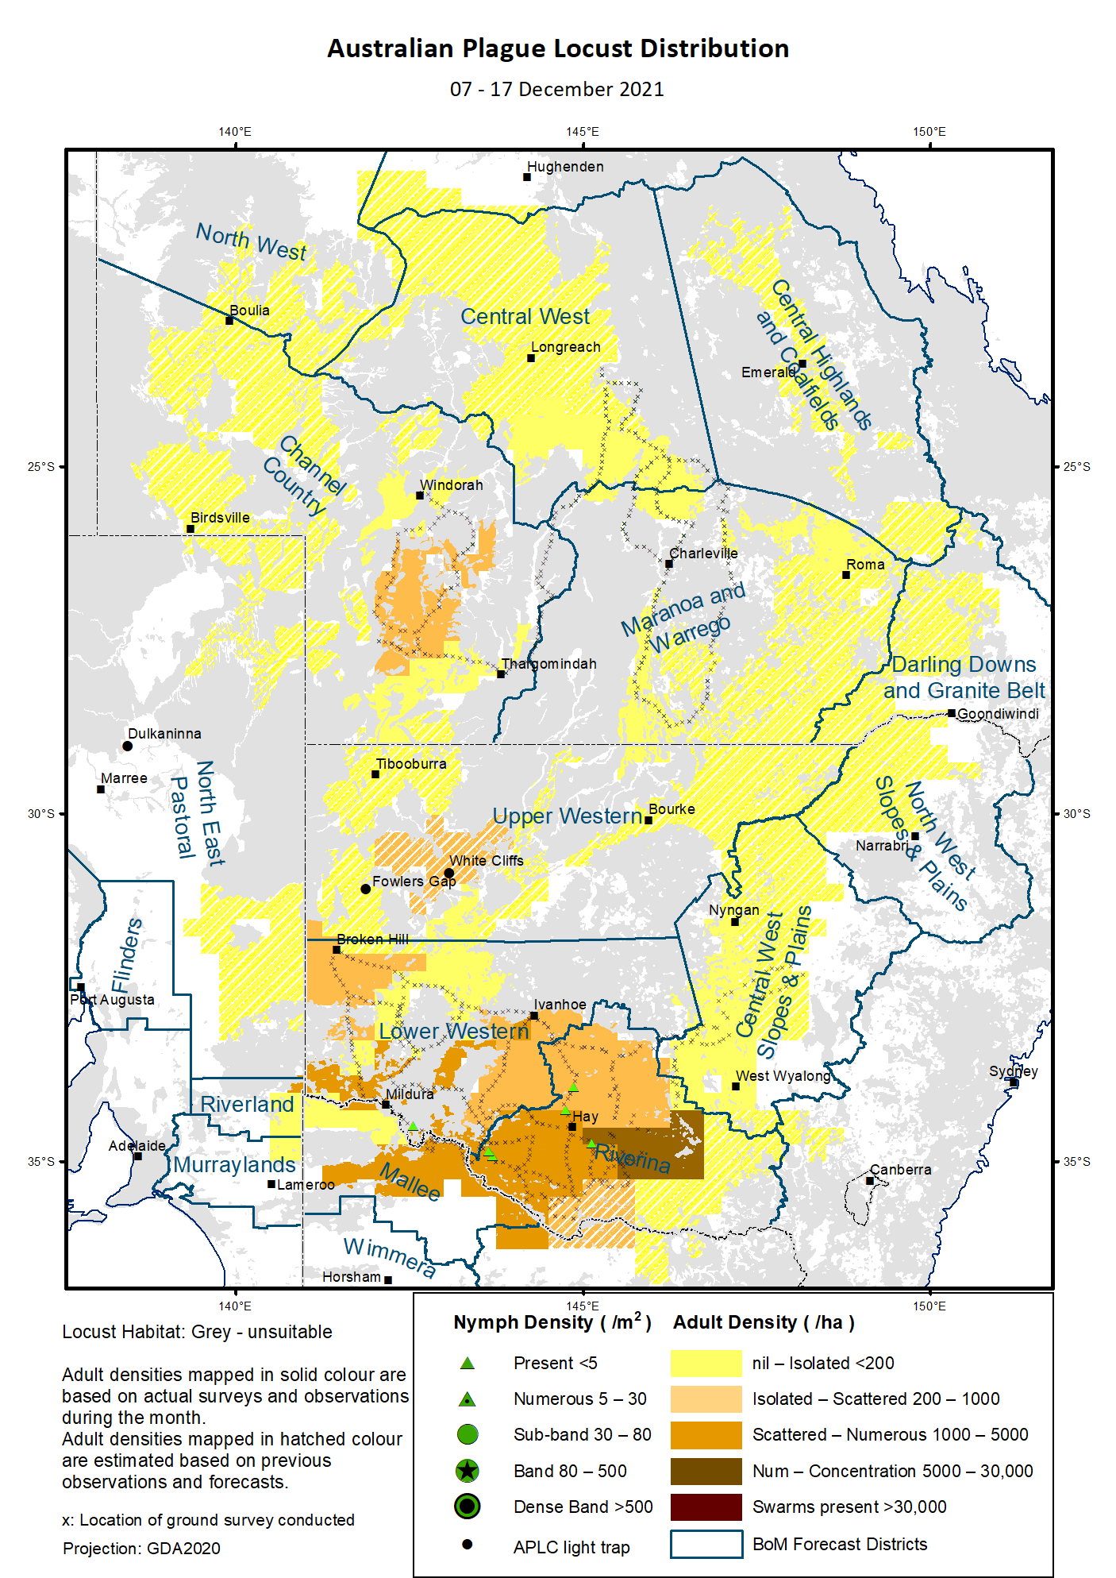

# Australian Plague Locust (*Chortoicetes terminifera*)

## SITUATION in December and OUTLOOK to March 2022

#### NEW SOUTH WALES

##### NORTH WEST SLOPES & PLAINS

###### Northwest Local Land Services

Locusts and conditions

* No surveys were conducted in this district in December.
* No locust reports were received from this district in December.
* This region received 25 – 140 mm rainfall in December, about average level.

Forecast

* Under wet conditions, only limited localised breeding is possible. The general population density is expected to be at low levels.
* There is a low probability of any significant migration during the remainder of summer and early autumn.

Risks

* There is a low risk of a widespread regional infestation developing during the remainder of summer and early autumn.

##### CENTRAL WEST SLOPES & PLAINS

###### Central West Local Land Services

Locusts and conditions

* Surveys in the south-western part of this district in mid-December only identified occasional Isolated-density adults.
* No locust reports were received from this district in December.
* This region received 20 – 90 mm rainfall in most parts in December, at general average level.

Forecast

* Localised breeding is possible, but general population level is likely to remain low.
* There is a low probability of any significant migration during the remainder of summer and early autumn.

Risks

* There is a low risk of widespread regional infestations developing during the remainder of summer and early autumn.

##### RIVERINA

###### Riverina, Murray, and part of Western Local Land Services

Locusts and conditions

* Surveys in mid-December identified persistent high-density adults in the Jerilderie-Darlington Point-Hay-Deniliquin areas with occasional 5th instar nymphs. A Medium-Density swarm was sampled, and 70% female adults were found with 1-3 mm eggs in development. Scattered – Numerous-density adults were detected in the western part of this district, in contrast to the previous low-level population. The moderate increase of population level might be mainly attributed to short-distance nocturnal migrations under frequent disturbed weathers in addition to any daytime dispersal.
* A dozen reports of locusts swarming were assessed by Local Land Service staff, with confirmed egg development among some swarms.
* The UNSW insect monitoring radar in Hay did not detect any significant locust migration.
* December rainfall ranged from 10 mm to 40 mm in this district, about average level.

Forecast

* Summer generation could have started to hatch since late December in this district, and localised bands may develop from early January onwards.
* Swarm formation may begin in February from uncontrolled bands.
* There is a moderate to high probability of redistribution/migration within the district and to adjacent regions under suitable weather patterns. A successful nocturnal migration could cover a distance of 50 km to 200 km, by the adults from both solitary and gregarious (swarm) populations. Daytime dispersal, on the other hand, can only cover 20-30 km per day usually.

Risks

* There is a moderate risk of a widespread infestation developing during the remainder of summer and early autumn.

##### UPPER and LOWER WESTERN

###### Western Local Land Services

Locusts and conditions

* Surveys in mid-December identified Isolated – Numerous-density adults in the Lower Western district with higher numbers in the south and southeast. A noticeable population increase from previous very low level indicates immigrations from the Riverina district occurred under frequent trough weather systems.
* No surveys were conducted in the Upper Western district.
* No locust reports were received from this district in December.
* The light trap at White Cliffs captured 40, 110 and 1 adult respectively on the three consecutive nights of 1 – 3 December with zero captures on all other nights, reflecting the occurrence and movement of some local populations. The light trap at Fowlers Gap, on the other hand, did not capture any locusts in December.
* December rainfall ranged from nil in the western part to localised 90 mm in Bourke region, with heavier falls in the north-eastern part of this district. Much of the district received average rainfall.

Forecast

* Locust population is likely to have a low-moderate increase in this district, and some localised medium-high density populations could develop under favourable habitats.
* There is a moderate likelihood of continuous immigration from the current spring generation in the Riverina district and adjacent areas, and migration to the west and northwest during the remainder of summer and early autumn.

Risks

* There is a low risk of a widespread infestation developing during the remainder of summer and early autumn.

**All locust activity should be reported to your** [**Local Land Services**](https://www.lls.nsw.gov.au/) **(1300 795 299) or the** [**Department of Primary Industries**](https://www.dpi.nsw.gov.au/climate-and-emergencies/locusts)**. A toll-free call to the APLC hotline can be made on 1800 635 962. An answering machine is attached to this phone for after-hours calls. Reports can also be emailed to APLC via** [**aplc@agriculture.gov.au**](mailto:aplc@agriculture.gov.au) **or sent through the web page at** [**https://www.agriculture.gov.au/pests-diseases-weeds/locusts/landholders/reporting_locusts**](https://www.agriculture.gov.au/pests-diseases-weeds/locusts/landholders/reporting_locusts)**.**

#### QUEENSLAND

##### CENTRAL HIGHLANDS AND COALFIELDS

###### Isaac and Central Highlands Regional Councils; Banana Shire

Locusts and conditions

* No surveys were conducted in this district in December.
* No reports of locust activity were received from this district.
* December rainfall ranged from 40 to 150 mm, at average to above average levels.

Forecast

* Localised breeding is possible, but the population is likely to be at low levels based on previous low background population.
* There is a low probability of migration during the remainder of summer and early autumn.

Risks

* There is a low risk of a widespread infestation developing in the remainder of summer and early autumn.

##### DARLING DOWNS AND GRANITE BELT

###### Western Downs and Goondiwindi Regional Councils

Locusts and conditions

* No surveys were conducted in this district in December.
* No locust reports were received from this district.
* December rainfall ranged from 25 to 170 mm, at average to very much above average levels.

Forecast

* Sporadic breeding is possible, but only a low-density population is expected.
* There is a low probability of migration in the remainder of summer and early autumn.

Risks

* There is a low risk of a widespread infestation developing during the remainder of summer and early autumn.

##### CENTRAL WEST

###### Barcaldine, Longreach, and Blackall-Tambo Regional Council; Flinders and Winton Shires

Locusts and conditions

* Surveys in the south-eastern part of this district in mid-December identified only occasional Isolated-density adults without nymphs detected.
* No locust reports were received from this district.
* December rainfall ranged from 10 to 50 mm, at below average to average levels.

Forecast

* Sporadic breeding may result in development of some low-density populations.
* There is a low probability of redistribution and migration in the remainder of summer and early autumn.

Risks

* There is a low risk of a widespread infestation in the remainder of summer and early autumn.

##### MARANOA AND WARREGO

###### Maranoa Regional Council; Murweh, Paroo, and Balonne Shires

Locusts and conditions

* Surveys in mid-December identified occasional Isolated-density adults with no nymphs found.
* No locust reports were received from this district.
* December rainfall ranged from 20 to 160 mm, at average to above average levels.

Forecast

* Locust numbers are likely to remain low with some localised breeding possible.
* There is a low probability of migration in the remainder of summer and early autumn.

Risks

* There is a low risk of a widespread infestation in the remainder of summer and early autumn.

##### NORTH WEST

###### Mt Isa, Cloncurry, McKinlay, Boulia, and Winton Shires

Locusts and conditions

* No surveys were conducted in this district in December.
* No locust reports were received from this district.
* December rainfall ranged from 10 to 40 mm, at below average to average levels.

Forecast

* Locust numbers are likely to remain at low levels, but sporadic localised breeding may occur in some areas.
* There is a low probability of migration activity during the remainder of summer and early autumn.

Risks

* There is a low risk of a widespread infestation developing during the remainder of summer and early autumn.

##### CHANNEL COUNTRY

###### Boulia, Diamantina, Barcoo, Quilpie, and Bulloo Shires

Locusts and conditions

* Surveys in the eastern part in early December identified only occasional Isolated-density adults without nymphs detected.
* No locust reports were received from this district.
* December rainfall ranged from nil to 20 mm, at very much below average to average levels.

Forecast

* Locust numbers are likely to remain at low levels during the remainder of summer and early autumn. Some sporadic localised breeding is possible.
* There is a low-moderate probability of immigration activity in the remainder of summer and early autumn.

Risks

* There is a low risk of a widespread infestation developing during the remainder of summer and early autumn.

**All locust activity should be reported the** [**Biosecurity Queensland (Department of Agriculture and Fisheries)**](https://www.daf.qld.gov.au/business-priorities/biosecurity) **via the** [**Customer Service Centre**](https://www.daf.qld.gov.au/contact/customer-service-centre) **on 13 25 23. A toll-free call to the APLC hotline can be made on 1800 635 962. An answering machine is attached to this phone for after-hours calls. Reports can also be emailed to APLC via** [**aplc@agriculture.gov.au**](mailto:aplc@agriculture.gov.au) **or sent through the website at** [**https://www.agriculture.gov.au/pests-diseases-weeds/locusts/landholders/reporting_locusts**](https://www.agriculture.gov.au/pests-diseases-weeds/locusts/landholders/reporting_locusts)**.**

#### SOUTH AUSTRALIA

##### NORTH EAST PASTORAL and FLINDERS

Locusts and conditions

* No surveys were conducted in this district in December.
* The Dulkaninna light-trap did not capture any locusts in December, nor any locusts were sighted.
* No locust reports were received from this district.
* December rainfall was less than 5 mm over much of this district, at below average to very much below average levels.

Forecast

* Locust numbers are likely to remain low, although some sporadic breeding may occur.
* There is a low-moderate probability of immigration during the remainder of summer and early autumn.

Risks

* There is a very low risk of a widespread infestation developing during the remainder of summer and early autumn.

##### RIVERLAND and MURRAYLANDS

Locusts and conditions

* No surveys were conducted in this district in December.
* No locust reports were received from this district.
* December rainfall was less than 5 mm, at below average to very much below average levels.

Forecast

* The locust population is likely to remain at very low densities.
* There is a low probability of migration during the remainder of summer and early autumn.

Risks

There is a very low risk of a widespread infestation developing during the remainder of summer and early autumn.

**Locust activity should be reported to** [**Biosecurity SA (Primary Industries and Regions South Australia)**](https://www.pir.sa.gov.au/biosecurity) **via the Plant Health Hotline on 1300 666 010.** **A toll-free call to the APLC hotline can be made on 1800 635 962. An answering machine is attached to this phone for after-hours calls. Reports can also be emailed to APLC via** [**aplc@agriculture.gov.au**](mailto:aplc@agriculture.gov.au) **or sent through the website at** [**https://www.agriculture.gov.au/pests-diseases-weeds/locusts/landholders/reporting_locusts**](https://www.agriculture.gov.au/pests-diseases-weeds/locusts/landholders/reporting_locusts)**.**

#### VICTORIA

##### MALLEE

**Mildura and Swan Hill Rural Cities; Yarriambiack and Buloke Shires**

Locusts and conditions

* No surveys were conducted in this district in December.
* No locust reports were received from this district.
* December rainfall was less than 15 mm with nearly nil in the western part of this district, at very much below average to average levels.

Forecast

* Locust numbers are likely to remain at low levels with some sporadic localised breeding possible.
* There is a low-medium probability of immigration during the remainder of summer, most likely from the NSW Riverina district.

Risks

* There is a low risk of a widespread infestation developing during the remainder of summer and early autumn.

##### WIMMERA

**Hindmarsh and West Wimmera Shires**

Locusts and conditions

* No surveys were conducted in this district in December.
* No locust reports were received from this district.
* December rainfall ranged was less than 15 mm with nearly nil in the western part of this district, at very much below average to below average levels.

Forecast

* Locust numbers are likely to remain at low levels with possible localised breeding.
* There is a low probability of migration during the remainder of summer and early autumn.

Risks

* There is a low risk of a widespread infestation developing during the remainder of summer and early autumn.

**Locust activity should be reported to the** [**Agriculture Victoria**](https://agriculture.vic.gov.au/)[**Customer Contact Centre**](https://agriculture.vic.gov.au/about/contact-us) **on 136 186. Alternatively, you can make a report via the online form at**[**https://forms.bio.vic.gov.au/2020**](https://forms.bio.vic.gov.au/2020)**.  Please include photos where possible. A toll-free call to the APLC hotline can be made on 1800 635 962. An answering machine is attached to this phone for after-hours calls. Reports can be emailed to APLC via** [**aplc@agriculture.gov.au**](mailto:aplc@agriculture.gov.au) **or sent through the website at** [**https://www.agriculture.gov.au/pests-diseases-weeds/locusts/landholders/reporting_locusts**](https://www.agriculture.gov.au/pests-diseases-weeds/locusts/landholders/reporting_locusts).

# Glossary of locust terms and density categories used in the Locust Bulletin

**Locust biology and behaviour**

|  |  |
| --- | --- |
| **Term** | **Definition** |
| adult | A fully winged, mature locust capable of breeding and migrating |
| band | Dense aggregation of nymphs, usually moving forward together |
| diapause | Period of dormancy induced in anticipation of unfavourable environmental conditions |
| egg bed | An area of soil containing many egg pods (hundreds per square metre) |
| fledge | Final nymphal moult to a soft-bodied adult incapable of long-distance flight |
| instar | Discrete stages of nymphal development each separated by a moult |
| laying | Female locusts depositing clutches of 20 – 60 eggs into the ground in froth-lined egg pods |
| nymph | Juvenile wingless locust. Often referred to as the hopper stage |
| swarm | Dense aggregation of adults, milling at the same spot or flying closely together |

###### Locust density categories

Where higher densities occur, a large proportion of the regional population is concentrated in very small areas with lower densities elsewhere, so the higher densities cannot be extrapolated over the area of an entire region. A range of density classes is usually found within a surveyed region.

|  |  |  |
| --- | --- | --- |
| **Nymph Densities** | **Number per m2** |  |
| Present | 1 – 5 |  |
| Numerous | 6 – 30 |  |
| Sub-band | 31 – 80 |  |
| Band | 81 – 500 |  |
| Dense Band | >500 |  |
|  |  |  |
| **Adult Densities** | **Number per m2** | **Number per 250 m2** |
| Isolated | – 0.02 | 1 5 |
| Scattered | 0.024 – 0.1 | 6 – 25 |
| Numerous | 0.104 – 0.5 | 26 – 125 |
| Concentration | 0.504 – 3 | 126 – 750 |
| Low Density Swarm | 4 – 10 | 751 – 2,500 |
| Medium Density Swarm | 11 – 50 | 2,501 – 12,500 |
| High Density Swarm | >50 | >12,500 |
|  |  |  |
| **General density classes** | **Nymph densities** | **Adult densities** |
| very low, occasional | Nil – Present | Nil – Isolated |
| low | Present – Numerous | Isolated – Scattered |
| medium | Numerous – Sub-band | Scattered – Numerous |
| high | Bands | Concentration – Swarms |

###### Reporting locust infestations

It is important that all locust activity is reported as soon as possible to your nearest state agriculture agency office or to the Australian Plague Locust Commission.

|  |  |
| --- | --- |
| **State** | **Authority for reporting locusts** |
| New South Wales | Local Land Services (LLS) or Department of Primary Industries |
| Queensland | Biosecurity Queensland, Department of Agriculture and Fisheries |
| South Australia | Biosecurity SA, Department of Primary Industries & Regions |
| Victoria | Biosecurity and Agriculture Services, Department of Jobs, Precincts and Resources |

Reports to the **Australian Plague Locust Commission** can be made by:

Free call (Canberra): 1800 635 962 (24 hours)

Fax (Canberra): (02) 6272 5074

Email: [aplc@agriculture.gov.au](mailto:aplc@agriculture.gov.au)

Website: <https://www.agriculture.gov.au/pests-diseases-weeds/locusts/landholders/reporting_locusts>