GENERAL SITUATION in October and OUTLOOK to January 2026

Australian Plague Locust Chortoicetes terminifera
The overall locust population was at low-medium levels across inland eastern Australia. Surveys identified frequent low-density and some medium-density adults in Queensland and New South Wales with occasional low-density nymphs detected except for the Channel Country where frequent low-density and some medium-density nymphs were observed. These late-instar nymphs detected in the Channel Country in mid-October likely hatched after mid-September rains from quiescent overwintering eggs laid in last Autumn. No locust captures were recorded by any light traps in Dulkaninna of South Australia, Fowlers Gap and White Cliffs of NSW. The light trap in Thargomindah of Queensland has not been in operation since August due to lack of operator. The UNSW insect monitoring radar in Hay was back in operation since mid-October but did not detect any significant migration of locust. No surveys were conducted in Victoria and much of South Australia except for its northeast corner. Several reports of high-density grasshoppers were received from the Flinders district of SA in late October. Investigation confirmed these appeared to be mostly Small Plague Grasshopper Austroicetes cruciata.
Apart from the significant rainfall (200 – 600 mm) received by inland Queensland during late March and early April, much of inland eastern Australia experienced a dry autumn and winter with less than 25 mm of monthly totals. Despite much of inland NSW and parts of the adjacent Channel Country where 25 – 60 mm of rainfall (above average to very much above average levels) was received for September, inland eastern Australia continued in dry conditions with monthly rainfall totals of less than 25 mm for September and October, ranging from average to very much below average levels historically. After the warmer autumn and cooler winter (largely attributed to lower overnight temperatures), the spring had been warmer with both higher daytime and overnight temperatures. With the forecast for above average rainfall and warmer temperatures for the rest of spring and early summer, some habitats may become favourable for locust breeding. Although El Niño–Southern Oscillation remains neutral there are signs towards La Niña for the coming summer.
The overall outlook is for low-medium density populations across inland eastern Australia, with possible localised higher densities developing in inland Queensland and parts of NSW if sufficient rainfall is received.
There is a low likelihood of widespread infestations developing in late spring and early summer.

07 November 2025

Locust distribution map—Chortoicetes terminifera

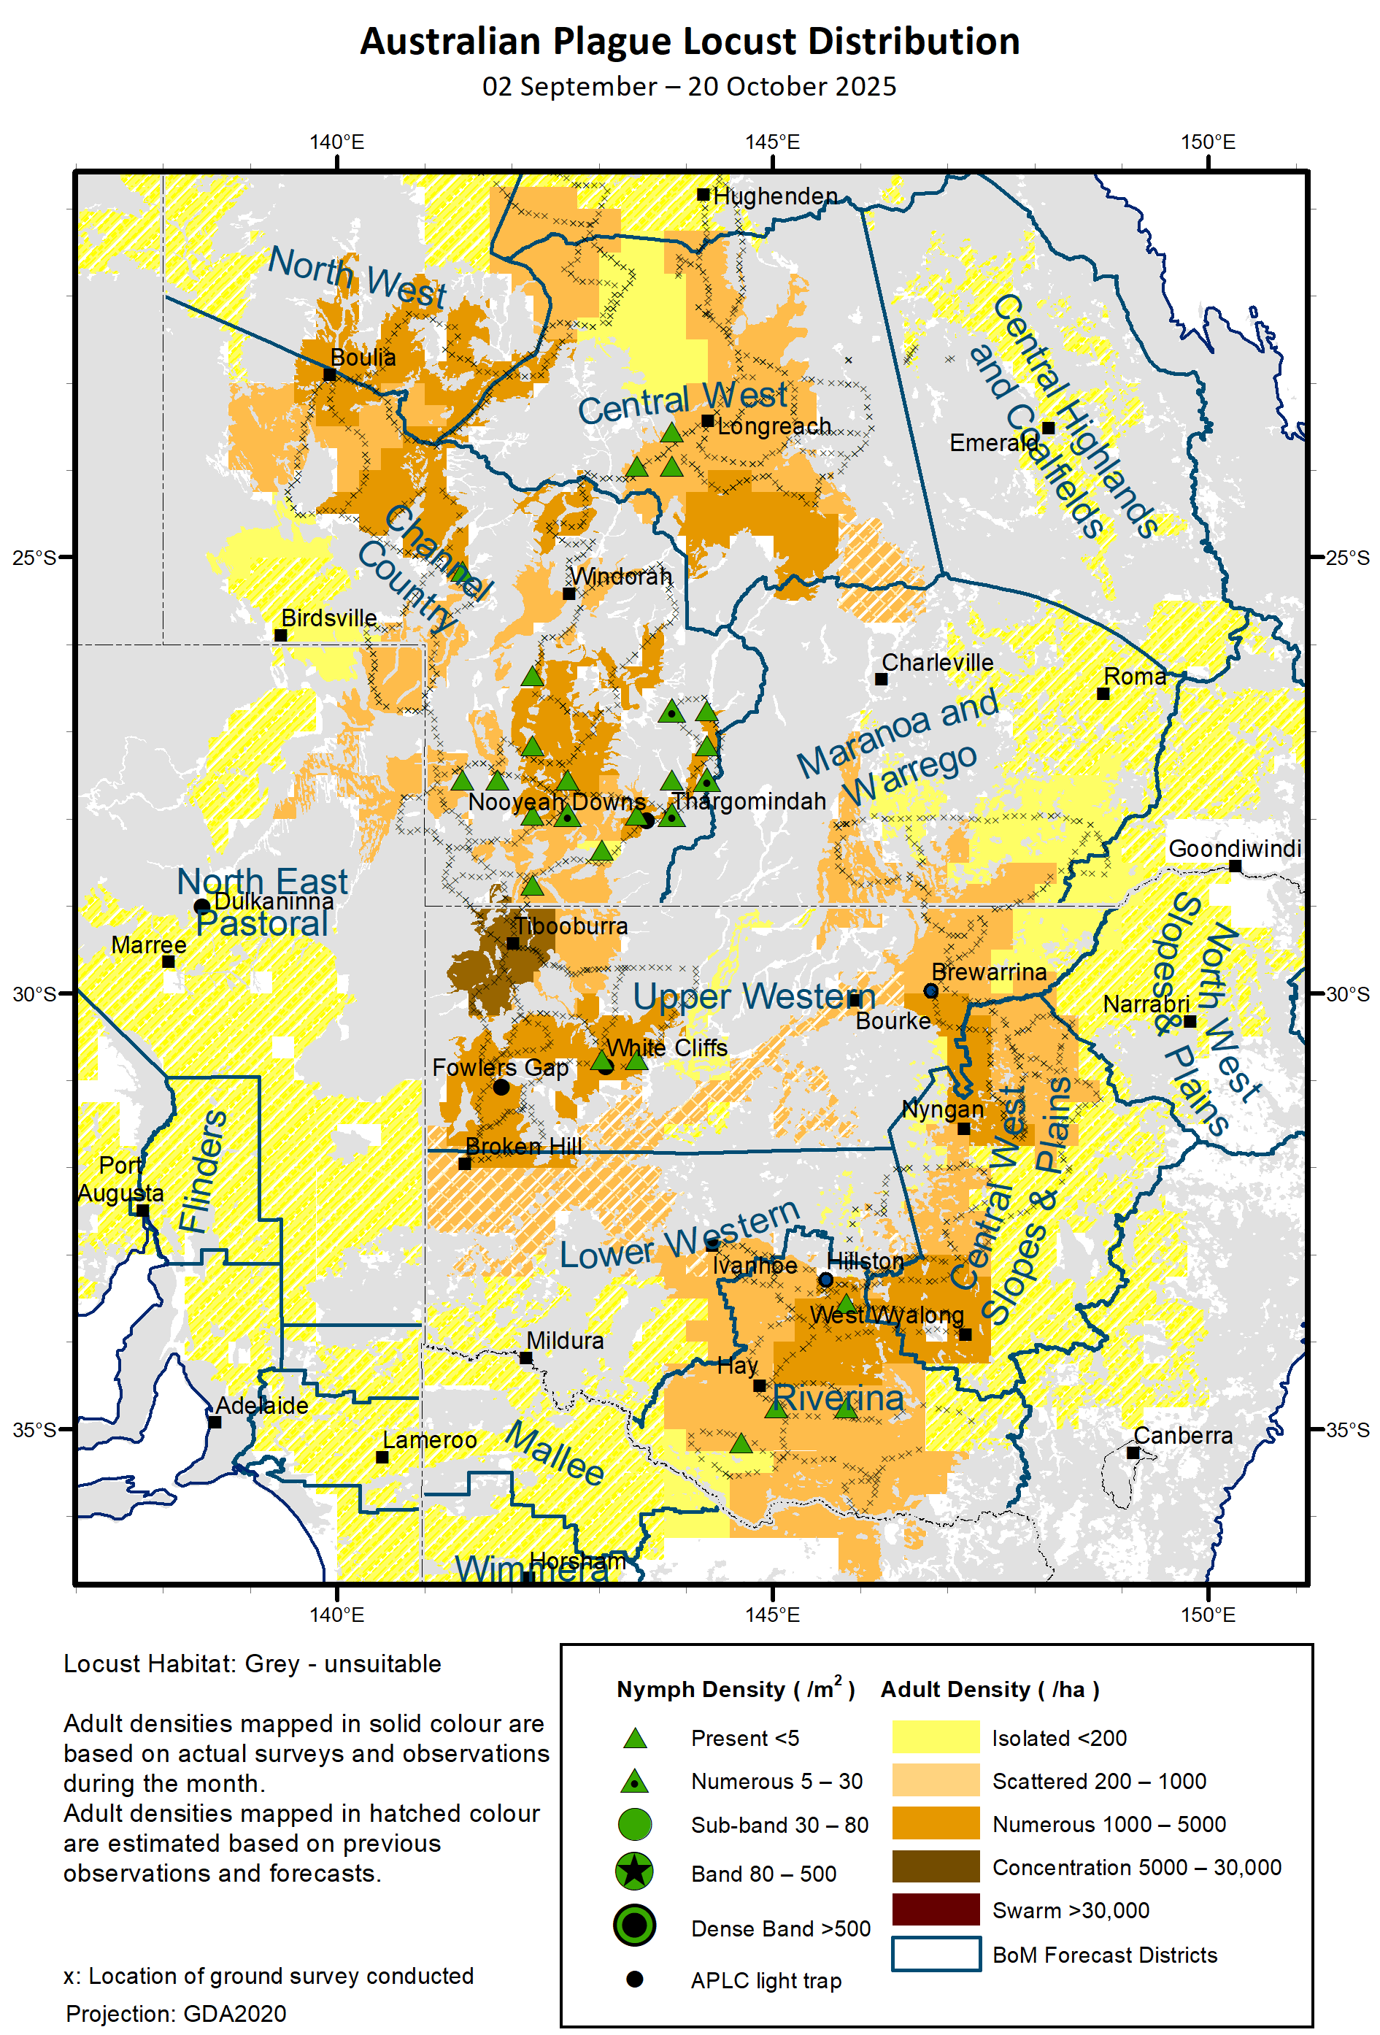

Spur-throated Locust Austracris guttulosa
The overall population was at low-medium levels across inland eastern Australia with consistent medium-density adults detected in Central West of Queensland and adjacent districts. Low-density adults were occasionally identified in surveyed areas of NSW. No capture was recorded by any light traps in White Cliffs and Fowlers Gap of NSW, and Dulkaninna of South Australia. With the forecast of above average rainfall, some habitats should remain favourable for locust survival and breeding.
There is a low-moderate risk of a regional infestation in Central West Queensland. However, a widespread infestation is less likely to occur in late spring and early summer.

Migratory Locust Locusta migratoria
The population decreased markedly in Central West and North West districts of Queensland after continuous northwest-wards movements of adult populations during winter and early spring and deteriorating habitat conditions. However, some localised high-density nymphs and fledglings were still identified in the Clermont area where the Queensland Department of Primary Industry (QDPI) conducted some aerial control in early October. QDPI had assessed two-dozen reports from the Central Highlands and Central West districts during September and October. Several late reports were received from sugar cane growers in the coast region. With the good background population, sufficient rainfall will encourage locust breeding and produce some localised high-density populations.
There is a moderate risk of a regional infestation developing in the Central Highlands and a low-moderate risk in the Central West and Darling Downs during late spring and early summer.

It is important that any locust activity be reported as soon as possible to your local biosecurity authority or to the Commission. A toll-free call to the Commission can be made on 1800 635 962. An answering machine is attached to this locust hotline for after-hours calls. Reports can also be emailed to the Commission at locust.report@agriculture.gov.au or sent through the web page at https://www.agriculture.gov.au/pests-diseases-weeds/locusts/landholders/reporting_locusts.

Australian Plague Locust (Chortoicetes terminifera)

SITUATION in October and OUTLOOK to January 202

NEW SOUTH WALES

NORTH WEST SLOPES & PLAINS

Northwest Local Land Services

Locusts and conditions
- No surveys were conducted in this district in September and October.
- No locust reports were received from this district in September and October.
- This district received 20 – 45 mm of rainfall for September (average levels), and similar amount for October (average to below average levels). Some habitats may remain favourable for locust breeding.

Forecast
- Limited breeding is possible under favourable habitat conditions.
- There is a low probability of any large bands/swarms developing or significant migrations occurring in late spring and early summer.
- The general population density is expected to be at low levels with possible localised higher densities developing under favourable habitat conditions in late spring and early summer.

Risks
- There is a low risk of a regional infestation developing in late spring and early summer.

CENTRAL WEST SLOPES & PLAINS

Central West Local Land Services

Locusts and conditions
- Surveys conducted in September and October identified frequent Isolated to Scattered-density adults in this district with occasional Numerous-density adults present. No nymphs were identified by survey.
- No locust reports were received from this district in September and October.
- This district received variable 20 – 80 mm of rainfall for September (average to very much above average levels historically), and 10 – 30 mm of rainfall for October (very much below average to average levels). Some habitats could have remained in good condition from localised rains.

Forecast
- Breeding is possible under favourable habitat conditions produced from localised rains.
- There is a low probability of any large bands/swarms developing or significant migrations occurring in late spring and early summer.
- The general population is expected to be at low-medium levels with possibly localised higher densities developing in late spring and early summer.

Risks
- There is a low-moderate risk of regional infestations developing in late spring and early summer.

RIVERINA

Riverina, Murray Local Land Services

Locusts and conditions
- Surveys conducted in mid-October identified frequent Isolated and Scattered-density adults with some Present-density early instars detected.
- No reports of locust activities were received from this district in September and October.
- The UNSW insect monitoring radar in Hay has been in operation since mid-October, but no significant locust migrations were observed yet.
- This district received variable 10 – 50 mm of rainfall for September (generally at average levels) and less than 20 mm of rainfall for October (ranging from below average to very much below average levels). Habitat conditions had been worsening during spring.

Forecast
- Limited breeding is possible under favourable habitats conditions produced by localised rains.
- There is a low probability of any significant bands/swarms developing or migrations occurring in late spring and early summer.
- The population is likely to be at low levels for late spring and early summer.

Risks
- There is a low risk of regional infestation developing in late spring and early summer.

UPPER and LOWER WESTERN

Western Local Land Services

Locusts and conditions
- Surveys were conducted mainly in the Upper Western district in September and October. Isolated to Scattered-density adults were identified in the north-eastern part and frequent Scattered to Numerous-density adults were detected in the western part of this district with occasional nymphs observed. Isolated-density adults were identified in the Lower Western district with no nymphs detected by limited survey conducted in eastern parts and the northwestern part of this district.
- Light traps at White Cliffs and Fowlers Gap did not capture any locusts in September and October.
- No locust reports were received from these two districts in September and October.
- These two districts received variable 10 – 70 mm of rainfall with more than 50 mm of rainfall only in the north-western part for September (ranging from average to very much above average levels). October rainfall totals were below 15 mm ranging from average to very much below average levels. Habitat conditions had become unfavourable for locust breeding during spring.

Forecast
- Sporadic breeding is possible under favourable habitat conditions produced from localised storms.
- There is a low probability of any significant bands/swarms developing or migrations occurring in late spring and early summer.
- The overall population is likely to remain at low levels with possible localised medium-density populations developing in late spring and early summer.

Risks
- There is a low risk of regional infestations developing in late spring and early summer.

All locust activity should be reported to your nearest Local Land Services Biosecurity Officer on 1300 795 299 or to the Commission. A toll-free call to the Commission can be made on 1800 635 962. An answering machine is attached to this phone for after-hours calls. Reports can also be emailed to the Commission at locust.report@agriculture.gov.au or sent through the web page at https://www.agriculture.gov.au/pests-diseases-weeds/locusts/landholders/reporting_locusts.

QUEENSLAND

CENTRAL HIGHLANDS AND COALFIELDS

Isaac and Central Highlands Regional Councils; Banana Shire

Locusts and conditions
- No surveys were conducted in this district in September and October.
- No reports of locust activity were received from this district in September and October.
- Much of this district received less than 10 mm of rainfall for September (at average levels), and variable 10 – 50 mm of rainfall over much of this district for October (generally at average levels). Some habitats may have remained favourable for locust breeding from localised rains.

Forecast
- Sporadic breeding is possible under favourable habitat conditions, but general population is likely to remain at low levels.
- There is a low probability of any significant bands/swarms developing or migrations occurring in late spring and early summer.

Risks
- There is a low risk of a regional infestation developing in late spring and early summer.

DARLING DOWNS AND GRANITE BELT

Western Downs and Goondiwindi Regional Councils

Locusts and conditions
- No surveys were conducted in this district in September and October.
- No reports of locust activity were received from this district in September and October.
- This district received less than 45 mm of rainfall with nearly nil over the northern part for September (ranging from average to very much below average levels), and 25 – 50 mm of rainfall over much of this district for October (below average to average levels). Habitat conditions had become unfavourable for locust breeding during spring.

Forecast
- Sporadic breeding is possible under favourable habitat conditions, but resulting population is likely to be at low levels.
- There is a low probability of any significant bands/swarms developing or migrations occurring in late spring and early summer.

Risks
- There is a low risk of a regional infestation developing in late spring and early summer.

CENTRAL WEST

Barcaldine, Longreach, and Blackall-Tambo Regional Council; Flinders and Winton Shires

Locusts and conditions
- Surveys identified frequent Isolated and Scattered-density adults with occasional Numerous-density adults detected in September and October. Occasional nymphs were also identified by survey.
- No locust reports were received from this district in September and October.
- This district received less than 5 mm of rainfall (below average levels) for September, and less than 25 mm of rainfall (at average levels) for October over much of this district. Habitat conditions continued to deteriorate since late winter and became unfavourable for locust breeding.

Forecast
- Limited breeding is possible under favourable habitat conditions produced by localised rains, but any resulting population is likely to remain at low levels.
- There is a low probability of any significant bands/swarms developing or migrations occurring in late spring and early summer.

Risks
- There is a low risk of a regional infestation developing in late spring and early summer.

MARANOA AND WARREGO

Maranoa Regional Council; Murweh, Paroo, and Balonne Shires

Locusts and conditions
- Limited surveys conducted in late September identified Isolated and Scattered-density adults in the southern part of this district without nymphs detected.
- No locust reports were received from this district in September and October.
- This district received variable amount of rainfall from nearly nil in northern parts to over 50 mm in the southwest corner for September, ranging from below average to above average levels. October rainfall totals varied from nearly nil to 50 mm in the direction from southwest to northeast and generally at average levels. Some habitats may remain in favour for locust breeding.

Forecast
- Sporadic breeding is possible under favourable habitat conditions, but any resulting locust population is likely to remain at low levels.
- There is a low probability of any significant bands/swarms developing or migrations occurring in late spring and early summer.

Risks
- There is a low risk of a regional infestation developing in late spring and early summer.

NORTH WEST

Mt Isa, Cloncurry, McKinlay, Boulia, and Winton Shires

Locusts and conditions
- Surveys identified consistent adults at Isolated to Numerous densities in south-eastern parts of this district in mid-October. No nymphs were detected by survey.
- No locust reports were received from this district in September and October.
- Monthly rainfall totals were less than 10 mm although still at average to above average levels for September, October rainfall totals varied from nil to 50 mm ranging from average to above average levels. Some habitats may remain favourable for locust breeding.

Forecast
- Sporadic breeding is possible, but any resulting locust population is likely to remain at low levels.
- There is a low probability of any significant bands/swarms developing or migrations occurring in late spring and early summer.

Risks
- There is a low risk of a regional infestation developing in late spring and early summer.

CHANNEL COUNTRY

Boulia, Diamantina, Barcoo, Quilpie, and Bulloo Shires

Locusts and conditions
- Surveys identified consistent adults at Isolated to Numerous densities in mid-October. Frequent Present-density nymphs with some Numerous densities were detected in the southern half of this district. These late-instar nymphs may have hatched from quiescent overwintering eggs laid in last autumn after mid-September rains.
- No locust reports were received from this district in September and October.
- This district received 10 – 25 mm of rainfall over the northern half to 25 – 60 mm of rainfall over the southern half of this district for September, ranging from above average to very much above average levels. October rainfall totals were less than 15 mm generally at average levels. Habitat conditions had worsened but some habitats may remain favourable for locust survival and breeding.

Forecast
- Locust breeding is possible if sufficient rainfall is received.
- There is a low-moderate probability of localised small bands/swarms developing if habitat conditions remain favourable for locust breeding in late spring and early summer.

Risks
- There is a low-moderate risk of a regional infestation developing in late spring and early summer.

All locust activity should be reported to Department of Primary Industries via the Customer Service Centre on 13 25 23, online reporting form at https://www.dpi.qld.gov.au/contact/report-a-biosecurity-pest-or-disease?form=other-1554285, email at locustreports@dpi.qld.gov.au, or to the Commission. A toll-free call to the Commission can be made on 1800 635 962. An answering machine is attached to this locust hotline for after-hours calls. Reports can also be sent to the Commission through the web page at https://www.agriculture.gov.au/pests-diseases-weeds/locusts/landholders/reporting_locusts or emailed at locust.report@agriculture.gov.au.

SOUTH AUSTRALIA

NORTH EAST PASTORAL and FLINDERS

Locusts and conditions
- Limited surveys were conducted in northeastern parts of the North East district in mid-October and identified frequent Isolated-density adults with no nymphs detected.
- The light-trap at Dulkaninna did not capture any locusts in September and October.
- Several reports of high-density grasshoppers were received from the Hawker area in late October. Investigation confirmed these appeared to be mostly Small Plague Grasshopper Austroicetes cruciata.
- These two districts received variable rainfall from nil to 50 mm for September, ranging from below average to very much above average levels. October rainfall totals were less than 30 mm with higher volumes over the western parts, ranging from below average to above average levels. Only these habitats along drainages may remain favourable for locust breeding.

Forecast
- Sporadic breeding is possible under favourable habitat conditions, but any resulting population is likely to remain at low levels.
- There is a low probability of any significant bands/swarms developing or migrations occurring in late spring and early summer.

Risks
- There is a very low risk of a regional infestation developing in late spring and early summer.

RIVERLAND and MURRAYLANDS

Locusts and conditions
- No surveys were conducted in these two districts in September and October.
- No locust reports were received from these two districts in September and October.
- These two districts received 20 – 30 mm of rainfall for September ranging from below average to average levels, and 10 – 50 mm of rainfall for October generally at average levels. Some habitats may remain favourable for locust breeding.

Forecast
- Sporadic breeding is possible, but any resulting population is likely to remain at low levels.
- There is a very low probability of any high-density nymphs developing or migrations occurring in late spring and early summer.

Risks
- There is a very low risk of a regional infestation developing in late spring and early summer.

All locust activity should be reported to Primary Industries and Regions South Australia via the Exotic Plant Pest Hotline on 1800 084 881, online plant pest reporting form at https://form.jotform.co/70732909804864, or to the Commission. A toll-free call to the Commission can be made on 1800 635 962. An answering machine is attached to this locust hotline for after-hours calls. Reports can also be sent to the Commission through the web page at https://www.agriculture.gov.au/pests-diseases-weeds/locusts/landholders/reporting_locusts or email at locust.report@agriculture.gov.au.

VICTORIA

MALLEE
Mildura and Swan Hill Rural Cities; Yarriambiack and Buloke Shires

Locusts and conditions
- No surveys were conducted in this district in September and October.
- No reports were received from this district in September and October.
- This district received 15 – 25 mm of rainfall for September ranging from below average to average levels. October rainfall totals varied from 5 mm to 30 mm ranging from very much below average to average levels. Habitats became unfavourable for locust breeding.

Forecast
- Limited sporadic breeding is possible under suitable habitats, but any resulting population is likely to remain at low levels.
- There is a very low probability of any significant bands/swarms developing or migrations occurring in late spring and early summer.

Risks
- There is a very low risk of a regional infestation developing in late spring and early summer.

WIMMERA
Hindmarsh and West Wimmera Shires

Locusts and conditions
- No surveys were conducted in this district in September and October.
- No locust reports were received from this district in September and October.
- This district received 15 – 50 mm of rainfall for September, ranging from below average to average levels. October rainfall totals were 20 – 90 mm, ranging from average to above average levels. Some habitats should become favourable for locust breeding.

Forecast
- Limited sporadic breeding is possible under suitable habitat conditions, but any resulting population is likely to remain at low levels.
- There is a very low probability of any significant bands/swarms developing or migrations occurring in late spring and early summer.

Risks
- There is a very low risk of a regional infestation developing in late spring and early summer.

All locust activity should be reported to Agriculture Victoria via the Customer Contact Centre on 136 186, online form at https://forms.bio.vic.gov.au/locusts, or to the Commission. A toll-free call to the Commission can be made on 1800 635 962. An answering machine is attached to this locust hotline for after-hours calls. Reports can also be sent to the Commission through the web page at https://www.agriculture.gov.au/pests-diseases-weeds/locusts/landholders/reporting_locusts, or emailed at locust.report@agriculture.gov.au.

Glossary of locust terms and density categories used in the Locust Bulletin
Term | Definition
adult | A fully developed, sexually mature locust capable of flight and reproduction
band | Dense congregation of nymphs (hopper band), usually marching together
diapause | Period of dormancy induced in anticipation of unfavourable environmental conditions
dispersal  egg bed | Spreading of individuals away from others (adaptation)  An area of soil containing many egg pods (usually hundreds per square metre)
fledge | Final instar moulting to a soft-bodied adult (fledgling) incapable of long-distance flight
hatch | A young nymph (hatchling) emerging from an egg
instar | A discrete stage of nymphal development after hatch/moult
laying | Female locusts depositing clutches of 20–60 eggs into the ground in froth-lined egg pods
migration  nymph  quiescence | Seasonal collective movements from one place to another (behaviour)  An immature locust (hopper) having the same morphological appearance as the adult  Cessation of growth and reduction of metabolic activity under unfavourable conditions
swarm | Dense congregation of adults, milling at the same spot or flying closely together

Locust density categories
Where higher densities occur, a large proportion of the regional population is concentrated in very small areas with lower densities elsewhere, so the higher densities cannot be extrapolated over the area of an entire region. A range of density classes is usually found within a surveyed region.
Nymph Densities | Number per m²
Present | 1 – 5
Numerous | 6 – 30
Sub-band | 31 – 80
Band | 81 – 500
Dense Band | >500
Adult Densities | Number per m² | Number per 250 m²
Isolated | < 0.02 | 1 – 5
Scattered | 0.024 – 0.1 | 6 – 25
Numerous | 0.104 – 0.5 | 26 – 125
Concentration | 0.504 – 3 | 126 – 750
Low Density Swarm | 4 – 10 | 751 – 2,500
Medium Density Swarm | 11 – 50 | 2,501 – 12,500
High Density Swarm | >50 | >12,500
General density classes | Nymph densities | Adult densities
very low, occasional | Nil – Present | Nil – Isolated
low | Present – Numerous | Isolated – Scattered
medium | Numerous – Sub-band | Scattered – Numerous
high | Bands | Concentration – Swarms

Reporting locust infestations
It is important that all locust activity be reported as soon as possible to your nearest state biosecurity agency office or to the Australian Plague Locust Commission.
State | Authority for reporting locusts
New South Wales | Local Land Services (LLS)
Queensland | Department of Agriculture and Fisheries
South Australia | Department of Primary Industries and Regions
Victoria | Agriculture Victoria
Reports to the Australian Plague Locust Commission can be made by:
Free call (Canberra): 1800 635 962 (24 hours)
Email: locust.report@agriculture.gov.au
Website: https://www.agriculture.gov.au/pests-diseases-weeds/locusts/landholders/reporting_locusts

