How do I login to the Biosecurity Portal as an Other User?
This task card demonstrates how to login to the Biosecurity Portal with an email and password.

Logging into the Portal

Registration Method
There are two registration methods available to log into the Biosecurity Portal (Portal):
- Method 1: myGovID with a digital identity
- Method 2: email and password

The method used to register will determine the services available:

- Method 1 provides access to inspection services including AIMS Directions and Approved Arrangement outcomes.
- Method 2 provides access to inspection services.

    - Method 2: Other User – Email and password
The Portal can be accessed using an email and password only. Simply,
- Browse to biosecurity.awe.gov.au
- Select Other User tile
- Enter your preferred email address
- Select Send verification code
- Enter the verification code emailed to your preferred email address
- Create an account, completing all mandatory fields.

Logging In for the first time
Once you have registered to use the Portal browse to the Portal landing page biosecurity.awe.gov.au

NOTE: The Portal works best with Google chrome, Safari and Microsoft Edge. Internet Explorer, Mozilla Firefox are not supported. Please enable cookies in your browser. The Portal uses cookies to enhance your site experience. The Portal also uses pop-ups. You must allow pop-ups on your browser before proceeding.

The Portal home page has links to important information to assist you in registering and using the Portal including:
- How to create your Digital Identity and register for the Portal.
- Information about the Portal.
- Information about new and upcoming features and services.
- User help guides and other helpful information.

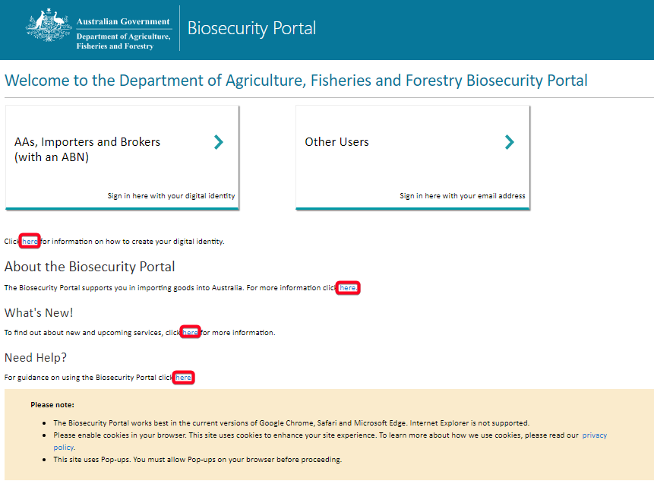
Figure 1: Biosecurity Portal Landing Page

    - Logging in with Other User email and password
Select ‘Sign in here with your email address. You will be asked to enter your email and password used when registering.

TIP: If you forget your password, select ‘Forgot your password?’ to have this re-set. Your password mut be 14-16 characters, have an uppercase letter, number and symbol.
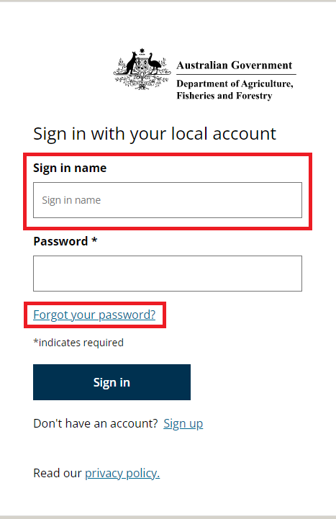
NOTE: Upon successfully logging in for the first time, you will be required to update your profile. Refer to “How do I complete my personal and business profiles?” task card.
.
Figure 2: Login with an email and password

