How do I login to the Biosecurity Portal with Digital ID?
This task card demonstrates how to login to the Biosecurity Portal with your Digital ID.

Logging into the Portal

Registration Method
There are two registration methods available to log into the Biosecurity Portal (Portal):
- Method 1: myID with a Digital ID
- Method 2: email and password

The method used to register will determine the services available:

- Method 1 provides access to inspection services including AIMS Directions and Approved Arrangement outcomes.
- Method 2 provides access to inspection services.

    - Method 1: myID – Digital ID
The Portal uses Digital ID, governed by the Digital Transformation Agency (DTA), as an authenticated and secure way of logging in. Digital ID is a whole of government strategy to prove who you are online and make it quicker and easier to access government services.

NOTE: myID and myGov are different and do not share information. myGov lets you link to and access government services like Medicare and the ATO. myID is the governments Digital ID app that you can use to sign in to a range of participating government online services.

Create a Digital ID using the Australian Government’s myID. You will need a Digital ID issued by myID of minimum Standard identity strength for users and Strong for Principal Authorities. You will also need to be linked to a business (ABN) in Relationship Authorisation Manager (RAM).

NOTE: For more information on setting up a Digital ID and linking a business (ABN) in Relationship Authorisation Manager, refer to the following links:

- About Digital ID - an overview of Digital ID https://www.digitalidsystem.gov.au/what-is-digital-id
- Steps to set up your Digital ID – a step by step guide to download the myID App and establish your identity https://www.myid.gov.au/set-up
- Verifying your identify - a guide on how to verify your identify https://www.myid.gov.au/verifying-your-identity-documents
- About the Principal Authority – information on the Principal Authority and linking a business online in RAM https://info.authorisationmanager.gov.au/principal-authority
- About authorised users and administrators – Information about roles in RAM https://info.authorisationmanager.gov.au/authorised-users-and-administrators

Logging In for the first time
Once you have registered to use the Portal, either with a Digital ID or with an email and password, browse to the Portal landing page biosecurity.awe.gov.au

NOTE: The Portal works best with Google chrome, Safari and Microsoft Edge. Internet Explorer, Mozilla Firefox are not supported. Please enable cookies in your browser. The Portal uses cookies to enhance your site experience. The Portal also uses pop-ups. You must allow pop-ups on your browser before proceeding.

The Portal home page has links to important information to assist you in registering and using the Portal including:
- How to create your Digital ID and register for the Portal.
- Information about the Portal.
- Information about new and upcoming features and services.
- User help guides and other helpful information.

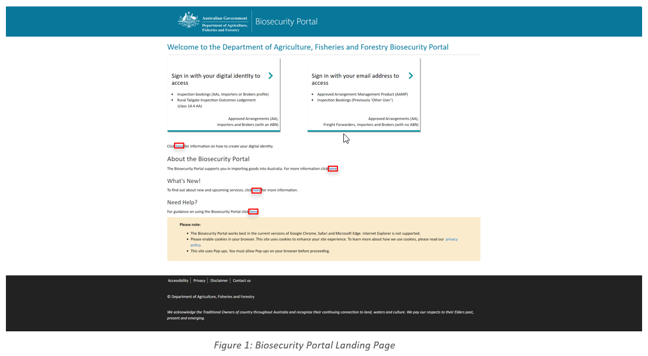

Figure 1: Biosecurity Portal Landing Page

    - Logging in with myID – Digital ID
NOTE: The Portal works best with Google chrome, Safari and Microsoft Edge. Internet Explorer, Mozilla Firefox is not supported. Please enable cookies in your browser. The Portal uses cookies to enhance your site experience. The Portal also uses pop-ups. You must allow pop-ups on your browser before proceeding.

Select ‘Sign in here with your Digital ID’. You will be directed to the Digital ID site to select the myID option. This selection only needs to be completed once, by ticking “Remember my choice”.

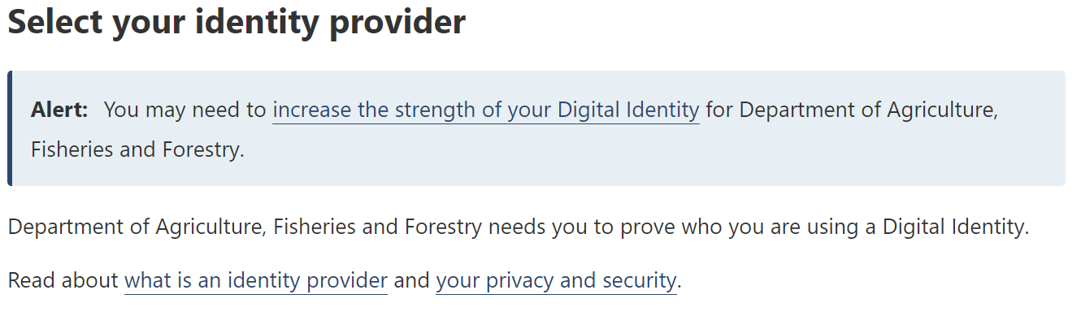
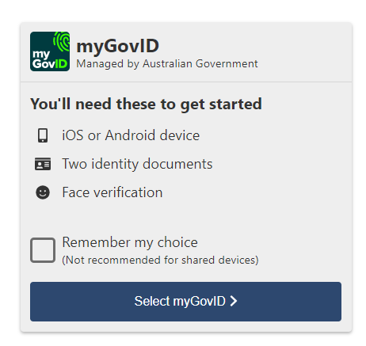
Figure 2: DTA myID Digital ID selection

You will be asked to indicate your consent to share details with the department in the first session, the answer will be remembered for following sessions.
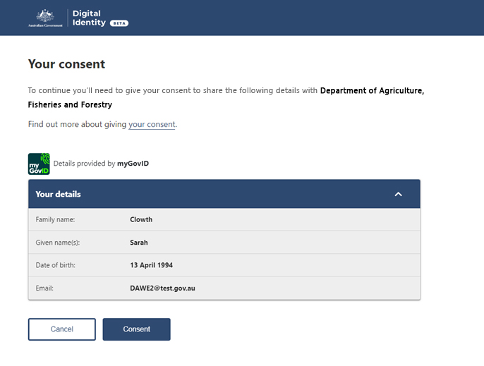
Figure 3: Consent to share details with the department

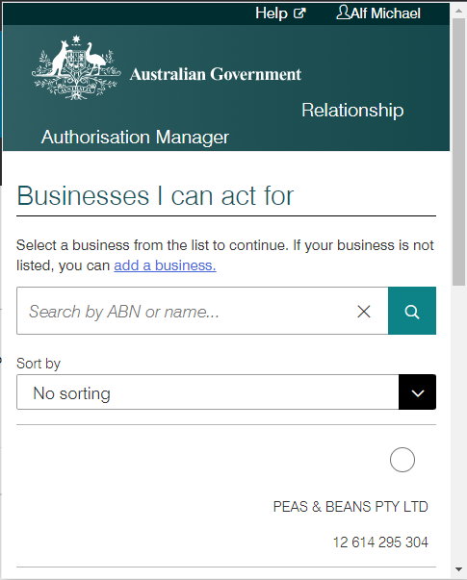
Figure 4: Relationship Authorisation Manager – business to act for in the Portal

NOTE: If you are a representative of only one ABN, this popup window will disappear in a few seconds.

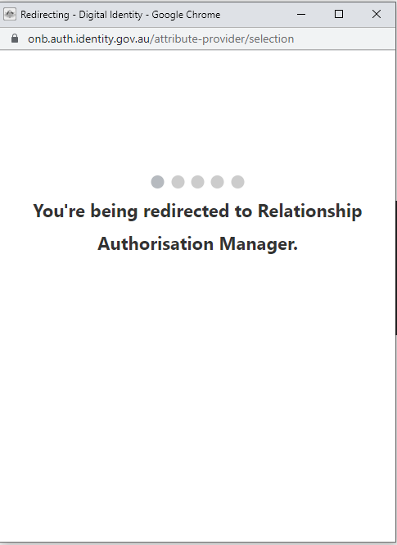
NOTE: If you are a representative of multiple ABNs, please select the organisation you are representing.

NOTE: Upon successfully logging in for the first time, you will be required to update your profile. Refer to “How do I complete my personal and business profile?” task card.

