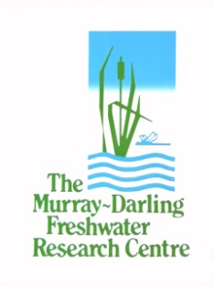
Long Term Intervention Monitoring Project
Logic and Rationale Document
Version 1.0

May 2013

Prepared by: Ben Gawne, Shane Brooks, Rhonda Butcher, Peter Cottingham, Penny Everingham, Jenny Hale, Daryl Nielson, Mike Stewardson and Rick Stoffels.

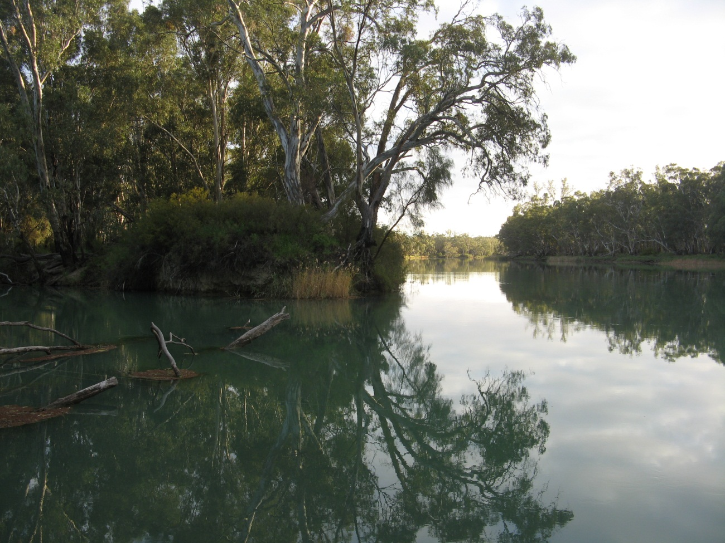

MDFRC Publication 01/2013





Long Term Intervention Monitoring Logic and Rationale Document

Report prepared for the Commonwealth Environmental Water Office by The Murray-Darling Freshwater Research Centre.

Disclaimer
The views and opinions expressed in this publication are those of the authors and do not necessarily reflect those of the Australian Government or the Minister for Sustainability, Environment, Water, Population and Communities. While reasonable efforts have been made to ensure that the contents of this publication are factually correct, the Commonwealth does not accept responsibility for the accuracy or completeness of the contents, and shall not be liable for any loss or damage that may be occasioned directly or indirectly through the use of, or reliance on, the contents of this publication.
© Commonwealth of Australia 2011. This work is copyright. Apart from any use as permitted under the Copyright Act 1968, no part may be reproduced by any process without prior written permission from the Commonwealth. Requests and enquiries concerning reproduction and rights should be addressed to Department of Sustainability, Environment, Water, Population and Communities, Public Affairs, GPO Box 787 Canberra ACT 2601 or email public.affairs@environment.gov.au.

This report was prepared by The Murray-Darling Freshwater Research Centre (MDFRC). The aim of the MDFRC is to provide the scientific knowledge necessary for the management and sustained utilisation of the Murray-Darling Basin water resources. The MDFRC is a joint venture between the Murray-Darling Basin Authority, La Trobe University and CSIRO (through its Division of Land and Water). Additional investment is provided through the Australian Government Department of Sustainability, Environment, Water, Population and Communities.

For further information contact:

Ben Gawne
The Murray-Darling Freshwater Research Centre
PO Box 991
Wodonga Vic 3689
Ph: (02) 6024 9650; Fax: (02) 6059 7531

Email: B.Gawne@latrobe.edu.au
Web: www.mdfrc.org.au
Enquiries: info@mdfrc.org.au

Report Citation: Gawne B, Brooks S, Butcher R, Cottingham P, Everingham P, Hale J, Nielson D, Stewardson M and Stoffels R (2013) Long Term Intervention Monitoring Logic and Rationale Document Final Report prepared for the Commonwealth Environmental Water Office by The Murray-Darling Freshwater Research Centre, MDFRC Publication 01/2013, May, 109pp.
Cover Image: Junction of River Murray and Mullaroo Mouth.
Photographer: David Wood
MDFRC Disclaimer
The material contained in this publication represents the opinion of the author only. Whilst every effort has been made to ensure that the information in this publication is accurate, the author and MDFRC do not accept any liability for any loss or damage howsoever arising whether in contract, tort or otherwise which may be incurred by any person as a result of any reliance or use of any statement in this publication. The author and MDFRC do not give any warranties in relation to the accuracy, completeness and up to date status of the information in this publication.
Where legislation implies any condition or warranty which cannot be excluded restricted or modified such condition or warranty shall be deemed to be included provided that the author’s and MDFRC’s liability for a breach of such term condition or warranty is, at the option of MDFRC, limited to the supply of the services again or the cost of supplying the services again.

Document History and Status
Version | Date Issued | Reviewed by | Approved by | Revision type
Draft | 19 December 2012 | CEWO | Penny Everingham | External
Draft | 8 March 2013 | CEWO | Penny Everingham | External
Draft | 20 April 2013 | Nina Schuuman | Penny Everingham | External
Final | 3 May 2013 | Penny Everingham | Ben Gawne | Internal

Distribution of Copies
Version | Quantity | Issued to
1.0 | 1x Word Doc | Tim Wyndham and Leanne Wilkinson

Filename and path: projects\CEWO\CEWH Long Term Monitoring Project\Final Reports\LTIM Logic and Rationale

Author(s): Ben Gawne, Shane Brooks, Rhonda Butcher, Peter Cottingham, Penny Everingham, Jenny Hale, Daryl Nielson, Mike Stewardson and Rick Stoffels.
Project Manager: Ben Gawne
Client: Commonwealth Environmental Water Office
Project Title: Long Term Intervention Monitoring Project
Document Version: Final
Project Number: M/BUS/435
Contract Number: SON339925

Contents
Executive summary 1
Scientific rationale 1
Long Term Intervention Monitoring 2
Identifying and prioritising monitoring indicators 3
Evaluation 4
Adaptive management 5
Next steps 5
Prelude 6
Chapter 1. Introduction 8
1.1 Legislative background 8
1.2 Basin Plan objectives for environmental water 9
1.3 Commonwealth environmental water 10
1.4 CEWO MERI Framework 12
Chapter 2. Scientific rationale for environmental watering 14
2.1 Objectives hierarchy 15
2.1.1 Biodiversity objectives hierarchy 19
2.1.2 Ecosystem function objectives hierarchy 21
2.1.3 Resilience objectives hierarchy 22
2.1.4 Water quality objectives hierarchy 24
2.1.5 Ecosystem condition hierarchy 26
2.2 Cause-effect diagrams 28
2.3 The major flow types 31
2.3.1 Base flow (low flows) 32
2.3.2 Freshes 32
2.3.3 Bankfull 33
2.3.4 Overbank 33
2.3.5 Discrete wetland and/or floodplain inundation 33
2.3.6 Flows to achieve Environmental Watering Plan objectives 33
2.4 Expected outcomes 35
2.4.1 One-Year expected outcomes 35
2.4.2 One-to-five-year expected outcomes 37
Chapter 3. Long Term intervention monitoring (LTIM) 39
3.1 Context 39
3.2 Indicator prioritisation 42
3.2.1 Identifying environmental indicators 42
3.2.2 Selecting indicators 43
3.2.3 LTIM selected area priorities 44
3.2.4 Basin–scale priorities 45
3.2.5 Causal factor priority indicators 53
3.2.6 Flow characteristic monitoring options – river channel 55
3.2.7 Flow characteristic monitoring options – floodplain 57
3.2.8 Water quality monitoring options 58
3.2.9 Summary of priority indicators 60
3.3 Monitoring design 63
3.3.1 General principles of good study design 63
3.3.2 Data analysis considerations for monitoring design 67
3.3.3 Standard methods 68
3.3.4 Data storage and management 71
3.3.5 Risk assessment and mitigation strategies 73
Chapter 4. Evaluation, reporting and adaptive management 75
4.1 Evaluation 76
4.2 Reporting 79
4.3 Adaptive Management 81
4.3.1 General principles 82
4.3.2 Models 83
4.3.3 Data requirements 85
4.3.5 Effects 87
Chapter 5. Conclusion 88
References 90
Appendix A: Basin Plan more specific Level 2 objectives. 96
Appendix B: Broad Indicators 99

Abbreviations
ANAE Australian National Aquatic Ecosystem
BACI Before-After-Control-Impact
CED Cause-Effect Diagram
CEWH Commonwealth Environmental Water Holder
CEWO Commonwealth Environmental Water Office
DEM Digital Elevation Model
EWP Environmental watering plan
GIS Geographical Information System
LTIM Long Term Intervention Monitoring
MBACI Multiple-Before-After-Control-Impact
MDB Murray-Darling Basin
MDBA Murray-Darling Basin Authority
MDFRC Murray-Darling Freshwater Research Centre
MERI Monitoring, Evaluation, Reporting and Improvement
NDVI Normalized Difference Vegetation Index
SDL Sustainable Diversion Limit
SRA Sustainable Rivers Audit
TLM The Living Murray
VEFMAP Victorian Environmental Flow Monitoring and Assessment Program

Executive summary

The role of the Commonwealth Environmental Water Holder (CEWH) is to manage Commonwealth environmental water to protect or restore the environmental assets of the Basin, and other areas outside the Basin where the Commonwealth holds water.
The Water Act 2007 (Cth) requires the CEWH to perform its functions and exercise its powers consistently with and in a manner that gives effect to the Water Act 2007 - Basin Plan 2012, and specifically, that Commonwealth environmental water is managed in accordance with the Basin Plan’s environmental watering plan. As part of this requirement, the Basin Plan places a number of obligations on the Commonwealth Environmental Water Holder (CEWH), including principles of monitoring and evaluation and reporting requirements.
Long Term Intervention Monitoring (LTIM) is a key element of the Commonwealth Environmental Water Office (CEWO) response to the requirements of the Water Act and Basin Plan. It aims to support improved decision making through the application of the principles of adaptive management, good governance and reporting. Monitoring and evaluation are critical steps in the management of Commonwealth environmental water; supporting the efficient and effective use of Commonwealth environmental water within the planning framework and demonstrating the achievement of environmental objectives. It will achieve this objective by measuring environmental responses to watering activities in selected areas as part of the Monitoring, Evaluation, Reporting and Improvement Framework (MERI Framework) for Commonwealth environmental watering in the Murray-Darling Basin (CEWO 2012).
This document describes the scope, high level design and monitoring priorities for the LTIM Project. The indicators and detailed monitoring design for long term intervention monitoring won’t be finalised until the Monitoring and Evaluation Plan for each area is completed in 2013-14. At that time, the approach set out here will be subject to a range of practical and cost considerations that may narrow or broaden the scope of monitoring that may be undertaken under this project.

Scientific rationale
The scientific rationale is based on the integration of four major inputs to predict the likely ecological outcomes of environmental water use:
- an objectives hierarchy of Basin Plan Environmental Water Plan objectives (EWP objectives). The objectives hierarchy classifies the EWP objectives in a way that is helpful for environmental water managers, practitioners and scientists, and also sets out the scientific basis of how delivery of environmental water will contribute to meeting EWP objectives.
- a suite of conceptual models (cause-effect diagrams) that use the best available science to link EWP objectives to changes in flow. The cause-effect diagrams (CEDs) have been developed to articulate important effects linked to EWP objectives and the way that flow influences these effects through a suite of environmental/causal factors.
- the major flow types described in the Basin Plan and their ecological role. The Basin Plan classifies the hydrology of the Basin in terms of five environmentally significant flow types. The role of four of the five flow types (base flows, freshes, bank full and overbank flows) is described in terms of their influence on biodiversity, ecosystem function, resilience and water quality.
- the range of possible water availability scenarios over the course of five years. Ecological outcomes of environmental watering over the one-to-five-year timeframe are strongly influenced by flow regimes over the period. Through reference to the CEWO flow management strategy, a range of water availability scenarios from a sequence of dry to very dry years through to a sequence of wet years are developed to formulate the range of potential flow objectives over the 1 to 5 year time frame.
These inputs are used to develop a generic set of expected outcomes over both less than 1 year and one-to-five year periods at each of the seven LTIM Selected Areas where long-term monitoring is to be established. The expected outcomes inform the selection of indicators, use of Commonwealth environmental water and underpin subsequent evaluation.

Long Term Intervention Monitoring
Intervention monitoring is one of three types of monitoring included in the CEWO MERI Framework with the other two being operational and program level monitoring. Intervention monitoring is a key step in the MERI process that underpins evaluation, reporting and improved decisions and future monitoring through the adaptive management process. The CEWO MERI Framework includes two types of intervention monitoring, targeted monitoring of selected actions and long term intervention monitoring of selected areas. The focus of CEWO Long Term Intervention Monitoring (LTIM) is the ecological response to Commonwealth environmental water. This Logic and Rationale document is a key input into the development of long term intervention monitoring of selected areas, which aims to:
- monitor the ecological response to Commonwealth environmental watering at each Selected Area
- evaluate ecological outcomes of Commonwealth environmental watering at each Selected Area
- evaluate the contribution of Commonwealth environmental watering to the objectives of the Murray-Darling Basin Plan
- infer ecological outcomes of Commonwealth environmental watering in areas of the Murray-Darling Basin not monitored
- support the adaptive management of Commonwealth environmental water.

LTIM is proposed at the following Selected Areas:
- Gwydir river system (in-stream, wetlands and floodplains)
- Lachlan river system (in-stream and fringing wetlands)
- Murrumbidgee river system (in-stream, fringing wetlands and floodplains)
- Edward–Wakool river system (in-stream and fringing wetlands)
- Goulburn River (in-stream and fringing wetlands)
- Lower Murray River (in-stream, connected wetlands, floodplain and temporary non-connected wetlands)
- Junction of the Warrego and Darling rivers.

Identifying and prioritising monitoring indicators

Prioritisation process
The Logic and Rationale provides a basis for selecting broad monitoring indicators at each of the seven Selected Areas. The broad indicators that have been selected include both effect indicators that provide information to support reporting against objectives and cause indicators that, when combined with effect indicators, provide information to support adaptive management. The list of indicators is then prioritised in order to ensure that the LTIM is “timely, efficient, cost-effective, consistent and should supply the information needed for evaluation” (CEWO MERI Principle 8).
The prioritisation involved a three stage process. In the first stage, stakeholders attended workshops in each Selected Area to provide a local perspective on ecological values and management priorities. The workshop results were used to generate a prioritised list of objectives for environmental watering in each area as set out in the relevant requirements documents.
In the second stage, the prioritised objectives were evaluated against three additional considerations:
- whole of Basin reporting obligations;
- the potential for monitoring results to be extrapolated to demonstrate ecological outcomes in areas not being monitored; and
- the value of monitoring results for adaptive management of environmental water.
Finally, prioritisation of causal indicators was based on the importance of causal indicators to delivery team decisions and their frequency or occurrence in CEDs.
Monitoring priorities
The process identified eighteen monitoring priorities and forty priority indicators, spread among the seven selected areas. Ten of the indicators were identified as priorities at all sites, including ecosystem diversity, vegetation condition and fish diversity.
Several of the prioritised indicators would rely on remote sensing, including ecosystem diversity, vegetation condition and extent, and the floodplain component of primary production. One benefit of remote sensing is that it can provide an estimate of the entire selected area in a cost-effective way. For this reason, these four indicators can be monitored at all areas.
Other indicators identified as priorities in all areas were chemical water quality, hydrological connectivity, suspended sediment, river channel primary production and decomposition. These indicators are both important to the outcome of an environmental flow and relatively inexpensive to collect.
Identifying standard methods, sampling design and analysis
With the indicators selected, some consideration can be given to standard methods, sampling design and analysis. In terms of standard methods, indicators fall into one of three categories. For some indicators, there are established methods available that meet the CEWO criteria, including tree condition, bird monitoring and river channel fish. For others, including hydrological and water quality monitoring, there are a range of options available that need to be developed in consultation with other government institutions. The third group of indicators, including wetland fish, will require development of a standard method in consultation with monitoring and evaluation service providers.
From a sampling design perspective there are a number of options available, the selection of which will depend on the type of ecosystem, opportunities for reference sites and the anticipated scale of response. Finalisation of the sampling design will inform the types of analysis that may be undertaken. Two of the options that have been successfully implemented in other environmental monitoring programs are Before After Control Impact (BACI) design analysis and Bayesian hierarchical analysis.

Evaluation
Evaluation is essential to identifying change, supporting adaptive management in a dynamic system and supporting learning at an individual, community and institutional level. For the LTIM, the evaluation process will be undertaken at multiple spatial and temporal scales in order to support different reporting requirements and both planning and operational decisions. Effective evaluation is reliant on robust program logic, which has been described in sections two and three. In addition, the LTIM will consider assumptions and explicitly state hypotheses to be tested in the development of the selected area Monitoring and Evaluation plans.
The objectives hierarchy and CEDs that underpin the development of expected outcomes provide a foundation for the alignment of the scales over which monitoring and evaluation are undertaken. In particular, this logic will support an evaluation of:
- the outcomes Commonwealth environmental watering against the expected outcomes relevant in each selected area
- the contribution Commonwealth environmental watering to the objectives of the Basin Plan.
Reporting at the Basin-scale requires interpretation of the contribution of watering-area outcomes to achievement of Basin scale objectives. To facilitate this process, five categories of outcome are described that guide this process;
- Basin-scale responses e.g. waterbirds
- Recruitment of potentially mobile species e.g. fish
- Protecting or restoring species with restricted distributions
- Protecting or restoring specific ecosystem types
- Contributing to the protection or restoration of wide-spread species.

Adaptive management
Evaluation also supports adaptive management which is a way of dealing with uncertainty in the management of complex systems and learning from experience to improve environmental outcomes as part of an iterative process. Effective adaptive management requires processes to generate, communicate, assimilate and apply new knowledge to improve monitoring, evaluation, system understanding and future interventions. LTIM will include the development of statistical models that will facilitate the generation, assimilation and application knowledge to future management decisions. The key decisions to be supported from the CEWO perspective are planning (one and five year time frames), operational and monitoring. The models required to support these different decisions will vary and so a suite of models will be identified and prioritised in the next phase of LTIM development.
The focus on model development does, however, create requirements in the areas of data labelling, flow descriptions and experimental design. While these can be considered in a generic sense, their development and finalisation will occur as the detailed monitoring requirements are developed for each of the LTIM Selected Areas.

Next steps
Overall, the Logic and Rationale document is part of the adaptive management process and should therefore be treated as an evolving document. Over time, the institutional context within which the CEWO operates will change and this may require changes to the logic and rationale. This document and the related Monitoring and Evaluation Requirements documents will in the first instance be used to guide the development of:
- detailed Monitoring and Evaluation Plans for each Selected Area
- Evaluation and Data Management Plans
Over the longer term, it is anticipated that the approach set out here will evolve as the LTIM Project is implemented. Developments in our knowledge, generated by LTIM, other monitoring programs and research, that the indicators, sampling designs, analytical methods, CEDs and associated descriptions and objectives hierarchy may all be modified to reflect our improved understanding.

Prelude

This document is the LTIM Logic and Rationale document developed to support the CEWO Long Term Intervention Monitoring (LTIM) Project. It has been developed because it is important that the implementation of the CEWO Monitoring, Evaluation, Reporting and Improvement (MERI) framework is based on a program logic that is clear, transparent and based on the best available science. This document is an important element of the implementation process and is designed to ensure that a logical and robust framework guides the development and implementation of the LTIM Project. It is also anticipated that the LTIM Logic and Rationale document will be important in the ongoing adaptive management of environmental water, providing an accessible source of information on the response of water-dependent ecosystems to environmental flows.
In order to achieve these objectives, the document is based on the CEWO MERI program logic, including conceptual understanding, broad scale monitoring objectives and approach, and methods for integrating knowledge obtained at localised scales to meet Basin-wide evaluation objectives. The CEWO MERI process is summarised in Figure 1.

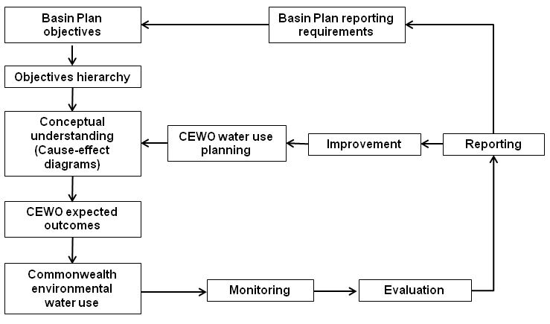
Figure 1. LTIM context for environmental water delivery, monitoring, evaluation and reporting.

The document is organised into four chapters.
Chapter 1 provides a summary of the legislative background, EWP objectives, the CEWO and the MERI Framework, which together provide the institutional context for the LTIM.
Chapter 2 assembles the major inputs required to develop expected outcomes for environmental watering. The first input is the EWP objectives which are organised into an objectives hierarchy. The second input is best available science concerning the relationship between flow and objectives, which is summarised into cause-effect diagrams (CEDs). The third input is the major flow-types available to the CEWO and their ecological roles, which have been derived from the Basin Plan. The final input is water availability over the course of five years. The chapter then describes how these inputs are used to develop the expected outcomes over both less-than-one-year and one-to-five-year periods. The expected outcomes inform the use of Commonwealth environmental water and underpin subsequent evaluation.
Chapter 3 describes the LTIM at seven selected areas in the Murray-Darling Basin (Monitoring box in Figure 1). The focus is on the identification and prioritisation of both cause and effect indicators. The chapter then discusses options for standard methods for some of the nominated indicators.
Chapter 4 describes the way in which LTIM information will be utilised to support evaluation, reporting and adaptive management (Figure 1) with a heavy emphasis on the use of models to support predictions of the expected outcomes in response to and in the absence of environmental flows. The chapter then goes on to discuss some data requirements in order to ensure data will support model development.
Chapter 5 summarises the key components of the Logic and Rationale.

Chapter 1. Introduction

The Commonwealth Environmental Water Office’s long-term intervention monitoring (LTIM) project aims to measure environmental responses to watering activities in selected areas where Commonwealth environmental water is delivered as part of the implementation of the Monitoring, Evaluation, Reporting and Improvement Framework (MERI Framework) for Commonwealth environmental watering in the Murray-Darling Basin (CEWO 2012). This document describes the underlying logic and rationale for the LTIM Project.
The long-term intervention monitoring project aims to support improved decision making through the application of the principles of adaptive management, good governance and reporting. To achieve this it is important that the program is based on clear and robust program logic that links EWP objectives to the monitoring of outcomes from flows delivered by the CEWO. The document also provides an objectives hierarchy that includes cause-effect diagrams (CEDs) that show generic relationships between flow and expected ecological outcomes. This LTIM Project logic will be applied to seven selected areas that are to be the focus of CEWO intervention monitoring. Consultation with stakeholders during the development of Monitoring and Evaluation Plans for each of the seven selected areas is a key step in the LTIM Project. This logic document is expected to evolve over time in line with the principles of adaptive management.

1.1 Legislative background
The Water Act 2007 (Water Act) initiated a number of key water reforms in the Murray-Darling Basin (the Basin). This included the establishment of the Murray-Darling Basin Authority (MDBA) and the Commonwealth Environmental Water Holder (CEWH).
The Murray-Darling Basin Authority is vested with the functions and powers, including enforcement powers, needed to ensure that Basin water resources are managed in an integrated and sustainable way. The Act also required the MDBA to prepare a strategic plan for the integrated and sustainable management of Basin water resources: the Basin Plan (COA 2012).
Key components of the Basin Plan include:
• environmentally sustainable limits on surface water and groundwater use
• an environmental watering plan
• a water quality and salinity management plan
• water resource plan requirements
• water trading rules
• a monitoring and evaluation program.
The Commonwealth Environmental Water Holder’s role is to manage Commonwealth environmental water ‘to protect or restore the environmental assets of the Basin, and other areas outside the Basin where the Commonwealth holds water, so as to give effect to relevant international agreements’ (Water Act 2007, s 105(3)). The CEWH must manage the Commonwealth environmental water holdings in accordance with the environmental watering plan, which is part of the Basin Plan. The statutory position of the CEWH is supported in meeting statutory obligations by the Commonwealth Environmental Water Office (CEWO), a division of the Department of Sustainability, Environment, Water, Population and Communities (the Department). The CEWH and the CEWO are further described in the Commonwealth Environmental Water 2012-13 Business Plan. (www.environment.gov.au/ewater/publications/cew-business-plan-2012-13.html)
The Water Act requires an annual report on the management of Commonwealth environmental water be provided to the Commonwealth Water Minister, to be tabled in each House of Parliament and given to relevant State Ministers for each of the Basin states (Section 114(1)). The report must include information on achievements against the objectives of the Basin Plan’s environmental watering plan (Section 114(2a)).
Environmental assets are defined by the Water Act as water-dependent ecosystems, ecosystem services and sites of ecological significance. Water-dependent ecosystems include; wetlands, streams, floodplains, lakes and other bodies of water, salt marshes, estuaries, karst and ground water systems.
The Water Act also requires the CEWH ‘to perform its functions and exercise its powers consistently with and in a manner that gives effect to the Basin Plan’ (Water Act s34), and specifically, that Commonwealth environmental water is managed in accordance with the Basin Plan’s environmental watering plan (Water Act s105(4a)).
The Basin Plan places a number of obligations on the CEWH, including:
• matters which the use of Commonwealth environmental water must be consistent with, or have regard to (refer Section 1.3)
• matters relating to the trading of water
• principles for monitoring and evaluation (refer Section 1.4)
• reporting requirements (refer Section 4.2).

1.2 Basin Plan objectives for environmental water
The Basin Plan identifies a number of environmental objectives for water-dependent ecosystems in the Murray-Darling Basin. Those objectives are further described in Part 8 of the Basin Plan (Attachment A). One of these objectives is ‘to protect and restore water-dependent ecosystems of the Murray-Darling Basin’. For the purposes of program logic development, this objective is interpreted within the context of the whole of Basin objective that the Basin Plan is to ‘give effect to relevant international agreements through the integrated management of Basin water resources’. These international agreements include Ramsar, JAMBA, CAMBA, ROKAMBA and the Convention on Biological Diversity. The Convention on Biological Diversity seeks the ‘conservation of biological diversity, sustainable use of its components and equitable sharing of the benefits’. The Convention uses the term biodiversity to mean the ‘variability among living organisms’ and this ‘includes diversity within species, between species and of ecosystems’. In this context, protection of water dependent ecosystems is a means of conserving biological diversity within species, between species and ecosystems.
For the LTIM Project, the Basin Plan objectives have been arranged hierarchically with the highest level objectives (Level 1) generically described as Biodiversity, Ecosystem function, Resilience and Water quality (Table 1).
Table 1. Basin Plan environmental and water quality objectives for water-dependent ecosystems.
Basin Plan reference | Basin Plan objective | Level 1 objectives referred to throughout as
Environmental watering plan | to protect and restore water-dependent ecosystems of the Murray-Darling Basin (Basin Plan, Chapter 8, Part 2, 8.04(a)) | Biodiversity
Environmental watering plan | to protect and restore the ecosystem functions of water-dependent ecosystems (Basin Plan, Chapter 8, Part 2, 8.04(b)) | Ecosystem function
Environmental watering plan | to ensure that water-dependent ecosystems are resilient to climate change and other risks and threats (Basin Plan, Chapter 8, Part 2, 8.04(c)) | Resilience
Water quality and salinity plan | to ensure water quality is sufficient to achieve the above objectives for water-dependent ecosystems, and for Ramsar wetlands, sufficient to maintain ecological character (Basin Plan, Chapter 9, Party 3, 9.04 (1) & (2)) | Water quality

The Basin Plan provides more detail around each of the Level 1 objectives above (modified from COA 2012, refer Appendix A for full text). The Basin Plan also includes environmental watering plan targets to measure progress towards Basin Plan objectives in Schedule 7 and water quality and salinity targets in Schedule 11.
Throughout this document the Level 1 objectives above are referred to as Basin Plan Environmental Watering Plan objectives (EWP objectives). To support the management of environmental water and development of the LTIM Project, the Level 1 objectives have been further classified into Level 2 and Level 3 objectives. Although the matters considered within the Level 2 and Level 3 objectives generally accord with the detailed objectives set out in Chapter 8 of the Basin Plan (Appendix A), they have been framed to support environmental watering, rather than reflect specific provisions.

1.3 Commonwealth environmental water
The CEWH was established in 2007, and in accordance with its Water Act obligations, began managing its portfolio of held environmental water in order to contribute to the achievement of the EWP objectives. To ensure best practice, considerable time and effort has been expended in the development of processes to undertake water purchase, planning, management, monitoring and evaluation. As at 31 March 2013, the Commonwealth held 1,557,757 ML (long-term average) of water entitlements across the Murray-Darling Basin and has been engaged in delivering environmental water to environmental assets since March 2009.
Planning for the use of Commonwealth environmental water is developed at strategic and operational levels and at a range of time scales, including:
- annual water use plans
- five-year portfolio management strategy
- the Basin Plan, which requires the use of Commonwealth environmental water to be undertaken having regard to the Basin annual environmental watering priorities.
The use of Commonwealth environmental water must also:
- be consistent with the environmental watering plan’s objectives
- be in accordance with the Principles to be Applied to Environmental Water (CEWO 2012)
- have regard to the water quality and salinity targets for managing water flows.
Within the scope established by the Basin Plan’s environmental watering plan, the use of Commonwealth environmental water is further guided by a planning framework for making determinations on the available water in any given year (CEWO 2011). It outlines a process that requires matching water availability with environmental demand based on a robust, scientifically defensible decision framework, in accordance with multi-year ecological and operational considerations.
The framework requires consideration of a mixture of operational factors, such as:
- the volumes of CEWH and other environmental water that are available
- cost effectiveness and feasibility
- constraints (e.g. release capacity, channel size)
- delivery partners
and ecological information such as:
- timing and impact of natural events (e.g. floods, drought)
- the ecological significance of the asset to be watered
- the expected ecological outcomes from the proposed watering
- the potential risks of the proposed watering action at the site and at connected locations
- the long-term sustainability of the asset
- priority species/communities.
Information needs are partially met by the MDBA, partner agencies, expert scientific advice and local expert knowledge. The CEWO is however, managing environmental water within a complex system with incomplete knowledge; and through application of the principles of adaptive management, monitoring of watering events and resulting ecosystem responses provides ongoing improvement of information feeding into the decision framework.

1.4 CEWO MERI Framework
Monitoring and evaluation are critical steps in the management of Commonwealth environmental water (Figure 1), supporting the efficient and effective use of Commonwealth environmental water within the planning framework and demonstrating the achievement of environmental objectives. In recognition of this the CEWO has developed a monitoring, evaluation, reporting and improvement (MERI) framework to support accountability, good governance and adaptive management, and to generate the knowledge to support future evidence based decisions.
The Basin Plan outlines ten principles to be applied in monitoring and evaluating the effectiveness of the Basin Plan. Where applicable, the CEWO has adopted those principles and has derived the following nine principles outlined in its MERI Framework:
- The Commonwealth Environmental Water Holder will report against matters in a manner which reflects the degree to which it is accountable.
- Monitoring and evaluation should be undertaken within the conceptual framework of program logic.
- Monitoring and evaluation findings, including in respect of progress towards meeting objectives and trends in the condition and availability of the Basin water resources, should enable decision-makers to use adaptive management.
- Monitoring and evaluation should harness the monitoring capabilities of existing Basin state and Commonwealth programs (including jointly funded programs), provided that the programs are consistent with these principles - with a view to aligning and improving these programs over time.
- The best available knowledge (including scientific, local and cultural knowledge), evidence and analysis should be used where practicable to ensure credibility, transparency and usefulness of monitoring and evaluation findings.
- Basin states and the Commonwealth should collaborate on the technical and operational elements of monitoring and evaluation in order to build engagement and ownership.
- A risk-based approach should be used for investment in monitoring and evaluation.
- Monitoring and reporting should be timely, efficient, cost-effective, consistent and should supply the information needed for evaluation.
- To the extent that it is possible, there will be open access to information collected or used in, or generated by, monitoring and evaluation.

The MERI Framework proposes an adaptive management cycle that aligns with the three levels of planning associated with the use of Commonwealth environmental water (Basin Plan, long-term portfolio management and annual water use) and includes operational, intervention and program level monitoring (Figure 2).
Monitoring and evaluation under the CEWO MERI Framework is cooperatively undertaken by a number of environmental water partners (Figure 2) that include:
- CEWH – statutory position under the Water Act responsible for managing Commonwealth environment water holdings.
- MDBA – responsibilities under the Water Act to measure, monitor and record the condition of water-dependent ecosystems associated with the Basin water resources.
- Basin states – delivery partners, management and monitoring partners.
- Bureau of Meteorology – integration and dissemination of water information under the Water Act.
- State agencies and research organisations – provide complementary monitoring and research.
Figure 2. Monitoring components outlined in the CEWO MERI Framework, including proposed lead agencies (image supplied by CEWO). Note: only The Living Murray (TLM) complementary monitoring is shown, although other complementary monitoring will contribute to the monitoring of Commonwealth environmental water.
The CEWO activities will focus on intervention monitoring that enables the CEWO to report on the outcomes of environmental water allocations and to develop the knowledge required to support water use in the future. Ensuring that the LTIM component of the framework meets these objectives requires consideration of the way that information will be used in the evaluation of both Commonwealth environmental water activities and achievement of EWP objectives.
The MDBA will also use the information generated by intervention monitoring to report on the contribution of environmental water to the protection or restoration of water-dependent ecosystem conditions. In this way, intervention monitoring will contribute to an assessment of the condition of river, wetland and floodplain ecosystems in relation to EWP objectives for water-dependent ecosystems.

Chapter 2. Scientific rationale for environmental watering
This chapter outlines the scientific basis for how Commonwealth environmental water contributes to the objectives of the Basin Plan. The Water Act (2007) requires that Commonwealth environmental watering be based on clear and robust science while the Commonwealth MERI guidelines require the establishment of clear program logic.
Chapter 2 assembles the major inputs required to develop expected outcomes for environmental watering (Figure 3). The first input is the EWP objectives which are organised into an objectives hierarchy. The second input is best available science on the role of flow on the objectives which is summarised into cause-effect diagrams (CEDs). The third input is the major flow types available to the CEWO and their ecological role which have been derived from the Basin Plan. The final input is the range of possible water availability over the course of five years. The chapter then describes how these inputs are used to develop the expected outcomes over both 12-month and one-to-five-year periods (Figure 3). The expected outcomes inform the use of Commonwealth environmental water and underpin subsequent evaluation.

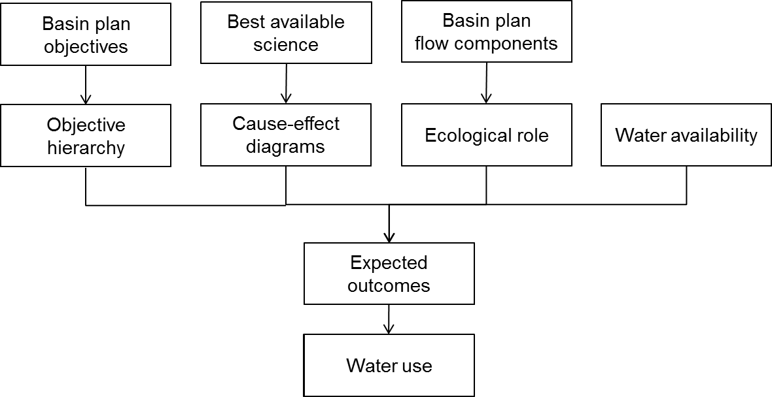
Figure 3. Chapter 2 describes the process for developing expected outcomes. This figure is an illustration of the relationship between sections of Chapter 2 and their contribution to expected outcomes.

2.1 Objectives hierarchy
An objectives hierarchy recognises the nested nature of complex systems in which a large number of detailed or small scale objectives contribute to a small number of overarching or large scale objectives. The development of an objectives hierarchy is a way of communicating these relationships (Kingsford et al. 2011). The relationship between the EWP objectives has been described in Section 1.2. The objectives hierarchy developed for this project seeks to classify the EWP objectives in a way that is helpful for environmental water managers, practitioners and scientists, and also sets out the scientific basis of how delivery of environmental water will contribute to meeting the EWP objectives. The objectives hierarchy is consistent with the observed ecological hierarchy (Noss 1990; Dale and Beyeler 2001) and recognises the complexity and nested nature of water-dependent ecosystems.
As outlined in Section 1.2, the Basin Plan’s environmental watering plan (Chapter 8) identifies three overall environmental objectives for water-dependent ecosystems which can be attributed to the broad headings of; biodiversity, ecosystem function and resilience. The Basin Plan’s water quality and salinity management plan (Chapter 9) provides a fourth objective which accounts for water quality related to water-dependent ecosystems and Ramsar sites.
Nested within each Level 1 objective are the water-dependent ecosystem types to which they apply. The objectives hierarchy for the Level 1 objectives is presented in Sections 2.1.1 to 2.1.4. Figure 4 shows a generic objectives hierarchy illustrating the key terms and components of the LTIM objectives hierarchy. Within each of the overall objectives, the Basin Plan identifies a suite of ‘particular objectives’ (Appendix A), which are referred to for the purposes of the LTIM Project as Level 2 objectives. Further, the Basin Plan has a suite of intermediate and long-term targets (Schedule 7) that are to be used to measure progress towards achieving the overall Level 1 objectives. These targets have been used to guide the development of the Level 3 objectives hierarchy (Figure 4). The terms Level 1, Level 2 and Level 3 objective are used for the LTIM Project to help arrange information hierarchically to assist the monitoring and evaluation approach. Level 2 and 3 objectives are not Basin Plan terminology.
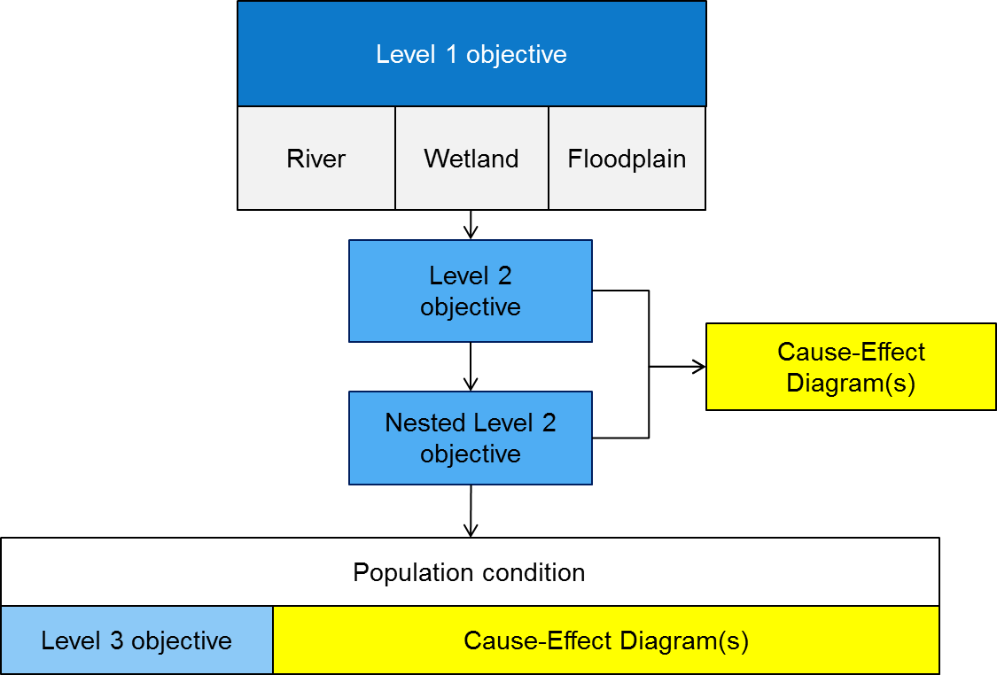
For the Level 2 and 3 objectives, cause-effect diagrams (CEDs) have been developed to explain the influence of flow on elements of the objectives hierarchy through its influence on causal categories including habitat, connectivity, processes, disturbance and cues. A further description of the CEDs is provided in section 2.2. Unique in this hierarchy is the reference to population condition in relation to the biodiversity Level 1 objectives. Population condition is an outcome of Level 3 objectives related to species diversity; however, is not a specific CED.

Figure 4. Generic objectives hierarchy showing the relationship between the key components of the LTIM Logic and Rationale.
Figure 5 shows the first three tiers of the objectives hierarchy as it has been applied to the LTIM Project, including the Level 1 objectives, as outlined above and in Section 1.2, and their related Level 2 objectives. For example, the Basin Plan, as it relates to the Level 2 biodiversity objectives, refers to both protecting and restoring a subset of all water-dependent ecosystems (ecosystem biodiversity) and representative populations and communities of native biota (species biodiversity). A further example is the Level 1 resilience objective which is supported by Level 2 objectives that refer to both water-dependent ecosystems and populations of native flora and fauna. Accordingly, the objectives hierarchy illustrates those relationships: species biodiversity is nested within ecosystem diversity and population resilience is nested within ecosystem resilience.
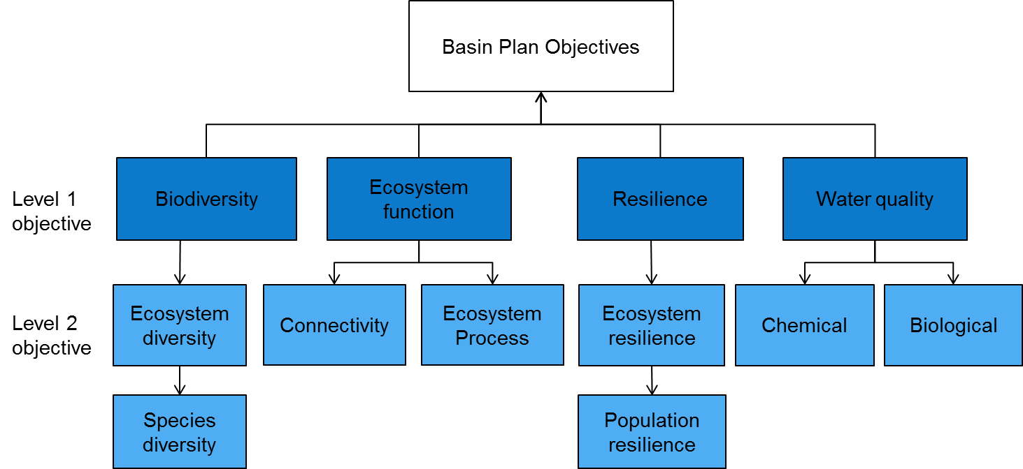
Figure 5. Environmental Water Plan objectives relevant to Level 1 and Level 2 of the objectives hierarchy.
Having classified the EWP objectives for water-dependent ecosystems into the structure presented in Figure 5, the next step is to establish the potential role of Commonwealth environmental water in achieving those objectives. To do so, we developed a series of cause-effect diagrams (CEDs) that show our understanding of the causal linkages between EWP objectives and flow. A CED is a graphical representation of the relationship between an expected outcome and potential factors that could influence the outcome.
In the case of ecosystem function and water quality, CEDs were developed on the content of the Level 2 objectives. For biodiversity, CEDs were developed for Level 2 and 3 objectives based on both the wording of the Basin Plan (e.g. populations of native biota) and the best available information on the population processes and characteristics required to sustain the Level 3 objectives. In the case of resilience, CEDs were developed to describe the major biotic strategies that enable biota to resist, adapt or recover from disturbances. In the first instance, the CEDs were designed to be generic to enable their modification and application to specific biota or processes in particular regions of the Basin.
The objectives hierarchy and CEDs provide a summary of the best available science in relation to the links between EWP objectives and flow (Table 2) and therefore provide a resource that can be used to support environmental water management, including planning, monitoring and evaluation. The CEDs describe the influence of flow on ecological responses that contribute to the achievement of the higher level objectives. In order to illustrate the contribution of each CED to achieve both higher level objectives and one-to-five-year outcomes, a series of diagrams have been developed to illustrate the spatial and temporal scale of the CEDs. The CEDs also directly inform the CEWO’s understanding of what can be achieved with environmental watering actions, which are known as the expected outcomes of environmental watering. The hierarchy shows how individual watering events, which often occur over short timeframes in discrete locations, contribute directly to EWP objectives over longer timeframes and at larger spatial scales. Interpreting and arranging the EWP objectives and outcomes in this way provides guidance for the management of environmental water, along with a structure for planning, monitoring, reporting and evaluation.
Level 1 Objectives | Level 2 Objectives | Level 3 Objectives | Expected outcome of watering actions (1-5 years) | Expected outcome of watering actions (<1 year) | Relevant Cause and Effect Diagram
Biodiversity  (Basin Plan S. 8.05) | Ecosystem diversity |  |  |  | Landscape Ecosystem Diversity
Biodiversity  (Basin Plan S. 8.05) | Ecosystem diversity |  | • Species diversity |  | Within Ecosystem Diversity
Biodiversity  (Basin Plan S. 8.05) |  | Vegetation | • Vegetation diversity |  | Landscape Vegetation Diversity
Biodiversity  (Basin Plan S. 8.05) |  | Vegetation |  | • Reproduction  • Condition | Vegetation Condition and Reproduction
Biodiversity  (Basin Plan S. 8.05) |  | Vegetation | • Growth and survival | • Germination  • Dispersal | Vegetation Recruitment and Extent
Biodiversity  (Basin Plan S. 8.05) |  | Macroinvertebrates | • Macroinvertebrate diversity |  | Within Ecosystem Macroinvertebrate Diversity
Biodiversity  (Basin Plan S. 8.05) |  | Fish | • Fish diversity |  | Landscape Fish Diversity
Biodiversity  (Basin Plan S. 8.05) |  | Fish |  | • Condition | Fish Condition
Biodiversity  (Basin Plan S. 8.05) |  | Fish |  | • Larval abundance  • Reproduction | Fish Reproduction
Biodiversity  (Basin Plan S. 8.05) |  | Fish | • Larval and juvenile recruitment |  | Fish Larval Growth and Survival
Biodiversity  (Basin Plan S. 8.05) |  | Waterbirds | •Waterbird diversity |  | Landscape Waterbird Diversity
Biodiversity  (Basin Plan S. 8.05) |  | Waterbirds | • Abundance  • Population structure | • Survival and condition | Waterbird Survival and Condition
Biodiversity  (Basin Plan S. 8.05) |  | Waterbirds |  | • Chicks | Waterbird Reproduction
Biodiversity  (Basin Plan S. 8.05) |  | Waterbirds |  | • Fledglings | Waterbird Recruitment and Fledging
Biodiversity  (Basin Plan S. 8.05) |  | Other vertebrate diversity |  | • Young | Other Vertebrate Reproduction
Biodiversity  (Basin Plan S. 8.05) |  | Other vertebrate diversity | • Adult abundance |  | Other Vertebrate Growth and Survival
Ecosystem Function  (Basin Plan S. 8.06) | Connectivity |  |  | • Biotic dispersal  • Sediment transport  • Nutrient and carbon cycling  • Primary productivity  • Decomposition | Hydrological Connectivity (including end of system flows)
Ecosystem Function  (Basin Plan S. 8.06) | Connectivity |  |  | • Movement | Biotic Dispersal
Ecosystem Function  (Basin Plan S. 8.06) | Connectivity |  |  | • Sediment transport | Sediment Transport
Ecosystem Function  (Basin Plan S. 8.06) | Process |  |  | • Primary productivity | Primary Production
Ecosystem Function  (Basin Plan S. 8.06) | Process |  |  | • Decomposition | Decomposition
Ecosystem Function  (Basin Plan S. 8.06) | Process |  | • Nutrient and carbon cycling |  | Nutrient and Carbon Cycling
Resilience  (Basin Plan S. 8.07) | Ecosystem resilience |  | • Population condition | • Individual survival and condition | Individual Refuges
Resilience  (Basin Plan S. 8.07) | Ecosystem resilience |  | • Population condition |  | Landscape Refuges
Resilience  (Basin Plan S. 8.07) | Ecosystem resilience |  |  | • Individual condition | Ecosystem Resistance
Resilience  (Basin Plan S. 8.07) | Ecosystem resilience |  | • Population condition |  | Ecosystem Recovery
Water quality  (Basin Plan S. 9.04) | Chemical |  |  | • Salinity | Salinity
 |  |  |  | • Dissolved Oxygen | Dissolved Oxygen
 |  |  |  | • pH | pH
 |  |  |  | • Dissolved organic carbon | Dissolved Organic Carbon
Water quality  (Basin Plan S. 9.04) | Biological |  |  | • Algal blooms | Algal Blooms
Table 2. Summary of objectives hierarchy and expected outcomes, and the relevant CEDs.

2.1.1 Biodiversity objectives hierarchy
The biodiversity objectives hierarchy applies across all ecosystem types within the Basin and includes ecosystem diversity and species diversity as a Level 2 objective (Figure 6). For ecosystem diversity there is an ecosystem diversity, and ecosystem scale waterbird and fish diversity CEDs to reflect the scales at which diversity of these groups respond to management. Species diversity is nested within ecosystem diversity because ecosystem condition is dependent on the species diversity within each ecosystem. At the species diversity Level 2 there is one CED, macroinvertebrate diversity, as this reflects the scale at which macroinvertebrate diversity is likely to be managed. Nested within the species diversity objective are the population objectives as sustaining biodiversity requires protection and restoration of populations of individual species. The Level 3 objectives and related CEDs associated with the Level 2 objective of species diversity include aspects of biodiversity relating to water-dependent species and populations. For vegetation, fish, waterbirds and other vertebrates there are CEDs to describe the relationship between flow and key population processes such as maintenance of condition, reproduction and recruitment. In the case of macroinvertebrates, no population CED was developed due to the low probability that the CEWO would explicitly allocate flows to achieve macroinvertebrate outcomes.

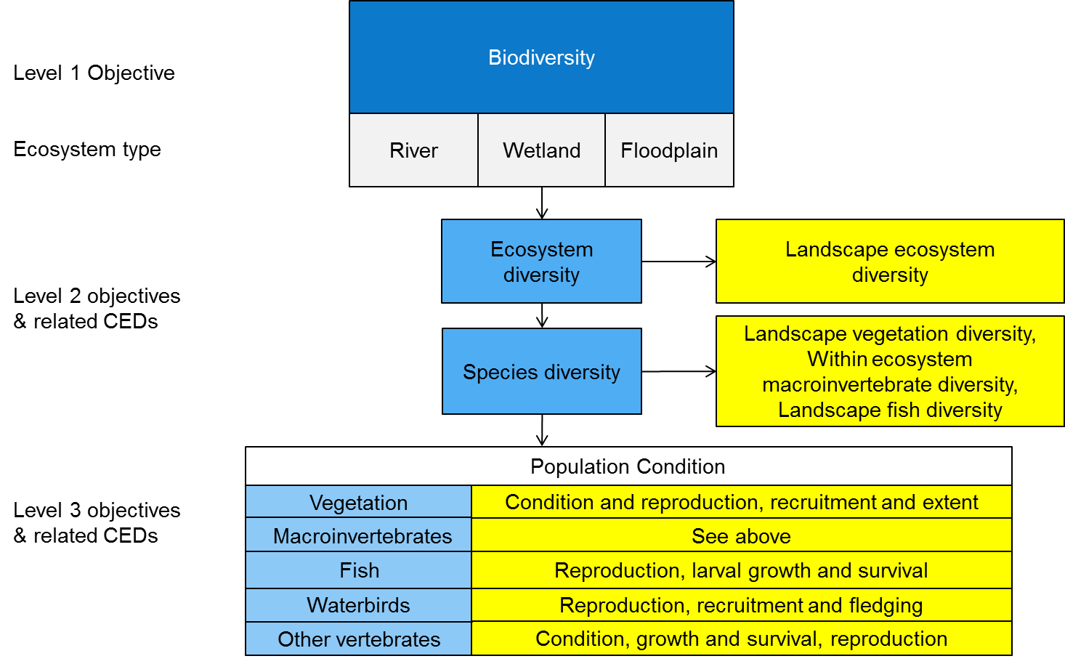

Figure 6. An illustration of the biodiversity objectives hierarchy. The mid shade blue boxes are Level 2 objectives, the light blue boxes are Level 3 objectives and the yellow boxes are CEDs.
The spatial and temporal relationship between the different levels of the objectives hierarchy are illustrated in Figure 7. This style of representation of the objectives hierarchy is useful in identifying appropriate expected outcomes over the one-year and one-to-five-year timeframes.
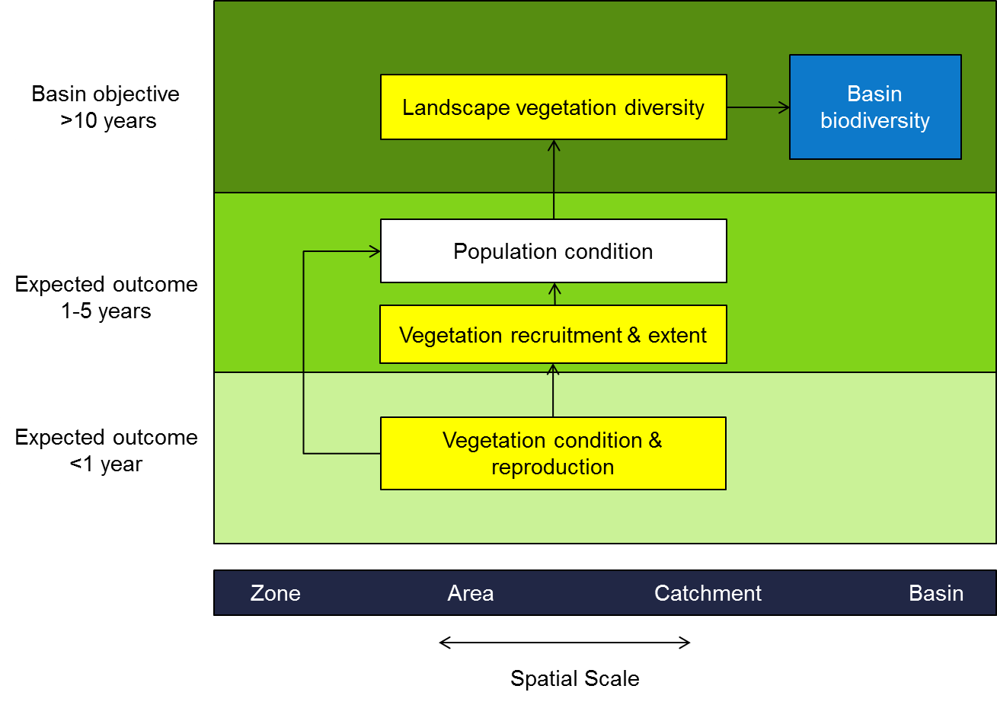
Figure 7. An illustration of the spatial and temporal relationships between elements of the vegetation objectives hierarchy. The yellow boxes represent aspects of the Level 3 vegetation objective for which cause-effect diagrams have been developed.
The EWP objectives include reference to Ramsar wetlands. The objective of the Ramsar convention is the ‘conservation and wise use of all wetlands’ where wise use is defined as ‘the maintenance of their ecological character, achieved through the implementation of ecosystem approaches within the context of sustainable development’. Ecological character is defined as ‘the combination of the ecosystem components, processes and benefits/services that characterise the wetland at a given point in time’. From an environmental perspective, the components of wetlands are aligned with Basin Plan biodiversity objectives and ecosystem processes align with Basin Plan function objectives. The LTIM Project is not however, designed to identify changes in the character of the Basin’s Ramsar wetlands as this would fall within the scope of long-term asset condition assessment. The LTIM Project and associated program logic would be appropriate to assess environmental flows designed to protect or restore the character of a Ramsar wetland.
One of the Environmental watering plan objectives is protection or restoration of representative populations and communities of native biota. The reference to populations is explicitly represented within the proposed objectives hierarchy. There is however, no reference to communities. In general a community is a level of organisation intermediate between population and ecosystem and refers to populations that interact in some way, whether these interactions are beneficial, competitive or exploitative. The wording of the Level 3 objectives suggests that the term community was being used to refer to populations from the same group (e.g. fish, vegetation) that occupy the same area. In this case, and for the purposes of the LTIM Project, response of communities aligns closely with Level 3 objectives of vegetation, macroinvertebrate, fish, waterbird and other vertebrates. If an alternate definition is developed during implementation of the Basin Plan, then the objectives hierarchy can be modified to accommodate it as appropriate.

2.1.2 Ecosystem function objectives hierarchy
For ecosystem function, the Basin Plan identifies six objectives relating to connectivity; processes that shape landforms and habitat diversity, processes that support populations and processes that influence energy, carbon and nutrient dynamics. The six objectives have been grouped into two Level 2 objectives (Figure 8):
- connectivity that includes hydrological connectivity, sediment transport that is fundamental to the maintenance of land forms and habitat diversity, and biotic dispersal
- functional processes including primary production, decomposition, and nutrient and carbon cycling.
The other ecosystem function objectives relating to water quality and sustaining populations are incorporated into the water quality and biodiversity hierarchies respectively.
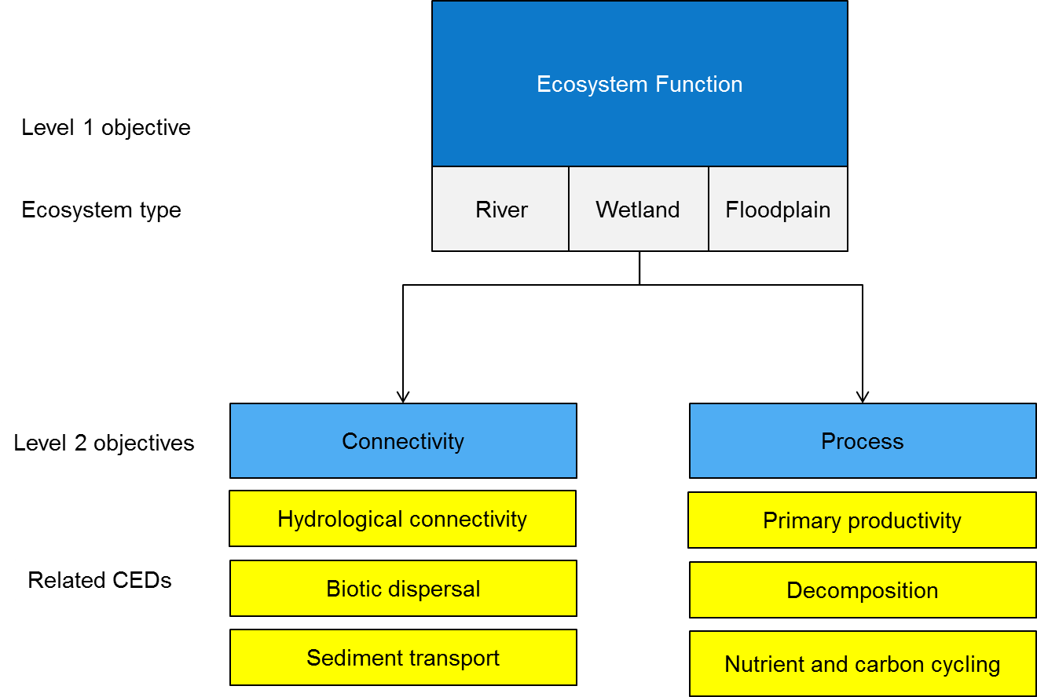
Figure 8. An illustration of the ecosystem function objectives hierarchy. The yellow boxes represent aspects of the Level 2 connectivity and ecosystem process objectives for which cause-effect diagrams have been developed.
Connectivity objectives are illustrated in Figure 9 which shows the relationship between the spatial scale and timeframes for expected ecological outcomes. This also illustrates some of the linkages between the Level 1 objectives; in this instance, hydrological connectivity and sediment transport sustain habitats that influence populations and therefore biodiversity while biotic dispersal influences resilience (Figure 9).

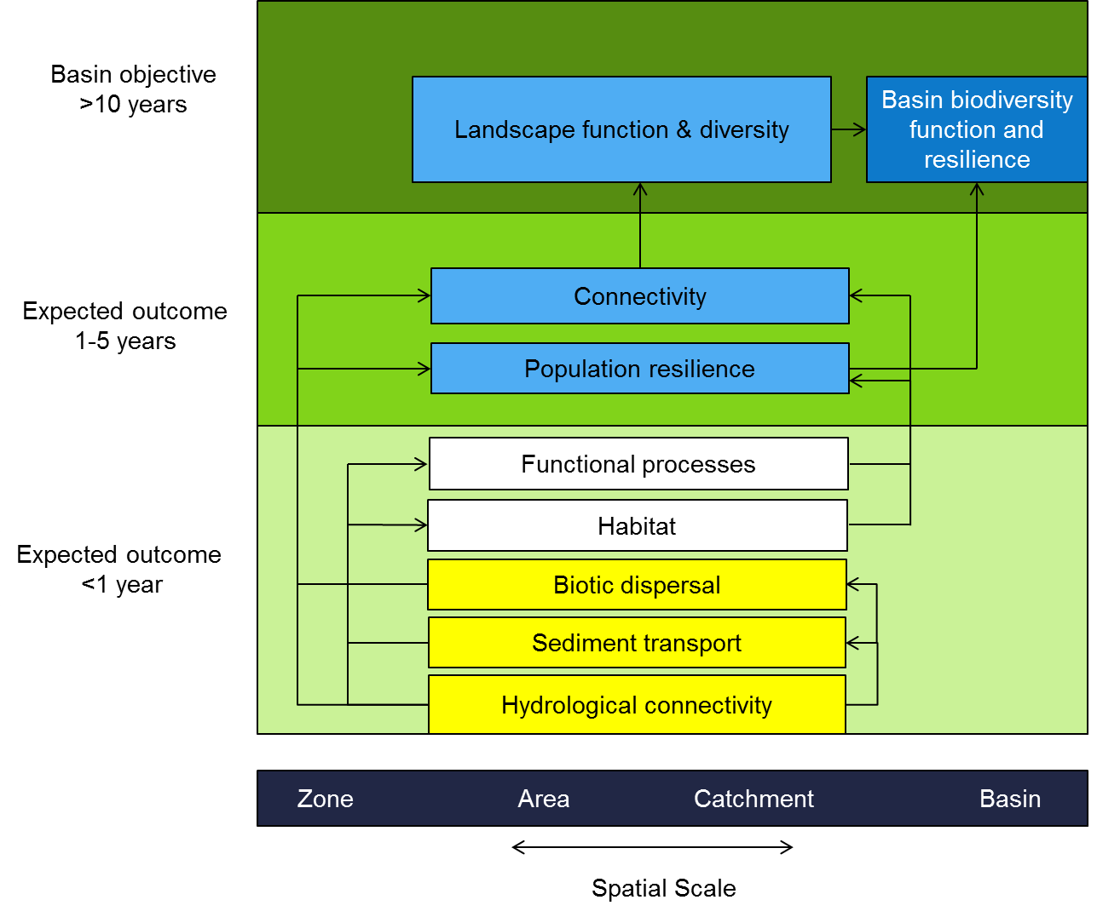
Figure 9. An illustration of the spatial and temporal relationships between elements of the ecosystem function objectives hierarchy. The blue boxes represent aspects of the Level 2 connectivity and ecosystem process objectives. The cause-effect diagrams that relate to these are indicated in yellow.

2.1.3 Resilience objectives hierarchy
For the purposes of the Commonwealth environmental water delivery, we define resilience as ‘the capacity of a system to respond to disturbance (resist, recover and adapt) while undergoing change so as to still retain essentially the same function, structure and feedbacks and therefore identity’ (Gawne 2012). Ecosystem resilience emerges from the characteristics of the broader landscape of which it is part and the populations of biota of which it is comprised. At the landscape scale, resilience is influenced by aquatic ecosystem diversity. While our understanding of ecosystem resilience is limited, the ecosystem diversity CED provides a starting point for developing improved understanding through adaptive management.
At the population level, species have a range of strategies to enable them to respond to disturbance that include; avoidance, resistance, resistance through the use of refugia and rapid recovery. The success of any of these strategies depends on the interaction between species traits and the characteristics of the ecosystem. As water management influences ecosystem characteristics and not species traits, resilience is comprised of two Level 2 objectives with population resilience nested within ecosystem resilience. Nested within population resilience are CEDs relating to the three broad resilience strategies and a CED describing the influence of flow on recovery which is important to all biota in disturbed environments (Figure 10).
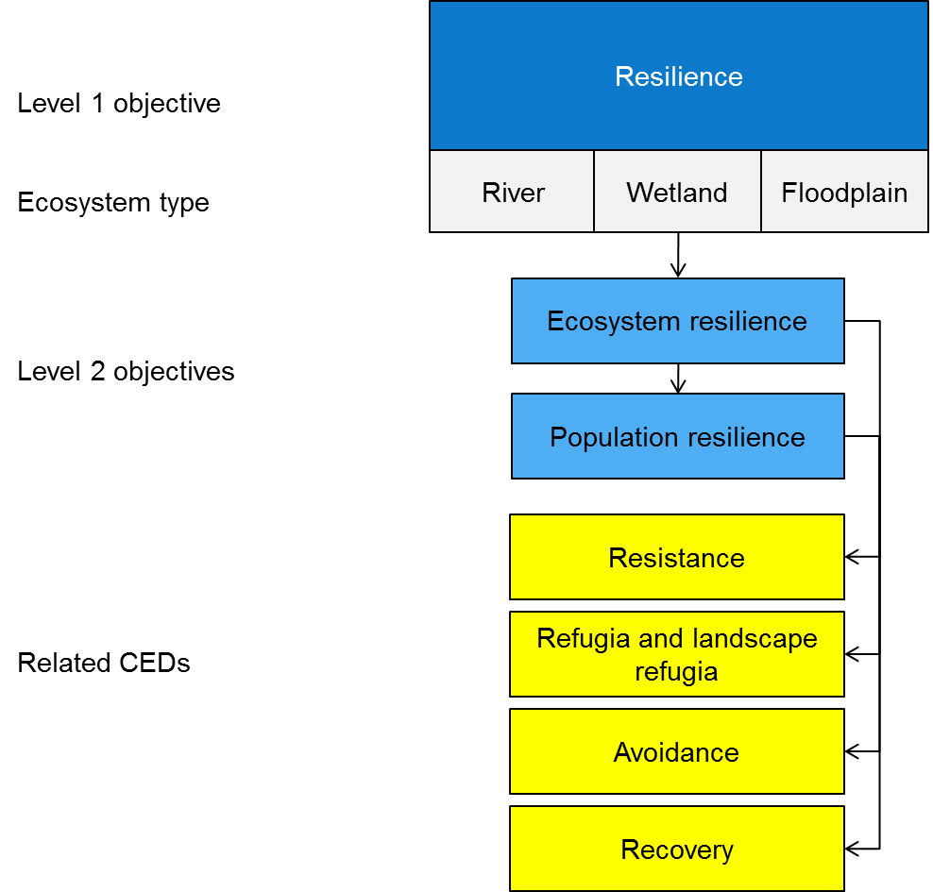

Figure 10. An illustration of the ecosystem function objectives hierarchy showing the relationship between the ecosystem function objectives, ecosystem types and related cause-effect diagrams. The yellow boxes represent aspects of the Level 2 ecosystem and population resilience objectives for which a cause-effect diagram has been developed.

Ecosystem resilience is believed to confer resilience on systems on the basis that populations of different species will utilise different ecosystems as refugia from different types of disturbances. The following provides a brief description of each CED in the resilience hierarchy:
- Resistance – the use of environmental water to enable populations to resist disturbance. This aligns with the EWP objective to ‘provide wetting and drying cycles and inundation intervals that do not exceed the tolerance of ecosystem resilience or the threshold of irreversible change’.
- Refugia – some species rely on refugia to resist disturbance. Water is an important determinant of the distribution and abundance of refugia (landscape scale) and the quality of individual refugia. The nested or hierarchical nature of water-dependent ecosystems means that refugia need to be managed at both of these scales. Protecting refugia aligns with the EWP objective of ‘protecting refugia in order to support the long-term survival and resilience of water-dependent populations of native flora and fauna, including during drought’.
- Avoidance - some species disperse away from disturbances. This may, in some instances, relate to the EWP objective ‘to minimise habitat fragmentation’ as fragmentation may affect some species capacity to disperse. It may also relate to the environmental watering plan function objective of protecting or restoring ‘ecosystem functions of water-dependent ecosystems that maintain populations (for example recruitment, regeneration, dispersal, immigration and emigration)’.
- Recovery – after a disturbance, all species need to recover if they are to persist over the long-term. This aligns with the function objective of protecting or restoring ‘ecosystem functions of water-dependent ecosystems that maintain populations (for example recruitment, regeneration, dispersal, immigration and emigration)’.
The resilience objectives hierarchy can also be illustrated showing the relationship between the spatial scale and timeframes for expected ecological outcomes (Figure 11). This representation of the objectives hierarchy is useful in identifying appropriate expected outcomes over the one-year and one-to-five-year timeframes (Figure 11).
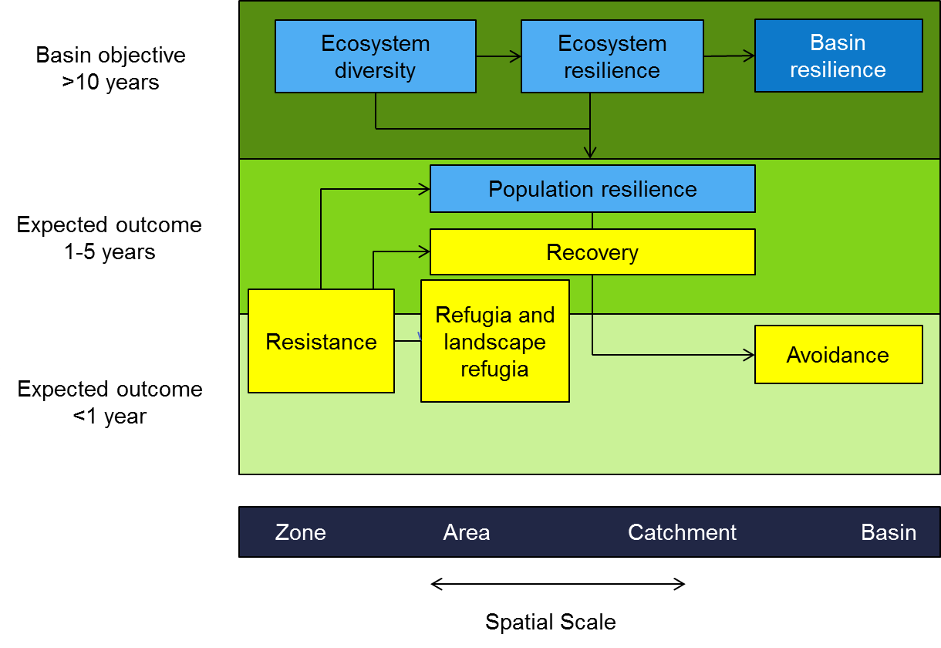

Figure 11. An illustration of the spatial and temporal relationships between elements of the resilience objectives hierarchy. The yellow boxes represent aspects of the Level 2 ecosystem and population resilience objectives for which cause-effect diagrams have been developed.

2.1.4 Water quality objectives hierarchy
The EWP objective for water quality is to ensure that water quality does not affect environmental, social and economic activities. The underlying premise is that water quality changes pose a threat to the achievement of EWP objectives. While there are many water quality parameters that have the capacity to affect environmental activities, Commonwealth environmental water delivery will focus on four characteristics of water quality where the relationship to flow and the impacts on biodiversity, ecosystem function and resilience are relatively well understood: salinity, pH, dissolved oxygen and dissolved organic carbon (Figure 12).
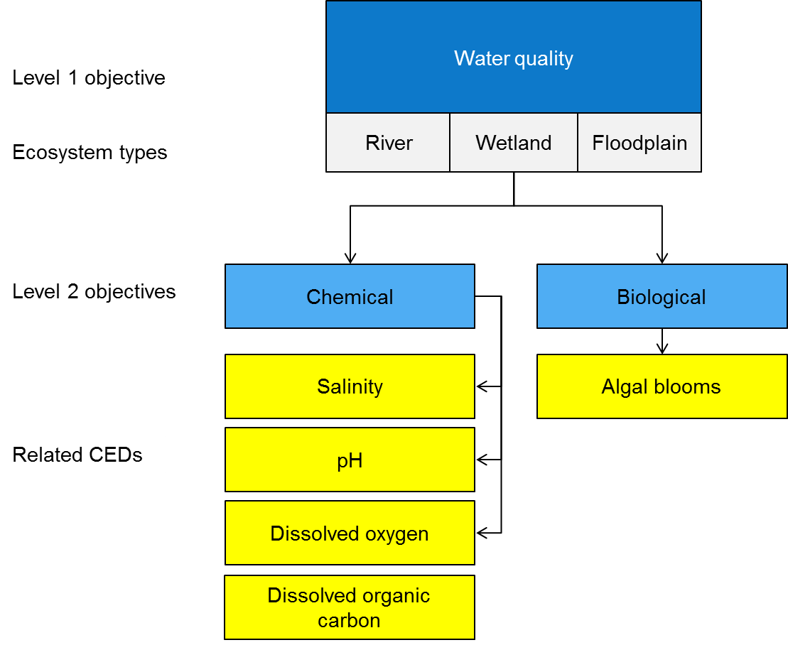

Figure 12. An illustration of the water quality objectives hierarchy showing the relationship between the ecosystem function objectives, ecosystem types and related cause-effect diagrams. The yellow boxes represent aspects of the Level 2 chemical and biological objectives for which cause-effect diagrams have been developed.
The Level 2 water quality objective can also be illustrated showing the relationship between the spatial scale and timeframes for expected ecological outcomes (Figure 13). This depiction of the hierarchy also illustrates some of the linkages between the Level 1 objectives. In this instance, water quality influences habitat quality and other functional processes that will influence achievement of biodiversity and ecosystem function objectives (Figure 13).
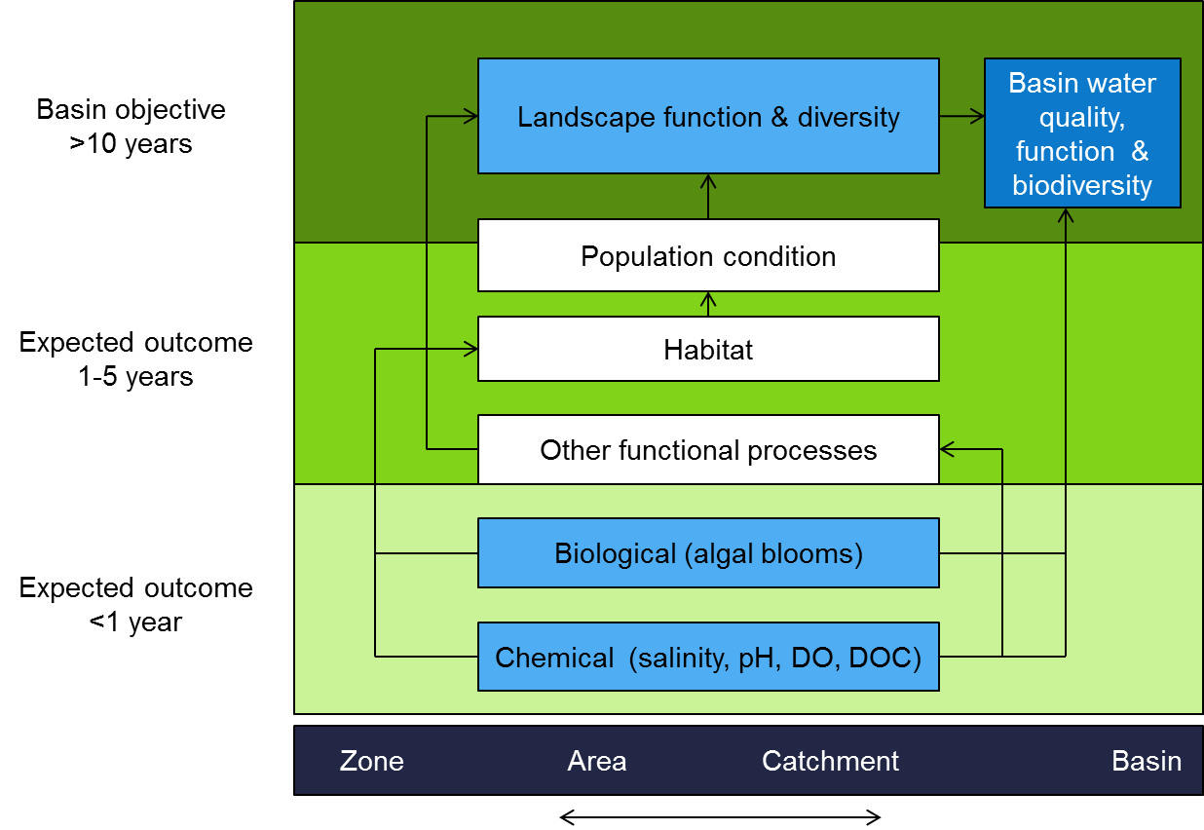
Figure 13. An illustration of the spatial and temporal relationships between elements of the water quality objectives hierarchy, including links to the water quality, function and biodiversity objectives. The blue boxes represent aspects of the Level 2 biological and chemical objectives for which a cause-effect diagram has been developed.

2.1.5 Ecosystem condition hierarchy
Having developed the objectives hierarchy, it is helpful to map the various levels and associated CEDs back to the way they may contribute to the MDBA’s assessment of the condition of water-dependent ecosystems. At the highest level, assessment of each ecosystem type would include biodiversity, ecosystem function, resilience and water quality. For each of the Level 1 objectives, the Level 2 objectives are likely to vary by ecosystem type. For example, macroinvertebrates may provide a good indicator in rivers (Figure 14) but not in wetlands (Figure 15) or floodplains (Figure 16) due to greater variability and greater uncertainty concerning their response to flow. Similarly, while waterbirds are a Level 3 objective, they are seldom included in assessments of river condition. The way in which EWP objectives and CEDs could inform an assessment of river, floodplain and wetland condition are illustrated in Figures 14 to Figure 16.
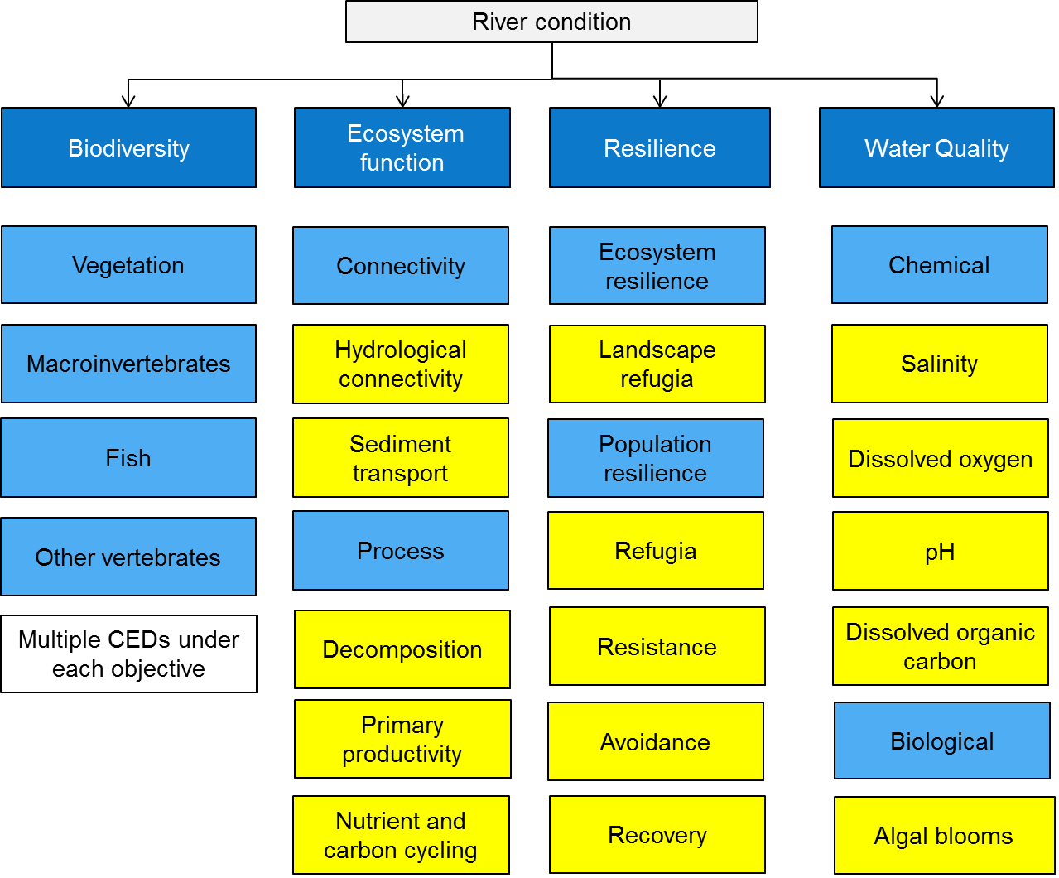
Figure 14. Illustration of the potential structure of an assessment of river condition in relation to the four Level 1 objectives and the nested Level 2 and 3 objectives in mid and light blue beneath. Cause-effect diagrams developed are indicated in yellow.
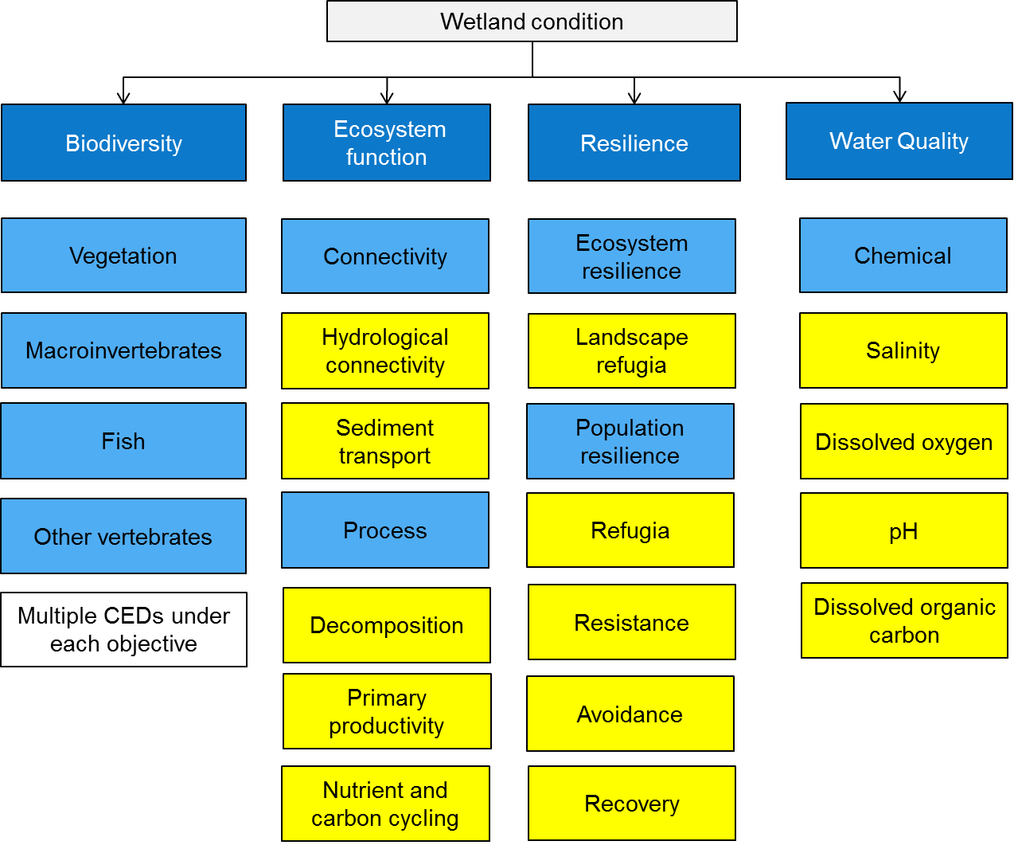
Figure 15. Illustration of the potential structure of an assessment of wetland condition in relation to the four Level 1 objectives and the nested Level 2 and 3 objectives in mid and light blue beneath. Cause-effect diagrams developed are indicated by the yellow.
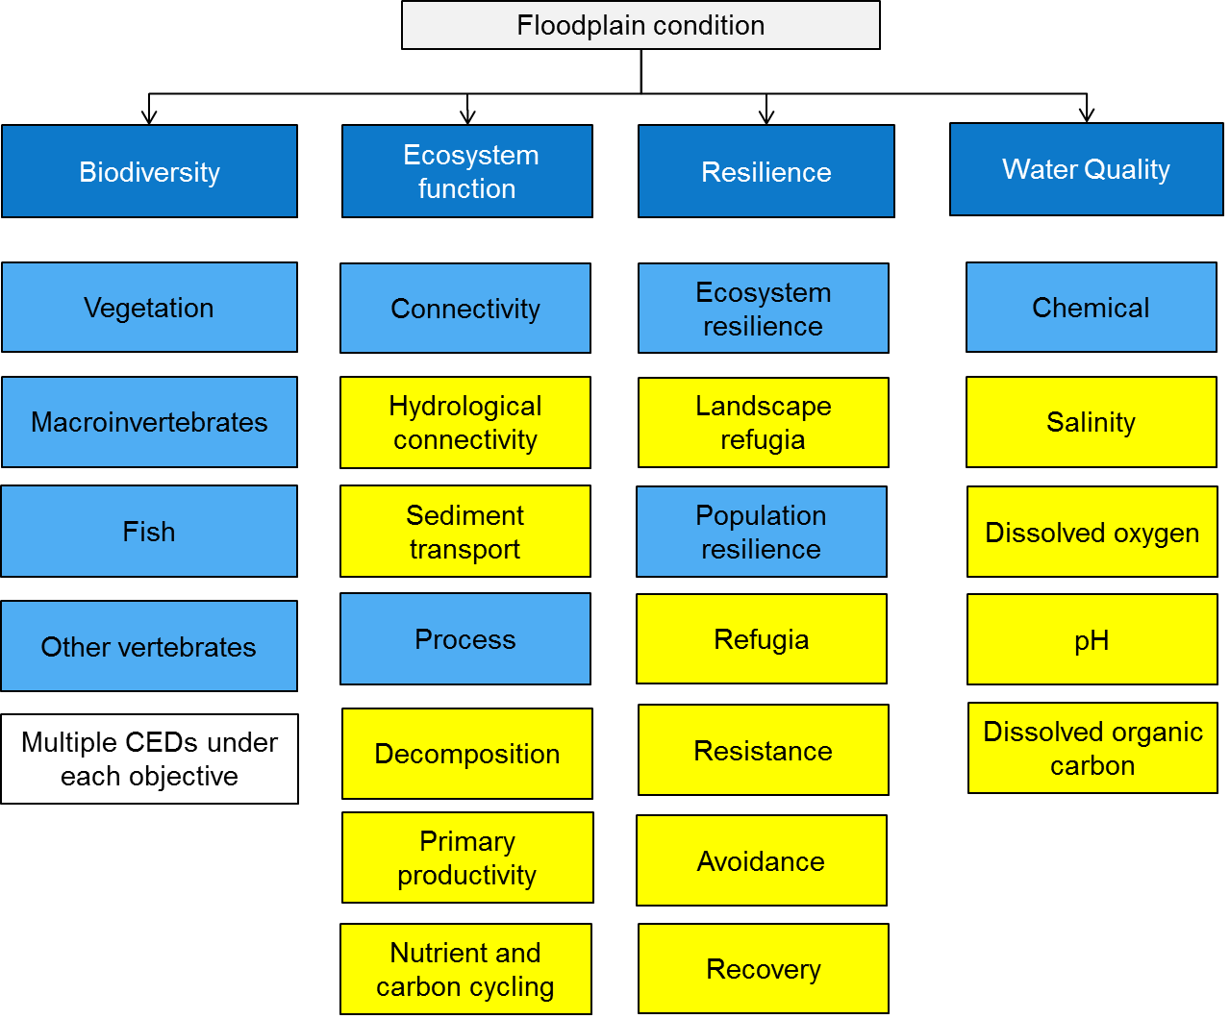
Figure 16. Illustration of the potential structure of an assessment of floodplain condition in relation to the four Level 1 objectives and the nested Level 2 and 3 objectives in mid and light blue beneath. Cause-effect diagrams developed are indicated in yellow.

2.2 Cause-effect diagrams
Conceptual models are useful tools for exploring and understanding the relationships within an ecosystem. In this instance, cause-effect diagrams (CEDs) have been developed to conceptually explore the relationships between flow and ecological responses in aquatic ecosystems. Gross (2003) provides a comprehensive guide to the development of conceptual models, particularly for the design of environmental monitoring programs. He states that a useful conceptual model will:
- articulate important processes and variables
- contribute to understanding interactions between ecosystem processes and dynamics
- identify key links between drivers, stressors and system responses
- facilitate selection and justification of monitoring variables
- facilitate evaluation of data from the monitoring program
- clearly communicate dynamic processes to technical and non-technical audiences.
CEDs, in a variety of forms, have become common conceptual models for informing environmental monitoring in Australia and elsewhere, for example, the Integrated Monitoring of Environmental Flows in the Murray-Darling Basin (Chessman and Jones 2001); Victorian Environmental Flows Monitoring and Assessment Program (Cottingham et al. 2005a) and CEWO Short Term Monitoring Project (MDFRC in prep). They have been advocated as an important mechanism for identifying appropriate indicators (Niemeijer and de Groot 2008); for exploring cause and effect relationships (e.g. driver-pressure-state-impact-response model) and as a communication tool.
Aquatic ecosystems are complex and dynamic and when developing diagrams there is always a trade-off between realism, generality and precision as it is impossible to maximise all three simultaneously. As a CED is a simplified representation of a complex natural system, a good CED does not attempt to explain all possible relationships or contain all possible factors that influence the management objective but tries to simplify reality by containing only the information most relevant (Gross 2003). Importantly, a good cause-effect diagram needs to explicitly state the underlying assumptions and the level of uncertainty associated with the links (King et al. 2003). As the CEDs are developed assumptions will be articulated and the uncertainty expressed.
CEDs have been developed to inform Commonwealth environmental water use, including to:
- describe the key relationships between flow and ecological responses to inform expected outcomes of Commonwealth environmental watering
- support planning for the use of Commonwealth environmental water
- underpin MERI processes
- support both reporting and adaptive management
- communicate the influence of flow to external stakeholders.
In developing the CEDs and ensuring the balance between simplicity and accurately representing ecological relationships, the following principles were followed:
- The CEDs focus on the influence of flow and ignore all non-flow related influences on the outcome. In some instances, this required a judgement about whether a minor or indirect influence warranted inclusion in the CED.
- The CEDs were developed in line with the objectives hierarchy approach outlined in Section 2.1 above. The relationships between CEDs are illustrated in hierarchy diagrams (Figure 4) that provide a visual representation of the underlying logic behind the selection of expected outcomes. The contribution of one cause-effect diagram to another is illustrated within the CED as a yellow box (Figure 17). For instance, in the recovery CED there are links to condition, dispersal and recruitment CEDs.
- The CEDs link flow through its influence on a suite of causal categories (habitat, connectivity, processes, disturbance and cues) to the expected outcome. Within each of these categories the relevant habitat or connectivity characteristics, cues, processes or disturbances are listed (Figure 17).
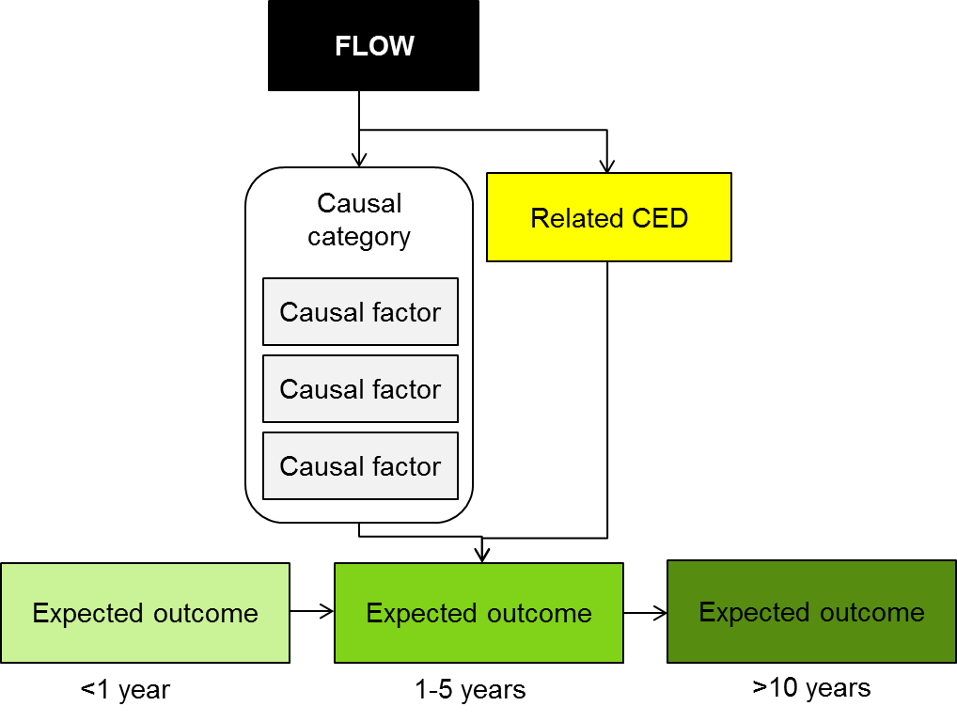
- The CEDs were designed to facilitate identification of the two broad types of indicators that will be used by LTIM; effect indicators that support reporting of progress against objectives and causal indicators that support evaluation and adaptive management (Figure 17). To facilitate this, the objective at the base of each CED is colour coded to align with the colour bands in the spatial and temporal hierarchy diagrams.

Figure 17. Generic structure of cause-effect diagrams, illustrating the influence of flow on an objective through the action of causal factors that are grouped within a causal factor. A related CED is identified within a yellow box. The objective is the major influence on identification of effect indicators while causal factors facilitate identification of causal indicators.
The general form of all the CEDs (except hydrological connectivity, and nutrients and carbon cycling) is the same with flow at the top of the CED influencing one or more causal categories (habitat, connectivity, processes, disturbance or cues) or subsidiary CEDs (Figure 18). Within each causal category is a list of causal factors. It is expected that the generic CEDs presented here will be adapted for specific indicators for each of the seven areas. Once particular species, processes or water quality characteristics have been identified, specific elements of the generic CED may be either removed or, in some instances, expanded to provide more detail relevant to the specific circumstances.
An example cause-effect diagram is provided in Figure 18. This CED illustrates the causal relationships linking flow to within wetland macroinvertebrate diversity which is a Level 3 biodiversity objective. The CED illustrates that macroinvertebrate diversity within an ecosystem is influenced by landscape ecosystem diversity as indicated by the yellow box. The macroinvertebrate diversity CED indicates that flow directly influences one causal factor (area) and two causal categories; habitat heterogeneity and connectivity, to the rest of the system. The influence of flow on habitat is influenced by the ecosystem type. Habitat and connectivity in turn influence a third causal category; ecosystem condition. Within each causal category are a list of causal factors that influence within macroinvertebrate diversity; these include soil moisture, vegetation condition, eggs and seeds, refugia and sediment organic matter.
The LTIM generic CEDs are included in a stand-alone accompanying document called LTIM Generic Cause and effect Diagrams. These CEDs contain a concise summary of the literature supporting each of the CEDs. In a number of instances the CEDs have been combined into one literature review where the literature content was inter-related and overlapping.
CED hierarchies have also been developed depicting the spatial and temporal scale over which a particular CED is likely to apply (see examples in Section 2.1).

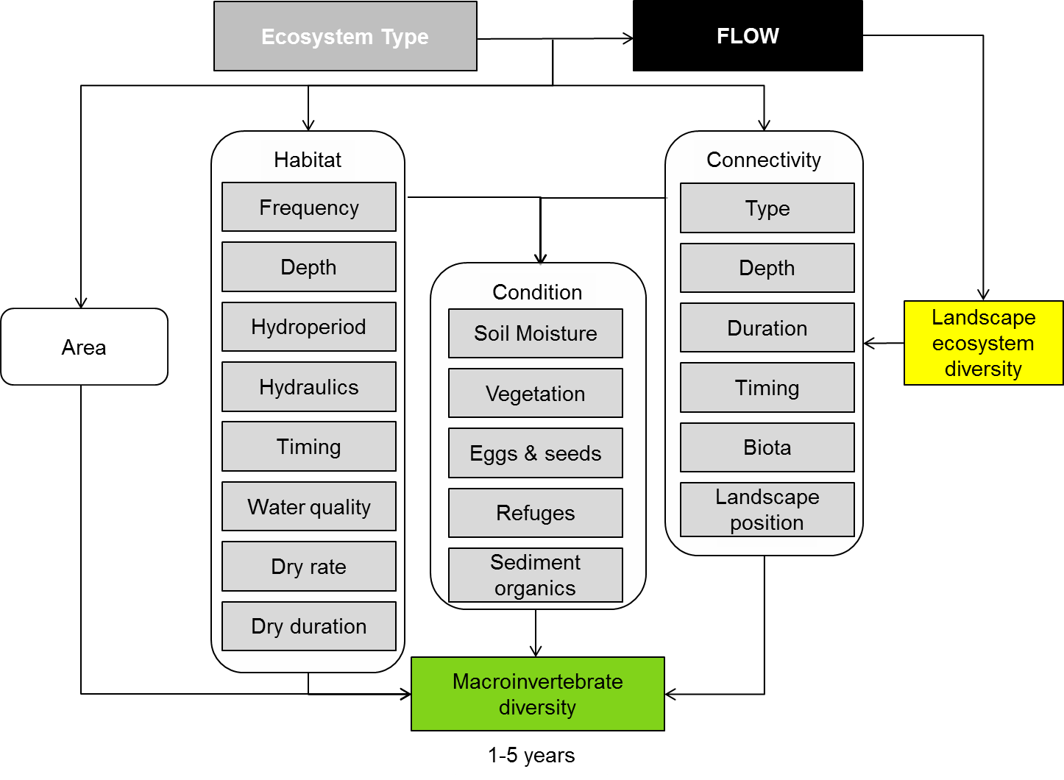
Figure 18. Example CED for the Level 3 objective within wetland macroinvertebrate diversity which relates to the Level 1 biodiversity objective.

2.3 The major flow types
The Basin Plan identifies five environmentally significant flow components (Figure 19) that are used to develop the Sustainable Diversion Limit (MDBA 2011). Of the five flow components, environmental water may be used to support four of these, specifically base flows, freshes, bankfull and overbank flows. Cease-to-flow events are not considered as environmental water managers do not have the capacity to withhold water to create a cease-to-flow event. Environmental water may be allocate to prevent or shorten the duration of cease-to-flow events, but these are considered under base-flow or freshes. Environmental watering may also be facilitated through the use of infrastructure. While it is acknowledged that the outcomes of these events may vary from natural flow events, for the current purposes these types of flows are considered as similar to the flows they try to emulate (i.e. bankfull and overbank).
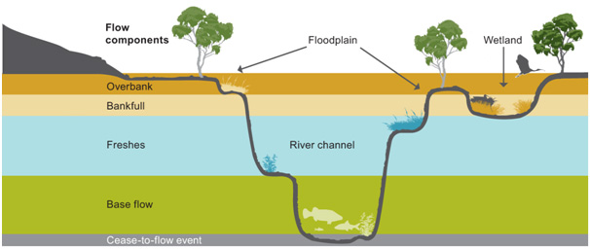
Figure 19. Five flow types and their influence on different parts of the river channel, wetlands and floodplains (Figure 5.1 in MDBA 2011).

2.3.1 Base flow (low flows)
Base flows are those that are confined to the low flow part of the channel. These flows would typically inundate geomorphic units such as pools and sustain riffle or shallow run areas between pools.
Base flows are important to obligate aquatic species and communities, including fish communities as they:
- Maintain a minimum diversity of habitats for shelter, feeding and spawning. They may create riffle or shallow runs of flowing water habitat which do not exist when flows cease.
- Establish connectivity and enable longitudinal movement of taxa between pools. Large bodied fish may not move during base flows due to inadequate water depth within riffles and connecting runs but small bodied fish and macroinvertebrates may move if conditions are suitable.
- Constantly dilute and refresh water in pools and thereby maintain reasonable water quality.

2.3.2 Freshes
Freshes provide inundation of additional habitat features such as in-channel benches, woody structural habitat and anabranches that connect at flows less than bank full but greater than base flow. These flows provide a greater range of in-channel habitats and enhance nutrient cycling processes, including:
- longitudinal connection of habitats allowing aquatic species to move through the river system
- maintenance of drought refuges
- dilution within the river channel, refreshing water in pools and thereby maintaining reasonable water quality
- provision of flows to support fish movement, recruitment and spawning.

2.3.3 Bankfull
While the role of bankfull flows are not explicitly described in the Basin Plan, the flows conceptualisation (Figure 19) illustrates that bankfull flows fill the main channel and inundate some wetlands and anabranches. The objectives emphasise riparian, wetland and floodplain vegetation, waterbirds and other significant species including fish, reptiles, frogs and invertebrates. Bankfull flows will be important in creating or sustaining habitat for riparian and wetland vegetation and those species of fish and frogs reliant on connected wetlands. For waterbirds, bankfull flows may be important in creating or sustaining foraging habitat.

2.3.4 Overbank
The role of overbank flows are not explicitly described in the Basin Plan, objectives emphasise riparian, wetland and floodplain vegetation, waterbirds and other significant species including fish, reptiles, frogs and invertebrates. Overbank flows are a major influence on habitat, both creating habitat and acting as a disturbance. Overbank flows also influence hydrological connectivity providing opportunities for the exchange of sediment, nutrients and organic matter, and the movement of biota. Finally, overbank flows influence major ecological processes such as primary production, decomposition and nutrient cycling. The boom in productivity and habitat availability is associated with breeding opportunities for waterbirds, frogs and some species of native fish.

2.3.5 Discrete wetland and/or floodplain inundation
There are a number of circumstances in which high flows are required to achieve a connection between the source of water and the nominated environmental asset. In these instances, infrastructure such as pumps, weirs and regulators may be used to deliver water. In most cases, the delivery of water through the use of infrastructure seeks to mimic the role of one of the flow types discussed above. In order to identify expected outcomes from these events, the objective of the watering or the flow type being simulated would be used to inform development of an appropriate outcome.
The other flow outcome that does not align with the typology is the inundation of terminal wetlands. Terminal wetlands can be inundated through prolonged base flows, or freshes as well as by bankfull or overbank flows.

2.3.6 Flows to achieve Environmental Watering Plan objectives
The next step in understanding the logic is to link the identified role of the major flow types available to the Commonwealth Environmental Water Holder to EWP objectives for water-dependent ecosystems.
The following table provides a brief summary of the role of the flow types described in the Basin Plan in relation to the three ecosystem types (river, wetland and floodplains) and the ways they may influence biodiversity, ecosystem function, resilience and/or water quality (Table 3).
Table 3. General description of the role of different flows types on rivers, wetlands and floodplains.
Flow Type | Ecosystem Type
Flow Type | River | Wetland | Floodplain
No Flow | Cease to flow.  Disturbance that influences biodiversity and function. | No surface water.  Disturbance that influences biodiversity and function. | No surface water.  An important determinant of floodplain character.
Base Flow | Flow that protects refugia, sustains water quality, productivity and biodiversity.  Provides limited longitudinal connectivity. | - | -
Fresh | In-channel disturbance maintains littoral habitat, scours biofilm and provides longitudinal connectivity.  Will affect water quality and ecosystem functions but the effects vary. | - | -
Bankfull | In-channel disturbance.  Influences in-channel and riparian habitat, provides longitudinal and limited lateral connectivity.  Sediment transport influences long-term channel form. | Only inundates wetlands connected at bank full, typically those closely connected to parent river.  Influence on all water-dependent species habitat, provides some lateral connectivity, major stimulus for primary productivity, decomposition and nutrient cycles.  Maintain permanent wetlands as refugia. | -
Overbank | In-channel disturbance.  Major influence on in-channel and riparian habitat, provides longitudinal and lateral connectivity, major stimulus for other functions.  Sediment transport influences long-term channel form. | Major influence on ecosystem diversity and habitat, provides connectivity, major stimulus for primary productivity, decomposition and nutrient cycles.  Maintain permanent wetlands as refugia. | Major influence on ecosystem diversity and habitat, provides connectivity, major stimulus for primary productivity, decomposition and nutrient cycles.  Maintain permanent wetlands as refugia. Magnitude of flows is important for differentially inundating low lying and higher areas of the floodplain.

2.4 Expected outcomes

2.4.1 One-Year expected outcomes
Our conceptual understanding of the relationships between flow and ecological responses, as informed by the literature reviews and represented in the CEDs, has been used to develop less-than-one-year expected outcomes of Commonwealth environmental watering. Expected outcomes at the one-year scale are heavily reliant on the flow type (base, fresh, bankfull, overbank etc.) and for this reason, outcomes have been expressed based on the types of flow that the CEWO is likely to be able to contribute to.
Expected outcomes are also reliant on the ecology of the aquatic ecosystem that receives environmental water. For example, a fresh delivered to a stream that has deep in-channel waterholes may be expected to improve water quality within the in-channel pool, while a fresh delivered to a system with significant in-channel vegetation may be expected to improve condition of that vegetation community. Therefore, expected outcomes have been created at the selected area level for the seven selected areas for which long-term monitoring is to be established. These are presented for each selected area in the corresponding specific Monitoring and Evaluation Requirements documents. An example of the types of expected outcomes that have been developed is provided for the Lower Murray River in Table 4.
Table 4. Some examples of expected outcomes for the Lower Murray River selected area.
Flow type | Objective Level 1 | Objective Level 2 | Objective Level 3 | Suggested one-year expected outcome
Base flow | Biodiversity | Species diversity | Fish | Contribute to the protection of native fish diversity and abundance through maintaining suitable habitat.
Base flow | Function | Process  Connectivity |  | Contribute to transport of nutrients from the Murray River to reduce primary production (excess algal growth).
Fresh | Biodiversity | Species diversity | Vegetation | Contribute to riparian native vegetation population viability, particularly extent and condition.
Bankfull | Biodiversity | Species diversity | Waterbirds | Maintaining habitat diversity and condition to contribute to successful breeding and recruitment and improvement of population condition of waterbirds.
Overbank | Function | Connectivity |  | Contribute to the increased distribution of native fish species.

The expected outcomes provide the basis for formulating hypotheses; i.e. the questions to be tested by the monitoring. For example in Table 4 above, a base flow in the Lower Murray River is expected to contribute to the protection of native fish diversity and abundance through maintaining suitable habitat. Hypotheses to be tested by the monitoring could then be:
Do implemented environmental base flows in the Lower Murray River:
- maintain condition of native fish
- maintain growth and survival of juvenile fish
- maintain native fish species diversity
- maintain native fish abundance?
Such hypotheses will underpin the monitoring design which is discussed in Section 3.3.

2.4.2 One-to-five-year expected outcomes
Ecological outcomes of environmental watering over the one-to-five-year timeframe are strongly influenced by water availability and flow regimes over the period. In order to formulate the range of expected outcomes likely from the use of Commonwealth environmental water, it is necessary to identify the range of possible water availability and flow regime scenarios over the five-year period. This was undertaken in a generic sense by defining five water availability classes:
- extreme dry
- dry
- median
- wet
- extreme wet.
The water availability, flow types and their roles and CEDs can all be used to identify expected outcomes under each water availability scenario. As the likely flow types under dry and very dry scenarios were believed to be similar, these two water availability scenarios were merged. The approach is illustrated in Figure 20.
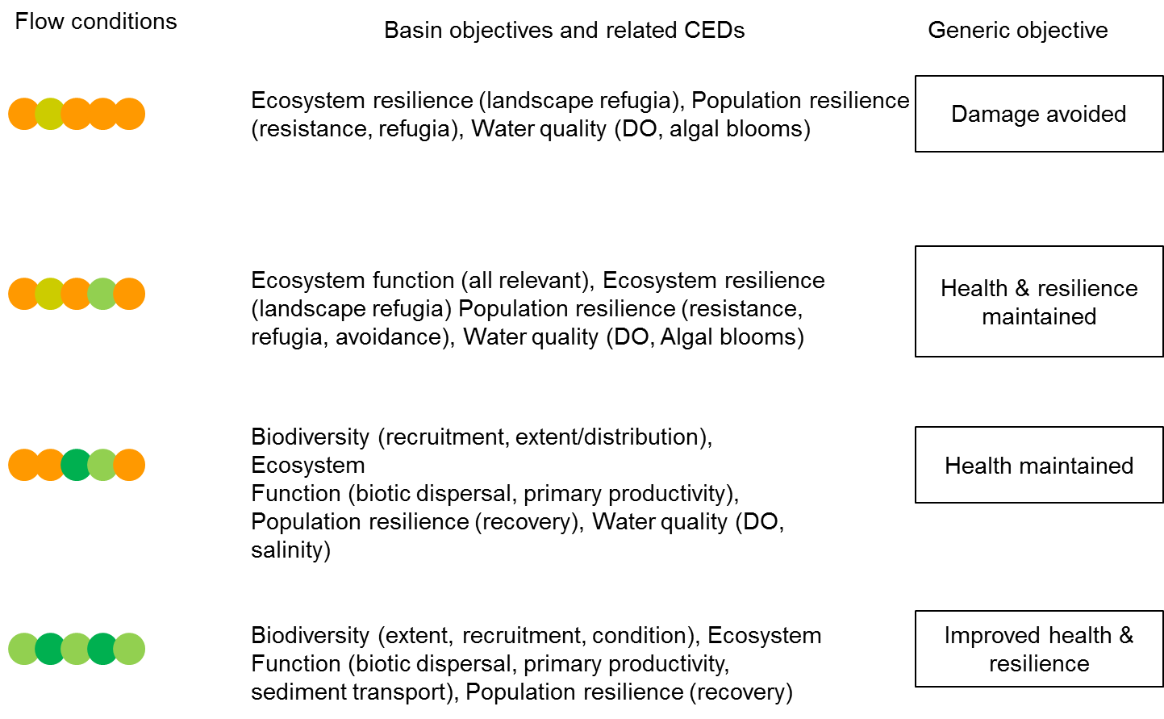
Figure 20. Level 2 and 3 objectives and associated generic cause-effect diagrams influenced by four different annual flow conditions. Each circle represents a year in a river valley with dry or very dry (orange circles), median (yellow), wet (light green) and very wet (green) years.
The process followed to generate one-to-five-year outcomes was the same as the process for generating less-than-one-year outcomes, with two additional considerations. The first was that the water availability over the five-year period was considered to identify the range of potential outcomes. The second was that the spatial and temporal scale of response, were considered to identify outcomes that respond over the one-to-five-year timeframe. The one-year and one-to-five-year expected outcomes for each of the selected areas is contained in each of the Monitoring and Evaluation Requirements documents.

Chapter 3. Long Term intervention monitoring (LTIM)

Chapter 3 describes the LTIM at seven selected areas in the Murray-Darling Basin (Monitoring box in Figure 1). The focus is on the identification and prioritisation of both cause and effect indicators through a three step process; selected area, Basin-scale and adaptive management. The chapter then discusses options for standard methods for some of the nominated indicators.

3.1 Context
Intervention monitoring is a key step in the MERI process that seeks to support accountability, good governance and adaptive management, and to generate the knowledge to support future evidence based decisions. Intervention monitoring underpins evaluation, reporting and improved decisions and future monitoring through the adaptive management process.
Within the broader MERI context, LTIM seeks to:
- assess ecological responses over the intermediate to long-term
- develop predictive models relating flow regime to ecological response
- improve monitoring cost-effectiveness across the Basin through extrapolation of results and application of the ecological response models.
Intervention monitoring is one of three types of monitoring included in the CEWO MERI Framework (Section 1.4), with the other two being operational and program level monitoring. Operational monitoring will assess whether water has been delivered as planned. Program level monitoring measures ecological condition at the Basin scale and identifies trends over the long-term. The three types of monitoring need to fit together to provide a coherent overall picture of environmental watering outcomes and their contribution to achieving the objectives of the Environmental watering plan (EWP).
The three different types of monitoring ask very different questions; however, there can be overlaps in the data required to answer these different questions. For example, intervention monitoring requires information on the delivery of water (operational monitoring) in order to interpret the environmental outcomes. Similarly, data generated to describe the condition of a system prior to an environmental watering can be used to inform program level monitoring, the prioritisation of environmental flows (assessment step in adaptive management) and provide the before data for the intervention monitoring. Program monitoring can also utilise responses to environmental flows. This is particularly important in cases where the system’s capacity to respond to flow is a key element of a system’s resilience. The sharing of data among the different types of monitoring will help ensure that monitoring is cost-effective (Principle 6 MERI Framework) and highlights the benefits of collaboration among water management institutions (Principle 3 MERI Framework). The identification of the LTIM information requirements should facilitate the identification of potential areas of collaboration.
Effective intervention monitoring relies on operational monitoring to provide information on the characteristics of the environmental flow and to then interpret ecological outcomes. Intervention monitoring will also inform program level monitoring. The CEWO MERI Framework includes two types of intervention monitoring, targeted monitoring of selected actions and long term intervention monitoring of selected areas. The focus of LTIM is the ecological response to Commonwealth environmental water.
There are a number of challenges associated with identifying the ecological response to environmental water. One challenge is that CEWO often collaborates with other environmental water-holders in the delivery of environmental water or piggy-backs on natural events and so identifying the incremental benefit of Commonwealth environmental water may be difficult. In the short-term this challenge will be addressed by monitoring the overall outcomes and inferring the contribution of Commonwealth environmental water through our conceptual understanding of the system. Over time, the development of models will enable predictions of environmental outcomes in the absence of Commonwealth participation, which can be used to identify the role of CEWO in delivering observed outcomes.
A further significant challenge is detection of environmental outcomes in aquatic ecosystems, which are extremely variable in space and time. This variability makes it difficult to both identify appropriate reference sites and to detect a flow response against a background of high natural variability. This is particularly true in the temperate rivers of the Murray-Darling Basin, which are among the most variable in the world, and where flows vary in response to a variety of influences of which environmental flow management is just one. The situation is further complicated by the influence of other stressors in the system. In general, the LTIM approach to minimising the risk of failing to detect a response includes the use of conceptual models that will be used to generate explicit hypotheses concerning the influence of flow on the ecosystem. In addition, by adopting a standardised approach across the Basin, the LTIM will increase the power to detect responses and create sampling design and analytical options that will increase the capacity to detect responses. Additional information on dealing with this challenge is provided in Section 3.3 and 4.3.
The LTIM Project involves monitoring in selected areas which will allow the assessment of sequences of watering events over a number of years (medium to long-term), demonstrating progress towards the EWP objectives. It is anticipated that long term intervention monitoring will be the key input for reporting under the Basin Plan for the use of Commonwealth environmental water.
Where monitoring and information needs overlap with The Living Murray Icon Sites or other sites that have adequate existing monitoring in place, the CEWO may invest to fill gaps, but has not planned to replace programs if they cease.
LTIM Projects are currently proposed to be established at the following selected areas:
- Gwydir river system
- Lachlan river system
- Murrumbidgee river system
- Edward–Wakool river system
- Goulburn River
- Lower Murray River
- Junction of the Warrego and Darling rivers.
There are two areas where the capacity to apply results to other areas may be constrained. First, the Junction of the Warrego and Darling rivers is going to experience significant changes in the short term through the change in management and decommissioning of infrastructure. Second, the Lower Murray River is a highly modified system dominated by a series of weirs and characterised by stable water levels. The capacity to apply results from these areas to other areas will vary depending on the indicator and an evaluation undertaken before extrapolating.
LTIM is being developed and implemented in two stages. This first stage is the scoping stage to develop the logic and rationale consistent with the Basin Plan and CEWO MERI Framework (Figure 21). This document is concerned with this first stage, as explained in Chapter 1.
The second phase of the LTIM Project is the development of detailed Monitoring and Evaluation Plans for each of the seven selected areas with the monitoring service providers. The selection of the service providers will be conducted through a procurement process undertaken by CEWO. The Monitoring and Evaluation Advisers will work closely with the service providers in the development of the detailed Monitoring and Evaluation Plans to support an integrated and rigorous approach to the monitoring, reporting and evaluation of outcomes at the selected areas and across the Basin as directed by the Basin Plan.

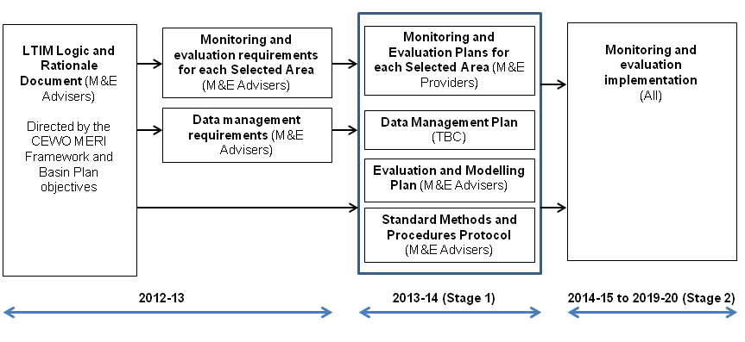
Figure 21. LTIM Project key timeframes and outputs
The logic and rationale for the LTIM is based on the objectives hierarchy, cause-effect diagrams and expected outcomes (Section 2). It is the key input into the design of the Monitoring and Evaluation Plans and includes the indicators to be monitored and the way that these indicators are sampled and analysed. The broad scope of the EWP objectives means that the range of indicators that could be measured greatly exceeds the capacity of the LTIM. It is therefore, necessary to undertake a prioritisation process that starts with the development of a list of broad indicators, then refines this list based on a prioritisation of objectives. This process is described in Section 3.2.

3.2 Indicator prioritisation

3.2.1 Identifying environmental indicators
Environmental indicators are measures that provide managerial and scientific evidence of ecosystem condition (Donnelly et al. 2007). In some instances, they also communicate a complex message about the ecosystem in a simplified and useful manner (Jackson et al. 2001). For the purposes of this document the term ‘indicator’ refers to measurable variable - or some set of variables - whose values provide an indication of flow effects. The value of variables may then by quantified using, in some cases, a number of different methods or protocols.
The identification of indicators builds on the development of the objectives hierarchy and the cause-effect diagrams as this ensures that there is a scientific framework and justification for the choice of indicators. The CEDs were used to develop a list of broad indicators that includes both ‘effect indicators’ and ‘cause indicators’ (Appendix B). Effect indicators are those indicators that relate directly to expected outcomes and EWP objectives, while cause indicators are those indicators which, although not targeted by the EWP objectives, provide essential information concerning the mechanisms by which flows influence effect indicators. Identification of such mechanisms underpin flow-response modelling and are important for adaptive management.
The description of each level in the hierarchy refines the list of potential indicators (Figure 22). For example, the Level 2 objective of species diversity gives rise to Level 3 objectives for vegetation, macroinvertebrates, fish, waterbirds and other vertebrates. Bacteria, fungi and algae are not included in the objectives hierarchy as they are not specifically mentioned in the EWP objectives, but they may be captured in the development of CEDs as causal factors and may in turn be identified as causal indicators.
Working through the objectives hierarchy to the list of expected outcomes generates an extensive list of indicators. However, there remains the challenge of determining ‘which of the numerous measures of ecological systems characterise the entire system yet are simple enough to be effectively and efficiently monitored and modelled’ (Dale and Beyeler 2001). This is particularly important in light of the CEWO MERI principle 8 that ‘monitoring, evaluation and reporting should be timely, efficient, cost-effective, consistent and should supply the information needed for evaluation’. A major influence on cost-effectiveness is the value of the information in terms of its contribution to the objectives of the program. As not all indicators will contribute equally to achievement of LTIM objectives and resources are not available to monitor all indicators, a prioritisation process is required to select indicators.
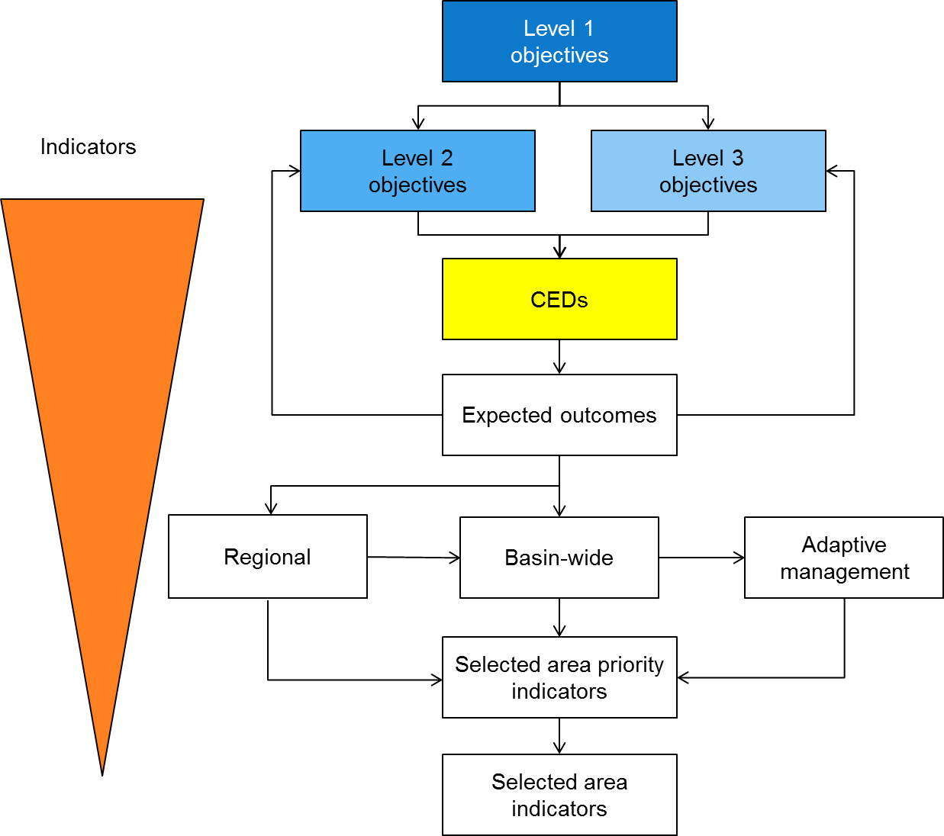
Figure 22. Diagram illustrating the indicator prioritisation process with the orange triangle on the left indicating that finalisation of each step in the objectives hierarchy reduces the number of potential indicators. The LTIM requirement documents include the list of area priority indicators that will be finalised by service providers in the development of the detail area MERI requirement documents.

3.2.2 Selecting indicators
Identification of priority indicators is based on the LTIM objectives hierarchy, the needs of annual reporting of outcomes, five year reporting against EWP objectives and adaptive management. In this context, the needs of adaptive management are defined as the expected outcomes that are the subject of CEWO decisions and the causal factors that are considered most likely to link flow to an expected outcome (see Section 3.2.5).
The selection process reflected the three objectives commencing with selected area annual reporting priorities as reflected by area stakeholder’s area priorities. The outcomes of the area prioritisation were used as a starting point that was compared to the Basin-wide reporting requirements. Finally, the output of the combined selected area and Basin-wide process was reviewed in light of the adaptive management requirements.
More detailed descriptions of these processes are provided in the following sections.

3.2.3 LTIM selected area priorities
A suite of expected outcomes were developed for each area based on the EWP objectives, our understanding of the system and the anticipated watering actions. Identification of selected area objectives and expected outcome priorities enabled identification of the priority indicators from an area perspective.
The development of selected area priorities provided an opportunity to establish a basis for collaboration between the Commonwealth and Basin states as outlined in the CEWO MERI Framework. This required that a link be established between EWP objectives and the area characteristics that stakeholders were interested in protecting or restoring (hereafter referred to as values). Stakeholder workshops were undertaken for each selected area in which local perspectives were captured on high priority values and associated expected outcomes.
The high priority values consisted of selected area characteristics or processes that managers sought to protect or restore. The values were drawn from relevant management documents and mapped against objectives and reviewed by key stakeholders. This enabled alignment of EWP objectives and area values which would facilitate a collaborative approach.
The values that related to the Level 2 and 3 objectives for each selected area were prioritised from a selected area perspective using three criteria. The prioritisation was completed at the ecosystem level. The three ecosystem types are; river, floodplain and wetland. The three criteria were selected in order to identify the most important values to stakeholders from a community (critical), ecological (support) and management perspective (selected area priority):
- Critical: Is a value critical to the character of the selected area? For example, the area is considered significant because it is the largest or only area of a specific vegetation type. Vegetation biodiversity would be the critical objective or value.
- Support: Does one area value support or significantly influence other values? This may, but not necessarily, imply a surrogate relationship for management. For example, aquatic plants provide habitat for waterbirds, in which case vegetation biodiversity or productivity is a high priority.
- Selected area priority: Is the value a selected area management priority? For example, is it included in planning frameworks, management plans etc. or is it both a regional and Federal priority?
Distinct ecosystem zones (i.e. specific wetlands, river or creeks/streams) within each selected area were considered separately as they supported different values. The zone scores were then added together to provide an overall selected area priority. In some instances, this meant that values considered a priority in one zone were of lower priority for the entire selected area. The priority values were used to identify priority Level 2 and 3 objectives for each selected area.
The zone prioritisation process informed a subsequent prioritisation of the related expected outcomes. The separate zone expected outcomes prioritisations were not used in the prioritisation of indicators at the selected area but will be important in the process of developing the detailed Monitoring and Evaluation Requirement documents for each selected area.

3.2.4 Basin–scale priorities
The output of the selected area prioritisation process was reviewed in light of the five year Basin-scale reporting requirements. The starting position was that in an ideal world, all the selected area priorities would be included in the LTIM. We considered a series of questions, the answers to which informed a judgement on which indicators should be monitored at each site. In the questions that follow, ‘objectives’ refers specifically to EWP objectives which, of course, may or may not be covered by the set of priority LTIM indicators for each area.
The questions were as follows:
- If the objectives were monitored at all areas where identified as a selected area priority, would the spatial extent of that monitoring be sufficient to meet Basin scale reporting requirements? At this stage the minimum spatial extent to meet Basin scale requirements will be arbitrary; it was decided that monitoring of an objective would have to take place at a minimum of three areas to meet Basin scale reporting requirements. Specifically:
  - If the objectives were monitored at all areas where it is identified as a selected area priority, would the objective be monitored at a minimum of three areas?
- If the objectives were monitored at all areas where they were identified as a selected area priority, would that enable prediction of outcomes at other sites in the Basin? In general, it was considered that there needed to be one selected area in the northern Basin and one in the southern Basin. The question was:
  - If the objectives were monitored at all areas where they were identified as a priority, would the number of areas exceed three (as specified in (1)) and would the subset of areas include at least one northern and one southern Basin area?
- Is the objective an important consideration from an adaptive management perspective? If the answer was yes, then additional areas would usually be included in the recommendation.
- If the objective is not identified as a priority, is it required to meet Basin scale reporting requirements?
  - If it is required, how many and which areas should indicators of the objective be monitored?
- How cost-effective is monitoring the objective? The question considered three elements. First, the strength of association with flow. Second, the cost of monitoring the objective. Finally, opportunities for collaboration and cost sharing. In several instances, the main cost associated with monitoring is having staff in the field and so can be integrated into sampling other outcomes for little additional cost.
Addressing these questions enabled identification of relevant CEDs and indicators, and recommendations concerning the selected areas where the indicators could be monitored. We now discuss the prioritisation of the specific EWP objectives.
Ecosystem diversity emerged as a priority at all seven areas and a high priority at the Junction of Warrego and Darling rivers, Edward-Wakool river system and Lower Murray River. The relevant CED is ‘Landscape ecosystem diversity’ and the appropriate indicator is the ecosystem types (using Australian National Aquatic Ecosystem (ANAE) classification) and their extent. It is recommended that this be monitored at all seven areas by building on the ANAE classification project being undertaken by CEWO (Cottingham et al. 2012), utilisation of digital elevation models (DEMs) developed by the MDBA, NSW Government and CSIRO; and vegetation information layers available from the Victorian, South Australian and NSW Governments. Interrogation of these information layers within a Geographical Information System (GIS) framework would enable identification of the types of ecosystems watered, the area inundated and over five years - the water received in relation to our current understanding of the various ecosystems’ water requirements.
Vegetation was listed as a high priority at all seven selected areas. The Basin Plan seeks to protect or restore vegetation diversity and the condition, diversity, extent and contiguousness of native water-dependent vegetation across the Basin. Among the seven selected areas there were three (Lower Murray River, Junction of Warrego and Darling rivers and Gwydir river system) that included vegetation diversity as a priority expected outcome. The relevant CED is ‘landscape vegetation diversity’ and the appropriate indicators are species number and abundance. In terms of using the vegetation expected outcomes from some selected areas and applying them to other sites, there are reservations about the capacity to use information from the Junction of Warrego and Darling rivers and the Lower Murray River to infer results at other sites. In the case of Junction of Warrego and Darling rivers the vegetation is highly modified due to historical management practices and the decommissioning of the associated infrastructure means the system is likely to be in transition. In the Lower Murray River the system is so highly modified by weir operations, that similar conditions are unlikely at other sites. It is suggested that vegetation diversity also be undertaken at the Murrumbidgee river system to provide a southern connected area from which predictions can be made to other southern sites.
For Basin scale reporting purposes, vegetation could be considered to be mobile, as plant propagules have the capacity to disperse over large distances. However, given the variation among species and limited knowledge of actual dispersal, it is more realistic to consider vegetation to contribute to local area biodiversity that contributes to Basin-scale biodiversity. Basin-scale reporting requires aggregation of the outcomes at the selected areas to provide an overall assessment of the contribution of Commonwealth environmental water to Basin-scale biodiversity. Therefore, it is considered that monitoring of vegetation at the four nominated sites (Lower Murray River, Junction of Warrego and Darling rivers, Gwydir river system and Murrumbidgee river system) is the minimum requirement to meet this need.
Vegetation condition and vegetation extent were priority expected outcomes at all seven water areas, although there was variation in the priority ranking for the different ecosystems. The condition of vegetation is an outcome for which a Basin-wide response would be expected and its inclusion in all seven selected areas is appropriate. The relevant CEDs are vegetation ‘condition and reproduction’ and ‘recruitment and extent’. The condition indicator is an individual condition which we recommend being undertaken using the TLM protocol that uses a combination of remote sensing and quantitative ground surveys. Using the TLM method will enable integration of TLM monitoring to facilitate Basin-wide reporting. In addition, the MDBA normalised difference vegetation index (NDVI) information may support this analysis which would ensure cost-effectiveness.
Vegetation extent is included within the CED ‘vegetation recruitment and extent’. The indicator for vegetation extent is the distribution and contiguousness of long-lived vegetation, which, given the size of the selected areas, is most effectively measured remotely. It is also a slow-response variable and would only need to be done at the beginning and end of a five year period.
Macroinvertebrates were not considered a priority at any site except the Murrumbidgee river system area, where they were a low priority. While food does emerge as an influence on CEWO water use decisions for several selected areas, in general, the reference was to larval fish food which implies microinvertebrates, not macroinvertebrates. Concerns have also been expressed about the capacity of macroinvertebrate monitoring to detect changes in flow (Rose et al., 2008). Despite this, there are several reasons for including macroinvertebrate monitoring in LTIM. As a Level 3 objective, the CEWO have an obligation to report on the influence of Commonwealth environmental water on macroinvertebrates and they are likely to be included in Basin-scale assessment of river condition. In addition, macroinvertebrates are a major source of food for many native fish, so their response to flow may influence fish condition which makes them of interest from an adaptive management perspective.
It is suggested that macroinvertebrate diversity be monitored in river channels in the Goulburn River, Edward-Wakool river system and Junction of Warrego and Darling river system. The Goulburn River and Edward-Wakool river system are included because environmental flows are restricted to in-channel flows and the monitoring of macroinvertebrates may provide valuable insight into the role of base flows and in-channel pulses to their condition. Junction of Warrego and Darling rivers is included as the unregulated nature of the system makes it difficult to predict the nature of environmental flows and the inclusion of macroinvertebrates will provide a range of options for identifying a response.
The relevant CED and indicator would be within ecosystem macroinvertebrate diversity. Macroinvertebrates contribute to local biodiversity and so Basin-scale outcomes would involve a comparison of outcomes among selected areas to report on the aggregate changes in biodiversity across the Basin. Given the uncertainty around macroinvertebrate responses to flow change, for example recent flows in the Edward-Wakool river system area, it is suggested that a sampling regime and indicators are developed based on our understanding of the relationship between flow and macroinvertebrates rather than relying on techniques developed for other purposes (e.g. rapid assessment).
Fish were listed as a high priority at all sites except the Lachlan river system where they were a medium priority. The priority expected outcomes included fish diversity in the main channel in all areas except the Gwydir river system. In the Lower Murray River there is no expectation that environmental flows will lead to an increase in the number of native fish species in the short-term. It appears reasonable however, to expect that environmental flows should increase the abundance of some rare native species which is included in some assessments of biodiversity. It is recommended that fish diversity be monitored within the river channel at all seven areas, using the standard sustainable rivers audit (SRA) protocol. In addition, while fish are being sampled additional information on population structure (as an indicator of recruitment) and condition should be collected. The relevant CEDs are ‘landscape fish diversity’ and ‘Fish larval growth and survival’. The indicators of diversity are native species richness and abundance. The minimum indicator for growth and survival is size frequency data, but consideration should be given to otolith analysis to identify precise spawning dates and rates, and timing of growth.
Three areas included wetland fish diversity among their priority expected outcomes (Lower Murray River, Murrumbidgee and Lachlan river systems). Once again, there is some uncertainty concerning the application of information from the Lower Murray River to other areas in the Basin due to its highly modified character. Predicting outcomes at sites across the Basin requires inclusion of a northern area. The Junction of Warrego and Darling rivers is not considered appropriate due to connectivity issues and stakeholders had reservations about the Gwydir wetlands because invasive species currently dominate the wetland fish community. Despite these concerns about the Gwydir river system, inclusion of wetland fish in the Gwydir river system would provide a northern area to both provide better representation across the Basin for Basin-scale reporting and less uncertainty in terms of the application of information to northern wetlands. It is also possible that environmental flows may promote the numbers of native fish within the wetlands. It is therefore recommended that wetland fish diversity, condition and recruitment be monitored in the Murrumbidgee river system, Lachlan river system and Gwydir river system selected areas. This will require development of a standard protocol, but the indicators are the same as those described for the main channel.
Fish reproduction was a priority expected outcome at all seven areas. Some fish species are highly mobile as adults and so fish spawned at one site have the capacity to disperse long distances thereby providing a Basin-wide response; however, this applies to only some species and may be better informed by monitoring of juvenile growth and survival, and fish dispersal monitoring. As most lowland species are widespread throughout the Basin, it may be more appropriate to regard fish reproduction as a Basin-wide response; that is fish are widespread throughout the Basin and Basin-wide improvement in flows would be expected to lead to widespread improvements in fish reproduction. Given the considerable effort invested in monitoring fish reproduction over the last twenty years it should be possible to predict fish reproduction from monitoring at three areas. It is therefore recommended that fish reproduction be monitored in the Edward-Wakool river system, Lachlan river system and Gwydir river system selected areas. The relevant CED is ‘fish reproduction’ and the indicator is egg and larval abundance.
Waterbirds were a high priority in the Lachlan and Gwydir river systems and a medium priority in the Lower Murray River, Edward-Wakool river system and Murrumbidgee river system. Waterbird nesting and fledging is a priority expected outcome at the five areas where waterbirds were a priority. The capacity to apply breeding and fledging information generated by monitoring at the selected areas to other sites requires areas spanning the north-south axis of the Basin. For this reason, it is recommended that waterbird nesting and fledging be monitored at Gwydir river system, Murrumbidgee river system and Lachlan river system. The relevant CEDs are ‘waterbird reproduction’ and ‘recruitment and fledging’ and the associated indicators are nest and chick abundance, and fledgling abundance respectively.
Reporting on populations of waterbirds over one-to-five-year time frames is problematic due to the widespread dispersal of waterbirds and the fact that waterbirds reared in one area are unlikely to remain in the area. Reid et al (2009) noted that ‘basin-wide monitoring of waterbirds is essential to prosecute the aim of detecting and quantifying population trends, otherwise waterbird movements will confound the analyses’. As a consequence, consideration should be given to engaging a single service provider to monitor bird nesting at the three nominated selected areas and that this be complemented with annual Basin-wide monitoring of waterbird populations. This is out of scope for the LTIM Project, but may be considered by the MDBA under its Basin Plan Monitoring and Evaluation program. The relevant CED would be landscape waterbird diversity and associated indicators species number and abundance.
Other vertebrates were a medium priority in the Gwydir river system, Edward-Wakool river system and Murrumbidgee river system selected areas. In these areas the expected outcomes relate to turtle (Edward-Wakool river system and Murrumbidgee river system) and frog (Gwydir river system, Edward-Wakool river system and Murrumbidgee river system) species and populations. The relevant CEDs are ‘other vertebrate growth and survival’ and ‘other vertebrate reproduction’. At the area scale, the indicators would include adult abundance and evidence of successful recruitment. Frogs and turtle species vary in their species range, but have limited dispersal capacity. As a consequence, frogs and turtles most closely align with the third category of Basin-scale reporting, i.e. protecting or restoring local populations of rare or endangered species that, if lost, would reduce Basin-scale biodiversity. This means that the selected area and Basin-scale information requirements are the same. The relevant indicators are frog and tadpole abundance changes over time and for turtles, abundance and size distribution changes over time.
Connectivity Three CEDs that contribute to the connectivity objective have emerged as priority indicators for the LTIM Project.
- Hydrological connectivity emerged as a priority at five selected areas. Monitoring hydrological connectivity enables the CEWO to report on ecosystem function, but is also an important causal factor that needs to be understood if ecological outcomes are to be modelled (see Adaptive Management Section 4.3). It is therefore recommended that hydrological connectivity be incorporated into hydrological monitoring at all sites and that this be the subject of a separate tender (see Adaptive Management Section 4.3). The ongoing improvement in digital elevation models across the Basin should enable the CEWO to report on connectivity outcomes at sites where water is allocated but there is no on-ground monitoring. The combination of detailed on ground hydrological connectivity from the seven selected areas and the digital elevation models will provide a basis for reporting on CEWO contribution to the protection and restoration of connectivity across the Basin. The relevant CED is ‘hydrological connectivity’ and the indicators include the volume, duration, depth, timing and type of connection.
- Biotic dispersal emerged as a medium priority at three selected areas. While biotic dispersal is relevant to all biota, stakeholders were focused on fish. Flow management is particularly important for fish as it provides both dispersal cues and influences opportunities for dispersal. The influence of environmental flows on Basin-scale fish outcomes is also going to be strongly mediated by fish dispersal as fish recruited to the adult population then have the capacity to disperse throughout the Basin.
In contrast, the evidence to date suggests that the influence of environmental flows on bird dispersal is limited and flow does not directly influence their capacity to disperse. Our understanding of seed and propagule dispersal would make it difficult to develop expected outcomes for vegetation dispersal and would recommend this be identified as a research topic.
Based on this logic it is recommended that the monitoring of biotic dispersal focus on fish. Consideration of the MERI principles suggests fish dispersal work be undertaken where there has been a history of monitoring and where it can be achieved in a cost effective manner.
The sites that appear to rank highest according to these criteria are:
- Edward-Wakool river system where a program of tagging and tracking has been undertaken for several years and the required infrastructure is in place
- Goulburn River where a similar program of tagging and tracking has been undertaken and the required infrastructure is in place
- Lower Murray River where the fish-way monitoring program has monitored longitudinal fish movements.
These three sites are all in the southern Murray-Darling Basin (MDB) and this may limit capacity to apply results across the Basin. One option to resolve this would be to include the Junction of the Warrego and Darling rivers as a site where fish dispersal is monitored as this would have the additional benefit of reporting the influence of flows on fish to be reported to the local community. Against this, the infrastructure in place at the Junction of the Warrego and Darling rivers means that fish dispersal is severely constrained along the Warrego River and associated floodplain and so fish dispersal did not emerge as a selected area priority.
The relevant CED is ‘biotic dispersal’ and the less-than-one-year indicator would be fish movement. As noted above, Basin-scale fish outcomes will be influenced by fish dispersal as fish recruited to the adult population then have the capacity to disperse throughout the Basin. The five year outcomes will vary depending on the underlying motivation for dispersal. In some cases, dispersal may enable expansion of a species’ range. In other instances it may improve recruitment of young fish. The one-to-five-year expected outcomes may therefore be changes in the distribution of fish or increased abundance of fish. The indicators would be changes in the abundance and population structure of fish and changes in their distribution.
- Sediment transport was only listed as a priority at the Junction of the Warrego and Darling rivers. It is also a difficult outcome to predict or evaluate as the influence of flow on sediment transport is understood in general terms (e.g. high flows transport sediment); however, predicting how much sediment should be transported and evaluating whether the outcomes of the transport were beneficial (creating habitat) or detrimental (smothering wetland macrophytes) is also problematic. With hydrological connectivity and fish dispersal being monitored, the need for CEWO to report on sediment transport may become a lower priority. It is recommended that suspended sediment be included in the standard suite of water quality measurements undertaken as it would represent a relatively minor additional cost.
The relevant CED is ‘sediment transport’ and the less-than-one-year indicator would be suspended sediment. All rivers transport sediment and therefore a Basin-wide response would be expected. Including suspended sediment in the water quality parameters monitored at all seven sites will provide local relationships between turbidity, flow and suspended sediment that could be used to estimate Basin-wide suspended sediment responses. The five year expected outcome of sediment transport is geomorphological change. The indicator is changes in channel or wetland shape and could be monitored through the creation of a DEM at the commencement of monitoring and again after five years. Any changes could then be interpreted in light of the suspended sediment information collected over the first phase of the LTIM.
Ecosystem processes. While all three CEDs that contribute to the ecosystem process objective will be included in the LTIM, the emphasis will be on primary production and decomposition with nutrient and carbon cycling being included in standard water quality monitoring where appropriate.
- Primary production was listed as a medium priority in the Lower Murray River, low priority in the Murrumbidgee and Lachlan river systems and did not rate at the other sites. Despite not being a priority it is recommended that primary production be monitored at all sites for reasons similar to the rationale for water quality (see below). In terms of Basin-scale reporting it is a function that would be expected to respond across the entire Basin. In terms of reporting outcomes, there is a reliable response to flow and from an adaptive management perspective it is one of the key pathways by which flows are believed to influence ecosystem condition. The relevant CED is ‘primary productivity’ and two methods are recommended. In river channels, open water oxygen logging provides reliable estimates of reach metabolism, including primary production. Two of the parameters logged (dissolved oxygen and temperature) are key water quality parameters that we recommend logging as part of the water quality program. The third is daylight which is cheap to monitor as well. For floodplain primary production we recommend the use of remote sensing using Normalized Difference Vegetation Index (NDVI) which compares the amount of photosynthetically useful light to the near-infrared light reflected from the land to provide an indication of the levels of photosynthesis (primary production). The MDBA is in the process of ensuring this data is regularly available across the Basin.
- Decomposition only emerged as a low priority in the Lower Murray River and did not rate at any of the other areas, despite most major water quality issues (blackwater, wetland acidification and blue-green algal blooms) being linked to decomposition processes. The open water method recommended for primary production in river channels also provides some information on decomposition and this would be enough to enable the CEWO to report on their influence on decomposition. Consideration could be given to monitoring floodplain surface (leaf litter) and sediment organic matter levels at Junction of Warrego and Darling rivers, Murrumbidgee river system, Edward-Wakool river system and Lachlan river system. The priority accorded to monitoring floodplain organic matter will depend to some extent on the future of The Living Murray Program that has been considering monitoring floodplain organic matter to inform management of blackwater.
Decomposition is a CED. The indicators for decomposition are river channel metabolism, floodplain surface and sediment organic matter.
- Nutrient and carbon cycling also emerged as a low priority in the Lower Murray River but did not rate at any of the other areas. While important to ecosystem function, it is not recommended that monitoring go beyond standard water quality measurements at this time. The CEWO can meet reporting requirements through the information generated from primary production, decomposition and standard water quality measurements.
Nutrient and carbon cycling is a CED. The indicators for nutrient and carbon cycling are total nitrogen, total phosphorus, NOx, filtered reactive phosphorus and dissolved organic carbon.
- Ecosystem resilience was rated a low priority in both the Lower Murray River and Lachlan river system selected areas. The CEDs and indicators for ecosystem resilience are the same as those for ecosystem diversity and so the recommendation is the same and is captured at all sites under ecosystem diversity.
- Population resilience was rated a high priority in both the Goulburn River and Lachlan river system and a low priority in the Murrumbidgee river system selected area. In the Lachlan river system, the associated expected outcomes include protecting long-lived vegetation and refuges for frogs and turtles. This reflects similar expected outcomes in the Murrumbidgee river system and Edward-Wakool river system. The relevant CED for long lived vegetation is ‘resistance’ and the indicator is population condition, in particular, population structure and individual condition. Long lived vegetation is included in monitoring at all seven areas and the information generated could be used to report on long-lived tree condition across the Basin. For frogs, the relevant CED is ‘refuge’ and the indicator would be changes in distribution and abundance through time. Frog monitoring has been recommended for the Gwydir river system, Edward-Wakool river system and Murrumbidgee river system areas and consideration of refugia could be incorporated into the design to enable reporting on other vertebrate population resilience. The other expected outcome in the Murrumbidgee river system, Edward-Wakool river system, Junction of Warrego and Darling rivers, and Gwydir river system is the presence of refugia or depth of pools. These could be monitored within the sediment transport and geomorphology monitoring recommended under the sediment transport ecosystem function. In the Goulburn River, the associated expected outcome was maintenance of hydraulic diversity and water quality. If hydraulic models are developed for each area, then assessment of this outcome would be cost-effective and the results integrated with the fish and macroinvertebrate monitoring to test hypotheses about the influence of hydraulic diversity of biodiversity and resilience. Overall, population monitoring of population resilience is encapsulated in monitoring of populations of groups within the biodiversity objectives or sediment transport.
- Chemical water quality was only rated a low priority in the Lower Murray River, Lachlan river system and Murrumbidgee river system areas while biological water quality was only rated a low priority in the Murrumbidgee river system. Although water quality is a characteristic that would be expected to show Basin-wide responses, the high degree of temporal and spatial variability in water quality means that extrapolation of results from the LTIM selected areas is unlikely to provide a reliable indication of Basin-scale responses. A more robust approach may be to use water quality data from the seven areas to develop models of the influence of environmental flows on water quality which could then be applied across the Basin using the existing network of water quality monitoring stations. From an adaptive management perspective, water quality is both an important consideration in CEWO decisions and a common causal factor influencing other outcomes. For these reasons, it is recommended that water quality be monitored at all seven areas. The standard suite of water quality parameters should include salinity, dissolved oxygen (DO), dissolved organic carbon (DOC) pH, temperature and turbidity. The relevant CEDs are ‘salinity’, ‘dissolved oxygen’ and ‘pH’ with the others being important causal factors. Nutrients are also an important causal factor influencing primary production and decomposition and are the subject of a EWP objective. Monitoring of key nutrients could also be included if believed to be cost-effective and did not preclude the monitoring of other indicators believed to be of greater value.

3.2.5 Causal factor priority indicators
While effect indicators generate information aligned with reporting requirements, evaluation and adaptive management require information generated by both effect and causal indicators in order to support the development of models. Prioritisation of causal indicators was based on the importance of causal indicators to CEWO delivery team decisions and their frequency or occurrence in CEDs.
A review of delivery team decisions found that water quality, fish and vegetation were the most common objectives considered while waterbirds, hydrological connectivity and dispersal are also significant influences. The causal factors most frequently considered in making delivery decisions were flow characteristics and water quality with a very small number of decisions considering cues, connectivity, vegetation or suspended sediment.
The cause-effect diagrams identified a large suite of causal factors that may influence objectives.
The ten causal factors that occurred most frequently in the CEDs were:
- water quality
- water depth
- vegetation
- hydraulics
- flow duration
- flow timing
- infrastructure
- connection type
- sediment
- landscape position.
The outcomes of this evaluation reveal that hydrological and water quality indicators are the main two groups of indicators that are both common causal factors influencing outcomes and, as a consequence, factors that influence CEWO decisions. The hydrological indicators enable identification of the influence of an environmental flow on critical habitat and connectivity characteristics. Key hydrological indicators include depth, velocity, duration and timing. The water quality indicators provide information on habitat, connectivity and cues for biota. Key indicators include salinity, dissolved oxygen, pH, temperature, turbidity and nutrients. There are a number of options available to monitor both flow characteristics and water quality at the seven selected areas. These options are discussed in Sections 3.2.6, 3.2.7 and 3.2.8.
There were three other causal factors identified within the CEDs that commonly influence a response to flow. In terms of their frequency within the CEDs these were vegetation, food and predation. The recommendation that vegetation condition be monitored at all sites and vegetation diversity be monitored at four sites should enable evaluation of the influence of vegetation on outcomes. Food availability is more problematic as diets vary widely among species; however, microinvertebrate abundance is widely believed to be a significant limiting factor in the growth and survival of larval and juvenile fish. Monitoring of microinvertebrates could therefore, be included if believed to be cost-effective and did not preclude the monitoring of other indicators believed to be of greater value.
The last common causal factor was predation which may be important for fish and other vertebrates. Large fish community information will be available for all river channel and wetland habitats in the Gwydir river system, Lachlan river system and Murrumbidgee river system and in the first instance, this is believed to be adequate. The inclusion of monitoring of bird feeding pressure does not appear justified at this point although some very general relationships may be discerned from examination of data from different habitats within the Gwydir river system, Lachlan river system and Murrumbidgee river system selected areas during breeding events.

3.2.6 Flow characteristic monitoring options – river channel
Options for monitoring flow characteristics in river channels include:
- Water level recording (single or multiple cross-sections):
- Description: This approach represents the minimum required to inform the interpretation of environmental outcomes.
- Causal factors monitored: Depth.
- Benefits: Standard methods are available and permanently installed equipment is low cost and robust.
- Drawbacks: Unless there is a stream-flow gauge nearby, these surveys alone do not provide data on stream discharge or flow velocity. Additional measurements are required (see next option). This approach becomes more complicated and costly in multi-channel rivers.
- Cost: Logging water level recorders are approximately $500 per site. Loggers may be placed at the top and bottom cross-section if multiple cross-sections are being monitored. Recorders need to be cleaned and downloaded approximately every two months (longer is possible with loss of accuracy/precision). An initial survey of the channel cross-sectional profile is required to convert water level to water depth. Costs can vary depending on the type of survey, number of cross-sections and site conditions. Typically it would require 2-3 days for a survey team for a 1 km river reach with some additional time processing data after the field survey. Channel surveys would need to be repeated after channel-forming flow events (every ~2-5 years).
- Stage-Discharge rating curve (modelled or fitted):
- Description: This approach would include all items in (1) in addition to measurements of streamflow at one or more discharge levels.
- Causal factors monitored: Depth, stream discharge and cross-sectional flow velocity.
- Benefits: Standard methods are available and permanently installed equipment is low cost and robust. The choice of one-dimensional hydraulic modelling or curve-fitting to observed discharges at multiple water levels should be made by an experienced hydrographer/hydraulic modeller based on required precision and cost.
- Drawbacks: This approach becomes more complicated and costly in multi-channel rivers. Hydraulic modelling, particularly in irregular channels and at low flows can be quite inaccurate and multiple surveys of water levels are desirable but scheduling of surveys to coincide with different discharges can be difficult.
- Cost: Logging water level recorders are approximately $500 per site and need to be cleaned and downloaded approximately every two months. An initial survey of the channel cross-sectional profile is required to convert water level to water depth. Costs can vary depending on the type of survey, number of cross-sections and site conditions. Typically it would require 2-3 days for a survey team for a 1 km river reach with some additional time processing data after the field survey. Stream flow gauging (i.e. discharge measurement) would need to be repeated approximately once per 2-4 months and would require a field team of ~two people for half a day on average. Hydraulic modelling or curve fitting would require 1-3 days. Channel surveys would need to be repeated after channel-forming flow events (every ~2-5 years) and the rating curve/hydraulic model revised.
- Flow velocity profiles (measured) at multiple cross-sections:
- Description: This approach would include all items in (2) in addition to measurements of velocity at all surveyed cross-sections for multiple discharges.
- Causal factors monitored: Depth, stream discharge, flow velocity variations across the channel and turbulence (if using acoustic Doppler velocimetry).
- Benefits: No modelling is required.
- Drawbacks: This approach becomes more complicated and costly in multi-channel rivers. Surveys must be repeated at multiple discharges to establish the discharge-dependencies. Scheduling of surveys to coincide with different discharges can be difficult.
- Cost: Logging water level recorders are approximately $500 per site and need to be cleaned and downloaded approximately every two months. An initial survey of the channel cross-sectional profile is required to convert water level to water depth. Costs can vary depending on the type of survey, number of cross-sections and site conditions. Typically it would require 2-3 days for a survey team for a 1 km river reach with some additional time processing data after the field survey. Stream flow gauging (i.e. discharge measurement) and velocity measurements (at each cross-section) would need to be repeated approximately once per 2-4 months and would require a field team of ~two people for one day on average.
- Flow velocity profiles (modelled) at multiple cross-sections with digital elevation model of channel:
- Description: This approach would include all items in (3) although velocity measurements are only used for model testing and may be restricted to one or two discharge levels and a sample of cross-sections.
- Causal factors monitored: Depth, stream discharge, cross-sectional flow velocity, turbulence, channel bed and bank survey to generate digital elevation model.
- Benefits: Provides detailed information of velocity variations with a river reach.
- Drawbacks: This approach becomes more complicated and costly in multi-channel rivers. Hydraulic modelling, particularly in irregular channels and at low flows can be quite inaccurate. Modelling is a specialised activity and modellers need to be involved with field survey design.
- Cost: Logging water level recorders are approximately $500 per site and need to be cleaned and downloaded approximately every two months. An initial survey of the channel cross-sectional profile is required to convert water level to water depth. Costs can vary depending on the type of survey, number of cross-sections and site conditions. Typically it would require 2-3 days for a survey team for a 1 km river reach with some additional time processing data after the field survey. Stream flow gauging (i.e. discharge measurement) would need to be repeated approximately once per 2-4 months and would require a field team of ~two people for half a day on average. Hydraulic modelling or curve fitting would require 1-3 days. Channel surveys would need to be repeated after channel-forming flow events (every ~2-5 years) and the rating curve/hydraulic model revised.

3.2.6.1 Recommendations
The choice of option will be informed by a number of factors, including channel length and morphology, extent of existing infrastructure and opportunities for collaboration. It is recommended that discussions be held with relevant state agencies and the Bureau of Meteorology to identify an optimal strategy. Where digital elevation models already exist, consideration should be given to the development of velocity profile models as these will facilitate interpretation of fish responses to changes in flow.

3.2.7 Flow characteristic monitoring options – floodplain
- Water level recorders and floodplain survey:
- Causal factors monitored: Water level, water depth.
- Benefits: Standard methods available.
- Drawbacks: Information limited to individual floodplain units being surveyed.
- Cost: Water level recorders cost approximately$500 per station. These need to be cleaned and downloaded every two months. Floodplain survey costs are highly site dependent but might require a survey team for one day in addition to data processing. Light detection and ranging (LiDAR) surveys may also be used but costs and logistical complexity increases and would only be justified for more extensive surveys.
- Satellite remote sensing:
- Causal factors monitored: Flood extent and connectivity.
- Benefits: Extensive data of entire floodplain is possible.
- Drawbacks: Resolution of data is limited in time or spatial detail for free products.
- Cost: Data processing is a specialised activity and quotes would need to be obtained. Costs for high-resolution tasked satellite imagery would need to be determined on a case-by-case basis.
- Flood Modelling:
- Causal factors monitored: Flood depth, extent and connectivity.
- Benefits: All key causal factors are monitored.
- Drawbacks: Cost and accuracy for low gradient floodplains needs to be considered.
- Cost: Needs to be determined on a case-by-case basis

3.2.7.1 Recommendations
The choice of option will be informed by a number of factors, including the selected area characteristics, extent of existing infrastructure and opportunities for collaboration. There are significant benefits in the utilisation of a single provider to manage all flow data collection and management in terms of consistency of data, quality assurance and access. It is recognised that this may not be feasible in light of the opportunities to collaborate and build on existing infrastructure. It is recommended that discussions be held with relevant state agencies and the Bureau of Meteorology to identify an optimal strategy. This will require identification of each selected area’s specific flow monitoring requirements and existing infrastructure and models.

3.2.8 Water quality monitoring options
There have been considerable developments in the area of water quality monitoring over the last few decades. These developments provide opportunities to improve the cost-effectiveness of water quality monitoring through either reducing the cost or increasing sampling accuracy and intensity to improve statistical power. The following section is a brief overview of some of the options.
- Spot field measurements. The development of the Sustainable Rivers Audit (SRA) evaluated the value of water quality spot measurements to assessing water quality as part of the assessment of river condition. The evaluation identified that the parameters evaluated varied independently and there was no redundancy that would enable one indicator to be used as a surrogate for other indicators. The SRA also identified issues with the identification of reference conditions that led them to exclude water quality from the assessment. This is not a significant issue for LTIM as the question is how changes in flow cause changes in water quality. Of greater concern was the level of variation observed in spot measurements that, for the SRA, limited their capacity to assess condition but within the LTIM process may make identifying changes difficult.
- Causal factors monitored: There are a range of probes available that are capable of reliably measuring conductivity (salinity), pH, turbidity, temperature, dissolved oxygen, water depth, current speed, chlorophyll a, ammonia, nitrate and chloride. Samples can also be collected for an enormous variety of water quality parameters that can be stored and processed in the laboratory.
- Benefits: Spot measurements are relatively cheap once staff are in the field and relatively flexible in terms of the number of measurements and their location. Spot measurements are also lower risk in terms of equipment failure, damage or loss. There is also flexibility in terms of the parameters that can be monitored.
- Drawbacks: Many water quality parameters vary through time in response to a variety of influences, only some of which are related to flow. High flows can limit access to sites limiting the samples that can be taken.
- Cost: As noted above, once staff are in the field, basic water quality parameters are relatively cheap.
- Logged data
Any of the probe mounted sensors can be associated with a data logger that enables the continuous logging of water quality parameters.
- Causal factors monitored: Include conductivity (salinity), pH, turbidity, temperature and dissolved oxygen.
- Benefits: Logging enables quantification of variations in water quality over the course of a day, weeks or months. Daily variations are important for parameters such as dissolved oxygen and temperature and logging these over 24 hours enables the calculation of aquatic metabolism. Longer term variations are likely to occur during environmental flows as water quality is known to change rapidly in response to initial connection and disconnection and it becomes expensive to maintain staff in the field for extended periods. The additional data also greatly increases the power of analysis thereby increasing chances of detecting significant changes.
- Drawbacks: The reliability of loggers has improved significantly, but they do occasionally fail or are lost due to natural events or human interference. The loss of a logger is associated with a loss of data and often there is no indication that the logger has failed or disappeared until the next scheduled maintenance event.
- Cost: Loggers are more expensive than manual probes and to achieve reasonable spatial replication requires the deployment of several loggers in each area.
- Logged and telemetered data
In addition to logging capacity, it is also possible to have telemetered probes that enable remote data access. Many of the water authority’s water quality monitoring stations are now telemetered in order to provide ready access to support operational decisions.
- Causal factors monitored: Include conductivity (salinity), pH, turbidity, temperature and dissolved oxygen.
- Benefits: The review of CEWO decisions revealed that real-time information was an important input to many delivery decisions during an environmental flow. Having access to real-time data may improve decisions and thereby improve outcomes from the flow. Remote access also enables regular checking of the probe to ensure that it is functioning properly.
- Drawbacks: There are significant cost implications in terms of both the probes and the host institution from the perspective of their information technology (IT) support for the probes.

3.2.8.1 Recommendations
The choice here is about the balance between spot measurements, logging and telemetered logging. It is always of value to ensure field staff have a multi-probe and a few additional sample bottles in order to take additional spot measurements. It is recommended that at a minimum, logging dissolved oxygen and temperature should be undertaken in order to enable calculation of river metabolism. The extent to which loggers should be telemetered will be informed by a number of factors, including the selected area characteristics, extent of existing water quality monitoring infrastructure and opportunities for collaboration. It is recommended that discussions be held with relevant state agencies and the Bureau of Meteorology to identify each selected area’s existing capacity and opportunities for enhancement.

3.2.9 Summary of priority indicators
Based on the process outlined above, priority objectives and indicators have been identified for each of the selected areas (Table 5). The priority indicators set the scope for what could ultimately be monitored in each area, noting that a final set of indicators will not be selected until the detailed monitoring design stage is completed in each area. The indicators ultimately selected will depend on their priority as outlined here, along with a practical monitoring and cost consideration.
Table 5 outlines eighteen priority objectives and forty priority indicators, spread among the seven selected areas. Ten of the objectives were identified as priorities at all sites, including ecosystem diversity, vegetation condition and reproduction, and landscape fish diversity. Two indicators in Table 5 have been listed as potential indicators (?) for the selected areas if it represents greater value than other priority indicators and/or is determined to be a priority during the development of the detailed Monitoring and Evaluation Plans.
There are several indicators that would rely on remote sensing, including ecosystem diversity, vegetation condition and extent, and the floodplain component of primary production. One benefit of remote sensing is that it can provide an estimate of the entire selected area in a cost-effective way. For this reason, these four indicators can be monitored at all areas.
Other indicators identified as priorities in all areas were chemical water quality, hydrological connectivity, suspended sediment, river channel primary production and decomposition. These indicators are both important to the outcome of an environmental flow and relatively inexpensive to collect.

Table 5. Summary of the CEDs and indicators that are monitoring priorities for Basin Plan reporting, adaptive management and at each of the seven selected areas. Effect indicators are those that quantify an expected outcome (denoted with a ‘E’ in type column) while others are causal factors that link flow to an expected outcome (denoted with a ‘C’ in type column). Many indicators provide information on both expected outcomes and causal factors, depending on the CED and these are designated with both a ‘C’ and an ‘E’. A ‘Y’ in the area column denotes that the indicator is a priority for that area. A ‘?’ in the table denotes a potential indicator.
CED | Indicators | Type (Effect or Cause) | Basin Plan | Adaptive Management | Edward-Wakool river system | Goulburn River | Gwydir river system | Lachlan river system | Lower Murray River | Murrumbidgee river system | Junction of the Warrego and Darling rivers
Landscape ecosystem diversity | Ecosystem type and extent | E | Y |  | Y | Y | Y | Y | Y | Y | Y
Landscape vegetation diversity | Species number and abundance | E C | Y |  |  |  | Y |  | Y | Y | Y
Vegetation recruitment and extent | Extent, distribution and contiguousness of long-lived vegetation | E C |  |  | Y | Y | Y | Y | Y | Y | Y
Vegetation condition and reproduction | Individual condition | E C | Y | Y | Y | Y | Y | Y | Y | Y | Y
Within ecosystem macroinvertebrate diversity | Species number and abundance | E C | Y |  | Y | Y |  |  |  |  | Y
Landscape fish diversity (channel) | Native species number and abundance | E | Y |  | Y | Y | Y | Y | Y | Y | Y
Landscape fish diversity | Microinvertebrate abundance | C |  | Y | ? | ? | ? | ? | ? | ? | ?
Landscape fish diversity (wetland) | Species number and abundance | E | Y |  |  |  | Y | Y |  | Y
Fish larval growth and survival | Size frequency data | E |  |  |  |  | Y | Y |  | Y
Fish reproduction | Egg and larval abundance, species and individual abundance | E |  |  | Y |  | Y | Y
Landscape waterbird diversity,  Waterbird reproduction,  Waterbird recruitment and fledging | Nests, eggs, chicks, fledglings, species number and abundance | E | Y |  |  |  | Y | Y |  | Y
Other vertebrates growth and survival,  Other vertebrates reproduction | Abundance, population structure, size, survival and reproduction of nominated species | E | Y |  | Y |  | Y |  |  | Y
Hydrological connectivity | Volume, duration, depth, timing and type of connection | E C | Y | Y | Y | Y | Y | Y | Y | Y | Y
Sediment transport | Suspended sediment, geomorphology | E C | Y | Y | Y | Y | Y | Y | Y | Y | Y
Biotic dispersal | Fish movement, distribution, abundance, population structure | E | Y | Y | Y | Y |  |  | Y |  | ?
Primary productivity | River channel metabolism, NDVI | E C | Y | Y | Y | Y | Y | Y | Y | Y | Y
Decomposition | River channel metabolism | E C |  | Y | Y | Y | Y | Y | Y | Y | Y
Decomposition | Floodplain surface and sediment organic matter | E C |  |  | Y |  |  | Y |  | Y | Y
Nutrient and carbon cycling | Total nitrogen, total phosphorus, NOx, filtered reactive phosphorus, dissolved organic carbon | E C | Y | Y | ? | ? | ? | ? | ? | ? | ?
Resistance, Recovery,  Refugia | Population and individual condition, population structure | E | Y |  | Y | Y | Y | Y | Y | Y | Y
Salinity,  Dissolved oxygen, pH,  Dissolved organic carbon | Salinity, dissolved oxygen, pH, temperature, turbidity, dissolved organic carbon | E C | Y | Y | Y | Y | Y | Y | Y | Y | Y
Hydrology* | Depth, duration, timing, hydraulics, dry rate, rise rate, area, hydroperiod, dry duration | C |  | Y | Y | Y | Y | Y | Y | Y | Y
*Hydrology is not a CED, however is a major driver of environmental outcomes, refer section 3.2.6 and 3.2.7.

3.3 Monitoring design
This section provides a brief introduction to some of the issues to be considered in the development of the LTIM study design. The discussion is generic because the study design is dependent on the indicator, the specific question and the structure of the models to be developed. These issues will be finalised once service providers have been engaged and specific models have been conceptualised. The study design is also influenced by the analysis to be undertaken. Section 3.3 focuses on the study design and analysis required to meet CEWO reporting requirements. Consideration of the study design requirements for development of models to meet the requirements of adaptive management are described in Section 4.3.3.

3.3.1 General principles of good study design
Sound experimental design is essential for quantifying the outcomes of environmental flows. Good design starts with setting clear, realistic, measurable and unambiguous objectives that inform the development of clear objectives and questions. This document describes the broad objectives of the LTIM and our understanding of the relationships between flow and EWP objectives (see Section 2.2). These will both be refined through the development of watering area monitoring plans. It will be important through this process to distinguish between environmental flow objectives which define the purpose(s) of delivering environmental water and monitoring objectives which define the purpose(s) of monitoring. The expected outcomes of environmental watering provide the basis for developing hypotheses to be tested by the monitoring program (see Section 2.4). The specific hypotheses then provide the basis for measureable end-points (Downes et al. 2002; Cottingham et al. 2005a).
The aim of the LTIM Project is to quantify the outcomes of Commonwealth environmental water over set periods of <1 and 1-5 years to underpin reporting requirements and adaptive management. It may also be used to understand changes in the condition of areas where CEWO long-term intervention monitoring is occurring. This requires being able to distinguish the responses to Commonwealth environmental watering from the myriad of other factors that affect aquatic ecosystems and their associated biota within the watering areas.
Experimental designs for generating inferences concerning environmental watering are diverse (Eberhardt and Thomas 1991, Stewart-Oaten and Bence 2001). The monitoring design will be informed by both the question being asked and the characteristics of the subject of the question (e.g. spatial and temporal scale of response). For reporting purposes, the CEWO is required to report on the outcomes of individual watering events, answering the question; what was the outcome of the specific environmental flow? For adaptive management purposes, the CEWO seeks the development of models based on relationships between environmental flow characteristics and the outcomes.
An additional consideration for the LTIM, associated with the nested nature of the objectives and associated questions is that, as far as possible, the design needs to be able to answer a question at a small-scale (unit, element or zone, <1 year) (Figure 23) and contribute to answering a question at a larger scale (area, Basin, 1-5 years). One element of this is that the CEWO wish to utilise the information from the watering areas to predict the outcomes at sites that are watered, but at which there is either no or only limited monitoring. This will require careful consideration of the ecosystem types that are sampled.
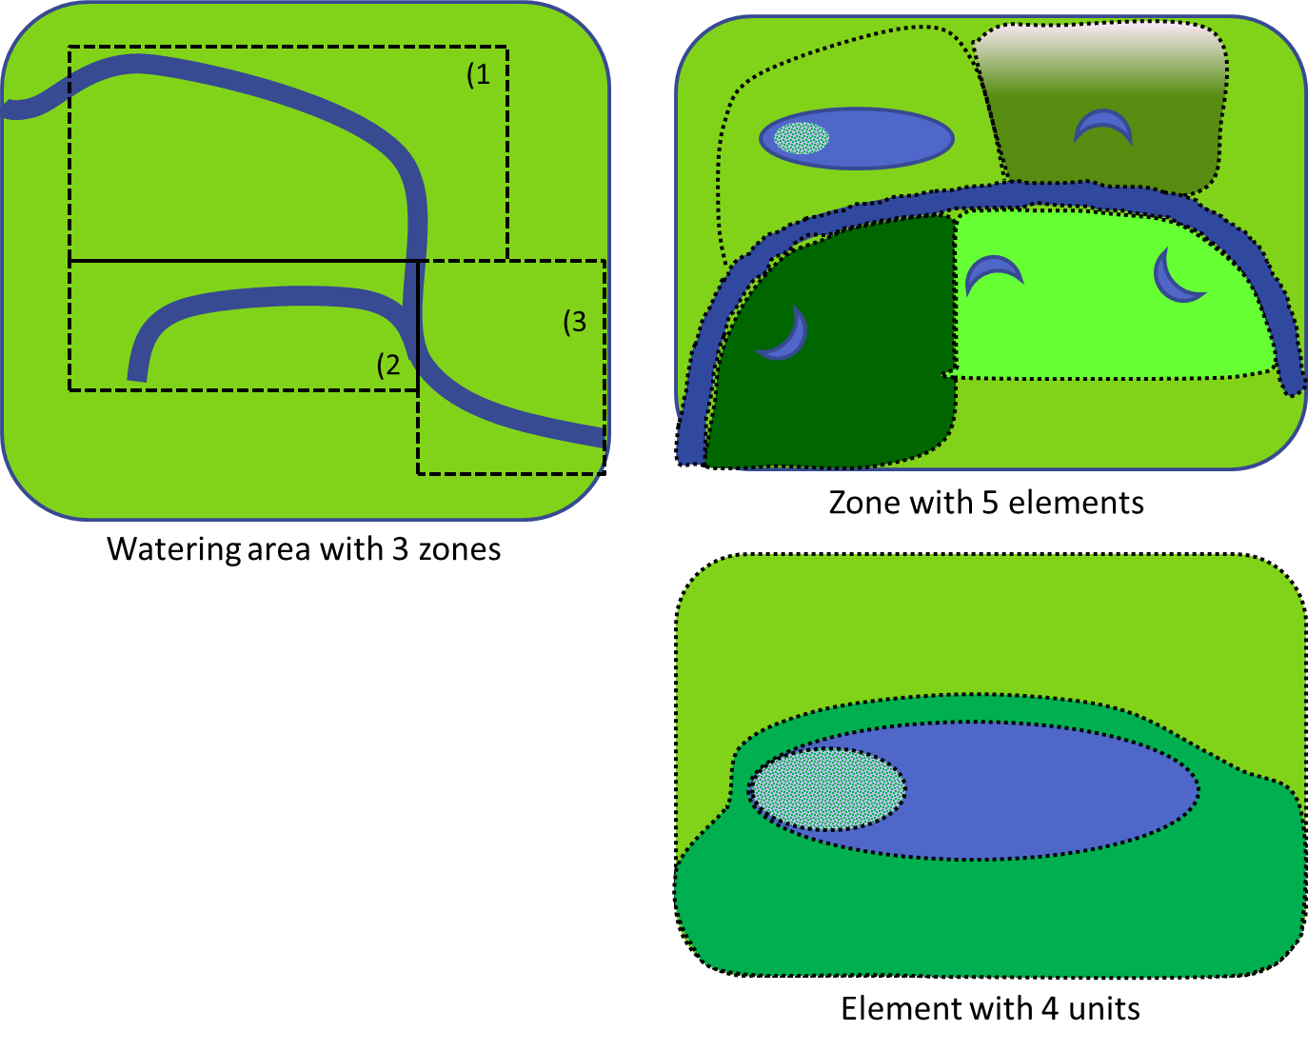
Figure 23. An illustration of the different spatial scales including zone, unit and element that will be used for the adaptive management and modelling.
For reporting purposes, the conventional view has been that establishing a causal link between an environmental watering and an ecosystem response requires Before-After-Control-Impact (BACI) or Multiple-Before-After-Control-Impact (MBACI) study designs (Downes et al. 2002). These involve measuring indicators before and after the watering event at impact sites (i.e. sites that receive environmental watering) and control sites (sites that are similar to impact sites in all ways, except that they did not receive environmental watering). Responses detected at impact sites that are not detected at control sites can then be attributed to the watering event with a level of certainty.
There are a number of difficulties associated with the implementation of BACI and MBACI designs, particularly in environmental monitoring. Downes et al. (2002) summarised these into three categories:
- The inherent nature of aquatic ecosystems makes it difficult to locate adequate control sites.
- The variability in environmental variables and indicators makes it difficult to reliably detect change and assign causal links.
- Institutional arrangements such as time and resource constraints limit proper application of the design (e.g. limited or no opportunity to collect ’before’ data; financial constraints for adequate sample size; requirements for reporting in too short a timeframe to reliably detect change).
One alternative is that in the absence of control sites, reference sites have been suggested as a useful alternative. A reference site is one that is as close to conditions unimpacted by human activity as possible (Downes et al. 2002). Reference sites then act as a benchmark against which change at impact sites can be compared (Cottingham et al. 2005a). Cottingham et al. (2005b) summarised the type of design relative to the availability of before, control and reference sites in Table 6. In some situations it may be possible to develop a synthetic reference condition based on base-line data, monitoring and models.
Table 6. Potential study designs (Cottingham et al. 2005b).
Before data | After data | Control sites | Reference sites | Timeframe of response
No | Yes | No | No | Intervention only
No | Yes | No | Yes | Reference – Intervention
No | Yes | Yes | No | Control – Intervention
No | Yes | Yes | Yes | Control – Reference – Intervention
Yes | Yes | No | No | Before – After – Intervention
Yes | Yes | No | Yes | Before – After – Reference – Intervention
Yes | Yes | Yes | No | Before – After – Control – Intervention
Yes | Yes | Yes | Yes | Before – After – Control – Reference – Intervention

In some situations, control or reference sites are not available. This is often the case in rivers where even the differences between rivers in adjacent catchments can prevent their being used as suitable reference sites. Even in situations where control or reference systems appear to be available, such as wetlands, the diversity among wetlands may preclude their use as reference sites. In these instances, the use of an unreplicated design may be the only solution; however, it is important to be clear about the scale of inference (Hargrove and Pickering 1992; Stewart-Oaten, Bence et al. 1992; Stewart-Oaten and Bence 2001). If control or reference sites are available, consideration will still need to be given to the advantages and disadvantages associated with expanding the number of wetlands studied (Carpenter 1990; Oksanen 2001; Stewart-Oaten and Bence 2001; Johnson 2002).
In other situations, variations in the timing of environmental flows confound simple before-after designs. Freshwater biota are very sensitive to temperature and responses may be cued by temperature and day length which means seasonal variation has an enormous impact on what we observe. This raises the issue of how to compare and contrast responses to environmental water that is delivered to, or arrives at, different sites at different times.
Recently, there has been a move toward the use of sites along a gradient of environmental stress (Bunn et al. 2010; Sheldon et al. 2012) or flow (Beesley et al. 2011; Webb et al. 2010) to quantify the effect of flow. This approach requires an increased number of sites to be sampled in order to generate the gradient. The LTIM approach of considering each watering area to be a nested hierarchy of zones, elements and units may enable the identification of sampling sites that would be amenable to this type of design.
Another important consideration in the design of a monitoring program is determining the required sample size. This relates to the power to detect effects and how we scale the risk of making both Type I and Type II errors. Type I errors occur when we conclude an impact has occurred when, in reality, it had not. Conventionally, scientists will either accept or reject a hypothesis while assuming the critical probability of making this error is 5%, αc = 0.05. In very powerful experimental designs this may seem reasonable. However, when the system we study is extremely ‘noisy’, when well-replicated designs are difficult or impossible, or when the social-economic-political consequences of not detecting impacts are great, we may be more concerned with making a Type II error; concluding ‘no impact,’ when in reality there has been one. The probability of making Type I and II errors is dependent on statistical power, which is in turn dependent on the spatial and temporal variability of the study system, and the associated spatial and temporal design of sampling (Clarke and Green 1988; Osenberg et al. 1994). Moreover, there exist methods to rescale αc based on the variability of our system and the relative socio-economic risks associated with making Type I and II errors (Mapstone 1995; Osenberg et al. 1994). It may be worth investigating these methods and their applicability to the assessment of Commonwealth environmental water use, given the level of investment in environmental water (but see Stewart-Oaten et al. 1992). Cottingham et al. (2005b) suggested that effect size is best achieved through a three step process of:
- Discussions with stakeholders to examine the level of evidence required from the monitoring program.
- Conducting a pilot study to determine the variability in indicators to be measured.
- Further discussions with stakeholders to consider benefits, costs and trade-offs of different effect sizes and reach a decision.
Cottingham et al. (2005a) recognise that this process is rarely done, due to time and financial constraints. However, again the implications of not conducting a pilot study and determining an appropriate effect size needs to be made explicit. In the case of the LTIM, both the CEWO short-term monitoring and other intervention monitoring programs may be able to provide this information. It is highly recommended that statistical advice be taken at the monitoring design phase to ensure that the design trade-offs are made with full knowledge of the implications and the best possible design, given resource constraints, can be implemented.
There are other factors that will shape the experimental design and associated analyses (Walters and Holling 1990; Osenberg et al. 1994; Mapstone 1995). All of these factors and associated modelling will need to be refined in the next phase of the development of LTIM. This process will be complicated by the need to design a sampling program that meets the needs of both short-term reporting and modelling requirements.

3.3.2 Data analysis considerations for monitoring design
Study design and data analysis are inextricably linked. The way in which monitoring data are collected will dictate the type of analysis that can be undertaken. Therefore, it is important to consider the type(s) of analysis that will be required to test the hypotheses and meet monitoring objectives in the study design phase of the program (Quinn and Keough 2002).
Traditional hypothesis testing relies on comparing data from at least two different types of sites (control and intervention, intervention and reference, and so forth). These methods use a variety of parametric or non-parametric statistical models to answer the question: ‘Is there a significant difference between sites?’ (Quinn and Keough 2002). That is, is there a significant difference between sites that received environmental water and sites that did not? The inference is then that at a defined level of probability, the ecological effects of environmental watering can be inferred.
In recognition of the difficulties of applying traditional sampling designs and statistical analyses to monitoring of environmental watering, the Victorian Environmental Flow Monitoring and Assessment Program (VEFMAP) suggest the use of Bayesian hierarchical modelling (Chee et al. 2006; Cottingham et al. 2005a). Bayesian data analysis uses probability models based on our scientific understanding of the issue (in this case environmental watering), observed (collected data) and expert judgement to evaluate the fit of the models and draw conclusions (Gelman et al. 2004).
The advantages of a Bayesian approach are in ‘borrowing power’, in that data from one site can be used to interpret responses at other sites within the same model (Chee et al. 2006). The use of Bayesian approaches to data analysis will have an effect on the study design requirements. As such, it is necessary to consider whether Bayesian hierarchical modelling may be useful for the program in the design phase, and again, appropriate statistical advice should be considered to ensure the study design will match data requirements.

3.3.3 Standard methods
The list of specific questions that can drive a long-term monitoring is potentially as diverse as the reasons for establishing long-term monitoring project. What is evident is that specific questions are necessary to direct the monitoring; otherwise, they become an exercise in data collection with no real purpose (ANZECC 2000; Butcher 2003; Cottingham et al. 2005a; Lindenmayer et al. 2011 ). An important component of the LTIM design and implementation phases will be to employ standard methods for indicator measurement, site selection and data management. Continuity, reliability and comparability of information are only assured if monitoring and evaluation plans are implemented to an appropriate standard with consistency and transparency being key elements. As such, standard methods are critical considerations in monitoring design, particularly if trends are to be determined within and between selected areas (Beard et al. 1999; ANZEEC 2000; Baldwin et al. 2005; Chee et al. 2006 ). In some instances, standard methods have been developed and recommendations made. In other instances, variation among practitioners and ecosystems will require agreement on an appropriate standard method to answer the questions posed by LTIM. A summary of the major indicators and either the standard method or next step to defining the standard method is summarised in Table 7.
Table 7. Summary of major indicators and associated standard method or the next step required to define the standard method.
CED | Indicators | Method | Reference
Landscape ecosystem diversity | Ecosystem type and extent | Method to follow ANAE classification project methodology
Landscape vegetation diversity | Species number and abundance | Species identification within quadrats or along transects. To be refined | Baldwin et al., 2005
Vegetation condition and reproduction | Individual condition | TLM Tree condition | Cunningham et al 2009
Within ecosystem macroinvertebrate diversity | Species number and abundance | To be determined | Humphries et al. 1998
Landscape fish diversity (channel) | Native species number and abundance | SRA Protocol
Landscape fish diversity | Microinvertebrate abundance | To be refined | Tan & Shiel 1993  Nielsen et al. 2005
Landscape fish diversity (wetland) | Species number and abundance | To be determined | Beesley et al. 2010
Fish larval growth and survival | Size frequency data | To be determined | Beesley et al. 2010
Fish reproduction | Egg and larval abundance, species and individual abundance | Netting and/or light trapping.  To be refined | Kelso & Rutherford 1996  Vilizzi et al., 2008  Neal et al., 2012
Landscape waterbird diversity,  Waterbird reproduction  Waterbird recruitment and fledging | Nests, eggs, chicks, fledglings, species number and abundance | Aerial Surveys  Nest Surveys | Kingsford and Thomas 2004  Brandis et al., 2011
Other vertebrates growth and survival  Other vertebrates reproduction | Abundance, population structure, size, survival and reproduction of nominated species | Species dependent | Frogs:  Wassens et al., 2010  Baldwin et al. 2005  Turtle:  Roe and Georges 2008
Hydrological connectivity | Volume, duration, depth, timing and type of connection | See section 3.2.6 to 3.2.7.  Requires further development
Sediment transport | Suspended sediment, geomorphology |  | Australian Standard 3550.4
Biotic dispersal | Fish movement, distribution, abundance, population structure | Infrastructure dependent
Primary productivity | River channel metabolism, NDVI | Replicate single station open water measurements | Young and Huryn 1996  Simms et al., 2009
Decomposition | River channel metabolism,  Floodplain surface and sediment organic matter | Replicate single station open water measurements | Young and Huryn 1996  Glazebrook and Robertson, 1999
Nutrient and carbon cycling | Total nitrogen, total phosphorus, NOx, filtered reactive phosphorus, dissolved organic carbon | Standard methods | Baldwin et al., 2005
Resistance,  Recovery,  Refugia | Population and individual condition, population structure  Geomorphology | TLM Tree condition  See section 3.2.6 to 3.2.7.  Requires further development
Salinity,  Dissolved Oxygen,  Dissolved Organic Carbon  pH | Salinity, dissolved oxygen, pH, temperature, turbidity, dissolved organic carbon  Needs refinement | Standard commercial probes or loggers | Baldwin et al., 2005
Hydrological connectivity | Depth, duration, timing, hydraulics, dry rate, rise rate, area, hydroperiod, dry duration | See section 3.2.6 to 3.2.7.  Requires further development | Cunningham et al 2009

As part of establishing the Monitoring and Evaluation Requirements for each selected area, it will be important to develop and implement appropriate quality assurance and control measures to ensure standards are upheld across all selected areas and that the data collected is of a high quality (Chee et al. 2006). Whilst in the past there has been substantial effort paid to study design, sampling methodology and methods of analysis, this has often failed to translate to consistency of method in long-term programs (Beard et al. 1999). In an adaptive monitoring program it will be essential to ensure that changes in monitoring design still maintain consideration of standard methods.
Long Term monitoring projects tend to have a poor record in terms of success, due to a number of factors including (Lindenmayer et al. 2011):
- lack of questions
- poor study design
- failure to properly articulate what to monitor and why it is important to monitor targeted entities
- an inappropriate assumption that there is a single approach to monitoring that is uniformly applicable to all monitoring programs.
The LTIM will evolve as it is an adaptive monitoring project; however, it therefore becomes critical to ensure that standard methods and quality assurance are a major element of the adaptive phase of the project.

3.3.4 Data storage and management
The successful delivery of the LTIM MERI Framework is reliant on multiple stakeholders and service providers contributing data towards annual and five-yearly reporting and evaluation cycles. Data collected by monitoring at individual watering areas also contributes to the analysis and evaluation of Basin level objectives. It is therefore, imperative that data being collected is of high quality, complete, compatible and available in consistent and standardised formats to meet reporting and evaluation needs.
Data management for this LTIM Project is guided by the following principles:
Good governance - Leadership and coordination is essential to ensure the effective delivery of the LTIM Project.
Custodianship - Data custodians are trustees that do not ‘own’ data but responsibly manage and maintain it for use by a wider community of users. Data is maintained in one location and the custodian becomes the authoritative source for the dataset.
Shared responsibility - Those collecting the data are responsible for the quality of the data. The CEWO is responsible for the integrity of the dataset. Data users are responsible for the wise and appropriate use of the data.
Standards and interoperability - Consistent adherence to data standards facilitates linkages with related or complementary data and preserves the utility and comparability of data through time.
Metadata - Accurate metadata accompanying each dataset provides contextual information on where, who, how and why the data were collected and document known assumptions or limitations to guide interpretation.
To help promote the collection of high quality data that is fit for purpose, an LTIM Data Standards document is under development to outline the base requirements for monitoring data and will be refined during the development of the Monitoring and Evaluation Plans. This will include information about valid data ranges, lookup lists, schema for site naming and other rules about data values. In addition, it will define the required fields (e.g. unique identifier, foreign key relationships) that all data must have. The data standards document will also identify the essential metadata fields that must be provided when data is submitted.
Data should be maintained in a central data repository that provides version control, data security, metadata compilation, and automated quality control procedures to ensure consistency and adherence to standards. The data repository will accommodate a variety of file formats that are submitted electronically according to delivery schedules developed during the design of the monitoring. Those undertaking the monitoring can approach their data collection and management as they wish, with the requirement that data conforms to the required data standards and is submitted on time. Once submitted, the data in the repository becomes a source for use by the CEWO and stakeholders to meet Basin Plan reporting obligations and for distribution to other data users.
Data is made available to users from the repository under a Creative Commons license, unless extenuating circumstances require restrictive access and licensing (e.g. confidentiality, threatened species, use of protected information).
For each data set being collected, monitoring service providers must include:
- quality assurance and quality control (QA/QC) procedures
- data delivery schedules for electronic submission to the data repository
- a nominated data custodian responsible for data delivery and QA/QC.

3.3.5 Risk assessment and mitigation strategies
Risk associated with LTIM Project monitoring measuring progress towards the EWP objectives should be considered in the monitoring design. Appropriate mitigation measures to minimise these risks need to be identified and residual risk made explicit. Risks associated with implementing the monitoring both to the environment and to service providers should be documented in a Health, Safety and Environment Plan (HSEP) with Job Safety Analysis (JSAs) completed for each activity.
Monitoring and evaluation service providers will be required to assess the potential risks associated with the LTIM Project monitoring in each of the Selected Areas. The risks identified will vary, and the risks assessments will need to account for external factors specific to each Selected Area. Categories of risks that need to be assessed in all areas will include, but will not be limited to:
- risks that monitoring will not be able to be implemented, or will not meet project objectives
- risks to the environment and aquatic ecosystems as a result of monitoring activities
- risks to the health and safety of consultants undertaking monitoring activities.
The risk assessment method must be consistent with the Australian/New Zealand Standard: Risk Management (AS/NZS 4360:2004; Standards Australia and Standards New Zealand 2004) and the Standards Australia Handbook: Environmental risk management - principles and process (HB 203-2000; Standards Australia and Standards New Zealand 2006). This approach follows a structured and iterative process (Figure 24 and should use the likelihood, consequence and risk categories provided (Table 8, Table 9 and Table 10).

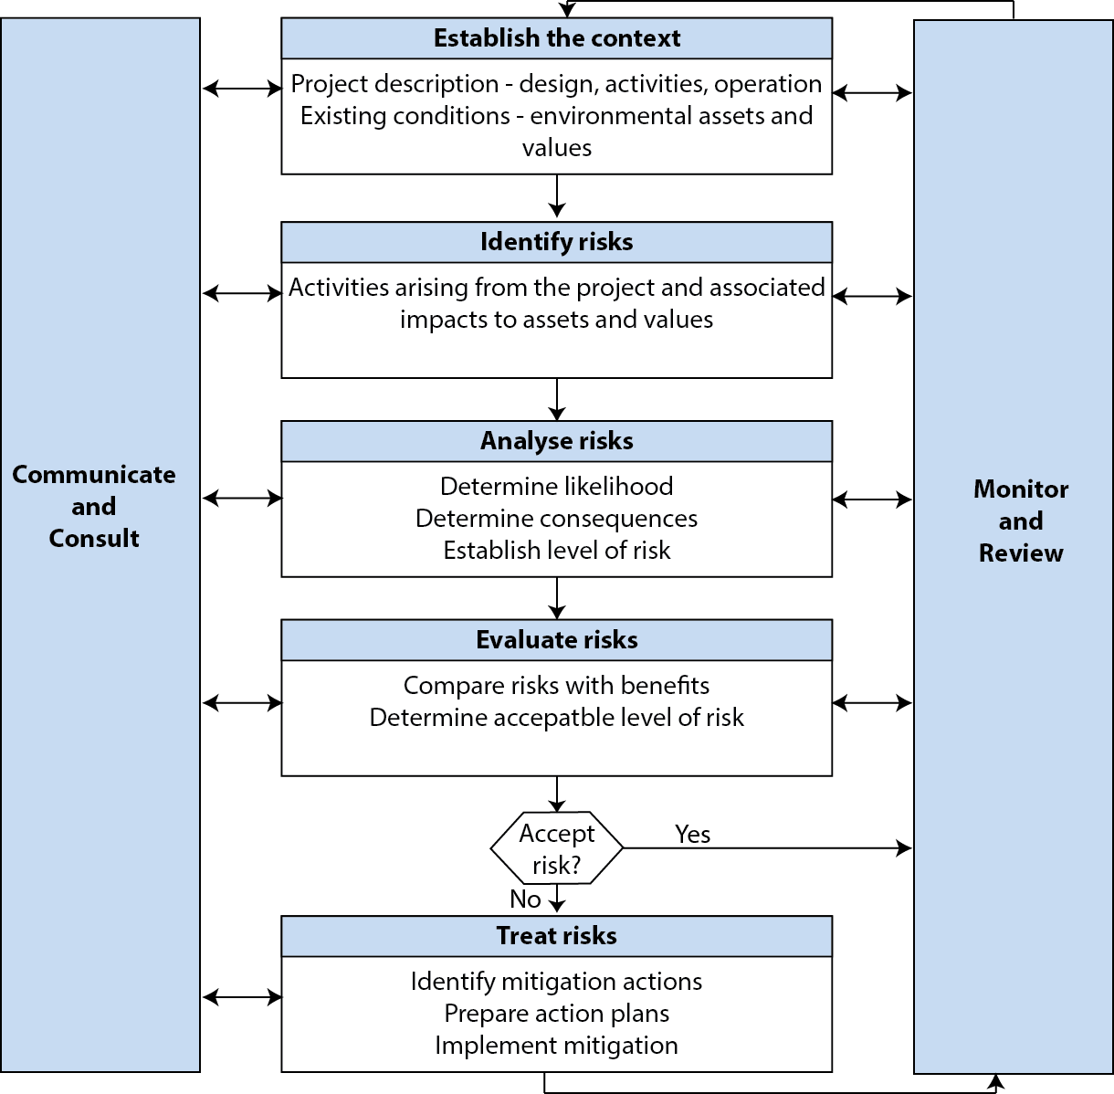
Figure 24. Risk assessment method (adapted from AS/NZS 2004).
Table 8. Risk likelihood rating
Almost certain | Is expected to occur in most circumstances
Likely | Will probably occur in most circumstances
Possible | Could occur at some time
Unlikely | Not expected to occur
Rare | May occur in exceptional circumstances only

Table 9. Risk consequence ratings.
 | Insignificant | Minor | Moderate | Major | Critical
Monitoring objectives | Monitoring according to design with data from all planned samples available. | Minor disruptions to the program with a small number of planned samples (< 10%) not collected or data not available. | Data from some watering areas or some events not collected / unavailable, sufficient for planned analyses. | Data from more than 50% of planned samples not collected / available. Limited monitoring outcomes reported. | No useable data collected, analyses unable to be performed, no monitoring outcomes reported.
Environment | No environmental damage. | Minor instances of environmental damage that could be reversed. | Isolated but significant instances of environmental damage that might be reversed with intensive efforts. | Severe loss of environmental amenity and danger of continuing environmental damage. | Major widespread loss of environmental amenity and progressive, irrecoverable environmental damage.
Health and safety | Minor injury/illness, no formal medical treatment required. | Minor injury/illness, medical assistance required. | Moderate injury/illness, short term hospitalisation required. | Major injury/illness, emergency treatment/extensive hospitalisation required. | Fatality.

Table 10. Risk analysis matrix.
Likelihood | Consequence
Likelihood | Insignificant | Minor | Moderate | Major | Critical
Almost certain | Low | Medium | High | Severe | Severe
Likely | Low | Medium | Medium | High | Severe
Possible | Low | Low | Medium | High | Severe
Unlikely | Low | Low | Low | Medium | High
Rare | Low | Low | Low | Medium | High

As stated above, service providers will be required, as part of the detailed monitoring design phase, to undertake a risk analysis identifying specific threats or conditions at the watering area which may provide a risk to the successful implementation of the project. This will include tailoring risk categories and risk consequence ratings and options for mitigation for each Selected Area, and should be linked to the adaptive management process associated with annual water planning.

Chapter 4. Evaluation, reporting and adaptive management

This LTIM Project generates information to be used for evaluation, reporting and adaptive management. This chapter describes the way in which LTIM information will be utilised in these processes with a heavy emphasis on the use of models to support predictions of the expected outcomes in response to and in the absence of environmental flows. The chapter then goes on to discuss some data requirements in order to ensure data will support model development.

4.1 Evaluation
Evaluation is essential to identifying change, supporting adaptive management in a dynamic system and supporting learning at an individual, community and institutional level (Bellamy et al. 2001). To be effective, evaluation needs to follow a program logic that links objectives, interventions and performance. Within this context, the LTIM will contribute to evaluation through:
- support the development of expected outcomes for watering actions that align with EWP objectives
- develop appropriate performance criteria (indicators)
- develop experimental designs and sampling techniques to quantify responses and build capacity
- identify appropriate analytical techniques and develop models to support evaluation and build capacity and identify progress.
In doing this, the LTIM faces a number of challenges, including:
- Breadth of outcomes. The environmental water allocations are likely to influence a diverse array of ecosystems, species, functions and water quality parameters, each of which may interact with each other to shape system resilience.
- Changing knowledge base. Considerable progress has been made in our understanding of water-dependent ecosystems in the MDB and it is likely that our knowledge will continue to improve during implementation of the Basin Plan. Improved knowledge will influence our perception of the system thereby influencing the priority indicators, methods or analytical techniques.
- Changing climatic conditions. Australian water-dependent ecosystems are highly variable and this variability will lead to changes in management priorities and challenges in terms of the assessment of progress toward objectives. In addition, climate change may lead to additional changes that may require revision of objectives, still further complicating the evaluation process.
- Changes in other pressures and threats. While the Basin Plan will address one of the major pressures on the system (water resource development), other pressures and stressors will either continue or change (e.g. land use and climate change). This will result in complex outcomes for the system and further challenges in terms of evaluating the effectiveness of environmental water management.
- Identifying causality. Identification of causality is important, as a causal understanding of system dynamics leads to more effective, efficient and targeted management of water allocations. However, water-dependent ecosystems are characterised by context-dependent behaviour and multiple interacting components, which often makes identifying causal links difficult. Such complexity needs to be carefully factored into the design of monitoring programs.
- Scale of responses. Ecological responses to flow restoration will occur over a variety of spatial and temporal scales (Figure 25). Only some of the response scales will align with the evaluation processes undertaken by the CEWO. As a consequence, the full system response to flow restoration will be difficult to quantify.
These challenges in no way reduce the need for, or value of, evaluation. There are a number of ways that the LTIM Project will endeavour to overcome the challenges and ensure that the effectiveness of Commonwealth environmental water is captured and supports ongoing improvements in environmental water management. The first of these is to ensure there is a clear and robust program logic underpinning the monitoring program. The need for program logic has been acknowledged in the Basin Plan monitoring principles and adopted by the CEWO (based on the scientific rationale for environmental watering outlined in Chapter 2). The second is that the assumptions and hypotheses underlying decisions are considered. Development of the Monitoring and Evaluation Plans will consider assumptions and explicitly state hypotheses to be tested as part of the detailed design phase of the project. Finally, the LTIM Project recognises the complex and nested nature of the MDB and has imbedded this in the development of the logic document and associated CEDs.
In recognition of the complex and nested nature of the system, the CEWO will undertake the evaluation process at multiple spatial and temporal scales (Figure 25). An effective Basin-scale evaluation will require that smaller-scale evaluations complement the larger scale. The use of the objectives hierarchy and CEDs that underpin the development of expected outcomes provide a foundation for the alignment. The alignment will be a key consideration in the development of the evaluation process which is one of the next steps after the design of the LTIM.
At each scale, the process will be similar. The process will be;
- what was expected
- what actually happened?
If the outcome was as expected, then what were the key success factors in terms of:
- our understanding of the system (cause-effect diagrams and models)
- the design of the water allocation
- the monitoring and analysis?
If the outcome did not meet or exceeded expectations, then what were the key lessons in terms of:
- our understanding of the system (cause-effect diagrams and models)
- the design of the water allocation
- the monitoring and analysis?
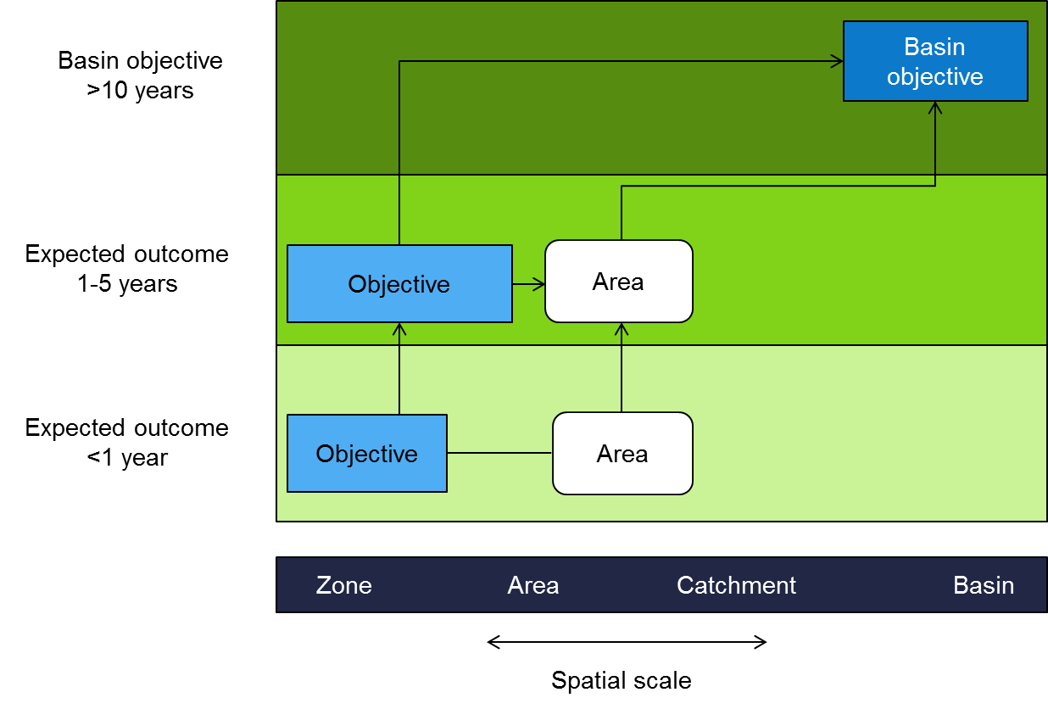
Figure 25. An illustration of the evaluations that will be undertaken by the CEWO. Light blue boxes are evaluations based on single expected outcomes and dark blue boxes indicate evaluations based on multiple expected outcomes.
At the selected area-scale (Figure 25), the outcomes of individual watering events will first be evaluated against the less-than-1-year expected outcomes for that individual selected area. This will be undertaken using LTIM data for those actions undertaken at one of the seven selected areas and using modelled outputs for watering actions undertaken in other parts of the Basin. Wherever possible, the outcomes of environmental flows will be compared to data from both before the intervention and from units located within other elements or zones within the selected area that have not received environmental water. Over time, models will become increasingly important in the process to provide the evaluation with a prediction of what would have happened in the absence of Commonwealth environmental water in situations where no reference is available (e.g. large floods) or where the CEWO water is only one part of the overall environmental flow.
Each individual watering event will also be evaluated across all expected outcomes in the selected area. This will enable identification of possible inter-dependencies or trade-offs among the possible outcomes that may be associated with intervention at the area-scale.
With respect to temporal scale, at the five-year scale, the observed five-year outcomes within each objective will be evaluated against the five-year expected outcomes in the selected area. Models will be particularly important in this process to provide a reference as there will be limited access to before data and a high probability that appropriate reference sites will also receive environmental water over the course of the five years. There will also be an evaluation across all objectives in the selected area. This will enable identification of area responses to the restored flow regime over the five-year period and any differential responses among expected outcomes.
The five-year outcomes will also be evaluated across the seven selected areas to provide an assessment of progress toward EWP objectives. The form of the evaluation will vary among objectives but it will be affected by the way in which selected area outcomes influence Basin-scale outcomes. This is described in more detail in the Reporting Section (4.2). The aggregation of area outcomes to the Basin-scale (CEWO 2012) will:
- Demonstrate the outcomes of the use of Commonwealth environmental water and how it has contributed to achieving the environmental objectives of the environmental watering plan (Section 114 of the Water Act and items 7 and 9 of Schedule 12 of the Basin Plan).
- Support adaptive management and improvement in the management of Commonwealth environmental water to meet ecological objectives.
- Identify information gaps to help build new knowledge.
In addition to the challenges of spatial and temporal scale, we must face those presented by changes in our understanding of the system, management processes and climate. In order to respond to these changes, it is likely that refinement of monitoring activities will occur over the long-term. The annual evaluation of outcomes of LTIM will inform decisions on refinement and will need to be captured annually as part of the evaluation process.
It will be important for LTIM to be undertaken in a way that supports aggregation to the Basin-scale. This will facilitate the aggregation of monitoring results to evaluate the ecological outcomes and effectiveness of the Environmental watering plan that will be undertaken by the MDBA.

4.2 Reporting
At the highest level, the reporting requirements for the LTIM will be to identify whether the management of Commonwealth environmental water has made a contribution to the protection of biodiversity, ecosystem function and resilience in the water dependent ecosystems of the MDB. The CEWO has a number of reporting obligations under the Basin Plan. Key amongst those is the obligation to report on the contribution of Commonwealth environmental water to the objectives of the environmental watering plan. Outputs from the LTIM project will contribute to meeting these reporting requirements. Assessing ecological responses underpins the CEWOs capacity to meet its reporting requirements which include (modified from COA 2012):
- Annual reporting on the management of Commonwealth environmental water be provided to the Commonwealth Water Minister, to be tabled in each House of Parliament and given to relevant State Ministers for each of the Basin states (Section 114(1)). The report must include information on achievements against the objectives of the Basin Plan’s environmental watering plan (Section 114(2a)).
- Reporting annually to the MDBA on the following matters:
  - the extent to which local knowledge and solutions inform the implementation of the Basin Plan (Basin Plan Schedule 12, item 6)
  - the identification of environmental water and the monitoring of its use (Basin Plan Schedule 12, item 9)
  - the implementation of the environmental management framework (which includes the Basin-wide environmental watering strategy, the development of Basin annual environmental watering priorities and the principles to be applied to environmental watering) (Basin Plan Schedule 12, item 10)
  - the implementation of the water quality and salinity management plan, including the extent to which regard is had to the objectives in Chapter 9 when making flow management decisions (Basin Plan Schedule 12, item 14).
- Reporting every five years to the MDBA on the achievement of environmental outcomes at a Basin-scale, by reference to the targets to measure progress towards the environmental objectives in Schedule 7 (Basin Plan Schedule 12, item 7).
The CEWO is committed to having a high level of transparency about its operations and this is underpinned by statutory and non-statutory reporting arrangements.
Beyond statutory reporting obligations described in the preceding section, there will be regular reporting of Commonwealth environmental water arrangements as part of broader public service obligations of accountability and good governance. Service providers engaged in the LTIM Project will be expected to contribute to this process. The CEWO will (modified from CEWO 2012):
- publish results from all monitoring and evaluation work that is commissioned
- continue to produce an annual environmental water outcomes report, which will summarise overall environmental outcomes at both the area and Basin-scales.
These reporting requirements provide the context for LTIM and guide its development to ensure it is fit for purpose. One of the key areas for LTIM will be generating information on the contribution of Commonwealth environmental water to achievement of EWP objectives and the evaluation of outcomes at the Basin-scale. Towards this end, LTIM needs to identify the contribution that selected area outcomes make to the achievement of Basin-scale objectives. This will be achieved by classifying outcomes into one of five different categories that then inform the way that selected area based or regional outcomes may report on one-to-five-year outcomes at the Basin-scale.
- Basin-scale responses – some animals and functions respond to flow regimes at the Basin-scale and so local effects have an influence on environmental condition at the Basin-scale. Waterbirds are an obvious example as they are known to disperse over large distances to breed and forage. Nutrient and carbon transport is a function that may be driven by local events but have large-scale influence. For example, flooding in the upper reaches may lead to nutrients and carbon being transported long distances downstream. For waterbird outcomes, any area based change in population condition or diversity can be treated as a Basin-wide outcome. For water-quality outcomes, the selected area outcomes will need to be integrated with downstream water quality information from other programs.
- Recruitment of potentially mobile species - some animals and plants are capable of dispersing long distances. As a consequence, recruitment of these species at a local scale may lead to population changes across a wide range. For example, golden perch movements have been observed up to 1000 km. While less well understood, it is also possible that plant propagules may disperse long distances. For fish outcomes, area based recruitment information would be integrated with subsequent dispersal information. For vegetation outcomes, the challenge is greater; however, some information could be inferred from changes in the distribution and extent of vegetation, but this will vary among selected areas.
- Protecting/restoring local biodiversity - populations of rare and endangered species often have limited distributions. This can mean that if a species is lost from an area, it may be lost from the Basin which would result in a decline in biodiversity at the basin-scale. For rare and endangered species outcomes, any area based change in population condition or diversity can be treated as a Basin-wide outcome.
- Ecosystem diversity - the Basin Plan includes reference to protecting or restoring adequate and representative ecosystem types. The loss or degradation of an ecosystem type within a selected area may mean that there are no longer adequate and representative examples of this ecosystem type in the MDB. Completion of the ecosystem classification project will enable interpretation of the protection or restoration of ecosystems within a selected area in a Basin-scale context.
- Basin-wide responses - some objectives refer to biota or functions that are widespread throughout the Basin. Reporting on the influence of Commonwealth environmental water requires aggregating local responses to provide an assessment of their response across the whole MDB. An example would be river red gum condition as they are widespread across the Basin, but the influence of environmental flows is localised. Reporting on Basin-wide responses will require integration of information from all selected areas and where available other data sources such as the MDBA remote sensing data on vegetation condition. In these instances, a standard method will be recommended that enables aggregation of monitoring from all seven selected areas and the extrapolation of outcomes to other areas in the Basin.

4.3 Adaptive Management
The Australian Government MERI Framework describes MERI as:
‘a continuous cycle of participation and communication rather than as a single evaluation event. MERI promotes learning and adaptive management in response to progressive monitoring and evaluation which enables improvement in program design and achievement of desired outcomes’ (Commonwealth of Australia 2009).
Implicit within this is the idea that MERI leads to changes in program direction or arrangements based on monitoring results and outcomes. In recognition of this, the Basin Plan has developed nine MERI principles that the CEWO has incorporated into its MERI Framework. Two of these principles relate to adaptive management, specifically (CEWO 2012):
Principle 2: Monitoring and evaluation should be undertaken within the conceptual framework of program logic. The program logic approach guides adaptive management of watering activities to better meet the ecological objectives of the Basin Plan.
Principle 4: Monitoring and evaluation findings, including in respect of progress towards meeting objectives and trends in condition and availability of the Basin water resources, should enable decision-makers to use adaptive management.
The CEWO MERI Framework recognises that adaptive management is critical to the achievement of EWP objectives and continual improvement in the management of Commonwealth environmental water (CEWO 2012). The framework indicates that the improvement process will be based on evaluation of the ecological outcomes from the use of water and will include:
- mechanisms for incorporating new knowledge into decision making
- selection of management activities that are specifically designed to test hypotheses through ecosystem-scale experiments. The LTIM is based on testing the hypotheses that underpin the development of the expected outcomes. The LTIM is designed to enable monitoring of most of the possible watering experiments that are currently envisaged. If, through time, improved understanding of the system supports undertaking an ecosystem scale experiment that would not be appropriately monitored by the existing arrangements, then there is provision through the evaluation and improvement steps to refine the monitoring to ensure an adequate test can be undertaken.
Specifically, improvement will result in refinement of:
- future watering actions, including decisions on whether to water, prioritisation of watering actions and the design of watering events (e.g. timing, delivery or volume)
- annual and five-year portfolio management plans
- the Basin Plan (to be undertaken by the MDBA through reviews including under Section 50 of the Act).
The focus of LTIM is the ecological response to Commonwealth environmental water at the Basin- and selected area-scales. LTIM Project
In light of these principles and commitments, the LTIM Project will develop to deliver information that can be used to develop predictive models. The models will provide a mechanism for integrating new knowledge and applying that knowledge to decision making in line with the principles of adaptive management. The models will inform management and planning decisions and thereby improve capacity to achieve EWP objectives.

4.3.1 General principles
Adaptive management is a way of dealing with uncertainty in the management of complex systems and learning from experience to improve environmental outcomes as part of an iterative process (McDaniels et al. 1999). Effective adaptive management requires defined targets, intervention monitoring and the capacity to assimilate new information in a way that influences both our understanding of the system and future decisions (Meredith and Beesley 2009). Models that improve managers’ capacity to predict the outcomes of different decisions facilitate adaptive management and increase the value of information generated by intervention monitoring.
An adaptive management approach is often advocated for flow management (Stanford et al. 1996; Poff et al. 2003; Poff et al. 2010; Richter and Thomas 2007), but capturing new information and applying it effectively and transparently to future decisions remains a significant challenge (McDaniels et al. 1999; Hillman and Brierley 2002; Richter and Thomas 2007). Meeting this challenge requires a commitment across the entire institution in order to ensure that there are processes in place to generate, communicate, assimilate and apply new knowledge to improve monitoring, evaluation, understanding of the system being managed and future interventions. Most of these institutional challenges are beyond the scope of the LTIM Project. The LTIM objective is to ensure that processes are established to generate and assimilate intervention monitoring information and that this information is converted to a form that can be applied to future decisions. Section 3 described the approach to information generation, the data management component of the project will address the data assimilation while this section on adaptive management will address the process to ensure that new monitoring information is capable of being assimilated and applied to evaluation and improvement.

4.3.2 Models
Planning, prioritisation, implementation and evaluation all rely on predictions of the outcomes of management actions. Predictions rely on mathematical models and the strength of the adaptive management approach is that management decisions are used as opportunities to improve models and ultimately future decisions. Models are also a powerful way of explicitly describing the system and the incorporation of new information represents an effective way to synthesise and apply knowledge derived from intervention monitoring to water allocation decisions. Models can accept new information about the response of individual system components and then bring those pieces of information together so that we may understand and forecast whole-of-system responses to water allocation decisions, whether the ‘system’ is a population, community or ecosystem.
While many elements of the CEWO approach to adaptive management are still in development, the LTIM Project can still ensure that it generates information about key environmental relationships and models that can then be incorporated into communication, evaluation and decision making processes as they are developed. An example is development of the systematic conservation planning decision support tool that is capable of accepting a wide range of ecological response relationships and integrating them to inform watering decisions. The LTIM Project will identify key relationships and support the development of models. A key consideration in this process is alignment between the decisions and evaluations to be supported, the models that will be developed, the relationships on which they are based and the data collected. The decisions to be supported exist within a hierarchy, with Basin Plan decisions setting the context for water planning decisions over one- and five-year timeframes, which in turn set the context for delivery decisions. The form of the models required to support these decisions will reflect the decision hierarchy. The evaluations to be supported are described in Section 4.1.
At the Basin-scale, the model used to identify the Sustainable Diversion Limit (SDL) in the Basin Plan was based on the water requirements of open wetlands, red gum and black box condition and waterbird reproduction applied at a suite of key environmental assets. There are several ways that the MDBA’s capacity to predict the outcomes of different SDL could be improved over the next ten years. These, in order of difficulty, are:
- improve the current species’-based water requirement models
- develop new species’ water requirement models
- develop new models of the response of ecosystem functions, resilience and water quality to flow
- develop ecosystem flow requirement models
- develop Basin-scale biodiversity, ecosystem function, resilience models.
The MDBA will need to determine which of these options it wants to pursue, but it is important to consider these options in the development of LTIM to ensure that, where appropriate, LTIM information facilitates their refinement or development. The improvement of existing and the development of new species’ water requirement models will be undertaken as part of the LTIM adaptive management process. It is also expected that LTIM information could make a significant contribution to the development of new models that describe the relationship between flow events and species, ecosystem function and resilience that could be applied to SDL decisions in a similar manner to the species models used in the current Basin Plan. The development of ecosystem flow requirement models and Basin-scale models may also include LTIM data, but it is likely that ecosystem models will require a mix of both long-term intervention monitoring and condition assessment data while Basin-scale models would be heavily reliant on condition assessment data.
At the next level in the decision hierarchy, five-year planning decisions will be supported through access to models that predict the likely outcomes from sequences of flow events. There are three types of models that may be developed. The first are population models for species that are either of significant value (e.g. endangered or charismatic species) or are believed to be good indicators of the broader ecological response. Population models rely on the development of information on rates of fecundity, survivorship and mortality within the population and in the case of LTIM, how these vary in response to flow. The models are often probabilistic which means that the outputs are expressed as a range of potential outcomes and the models estimate the likelihood of the outcome and the associated uncertainty around that likelihood.
The second model type would be simple ecosystem models that would seek to capture not only the influence of flow on specific populations but also the response of multispecies communities to flow. Although useful, single-species models provide a very limited picture of how freshwater systems respond to management and may in fact heavily bias both our assessment of outcomes and watering decisions in the future. Multi-species models provide a more holistic approach to adaptive management of flows; one that enables us to better incorporate both costs and benefits associated with planning decisions. To date, this type of model has not been attempted in freshwater systems in Australia; however, implementation of the Basin Plan has created a demand and the LTIM monitoring will provide an opportunity to attempt the development of these types of models.
Finally, some adjustments in the physical environment occur over these time-scales, such as shifting groundwater levels and some adjustments in channel morphology. Models of these hydro-geomorphic responses may be developed and refined based on monitoring at the five-year time scale.
For annual planning and delivery decisions it is useful to consider that the ecological outcomes of individual environmental watering events emerge from the interaction between the characteristics of the flow event, the asset type and the current condition of the asset (Figure 26). From a planning perspective the condition of the system and its response to watering decisions (including deferring watering) will be significant considerations in planning annual allocations. If, for instance, species are in poor condition and likely to suffer irrecoverable decline in the absence of an environmental flow, meeting their water requirements becomes a high priority. Ecosystem type is also an important input to planning decisions in terms of both achieving ecosystem diversity objectives and optimising outcomes for nominated species.
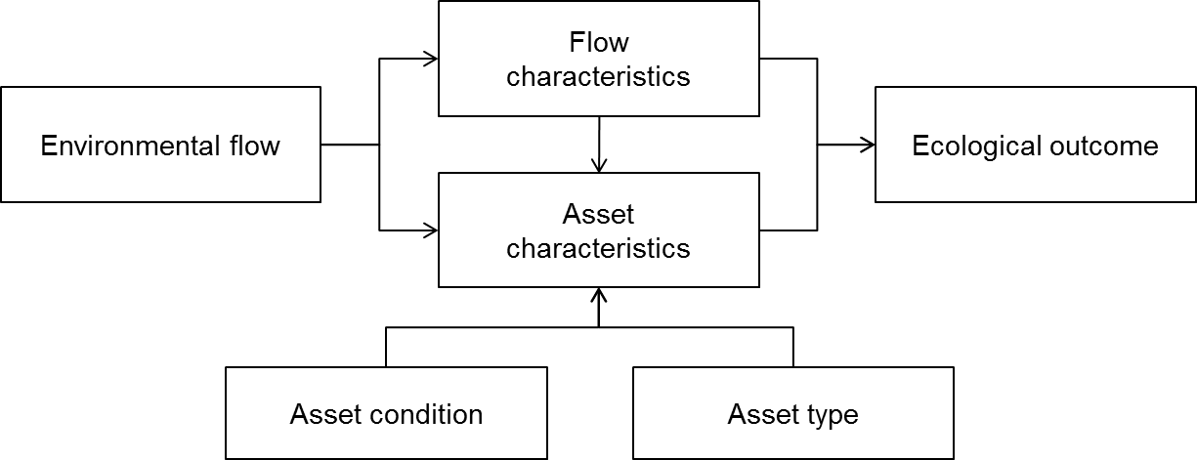.
Figure 26. An illustration of the high level influences on the ecological outcome from an environmental flow, specifically flow characteristics, asset condition and asset type.
From a delivery perspective, it is important to understand the influence of flow characteristics such as the timing, duration, depth and frequency of flow events on ecological outcomes. The type of ecosystem into which the water is delivered will also have a significant influence due to the different habitat and connectivity requirements of different species.
Annual planning and delivery decisions will be supported through the development of statistical models of the relationship between flow, casual factors and outcomes (asset characteristics in Figure 26) expected to occur within twelve months of the environmental flow.

4.3.3 Data requirements
In order to facilitate the incorporation of LTIM data into models it will be important to identify the model data requirements prior to the collection of data. In nearly every instance, model refinement or development will require the integration of data from multiple events across multiple areas. In order to achieve this it is critical that standard methods are used across the seven selected areas. The following sections give a very brief overview of some of the data requirements to ensure data informs models.

4.3.3.1 Data labelling
One of the requirements is that there is a standard site labelling protocol for all data collected. This ensures that sites are named consistently and that the spatial scale of the data is explicit in the data label. For the LTIM we suggest a four level hierarchy with area being the entire selected area, zone being a portion of the area comprised of river, wetland and floodplain elements. Each element would be comprised of a number of units which would correspond to a single ANAE classification type and have a unique identifier.

4.3.3.2 Flow events
Flow events and flow conditions at the time of sampling will also need to be captured in a consistent form to enable comparison among events and sites. The flow characteristics will need to be described in both absolute terms (e.g. megalitres/day) and relative terms (e.g. % change and return interval).

4.3.3.3 Experimental design
Sound experimental design is essential for both the estimation of parameters for predictive models and for making defensible inferences concerning flow impacts, in general. The design considerations will be similar to those considered in Section 3.3: The ecosystem type and availability of reference sites. For a number of reasons, control or reference sites are often not available. This is most often the case in rivers where even the differences between rivers in adjacent catchments can prevent their being used as suitable reference sites. Even in situations where control or reference systems appear to be available, such as wetlands, the diversity among wetlands may preclude their use as reference sites. In these instances, the use of unreplicated designs may be the only solution; however, it is important to be clear about the scale of inference (Hargrove and Pickering 1992, Stewart-Oaten, Bence et al. 1992, Stewart-Oaten and Bence 2001). If control or reference sites are available, consideration will still need to be given to the advantages and disadvantages associated with expanding the number of wetlands studied (Carpenter 1990, Oksanen 2001, Stewart-Oaten and Bence 2001, Johnson 2002).
When estimating the parameters of a predictive model, ‘intervention analysis’ targeting particular parameters may be appropriate, and time-series’ of responses are of paramount importance because the analysis relies on a comparison of a series of samples prior to and then after the intervention (Box and Tiao 1975, Carpenter 1990, Stewart-Oaten and Bence 2001).
There are numerous other factors that will shape the experimental design and associated analyses (e.g. Walters and Holling 1990, Osenberg, Schmitt et al. 1994, Mapstone 1995), All of these factors and associated modelling will need to be refined in the next phase of the development of LTIM. This process will be complicated by the need to design a sampling program that meets the needs of both short-term reporting and modelling requirements.

4.3.5 Effects
Development of models to inform annual decisions requires information on the influence of environmental flows on effect indicators. Ideally, data should be collected on the state of the indicator prior to the environmental flow and then at time intervals during and/or after the flow. The duration of the time intervals will be informed by our conceptual understanding of the ecological response to the planned flow. When the monitoring objective is to report an outcome, it is necessary to have both reference or control sites to evaluate whether there has been a response (Section 3.3.1). For the adaptive management component of the LTIM, the model will be derived from multiple events across the seven selected areas that occur along a gradient of the relevant cause indicator.
Development of five-year models will require monitoring of the state of the effect indicator over the five-year period. This monitoring will occur at a specific time of year. Due to the longer timeframes involved, model development will be more reliant on comparisons among zones within areas and comparisons among areas. In years where there is no environmental flow applied, this annual monitoring will contribute to our understanding of both levels of variability within the system and system responses in the absence of environmental flows, providing a temporal reference for the watering effects. For indicators that vary over relatively short time frames (e.g. macroinvertebrates, some species of life history stages of fish) it may be desirable to include two sampling events in years where there is no environmental allocation.
As noted in Section 4.3.2, the type of models that will be used to inform revision of the SDL will be identified by the MDBA.
In each case, LTIM data may make a contribution to these models:
- Improve the current species’ based water requirement models. The annual response to flow event data could be used to improve the open wetland, red gum, black box and waterbird breeding models.
- Develop new species’ water requirement models. LTIM annual response to flow event data will enable the development of a number of new species models.
- Develop new models of the response of ecosystem functions, resilience and water quality to flow. LTIM annual response to flow event data will enable the development of a number of new ecosystem function and resilience models.
- Develop ecosystem flow requirement models. The monitoring of multiple biotic components, ecosystem functions and resilience over several years may enable the development of ecosystem models that include interdependencies among species and ecosystem functions.
- Develop Basin-scale biodiversity, ecosystem function, resilience models. The LTIM information will provide information on the response of the seven selected areas to flow restoration. This information, in conjunction with other large-scale data could contribute to the development of Basin-scale models.

Chapter 5. Conclusion
Monitoring, evaluation, reporting and improvement are critical for supporting the efficient and effective use of Commonwealth environmental water, and demonstrating the achievement of environmental objectives. The LTIM Project will represent a significant part of the CEWO commitment to good governance and adaptive management in the implementation of the Basin Plan.
This Logic and Rationale document is an important step in the implementation of LTIM providing a means of promoting a number of the MERI principles. First among these is that the Logic and Rationale document provides a conceptual framework and program logic for LTIM Project. The document also provides a focus for the application of best available scientific knowledge to the development and implementation of LTIM. By clearly articulating LTIM needs and direction, the document also supports the development of collaborative relationships between state and Commonwealth governments.
In developing clear links between objectives, decisions and monitoring, the Logic and Rational document supports the effective implementation of adaptive management. The document, takes this one further step by identifying a process for capturing information generated by the LTIM and applying it in order to improve future decision. Ensuring that the LTIM is fit for purpose is one of the means by which this document helps ensure that LTIM is cost-effective, consistent and supplies the information needed for evaluation. The document has also included consideration of timeliness, efficiency, cost-effectiveness, consistency in the LTIM structure and in the selection of indicators.
The Logic and Rationale document is, however, a high level, generic document designed to guide development of the LTIM. It is almost certain that the application of information contained in the document to specific circumstances should only be undertaken with consideration of the context and appropriate modification of the logic, advice and information. For example, the CEDs describe in broad terms the relationship between flow, a suite of causal factors and an effect relating to an objective. This does not mean that all flows will influence all of the causal factors or the nominated effect. Rather, the CED is designed to guide the process of developing intervention monitoring that will comply with the principles outlined in the CEWO MERI Framework (2012).
The development of the Logic and Rationale document is one step in the development of the processes the CEWO need to undertake initiated by the development of the MERI Framework. The Logic and Rationale document provides a foundation for the development of specific Monitoring and Evaluation Requirements documents and Monitoring and Evaluation plans for each of the selected areas. The development of the selected area Monitoring and Evaluation Plans will influence the overall program logic and it is therefore anticipated that the Logic and Rationale document will be modified as the selected area Monitoring and Evaluation plans are refined. The major areas of refinement are likely to be in the areas of the CEDs, standard methods for indicators, experimental design, analysis and models to support adaptive management.
The Logic and Rationale document is not the only input to the development of the selected area Monitoring and Evaluation Plans. A plan is also being developed to manage data to ensure it is reliable and accessible for reporting and modelling activities. The development of the data management plan will have consequences for Quality Assurance and Quality Control procedures that will influence the way in which monitoring is undertaken and this may, in some instances lead to refinement of this document.
Overall, the Logic and Rationale document is part of the adaptive management process and should therefore be treated as an evolving document. Over time, the institutional context within which the CEWO operates will change and this may require changes to the logic and rationale. More certain is that with developments in our knowledge, generated by LTIM, other monitoring programs and research, that the indicators, sampling designs, analytical methods, CEDs and associated descriptions and objectives hierarchy may all be modified to reflect our improved understanding.
A measure of the success of this document will be the extent to which it evolves and continues to inform the implementation of LTIM over at least the next five years.

References
ANZECC and ARMCANZ (2000) Australian Guidelines for Water Quality Monitoring and Reporting, Canberra.
Baldwin D S, Nielsen D L, Bowen P M and Williams J (2005) Recommended methods for monitoring floodplains and wetlands. Murray–Darling Basin Commission, Canberra.
Beard G R, Scot, W A and Adamson J K (1999) The value of consistent methodology in long term environmental monitoring. Environmental Monitoring and Assessment 54: 239–258.
Beesley, L., et al. (2010). Watering floodplain wetlands in the Murray-Darling Basin for native fish. Waterlines Series. Canberra, ACT, National Water Commission.
Beesley L, Price A, King A, Gawne B, Nielsen, D, Koehn J, Meredith S, Vilizzi, L and Hladyz S (2011) Watering floodplain wetlands in the Murray–Darling Basin for native fish. Waterlines report, National Water Commission, Canberra.
Bellamy J A, Walker D H, McDonald G T and Syme G J (2001) A systems approach to the evaluation of natural resource management initiatives. Journal of Environmental Management, 63: 407-423.
Box G E P and Tiao G C (1975) "Intervention analysis with applications to economic and environmental problems." Journal of the American Statistical Association 70: 70-79.
Brandis K, Kingsford R, Ren S, Ramp D (2011) Crisis water management and Ibis breeding at Narran Lakes in arid Australia. Environmental Management 48:489-498.
Bunn S E, Abal E G, Smith MJ, Choy S C, Fellows C S, Harch B D, Kennard M J and Sheldon F (2010) Integration of science and monitoring of river ecosystem health to guide investments in catchment protection and rehabilitation. Freshwater Biology, 55: 223–240.
Butcher R (2003) Developing a long-term environmental fixed sites monitoring program for Melbourne Water. Report prepared for Melbourne Water.
Carpenter S R (1990) "Large-scale perturbations: Opportunities for innovation." Ecology 71(6): 2038-2043.
CEWO (2011) A Framework for Determining Commonwealth Environmental Water Use, Commonwealth Environmental Water, Canberra.
CEWO (2012) Commonwealth Environmental Water - Monitoring, Evaluation, Reporting and Improvement Framework v2.0, Commonwealth Environmental Water, Canberra.
Chee Y E, Webb J A, Stewardson M and Cottingham P (2006) Victorian environmental flows monitoring and assessment program: Monitoring and evaluation of environmental flow releases in the Broken River. Report prepared for the Goulburn Broken Catchment Management Authority and the Department of Sustainability and Environment by eWater Cooperative Research Centre, Canberra.
Chessman B and Jones H (2001) Integrated Monitoring of Environmental Flows: Design Report. New South Wales Department of Land and Water Conservation, NSW Government, Parramatta.
Clarke, K R & Green, R H (1988) Statistical design and analysis for a 'biological effects' study. Marine Ecology Progress Series, 46, 213–226.
Commonwealth of Australia (2009) NRM MERI Framework: Australian Government natural resource management monitoring, evaluation, reporting and improvement framework p 40.
Commonwealth of Australia (2012) Murray Darling Basin Plan, Federal Register of Legislative Instruments F2012L02240.
Cottingham P, Quinn G, King A, Norris R, Chessman B and Marshall C (2005a) Environmental flows monitoring and assessment framework. CRC for Freshwater Ecology, Canberra.
Cottingham P, Stewardson M and Webb A (2005b) Victorian Environmental Flows Monitoring and Assessment Program: Stage 1 Statewide framework. CRC Freshwater Ecology and CRC Catchment Hydrology report to the Department of Sustainability and Environment.
Cottingham P, Brooks S, Butcher, R and Hale J (2012) Murray-Darling Basin aquatic ecosystem classification: Stage 1 report. Peter Cottingham and Associates report to the Department of Sustainability, Environment, Water, Population and Communities, Canberra.
Cunningham S, Mac Nally R, Griffioen P, White M (2009) Mapping the Condition of River Red Gum and Black Box Stands in The Living Murray Icon Sites. A Milestone Report to the Murray-Darling Basin Authority as part of Contract MD1114. Murray-Darling Basin Authority, Canberra. p 54.
Dale V H and Beyeler S C (2001) Challenges in the development and use of ecological indicators, Ecological Indicators, 1: 3–10.
Donnelly A, Jones M, O’Mahony T and Byrne G (2007) Selecting environmental indicator for use in strategic environmental assessment, Environmental Impact Assessment Review, 27: 161–175.
Downes B J, Barmuta, L A, Fairweather P G, Faith D P, Keough M J, Lake P S, Mapstone B D and Quinn G P (2002) Monitoring Ecological Impacts: Concepts and Practice in Flowing Waters. Cambridge University Press, Cambridge.
Eberhardt L L and Thomas J M (1991) Designing environmental field studies. Ecological Monographs 61(1): 53-73.
Gawne B (2012) Resilience Knowledge Requirements to support implementation of the Basin Plan: Outcomes of an MDBA workshop. Wodonga, Vic, Murray-Darling Freshwater Research Centre: 9.
Gelman A, Rubin J B, Stern H S and Rubin D B (2004) Bayesian Data Analysis. Chapman and Hall/CRC, Boca Raton, Florida.
Glazebrook H, Robertson A (1999) The effect of flooding and flood timing on leaf litter breakdown rates and nutrient dynamics in a river red gum (Eucalypytus camaldulensis) forest. Australian Journal of Ecology 24:625-635.
Gross J E (2003) Developing Conceptual Models for Monitoring Programs. National Park Service US Department of the Interior. Available from URL: http://science.nature.nps.gov/im/monitor/docs/Conceptual_Modelling.pdf.
Hargrove W W and Pickering J (1992). Pseudoreplication: A sine qua non for regional ecology. Landscape Ecology 6(4): 251-258.
Hillman M and Brierley G (2002) Information needs for environmental-flow allocation: A case study from the Lachlan River, New South Wales, Australia. Annals of the Association of American Geographers 92: 617-30.
Humphries P, King AJ, Koehn JD (1999) Fish, flows and floodplains: link between freshwater fishes and their environment in the Murray Darling River system, Australia. Environmental Biology of Fishes 56:129-151.
Jackson DA, Peres-Neto P R and Olden J D (2001) What controls who is where in freshwater fish communities - the roles of biotic, abiotic, and spatial factors. Canadian Journal of Fisheries and Aquatic Sciences, 58, 157-170.
Johnson D H (2002) The importance of replication in wildlife research. Journal of Wildlife Management 66(4): 919-932.
Kelso W and Rutherford D (1996) Collection, Preservation, and Identification of Fish Eggs and Larvae. In: Murphy B, Willis D (eds) Fisheries Techniques, 2 edn.
King A, Brooks J, Quinn G, Sharpe A and McKay S (2003) Monitoring Programs for Environmental Flows in Australia — A Literature Review. Department of Sustainability and Environment, Sinclair Knight Merz and the CRC Freshwater Ecology.
Kingsford R T, Biggs H C, Pollard S R (2011) Strategic adaptive management in freshwater protected areas and their rivers. Biological Conservation, 144(4): 1194-1203.
Kingsford R and Thomas R (2004) Destruction of wetlands and waterbird populations by dams and irrigation on the Murrumbidgee River in arid Australia. Environmental Management 34:383-396.
Lindenmayer D B, Likens G E, Haywood A and Miezis L (2011) Adaptive monitoring in the real world: proof of concept. Trends in Ecology and Evolution, 26: 641-666.
Mapstone B D (1995). Scalable decision rules for environmental impact studies: effect size, Type I and Type II errors. Ecological Applications 5(2): 401-410.
McDaniels T L, Gregory R S and Fields D (1999) Democratizing risk management: Successful public involvement in local water management decisions. Risk Analysis 19: 497-510.
MDBA (2011) The proposed “environmentally sustainable level of take” for surface water of the Murray-Darling Basin: Methods and outcomes, MDBA publication no: 226/11, Murray-Darling Basin Authority, Canberra.
MDFRC (2012) Evaluation of the ecological benefits of Commonwealth environmental water in the southern basin. Draft Report prepared for the Commonwealth Environmental Water Office by The Murray-Darling Freshwater Research Centre, Albury.
MDFRC (in prep) IECA Framework Victorian Icon Sites ‘Proof of concept’ Trial, Scoping Report, December 2012. Report to Department of Sustainability, Environment, Water, Population and Communities, Canberra.
Meredith S and Beesley L (2009) Watering floodplain wetlands in the Murray-Darling Basin to benefit fish: a discussion with managers. Arthur Rylah Institute, Heidelberg, Vic.
Neal J, Adelsberger C, Lochman S (2012) A Comparison of Larval Fish Sampling Methods for Tropical Streams. Marine and Coastal Fisheries 4:23-29
Nielsen D, Watson G, Petrie R (2005) Microfaunal communities in three lowland rivers under differing flow regimes. Hydrobiologia 543:101-111 doi: 10.1007/s10750-004-6946-9
Niemeijer D, and de Groot R S (2008) A conceptual framework for selecting environmental indicator sets, Ecological Indicators, 8: 14–25.
Noss R F (1990) Indicators for monitoring biodiversity: a hierarchical approach. Conservation biology, 4(4), 355-364.
Oksanen L (2001) Logic of experiments in ecology: is pseudoreplication a pseudoissue? Oikos 94(1): 27-38.
Osenberg C W, Russell J, Schmitt S J, Holbrook K E A and Flegal A R (1994) Detection of environmental impacts: natural variability, effect size, and power analysis. Ecological Applications 4, no. 1 (1994): 16-30.
Poff N L, Allan J D, Palmer M A, Hart D D, Richter B D, Arthington A H, Rogers KH, Meyers J L, and Stanford J A (2003) Fiver flows and water wars: emerging science for environmental decision making. Frontiers in Ecology and the Environment, 1: 298-306.
Poff N L, Richter B D, Arthington A H, Bunn S E, Naiman R J, Kendy E, Acreman M, Apse C, Bledsoe BP, Freeman M C, Henriksen J, Jacobson R B, Kennen J G, Merritt D M, O'keeffe, J H, Olden J D, Rogers K, Tharme RE and Warner A (2010) The ecological limits of hydrologic alteration (ELOHA): a new framework for developing regional environmental flow standards. Freshwater Biology, 55, 147-170.
Quinn G P and Keough MJ (2002) Experimental design and data analysis for biologists. Cambridge University Press, Cambridge.
Richter B D and Thomas G A (2007) Restoring environmental flows by modifying dam operations. Ecology and Society 1212.
Reid J, Kingsford R, Jaensch R (2009) Waterbird Surveys in the Channel Country Floodplain Wetlands, Autumn 2009. Report by Australian National University, Canberra, University of New South Wales, Sydney, and Wetlands International, Oceania, Brisbane, for the Australian Government Department of Environment, Water, Heritage and the Arts
Roe J and Georges A (2008) Terrestrial activity, movements and spatial ecology of an Australian freshwater turtle, Chelodina longicollis, in a temporally dynamic wetland system. Austral Ecology 33:1045-1056 doi: 10.1111/j.1442-9993.2008.01877.x
Rose P, Metzeling L and Catzikiris S (2008) Can macroinvertebrate rapid bioassessment methods be used to assess river health during drought in south eastern australian streams? Freshwater Biology 53, 2626-2638.
Sheldon F, Peterson EE, Boone EL, Sippel S, Bunn SE, Harch BD (2012) Identifying the spatial scale of land use that most strongly influences overall river ecosystem health score. Ecological Applications 22:2188-2203.
Sims N, Colloff M and Guerschman J P (2009) Basin-scale vegetation (Chapter 12). In: Overton, I.C., Colloff, M.J., Doody, T.M., Henderson, B. and Cuddy, S.M. (eds). Ecological Outcomes of Flow Regimes in the Murray-Darling Basin. Report prepared for the National Water Commission by CSIRO Water for a Healthy Country Flagship, CSIRO.
Stanford J A, Ward J V, Liss W J, Frissell C A, Williams R N, Lichatowich J A, and Coutant CC (1996) A general protocol for restoration of regulated rivers. Regulated Rivers: Research and Management, 12: 391-413.
Stewart-Oaten A and Bence J R (2001) Temporal and spatial variation in environmental impact assessment. Ecological Monographs 71(2): 305-339.
Stewart-Oaten A, Bence J R, Osenberg C W (1992) Assessing effects of unreplicated perturbations: no simple solutions. Ecology 73(4): 1396-1404.
Tan L and Shiel RJ (1993) Responses of billabong rotifer communities to inundation. Hydrobiologia 255/256:361-369.
Vilizzi L, Meredith S, Sharpe CP, Rehwinkle R (2008) Evaluating light trap efficiency by application of mesh to prevent inter- and intra-specific in situ predation on fish larvae and juveniles. FISHERIES RESEARCH 93: 146-153 Fisheries Research 93:146-153.
Walters C J and Holling C S (1990) LARGE-SCALE MANAGEMENT EXPERIMENTS AND LEARNING BY DOING. Ecology 71(6): 2060-2068.
Wassens S, Hall A, Osborne W, Watts RJ (2010) Habitat characteristics predict occupancy patterns of the endangered amphibian Litoria raniformis in flow-regulated flood plain wetlands. Austral Ecology 35:944-955 doi: 10.1111/j.1442-9993.2010.02106.x
Water Act (2007) Commonwealth of Australia, Canberra.
Webb J A, Stewardson M J, Koster W M (2010) Detecting ecological responses to flow variation using Bayesian hierarchical models. Freshwater Biology 55:108-126.
Young R and Huryn A (1996) Interannual variation in discharge controls ecosystem metabolism along a grassland river continuum. Canadian Journal of Fisheries and Aquatic Sciences 53:2199-2211.

Appendix A: Basin Plan more specific Level 2 objectives.

- Biodiversity: ‘To protect and restore water-dependent ecosystems of the Murray-Darling Basin’ (Part 2, 8.05, (1), (2), & (3))
- To protect and restore a subset of all water-dependent ecosystems by ensuring that:
  - Declared Ramsar wetlands that depend on Basin water resources maintain their ecological character (see paragraph 21(3)(c) of the Act); and
  - Water-dependent ecosystems that depend on Basin water resources and support the life cycles of species listed under the Bonn Convention, CAMBA, JAMBA or ROKAMBA continue to support those species; and
  - Water-dependent ecosystems are able to support episodically high ecological productivity and its ecological dispersal.
- To protect and restore biodiversity that is dependent on Basin water resources by ensuring that:
  - Water-dependent ecosystems that support the life cycles of a listed threatened species or listed threatened ecological community, or species treated as threatened or endangered (however described) in State law, are protected and, if necessary, restored so that they continue to support those life cycles; and
  - Representative populations and communities of native biota are protected and, if necessary, restored.
- Function: ‘To protect and restore the ecosystem functions of water-dependent ecosystems’ (Part 2, 8.06, (1), (2), (3, (4), (5), (6) & (7)).
- That the water quality of Basin water resources does not adversely affect water-dependent ecosystems and is consistent with the water quality and salinity management plan.
- To protect and restore connectivity within and between water-dependent ecosystems, including by ensuring that:
  - The diversity and dynamics of geomorphic structures, habitats, species and genes are protected and restored; and
  - Ecological processes dependent on hydrologic connectivity:
    - longitudinally along watercourses; and
    - laterally between watercourse and their floodplains (and associated wetlands); and
    - vertically between the surface and subsurface; and
are protected and restored; and
  - The Murray Mouth remains open at frequencies, and for durations, sufficient to ensure that the tidal exchanges maintain the Coorong’s water quality (in particular salinity levels) within the tolerance of the Coorong ecosystem’s resilience (Note: This is to ensure that water quality is maintained at a level that does not compromise the ecosystem and that hydrologic connectivity is restored and maintained); and
  - The levels of the Lower Lakes are managed to ensure sufficient discharge to the Coorong and Murray Mouth and help prevent river bank collapse and acidification of wetlands below Lock 1, and to avoid acidification and allow connection between Lakes Alexandrina and Albert, by:
- maintaining levels above 0.4 metres Australian Height Datum for 95% of the time, as far as practicable; and
- maintaining levels above 0.0 metres Australian Height Datum all of the time; and
  - Barriers to the passage of biological resources (including biota, carbon and nutrients) through the Murray-Darling Basin are overcome or mitigated.
- Natural in-stream and floodplain processes that shape landforms are protected and restored.
- Habitat diversity for biota is supported at a range of scales (including, for example, the Murray-Darling Basin, riverine landscape, river reach and asset class).
- Protect and restore ecosystem functions of water-dependent ecosystems that maintain populations (for example recruitment, regeneration, dispersal, immigration and emigration) including that:
  - Flow sequences and inundation and recession events meet ecological requirements (for example, cues for migration, germination and breeding); and
  - Habitat diversity, extent, condition and connectivity that supports the life cycles of biota of water-dependent ecosystems (for example, habitats that protect juveniles from predation) is maintained.
- To protect and restore ecological community structure, species interactions and food webs that sustain water-dependent ecosystems, including by protecting and restoring energy, carbon and nutrient dynamics, primary production and respiration.

- Resilience: ‘To ensure that water-dependent ecosystems are resilient to climate change and other risks and threats’ (Part 2, 8.07, (1), (2), (3, (4), (5) & (6)).
- That water-dependent ecosystems are resilient to climate change, climate variability and disturbances (for example drought and fire).
- To protect refugia in order to support the long term survival and resilience of water-dependent populations of native flora and fauna, including during drought to allow for subsequent re-colonisation beyond the refugia.
- To provide wetting and drying cycles and inundation intervals that do not exceed the tolerance of ecosystem resilience or the threshold of irreversible change.
- To mitigate human-induced threats (for example, the impact of alien species, water management activities and degraded water quality).
- To minimise habitat fragmentation.

- Water Quality: ‘To ensure water quality is sufficient to achieve the above objectives for water-dependent ecosystems; and for Ramsar wetlands, sufficient to maintain ecological character’ (Part 3, 9.04, (1) & (2)).
- Water quality must be sufficient to maintain the ecological character of Ramsar wetlands.
- For those wetlands other than declared Ramsar wetlands, the quality of the water must be sufficient to:
  - To protect and restore ecosystems; and
  - To protect and restore the ecosystem function; and
  - To ensure that the ecosystems are resilience to climate change and other risks and threats.

Appendix B: Broad Indicators
Table B1. Biodiversity objectives Level 2 and 3, and associated CEDs and broad indicators.
Level 2 Objective | Level 3 Objective |  | CED | Indicators
Ecosystem diversity |  |  | Landscape ecosystem diversity | Ecosystem type using ANAE classification or suitable alternative  Individual ecosystem’s extent
Ecosystem diversity |  |  | Within ecosystem diversity | Species number and abundance
Species diversity | Vegetation | Diversity | Landscape vegetation diversity | species number and abundance
Species diversity | Vegetation | Population | Vegetation condition and reproduction | Individual condition (mean and variance)  Population structure  Abundance  Vegetation reproduction (e.g. flowering)
Species diversity | Vegetation | Population | Vegetation recruitment and extent | Recruitment  Germination  Seedling recruitment  Population structure  Vegetation distribution  Vegetation extent  Contiguousness of long-lived vegetation
Species diversity | Macroinvertebrates |  | Within ecosystem macroinvertebrate diversity | Species number and abundance
Species diversity | Fish | Diversity | Landscape fish diversity | Species number and abundance  Microinvertebrate abundance
Species diversity |  | Population condition | Fish condition | Individual condition  Abundance  Fish population structure
Species diversity |  |  | Fish reproduction | Egg and larval abundance  Individual abundance  Change in gonad condition
Species diversity |  |  | Fish larval growth and survival | Juvenile abundance  Size-frequency  Spawning dates  Rate and timing of growth
Species diversity | Waterbirds | Diversity | Landscape waterbird diversity | Species number and abundance
Species diversity | Waterbirds | Population | Waterbird survival and condition | Waterbird survival  Changes in abundance over time
Species diversity | Waterbirds | Population | Waterbird reproduction | Nest, eggs, chicks and species abundance  Population structure
Species diversity | Waterbirds | Population | Waterbird recruitment and fledging | Fledgling abundance
Species diversity | Other vertebrates | Population | Other vertebrate condition (individual) | Length: weight ratio  Size-distribution
Species diversity | Other vertebrates | Population | Other vertebrate reproduction | Egg numbers  Tadpole abundance  Juvenile abundance
Species diversity | Other vertebrates | Population | Other vertebrate growth and survival | Growth and survival of nominated species  Frog and tadpole abundance  Turtle size distribution over time  Population structure
Table B2. Ecosystem function Level 2 objectives and associated CED and indicators.
Level 2 Objective | CED | Component | Indicators
Connectivity | Hydrological connectivity | Lateral connectivity - event | Volume, duration, depth, timing, type of connection
Connectivity | Hydrological connectivity | Lateral connectivity - regime | Frequency, return period
Connectivity | Hydrological connectivity | Longitudinal connectivity -event | Volume, duration, depth, timing, type
Connectivity | Hydrological connectivity | Longitudinal connectivity -regime | Frequency, return period
Connectivity | Hydrological connectivity | Vertical connectivity - event | Volume, direction, duration, depth, timing, type
Connectivity | Hydrological connectivity | Vertical connectivity - regime | Frequency, return period
Connectivity | Biotic dispersal | Dispersal (fish) | Individual condition  Changes in abundance or population structure  Movement  Changes in distribution  Population genetics
Connectivity | Biotic dispersal | Cues | Water quality  Flow
Connectivity | Biotic dispersal | Hydrological connectivity | Type, duration, landscape position, volume, depth, timing, type of connection
 | Vegetation recruitment and extent | Dispersal | Movement  Abundance  Changes in distribution and population structure
Connectivity | Sediment transport | Suspended sediment | Suspended sediment  Geomorphology
Connectivity | Sediment transport | Bed load | Bed load sediment
Connectivity | Sediment transport | Sediment deposition or erosion | Changes in morphology  Changes in sediment character
Ecosystem process | Primary productivity | Aquatic phase | Aquatic metabolism  Biomass accumulation
Ecosystem process | Primary productivity | Terrestrial phase | Vegetation Production  Biomass accumulation  NDVI  Remote Sensing
Ecosystem process | Decomposition | Aquatic phase | Aquatic metabolism  Biomass loss
Ecosystem process | Decomposition | Terrestrial phase | Microbial production  Biomass loss
Ecosystem process | Nutrient and carbon cycling |  | Changes in nutrient concentration or speciation  Total nitrogen, total phosphorus, NOx, filtered reactive phosphorus, DOC.

Table B3. Resilience Level 2 objectives and associated CED and indicators.
Level 2 Objective | CED | Category | Indicators
Ecosystem resilience | Landscape refugia | Refuges | Distribution  Abundance
Ecosystem resilience | Landscape refugia | Population condition | Individual and population condition  Population structure  Abundance  Distribution
Ecosystem resilience | Landscape refugia | Connectivity | Ecosystem connectivity  Landscape position  Dispersal
Population resilience | Refugia | Population condition | Individual condition  Population structure  Changes in distribution and abundance through time
Population resilience | Refugia | Habitat | Species dependent but may include:  Geomorphology  Water quality  Vegetation
Population resilience | Refugia | Connectivity | Dispersal  Landscape position  Flow
Population resilience | Resistance | Population condition | Individual and population condition  Abundance  Population structure
Population resilience | Resistance | Habitat | Species dependent but may include:  Geomorphology  Water quality  Vegetation
Population resilience | Resistance | Connectivity | Flow  Landscape position
 | Avoidance | Population condition | Individual condition  Abundance  Population structure
 |  | Connectivity (Dispersal) | Cues  Movement  Landscape Position  Flow
 | Recovery | Population condition | Individual condition  Abundance  Population structure
 |  | Recruitment | Reproduction  Recruitment
 |  | Connectivity (Dispersal) | Cues  Flow  Movement  Landscape position

Table B4. Water quality objectives Level 2 and associated CED and indicators.
Objective Level 2 | CED | Component | Indicators
Chemical | Salinity | Water | Salt concentration or loads  Ionic composition
Chemical | Salinity | Sediment | Salt concentration  Ionic composition
Chemical | pH |  | pH  Buffering capacity
Chemical | Dissolved oxygen (DO) |  | Dissolved oxygen
Chemical | Dissolved organic carbon (DOC) |  | DOC concentration  DOC bioavailability
Biological | Algal blooms |  | Cyanobacterial species and abundance  Turbidity

Creative Commons Attribution - 3.0 Australia http://creativecommons.org/licenses/by/3.0/au

