# Look out for khapra beetle!

## Khapra beetle

Khapra beetle is a serious threat to Australia's agriculture and food production. We need your help to keep it out.

Khapra is a tiny beetle - smaller than a 5c coin! They can survive without food for up to 6 years. They can hide under the floor, and in cracks and crevices of containers. This helps them spread around the world.

* Adult beetles (1.6-3mm long) are reddish brown, oval shaped with faint dark lines and do not fly.
* Larvae (1.6-4.5mm long) typically appear very hairy and are golden brown.

## Where to look

Although these beetles are tiny, they can leave piles of yellowish skins in the container. These yellow skins are easier to spot than the beetles and are the most obvious sign that khapra is in the container. They are often found underneath container floorboards and rubber door seals.

Think you’ve seen khapra beetle?

Call the See. Secure. Report. Hotline on 1800 798 636

Website: awe.gov.au/khapra-urgent-actions

Facebook: Australian Biosecurity

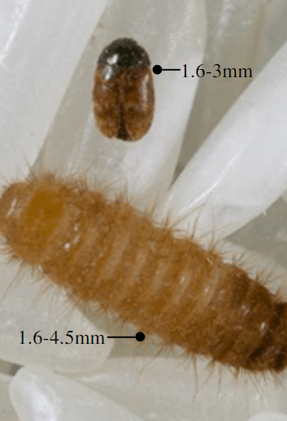

Photo of two khapra beetles and a larva against a 5c cent and a photo of the two khapra beetles and larva enlarged.


