Part 1

Introduction, scoping review, conceptual model and field program design

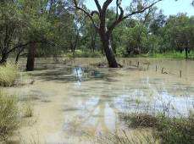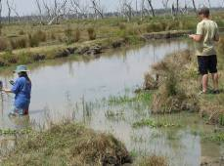

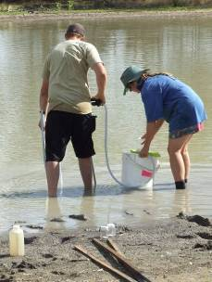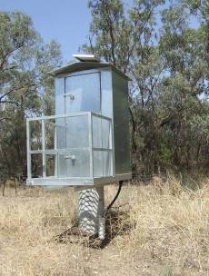

Chapter 1

General introduction

Agricultural floodplain landscapes across the Murray-Darling Basin are increasingly being recognised for their biodiversity potential (e.g. Morton et al., 2002; Smith & Pritchard, 2003). One such region, the Lower Gwydir valley, comprises an extensive floodplain with multiple distributary stream channels and terminal wetlands of national importance. These wetlands include four ‘sub-sites’ listed under the Ramsar Convention, and are noted as critical waterbird breeding areas for eastern Australia (Kingsford, 2000).

The development of irrigated agriculture in the Gwydir Valley over the past 30 years (Keyte, 1994; McCosker et al., 1999) has significantly affected flow patterns into these key wetlands. The Gwydir Valley is one of the largest cotton-growing regions in Australia, and also contains extensive development of grazing and dryland cropping enterprises. Regulation of flows to the Lower Gwydir floodplain began in 1972 and has continued with the subsequent completion of Copeton Dam on the Gwydir River in 1976. A major driver for this was securing the supply of water for floodplain irrigation, stock and domestic uses downstream. Today, prominent industries on the Lower Gwydir floodplain include irrigated cropping, cattle and sheep grazing, and the farming of grain crops such as wheat, barley and sorghum. Water resources development in the lower catchment, and associated construction of levees and numerous supply or diversion channels, has caused major challenges with supplying water to downstream floodplain areas, including the various channel systems, floodplain waterholes and wetlands.

The Water Sharing Plan (WSP) for the Gwydir Regulated River Water Source established a planned environmental water rule that sets aside an Environmental Contingency Allowance (ECA) of up to 45,000 ML in Copeton Dam. This allows for environmental flow releases into the Lower Gwydir floodplain. A stakeholder operations advisory committee, comprising industry, scientific, conservation, agency and Catchment Management Authority representation, provides advice to the NSW Department of Environment, Climate Change and Water on the timing, rate and duration of ECA releases. Such releases are implemented to achieve a set of nine ecological objectives (NSW DIPNR, 2005a), namely:

- To support a colonially nesting native bird breeding event that has been initiated in the Gwydir wetlands following natural flood inundation;
- To provide additional inundation in the Gingham and Lower Gwydir Wetlands during or following periods of extended dry climatic conditions;
- To provide inundation of higher level benches in the river reaches between Copeton Dam and the Gwydir river at Gravesend;
- To provide short-term inundation of the wetlands to promote germination of Hyacinth as part of a weed management strategy involving a wetting and drying cycle;
- to provide environmental flows along downstream effluent streams;
- to support native fish populations and habitats;
- to support invertebrates and other aquatic species;
- to support threatened species; and
- to maintain aquatic ecosystem health.

In order for ECA releases to occur in a scientifically defensible manner, the ECA committee requires sound information on the downstream aquatic responses to flow variability in this ecosystem. While preliminary work has assessed macroinvertebrate and vegetation responses to flows within the wetland ecosystem, there is no concise model that can be used to predict the likely outcome of ECA releases for a broader range of ecosystem components and processes. Very little information is currently available on ecological responses to flow variability within channels such as the Lower Gwydir River, Mehi River or Gingham Watercourse. While industries across this landscape continue to grapple with incorporating environmental values into on-farm planning, extensive debate about the water sharing arrangements in the valley has highlighted the lack of research on the aquatic ecosystems of the region. To this end, the present project was initiated to guide industry, managers and the community on how to maximise environmental flow benefits on the Lower Gwydir floodplain.

The objectives of this project are:
1) To determine the flow requirements of streams and terminal wetlands on the Lower Gwydir floodplain (chapters 2–7);
2) To develop recommendations for future flow management, monitoring indicators, and institutional arrangements for the Lower Gwydir aquatic ecosystem (chapter 9); and
3) To provide managers of the Gwydir Regulated River ECA and other river flows into floodplain terminal wetlands with a model guiding the effective management of flows to maximise environmental outcomes (chapter 9).

The project was structured into four discrete stages, namely (1) review of existing knowledge and development of a communication plan, (2) conceptual model development and design of field sampling program, (3) field program, and (4) final reporting. Wherever possible, we took the approach of examining ecological responses to flows at two temporal scales. Analyses of responses by wetland vegetation, fish and in-stream water chemistry are all examined in relation to individual ECA releases as well as over longer timeframes from months (fish, water chemistry) to years (vegetation). While much of our focus was on responses to ECA releases, we acknowledge that a thorough understanding of aquatic ecological responses to flows in this valley will require similar analyses of natural flood events.

