Part 3

Communication and Management implications

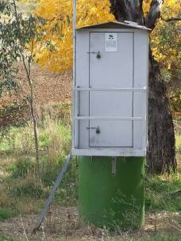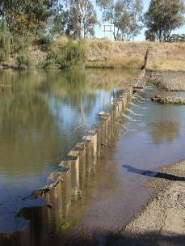

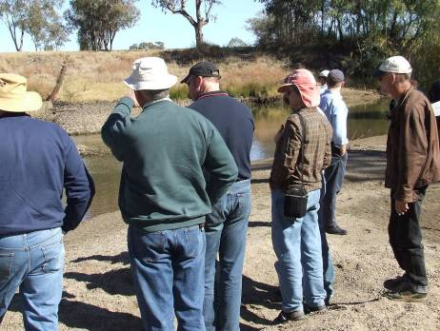

Chapter 8

Communication of project findings

8.1 Introduction

Communication is a key step in gaining stakeholder trust for any management-focused ecological research project and maximising the acceptance of its recommendations. The condition and functioning of floodplain wetland ecosystems like the Lower Gwydir has a complex mix of stakeholders that incudes the general public, wetland landholders, management committee members, research colleagues and state and Commonwealth environment agencies. However, each stakeholder group will have a different level of ‘buy-in’ to the ecology of such ecosystems, ranging from the general public’s broad interest, to the business concerns of upstream irrigators and wetland landholders, and the legislated oversight of state and commonwealth managers. Scientific colleagues will also have an interest in the implications of methods and findings for their own parallel research. This diversity in local knowledge, ecological technical expertise, and concern means that any communication strategy needs to include a range of products and methods tailored to the specific audience(s).

The project team in this study placed considerable emphasis on communicating its activities and findings to as broad a range of audiences as possible. This chapter summarises the communication activities completed by team members from early 2006 through to mid 2009. A complete listing of project presentations is given in Appendix 1, and details of outputs and, where relevant, their abstracts are given in Appendix 2.

8.2 Industry and community stakeholders

- General public
- Australian Cotton Conference
- Cotton Catchment Communities Cooperative Research Centre
- Community Advisory Committee of the Murray-Darling Basin Authority’s Native Fish Strategy

Three project newsletters were produced (summer 2006/2007, winter/spring 2007, winter 2009) to highlight the project and recent findings to a range of stakeholders. These were distributed to state and Commonwealth agency staff, wetland landholders, and the general public. Newsletters were distributed to the general public through the Border Rivers – Gwydir Catchment Management Authority office and displays at the July 2008 community forum in Moree.

Presentations were also given to community and agricultural industry audiences on a number of occasions. These included the Australian Cotton Conference on the Gold Coast (August 2006), annual Cotton CRC conferences in Narrabri (2007, 2008, 2009), the Community Advisory Committee of the Murray-Darling Basin Authority’s Native Fish Strategy near Goondiwindi (May 2009), and field days for wetland landholders at “Bunnor” near Moree, March and August 2009.

Throughout the project, we also used a range of (mostly regional) media outlets to communicate project activities and findings to industry and community audiences. These included regional ABC radio, local commercial radio, regional television, and various local print media. Stories also appeared in the FarmOnline emailed media service. While most media hits followed dedicated media releases, comment was also sought by regional ABC radio on specific Lower Gwydir issues such as the Commonwealth buy-back of water licences for environmental purposes in the valley.

8.3 Scientific and management audiences

- Gwydir ECA Operations Advisory Committee, Moree
- Australian Cotton Conference, Gold Coast
- Cotton Catchment Communities Cooperative Research Centre, Narrabri
- Ecological Society of Australia, Perth and Sydney
- Australian Society for Fish Biology, Sydney
- University of Cape Town
- University of New England, Armidale and Coffs Harbour
- Australian National University, Canberra
- University of Botswana, Maun
- National Water Commission, Canberra
- Australian Government Department of the Environment, Water, Heritage and the Arts, Canberra
- Ecological response modelling in the Murray-Darling Basin conference, Sydney
- International Conference on Implementing Environmental Water Allocations, Port Elizabeth, South Africa

The principal stakeholder of this project was the Gwydir ECA Operations Advisory Committee which, at the time of project completion, was administered by the NSW Department of Environment, Climate Change and Water. While the project leader’s (Glenn Wilson) membership of this committee allowed up to date advice on project findings to be incorporated into committee decisions, the project team also gave a number of formal presentations to the committee including in February 2006 and August 2007. The majority of ECAOAC members also represented their agency or industry organisation on the project’s steering committee, providing a further means of transferring knowledge to the ECAOAC.

Presentations were given to research colleagues at both cotton industry and aquatic ecology conferences. Talks were given at the Australian Cotton Conference on the Gold Coast (August 2006) and at the 2007, 2008 and 2009 Cotton CRC conferences in Narrabri. Other presentations were given at the Ecological Society of Australia (November 2007, December 2008), the Australian Society for Fish Biology (September 2008), and at the conference on ecological response modelling in the Murray-Darling Basin organised jointly by the CSIRO and NSW Department of Environment, Climate Change and Water, November 2008.

Presentations were also given to ecological and catchment management research groups at a number of universities. These included the University of Cape Town (Freshwater Research Unit, Cape Town, November 2006), University of New England (School of Environmental and Rural Science, Armidale, April 2007 and June 2008), the Australian National University (Integrated Catchment Assessment and Management Centre, Canberra, August 2008), and the University of Botswana (Harry Oppenheimer Okavango Research Centre, Maun, November 2008).

Two talks were also given at an international conference on implementing environmental water allocation programs, held in Port Elizabeth South Africa in February 2009. Notably, these were some of only a few presentations during the 4-day event that highlighted the need for rigorous ecological data to underpin environmental flow decisions, and audience comment was made to that effect.

Presentations were also made to key national management bodies. In June 2006, a brief presentation was made to staff at the National Water Commission on the design and rationale of the project at its outset, while a more extensive talk on project findings was given to the Water Group of the Australian Government Department of the Environment, Water, Heritage and the Arts in August 2008.

8.4 The Lower Gwydir: Surface Flows and the Ecology of Streams and Wetlands: A Forum to Inform the Local Community and Guide Management. Moree, NSW, July 2008

- State and Commonwealth catchment managers
- Agricultural industry representatives
- Landholders
- General public, including the local indigenous community

In July 2008, a two-day community forum on the flow ecology of the Lower Gwydir wetlands was held in Moree. It was convened by the project team, and organised jointly with staff from the Border Rivers – Gwydir CMA and the NSW Department of Primary Industries. The forum’s objectives were to (1) provide an opportunity for researchers to extend their work to the Moree Community, (2) give the Moree Community the opportunity to hear about what research is taking place on the surface flow ecology of the mid to lower Gwydir, and (3) demonstrate how findings from the different research projects mesh together to guide management of the catchment’s rivers and wetlands. The forum attracted wide media attention in regional television, radio and newspapers.

The first day of the forum comprised a series of invited presentations and discussions on recent research findings and management initiatives in the Lower Gwydir wetlands, while the second day was a bus tour of key wetland sites and included brief talks from landholders and researchers. Project team members were involved in five of the 13 presentations on day 1, as well as a number of the field talks on day 2. The forum attracted a diverse audience of approximately 80 participants, including interested members of the public (indigenous and non-indigenous), wetland landholders, CMAs, the Cotton CRC, agricultural industries, Moree Plains Shire Council, universities and state (Primary Industries; Environment and Climate Change; Water and Energy) and Australian Government natural resource management agencies (Department of the Environment, Water, Heritage and the Arts; Murray-Darling Basin Commission).

