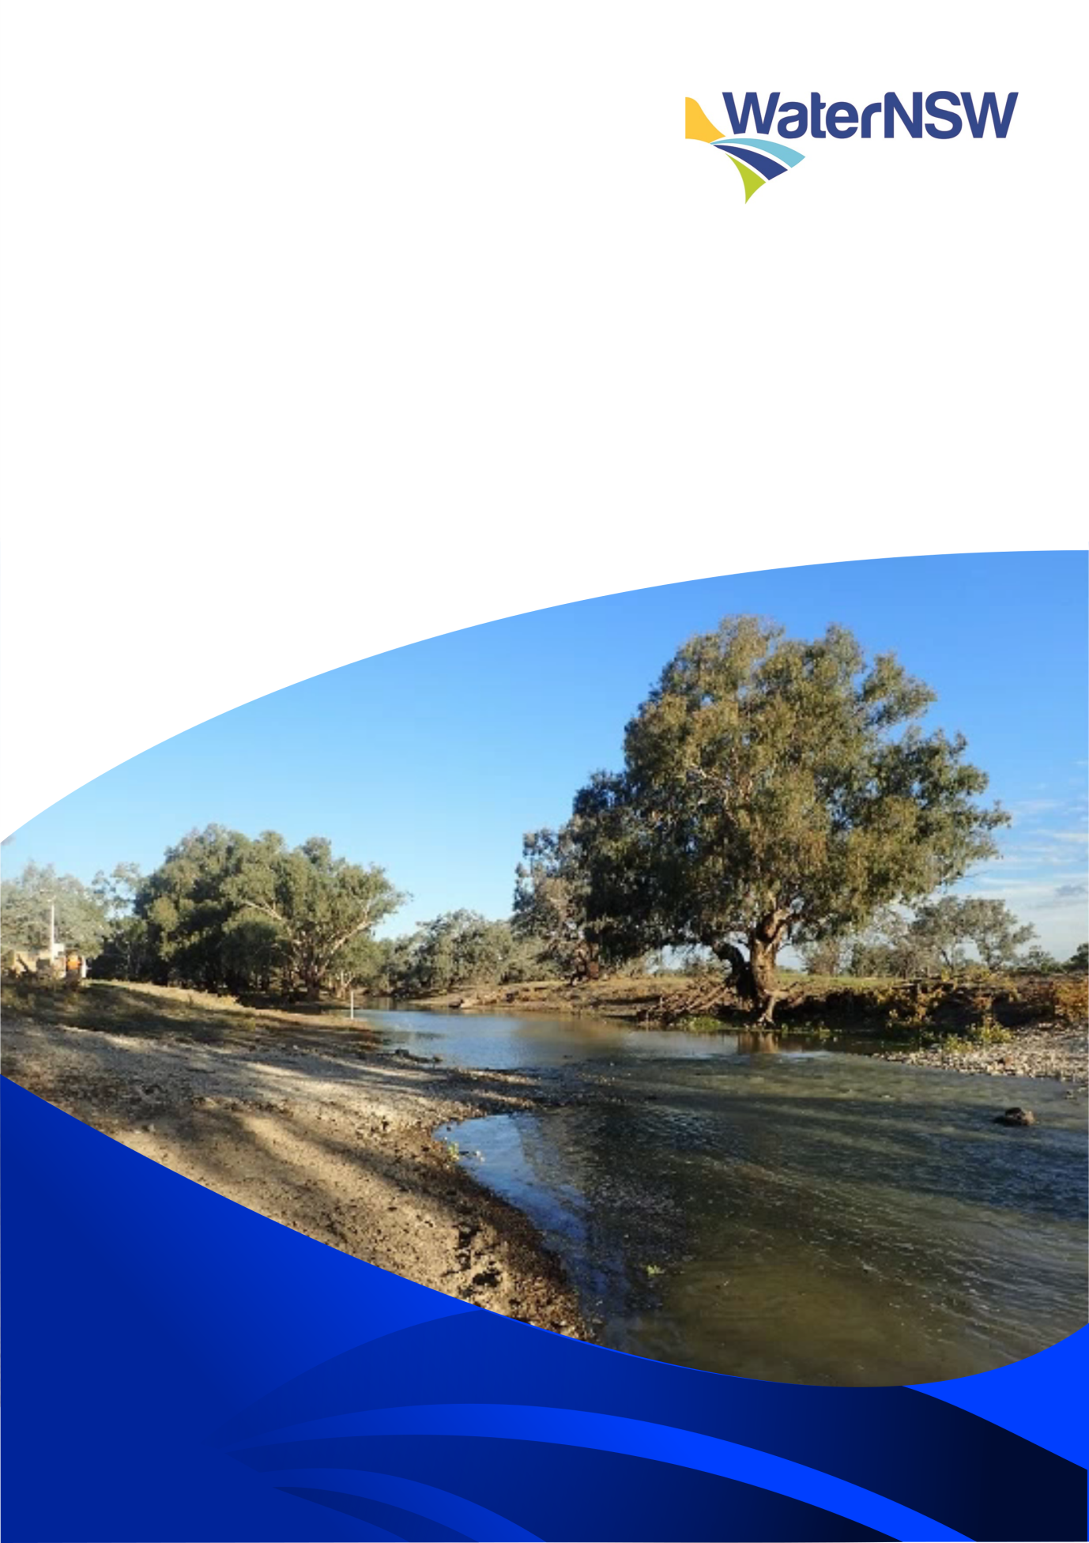

Commonwealth of Australia, Department of Environment and Energy  
and NSW Office of Environment and Heritage

Lower Macquarie Catchment  
Temporary Water Monitoring 2017

Prepared for: Commonwealth of Australia, Department of Environment and Energy and concurrently NSW Office of Environment and Heritage

Report Prepared: October 2017

Data Provided By: WaterNSW, Water Catchment and Protection Unit, Hydrometrics

Front Cover: Gauging Station Site 421907, Macquarie River @ Brewon Bridge

WaterNSW has prepared the information in this report with all due care and endeavours to provide accurate information that is considered true and correct at the date of publication. The information may change without notice. Any mistakes in this information that are brought to our attention will be corrected as soon as possible. WaterNSW disclaims, to the extent permitted by law, all warranties, representations or endorsements, express or implied, with regard to the information including but not limited to, all implied warranties of merchantability, fitness for a particular purpose, or non-infringement.

The information is provided on the understanding that the WaterNSW, its employees and agents have no liability (including but not limited to liability by reason of negligence) to the client for any loss, damage, cost or expense whether direct, indirect consequential or special, incurred by, or arising by reason of, any person using or relying on the information and whether caused by reason of any error, omission or misrepresentation in the information or otherwise.

This report was prepared by the Water Catchment and Protection Unit of WaterNSW to describe the installation of a temporary river gauging station and to provide the hydrological data recorded during an environmental flow delivery to the Barwon River from the Macquarie River during May to July 2017.

Table of Contents

[Hydrometric Gauging Stations within the Lower Macquarie Area 4](#_Toc504477972)

[Site Reconnaissance 27th and 28th of April 2017 4](#_Toc504477973)

[Installation of 421907 Macquarie River @ Brewon Bridge 5](#_Toc504477974)

[Discharge Gaugings 8](#_Toc504477976)

[Rating table development 9](#_Toc504477977)

[Discussion of key findings 14](#_Toc504477980)

**Table of Figures**

[Figure 1 - Gauging station 421907 Macquarie River @ Brewon Bridge](file:///P:\Dubbo%20Hydro\Report_Temporary%20OEH%20Monitoring%20site%20Final%20report1.docx#_Toc495656765) Cover

[Figure 2 - Location map of gauging stations 4](file:///P:\Dubbo%20Hydro\Report_Temporary%20OEH%20Monitoring%20site%20Final%20report1.docx#_Toc495656766)

[Figure 3 - Gravel causeway at 421907 5](#_Toc495656767)

[Figure 4 - Benchmark 6](file:///P:\Dubbo%20Hydro\Report_Temporary%20OEH%20Monitoring%20site%20Final%20report1.docx#_Toc495656768)

Plot 1 - Cross Section 6

Table 1 - OEH Gauging Station Locations 7

[Figure 5 - Instrument shelter and staff gauges, Gauging Station 421907 7](file:///P:\Dubbo%20Hydro\Report_Temporary%20OEH%20Monitoring%20site%20Final%20report1.docx#_Toc495656770)

Table 2 - Gauging Results 8

Plot 2 - Level and Gauging Plot for gauging stations 421907 and OEH1 9

Table 3 - Discharge Rating Table 1.04 Gauge height and Discharge (ML/d) 10

Plot 3 - 421907 Discharge Raging curve with gaugings plotted 10

Plot 4 - Discharge traces for 421907 and the upstream station 421012 11

Plot 5 - Level traces for 421907, 422026 and 422027 12

Plot 6 - Discharge traces for 421907, 422026, 422027 12

Plot 7 - Cumulative discharge for 421907, 422026, 422027 13

# Hydrometric Gauging Stations within the Lower Macquarie Area

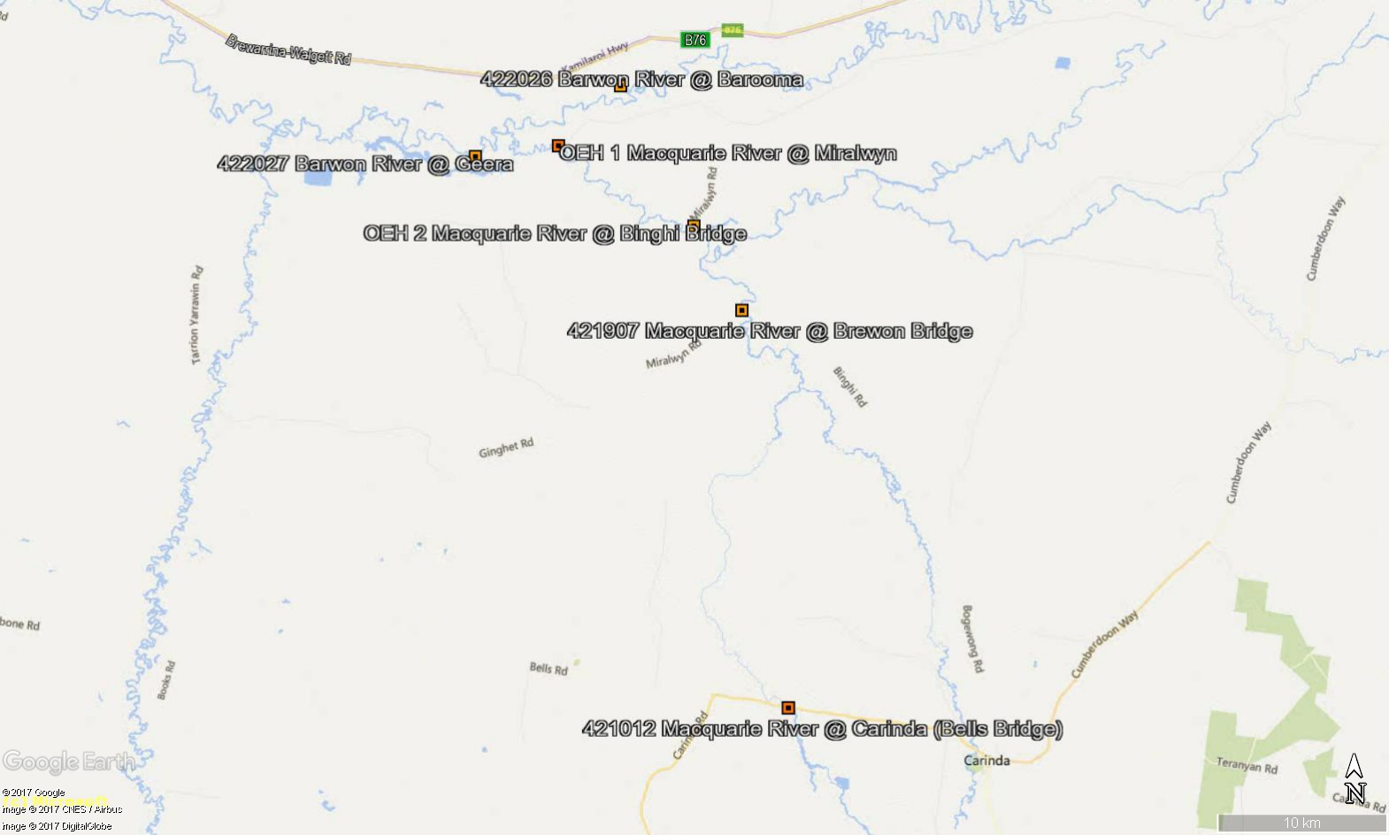

Figure 2: Location map of gauging stations

# 

# Site Reconnaissance 27th and 28th of April 2017

An initial site reconnaissance was conducted to find a suitable location for a temporary gauging station on the Macquarie River, upstream of the confluence with the Barwon River.

Three sites were inspected:

**Site OEH 1** – Macquarie River at Miralwyn

The causeway was considered unsuitable due to the uncertain nature of the controlling feature (earth causeway) and the pipes draining the pool upstream of the causeway. There were no obvious locations downstream of the causeway considered suitable.

**Site OEH 2** – Macquarie River at Binghi Bridge on the Ginghet Rd

The site was considered unsuitable to derive flow due to insensitive control conditions, being a broad long stretch of river with very slow velocities and no defined controlling feature. The gauging sections comprise a thick soft silt bed creating inaccuracies in depth measurements and poor hydraulic conditions for satisfactory gaugings.

**Site OEH 3** – Macquarie River at Brewon Bridge on the Binghi Rd

The site was considered suitable due to the relatively stable controlling feature (gravel causeway) and upstream gauge pool. Site conditions would also allow for reliable gaugings at a range of flows. (Installed site reference 421907 Macquarie River @ Brewon Bridge).

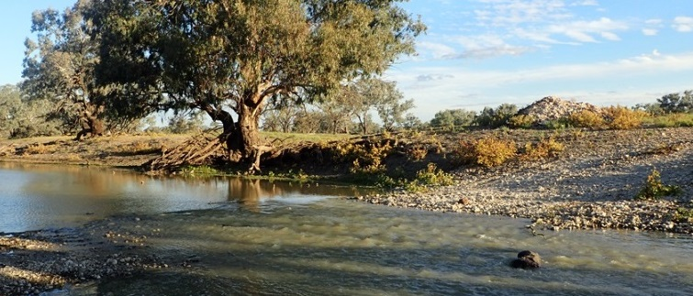

Figure 3: Gravel causeway at site 421907

# Installation of 421907 Macquarie River @ Brewon Bridge

A benchmark was created on the Brewon Bridge and given an assumed datum value of 10.000m. The benchmark is a bolt painted white, right bank, upstream side of Brewon Bridge (Figure 4).

# C:\Users\Bernard.Finch\Desktop\Hydrometric\Dubbo Files\OEH Lower Macquarie site\IMG_3627.JPG

Figure 4: Benchmark on Brewon Bridge

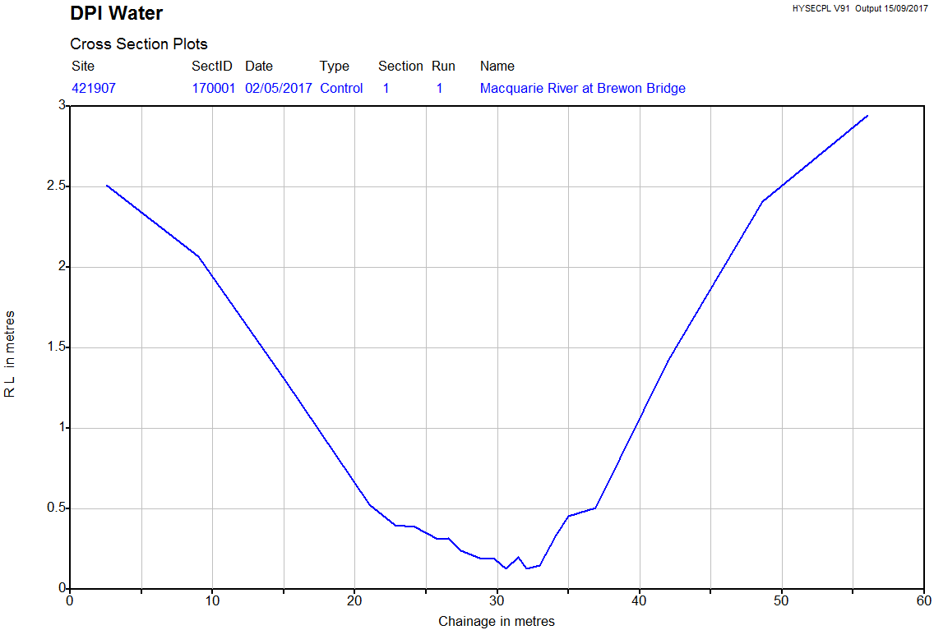A cross section (Plot 1) was carried out on the upstream side of the gravel causeway (the control) to define the channel shape, cross sectional area and cease to flow height, which will be used to develop the stage discharge relationship (rating table).

Plot 1: Cross section

Staff gauges were installed from 0 – 2m in the gauge pool upstream of the gravel causeway. Gauge zero was set at 6.777m (ass. Datum) and the cease to flow value was measured at 6.902m (ass. Datum) which equals 0.125m staff gauge level. Instrument shelter and orifice line were installed in line with staff gauges. (Figure 5)

Temporary loggers and a staff gauges were also installed at gauging stations OEH 1 and OEH 2 to record level data during the environmental flow period (Figure 2 and Table 1). Level data for gauging station OEH 1 is presented in the Plot 2. The logger at OEH 2 could not be located at the end of the flow period. The reason for the removal or loss of these items is unknown.

|  |  |  |  |
| --- | --- | --- | --- |
| Site Number | Site Name | Easting | Northing |
| 421907 | Macquarie River @ Brewon Bridge | 552115 | 6656147 |
| OEH1 | Macquarie River @ Miralwyn | 541229 | 6666019 |
| OEH2 | Macquarie River @ Binghi Bridge | 549278 | 6661191 |

Table 1 OEH Gauging Station Locations

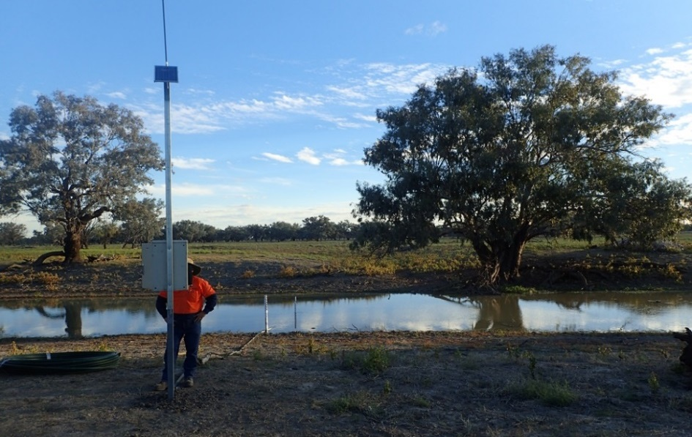

Figure 5: Instrument Shelter and Staff Gauges, Gauging Station 421907

Discharge Gaugings

All discharge gaugings were conducted by wading method using the Sontek Flowtracker Acoustic Doppler Velocity Meter.

Gaugings at 421907 were carried out upstream of the control and in the vicinity of the staff gauges. Gaugings at OEH1 were conducted 100 – 200m d/s of the Miralwyn causeway. A gauging at OEH2 was conducted 50m upstream of the Binghi Bridge (Figure 2). All discharge measurements were conducted in accordance with the National Industry Guidelines for Hydrometric Monitoring and WaterNSW gauging procedures.

A number of gaugings were performed at 421907 when the gauging station was established in May 2017. Further gaugings were undertaken in June, July and August to assist in the development of the discharge rating. Gaugings were also performed at site OEH 1 at the beginning and end of the project period. Plot 2 shows the distribution of gaugings against the level trace throughout the flow period for gauging stations 421907 and OEH1.

It was not possible to gauge any of these sites during the peak of the environmental flow in May as monitoring staff were unavailable at this time. While the gauging method and accuracy are considered reliable, the site characteristics of a broad shallow gauge pool with very slow velocities and soft mud bed has led to some variability in gauging results (see table 2). This is a common feature of gauging sections in the Lower Macquarie River.

|  |  |  |  |  |  |  |
| --- | --- | --- | --- | --- | --- | --- |
| Site Number | Site Name | Date of Visit | Gauged Flow MLd | (%)  Deviation from Rating Curve | Table # | Mean SG (m) |
| 421907 | Macquarie River @ Brewon Bridge | 27/04/2017 | 49.49 | -18.06 | 1.04 | 0.392 |
| OEH2 | Macquarie River @ Binghi Bridge | 27/04/2017 | 62.56 | NR | 1.04 | 0.585 |
| OEH1 | Macquarie River @ Miralwyn | 27/04/2017 | 59.32 | NR | 1.04 | 0.533 |
| 421907 | Macquarie River @ Brewon Bridge | 2/05/2017 | 58.73 | -8.67 \*\* | 1.04 | 0.400 |
| 421907 | Macquarie River @ Brewon Bridge | 3/05/2017 | 67.30 | -1.99 \*\* | 1.04 | 0.408 |
| OEH1 | Macquarie River @ Miralwyn | 3/05/2017 | 52.06 | NR | 1.04 | 0.485 |
| 421907 | Macquarie River @ Brewon Bridge | 9/05/2017 | 99.10 | 6.84 \*\* | 1.04 | 0.448 |
| 421907 | Macquarie River @ Brewon Bridge | 9/05/2017 | 96.86 | 3.78 \*\* | 1.04 | 0.449 |
| 421907 | Macquarie River @ Brewon Bridge | 7/06/2017 | 68.34 | 3.66 \*\* | 1.04 | 0.403 |
| 421907 | Macquarie River @ Brewon Bridge | 17/07/2017 | 2.95 | 0.99 \*\* | 1.04 | 0.220 |
| OEH1 | Macquarie River @ Miralwyn | 18/07/2017 | 0.30 | NR | 1.04 | 0.110 |
| 421907 | Macquarie River @ Brewon Bridge | 16/08/2017 | 25.62 | 3.57 \*\* | 1.04 | 0.220 |
| \*\* The flow accuracies are described above, shown as deviations, are within the error percentages requirements of + or – 10% prescribed in the WaterNSW Procedures and National Industry Guidelines for Hydrometric Monitoring.  NR = Not rated | | | | | | |

Table 2: Gauging Results

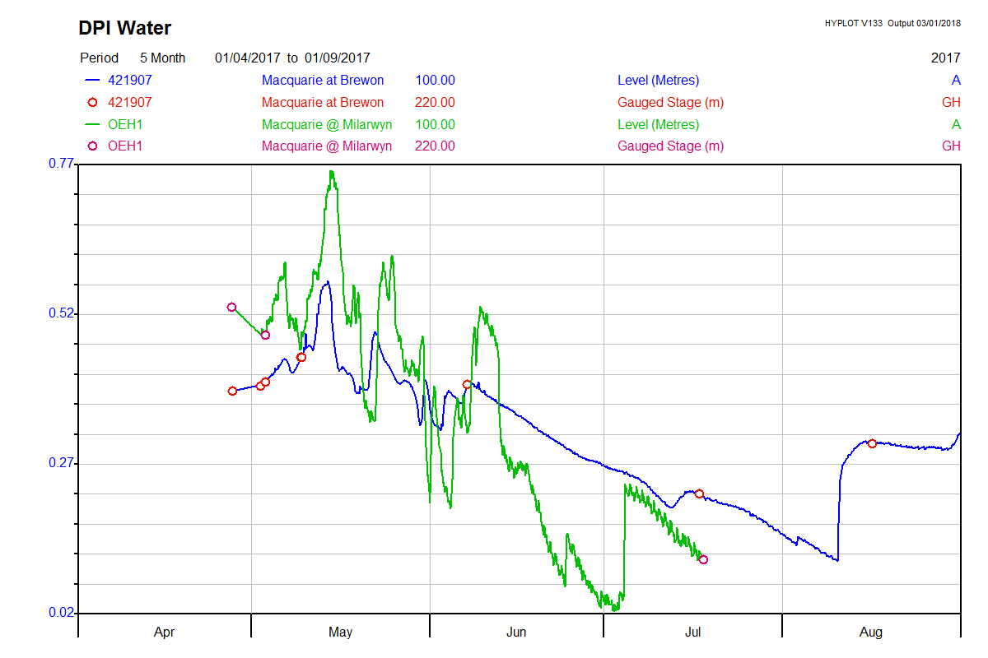Plot 2: Level and Gauging plot for gauging stations 421907 and OEH1

Level data for sites 421907 and OEH1 (Plot 2) indicate that there was pumping activity during May and some pumping which affected the level at OEH1 in June as the environmental flow receded. It is not possible to determine the location of this pumping.

# Rating table development

A rating table RT1.00 was created on 11/5/17 using the results of a number of gaugings already conducted and the measured CTF value of 0.125m. A Theoretical rating point was created at 0.500m using the non-standard section control formulae Q=CdH2 for a parabolic shaped section control. This was based on the Cd (coefficient of discharge) calculated from previous gauging’s.

Rating RT1.01 was created on 21/6/17 using a straight-line log extension to 0.600m, which was above the highest level recorded during the flow event.

RT1.02 was created on 21/6/17 from an additional gauging on 7/6/17 and adjustments made above 100ML/d through a peak correlation method with upstream sites 421135 and 421012 during the same event.

RT1.03 was created on 25/7/17 after a low flow gauging on 17/7/17. This resulted in adjustments below 60ML/d.

RT1.04 was created on 21/8/17 after a gauging on 16/8/17. This resulted in adjustments to the rating table up to 100ML/d

|  |  |  |  |  |  |  |  |  |  |  |
| --- | --- | --- | --- | --- | --- | --- | --- | --- | --- | --- |
| Gauge Height | 0 | 0.01 | 0.02 | 0.03 | 0.04 | 0.05 | 0.06 | 0.07 | 0.08 | 0.09 |
| 0.0 | 0.0 | 0.0 | 0.0 | 0.0 | 0.0 | 0.0 | 0.0 | 0.0 | 0.0 | 0.0 |
| 0.1 | 0.0 | 0.0 | 0.0 | 0.02 | 0.07 | 0.14 | 0.27 | 0.43 | 0.66 | 1.03 |
| 0.2 | 1.50 | 2.11 | 2.92 | 3.97 | 5.49 | 7.38 | 9.7 | 12.3 | 15.3 | 18.8 |
| 0.3 | 22.8 | 26.4 | 30.0 | 33.8 | 38.0 | 42.3 | 46.7 | 50.8 | 55.1 | 59.5 |
| 0.4 | 64.3 | 69.8 | 75.5 | 81.5 | 87.7 | 93.9 | 99.8 | 106 | 112 | 118 |
| 0.5 | 125 | 130 | 135 | 141 | 146 | 152 | 158 | 163 | 168 | 173 |

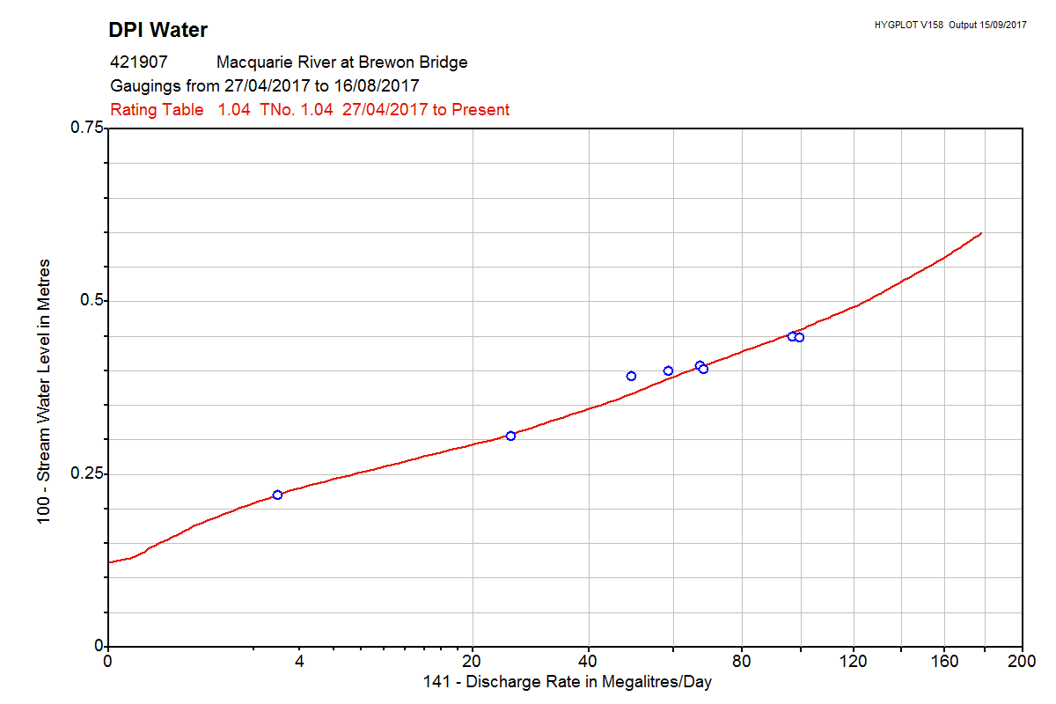Table 3: Discharge Rating table 1.04 Gauge Height v Discharge Rate (ML/d)

Plot 3: 421907 Discharge rating curve with gaugings plotted

This rating table relates only to the gauge pool at 421907 and it is not possible to estimate depths in the Macquarie River upstream or downstream of this point based on this rating table alone.

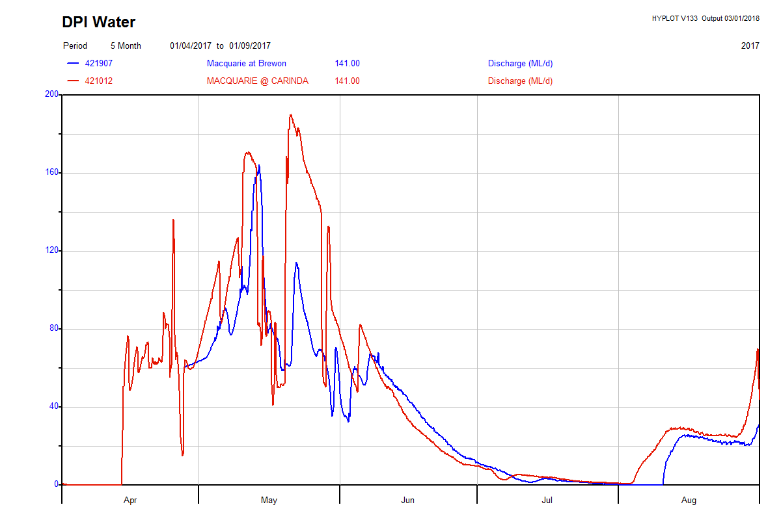

Plot 4: Discharge traces for stations 421907 Macquarie River @ Brewon Bridge and the upstream station 421012 Macquarie River @ Carinda.

The discharge data for sites 421012 Macquarie River @ Carinda and 421907 Macquarie River @ Brewon Bridge (Plot 4) indicates that there was pumping activity upstream of 421907, affecting flows at the monitoring point during May. Significant differences in discharge rates of up to 70ML/d were recorded between sites 421012 and 421907 during this time. It is not possible to determine the effect this has had on water depth throughout this section of the Macquarie River.

The discharge plots for sites 422026 Barwon River @ Boorooma and 422027 Barwon River @ Geera (Plot 5 and 6) show there is an increase in flow downstream of the Macquarie River confluence at site 422027 during May and into June. This would indicate that the environmental flow in the Macquarie River reached the Barwon River in May during the recession of a significant flow event in the Barwon River during April. There doesn’t appear to be any backwater effects evident on any of the level data recorded on the Macquarie River sites during the environmental flow in May.

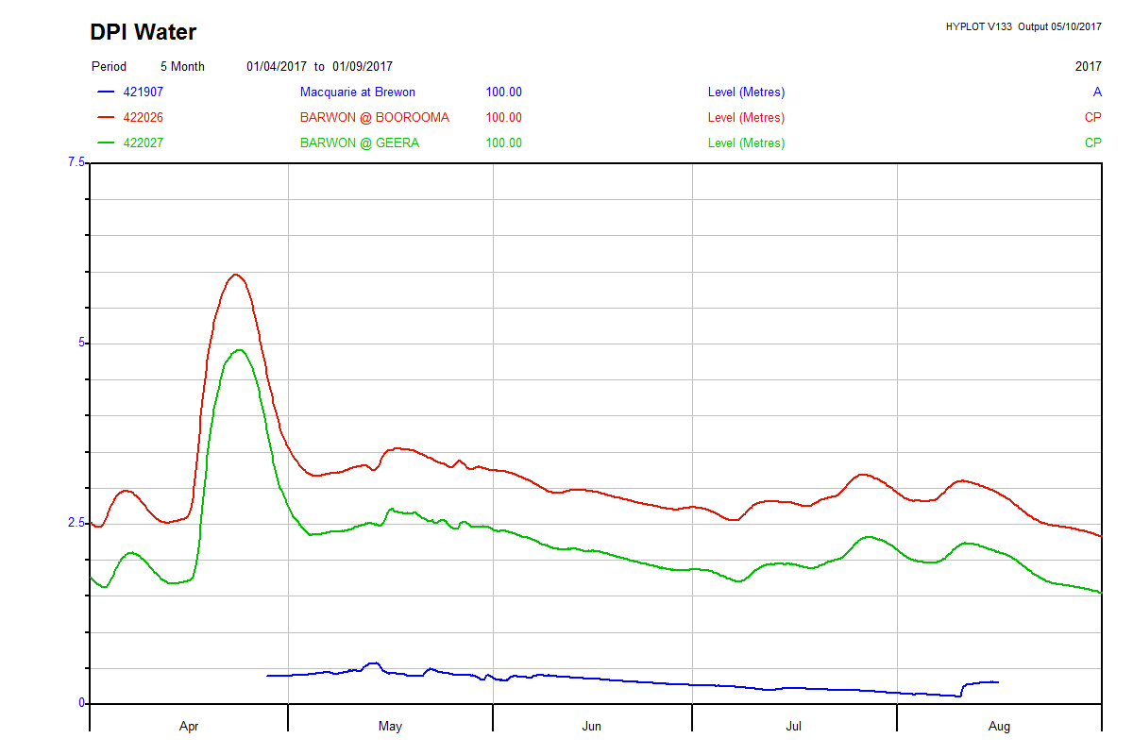

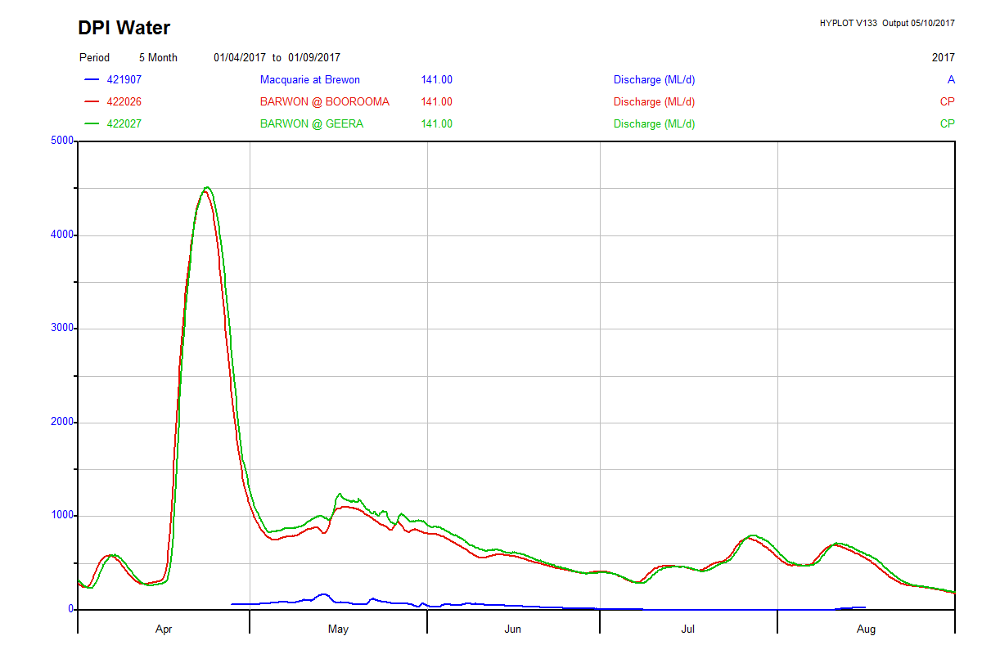Plot 5: Level traces for stations 421907 on the Macquarie River and stations 422026 and 422027 on the Barwon River

Plot 6: Discharge traces for stations 421907 on the Macquarie River and stations 422026 and 422027 on the Barwon River

# C:\Users\Bernard.Finch\Desktop\Hydrometric\Dubbo Files\OEH Lower Macquarie site\Total flow 421907_422026_422027.pngPlot 7: Cumulative Discharge for stations 421907 on the Macquarie River and stations 422026 and 422027 on the Barwon River

# The cumulative discharge totals for site 421907 (Plot 7) indicates there was an approximate total of 4000ML of environmental water flowing in the lower Macquarie River during May and June. This correlates reasonably well with the cumulative discharge totals for site 422026 and 422027 which indicate approximately 45000ML and 49000ML at these sites on the Barwon River, respectively.

It should be noted that care should be taken when using this data as the approximate total of 4000ML from the Macquarie River is within the range of potential measurement error for the sites on the Barwon River. There may be other factors such as natural system losses, pumping activity on the Barwon and instrument accuracy tolerances which are not accounted for in this evaluation.

# Discussion of key findings

* Site 421907 was considered the most suitable location for a temporary site installation and reliable gaugings at a range of levels.
* Site characteristics are a broad gravel causeway in a shallow U shaped channel forming a broad shallow gauge pool.
* Numerous gaugings were conducted at site 421907 during the monitoring period
* Monitoring staff were unavailable to gauge the peak of the environmental flow event.
* The peak of the flow event was of a relatively short duration and there were significant water losses during this time.
* Depth/Level measurements relate to the specific locations of each gauging station and is not possible to estimate water levels throughout this stretch of the Macquarie River in other locations.
* The rating table for site 421907 was developed using a combination of theoretical methods, peak correlation with upstream sites and adjustments from the results of gaugings during the monitoring period.
* The environmental flow from the Macquarie River was evident as approximately 4000ML inflow to the Barwon River during May and June, as per the aims of the monitoring project.
* Long term monitoring of flow in this section of the Macquarie River would result in a more accurate rating table over time and give a greater understanding of the amount of environmental water delivered through this system.
* All data should be used with a degree of caution as there are potential error sources associated with the measurement of water level and discharge in natural systems.