|  |  |
| --- | --- |
| **In this issue, you will find:**   * Project updates * Field work in full steam * Flows and fish spawning * E&C updates * What’s next? |  |
|  |  |

# Lower Murray Newsletter

Issue 10 – October to December 2021

Welcome to Issue 10 of the Lower Murray newsletter where we provide updates on our

work monitoring the ecological responses to the Commonwealth environmental water delivery in the Lower Murray

Cheers to the end of 2021 Recharging/refueling Water flowing over Lock 4

# Project Updates

During this quarter our team worked hard to complete all the data analyses and prepare the report for the 2020-21 season. Some of the interesting findings from 2020-21 include:

Eggs collected during the 2020-21 season in the Lower Murray were confirmed, by molecular analysis, to be golden perch.

Field work being undertaken aboard SARDI vessel RAKALI. Photo credit: SARDI.

Fish larvae and young-of-the-year Murray cod, silver perch and golden perch have been aged and results for water and otolith microchemistry were received from Melbourne University and the University of Western Australia, respectively.

The majority of the larvae collected in 2020-21 were silver perch. All silver perch larvae (8–15 mm) came from spawning in the mid-Murray.

Arriving at site (downstream of Lock 1) and preparing to start water, microinvertebrate and fish sampling. Photo credit: SARDI.

Small (<6 mm) golden perch larvae collected in spring-summer of 2020 were likely to have been from local spawning, however otoliths were too small to confirm this by microchemistry analyses.

larger (8–13 mm) golden perch larvae confirmed they had travelled from the mid-Murray, upstream of Lock 6.

The 2021-22 field season continues, with fortnightly sampling for fish larvae, microinvertebrates and water quality. Fish larvae sorting/identification has already started, and two Murray cod larval sampling trips occurred in November 2021 and January 2022.

Retrieving water quality logger to be cleaned, calibrated, and returned to water. Loggers set to measure in water respiration and photosynthesis at 10 minutes interval. Photo credit: SARDI.

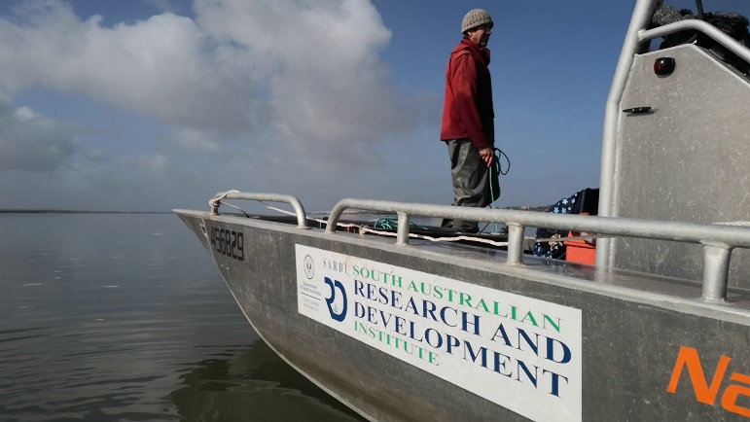**Field work in full steam (2021-22)**

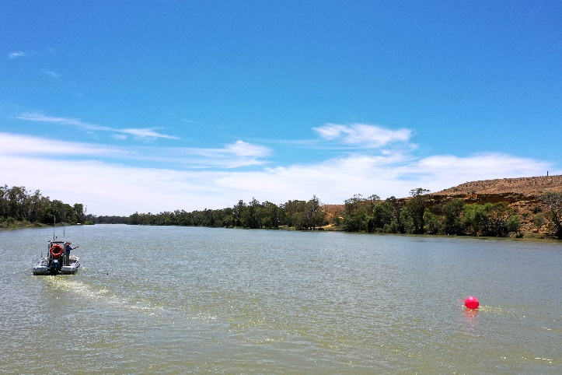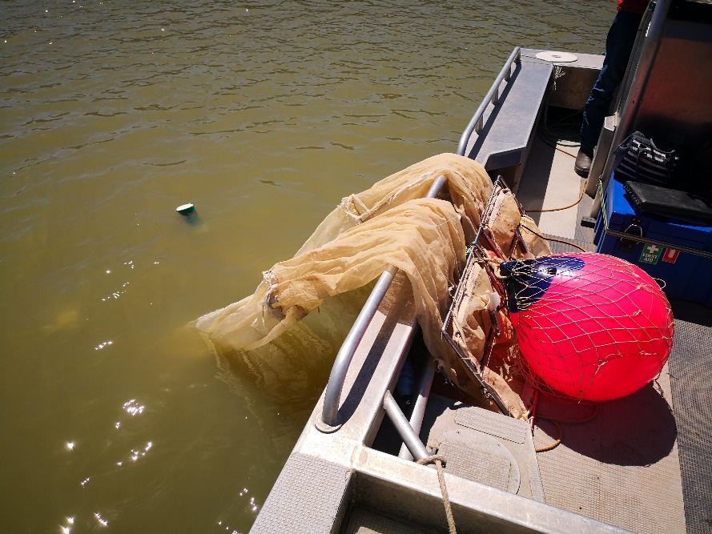

Fish larvae collection using plankton net. The hopes are up to continue collecting large numbers of golden perch and silver perch eggs/larvae during this high flow period. Photo credit: SARDI.

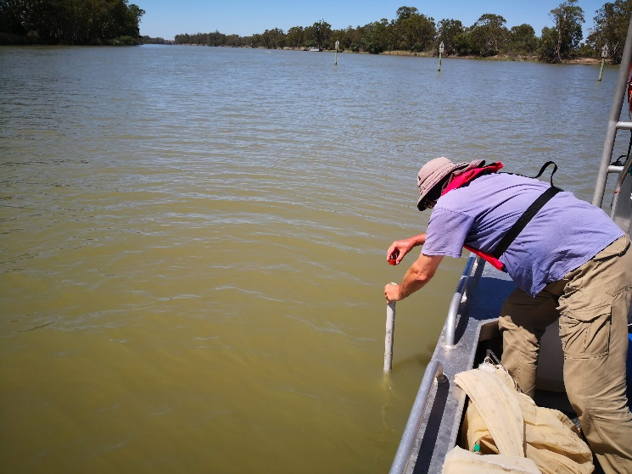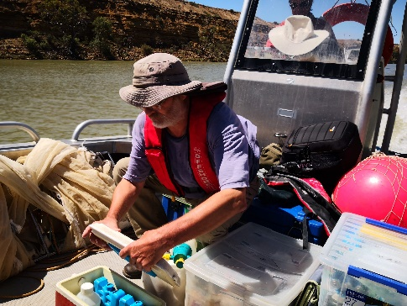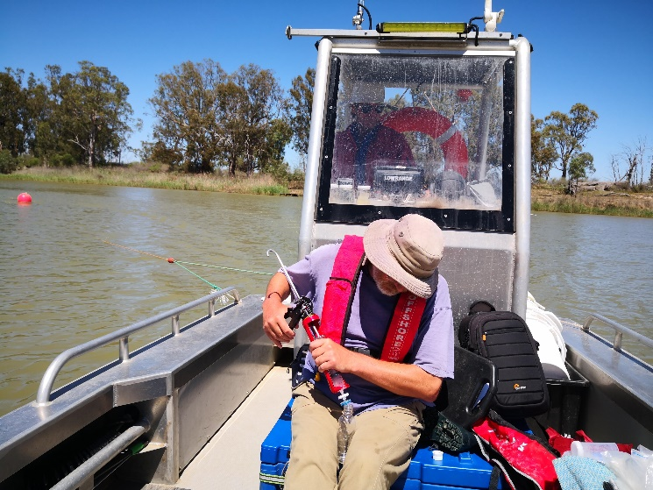

River water being collected, filtered, and stored to be sent for analysis such as chlorophyll a, dissolved organic carbon. Photo credit: SARDI.

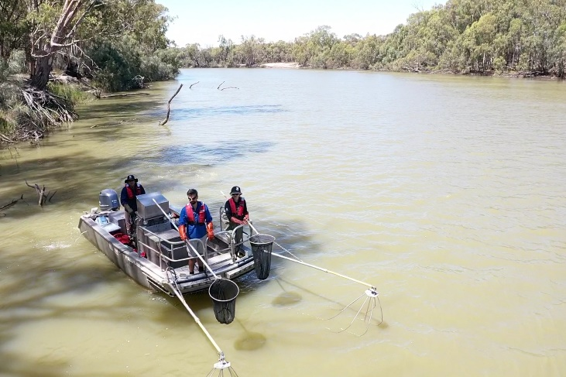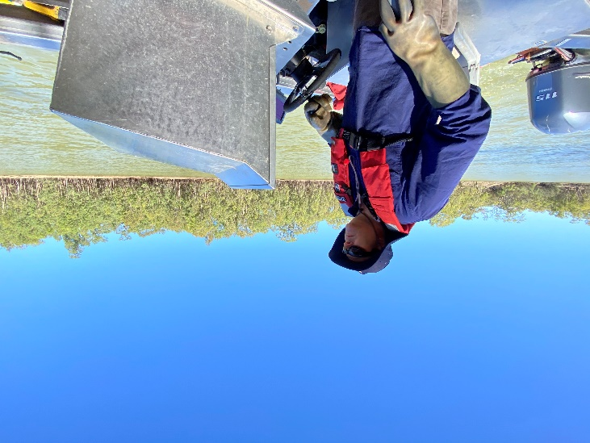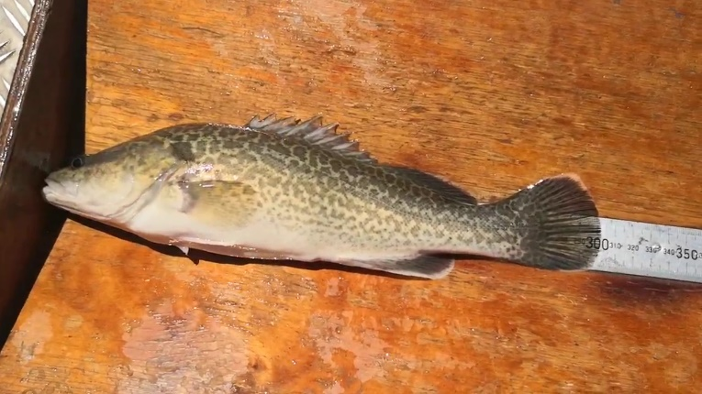

SARDI electrofishing boat in action (top). Healthy one-year-old Murray cod collected through electrofishing (bottom). Numbers of one/two-year-old Murray cod have been up this year. We collected 110 in the January trip alone. Photo credit: SARDI.

Collection of microinvertebrates using a Perspex Haney trap. It will be interesting to know how upstream high flows will influence the microinvertebrate community in the Lower Murray River. Photo credit: SARDI.

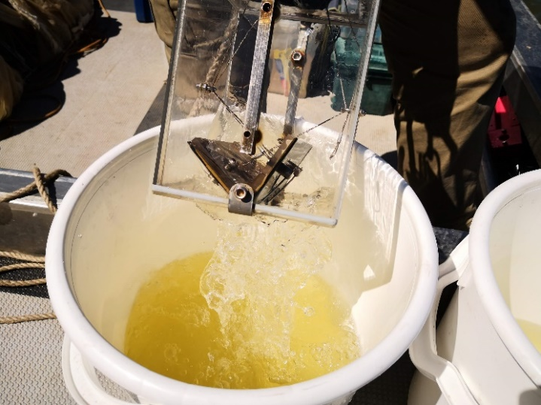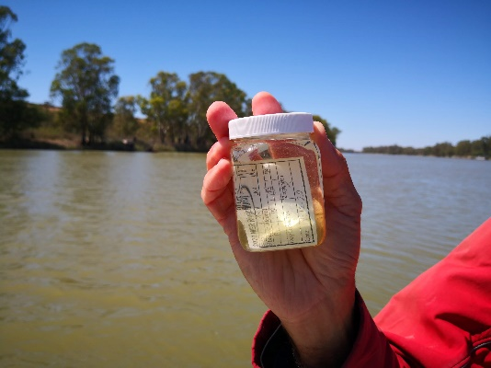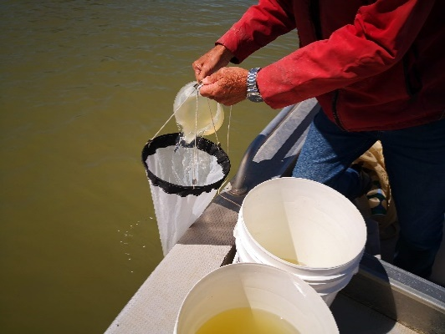

Flows and fish spawning

Many native fish species respond to environmental cues which trigger spawning events. Such cues could be rises in water level or flow velocity (as a result of increase in water discharge or weir pool level manipulations), and changes in water temperature and day/night length.

Golden perch and silver perch are two fish species of the Murray-Darling Basin considered to be flow-cued spawners. Their spawning and recruitment (larval/juvenile survival) corresponds with increases in water temperature (> 17°C) and flow, either in-channel or overbank.

Adult golden perch (top) and silver perch (bottom). We are looking at our samples with eager eyes, as we are expecting strong recruitment due to the high flow conditions. Photo credit: SARDI.

The Lower Murray research team has been monitoring the spawning of large-bodied native fish, including these two flow-cued spawners. During years of elevated spring flow (>15,000 ML/day), between October and January, our fish team fortnightly samples fish eggs and larvae using a plankton net towed behind our research boat (see photos on “Field work in full steam” section).

Early-stage (‘hatchlings’) (top) and larvae (bottom) of golden perch collected early in the season. Photo credit: SARDI.

The 2021-22 season has experienced high in-channel flows, varying between 29,000 and 37,000 ML/day in the Lower Murray River. This provided ideal river conditions to investigate perch spawning and recruitment in response to high in-channel flow pulses in this region. Where possible, our team has been sorting and identifying samples as they were collected, keenly looking for perch eggs and larvae. Temperature was 17.1°C in mid-October during our first sampling event and around 25-27 °C during the early January sampling event.

Over the past monitoring seasons, South Australia has not received these flow levels. They were usually not higher than 18,000 ML/day (low in-channel flows) or were over 50,000 ML/d (overbank flows). Having flows between 25,000 ML/day and 40,000 ML/day presents a great opportunity to learn more about perch spawning responses during high in-channel flows.

Preliminary sorting and identification of 2021-22 samples has yielded promising results. Perch eggs were found in good numbers in late October and November, whilst perch larvae were present in varying stages/sizes and numbers from early November through to late December. Samples from the two January trips are yet to be processed. Further analyses will tell us more about the spawning response of these two species to flows, in Lower Murray River.

***E&C updates***

* Our plant and fish ecologists, Jason Nicol and David Short, attended another Indigenous Ecology in Action workshop at Calperum Station, on 21–22 October 2021. The event was again successful; 12 indigenous and non-indigenous students from Renmark, Glossop and Loxton schools attended and learnt about western scientific methods as well as traditional culture and knowledge.
* The E&C coordinator, Luciana Bucater and Emma Woodward, from CSIRO team leading a Basin-scale indigenous engagement plan, met virtually to discuss community engagement, particularly what indigenous engagement activities had occurred in the Lower Murray Selected Area and indications of what worked well and where the challenges were. This will inform future engagement during MER2.0.

The Annual Fishcare Volunteers Forum was held in Adelaide on 14 November 2021. The forum is an opportunity for the volunteers to get together and learn about information which will assist them when speaking to the recreational fishing public.

Qifeng Ye and George Giatas were invited to present at the forum. Qifeng provided an overview of the Flow-MER Project in our selected area, whilst George talked about the Murray cod ecology and population dynamics in the Lower Murray.

Qifeng Ye presenting at the Annual Fishcare Volunteers Forum. Photo credit: PIRSA.

A second Lower Murray animation video is currently being compiled with the help of the science communicators, *Animate Your Science*. The video explains how ongoing monitoring and research is building our understanding of how river flows influence the health of the Lower Murray and its inhabitants. Watch out for the video which we expect to release by early March 2022.

Screen grab of the Lower Murray Selected Area animation video.

* Another video documenting the exciting exploits of the team when we are out in the field is also in its final stage of post-production. Final product should be ready by the end of 2022 first quarter.

***What’s next***

During the January-March quarter, field teams will continue to collect samples and data for the 2021-22 season, while researchers will finalise the 2020-21 technical and summary reports. In early March, the selected area working group will gather (likely online) to discuss and provide feedback on the 2020-21 report with the project team.

Upcoming engagement and communication activities include finalising the “in field” and animation videos where we will showcase the important activities our research team performs and highlight the important role that water for the environment plays in restoring the riverine ecosystem in this region.

We are also in discussion with the Calperum station manager and ecologists to build on our past success of Indigenous Ecology in Action workshops and plan for future activities (COVID permitting).

For more information about the work we do, visit our webpage [https://flow-](https://flow-mer.org.au/selected-area-lower-murray/)mer.org.au/selected-area-[lower-murray/](https://flow-mer.org.au/selected-area-lower-murray/) and follow us on social media and <https://twitter.com/FlowMERprogram>

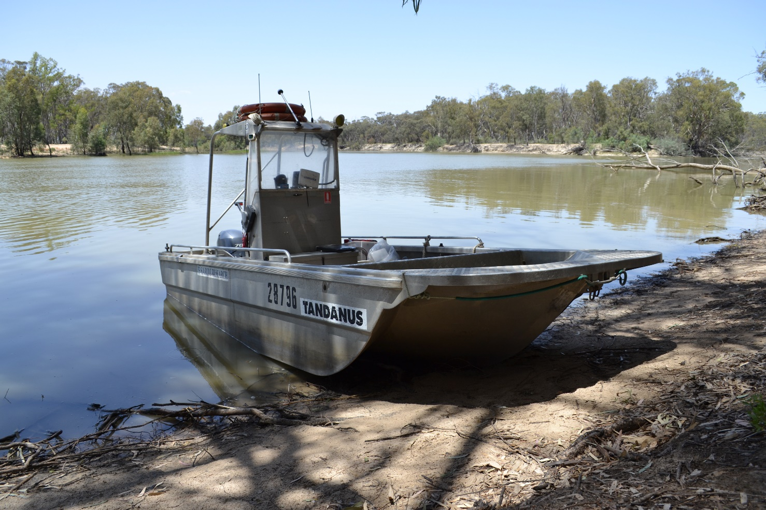

SARDI boat, TANDANUS at the margins of the Lower Murray River. Photo credit: SARDI.

